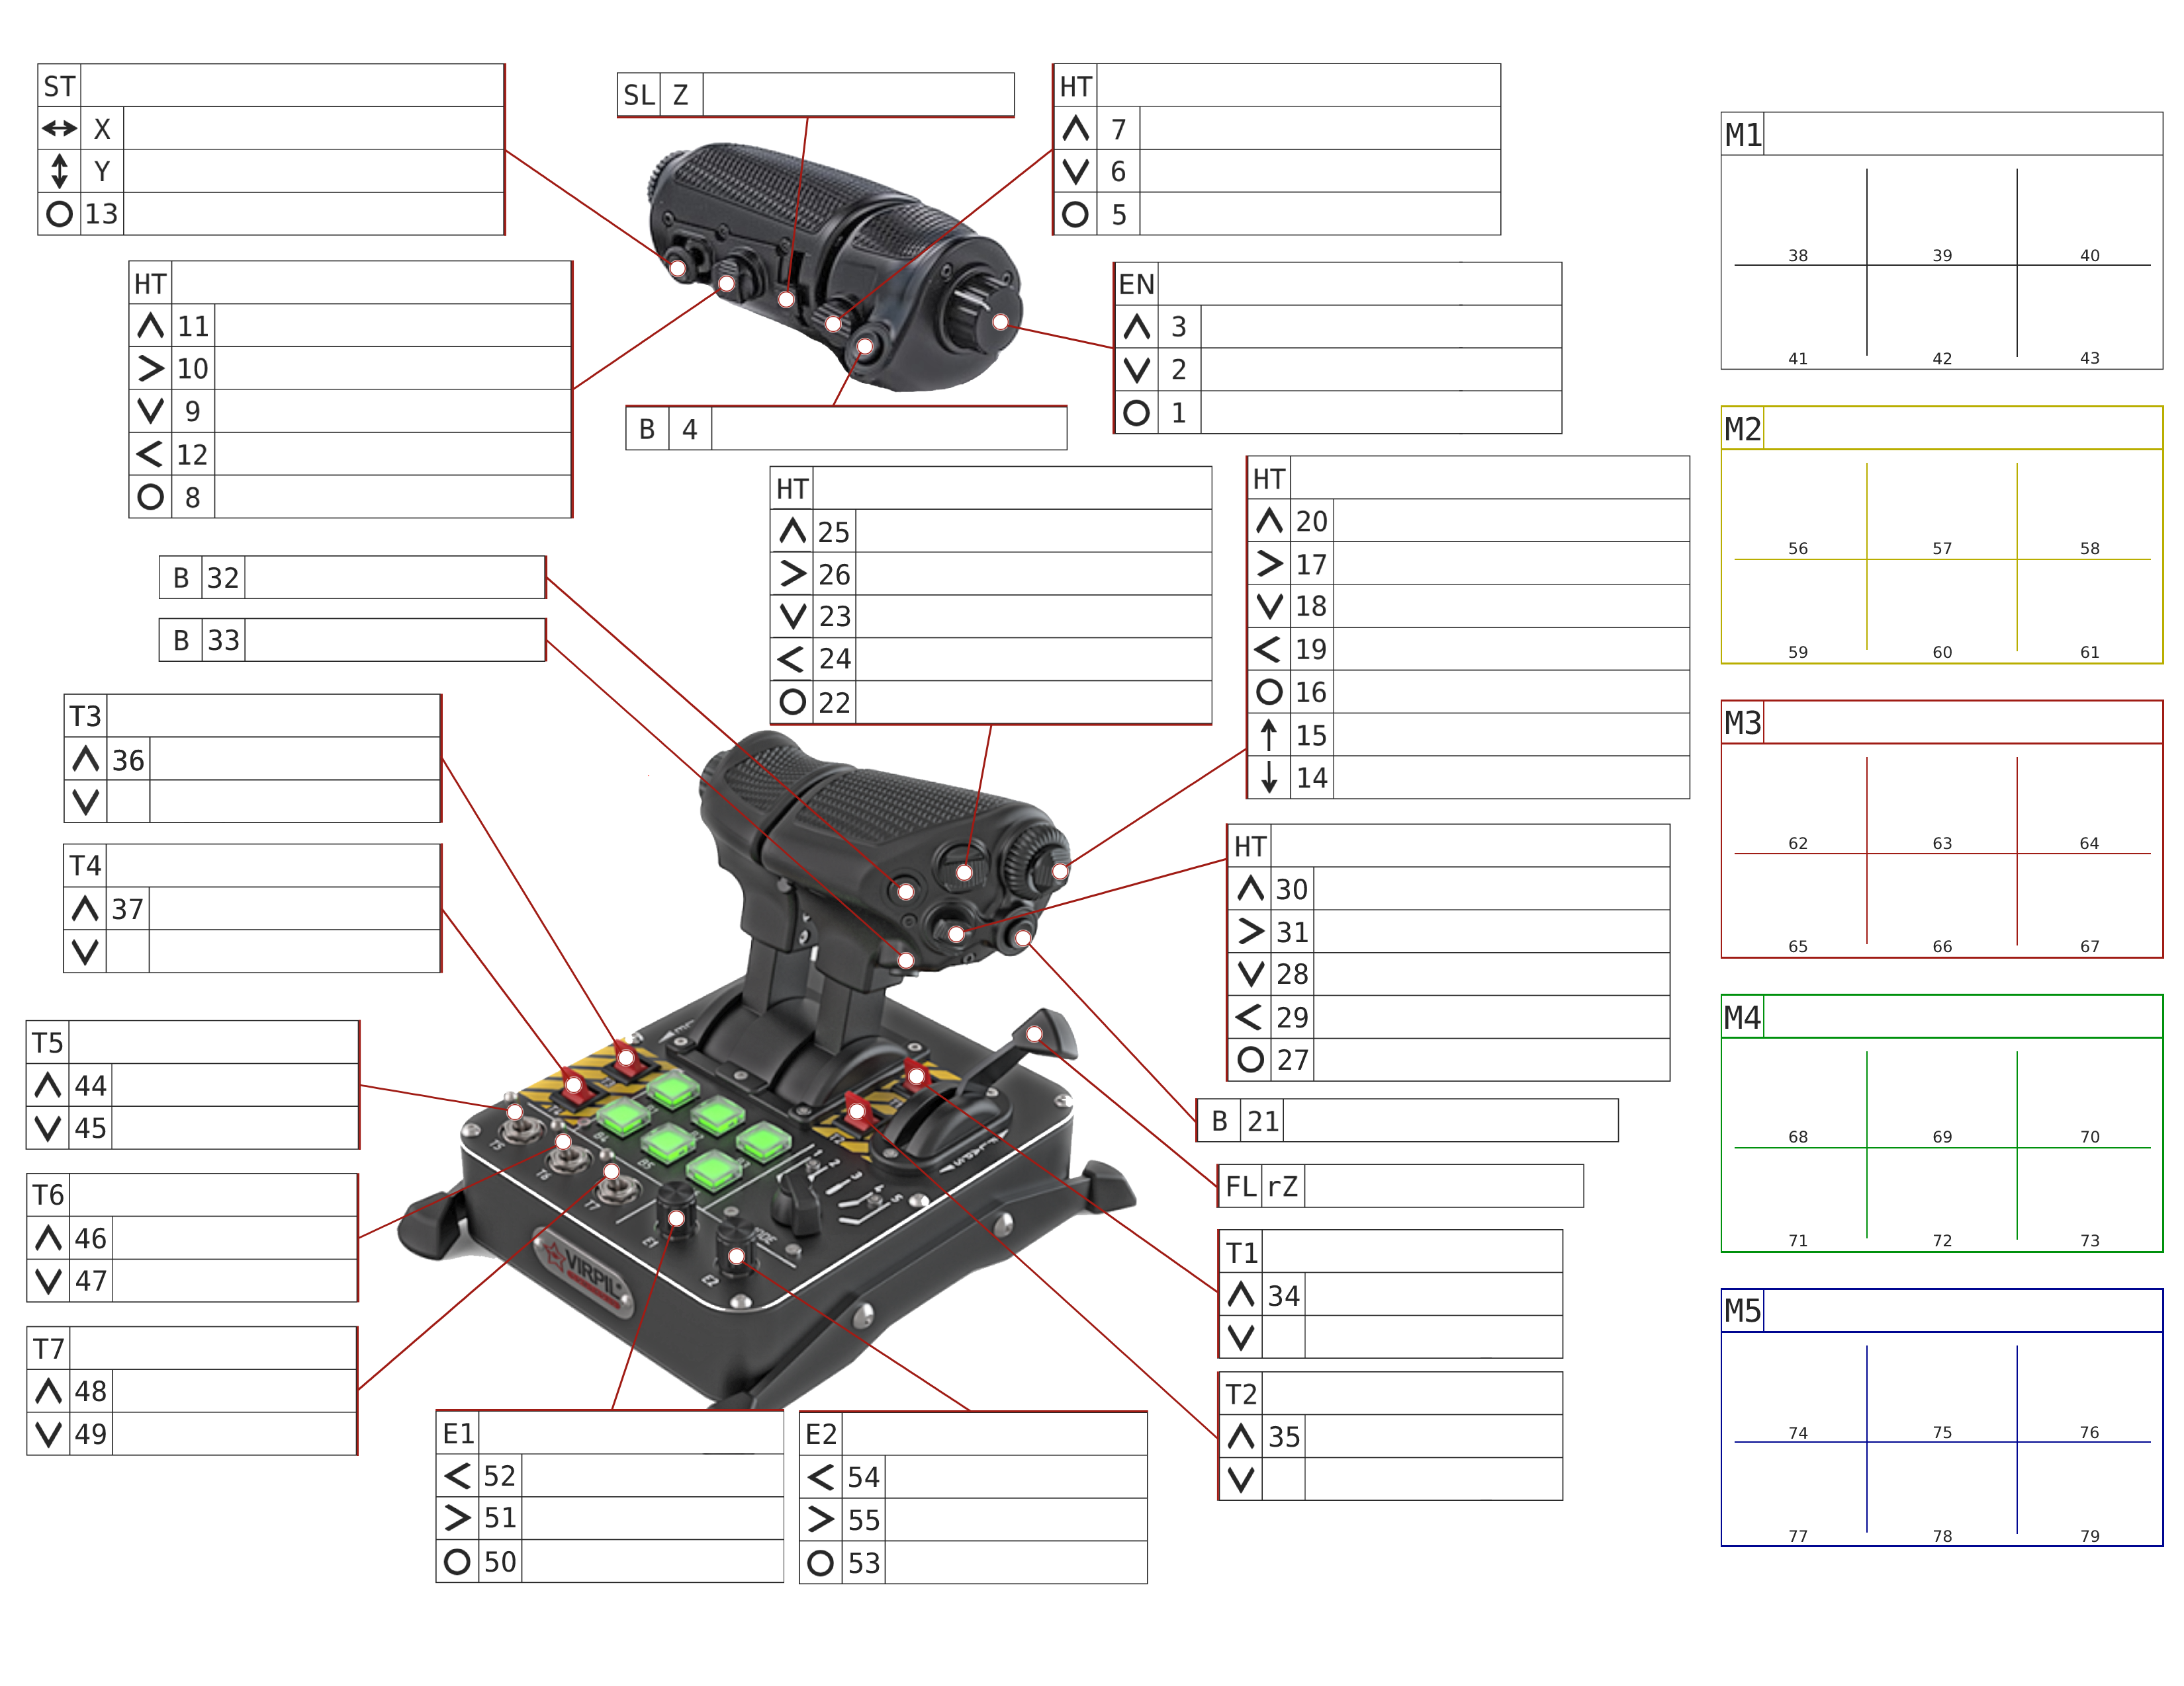
P47 interconn
Prop/turbo
Turbosup
+/-
Tailwhl
lock
Auto RPM
Auto rads
Auto mix
/ sup
canopy
Engine st
Water Rad +
Cowl flaps +
Water Rad –
Cowl flaps –
Man/auto water
Oil rad+
Cowl flaps +
Oil rad –
Cowl flaps –
Man/auto oil
x
x
x
Prop RPM +/-
VR Zoom
x
Kneeboard on/off
Kneeboard pg dn
Kneeboard pg up
x
Speedbrake
Ldg Gear
Flaps
x
Prop pitc +/-

Auto pitch
Mixture +/-
CHANGE MIX
Supchg mode
Flaps
Weap Jettison
Drogue chute
SRS PTT
SRS radio dn
SRS radio up
x
Modifier

