Table of Contents
September 2022 4
Thursday, September 1, 2022 4
Setting Up KRLVS148, KRLVS149, KRLVS111, KRLVS112 Cultures for RNA Purification 4
RNA Purification of KRLVS148, KRLVS149, KRLVS111, and KRLVS112 4
Friday, September 2, 2022 5
Wednesday, September 7, 2022 6
Generate cDNA (Half) KRLVS148, KRLVS149, KRLVS111, KRLVS112 (8/24/22 Pure RNA) 6
cDNA Purification with PCR Purification Kit 6
Thursday, September 8, 2022 7
DNase treatment of KRLVS148, KRLVS149, KRLVS111, and KRLVS112 RNA Samples 7
Friday, September 9, 2022 8
Generate cDNA (Half) KRLVS148, KRLVS149, KRLVS111, KRLVS112 (8/24/22 Pure RNA) 8
Monday, September 12, 2022 10
Finish Generating cDNA of 9/8/22 Pure RNA Samples 10
Gel of KRLVS148, KRLVS149, KRLVS111, and KRLVS112 RNA Samples 10
cDNA Purification with PCR Purification Kit 11
Tuesday, September 13, 2022 12
qRT-PCR of KRLVS148, KRLVS149, KRLVS111, KRLVS112 (8/25/22) cDNA 12
qRT-PCR of KRLVS148, KRLVS149, KRLVS111, KRLVS112 (9/8/22) cDNA 13
Reagents 14
Wednesday, September 14, 2022 14
Transformation of PrpsU2 tul4 5’UTR 5X and 3X Ligation (8/29) into E. coli 14
Reagents 15
Thursday, September 15, 2022 15
Making Single Use Aliquots of KRLVS192 and KRLVS193 15
Friday, September 16, 2022 15
Miniprep of Candidate pKR122 from E. coli 15
Diagnostic Digest of Candidate pKR122 Miniprep w/KpnI and NotI 16
Gel of Diagnostic Digest of Candidate pKR122 Miniprep 16
Preparing Electrocompetent KRLVS28 and KRLVS75 Cells 17
Making Personal Glycerol Stocks of KRLVS28 and KRLVS75 17
Monday, September 19, 2022 18
Electroporating pKR141 into electrocompetent KRLVS28 and KRLVS75 18
Tuesday, September 20, 2022 18
DNA Digest of PrpsU2_tul4UTR gBlock PCR and pKR128 Backbone w/KpnI and NotI 18
Gel of Digested PrpsU2_tul4UTR PCR Fragment + pKR89 Backbone 19
Visualizing and Cutting Gel 19
Reagents 19
Wednesday, September 21, 2022 20
Testing the Effect of Temperature on rpsU1 and rpsU3 Production in KRLVS192 and 193 20
GFP Assay on Temperature Conditions in KRLVS192 and KRLVS193 21
Gel Extraction with QIAquick Gel Extraction Kit 22
Thursday, September 22, 2022 22
Agar overlay for β-galactosidase activity in KRLVS28 and KRLVS75 + pKR141 23
Ligation of PrpsU2 tul4 5’UTR PCR from gBlock with pKR128 backbone 24
Making electrocompetent cells – Day 1 24
Reagents 24
Friday, September 23, 2022 25
Making electrocompetent cells 25
Electroporation of cells 25
Monday, September 26, 2022 27
qRT-PCR of KRLVS148, KRLVS149, KRLVS111, KRLVS112 (8/25/22) cDNA 27
Reagents 29
Tuesday, September 27, 2022 29
Miniprep of Candidate pKR122 Plasmid from Yeast 29
Freezing Down KRLVS28 Transposon Integrants 30
Wednesday, September 28, 2022 30
Testing the Effect of Salinity on rpsU1 and rpsU3 Production in KRLVS192 and 193 30
GFP Assay on Salinity Conditions in KRLVS192 and KRLVS193 31
Thursday, September 29, 2022 32
Friday, September 30, 2022 32
October 2022 34
Monday, October 3, 2022 34
Tuesday, October 4, 2022 34
Wednesday, October 5, 2022 34
Thursday, October 6, 2022 34
Friday, October 7, 2022 34
Monday, October 10, 2022 35
Tuesday, October 11, 2022 35
Wednesday, October 12, 2022 35
Thursday, October 13, 2022 35
Friday, October 14, 2022 35
Monday, October 17, 2022 36
Tuesday, October 18, 2022 36
Wednesday, October 19, 2022 36
Thursday, October 20, 2022 36
Friday, October 21, 2022 36
Monday, October 24, 2022 37
Tuesday, October 25, 2022 37
Wednesday, October 26, 2022 37
Thursday, October 27, 2022 37
Friday, October 28, 2022 37
Monday, October 31, 2022 38
Bibliography 39

September 2022

Thursday, September 1, 2022
To Do:
- Set up KRLVS148, KRLVS149, KRLVS111, and KRLVS112 cultures for RNA purification
- RNA purification of KRLVS148, KRLVS149, KRLVS111, and KRLVS112
Results and Data:

Setting Up KRLVS148, KRLVS149, KRLVS111, KRLVS112 Cultures for RNA Purification
- Scrape each duplicate patch of KRLVS148, KRLVS149, KRLVS111, and KRLVS112 into individual tubes of 400uL MHB
- Check OD”s in a 1:20 dilution (50uL of sample in 950uL of MHB)
- Calculate volume to add to tubes of 8 mL MHB for an OD of 0.08 for KRLVS149 and KRLVS112, and 0.1 for KRLVS148 and KRLVS111 (calculated OD of 0.095 or 0.13 for error)
- Check OD’s with 600uL
- Shake @37°C and grow to mid-log, checking OD’s at 2 hours initially

RNA Cultures OD’s
Sample | 0 hours | 2 hours | 4 hours | 5 hours | 5.6 hours
148-1 | 0.107 | 0.168 | 0.199 | 0.265 | 0.286
148-2 | 0.144 | 0.195 | 0.226 | 0.288 | 0.307
149-1 | 0.084 | 0.142 | 0.159 | 0.227 | 0.262
149-2 | 0.114 | 0.150 | 0.170 | 0.249 | 0.302
111-1 | 0.120 | 0.163 | 0.193 | 0.242 | 0.252
111-2 | 0.109 | 0.142 | 0.156 | 0.204 | 0.218
112-1 | 0.095 | 0.138 | 0.191 | 0.262 | 0.299
112-2 | 0.109 | 0.129 | 0.169 | 0.248 | 0.304
Clearly my samples took a fair bit longer to grow than normal. I briefly considered that perhaps it was due to the fact I grew up the KRLVS149 and KRLVS112 plates a day earlier than normal, in order to guarantee enough cells. However, this should have, in theory, only affected those cultures then. Otherwise, I placed them in a different location in the shaking incubator than normal, however I highly doubt that this was the reason why they seemed to grow so slowly. Obviously, cells can grow differently from day to day, and I assume it was just that. However, if something is weird about the qRT-PCR results, then perhaps there was something odd going on.

RNA Purification of KRLVS148, KRLVS149, KRLVS111, and KRLVS112
- Pellet 1.8mLx2 of culture at max speed @room temperature
- Resuspend cell pellet in 1 mL TRI-Reagent
- Incubate at 60°C for 10 min
- Spin at 4°C for 10 min at max speed
- Transfer supernatant to new 2mL tube (~950 uL).
- Add equal volume 100% ethanol
- Pass sample over Directzol column, 600 uL per spin, 30 sec per spin at max speed, discarding flow-through in phenol and methanol waste
- Place spin column in new collection tube
- Wash twice with 400 uL RNA PreWash buffer, discarding flow-through in phenol and methanol waste
- Add 700 ul of Wash buffer, let sit on column for 3 min
- Spin max speed for 2 min
- Wash again with 700 ul Wash buffer
- Spin max speed for 2 min
- Place column in new collection tube
- Spin max speed for 3 min
- Place column in clean 1.5 mL tube
- Add 90 uL RNase-free water, let sit on column 2 min
- Spin max speed 1 min
- Place flow-through on column again, spin 1 min
- Store nucleic acids at -80°C if not moving directly to the next step
Stored total nucleic acids in -80C freezer in new RNA box. Labelled with the date on the side and, on the lid, the following:

Labelled | Contents
1 RNA | KRLVS148-1
2 RNA | KRLVS148-2
3 RNA | KRLVS149-1
4 RNA | KRLVS149-2
5 RNA | KRLVS111-1
6 RNA | KRLVS111-2
7 RNA | KRLVS112-1
8 RNA | KRLVS112-2
During the 10 minute spin, three of my tubes seemingly became stuck in the rotor somehow. It took me several moments to extricate them. I forgot to note all three, but sample 5 and 6 were two of the three. The lid broke off on, I believe, sample 5 but I can’t quite recall. If there is degradation, I would expect that it came from this issue. Otherwise, nothing notable happened during the purification.

Friday, September 2, 2022
To Do:
- Process qRT-PCR data of KRLVS148, KRLVS149, KRLVS150, and KRLVS151
- Lab Organization
Results and Data:

Wednesday, September 7, 2022
To Do:
- cDNA generation of 8/25 RNA samples
- Set up candidate pKR122 for sequencing
- Run dishwasher
Results and Data:

Generate cDNA (Half) KRLVS148, KRLVS149, KRLVS111, KRLVS112 (8/24/22 Pure RNA)
- Combine the first components for primer annealing:
Component | Volume or Amount | Final Concentration
RNA | 3 ug | 267 - 333 ng/ ul
(NS)₅ Primer (250 ng/ul) | 1.5 ul | 25 ng/ul
RNase-free water | up to 13.5 ul
- To normalize all the cDNA samples to the same DNA mass, dilute with RNase-free water in PCR strip tubes. Total volume of cDNA and water is 13.5 uL.
- Add the 1.5 uL (NS)₅ oligo to the tubes.
- Incubate using program JSScDNA1 in the thermocycler:
Step Temp Time
1 70°C 10'
2 25°C 10'
3 4°C hold
- Prepare master mix at 1.5 + #reactions.
Component | Final Concentration | Volume | X9.5
5X 1st strand buffer | 1x | 6 | 57
RNase-free water |  | 2.88 | 27.36
100 mM DTT | 10 mM | 3 | 28.5
10 mM dNTPs | 0.5 mM | 1.5 | 14.25
Superscript III (200 U/ul) | 10.8 U/ul | 1.63 | 15.49
- Aliquot 15 ul of master mix into each PCR tube from the first reaction (total volume now 30ul)
- Incubate using program JSScDNA2
Step Temp Time
1 25°C 10'
2 37°C 60'
4 42°C 60'
5 70°C 10'
6 4°C hold
- Remove RNA from sample by degrading with sodium hydroxide:
  - Add 10 ul of 1N NaOH
  - Incubate 65°C for 30'
  - Neutralize with 10 ul of 1N HCl
  - Final volume is 50 ul
- Purify cDNA using Qiagen PCR clean-up column (be very sure there is no ethanol carry-over!)
- Elute in 60 ul of 0.1x EB
- Check concentration by Nanodrop
- Store cDNA at -80°C

cDNA Purification with PCR Purification Kit
- Add 250 uL of Buffer PB to each 50 uL cDNA reaction tube and mix.
- Place a QIAquick column in a 2mL collection tube.
- Centrifuge tube for 30-60s at 13,000rpm. Discard flow through.
- Wash: add 750uL of Buffer PE to the QIAquick column. Centrifuge for 30-60s at 13,000rpm. Discard flow through.
- Centrifuge again for 3 minutes at 13,000rpm to remove any residual wash buffer.
- Place the QIAquick column in a fresh 1.5mL centrifuge tube.
- Elute: add 60uL of Buffer 0.1x EB. Let column stand for 1 minute. Centrifuge for 1 minute at 13,000rpm.
While I was performing my cDNA synthesis I nanodrop’d my candidate pKR122 Miniprep samples, just 1 and 2 based on the diagnostic digest:
After I nanodrop’d the samples, I set up sequencing according to the following table:

Thursday, September 8, 2022
To Do:
- DNase treatment of (9/1) RNA samples
- Second RNA purification of 9/1 samples
- Nanodrop RNA samples
- Set up aliquots for cDNA synthesis and RNA gel
Results and Data:
Prior to beginning my DNase treatment and the second purification of my RNA samples, I forgot to nanodrop the samples, so I am unsure of the concentration of the total nucleic acids prior to the pure RNA.

DNase treatment of KRLVS148, KRLVS149, KRLVS111, and KRLVS112 RNA Samples
- Add 10 uL RNase-free DNase buffer and 10 uL RNase-free DNase (Promega, RQ1)
- Incubate at 37°C for 1 hour
- Add 300 uL TRI-Reagent
- Add 400 uL 100% ethanol
- Pass sample over Directzol column, 600 uL per spin, 30 sec per spin at max speed, discarding flow-through in phenol and methanol waste
- Place spin column in new collection tube
- Wash twice with 400 uL RNA PreWash buffer, 30s at max speed, discarding flow-through in phenol and methanol waste
- Add 700 ul of Wash buffer, let sit on column for 3 min
- Spin max speed for 2 min
- Wash again with 700 ul Wash buffer
- Spin max speed for 2 min
- Place column in new collection tube
- Spin max speed for 3 min
- Place column in clean 1.5 mL tube
- Add 100 uL RNase-free water, let sit on column 2 min
- Spin max speed 1 min
- Place flow-through on column again, spin 1 min
Nothing extraordinary occurred while doing the DNase treatment and second RNA purification of my samples. Afterwards, I nanodrop’d my samples:
After I nanodrop’d my samples, I set up aliquots for the RNA gel and the cDNA synthesis according to the following tables:
Once again, for the sample with too low of a concentration, I simply added 13.5 uL of RNA, since there can’t be more volume in the reaction. Given that it worked last time, I am not worried about it. I stored both in strip tubes in my RNA box.

Friday, September 9, 2022
To Do:
- cDNA synthesis of 9/8 Pure RNA samples
Results and Data:

Generate cDNA (Half) KRLVS148, KRLVS149, KRLVS111, KRLVS112 (8/24/22 Pure RNA)
- Combine the first components for primer annealing:
Component | Volume or Amount | Final Concentration
RNA | 3 ug | 267 - 333 ng/ ul
(NS)₅ Primer (250 ng/ul) | 1.5 ul | 25 ng/ul
RNase-free water | up to 13.5 ul
- To normalize all the cDNA samples to the same DNA mass, dilute with RNase-free water in PCR strip tubes. Total volume of cDNA and water is 13.5 uL.
- Add the 1.5 uL (NS)₅ oligo to the tubes.
- Incubate using program JSScDNA1 in the thermocycler:
Step Temp Time
1 70°C 10'
2 25°C 10'
3 4°C hold
- Prepare master mix at 1.5 + #reactions.
Component | Final Concentration | Volume | X9.5
5X 1st strand buffer | 1x | 6 | 57
RNase-free water |  | 2.88 | 27.36
100 mM DTT | 10 mM | 3 | 28.5
10 mM dNTPs | 0.5 mM | 1.5 | 14.25
Superscript III (200 U/ul) | 10.8 U/ul | 1.63 | 15.49
- Aliquot 15 ul of master mix into each PCR tube from the first reaction (total volume now 30ul)
- Incubate using program JSScDNA2
Step Temp Time
1 25°C 10'
2 37°C 60'
3 42°C 60'
4 70°C 10'
5 4°C hold
- Store at -80°C
Thermocycler had a power failure at Step 3. Hannah let me know, and I asked her to hit ‘Ok’ on the dialogue box. It specifically said:

Monday, September 12, 2022
To Do:
- Finish cDNA synthesis
- Purify cDNA samples
- Run gel of 9/8 Pure RNA Samples
- Nanodrop and set up 0.99 ng/uL dilutions of 9/7 cDNA samples
- Nanodrop and set up 0.99 ng/uL dilutions of 9/9 cDNA samples
Results and Data:

Finish Generating cDNA of 9/8/22 Pure RNA Samples
- Remove RNA from sample by degrading with sodium hydroxide:
  - Add 10 ul of 1N NaOH
  - Incubate 65°C for 30'
  - Neutralize with 10 ul of 1N HCl
  - Final volume is 50 ul
- Purify cDNA using Qiagen PCR clean-up column (be very sure there is no ethanol carry-over!)
- Elute in 60 ul of 0.1x EB
- Check concentration by Nanodrop
- Store cDNA at -80°C

Gel of KRLVS148, KRLVS149, KRLVS111, and KRLVS112 RNA Samples
- Make 10 uL aliquots with normalized concentrations, using water to dilute. Then add 2 uL purple loading dye for a final concentration of 1-1.5x.
- Rinse comb and gel rig with DI water, then ethanol both as well
- Make fresh agarose gel by adding 0.6g to 60mL fresh 1xTAE and stir with heat until completely dissolved, then place in 50°C water bath until cool enough to touch.
- Set up gel rig to cast gel, with ladder.
- Add 6uL of Sbyr Safe dye to gel rig, pour ~60uL of agarose gel, use ladder to mix, then replace ladder and allow to set.
- Make fresh 1xTAE, turn gel, add TAE, and remove ladder.
- Add 12 uL of each sample according to the loading order below.
- Ran until separated at 113V.
- Look for distinctive bands (23s, 16s, tRNA), rather than smears.
Gel Loading Order
Lane1 | Lane 2 | Lane 3 | Lane 4 | Lane 5 | Lane 6 | Lane 7 | Lane 8
RNA 1 | RNA 2 | RNA 3 | RNA 4 | RNA 5 | RNA 6 | RNA 7 | RNA 8
While I was removing the RNA from my cDNA synthesis from 9.8, I ran the pure RNA samples on a gel to check for the integrity of the RNA I purified:
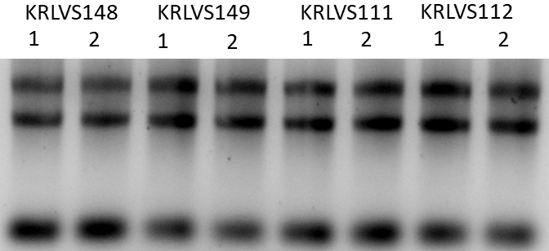
The RNA looks good, distinct 23S, 16S, and tRNAs wooo.

cDNA Purification with PCR Purification Kit
- Add 250 uL of Buffer PB to each 50 uL cDNA reaction tube and mix.
- Place a QIAquick column in a 2mL collection tube.
- Centrifuge tube for 30-60s at 13,000rpm. Discard flow through.
- Wash: add 750uL of Buffer PE to the QIAquick column. Centrifuge for 30-60s at 13,000rpm. Discard flow through.
- Centrifuge again for 3 minutes at 13,000rpm to remove any residual wash buffer.
- Place the QIAquick column in a fresh 1.5mL centrifuge tube.
- Elute: add 60uL of Buffer 0.1x EB. Let column stand for 1 minute. Centrifuge for 1 minute at 13,000rpm.
After I completed the purification of the cDNA synthesis started on 9.8, I nanodropped all my current cDNA samples, getting the following concentrations:
The concentrations and purity look pretty good to me, I think that the purity is better than it has been. When I was doing the purifications, I just left the lids open for a bit longer to encourage ethanol evaporation. After I nanodrop’d the samples, I set up my 0.99 (etc) ng/uL stocks of cDNA according to the following dilutions:
After diluting, I prepared water+primer aliquots and added my cDNA to strip tubes for tomorrow.

Tuesday, September 13, 2022
To Do:
- qRT-PCR of 8/25 RNA samples
- qRT-PCR of 9/8 RNA samples
- Make and filter sterilize 2.5% iron pyrophosphate
- Supplement MHB
Results and Data:

qRT-PCR of KRLVS148, KRLVS149, KRLVS111, KRLVS112 (8/25/22) cDNA
- Each experiment will need at least one test primer and one control primer for each sample
  - KROL343/344, KROL504/505, and KROL499/500 as test primers to amplify the 5’UTR, downstream of rpsU2, and lacZ respectively. KROL63/64 the control, amplifying tul4.
- Each cDNA sample will be used in a reaction with each primer set meaning #Samples*#Primer Sets (6*4=24 reactions)
- Set up a master mixes, labelling the tubes as A, B, C, etc.:
Component | Volume per Reaction | Master Mix (#Samplesx3.5+3.5)
PowerUp SYBR Green MM | 10 uL | 315.0 uL
5uM primer set | 1 uL | 31.5 uL
1.5 ng/uL Stock cDNA | 1 uL
ddiH₂O | 8 uL | 252.0 uL
Total: | 20 uL | 598.5 uL
- Obtain a strip of strip tubes per each primer set with the appropriate number of tubes in the strip, according to the number of cDNA samples. Label strip tubes with letter of primer master mix, and the sample number.
- Add 3.5µL of cDNA into appropriately labelled tubes.
- As these will be in technical triplicate, each tube will be an individual master mix, totaling 70 uL. Thusly, add corresponding primer master mix to tubes containing DNA at a volume of 66.5 uL.
- Pipette 20 µL of each primer set strip tubes, in triplicate, using multichannel pipet.
- Spin plate down and run in LightCycler using the ‘KRamsey_Lab_old_stepone’ program according to ‘qRT-PCR_LightCycler_Machine.docx’
Labelling was as follows:
Master Mix Label | Primer Set
A | KROL343/344 5’UTR
B | KROL504/505 ds rpsU2
C | KROL399/400 lacZ
D | KROL63/64 tul4

1 | 2 | 3 | 4 | 5 | 6 | 7 | 8
148-1 | 148-2 | 149-1 | 149-2 | 111-1 | 111-2 | 112-1 | 112-2
Loaded 96-well plate according to the following table:
 | 1 | 2 | 3 | 4 | 5 | 6 | 7 | 8 | 9 | 10 | 11 | 12
A | A1 |  |  | B1 |  |  | C1 |  |  | D1
B | A2 |  |  | B2 |  |  | C2 |  |  | D2
C | A3 |  |  | B3 |  |  | C3 |  |  | D3
D | A4 |  |  | B4 |  |  | C4 |  |  | D4
E | A5 |  |  | B5 |  |  | C5 |  |  | D5
F | A6 |  |  | B6 |  |  | C6 |  |  | D6
G | A7 |  |  | B7 |  |  | C7 |  |  | D7
H | A8 |  |  | B8 |  |  | C8 |  |  | D8

qRT-PCR of KRLVS148, KRLVS149, KRLVS111, KRLVS112 (9/8/22) cDNA
- Each experiment will need at least one test primer and one control primer for each sample
  - KROL343/344, KROL504/505, and KROL499/500 as test primers to amplify the 5’UTR, downstream of rpsU2, and lacZ respectively. KROL63/64 the control, amplifying tul4.
- Each cDNA sample will be used in a reaction with each primer set meaning #Samples*#Primer Sets (6*4=24 reactions)
- Set up a master mixes, labelling the tubes as A, B, C, etc.:
Component | Volume per Reaction | Master Mix (#Samplesx3.5+3.5)
PowerUp SYBR Green MM | 10 uL | 315.0 uL
5uM primer set | 1 uL | 31.5 uL
1.5 ng/uL Stock cDNA | 1 uL
ddiH₂O | 8 uL | 252.0 uL
Total: | 20 uL | 598.5 uL
- Obtain a strip of strip tubes per each primer set with the appropriate number of tubes in the strip, according to the number of cDNA samples. Label strip tubes with letter of primer master mix, and the sample number.
- Add 3.5µL of cDNA into appropriately labelled tubes.
- As these will be in technical triplicate, each tube will be an individual master mix, totaling 70 uL. Thusly, add corresponding primer master mix to tubes containing DNA at a volume of 66.5 uL.
- Pipette 20 µL of each primer set strip tubes, in triplicate, using multichannel pipet.
- Spin plate down and run in LightCycler using the ‘KRamsey_Lab_old_stepone’ program according to ‘qRT-PCR_LightCycler_Machine.docx’
Labelling was as follows:
Master Mix Label | Primer Set
A | KROL343/344 5’UTR
B | KROL504/505 ds rpsU2
C | KROL399/400 lacZ
D | KROL63/64 tul4

1 | 2 | 3 | 4 | 5 | 6 | 7 | 8
148-1 | 148-2 | 149-1 | 149-2 | 111-1 | 111-2 | 112-1 | 112-2
Loaded 96-well plate according to the following table:
 | 1 | 2 | 3 | 4 | 5 | 6 | 7 | 8 | 9 | 10 | 11 | 12
A | A1 |  |  | B1 |  |  | C1 |  |  | D1
B | A2 |  |  | B2 |  |  | C2 |  |  | D2
C | A3 |  |  | B3 |  |  | C3 |  |  | D3
D | A4 |  |  | B4 |  |  | C4 |  |  | D4
E | A5 |  |  | B5 |  |  | C5 |  |  | D5
F | A6 |  |  | B6 |  |  | C6 |  |  | D6
G | A7 |  |  | B7 |  |  | C7 |  |  | D7
H | A8 |  |  | B8 |  |  | C8 |  |  | D8

Reagents
2.5% Iron pyrophosphate
0.75g iron pyrophosphate (cabinet) in 30mL of ddiH2O (type 1), dissolved overnight, fresh solution every 2 weeks

Mueller Hinton Broth (500 mL)
To supplement add:
5mL of 10% glucose
5mL of 2.5% iron pyrophosphate
isovitalex (combine 10mL from liquid vial with solids, add entire volume to broth)
Can keep this supplemented media for 2 weeks, storing at 4 ̊C

Wednesday, September 14, 2022
To Do:
- Transform ligation from 8/29 of pKR122 into E. coli
- Patch out KRLVS28 and KRLVS75 on Kan x2
- Enter GFP strains into worksheet
- Patch out GFP strains on Kan plates
- Make LB+Kan plates
Results and Data:

Transformation of PrpsU2 tul4 5’UTR 5X and 3X Ligation (8/29) into E. coli
- Set up reaction table. Always include a positive and negative control for each antibiotic. Use 8 uL per ligation and plate 10 uL and 200 uL.
  - Positive control: pF; Backbone ligation: KpnI-NotI digested pKR68
Reaction table
Tube# | Purpose | DNA | Vol. of DNA | Final vol. to plate | # of LB-kan plates
1 | (+) control | pKR89 | 1 uL | 100 ul | 1
2 | (-) control | None | 0 | Remaining | 1
3 | Backbone Ligation | BB only ligation | 8 uL | 100 uL, Rem. | 2
4 | 3x Ligation | 3x Ligation | 8 uL | 100 uL, Rem. | 2
5 | 5x Ligation | 5x Ligation | 8 uL | 100 uL, Rem. | 2
Total number of plates |  |  |  |  | 8

- Check to be sure you have enough LB-Kan plates. If plates were stored at 4°C, warm at 37°C until needed.
- Obtain DNA and thaw on ice if necessary.
- Thaw appropriate number of competent cell tubes on ice (5 reactions per tube of competent cells)
- Label sterile tubes as indicated in reaction table. Add indicated volume of indicated DNA on ice.
- When competent cells are thawed (check by probing for frozen cells using a sterile pipette tip), gently pipette 100 uL of cells into each reaction tube directly onto DNA using aseptic technique.
- Incubate cells on ice for 20 minutes. During incubation, find or set heat block to 42°C.
- Place tubes with cells and DNA onto 42°C heatblock for 30 seconds (heat shock step).
- After heat shock, place tubes back on ice until next step (don’t keep them here too long).
- Using aseptic technique, add 1 mL LB (no antibiotic) to each microfuge tube.
- Using autoclave tape, tape microfuge tubes down in shaking incubator set to 37°C.
- Allow cells to recover for 1 hour at 37°C, shaking. Place in a rack after shaking
- Using aseptic technique, plate indicated amount of cells on appropriate antibiotic plates (LB-Kan), spreading until plates look dry.

Reagents
LB Agar + Kanamycin
Melt LB agar and then cool at 56°C
0.5 mL 50 ug/mL Kanamycin
Pour plates (24 mL)

Thursday, September 15, 2022
To Do:
- Count transformation paltes
- Make overnights of candidate pKR122
- Make single use aliquots of GFP strains
- Patch out KRLVS28 and KRLVS75 on regular CHAH
Results and Data:
Transformation Counts
 | 3x | 5x | BB
100 uL | 1 | 1 | 0
Remaining | 1 | 5 | 8
Most of the colonies on the plates were very small, but I picked every colony I (at least thought I) saw. Obviously, it is not a great ratio, but that’s all I had.

Making Single Use Aliquots of KRLVS192 and KRLVS193
- Prepare 800uL of MHB in a 1.5mL tube
- Take at least half of a thickly spread plate and add cells to the MHB tube
- Resuspend until there are no clumps in the MHB
- Add 200ul of 75% glycerol to the 800uL mix by pipetting
- Aliquot 50ul of solution to tubes, freeze at -80

Friday, September 16, 2022
To Do:
- Miniprep candidate pKR122
- Run diagnostic digest of candidate pKR122
- Run gel of diagnostic digest
- Make single use aliquots of KRLVS28 and KRLVS75
- Make EC cells from KRLVS28 and KRLVS75
- Streak KRLVS192 and KRLVS193 to single colony on CHAH+Kan
- CHAH-Kan
Results and Data:

Miniprep of Candidate pKR122 from E. coli
- Pellet overnight cultures by centrifugation at 15,000rpm for 3 minutes.
- Resuspend pellets in a 250uL Buffer P1 and transfer to a microcentrifuge tube.
- Add 250uL Buffer P2 and mix thoroughly by inverting the tube 4-6 times until the solution becomes clear. Do not allow lysis reaction to proceed for more than 5 minutes.
- Add 350uL Buffer N3 and mix immediately and thoroughly by inverting the tube 4-6 times.
- Centrifuge for 10 minutes at 13,000rpm.
- Transfer 800uL of supernatant to a QIAprep 2.0 spin column through pipetting.
- Wash the QIAprep column by adding 500uL Buffer PB. Centrifuge for 30-60s and discard flow through.
- Wash the QIAprep column with 750uL Buffer PE. Centrifuge 30-60s x3 and discard flow through.
- Centrifuge for 3 minutes at 13,000rpm to remove residual buffer.
- Place QIAprep column in a clean 1.5mL microcentrifuge tube. Add 50uL of Buffer EB. Let stand for 1 minute. Centrifuge for 1 minute at 13,000rpm.

Diagnostic Digest of Candidate pKR122 Miniprep w/KpnI and NotI
- Make a reaction table with desired digests:
Tube | DNA | Enzyme(s) | DNA Volume (uL) | H₂O Volume (uL)
1 | pKR122 | KpnI, NotI | 2.0 | -
2 | Cand. pKR122 1 | KpnI, NotI | 2.0 | -
3 | Cand. pKR122 2 | KpnI, NotI | 2.0 | -
4 | Cand. pKR122 3 | KpnI, NotI | 2.0 | -
5 | Cand. pKR122 4 | KpnI, NotI | 2.0 | -
6 | Cand. pKR122 5 | KpnI, NotI | 2.0 | -
7 | Water | KpnI, NotI | - | 2.0

- Set up master mix table:
Components | Volumes in 1 reaction (uL) | Volumes in Master Mix 8x (uL)
H₂O | 15 | 120
10x Buffer (Cutsmart) | 2 | 16
DNA | (2)
KpnI | 0.5 | 4
NotI | 0.5 | 4
Total | 20.0 (18.0 actual b/c of DNA) | 144

- Add indicated amounts of H₂O, 10x buffer, and DNA to individual tube for digest (1.5 mL microfuge tubes for digest in incubator).
- Add indicated amount of each enzyme to the tube.
- Mix by pipetting up and down.
- Incubate at 37°C for 1 hour.

Gel of Diagnostic Digest of Candidate pKR122 Miniprep
- Melt agarose gel until completely dissolved, then place in 50°C water bath until cooled
- Set up small gel rig to cast gel, with ladder.
- Add 6uL of Sbyr Safe and pour ~60uL gel, use ladder to mix, then place ladder and allow to set.
- Turn gel, add used 1xTAE, remove ladder.
- Loaded 10 uL ladder, and 24 uL of each sample according to the loading order below.
- Ran for 45 minutes at 113V.

Loading Order of Diagnostic Digest of Candidate pKR122
Lane 1 | Lane 2 | Lane 3 | Lane 4 | Lane 5 | Lane 6 | Lane 7 | Lane 8 | Lane 9 | Lane 10
Ladder |  | (-) | (+) | 1 | 2 | 3 | 4 | 5
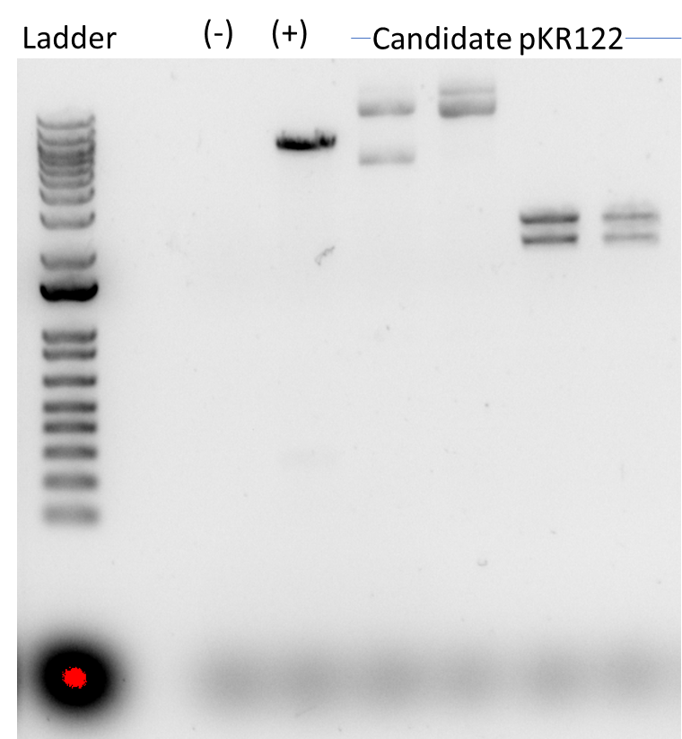

Preparing Electrocompetent KRLVS28 and KRLVS75 Cells
- Scrape up entire plate of cells into 400 uL of sterile 10% sucrose and resuspend
- Add 1.1 mL of 10% sucrose to a final volume of 1.5 mL
- Spin for 3 minutes at 10,000 rpm
- Remove supernatant, throw out, and resuspend in fresh 1 mL 10% sucrose
- Repeat 5x in 10% sucrose
- After final spin, remove all supernatant.
- Resuspend cells in 10% sucrose at high density (corresponding to ~1x10¹¹ cells /mL); these are EC cells by slowly adding 110 uL at a time. It should be about equal amounts of cells as sucrose.
I resuspended both strains in 120 uL of 10% sucrose. This will allow me to do one positive control and one transposon reaction for each, as well as leave a little bit to streak on a plate for the negative control.

Making Personal Glycerol Stocks of KRLVS28 and KRLVS75
- Make 1 cryovial for each strain, label!
- Prepare 1.6mL of MHB in a 2mL centrifuge tube
- Take at least half of a thickly spread plate and add cells to the MHB tube
- Resuspend until there are no clumps in the MHB
- Add 400ul of 75% glycerol to the 1.6mL mix by pipetting
- Aliquot 1mL per cryovial, freeze at -80
- For single use stocks pipet 50ul of solution to tubes

Monday, September 19, 2022
To Do:
- Electroporate pKR141 into EC cells
- Make patches of KRLVS192 and KRLVS193
Results and Data:

Electroporating pKR141 into electrocompetent KRLVS28 and KRLVS75
- For each electroporation, aliquot 4 mL MHB into glass test tubes for recovery, warm in shaker at 37°C
- For each electroporation, in a 2 mm sterile electroporation cuvette, combine:
3 μL of pKR141 plasmid DNA
50 μL electrocompetent cells
- Have recovery media ready
- Electroporate using the EC2 program
- Immediately after individual electroporations, use 1 mL warm recovery media from test tube to wash cells out of cuvette and transfer cells to recovery test tube
- Recover cells for 3 hours, shaking at 37°C
- Plate on CHAH-Kan plates
  - Plated 10 uL, 100 uL, 200 uL, and 1 mL of cells spun down and resuspended in ~100 uL of liquid
- Incubate plates at 37°C for 3 days
I went through the protocol that Aisling used when she used this plasmid, and for the most part it was the same as the standard electroporation protocol, however, the recovery time was very specifically three hours so that is what I will do. Additionally, since we do not know the transposon efficiency, I plated a variety of volumes for both strains.
Both of my electroporations arced which isn’t fantastic, but has previously been okay so here’s hoping. Additionally, KRLVS28 + pKR141 has a whole bunch of cells, visibly. But KRLVS75 + pKR141 had very few cells, so I may have to redo that electroporation, but I have about 70 uL of competent cells left so hopefully that’ll work out.

Tuesday, September 20, 2022
To Do:
- Digest pKR128 and PrspU2 tul4 5’UTR PCR fragment with NotI/KpnI
- Run digest on gel and excise fragments
- Make YEPD plates
Results and Data:

DNA Digest of PrpsU2_tul4UTR gBlock PCR and pKR128 Backbone w/KpnI and NotI
- Make a reaction table with desired digests:
Tube | DNA | Enzyme(s) | DNA Volume (uL) | H₂O Volume (uL)
1 | PrpsU2_tul4UTR | NotI, KpnI | 15 | -
2 | pKR128 | NotI, KpnI | 5 | 10
- Set up master mix table:
Components | Volumes in 1 reaction (uL) | Volumes in Master Mix 3x (uL)
H₂O | 10.8 | 32.4
10x Buffer* | 3.0 | 9.0
DNA | (15.0) | -
Not1 | 0.6 | 1.8
Kpn1 | 0.6 | 1.8
Total | 30.0 (15.0 actual b/c of DNA)
- Add 15 uL of Master Mix to individual tube for digest.
- Mix by pipetting up and down.
- Incubate at 37°C for 1 hour.
- After digest: add 1 uL of QuickCIP enzyme to backbone tube, mix by pipetting and put back in 37°C incubator for 10 minutes, then put at 80C for 2 minutes to inactivate the enzyme.

Gel of Digested PrpsU2_tul4UTR PCR Fragment + pKR89 Backbone
- Melt agarose gel until completely dissolved, then place in 50°C water bath until cool enough
- Set up gel rig to cast gel, with ladder.
- Add 6uL of Sbyr Safe dye to gel rig, pour ~60uL of agarose gel, use ladder to mix, then replace ladder and allow to set.
- Turn gel, add used TAE, remove ladder.
- Loaded 15 uL ladder, and 36 uL of each sample.
- Ran for 45 minutes at 113V.

Visualizing and Cutting Gel
- Using Bio Rad Gel Doc XR+ imager equipped with XcitaBlue Conversion Screen
- Nucleic Acid Gel > Sybr Safe
- To cut gel: put on visualizing UV glasses and use a clean razor, cutting straight down. Add to 2mL tube. Placed fragments in the fridge to purify tomorrow.
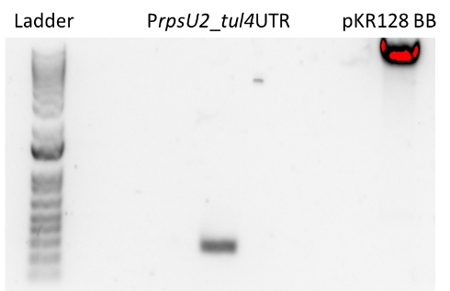
Additionally, I finally processed my qRT-PCR data. My 9.12 cDNA samples came out predictably, but my 9.7 cDNA samples came out super weird, Kathryn agreed in the meeting that I ought to re-dilute my cDNA samples and re-run the qRT-PCR.
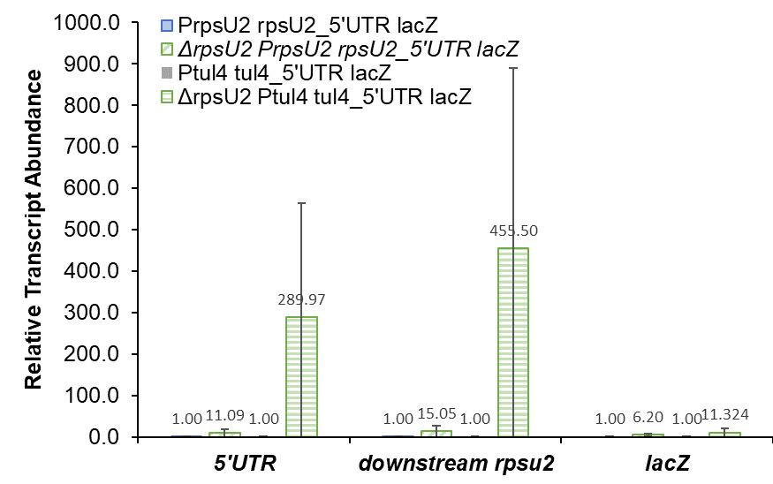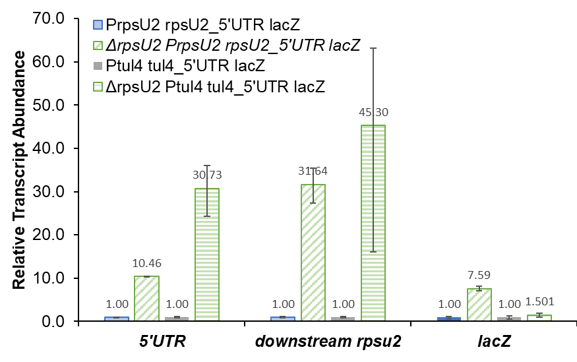

Reagents
YPD Plates
- For 250 mL of YPD, weigh out the components and add to a 500 mL flask:
  - 2.5 g Yeast extract
  - 5.0 g Protease-Peptone
  - 5.0 g Glucose
  - 5.0 g Agar
- Add 250 mL type I ddiH20
- Stirred on plate until combined
- Autoclave 15 minutes on the liquid cycle
- Pour plates
- Let dry for 2-3 days prior to bagging, can be stored for 3 months at room temperature or longer in the fridge

Wednesday, September 21, 2022
To Do:
- Set up cultures for temperature environment experiment in duplicate
- Conduct temperature environment experiment in duplicate
- Run GFP assay on temperature conditions
- Patch out yeast
- Purify gel extracts
Results and Data:

Testing the Effect of Temperature on rpsU1 and rpsU3 Production in KRLVS192 and 193
Experimental Layout
Condition Number | 1 | 2 | 3
Experiment Component | Control | Test 1 | Test 2
Condition | 37°C | 4°C | 42°C

- Begin by streaking out relevant GFP tagged strains to single colony on selective antibiotic plates, 3 days prior to experiment if no growth defect is expected
- Patch out each strain in duplicate/triplicate per condition on CHAH+selective antibiotic the day prior to the experiment
- Scrape up patches of cells and resuspend in 400uL of MHB, checking OD in a 1:20 dilution in the spectrophotometer
- Normalize samples to an OD of 0.08-0.10 in 8 mL of MHB.
- Shake cells at 37°C to an OD of 0.25-0.30, typically around 4 hours.
- Once desired OD is reached, split tubes between conditions: 4°, 37°, and 42°C; shaking for an additional hour
  - To accommodate the resources in the cold room, add tube volume to baffled flask and place on nutator for aeration
- Then follow the GFP reporter assay protocol, starting at Step 4, normalizing each sample to its own OD, then to the fluorescence of standard condition, cells continued to shake at 37°C
OD Readings
Sample | 0 hours | 2 hr 45’ | 4 hours
KRLVS192 1 | 0.094 | 0.200 | 0.311
KRLVS192 2 | 0.083 | 0.172 | 0.282
KRLVS192 3 | 0.079 | 0.178 | 0.275
KRLVS192 4 | 0.092 | 0.197 | 0.307
KRLVS192 5 | 0.084 | 0.202 | 0.292
KRLVS192 6 | 0.082 | 0.185 | 0.293
KRLVS193 1 | 0.082 | 0.177 | 0.291
KRLVS193 2 | 0.074 | 0.188 | 0.269
KRLVS193 3 | 0.097 | 0.168 | 0.288
KRLVS193 4 | 0.092 | 0.203 | 0.319
KRLVS193 5 | 0.074 | 0.150 | 0.248
KRLVS193 6 | 0.096 | 0.197 | 0.300

Sample Label Condition
4°C |  | 37°C |  | 42°C |  | 4°C |  | 37°C |  | 42°C
192 1 | 192 2 | 192 3 | 192 4 | 192 5 | 192 6 | 193 1 | 193 2 | 193 3 | 193 4 | 193 5 | 193 6

GFP Assay on Temperature Conditions in KRLVS192 and KRLVS193
- Take 1 mL from each culture tube into microcentrifuge tubes. Spin at max speed for 3 minutes
- Remove all MHB, using 20 ul pipette to remove small amount at bottom of tube.
- Add 1 mL of 1XPBS and resuspend the cells.
- Aliquot 250 ul from each microfuge tube in triplicate into a clear 96-well plate (not tissue culture treated). Pipette PBS in triplicate as a control.
- Go to INBRE lab with multichannel pipette, Rainin tips, black 96-well plate, and flash drive.
- Read OD600 from clear plate on ID3 plate reader:
  - Select Absorbance, wavelength=600
  - Plate type: 96-well standard clearbtm (first option)
  - Copy and paste results into an excel file on the plate reader’s computer
- Transfer 200 ul of each well from clear plate to black plate using the multichannel
- Read fluorescence from black plate on ID3 plate reader:
  - Select fluorescence
  - Wavelength: 495 to 535
  - Plate type: CoStar 3789
  - Gain: Automatic
  - Integration: 380 ms
  - Copy and paste results into excel file, then save onto flash drive
- Analyze by dividing fluorescence for each well by OD600 for each well. Normalize each well to the wild-type strain such that wild-type is set to 1.

 | 1 | 2 | 3 | 4 | 5 | 6 | 7 | 8 | 9 | 10 | 11 | 12
A | 192 1 |  | 192 1 |  | 192 1 |  | 193 1 |  | 193 1 |  | 193 1
B | 192 2 |  | 192 2 |  | 192 2 |  | 193 2 |  | 193 2 |  | 193 2
C | 192 3 |  | 192 3 |  | 192 3 |  | 193 3 |  | 193 3 |  | 193 3
D | 192 4 |  | 192 4 |  | 192 4 |  | 193 4 |  | 193 4 |  | 193 4
E | 192 5 |  | 192 5 |  | 192 5 |  | 193 5 |  | 193 5 |  | 193 5
F | 192 6 |  | 192 6 |  | 192 6 |  | 193 6 |  | 193 6 |  | 193 6
G | 1xPBS |  | 1xPBS |  | 1xPBS
H
Spoke to Hannah and she suggested alqays doing a single replicate of LVS, which I will do with my next experiment, in order to know if the fluorescent cells need to be condensed. This will mean that I subtract the LVS fluorescence from each sample, and then divide the test replicates by the control replicates in order to get my fluorescent values. This subtraction helps to eliminate the basal fluorescent input by LVS, in order to more clearly see whether fold changes are significant or not.
Additionally, when I was performing the actual GFP assay and transferring volume to the black plate from the white plate, I had some issues with pipetting. I drew up some liquid, saw a large air bubble and dispensed, and then continued to have issues getting the right volume for a couple of the technical replicates. Hannah recommended that I keep the pipet tips at the very bottom of the wells. While my standard deviations were a bit high for some of the technical replicates, I think they were probably okay.
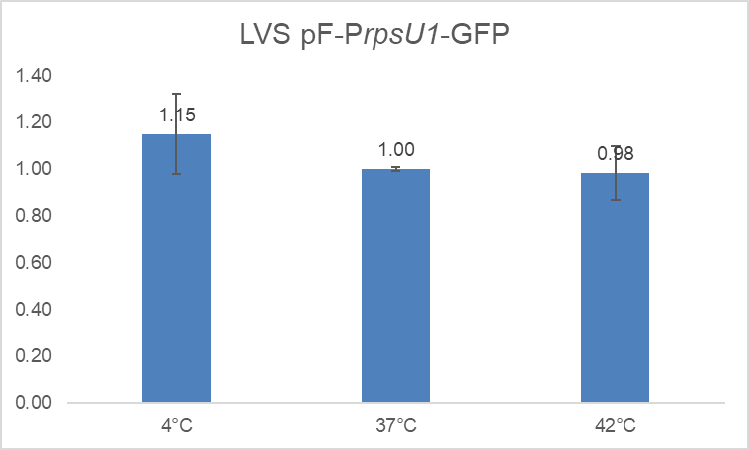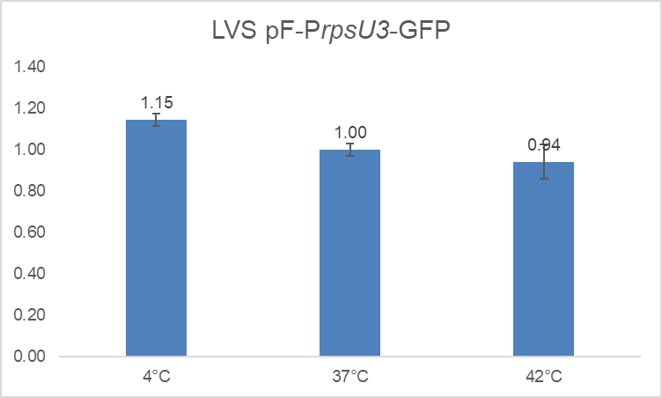
I performed a t-test on the samples, and there was no significant difference between either 4° or 42° with 37°. So dang, not temperature! It’s definitely going to be a CDM media change lol.

Gel Extraction with QIAquick Gel Extraction Kit
- Excise the DNA fragment from the agarose gel with a clean, sharp razor
- Weigh the gel slice in a colorless tube. Add 3 volumes Buffer QG to 1 volume gel.
- Incubate at 42C for 10 minutes or until gel is dissolved. Vortex every 2-3min to help dissolve.
- Add 1 gel volume isopropanol to the sample and mix.
- Load sample into QIAquick column and centrifuge for 1 min at 13,000rpm. Discard flow through.
- Add 500uL Buffer QG. Centrifuge for 1 min at 13,000rpm. Discard flow through.
- Wash: Add 750uL Buffer PE to the QIAquick column. Centrifuge 1 min at 13,000rpm. Discard flow through. Place column back in tube. Centrifuge again for 3 minutes. Discard flow through.
- Place columns in a fresh 1.5mL microcentrifuge tube.
- Elute: Add 30uL Buffer EB .01x and let stand for 1-4 minutes. Centrifuge for 1 min at 13,000rpm.
Component | Weight (mg) | Buffer QG 3 vol (uL) | Isopropanol 1 vol (uL)
PrpsU2 tul45’UTR | 160 | 480 | 160
pKR128 Backbone | 371 | 1130 | 371

I stored the gel purified samples in my cloning box, labelled as per typical with the description of the fragment, dig., gp, and the date.

Thursday, September 22, 2022
To Do:
- Apply overlay to electroporation plates
- Make MHB with 10% NaCl
- Sterilize water
- Make yeast overnight for EC cells
- Run overnight ligation of pKR128 backbone with PrpsU2 tul4 5’UTR gel purified fragment
Results and Data:

Agar overlay for β-galactosidase activity in KRLVS28 and KRLVS75 + pKR141
- Prior to overlay protocol, incubate intended cells on CHAH until single colonies form.
- On the day of the experiment:
  - Prepare soft agar overlay solution by adding the following components to a flask:
60 mL of diH₂O
0.42 g of agar
  - Add stir bar
  - Stir for 5 min
  - Autoclave Liquid 30
- Place agar in water bath at 56°C until cool enough to touch. Add 120 uL x-gal to agar.
- Overlay 8mL of the agar solution to each plate. Protect from light by wrapping in foil. Incubate lid side up.
- The next day look for any blue colonies
  - Dark blue indicates high β-galactosidase activity, light blue indicates some, white indicates none
- Isolate colonies of interest
I made the overlay in the morning and autoclaved it in the Instant Pot. Due to class I asked Hannah to remove it and my salty MHB, and to play the overlay in the water bath. It was stored at 56°C for a few hours due to my class and then the rain/thunderstorms keeping me away from Avedisian. There didn’t seem to be any problem with the overlay from eye, and although not all the agar dissolved it dissolved while being autoclaved.
Just realized I accidentally used agarose instead of agar, yikes. There shouldn’t be an issue since agarose is the purified version of agar, but I am dumb and that was expensive. At least I didn’t have to use too much?
I did actually get colonies on the KRLVS75 plates, though I had substantially fewer cells, so I will do the overlay on each plate that has colonies (only the 10 uL didn’t, which... makes sense). Regardless, KRLVS28 had quite a few more colonies.
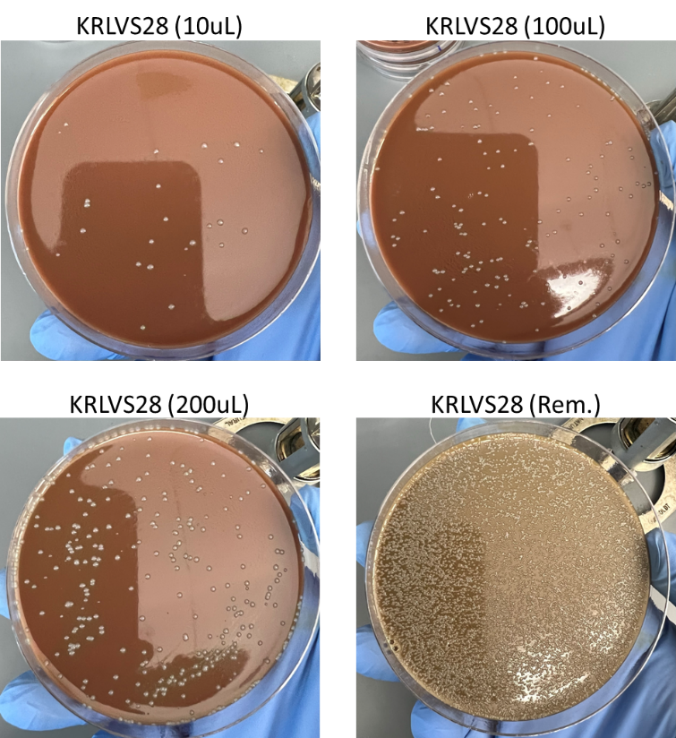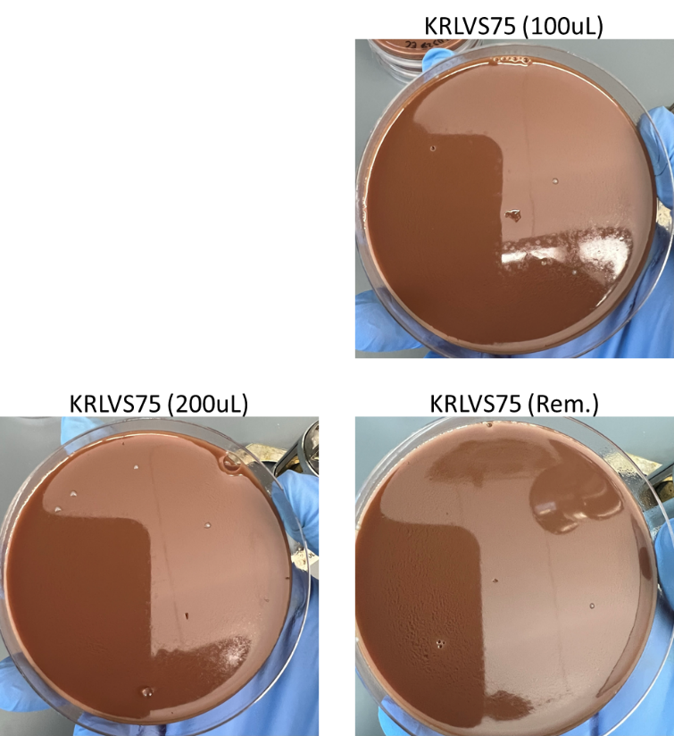
For the future, as long as I have the proper number of cells, I believe that a few plates at 200 uL will suffice, if I need to do it again, which, I probably will because of KRLVS75 lmao.
Prior to adding the overlay, I allowed the soft agar to cool for a period of time, after removing it from the waterbath and adding the x-gal, after I stirred it with the x-gal. I wrapped it in foil during this period of waiting. Once it didn’t burn my hand to touch, I added the 8 mL of overlay to the plates. I tried to add it gently as to not disturb the colonies, however I did not move the serological pipet at first and did swirl the first few plates in order to spread the overlay. After the first few, I moved the serological pipet in order to distribute the overlay without swirling the plates. After I applied the overlay, I covered my stack of plates with foil, and left them on my bench to set for several minutes prior to putting them into the incubator.

Ligation of PrpsU2 tul4 5’UTR PCR from gBlock with pKR128 backbone
- Make a reaction table with desired ligations. Always include a backbone only control for each plasmid backbone used.
Tube | Insert | Backbone
1 | KpnI, NotI dig., pur. PrpsU2:tul4 5’UTR PCR | KpnI, NotI digested, purified pKR128
2 | - | KpnI, NotI digested, purified pKR128
- Set up master mix table:
Component | Reaction 1 (uL) | Reaction 2 (uL) | Master Mix (3x)
H₂O | 11.5 | 11.5 | 34.5
10x ligase buffer | 2.0 | 2.0 | 6.0
Insert | 4.0 | - | -
Backbone | 2.0 | 2.0 | 6.0
Ligase | 0.5 | 0.5 | 1.5
TOTAL | 20.0 | 20.0 | 48.0
- Obtain ice to assemble and keep the reactions on. This is important, as the reaction happens at 16°C and the ligase buffer (which contains ATP) needs to be kept cold in order to avoid degradation.
- Obtain and label 1.5mL tubes for the reactions. Be sure to include the date and your initials.
- To the individual tubes, add indicated amounts of H₂O (___uL), 10x buffer (_____uL), insert (____uL), and backbone (____uL).
- Add indicated amount of ligase (___uL) to the individual tubes. Remember to keep the ligase in a mini cooler.
- After all of the components have been added, mix each tube with a pipette set to 18 uL.
- Incubate at 16°C overnight.

Making electrocompetent cells – Day 1
- Have a thick patch of S. cerevisiae parental strain grown up on a YPD plate in advance. Grow 250 mL overnight cultures of yeast strain in YEPD media at 30C, shaking at 250 rpm. Start from plates and resuspend to OD of approximately 0.06 if from an older plate or 0.01 if from a new plate.
After speaking with Hannah yesterday about the differences in her experiments between OD 0.06 and 0.01, decided to go with OD 0.01 rather than 0.06, since if they undergrow they can continue growing. I calculated for 0.0115, to cover the 30%, could no check to make sure it was right because OD <0.05

Reagents
Mueller Hinton Broth with 10% NaCl (100 mL)
To make, add to a 250 mL bottle:
2.1g of Mueller Hinton Broth mix
10 g NaCl
100 mL of diH₂O
Autoclave on Liquid 30’
Can keep un-supplemented media at room temperature indefinitely
To supplement add:
1mL of 10% glucose
1mL of 2.5% iron pyrophosphate
Small vial isovitalex (combine 10mL from liquid vial with solids, add entire volume to broth)
Can keep this supplemented media for 2 weeks, storing at 4 ̊C

Friday, September 23, 2022
To Do:
- Patch out promising colonies from electroporation overlays
- Prepare electrocompetent yeast cells
- Electroporate yeast with ligation
Results and Data:
When I got in, around 13 hours after I started the culture, the OD was 0.94, so I let it grow for another hour and fifteen minutes, at which point it was OD 1.31 so I went forward with the protocol. Unfortunately, I did not realize there was an o-ring in the 250 mL centrifuge bottles and a quarter of my sample was sucked out of the bottle. I cleaned the centrifuge and then continued with that volume.

Making electrocompetent cells
- Have a thick patch of S. cerevisiae parental strain grown up on a YPD plate in advance. Grow 250 mL overnight cultures of yeast strain in YEPD media at 30C, shaking at 250 rpm. Start from plates and resuspend to OD of approximately 0.06 if from an older plate or 0.01 if from a new plate.
- Take OD600 (dilute 1:10) until it reaches about 1.3-1.5 OD
- Place entire volume of culture in sterile 250 mL centrifuge bottle
- Centrifuge at 3000 xg for 5 min at 4C. Discard supernatant.
- Wash with ~200 mL of ice-cold water twice with identical centrifugation.
- Wash in 20 ml of ice cold 1M sorbitol and centrifuge again, as above.
- Resuspend in smallest volume of ice cold 1M sorbitol, starting with 200 ul and up to 500 ul as needed.

Electroporation of cells
- Add 3 ul of plasmid to 100 ul of electrocompetent cells. For ligations, add 8 ul. Mix via pipette. Incubate on ice for 5 min.
- Transfer to prechilled 0.2 cm cuvette
- Electroporate on presetting SC2 (1500 V, 5 msec)
- Immediately add the cells to 1 mL of cold 1M sorbitol
- Plate onto -ura selective plates. For ligations, plate 200 ul and remaining. Put in incubator set to 30C. Colonies will be visible within 2-3 days for successful transformations.
Tube # | Purpose | DNA | Vol. of DNA | Vol. Plated | Number of Plates
1 | pKR122 | Lig. 1 | 8 uL | 200 uL, Rem. | 2
2 | Backbone | Lig. BB | 8 uL | 200 uL, Rem. | 2
3 | (+) control | pKR128 | 3 uL | 200 uL, Rem. | 2
4 | (-) control | - |  | 200 uL | 1
 |  |  |  | Total: | 7
Decided to plate 200 uL and remaining rather than 100 uL and 500 uL after speaking with Hannah and reviewing her colony counts and success rate. I misinterpreted the amount of plasmid to add for my positive control, so rather than adding 1 ug, I just added 3 uL of the stock plasmid. For the negative control, I just plated 200 uL of the straight competent cells, which was a mistake, the cells were too thick and made the plate sticky. I don’t think it will be an accurate representation.
On a different note, I realized as I was putting away the remaining -ura plates that they technically expired in June, so this might not actually work at all, but we’ll see. The plates certainly weren’t dry or anything, but I couldn’t quite find any information on other people using them for longer, and in my quick glances at potential recipes I wasn’t quite sure what was expiring. Who knows.
Next, I looked at my overlay plates, and there definitely seemed to be some dark blue colonies, as well as some white and lighter colonies. I wasn’t completely confident on identifying the dark blue colonies on my own this first time (I probably should have struck out the strain that Caterina and I used to test the overlay method, as a positive control for comparison, whoops). Kathryn came by to look at the plates with me and she picked out some colonies that she thought were interesting and marked the soft agar for me. The plan is for me to patch them out and freeze them down. After I freeze them down, I can do some validation experiments. This may include another overlay, but will definitely include cross-patching on CHAH and CHAH+x-gal so we can see which do not grow, because if the colonies do not grow then we know that they are producing a bunch of lacZ.
I patched out the colonies that Kathryn indicated on my plate. I am leaving them out at room temperature over the weekend. The patches were labelled as follows:
Patch Number | Electroporation | Description
1 | KRLVS28 + pKR141 | Very small dark blue colony
2 | KRLVS28 + pKR141 | Very small dark blue colony
3 | KRLVS28 + pKR141 | Average size colony with dark blue margin and white center
4 | KRLVS28 + pKR141 | Very small colony with dark blue margin and white center
5 | KRLVS28 + pKR141 | Average size dark blue colony
6 | KRLVS28 + pKR141 | Large colony with dark margin and light center
7 | KRLVS28 + pKR141 | Small dark blue colony
8 | KRLVS28 + pKR141 | Moderately small dark blue colony
9 | KRLVS28 + pKR141 | Very small colony with dark blue margin and light center
10 | KRLVS28 + pKR141 | White colony, for control
Kathryn determined that the plates with few colonies were not good to use because their colony color could not really be compared to any other colonies on the plate. This means that I will definitely have to redo the KRLVS75 electroporation.

Monday, September 26, 2022
To Do:
- Re-dilute cDNA from 8/25
- qRT-PCR of 8/25 RNA cDNA samples – Redo
- Make and filter sterilize 2.5% iron pyrophosphate
- Supplement MHB
- Make overnights from yeast transformation
Results and Data:
Due to the weird results I got on the previous qRT-PCR of the 9/7 cDNA samples, I decided I would need to re-run the qRT-PCR, but I thought it would be best to re-dilute the cDNA samples. Just in case, it was an issue here rather than a mechanical issue. I got the following nanodrop concentrations:
After getting these new concentrations, I re-diluted the cDNA according to the following calculated table:

qRT-PCR of KRLVS148, KRLVS149, KRLVS111, KRLVS112 (8/25/22) cDNA
- Each experiment will need at least one test primer and one control primer for each sample
  - KROL343/344, KROL504/505, and KROL499/500 as test primers to amplify the 5’UTR, downstream of rpsU2, and lacZ respectively. KROL63/64 the control, amplifying tul4.
- Each cDNA sample will be used in a reaction with each primer set meaning #Samples*#Primer Sets (6*4=24 reactions)
- Set up a master mixes, labelling the tubes as A, B, C, etc.:
Component | Volume per Reaction | Master Mix (#Samplesx3.5+3.5)
PowerUp SYBR Green MM | 10 uL | 315.0 uL
5uM primer set | 1 uL | 31.5 uL
1.5 ng/uL Stock cDNA | 1 uL
ddiH₂O | 8 uL | 252.0 uL
Total: | 20 uL | 598.5 uL
- Obtain strip tubes per primer set with appropriate number of tubes, according to the number of cDNA samples. Label strip tubes with letter of primer master mix, and the sample number.
- Add 3.5µL of cDNA into appropriately labelled tubes.
- As these will be in technical triplicate, each tube will be an individual master mix, totaling 70 uL. Thusly, add corresponding primer master mix to tubes containing DNA at a volume of 66.5 uL.
- Pipette 20 µL of each primer set strip tubes, in triplicate, using multichannel pipet.
- Spin plate down and run in LightCycler using the ‘KRamsey_Lab_old_stepone’ program according to ‘qRT-PCR_LightCycler_Machine.docx’
Labelling was as follows:
Master Mix Label | Primer Set
A | KROL343/344 5’UTR
B | KROL504/505 ds rpsU2
C | KROL399/400 lacZ
D | KROL63/64 tul4

1 | 2 | 3 | 4 | 5 | 6 | 7 | 8
148-1 | 148-2 | 149-1 | 149-2 | 111-1 | 111-2 | 112-1 | 112-2
Loaded 96-well plate according to the following table:
 | 1 | 2 | 3 | 4 | 5 | 6 | 7 | 8 | 9 | 10 | 11 | 12
A | A1 |  |  | B1 |  |  | C1 |  |  | D1
B | A2 |  |  | B2 |  |  | C2 |  |  | D2
C | A3 |  |  | B3 |  |  | C3 |  |  | D3
D | A4 |  |  | B4 |  |  | C4 |  |  | D4
E | A5 |  |  | B5 |  |  | C5 |  |  | D5
F | A6 |  |  | B6 |  |  | C6 |  |  | D6
G | A7 |  |  | B7 |  |  | C7 |  |  | D7
H | A8 |  |  | B8 |  |  | C8 |  |  | D8
As I was setting up the qRT-PCR, I ran out of “C” Master Mix for the last sample, C8, so I quickly made a little bit extra (20 uL Sybr Green MasterMix, 2 uL KROL399/400, 16 uL of water), but this does make me worry for the rest of these samples. Which pretty much sucks a lot because lacZ is really the only one we super care about in this case. Hopefully it’ll be fine, I may perish if I have to repeat the qPCR or RNA purification. :”)
Weirdly enough, it was in downstream of rpsU2 (master mix for “B” which had issues, specifically KRLVS148 both had larger standard deviations than should have been between technical replicates). Regardless, this data looks substantially better.
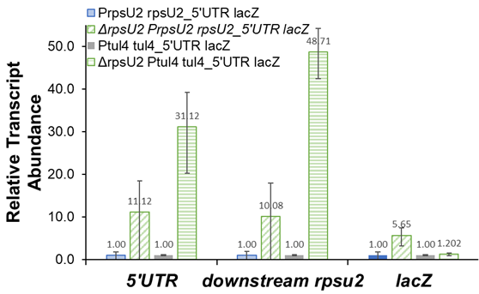
After I set up the qRT-PCR, I counted my yeast transformation plates from Friday. I was having difficulty distinguishing the colonies on the remaining plate, so Hannah double checked them for me.
Volume Plated | BB Only | Ligation
200 uL | 0 | 7
Remaining | 0 | 8
Hannah suggested I screen two colonies to start since there were no backbone colonies. Thus, I inoculated two tubes containing 5 mL SD-ura media with one colony each and stored the two ligation plates in the fridge.

Reagents
2.5% Iron pyrophosphate
0.75g iron pyrophosphate (cabinet) in 30mL of ddiH2O (type 1), dissolved overnight, fresh solution every 2 weeks

Mueller Hinton Broth (500 mL)
To supplement add:
5mL of 10% glucose
5mL of 2.5% iron pyrophosphate
isovitalex (combine 10mL from liquid vial with solids, add entire volume to broth)
Can keep this supplemented media for 2 weeks, storing at 4 ̊C

Tuesday, September 27, 2022
To Do:
- Patch out LVS, KRLVS192, and KRLVS193
- Miniprep candidate pKR122 plasmids from yeast
- Freeze down patches from electroporation overlay assay
Results and Data:

Miniprep of Candidate pKR122 Plasmid from Yeast
- Aliquot 3x 1.5 mL of the yeast cells (early log phase, total of 4.5 mL) into 2 ml microfuge tubes and spin down the cells at 600 x g for 3 minutes.
- Discard the supernatant and add 200 ul Solution 1 to each pellet and add 3 ul Zymolyase. Resuspend pellet by flicking tube or mild vortexing. Note: If running multiple samples, can make a solution 1-enyzme mixture by combining 15 ul of Zymolyase with 1 mL of Solution 1, then adding 200 ul to each pellet. If cells are from stationary phase, add more Zymolyase to ensure efficient lysis.
- Incubate at 37C for 30 minutes. Then add ~100 ul of glass beads and strap tubes to a vortex set to high speed to help lyse cells, for 30 additional minutes.
- Add 200 ul Solution 2 to each tube and mix well.
- Add 400 ul Solution 3 to each tube and mix well. Centrifuge at maximum speed for 3 minutes.
- Transfer the supernatant from one tube to the Zymo-Spin I Column in a collection tube and centrifuge at >10,000 x g for 30 seconds. Add supernatant from next tube and centrifuge again until entire culture has been added to one column.
- Discard the flow-through and ensure the flow-through does not come into contact with the column tip.
- Add 550 ul DNA Wash Buffer to the Spin Column and centrifuge at >10,000 x g for 2 minutes. Discard the flow-through. Spin for 3 more minutes to remove residual ethanol.
- Place the Spin Column in a clean 1.5 mL microcentrifuge tube and add 15 ul of 0.1xEB. Allow to sit for 5 minutes. Centrifuge at 10,000 x g for 1 minute to elute the plasmid DNA. Put the eluate back on the column, let sit, and centrifuge again

Freezing Down KRLVS28 Transposon Integrants
- Make 1 cryovials for each mutant patch, label!
- Prepare 0.8 mL of MHB in a 1.5mL tube
- Scrape up plate and add cells to the MHB tube
- Resuspend until there are no clumps in the MHB
- Add 200ul of 75% glycerol to the 0.8mL mix by pipetting
- Aliquot 1mL per cryovial, freeze at -80
Not all of my patches grew up, so the glycerol stocks are labelled as such:
Tube Number | Electroporation | Description
1 | KRLVS28 + pKR141 | Very small dark blue colony
2 | KRLVS28 + pKR141 | Average size colony with dark blue margin and white center
3 | KRLVS28 + pKR141 | Average size dark blue colony
4 | KRLVS28 + pKR141 | Large colony with dark margin and light center
5 | KRLVS28 + pKR141 | Small dark blue colony
6 | KRLVS28 + pKR141 | Moderately small dark blue colony
7 | KRLVS28 + pKR141 | Very small colony with dark blue margin and light center
8 | KRLVS28 + pKR141 | White colony, for control

Wednesday, September 28, 2022
To Do:
- Set up cultures for NaCl environmental condition test
- Conduct NaCl environmental condition protocol
- GFP assay for NaCl environmental conditions
Results and Data:

Testing the Effect of Salinity on rpsU1 and rpsU3 Production in KRLVS192 and 193
Experimental Layout
Condition Number | 0 | 1 | 2 | 3
Experiment Component | Background | Control | Test 1 | Test 2
Condition | 0% NaCl | 0% NaCl | 0.85% NaCl | 3% NaCl

- Scrape up patches of cells and resuspend in 400uL of MHB, checking OD in a 1:20 dilution in the spectrophotometer
- Normalize samples to an OD of 0.08-0.10 in 40 mL of MHB+Kan in baffled flasks.
- Shake cells at 37°C to an OD of 0.25-0.30 typically 4 hours.
- Prepare %NaCl MHB by:
  - 3% NaCl
    - 6 mL 10% NaCl MHB
    - 14 mL MHB
  - 0.85%
    - 1.7 mL 10% NaCl MHB
    - 18.3 mL MHB
- Centrifuge 10 mL of each strain/replicate and resuspend in 10 mL of MHB, 0.85% NaCl MHB, or 3% NaCl MHB.
- Shake cells at 37°C for an additional 1-1.5 hours to mid-log (OD 0.3-0.4)
- Then follow the GFP reporter assay protocol, starting at Step 4, normalizing to the OD, then to the fluorescence of each strain to standard condition, MHB with no NaCl supplementation
Experimental Set-Up
Strain | KRLVS192 BR-1 |  |  | KRLVS192 BR-2 |  |  | KRLVS193 BR-1 |  |  | KRLVS193 BR-2
Culture Vol. | 40 mL |  |  | 40 mL |  |  | 40 mL |  |  | 40 mL
%NaCl | 0.0% | 0.85% | 3.0% | 0.0% | 0.85% | 3.0% | 0.0% | 0.85% | 3.0% | 0.0% | 0.85% | 3.0%
Separated Vol. | 10 mL | 10 mL | 10 mL | 10 mL | 10 mL | 10 mL | 10 mL | 10 mL | 10 mL | 10 mL | 10 mL | 10 mL
I included a 12 mL culture of LVS alongside KRLVS192 and KRLVS193, in order to exclude background from LVS+PBS. I started the LVS at the same OD as KRLVS192 and KRLVS193, spun down 10 mL of the culture, resuspended in 10 mL of fresh MHB and shook at 37°C for the additional growing time.
OD Readings
Sample | 0 hours | 2 hours | 4 hours
KRLVS192 1 | 0.103 | 0.175
KRLVS192 2 | 0.082 | 0.151
KRLVS193 1 | 0.095 | 0.176
KRLVS193 2 | 0.096 | 0.277
LVS | 0.103 | 0.161
It looks like KRLVS193 2 is contaminated based on the growth rate, that certainly is not LVS. The MHB had kan in it, and clearly that OD is not LVS, so it must be kan resistant E. coli (maybe not resistant, since the concentration of kan for LVS is much lower)? I cleared off plates from my bench this morning, though I thought those were only yeast. I don’t think it’s yeast contamination, unless yeast can grow in MHB? I will ask Kathryn how to move forward, whether I should only test KRLVS192 or what.
I spoke with Kathryn and she recommended that I make technical replicates for KRLVS193, clearly I do not have enough to do 10 mL cultures, so instead I will do 6 mL cultures for each replicate. This means that I will spin down 6 mL of culture and resuspend in 6 mL of culture.

GFP Assay on Salinity Conditions in KRLVS192 and KRLVS193
- Take 1 mL from each culture tube into microcentrifuge tubes. Spin at max speed for 3 minutes
- Remove all MHB, using 20 ul pipette to remove small amount at bottom of tube.
- Add 1 mL of 1XPBS and resuspend the cells.
- Aliquot 250 ul from each microfuge tube in triplicate into a clear 96-well plate (not tissue culture treated). Pipette LVS in PBS in triplicate as a control.
- Go to INBRE lab with multichannel pipette, Rainin tips, black 96-well plate, and flash drive.
- Read OD600 from clear plate on ID3 plate reader:
  - Select Absorbance, wavelength=600
  - Plate type: 96-well standard clearbtm (first option)
  - Copy and paste results into an excel file on the plate reader’s computer
- Transfer 200 ul of each well from clear plate to black plate using the multichannel
- Read fluorescence from black plate on ID3 plate reader:
  - Select fluorescence
  - Wavelength: 495 to 535
  - Plate type: CoStar 3789
  - Gain: Automatic
  - Integration: 380 ms
  - Copy and paste results into excel file, then save onto flash drive
 | 1 | 2 | 3 | 4 | 5 | 6 | 7 | 8 | 9 | 10 | 11 | 12
A | 192 1 |  | 192 1 |  | 192 1 |  | 193 1 |  | 193 1 |  | 193 1
B | 192 2 |  | 192 2 |  | 192 2 |  | 193 2 |  | 193 2 |  | 193 2
C | 192 3 |  | 192 3 |  | 192 3 |  | 193 3 |  | 193 3 |  | 193 3
D | 192 4 |  | 192 4 |  | 192 4 |  | 193 4 |  | 193 4 |  | 193 4
E | 192 5 |  | 192 5 |  | 192 5 |  | 193 5 |  | 193 5 |  | 193 5
F | 192 6 |  | 192 6 |  | 192 6 |  | 193 6 |  | 193 6 |  | 193 6
G | LVS |  | LVS |  | LVS
H | 1xPBS |  | 1xPBS |  | 1xPBS

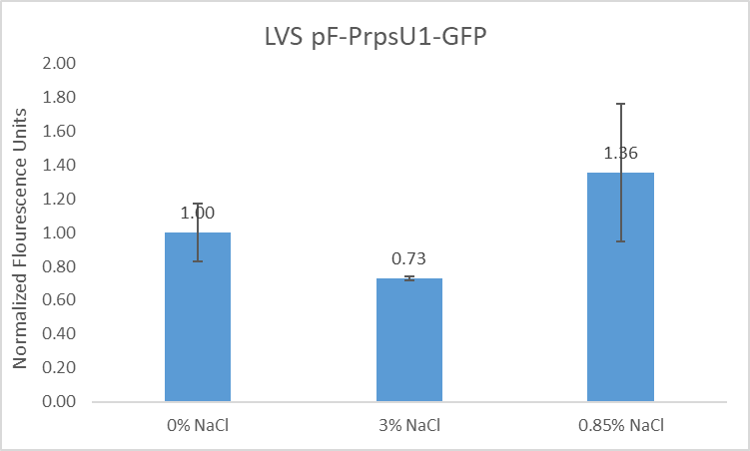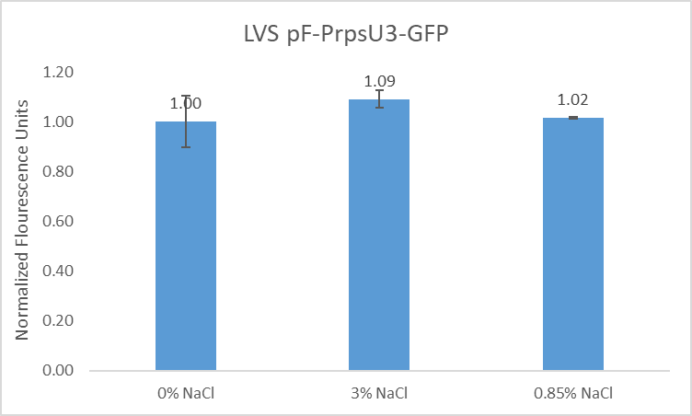
According to the t-test there was no significant difference in the fluorescence of either KRLVS192 or KRLVS193 when exposed to increasing concentrations of salinity.

Thursday, September 29, 2022
To Do:
- Set up candidate plasmids for sequencing
- Supplement MHB
- Put away dishes
- Patch out LVS, KRLVS192, and KRLVS193
Results and Data:
I was finally able to nanodrop my miniprep samples, however, I realized after thawing my tubes that my first pKR122 candidate did not have any volume. I ‘m not entirely sure what happened, however the best approximation that I can think of is that in my rush to get to class I ejected my tip in the re-elution step prior to adding the volume back into the column. I re-blanked and sampled (the unlabeled sample). Clearly, the contamination was super bad, maybe I didn’t bead beat well enough? Or sucked up some debris, I wasn’t able to sequence it due to the purity and will have to redo.

Reagents
Mueller Hinton Broth (500 mL)
To supplement add:
5mL of 10% glucose
5mL of 2.5% iron pyrophosphate
isovitalex (combine 10mL from liquid vial with solids, add entire volume to broth)
Can keep this supplemented media for 2 weeks, storing at 4 ̊C

Friday, September 30, 2022
To Do:
- Set up cultures for second NaCl environmental condition test
- Conduct 0%, 0.5%, 1.0%, and 1.5% NaCl environmental condition protocol
- GFP assay for NaCl environmental conditions
Results and Data:

Testing the Effect of Salinity on rpsU1 and rpsU3 Production in KRLVS192 and 193
Experimental Layout
Condition Number | 0 | 1 | 2 | 3
Experiment Component | Background | Control | Test 1 | Test 2
Condition | 0% NaCl | 0% NaCl | 0.85% NaCl | 3% NaCl

- Scrape up patches of cells and resuspend in 400uL of MHB, checking OD in a 1:20 dilution in the spectrophotometer
- Normalize samples to an OD of 0.08-0.10 in 45 mL of MHB+Kan in baffled flasks.
- Shake cells at 37°C to an OD of 0.25-0.30 typically 4 hours.
- Prepare %NaCl MHB by:
  - 0.5% NaCl
    - 1.25 mL 10% NaCl MHB
    - 23.75 mL MHB
  - 1.0%
    - 2.5 mL 10% NaCl MHB
    - 22.5 mL MHB
  - 1.5%
    - 3.75 mL 10% NaCl MHB
    - 21.25 mL MHB
- Centrifuge full culture at 8,000 xg for 5 minutes, then resuspend in 1 mL of MHB and add 110 uL to 5 mL of MHB, 0.5% NaCl MHB, 1.0% NaCl MHB, or 1.5% NaCl MHB.
- Shake cells at 37°C for an additional 1.5 hours to mid-log (OD 0.3-0.4)
- Then follow the GFP reporter assay protocol, starting at Step 4, normalizing to the OD, then to the fluorescence of each strain to standard condition, MHB with no NaCl supplementation
Experimental Set-Up
Strain | KRLVS192 BR-1 |  |  |  | KRLVS192 BR-2
Culture Vol. | 45 mL |  |  |  | 45 mL
%NaCl | 0.0% | 0.05% | 1.0% | 1.5% | 0.0% | 0.05% | 1.0% | 1.5%
Separated Vol. | 5 mL | 5 mL | 5 mL | 5 mL | 5 mL | 5 mL | 5 mL | 5 mL

OD Readings
Sample | 0 hours | 4 hours
KRLVS192 1 | 0.074 | 0.260
KRLVS192 2 | 0.073 | 0.243
LVS | 0.050 | 0.274

GFP Assay on Salinity Conditions in KRLVS192 and KRLVS193
- Take 1 mL from each culture tube into microcentrifuge tubes. Spin at max speed for 3 minutes
- Remove all MHB, using 20 ul pipette to remove small amount at bottom of tube.
- Add 1 mL of 1XPBS and resuspend the cells.
- Aliquot 250 ul from each microfuge tube in triplicate into a clear 96-well plate. Pipette LVS in PBS in triplicate as a control.
- Go to INBRE lab with multichannel pipette, Rainin tips, black 96-well plate, and flash drive.
- Read OD600 from clear plate on ID3 plate reader:
  - Select Absorbance, wavelength=600
  - Plate type: 96-well standard clearbtm (first option)
- Transfer 200 ul of each well from clear plate to black plate using the multichannel
- Read fluorescence from black plate on ID3 plate reader:
  - Select fluorescence
  - Wavelength: 495 to 535
  - Plate type: CoStar 3789
  - Gain: Automatic
  - Integration: 380 ms
Label | Condition |  | Label | Strain and BR
A | 0% NaCl |  | 1 | KRLVS192 1
B | 0.5% NaCl |  | 2 | KRLVS192 2
C | 1.0% NaCl
D | 1.5% NaCl

 | 1 | 2 | 3 | 4 | 5 | 6 | 7 | 8 | 9 | 10 | 11 | 12
A | A1 |  | A1 |  | A1 |  | LVS |  | LVS |  | LVS
B | A2 |  | A2 |  | A2 |  | 1xPBS |  | 1xPBS |  | 1xPBS
C | B1 |  | B1 |  | B1
D | B2 |  | B2 |  | B2
E | C1 |  | C1 |  | C1
F | C2 |  | C2 |  | C2
G | D1 |  | D1 |  | D1
H | D2 |  | D2 |  | D2
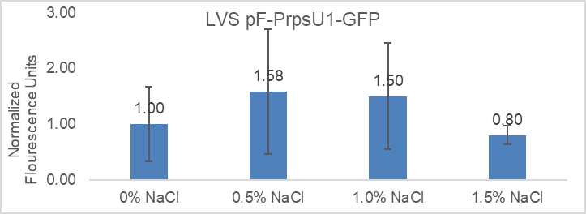

October 2022

Monday, October 3, 2022
To Do:
- Make and supplement MHB
- Make CHAH+xgal plates
- Make CHAH+nat plates
- Autoclave plate waste
- Electroporate pKR141 into KRLVS75
- Buffer 22 mL of MHB each at pH 3.0, 5.0 and 10.0
- Start overnights of candidate plasmid containing yeast colonies
Results and Data:

Tuesday, October 4, 2022
To Do:
- Patch out LVS, KRLVS192, and KRLVS193
- Validate electroporation overlay assay stocks
- Crosspatch triple deletion electroporations

Results and Data:

Wednesday, October 5, 2022
To Do:

Results and Data:

Thursday, October 6, 2022
To Do:
- Do overlay on KRLVS75 electroporation plate

Results and Data:

Friday, October 7, 2022
To Do:
- Select colonies from overlay and patch out onto CHAH

Results and Data:

Monday, October 10, 2022
To Do:

Results and Data:

Tuesday, October 11, 2022
To Do:

Results and Data:

Wednesday, October 12, 2022
To Do:

Results and Data:

Thursday, October 13, 2022
To Do:

Results and Data:

Friday, October 14, 2022
To Do:

Results and Data:

Monday, October 17, 2022
To Do:

Results and Data:

Tuesday, October 18, 2022
To Do:

Results and Data:

Wednesday, October 19, 2022
To Do:

Results and Data:

Thursday, October 20, 2022
To Do:

Results and Data:

Friday, October 21, 2022
To Do:

Results and Data:

Monday, October 24, 2022
To Do:

Results and Data:

Tuesday, October 25, 2022
To Do:

Results and Data:

Wednesday, October 26, 2022
To Do:

Results and Data:

Thursday, October 27, 2022
To Do:

Results and Data:

Friday, October 28, 2022
To Do:

Results and Data:

Monday, October 31, 2022
To Do:

Results and Data:

Bibliography

Ramsey, K. M. and Dove, S. L. (2016) ‘ A response regulator promotes Francisella tularensis intramacrophage growth by repressing an anti-virulence factor ’, Molecular Microbiology. doi: 10.1111/mmi.13418.

