Table of Contents
March 2023 5
Friday, March 3, 2023 5
Monday, March 6, 2023 6
Reagents 6
Tuesday, March 7, 2023 6
Setting Up KRLVS16, KMLFT104, and LVS Cultures for RNA Purification 6
Miniprep of Candidate pKR168 Plasmid from Yeast 6
PCR of Candidate pKR168 Minipreps for Sequencing 7
RNA Purification of KRLVS16, KMLFT104, and LVS 8
Wednesday, March 8, 2023 9
DNase treatment of KRLVS16, KMLFT104, and LVS 9
Gel of KRLVS16, KMLFT104, and LVS Pure RNA Samples 9
PCR Purification of Candidate pKR168 Yeast Miniprep PCR 10
Gel of Candidate pKR168 Yeast Miniprep PCR 10
Modified GFP Assay on Chromosomal Integration of GFP in KRLVS113 11
Thursday, March 9, 2023 12
Media Transfer of Overnight Cultures 12
β-galactosaidase Assay of KRLVS28 and KRLVS75 in Standard and Low pH MHB 12
Friday, March 10, 2023 14
Generate cDNA (Half) of KMLFT104, KRLVS16, and LVS (3/8/23 Pure RNA) 14
cDNA Purification with PCR Purification Kit 15
Monday, March 13, 2023 16
qRT-PCR of KMLFT104, KRLVS16, and LVS cDNA Samples 16
DNA Digest of Ptul4 rpsU2UTR, GFP, and pKR69 Backbone w/KpnI, NotI, and BamHI 17
Gel of Digested Ptul4 rpsU2UTR and GFP + pKR69 Backbone 17
Visualizing and Cutting Gel 18
Tuesday, March 14, 2023 18
β-galactosaidase Assay of KRLVS111, KRLVS112, KRLVS148, and KRLVS149 18
Gel Extraction with QIAquick Gel Extraction Kit 19
Wednesday, March 15, 2023 19
Thursday, March 16, 2023 20
Preparing Electrocompetent KRLVS97, KRLVS111, and KRLVS127 Cells 20
Electroporating pF-nat or pKR15 into EC KRLVS97 and KRLVS111 Cells 20
Electroporating pKR168 into EC KRLVS127 Cells 20
DNA Digest of Ptul4 rpsU2UTR, GFP, and pKR69 Backbone w/KpnI, NotI, and BamHI 21
Gel of Digested Ptul4 rpsU2UTR and GFP + pKR69 Backbone 21
Visualizing and Cutting Gel 22
Making Personal Glycerol Stocks and Single Use Aliquots of KRLVS150 and KRLVS151 22
Friday, March 17, 2023 22
Preparing Electrocompetent KRLVS96, KRLVS112, and KRLVS126 Cells 23
Electroporating pF-nat into EC KRLVS96 and KRLVS112 Cells 23
Electroporating pKR168 into EC KRLVS126 Cells 23
DNA Digest of pKR121 Backbone w/KpnI and BamHI 24
Gel of Digested pKR121 Backbone 24
Visualizing and Cutting Gel 24
Gel Extraction with QIAquick Gel Extraction Kit 25
Ligation of Digested Ptul4 rpsU2UTR and GFP Fragments with Digested pKR69 Backbone 25
Transformation of pKR184 Ligation into E. coli 25
Sunday, March 19, 2023 26
Monday, March 20, 2023 27
qRT-PCR of KRLVS16, and LVS cDNA Samples 27
Tuesday, March 21, 2023 28
β-galactosaidase Assay of KRLVS148, KRLVS149, KRLVS150, and KRLVS151 28
Wednesday, March 22, 2023 30
β-galactosaidase Assay of KRLVS148, KRLVS149, KRLVS150, and KRLVS151 30
Thursday, March 23, 2023 31
Making Glycerol Stocks of Potential pKR168 Integrant Strains 31
Friday, March 24, 2023 31
Colony PCR of Candidate pKR168 Integration into LVS and drpsU2 31
Gel of Colony PCR of PrpsU2 tul4 5’UTR lacZ Integrant into LVS and d2 32
Miniprep of Candidate pKR184 from E. coli 33
Monday, March 27, 2023 34
DNA Digest of Candidate pKR184 w/KpnI and BamHI 34
Gel of Diagnostic Digest of Candidate pKR184 Minipreps 34
Tuesday, March 28, 2023 35
gDNA Prep of Cand. pKR168 Integrant 35
Making Personal Glycerol Stocks and Single Use Aliquots of KRLVS150 and KRLVS151 36
Wednesday, March 29, 2023 36
PCR of Candidate pKR168 Integrations for Sequencing 36
PCR Purification of Candidate pKR168 Integration into d2 PCR 37
Gel of Candidate pKR168 Integration into d2 PCR 37
Thursday, March 30, 2023 38
Preparing Electrocompetent KRLVS126 and KRLVS127 Cells 38
Electroporating pKR184 into EC KRLVS127 Cells 38
Reagents 38
Friday, March 31, 2023 39
Electroporating pKR184 into EC KRLVS126 Cells 39
April 2023 40
Wednesday, April 5, 2023 40
DNA Digest of pF Backbone and pKR184 Insert w/KpnI and BamHI 40
Gel of Digested pF Backbone + pKR184 Insert 40
Visualizing and Cutting Gel 41
Thursday, April 6, 2023 41
Colony PCR of Candidate pKR168 Integration into LVS and drpsU2 41
Gel of Colony PCR of Candidate pKR184 Integrations into LVS and d2 42
Gel Extraction with QIAquick Gel Extraction Kit 42
Making Glycerol Stocks of Potential pKR184 Integrant Strains 43
Monday, April 17, 2023 44
Electroporating pKR168 into EC KRLVS126 Cells 44
Ligation of Digested pKR184 Insert with Digested pF Backbone 44
Transformation of pKR196 Ligation into E. coli 45
Receiving pKR184/pKR196 Mut. 1 Primer 45
PCR of Mutant 1 Fragment from pKR184 45
Tuesday, April 18, 2023 46
PCR Purification of rpsU2 UTR Stem Loop Deletion PCR 46
DNA Digest of rpsU2 Mut. 1 PCR and pKR184 Backbone w/PacI and MfeI 47
Gel of Digested rpsU2 UTR Mutant Insert and pKR184 Backbone 47
Visualizing and Cutting Gel 47
Gel Extraction with QIAquick Gel Extraction Kit 48
Ligation of Digested Mutant 1 + pKR184 Backbone and pKR184 Insert + pF Backbone 48
Wednesday, April 19, 2023 49
Transformation of pKR191 and pKR196 Ligation into E. coli 49
gDNA Prep of Cand. pKR184 Integrants in LVS and ΔrpsU2 49
PCR of Candidate pKR184 Integrations for Sequencing 50
Thursday, April 20, 2023 51
PCR Purification of pKR184 Integrants gDNA PCR for Sequencing 51
Gel of Potential pKR184 Integrants into WT and d2 gDNA PCR for Sequencing 51
Real-Time Primer Efficiency Test of GFP qRT-PCR Primers for cDNA 52
Friday, April 21, 2023 53
Miniprep of Candidate pKR196 from E. coli 54
Receiving RNA Stability Control qPCR Primers 54
Real-Time Primer Efficiency Test of secG and rpsO qRT-PCR Primers for cDNA 54
Satrurday, April 22, 2023 55
Sunday, April 23, 2023 55
Monday, April 24, 2023 56
Tuesday, April 25, 2023 56
Wednesday, April 26, 2023 56
Thursday, April 27, 2023 56
Friday, April 28, 2023 56
Bibliography 57

March 2023

Friday, March 3, 2023
To Do:
- Streak out KMLFT104, KRLVS16, and LVS-pF
- Streak out KRLVS28 and KRLVS75
Results and Data:
I struck out all of my strains, a couple of the plates were a little wet, but hopefully they’re okay.

Monday, March 6, 2023
To Do:
- Patch out KMLFT104, KRLVS16, and LVS-pF
- Take KRLVS28 and KRLVS75 plates out of the incubator
- Make and filter sterilize 2.5% iron pyrophosphate
- Supplement MHB
- Make yeast overnights
- Set up tubes for tomorrow
Results and Data:

Reagents
2.5% Iron pyrophosphate
0.75g iron pyrophosphate (cabinet) in 30mL of ddiH2O (type 1), dissolved overnight, fresh solution every 2 weeks

Mueller Hinton Broth (500 mL)
To supplement add:
5mL of 10% glucose
5mL of 2.5% iron pyrophosphate
isovitalex (combine 10mL from liquid vial with solids, add entire volume to broth)
Can keep this supplemented media for 2 weeks, storing at 4 ̊C

Tuesday, March 7, 2023
To Do:
- Set up cultures of 1/3/LVS for RNA putification
- Miniprep yeast transformations
- Patch out KRLVS113 and LVS-pF
- Nanodrop yeast minipreps
- PCR of yeast minipreps
- RNA extraction and purification of 1/3/LVS
- Nanodrop RNA samples
- Patch out KRLVS28 and KRLVS75
Results and Data:

Setting Up KRLVS16, KMLFT104, and LVS Cultures for RNA Purification
- Scrape each triplicate patch of KRLVS16, KMLFT104, and LVS into tubes of 400uL MHB
- Check OD”s in a 1:20 dilution (50uL of sample in 950uL of MHB)
- Calculate volume to add to tubes of 8 mL MHB for an OD of 0.08
- Check OD’s with 600uL
- Shake @37°C and grow to mid-log, checking OD’s at ~2-2.5 hours initially

Miniprep of Candidate pKR168 Plasmid from Yeast
- Aliquot 3x 1.666 mL of the yeast cells (early log phase, total of 4.5 mL) into 2 ml microfuge tubes and spin down the cells at 600 x g for 3 minutes.
- Discard the supernatant and add 200 ul Solution 1 to each pellet and add 3 ul Zymolyase. Resuspend pellet by flicking tube or mild vortexing. Note: If running multiple samples, can make a solution 1-enyzme mixture by combining 15 ul of Zymolyase with 1 mL of Solution 1, then adding 200 ul to each pellet. If cells are from stationary phase, add more Zymolyase to ensure efficient lysis.
- Incubate at 37C for 30 minutes. Then add ~100 ul of glass beads and strap tubes to a vortex set to high speed to help lyse cells, for 30 additional minutes.
- Add 200 ul Solution 2 to each tube and mix well.
- Add 400 ul Solution 3 to each tube and mix well. Centrifuge at maximum speed for 3 minutes.
- Transfer the supernatant from one tube to the Zymo-Spin I Column in a collection tube and centrifuge at >10,000 x g for 30 seconds, repeat until all accordant tubes are combined.
- Discard flow-through and ensure the flow-through does not come into contact with the column tip.
- Add 550 ul DNA Wash Buffer to the Spin Column and centrifuge at >10,000 x g for 2 minutes. Discard the flow-through. Spin for 3 more minutes to remove residual ethanol.
- Place the Spin Column in a clean 1.5 mL microcentrifuge tube and add 15 ul of 0.1xEB. Allow to sit for 5 minutes. Centrifuge at 10,000 x g for 1 minute to elute the plasmid DNA. Put the eluate back on the column, let sit, and centrifuge again

PCR of Candidate pKR168 Minipreps for Sequencing
- Acquired and labelled PCR tubes
Reaction# | Plasmid/Region | Source DNA | Primers | Length (bp)
1-6 | PrpsU2_tul4UTR | MP pKR168 | KROL6, KROL257 | 633
7 | - control | - | KROL6, KROL257 | -
- Acquire the following components and put them on ice, labeling tubes if necessary:
  - mgH2O, Primestar buffer, dNTPs, KROL6, KROL257, (10uM), and candidate pKR168
- Vortex each component (aside from enzyme)
- Add appropriate volume (based on PCR worksheet) of each experiment specific primer (forward and reverse) and respective template to PCR tubes
- Add ddi H2O to negative control tube (template volume for 1 reaction)
- Prepare a master-containing:
  - mgH2O, dNTPs, Primestar buffer, and Primestar enzyme
- Mix the master-mix solution by pipetting up and down
- Add 19.0 uL of master-mix to negative control PCR tube
- Add 19.0 uL of master mix to each PCR tube and pipet up and down to mix
- Place the PCR Tubes in the thermocycler on STN 1

Total reaction volume | 20
Total number of reactions | 7
 |  |  |  | Factor
Component | Stock concentration | Final concentration | 1 rxn volume | 8
ddiH2O |  |  | 11.4 | 85.2
PrimeSTAR GXL Buffer | 5x | 1x | 4.0 | 32
dNTPs | 2.5 mM | 0.2 mM | 1.6 | 12.8
oligo F | 10 uM | 0.3 uM | 0.6 | 4.8
oligo R | 10 uM | 0.3 uM | 0.6 | 4.8
template | 40.0 ng/ul | 2 ng/ul | 1.0
PrimeSTAR GXL DNA Polymerase | 1.25 U/ul | 0.025 U/ul | 0.4 | 3.2
 |  | Total volume | 20 | 152

RNA Purification of KRLVS16, KMLFT104, and LVS
- Pellet 1.8mLx2 of culture at max speed @room temperature
- Resuspend cell pellet in 1 mL TRI-Reagent
- Incubate at 60°C for 10 min
- Spin at 4°C for 10 min at max speed
- Transfer supernatant to new 2mL tube (~950 uL).
- Add equal volume 100% ethanol
- Pass sample over Directzol column, 600 uL per spin, 30 sec per spin at max speed, discarding flow-through in phenol and methanol waste
- Place spin column in new collection tube
- Wash twice with 400 uL RNA PreWash buffer, discarding flow-through in phenol and methanol waste
- Add 700 ul of Wash buffer, let sit on column for 3 min
- Spin max speed for 2 min
- Wash again with 700 ul Wash buffer
- Spin max speed for 2 min
- Place column in new collection tube
- Spin max speed for 3 min
- Place column in clean 1.5 mL tube
- Add 90 uL RNase-free water, let sit on column 2 min
- Spin max speed 1 min
- Place flow-through on column again, spin 1 min
- Store nucleic acids at -80°C if not moving directly to the next step
Labelled | Contents
1 RNA | KMLFT104 1
2 RNA | KMLFT104 2
3 RNA | KMLFT104 3
4 RNA | KRLVS16 1
5 RNA | KRLVS16 2
6 RNA | KRLVS16 3
7 RNA | LVS 1
8 RNA | LVS 2
9 RNA | LVS 3
Then, I nanodrop’d the total nucleic acid samples:
I then struck out KRLVS28 and KRLVS75 for overnights tomorrow.

Wednesday, March 8, 2023
To Do:
- DNase treatment of 1/3/LVS RNA samples
- Second purification of 1/3/LVS RNA samples
- Nanodrop RNA samples
- Set up aliquots for gel and cDNA synthesis
- Run gel of RNA samples
- Quick and dirty GFP assay of LVS-pF and KRLVS113
- PCR purification of yeast plasmid PCR
- Gel of purified PCR of yeast plasmids
- Set up candidate pKR168 for sequencing
- pH 30 mL MHB to 3.5
- Set up overnights for pH experiment
Results and Data:

DNase treatment of KRLVS16, KMLFT104, and LVS
- Add 10 uL RNase-free DNase buffer and 10 uL RNase-free DNase (Promega, RQ1)
- Incubate at 37°C for 1 hour
- Add 300 uL TRI-Reagent
- Add 400 uL 100% ethanol
- Pass sample over Directzol column, 600 uL per spin, 30 sec per spin at max speed, discarding flow-through in phenol and methanol waste
- Place spin column in new collection tube
- Wash twice with 400 uL RNA PreWash buffer, 30s at max speed, discarding flow-through in phenol and methanol waste
- Add 700 ul of Wash buffer, let sit on column for 3 min
- Spin max speed for 2 min
- Wash again with 700 ul Wash buffer
- Spin max speed for 2 min
- Place column in new collection tube
- Spin max speed for 3 min
- Place column in clean 1.5 mL tube
- Add 100 uL RNase-free water, let sit on column 2 min
- Spin max speed 1 min
- Place flow-through on column again, spin 1 min

Gel of KRLVS16, KMLFT104, and LVS Pure RNA Samples
- Make 10 uL aliquots with normalized concentrations, using water to dilute. Then add 2 uL purple loading dye for a final concentration of 1-1.5x and run on gel.
- Rinse comb and gel rig with DI water, then ethanol both as well
- Make fresh agarose gel by adding 0.6 g to 60 mL fresh 1xTAE and stir with heat until completely dissolved, then place in 50°C water bath until cool enough to touch.
- Set up gel rig to cast gel, with ladder.
- Add 6 uL of Sbyr Safe dye to rig, pour gel, use ladder to mix, then replace ladder and allow to set.
- Add new 1xTAE, turn gel, add TAE, and remove ladder.
- Add 12 uL of each sample according to the loading order below.
- Ran until separated at 113V.
- Look for distinctive bands (23s, 16s, tRNA+5s), rather than smears.
Loading Order of 3/8/23 RNA
Lane 2 | Lane 3 | Lane 4 | Lane 5 | Lane 6 | Lane 7 | Lane 8 | Lane 9 | Lane 10
RNA 1 | RNA 2 | RNA 3 | RNA 4 | RNA 5 | RNA 6 | RNA 7 | RNA 8 | RNA 9
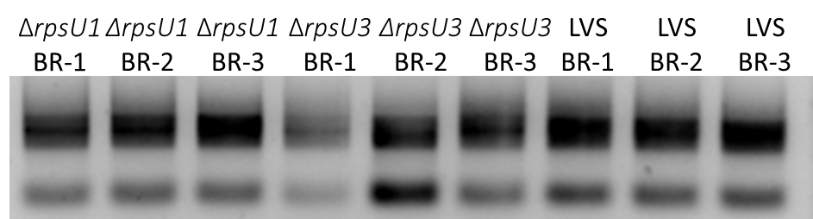
I didn’t quite let it run long enough, but you can start to see the separation in the 23s and 16s RNA, and none of them are a smudge so it looks all good to me.

PCR Purification of Candidate pKR168 Yeast Miniprep PCR
- Add 100 uL of Buffer PB to each 20 uL PCR reaction tube and mix.
- Place a QIAquick column in a 2mL collection tube.
- Centrifuge tube for 30-60s at 13,000rpm. Discard flow through.
- Wash: add 750uL of Buffer PE to the QIAquick column. Centrifuge for 30-60s at 13,000rpm. Discard flow through.
- Centrifuge again for 3 minutes at 13,000rpm to remove any residual wash buffer.
- Place the QIAquick column in a fresh 1.5mL centrifuge tube.
- Elute: add 35 uL of Buffer 0.1x EB. Let column stand for 1 minute. Centrifuge for 1 minute at 13,000rpm.

Gel of Candidate pKR168 Yeast Miniprep PCR
- Melt agarose gel until completely dissolved, then place in 56°C water bath until cool enough to touch.
- Set up gel rig to cast gel, with ladder.
- Add 6uL of Sbyr Safe dye to gel rig, pour ~60uL of agarose gel, use ladder to mix, then replace ladder and allow to set.
- Turn gel, add used TAE, remove ladder.
- Loaded 10 uL ladder, and 5 uL of each sample.
- Ran for 45 minutes at 113V.
Loading Order of 2/3/23 RNA
Lane 1 | Lane 2 | Lane 3 | Lane 4 | Lane 5 | Lane 6 | Lane 7 | Lane 8 | Lane 9 | Lane 10 | Lane 11 | Lane 12
Ladder |  | (-) |  | Cand. 1 | Cand. 2 | Cand. 3 | Cand. 4 | Cand. 5 | Cand. 6 |  | (+)
Obviously, there is contamination in my negative control. Given that I had contaminations, I did replace everything prior to running the PCR> Clearly, it was the primers which had contamination, so that’s not great. However, given the faintness of the negative band, I decided the other six were likely real amplifications, so I decided to sequence half of them.
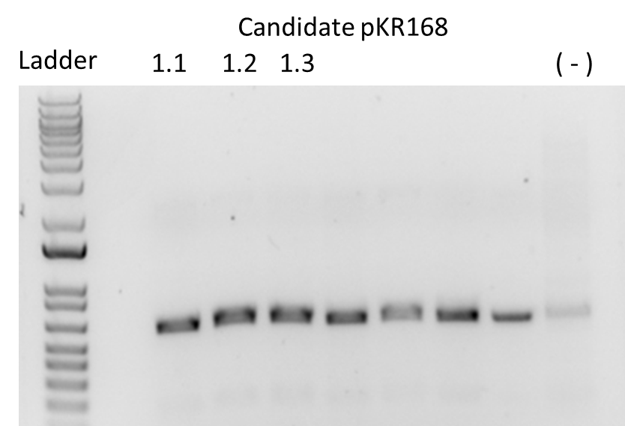
Then I nanodrop’d the PCR:
And I set up sequencing of three of the PCR’s, based on the highest plasmid concentrations:

Modified GFP Assay on Chromosomal Integration of GFP in KRLVS113
- Scrape up patches of KRLVS113 and LVS-pF into 1xPBS
- Normalize in 1 mL of 1xPBS to an OD of 1 mL
- Aliquot 250 ul from each tube in quadruplicate to clear 96-well plate.
- Go to INBRE lab with 200 uL pipet, pipet tips, black 96-well plate, and flash drive.
- Read OD600 from clear plate on ID3 plate reader:
  - Select Absorbance, wavelength=600
  - Plate type: 96-well standard clearbtm (first option)
- Transfer 200 ul of each well from clear plate to black plate using the multichannel
- Read fluorescence from black plate on ID3 plate reader:
  - Select fluorescence
  - Wavelength: 495 to 535
  - Plate type: CoStar 3789
  - Gain: Automatic
  - Integration: 380 ms

 | 1 | 2 | 3 | 4 | 5 | 6 | 7 | 8 | 9 | 10 | 11 | 12
A | KRLVS113 | KRLVS113 | KRLVS113 | KRLVS113
B
C | LVS-oF | LVS-oF | LVS-oF | LVS-oF
D
E
F
G
H
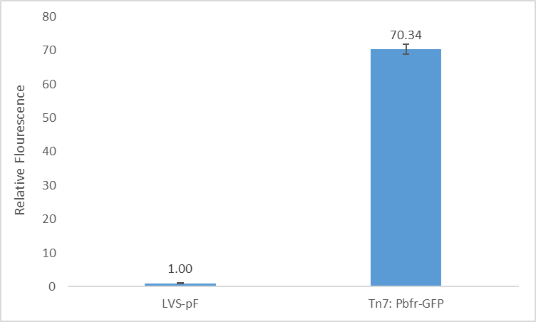
I took the average of the quadruplicates and normalized both to the raw fluorescence of LVS-pF. It looks like the chromosomal integration with the bfr promoter is 70-fold greater than LVS-pF. Obviously, the tul4 promoter and rpsU2 5’ UTR will possibly be weaker, however, this looks promising to me for doing an integration of that construct into the Tn7 site. Additionally, I showed Kathryn and she agreed with my estimation. She also had me look at plasmid fluorescence values for comparison, and looking at the tul4 promoter from Hannah’s experiment, she had 1000-fold increase, which is obviously pretty crazy.

Thursday, March 9, 2023
To Do:
- Media transfer of KRLVS28 and KRLVS75 overnights
- Streak out KRLVS11 and KRLVS148
- B-gal of pH experiment
Results and Data:

Media Transfer of Overnight Cultures
- Once OD’s have reached OD 0.25-0.3 remove from the shaking incubator
- Transfer contents to 50 mL conical tubes and pellet at 8000 xg for 5 minutes, ensure proper pelleting
- Pour off supernatant and resuspend each in 300 uL of MHB
- Addded 175 uL to each replicate tube
- Shake at 37°C for an additional hour

β-galactosaidase Assay of KRLVS28 and KRLVS75 in Standard and Low pH MHB
- Once cultures are ready, spin 1.8 mL of each culture in 2 mL tubes and resuspend in 1 mL 1x PBS then set on ice for 30 minutes
- Turn on 28°C water bath and put ONPG in water bath
- Determine Z-buffer needed (0.8ml x 2 x # of cultures plus 1, the 2 is for running duplicates, the 1 is for a blank replicate). Add BME to Z-buffer (2.72 x Xml Z-buffer = µl of BME).
- Set up reaction tubes with 800µl Z-buffer, put on lids
- Turn on spec and gather cuvettes
- After cells have incubated on ice, measure OD₆₀₀ of bacterial cultures
- Add 200µl culture to each reaction tube (add 200µl culture media to blank tube)
- Add 30µl 0.1% SDS to each reaction tube
- Add 60µl CHCl3 (chloroform) to each reaction tube
- Vortex reaction pairs on high for 6 secs (time precisely with timer)
- Put in water bath for 10 min
- Prepare repeater pipette with 1M Na₂CO₃ (stop)
- Add 200µl ONPG in 5 sec intervals (use timer with hours)
- Shake gently and watch for yellow (goal OD420 is 0.6-0.9)
- Stop with 500µl 1M Na₂CO₃, record time, vortex at 4 for 10 sec
- Give all reaction at least 2 hours
- Remove 1 mL from reaction (avoid chloroform at bottom), measure OD₄₂₀ and OD_{550,} using blank reaction as blank in spectrophotometer.
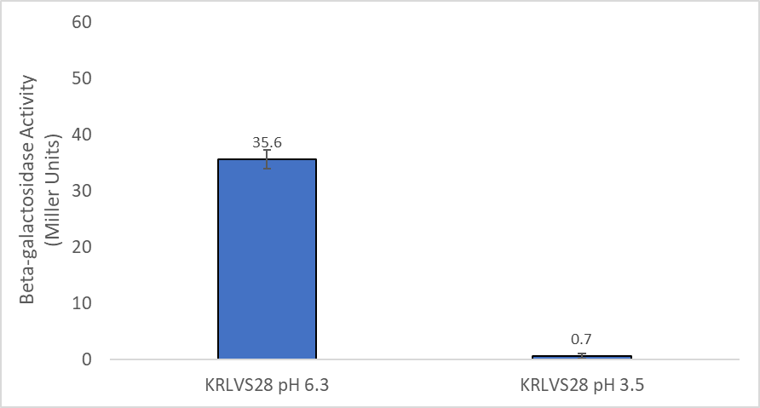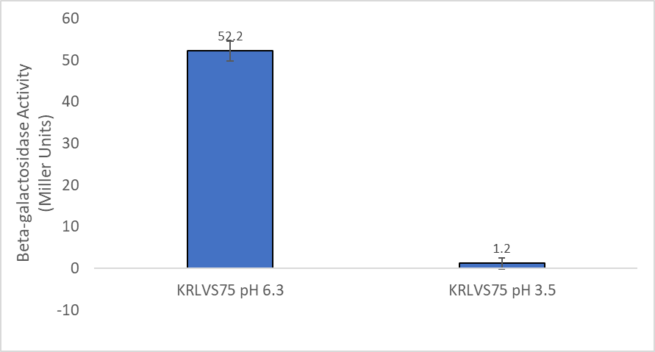
Given that this procecure was modified in such a way as to reflect the the protocol of the GFP assay, for reduction of the acidic environment, I am inclined to believe that this test-run is accurate. And, in fact, there just isn’t any B-gal activity. Speaking with Kathryn, it is possible that either the protein is down-regualted while the trans ript is up-regulated. Or else that translation is stopping, if that were true I believe that the transcript that is not being transcribed could be being “built-up”. Given these results, I believe my last run was also valid, data shown for February 8th:
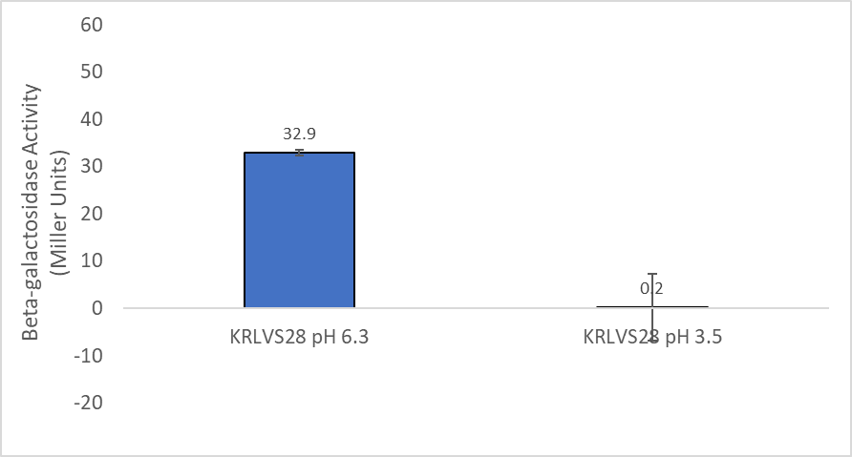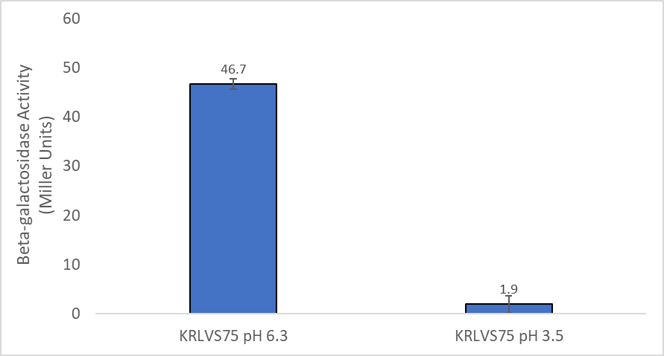

Friday, March 10, 2023
To Do:
- Check sequencing results
- Streak out KRLVS112 and KRLVS149
- cDNA synthesis of KMLFT104, KRLVS16, and LVS
- Purify cDNA samples
- Nanodrop cDNA samples
- Dilute cDNA samples
Results and Data:
I took a glance at my sequencing results and both candidate 1.2 and 2.1 look good, 1.3 has a gap. Obviously, my sequencing does not fully cover the lacZ gene, but I will go forward with it and hopefully it will be fine when I sequence the PCR on the integration.

Generate cDNA (Half) of KMLFT104, KRLVS16, and LVS (3/8/23 Pure RNA)
- Combine the first components for primer annealing:
Component | Volume or Amount | Final Concentration
RNA | 3 ug | 267 - 333 ng/ ul
(NS)₅ Primer (250 ng/ul) | 1.5 ul | 25 ng/ul
RNase-free water | up to 13.5 ul
- To normalize all the cDNA samples to the same DNA mass, dilute with RNase-free water in PCR strip tubes. Total volume of cDNA and water is 13.5 uL.
- Add the 1.5 uL (NS)₅ oligo to the tubes.
- Incubate using program JSScDNA1 in the thermocycler:
Step Temp Time
1 70°C 10'
2 25°C 10'
3 4°C hold
- Prepare master mix at 1.5 + #reactions.
Component | Final Concentration | Volume | X10.5
5X 1st strand buffer | 1x | 6 | 63
RNase-free water |  | 2.88 | 30.24
100 mM DTT | 10 mM | 3 | 31.5
10 mM dNTPs | 0.5 mM | 1.5 | 15.75
Superscript III (200 U/ul) | 10.8 U/ul | 1.63 | 17.12
- Aliquot 15 ul of master mix into each PCR tube from the first reaction (total volume now 30ul)
- Incubate using program JSScDNA2
Step Temp Time
1 25°C 10'
2 37°C 60'
4 42°C 60'
5 70°C 10'
6 4°C hold
- Remove RNA from sample by degrading with sodium hydroxide:
  - Add 10 ul of 1N NaOH
  - Incubate 65°C for 30'
  - Neutralize with 10 ul of 1N HCl
  - Final volume is 50 ul
- Purify cDNA using Qiagen PCR clean-up column (be very sure there is no ethanol carry-over!)
- Elute in 60 ul of 0.1x EB
- Store cDNA at -80°C

cDNA Purification with PCR Purification Kit
- Add 250 uL of Buffer PB to each 50 uL cDNA reaction tube and mix.
- Place a QIAquick column in a 2mL collection tube.
- Centrifuge tube for 30-60s at 13,000rpm. Discard flow through.
- Wash: add 750uL of Buffer PE to the QIAquick column. Centrifuge for 30-60s at 13,000rpm. Discard flow through.
- Centrifuge again for 3 minutes at 13,000rpm to remove any residual wash buffer.
- Place the QIAquick column in a fresh 1.5mL centrifuge tube.
- Elute: add 60uL of Buffer 0.1x EB. Let column stand for 1 minute. Centrifuge for 1 minute at 13,000rpm.
I then nanodrop’d my cDNA:
Then I diluted my cDNA samples accordingly:

Monday, March 13, 2023
To Do:
- Patch out KRLVS111, KRLVS112, KRLVS148, and KRLVS149
- qRT-PCR of KMLFT104, KRLVS16, and LVS samples
- Restriction digest of pKR69, pKR123, and pKR183
- Run gel of restriction digest
Results and Data:

qRT-PCR of KMLFT104, KRLVS16, and LVS cDNA Samples
- Each experiment will need at least one test primer and one control primer for each sample
  - KROL337/338 and KROL347/348 as test primers to amplify the rpsU1 5’UTR and rpsU3 5’UTR respectively. KROL63/64 the control, amplifying tul4.
- Each cDNA sample will be used in a reaction with each primer set meaning #Samples*#Primer Sets (12*2=24 reactions)
- Set up a master mixes, labelling the tubes as A, B, C, etc.:
Component | Volume per Reaction | Master Mix (#Samplesx3.5+3.5)
PowerUp SYBR Green MM | 10 uL | 245.0 uL
5uM primer set | 1 uL | 24.5 uL
1.5 ng/uL Stock cDNA | 1 uL
ddiH₂O | 8 uL | 196.0 uL
Total: | 20 uL | 465.5 uL
- Obtain strip tubes per primer set with appropriate number of tubes, according to the number of cDNA samples. Label strip tubes with letter of primer master mix, and the sample number.
- Add 3.5µL of cDNA into appropriately labelled tubes.
- As these will be in technical triplicate, each tube will be an individual master mix, totaling 70 uL. Thusly, add corresponding primer master mix to tubes containing DNA at a volume of 66.5 uL.
- Pipette 20 µL of each primer set strip tubes, in triplicate, using multichannel pipet.
- Spin plate down and run in LightCycler
Labelling was as follows:
Master Mix Label | Primer Set
A | KROL337/338 rpsU1 5’UTR
B | KROL347/348 rpsU3 5’UTR
C | KROL63/64 tul4
D | KROL211/212 rpoA

1 | 2 | 3 | 4 | 5 | 6 | 7 | 8 | 9 | 10 | 11 | 12
Δ1-1 | Δ1-2 | Δ1-3 | WT.99-1 | WT.99-2 | WT.99-3 | Δ3-1 | Δ3-2 | Δ3-3 | WT2-1 | WT2-2 | WT2-3
Loaded 96-well plate according to the following table:
 | 1 | 2 | 3 | 4 | 5 | 6 | 7 | 8 | 9 | 10 | 11 | 12
A | A1 |  |  | B7 |  |  | C5 |  |  | D7
B | A2 |  |  | B8 |  |  | C6 |  |  | D8
C | A3 |  |  | B9 |  |  | C7 |  |  | D9
D | A4 |  |  | B10 |  |  | C8 |  |  | D10
E | A5 |  |  | B11 |  |  | C9 |  |  | D11
F | A6 |  |  | B12 |  |  | C10 |  |  | D12
G | C1 |  |  | C3 |  |  | C11
H | C2 |  |  | C4 |  |  | C12
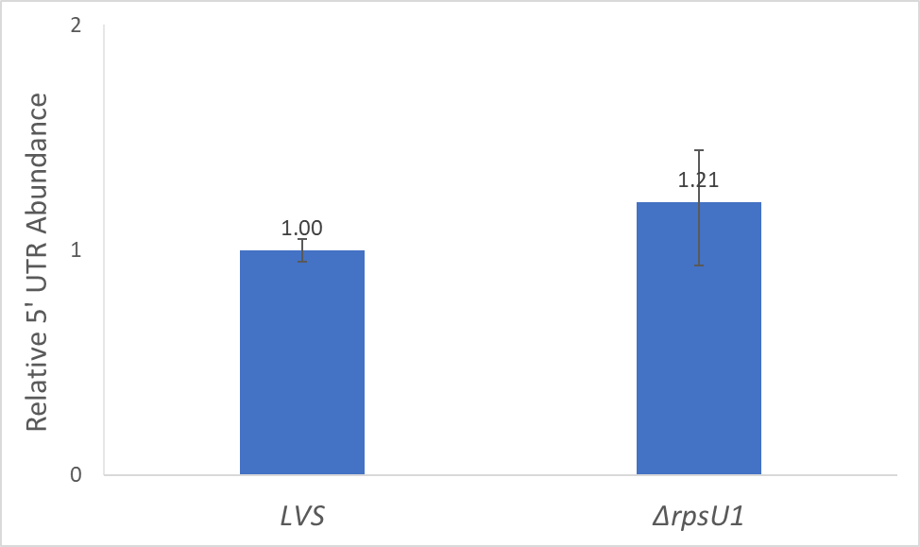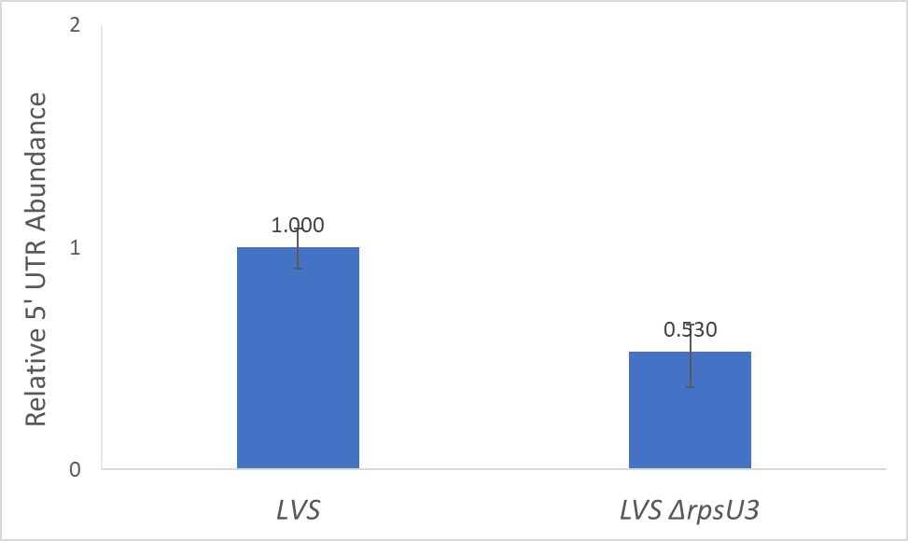
With the new concentrations for d1 the crossing point values are within range, and there is still no significant difference in the values. For the d3 the crossing point values for d3 are too high again, but the rpoA1 were within range, and a better control. However, it looks like there might be a significant difference so Kathryn is having me run the samples again at yet again, a higher concentration.

DNA Digest of Ptul4 rpsU2UTR, GFP, and pKR69 Backbone w/KpnI, NotI, and BamHI
- Make a reaction table with desired digests:
Tube | DNA | Enzyme(s) | DNA Volume (uL) | H₂O Volume (uL)
1 | pKR123 | NotI, KpnI | 5 | 10
2 | pKR183 | NotI, BamHI | 5 | 10
3 | pKR69 | KpnI, BamHI | 5 | 10
- Set up master mix table:
Components | Volumes in 1 reaction (uL)
H₂O | 10.8
10x Buffer* | 3.0
DNA | (15.0)
Not1 | 0.6
Kpn1 | 0.6
Total | 30.0 (15.0 actual b/c of DNA)
- Add 15 uL of Master Mix to individual tube for digest.
- Mix by pipetting up and down.
- Incubate at 37°C for 1 hour.
- After digest: add 1 uL of QuickCIP enzyme to backbone tube, mix by pipetting and put back in 37°C incubator for 10 minutes, mix, then put at 80C for 2 minutes to inactivate the enzyme.

Gel of Digested Ptul4 rpsU2UTR and GFP + pKR69 Backbone
- Melt agarose gel until completely dissolved, then place in 50°C water bath until cool enough to touch.
- Set up gel rig to cast gel, with ladder.
- Add 6uL of Sbyr Safe dye to gel rig, pour ~60uL of agarose gel, use ladder to mix, then replace ladder and allow to set.
- Turn gel, add used TAE, remove ladder.
- Loaded 15 uL ladder, and 36 uL of each sample.
- Ran for 45 minutes at 113V.
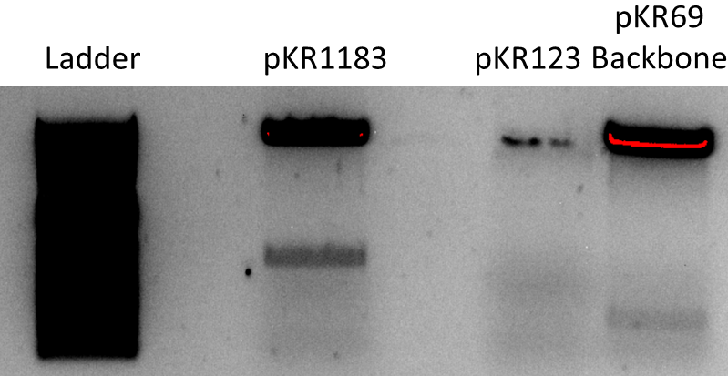

Visualizing and Cutting Gel
- Using Bio Rad Gel Doc XR+ imager equipped with XcitaBlue Conversion Screen
- Nucleic Acid Gel > Sybr Safe
- To cut gel, put on visualizing UV glasses and use a clean razor, cutting straight down. Add to 2mL tube. Stored gel pieces in fridge overnight.

Tuesday, March 14, 2023
To Do:
- Start cultures of KRLVS111, KRLVS112, KRLVS148, and KRLVS149
- Gel purification of restriction digest
- Run B-gal of KRLVS111, KRLVS112, KRLVS148, and KRLVS149
- Patch out KRLVS150 and KRLVS151
Results and Data:

β-galactosaidase Assay of KRLVS111, KRLVS112, KRLVS148, and KRLVS149
- Grow 7ml cultures until OD600 = 0.3
- Turn on 28°C water bath
- Determine amount of Z-buffer needed (0.8ml x 2 x # of cultures plus 1, the 2 is for running duplicates, the 1 is for a blank replicate). Add BME to Z-buffer (2.72 x Xml Z-buffer = _µl of BME).
- Set up reaction tubes with 800µl Z-buffer, put on lids
- Turn on spec and gather cuvettes
- Once cultures reach OD₆₀₀ = 0.3, place on ice 30 min and put ONPG in water bath
- After cells have incubated on ice, measure OD₆₀₀ of bacterial cultures
- Add 200µl culture to each reaction tube (add 200µl culture media to blank tube)
- Add 30µl 0.1% SDS to each reaction tube
- Add 60µl CHCl3 (chloroform) to each reaction tube
- Vortex reaction pairs on high for 6 secs (time precisely with timer)
- Put in water bath for 10 min
- Prepare repeater pipette with 1M Na₂CO₃ (stop)
- Add 200µl ONPG in 5 sec intervals (use timer with hours)
- Shake gently and watch for yellow (goal OD420 is 0.6-0.9)
- Stop with 500µl 1M Na₂CO₃, record time, vortex at 4 for 10 sec
- Give all reaction at least 2 hours
- Remove 1 mL from reaction (avoid chloroform at bottom), measure OD₄₂₀ and OD_{550,} using blank reaction as blank in spectrophotometer.
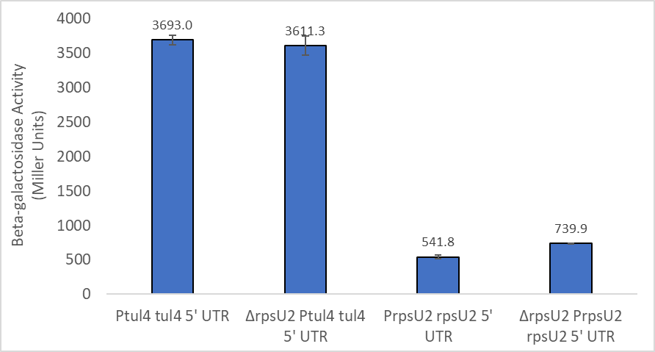
Looks good, similar to the other trial, so woo.

Gel Extraction with QIAquick Gel Extraction Kit
- Excise the DNA fragment from the agarose gel with a clean, sharp razor
- Weigh the gel slice in a colorless tube. Add 3 volumes Buffer QG to 1 volume gel.
- Incubate at 42C for 10 minutes or until gel is dissolved. Vortex every 2-3min to help dissolve.
- Add 1 gel volume isopropanol to the sample and mix.
- Load sample into QIAquick column and centrifuge for 1 min at 13,000rpm. Discard flow through.
- Add 500uL Buffer QG. Centrifuge for 1 min at 13,000rpm. Discard flow through.
- Wash: Add 750uL Buffer PE to the QIAquick column. Centrifuge 1 min at 13,000rpm. Discard flow through. Place column back in tube. Centrifuge again for 3 minutes. Discard flow through.
- Place columns in a fresh 1.5mL microcentrifuge tube.
- Elute: Add 30uL Buffer EB .01x and let stand for 1-4 minutes. Centrifuge for 1 min at 13,000rpm.
Component | Weight (mg) | Buffer QG 3 vol (uL) | Isopropanol 1 vol (uL)
Ptul4 rpsU2 5’UTR | 0.160 | 480 | 160
GFP | 0.400 | 1200 | 400
pKR69 Backbone | 0.370 | 1110 | 370
Due to the volume of the GFP and Backbone I split it into two tubes, making sure they were equal by eye, prior to add one half of the volume of isopropanol to each.
Additionally, Ben poured the CHAH I made for me. This included the total 500 mL of CHAH+Nat (25 ul of 100 mg/mL Nat) and the total 100 mL CHAH+Hyg (370 ul of 54 mg/mL Hyg).

Wednesday, March 15, 2023
To Do:
- Patch out KRLVS127
- Patch out KRLVS97 and KRLVS111
Results and Data:
When I cheked the concentration of my gel extractions they were NOT good, and with the suboptimal gel situation, I decided to just re-do the digest.

Thursday, March 16, 2023
To Do:
- Patch out KRLVS126
- Patch out KRLVS96 and KRLVS112
- Streak KRLVS148 and KRLVS150 to single colony
- Make KRLVS97 and KRLVS111 electrocompetent cells
- Electroporate KRLVS97 and KRLVS111
- Make electrocompetent KRLVS127
- Electroporate pKR168 into KRLVS127
- Restriction digest of pKR69, pKR123, and pKR183
- Run gel of restriction digest
- Make personal stocks and single use aliquots of KRLVS150 and KRLVS151
Results and Data:

Preparing Electrocompetent KRLVS97, KRLVS111, and KRLVS127 Cells
- Scrape up entire plate of cells into 400 uL of sterile 10% sucrose and resuspend
- Add 1.1 mL of 10% sucrose to a final volume of 1.5 mL
- Spin for 3 minutes at 10,000 rpm
- Remove supernatant, throw out, and resuspend in fresh 1 mL 10% sucrose
- Repeat 3x-5x in 10% sucrose
- After final spin, remove all supernatant.
- Resuspend cells in 10% sucrose at high density (corresponding to ~1x10¹¹ cells /mL); these are EC cells by slowly adding 110 uL at a time. It should be about equal amounts of cells as sucrose.
- For any extra EC cells, aliquot ~110 μL / sterile tube (enough for 2 electroporations) and freeze at -80°C

Electroporating pF-nat or pKR15 into EC KRLVS97 and KRLVS111 Cells
- For each electroporation, aliquot 4 mL MHB into glass test tubes for recovery, warm in shaker at 37°C
- For each electroporation, in a 2 mm sterile electroporation cuvette, combine:
3 μL of plasmid DNA
50 μL electrocompetent cells
- Have recovery media ready
- Electroporate using the EC2 program
- Immediately after individual electroporations, use 1 mL warm recovery media from test tube to wash cells out of cuvette and transfer cells to recovery test tube
- Recover cells for 2 hours, shaking at 37°C
- Plate on CHAH-Kan plates
  - Plated 10 uL and 100 uL of each, straight from recovery tube
- Incubate plates at 37°C for 3 days (or until single colonies appear)
Tube # | Purpose | Strain | DNA | Vol. of DNA | Vol. Plated | Number of Plates
1 | EV | KRLVS97 | pF-nat | 3 uL | 10 uL. 100 uL | 2
2 | o.e. rpsU2 | KRLVS97 | pKR15 | 3 uL | 10 uL. 100 uL | 2
3 | EV | KRLVS111 | pF-nat | 3 uL | 10 uL. 100 uL | 2
4 | (-) control | KRLVS97 | - | - | 200 uL | 1
5 | (-) control | KRLVS111 | - | - | 200 uL | 1
 |  |  |  |  | Total: | 8

Electroporating pKR168 into EC KRLVS127 Cells
- For each electroporation, aliquot 4 mL MHB into glass test tubes for recovery, warm in shaker at 37°C
- For each electroporation, in a 2 mm sterile electroporation cuvette, combine:
5 μL of plasmid DNA
50 μL electrocompetent cells
- Have recovery media ready
- Electroporate using the EC2 program
- Immediately after individual electroporations, use 1 mL warm recovery media from test tube to wash cells out of cuvette and transfer cells to recovery test tube
- Recover cells for 4-8 hours, shaking at 37°C
- Plate on CHAH-Kan plates
  - Plated 20 uL, 200 uL, and remaining of each
- Incubate plates at 37°C for 3 days (or until single colonies appear)
Tube # | Purpose | Strain | DNA | Vol. of DNA | Vol. Plated | # of Plates
1 | d2+pKR168 | KRLVS127 | Cand. pKR168 1.2 | 5 uL | 20 uL. 200 uL, Rem. | 3
2 | d2+pKR168 | KRLVS127 | Cand. pKR168 2.1 | 5 uL | 20 uL. 200 uL, Rem. | 3
3 | (-) control | KRLVS127 | - | - | 200 uL | 1
 |  |  |  |  | Total: | 7

DNA Digest of Ptul4 rpsU2UTR, GFP, and pKR69 Backbone w/KpnI, NotI, and BamHI
- Make a reaction table with desired digests:
Tube | DNA | Enzyme(s) | DNA Volume (uL) | H₂O Volume (uL)
1 | pKR123 | NotI, KpnI | 15 | -
2 | pKR183 | NotI, BamHI | 15 | -
3 | pKR69 | KpnI, BamHI | 5 | 10
- Set up master mix table:
Components | Volumes in 1 reaction (uL)
H₂O | 10.8
10x Buffer* | 3.0
DNA | (15.0)
Not1 | 0.6
Kpn1 | 0.6
Total | 30.0 (15.0 actual b/c of DNA)
- Add 15 uL of Master Mix to individual tube for digest.
- Mix by pipetting up and down.
- Incubate at 37°C for 1 hour.
- After digest: add 1 uL of QuickCIP enzyme to backbone tube, mix by pipetting and put back in 37°C incubator for 10 minutes, mix, then put at 80C for 2 minutes to inactivate the enzyme.
Due to the difficulty I had seeing the GFP and regulatory region with the last gel, I added 15 uL of these plasmid’s DNA, also fueled by the low yield from the gel purification. However, I retained the 5 uL of the backbone. Previously I had done low volumes with the expectation that there would be a higher concentration of plasmid than if I was working from a PCR, however given how small these bands are, I thought it better to course correct.

Gel of Digested Ptul4 rpsU2UTR and GFP + pKR69 Backbone
- Melt agarose gel until completely dissolved, then place in 50°C water bath until cool enough to touch.
- Set up large gel rig to cast gel, with ladder.
- Add 12uL of Sbyr Safe dye to gel rig, pour ~120mL of agarose gel, use ladder to mix, then replace ladder and allow to set.
- Turn gel, add used TAE, remove ladder.
- Loaded 15 uL ladder, and 36 uL of each sample.
- Ran for 45 minutes at 113V.
Loaded: Backbone, GFP, regulatory elements.
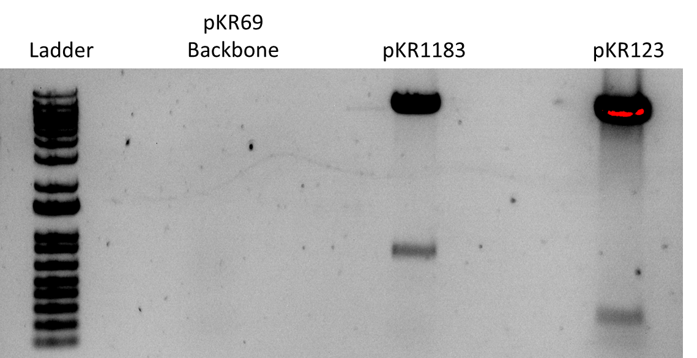

Visualizing and Cutting Gel
- Using Bio Rad Gel Doc XR+ imager equipped with XcitaBlue Conversion Screen
- Nucleic Acid Gel > Sybr Safe
- To cut gel, put on visualizing UV glasses and use a clean razor, cutting straight down. Add to 2mL tube. Stored gel pieces in fridge overnight.

Making Personal Glycerol Stocks and Single Use Aliquots of KRLVS150 and KRLVS151
- Prepare 1200uL of MHB in a 2mL tube
- Take at least half of a thickly spread plate and add cells to the MHB tube
- Resuspend until there are no clumps in the MHB
- Add 300ul of 75% glycerol to the 1200uL, mix by pipetting
- Aliquot 1 mL to cryovial and 50ul of solution to tubes, freeze at -80

Friday, March 17, 2023
To Do:
- Streak KRLVS149 and KRLVS151 to single colony
- Make electrocompetent KRLVS96 and KRLVS112
- Electroporate KRLVS96 and KRLVS112
- Make electrocompetent KRLVS126
- Electroporate pKR168 into KRLVS126
- Restriction digest of pKR121
- Run gel of restriction digest
- Gel purification of pKR183, pKR123, and pKR121
- Run ligation for pKR184
- Transform ligation into E. coli
- Load dishwasher
Results and Data:

Preparing Electrocompetent KRLVS96, KRLVS112, and KRLVS126 Cells
- Scrape up entire plate of cells into 400 uL of sterile 10% sucrose and resuspend
- Add 1.1 mL of 10% sucrose to a final volume of 1.5 mL
- Spin for 3 minutes at 10,000 rpm
- Remove supernatant, throw out, and resuspend in fresh 1 mL 10% sucrose
- Repeat 3x-5x in 10% sucrose
- After final spin, remove all supernatant.
- Resuspend cells in 10% sucrose at high density (corresponding to ~1x10¹¹ cells /mL); these are EC cells by slowly adding 110 uL at a time. It should be about equal amounts of cells as sucrose.
- For any extra EC cells, aliquot ~110 μL / sterile tube (enough for 2 electroporations) and freeze at -80°C

Electroporating pF-nat into EC KRLVS96 and KRLVS112 Cells
- For each electroporation, aliquot 4 mL MHB into glass test tubes for recovery, warm in shaker at 37°C
- For each electroporation, in a 2 mm sterile electroporation cuvette, combine:
3 μL of plasmid DNA
50 μL electrocompetent cells
- Have recovery media ready
- Electroporate using the EC2 program
- Immediately after individual electroporations, use 1 mL warm recovery media from test tube to wash cells out of cuvette and transfer cells to recovery test tube
- Recover cells for 2 hours, shaking at 37°C
- Plate on CHAH-Kan plates, using 1 plate for each 2 mL tube (2 plates per electroporation)
  - Plated 10 uL and 100 uL of each, straight from recovery tube
- Incubate plates at 37°C for 3 days (or until single colonies appear)
Tube # | Purpose | Strain | DNA | Vol. of DNA | Vol. Plated | Number of Plates
1 | EV | KRLVS96 | pF-nat | 3 uL | 10 uL. 100 uL | 2
2 | EV | KRLVS112 | pF-nat | 3 uL | 10 uL. 100 uL | 2
3 | (-) control | KRLVS96 | - | - | 200 uL | 1
4 | (-) control | KRLVS112 | - | - | 200 uL | 1
 |  |  |  |  | Total: | 6

Electroporating pKR168 into EC KRLVS126 Cells
- For each electroporation, aliquot 4 mL MHB into glass test tubes for recovery, warm in shaker at 37°C
- For each electroporation, in a 2 mm sterile electroporation cuvette, combine:
5 μL of plasmid DNA
50 μL electrocompetent cells
- Have recovery media ready
- Electroporate using the EC2 program
- Immediately after individual electroporations, use 1 mL warm recovery media from test tube to wash cells out of cuvette and transfer cells to recovery test tube
- Recover cells for 4-8 hours, shaking at 37°C
- Plate on CHAH-Kan plates
  - Plated 20 uL, 200 uL, and remaining of each
- Incubate plates at 37°C for 3 days (or until single colonies appear)
Tube # | Purpose | Strain | DNA | Vol. of DNA | Vol. Plated | # of Plates
1 | WT+pKR168 | KRLVS126 | Cand. pKR168 1.2 | 5 uL | 20 uL. 200 uL, Rem. | 3
2 | WT+pKR168 | KRLVS126 | Cand. pKR168 2.1 | 5 uL | 20 uL. 200 uL, Rem. | 3
3 | (-) control | KRLVS126 | - | - | 200 uL | 1
 |  |  |  |  | Total: | 7

DNA Digest of pKR121 Backbone w/KpnI and BamHI
- Make a reaction table with desired digests:
Tube | DNA | Enzyme(s) | DNA Volume (uL) | H₂O Volume (uL)
1 | pKR121 | KpnI, BamHI | 15 | -
- Set up master mix table:
Components | Volumes in 1 reaction (uL)
H₂O | 10.8
10x Buffer* | 3.0
DNA | (15.0)
Not1 | 0.6
Kpn1 | 0.6
Total | 30.0 (15.0 actual b/c of DNA)
- Add 15 uL of Master Mix to individual tube for digest.
- Mix by pipetting up and down.
- Incubate at 37°C for 1 hour.
- After digest: add 1 uL of QuickCIP enzyme to backbone tube, mix by pipetting and put back in 37°C incubator for 10 minutes, mix, then put at 80C for 2 minutes to inactivate the enzyme.

Gel of Digested pKR121 Backbone
- Melt agarose gel until completely dissolved, then place in 50°C water bath until cool enough to touch.
- Set up large gel rig to cast gel, with ladder.
- Add 12uL of Sbyr Safe dye to gel rig, pour ~120mL of agarose gel, use ladder to mix, then replace ladder and allow to set.
- Turn gel, add used TAE, remove ladder.
- Loaded 15 uL ladder, and 36 uL of each sample.
- Ran for 45 minutes at 113V.
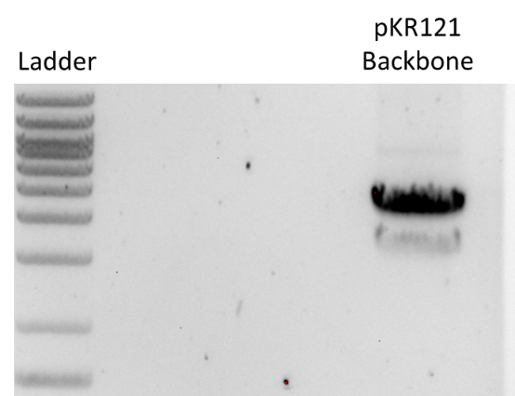

Visualizing and Cutting Gel
- Using Bio Rad Gel Doc XR+ imager equipped with XcitaBlue Conversion Screen
- Nucleic Acid Gel > Sybr Safe
- To cut gel, put on visualizing UV glasses and use a clean razor, cutting straight down. Add to 2mL tube. Stored gel pieces in fridge overnight.

Gel Extraction with QIAquick Gel Extraction Kit
- Excise the DNA fragment from the agarose gel with a clean, sharp razor
- Weigh the gel slice in a colorless tube. Add 3 volumes Buffer QG to 1 volume gel.
- Incubate at 42C for 10 minutes or until gel is dissolved. Vortex every 2-3min to help dissolve.
- Add 1 gel volume isopropanol to the sample and mix.
- Load sample into QIAquick column and centrifuge for 1 min at 13,000rpm. Discard flow through.
- Add 500uL Buffer QG. Centrifuge for 1 min at 13,000rpm. Discard flow through.
- Wash: Add 750uL Buffer PE to the QIAquick column. Centrifuge 1 min at 13,000rpm. Discard flow through. Place column back in tube. Centrifuge again for 3 minutes. Discard flow through.
- Place columns in a fresh 1.5mL microcentrifuge tube.
- Elute: Add 30uL Buffer EB .01x and let stand for 1-4 minutes. Centrifuge for 1 min at 13,000rpm.
Component | Weight (mg) | Buffer QG 3 vol (uL) | Isopropanol 1 vol (uL)
Ptul4 rpsU2 5’UTR | 351 | 1053 | 351
GFP | 190 | 570 | 190
pKR121 Backbone | 333 | 999 | 333

Ligation of Digested Ptul4 rpsU2UTR and GFP Fragments with Digested pKR69 Backbone
- Make a reaction table with desired ligations. Always include a backbone only control for each plasmid backbone used.
Tube | Insert | Backbone
1 | Ptul4 rpsU2 UTR (pKR123) + GFP (pKR183) | KpnI, BamHI digested, purified pKR69
2 | - | KpnI, BamHI digested, purified pKR69
- Set up master mix table:
Component | Reaction 1 (uL) | Reaction 2 (uL)
H₂O | 1.13 | 11.82
pKR121 Backbone | 1.68 | 1.68
pKR123 Ptul4 rpsU2UTR | 3.27 | -
pKR183 GFP | 11.42 | -
T4 Ligase Buffer | 2.0 | 2.0
T4 ligase | 0.5 | 0.5
TOTAL | 20.0 | 20.0
- Obtain ice to assemble and keep the reactions on.
- Obtain and label 1.5mL tubes for the reactions. Be sure to include the date and your initials.
- To the individual tubes, add indicated amounts of H₂O, 10x buffer, insert, and backbone.
- Add indicated amount of ligase to the individual tubes.
- After all of the components have been added, mix each tube with a pipette set to 18 uL.
- Left on bench at room temperature for 10 minutes.

Transformation of pKR184 Ligation into E. coli
- Set up reaction table. Always include a positive and negative control for each antibiotic. Use 8 uL per ligation and plate 100 uL and remaining.
  - Positive control: pKR121; Backbone ligation: KpnI-BamHI digested pKR121
Reaction table
Tube# | Purpose | DNA | Vol. of DNA | Final vol. to plate | # of LB-kan plates
1 | (+) control | pKR121 | 1 uL | 200 ul | 1
2 | (-) control | None | 0 | 200 ul | 1
3 | Backbone Ligation | BB only ligation | 8 uL | 10 uL, 200 ul | 2
4 | pKR184 Ligation | pKR184 | 8 uL | 10 uL, 200 ul | 2
Total number of plates |  |  |  |  | 6

- Check to be sure you have enough LB-Kan plates. If plates were stored at 4°C, warm at 37°C until needed.
- Obtain DNA and thaw on ice if necessary.
- Thaw appropriate number of competent cell tubes on ice (5 reactions per tube of competent cells)
- Label sterile tubes as indicated in reaction table. Add indicated volume of indicated DNA on ice.
- When competent cells are thawed (check by probing for frozen cells using a sterile pipette tip), gently pipette 100 uL of cells into each reaction tube directly onto DNA using aseptic technique.
- Incubate cells on ice for 20 minutes. During incubation, find or set heat block to 42°C.
- Place tubes with cells and DNA onto 42°C heatblock for 30 seconds (heat shock step).
- After heat shock, place tubes back on ice until next step (don’t keep them here too long).
- Using aseptic technique, add 1 mL LB (no antibiotic) to each microfuge tube.
- Using autoclave tape, tape microfuge tubes down in shaking incubator set to 37°C.
- Allow cells to recover for 1 hour at 37°C, shaking. Place in a rack after shaking
- Using aseptic technique, plate indicated amount of cells on appropriate antibiotic plates (LB-Kan), spreading until plates look dry.

Sunday, March 19, 2023
To Do:
- Check E. coli transformation plates
Results and Data:
When I came in, there were no visible colonies on the plate, so I placed them into the incubator.

Monday, March 20, 2023
To Do:
- Patch KRLVS148, KRLVS149, KRLVS150, and KRLVS151
- Make and filter sterilize 2.5% iron pyrophosphate
- Supplement MHB
- Streak to single colony pKR168 transformants on CHAH
- Re-dilute KRLVS16 and LVS cDNA samples
- qRT-PCR of KRLVS16 and LVS with just rpoA1 and the UTR
- Put away dishes
- Set up culture tubes for B-gal tomorrow
- Start overnights of E. coli transformants
Results and Data:
I re-diluted my cDNA samples according to:

qRT-PCR of KRLVS16, and LVS cDNA Samples
- Each experiment will need at least one test primer and one control primer for each sample
  - KROL347/348 as test primers to amplify the rpsU3 5’UTR respectively. KROL211/212 as the control, amplifying rpoA1.
- Each cDNA sample will be used in a reaction with each primer set meaning #Samples*#Primer Sets (12*2=24 reactions)
- Set up a master mixes, labelling the tubes as A, B, C, etc.:
Component | Volume per Reaction | Master Mix (#Samplesx3.5+3.5)
PowerUp SYBR Green MM | 10 uL | 245.0 uL
5uM primer set | 1 uL | 24.5 uL
1.5 ng/uL Stock cDNA | 1 uL
ddiH₂O | 8 uL | 196.0 uL
Total: | 20 uL | 465.5 uL
- Obtain strip tubes per primer set with appropriate number of tubes, according to the number of cDNA samples. Label strip tubes with letter of primer master mix, and the sample number.
- Add 3.5µL of cDNA into appropriately labelled tubes.
- As these will be in technical triplicate, each tube will be an individual master mix, totaling 70 uL. Thusly, add corresponding primer master mix to tubes containing DNA at a volume of 66.5 uL.
- Pipette 20 µL of each primer set strip tubes, in triplicate, using multichannel pipet.
- Spin plate down and run in LightCycler using the ‘KRamsey_Lab_old_stepone’ program according to ‘qRT-PCR_LightCycler_Machine.docx’
Labelling was as follows:
Master Mix Label | Primer Set
A | KROL347/348 rpsU3 5’UTR
B | KROL211/212 rpoA

1 | 2 | 3 | 4 | 5 | 6
Δ3-1 | Δ3-2 | Δ3-3 | WT4-1 | WT4-2 | WT4-3
Loaded 96-well plate according to the following table:
 | 1 | 2 | 3 | 4 | 5 | 6 | 7 | 8 | 9 | 10 | 11 | 12
A | A1 |  |  | B1
B | A2 |  |  | B2
C | A3 |  |  | B3
D | A4 |  |  | B4
E | A5 |  |  | B5
F | A6 |  |  | B6
G
H
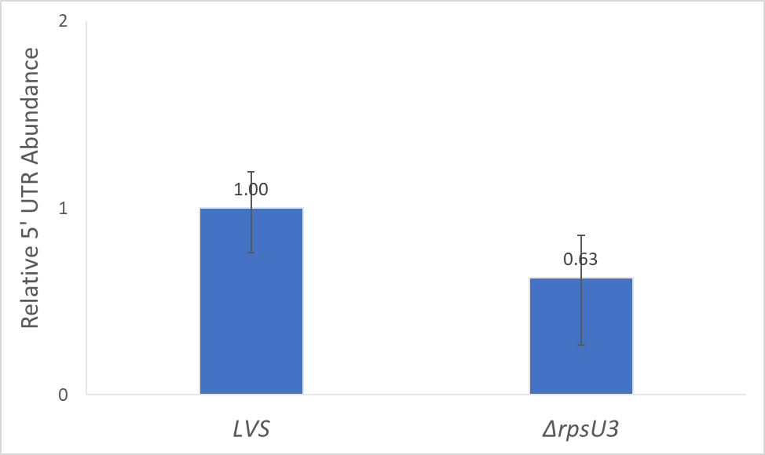
My crossing point values were still over the limit for d3, however, there is obviously no significant difference on this run. I spoke with Kathryn and given that we have multiple runs that show no significance, we’re going with there being no significant levels of autoregulation.
Additionally, I struck out six total colonies for LVS and d2 each of my PrpsU2 tul4 UTR transformations. Specifically, I struck out three each of either 1.2 or 2.1 in LVS or d2.
Next, I started four overnight cultures of candidate pKR184 transformed E. coli in 5 mLs of LB + 5 uL of 50 mg/mL kanamycin.

Tuesday, March 21, 2023
To Do:
- Patch KRLVS148, KRLVS149, KRLVS150, and KRLVS151
- Set up cultures of KRLVS148, KRLVS149, KRLVS150, and KRLVS151 for b-gal
- B-gal of KRLVS148, KRLVS149, KRLVS150, and KRLVS151
Results and Data:
I spun down my overnight cultures and froze the pellets.

β-galactosaidase Assay of KRLVS148, KRLVS149, KRLVS150, and KRLVS151
- Grow 7ml cultures until OD600 = 0.3
- Turn on 28°C water bath
- Determine amount of Z-buffer needed (0.8ml x 2 x # of cultures plus 1, the 2 is for running duplicates, the 1 is for a blank replicate). Add BME to Z-buffer (2.72 x Xml Z-buffer = _µl of BME).
- Set up reaction tubes with 800µl Z-buffer, put on lids
- Turn on spec and gather cuvettes
- Once cultures reach OD₆₀₀ = 0.3, place on ice 30 min and put ONPG in water bath
- After cells have incubated on ice, measure OD₆₀₀ of bacterial cultures
- Add 200µl culture to each reaction tube (add 200µl culture media to blank tube)
- Add 30µl 0.1% SDS to each reaction tube
- Add 60µl CHCl3 (chloroform) to each reaction tube
- Vortex reaction pairs on high for 6 secs (time precisely with timer)
- Put in water bath for 10 min
- Prepare repeater pipette with 1M Na₂CO₃ (stop)
- Add 200µl ONPG in 5 sec intervals (use timer with hours)
- Shake gently and watch for yellow (goal OD420 is 0.6-0.9)
- Stop with 500µl 1M Na₂CO₃, record time, vortex at 4 for 10 sec
- Give all reaction at least 2 hours
- Remove 1 mL from reaction (avoid chloroform at bottom), measure OD₄₂₀ and OD_{550,} using blank reaction as blank in spectrophotometer.
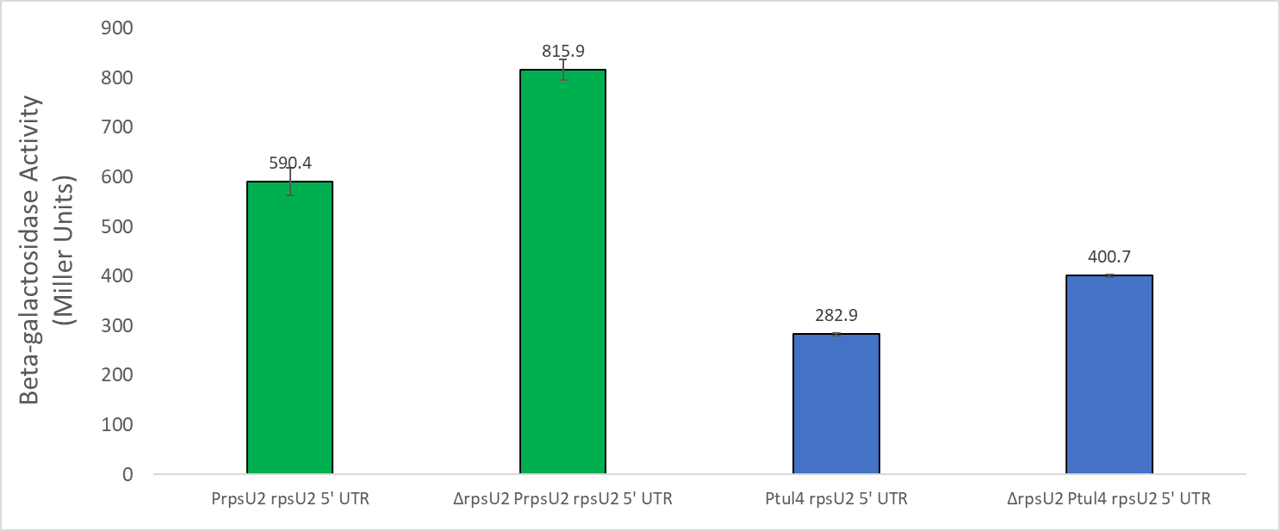
Obviously, the strain with the promoter for tul4 has level overall protein output than the construct containing both the promoter and UTR for rpsU2. This could mean a number of things, but potentially the tul4 promoter isn’t as strong as the rpsU2 promoter. I don’t believe our data up to this point supports that, however. I wonder if perhaps there is some regulatory process which promoters protein regulation based on the rpsU2 promoter, however, we will certainly try to test that. Though, if its some combination of both the promoter and UTR then I image we will still see lower protein output. Super wacky thought, which might be why the rpsU2 promoter seems so biologically unfavorable: regulation at the promoter increases the abundance, while regulation of the UTR might down-regulate? Probably not though, that would be insane and certainly would not be something I could necessarily tease out in the next couple of months.

Wednesday, March 22, 2023
To Do:
- Set up cultures of KRLVS148, KRLVS149, KRLVS150, and KRLVS151 for b-gal
- B-gal of KRLVS148, KRLVS149, KRLVS150, and KRLVS151
Results and Data:

β-galactosaidase Assay of KRLVS148, KRLVS149, KRLVS150, and KRLVS151
- Grow 7ml cultures until OD600 = 0.3
- Turn on 28°C water bath
- Determine amount of Z-buffer needed (0.8ml x 2 x # of cultures plus 1, the 2 is for running duplicates, the 1 is for a blank replicate). Add BME to Z-buffer (2.72 x Xml Z-buffer = _µl of BME).
- Set up reaction tubes with 800µl Z-buffer, put on lids
- Turn on spec and gather cuvettes
- Once cultures reach OD₆₀₀ = 0.3, place on ice 30 min and put ONPG in water bath
- After cells have incubated on ice, measure OD₆₀₀ of bacterial cultures
- Add 200µl culture to each reaction tube (add 200µl culture media to blank tube)
- Add 30µl 0.1% SDS to each reaction tube
- Add 60µl CHCl3 (chloroform) to each reaction tube
- Vortex reaction pairs on high for 6 secs (time precisely with timer)
- Put in water bath for 10 min
- Prepare repeater pipette with 1M Na₂CO₃ (stop)
- Add 200µl ONPG in 5 sec intervals (use timer with hours)
- Shake gently and watch for yellow (goal OD420 is 0.6-0.9)
- Stop with 500µl 1M Na₂CO₃, record time, vortex at 4 for 10 sec
- Give all reaction at least 2 hours
- Remove 1 mL from reaction (avoid chloroform at bottom), measure OD₄₂₀ and OD_{550,} using blank reaction as blank in spectrophotometer.
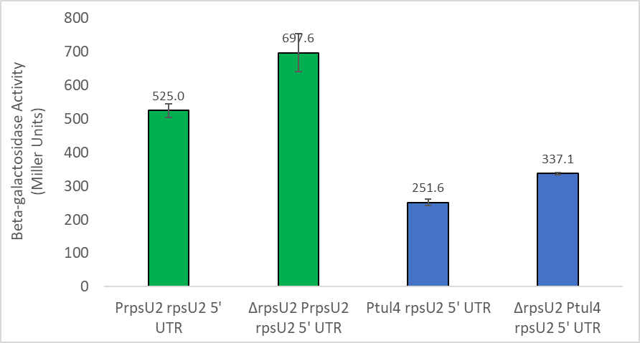
I was a little worried about the fold change being a little different in this run, since my B-gal data has been pretty consistent, however, Hannah said it was probably okay.

Thursday, March 23, 2023
To Do:
- Cross patch single colonies from pKR168 integrant plates on Hyg and Kan
- Prepare lysates of potential pKR168 integrants
- Freeze down promising first quadrant patches based on colony PCR
Results and Data:
I prepared lysates of each potential integrant and stored them in my working strains box in the -80.

Making Glycerol Stocks of Potential pKR168 Integrant Strains
- Prepare 800uL of MHB in a 2mL tube
- Take at least half of a thickly spread plate and add cells to the MHB tube
- Resuspend until there are no clumps in the MHB
- Add 200ul of 75% glycerol cryovial, then add 800 uL of resuspended cells
- Vortex until mixed and minifuge, freeze at -80
Sample # | Description
1 | ΔrpsU2 + pKR168 1.2
2 | ΔrpsU2 + pKR168 1.2
3 | ΔrpsU2 + pKR168 1.2
4 | ΔrpsU2 + pKR168 2.1
5 | ΔrpsU2 + pKR168 2.1
6 | LVS + pKR168 2.1
7 | LVS + pKR168 2.1
8 | LVS + pKR168 1.2
9 | LVS + pKR168 2.1
10 | LVS + pKR168 1.2
11 | LVS + pKR168 1.2

Friday, March 24, 2023
To Do:
- Miniprep E. coli transformants
- Colony PCR from patch quadrant of potential pKR168 integrants
- Run gel of colony PCR
Results and Data:

Colony PCR of Candidate pKR168 Integration into LVS and drpsU2
- Take small amounts of each patch and resuspend in 50 μL sterile water using a sterile toothpick.
- Heat samples at 95°C for 10’ to lyse and kill cells
- Dilute lysates 1:10
- Use 1-2 μL of heat-killed cells as template in colony PCR to check for desired mutation.
- Acquired and labelled PCR tubes
Reaction# | Plasmid/Region | Source DNA | Primers | Length (bp)
1 | - control | - | KROL472, KROL319 | -
2 | LVS gDNA | LVS gDNA | KROL472, KROL319 | -
3-8 | PrpsU2_tul4UTR LacZ | Lysate | KROL472, KROL319 | 3328
9-14 | d2 PrpsU2_tul4UTR LacZ | Lysate | KROL472, KROL319 | 3328
- Acquire the following components and put them on ice, labeling tubes if necessary:
  - mgH2O, Primestar buffer, dNTPs, KROL472, KROL319 (10uM), LVS gDNA, LVS lysate, and candidate pKR168 integrant lysates
- Vortex each component (aside from enzyme)
- Add appropriate volume (based on PCR worksheet) of each experiment specific primer (forward and reverse) and respective template to PCR tubes
- Add ddi H2O to negative control tube (template volume for 1 reaction)
- Prepare a master-containing:
  - mgH2O, dNTPs, Primestar buffer, and Primestar enzyme
- Mix the master-mix solution by pipetting up and down
- Add 19.0 uL of master-mix to negative control PCR tube
- Add 19.0 uL of master mix to each PCR tube and pipet up and down to mix
- Place the PCR Tubes in the thermocycler according to the following program:
  - 94°C 2'
  - 94°C 20"
  - 50°C 30"
  - 68°C (1' per kb)
  - Go to step 2, rep 32x
  - 68°C 5'
  - Hold 12°C

Total reaction volume | 20
Total number of reactions | 14
 |  |  |  | Factor
Component | Stock concentration | Final concentration | 1 rxn volume | 15
ddiH2O |  |  | 11.8 | 177
PrimeSTAR GXL Buffer | 5x | 1x | 4 | 60
dNTPs | 2.5 mM | 0.2 mM | 1.6 | 24
oligo F | 10 uM | 0.3 uM | 0.6 | 9
oligo R | 10 uM | 0.3 uM | 0.6 | 9
PrimeSTAR GXL DNA Polymerase | 1.25 U/ul | 0.025 U/ul | 0.4 | 6
Cell lysate | - | - | 1
 |  | Total volume | 20 | 285

Gel of Colony PCR of PrpsU2 tul4 5’UTR lacZ Integrant into LVS and d2
- Melt agarose gel until completely dissolved, then place in 50°C water bath until cool enough to touch.
- Set up gel rig to cast gel, with ladder.
- Add 12 uL of Sbyr Safe dye to gel rig, pour ~120mL of agarose gel, use ladder to mix, then replace ladder and allow to set.
- Turn gel, add used TAE, remove ladder.
- Loaded 10 uL ladder, and 36 uL of each sample.
- Ran for 45 minutes at 113V.
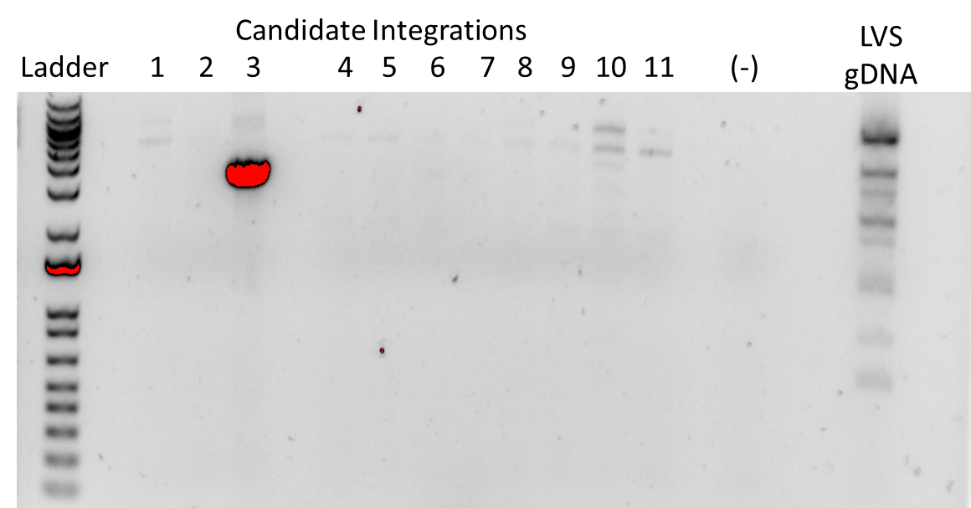

Miniprep of Candidate pKR184 from E. coli
- Pellet overnight cultures by centrifugation at 15,000rpm for 3 minutes.
- Resuspend pellets in a 250uL Buffer P1 and transfer to a microcentrifuge tube.
- Add 250uL Buffer P2 and mix thoroughly by inverting the tube 4-6 times until the solution becomes clear. Do not allow lysis reaction to proceed for more than 5 minutes.
- Add 350uL Buffer N3 and mix immediately and thoroughly by inverting the tube 4-6 times.
- Centrifuge for 10 minutes at 13,000rpm.
- Transfer 800uL of supernatant to a QIAprep 2.0 spin column through pipetting.
- Wash the QIAprep column by adding 500uL Buffer PB. Centrifuge for 30-60s and discard flow through.
- Wash the QIAprep column with 750uL Buffer PE. Centrifuge 30-60s x3 and discard flow through.
- Centrifuge for 3 minutes at 13,000rpm to remove residual buffer.
- Place QIAprep column in a clean 1.5mL microcentrifuge tube. Add 50uL of Buffer EB. Let stand for 1 minute. Centrifuge for 1 minute at 13,000rpm.

Monday, March 27, 2023
To Do:
- Patch out candidate d2 strain for gDNA prep
- Patch out KRLVS126 and KRLVS127
- Check miniprep concentrations
- Diagnostic digest of minipreps
- Run gel of diagnostic digest of minipreps
Results and Data:
Based on my gel, I patched out candidate integrant #3 for gDNA prep.

DNA Digest of Candidate pKR184 w/KpnI and BamHI
- Make a reaction table with desired digests:
Tube | DNA | Enzyme(s) | DNA Volume (uL) | H₂O Volume (uL)
1 | Water | KpnI, BamHI | - | 15
2 | pKR121 | KpnI, BamHI | 5 | 10
3-6 | Cand. pKR184 | KpnI, BamHI | 5 | 10
- Set up master mix table:
Components | Volumes in 1 reaction (uL) | Volumes in 7x Master Mix (uL)
H₂O | 20.8 | 145.6
10x Buffer* | 3.0 | 21.0
DNA | (5.0) | -
KpnI | 0.6 | 4.2
BamH1 | 0.6 | 4.2
Total | 30.0 (25.0 actual b/c of DNA) | 175.0
- Add 25 uL of Master Mix to individual tube for digest.
- Mix by pipetting up and down.
- Incubate at 37°C for 1 hour.

Gel of Diagnostic Digest of Candidate pKR184 Minipreps
- Melt agarose gel until completely dissolved, then place in 50°C water bath until cool enough to touch.
- Set up gel rig to cast gel, with ladder.
- Add 6 uL of Sbyr Safe dye to gel rig, pour ~60mL of agarose gel, use ladder to mix, then replace ladder and allow to set.
- Turn gel, add used TAE, remove ladder.
- Loaded 10 uL ladder, and 36 uL of each sample.
- Ran for 45 minutes at 113V.
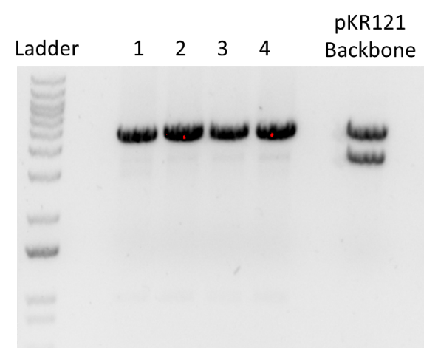
I nanodrop’d the other three PCR reactions I had from my candidate pKR168 minipreps from yeast in preparation for sequencing:
Additionally, I nanodrop’d my candidate pKR184 minipreps from E. coli in preparation for sequencing:

Tuesday, March 28, 2023
To Do:
- Set up candidate pKR168 PCR for sequencing
- Set up pKR184 for sequencing
- gDNA prep of candidate d2 strain
- Dilute gDNA to 100 ng/uL
- Make personal glycerol stocks of KRLVS126 and KRLVS127
Results and Data:
I set up my candidate pKR168 and pKR184 for sequencing. I followed the same PC sequencing set-up I have been using for pKR168. For pKR184, I used two primers to cover the regulatory elements and the GFP, in the plasmid:

gDNA Prep of Cand. pKR168 Integrant
- Dilute 1uL of Proteinase K into 310uL of Tissue and Cell Lysis Solution for each sample.
- Scraped up patches of candidate pKR168 integrant into d2 and resuspended in MHB
- Pellet cells by centrifugation and discard the supernatant, leaving approximately 25 uL of liquid.
- Vortex for 10 seconds to resuspend the cell pellet.
- Add 300uL of Tissue and Cell Lysis Solution containing the Proteinase K and mix thoroughly.
- Incubate at 65°C for 15 minutes, vortex every 5 minutes.
- Cool the samples to 37°C and add 2ul of 20mg/mL RNase A to the sample, mix thoroughly.
- Incubate at 37°C for 30 minutes.
- Place the samples on ice for 3-5 minutes.
- Add 150uL of MPC Protein Precipitation Reagent to 200uL of lysed sample and vortex vigorously for 10 seconds.
- Pellet debris by centrifugation at 4°C for 10 minutes at max speed in a microcentrifuge. If the resultant pellet is clear, small, or loose, add an additional 25uL of MPC Protein Precipitation Reagent, mix, and pellet the debris again.
- Transfer the supernatant to a clean microcentrifuge tube and discard the pellet.
- Add 500uL of isopropanol to the recovered supernatant. Invert the tube 30-40 times.
- Pellet the DNA by centrifugation at 4°C for 10 minutes in a microcentrifuge.
- Carefully pour off the isopropanol without dislodging the DNA pellet.
- Rinse twice with 70% ethanol (~1mL) being careful to not dislodge the pellet. Centrifuge briefly if the pellet is dislodged. Remove all the residual ethanol with a pipet and let it air dry.
- Resuspend the DNA in 35uL of 0.1x EB.

Making Personal Glycerol Stocks and Single Use Aliquots of KRLVS150 and KRLVS151
- Prepare 1200uL of MHB in a 2mL tube
- Take at least half of a thickly spread plate and add cells to the MHB tube
- Resuspend until there are no clumps in the MHB
- Add 300ul of 75% glycerol to the 1200uL, mix by pipetting
- Aliquot 1 mL to cryovial and 50ul of solution to tubes, freeze at -80

Wednesday, March 29, 2023
To Do:
- Patch out KRLVS126 and KRLVS127
- PCR of candidate d2 strain gDNA
- PCR purification of candidate pKR168 integration
- Run gel of PCR
- Check sequencing results
Results and Data:

PCR of Candidate pKR168 Integrations for Sequencing
- Acquired and labelled PCR tubes
Reaction# | Plasmid/Region | Source DNA | Primers | Length (bp)
1 | Tn7 PrpsU2 tul4UTR | Cand.3 gDNA | KROL 252, KROL253 | 5000
2 | Tn7 LVS | LVS | KROL 252, KROL253 | 350
3 | - control | - | KROL 252, KROL253 | -
- Acquire the following components and put them on ice, labeling tubes if necessary:
  - mgH2O, Primestar buffer, dNTPs, KROL252, KROL253 (10uM), and candidate pKR168
- Vortex each component (aside from enzyme)
- Add appropriate volume (based on PCR worksheet) of each experiment specific primer (forward and reverse) and respective template to PCR tubes
- Add ddi H2O to negative control tube (template volume for 1 reaction)
- Prepare a master-containing:
  - mgH2O, dNTPs, Primestar buffer, and Primestar enzyme
- Mix the master-mix solution by pipetting up and down
- Add 19.6 uL of master-mix to negative control PCR tube
- Add 19.6 uL of master mix to each PCR tube and pipet up and down to mix
- Place the PCR Tubes in the thermocycler on STN 1

Total reaction volume | 20
Total number of reactions | 3
 |  |  |  | Factor
Component | Stock concentration | Final concentration | 1 rxn volume | 4
ddiH2O |  |  | 12.4 | 49.6
PrimeSTAR GXL Buffer | 5x | 1x | 4.0 | 16
dNTPs | 2.5 mM | 0.2 mM | 1.6 | 6.4
oligo F | 10 uM | 0.3 uM | 0.6 | 2.4
oligo R | 10 uM | 0.3 uM | 0.6 | 2.4
template | 40.0 ng/ul | 2 ng/ul | 0.4
PrimeSTAR GXL DNA Polymerase | 1.25 U/ul | 0.025 U/ul | 0.4 | 1.6
 |  | Total volume | 20 | 78.4
I checked my sequencing results and the additional three pKR168 plasmids look good. There might be a gap in 2.2, though, that’s near the end of the sequence, so I’m not sure if I entirely trust it. So, I will move forward with the other two first.
Additionally, the sequences for pKR184 look good. There is a bit of a discrepancy between the two sequencing reactions, potential insertions appearing on the sequencing that begins earlier, which makes me trust the second reaction more for those later sequences, but I double checked with Kathryn to be sure. She confirmed my thoughts so I they’re all good(:

PCR Purification of Candidate pKR168 Integration into d2 PCR
- Add 100 uL of Buffer PB to each 20 uL PCR reaction tube and mix.
- Place a QIAquick column in a 2mL collection tube.
- Centrifuge tube for 30-60s at 13,000rpm. Discard flow through.
- Wash: add 750uL of Buffer PE to the QIAquick column. Centrifuge for 30-60s at 13,000rpm. Discard flow through.
- Centrifuge again for 3 minutes at 13,000rpm to remove any residual wash buffer.
- Place the QIAquick column in a fresh 1.5mL centrifuge tube.
- Elute: add 35 uL of Buffer 0.1x EB. Let column stand for 1 minute. Centrifuge for 1 minute at 13,000rpm.

Gel of Candidate pKR168 Integration into d2 PCR
- Melt agarose gel until completely dissolved, then place in 56°C water bath until cool enough.
- Set up gel rig to cast gel, with ladder.
- Add 6uL of Sbyr Safe dye to gel rig, pour ~60uL of agarose gel, use ladder to mix, then replace ladder and allow to set.
- Turn gel, add used TAE, remove ladder.
- Loaded 10 uL ladder, and 5 uL of each sample.
- Ran for 45 minutes at 113V.
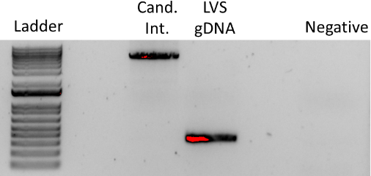

Thursday, March 30, 2023
To Do:
- Set up sequencing of candidate pKR168 integration PCR
- Make electrocompetent KRLVS126 and KRLVS127
- Electroporate pKR184 into KRLVS127
- Make 10% sucrose
Results and Data:
I nanodrop’d the PCR of my potential pKR168 Tn7 integration mutant in d2:

Preparing Electrocompetent KRLVS126 and KRLVS127 Cells
- Scrape up entire plate of cells into 400 uL of sterile 10% sucrose and resuspend
- Add 1.1 mL of 10% sucrose to a final volume of 1.5 mL
- Spin for 3 minutes at 10,000 rpm
- Remove supernatant, throw out, and resuspend in fresh 1 mL 10% sucrose
- Repeat 3x-5x in 10% sucrose
- After final spin, remove all supernatant.
- Resuspend cells in 10% sucrose at high density (corresponding to ~1x10¹¹ cells /mL); these are EC cells by slowly adding 110 uL at a time. It should be about equal amounts of cells as sucrose.
- For any extra EC cells, aliquot ~110 μL / sterile tube (enough for 2 electroporations) and freeze at -80°C

Electroporating pKR184 into EC KRLVS127 Cells
- For each electroporation, aliquot 4 mL MHB into glass test tubes for recovery, warm in shaker at 37°C
- For each electroporation, in a 2 mm sterile electroporation cuvette, combine:
3 μL of plasmid DNA
50 μL electrocompetent cells
- Have recovery media ready
- Electroporate using the EC2 program
- Immediately after individual electroporations, use 1 mL warm recovery media from test tube to wash cells out of cuvette and transfer cells to recovery test tube
- Recover cells for 4-8 hours, shaking at 37°C
- Plate on CHAH-Kan plates
  - Plated 20 uL, 200 uL, and remaining of each
- Incubate plates at 37°C for 3 days (or until single colonies appear)
Tube # | Purpose | Strain | DNA | Vol. of DNA | Vol. Plated | # of Plates
1 | d2+pKR184 | KRLVS127 | pKR184 | 3 uL | 20 uL. 200 uL, Rem. | 3
2 | (-) control | KRLVS127 | - | - | 200 uL | 1
 |  |  |  |  | Total: | 4

Reagents
10% Sucrose
Dissolve 25g sucrose in a total of 250mL of ddiH2O (type 1)
Filter sterilize

Friday, March 31, 2023
To Do:
- Electroporate pKR184 into KRLVS126
Results and Data:

Electroporating pKR184 into EC KRLVS126 Cells
- For each electroporation, aliquot 4 mL MHB into glass test tubes for recovery, warm in shaker at 37°C
- For each electroporation, in a 2 mm sterile electroporation cuvette, combine:
3 μL of plasmid DNA
50 μL electrocompetent cells
- Have recovery media ready
- Electroporate using the EC2 program
- Immediately after individual electroporations, use 1 mL warm recovery media from test tube to wash cells out of cuvette and transfer cells to recovery test tube
- Recover cells for 4-8 hours, shaking at 37°C
- Plate on CHAH-Kan plates
  - Plated 20 uL, 200 uL, and remaining of each
- Incubate plates at 37°C for 3 days (or until single colonies appear)
Tube # | Purpose | Strain | DNA | Vol. of DNA | Vol. Plated | # of Plates
1 | d2+pKR184 | KRLVS126 | pKR184 | 3 uL | 20 uL. 200 uL, Rem. | 3
2 | (-) control | KRLVS126 | - | - | 200 uL | 1
 |  |  |  |  | Total: | 4
FTL_1362 rpsU3
FTL_0456 rpsU1
FTL_1047 rpsU2

April 2023

Wednesday, April 5, 2023
To Do:
- Restriction digest of pKR184 and pF
- Run gel of restriction digest
- Order primers and qPCR primers
Results and Data:

DNA Digest of pF Backbone and pKR184 Insert w/KpnI and BamHI
- Make a reaction table with desired digests:
Tube | DNA | Enzyme(s) | DNA Volume (uL) | H₂O Volume (uL)
1 | pKR184 | KpnI, BamHI | - | 15
2 | pF | KpnI, BamHI | 5 | 10
- Set up master mix table:
Components | Volumes in 1 reaction (uL) | Volumes in 3x Master Mix (uL)
H₂O | 10.8 | 32.4
10x Buffer* | 3.0 | 9.0
DNA | (5.0) | -
KpnI | 0.6 | 1.8
BamH1 | 0.6 | 1.8
Total | 30.0 (25.0 actual b/c of DNA) | 75.0
- Add 15 uL of Master Mix to individual tube for digest.
- Mix by pipetting up and down.
- Incubate at 37°C for 1 hour.
- After digest: add 1 uL of QuickCIP enzyme to backbone tube, mix by pipetting and put back in 37°C incubator for 10 minutes, mix, then put at 80C for 2 minutes to inactivate the enzyme.

Gel of Digested pF Backbone + pKR184 Insert
- Melt agarose gel until completely dissolved, then place in 50°C water bath until cool enough to touch.
- Set up gel rig to cast gel, with ladder.
- Add 6 uL of Sbyr Safe dye to gel rig, pour ~60mL of agarose gel, use ladder to mix, then replace ladder and allow to set.
- Turn gel, add used TAE, remove ladder.
- Loaded 10 uL ladder, and 36 uL of each sample.
- Ran for 45 minutes at 113V.
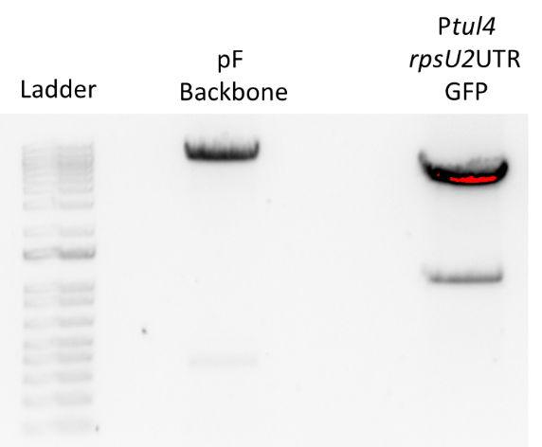

Visualizing and Cutting Gel
- Using Bio Rad Gel Doc XR+ imager equipped with XcitaBlue Conversion Screen
- Nucleic Acid Gel > Sybr Safe
- To cut gel, put on visualizing UV glasses and use a clean razor, cutting straight down. Add to 2mL tube. Stored gel pieces in fridge overnight.

Thursday, April 6, 2023
To Do:
- Make 2.5% iron pyrophosphate
- Gel purification of restriction digest
- Colony PCR from patch quadrant of potential pKR184 integrants
- Run gel of colony PCR
- Freeze down promising first quadrant patches based on colony PCR
Results and Data:

Colony PCR of Candidate pKR184 Integration into LVS and drpsU2
- Take a small amount of each patch and resuspend in separate aliquots of 50 μL sterile water using a sterile toothpick.
- Heat samples at 95°C for 10’ to lyse and kill cells
- Dilute lysates 1:10
- Use 1-2 μL of heat-killed cells as template in colony PCR to check for desired mutation.
- Acquired and labelled PCR tubes
Reaction# | Plasmid/Region | Source DNA | Primers | Length (bp)
1 | - control | - | KROL326, KROL402 | -
2 | LVS gDNA | LVS gDNA | KROL326, KROL402 | -
3-6 | Ptul_ rpsU2UTR gfp | Lysate | KROL326, KROL402 | 995
7-10 | d2 Ptul_ rpsU2UTR gfp | Lysate | KROL326, KROL402 | 995
- Acquire the following components and put them on ice, labeling tubes if necessary:
  - mgH2O, Primestar buffer, dNTPs, KROL472, KROL319 (10uM), LVS gDNA, LVS lysate, and candidate pKR168 integrant lysates
- Vortex each component (aside from enzyme)
- Add appropriate volume (based on PCR worksheet) of each experiment specific primer (forward and reverse) and respective template to PCR tubes
- Add ddi H2O to negative control tube (template volume for 1 reaction)
- Prepare a master-containing:
  - mgH2O, dNTPs, Primestar buffer, and Primestar enzyme
- Mix the master-mix solution by pipetting up and down
- Add 19.0 uL of master-mix to negative control PCR tube
- Add 19.0 uL of master mix to each PCR tube and pipet up and down to mix
- Place the PCR Tubes in the thermocycler according to the following program:
  - 94°C 2'
  - 94°C 20"
  - 50°C 30"
  - 68°C (1' per kb)
  - Go to step 2, rep 32x
  - 68°C 5'
  - Hold 12°C

Total reaction volume | 20
Total number of reactions | 10
 |  |  |  | Factor
Component | Stock concentration | Final concentration | 1 rxn volume | 11
ddiH2O |  |  | 11.8 | 129.8
PrimeSTAR GXL Buffer | 5x | 1x | 4 | 44
dNTPs | 2.5 mM | 0.2 mM | 1.6 | 17.6
oligo F | 10 uM | 0.3 uM | 0.6 | 6.6
oligo R | 10 uM | 0.3 uM | 0.6 | 6.6
PrimeSTAR GXL DNA Polymerase | 1.25 U/ul | 0.025 U/ul | 0.4 | 4.4
Cell lysate | - | - | 1
 |  | Total volume | 20 | 209

Gel of Colony PCR of Candidate pKR184 Integrations into LVS and d2
- Melt agarose gel until completely dissolved, then place in 50°C water bath until cool enouh..
- Set up large gel rig to cast gel, with ladder.
- Add 12 uL of Sbyr Safe dye to gel rig, pour ~120mL of agarose gel, use ladder to mix, then replace ladder and allow to set.
- Turn gel, add used TAE, remove ladder.
- Loaded 10 uL ladder, and 15 uL of each sample.
- Ran for 45 minutes at 113V.
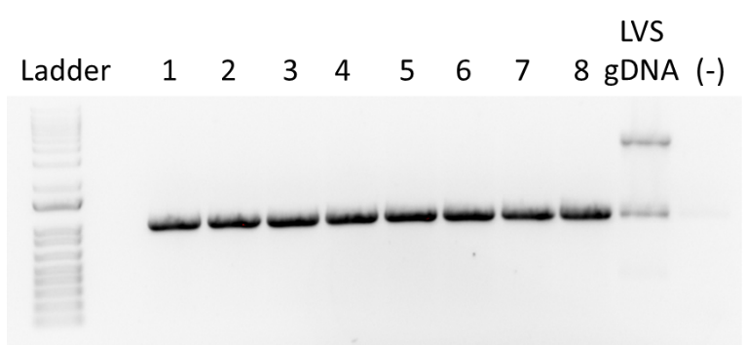
The ladder is difficult to see, however, I was looking for a 3000-ish bp band and it looks like the bands are in the 3000/4000 range, so I think it’s good.

Gel Extraction with QIAquick Gel Extraction Kit
- Excise the DNA fragment from the agarose gel with a clean, sharp razor
- Weigh the gel slice in a colorless tube. Add 3 volumes Buffer QG to 1 volume gel.
- Incubate at 42C for 10 minutes or until gel is dissolved. Vortex every 2-3min to help dissolve.
- Add 1 gel volume isopropanol to the sample and mix.
- Load sample into QIAquick column and centrifuge for 1 min at 13,000rpm. Discard flow through.
- Add 500uL Buffer QG. Centrifuge for 1 min at 13,000rpm. Discard flow through.
- Wash: Add 750uL Buffer PE to the QIAquick column. Centrifuge 1 min at 13,000rpm. Discard flow through. Place column back in tube. Centrifuge again for 3 minutes. Discard flow through.
- Place columns in a fresh 1.5mL microcentrifuge tube.
- Elute: Add 30uL Buffer EB .01x and let stand for 1-4 minutes. Centrifuge for 1 min at 13,000rpm.
Component | Weight (mg) | Buffer QG 3 vol (uL) | Isopropanol 1 vol (uL)
Ptul4 rpsU2 5’UTR GFP | 298 | 894 | 298
pF Backbone | 286 | 858 | 286

Making Glycerol Stocks of Potential pKR184 Integrant Strains
- Prepare 800uL of MHB in a 2mL tube
- Take at least half of a thickly spread plate and add cells to the MHB tube
- Resuspend until there are no clumps in the MHB
- Add 200ul of 75% glycerol cryovial, then add 800 uL of resuspended cells
- Vortex until mixed and minifuge, freeze at -80
Sample # | Description
1 | LVS + pKR184
2 | LVS + pKR184
3 | LVS + pKR184
4 | LVS + pKR184
5 | ΔrpsU2 + pKR184
6 | ΔrpsU2 + pKR184
7 | ΔrpsU2 + pKR184
8 | ΔrpsU2 + pKR184

Monday, April 17, 2023
To Do:
- Start dishwasher
- Electroporate pKR168 into KRLVS126 (LVS)
- Ligate gel purification
- Transform ligation of pF+Ptul4 rpsU2UTR GFP into E. coli
- Receive and dilute primers
- Run PCR for rpsU2UTR mutant 1
Results and Data:

Electroporating pKR168 into EC KRLVS126 Cells
- For each electroporation, aliquot 4 mL MHB into glass test tubes for recovery, warm in shaker at 37°C
- For each electroporation, in a 2 mm sterile electroporation cuvette, combine:
5 μL of plasmid DNA
50 μL electrocompetent cells
- Have recovery media ready
- Electroporate using the EC2 program
- Immediately after individual electroporations, use 1 mL warm recovery media from test tube to wash cells out of cuvette and transfer cells to recovery test tube
- Recover cells for 4-8 hours, shaking at 37°C
- Plate on CHAH-Kan plates
  - Plated 20 uL, 200 uL, and remaining
- Incubate plates at 37°C for 3 days (or until single colonies appear)
Tube # | Purpose | Strain | DNA | Vol. of DNA | Vol. Plated | # of Plates
1 | WT+pKR168 | KRLVS126 | pKR168 1.1 | 5 uL | 20 uL. 200 uL, Rem. | 3
2 | (-) control | KRLVS126 | - | - | 200 uL | 1
 |  |  |  |  | Total: | 4

Ligation of Digested pKR184 Insert with Digested pF Backbone
- Make a reaction table with desired ligations. Always include a backbone only control for each plasmid backbone used.
Tube | Insert | Backbone
1 | Ptul4 rpsU2 UTR GFP (pKR184) | KpnI, BamHI digested, purified pF
2 | - | KpnI, BamHI digested, purified pF
- Set up master mix table:
Component | Reaction 1 (uL) | Reaction 2 (uL)
H2O | 11.5 | 11.5
10x ligase buffer | 2.0 | 2.0
Insert | 4.0 | -
Backbone | 2.0 | 2.0
Ligase | 0.5 | 0.5
TOTAL | 20.0 | 20.0
- Obtain ice to assemble and keep the reactions on.
- Obtain and label 1.5mL tubes for the reactions. Be sure to include the date and your initials.
- To the individual tubes, add indicated amounts of H₂O, 10x buffer, insert, and backbone.
- Add indicated amount of ligase to the individual tubes.
- After all of the components have been added, mix each tube with a pipette set to 18 uL.
- Left on bench at room temperature for 10 minutes.

Transformation of pKR196 Ligation into E. coli
- Set up reaction table. Always include a positive and negative control for each antibiotic. Use 8 uL per ligation and plate 10 uL and 100 uL.
  - Positive control: pF; Backbone ligation: KpnI-BamHI digested pKR184
Reaction table
Tube# | Purpose | DNA | Vol. of DNA | Final vol. to plate | # of LB-kan plates
1 | (-) control | None | 0 | 200 ul | 1
2 | Backbone Ligation | BB only ligation | 8 uL | 10 uL, 100 ul | 2
3 | pKR196 Ligation | pKR196 Ligation | 8 uL | 10 uL, 100 ul | 2
Total number of plates |  |  |  |  | 5

- Check to be sure you have enough LB-Kan plates. If plates were stored at 4°C, warm at 37°C until needed.
- Obtain DNA and thaw on ice if necessary.
- Thaw appropriate number of competent cell tubes on ice (5 reactions per tube of competent cells)
- Label sterile tubes as indicated in reaction table. Add indicated volume of indicated DNA on ice.
- When competent cells are thawed (check by probing for frozen cells using a sterile pipette tip), gently pipette 100 uL of cells into each reaction tube directly onto DNA using aseptic technique.
- Incubate cells on ice for 20 minutes. During incubation, find or set heat block to 42°C.
- Place tubes with cells and DNA onto 42°C heatblock for 30 seconds (heat shock step).
- After heat shock, place tubes back on ice until next step (don’t keep them here too long).
- Using aseptic technique, add 1 mL LB (no antibiotic) to each microfuge tube.
- Using autoclave tape, tape microfuge tubes down in shaking incubator set to 37°C.
- Allow cells to recover for 1 hour at 37°C, shaking. Place in a rack after shaking
- Using aseptic technique, plate indicated amount of cells on appropriate antibiotic plates (LB-Kan), spreading until plates look dry.

Receiving pKR184/pKR196 Mut. 1 Primer
- Spin primers at maximum speed in tabletop centrifuge for 3 minutes so desiccated primers go to the bottom of the tube.
- Add 0.1x EB to a final concentration of 100 uM. Calculate this by multiplying the reported nm by 10 and adding that volume in ul (i.e. 12.7 nmoles = add 127 uL of 0.1xEB).
- Put on 42°C heat block for 5 minutes to help primers dissolve
- Vortex and brief spin.
- Label tubes with KROL numbers on the top and put in the appropriate 100 uM stock box in the -20°C freezer.
- Optional: Make dilution for intended purpose of primer.
  - If a PCR primer, make a 10 uM stock by diluting 20 uL of the 100 uM stock into 180 uL of 0.1xEB. Label with purple sticker and put in appropriate freezer box.
- Put Certificate of Analysis sheet in “Oligos Spec Sheet” binder and shipping sheet in Invoices box.

PCR of Mutant 1 Fragment from pKR184
- Acquired and labelled PCR tubes
Reaction# | Plasmid/Region | Source DNA | Primers | Length (bp)
1 | Ptul4 rpsU2UTR Mut. 1 | pKR184 | KROL 635, KROL560 | 658
2 | - control | - | KROL 635, KROL560 | -
- Acquire the following components and put them on ice, labeling tubes if necessary:
  - mgH2O, Primestar buffer, dNTPs, KROL252, KROL253 (10uM), and candidate pKR168
- Vortex each component (aside from enzyme)
- Add appropriate volume (based on PCR worksheet) of each experiment specific primer (forward and reverse) and respective template to PCR tubes
- Add ddi H2O to negative control tube (template volume for 1 reaction)
- Prepare a master-containing:
  - mgH2O, dNTPs, Primestar buffer, and Primestar enzyme
- Mix the master-mix solution by pipetting up and down
- Add 19.6 uL of master-mix to negative control PCR tube
- Add 19.6 uL of master mix to each PCR tube and pipet up and down to mix
- Place the PCR Tubes in the thermocycler on STN 1

Total reaction volume | 100
Total number of reactions | 2
 |  |  |  | Factor
Component | Stock concentration | Final concentration | 1 rxn volume | 4
ddiH2O |  |  | 62.0 | 186
PrimeSTAR GXL Buffer | 5x | 1x | 20.0 | 60
dNTPs | 2.5 mM | 0.2 mM | 8.0 | 24
oligo F | 10 uM | 0.3 uM | 3.0 | 9
oligo R | 10 uM | 0.3 uM | 3.0 | 9
template | 100 ng/ul | 2 ng/ul | 2.0
PrimeSTAR GXL DNA Polymerase | 1.25 U/ul | 0.025 U/ul | 2.0 | 6
 |  | Total volume | 100 | 294

Tuesday, April 18, 2023
To Do:
- Patch out promising frozen stocks of pKR184 integrants
- PCR purify Ptul4 rpsU2UTR stem loop deletion PCR
- Restriction digest of backbone and rpsU2 UTR mutant
- Run gel of restriction digest and excise bands
- Gel purification of restriction digest
- Ligation of gel purification of restriction digest
Results and Data:

PCR Purification of rpsU2 UTR Stem Loop Deletion PCR
- Add 500 uL of Buffer PB to each 100 uL PCR reaction tube and mix.
- Place a QIAquick column in a 2mL collection tube.
- Centrifuge tube for 30-60s at 13,000rpm. Discard flow through.
- Wash: add 750uL of Buffer PE to the QIAquick column. Centrifuge for 30-60s at 13,000rpm. Discard flow through.
- Centrifuge again for 3 minutes at 13,000rpm to remove any residual wash buffer.
- Place the QIAquick column in a fresh 1.5mL centrifuge tube.
- Elute: add 35 uL of Buffer 0.1x EB. Let column stand for 1 minute. Centrifuge for 1 minute at 13,000rpm.

DNA Digest of rpsU2 Mut. 1 PCR and pKR184 Backbone w/PacI and MfeI
- Make a reaction table with desired digests:
Tube | DNA | Enzyme(s) | DNA Volume (uL) | H₂O Volume (uL)
1 | rpsU2 UTR Mut. 1 PCR | PacI, MfeI | 15 | -
2 | pKR184 | PacI, MfeI | 5 | 10
- Set up master mix table:
Components | Volumes in 1 reaction (uL) | Volume in 3x Master Mix (uL)
H₂O | 10.8 | 32.4
10x Buffer* | 3.0 | 9.0
DNA | (15.0) | -
Not1 | 0.6 | 1.8
Kpn1 | 0.6 | 1.8
Total | 30.0 (15.0 actual b/c of DNA) | 45 (15 uL for each reaction)
- Add 15 uL of Master Mix to individual tube for digest.
- Mix by pipetting up and down.
- Incubate at 37°C for 1 hour.
- After digest: add 1 uL of QuickCIP enzyme to backbone tube, mix by pipetting and put back in 37°C incubator for 10 minutes, mix, then put at 80C for 2 minutes to inactivate the enzyme.

Gel of Digested rpsU2 UTR Mutant Insert and pKR184 Backbone
- Melt agarose gel until completely dissolved, then place in 50°C water bath until cool enough to touch.
- Set up gel rig to cast gel, with ladder.
- Add 12uL of Sbyr Safe dye to gel rig, pour ~120mL of agarose gel, use ladder to mix, then replace ladder and allow to set.
- Turn gel, add used TAE, remove ladder.
- Loaded 15 uL ladder, and 36 uL of each sample.
- Ran for 45 minutes at 113V.
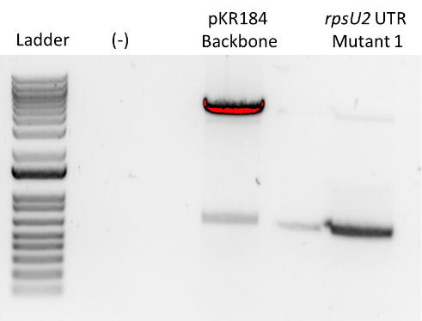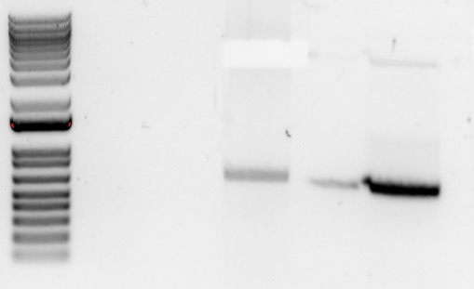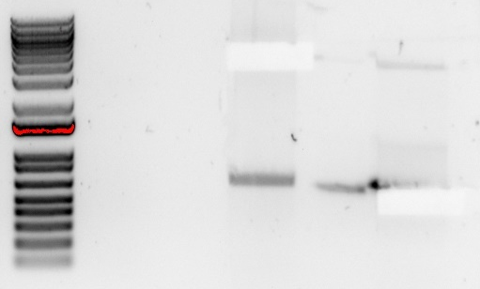
Expecting band sizes of ~5600 for the backbone and ~650 for the insert. Which looks like what I got to me. I cut it accordingly. I missed some of the insert, however, given that there was some spillover which could have either been insert or the unwanted insert from the backbone, I did not go back to cut out more. That said, my insert looks like it’s a bit smaller than the region we are removing from the backbone, which is good, since it should be about ~50 base pairs smaller. The stain blob was not visible in the uncropped gel picture, but it was there in real life, so I know the negative ran and is just clean.

Visualizing and Cutting Gel
- Using Bio Rad Gel Doc XR+ imager equipped with XcitaBlue Conversion Screen
- Nucleic Acid Gel > Sybr Safe
- To cut gel, put on visualizing UV glasses and use a clean razor, cutting straight down. Add to 2mL tube. Stored gel pieces in fridge overnight.

Gel Extraction with QIAquick Gel Extraction Kit
- Excise the DNA fragment from the agarose gel with a clean, sharp razor
- Weigh the gel slice in a colorless tube. Add 3 volumes Buffer QG to 1 volume gel.
- Incubate at 42C for 10 minutes or until gel is dissolved. Vortex every 2-3min to help dissolve.
- Add 1 gel volume isopropanol to the sample and mix.
- Load sample into QIAquick column and centrifuge for 1 min at 13,000rpm. Discard flow through.
- Add 500uL Buffer QG. Centrifuge for 1 min at 13,000rpm. Discard flow through.
- Wash: Add 750uL Buffer PE to the QIAquick column. Centrifuge 1 min at 13,000rpm. Discard flow through. Place column back in tube. Centrifuge again for 3 minutes. Discard flow through.
- Place columns in a fresh 1.5mL microcentrifuge tube.
- Elute: Add 30uL Buffer EB .01x and let stand for 1-4 minutes. Centrifuge for 1 min at 13,000rpm.
Component | Weight (mg) | Buffer QG 3 vol (uL) | Isopropanol 1 vol (uL)
rpsU2 5’UTR Mut. 1 | 265 | 795 | 265
pKR184 Backbone | 329 | 987 | 329
Additionally, I checked my transformation plates from yesterday and did not see any growth. The cells I started with seemed a little light, so hopefully that was the issue. I will do an overnight ligation along with my pKR191 ligation and re-transform tomorrow. Additionally, I placed my plates back into the incubator in case there is growth tomorrow.

Ligation of Digested Mutant 1 + pKR184 Backbone and pKR184 Insert + pF Backbone
- Make a reaction table with desired ligations. Always include a backbone only control for each plasmid backbone used.
Tube | Insert | Backbone
1 | rpsU2 UTR Mut. 1 PCR | PacI, MfeI digested, purified pKR184
2 | - | PacI, MfeI digested, purified pKR184
3 | Ptul4 rpsU2 UTR GFP (pKR184) | KpnI, BamHI digested, purified pF
4 | - | KpnI, BamHI digested, purified pF
- Set up master mix table:
Component | Reaction 1 (uL) | 4.5 x Master Mix (uL)
H2O | 11.5 | 51.75
10x ligase buffer | 2.0 | 9.0
Insert | 4.0 | -
Backbone | 2.0 | -
Ligase | 0.5 | 2.25
TOTAL | 20.0 | 63
- Obtain ice to assemble and keep the reactions on the ice.
- Obtain and label 1.5mL tubes for the reactions. Be sure to include the date and your initials.
- To the individual tubes, add indicated amounts of H₂O, 10x buffer, insert, and backbone.
- Add indicated amount of ligase to the individual tubes.
- After all of the components have been added, mix each tube with a pipette set to 18 uL.
- Incubated at 16°C overnight.

Wednesday, April 19, 2023
To Do:
- Transform pKR191 ligation into E. coli
- Transform pKR196 ligation into E. coli
- gDNA prep of potential pKR184 integrants
- PCR of gDNA of potential pKR184 integrants
Results and Data:

Transformation of pKR191 and pKR196 Ligation into E. coli
- Set up reaction table. Always include a positive and negative control for each antibiotic. Use 8 uL per ligation and plate 100 uL and remaining.
Reaction table
Tube# | Purpose | DNA | Vol. of DNA | Final vol. to plate | # of LB-kan plates
1 | (-) control | None | 0 | 100 ul | 1
2 | Backbone Ligation | BB only ligation | 8 uL | 100 uL, remaining | 2
3 | pKR196 Ligation | pKR196 Ligation | 8 uL | 100 uL, remaining | 2
4 | Backbone Ligation | BB only ligation | 8 uL | 100 uL, remaining | 2
5 | pKR191 Ligation | pKR196 Ligation | 8 uL | 100 uL, remaining | 2
Total number of plates |  |  |  |  | 9

- Check to be sure you have enough LB-Kan plates. If plates were stored at 4°C, warm at 37°C until needed.
- Obtain DNA and thaw on ice if necessary.
- Thaw appropriate number of competent cell tubes on ice (5 reactions per tube of competent cells)
- Label sterile tubes as indicated in reaction table. Add indicated volume of indicated DNA on ice.
- When competent cells are thawed (check by probing for frozen cells using a sterile pipette tip), gently pipette 100 uL of cells into each reaction tube directly onto DNA using aseptic technique.
- Incubate cells on ice for 20 minutes. During incubation, find or set heat block to 42°C.
- Place tubes with cells and DNA onto 42°C heatblock for 30 seconds (heat shock step).
- After heat shock, place tubes back on ice until next step (don’t keep them here too long).
- Using aseptic technique, add 1 mL LB (no antibiotic) to each microfuge tube.
- Using autoclave tape, tape microfuge tubes down in shaking incubator set to 37°C.
- Allow cells to recover for 1 hour at 37°C, shaking. Place in a rack after shaking
- Using aseptic technique, plate indicated amount of cells on appropriate antibiotic plates (LB-Kan), spreading until plates look dry.

gDNA Prep of Cand. pKR184 Integrants in LVS and ΔrpsU2
- Dilute 1uL of Proteinase K into 310uL of Tissue and Cell Lysis Solution for each sample.
- Scraped up patches of candidate pKR184 integrant into WT/d2 and resuspended in MHB
- Pellet cells by centrifugation and discard the supernatant, leaving approximately 25 uL of liquid.
- Vortex for 10 seconds to resuspend the cell pellet.
- Add 300uL of Tissue and Cell Lysis Solution containing the Proteinase K and mix thoroughly.
- Incubate at 65°C for 15 minutes, vortex every 5 minutes.
- Cool the samples to 37°C and add 2ul of 20mg/mL RNase A to the sample, mix thoroughly.
- Incubate at 37°C for 30 minutes.
- Place the samples on ice for 3-5 minutes.
- Add 150uL of MPC Protein Precipitation Reagent to 200uL of lysed sample and vortex vigorously for 10 seconds.
- Pellet debris by centrifugation at 4°C for 10 minutes at max speed in a microcentrifuge. If the resultant pellet is clear, small, or loose, add an additional 25uL of MPC Protein Precipitation Reagent, mix, and pellet the debris again.
- Transfer the supernatant to a clean microcentrifuge tube and discard the pellet.
- Add 500uL of isopropanol to the recovered supernatant. Invert the tube 30-40 times.
- Pellet the DNA by centrifugation at 4°C for 10 minutes in a microcentrifuge.
- Carefully pour off the isopropanol without dislodging the DNA pellet.
- Rinse twice with 70% ethanol (~1mL) being careful to not dislodge the pellet. Centrifuge briefly if the pellet is dislodged. Remove all the residual ethanol with a pipet and let it air dry.
- Resuspend the DNA in 70uL of 0.1x EB.
Then I nanodrop’d my gDNA samples:
I diluted both 1:10, with 10 uL of gDNA in 90 uL of 0.1xEB.

PCR of Candidate pKR184 Integrations for Sequencing
- Acquired and labelled PCR tubes
Reaction# | Plasmid/Region | Source DNA | Primers | Length (bp)
1 | LVS Ptul4 rpsU2UTR GFP | Cand 1 gDNA | KROL 252, KROL253 | 3000
2 | Ptul4 rpsU2UTR GFP | Cand 5 gDNA | KROL 252, KROL253 | 3000
3 | Tn7 LVS | LVS | KROL 252, KROL253 | 350
4 | - control | - | KROL 252, KROL253 | -
- Acquire the following components and put them on ice, labeling tubes if necessary:
  - mgH2O, Primestar buffer, dNTPs, KROL252, KROL253 (10uM), and candidate pKR168
- Vortex each component (aside from enzyme)
- Add appropriate volume (based on PCR worksheet) of each experiment specific primer (forward and reverse) and respective template to PCR tubes
- Add ddi H2O to negative control tube (template volume for 1 reaction)
- Prepare a master-containing:
  - mgH2O, dNTPs, Primestar buffer, and Primestar enzyme
- Mix the master-mix solution by pipetting up and down
- Add 19.6 uL of master-mix to negative control PCR tube
- Add 19.6 uL of master mix to each PCR tube and pipet up and down to mix
- Place the PCR Tubes in the thermocycler on STN 1

Total reaction volume | 20
Total number of reactions | 4
 |  |  |  | Factor
Component | Stock concentration | Final concentration | 1 rxn volume | 5
ddiH2O |  |  | 12.4 | 62
PrimeSTAR GXL Buffer | 5x | 1x | 4.0 | 20
dNTPs | 2.5 mM | 0.2 mM | 1.6 | 8
oligo F | 10 uM | 0.3 uM | 0.6 | 3
oligo R | 10 uM | 0.3 uM | 0.6 | 3
template | 40.0 ng/ul | 2 ng/ul | 0.4
PrimeSTAR GXL DNA Polymerase | 1.25 U/ul | 0.025 U/ul | 0.4 | 2
 |  | Total volume | 20 | 98

Thursday, April 20, 2023
To Do:
- PCR purification of pKR184 integrate gDNA PCR
- Run gel of PCR purification
- Submit potential pKR184 integrant candidates for sequencing
- Primer efficiencies of GFP qPCR primers
- Make E. coli overnights
Results and Data:

PCR Purification of pKR184 Integrants gDNA PCR for Sequencing
- Add 500 uL of Buffer PB to each 100 uL PCR reaction tube and mix.
- Place a QIAquick column in a 2mL collection tube.
- Centrifuge tube for 30-60s at 13,000rpm. Discard flow through.
- Wash: add 750uL of Buffer PE to the QIAquick column. Centrifuge for 30-60s at 13,000rpm. Discard flow through.
- Centrifuge again for 3 minutes at 13,000rpm to remove any residual wash buffer.
- Place the QIAquick column in a fresh 1.5mL centrifuge tube.
- Elute: add 35 uL of Buffer 0.1x EB. Let column stand for 1 minute. Centrifuge for 1 minute at 13,000rpm.
Next, I nanodrop’d my PCR samples:
And set them up for sequencing:

Gel of Potential pKR184 Integrants into WT and d2 gDNA PCR for Sequencing
- Melt agarose gel until completely dissolved, then place in 50°C water bath until cool enough to touch.
- Set up gel rig to cast gel, with ladder.
- Add 12uL of Sbyr Safe dye to gel rig, pour ~120mL of agarose gel, use ladder to mix, then replace ladder and allow to set.
- Turn gel, add used TAE, remove ladder.
- Loaded 15 uL ladder, and 36 uL of each sample.
- Ran for 45 minutes at 113V.
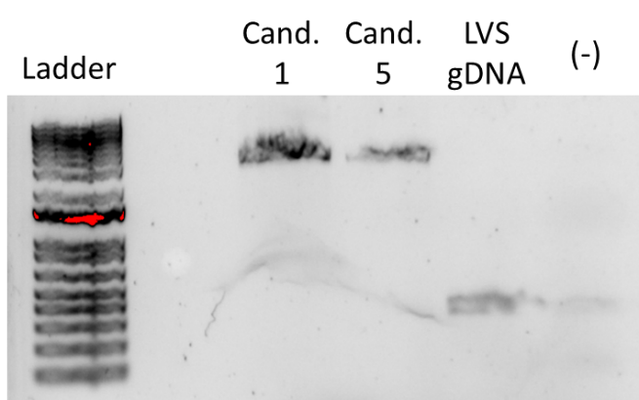
There’s obviously a bit of contamination in the negative, however, I was loading pretty quickly and this band isn’t in any of the other lanes, so I’m pretty sure it was just carryover from LVS. The band size I was expecting is around 3000 bp. It looks like its around that range (10 bands from the bottom of the ladder), though there’s not great resolution since I didn’t have time to run it as long as I should have. Regardless, I already saw the proper bands in the colony PCR, this gel was just for checksies.
Additionally, I used the 2nd replicate of LVS cDNA from my second rep of my rpsU1/rpsU3 autoregulation experiment to make the serially diluted cDNA for my primer efficiencies. I made enough for 4 reactions today, GFP plus tul4 control. And then a separate tube for 7 reactions for tomorrow. Ergo, secG, rpsO, and the tul4 control. As follows:

Real-Time Primer Efficiency Test of GFP qRT-PCR Primers for cDNA
- Dilute cDNA to 1.5 ng/uL and make 10-fold serial dilutions (1.5ng/ul, 0.15ng/ul, 0.015ng/ul, 0.0015ng/ul)
- Add 17.5ul of each DNA sample into strip tubes, for each primer set
- Set up master mixes for each primer set:
10 ul of SYBR green x 17.5 = 175
1 ul of 5uM primer set x 17.5 = 17.5
4 ul ddH2O x 17.5 = 70
TOTAL = 262.5
- Add 52.5 uL of accordant primer master mix to each strip tube
- Using multi-channel pipette, transfer 20 uL of each primer set + diluted cDNA to 96-well plate in triplicate
- Place adhesive film onto plate and centrifuge 3 minutes at 500xg to draw all liquid to the bottom
- Place in light cycler and run the following program:
Old StepOne Plus (2-step amplification)
95°C 10’
95°C 15”
60°C 60”
Go to step 2, 39x (total 40 cycles)
95°C 10”
65°C 60”
97°C 60”
Melt curve (95°C 10”, 65°C 60”, 97°C 60” with continuous ramp)
- Plot a standard curve, as well as a melting curve. Ideally you want the calculated primer efficiency to be between 1.8 and 2.0. Ensure melting curve has only one peak.
- Labelling was as follows:
Master Mix Label | Primer Set
A | KROL431/432 GFP
B | KROL433/434 GFP
C | KROL435/436 GFP
D | KROL63/64 tul4

1 | 2 | 3 | 4
1.5 ng/uL | 0.15 ng/uL | 0.015 ng/uL | 0.0015 ng/uL
- Loaded 96-well plate according to the following table:
 | 1 | 2 | 3 | 4 | 5 | 6 | 7 | 8 | 9 | 10 | 11 | 12
A | A1 |  |  | C1
B | A2 |  |  | C2
C | A3 |  |  | C3
D | A4 |  |  | C4
E | B1 |  |  | D1
F | B2 |  |  | D2
G | B3 |  |  | D3
H | B4 |  |  | D4
I started to do the standard curves and melting curves, however, I didn’t really have standard curves fro any of my GFP samples. My tul4 looked good, which is when it dawned on me that LVS does not have GFP.
Then, because Aisling and I both had LVS on our negatives, and Kathryn saw a patch of a negative control grow on Kan, we thought the kanamycin plates might not be good. As such, I’m goanna hold off on streaking out potential integrant colonies since there may have been no pressure. Additionally, I am patching out LVS on a made kan plate, a CHAH plate with added kanamycin, and a regular CHAH plate to diagnose if there is an issue.

Friday, April 21, 2023
To Do:
- Pellet overnights
- Put away dishes
- Check sequencing results
- Patch out potential integrants of pKR168 into LVS
Results and Data:
I checked my sequencing results, and although KROL257 did not have signal for either of my candidates, I had enough coverage otherwise. Both candidate 1 and 5 integrated successful, so pKR184 is in both WT and d2!

Miniprep of Candidate pKR196 from E. coli
- Pellet overnight cultures by centrifugation at 15,000rpm for 3 minutes.
- Placed pellets removed of supernatant in the -20.

Satrurday, April 22, 2023
To Do:
- Colony PCR of first quadrant from streaks of potential integrants
- Receive and dilute primers
- Primer efficiencies of secG and rpsO qPCR primers
- Miniprep E. coli overnights
- Run gel of colony PCR
Results and Data:

Colony PCR of Candidate pKR168 Integrations into LVS
- Take a small amount of each patch and resuspend in separate aliquots of 50 μL sterile water using a sterile toothpick.
- Heat samples at 95°C for 10’ to lyse and kill cells
- Dilute lysates 1:10
- Use 1-2 μL of heat-killed cells as template in colony PCR to check for desired mutation.
- Acquired and labelled PCR tubes
Reaction# | Plasmid/Region | Source DNA | Primers | Length (bp)
1 | - control | - | KROL472, KROL319 | -
2 | LVS gDNA | LVS gDNA | KROL472, KROL319 | -
3-10 | PrpsU2 tul4UTR lacZ | Lysate | KROL472, KROL319 | 3328
- Acquire the following components and put them on ice, labeling tubes if necessary:
  - mgH2O, Primestar buffer, dNTPs, KROL472, KROL319 (10uM), LVS gDNA, LVS lysate, and candidate pKR168 integrant lysates
- Vortex each component (aside from enzyme)
- Add appropriate volume (based on PCR worksheet) of each experiment specific primer (forward and reverse) and respective template to PCR tubes
- Add ddi H2O to negative control tube (template volume for 1 reaction)
- Prepare a master-containing:
  - mgH2O, dNTPs, Primestar buffer, and Primestar enzyme
- Mix the master-mix solution by pipetting up and down
- Add 19.0 uL of master-mix to negative control PCR tube
- Add 19.0 uL of master mix to each PCR tube and pipet up and down to mix
- Place the PCR Tubes in the thermocycler according to the following program:
  - 94°C 2'
  - 94°C 20"
  - 50°C 30"
  - 68°C (1' per kb)
  - Go to step 2, rep 32x
  - 68°C 5'
  - Hold 12°C

Total reaction volume | 20
Total number of reactions | 10
 |  |  |  | Factor
Component | Stock concentration | Final concentration | 1 rxn volume | 11
ddiH2O |  |  | 11.8 | 129.8
PrimeSTAR GXL Buffer | 5x | 1x | 4 | 44
dNTPs | 2.5 mM | 0.2 mM | 1.6 | 17.6
oligo F | 10 uM | 0.3 uM | 0.6 | 6.6
oligo R | 10 uM | 0.3 uM | 0.6 | 6.6
PrimeSTAR GXL DNA Polymerase | 1.25 U/ul | 0.025 U/ul | 0.4 | 4.4
Cell lysate | - | - | 1
 |  | Total volume | 20 | 209

Gel of Colony PCR of Candidate pKR168 Integrations into LVS
- Melt agarose gel until completely dissolved, then place in 50°C water bath until cool enouh..
- Set up large gel rig to cast gel, with ladder.
- Add 12 uL of Sbyr Safe dye to gel rig, pour ~60mL of agarose gel, use ladder to mix, then replace ladder and allow to set.
- Turn gel, add used TAE, remove ladder.
- Loaded 10 uL ladder, and 15 uL of each sample.
- Ran for 45 minutes at 113V.

Receiving RNA Stability Control qPCR Primers
- Spin primers at maximum speed in tabletop centrifuge for 3 minutes so desiccated primers go to the bottom of the tube.
- Add 0.1x EB to a final concentration of 100 uM. Calculate this by multiplying the reported nm by 10 and adding that volume in ul (i.e. 12.7 nmoles = add 127 uL of 0.1xEB).
- Put on 42°C heat block for 5 minutes to help primers dissolve
- Vortex and brief spin.
- Label tubes with KROL numbers on the top and put in the appropriate 100 uM stock box in the -20°C freezer.
- Optional: Make dilution for intended purpose of primer.
  - If qPCR primer pairs, make a combined 5 uM stock by diluting 15 uL of the 100 uM stock each of the forward and reverse qPCR primer in 270 uL of 0.1x EB. Label with red sticker and put in appropriate freezer box.
- Put Certificate of Analysis sheet in “Oligos Spec Sheet” binder and shipping sheet in Invoices box.

Real-Time Primer Efficiency Test of secG and rpsO qRT-PCR Primers for cDNA
- Dilute cDNA to 1.5 ng/uL and make 10-fold serial dilutions (1.5ng/ul, 0.15ng/ul, 0.015ng/ul, 0.0015ng/ul)
- Add 17.5ul of each DNA sample into strip tubes, for each primer set
- Set up master mixes for each primer set:
10 ul of SYBR green x 17.5 = 175
1 ul of 5uM primer set x 17.5 = 17.5
4 ul ddH2O x 17.5 = 70
TOTAL = 262.5
- Add 52.5 uL of accordant primer master mix to each strip tube
- Using multi-channel pipette, transfer 20 uL of each primer set + diluted cDNA to 96-well plate in triplicate
- Place adhesive film onto plate and centrifuge 3 minutes at 500xg to draw all liquid to the bottom
- Place in light cycler and run the following program:
Old StepOne Plus (2-step amplification)
95°C 10’
95°C 15”
60°C 60”
Go to step 2, 39x (total 40 cycles)
95°C 10”
65°C 60”
97°C 60”
Melt curve (95°C 10”, 65°C 60”, 97°C 60” with continuous ramp)
- Plot a standard curve, as well as a melting curve. Ideally you want the calculated primer efficiency to be between 1.8 and 2.0. Ensure melting curve has only one peak.
- Labelling was as follows:
Master Mix Label | Primer Set
A | KROL640/641 secG
B | KROL642/643 secG
C | KROL644/645 secG
D | KROL646/647 rpsO
E | KROL648/649 rpsO
F | KROL650/651 rpsO
G | KROL63/64 tul4

1 | 2 | 3 | 4
1.5 ng/uL | 0.15 ng/uL | 0.015 ng/uL | 0.0015 ng/uL
- Loaded 96-well plate according to the following table:
 | 1 | 2 | 3 | 4 | 5 | 6 | 7 | 8 | 9 | 10 | 11 | 12
A | A1 |  |  | C1 |  |  | E1 |  |  | G1
B | A2 |  |  | C2 |  |  | E2 |  |  | G2
C | A3 |  |  | C3 |  |  | E3 |  |  | G3
D | A4 |  |  | C4 |  |  | E4 |  |  | G4
E | B1 |  |  | D1 |  |  | F1
F | B2 |  |  | D2 |  |  | F2
G | B3 |  |  | D3 |  |  | F3
H | B4 |  |  | D4 |  |  | F4

Miniprep of Candidate pKR196 from E. coli
- Resuspend pellets in a 250uL Buffer P1 and transfer to a microcentrifuge tube.
- Add 250uL Buffer P2 and mix thoroughly by inverting the tube 4-6 times until the solution becomes clear. Do not allow lysis reaction to proceed for more than 5 minutes.
- Add 350uL Buffer N3 and mix immediately and thoroughly by inverting the tube 4-6 times.
- Centrifuge for 10 minutes at 13,000rpm.
- Transfer 800uL of supernatant to a QIAprep 2.0 spin column through pipetting.
- Wash the QIAprep column by adding 500uL Buffer PB. Centrifuge for 30-60s and discard flow through.
- Wash the QIAprep column with 750uL Buffer PE. Centrifuge 30-60s x3 and discard flow through.
- Centrifuge for 3 minutes at 13,000rpm to remove residual buffer.
- Place QIAprep column in a clean 1.5mL microcentrifuge tube. Add 50uL of Buffer EB. Let stand for 1 minute. Centrifuge for 1 minute at 13,000rpm.

Monday, April 24, 2023
To Do:
- gDNA prep of potential WT + pKR168 integrants
- Run PCR of potential WT + pKR168 integrants
- Run gel of potential WT + pKR168 integrants
- Freeze down promising strains based on colony PCR
- Diagnostic digest of pKR191 and pKR196
- Set-up pKR191 and pKR196 for sequencing
- Set up potential pKR168 integration into WT for sequencing
- Make CHAH+Hyg plates
- Make 2.5% iron pyrophosphate
- Supplement MHB
Results and Data:

Tuesday, April 25, 2023
To Do:
- qPCR of Stability Assay sample controls - 1
- qPCR of Stability Assay sample controls – 2
- qPCR of Stability Assay sample controls - 3

Results and Data:

Wednesday, April 26, 2023
To Do:
- Patch out d2 and LVS
- Restriction digest of pKR196 backbones + PCR of stem loop deletion
- Run gel of restriction digest
- Gel purification of restriction digest
- Ligation of gel purification
- Transform ligation into E. coli

Results and Data:

Thursday, April 27, 2023
To Do:
- Make electrocompetent LVS and d2
- Electroporate pKR191 into d2+hp
- Electroporate pKR196 into d2
- Make E. coli overnights

Results and Data:

Friday, April 28, 2023
To Do:
- Electroporate pKR191 into WT+hp
- Electroporate pKR196 into WT
- Miniprep E. coli overnights

Results and Data:

Bibliography

Ramsey, K. M. and Dove, S. L. (2016) ‘ A response regulator promotes Francisella tularensis intramacrophage growth by repressing an anti-virulence factor ’, Molecular Microbiology. doi: 10.1111/mmi.13418.

