Table of Contents
November 2022 4
Tuesday, November 1, 2022 4
Wednesday, November 2, 2022 4
Testing the Effect of pH on rpsU1 and rpsU3 Production in KRLVS192 and KRLVS193 4
GFP Assay on pH Conditions in KRLVS192 and KRLVS193 5
Thursday, November 3, 2022 6
β-galactosaidase Assay of KRLVS28 Transposon Insertion Mutants 6
Friday, November 4, 2022 7
Monday, November 7, 2022 8
gDNA Prep of Potential Triple Mutants and KRLVS153 8
Reagents 8
Tuesday, November 8, 2022 8
Receiving and Dissolving Primers 9
PCR of Potential Triple Mutants to Check for rpsU1 or rpsU3 9
Reagents 10
Wednesday, November 9, 2022 10
Gel of Potential Triple Mutants 11
Making Single Use Aliquots of KRLVS192 1+2, KRLVS193 1+2, and LVS-pF 11
Reagents 11
Thursday, November 10, 2022 12
qRT-PCR of KRLVS148, KRLVS149, KRLVS150, KRLVS151 (8/5/22) cDNA with LacZ 12
Reagents 13
Friday, November 11, 2022 13
PCR of Potential Triple Mutants to Check for rpsU1 or rpsU3 13
Gel of Potential Triple Mutants 14
Monday, November 14, 2022 16
Reagents 16
Tuesday, November 15, 2022 16
MHB v. CDM and CHAH on rpsU1 and rpsU3 Production in KRLVS192 and KRLVS193 16
GFP Assay on CDM Conditions in KRLVS192 and KRLVS193 17
Reagents 18
Wednesday, November 16, 2022 18
CDM Iron Conditions on rpsU1 and rpsU3 Production in KRLVS192 and KRLVS193 18
GFP Assay on CDM Iron Conditions in KRLVS192 and KRLVS193 19
Reagents 21
Thursday, November 17, 2022 21
CDM Mg Conditions on rpsU1 and rpsU3 Production in KRLVS192 and KRLVS193 21
GFP Assay on CDM Mg Conditions in KRLVS192 and KRLVS193 22
Reagents 23
Friday, November 18, 2022 23
Monday, November 21, 2022 24
Tuesday, November 22, 2022 24
Monday, November 28, 2022 25
PCR of Potential Triple Mutants to Check for rpsU1 or rpsU3 25
Reagents 26
Tuesday, November 29, 2022 26
Gel of Potential Triple Mutants 26
Reagents 27
Wednesday, November 30, 2022 27
December 2022 28
Thursday, December 1, 2022 28
Friday, December 2, 2022 28
Monday, December 5, 2022 29
Tuesday, December 6, 2022 29
Reagents 29
Wednesday, December 7, 2022 29
Making Electrocompetent Yeast Cells 30
Electroporation of Yeast with pKR168 30
PCR of Potential Triple Mutants to Check for rpsU1 or rpsU3 30
Reagents 31
Thursday, December 8, 2022 32
Gel of Potential Triple Mutants 32
Reagents 32
Friday, December 9, 2022 33
CDM Fe and Mg Conditions on rpsU1 and rpsU3 Production in KRLVS192 and KRLVS193 33
GFP Assay on CDM Mg and Fe Conditions in KRLVS192 and KRLVS193 33
Sunday, December 11, 2022 34
Reagents 34
Monday, December 12, 2022 35
β-galactosaidase Assay of KRLVS148 and KRLVS149 35
Reagents 36
Tuesday, December 13, 2022 36
β-galactosidase Assay of KRLVS28 and KRLVS75 in MHB and CDM 36
Wednesday, December 14, 2022 37
Growth Curve of LVS and drpsU2 in CDM and MHB 37
Reagents 38
Thursday, December 15, 2022 38
Agar overlay for β-galactosidase activity in Mutant 4 from MM 38
Ligation of PrpsU2 tul4 5’UTR PCR from gBlock with pKR128 backbone 38
Reagents 39
Friday, December 16, 2022 40
Making electrocompetent yeast 40
Electroporation of Candidate pKR168 + pKR168 Ligation into Yeast 41
Monday, December 19, 2022 42
Effect of 10x, 100x, and 1000x Fe on rpsU1 and rpsU3 Production in KRLVS192 and 193 42
GFP Assay on CDM Fe Conditions in KRLVS192 and KRLVS193 42
Tuesday, December 20, 2022 43
Miniprep of Candidate pKR168 Plasmid from Yeast 43
Wednesday, December 28, 2022 45
Thursday, December 29, 2022 45
Friday, December 30, 2022 45
Bibliography 46

November 2022

Tuesday, November 1, 2022
To Do:
- Patch out KRLVS192, KRLVS193, and LVS-pF
- Patch out triple mutants
Results and Data:
I was unable to miniprep my (hopefully) pKR168 from the yeast cultures, as the cultures did not grow. Boo ☹

Wednesday, November 2, 2022
To Do:
- Set up cultures for pH experiment
- pH experiment on KRLVS192 and KRLVS193
- GFP assay on pH experiment
Results and Data:

Testing the Effect of pH on rpsU1 and rpsU3 Production in KRLVS192 and KRLVS193
Condition Number | 0 | 1 | 2 | 3
Experiment Component | Background | Test 1 | Test 2 | Control
Condition | Unaltered pH | pH 2.75 | pH 4.5 | pH 6.5

- Prepare (3) MHB (35 mL) by buffering in INBRE, and filter sterilizing
- Scrape up patches of cells and resuspend in 400uL of MHB, checking OD in a 1:20 dilution
- Normalize samples to an OD of 0.08-0.10 in 18 mL of MHB in baffled flasks.
- Shake cells at 37°C to an OD of 0.25-0.30 typically 4 hours.
- Pellet cells at 8,000 xg for 5 minutes and resuspend in 300 uL of MHB and split evenly
- Shake cells at 37°C for an additional 0.5-1 hour to mid-log (OD 0.3-0.4)
- Then follow the GFP reporter assay protocol, starting at Step 4, subtracting LVS in PBS, and normalizing to the fluorescence of each strain to standard condition, non-buffered MHB
Experimental Set-Up
Strain | KRLVS192/3 1 |  |  | KRLVS192/3 2 |  |  | KRLVS192/3 3
Culture Vol. | 18 mL |  |  | 18 mL |  |  | 18 mL
pH | 2.75 | 4.5 | 6.5 | 2.75 | 4.5 | 6.5 | 2.75 | 4.5 | 6.5
Separated Vol. | 5 mL | 5 mL | 5 mL | 5 mL | 5 mL | 5 mL | 5 mL | 5 mL | 5 mL

OD Readings
Sample | 0 hours | 2 hours | 4 hours
KRLVS192 1 | 0.078 | 0.111 | oops
KRLVS192 2 | 0.064 | 0.112 | oops
KRLVS192 3 | 0.068 | 0.101 | oops
KRLVS193 1 | 0.063 | 0.128 | oops
KRLVS193 2 | 0.082 | 0.143 | oops
KRLVS193 3 | 0.075 | 0.131 | oops
LVS-pF | 0.067 | 0.170 | oops
I forgot to write down the 4 hour time point, but they were all between 0.205 and 0.270. I let them grow for another 30 minutes prior to media transfer.

GFP Assay on pH Conditions in KRLVS192 and KRLVS193
- Pellet 4 mLs of culture and spin at max speed for 3 minutes
- Remove all MHB, using 20 ul pipette to remove small amount at bottom of tube.
- Add 1 mL of 1XPBS and resuspend the cells.
- Aliquot 250 ul from each tube in triplicate to clear 96-well plate. Add PBS in triplicate as control.
- Go to INBRE lab with multichannel pipette, Rainin tips, black 96-well plate, and flash drive.
- Read OD600 from clear plate on ID3 plate reader:
  - Select Absorbance, wavelength=600
  - Plate type: 96-well standard clearbtm (first option)
- Transfer 200 ul of each well from clear plate to black plate using the multichannel
- Read fluorescence from black plate on ID3 plate reader:
  - Select fluorescence
  - Wavelength: 495 to 535
  - Plate type: CoStar 3789
  - Gain: Automatic
  - Integration: 380 ms
Label | Condition |  | Label | Strain and BR
A | pH 6.5 |  | 1 | KRLVS192 1
B | pH 2.75 |  | 2 | KRLVS192 2
C | pH 4.5 |  | 3 | KRLVS192 3
 |  |  | 4 | KRLVS193 1
 |  |  | 5 | KRLVS193 2
 |  |  | 6 | KRLVS193 3

 | 1 | 2 | 3 | 4 | 5 | 6 | 7 | 8 | 9 | 10 | 11 | 12
A | A1 | A1 | A1 |  | C1 | C1 | C1 |  | B4 | B4 | B4
B | A2 | A2 | A2 |  | C2 | C2 | C2 |  | B5 | B5 | B5
C | A3 | A3 | A3 |  | C3 | C3 | C3 |  | B6 | B6 | B6
D | B1 | B1 | B1 |  | A4 | A4 | A4 |  | C4 | C4 | C4
E | B2 | B2 | B2 |  | A5 | A5 | A5 |  | C5 | C5 | C5
F | B3 | B3 | B3 |  | A6 | A6 | A6 |  | C6 | C6 | C6
G |  |  |  |  |  |  |  |  | LVS | LVS | LVS
H |  |  |  |  |  |  |  |  | 1xPBS | 1xPBS | 1xPBS
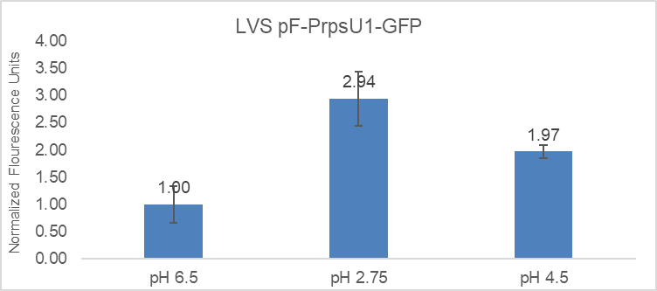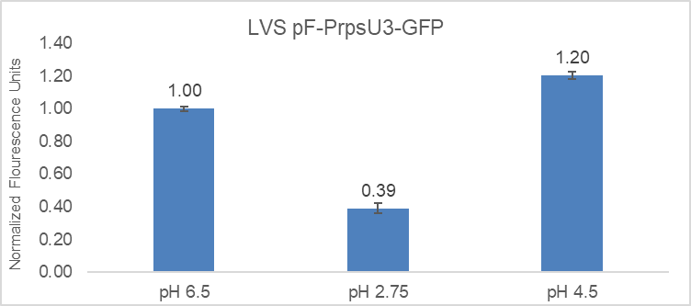
KRLVS192 still appears to be pretty variable in its level of fluorescent expression, however, there is still a fold increase at lower pH levels so I’m hoping that that is still promising.

Thursday, November 3, 2022
To Do:
- Prepare cultures for β-gal with Brenna
- Run β-gal assay with Brenna
Results and Data:

β-galactosaidase Assay of KRLVS28 Transposon Insertion Mutants
- Grow 6ml cultures until OD600 = 0.3
- Turn on 28°C water bath
- Determine amount of Z-buffer needed (0.8ml x 2 x # of cultures plus 1, the 2 is for running duplicates, the 1 is for a blank replicate). Add BME to Z-buffer (2.72 x Xml Z-buffer = _µl of BME).
- Set up reaction tubes with 800µl Z-buffer, put on lids
- Turn on spec and gather cuvettes
- Once cultures reach OD₆₀₀ = 0.3, place on ice 30 min and put ONPG in water bath
- After cells have incubated on ice, measure OD₆₀₀ of bacterial cultures
- Add 200µl culture to each reaction tube (add 200µl culture media to blank tube)
- Add 30µl 0.1% SDS to each reaction tube
- Add 60µl CHCl3 (chloroform) to each reaction tube
- Vortex reaction pairs on high for 6 secs (time precisely with timer)
- Put in water bath for 10 min
- Prepare repeater pipette with 1M Na₂CO₃ (stop)
- Add 200µl ONPG in 5 sec intervals (use timer with hours)
- Shake gently and watch for yellow (goal OD420 is 0.6-0.9)
- Stop with 500µl 1M Na₂CO₃, record time, vortex at 4 for 10 sec
- Give all reaction at least 2 hours
- Remove 1 mL from reaction (avoid chloroform at bottom), measure OD₄₂₀ and OD_{550,} using blank reaction as blank in spectrophotometer.

Obviously, neither mutant really resulted in the up-regulation of rpsU1.

Friday, November 4, 2022
To Do:
- gDNA prep
Results and Data:
I realized that I forgot to patch out KRLVS153 yesterday, so I scraped up my patches and pelleted them, and put them in my -80 to get gDNA from on Monday along with KRLVS153.

Monday, November 7, 2022
To Do:
- gDNA prep of triple deletion strains
- Make 2.5% iron pyrophosphate
Results and Data:

gDNA Prep of Potential Triple Mutants and KRLVS153
- Dilute 1uL of Proteinase K into 310uL of Tissue and Cell Lysis Solution for each sample.
- Scrape up patches and resuspend in MHB
- Pellet cells by centrifugation and discard the supernatant, leaving approximately 25 uL of liquid.
- Vortex for 10 seconds to resuspend the cell pellet.
- Add 300uL of Tissue and Cell Lysis Solution containing the Proteinase K and mix thoroughly.
- Incubate at 65°C for 15 minutes, vortex every 5 minutes.
- Cool the samples to 37°C and add 2ul of 20mg/mL RNase A to the sample, mix thoroughly.
- Incubate at 37°C for 30 minutes.
- Place the samples on ice for 3-5 minutes.
- Add 150uL of MPC Protein Precipitation Reagent to 200uL of lysed sample and vortex vigorously for 10 seconds.
- Pellet the debris by centrifugation at 4°C for 10 minutes at max speed. If the resultant pellet is clear, small, or loose, add an additional 25uL of MPC Protein Precipitation Reagent, mix, and pellet the debris again.
- Transfer the supernatant to a clean microcentrifuge tube and discard the pellet.
- Add 500uL of isopropanol to the recovered supernatant. Invert the tube 30-40 times.
- Pellet the DNA by centrifugation at 4°C for 10 minutes in a microcentrifuge.
- Carefully pour off the isopropanol without dislodging the DNA pellet.
- Rinse twice with 70% ethanol (~1mL) being careful to not dislodge the pellet. Centrifuge briefly if the pellet is dislodged. Remove all the residual ethanol with a pipet and let it air dry.
- Resuspend the DNA in 35uL of 0.1x EB.
I lost some of the sample from mutant 2 and 4, and maybe 5, after the 65°C incubation step. It seemed the lids lifted silently, so when I vortexed them I lost some of the sample. Maybe I should have calculated the concentration of reagents to add after that, but I did not bother. Additionally, after the protein precipitation, sample 8’s pellet was large and not all pelleted into the bottom. So after I took the supernatant out of the other samples, I added an additional volume of MPC and spun again, but I had the same issue, so I centrifuged on a shorter spin time a few times and tried to get as much supernatant as I could out without disturbing the pellet. I did get some of the debris in the tube, so I centrifuged again at 4°C and took off what I could into another new tube.

Reagents
2.5% Iron pyrophosphate
0.75g iron pyrophosphate (cabinet) in 30mL of ddiH2O (type 1), dissolved overnight, fresh solution every 2 weeks

Tuesday, November 8, 2022
To Do:
- Patch out KRLVS192, KRLVS193, and LVS-pF
- Supplement MHB
- Nanodrop gDNA
- Process primers
- Set up PCR to check for rpsU1 or rpsU2 in triple deletion mutants
Results and Data:
I diluted my gDNA samples 1:2 for a total of 3 uL, using 2 uL to nanodrop. Two of my samples, mutants 7 and 8 were still too high so I used the remaining 1 uL and diluted it again, so it was 1:4.
In order to run my PCR, I diluted my gDNA to 100 ng/uL via the following amounts in a total of 200 uL:

Receiving and Dissolving Primers
- Spin primers at maximum speed in tabletop centrifuge for 3 minutes so dessicated primers go to the bottom of the tube.
- Add 0.1x EB to a final concentration of 100 uM. Calculate this by multiplying the reported nm by 10 and adding that volume in ul (i.e. 12.7 nmoles = add 127 uL of 0.1xEB).
- Put on 42°C heat block for 5 minutes to help primers dissolve
- Vortex and brief spin.
- Label tubes with KROL numbers on the top and put in the appropriate 100 uM stock box in the -20°C freezer.
  - If a PCR primer, make a 10 uM stock by diluting 20 uL of the 100 uM stock into 180 uL of 0.1xEB. Label with purple sticker and put in appropriate freezer box.
- Put Certificate of Analysis sheet in “Oligos Spec Sheet” binder and shipping sheet in Invoices box.

PCR of Potential Triple Mutants to Check for rpsU1 or rpsU3
- Acquired and labelled PCR tubes: 1, 2, 3, 4, 5, 7, 8, LVS’, and negative controls.
Reaction# | Plasmid/Region | Source DNA | Primers | Length (bp)
1 | rpsU2 | Mutant 1 | KROL601, KROL602 | -
2 | rpsU2 | Mutant 2 | KROL601, KROL602 | -
3 | rpsU2 | Mutant 7 | KROL601, KROL602 | -
4 | rpsU2 | Mutant 8 | KROL601, KROL602 | -
5 | rpsU2 | LVS | KROL601, KROL602 | 193
6 | - control | - | KROL601, KROL602 | -
7 | rpsU1 | Mutant 3 | KROL599, KROL600 | -
8 | rpsU1 | Mutant 4 | KROL599, KROL600 | -
9 | rpsU1 | Mutant 5 | KROL599, KROL600 | -
10 | rpsU1 | LVS | KROL599, KROL600 | 178
11 | - control | - | KROL599, KROL600 | -
- Acquire the following components and put them on ice, labeling tubes if necessary:
  - mgH2O, Primestar buffer, dNTPs, KROL6, KROL257, (10uM), and candidate pKR122
- Vortex each component (aside from enzyme)
- Add appropriate volume (based on PCR worksheet) of each experiment specific primer (forward and reverse) and respective template to PCR tubes
- Add ddi H2O to negative control tube (template volume for 1 reaction)
- Prepare a master-containing:
  - mgH2O, dNTPs, Primestar buffer, respective primers, and Primestar enzyme
- Mix the master-mix solution by pipetting up and down
- Add 19.6 uL of master-mix to negative control PCR tube
- Add 19.6 uL of master mix to each PCR tube and pipet up and down to mix
- Place the PCR Tubes in the thermocycler on STN 1

Total reaction volume | 20
Total number of reactions | 6
 |  |  |  | Factor
Component | Stock concentration | Final concentration | 1 rxn volume | 7
ddiH2O |  |  | 12.4 | 86.8
PrimeSTAR GXL Buffer | 5x | 1x | 4.0 | 28
dNTPs | 2.5 mM | 0.2 mM | 1.6 | 11.2
oligo F | 10 uM | 0.3 uM | 0.6 | 4.2
oligo R | 10 uM | 0.3 uM | 0.6 | 4.2
template | 18.0 ng/ul | 2 ng/ul | 0.4
PrimeSTAR GXL DNA Polymerase | 1.25 U/ul | 0.025 U/ul | 0.4 | 2.8
 |  | Total volume | 20 | 137.2
Used these master mix volumes for both master mixes, with their respective primers.

Reagents
Mueller Hinton Broth (500 mL)
To supplement add:
5mL of 10% glucose
5mL of 2.5% iron pyrophosphate
isovitalex (combine 10mL from liquid vial with solids, add entire volume to broth)
Can keep this supplemented media for 2 weeks, storing at 4 ̊C

Wednesday, November 9, 2022
To Do:
- Run gel of potential triple mutant PCR samples
- Put away dishes
- Make 75% glycerol
- Make CDM components
- Make single use aliquots of KRLVS192 1 and 2, KRLVS193 1 and 2, and LVS_pF
Results and Data:

Gel of Potential Triple Mutants
- Melt agarose gel until completely dissolved, then place in 50°C water bath until cooled
- Set up large gel rig to cast gel, with ladder.
- Add 12uL of Sbyr Safe and pour ~120uL gel, use ladder to mix, then add ladder and allow to set.
- Turn gel, add used 1xTAE, remove ladder.
- Loaded 10 uL ladder, and 24 uL of each sample according to the loading order below.
- Ran for 45 minutes at 113V.

Loading Order of Diagnostic Digest of Candidate pKR122
1 | 2 | 3 | 4 | 5 | 6 | 7 | 8 | 9 | 10 | 11 | 12 | 13 | 14 | 15 | 16 | 17
 | LD |  | 1 |  | 2 | 7 | 8 | LVS |  | - |  | 3 | 4 | 5 | LVS | -

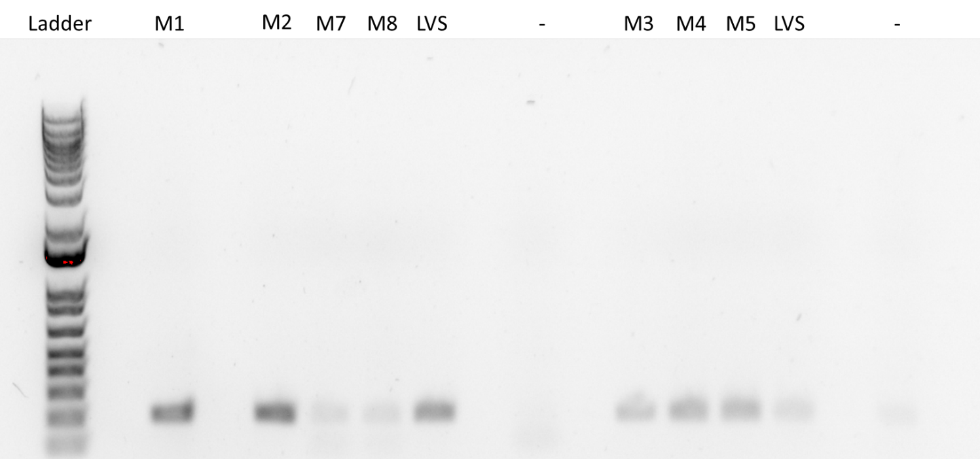

Making Single Use Aliquots of KRLVS192 1+2, KRLVS193 1+2, and LVS-pF
- Prepare 800uL of MHB in a 1.5mL tube
- Take at least half of a thickly spread plate and add cells to the MHB tube
- Resuspend until there are no clumps in the MHB
- Add 200ul of 75% glycerol to the 800uL mix by pipetting
- Aliquot 50ul of solution to tubes, freeze at -80

Reagents
75% Glycerol
To 250 mL bottle add:
75 mL 100% glycerol
25 mL water
Pipet up and down until mixed
Autoclave Liquid 30’
400 mg/mL Glucose
To 50 mL beaker add:
18 g glucose
~20 mL of water
Stir on heat until complete dissolved
Add solution to graduated cylinder and add water to final volume of 45 mL
Filter sterilize

0.5 mg/mL FeSO₄•7H₂O
To 50 mL beaker add:
22.5 mg FeSO₄•7H₂O
45 mL water
Stir until complete dissolved

33.75 mg/mL MgSO₄•7H₂O
To 50 mL beaker add:
1.52 g MgSO₄•7H₂O
~40 mL water
Stir until complete dissolved
Add solution to graduated cylinder and add water to final volume of 45 mL

Thursday, November 10, 2022
To Do:
- qRT PCR of lacZ region of rpsU2 5’UTR samples -1
- Ask Camberg lab for -ura media
- Make SC -ura media
- Make yeast overnights
Results and Data:

qRT-PCR of KRLVS148, KRLVS149, KRLVS150, KRLVS151 (8/5/22) cDNA with LacZ
- Each experiment will need at least one test primer and one control primer for each sample
  - KROL399/400 as test primers to amplify LacZ. KROL63/64 the control, amplifying tul4.
- Each cDNA sample will be used in a reaction with each primer set meaning #Samples*#Primer Sets (12*2=24 reactions)
- Set up a master mixes, labelling the tubes as A, B, C, etc.:
Component | Volume per Reaction | Master Mix (#Samplesx3.5+3.5)
PowerUp SYBR Green MM | 10 uL | 455.0 uL
5uM primer set | 1 uL | 45.5 uL
1.5 ng/uL Stock cDNA | 1 uL
ddiH₂O | 8 uL | 364.0 uL
Total: | 20 uL | 864.5 uL
- Obtain a strip of strip tubes per each primer set with the appropriate number of tubes in the strip, according to the number of cDNA samples. Label strip tubes with letter of primer master mix, and the sample number.
- Add 3.5µL of cDNA into appropriately labelled tubes.
- As these will be in technical triplicate, each tube will be an individual master mix, totaling 70 uL. Thusly, add corresponding primer master mix to tubes containing DNA at a volume of 66.5 uL.
- Pipette 20 µL of each primer set strip tubes, in triplicate, using multichannel pipet.
- Spin plate down and run in LightCycler using the ‘KRamsey_Lab_old_stepone’ program according to ‘qRT-PCR_LightCycler_Machine.docx’
Labelling was as follows:
Master Mix Label | Primer Set
A | KROL399/400 LacZ
B | KROL63/64 tul4

1 | 2 | 3 | 4 | 5 | 6 | 7 | 8 | 9 | 10 | 11 | 12
148-1 | 148-2 | 148-3 | 149-1 | 149-2 | 149-3 | 150-1 | 150-2 | 150-3 | 151-1 | 151-2 | 151-3
Loaded 96-well plate according to the following table:
 | 1 | 2 | 3 | 4 | 5 | 6 | 7 | 8 | 9 | 10 | 11 |  | 12
A | A1 | A2 | A3 | A4 | A5 | A6 | A7 | A8 | A9 | A10 |  | A11 | A12
B
C
D | B1 | B2 | B3 | B4 | B5 | B6 | B7 | B8 | B9 | B10 |  | B11 | B12
E
F

Reagents
SC-ura Media (100 mL)
To 250 mL bottle add:
0.19 g of SC-ura media
100 mL of water
Mix and autoclave Liquid 15’

Friday, November 11, 2022
To Do:
- Miniprep yeast plasmid
- PCR of potential triple mutants again
- Gel of PCR of potential triple mutants
Results and Data:
My yeast overnights didn’t grow even a little bit.

PCR of Potential Triple Mutants to Check for rpsU1 or rpsU3
- Acquired and labelled PCR tubes: 1, 2, 3, 4, 5, 7, 8, LVS’, and negative controls.
Reaction# | Plasmid/Region | Source DNA | Primers | Length (bp)
1 | rpsU2 | Mutant 1 | KROL601, KROL602 | -
2 | rpsU2 | Mutant 2 | KROL601, KROL602 | -
3 | rpsU2 | Mutant 7 | KROL601, KROL602 | -
4 | rpsU2 | Mutant 8 | KROL601, KROL602 | -
5 | rpsU2 | LVS | KROL601, KROL602 | 193
6 | rpsU2 | KRLVS47 | KROL601, KROL602 | -
7 | - control | - | KROL601, KROL602 | -
8 | rpsU1 | Mutant 3 | KROL599, KROL600 | -
9 | rpsU1 | Mutant 4 | KROL599, KROL600 | -
10 | rpsU1 | Mutant 5 | KROL599, KROL600 | -
11 | rpsU1 | LVS | KROL599, KROL600 | 178
12 | rpsU1 | KRLVS47 | KROL599, KROL600 | -
13 | - control | - | KROL599, KROL600 | -
- Acquire the following components and put them on ice, labeling tubes if necessary:
  - mgH2O, Primestar buffer, dNTPs, KROL599, KROL600, KROL601, KROL602, (10uM), and candidate triple mutants
- Vortex each component (aside from enzyme)
- Add appropriate volume (based on PCR worksheet) of each experiment specific primer (forward and reverse) and respective template to PCR tubes
- Add ddi H2O to negative control tube (template volume for 1 reaction)
- Prepare a master-containing:
  - mgH2O, dNTPs, Primestar buffer, respective primers, and Primestar enzyme
- Mix the master-mix solution by pipetting up and down
- Add 19.6 uL of master-mix to negative control PCR tube
- Add 19.6 uL of master mix to each PCR tube and pipet up and down to mix
- Place the PCR Tubes in the thermocycler on STN 1

Total reaction volume | 20
Total number of reactions | 7
 |  |  |  | Factor
Component | Stock concentration | Final concentration | 1 rxn volume | 8
ddiH2O |  |  | 12.4 | 99.2
PrimeSTAR GXL Buffer | 5x | 1x | 4.0 | 32
dNTPs | 2.5 mM | 0.2 mM | 1.6 | 12.8
oligo F | 10 uM | 0.3 uM | 0.6 | 4.8
oligo R | 10 uM | 0.3 uM | 0.6 | 4.8
template | 18.0 ng/ul | 2 ng/ul | 0.4
PrimeSTAR GXL DNA Polymerase | 1.25 U/ul | 0.025 U/ul | 0.4 | 3.2
 |  | Total volume | 20 | 156.8

Gel of Potential Triple Mutants
- Melt agarose gel until completely dissolved, then place in 50°C water bath until cooled
- Set up large gel rig to cast gel, with ladder.
- Add 12uL of Sbyr Safe and pour ~120uL gel, use ladder to mix, then add ladder and allow to set.
- Turn gel, add used 1xTAE, remove ladder.
- Loaded 10 uL ladder, and 15 uL of each sample according to the loading order below.
- Ran for 45 minutes at 113V.

Loading Order of Diagnostic Digest of Candidate pKR122
1 | 2 | 3 | 4 | 5 | 6 | 7 | 8 | 9 | 10 | 11 | 12 | 13 | 14 | 15 | 16 | 17
LD |  | 1 | 2 | 7 | 8 | 47 | LVS |  | 3 | 4 | 5 | 47 | LVS |  | - | -

Given my issues with my last gel, I made sure to pour this one much thicker. Additionally, I added less of each PCR reaction to each individual well.
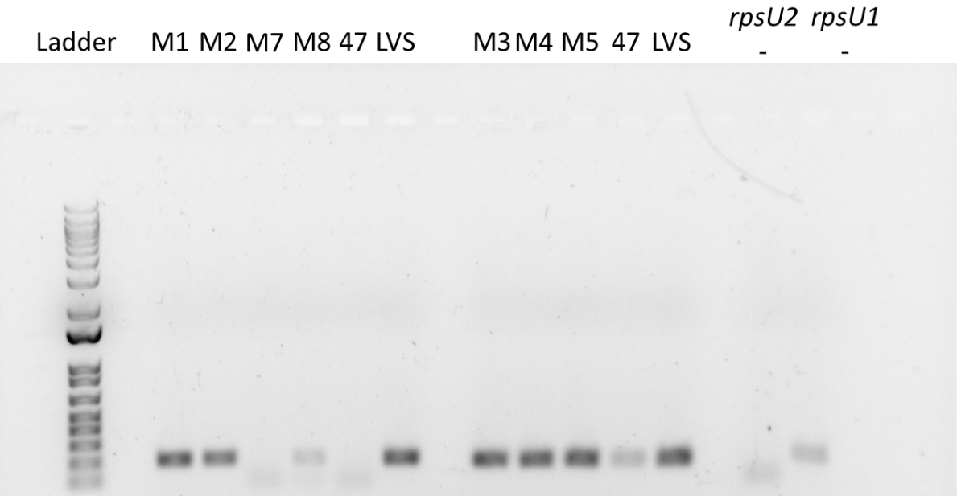

It does look like my rpsU2 primers are forming primer dimers, given the lower band in the negative, also seen in the (positive) negative control, and mutant 8. It looks like I still have LVS contamination in the rpsU1primer set mix, though I am unsure of how it got there given that I got new aliquots of each component, apart from the enzyme. Additionally, I added each component to both master mixes at the same time (ie. water into both, followed by buffer into both, etc.) It’s not just spillover either, given that the negative was so separate. My best guess is it might be the diluted primers, so I might re-dilute and run the PCR on the rpsU1 set again.

Monday, November 14, 2022
To Do:
- Patch out KRLVS192, KRLVS193, LVS-pF
- Make KH2PO4
- Make CDM
Results and Data:

Reagents
KH₂PO₄ (45 mL)
To 100 mL beaker add:
4.5 g KH₂PO₄
~35 mL water
Stir until mixed
Add water to a total volume of 45 mL

CDM (150mL)
To 250 mL beaker add:
12 mL Combined Amino Acid Stock
Then add:
600 uL Thiamine HCl
600 uL Spermine tetrahydrochloride
600 uL DL-Calcium pantothenate
Then add:
5.13 mL 5N NaCl
1.5 mL KH2PO4
600 uL K2HPO4
Then:
1.5 mL 400 mg/mL Glucose
Then:
115 mL Water
Then:
600 uL FeSO4•7H2O
600 uL MgSO4•7H2O
pH media to a pH between 6.3 and 6.5
Add water to 150 mL total
Filter sterilize

Tuesday, November 15, 2022
To Do:
- Patch out KRLVS192, KRLVS193, and LVS-pF
- Set-up cultures for MHB v. CDM, CHAH, and overgrowth experiment
- GFP assay of MHB v. CDM and CHAH
- Make differing iron CDM solutions
Results and Data:

MHB v. CDM and CHAH on rpsU1 and rpsU3 Production in KRLVS192 and KRLVS193
Condition Number | 0 | 0 | 1 | 2
Experiment Component | Background | Background | Test 1 | Test 2
Condition | CDM | MHB | CDM | MHB

- Resuspend patches of cells in 400uL of MHB or CDM, checking OD in a 1:20 dilution
- Normalize samples to an OD of 0.08-0.10 in 7 mL of MHB or CDM in culture tubes.
- Shake cells at 37°C to an OD of 0.3-0.4 typically 4 and a half hours.
- Then follow the GFP reporter assay protocol, starting at Step 4, subtracting LVS in PBS, and normalizing to the fluorescence of each strain to standard condition, non-buffered MHB

OD Readings
Sample | 0 hours | 2 hours | 4 hours
KRLVS192 1 C | 0.094 | 0.193 | 0.345
KRLVS192 2 C | 0.083 | 0.192 | 0.345
KRLVS193 1 C | 0.084 | 0.186 | 0.330
KRLVS193 2 C | 0.099 | 0.201 | 0.333
LVS-pF C | 0.104 | 0.235 | 0.427
KRLVS192 1 M | 0.086 | 0.162 | 0.278
KRLVS192 2 M | 0.089 | 0.150 | 0.242
KRLVS193 1 M | 0.089 | 0.164 | 0.294
KRLVS193 2 M | 0.077 | 0.151 | 0.278
LVS-pF M | 0.084 | 0.150 | 0.264
I additionally started cultures of KRLVS192 1 and 2, and KRLVS193 1 and 2 in 5mL MHB OD600=0.05 at 3:30 pm in order to test stationary phase with the assay the next day.

GFP Assay on CDM Conditions in KRLVS192 and KRLVS193
- Pellet 2 mLs of culture (MHB and CDM, obviously not CHAH) and spin at max speed for 3 minutes
  - Scrape up patches of CHAH and resuspend in PBS
- Remove all MHB, using 20 ul pipette to remove small amount at bottom of tube.
- Add 1 mL of 1XPBS and resuspend the cells.
- Aliquot 250 ul from each tube in triplicate to clear 96-well plate. Add PBS in triplicate as control.
- Go to INBRE lab with multichannel pipette, Rainin tips, black 96-well plate, and flash drive.
- Read OD600 from clear plate on ID3 plate reader:
  - Select Absorbance, wavelength=600
  - Plate type: 96-well standard clearbtm (first option)
- Transfer 200 ul of each well from clear plate to black plate using the multichannel
- Read fluorescence from black plate on ID3 plate reader:
  - Select fluorescence
  - Wavelength: 495 to 535
  - Plate type: CoStar 3789
  - Gain: Automatic
  - Integration: 380 ms
Label | Condition |  | Label | Strain and BR
A | MHB |  | 1 | KRLVS192 1
B | CDM |  | 2 | KRLVS192 2
C | CHAH |  | 3 | KRLVS193 1
 |  |  | 4 | KRLVS193 2

 | 1 | 2 | 3 | 4 | 5 | 6 | 7 | 8 | 9 | 10 | 11 | 12
A | A1 | A1 | A1 |  | B3 | B3 | B3 |  | C1 | C1 | C1
B | A2 | A2 | A2 |  | B4 | B4 | B4 |  | C2 | C2 | C2
C | A3 | A3 | A3 |  | B1 | B1 | B1 |  | C3 | C3 | C3
D | A4 | A4 | A4 |  | B2 | B2 | B2 |  | C4 | C4 | C4
E | A.LVS | A.LVS | A.LVS |  | B.LVS | B.LVS | B.LVS |  | C.LVS | C.LVS | C.LVS
F
G
H
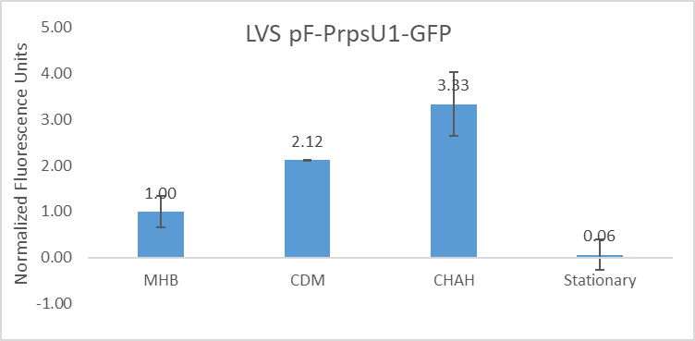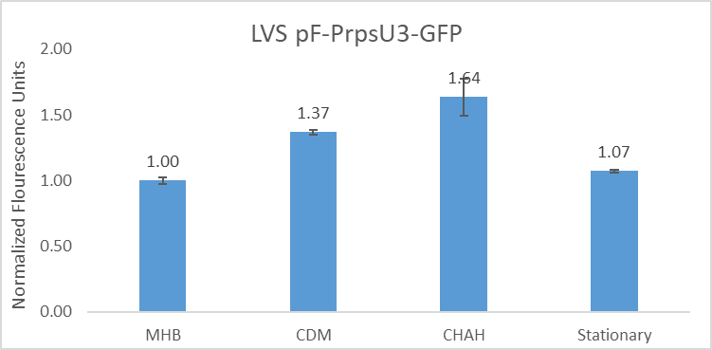

Reagents

Wednesday, November 16, 2022
To Do:
- Prepare cultures for iron concentration
- Patch out KRLVS192, KRLVS193, and LVS_pF
- Ship triple mutant 7 for whole genome sequencing
- Put away dishes
- Make CDM with varying Magnesium concnetrations
- Make 200 mL MHB
- Run GFP assay on iron and stationary phase
Results and Data:

CDM Iron Conditions on rpsU1 and rpsU3 Production in KRLVS192 and KRLVS193
Condition Number | 0 | 1 | 2 | 3 | 4
Experiment Component | Background | Control | Test 1 | Test 2 | Test 3
Condition | CDM | CDM | 0 mg/mL Fe | 0.0005 mg/mL Fe | 0.004 mg/mL Fe

- Resuspend patches of cells in 400uL of CDM, with 0 mg/mL Fe, checking OD in a 1:20 dilution
- Normalize samples to an OD of 0.08-0.10 in 7 mL of respective CDM, either regular or varying concentrations of iron
- Shake cells at 37°C to an OD of 0.3-0.4 typically 4 and a half hours.
- Then follow the GFP reporter assay protocol, starting at Step 4, subtracting LVS in PBS, and normalizing to the fluorescence of each strain to standard condition, CDM

OD Readings
Sample | 0 hours | 2 hours | 4 hours
KRLVS192 1 C | 0.103 | 0.233 | 0.444
KRLVS192 2 C | 0.087 | 0.213 | 0.383
KRLVS193 1 C | 0.083 | 0.207 | 0.403
KRLVS193 2 C | 0.026 | 0.067 | 0.131
KRLVS192 1 0 | 0.095 | 0.223 | 0.424
KRLVS192 2 0 | 0.084 | 0.217 | 0.435
KRLVS193 1 0 | 0.083 | 0.211 | 0.418
KRLVS193 2 0 | 0.085 | 0.207 | 0.398
KRLVS192 1 ¼ | 0.092 | 0.228 | 0.441
KRLVS192 2 ¼ | 0.089 | 0.224 | 0.427
KRLVS193 1 ¼ | 0.083 | 0.223 | 0.419
KRLVS192 2 ¼ | 0.093 | 0.227 | 0.432
KRLVS192 1 2x | 0.095 | 0.241 | 0.458
KRLVS192 2 2x | 0.086 | 0.210 | 0.383
KRLVS193 1 2x | 0.083 | 0.223 | 0.434
KRLVS193 2 2x | 0.078 | 0.210 | 0.363
LVS-pF CDM | 0.080 | 0.203 | 0.376
These cultures obviously grew up very fast for LVS which makes me kind of nervous. I had been a little worried about my plates since there’s still an unknown source of contamination from when Brenna was in lab, so I had theorized maybe it was the glycerol (after already making new single use aliquots). However, Morgan checked the glycerol on a plate (plated 50uL) and didn’t see growth so it’s definitely fine, probably. Regardless, because I was nervous I had Hannah check out the plates when she came in and she said that she didn’t see any contamination, and all of the cultures grew quickly so if it was a different contaminant then it would have had to enter all the cultures. The doubling time was about ~2 hours here, with like no lag time. I did change up my plating and scraping protocol to try to have more active cells, but I don’t think they changed it that much. (Also though... I used the same single use aliquots for the experiment on Wednesday and they grew as expected in MHB, so it’s probably not the single use aliquots). It’s maybe fine, I looked for a previous growth experiment in CDM and couldn’t find any, so I’ll ask Kathryn if she wants one.

GFP Assay on CDM Iron Conditions in KRLVS192 and KRLVS193
- Pellet 2 mLs of culture and spin at max speed for 3 minutes
- Remove all CDM, using 20 ul pipette to remove small amount at bottom of tube.
- Add 1 mL of 1XPBS and resuspend the cells.
- Aliquot 250 ul from each tube in triplicate to clear 96-well plate. Add PBS in triplicate as control.
- Go to INBRE lab with multichannel pipette, Rainin tips, black 96-well plate, and flash drive.
- Read OD600 from clear plate on ID3 plate reader:
  - Select Absorbance, wavelength=600
  - Plate type: 96-well standard clearbtm (first option)
- Transfer 200 ul of each well from clear plate to black plate using the multichannel
- Read fluorescence from black plate on ID3 plate reader:
  - Select fluorescence
  - Wavelength: 495 to 535
  - Plate type: CoStar 3789
  - Gain: Automatic
  - Integration: 380 ms
Label | Condition |  | Label | Strain and BR
A | CDM |  | 1 | KRLVS192 1
B | 0 mg/mL Fe |  | 2 | KRLVS192 2
C | 0.0005 mg/mL Fe |  | 3 | KRLVS193 1
D | 0.004 mg/mL Fe |  | 4 | KRLVS193 2
E | Stationary Phase

 | 1 | 2 | 3 | 4 | 5 | 6 | 7 | 8 | 9 | 10 | 11 | 12
A | A1 | A1 | A1 |  | A3 | A3 | A3 |  | LVS | LVS | LVS
B | A2 | A2 | A2 |  | A4 | A4 | A4 |  | PBS | PBS | PBS
C | B1 | B1 | B1 |  | B3 | B3 | B3 |  | E1 | E1 | E1
D | B2 | B2 | B2 |  | B4 | B4 | B4 |  | E2 | E2 | E2
E | C1 | C1 | C1 |  | C3 | C3 | C3 |  | E3 | E3 | E3
F | C2 | C2 | C2 |  | C4 | C4 | C4 |  | E4 | E4 | E4
G | D1 | D1 | D1 |  | D3 | D3 | D3
H | D2 | D2 | D2 |  | D4 | D4 | D4
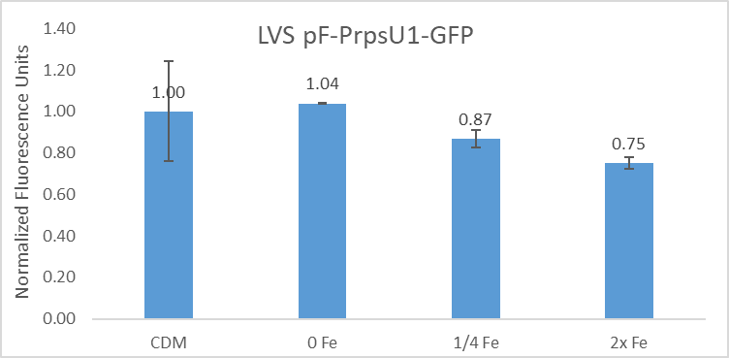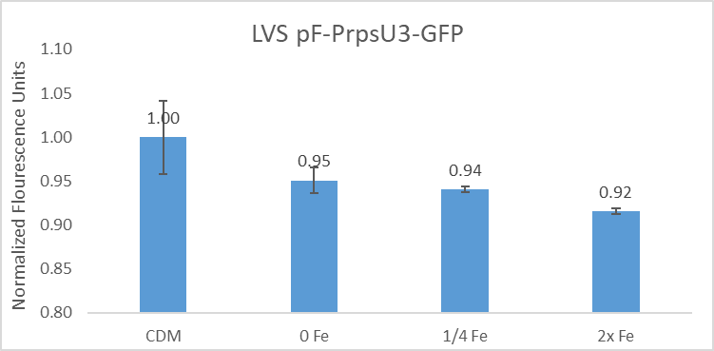

Reagents
Mueller Hinton Broth (200 mL)
To make, add to a 500 mL bottle:
4.2g of Mueller Hinton Broth mix
200 mL of diH₂O
Autoclave on Liquid 30’
Can keep un-supplemented media at room temperature indefinitely

Thursday, November 17, 2022
To Do:
- Supplement MHB
- Set up cultures for magnesium environmental condition test
- Autoclave plates and take out glass
- Run GFP assay on magnesium
Results and Data:

CDM Mg Conditions on rpsU1 and rpsU3 Production in KRLVS192 and KRLVS193
Condition Number | 0 | 1 | 2 | 3 | 4
Experiment Component | Background | Control | Test 1 | Test 2 | Test 3
Condition | CDM | CDM | 0 mg/mL Mg | 0.025 mg/mL Fe | 0.2 mg/mL Fe

- Resuspend patches of cells in 400uL of CDM, with 0 mg/mL Mg, checking OD in a 1:20 dilution
- Normalize samples to an OD of 0.08-0.10 in 7 mL of respective CDM, either regular or varying concentrations of iron
- Shake cells at 37°C to an OD of 0.3-0.4 typically 4 and a half hours.
- Then follow the GFP reporter assay protocol, starting at Step 4, subtracting LVS in PBS, and normalizing to the fluorescence of each strain to standard condition, CDM

OD Readings
Sample | 0 hours | 4 hours
KRLVS192 1 C | 0.087 | 0.356
KRLVS192 2 C | 0.080
KRLVS193 1 C | 0.076
KRLVS193 2 C | 0093
KRLVS192 1 0 | 0.090 | 0.244
KRLVS192 2 0 | 0.081
KRLVS193 1 0 | 0.072
KRLVS193 2 0 | 0.086
KRLVS192 1 ¼ | 0.095 | 0.380
KRLVS192 2 ¼ | 0.090
KRLVS193 1 ¼ | 0.076
KRLVS192 2 ¼ | 0.104
KRLVS192 1 2x | 0.084 | 0.318
KRLVS192 2 2x | 0.073
KRLVS193 1 2x | 0.082
KRLVS193 2 2x | 0.098
LVS-pF CDM | 0.081 | 0.0349

GFP Assay on CDM Mg Conditions in KRLVS192 and KRLVS193
- Pellet 2 mLs of culture and spin at max speed for 3 minutes
- Remove all CDM, using 20 ul pipette to remove small amount at bottom of tube.
- Add 1 mL of 1XPBS and resuspend the cells.
- Aliquot 250 ul from each tube in triplicate to clear 96-well plate. Add PBS in triplicate as control.
- Go to INBRE lab with multichannel pipette, Rainin tips, black 96-well plate, and flash drive.
- Read OD600 from clear plate on ID3 plate reader:
  - Select Absorbance, wavelength=600
  - Plate type: 96-well standard clearbtm (first option)
- Transfer 200 ul of each well from clear plate to black plate using the multichannel
- Read fluorescence from black plate on ID3 plate reader:
  - Select fluorescence
  - Wavelength: 495 to 535
  - Plate type: CoStar 3789
  - Gain: Automatic
  - Integration: 380 ms
Label | Condition |  | Label | Strain and BR
A | CDM |  | 1 | KRLVS192 1
B | 0 mg/mL Mg |  | 2 | KRLVS192 2
C | 0.025 mg/mL Mg |  | 3 | KRLVS193 1
D | 0.2 mg/mL Mg |  | 4 | KRLVS193 2

 | 1 | 2 | 3 | 4 | 5 | 6 | 7 | 8 | 9 | 10 | 11 | 12
A | A1 | A1 | A1 |  | A3 | A3 | A3 |  | LVS | LVS | LVS
B | A2 | A2 | A2 |  | A4 | A4 | A4 |  | PBS | PBS | PBS
C | B1 | B1 | B1 |  | B3 | B3 | B3
D | B2 | B2 | B2 |  | B4 | B4 | B4
E | C1 | C1 | C1 |  | C3 | C3 | C3
F | C2 | C2 | C2 |  | C4 | C4 | C4
G | D1 | D1 | D1 |  | D3 | D3 | D3
H | D2 | D2 | D2 |  | D4 | D4 | D4

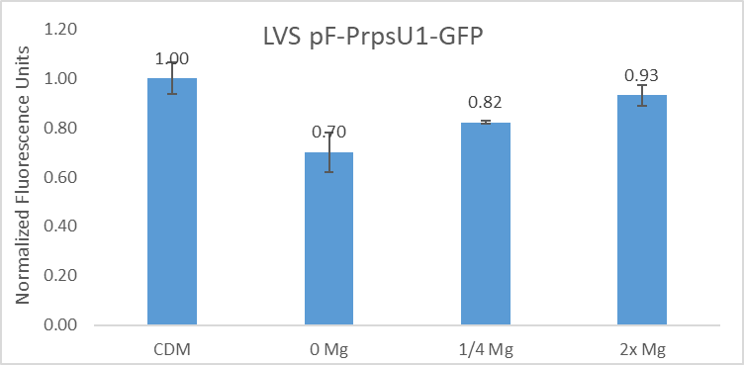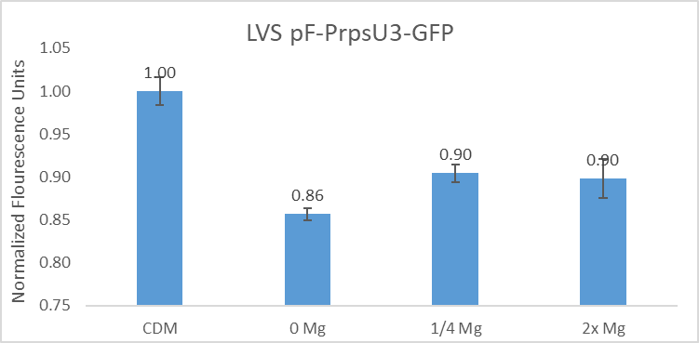

Reagents
Mueller Hinton Broth (200 mL)
To supplement add:
1 mL of 10% glucose
1 mL of 2.5% iron pyrophosphate
2x isovitalex (combine 2mL from liquid vial with solids, add entire volume to broth)
Can keep this supplemented media for 2 weeks, storing at 4 ̊C

Friday, November 18, 2022
To Do:
- Streak out KRLVS9 (drpsU2) and LVS
Results and Data:

Monday, November 21, 2022
To Do:
- Patch out drpsU2 and LVS from single colony streak
Results and Data:

Tuesday, November 22, 2022
To Do:
- Streak out drpsU2 and LVS to single colony and leave out on bench over holiday
Results and Data:

Monday, November 28, 2022
To Do:
- Patch out drpsU2 from single colony streak
- Make 2.5% iron pyrophosphate
- Supplement MHB
- Run dishwasher
- Run PCR of rpsU1 mutants
Results and Data:

PCR of Potential Triple Mutants to Check for rpsU1 or rpsU3
- Acquired and labelled PCR tubes: 1, 2, 3, 4, 5, 7, 8, LVS’, and negative controls.
Reaction# | Plasmid/Region | Source DNA | Primers | Length (bp)
1 | rpsU1 | Mutant 3 | KROL599, KROL600 | -
2 | rpsU1 | Mutant 4 | KROL599, KROL600 | -
3 | rpsU1 | Mutant 5 | KROL599, KROL600 | -
4 | rpsU1 | LVS | KROL599, KROL600 | 178
5 | rpsU1 | KRLVS47 | KROL599, KROL600 | -
6 | - control | - | KROL599, KROL600 | -
- Acquire the following components and put them on ice, labeling tubes if necessary:
  - mgH2O, Primestar buffer, dNTPs, KROL599, KROL600, KROL601, KROL602, (10uM), and candidate triple mutants
- Vortex each component (aside from enzyme)
- Add appropriate volume (based on PCR worksheet) of each experiment specific primer (forward and reverse) and respective template to PCR tubes
- Add ddi H2O to negative control tube (template volume for 1 reaction)
- Prepare a master-containing:
  - mgH2O, dNTPs, Primestar buffer, respective primers, and Primestar enzyme
- Mix the master-mix solution by pipetting up and down
- Add 19.6 uL of master-mix to negative control PCR tube
- Add 19.6 uL of master mix to each PCR tube and pipet up and down to mix
- Place the PCR Tubes in the thermocycler on STN 1

Total reaction volume | 20
Total number of reactions | 6
 |  |  |  | Factor
Component | Stock concentration | Final concentration | 1 rxn volume | 7
ddiH2O |  |  | 12.4 | 86.8
PrimeSTAR GXL Buffer | 5x | 1x | 4.0 | 28.0
dNTPs | 2.5 mM | 0.2 mM | 1.6 | 11.2
oligo F | 10 uM | 0.3 uM | 0.6 | 4.2
oligo R | 10 uM | 0.3 uM | 0.6 | 4.2
template | 18.0 ng/ul | 2 ng/ul | 0.4
PrimeSTAR GXL DNA Polymerase | 1.25 U/ul | 0.025 U/ul | 0.4 | 2.8
 |  | Total volume | 20 | 137.2

Reagents
2.5% Iron pyrophosphate
0.75g iron pyrophosphate (cabinet) in 30mL of ddiH2O (type 1), dissolved overnight, fresh solution every 2 weeks

Mueller Hinton Broth (500 mL)
To supplement add:
5mL of 10% glucose
5mL of 2.5% iron pyrophosphate
isovitalex (combine 10mL from liquid vial with solids, add entire volume to broth)
Can keep this supplemented media for 2 weeks, storing at 4 ̊C

Tuesday, November 29, 2022
To Do:
- Run gel on triple mutant PCR
- Make CDM
- Put away dishes
Results and Data:
My cultures of yeast from my electroporation of pKR168 were once again not grown when I got in. I let them grow for an additional 7 hours but did not see any change in turbidity. Hannah suggested I try making one 5 mL overnight culture and then add to a 20 mL culture in the morning, so I will try that and also prepare to do a new yeast electroporation.

Gel of Potential Triple Mutants
- Melt agarose gel until completely dissolved, then place in 50°C water bath until cooled
- Set up small gel rig to cast gel, with ladder.
- Add 6uL of Sbyr Safe and pour ~60mL gel, use ladder to mix, then add ladder and allow to set.
- Turn gel, add used 1xTAE, remove ladder.
- Loaded 10 uL ladder, and 15 uL of each sample according to the loading order below.
- Ran for 45 minutes at 113V.

Loading Order of Triple Deletion Mutant PCR
1 | 2 | 3 | 4 | 5 | 6 | 7 | 8 | 9 | 10
Ladder |  | Mut. 3 | Mut. 4 | Mut. 5 |  | KRLVS47 | LVS |  | (-)
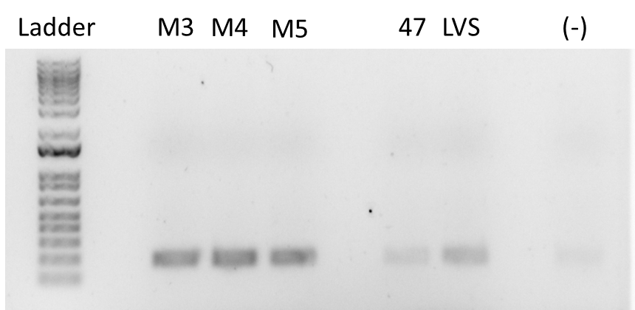
Obviously, there is still contamination in the negative of LVS gDNA. I hadn’t changed my water since in my last gel the drpsU2 were fine, however Hannah pointed out it could have gotten contaminated between making the master mixes (though I technically added the water to both at the same time). I also didn’t change out my enzyme last time, so I’ll use fresh water and a fresh enzyme when I do it again.

Reagents
CDM (150mL)
To 250 mL beaker add:
12 mL Combined Amino Acid Stock
Then add:
600 uL Thiamine HCl
600 uL Spermine tetrahydrochloride
600 uL DL-Calcium pantothenate
Then add:
5.13 mL 5N NaCl
1.5 mL KH2PO4
600 uL K2HPO4
Then:
1.5 mL 400 mg/mL Glucose
Then:
115 mL Water
Then:
600 uL FeSO4•7H2O
600 uL MgSO4•7H2O
pH media to a pH between 6.3 and 6.5
Add water to 150 mL total
Filter sterilize

Wednesday, November 30, 2022
To Do:
- Patch out KRLVS28 and KRLVS75 for Morgan
- Patch out yeast
- Start 5 mL overnight culture of yeast with pKR168 hopefully
Results and Data:
I was going to set up my cultures for the growth curve today, however I realized that my drpsU2 plate was contaminated and when I looked back at the single colony streak I realized that the colonies were not in fact LVS. It appears to be the same contaminant that Brenna had issues with, and Morgan had an issue with so I’m really nervous about it.
I started a 5 mL culture of pKR168 in the new SD -ura, allowing the media to warm to 30°C. I will add it to a 20 mL culture in the morning.

December 2022

Thursday, December 1, 2022
To Do:
- Help Morgan start cultures for B-gal
- Miniprep pKR168 - ☹ nvm
- Help Morgan take OD600 for her cultures
- Help Morgan set up for B-gal - ☹ nvm mostly
- Help Morgan with B-gal - ☹ nvm
Results and Data:
In the morning I help Morgan set up her cultures for the B-gal. She had done most of the techniques that go into it, so I mostly helped with questions/math/etc.
Alternatively, my yeast cells did not grow up enough to do a miniprep, ie they did no grow at all. I gave them a few extra hours in the incubator prior to tossing them.
I started helping Morgan with setting up for the B-gal, however I got ill and Hannah took over for me.

Friday, December 2, 2022
To Do:
- Help Morgan with transformation efficiency math
- Help Morgan with transformation
- Help Morgan with gel
- Image gel for Morgan
Results and Data:

Monday, December 5, 2022
To Do:
- Clean hemoglobin flasks
Results and Data:

Tuesday, December 6, 2022
To Do:
- Make 35 mL of 10x Iron CDM
- Make 250 mL of YPD
- Autoclave x@ 200 mL of water
- Start overnight culture of yeast
- Put away dishes
Results and Data:
Started my yeast overnight at an OD of 0.013. Obviously, I could not check that this was accurate. However, I think that it will grow slower due to the fact that the plate is old. However, I have pretty much all day tomorrow so it can grow for longer if need be.

Reagents
YPD (250 mL)
To 500 mL baffled flask add:
2.5 g Yeast extract
5.0 g Protease-Peptone
5.0 g Glucose
Mix thoroughly and autoclave Liquid 15’
Store at room temperature

pH’d to 6.5

Wednesday, December 7, 2022
To Do:
- Patch out drpsU2
- Streak KRLVS149 to single colony
- Streak out LVS to single colony @room temperature
- Make electrocompetent yeast
- Electroporate yeast with pKR168
- Make 20x Iron
- PCR of triple deletion strains
Results and Data:
I checked my cells at 9:50 am, which means they were in the incubator for ~17.5 hours and it was at an OD of 0.89, so clearly a week old plate does grow slower, so I probably could have started it at a higher OD600.

Making Electrocompetent Yeast Cells
- Take OD600 (dilute 1:10) until it reaches about 1.3-1.5 OD
- Place entire volume of culture in sterile 250 mL centrifuge bottle
- Centrifuge at 3000 xg for 5 min at 4C. Discard supernatant.
- Wash with ~200 mL of ice-cold water twice with identical centrifugation.
- Wash in 20 ml of ice cold 1M sorbitol and centrifuge again, as above.
- Resuspend in smallest volume of ice cold 1M sorbitol, starting with 200 ul and up to 500 ul

Electroporation of Yeast with pKR168
- Add 3 ul of plasmid to 100 ul of electrocompetent cells. Mix via pipette. Incubate on ice for 5 min.
- Transfer to prechilled 0.2 cm cuvette
- Electroporate on presetting SC2 (1500 V, 5 msec)
- Immediately add the cells to 1 mL of cold 1M sorbitol
- Plate onto -ura selective plates. For plasmid transformation, plate 10 ul and 100 ul. Put in incubator set to 30C. Colonies will be visible within 2-3 days for successful transformations.
Tube # | Purpose | DNA | Vol. of DNA | Vol. Plated | Number of Plates
1 | pKR168 | pKR168 | 3 uL | 100, 200 uL, Rem. | 3
2 | (+) control | pKR128 | 3 uL | 200 uL | 1
3 | (-) control | - |  | 200 uL | 1
 |  |  |  | Total: | 5

PCR of Potential Triple Mutants to Check for rpsU1 or rpsU3
- Acquired and labelled PCR tubes: 1, 2, 3, 4, 5, 7, 8, LVS’, and negative controls.
Reaction# | Plasmid/Region | Source DNA | Primers | Length (bp)
1 | rpsU1 | Mutant 3 | KROL599, KROL600 | -
2 | rpsU1 | Mutant 4 | KROL599, KROL600 | -
3 | rpsU1 | Mutant 5 | KROL599, KROL600 | -
4 | rpsU1 | LVS | KROL599, KROL600 | 178
5 | rpsU1 | KRLVS47 | KROL599, KROL600 | -
6 | - control | - | KROL599, KROL600 | -
- Acquire the following components and put them on ice, labeling tubes if necessary:
  - mgH2O, Primestar buffer, dNTPs, KROL599, KROL600, KROL601, KROL602, (10uM), and candidate triple mutants
- Vortex each component (aside from enzyme)
- Add appropriate volume (based on PCR worksheet) of each experiment specific primer (forward and reverse) and respective template to PCR tubes
- Add ddi H2O to negative control tube (template volume for 1 reaction)
- Prepare a master-containing:
  - mgH2O, dNTPs, Primestar buffer, respective primers, and Primestar enzyme
- Mix the master-mix solution by pipetting up and down
- Add 19.6 uL of master-mix to negative control PCR tube
- Add 19.6 uL of master mix to each PCR tube and pipet up and down to mix
- Place the PCR Tubes in the thermocycler on STN 1

Total reaction volume | 20
Total number of reactions | 6
 |  |  |  | Factor
Component | Stock concentration | Final concentration | 1 rxn volume | 7
ddiH2O |  |  | 12.4 | 86.8
PrimeSTAR GXL Buffer | 5x | 1x | 4.0 | 28.0
dNTPs | 2.5 mM | 0.2 mM | 1.6 | 11.2
oligo F | 10 uM | 0.3 uM | 0.6 | 4.2
oligo R | 10 uM | 0.3 uM | 0.6 | 4.2
template | 18.0 ng/ul | 2 ng/ul | 0.4
PrimeSTAR GXL DNA Polymerase | 1.25 U/ul | 0.025 U/ul | 0.4 | 2.8
 |  | Total volume | 20 | 137.2

Reagents
YPD (250 mL)
To 500 mL baffled flask add:
2.5 g Yeast extract
5.0 g Protease-Peptone
5.0 g Glucose
Mix thoroughly and autoclave Liquid 15’
Store at room temperature

pH’d to 6.5

Thursday, December 8, 2022
To Do:
- Streak out KRLVS148 to single colony
- Streak out LVS to single colony @room tmperature
- Patch out KRLVS192, KRLVS193, and LVS-pF
- Run gel of rpsU1 triple deletion PCR
- Make 20x Mg CDM
Results and Data:

Gel of Potential Triple Mutants
- Melt agarose gel until completely dissolved, then place in 50°C water bath until cooled
- Set up small gel rig to cast gel, with ladder.
- Add 6uL of Sbyr Safe and pour ~60mL gel, use ladder to mix, then add ladder and allow to set.
- Turn gel, add used 1xTAE, remove ladder.
- Loaded 10 uL ladder, and 15 uL of each sample according to the loading order below.
- Ran for 45 minutes at 113V.

Loading Order of Triple Deletion Mutant PCR
1 | 2 | 3 | 4 | 5 | 6 | 7 | 8 | 9 | 10
Ladder |  | Mut. 3 | Mut. 4 | Mut. 5 |  | KRLVS47 | LVS |  | (-)
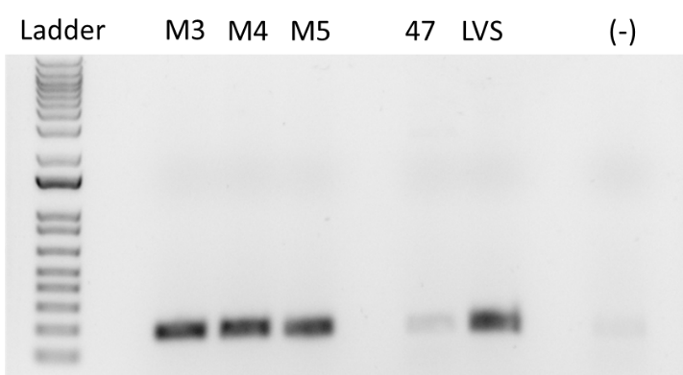
Obviously, there is still some contamination in the negative controls. However, based on how intense the bands are between the positive and the three mutants, I think that it is safe to assume that each of the three mutants did snatch rpsU1 back from the plasmid.

Reagents
pH’d to 6.5. After I added the 2.8 mL of magnesium sulfate the media precipitated. I stirred it for awhile and then took it to pH. Once it reached a pH of 6.8-6.5 it went back into solution. I also realized that I was making 20x of the ions rather than 10x, as I meant to. Regardless, in the future, if there is an issue with precipitation it seems bringing it down to the proper pH helps.

Friday, December 9, 2022
To Do:
- Start cultures of KRLVS192 and KRLVS193 in iron and magnesium
- Streak KRLVS28 and KRLVS75 to single colony
- Check yeast plates for colonies
- Take plates out of the incubator for Hannah
- GFP assay of iron and magnesium of KRLVS192 and KRLVS193
Results and Data:

CDM Fe and Mg Conditions on rpsU1 and rpsU3 Production in KRLVS192 and KRLVS193
Condition Number | 0 | 1 | 2 | 3
Experiment Component | Background | Control | Test 1 | Test 2
Condition | CDM | CDM | 0.08 mg/mL Fe | 2.0 mg/mL Mg

- Resuspend patches of cells in 400uL of CDM, with 0 mg/mL Mg, checking OD in a 1:20 dilution
- Normalize samples to an OD of 0.08-0.10 in 7 mL of respective CDM, either regular or varying concentrations of iron
- Shake cells at 37°C to an OD of 0.3-0.4 typically 4 and a half hours.
- Then follow the GFP reporter assay protocol, starting at Step 4, subtracting LVS in PBS, and normalizing to the fluorescence of each strain to standard condition, CDM

OD Readings
Sample | 0 hours
KRLVS192 1 C | 0.073
KRLVS192 2 C | 0.076
KRLVS193 1 C | 0.059
KRLVS193 2 C | 0.083
KRLVS192 1 Fe | 0.082
KRLVS192 2 Fe | 0.066
KRLVS193 1 Fe | 0.080
KRLVS193 2 Fe | 0.074
KRLVS192 1 Mg | 0.073
KRLVS192 2 Mg | 0.073
KRLVS193 1 Mg | 0.088
KRLVS192 2 Mg | 0.071
LVS-pF CDM | 0.070
I checked my yeast plates and saw small colonies on the positive control, but did not see any on my electroporation plates. I took them out of the incubator and set them on the bench for over the weekend, and I’ll check again on Monday.

GFP Assay on CDM Mg and Fe Conditions in KRLVS192 and KRLVS193
- Pellet 2 mLs of culture and spin at max speed for 3 minutes
- Remove all CDM, using 20 ul pipette to remove small amount at bottom of tube.
- Add 1 mL of 1XPBS and resuspend the cells.
- Aliquot 250 ul from each tube in triplicate to clear 96-well plate. Add PBS in triplicate as control.
- Go to INBRE lab with multichannel pipette, Rainin tips, black 96-well plate, and flash drive.
- Read OD600 from clear plate on ID3 plate reader:
  - Select Absorbance, wavelength=600
  - Plate type: 96-well standard clearbtm (first option)
- Transfer 200 ul of each well from clear plate to black plate using the multichannel
- Read fluorescence from black plate on ID3 plate reader:
  - Select fluorescence
  - Wavelength: 495 to 535
  - Plate type: CoStar 3789
  - Gain: Automatic
  - Integration: 380 ms
Label | Condition |  | Label | Strain and BR
A | CDM |  | 1 | KRLVS192 1
B | 0.08 mg/mL Fe |  | 2 | KRLVS192 2
C | 2.0 mg/mL Mg |  | 3 | KRLVS193 1
 |  |  | 4 | KRLVS193 2

 | 1 | 2 | 3 | 4 | 5 | 6 | 7 | 8 | 9 | 10 | 11 | 12
A | A1 | A1 | A1 |  | A3 | A3 | A3 |  | LVS | LVS | LVS
B | A2 | A2 | A2 |  | A4 | A4 | A4 |  | PBS | PBS | PBS
C | B1 | B1 | B1 |  | B3 | B3 | B3
D | B2 | B2 | B2 |  | B4 | B4 | B4
E | C1 | C1 | C1 |  | C3 | C3 | C3
F | C2 | C2 | C2 |  | C4 | C4 | C4
G
H

Sunday, December 11, 2022
To Do:
- Patch out KRLVS148 and KRLVS149
- Make 2.5% iron pyrophosphate
- Check LVS and drpsU2 plates and put in incubator if necessary
Results and Data:
I checked my yeast plates and it almost looked like there may actually be colonies, so I put them back into the incubator.

Reagents
2.5% Iron pyrophosphate
0.75g iron pyrophosphate (cabinet) in 30mL of ddiH2O (type 1), dissolved overnight, fresh solution every 2 weeks

Monday, December 12, 2022
To Do:
- Set up cultures for B gal of KRLVS148 and KRLVS149
- Patch out KRLVS28 and KRLVS75
- Patch out transformants for Hannah
- Streak out mutant 4 to single colony from freezer stock
- B-gal of KRLVS148 and KRLVS149
- Filter sterilize 2.5% iron pyrophosphate
- Supplement MHB
- Prepare tubes for tomorrow
- Make 4 mg/mL ONPG
- Start yeast overnights hopefully – nvm ☹
Results and Data:
I checked my yeast plates again, and what I thought were potentially colonies were in fact just condensation. Given that I can’t seem to get colonies from these plates to grow, I think I need to just re-do the ligation electroporation and start from scratch sort of. I can’t remember if I still have gel purified stuff, but I’ll check my box.

β-galactosaidase Assay of KRLVS148 and KRLVS149
- Grow 6ml cultures until OD600 = 0.3
- Turn on 28°C water bath
- Determine amount of Z-buffer needed (0.8ml x 2 x # of cultures plus 1, the 2 is for running duplicates, the 1 is for a blank replicate). Add BME to Z-buffer (2.72 x Xml Z-buffer = _µl of BME).
- Set up reaction tubes with 800µl Z-buffer, put on lids
- Turn on spec and gather cuvettes
- Once cultures reach OD₆₀₀ = 0.3, place on ice 30 min and put ONPG in water bath
- After cells have incubated on ice, measure OD₆₀₀ of bacterial cultures
- Add 200µl culture to each reaction tube (add 200µl culture media to blank tube)
- Add 30µl 0.1% SDS to each reaction tube
- Add 60µl CHCl3 (chloroform) to each reaction tube
- Vortex reaction pairs on high for 6 secs (time precisely with timer)
- Put in water bath for 10 min
- Prepare repeater pipette with 1M Na₂CO₃ (stop)
- Add 200µl ONPG in 5 sec intervals (use timer with hours)
- Shake gently and watch for yellow (goal OD420 is 0.6-0.9)
- Stop with 500µl 1M Na₂CO₃, record time, vortex at 4 for 10 sec
- Give all reaction at least 2 hours
- Remove 1 mL from reaction (avoid chloroform at bottom), measure OD₄₂₀ and OD_{550,} using blank reaction as blank in spectrophotometer.
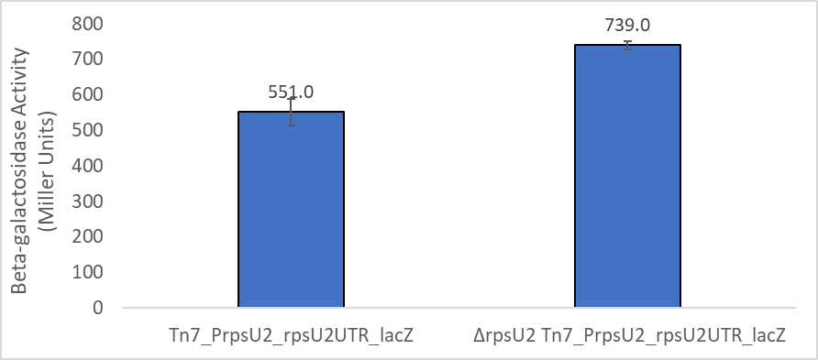
This was about a 34% increase from WT to drpsU2, and corresponds with the previous data shown by Aisling. So, that’s looking good. I had to throw out one of the technical replicates from the first biological replicate due to the fact I accidentally added a bunch of stop buffer. Oops.

Reagents
Mueller Hinton Broth (500 mL)
To supplement add:
5mL of 10% glucose
5mL of 2.5% iron pyrophosphate
isovitalex (combine 10mL from liquid vial with solids, add entire volume to broth)
Can keep this supplemented media for 2 weeks, storing at 4 ̊C

4 mg/mL ONPG (40 mL)
To a 50 mL beaker add:
160 mg of ONPG (stored at -20°C
40mL of Z-buffer
Cover in foil and stir until dissolved
Transfer to a 50 mL conical tube wrapped in foil and store in the -20°C

Tuesday, December 13, 2022
To Do:
- Set up cultures of KRLVS28 and KRLVS75
- Patch out LVS and drpsU2
- B gal of KRLVS28 and KRLVS75 in MHB and CDM
Results and Data:

β-galactosidase Assay of KRLVS28 and KRLVS75 in MHB and CDM
- Grow 6ml cultures until OD600 = 0.3
- Turn on 28°C water bath
- Determine amount of Z-buffer needed (0.8ml x 2 x # of cultures plus 1, the 2 is for running duplicates, the 1 is for a blank replicate). Add BME to Z-buffer (2.72 x Xml Z-buffer = _µl of BME).
- Set up reaction tubes with 800µl Z-buffer, put on lids
- Turn on spec and gather cuvettes
- Once cultures reach OD₆₀₀ = 0.3, place on ice 30 min and put ONPG in water bath
- After cells have incubated on ice, measure OD₆₀₀ of bacterial cultures
- Add 200µl culture to each reaction tube (add 200µl culture media to blank tube)
- Add 30µl 0.1% SDS to each reaction tube
- Add 60µl CHCl3 (chloroform) to each reaction tube
- Vortex reaction pairs on high for 6 secs (time precisely with timer)
- Put in water bath for 10 min
- Prepare repeater pipette with 1M Na₂CO₃ (stop)
- Add 200µl ONPG in 5 sec intervals (use timer with hours)
- Shake gently and watch for yellow (goal OD420 is 0.6-0.9)
- Stop with 500µl 1M Na₂CO₃, record time, vortex at 4 for 10 sec
- Give all reaction at least 2 hours
- Remove 1 mL from reaction (avoid chloroform at bottom), measure OD₄₂₀ and OD_{550,} using blank reaction as blank in spectrophotometer.
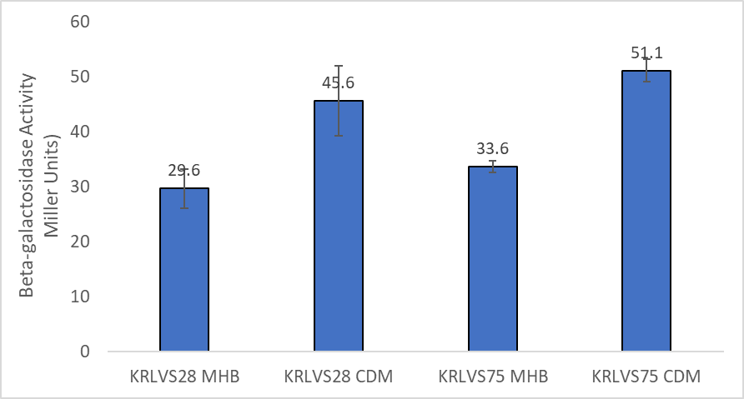
When compared to the GFP fluorescence assay, rpsU1 showed a 2.12 fold increase, while rpsU3 showed a 1.37 fold increase. This B-gal is showing, for both rpsU a 1.5 ish fold increase. This suggests that in regards to rpsU1 the protein abundance is slightly less, while for rpsU3 the protein abundance is slightly more when normalized to MHB. However, the error bars are also none too small.

Wednesday, December 14, 2022
To Do:
- Set up cultures for growth curve of LVS and drpsU2 in CDM
- Patch out yeast
- Run dishwasher
- Make iron and magnesium sulfate with higher concentration
- Put away dishes
Results and Data:

Growth Curve of LVS and drpsU2 in CDM and MHB
- Resuspend patches of cells in 400uL of CDM or MHB, checking OD in a 1:20 dilution
- Normalize samples to an OD of 0.08-0.10 in 8 mL of CDM or MHB
- Shake cells at 37°C for 24 hours
OD Readings
Sample | 0 hours | 2 hours | 3.5 hours | 5 hours | 6 hours | 25 hours
LVS 1 MHB | 0.061 | 0.085 | 0.158 | 0.207 | 0.259 | 1.612
LVS 2 MHB | 0.071 | 0.146 | 0.211 | 0.298 | 0.378 | 1.708
LVS 3 MHB | 0.097 | 0.137 | 0.238 | 0.308 | 0.377 | 1.720
drpsU2 1 MHB | 0.077 | 0.115 | 0.162 | 0.212 | 0.254 | 0.780
drpsU2 2 MHB | 0.066 | 0.109 | 0.151 | 0.203 | 0.234 | 0.720
drpsU2 3 MHB | 0.078 | 0.122 | 0.167 | 0.242 | 0.270 | 0.772
LVS 1 CDM | 0.073 | 0.179 | 0.311 | 0.436 | 0.526 | 3.136
LVS 2 CDM | 0.072 | 0.172 | 0.262 | 0.369 | 0.425 | 3.540
LVS 3 CDM | 0.075 | 0.159 | 0.260 | 0.358 | 0.448 | 3.620
drpsU2 1 CDM | 0.077 | 0.192 | 0.285 | 0.405 | 0.502 | 2.256
drpsU2 2 CDM | 0.074 | 0.165 | 0.266 | 0.369 | 0.453 | 2.016
drpsU2 3 CDM | 0.075 | 0.168 | 0.273 | 0.384 | 0.473 | 2.124

Reagents
50 mg/mL FeSO₄•7H₂O
To 50 mL beaker add:
250 mg FeSO₄•7H₂O
~5 mL water
Stir until complete dissolved, filter sterilize

500 mg/mL MgSO₄•7H₂O
To 50 mL beaker add:
5 g MgSO₄•7H₂O
~7 mL water
Stir until complete dissolved and add water to final volume of 5 mL

Thursday, December 15, 2022
To Do:
- Check 24 hour time point of growth curve
- Soft agar overlay of mutant 4
- Make CDM with iron and magnesium sulfate x10, x100, and x1000
- Make CDM (150 mL)
- Make YPD in 250 mL flask
- Autoclave 2x200 mL water
- Ligation of PrpsU2 tul4 5’ UTR PCR with pKR128 backbone (from 9/21/22)
- Set up yeast overnight
Results and Data:

Agar overlay for β-galactosidase activity in Mutant 4 from MM
- Prior to overlay protocol, incubate intended cells on CHAH until single colonies form.
- On the day of the experiment:
  - Prepare soft agar overlay solution by adding the following components to a flask:
20 mL of diH₂O
0.14 g of agar
  - Stir and autoclave Liquid 30
- Place in water bath at 56°C until cool enough to touch. Add 20 uL x-gal to agar.
- Overlay 10mL of the agar solution to each plate. Protect from light by wrapping in foil. Incubate lid side up.

Ligation of PrpsU2 tul4 5’UTR PCR from gBlock with pKR128 backbone
- Make a reaction table with desired ligations. Always include a backbone only control for each plasmid backbone used.
Tube | Insert | Backbone
1 | KpnI, NotI dig., pur. PrpsU2:tul4 5’UTR PCR | KpnI, NotI digested, purified pKR128
2 | - | KpnI, NotI digested, purified pKR128
- Set up master mix table:
Component | Reaction 1 (uL) | Reaction 2 (uL) | Master Mix (3x)
H₂O | 11.5 | 11.5 | 34.5
10x ligase buffer | 2.0 | 2.0 | 6.0
Insert | 4.0 | - | -
Backbone | 2.0 | 2.0 | 6.0
Ligase | 0.5 | 0.5 | 1.5
TOTAL | 20.0 | 20.0 | 48.0
- Obtain ice to assemble and keep the reactions on. This is important, as the reaction happens at 16°C and the ligase buffer (which contains ATP) needs to be kept cold in order to avoid degradation.
- Obtain and label 1.5mL tubes for the reactions. Be sure to include the date and your initials.
- To the individual tubes, add indicated amounts of H₂O (___uL), 10x buffer (_____uL), insert (____uL), and backbone (____uL).
- Add indicated amount of ligase (___uL) to the individual tubes. Remember to keep the ligase in a mini cooler.
- After all of the components have been added, mix each tube with a pipette set to 18 uL.
- Incubate at 16°C overnight.

Reagents
YPD (250 mL)
To 500 mL baffled flask add:
2.5 g Yeast extract
5.0 g Protease-Peptone
5.0 g Glucose
Mix thoroughly and autoclave Liquid 15’
Store at room temperature

CDM (150mL)
To 250 mL beaker add:
12 mL Combined Amino Acid Stock
Then add:
600 uL Thiamine HCl
600 uL Spermine tetrahydrochloride
600 uL DL-Calcium pantothenate
Then add:
5.13 mL 5N NaCl
1.5 mL KH2PO4
600 uL K2HPO4
Then:
1.5 mL 400 mg/mL Glucose
Then:
115 mL Water
Then:
600 uL FeSO4•7H2O
600 uL MgSO4•7H2O
pH media to a pH between 6.3 and 6.5
Add water to 150 mL total
Filter sterilize

Friday, December 16, 2022
To Do:
- Make electrocompotent yeast
- Electroporation yeast with leftover candidate pKR168 and new ligation
- Patch out KRLVS192, KRLVS193, and LVS-pF
- Set up cultures for GFP assay on Monday
- Check soft agar overlay
Results and Data:

Making electrocompetent yeast
- Have a thick patch of S. cerevisiae parental strain grown up on a YPD plate in advance. Grow 250 mL overnight cultures of yeast strain in YEPD media at 30C, shaking at 250 rpm. Start from plates and resuspend to OD of approximately 0.06 if from an older plate or 0.01 if from a new plate.
- Take OD600 (dilute 1:10) until it reaches about 1.3-1.5 OD
- Place entire volume of culture in sterile 250 mL centrifuge bottle
- Centrifuge at 3000 xg for 5 min at 4C. Discard supernatant.
- Wash with ~200 mL of ice-cold water twice with identical centrifugation.
- Wash in 20 ml of ice cold 1M sorbitol and centrifuge again, as above.
- Resuspend in smallest volume of ice cold 1M sorbitol, starting with 200 ul and up to 500 ul as needed.

Electroporation of Candidate pKR168 + pKR168 Ligation into Yeast
- Add 3 ul of plasmid to 100 ul of electrocompetent cells. For ligations, add 8 ul. Mix via pipette. Incubate on ice for 5 min.
- Transfer to prechilled 0.2 cm cuvette
- Electroporate on presetting SC2 (1500 V, 5 msec)
- Immediately add the cells to 1 mL of cold 1M sorbitol
- Plate onto -ura selective plates. For ligations, plate 200 ul and remaining. Put in incubator set to 30C. Colonies will be visible within 2-3 days for successful transformations.
Tube # | Purpose | DNA | Vol. of DNA | Vol. Plated | # of Plates
1 | pKR168 | MP plasmid | 3 uL | 200 uL, Rem. | 2
2 | pKR168 | Lig. 1 | 8 uL | 200 uL, Rem. | 2
3 | Backbone | Lig. BB | 8 uL | 200 uL, Rem. | 2
4 | (+) control | pKR128 | 3 uL | 200 uL, Rem. | 2
5 | (-) control | - |  | 200 uL | 1
 |  |  |  | Total: | 9

Monday, December 19, 2022
To Do:
- Set up cultures for 10x, 100x, and 1000x Fe environmental condition
- Check yeast electroporation plate
- GFP assay of iron conditions on KRLVS192 and KRLVS193
Results and Data:

Effect of 10x, 100x, and 1000x Fe on rpsU1 and rpsU3 Production in KRLVS192 and 193
Condition Number | 0 | 1 | 2 | 3 | 4
Experiment Component | Background | Control | Test 1 | Test 2 | Test 3
Condition | CDM | CDM | 0.02 mg/mL Fe | 0.2 mg/mL Fe | 2.0 mg/mL Fe

- Resuspend patches of cells in 400uL of CDM, with 0 mg/mL Mg, checking OD in a 1:20 dilution
- Normalize samples to an OD of 0.08-0.10 in 7 mL of respective CDM, either regular or varying concentrations of iron
- Shake cells at 37°C to an OD of 0.3-0.4 typically 4 and a half hours.
- Then follow the GFP reporter assay protocol, starting at Step 4, subtracting LVS in PBS, and normalizing to the fluorescence of each strain to standard condition, CDM

OD Readings
Sample | 0 hours
KRLVS192 1 C
KRLVS192 2 C
KRLVS193 1 C
KRLVS193 2 C
KRLVS192 1 10x
KRLVS192 2 10x
KRLVS193 1 10x
KRLVS193 2 10x
KRLVS192 1 100x
KRLVS192 2 100x
KRLVS193 1 100x
KRLVS193 2 100x
KRLVS192 1 1000x
KRLVS192 2 1000x
KRLVS193 1 1000x
KRLVS193 2 1000x
LVS-pF CDM

GFP Assay on CDM Fe Conditions in KRLVS192 and KRLVS193
- Pellet 2 mLs of culture and spin at max speed for 3 minutes
- Remove all CDM, using 20 ul pipette to remove small amount at bottom of tube.
- Add 1 mL of 1XPBS and resuspend the cells.
- Aliquot 250 ul from each tube in triplicate to clear 96-well plate. Add PBS in triplicate as control.
- Go to INBRE lab with multichannel pipette, Rainin tips, black 96-well plate, and flash drive.
- Read OD600 from clear plate on ID3 plate reader:
  - Select Absorbance, wavelength=600
  - Plate type: 96-well standard clearbtm (first option)
- Transfer 200 ul of each well from clear plate to black plate using the multichannel
- Read fluorescence from black plate on ID3 plate reader:
  - Select fluorescence
  - Wavelength: 495 to 535
  - Plate type: CoStar 3789
  - Gain: Automatic
  - Integration: 380 ms
Label | Condition |  | Label | Strain and BR
A | CDM |  | 1 | KRLVS192 1
B | 0.02 mg/mL Fe |  | 2 | KRLVS192 2
C | 0.20 mg/mL Fe |  | 3 | KRLVS193 1
D | 2.00 mg/mL Fe |  | 4 | KRLVS193 2

 | 1 | 2 | 3 | 4 | 5 | 6 | 7 | 8 | 9 | 10 | 11 | 12
A | A1 | A1 | A1 |  | A3 | A3 | A3 |  | LVS | LVS | LVS
B | A2 | A2 | A2 |  | A4 | A4 | A4 |  | PBS | PBS | PBS
C | B1 | B1 | B1 |  | B3 | B3 | B3
D | B2 | B2 | B2 |  | B4 | B4 | B4
E | C1 | C1 | C1 |  | C3 | C3 | C3
F | C2 | C2 | C2 |  | C4 | C4 | C4
G | D1 | D1 | D1 |  | D3 | D3 | D3
H | D2 | D2 | D2 |  | D4 | D4 | D4

Tuesday, December 20, 2022
To Do:
- Miniprep yeast colonies
Results and Data:

Miniprep of Candidate pKR168 Plasmid from Yeast
- Aliquot 3x 1.666 mL of the yeast cells (early log phase, total of 4.5 mL) into 2 ml microfuge tubes and spin down the cells at 600 x g for 3 minutes.
- Discard the supernatant and add 200 ul Solution 1 to each pellet and add 3 ul Zymolyase. Resuspend pellet by flicking tube or mild vortexing. Note: If running multiple samples, can make a solution 1-enyzme mixture by combining 15 ul of Zymolyase with 1 mL of Solution 1, then adding 200 ul to each pellet. If cells are from stationary phase, add more Zymolyase to ensure efficient lysis.
- Incubate at 37C for 30 minutes. Then add ~100 ul of glass beads and strap tubes to a vortex set to high speed to help lyse cells, for 30 additional minutes.
- Add 200 ul Solution 2 to each tube and mix well.
- Add 400 ul Solution 3 to each tube and mix well. Centrifuge at maximum speed for 3 minutes.
- Transfer the supernatant from one tube to the Zymo-Spin I Column in a collection tube and centrifuge at >10,000 x g for 30 seconds. Add supernatant from next tube and centrifuge again until entire culture has been added to one column.
- Discard the flow-through and ensure the flow-through does not come into contact with the column tip.
- Add 550 ul DNA Wash Buffer to the Spin Column and centrifuge at >10,000 x g for 2 minutes. Discard the flow-through. Spin for 3 more minutes to remove residual ethanol.
- Place the Spin Column in a clean 1.5 mL microcentrifuge tube and add 15 ul of 0.1xEB. Allow to sit for 5 minutes. Centrifuge at 10,000 x g for 1 minute to elute the plasmid DNA. Put the eluate back on the column, let sit, and centrifuge again

Wednesday, December 28, 2022
To Do:
- Patch out KRLVS192, KRLVS193, and LVS-pF
- Patch out KRLVS28 and KRLVS75 at room temperature
- PCR of candidate pKR168
- Run gel of candidate pKR168 PCR
- Set up sequencing for candidate pKR168
- Prepare tubes for GFP assay
Results and Data:

Thursday, December 29, 2022
To Do:
- Set up cultures for 10x, 100x, and 1000x Mg environmental conditions
- Streak out KRLVS148 and KRLVS111
- GFP assay of Mg environmental conditions
- Check KRLVS28 and KRLVS75 and put in incubator if necessary
Results and Data:

Friday, December 30, 2022
To Do:
- Set up cultures of KRLVS28 and KRLVS75
- B-gal of KRLVS28 and KRLVS75 in MHB vs. CHAH
- Streak out KRLVS149 and KRLVS112
Results and Data:

Monday – patch out KRLVS148, KRLVS149, KRLVS111, and KRLVS112

Bibliography

Ramsey, K. M. and Dove, S. L. (2016) ‘ A response regulator promotes Francisella tularensis intramacrophage growth by repressing an anti-virulence factor ’, Molecular Microbiology. doi: 10.1111/mmi.13418.

