Table of Contents
November 2022 3
Tuesday, November 1, 2022 3
Wednesday, November 2, 2022 3
Testing the Effect of pH on rpsU1 and rpsU3 Production in KRLVS192 and KRLVS193 3
GFP Assay on pH Conditions in KRLVS192 and KRLVS193 4
Thursday, November 3, 2022 5
Friday, November 4, 2022 5
Monday, November 7, 2022 6
gDNA Prep of Potential Triple Mutants and KRLVS153 6
Reagents 6
Tuesday, November 8, 2022 6
Receiving and Dissolving Primers 7
Reagents 7
Wednesday, November 9, 2022 7
Reagents 8
Thursday, November 10, 2022 8
Friday, November 11, 2022 8
Electroporating pKR168 into Electrocompetent KRLVS126 and KRLVS127 8
Monday, November 14, 2022 10
Tuesday, November 15, 2022 10
Wednesday, November 16, 2022 10
Thursday, November 17, 2022 10
Friday, November 18, 2022 10
Monday, November 21, 2022 11
Tuesday, November 22, 2022 11
Wednesday, November 23, 2022 11
Thursday, November 24, 2022 11
Friday, November 25, 2022 11
Monday, November 28, 2022 12
Tuesday, November 29, 2022 12
Wednesday, November 30, 2022 12
December 2022 13
Thursday, December 1, 2022 13
Friday, December 2, 2022 13
Monday, December 5, 2022 14
Tuesday, December 6, 2022 14
Wednesday, December 7, 2022 14
Thursday, December 8, 2022 14
Friday, December 9, 2022 14
Monday, December 12, 2022 15
Tuesday, December 13, 2022 15
Wednesday, December 14, 2022 15
Thursday, December 15, 2022 15
Friday, December 16, 2022 15
Monday, December 19, 2022 16
Tuesday, December 20, 2022 16
Wednesday, December 21, 2022 16
Thursday, December 22, 2022 16
Friday, December 23, 2022 16
Monday, December 26, 2022 17
Tuesday, December 27, 2022 17
Wednesday, December 28, 2022 17
Thursday, December 29, 2022 17
Friday, December 30, 2022 17
Bibliography 18

November 2022

Tuesday, November 1, 2022
To Do:
- Patch out KRLVS192, KRLVS193, and LVS-pF
- Patch out triple mutants
Results and Data:
I was unable to miniprep my (hopefully) pKR168 from the yeast cultures, as the cultures did not grow. Boo ☹

Wednesday, November 2, 2022
To Do:
- Set up cultures for pH experiment
- pH experiment on KRLVS192 and KRLVS193
- GFP assay on pH experiment
Results and Data:

Testing the Effect of pH on rpsU1 and rpsU3 Production in KRLVS192 and KRLVS193
Condition Number | 0 | 1 | 2 | 3
Experiment Component | Background | Test 1 | Test 2 | Control
Condition | Unaltered pH | pH 2.75 | pH 4.5 | pH 6.5

- Prepare (3) MHB (35 mL) by buffering in INBRE, and filter sterilizing
- Scrape up patches of cells and resuspend in 400uL of MHB, checking OD in a 1:20 dilution
- Normalize samples to an OD of 0.08-0.10 in 18 mL of MHB in baffled flasks.
- Shake cells at 37°C to an OD of 0.25-0.30 typically 4 hours.
- Pellet cells at 8,000 xg for 5 minutes and resuspend in 300 uL of MHB and split evenly
- Shake cells at 37°C for an additional 0.5-1 hour to mid-log (OD 0.3-0.4)
- Then follow the GFP reporter assay protocol, starting at Step 4, subtracting LVS in PBS, and normalizing to the fluorescence of each strain to standard condition, non-buffered MHB
Experimental Set-Up
Strain | KRLVS192/3 1 |  |  | KRLVS192/3 2 |  |  | KRLVS192/3 3
Culture Vol. | 18 mL |  |  | 18 mL |  |  | 18 mL
pH | 2.75 | 4.5 | 6.5 | 2.75 | 4.5 | 6.5 | 2.75 | 4.5 | 6.5
Separated Vol. | 5 mL | 5 mL | 5 mL | 5 mL | 5 mL | 5 mL | 5 mL | 5 mL | 5 mL

OD Readings
Sample | 0 hours | 2 hours | 4 hours
KRLVS192 1 | 0.078 | 0.111 | oops
KRLVS192 2 | 0.064 | 0.112 | oops
KRLVS192 3 | 0.068 | 0.101 | oops
KRLVS193 1 | 0.063 | 0.128 | oops
KRLVS193 2 | 0.082 | 0.143 | oops
KRLVS193 3 | 0.075 | 0.131 | oops
LVS-pF | 0.067 | 0.170 | oops
I forgot to write down the 4 hour time point, but they were all between 0.205 and 0.270. I let them grow for another 30 minutes prior to media transfer.

GFP Assay on pH Conditions in KRLVS192 and KRLVS193
- Pellet 4 mLs of culture and spin at max speed for 3 minutes
- Remove all MHB, using 20 ul pipette to remove small amount at bottom of tube.
- Add 1 mL of 1XPBS and resuspend the cells.
- Aliquot 250 ul from each tube in triplicate to clear 96-well plate. Add PBS in triplicate as control.
- Go to INBRE lab with multichannel pipette, Rainin tips, black 96-well plate, and flash drive.
- Read OD600 from clear plate on ID3 plate reader:
  - Select Absorbance, wavelength=600
  - Plate type: 96-well standard clearbtm (first option)
- Transfer 200 ul of each well from clear plate to black plate using the multichannel
- Read fluorescence from black plate on ID3 plate reader:
  - Select fluorescence
  - Wavelength: 495 to 535
  - Plate type: CoStar 3789
  - Gain: Automatic
  - Integration: 380 ms
Label | Condition |  | Label | Strain and BR
A | pH 6.5 |  | 1 | KRLVS192 1
B | pH 2.75 |  | 2 | KRLVS192 2
C | pH 4.5 |  | 3 | KRLVS192 3
 |  |  | 4 | KRLVS193 1
 |  |  | 5 | KRLVS193 2
 |  |  | 6 | KRLVS193 3

 | 1 | 2 | 3 | 4 | 5 | 6 | 7 | 8 | 9 | 10 | 11 | 12
A | A1 | A1 | A1 |  | C1 | C1 | C1 |  | B4 | B4 | B4
B | A2 | A2 | A2 |  | C2 | C2 | C2 |  | B5 | B5 | B5
C | A3 | A3 | A3 |  | C3 | C3 | C3 |  | B6 | B6 | B6
D | B1 | B1 | B1 |  | A4 | A4 | A4 |  | C4 | C4 | C4
E | B2 | B2 | B2 |  | A5 | A5 | A5 |  | C5 | C5 | C5
F | B3 | B3 | B3 |  | A6 | A6 | A6 |  | C6 | C6 | C6
G |  |  |  |  |  |  |  |  | LVS | LVS | LVS
H |  |  |  |  |  |  |  |  | 1xPBS | 1xPBS | 1xPBS
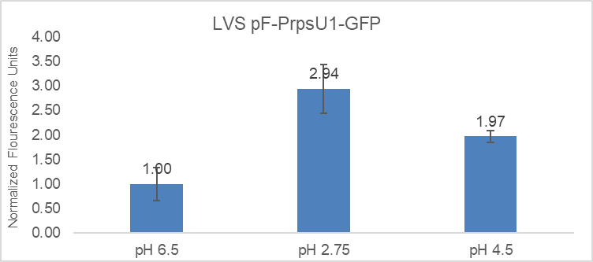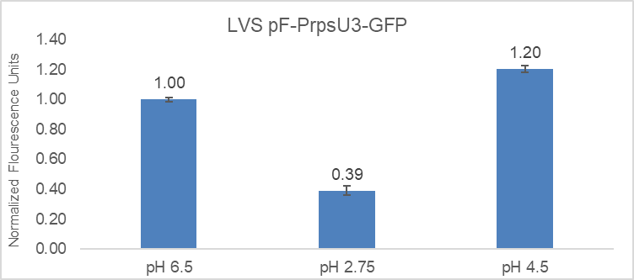
KRLVS192 still appears to be pretty variable in its level of fluorescent expression, however, there is still a fold increase at lower pH levels so I’m hoping that that is still promising.

Thursday, November 3, 2022
To Do:
- Prepare cultures for β-gal with Brenna
- Run β-gal assay with Brenna
Results and Data:

β-galactosaidase Assay of KRLVS28 Transposon Insertion Mutants
- Grow 6ml cultures until OD600 = 0.3
- Turn on 28°C water bath
- Determine amount of Z-buffer needed (0.8ml x 2 x # of cultures plus 1, the 2 is for running duplicates, the 1 is for a blank replicate). Add BME to Z-buffer (2.72 x Xml Z-buffer = _µl of BME).
- Set up reaction tubes with 800µl Z-buffer, put on lids
- Turn on spec and gather cuvettes
- Once cultures reach OD₆₀₀ = 0.3, place on ice 30 min and put ONPG in water bath
- After cells have incubated on ice, measure OD₆₀₀ of bacterial cultures
- Add 200µl culture to each reaction tube (add 200µl culture media to blank tube)
- Add 30µl 0.1% SDS to each reaction tube
- Add 60µl CHCl3 (chloroform) to each reaction tube
- Vortex reaction pairs on high for 6 secs (time precisely with timer)
- Put in water bath for 10 min
- Prepare repeater pipette with 1M Na₂CO₃ (stop)
- Add 200µl ONPG in 5 sec intervals (use timer with hours)
- Shake gently and watch for yellow (goal OD420 is 0.6-0.9)
- Stop with 500µl 1M Na₂CO₃, record time, vortex at 4 for 10 sec
- Give all reaction at least 2 hours
- Remove 1 mL from reaction (avoid chloroform at bottom), measure OD₄₂₀ and OD_{550,} using blank reaction as blank in spectrophotometer.

Obviously, neither mutant really resulted in the up-regulation of rpsU1.

Friday, November 4, 2022
To Do:
- gDNA prep
Results and Data:
I realized that I forgot to patch out KRLVS153 yesterday, so I scraped up my patches and pelleted them, and put them in my -80 to get gDNA from on Monday along with KRLVS153.

Monday, November 7, 2022
To Do:
- gDNA prep of triple deletion strains
- Make 2.5% iron pyrophosphate
Results and Data:

gDNA Prep of Potential Triple Mutants and KRLVS153
- Dilute 1uL of Proteinase K into 310uL of Tissue and Cell Lysis Solution for each sample.
- Scrape up patches and resuspend in MHB
- Pellet cells by centrifugation and discard the supernatant, leaving approximately 25 uL of liquid.
- Vortex for 10 seconds to resuspend the cell pellet.
- Add 300uL of Tissue and Cell Lysis Solution containing the Proteinase K and mix thoroughly.
- Incubate at 65°C for 15 minutes, vortex every 5 minutes.
- Cool the samples to 37°C and add 2ul of 20mg/mL RNase A to the sample, mix thoroughly.
- Incubate at 37°C for 30 minutes.
- Place the samples on ice for 3-5 minutes.
- Add 150uL of MPC Protein Precipitation Reagent to 200uL of lysed sample and vortex vigorously for 10 seconds.
- Pellet the debris by centrifugation at 4°C for 10 minutes at max speed. If the resultant pellet is clear, small, or loose, add an additional 25uL of MPC Protein Precipitation Reagent, mix, and pellet the debris again.
- Transfer the supernatant to a clean microcentrifuge tube and discard the pellet.
- Add 500uL of isopropanol to the recovered supernatant. Invert the tube 30-40 times.
- Pellet the DNA by centrifugation at 4°C for 10 minutes in a microcentrifuge.
- Carefully pour off the isopropanol without dislodging the DNA pellet.
- Rinse twice with 70% ethanol (~1mL) being careful to not dislodge the pellet. Centrifuge briefly if the pellet is dislodged. Remove all the residual ethanol with a pipet and let it air dry.
- Resuspend the DNA in 35uL of 0.1x EB.
I lost some of the sample from mutant 2 and 4, and maybe 5, after the 65°C incubation step. It seemed the lids lifted silently, so when I vortexed them I lost some of the sample. Maybe I should have calculated the concentration of reagents to add after that, but I did not bother. Additionally, after the protein precipitation, sample 8’s pellet was large and not all pelleted into the bottom. So after I took the supernatant out of the other samples, I added an additional volume of MPC and spun again, but I had the same issue, so I centrifuged on a shorter spin time a few times and tried to get as much supernatant as I could out without disturbing the pellet. I did get some of the debris in the tube, so I centrifuged again at 4°C and took off what I could into another new tube.

Reagents
2.5% Iron pyrophosphate
0.75g iron pyrophosphate (cabinet) in 30mL of ddiH2O (type 1), dissolved overnight, fresh solution every 2 weeks

Tuesday, November 8, 2022
To Do:
- Patch out KRLVS192, KRLVS193, and LVS-pF
- Supplement MHB
- Nanodrop gDNA
- Process primers
- Set up PCR to check for rpsU1 or rpsU2 in triple deletion mutants
Results and Data:
I diluted my gDNA samples 1:2 for a total of 3 uL, using 2 uL to nanodrop. Two of my samples, mutants 7 and 8 were still too high so I used the remaining 1 uL and diluted it again, so it was 1:4.
In order to run my PCR, I diluted my gDNA to 100 ng/uL via the following amounts in a total of 200 uL:

Receiving and Dissolving Primers
- Spin primers at maximum speed in tabletop centrifuge for 3 minutes so dessicated primers go to the bottom of the tube.
- Add 0.1x EB to a final concentration of 100 uM. Calculate this by multiplying the reported nm by 10 and adding that volume in ul (i.e. 12.7 nmoles = add 127 uL of 0.1xEB).
- Put on 42°C heat block for 5 minutes to help primers dissolve
- Vortex and brief spin.
- Label tubes with KROL numbers on the top and put in the appropriate 100 uM stock box in the -20°C freezer.
  - If a PCR primer, make a 10 uM stock by diluting 20 uL of the 100 uM stock into 180 uL of 0.1xEB. Label with purple sticker and put in appropriate freezer box.
- Put Certificate of Analysis sheet in “Oligos Spec Sheet” binder and shipping sheet in Invoices box.

PCR of Potential Triple Mutants to Check for rpsU1 or rpsU3
- Acquired and labelled PCR tubes: 1, 2, 3, 4, 5, 7, 8, LVS’, and negative controls.
Reaction# | Plasmid/Region | Source DNA | Primers | Length (bp)
1 | rpsU2 | Mutant 1 | KROL601, KROL602 | -
2 | rpsU2 | Mutant 2 | KROL601, KROL602 | -
3 | rpsU2 | Mutant 7 | KROL601, KROL602 | -
4 | rpsU2 | Mutant 8 | KROL601, KROL602 | -
5 | rpsU2 | LVS | KROL601, KROL602 | 193
6 | - control | - | KROL601, KROL602 | -
7 | rpsU1 | Mutant 3 | KROL599, KROL600 | -
8 | rpsU1 | Mutant 4 | KROL599, KROL600 | -
9 | rpsU1 | Mutant 5 | KROL599, KROL600 | -
10 | rpsU1 | LVS | KROL599, KROL600 | 178
11 | - control | - | KROL599, KROL600 | -
- Acquire the following components and put them on ice, labeling tubes if necessary:
  - mgH2O, Primestar buffer, dNTPs, KROL6, KROL257, (10uM), and candidate pKR122
- Vortex each component (aside from enzyme)
- Add appropriate volume (based on PCR worksheet) of each experiment specific primer (forward and reverse) and respective template to PCR tubes
- Add ddi H2O to negative control tube (template volume for 1 reaction)
- Prepare a master-containing:
  - mgH2O, dNTPs, Primestar buffer, respective primers, and Primestar enzyme
- Mix the master-mix solution by pipetting up and down
- Add 19.6 uL of master-mix to negative control PCR tube
- Add 19.6 uL of master mix to each PCR tube and pipet up and down to mix
- Place the PCR Tubes in the thermocycler on STN 1

Total reaction volume | 20
Total number of reactions | 6
 |  |  |  | Factor
Component | Stock concentration | Final concentration | 1 rxn volume | 7
ddiH2O |  |  | 12.4 | 86.8
PrimeSTAR GXL Buffer | 5x | 1x | 4.0 | 28
dNTPs | 2.5 mM | 0.2 mM | 1.6 | 11.2
oligo F | 10 uM | 0.3 uM | 0.6 | 4.2
oligo R | 10 uM | 0.3 uM | 0.6 | 4.2
template | 18.0 ng/ul | 2 ng/ul | 0.4
PrimeSTAR GXL DNA Polymerase | 1.25 U/ul | 0.025 U/ul | 0.4 | 2.8
 |  | Total volume | 20 | 137.2
Used these master mix volumes for both master mixes, with their respective primers.

Reagents
Mueller Hinton Broth (500 mL)
To supplement add:
5mL of 10% glucose
5mL of 2.5% iron pyrophosphate
isovitalex (combine 10mL from liquid vial with solids, add entire volume to broth)
Can keep this supplemented media for 2 weeks, storing at 4 ̊C

Wednesday, November 9, 2022
To Do:
- Run gel of potential triple mutant PCR samples
- Put away dishes
- Make 75% glycerol
- Make CDM components
- Make single use aliquots of KRLVS192 1 and 2, KRLVS193 1 and 2, and LVS_pF
Results and Data:

Gel of Potential Triple Mutants
- Melt agarose gel until completely dissolved, then place in 50°C water bath until cooled
- Set up large gel rig to cast gel, with ladder.
- Add 12uL of Sbyr Safe and pour ~120uL gel, use ladder to mix, then add ladder and allow to set.
- Turn gel, add used 1xTAE, remove ladder.
- Loaded 10 uL ladder, and 24 uL of each sample according to the loading order below.
- Ran for 45 minutes at 113V.

Loading Order of Diagnostic Digest of Candidate pKR122
1 | 2 | 3 | 4 | 5 | 6 | 7 | 8 | 9 | 10 | 11 | 12 | 13 | 14 | 15 | 16 | 17
 | LD |  | 1 |  | 2 | 7 | 8 | LVS |  | - |  | 3 | 4 | 5 | LVS | -

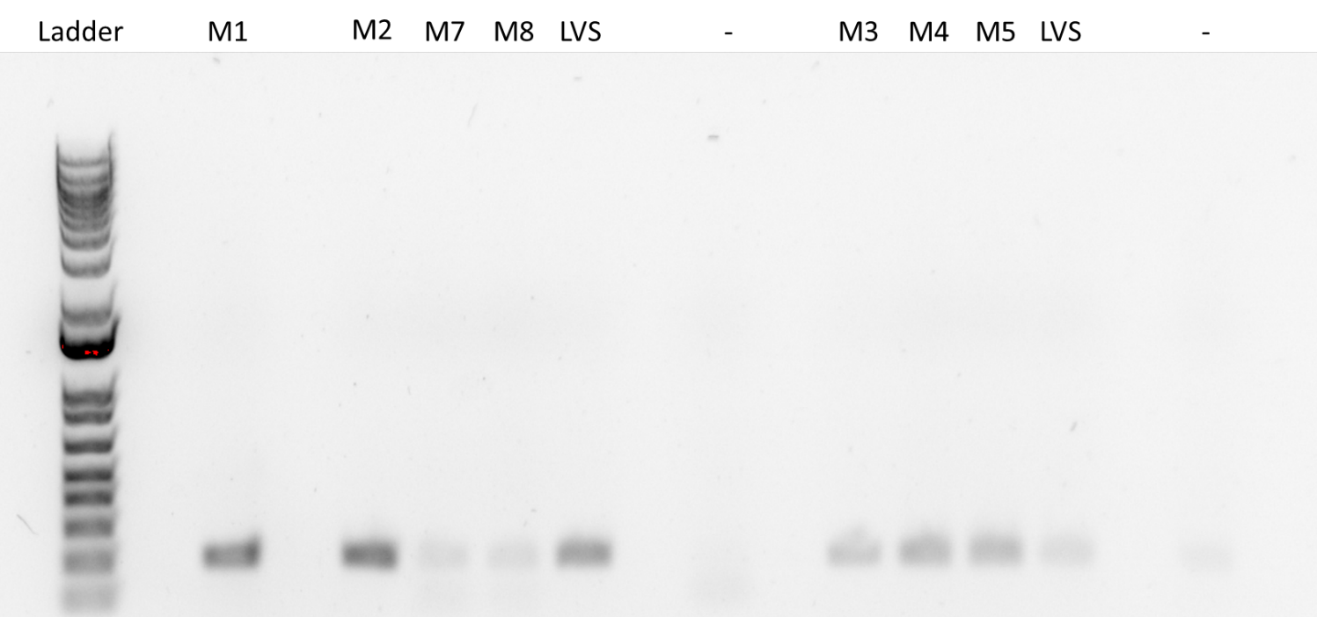

Making Single Use Aliquots of KRLVS192 1+2, KRLVS193 1+2, and LVS-pF
- Prepare 800uL of MHB in a 1.5mL tube
- Take at least half of a thickly spread plate and add cells to the MHB tube
- Resuspend until there are no clumps in the MHB
- Add 200ul of 75% glycerol to the 800uL mix by pipetting
- Aliquot 50ul of solution to tubes, freeze at -80

Reagents
75% Glycerol
To 200 mL bottle add:
75 mL 100% glycerol
25 mL water
Pipet up and down until mixed
Autoclave Liquid 30’
400 mg/mL Glucose
To 50 mL beaker add:
18 g glucose
~20 mL of water
Stir on heat until complete dissolved
Add solution to graduated cylinder and add water to final volume of 45 mL
Filter sterilize

0.5 mg/mL FeSO₄•7H₂O
To 50 mL beaker add:
22.5 mg FeSO₄•7H₂O
45 mL water
Stir until complete dissolved

33.75 mg/mL MgSO₄•7H₂O
To 50 mL beaker add:
1.52 g MgSO₄•7H₂O
~40 mL water
Stir until complete dissolved
Add solution to graduated cylinder and add water to final volume of 45 mL

Thursday, November 10, 2022
To Do:
- Make CDM
- qRT PCR of lacZ region of rpsU2 5’UTR samples -1
- qRT PCR of lacZ region of rpsU2 5’UTR samples -1
- PCR of triple mutants with drpsU1/drpsU2 negative control
- Ask Camberg lab for -ura media
- Make yeast overnights
Results and Data:

Reagents
CDM (100mL)
To 100 mL graduate cylinder add:
8 mL Combined Amino Acid Stock
400 uL Thiamine HCl
400 uL Spermine tetrahydrochloride
400 uL DL-Calcium pantothenate
3.42 mL 5N NaCl
1 mL KH2PO4
400 uL K2HPO4
1 mL 400 mg/mL Glucose
400 uL FeSO4•7H2O
400 uL MgSO4•7H2O
Add water to 100 mL
pH media to a pH between 6.3 and 6.5
Filter sterilize

Friday, November 11, 2022
To Do:
- Miniprep yeast plasmid

Results and Data:

Monday, November 14, 2022
To Do:

Results and Data:

Tuesday, November 15, 2022
To Do:

Results and Data:

Wednesday, November 16, 2022
To Do:

Results and Data:

Thursday, November 17, 2022
To Do:

Results and Data:

Friday, November 18, 2022
To Do:

Results and Data:

Monday, November 21, 2022
To Do:

Results and Data:

Tuesday, November 22, 2022
To Do:

Results and Data:

Wednesday, November 23, 2022
To Do:

Results and Data:

Thursday, November 24, 2022
To Do:

Results and Data:

Friday, November 25, 2022
To Do:

Results and Data:

Monday, November 28, 2022
To Do:

Results and Data:

Tuesday, November 29, 2022
To Do:

Results and Data:

Wednesday, November 30, 2022
To Do:

Results and Data:

December 2022

Thursday, December 1, 2022
To Do:

Results and Data:

Friday, December 2, 2022
To Do:

Results and Data:

Monday, December 5, 2022
To Do:

Results and Data:

Tuesday, December 6, 2022
To Do:

Results and Data:

Wednesday, December 7, 2022
To Do:

Results and Data:

Thursday, December 8, 2022
To Do:

Results and Data:

Friday, December 9, 2022
To Do:

Results and Data:

Monday, December 12, 2022
To Do:

Results and Data:

Tuesday, December 13, 2022
To Do:

Results and Data:

Wednesday, December 14, 2022
To Do:

Results and Data:

Thursday, December 15, 2022
To Do:

Results and Data:

Friday, December 16, 2022
To Do:

Results and Data:

Monday, December 19, 2022
To Do:

Results and Data:

Tuesday, December 20, 2022
To Do:

Results and Data:

Wednesday, December 21, 2022
To Do:

Results and Data:

Thursday, December 22, 2022
To Do:

Results and Data:

Friday, December 23, 2022
To Do:

Results and Data:

Monday, December 26, 2022
To Do:

Results and Data:

Tuesday, December 27, 2022
To Do:

Results and Data:

Wednesday, December 28, 2022
To Do:

Results and Data:

Thursday, December 29, 2022
To Do:

Results and Data:

Friday, December 30, 2022
To Do:

Results and Data:

Bibliography

Ramsey, K. M. and Dove, S. L. (2016) ‘ A response regulator promotes Francisella tularensis intramacrophage growth by repressing an anti-virulence factor ’, Molecular Microbiology. doi: 10.1111/mmi.13418.

