Table of Contents
July 2022 4
Friday, July 1, 2022 4
Miniprep of pKR135 Mixed Population Candidates from E. coli 4
Monday, July 11, 2022 6
Diagnostic Digest of Candidate pKR143 Miniprep w/EcoRI and BamHI 6
Diagnostic Digest of Candidate pKR135 Miniprep w/KpnI and BamHI 7
Gel of Diagnostic Digest of Candidate pKR143 and pKR135 Minipreps 7
Tuesday, July 12, 2022 8
Wednesday, July 13, 2022 9
Thursday, July 14, 2022 9
DNase treatment 9
Friday, July 15, 2022 10
Monday, July 18, 2022 11
Tuesday, July 19, 2022 11
Gel of LVS and Δrpsu RNA Samples 11
Generating cDNA (Half Reaction) 12
Wednesday, July 20, 2022 13
Reagents 13
Thursday, July 21, 2022 13
Preparing Electrocompetent LVS and KRLVS24 Cells 14
Electroporating pKR135 into electrocompetent KRLVS24 14
Electroporating pKR143 into electrocompetent LVS 14
Generating cDNA (Half Reaction) Cont’d. 15
cDNA Purification with PCR Purification Kit 15
Friday, July 22, 2022 15
qRT-PCR of LVS and Δrpsu2 cDNA 16
Saturday, July 23, 2022 17
Preparing Electrocompetent KRLVS153 and KRLVS157 Cells 17
Electroporating pKR135 and pKR30 into electrocompetent KRLVS153 17
Electroporating pF into electrocompetent KRLVS157 18
Sunday, July 24, 2022 18
Monday, July 25, 2022 19
Freezing and Storing Permanent Strains 19
Note for Future Experiment. 20
Tuesday, July 26, 2022 20
Wednesday, July 27, 2022 21
Thursday, July 28, 2022 21
Ligation of PrpsU2 tul4 5’UTR PCR from gBlock with pKR68 backbone 21
Transformation of PrpsU2 tul4 5’UTR Ligation into E. coli 22
Friday, July 29, 2022 22
Reagents 23
Saturday, July 30, 2022 23
Reagents 23
Sunday, July 31, 2022 24
Setting Up KRLVS148 and KRLVS149 Cultures for RNA Purification 24
RNA Purification of KRLVS148 and KRLVS149 24
Reagents 25
August 2022 26
Monday, August 1, 2022 26
DNase treatment of KRLVS148 and KRLVS149 26
Setting Up KRLVS148, KRLVS149, KRLVS111, KRLVS112 Cultures for RNA Purification 27
RNA Purification of KRLVS148, KRLVS149, KRLVS111, and KRLVS112 27
Reagents 29
Tuesday, August 2, 2022 29
DNase treatment of KRLVS148, KRLVS149, KRLVS111, and KRLVS112 RNA Samples 29
Setting Up KRLVS148, KRLVS149, KRLVS150, KRLVS151 Cultures for RNA Purification 30
RNA Purification of KRLVS148, KRLVS149, KRLVS150, and KRLVS151 31
Wednesday, August 3, 2022 32
Transformation of PrpsU2 tul4 5’UTR Ligation into E. coli 32
Gel of 8/1 and 8/2 Pure RNA Samples 33
Thursday, August 4, 2022 34
DNase treatment of KRLVS148, KRLVS149, KRLVS111, and KRLVS112 RNA Samples 34
Gel of KRLVS148, KRLVS149, KRLVS150, and KRLVS151 RNA Samples 34
Generate cDNA (Half) of KRLVS148, KRLVS149, KRLVS111, KRLVS112 (8/2/22 Pure RNA) 35
cDNA Purification with PCR Purification Kit 35
qRT-PCR of KRLVS148 and KRLVS149 (8/3/22) cDNA 36
Friday, August 5, 2022 37
Generate cDNA (Half) of KRLVS148, KRLVS149, KRLVS150, KRLVS151 (8/3/22 Pure RNA) 37
cDNA Purification with PCR Purification Kit 38
qRT-PCR of KRLVS148, KRLVS149, KRLVS111, KRLVS112 (8/4/22) cDNA 38
Monday, August 8, 2022 40
qRT-PCR of KRLVS148, KRLVS149, KRLVS150, KRLVS151 (8/5/22) cDNA - 1 40
qRT-PCR of KRLVS148, KRLVS149, KRLVS150, KRLVS151 (8/5/22) cDNA - 2 41
Tuesday, August 9, 2022 41
Wednesday, August 10, 2022 42
Thursday, August 11, 2022 42
Friday, August 12, 2022 42
Monday, August 15, 2022 43
Tuesday, August 16, 2022 43
Wednesday, August 17, 2022 43
Thursday, August 18, 2022 43
Friday, August 19, 2022 43
Monday, August 22, 2022 44
Tuesday, August 23, 2022 44
Wednesday, August 24, 2022 44
Thursday, August 25, 2022 44
Friday, August 26, 2022 44
Monday, August 29, 2022 45
Tuesday, August 30, 2022 45
Wednesday, August 31, 2022 45
Bibliography 46

July 2022

Friday, July 1, 2022
To Do:
- Miniprep candidate pKR135-2, pKR135-3, and pKR135-4 colonies
- Look at KRLVS174, KRLVS175, KRLVS177, and KRLVS113 under the microscope with Colby

Results and Data:

N/A.

Miniprep of pKR135 Mixed Population Candidates from E. coli
- Pellet overnight cultures by centrifugation at 15,000rpm for 3 minutes.
- Resuspend pellets in a 250uL Buffer P1 and transfer to a microcentrifuge tube.
- Add 250uL Buffer P2 and mix thoroughly by inverting the tube 4-6 times until the solution becomes clear. Do not allow lysis reaction to proceed for more than 5 minutes.
- Add 350uL Buffer N3 and mix immediately and thoroughly by inverting the tube 4-6 times.
- Centrifuge for 10 minutes at 13,000rpm.
- Transfer 800uL of supernatant to a QIAprep 2.0 spin column through pipetting.
- Wash the QIAprep column by adding 500uL Buffer PB. Centrifuge for 30-60s and discard flow through.
- Wash the QIAprep column with 750uL Buffer PE. Centrifuge 30-60s x3 and discard flow through.
- Centrifuge for 3 minutes at 13,000rpm to remove residual buffer.
- Place QIAprep column in a clean 1.5mL microcentrifuge tube. Add 50uL of Buffer EB. Let stand for 1 minute. Centrifuge for 1 minute at 13,000rpm.
Due to timing, I pelleted the 9 cultures prior to the joint lab meeting and stored the pellets in their tubes in the fridge for later miniprep. Was originally planning on miniprepping them after the meeting, before fluorescent microscopy, however, I wanted to make sure to give myself ample time so that I do not mess anything up, as I would really like to get a single isolated plasmid prep. I think it should be okay in the fridge for the couple more hours. Stored in cloning box ‘135-2 1 EV’ format.
For the fluorescent microscopy, Colby and I will be using poly-L lysine as opposed to an agarose pad as it is a quiker method. The chemical will stick the bacteria directly to the slide, the drawback, and why the Camberg lab doesn’t necessarily use, is that the cells will die off quicker, but that does not matter for this application. I grew up plates overnight of each of our strains that we are hoping to look at and we will resuspend the patches in buffer prior to the poly-L lysine treatment.
iLOV Excitation and Emission Maximums Used
LanYFP Excitation and Emission Maiumums Used
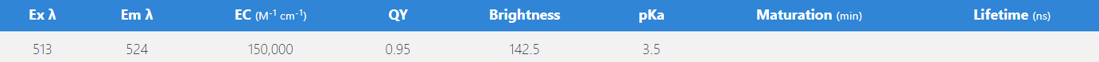
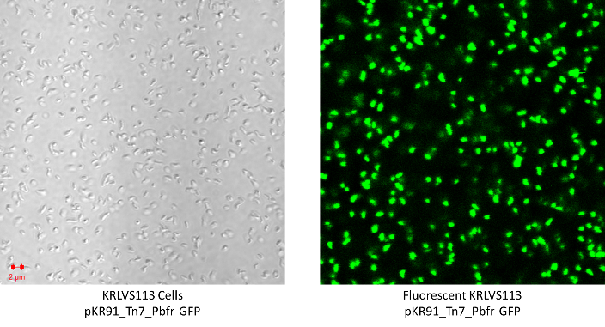
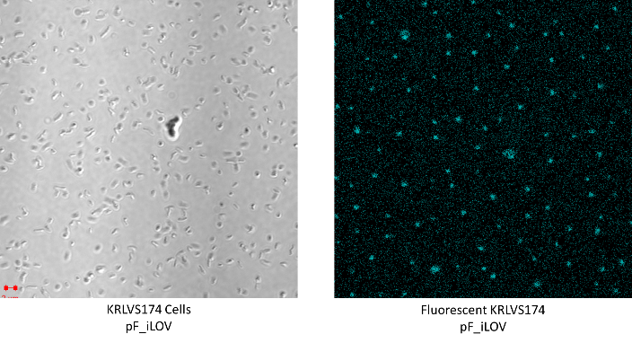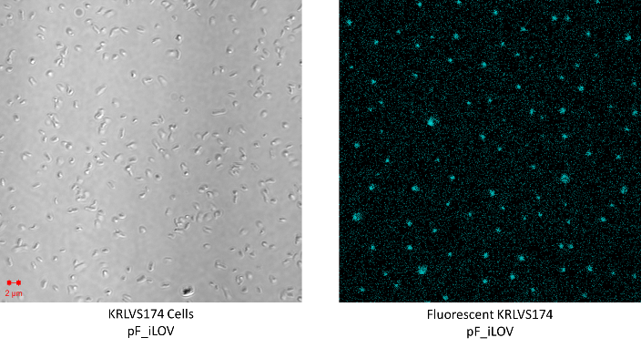
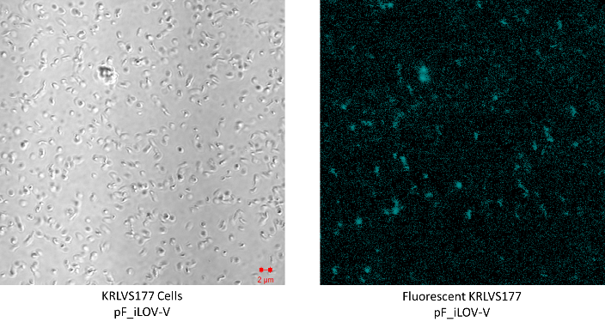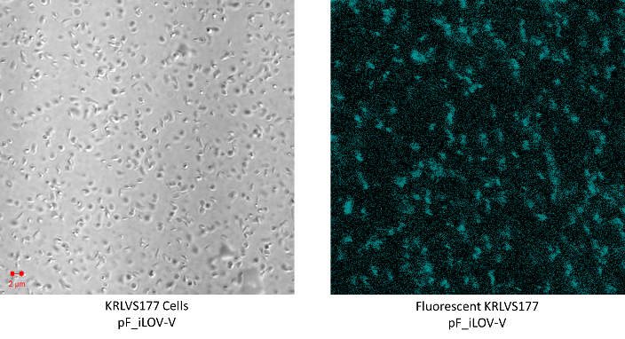
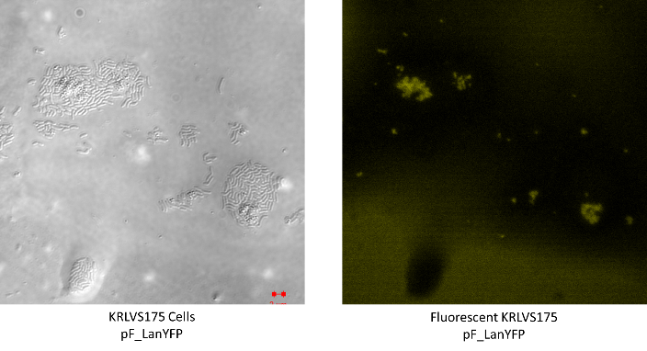
Resuspended some of each patch into 20uL 1xPBS. Meanwhile, left cover slides in poly-L lysine for 5-10 minutes. Let cover slides air dry in fume hood. Applied 5uL of resuspended LVS to microscope slide, followed by cover slip, then imaged using GFP protocol adjusted to corrected excitation. Had to re-dilute both iLOV cultures as they were too thick, cells were moving a lot as it seemed the pol-L lysine did not stick as well, so images were a bit blurry but fluorescence was observed. LanYFP was odd throughout the slide, with patches of yellow fluorescence in weird places, potentially agar, however, clearly was not being expressed in each cell of the population. GFP seemed to have the most ‘coverage’ of fluorescence, but it seemed like iLOV is good too. Will need to be tested quantitatively. LanYFP-V was not ready yet.

Monday, July 11, 2022
To Do:
- Nanodrop candidate pKR143 minipreps
- Run diagnostic restriction digest on candidate pKR143 minipreps
- Run diagnostic gel on candidate pKR143 minipreps
- Nanodrop candidate pKR135 minipreps
- Run diagnostic restriction digest on candidate pKR135 minipreps
- Run diagnostic gel on candidate pKR135 minipreps
- Set up sequencing reactions for candidate pKR143 minipreps
- Set up sequencing reactions for candidate pKR135 minipreps
Results and Data:

Diagnostic Digest of Candidate pKR143 Miniprep w/EcoRI and BamHI
- Make a reaction table with desired digests:
Tube | DNA | Enzyme(s) | DNA Volume (uL) | H₂O Volume (uL)
1 | pKR143-1 | EcoRI, BamHI | 2.0 | -
2 | pKR143-2 | EcoRI, BamHI | 2.0 | -
3 | pKR143-3 | EcoRI, BamHI | 2.0 | -
4 | pKR143-4 | EcoRI, BamHI | 2.0 | -
5 | pKR143-5 | EcoRI, BamHI | 2.0 | -
6 | pKR143-6 | EcoRI, BamHI | 2.0 | -
7 | Water | EcoRI, BamHI | - | 2.0

- Set up master mix table:
Components | Volumes in 1 reaction (uL) | Volumes in Master Mix 8x (uL)
H₂O | 15 | 105
10x Buffer (Cutsmart) | 2 | 14
DNA | (2)
EcoR1 | 0.5 | 3.5
BamH1 | 0.5 | 3.5
Total | 20.0 (18.0 actual b/c of DNA) | 126

- Add indicated amounts of H₂O, 10x buffer, and DNA to individual tube for digest (1.5 mL microfuge tubes for digest in incubator).
- Add indicated amount of each enzyme to the tube.
- Mix by pipetting up and down.
- Incubate at 37°C for 1 hour.

Diagnostic Digest of Candidate pKR135 Miniprep w/KpnI and BamHI
- Make a reaction table with desired digests:
Tube | DNA | Enzyme(s) | DNA Volume (uL) | H₂O Volume (uL)
1 | pKR135-1 | KpnI, BamHI | 2.0 | -
2 | pKR135-2 | KpnI, BamHI | 2.0 | -
3 | pKR135-3 | KpnI, BamHI | 2.0 | -
4 | pKR135-4 | KpnI, BamHI | 2.0 | -
5 | pKR135-5 | KpnI, BamHI | 2.0 | -
6 | pKR135-6 | KpnI, BamHI | 2.0 | -
7 | pKR135-7 | KpnI, BamHI | 2.0 | -
8 | pKR135-8 | KpnI, BamHI | 2.0 | -
9 | pKR135-9 | KpnI, BamHI | 2.0 | -
10 | Water | KpnI, BamHI | - | 2.0

- Set up master mix table:
Components | Volumes in 1 reaction (uL) | Volumes in Master Mix 11x (uL)
H₂O | 15 | 165
10x Buffer (Cutsmart) | 2 | 22
DNA | (2)
Kpn1 | 0.5 | 5.5
BamH1 | 0.5 | 5.5
Total | 20.0 (18.0 actual b/c of DNA) | 198

- Add indicated amounts of H₂O, 10x buffer, and DNA to individual tube for digest (1.5 mL microfuge tubes for digest in incubator).
- Add indicated amount of each enzyme to the tube.
- Mix by pipetting up and down.
- Incubate at 37°C for 1 hour.

Gel of Diagnostic Digest of Candidate pKR143 and pKR135 Minipreps
- Melt agarose gel until completely dissolved, then place in 50°C water bath until cool enough to touch.
- Set up large gel rig to cast gel, with ladder.
- Add 12uL of Sbyr Safe dye to gel rig, pour ~120uL of agarose gel, use ladder to mix, then replace ladder and allow to set.
- Turn gel, add used 1xTAE, remove ladder.
- Loaded 15 uL ladder, and 20 uL of each sample according to the loading order below.
- Ran for 45 minutes at 113V.

Loading Order of Diagnostic Digest of Candidate pKR143 and pKR135
Lane 1 | Lane 2 | Lane 3 | Lane 4 | Lane 5 | Lane 6 | Lane 7 | Lane 8 | Lane 9 | Lane 10
Ladder |  | MP₁₄₃-1/2 | MP₁₄₃-3 | MP₁₄₃-4 | MP₁₄₃-5 | MP₁₄₃-6 | Neg₁₄₃ |  | MP₁₃₅-1
Lane 11 | Lane 12 | Lane 13 | Lane 14 | Lane 15 | Lane 16 | Lane 17 | Lane 18 | Lane 19 | Lane 20
MP₁₃₅-2 | MP₁₃₅-3 | MP₁₃₅-4 | MP₁₃₅-5 | MP₁₃₅-6 | MP₁₃₅-7 | MP₁₃₅-8 | MP₁₃₅-9 | Neg₁₃₅ | MP₁₄₃-1
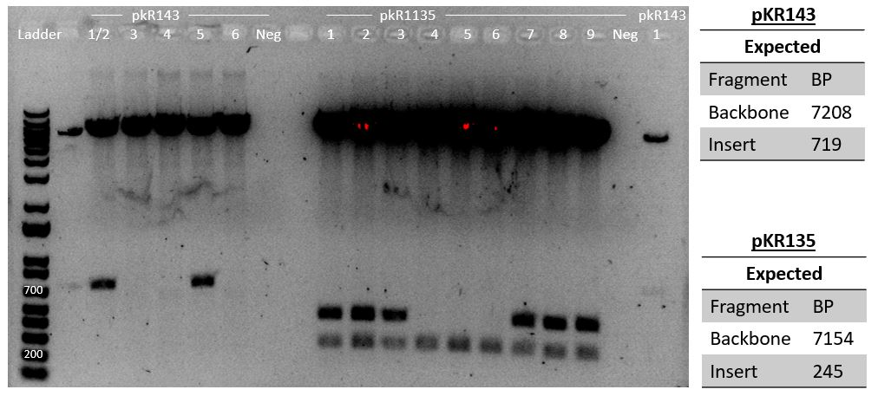
Accidentally loaded candidate pKR143 1 and 2 on top of each other, due to dimpling in the ladder region. Loaded the last 4uL in the resultant last empty lane, lane 20. Since it was such a small volume compared to the rest, might not be able to see it. If I can, I’ll be able to compare to Lane 3 in order to compare and determine what each has.

Tuesday, July 12, 2022
To Do:
- Drop off sequencing sheet at loading dock (oops!)

Results and Data:
Kathryn and I agreed that I will go ahead and complete these cloning projects, specifically in regards to pKR143 despite the fact that LanYFP seems to fluoresce oddly (toxic?) in LVS. Simply seems like a good idea to have it since I am already almost done with it. Regardless, with how LanYFP acts, determined that it would not be worth my time to complete any microscopy, this isn’t really my project anyways. Otherwise, in meeting, discussed how its interesting how all of the third miniprep of the candidate pKR135 prior to retransformation were all correct. Regardless, sent them out for sequencing so we will know (hopefully) tomorrow, and will then transform into LVS on Friday.
Otherwise, discussed the purpose of nanodrop before and after DNase treatment for the RNA samples. After treatment and re-purification, will run on a gel. If I have time tomorrow, then I will do it tomorrow as well. After I have completed this, then I will discuss with Kathryn.

Wednesday, July 13, 2022
To Do:
- Analyze sequencing results
- Patch out LVS for electrocompetent cells
Results and Data:
pKR135 candidates: All of them were good, mismatches showing in the poor sequencing region, but otherwise all of the insert, tetO sites and such appeared to be quite good. I think the sequence for pKR135-3.3 looked a little worse? Maybe it didn’t but I feel it in my heart and pKR135-3.1 looked great so will go ahead with that for the transformation. Need to ask Kathryn about the transformation though, what strain should I be using?

pKR143 candidates: pKR143-1 and -2 both look good. pKR143-5 does not contain the LanYFP-V gene. pKR143-1 does not seem to have the preceding 50 base pairs as I would expect, which is present in the pKR143-2 sample, but the region of bad sequence is literally not in -1, shorter on both sides. As such, I will transform pKR143-2 into LVS rather than -1.

Thursday, July 14, 2022
To Do:
- Nanodrop RNA/DNA Samples
- DNase Treatment and Re-Purify RNA
Results and Data:
Table 1. Total nucleic acid concentrations.

DNase treatment
- Add 10 uL RNase-free DNase buffer and 10 uL RNase-free DNase (Promega, RQ1)
- Incubate at 37°C for 1 hour
- Add 300 uL TRI-Reagent
- Add 400 uL 100% ethanol
- Pass sample over Directzol column, 600 uL per spin, 30 sec per spin at max speed, discarding flow-through in phenol and methanol waste
- Place spin column in new collection tube
- Wash twice with 400 uL RNA PreWash buffer, 30s at max speed, discarding flow-through in phenol and methanol waste
- Add 700 ul of Wash buffer, let sit on column for 3 min
- Spin max speed for 2 min
- Wash again with 700 ul Wash buffer
- Spin max speed for 2 min
- Place column in new collection tube
- Spin max speed for 3 min
- Place column in clean 1.5 mL tube
- Add 100 uL RNase-free water, let sit on column 2 min
- Spin max speed 1 min
- Place flow-through on column again, spin 1 min
During the last spin, sample 4’s, Δrpsu2 BR-1, lid broke off in the centrifuge. Transferred to a new RNase free 1.5mL tube. If there is something wrong with it that may be why. Hopefully it’s okay though:(.
Additionally, accidentally used 1.5mL tubes as collection tubes, but given how much liquid was expected to come out, I switched to collection tubes from the kit. As such, next time I do an RNA purification, I will use 2 mL centrifuge tubes for each collection step (so 3x the number of samples).
Labelled | Contents
1 RNA | LVS BR-1
2 RNA | LVS BR-2
3 RNA | LVS BR-3
4 RNA | Δrpsu2 BR-1
5 RNA | Δrpsu2 BR-2
6 RNA | Δrpsu2 BR-3

Spoke with Hannah and Kathryn regarding the pKR135 plasmid and where to move forward with it. It is not clear if this empty vector will be able to go into the triple deletion strain, as this would leave LVS without any bS21 at all. As such, I will be doing a number of electroporations with different strains and a few different plasmids:

Experiment 1: Will put pKR135 into the double deletion strain, LVS ∆rpsU1 ∆rpsU3, KRLVS24. Given that induction was seen with this strain, this will allow us to sus out if there is toxicity from ATc or something to do with the production of bS21 (overproduction causing toxicity).

Experiment 2: Will electroporate pKR135 and pKR30 (pf-nat) into electrocompetent KRLVS153. Trying to get KRLVS153 to lose kanamycin resistance, so will grow up on regular CHAH plates for preparation of the cells. After electroporation will let transformants grow to single colony on Nat plates, then cross-patch onto Kan and Nat plates to confirm if the Kan plasmid has been lost.

Experiment 3: Will electroporate pF (kanamycin resistant) into pKR157 and allow to grow to single colony then cross-patch on Nat and Kan to try to lose the nat resistant plasmid. Will grow the cells on regular CHAH to encourage loss of the plasmid prior to preparation of the electrocompetent cells.

Friday, July 15, 2022
To Do:
- Run dishwasher

Monday, July 18, 2022
To Do:
- Put away dishes
Results and Data:

N/A. Worked on Program of Study and other graduate school forms. Also looked for proposal templates or guidelines but couldn’t find any specific to the program .

Tuesday, July 19, 2022
To Do:
- Nanodrop RNA
- Run gel of RNA
- cDNA Synthesis
- Start making iron pyrophosphate
- Run dishwasher
Results and Data:

Gel of LVS and Δrpsu RNA Samples
- Make 10 uL aliquots with normalized concentrations, using water to dilute. Then add 2 uL purple loading dye for a final concentration of 1-1.5x and run on gel.
- Rinse comb and gel rig with DI water, then ethanol both as well
- Make fresh agarose gel by adding 1.0g to 100mL fresh 1xTAE and stir with heat until completely dissolved, then place in 50°C water bath until cool enough to touch.
- Set up gel rig to cast gel, with ladder.
- Add 6uL of Sbyr Safe dye to gel rig, pour ~60uL of agarose gel, use ladder to mix, then replace ladder and allow to set.
- Make fresh 1xTAE, turn gel, add TAE, and remove ladder.
- Add 12 uL of each sample according to the loading order below.
- Ran until separated at 113V.
- Look for distinctive bands (23s, 16s, tRNA), rather than smears.

There seemed to be less loading dye in the last two samples, meant to add an additional 0.5uL but forgot before loading the samples. Oops.

Loading Order of RNA Samples Gel
Lane 1 | Lane 2 | Lane 3 | Lane 4 | Lane 5 | Lane 6
LVS-1 | LVS-2 | LVS-3 | Δrpsu2-1 | Δrpsu2-2 | Δrpsu2-3
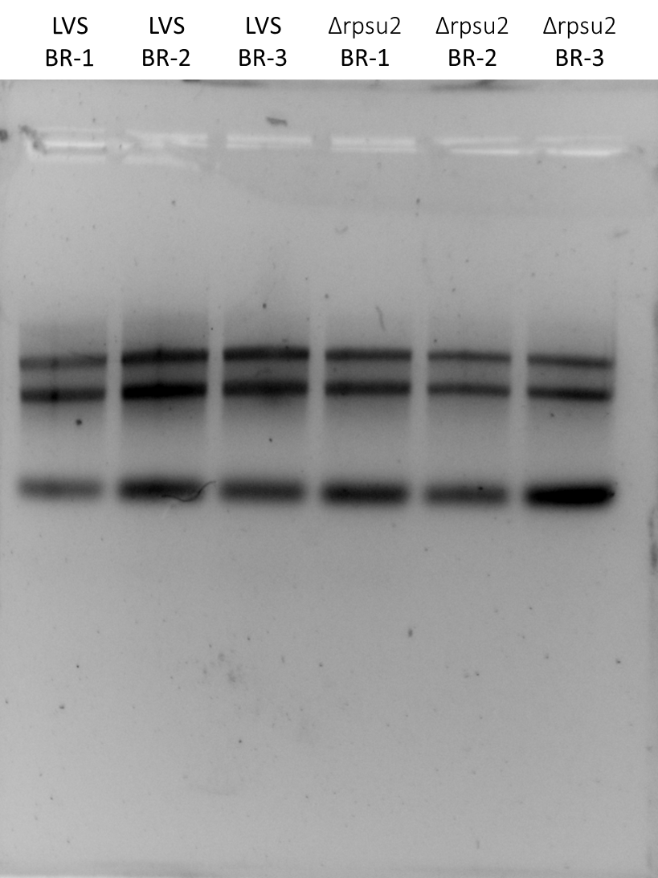
Properly shows 26S, 16S, and tRNA/5SRNA. Omg yay! Look at it! It’s beautiful. Kathryn also looked at my concentrations and purity during the lab meeting and demonstrated how they are quite pure and high concentrations, and the gel confirms that there’s no degradation mush soooo yay I did it!
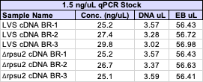

Generating cDNA (Half Reaction)
- Combine the first components for primer annealing:
Component | Volume or Amount | Final Concentration
RNA | 3 ug | 267 - 333 ng/ ul
(NS)₅ Primer (250 ng/ul) | 1.5 ul | 25 ng/ul
RNase-free water | up to 13.5 ul
- To normalize all the cDNA samples to the same DNA mass, dilute with RNase-free water in PCR strip tubes. Total volume of cDNA and water is 13.5 uL.
- Add the 1.5 uL (NS)₅ oligo to the tubes.
- Incubate using program JSScDNA1 in the thermocycler:
Step Temp Time
1 70°C 10'
2 25°C 10'
3 4°C hold
- Prepare master mix at 1.5x the number of reactions.
Component | Final Concentration | Volume | x7.5
5X 1st strand buffer | 1x | 6 | 45
RNase-free water |  | 2.88 | 21.6
100 mM DTT | 10 mM | 3 | 22.5
10 mM dNTPs | 0.5 mM | 1.5 | 11.25
Superscript III (200 U/ul) | 10.8 U/ul | 1.63 | 12.23
- Aliquot 15 ul of master mix into each PCR tube from the first reaction (total volume now 30ul)
- Incubate using program JSScDNA2
Step Temp Time
1 25°C 10'
2 37°C 60'
4 42°C 60'
5 70°C 10'
6 4°C hold
Stopped here as I could not locate the Acid/Bases box. Not sure where it’s held. Strip tube in my RNA box in the -80C.

Wednesday, July 20, 2022
To Do:
- Make patch plate of LVS
- Make patch plate of KRLVS24
- Filter sterilize 2.5% iron pyrophosphate
- Supplement MHB
- Put away dishes
Results and Data:
For the patch plates, I made two for KRLVS24, hopefully so that I can make some singlue use aliquots with the second just in case I have to redo the electroporation at all. However, if I end up needing more cells then I will use that for the electrocompetent prep. I also added two single use aliquots of LVS to the single LVS plate as I was worried about there being enough cells, since there was only enough for two reactions the first time I made electrocompetent cells.
I grew both on no antibiotics plates, LVS for obvious reasons, and KRLVS24 because I saw no indication that it was antibiotic resistant in the strains list.

Reagents
Mueller Hinton Broth (500 mL)
To supplement add:
5mL of 10% glucose
5mL of 2.5% iron pyrophosphate
isovitalex (combine 10mL from liquid vial with solids, add entire volume to broth)
Can keep this supplemented media for 2 weeks, storing at 4 ̊C

2.5% Iron pyrophosphate
0.75g iron pyrophosphate (cabinet) in 30mL of ddiH2O (type 1), dissolved overnight, fresh solution every 2 weeks

Thursday, July 21, 2022
To Do:
- Make patch plate of KRLVS153
- Make patch plate of KRLVS157
- Make electrocompetent LVS
- Make electrocompetent KRLVS24
- Electroporate LVS with pKR143
- Electroporate KRLVS24 with pKR135
- Continue cDNA generation
- Purify cDNA
- Nanodrop cDNA
- Move plasmid stocks into plasmid boxes in -20 and -80
Results and Data:
First, I made electrocompetent cells, both LVS and KRLVS24. I decided to make them day of as, it shouldn’t particularly matter for the LanYFP-V plasmid, nor really the KRLVS24 since there is no plasmid exchange. However, I am following the protocol that Hannah used for each of the EV electroporation experiments, and she made the electrocompetent cells the day of.

Preparing Electrocompetent LVS and KRLVS24 Cells
- Scrape up entire plate of cells into 400 uL of sterile 10% sucrose and resuspend
- Add 1.1 mL of 10% sucrose to a final volume of 1.5 mL
- Spin for 3 minutes at 10,000 rpm
- Remove supernatant, throw out, and resuspend in fresh 1 mL 10% sucrose
- Repeat 3x-5x in 10% sucrose
- After final spin, remove all supernatant.
- Resuspend cells in 10% sucrose at high density (corresponding to ~1x10¹¹ cells /mL); these are EC cells by slowly adding 110 uL at a time. It should be about equal amounts of cells as sucrose.
- For any extra EC cells, aliquot ~110 μL / sterile tube (enough for 2 electroporations) and freeze at -80°C

Electroporating pKR135 into electrocompetent KRLVS24
- For each electroporation, aliquot 4 mL MHB into glass test tubes for recovery, warm in shaker at 37°C
- For each electroporation, in a 2 mm sterile electroporation cuvette, combine:
3 μL of pKR135 plasmid DNA
50 μL electrocompetent cells
- Have recovery media ready
- Electroporate using the EC2 program
- Immediately after individual electroporations, use 1 mL warm recovery media from test tube to wash cells out of cuvette and transfer cells to recovery test tube
- Recover cells for 2 hours, shaking at 37°C
- Plate on CHAH-Nat plates, using 1 plate for each 2 mL tube (2 plates per electroporation)
  - Plated 10 uL and 100 uL of each, straight from recovery tube
- Incubate plates at 37°C for 3 days (or until single colonies appear)
Volume of plasmid used, recovery time, and plating volume based on Hannah’s previous experiments. These parameters were specifically used in the plasmid exchange electroporation which I will be completing tomorrow, but I thought that it was potentially good, or else neutral, to keep the parameters the same for the EV plasmid experiments.
Yay, no arcing.

Electroporating pKR143 into electrocompetent LVS
- For each electroporation, aliquot 4 mL MHB into glass test tubes for recovery, warm in shaker at 37°C
- For each electroporation, in a 2 mm sterile electroporation cuvette, combine:
3 μL of pKR143 plasmid DNA
50 μL electrocompetent cells
- Have recovery media ready
- Electroporate using the EC2 program
- Immediately after individual electroporations, use 1 mL warm recovery media from test tube to wash cells out of cuvette and transfer cells to recovery test tube
- Recover cells for 2 hours, shaking at 37°C
- Plate on CHAH-Kan plates, using 1 plate for each 2 mL tube (2 plates per electroporation)
  - Plated 20 uL and 200 uL of each, straight from recovery tube
- Incubate plates at 37°C for 3 days (or until single colonies appear)
Used these parameters in order to keep with the parameters from the previous fluorescent protein transformation, with pKR142. Also did not arc.
For both electroporations, only did one negative control plate with the higher volume of sample due to number of plates, just in case. Additionally, if something grows, we don’t really need to grow two plates to see if they can grow or if there’s contamination.

Generating cDNA (Half Reaction) Cont’d.
- Remove RNA from sample by degrading with sodium hydroxide:
  - Add 10 ul of 1N NaOH
  - Incubate 65°C for 30'
  - Neutralize with 10 ul of 1N HCl
  - Final volume is 50 ul
- Purify cDNA using Qiagen PCR clean-up column (be very sure there is no ethanol carry-over!)
- Elute in 60 ul of 0.1x EB
- Check concentration by Nanodrop
- Store cDNA at -80°C

cDNA Purification with PCR Purification Kit
- Add 300 uL of Buffer PB to each 60 uL cDNA reaction tube and mix.
- Place a QIAquick column in a 2mL collection tube.
- Centrifuge tube for 30-60s at 13,000rpm. Discard flow through.
- Wash: add 750uL of Buffer PE to the QIAquick column. Centrifuge for 30-60s at 13,000rpm. Discard flow through.
- Centrifuge again for 3 minutes at 13,000rpm to remove any residual wash buffer.
- Place the QIAquick column in a fresh 1.5mL centrifuge tube.
- Elute: add 60uL of Buffer 0.1x EB. Let column stand for 1 minute. Centrifuge for 1 minute at 13,000rpm.
Nanodropped samples with 2 uL. I was initially surprised by the concentration of the cDNA, but I spoke with someone else who does cDNA generation and this is around where they get. Regardless, I will speak to Hannah or Kathryn over whether this is standard.

Friday, July 22, 2022
To Do:
- Dilute cDNA samples for qRT-PCR
- qRT-PCR of cDNA samples
Results and Data:
Patch plates of KRLVS157 and KRLVS153 have not grown enough to make competent cells. This was an issue with KRLVS157 when I was doing the inducible experiments, however I used a large bit of ice from my glycerol stock (since I’m out of single use aliquots) and thought it would be fine. It was not. Otherwise, I wasn’t sure if KRLVS153 had a growth defect, however it makes sense that it would since it seems all the triple mutants have one. I will let them grow another day and do the electroporation tomorrow instead.
Spoke with Kathryn about how to do qRT-PCR specifically in our lab. Discussed what primers to use, which will be KROL343/344 for the 5’UTR region, KROL63/64 for the tul4 region (the control for normalization), and, after speaking with Aisling and looking at her primer efficiencies, KROL504/505 for downstream of the rpsu2 gene. Additionally, Hannah showed me how to use the plate spinner and the LightCyler.
Diluted cDNA samples to 1.5 ng/uL as needed for qRT-PCR according to the following table:

qRT-PCR of LVS and Δrpsu2 cDNA
- Each experiment will need at least one test primer and one control primer for each sample
  - KROL343/344 and KROL504/505 as test primers, specifically to amplify the 5’UTR and downstream of the rpsu2 gene respectively. KROL63/64 as the control, amplifying tul4.
- Each cDNA sample will be used in a reaction with each primer set meaning #Samples*#Primer Sets (6*3=18 reactions)
- Set up a master mixes, labelling the tubes as A, B, C, etc.:
Component | Volume per Reaction | Master Mix (#Samplesx3.5+3.5)
PowerUp SYBR Green MM | 10 uL | 245.0 uL
5uM primer set | 1 uL | 24.5 uL
1.5 ng/uL Stock cDNA | 1 uL
ddiH₂O | 8 uL | 171.5 uL
Total: | 20 uL | 465.5 uL
- Obtain a strip of strip tubes per each primer set with the appropriate number of tubes in the strip, according to the number of cDNA samples. Label strip tubes with letter of primer master mix, and the sample number.
- Add 3.5µL of cDNA into appropriately labelled tubes.
- As these will be in technical triplicate, each tube will be an individual master mix, totaling 70 uL. Thusly, add corresponding primer master mix to tubes containing DNA at a volume of 66.5 uL.
- Pipette 20 µL of each primer set strip tubes, in triplicate, using multichannel pipet.
- Spin plate down and run in LightCycler using the ‘KRamsey_Lab_old_stepone’ program according to ‘qRT-PCR_LightCycler_Machine.docx’
Labelling was as follows:
Master Mix Label | Primer Set
A | KROL343/344 5’UTR
B | KROL504/505 ds-rpsu2
C | KROL63/64 tul4

1 | 2 | 3 | 4 | 5 | 6
LVS 1 | LVS 2 | LVS 3 | Δrpsu2 1 | Δrpsu2 2 | Δrpsu2 3
Loaded 96-well plate according to the following table:
 | 1 | 2 | 3 | 4 | 5 | 6 | 7 | 8 | 9
A | A1 |  |  | B1 |  |  | C1
B | A2 |  |  | B2 |  |  | C2
C | A3 |  |  | B3 |  |  | C3
D | A4 |  |  | B4 |  |  | C4
E | A5 |  |  | B5 |  |  | C5
F | A6 |  |  | B6 |  |  | C6

Saturday, July 23, 2022
To Do:
- Make electrocompetent KRLVS153
- Make electrocompetent KRLVS157
- Electroporate KRLVS153 with pKR135 and pKR30
- Electroporate KRLVS157 with pF
Results and Data:

Preparing Electrocompetent KRLVS153 and KRLVS157 Cells
- Scrape up entire plate of cells into 400 uL of sterile 10% sucrose and resuspend
- Add 1.1 mL of 10% sucrose to a final volume of 1.5 mL
- Spin for 3 minutes at 10,000 rpm
- Remove supernatant, throw out, and resuspend in fresh 1 mL 10% sucrose
- Repeat 3x-5x in 10% sucrose
- After final spin, remove all supernatant.
- Resuspend cells in 10% sucrose at high density (corresponding to ~1x10¹¹ cells /mL); these are EC cells by slowly adding 110 uL at a time. It should be about equal amounts of cells as sucrose.
- For any extra EC cells, aliquot ~110 μL / sterile tube (enough for 2 electroporations) and freeze at -80°C

Electroporating pKR135 and pKR30 into electrocompetent KRLVS153
- For each electroporation, aliquot 4 mL MHB into glass test tubes for recovery, warm in shaker at 37°C
- For each electroporation, in a 2 mm sterile electroporation cuvette, combine:
3 μL of pKR135 and pKR30 plasmid DNA
50 μL electrocompetent cells
- Have recovery media ready
- Electroporate using the EC2 program
- Immediately after individual electroporations, use 1 mL warm recovery media from test tube to wash cells out of cuvette and transfer cells to recovery test tube
- Recover cells for 2 hours, shaking at 37°C
- Plate on CHAH-Nat plates, using 1 plate for each 2 mL tube (2 plates per electroporation)
  - Plated 10 uL and 100 uL of each, straight from recovery tube
- Incubate plates at 37°C for 3 days (or until single colonies appear)

Electroporating pF into electrocompetent KRLVS157
- For each electroporation, aliquot 4 mL MHB into glass test tubes for recovery, warm in shaker at 37°C
- For each electroporation, in a 2 mm sterile electroporation cuvette, combine:
3 μL of pF plasmid DNA
50 μL electrocompetent cells
- Have recovery media ready
- Electroporate using the EC2 program
- Immediately after individual electroporations, use 1 mL warm recovery media from test tube to wash cells out of cuvette and transfer cells to recovery test tube
- Recover cells for 2 hours, shaking at 37°C
- Plate on CHAH-Kan plates, using 1 plate for each 2 mL tube (2 plates per electroporation)
  - Plated 10 uL and 100 uL of each, straight from recovery tube
- Incubate plates at 37°C for 3 days (or until single colonies appear)

Sunday, July 24, 2022
To Do:
- Patch single colonies of pKR143 onto CHAH+Kan plates
- Patch single colonies of pKR135 onto CHAH+Nat plates
- Check Hannah’s plates in the Burtin Lab incubator to see if there are colonies
Results and Data:
Pulled out Hannah’s plates at 3:20 pm.
Electroporation:
pKR135
Did not see any colonies on the 10 uL plate, but there were quite a few on the 100 uL plate. They were kind of group to one side, but there were some larger, well isolated ones.
pKR143
Pretty much a lawn on the 200uL plate, so used the 20uL plate to make patches. The colonies, again, grouped to one side so I wonder if I had the plates on the edge of the base of the Bunsen burner when they were drying. The colonies were pretty grouped and not super well isolated, but I took what were the most isolated.

Monday, July 25, 2022
To Do:
- Make permanent stocks of LVS + pKR143
- Make permanent stocks of KRLVS24 + pKR135
Results and Data:
Looked through my qRT-PCR data with Hannah. She checked that all the formulas were correct and explained the different parts of the worksheet to me. ΔCt are the normalized values based on tul4. ‘Normalizing’ WT to 1 using 1.8 (as each cycle should double DNA but doesn’t ever quite reach that point, 1.8x each cycle is the value) with negative exponents in order to reduce back from the 40 cycles to the amount of DNA in the first.
The standard deviation for the technical replicants shouldn’t be over 0.1, shaded some which were. In red, they couldn’t be corrected to 0.1 by removing the outliers. For the two shaded red, removed the outlier as compared to the data for the first replicate which was pretty perfect. I recalled that I did have less master mix than I was expecting at some point during the set-up. I probably should have redone it, but I didn’t because I am DUMB. But anyways, that’s probably why those two are so off from the rest. I will discuss with Kathryn, but I kind of want to redo it.
Looked at Aisling’s and Dan’s data, and my qRT-PCR showed a several times larger difference between the relative transcript abundance of Δrpsu2 as compared to WT.
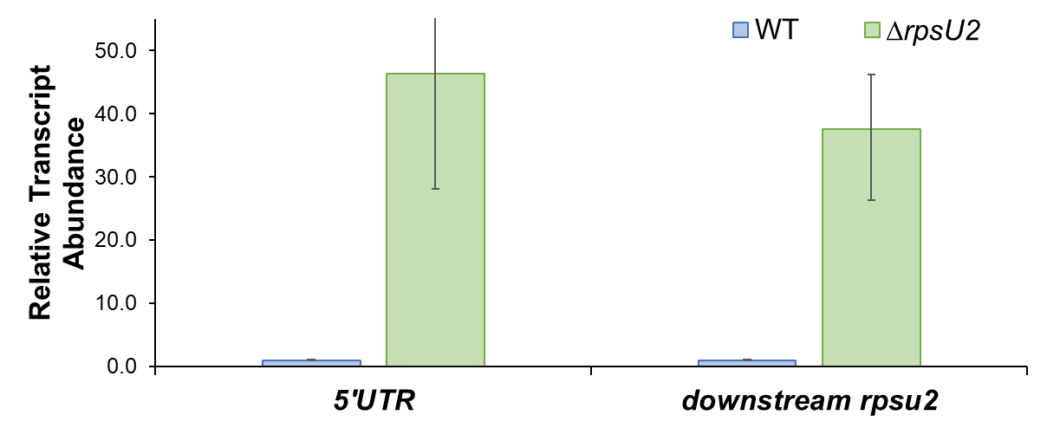

Freezing and Storing Permanent Strains
- Per strain, label 2 cryotubes with strain number. Include LVS, strain number, genotype, date.
- Add 200 uL sterile 75% glycerol to each tube (2 per strain).
- In a sterile 2 mL tube (1 per strain), add 400 uL of MHB
- Resuspend patch (all of what you have) in MHB to homogeneity
- Correct volume to 1700 uL (add 2x 650 uL MHB)
- Transfer 800 uL to each cryotube (final volume should be 1 mL)
- Vortex cryotube
- Quickly spin (mini-fuge) to get liquid to the bottom of the tube
- Freeze at -80°C in appropriate strain box
Spoke with Kathryn and ultimately, she sees no reason to repeat this experiment again. Instead, next I will be looking at the strains which Aisling and Dan were working on. These strains utilize different combinations of the rpsU2 and tul4 promoter/5’UTR. The purpose of this is in order to isolate which component of the gene bS21-2 is interacting with in order to regulate its own expression. These strains are designed to have the downstream primer only at the native locus, LacZ is only in the Tn7 site, and 5’UTR is at both the native and Tn7 location.
I confirmed the strain numbers with Aisling and determined that two of the strains were not created, as they were having difficulty creating the plasmid. As such, I will work on creating those strains alongside the following experiments to look at the relative transcript abundance through qRT-PCR. Experiment 1 will be completed in biological triplicate, however experiment 2 will be completed in biological duplicate in order to work up to experiment 3 (and eventually 4), which will be completed in biological triplicate.

Note for Future Experiment. After I have these qRT-PCR results, I will use these strains in a β-galactosidase assay in order to examine the protein abundance via activity (due to the LacZ fusion). Eventually, I will look at rpsU1, rpsU2, and rpsU3 in the context of ΔrpsU1 or ΔrpsU3 due to some indication that these homologs also interact in the regulation of bS21-2.

Tuesday, July 26, 2022
To Do:
- Check electroporation of KRLVS153 + pKR135
- Check electroporation of KRLVS153 + pKR30
- Check electroporation of KRLVS157 + pF
Results and Data:
Electroporations: Did not see single colonies yet, of which I am not surprised given that triple mutant strain tends to grow poorly. Will ask Hannah how long it took single colonies to grow on her plates for either KRLVS153 or KRLVS157, but I am expecting that they took longer, maybe five days? Did see a couple colonies on the negative plate which is obviously very concerning, but I am hoping that there will be very many more colonies on the electroporation plates. That said, given that the other plates were completely clear, I would suspect that the contaminant would should up at the same time on all of the plates, but it was only on the negative so..

Wednesday, July 27, 2022
To Do:
- Streak out KRLVS148 and KRLVS149 to single colony
- Patch out KRLVS148 and KRLVS149 for freezing down
Results and Data:
Struck for isolation on individual CHAH+Kan plates. Grew patches on same CHAH+Kan plate.

Thursday, July 28, 2022
To Do:
- Check and crosspatch electroporation of KRLVS153 + pKR135
- Check and crosspatch electroporation of KRLVS153 + pKR30
- Check and crosspatch electroporation of KRLVS157 + pF
- Streak out KRLVS148, KRLVS149, KRLVS111, and KRLVS112 to single colony
- Ligation of gel purified pKR122 sample and backbone
- Transformation of ligation of pKR122 sample
Results and Data:
Received restricted and gel purified PrpsU2 and tul4 5’UTR PCR amplified gBlock fragment and restricted/gel purified pKR68 backbone from Aisling, completed on 2/03/2022. Will attempt to ligate and transform. Her and Dan were having a lot of trouble getting this plasmid, however, Hannah believes that they kept trying from the first gel purification. Additionally, Dan was having difficulty ligating. I will try this out, and if it does not work, then begin from the beginning. Kathryn asked me to double check that we were using the correct restriction sites, which should be KpnI and NotI based on the plasmid map, which is what is stated in Aisling’s notebook as what they used.

Ligation of PrpsU2 tul4 5’UTR PCR from gBlock with pKR68 backbone
- Make a reaction table with desired ligations. Always include a backbone only control for each plasmid backbone used.
Tube | Insert | Backbone
1 | KpnI, NotI dig., pur. PrpsU2:tul4 5’UTR PCR | KpnI, NotI digested, purified pKR68
2 | - | KpnI, NotI digested, purified pKR68
- Set up master mix table:
Component | Reaction 1 (uL) | Reaction 2 (uL) | Master Mix (3x)
H₂O | 11.5 | 11.5 | 34.5
10x ligase buffer | 2.0 | 2.0 | 6.0
Insert | 4.0 | - | -
Backbone | 2.0 | 2.0 | 6.0
Ligase | 0.5 | 0.5 | 1.5
TOTAL | 20.0 | 20.0 | 48.0
- Obtain ice to assemble and keep the reactions on. This is important, as the reaction happens at 16°C and the ligase buffer (which contains ATP) needs to be kept cold in order to avoid degradation. Take a 10 uL aliquot of 10X ligase buffer from the miscellaneous buffers box in the -20C.
- Obtain and label 1.5mL tubes for the reactions. Be sure to include the date and your initials.
- To the individual tubes, add indicated amounts of H₂O (___uL), 10x buffer (_____uL), insert (____uL), and backbone (____uL).
- Add indicated amount of ligase (___uL) to the individual tubes. Remember to keep the ligase in a mini cooler.
- After all of the components have been added, mix each tube with a pipette set to 18 uL.
- Place on bench for 10 minutes.

Transformation of PrpsU2 tul4 5’UTR Ligation into E. coli
- Set up reaction table. Always include a positive and negative control for each antibiotic. Use 8 uL per ligation and plate 10 uL and 200 uL.
  - Positive control: pF; Backbone ligation: KpnI-NotI digested pKR68
Reaction table
Tube# | Purpose | DNA | Vol. of DNA | Final vol. to plate | # of LB-kan plates
1 | (+) control | pF | 1 uL | 20 ul, 100 ul | 2
2 | (-) control | None | 0 | 20 ul, 100 ul | 2
3 | Backbone Ligation | pKR68 (digested) | 8 uL | 10 uL, 200 uL | 2
4 | Ligation 1 | pKR122 | 8 uL | 10 uL, 200 uL | 2
Total number of plates |  |  |  |  | 8

- Check to be sure you have enough LB-Kan plates. If plates were stored at 4°C, warm at 37°C until needed.
- Obtain DNA and thaw on ice if necessary.
- Thaw appropriate number of competent cell tubes on ice (5 reactions per tube of competent cells)
- Label sterile tubes as indicated in reaction table. Add indicated volume of indicated DNA on ice.
- When competent cells are thawed (check by probing for frozen cells using a sterile pipette tip), gently pipette 100 uL of cells into each reaction tube directly onto DNA using aseptic technique.
- Incubate cells on ice for 20 minutes. During incubation, find or set heat block to 42°C.
- Place tubes with cells and DNA onto 42°C heatblock for 30 seconds (heat shock step).
- After heat shock, place tubes back on ice until next step (don’t keep them here too long).
- Using aseptic technique, add 1 mL LB (no antibiotic) to each microfuge tube.
- Using autoclave tape, tape microfuge tubes down in shaking incubator set to 37°C.
- Allow cells to recover for 1 hour at 37°C, shaking. Place in a rack after shaking (NOT back on ice).
- Using aseptic technique, plate indicated amount of cells on appropriate antibiotic plates (LB-Kan), spreading until plates look dry.
Crosspatches: Picked mostly small colonies, but a few large colonies from each transformation and cross-patched 6 colonies. Scraped up entire colony with stick, patched onto antibiotic plate containing the antibiotic from the desire plasmid cassette, then on the opposing antibiotic plate. Hannah suggested I will likely have to streak out patches to single colony again in order to encourage the loss of the other plasmid. Additionally, stated it might take two days for the EV/30 plasmid patches to show on Kan, and the pF to show on Nat.

Friday, July 29, 2022
To Do:
- Make overnights of pKR122 in E. coli
- Check crosspatches
- Streak out KRLVS148, KRLVS149, KRLVS150 and KRLVS151 to single colony
- Make CHAH + Kan plates
Results and Data:
Only had two colonies from transformation so, I made two overnights in 5mL LB + 50 ug/mL Kan.
Checked crosspatches, given how late I did them in the day yesterday and their slow growth, I am not surprised that there is not much growth yet. From my brief glance, it does look as though they all grew on both antibiotic plates, so tomorrow when I check to make sure I will streak out the plates to single colony in my continued effort to make them lose their plasmids.

Reagents
CHAH+Kan
To a 1L flask add:
30.6g of cystine heart agar
300mL of ddiH2O (type I)
stirbar
Heat on 60°C, stirring, for 10 minutes (media should be totally dissolved)
Autoclave on 30’ liquid cycle, filling the water bin up to the height of the media
Add 2% hemoglobin to water bath, after autoclave add CHA as well
Using sterile technique, pour hemoglobin into CHA
For 5 ug/ml, add 60 ul of 50 mg/mL kanamycin to 600 mL of media MADE HALF FLASK

Saturday, July 30, 2022
To Do:
- Miniprep pKR122
- Patch out single colonies of KRLVS148 and KRLVS149 in triplicate
- Wrap Hannah’s transformation plates in parafilm and put in fridge
- Run dishwasher
- Make CHAH+Kan plates AGAIN because I can’t COUNT
- Streak crosspatches to single colony on desired antibiotic plate
Results and Data:
Overnights did not grow up, which I kind of expected because when I was collecting the colonies it seemed like the colonies were maybe just marks on the bottom of the plate, or contamination on the bottom of the plate. As such, I will start over from the PCR step and we’ll go from there. Jk. I was looking through Aisling’s notebook and she used PIR cells for her ligation so I guess I’ll use the correct competent cells and go from there. End me.

Reagents
CHAH+Kan
To a 1L flask add:
30.6g of cystine heart agar
300mL of ddiH2O (type I)
stirbar
Heat on 60°C, stirring, for 10 minutes (media should be totally dissolved)
Autoclave on 30’ liquid cycle, filling the water bin up to the height of the media
Add 2% hemoglobin to water bath, after autoclave add CHA as well
Using sterile technique, pour hemoglobin into CHA
For 5 ug/ml, add 60 ul of 50 mg/mL kanamycin to 600 mL of media MADE HALF FLASK
Crosspatch: all grew on both antibiotic plates. For single colony plates, I chose to streak the patch from the plate with the desired antibiotic resistance which looked comparably less on the antibiotic plate where we want susceptibility. Aka KRLVS153+pKR135/pKR30 were struck to single colony on Nat (based on the patch which grew much less on its Kan), and KRLVS157+pF was struck to single colony on Kan.

Sunday, July 31, 2022
To Do:
- Resuspend patches of KRLVS148 and KRLVS149 and grow up cultures for RNA purification
- Put away dishes
- Make 2.5% iron pyrophosphate
- RNA purification
- Nanodrop RNA samples
- Patch out single colonies of KRLVS148, KRLVS149, KRLVS111, and KRLVS112 in duplicate
Results and Data:

Setting Up KRLVS148 and KRLVS149 Cultures for RNA Purification
- Scrape each triplicate patch of KRLVS148 and KRLVS149 into individual tubes of 400uL MHB
- Check OD”s in a 1:20 dilution (50uL of sample in 950uL of MHB)
- Calculate volume to add to tubes of 8 mL MHB for an OD of 0.08 for KRLVS149 and 0.1 for KRLVS148 (calculate for an OD of 0.1 or 0.13 to account for error)
- Check OD’s with 600uL
- Shake @37°C and grow to mid-log, checking OD’s at ~2-2.5 hours initially

RNA Cultures OD’s
 | 0 hours | 2 hours | 4 hours | 4.6 hours
148-1 | 0.124 | 0.159 | 0.256 | 0.305
148-2 | 0.081 | 0.122 | 0.196 | 0.220
148-3 | 0.109 | 0.181 | 0.284 | 0.325
149-1 | 0.102 | 0.156 | 0.286 | 0.335
149-2 | 0.106 | 0.167 | 0.305 | 0.363
149-3 | 0.102 | 0.162 | 0.313 | 0.383
I calculated for 30% more OD than wanted, as suggested by Hannah, which worked for KRLVS148 (drpsU2) almost perfectly (I knew the second replicate would be a little low but it shouldn’t have been THAT low), but obviously was too high for KRLVS149 (rpsU2 +). Tomorrow I will calculate for 0.9 OD for the rpsU2 + cells.
Additionally, I set up my centrifuge tubes and culture tubes for the next two days. I set them in the fridge, obviously, because MHB.

RNA Purification of KRLVS148 and KRLVS149
- Pellet 1.8mLx2 of culture at max speed @room temperature
- Resuspend cell pellet in 1 mL TRI-Reagent
- Incubate at 60°C for 10 min
- Spin at 4°C for 10 min at max speed
- Transfer supernatant to new 2mL tube (~950 uL).
- Add equal volume 100% ethanol
- Pass sample over Directzol column, 600 uL per spin, 30 sec per spin at max speed, discarding flow-through in phenol and methanol waste
- Place spin column in new collection tube
- Wash twice with 400 uL RNA PreWash buffer, discarding flow-through in phenol and methanol waste
- Add 700 ul of Wash buffer, let sit on column for 3 min
- Spin max speed for 2 min
- Wash again with 700 ul Wash buffer
- Spin max speed for 2 min
- Place column in new collection tube
- Spin max speed for 3 min
- Place column in clean 1.5 mL tube
- Add 90 uL RNase-free water, let sit on column 2 min
- Spin max speed 1 min
- Place flow-through on column again, spin 1 min
- Store nucleic acids at -80°C if not moving directly to the next step

My pellets seemed comparably smaller as compared to last time, however, that could be because, I believe, I spun down in 1.5 mL tubes as opposed to 2 mL tubes as I did this time (because I read the protocol better or something lol). However, given the yield I do believe it is possible that they were in fact smaller than last time. Otherwise, nothing notable happened during the purification aside from the cap snapping on sample 6, guess at max speed you really can’t just turn the lids inwards. Oh well, noted.
Stored total nucleic acids in -80C freezer in new RNA box. Labelled with the date on the side and, on the lid, the following:

Labelled | Contents
1 RNA | KRLVS148-1
2 RNA | KRLVS148-2
3 RNA | KRLVS148-3
4 RNA | KRLVS149-1
5 RNA | KRLVS149-2
6 RNA | KRLVS149-3
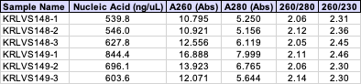

Reagents
2.5% Iron pyrophosphate
0.75g iron pyrophosphate (cabinet) in 30mL of ddiH2O (type 1), dissolved overnight, fresh solution every 2 weeks

August 2022

Monday, August 1, 2022
To Do:
- Resuspend patches of KRLVS148, KRLVS149, KRLVS111, and KRLVS112 for RNA purification
- Make patches of KRLVS148, KRLVS149, KRLVS150, and KRLVS151
- DNase treatment of 7/31/22 RNA samples
- Second RNA purification of 7/31/22 RNA samples
- Nanodrop 7/31/22 RNA samples
- Prepare aliquots of 7/31/22 RNA samples for cDNA synthesis and gel
- Run RNA gel of 7/31/22 RNA samples – will do either tomorrow or Wednesday
- RNA purification of KRLVS148, KRLVS149, KRLVS111, and KRLVS112
- Nanodrop KRLVS148, KRLVS149, KRLVS111, and KRLVS112 RNA samples
- Filter sterilize 2.5% iron pyrophosphate
- Supplement MHB
- Check Aisling’s plates
Results and Data:

DNase treatment of KRLVS148 and KRLVS149
- Add 10 uL RNase-free DNase buffer and 10 uL RNase-free DNase (Promega, RQ1)
- Incubate at 37°C for 1 hour
- Add 300 uL TRI-Reagent
- Add 400 uL 100% ethanol
- Pass sample over Directzol column, 600 uL per spin, 30 sec per spin at max speed, discarding flow-through in phenol and methanol waste
- Place spin column in new collection tube
- Wash twice with 400 uL RNA PreWash buffer, 30s at max speed, discarding flow-through in phenol and methanol waste
- Add 700 ul of Wash buffer, let sit on column for 3 min
- Spin max speed for 2 min
- Wash again with 700 ul Wash buffer
- Spin max speed for 2 min
- Place column in new collection tube
- Spin max speed for 3 min
- Place column in clean 1.5 mL tube
- Add 100 uL RNase-free water, let sit on column 2 min
- Spin max speed 1 min
- Place flow-through on column again, spin 1 min
Again, nothing particularly notable happened during this RNA purification, except I dropped sample 6 after the first elution but it appears to have been fine. Just in the centrifuge, not on the floor or anything. Additionally, nanodrop’d the pure RNA:
It could be better as for the purity but whatever, I guess. I set up my normalized samples for the RNA gel and cDNA and placed them in my RNA box. Originally was going to run gel today, but decided on later. Did the following dilutions for the gel:
And the following dilutions for the cDNA generation:

Setting Up KRLVS148, KRLVS149, KRLVS111, KRLVS112 Cultures for RNA Purification
- Scrape each duplicate patch of KRLVS148, KRLVS149, KRLVS111, and KRLVS112 into individual tubes of 400uL MHB
- Check OD”s in a 1:20 dilution (50uL of sample in 950uL of MHB)
- Calculate volume to add to tubes of 8 mL MHB for an OD of 0.08 for KRLVS149 and KRLVS112 and 0.1 for KRLVS148 and KRLVS111 (calculate for an OD of 0.095 or 0.13 to account for error)
- Check OD’s with 600uL
- Shake @37°C and grow to mid-log, checking OD’s at ~2-2.5 hours initially

RNA Cultures OD’s
 | 0 hours | 2 hours | 4 hours | 5 hours
148-1 | 0.106 | 0.153 | 0.192 | 0.222
148-2 | 0.118 | 0.175 | 0.258 | 0.287
149-1 | 0.081 | 0.167 | 0.270 | 0.354
149-2 | 0.087 | 0.182 | 0.300 | 0.390
111-1 | 0.113 | 0.126 | 0.185 | 0.216
111-2 | 0.121 | 0.153 | 0.234 | 0.274
112-1 | 0.079 | 0.140 | 0.258 | 0.334
112-2 | 0.079 | 0.128 | 0.237 | 0.309
Wowee! These cells sure do not want to grow! If this is a persistent issue, with my second repetition I might shoot for a calculated OD of 0.15.

RNA Purification of KRLVS148, KRLVS149, KRLVS111, and KRLVS112
- Pellet 1.3mLx3 of culture at max speed @room temperature
- Resuspend cell pellet in 1 mL TRI-Reagent
- Incubate at 60°C for 10 min
- Spin at 4°C for 10 min at max speed
- Transfer supernatant to new 2mL tube (~950 uL).
- Add equal volume 100% ethanol
- Pass sample over Directzol column, 600 uL per spin, 30 sec per spin at max speed, discarding flow-through in phenol and methanol waste
- Place spin column in new collection tube
- Wash twice with 400 uL RNA PreWash buffer, discarding flow-through
- Add 700 ul of Wash buffer, let sit on column for 3 min
- Spin max speed for 2 min
- Wash again with 700 ul Wash buffer
- Spin max speed for 2 min
- Place column in new collection tube
- Spin max speed for 3 min
- Place column in clean 1.5 mL tube
- Add 90 uL RNase-free water, let sit on column 2 min
- Spin max speed 1 min
- Place flow-through on column again, spin 1 min
- Store nucleic acids at -80°C if not moving directly to the next step

I took a bit longer than normal to transfer the supernatant to the ethanol and I noticed what appeared to be sticky strings, which I assume was cell gunk, even though I couldn’t see it after I spun them. I am worried about protein contamination, next time I definitely will not take so long! I hadn’t ever seen that before.
Stored total nucleic acids in -80C freezer in new RNA box. Labelled with the date on the side and, on the lid, the following:

Labelled | Contents
1 RNA | KRLVS148-1
2 RNA | KRLVS148-2
3 RNA | KRLVS149-1
4 RNA | KRLVS149-2
5 RNA | KRLVS111-1
6 RNA | KRLVS111-2
7 RNA | KRLVS112-1
8 RNA | KRLVS112-2
I nandrop’d the samples of total nucleic acids after the RNA purification. There doesn’t seem to be a lot of protein contamination, as I expected, unless I’m mixing up the ratios. There is, however, a lot of phenol/ethanol contamination. Dang! Hopefully I can get that out in the second purification.
Aisling’s plates had no growth as expected.

Reagents
Mueller Hinton Broth (500 mL)
To supplement add:
5mL of 10% glucose
5mL of 2.5% iron pyrophosphate
isovitalex (combine 10mL from liquid vial with solids, add entire volume to broth)
Can keep this supplemented media for 2 weeks, storing at 4 ̊C

2.5% Iron pyrophosphate
0.75g iron pyrophosphate (cabinet) in 30mL of ddiH2O (type 1), dissolved overnight, fresh solution every 2 weeks

Tuesday, August 2, 2022
To Do:
- Resuspend patches of KRLVS148, KRLVS149, KRLVS150, and KRLVS151 and grow for RNA purification
- DNase treatment of 8/1/2022 RNA samples
- Second RNA purification of 8/1/2022 RNA samples
- Nanodrop 8/1/22 RNA samples
- Prepare aliquots of 8/1/22 RNA samples for cDNA synthesis and gel
- RNA purification of KRLVS148, KRLVS149, KRLVS150, and KRLVS151
- Nanodrop KRLVS148, KRLVS149, KRLVS150, and KRLVS151 RNA samples
- Check electroporation single colony plates and crosspatch
Results and Data:

DNase treatment of KRLVS148, KRLVS149, KRLVS111, and KRLVS112 RNA Samples
- Add 10 uL RNase-free DNase buffer and 10 uL RNase-free DNase (Promega, RQ1)
- Incubate at 37°C for 1 hour
- Add 300 uL TRI-Reagent
- Add 400 uL 100% ethanol
- Pass sample over Directzol column, 600 uL per spin, 30 sec per spin at max speed, discarding flow-through in phenol and methanol waste
- Place spin column in new collection tube
- Wash twice with 400 uL RNA PreWash buffer, 30s at max speed, discarding flow-through in phenol and methanol waste
- Add 700 ul of Wash buffer, let sit on column for 3 min
- Spin max speed for 2 min
- Wash again with 700 ul Wash buffer
- Spin max speed for 2 min
- Place column in new collection tube
- Spin max speed for 3 min
- Place column in clean 1.5 mL tube
- Add 100 uL RNase-free water, let sit on column 2 min
- Spin max speed 1 min
- Place flow-through on column again, spin 1 min
Nothing exciting happened during the second purification of these samples. I nanodrop’d the samples afterwards:
Additionally, I set up normalized aliquots of the RNA for my gel and cDNA synthesis, according to the following tables:

Setting Up KRLVS148, KRLVS149, KRLVS150, KRLVS151 Cultures for RNA Purification
- Scrape each triplicate patch of KRLVS148, KRLVS149, KRLVS150, and KRLVS151 into individual tubes of 400uL MHB
- Check OD”s in a 1:20 dilution (50uL of sample in 950uL of MHB)
- Calculate volume to add to tubes of 8 mL MHB for an OD of 0.08 for KRLVS149 and KRLVS151, and 0.1 for KRLVS148 and KRLVS150 (calculate for an OD of 0.1 or 0.13 to account for error)
- Check OD’s with 600uL
- Shake @37°C and grow to mid-log, checking OD’s at ~2-2.5 hours initially

RNA Cultures OD’s
 | 0 hours | 2 hours | 4 hours | 5 hours
148-1 | 0.121 | 0.179 | 0.236 | 0.263
148-2 | 0.088 | 0.134 | 0.205 | 0.215
148-3 | 0.107 | 0.150 | 0.195 | 0.224
149-1 | 0.087 | 0.171 | 0.305 | 0.382
149-2 | 0.092 | 0.170 | 0.311 | 0.393
149-3 | 0.079 | 0.125 | 0.208 | 0.283
150-1 | 0.119 | 0.162 | 0.209 | 0.238
150-2 | 0.111 | 0.156 | 0.207 | 0.239
150-3 | 0.114 | 0.185 | 0.230 | 0.272
151-1 | 0.096 | 0.179 | 0.320 | 0.404
151-2 | 0.062 | 0.136 | 0.249 | 0.322
151-3 | 0.092 | 0.144 | 0.185 | 0.235

My patches for KRLVS149 and KRLVS151 were pretty undergrown. Obviously, the worst was the second replicate for KRLVS151. I noticed that there were more air bubbles with these pipet tips, so that may be part of my problem with the extreme inconsistency, as I only noticed partway through measuring. I will be more careful in the future, and hopefully that will fix it.

RNA Purification of KRLVS148, KRLVS149, KRLVS150, and KRLVS151
- Pellet 1.8mLx2 of culture at max speed @room temperature
- Resuspend cell pellet in 1 mL TRI-Reagent
- Incubate at 60°C for 10 min
- Spin at 4°C for 10 min at max speed
- Transfer supernatant to new 2mL tube (~950 uL).
- Add equal volume 100% ethanol
- Pass sample over Directzol column, 600 uL per spin, 30 sec per spin at max speed, discarding flow-through in phenol and methanol waste
- Place spin column in new collection tube
- Wash twice with 400 uL RNA PreWash buffer, discarding flow-through in phenol and methanol waste
- Add 700 ul of Wash buffer, let sit on column for 3 min
- Spin max speed for 2 min
- Wash again with 700 ul Wash buffer
- Spin max speed for 2 min
- Place column in new collection tube
- Spin max speed for 3 min
- Place column in clean 1.5 mL tube
- Add 90 uL RNase-free water, let sit on column 2 min
- Spin max speed 1 min
- Place flow-through on column again, spin 1 min
- Store nucleic acids at -80°C if not moving directly to the next step

Stored total nucleic acids in -80C freezer in new RNA box. Labelled with the date on the side and, on the lid, the following:

Labelled | Contents
1 RNA | KRLVS148-1
2 RNA | KRLVS148-2
3 RNA | KRLVS148-3
4 RNA | KRLVS149-1
5 RNA | KRLVS149-2
6 RNA | KRLVS149-3
7 RNA | KRLVS150-1
8 RNA | KRLVS150-2
9 RNA | KRLVS150-3
10 RNA | KRLVS151-1
11 RNA | KRLVS151-2
12 RNA | KRLVS151-3
Nothing notable happened during the purification. However, before I begin the second purification tomorrow I will need to add ethanol to the second wash buffer bottle. Additionally, I nanodrop’d my samples:
I believe both KRLVS149-1 and -2 are outside of the linear range, which is super annoying. Hopefully I lose some in the second purification, or else I will probably have to dilute and re-nanodrop prior to making the aliquots.

Additionally, I looked at my electroporation plates and they had come to single colony. I cross patched the same as before, by scraping up a colony and patching it on the plate with the desire antibiotic followed by the plate with the undesired antibiotic. This time I only patched out four, as per Hannah’s suggestion, in the event that I actually lose the plasmid so I can make a stock. The colonies were very tiny, but I was able to get isolated, though not well isolated, colonies. If I have to bring them to single colony again, I will exchange my stick more. As I completed this in the evening, I do not believe the patches will be ready to view until Thursday.

Wednesday, August 3, 2022
To Do:
- Run gel of pure RNA samples from 8/1 and 8/2
- Transform pKR122 into PIR cells
- Plate Aisling’s cells
- CHAH + Kan and CHAH + Nat
- Check electroporation patch plates
Results and Data:

Transformation of PrpsU2 tul4 5’UTR Ligation into E. coli
- Set up reaction table. Always include a positive and negative control for each antibiotic. Use 8 uL per ligation and plate 10 uL and 200 uL.
  - Positive control: pEX; Backbone ligation: KpnI-NotI digested pKR68
Reaction table
Tube# | Purpose | DNA | Vol. of DNA | Final vol. to plate | # of LB-kan plates
1 | (+) control | pEX | 1 uL | 100 ul | 1
2 | (-) control | None | 0 | 100 ul | 1
3 | Backbone Ligation | pKR68 (digested) | 8 uL | 10 uL, 200 uL | 2
4 | Ligation 1 | pKR122 | 8 uL | 10 uL, 200 uL | 2
Total number of plates |  |  |  |  | 6
- Check to be sure you have enough LB-Kan plates. If plates were stored at 4°C, warm at 37°C until needed.
- Obtain DNA and thaw on ice if necessary.
- Thaw appropriate number of competent cell tubes on ice (5 reactions per tube of competent cells)
- Label sterile tubes as indicated in reaction table. Add indicated volume of indicated DNA on ice.
- When competent cells are thawed (check by probing for frozen cells using a sterile pipette tip), gently pipette 100 uL of cells into each reaction tube directly onto DNA using aseptic technique.
- Incubate cells on ice for 20 minutes. During incubation, find or set heat block to 42°C.
- Place tubes with cells and DNA onto 42°C heatblock for 30 seconds (heat shock step).
- After heat shock, place tubes back on ice until next step (don’t keep them here too long).
- Using aseptic technique, add 1 mL LB (no antibiotic) to each microfuge tube.
- Using autoclave tape, tape microfuge tubes down in shaking incubator set to 37°C.
- Allow cells to recover for 1 hour at 37°C, shaking. Place in a rack after shaking.
- Using aseptic technique, plate indicated amount of cells on appropriate antibiotic plates (LB-Kan), spreading until plates look dry.
Last time I tried this transformation I used XL1 Blue cells, however, when I looked back at Aisling’s notebook I saw that they used PIR cells. I probably should have checked prior to doing the initial transformation, however, I thought it was another pF based plasmid. I saved my ligation from last week, so I will try using that to transform the cells and hopefully I will actually get transformants this time. As with last time, I will only used one positive and one negative plate.

Gel of 8/1 and 8/2 Pure RNA Samples
- Make 10 uL aliquots with normalized concentrations, using water to dilute. Then add 2 uL purple loading dye for a final concentration of 1-1.5x and run on gel.
- Rinse comb and gel rig with DI water, then ethanol both as well
- Make fresh agarose gel by adding 1.2g to 120mL fresh 1xTAE and stir with heat until completely dissolved, then place in 50°C water bath until cool enough to touch.
- Set up gel rig to cast gel, with ladder.
- Add 12uL of Sbyr Safe dye to rig, pour gel, use ladder to mix, then replace ladder and allow to set.
- Add new 1xTAE, turn gel, add TAE, and remove ladder.
- Add 12 uL of each sample according to the loading order below.
- Ran until separated at 113V.
- Look for distinctive bands (23s, 16s, tRNA), rather than smears.
Loading Order of 8/1/22 RNA
Lane 2 | Lane 3 | Lane 4 | Lane 5 | Lane 6 | Lane 7
RNA 1 | RNA 2 | RNA 3 | RNA 4 | RNA 5 | RNA 6

Loading Order of 8/2/22 RNA
Lane 11 | Lane 12 | Lane 13 | Lane 14 | Lane 15 | Lane 16 | Lane 17 | Lane 18
RNA 1 | RNA 2 | RNA 3 | RNA 4 | RNA 5 | RNA 6 | RNA 7 | RNA 8
I ran these samples on one large gel, since there was not a ladder which had 14 wells on the small gel rig. These are the pure RNA samples of the KRLVS148 and KRLVS149 control strains and KRLVS148, KRLVS149, KRLVS111, and KRLVS122, also control.

I accidentally loaded KRLVS148-1 and -2 from 8/1/22 on top of each other again. I might need to ask Kathryn for some sort of clip lamp so I can see the wells better. I might also try turning the gel rig around so it’s closer to the edge of the counter next time. Obviously this is not ideal, however, hopefully neither of them are degraded so I can confirm that they’re both in tact...
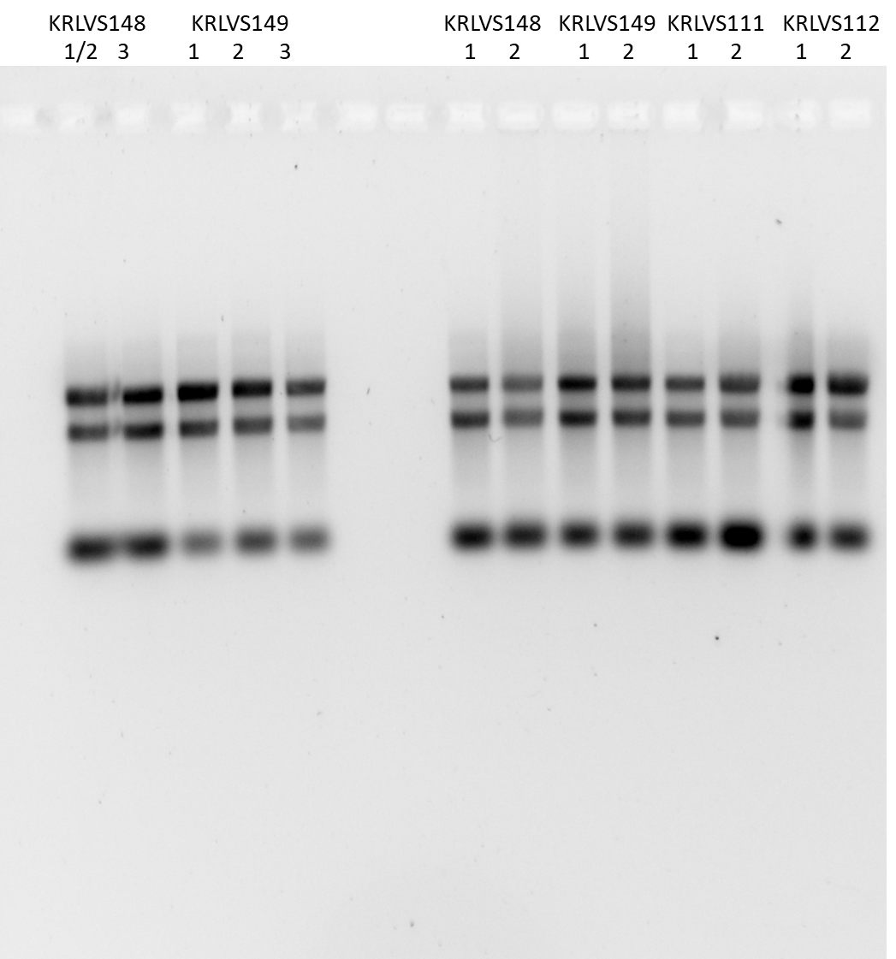
Aaand, it looks good! Not smeary degradation. Woohoo!

Plating Day 42 of 4°C Samples of Aislings Project
- Place ~20 beads on each plate aseptically
- Pipette 300 ul of each sample onto each plate
  - Three samples from 4C room
  - 2 plates per sample = 6 plates total.
- Shake in each direction
- Let each plate sit for at least 2-3 minutes so all of the liquid is absorbed
- Remove the beads within the flame into the 50 mL tube and add ethanol if it is not covering all the beads.
- Place in the incubator to pull out on Friday
Finally, I took a glance at my electroporation plates, and they definitely need another day of growth, so I will look at them tomorrow and streak for isolation.

Reagents
CHAH+Kan
To a 1L flask add:
30.6g of cystine heart agar
300mL of ddiH2O (type I)
stirbar
Heat on 60°C, stirring, for 10 minutes (media should be totally dissolved)
Autoclave on 30’ liquid cycle, filling the water bin up to the height of the media
Add 2% hemoglobin to water bath, after autoclave add CHA as well
Using sterile technique, pour hemoglobin into CHA
For 5 ug/ml, add 60 ul of 50 mg/mL kanamycin to 600 mL of media MADE HALF FLASK

CHAH+Nat
To a 1L flask add:
30.6g of cystine heart agar
300mL of ddiH2O (type I)
stirbar
Heat on 60°C, stirring, for 10 minutes (media should be totally dissolved)
Autoclave on 30’ liquid cycle, filling the water bin up to the height of the media
Add 2% hemoglobin to water bath, after autoclave add CHA as well
Using sterile technique, pour hemoglobin into CHA
For 5 ug/ml, add 30 ul of 100 mg/mL nourseothricin to 600 mL of media MADE HALF FLASK

Thursday, August 4, 2022
To Do:
- DNase treatment of 8/2/2022 RNA samples
- Second RNA purification of 8/2/2022 RNA samples
- Nanodrop pure RNA samples
- Run RNA gel of 8/4/22 pure RNA samples
- Generate cDNA of 8/2/22 Pure RNA samples
- qRT-PCR of 8/3/22 cDNA samples
- Patch out KRLVS111, KRLVS112, KRLVS148, KRLVS149, KRLVS150, and KRLVS151 for glycerol stocks and SUA
- Check transformation plates and make overnights
- Patch electroporation plates
Results and Data:

DNase treatment of KRLVS148, KRLVS149, KRLVS111, and KRLVS112 RNA Samples
- Add 10 uL RNase-free DNase buffer and 10 uL RNase-free DNase (Promega, RQ1)
- Incubate at 37°C for 1 hour
- Add 300 uL TRI-Reagent
- Add 400 uL 100% ethanol
- Pass sample over Directzol column, 600 uL per spin, 30 sec per spin at max speed, discarding flow-through in phenol and methanol waste
- Place spin column in new collection tube
- Wash twice with 400 uL RNA PreWash buffer, 30s at max speed, discarding flow-through in phenol and methanol waste
- Add 700 ul of Wash buffer, let sit on column for 3 min
- Spin max speed for 2 min
- Wash again with 700 ul Wash buffer
- Spin max speed for 2 min
- Place column in new collection tube
- Spin max speed for 3 min
- Place column in clean 1.5 mL tube
- Add 100 uL RNase-free water, let sit on column 2 min
- Spin max speed 1 min
- Place flow-through on column again, spin 1 min

Gel of KRLVS148, KRLVS149, KRLVS150, and KRLVS151 RNA Samples
- Make 10 uL aliquots with normalized concentrations, using water to dilute. Then add 2 uL purple loading dye for a final concentration of 1-1.5x.
- Rinse comb and gel rig with DI water, then ethanol both as well
- Make fresh agarose gel by adding 2.0g to 200mL fresh 1xTAE and stir with heat until completely dissolved, then place in 50°C water bath until cool enough to touch.
- Set up gel rig to cast gel, with ladder.
- Add 6uL of Sbyr Safe dye to gel rig, pour ~60uL of agarose gel, use ladder to mix, then replace ladder and allow to set.
- Make fresh 1xTAE, turn gel, add TAE, and remove ladder.
- Add 12 uL of each sample according to the loading order below.
- Ran until separated at 113V.
- Look for distinctive bands (23s, 16s, tRNA), rather than smears.
Loading Order of RNA Gel
Lane1 | Lane 2 | Lane 3 | Lane 4 | Lane 5 | Lane 6 | Lane 7 | Lane 8 | Lane 9 | Lane 10 | Lane 11 | Lane 12
RNA 1 | RNA 2 | RNA 3 | RNA 4 | RNA 5 | RNA 6 | RNA 7 | RNA 8 | RNA 9 | RNA 10 | RNA 11 | RNA 12

Generate cDNA (Half) of KRLVS148, KRLVS149, KRLVS111, KRLVS112 (8/2/22 Pure RNA)
- Combine the first components for primer annealing:
Component | Volume or Amount | Final Concentration
RNA | 3 ug | 267 - 333 ng/ ul
(NS)₅ Primer (250 ng/ul) | 1.5 ul | 25 ng/ul
RNase-free water | up to 13.5 ul
- To normalize all the cDNA samples to the same DNA mass, dilute with RNase-free water in PCR strip tubes. Total volume of cDNA and water is 13.5 uL.
- Add the 1.5 uL (NS)₅ oligo to the tubes.
- Incubate using program JSScDNA1 in the thermocycler:
Step Temp Time
1 70°C 10'
2 25°C 10'
3 4°C hold
- Prepare master mix at 1.5x the number of reactions.
Component | Final Concentration | Volume | x7.5
5X 1st strand buffer | 1x | 6 | 45
RNase-free water |  | 2.88 | 21.6
100 mM DTT | 10 mM | 3 | 22.5
10 mM dNTPs | 0.5 mM | 1.5 | 11.25
Superscript III (200 U/ul) | 10.8 U/ul | 1.63 | 12.23
- Aliquot 15 ul of master mix into each PCR tube from the first reaction (total volume now 30ul)
- Incubate using program JSScDNA2
Step Temp Time
1 25°C 10'
2 37°C 60'
4 42°C 60'
5 70°C 10'
6 4°C hold
- Remove RNA from sample by degrading with sodium hydroxide:
  - Add 10 ul of 1N NaOH
  - Incubate 65°C for 30'
  - Neutralize with 10 ul of 1N HCl
  - Final volume is 50 ul
- Purify cDNA using Qiagen PCR clean-up column (be very sure there is no ethanol carry-over!)
- Elute in 60 ul of 0.1x EB
- Check concentration by Nanodrop
- Store cDNA at -80°C

cDNA Purification with PCR Purification Kit
- Add 300 uL of Buffer PB to each 60 uL cDNA reaction tube and mix.
- Place a QIAquick column in a 2mL collection tube.
- Centrifuge tube for 30-60s at 13,000rpm. Discard flow through.
- Wash: add 750uL of Buffer PE to the QIAquick column. Centrifuge for 30-60s at 13,000rpm. Discard flow through.
- Centrifuge again for 3 minutes at 13,000rpm to remove any residual wash buffer.
- Place the QIAquick column in a fresh 1.5mL centrifuge tube.
- Elute: add 60uL of Buffer 0.1x EB. Let column stand for 1 minute. Centrifuge for 1 minute at 13,000rpm.

qRT-PCR of KRLVS148 and KRLVS149 (8/3/22) cDNA
- Each experiment will need at least one test primer and one control primer for each sample
  - KROL343/344 and KROL504/505 as test primers, specifically to amplify the 5’UTR and downstream of the rpsu2 gene respectively. KROL63/64 as the control, amplifying tul4.
- Each cDNA sample will be used in a reaction with each primer set meaning #Samples*#Primer Sets (6*3=18 reactions)
- Set up a master mixes, labelling the tubes as A, B, C, etc.:
Component | Volume per Reaction | Master Mix (#Samplesx3.5+3.5)
PowerUp SYBR Green MM | 10 uL | 245.0 uL
5uM primer set | 1 uL | 24.5 uL
1.5 ng/uL Stock cDNA | 1 uL
ddiH₂O | 8 uL | 171.5 uL
Total: | 20 uL | 465.5 uL
- Obtain a strip of strip tubes per each primer set with the appropriate number of tubes in the strip, according to the number of cDNA samples. Label strip tubes with letter of primer master mix, and the sample number.
- Add 3.5µL of cDNA into appropriately labelled tubes.
- As these will be in technical triplicate, each tube will be an individual master mix, totaling 70 uL. Thusly, add corresponding primer master mix to tubes containing DNA at a volume of 66.5 uL.
- Pipette 20 µL of each primer set strip tubes, in triplicate, using multichannel pipet.
- Spin plate down and run in LightCycler using the ‘KRamsey_Lab_old_stepone’ program according to ‘qRT-PCR_LightCycler_Machine.docx’
Labelling was as follows:
Master Mix Label | Primer Set
A | KROL343/344 5’UTR
B | KROL504/505 ds-rpsu2
C | KROL63/64 tul4

1 | 2 | 3 | 4 | 5 | 6
148-1 | 148-2 | 148-3 | 149-1 | 149-2 | 149-3
Loaded 96-well plate according to the following table:
 | 1 | 2 | 3 | 4 | 5 | 6 | 7 | 8 | 9
A | A1 |  |  | B1 |  |  | C1
B | A2 |  |  | B2 |  |  | C2
C | A3 |  |  | B3 |  |  | C3
D | A4 |  |  | B4 |  |  | C4
E | A5 |  |  | B5 |  |  | C5
F | A6 |  |  | B6 |  |  | C6

Friday, August 5, 2022
To Do:
- Generate cDNA of 8/3/22 Pure RNA samples
- qRT-PCR of 8/4/22 cDNA samples
- Make glycerol stocks and SUA of KRLVS111, KRLVS112, KRLVS148, KRLVS149, KRLVS150, and KRLVS151
- Miniprep pKR122 transformants hopefully
Results and Data:

Generate cDNA (Half) of KRLVS148, KRLVS149, KRLVS150, KRLVS151 (8/3/22 Pure RNA)
- Combine the first components for primer annealing:
Component | Volume or Amount | Final Concentration
RNA | 3 ug | 267 - 333 ng/ ul
(NS)₅ Primer (250 ng/ul) | 1.5 ul | 25 ng/ul
RNase-free water | up to 13.5 ul
- To normalize all the cDNA samples to the same DNA mass, dilute with RNase-free water in PCR strip tubes. Total volume of cDNA and water is 13.5 uL.
- Add the 1.5 uL (NS)₅ oligo to the tubes.
- Incubate using program JSScDNA1 in the thermocycler:
Step Temp Time
1 70°C 10'
2 25°C 10'
3 4°C hold
- Prepare master mix at 1.5x the number of reactions.
Component | Final Concentration | Volume | x7.5
5X 1st strand buffer | 1x | 6 | 45
RNase-free water |  | 2.88 | 21.6
100 mM DTT | 10 mM | 3 | 22.5
10 mM dNTPs | 0.5 mM | 1.5 | 11.25
Superscript III (200 U/ul) | 10.8 U/ul | 1.63 | 12.23
- Aliquot 15 ul of master mix into each PCR tube from the first reaction (total volume now 30ul)
- Incubate using program JSScDNA2
Step Temp Time
1 25°C 10'
2 37°C 60'
4 42°C 60'
5 70°C 10'
6 4°C hold
- Remove RNA from sample by degrading with sodium hydroxide:
  - Add 10 ul of 1N NaOH
  - Incubate 65°C for 30'
  - Neutralize with 10 ul of 1N HCl
  - Final volume is 50 ul
- Purify cDNA using Qiagen PCR clean-up column (be very sure there is no ethanol carry-over!)
- Elute in 60 ul of 0.1x EB
- Check concentration by Nanodrop
- Store cDNA at -80°C

cDNA Purification with PCR Purification Kit
- Add 300 uL of Buffer PB to each 60 uL cDNA reaction tube and mix.
- Place a QIAquick column in a 2mL collection tube.
- Centrifuge tube for 30-60s at 13,000rpm. Discard flow through.
- Wash: add 750uL of Buffer PE to the QIAquick column. Centrifuge for 30-60s at 13,000rpm. Discard flow through.
- Centrifuge again for 3 minutes at 13,000rpm to remove any residual wash buffer.
- Place the QIAquick column in a fresh 1.5mL centrifuge tube.
- Elute: add 60uL of Buffer 0.1x EB. Let column stand for 1 minute. Centrifuge for 1 minute at 13,000rpm.

qRT-PCR of KRLVS148, KRLVS149, KRLVS111, KRLVS112 (8/4/22) cDNA
- Each experiment will need at least one test primer and one control primer for each sample
  - KROL343/344 and KROL504/505 as test primers, specifically to amplify the 5’UTR and downstream of the rpsu2 gene respectively. KROL63/64 as the control, amplifying tul4.
- Each cDNA sample will be used in a reaction with each primer set meaning #Samples*#Primer Sets (6*3=18 reactions)
- Set up a master mixes, labelling the tubes as A, B, C, etc.:
Component | Volume per Reaction | Master Mix (#Samplesx3.5+3.5)
PowerUp SYBR Green MM | 10 uL | 245.0 uL
5uM primer set | 1 uL | 24.5 uL
1.5 ng/uL Stock cDNA | 1 uL
ddiH₂O | 8 uL | 171.5 uL
Total: | 20 uL | 465.5 uL
- Obtain a strip of strip tubes per each primer set with the appropriate number of tubes in the strip, according to the number of cDNA samples. Label strip tubes with letter of primer master mix, and the sample number.
- Add 3.5µL of cDNA into appropriately labelled tubes.
- As these will be in technical triplicate, each tube will be an individual master mix, totaling 70 uL. Thusly, add corresponding primer master mix to tubes containing DNA at a volume of 66.5 uL.
- Pipette 20 µL of each primer set strip tubes, in triplicate, using multichannel pipet.
- Spin plate down and run in LightCycler using the ‘KRamsey_Lab_old_stepone’ program according to ‘qRT-PCR_LightCycler_Machine.docx’
Labelling was as follows:
Master Mix Label | Primer Set
A | KROL343/344 5’UTR
B | KROL504/505 ds-rpsu2
C | KROL63/64 tul4

1 | 2 | 3 | 4 | 5 | 6 | 7 | 8
148-1 | 148-2 | 149-1 | 149-2 | 111-1 | 111-2 | 112-1 | 112-2
Loaded 96-well plate according to the following table:
 | 1 | 2 | 3 | 4 | 5 | 6 | 7 | 8 | 9
A | A1 |  |  | B1 |  |  | C1
B | A2 |  |  | B2 |  |  | C2
C | A3 |  |  | B3 |  |  | C3
D | A4 |  |  | B4 |  |  | C4
E | A5 |  |  | B5 |  |  | C5
F | A6 |  |  | B6 |  |  | C6
G | A7 |  |  | B7 |  |  | C7
H | A8 |  |  | B8 |  |  | C8

Monday, August 8, 2022
To Do:
- qRT-PCR of 8/2/22 cDNA samples
- Transform pKR122 into PIR cells

Results and Data:

qRT-PCR of KRLVS148, KRLVS149, KRLVS150, KRLVS151 (8/5/22) cDNA - 1
- Each experiment will need at least one test primer and one control primer for each sample
  - KROL343/344 and KROL504/505 as test primers, specifically to amplify the 5’UTR and downstream of the rpsu2 gene respectively. KROL63/64 as the control, amplifying tul4.
- Each cDNA sample will be used in a reaction with each primer set meaning #Samples*#Primer Sets (6*3=18 reactions)
- Set up a master mixes, labelling the tubes as A, B, C, etc.:
Component | Volume per Reaction | Master Mix (#Samplesx3.5+3.5)
PowerUp SYBR Green MM | 10 uL | 245.0 uL
5uM primer set | 1 uL | 24.5 uL
1.5 ng/uL Stock cDNA | 1 uL
ddiH₂O | 8 uL | 171.5 uL
Total: | 20 uL | 465.5 uL
- Obtain a strip of strip tubes per each primer set with the appropriate number of tubes in the strip, according to the number of cDNA samples. Label strip tubes with letter of primer master mix, and the sample number.
- Add 3.5µL of cDNA into appropriately labelled tubes.
- As these will be in technical triplicate, each tube will be an individual master mix, totaling 70 uL. Thusly, add corresponding primer master mix to tubes containing DNA at a volume of 66.5 uL.
- Pipette 20 µL of each primer set strip tubes, in triplicate, using multichannel pipet.
- Spin plate down and run in LightCycler using the ‘KRamsey_Lab_old_stepone’ program according to ‘qRT-PCR_LightCycler_Machine.docx’
Labelling was as follows:
Master Mix Label | Primer Set
A | KROL343/344 5’UTR
B | KROL504/505 ds-rpsu2
C | KROL63/64 tul4

1 | 2 | 3 | 4 | 5 | 6 | 7 | 8 | 9 | 10 | 11 | 12
148-1 | 148-2 | 148-3 | 149-1 | 149-2 | 149-3 | 150-1 | 150-2 | 150-3 | 151-1 | 151-2 | 151-3
Loaded 96-well plate according to the following table:
 | 1 | 2 | 3 | 4 | 5 | 6 | 7 | 8 | 9
A | A1 |  |  | B1 |  |  | C1
B | A2 |  |  | B2 |  |  | C2
C | A3 |  |  | B3 |  |  | C3
D | A4 |  |  | B4 |  |  | C4
E | A5 |  |  | B5 |  |  | C5
F | A6 |  |  | B6 |  |  | C6

qRT-PCR of KRLVS148, KRLVS149, KRLVS150, KRLVS151 (8/5/22) cDNA - 2
- Each experiment will need at least one test primer and one control primer for each sample
  - KROL343/344 and KROL504/505 as test primers, specifically to amplify the 5’UTR and downstream of the rpsu2 gene respectively. KROL63/64 as the control, amplifying tul4.
- Each cDNA sample will be used in a reaction with each primer set meaning #Samples*#Primer Sets (6*3=18 reactions)
- Set up a master mixes, labelling the tubes as A, B, C, etc.:
Component | Volume per Reaction | Master Mix (#Samplesx3.5+3.5)
PowerUp SYBR Green MM | 10 uL | 245.0 uL
5uM primer set | 1 uL | 24.5 uL
1.5 ng/uL Stock cDNA | 1 uL
ddiH₂O | 8 uL | 171.5 uL
Total: | 20 uL | 465.5 uL
- Obtain a strip of strip tubes per each primer set with the appropriate number of tubes in the strip, according to the number of cDNA samples. Label strip tubes with letter of primer master mix, and the sample number.
- Add 3.5µL of cDNA into appropriately labelled tubes.
- As these will be in technical triplicate, each tube will be an individual master mix, totaling 70 uL. Thusly, add corresponding primer master mix to tubes containing DNA at a volume of 66.5 uL.
- Pipette 20 µL of each primer set strip tubes, in triplicate, using multichannel pipet.
- Spin plate down and run in LightCycler using the ‘KRamsey_Lab_old_stepone’ program according to ‘qRT-PCR_LightCycler_Machine.docx’
Labelling was as follows:
Master Mix Label | Primer Set
A | KROL343/344 5’UTR
B | KROL504/505 ds-rpsu2
C | KROL63/64 tul4

1 | 2 | 3 | 4 | 5 | 6 | 7 | 8 | 9 | 10 | 11 | 12
148-1 | 148-2 | 148-3 | 149-1 | 149-2 | 149-3 | 150-1 | 150-2 | 150-3 | 151-1 | 151-2 | 151-3
Loaded 96-well plate according to the following table:
 | 1 | 2 | 3 | 4 | 5 | 6 | 7 | 8 | 9
A | A7 |  |  | B7 |  |  | C7
B | A8 |  |  | B8 |  |  | C8
C | A9 |  |  | B9 |  |  | C9
D | A10 |  |  | B10 |  |  | C10
E | A11 |  |  | B11 |  |  | C11
F | A12 |  |  | B12 |  |  | C12

Tuesday, August 9, 2022
To Do:
- Nopefully make overnights of pKR122

Results and Data:

Wednesday, August 10, 2022
To Do:
- Hopefully miniprep pKR122
- Hopefully set up sequencing of pKR122

Results and Data:

Thursday, August 11, 2022
To Do:

Results and Data:

Friday, August 12, 2022
To Do:

Results and Data:

Monday, August 15, 2022
To Do:

Results and Data:

Tuesday, August 16, 2022
To Do:

Results and Data:

Wednesday, August 17, 2022
To Do:

Results and Data:

Thursday, August 18, 2022
To Do:

Results and Data:

Friday, August 19, 2022
To Do:

Results and Data:

Monday, August 22, 2022
To Do:

Results and Data:

Tuesday, August 23, 2022
To Do:

Results and Data:

Wednesday, August 24, 2022
To Do:

Results and Data:

Thursday, August 25, 2022
To Do:

Results and Data:

Friday, August 26, 2022
To Do:

Results and Data:

Monday, August 29, 2022
To Do:

Results and Data:

Tuesday, August 30, 2022
To Do:

Results and Data:

Wednesday, August 31, 2022
To Do:

Results and Data:

Bibliography

Ramsey, K. M. and Dove, S. L. (2016) ‘ A response regulator promotes Francisella tularensis intramacrophage growth by repressing an anti-virulence factor ’, Molecular Microbiology. doi: 10.1111/mmi.13418.

