EXAMINING THE REGULATION OF THE BS21 HOMOLOGS
IN FRANCISELLA TULARENSIS
BY
SIERRA SCHMIDT

A THESIS SUBMITTED IN PARTIAL FULFILLMENT OF THE
REQUIREMENTS FOR THE DEGREE OF
MASTER OF SCIENCE
IN
CELL AND MOLECULAR BIOLOGY

UNIVERSITY OF RHODE ISLAND
2023

MASTER OF SCIENCE IN CELL AND MOLECULAR BIOLOGY THESIS

OF

SIERRA SCHMIDT

APPROVED:

Thesis Committee:

Major Professor Kathryn Ramsey

Steven Gregory

David Rowley

Brenton DeBoef
DEAN OF THE GRADUATE SCHOOL

UNIVERSITY OF RHODE ISLAND
2023

ABSTRACT
Francisella tularensis is a facultative intracellular pathogen, which relies on a network of regulation for its virulence. It contains three homologs of the ribosomal protein bS21. These three ribosomal protein homologs can independently associate with ribosomes, leading to ribosomal heterogeneity. The second homolog, bS21-2, is implicated in the positive regulation of a number of virulence proteins. Additionally, transcriptomic data indicates that bS21-2 is autoregulated. The mechanism by which this autoregulation occurs is unknown, as is the regulation of the other two homologs, bS21-1 and bS21-3. In the following chapters, I will show that bS21-1 and bS21-3 do not autoregulate their transcript. Further, I will demonstrate that the leader sequence of bS21-2 is sufficient to result in autoregulation of its transcript. And in particular, a specific portion of the leader sequence is sufficient for regulation. This regulation is potentially accomplished through the degradation of the bS21-2 transcript. Alternatively, I will show that the bS21-2 protein is not autoregulated.
I will then explore different environmental conditions to determine what conditions may up-regulate bS21-1 and bS21-3. Particularly, growth on CHA-H results in up-regulation of transcript abundance of bS21-1 and bS21-3, as compared to supplemented MHB. This growth condition leads to a subsequent increase of both bS21-1 and bS21-3 protein. In addition, low pH increases bS21-1 transcript abundance, but the effect on protein is unclear.

ACKNOWLEDGMENTS
First and foremost, I want to thank my advisor, Dr. Kathryn Ramsey who, through her insight, patience, and kindness, guided me through my master’s degree with diligence and care. Through both ups and downs she approached any issue or discovery I brought to her with great knowledge and advice, and perfectly balanced the downs with humor and encouragement. She both challenged and encouraged me, helping me to grow as a scientist in not only the practical sense, but the mental aspect as well. Additionally, I would also like to extend my gratitude to my committee members Dr. Steven Gregory and Dr. David Rowley. I thank Dr. Gregory for both his immeasurable knowledge and scientific advice, but for his warmth and mentorship. Dr. Rowley for his positivity and encouragement, in addition to allowing me to constantly take up space in his lab for use of the fume hood. Importantly, thank you all for the generous time you have dedicated to my success.
In addition, I want to thank the faculty and graduate students of the Cell and Molecular department. I felt truly lucky to have met everyone in this department, all of whom were welcoming, eager to help, and remarkably supportive. There is no measure of the comfort I felt asking for help or insight from the faculty, and there is no measure of the connections that I forged with my fellow students.
Lastly I would like to thank my friends and family who supported me from across the country, and were almost always ready to listen to my to-do list.

PREFACE
This thesis has been prepared in manuscript format according to the guidelines of the Graduate School of the University of Rhode Island. The thesis includes an introductory chapter, two manuscripts, and a summary chapter:

Chapter 1: Literature Review and Introduction

Chapter 2: “Control of bS21 homolog production in Francisella tularensis” was prepared for submission to the Journal of Bacteriology.

Chapter 3: “Identification of conditions that lead to changes in bS21-1 and bS21-3 abundance in Francisella tularensis” was prepared for submission to the Journal of Bacteriology.

Chapter 4: Conclusions and Further Questions

TABLE OF CONTENTS

LIST OF TABLES viii
LIST OF FIGURES 9
CHAPTER 1 11
REVIEW OF THE LITERATURE 11
SUMMARY AND OBJECTIVES 31
REFERENCES 32
CHAPTER 2 42
Manuscript 1 42
CHAPTER 3 63
Manuscript 2 63
CHAPTER 4 88
SUMMARY AND CONCLUSIONS 88
FURTHER QUESTIONS 92

LIST OF TABLES

TABLE PAGE

Chapter 2

Table 1. F. tularensis LVS strains used in this study. 60

LIST OF FIGURES

FIGURE PAGE

Chapter 1

Figure 1. A number of Type VI Secretion System proteins and their functions are defined in F. tularensis.. 16

Figure 2. The rpsU2 operon structure.. 25

Figure 3. Cells lacking bS21-2 have changes in protein abundance that cannot be explained by changes in transcript abundance... 26

Figure 4. RNA Seq data suggests that bS21-2, bS21-1, and bS21-3 negatively regulate the rpsU2 operon.... 27

Figure 5. bS21-1 and bS21-3 are the least abundant homologs in F. tularensis... 30

Chapter 2

Figure 1. All three F. tularensis bS21 homologs negatively regulate the rpsU2 operon... 48

Figure 2. bS21-1 and bS21-3 do not regulate their own transcript abundance... 50

Figure 3. The rpsU2 5´ UTR allows control transcript abundance yet transcript and protein abundance changes are not correlated... 51

Figure 4. Predicted stem-loops in the rpsU2 mRNA are dispensable for control by bS21-2..... 54

Figure 5. The presence of bS21-2 may destabilize the rpsU2 mRNA.... 55

FIGURE PAGE

Chapter 3

Figure 1. F. tularensis cells exposed to different temperatures, salt concentrations, or amounts of oxidative or UV stress do not appear to have changes in rpsU1 production... 71

Figure 2. F. tularensis cells exposed to different iron, magnesium, or spermine concentrations do not appear to have changes in rpsU1 production.... 72

Figure 3. F. tularensis cells exposed to different temperatures, salt concentrations, or amounts of oxidative or UV stress do not appear to have changes in rpsU3 production.... 74

Figure 4. F. tularensis cells exposed to different iron, magnesium, or spermine concentrations do not appear to have changes in rpsU3 production...... 75

Figure 5. F. tularensis cells grown in CDM or on CHAH increases rpsU1 transcript and protein production.... 76

Figure 6. F. tularensis cells grown in CDM or on CHAH increases rpsU3 transcript and protein production..... 78

Figure 7. F. tularensis cells exposed to low pH increases rpsU1 transcript, but decreases protein production.... 79

Figure 8. F. tularensis cells exposed to different pH do not greatly affect rpsU3 transcript, but decreases protein production..... 80

CHAPTER 1

REVIEW OF THE LITERATURE
Francisella tularensis is an intracellular pathogen.
Francisella tularensis is a Gram-negative coccobacillus bacterium. It is the causative agent of tularemia, also known as rabbit fever (Keim, Johansson, and Wagner 2007). It is a facultative intracellular pathogen and must grow within macrophage to cause illness. Due to its high infectivity and low infectious dose (estimated at 10 cells), it is classified as a potential bioweapon alongside other bacterial species such as Bacillus anthracis, the causative agent of anthrax (Dennis et al. 2001). That said, it is an environmental pathogen that is endemic to North America, Europe, and Asia. The majority of reported cases arise from the United States, with the highest incidence in the south-central region of the country (Keim et al. 2007).
There are multiple routes by which F. tularensis may infect a host, including inhalation, ingestion, or through contact with open wounds (Keim et al. 2007). The disease tularemia may present in a number of ways, which vary dependent on the route of entry. This presentation can include flu-like symptoms such as malaise and cough. It may also cause ulcers or swelling in areas such as the stomach, mouth, or eyes (Keim et al. 2007).
The two subspecies of F. tularensis that are the most clinically-relevant are F. tularensis subsp. tularensis and F. tularensis subsp. holarctica (Kingry and Petersen 2014; Olsufjev and Meshcheryakova, 1983; Petersen and Molins 2010). Infection with F. tularensis subsp. tularensis causes the most severe human disease and can be lethal (Kingry and Petersen 2014). In contrast, infection by F. tularensis subsp. holarctica generally leads to less severe disease outcomes (Kingry and Petersen 2014).
Three strains of F. tularensis are commonly used in laboratory research. They are the highly pathogenic F. tularensis subsp. tularensis SCHU S4; F. tularensis subsp. holarctica LVS (live vaccine strain), which is a strain attenuated for virulence in humans; and a strain from related species that is not infectious to humans, Francisella novicida U112.
F. tularensis subsp. tularensis SCHU S4 is highly virulent strain derived from a clinical sample from an infected finger (Eigelsbach, Braun, and Herring 1951; Hesselbrock and Foshay 1945). Like all F. tularensis species, its genome contains two copies of the Francisella Pathogenicity Island (FPI), which encodes a type VI secretion system (T6SS) that is critical for virulence (Bell, Owen, and Larson 1955). In addition, the SCHU S4 genome was the first F. tularensis strain to be fully sequenced. While it is highly pathogenic, making it an ideal model for research regarding F. tularensis virulence, it is also classified as a select agent. Thus, in order to prevent laboratory-acquired infections, BSL-3 safety measures must be used in order to study it safely.
Unlike SCHU S4, F. novicida U112 does not cause human disease and is only pathogenic in animal hosts. Unlike F. tularensis species, U112 has a single copy of the FPI, making it a tractable model system for genetic studies of the FPI. However, it is not an ideal model for human virulence, as it does not infect immunocompetent individuals (Kingry and Petersen 2014; Nano et al. 2004).
F. tularensis subsp. holarctica LVS is a strain which is attenuated for virulence in humans and was originally developed as a vaccine. Importantly, it has the ability to infect macrophage and cause disease in animal models, but can be safely used in BSL2 laboratory settings. Despite attenuation, it remains highly related to similar virulent strains; the LVS genome has mutations in 35 protein coding regions compared to a pathogenic F. tularensis subsp. holarctica strain, FSC200. The majority of these differences are single nucleotide polymorphisms, SNPs, leading to loss or impaired function of 15 proteins (Rohmer et al. 2006). One gene in particular, pilA, a putative Type IV pilin, is mutated in LVS. Re-introduction of this functional gene restored LVS virulence to levels comparable to non-attenuated F. tularensis subsp. holarctica strains (Salomonsson et al. 2009). Additionally, a gene important for iron uptake in pathogenic strains (fupA) has recombined with a neighboring gene (fupB) in LVS, resulting in less efficient ferric iron transport and reduced virulence (Ramakrishnan, Sen, and Johnson 2012; Salomonsson et al. 2009). Together, the reduced biosafety level needs and the ability of LVS to infect animal models make the LVS strain an ideal candidate to study mechanisms of pathogenicity in a biologically relevant manner.
There are a number of genes important for virulence in F. tularensis (Jones et al. 2014; Rowe and Huntley 2015). Many factors have been linked to regulation of virulence genes in F. tularensis, including temperature, iron availability, oxidative stress, host-cell-specific components, transcriptional regulators, and translational regulators (Dai et al. 2011; Trautmann and Ramsey 2022). Arguably, the virulence factor with the most well-understood regulation in F. tularensis is the Francisella Pathogenicity Island (FPI), so in the following section it will provide an example of how virulence genes are controlled in this pathogen.
Francisella Pathogenicity Island (FPI)
The FPI is a cluster of 16 conserved genes with three variable genes encoded by the Francisella genomes (de Bruin et al. 2011; Nano et al. 2004; Nano and Schmerk 2007). The FPI contains the genes encoding T6SS proteins. These genes include structural components of the T6SS and putative effectors (Brodmann et al. 2017; Clemens, Lee, and Horwitz 2018; Eshraghi et al. 2016; Lai, Golovliov, and Sjöstedt 2004) (Figure 1). The T6SS is essential for intracellular survival and virulence, as it is necessary for phagosomal escape (Brodmann et al. 2017).
Consistent with their essentiality for intramacrophage survival, FPI genes are up-regulated when F. tularensis infect macrophage (Bent et al. 2013; Golovliov et al. 1997). Significant work has revealed how the FPI genes are controlled at the level of transcription. Specifically, the FPI genes are regulated by the transcription factors MglA, SspA, and PigR, acting together with the small molecule ppGpp. The specific mechanism of regulation relies on the intrinsic formation of the MglA-SspA complex, and its interactions with the RNA polymerase. In the presence of ppGpp, PigR (also referred to as FevR in F. novicida) interacts directly with the MglA-SspA complex to positively regulate genes with a specific PigR-responsive element (PRE), including FPI genes (Charity et al. 2007; Cuthbert et al. 2017; Ramsey et al. 2015; Rohlfing and Dove 2014; Travis et al. 2021).
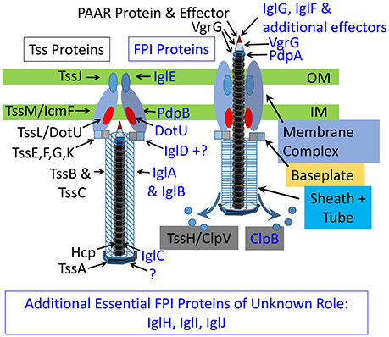
Figure 1. A number of Type VI Secretion System proteins and their functions are defined in F. tularensis. Illustration depicting the extended (left) and contracted (right), forms of the canonical and Francisella Type VI Secretion System (T6SS). Identified F. tularensis T6SS proteins are indicated in blue font, whereas canonical elements are indicated in black font (Clemens et al. 2018).
Because ppGpp influences the activity of PigR-regulated genes like the FPI, factors that influence ppGpp levels influence FPI gene expression. That said, a number of genes influence ppGpp levels (Buchan et al. 2009; Faron et al. 2013; Travis and Schumacher 2022). Ultimately, this leads to a complex network of regulators all affecting F. tularensis pathogenicity.
Ribosome production is tightly regulated.
Ribosomes are large, multi-component molecular machines, composed of both ribosomal RNAs (rRNAs) and ribosomal proteins (r-proteins). They act as a key component of cellular life, translating mRNA into protein. Ribosomes have a large number of components, and are energetically costly to the cell. Production of ribosomal components is tightly controlled so that each component is produced within stoichiometric ratio. Studies have elucidated multiple mechanisms by which individual rRNAs and r-proteins are regulated to retain their stoichiometric balance.
As rRNA is the primary component of the ribosome, its regulation has been a particular focus of study. Production of rRNA is regulated at the transcriptional level and depends on factors such as the growth state of the cell. In particular, the promoter of rRNA plays a significant role in the control of rRNA. These promoters are quite strong and promoter activity is carefully regulated through multiple inputs such as the small molecule ppGpp, abundance of the initiating NTP of transcription, and DksA, a component of the transcription machinery (Paul et al. 2004).
Bacteria may encode more than 50 r-proteins, 34 of which are universally conserved (Yutin et al. 2012). Regulation of r-protein production can be complex and can occur at multiple levels. Regulation of r-proteins can start at the level of DNA organization, as operons encoding r-proteins are often organized to allow for co-regulation of multiple r-protein-coding genes.
Additionally, r-proteins may act as regulators of their own transcript. Specifically, some r-proteins can bind their own transcript in addition to their ability to bind ribosomal RNA, particularly if that r-protein is in excess compared to the amount of r-protein needed for ribosome assembly. Attenuation and destabilization of mRNA transcripts are major pathways in which an r-protein may control translation of its own transcript. Attenuation describes the early termination of an r-protein transcript via the r-protein, directly or indirectly. It can either be Rho-dependent or Rho-independent. Regardless of the necessity of Rho, this type of regulation relies on the formation of specific secondary structures of the mRNA transcript that lead to termination (Turnbough 2019). Alternatively, r-proteins may recruit nucleases to their own transcripts, leading to the destabilization of their mRNA post-transcriptionally. As with attenuation, the secondary structures of the mRNA transcript are often important for degradation (Rauhut and Klug 1999).
Finally, r-proteins may regulate their own production at the level of translation, by inhibiting translation initiation for its own transcript. There are several mechanisms by which this could occur. One possibility is that direct contact by the r-protein with the Shine-Dalgarno of its transcript physically prevents the transcript from becoming associated with ribosomes. Alternatively, direct binding of the r-protein could cause conformational changes in the mRNA to prevent translation, or the r-protein may interrupt a step in the translation initiation pathway (Zengel and Lindahl 1994).
Production of one r-protein can be controlled by multiple mechanisms. The next section will illustrate this by describing regulation of ribosomal protein uL10 (previously referred to as L10; Ban et al. 2014).
uL10 Regulation
uL10, the bacterial ribosomal protein encoded by rplJ, is a large subunit ribosomal protein. In the ribosome structure, uL10 forms the stalk complex with bL12, performing the essential function of facilitating interactions between GTP-bound translation factors and the ribosome (Diaconu et al. 2005) The rplJ gene is found in an operon upstream of rplL (bL12 or, when acetylated, bL7), denoted rplJL (O’Connell and Thomashow 2000). These r-proteins are followed by rpoB and rpoC encoding the β and β′ subunits of RNA polymerase (Fukuda 1980). uL10, along with bL12, binds to the 23s rRNA early in ribosomal assembly (de Narvaez and Schaup 1979).
In Escherichia coli, the first level of regulation of uL10 is at the transcriptional level. A study determined the promoter strength of rplJ in comparison to other gene promoters, and found that the strength of the promoter for transcription changed with temperature and salt concentrations (Kajitani and Ishihama 1983). Further, the rplJ gene is co-transcribed with both rpoB and rpoC (Linn and Scaife 1978; Yamamoto and Nomura 1978). While promoter strength and environmental conditions can lead to the transcriptional regulation of uL10, proposed intrinsic attenuators in the operon reduce the expression of the downstream rpo genes. This results in approximately 5 times the amount of mRNA encoding the ribosomal proteins compared to the RNA polymerase proteins (Barry, Squires, and Squires 1979).
When uL10 is present in excess of the amount needed for ribosome assembly, a negative feedback mechanism (autoregulation) leads to its repression. This requires uL10 and the uL10-L7/L12 complex (Fukuda 1980). This autoregulation was determined to act at a specific site, near the translational start site of uL10, in particular at a bulge loop secondary structure of the mRNA where it is proposed the complex binds and changes conformation (Climie and Friesen 1987; Yates et al. 1981). Additionally, it is suggested that uL10 when not coupled with L7/L12 is subject to proteolytic decay (Petersen 1990).
While the regulation of uL10 is both interesting and complex, it is important to note that it does not set a canonic precedent for each ribosomal protein. Some others share the same regulatory mechanism, however, there is a variety of mechanisms described in other literature (Zengel and Lindahl 1994). It is possible that there are more mechanisms in the control of r-proteins which are not yet elucidated.
Ribosomes are heterogenous.
The ribosome is generally thought to operate as a homogenous machine, indiscriminately translating mRNAs. However, ribosome composition can be heterogenous with respect to its rRNAs and proteins, meaning that all ribosomes in an organism, or even in a single cell, may not have precisely the same composition (Byrgazov, Vesper, and Moll 2013). There are a number of sources of genetically-encoded ribosome heterogeneity; including multiple rRNA operons, post-transcriptional modifications of rRNA, post-translational modifications of r-proteins, or incorporation of one of multiple homologs of a given r-protein. Ribosome heterogeneity has been identified in multiple organisms, including well-studied organisms such as E. coli. In the case of ribosomal heterogeneity induced by zinc concentration, the regulation of ribosomal composition is well-studied.
Zinc as a regulator of ribosomal composition
In some bacterial species, such as Mycobacterium tuberculosis, Mycobacterium smegmatis, Bacillus subtilis, and E. coli, there are paralogs of r-proteins which either coordinate or do not coordinate zinc. When in zinc-rich conditions, these organisms will produce the zinc-coordinating paralog. However, decreasing zinc concentrations leads to production of the alternate paralogs of these r-proteins, which do not coordinate zinc (Dow et al. 2021; Dow and Prisic 2018; Li et al. 2020; Nanamiya et al. 2004). The alternate paralogs are typically regulated transcriptionally by Zur, the zinc uptake regulator protein. Specifically Zur, when bound by zinc, will repress expression of certain transcripts by binding a so-called Zur box in their promoter regions, including in the promoter regions of genes encoding the alternative r-proteins. When zinc concentrations decrease, Zur does not coordinate zinc and does not bind DNA, thus repression is lifted (Akanuma et al. 2006; Dow et al. 2021; Dow and Prisic 2018; Li et al. 2020; Nanamiya et al. 2004; Nanamiya, Kawamura, and Kosono 2006; Nanamiya and Kawamura 2010; Prisic et al. 2015; Rasmussen et al. 2022; Shin and Helmann 2016). De-repression of the genes encoding alternate r-proteins provides a straightforward mechanism to permit their production under low zinc concentrations.
In B. subtilis, switching the zinc-coordinating bL31 paralog RpmE in the ribosome for the alternate paralog, YtiA, allows for the release of the zinc coordinated by RpmE when environmental zinc is low (Nanamiya and Kawamura 2010; Shin and Helmann 2016). This suggests that this ribosomal state switching is useful in modulating zinc availability when environmental reservoirs are low.
Beyond regulating zinc availability, how incorporation of non-zinc coordinating paralogs impacts the function of ribosomes is not well-understand. In E. coli, one paralog of r-protein bL31, bL31A, which coordinates zinc, appears to lead to higher fitness under low temperatures and alters translation reading frame maintenance (Lilleorg et al. 2020). In M. tuberculosis ribosomal switching of S18 paralogs may facilitate the transition from intracellular to extracellular environments, wherein zinc concentrations are lower due to host immune responses. The production of a non-zinc coordinating homolog would necessarily allow translation to continue in these zinc-deplete environments (Prisic et al. 2015). Further, in M. smegmatis, alternative ribosomes have altered translation activity, leading to the possibility that alternative ribosomes regulate proteome composition (Chen et al. 2020).
Specialized ribosomes
The presence of ribosome heterogeneity raises the possibility that ribosomes with different compositions have altered function. Ribosomes with altered composition and function are referred to as “specialized ribosomes.” It is proposed that specialized ribosomes may function as regulators of gene expression (Byrgazov et al. 2013).
bS21 leads to ribosomal heterogeneity in F. tularensis.
The ribosomal protein bS21
bS21 is a small subunit ribosomal protein encoded by the gene rpsU. rpsU is often, though not always, encoded on the so-called macromolecular synthesis (MMS) operon. This operon is conserved across diverse species, including many Gram-negative species (Versalovic et al. 1993). The MMS operon is typically structured as rpsU-dnaG-rpoD. The rpsU gene encodes bS21, which has been implicated in translation initiation (Chang and Craven 1977; Van Duin and Robert 1981). The dnaG gene encodes DNA primase, which is critical for initiation of DNA replication (Rowen and Kornberg 1978). The rpoD gene encodes σ⁷⁰, which is the primary sigma factor responsible for transcription of many housekeeping genes (Miura et al. 2015). Importantly, each of these three genes is important for the initiation of different steps of macromolecular synthesis, thus leading to the common name of the operon.
As indicated, bS21 has been implicated in translation initiation. Specifically, one study deactivated mRNA binding activity in the ribosome by inducing ribosomal protein damage, preventing mRNA binding. By adding back undamaged proteins, the researchers determined that bS21 was one of the proteins required to allow the ribosome to bind mRNA again. This indicated that it, along with some other proteins, were critical in the initiation of translation (Chang and Craven 1977). Additionally, it was determined that bS21 is required to translate certain mRNAs (Van Duin and Robert 1981). However, bS21 is thought to be non-essential, as it is not encoded in all bacteria (Galperin et al. 2021), although it is encoded by some phage (Mizuno et al. 2019).
In bacteria that do encode bS21, there are specific phenotypes observed when it is lost. For example, in B. subtilis, deletion of rpsU lead to filamentous cells with impaired motility (Akanuma et al. 2012). In Staphylococcus aureus, clinical samples with increased resistance to daptomycin and vancomycin have mutations in rpsU (Basco et al. 2019; Blake and O’Neill 2013; Friedman, Alder, and Silverman 2006). In Burkholderia pseudomallei, a Tn-Seq strategy using a transposon mutant library passaged through a mouse infection model identified bS21 as critical for B. pseudonallei to cause disease (Gutierrez, Yoder-Himes, and Warawa 2015). Through a similar method, a bS21 homolog in F. tularensis, rpsU1, was implicated as a potential virulence gene in mice (Su et al. 2007).
bS21-2 in F. tularensis
The genome of F. tularensis encodes three distinct bS21 homologs, bS21-1, bS21-2, and bS21-3, (encoded by rpsU1, rpsU2, and rpsU3, respectively). This is notable due to the limited size of the F. tularensis genome (approximately 2 Mbp). Small, reduced genomes are characteristic of intracellular pathogens, making the presence of three bS21 homologs in F. tularensis remarkable (Larsson et al. 2005; Murray et al. 2021; Riffaud, Rucks, and Ouellette 2023).
The most abundant bS21 homolog in F. tularensis is bS21-2 (Trautmann and Ramsey 2022). This homolog is encoded in the F. tularensis MMS operon, which includes an additional gene between rpsU and dnaG, yqeY (Figure 2). The protein YqeY is thought to aid in accurately charging tRNAs (Deniziak et al., 2007). Loss of bS21-2 leads to an intramacrophage growth defect and is implicated in control of translation for certain proteins (Trautmann and Ramsey 2022).
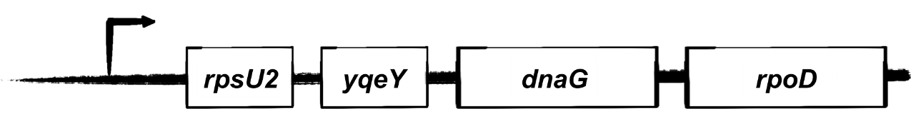
Figure 2. The rpsU2 operon structure. The sequence of genes of the macromolecular synthesis (MMS) operon of F. tularensis (not to scale).
The role of bS21-2 in F. tularensis
A recent study by the Ramsey lab compared wild-type F. tularensis with cells lacking bS21-2 and analyzed differences in both protein and transcript abundance. This revealed that loss of bS21-2 leads to changes in protein abundance for 162 genes that cannot be explained by a concordant change in transcript abundance (Trautmann and Ramsey 2022) (Figure 3). These genes include a number of critical virulence genes. Further, the study revealed that cells lacking bS21-2 have a reduced ability to grow within macrophage. The data from this study is consistent with a model in which bS21-2 positively influences translation of virulence proteins (Trautmann and Ramsey 2022).
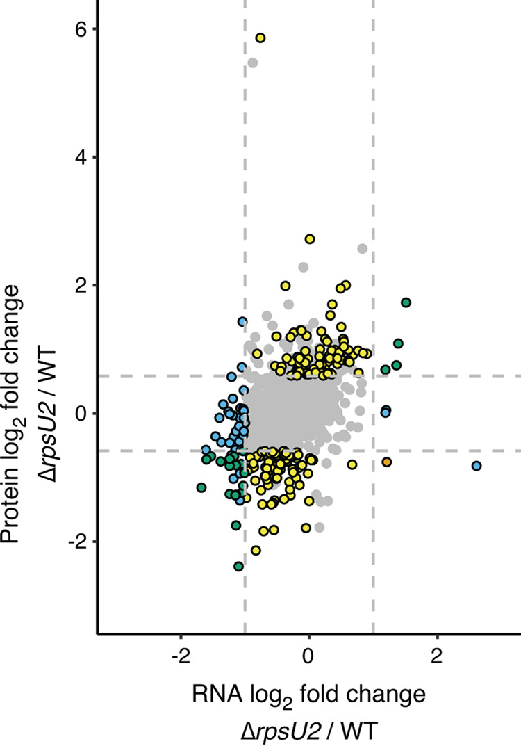
Figure 3. Cells lacking bS21-2 have changes in protein abundance that cannot be explained by changes in transcript abundance. Dots indicate genes. Log₂-transformed fold change of transcript abundances (x-axis versus log₂-transformed fold change of protein abundances (y-axis) between wild-type and ΔrpsU2 cells. The dot representing the gene yqeY is indicated in a red circle (Trautmann and Ramsey 2022).
We propose a general model in which each bS21 homolog is able to independently associate with ribosomes, and subsequently preferentially initiate translation of certain transcripts. With regard to bS21-2, we have determined that bS21-2 affects virulence protein abundance. However, the mechanism by which bS21-2 exerts its effects on the proteome of F. tularensis is an ongoing research topic. We have determined that specific leader sequences do lead to control by bS21-2, and that this control depends on an imperfect Shine-Dalgarno sequence (Trautmann et al. 2023).
Ribosome heterogeneity in F. tularensis
While zinc is known to affect paralogous ribosomal protein abundances resulting in changes in ribosome composition, none of the three homologs of bS21 in F. tularensis coordinate zinc. Further, the regulatory network controlling production of these three homologs has not been previously investigated.
Transcriptomic data of wild-type cells, cells lacking bS21-2, and cells lacking bS21-2 with ectopic expression of each of these three homologs reveals some interesting features regarding regulation of the gene encoding bS21-2, rpsU2. Specifically, in cells lacking bS21-2, there is a substantial increase in transcript abundance corresponding to the rpsU2 operon in comparison to wild-type cells. This increase in rpsU2 operon transcript abundance can be complemented by ectopic expression of all three bS21 homologs. Given that in the absence of bS21-2, the rpsU2 transcript abundance increases so drastically, it follows that bS21-2 is capable of repressing, or autogenously regulating, its own operon.
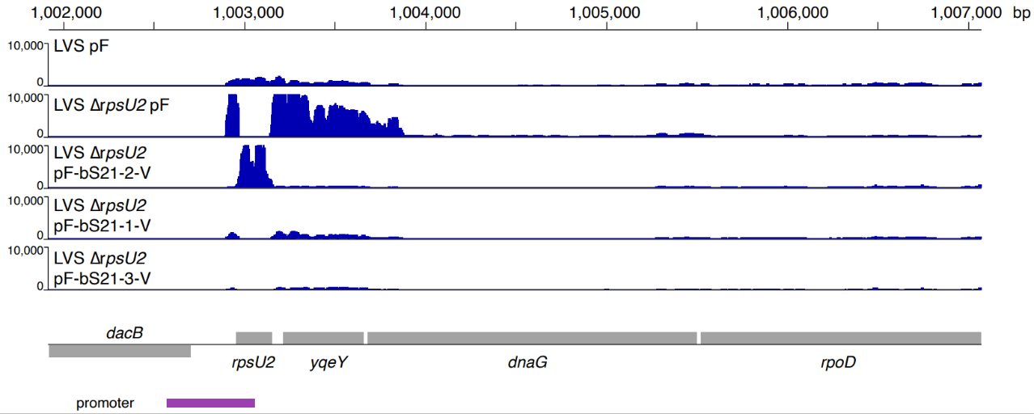
Figure 4. RNA Seq data suggests that bS21-2, bS21-1, and bS21-3 negatively regulate the rpsU2 operon. Normalized transcript abundance reads from RNA-Seq experiments mapped to the rpsU2 operon. Data from cells with bS21-2 (LVS pF), cells lacking bS21-2 (LVS ΔrpsU2 pF), and cells lacking bS21-2 but ectopically expressing either bS21-2, bS21-1, or bS21-3 (LVS ΔrpsU2 pF-bS21-2-V, pF-bS21-1-V, pF-bS21-3-V, respectively) from a heterologous strong promoter.
Unlike the zinc mediated r-protein regulation, this autogenous regulation mechanism appears to be more similar to other ribosomal proteins.
bS21-1 and bS21-3 in F. tularensis
rpsU1 and rpsU3 operon structure
Less is known about the roles of bS21-1 and bS21-3 in F. tularensis and limited information can be gleaned from the genomic context of their genes. The bS21-3-encoding gene, rpsU3, does not reside within an open reading frame with other annotated genes. The gene encoding bS21-1 is encoded downstream of cspC, a cold shock family protein (Trautmann and Ramsey 2022).
rpsU1-like operon in other species and F. tularensis
The location of rpsU1 adjacent to a cold shock protein is similar to the genetic organization of one of two rpsU homologs in Sinorhizobium meliloti. Specifically, the S. meliloti rpsU homolog is encoded in an operon downstream of two genes, cspA and ORF2 (now annotated as SM_RS10560) in S. meliloti. ORF2 encodes a novel polypeptide sequence which the authors determined to respond to cold shock although it does not have similarity to other Csp family proteins. The authors determined that cspA could be transcribed as a single mRNA transcript, or a polycistronic mRNA corresponding to the full operon. These transcripts both responded to cold shock, with a larger increase of the polycistronic transcript including the rpsU mRNA (105-fold increase). In order to assess the regulation of the cspA operon, the authors created fusions of either the promoter or the promoter and most of the 5′ UTR of the cspA operon fused to the luxAB reporter gene, integrated into the chromosome. Through exposure to cold shock and subsequent total RNA Northern Blots, it was determined that both the promoter and 5′ UTR lead to regulation of the cspA operon during cold shock, with more effect due to the presence of the 5′ UTR. Interestingly, the authors also noted that at 30 °C, the 5′ UTR decreased transcript abundance, which they suggest may be due to degradation. The authors speculated that bS21 may increase the affinity of mRNAs with ribosomal machinery, which is decreased during cold stress. Contrary to their hypothesis, the authors did not observe a cold-shock susceptible phenotype in S. meliloti cells lacking rpsU, though they did note that another rpsU homolog was present in the genome and that it was possible that this homolog compensated for the deleted rpsU (O’Connell and Thomashow 2000).
In F. tularensis, rpsU1 does not share an operon with cspA, but rather cspC (Trautmann and Ramsey 2022). In E. coli the CspC protein has been found to act as a transcription antiterminator, and may down-regulate heat shock proteins (Bae et al. 2000; Shenhar et al. 2009). Additionally the production of CspC is not induced by cold-shock (Czapski and Trun 2014). While rpsU genes in both S. meliloti and F. tularensis share an operon with cold shock family proteins, it is currently unclear how similar their regulation and function may be.
The roles of bS21-1 and bS21-3 in F. tularensis
In F. tularensis, bS21-1 and bS21-3 are the least abundant homologs (Trautmann and Ramsey 2022). This was determined through mass spectrometry analysis of purified 70S ribosomes. bS21-1 and bS21-3 could not be unambiguously identified due to their high sequence identity, and peptides corresponding to these proteins were only identified in one sample (Figure 5). Additionally, the spectral counts, on account of them being generated from purified ribosomes, shows that bS21-1 and/or bS21-3 can incorporate into ribosomes. This gives rise to evidence that F. tularensis possesses heterogenous ribosomes (Trautmann and Ramsey 2022).
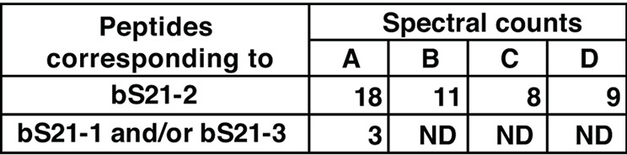
Figure 5. bS21-1 and bS21-3 are the least abundant homologs in F. tularensis. Spectral counts suggesting the number of peptide particles corresponding to either bS21-1/bS21-3 or bS21-2 incorporated into ribosomes of wild-type cells. bS21-1 and bS21-3 could not be further resolved due to peptide similarity. A-D refer to individual ribosomal purifications. ND refers to none detected, indicating that bS21-1/bS21-3 were only detected in sample A (Trautmann and Ramsey 2022).
There is limited information with respect to how bS21-1 and bS21-3 influence translation. Specifically, it was found that ectopic expression of either bS21-1 or bS21-3 could, to some level, restore abundance of T6SS proteins in cells lacking bS21-2 (Trautmann and Ramsey 2022). Particularly, ectopic expression of bS21-3 in cells lacking bS21-2 was found to restore virulence protein levels to wild-type or higher levels. On the other hand, ectopic expression of bS21-1 in cells lacking bS21-2 only led to partial restoration of wild-type virulence protein levels. However, while cells lacking bS21-2 have reduced fitness within macrophage, intramacrophage growth was only rescued by ectopic expression of bS21-2, not bS21-1 or bS21-3 (Trautmann and Ramsey 2022). This indicates that bS21-2, but not bS21-1 or bS21-3, is specifically required for survival inside macrophage (Trautmann and Ramsey 2022).
While bS21-1 and bS21-3 can independently incorporate into ribosomes, leading to ribosomal heterogeneity, the factors controlling production of these two homologs is still unclear. And although prior data revealed that bS21-2 is autogenously regulated, how bS21-2 exerts its effects on its own production is also unknown. These topics will be explored in the following chapters.

SUMMARY AND OBJECTIVES

Ribosomes may be heterogenous due to a number of factors, including incorporation of distinct ribosomal protein homologs. In our organism of interest, F. tularensis, there are three homologs of the ribosomal protein bS21. Previous work in the lab has indicated that bS21-2 is the most abundant of the three homologs, but that bS21-1 and bS21-3 can also be assembled into ribosomes. When present in ribosomes, bS21-2 affects the production of certain virulence proteins. How the production of specific bS21 homologs is regulated and how the three homologs are kept in balance with other ribosomal components is not well understood.
In the following chapters, I show that the autogenous regulation of bS21-2 is, at least in part, due to its leader sequence. Additionally, I show that two stem-loops in the leader sequence are not important for regulation by bS21-2, but that bS21-2 may de-stabilize its own transcript. Uniquely, bS21-1 and bS21-3 are not autogenously regulated. In the third chapter, I describe a number of environmental conditions and their impacts on regulation of bS21-1 and bS21-3 at either the transcriptional or translational level.

REFERENCES
Akanuma, Genki, Hideaki Nanamiya, Yousuke Natori, Naofumi Nomura, and Fujio Kawamura. 2006. “Liberation of Zinc-Containing L31 (RpmE) from Ribosomes by Its Paralogous Gene Product, YtiA, in Bacillus Subtilis.” Journal of Bacteriology 188(7):2715–20. doi: 10.1128/jb.188.7.2715-2720.2006.
Akanuma, Genki, Hideaki Nanamiya, Yousuke Natori, Koichi Yano, Shota Suzuki, Shuya Omata, Morio Ishizuka, Yasuhiko Sekine, and Fujio Kawamura. 2012. “Inactivation of Ribosomal Protein Genes in Bacillus Subtilis Reveals Importance of Each Ribosomal Protein for Cell Proliferation and Cell Differentiation.” Journal of Bacteriology 194(22):6282–91. doi: 10.1128/JB.01544-12.
Bae, W., B. Xia, M. Inouye, and K. Severinov. 2000. “Escherichia Coli CspA-Family RNA Chaperones Are Transcription Antiterminators.” Proceedings of the National Academy of Sciences of the United States of America 97(14):7784–89. doi: 10.1073/pnas.97.14.7784.
Ban, Nenad, Roland Beckmann, Jamie H. D. Cate, Jonathan D. Dinman, François Dragon, Steven R. Ellis, Denis L. J. Lafontaine, Lasse Lindahl, Anders Liljas, Jeffrey M. Lipton, Michael A. McAlear, Peter B. Moore, Harry F. Noller, Joaquin Ortega, Vikram Govind Panse, V. Ramakrishnan, Christian M. T. Spahn, Thomas A. Steitz, Marek Tchorzewski... Marat Yusupov. 2014. “A New System for Naming Ribosomal Proteins.” Current Opinion in Structural Biology 24:165–69. doi: 10.1016/j.sbi.2014.01.002.
Barry, G., C. L. Squires, and C. Squires. 1979. “Control Features within the rplJL-rpoBC Transcription Unit of Escherichia Coli.” Proceedings of the National Academy of Sciences of the United States of America 76(10):4922–26. doi: 10.1073/pnas.76.10.4922.
Basco, M. D. S., A. Kothari, Page B.McKinzie, J. R. Revollo, S. Agnihothram, M. P. Azevedo, M. Saccente, and M. E. Hart. 2019. “Reduced Vancomycin Susceptibility and Increased Macrophage Survival in Staphylococcus Aureus Strains Sequentially Isolated from a Bacteraemic Patient during a Short Course of Antibiotic Therapy.” Journal of Medical Microbiology 68(6):848–59. doi: 10.1099/jmm.0.000988.
Bell, J. Frederick, Cora R. Owen, and Carl L. Larson. 1955. “Virulence of Bacterium Tularense I. A Study of the Virulence of Bacterium Tularense in Mice, Guinea Pigs, and Rabbits.” The Journal of Infectious Diseases 97(2):162–66. doi: 10.1093/infdis/97.2.162.
Bent, Zachary W., David M. Brazel, Mary B. Tran-Gyamfi, Rachelle Y. Hamblin, Victoria A. VanderNoot, and Steven S. Branda. 2013. “Use of a Capture-Based Pathogen Transcript Enrichment Strategy for RNA-Seq Analysis of the Francisella tularensis LVS Transcriptome during Infection of Murine Macrophages.” PLOS ONE 8(10):e77834. doi: 10.1371/journal.pone.0077834.
Blake, Katy L., and Alex J. O’Neill. 2013. “Transposon Library Screening for Identification of Genetic Loci Participating in Intrinsic Susceptibility and Acquired Resistance to Antistaphylococcal Agents.” Journal of Antimicrobial Chemotherapy 68(1):12–16. doi: 10.1093/jac/dks373.
Brodmann, Maj, Roland F. Dreier, Petr Broz, and Marek Basler. 2017. “Francisella Requires Dynamic Type VI Secretion System and ClpB to Deliver Effectors for Phagosomal Escape.” Nature Communications 8(1):15853. doi: 10.1038/ncomms15853.
de Bruin, Olle M., Barry N. Duplantis, Jagjit S. Ludu, Rebekah F. Hare, Eli B. Nix, Crystal L. Schmerk, Craig S. Robb, Alisdair B. Boraston, Karsten Hueffer, and Francis E. Nano. 2011. “The Biochemical Properties of the Francisella Pathogenicity Island (FPI)-Encoded Proteins IglA, IglB, IglC, PdpB and DotU Suggest Roles in Type VI Secretion.” Microbiology 157(Pt 12):3483–91. doi: 10.1099/mic.0.052308-0.
Buchan, Blake W., Ramona L. McCaffrey, Stephen R. Lindemann, Lee-Ann H. Allen, and Bradley D. Jones. 2009. “Identification of migR, a Regulatory Element of the Francisella tularensis Live Vaccine Strain iglABCD Virulence Operon Required for Normal Replication and Trafficking in Macrophages.” Infection and Immunity 77(6):2517–29. doi: 10.1128/iai.00229-09.
Byrgazov, Konstantin, Oliver Vesper, and Isabella Moll. 2013. “Ribosome Heterogeneity: Another Level of Complexity in Bacterial Translation Regulation.” Current Opinion in Microbiology 16(2):133–39. doi: 10.1016/j.mib.2013.01.009.
Chang, Chu, and Gary R. Craven. 1977. “Identification of Several Proteins Involved in the Messenger RNA Binding Site of the 30 S Ribosome by Inactivation with 2-Methoxy-5-Nitrotropone.” Journal of Molecular Biology 117(2):401–18. doi: 10.1016/0022-2836(77)90135-8.
Charity, James C., Michelle M. Costante-Hamm, Emmy L. Balon, Dana H. Boyd, Eric J. Rubin, and Simon L. Dove. 2007. “Twin RNA Polymerase–Associated Proteins Control Virulence Gene Expression in Francisella tularensis.” PLOS Pathogens 3(6):e84. doi: 10.1371/journal.ppat.0030084.
Chen, Yu-Xiang, Zhi-yu Xu, Xueliang Ge, Jia-Yao Hong, Suparna Sanyal, Zhi John Lu, and Babak Javid. 2020. “Selective Translation by Alternative Bacterial Ribosomes.” Proceedings of the National Academy of Sciences 117(32):19487–96. doi: 10.1073/pnas.2009607117.
Clemens, Daniel L., Bai-Yu Lee, and Marcus A. Horwitz. 2018. “The Francisella Type VI Secretion System.” Frontiers in Cellular and Infection Microbiology 8.
Climie, Shane C., and James D. Friesen. 1987. “Feedback Regulation of the rplJL-rpoBC Ribosomal Protein Operon of Escherichia Coli Requires a Region of mRNA Secondary Structure.” Journal of Molecular Biology 198(3):371–81. doi: 10.1016/0022-2836(87)90287-7.
Cuthbert, Bonnie J., Wilma Ross, Amy E. Rohlfing, Simon L. Dove, Richard L. Gourse, Richard G. Brennan, and Maria A. Schumacher. 2017. “Dissection of the Molecular Circuitry Controlling Virulence in Francisella tularensis.” Genes & Development 31(15):1549–60. doi: 10.1101/gad.303701.117.
Czapski, Tiffaney R., and Nancy Trun. 2014. “Expression of Csp Genes in E. Coli K-12 in Defined Rich and Defined Minimal Media during Normal Growth, and after Cold-Shock.” Gene 547(1):91–97. doi: 10.1016/j.gene.2014.06.033.
Dai, Shipan, Nrusingh Mohapatra, Larry Schlesinger, and John Gunn. 2011. “Regulation of Francisella tularensis Virulence.” Frontiers in Microbiology 1.
Dennis, David T., Thomas V. Inglesby, Donald A. Henderson, John G. Bartlett, Michael S. Ascher, Edward Eitzen, Anne D. Fine, Arthur M. Friedlander, Jerome Hauer, Marcelle Layton, Scott R. Lillibridge, Joseph E. McDade, Michael T. Osterholm, Tara O’Toole, Gerald Parker, Trish M. Perl, Philip K. Russell, Kevin Tonat, and for the Working Group on Civilian Biodefense. 2001. “Tularemia as a Biological WeaponMedical and Public Health Management.” JAMA 285(21):2763–73. doi: 10.1001/jama.285.21.2763.
Diaconu, Mihaela, Ute Kothe, Frank Schlünzen, Niels Fischer, Jörg M. Harms, Alexander G. Tonevitsky, Holger Stark, Marina V. Rodnina, and Markus C. Wahl. 2005. “Structural Basis for the Function of the Ribosomal L7/12 Stalk in Factor Binding and GTPase Activation.” Cell 121(7):991–1004. doi: 10.1016/j.cell.2005.04.015.
Dow, Allexa, and Sladjana Prisic. 2018. “Alternative Ribosomal Proteins Are Required for Growth and Morphogenesis of Mycobacterium Smegmatis under Zinc Limiting Conditions.” PLOS ONE 13(4):e0196300. doi: 10.1371/journal.pone.0196300.
Dow, Allexa, Preeti Sule, Timothy J. O’Donnell, Andrew Burger, Joshua T. Mattila, Brandi Antonio, Kevin Vergara, Endrei Marcantonio, L. Garry Adams, Nicholas James, Philip G. Williams, Jeffrey D. Cirillo, and Sladjana Prisic. 2021. “Zinc Limitation Triggers Anticipatory Adaptations in Mycobacterium Tuberculosis.” PLOS Pathogens 17(5):e1009570. doi: 10.1371/journal.ppat.1009570.
Eigelsbach, H. T., Werner Braun, and Ruth D. Herring. 1951. “STUDIES ON THE VARIATION OF BACTERIUM TULARENSE.” Journal of Bacteriology 61(5):557–69.
Eshraghi, Aria, Jungyun Kim, Alexandra C. Walls, Hannah E. Ledvina, Cheryl N. Miller, Kathryn M. Ramsey, John C. Whitney, Matthew C. Radey, S. Brook Peterson, Brittany R. Ruhland, Bao Q. Tran, Young Ah Goo, David R. Goodlett, Simon L. Dove, Jean Celli, David Veesler, and Joseph D. Mougous. 2016. “Secreted Effectors Encoded within and Outside of the Francisella Pathogenicity Island Promote Intramacrophage Growth.” Cell Host & Microbe 20(5):573–83. doi: 10.1016/j.chom.2016.10.008.
Faron, Matthew, Joshua Fletcher, Jed Rasmussen, Matthew Long, Lee-Ann Allen, and Bradley Jones. 2013. “The Francisella tularensis migR, trmE, and cphA Genes Contribute to F. tularensis Pathogenicity Island Gene Regulation and Intracellular Growth by Modulation of the Stress Alarmone ppGpp.” Infection and Immunity 81. doi: 10.1128/IAI.00073-13.
Friedman, Lisa, Jeff D. Alder, and Jared A. Silverman. 2006. “Genetic Changes That Correlate with Reduced Susceptibility to Daptomycin in Staphylococcus Aureus.” Antimicrobial Agents and Chemotherapy 50(6):2137–45. doi: 10.1128/aac.00039-06.
Fukuda, Ryuji. 1980. “Autogenous Regulation of the Synthesis of Ribosomal Proteins, L10 and L7/12, in Escherichia Coil.”
Galperin, Michael Y., Yuri I. Wolf, Sofya K. Garushyants, Roberto Vera Alvarez, and Eugene V. Koonin. 2021. “Nonessential Ribosomal Proteins in Bacteria and Archaea Identified Using Clusters of Orthologous Genes.” Journal of Bacteriology 203(11):e00058-21. doi: 10.1128/JB.00058-21.
Golovliov, I., M. Ericsson, G. Sandström, A. Tärnvik, and A. Sjöstedt. 1997. “Identification of Proteins of Francisella tularensis Induced during Growth in Macrophages and Cloning of the Gene Encoding a Prominently Induced 23-Kilodalton Protein.” Infection and Immunity 65(6):2183–89.
Gutierrez, Maria G., Deborah R. Yoder-Himes, and Jonathan M. Warawa. 2015. “Comprehensive Identification of Virulence Factors Required for Respiratory Melioidosis Using Tn-Seq Mutagenesis.” Frontiers in Cellular and Infection Microbiology 5:78. doi: 10.3389/fcimb.2015.00078.
Hesselbrock, W., and L. Foshay. 1945. “The Morphology of Bacterium Tularense.” Journal of Bacteriology 49(3):209–31. doi: 10.1128/jb.49.3.209-231.1945.
Jones, Bradley, Matt Faron, Jed Rasmussen, and Josh Fletcher. 2014. “Uncovering the Components of the Francisella tularensis Virulence Stealth Strategy.” Frontiers in Cellular and Infection Microbiology 4.
Kajitani, M., and A. Ishihama. 1983. “Determination of the Promoter Strength in the Mixed Transcription System: Promoters of Lactose, Tryptophan and Ribosomal Protein L10 Operons from Escherichia Coli.” Nucleic Acids Research 11(3):671–86.
Keim, Paul, Anders Johansson, and David M. Wagner. 2007. “Molecular Epidemiology, Evolution, and Ecology of Francisella.” Annals of the New York Academy of Sciences 1105(1):30–66. doi: 10.1196/annals.1409.011.
Kingry, Luke C., and Jeannine M. Petersen. 2014. “Comparative Review of Francisella tularensis and Francisella Novicida.” Frontiers in Cellular and Infection Microbiology 4:35. doi: 10.3389/fcimb.2014.00035.
Lai, Xin-He, Igor Golovliov, and Anders Sjöstedt. 2004. “Expression of IglC Is Necessary for Intracellular Growth and Induction of Apoptosis in Murine Macrophages by Francisella tularensis.” Microbial Pathogenesis 37(5):225–30. doi: 10.1016/j.micpath.2004.07.002.
Larsson, Pär, Petra C. F. Oyston, Patrick Chain, May C. Chu, Melanie Duffield, Hans-Henrik Fuxelius, Emilio Garcia, Greger Hälltorp, Daniel Johansson, Karen E. Isherwood, Peter D. Karp, Eva Larsson, Ying Liu, Stephen Michell, Joann Prior, Richard Prior, Stephanie Malfatti, Anders Sjöstedt, Kerstin Svensson... Richard W. Titball. 2005. “The Complete Genome Sequence of Francisella tularensis, the Causative Agent of Tularemia.” Nature Genetics 37(2):153–59. doi: 10.1038/ng1499.
Li, Yunlong, Jamie H. Corro, Christopher D. Palmer, and Anil K. Ojha. 2020. “Progression from Remodeling to Hibernation of Ribosomes in Zinc-Starved Mycobacteria.” Proceedings of the National Academy of Sciences 117(32):19528–37. doi: 10.1073/pnas.2013409117.
Lilleorg, Silva, Kaspar Reier, Pavel Volõnkin, Jaanus Remme, and Aivar Liiv. 2020. “Phenotypic Effects of Paralogous Ribosomal Proteins bL31A and bL31B in E. Coli.” Scientific Reports 10(1):11682. doi: 10.1038/s41598-020-68582-2.
Linn, Thomas, and J. Scaife. 1978. “Identification of a Single Promoter in E. Coli for rplJ, rplL and rpoBC.” Nature 276(5683):33–37. doi: 10.1038/276033a0.
Miura, Chihiro, Ken Komatsu, Kensaku Maejima, Takamichi Nijo, Yugo Kitazawa, Tatsuya Tomomitsu, Akira Yusa, Misako Himeno, Kenro Oshima, and Shigetou Namba. 2015. “Functional Characterization of the Principal Sigma Factor RpoD of Phytoplasmas via an in Vitro Transcription Assay.” Scientific Reports 5:11893. doi: 10.1038/srep11893.
Mizuno, Carolina M., Charlotte Guyomar, Simon Roux, Régis Lavigne, Francisco Rodriguez-Valera, Matthew B. Sullivan, Reynald Gillet, Patrick Forterre, and Mart Krupovic. 2019. “Numerous Cultivated and Uncultivated Viruses Encode Ribosomal Proteins.” Nature Communications 10(1):752. doi: 10.1038/s41467-019-08672-6.
Murray, Gemma G. R., Jane Charlesworth, Eric L. Miller, Michael J. Casey, Catrin T. Lloyd, Marcelo Gottschalk, Alexander W. (Dan) Tucker, John J. Welch, and Lucy A. Weinert. 2021. “Genome Reduction Is Associated with Bacterial Pathogenicity across Different Scales of Temporal and Ecological Divergence.” Molecular Biology and Evolution 38(4):1570–79. doi: 10.1093/molbev/msaa323.
Nanamiya, Hideaki, Genki Akanuma, Yousuke Natori, Rikinori Murayama, Saori Kosono, Toshiaki Kudo, Kazuo Kobayashi, Naotake Ogasawara, Seung-Moon Park, Kozo Ochi, and Fujio Kawamura. 2004. “Zinc Is a Key Factor in Controlling Alternation of Two Types of L31 Protein in the Bacillus Subtilis Ribosome.” Molecular Microbiology 52(1):273–83. doi: 10.1111/j.1365-2958.2003.03972.x.
Nanamiya, Hideaki, and Fujio Kawamura. 2010. “Towards an Elucidation of the Roles of the Ribosome during Different Growth Phases in Bacillus Subtilis.” Bioscience, Biotechnology, and Biochemistry 74(3):451–61. doi: 10.1271/bbb.90859.
Nanamiya, Hideaki, Fujio Kawamura, and Saori Kosono. 2006. “Proteomic Study of the Bacillus Subtilis Ribosome: Finding of Zinc-Dependent Replacement for Ribosomal Protein L31 Paralogues.” The Journal of General and Applied Microbiology 52(5):249–58. doi: 10.2323/jgam.52.249.
Nano, Francis E., and Crystal Schmerk. 2007. “The Francisella Pathogenicity Island.” Annals of the New York Academy of Sciences 1105(1):122–37. doi: 10.1196/annals.1409.000.
Nano, Francis E., Na Zhang, Siobhán C. Cowley, Karl E. Klose, Karen K. M. Cheung, Michael J. Roberts, Jagjit S. Ludu, Gregg W. Letendre, Anda I. Meierovics, Gwen Stephens, and Karen L. Elkins. 2004. “A Francisella tularensis Pathogenicity Island Required for Intramacrophage Growth.” Journal of Bacteriology 186(19):6430–36. doi: 10.1128/JB.186.19.6430-6436.2004.
de Narvaez, C. Cowgill, and H. W. Schaup. 1979. “In Vivo Transcriptionally Coupled Assembly of Escherichia Coli Ribosomal Subunits.” Journal of Molecular Biology 134(1):1–22. doi: 10.1016/0022-2836(79)90411-X.
O’Connell, Kevin, and Michael Thomashow. 2000. “Transcriptional Organization and Regulation of a Polycistronic Cold Shock Operon in Sinorhizobium Meliloti RM1021 Encoding Homologs of the Escherichia Coli Major Cold Shock Gene cspA and Ribosomal Protein GenerpsU.” Retrieved May 8, 2023 (https://journals.asm.org/doi/epdf/10.1128/AEM.66.1.392-400.2000).
Olsufjev, N. G., and I. S. Meshcheryakova,. 1983. “Subspecific Taxonomy of Francisella tularensis McCoy and Chapin 1912†.” International Journal of Systematic and Evolutionary Microbiology 33(4):872–74. doi: 10.1099/00207713-33-4-872.
Paul, Brian J., Wilma Ross, Tamas Gaal, and Richard L. Gourse. 2004. “rRNA Transcription in Escherichia Coli.” Annual Review of Genetics 38(1):749–70. doi: 10.1146/annurev.genet.38.072902.091347.
Petersen, C. 1990. “Escherichia Coli Ribosomal Protein L10 Is Rapidly Degraded When Synthesized in Excess of Ribosomal Protein L7/L12.” Journal of Bacteriology 172(1):431–36.
Petersen, Jeannine M., and Claudia R. Molins. 2010. “Subpopulations of Francisella tularensis Ssp. Tularensis and Holarctica: Identification and Associated Epidemiology.” Future Microbiology 5(4):649–61. doi: 10.2217/fmb.10.17.
Prisic, Sladjana, Hyonson Hwang, Allexa Dow, Omar Barnaby, Tenny S. Pan, Jaymes A. Lonzanida, Walter J. Chazin, Hanno Steen, and Robert N. Husson. 2015. “Zinc Regulates a Switch between Primary and Alternative S18 Ribosomal Proteins in Mycobacterium Tuberculosis.” Molecular Microbiology 97(2):263–80. doi: 10.1111/mmi.13022.
Ramakrishnan, Girija, Bhaswati Sen, and Richard Johnson. 2012. “Paralogous Outer Membrane Proteins Mediate Uptake of Different Forms of Iron and Synergistically Govern Virulence in Francisella tularensis.” The Journal of Biological Chemistry 287(30):25191–202. doi: 10.1074/jbc.M112.371856.
Ramsey, Kathryn M., Melisa L. Osborne, Irina O. Vvedenskaya, Cathy Su, Bryce E. Nickels, and Simon L. Dove. 2015. “Ubiquitous Promoter-Localization of Essential Virulence Regulators in Francisella tularensis.” PLOS Pathogens 11(4):e1004793. doi: 10.1371/journal.ppat.1004793.
Rasmussen, Rebecca A., Suning Wang, Jeannie M. Camarillo, Victoria Sosnowski, Byoung-Kyu Cho, Young Ah Goo, Julius B. Lucks, and Thomas V. O’Halloran. 2022. “Zur and Zinc Increase Expression of E. Coli Ribosomal Protein L31 through RNA-Mediated Repression of the Repressor L31p.” Nucleic Acids Research 50(22):12739–53. doi: 10.1093/nar/gkac1086.
Rauhut, Reinhard, and Gabriele Klug. 1999. “mRNA Degradation in Bacteria.” FEMS Microbiology Reviews 23(3):353–70. doi: 10.1111/j.1574-6976.1999.tb00404.x.
Riffaud, Camille M., Elizabeth A. Rucks, and Scot P. Ouellette. 2023. “Persistence of Obligate Intracellular Pathogens: Alternative Strategies to Overcome Host-Specific Stresses.” Frontiers in Cellular and Infection Microbiology 13.
Rohlfing, Amy E., and Simon L. Dove. 2014. “Coordinate Control of Virulence Gene Expression in Francisella tularensis Involves Direct Interaction between Key Regulators.” Journal of Bacteriology 196(19):3516–26. doi: 10.1128/jb.01700-14.
Rohmer, Laurence, Mitchell Brittnacher, Kerstin Svensson, Danielle Buckley, Eric Haugen, Yang Zhou, Jean Chang, Ruth Levy, Hillary Hayden, Mats Forsman, Maynard Olson, Anders Johansson, Rajinder Kaul, and Samuel I. Miller. 2006. “Potential Source of Francisella tularensis Live Vaccine Strain Attenuation Determined by Genome Comparison.” Infection and Immunity 74(12):6895–6906. doi: 10.1128/iai.01006-06.
Rowe, Hannah M., and Jason F. Huntley. 2015. “From the Outside-In: The Francisella tularensis Envelope and Virulence.” Frontiers in Cellular and Infection Microbiology 5.
Rowen, L., and A. Kornberg. 1978. “Primase, the dnaG Protein of Escherichia Coli. An Enzyme Which Starts DNA Chains.” Journal of Biological Chemistry 253(3):758–64. doi: 10.1016/S0021-9258(17)38167-X.
Salomonsson, Emelie, Kerstin Kuoppa, Anna-Lena Forslund, Carl Zingmark, Igor Golovliov, Anders Sjöstedt, Laila Noppa, and Åke Forsberg. 2009. “Reintroduction of Two Deleted Virulence Loci Restores Full Virulence to the Live Vaccine Strain of Francisella tularensis.” Infection and Immunity 77(8):3424–31. doi: 10.1128/IAI.00196-09.
Shenhar, Yotam, Aviram Rasouly, Dvora Biran, and Eliora Z. Ron. 2009. “Adaptation of Escherichi Coli to Elevated Temperatures Involves a Change in Stability of Heat Shock Gene Transcripts.” Environmental Microbiology 11(12):2989–97. doi: 10.1111/j.1462-2920.2009.01993.x.
Shin, Jung-Ho, and John D. Helmann. 2016. “Molecular Logic of the Zur-Regulated Zinc Deprivation Response in Bacillus Subtilis.” Nature Communications 7(1):12612. doi: 10.1038/ncomms12612.
Su, Jingliang, Jun Yang, Daimin Zhao, Thomas H. Kawula, Jeffrey A. Banas, and Jing-Ren Zhang. 2007. “Genome-Wide Identification of Francisella tularensis Virulence Determinants.” Infection and Immunity 75(6):3089–3101. doi: 10.1128/iai.01865-06.
Trautmann, Hannah, and Kathryn Ramsey. 2022. “A Ribosomal Protein Homolog Governs Gene Expression and Virulence in a Bacterial Pathogen.” Journal of Bacteriology 204(10):e00268-22. doi: https://doi.org/10.1128/jb.00268-22.
Trautmann, Hannah, Sierra Schmidt, Steven Gregory, and Kathryn Ramsey. 2023. “Ribosome Heterogeneity Results in Leader Sequence-Mediated Regulation of Protein Synthesis in Francisella tularensis.” Manuscript Submitted for Publication.
Travis, Brady A., Kathryn M. Ramsey, Samantha M. Prezioso, Thomas Tallo, Jamie M. Wandzilak, Allen Hsu, Mario Borgnia, Alberto Bartesaghi, Simon L. Dove, Richard G. Brennan, and Maria A. Schumacher. 2021. “Structural Basis for Virulence Activation of Francisella tularensis.” Molecular Cell 81(1):139-152.e10. doi: 10.1016/j.molcel.2020.10.035.
Travis, Brady A., and Maria A. Schumacher. 2022. “Diverse Molecular Mechanisms of Transcription Regulation by the Bacterial Alarmone ppGpp.” Molecular Microbiology 117(2):252–60. doi: 10.1111/mmi.14860.
Turnbough, Charles L. 2019. “Regulation of Bacterial Gene Expression by Transcription Attenuation.” Microbiology and Molecular Biology Reviews 83(3):10.1128/mmbr.00019-19. doi: 10.1128/mmbr.00019-19.
Van Duin, Jan, and Wijnands Robert. 1981. “The Function of Ribosomal Protein S21 in Protein Synthesis.” European Journal of Biochemistry 118(3):615–19. doi: 10.1111/j.1432-1033.1981.tb05563.x.
Versalovic, James, Thearith Koeuth, Robert Britton, Kati Geszvain, and James R. Lupski. 1993. “Conservation and Evolution of the rpsU-dnaG-rpoD Macromolecular Synthesis Operon in Bacteria.” Molecular Microbiology 8(2):343–55. doi: 10.1111/j.1365-2958.1993.tb01578.x.
Yamamoto, M., and M. Nomura. 1978. “Contranscription of Genes for RNA Polymerase Subunits Beta and Beta’ with Genes for Ribosomal Proteins in Escherichia Coli.” Proceedings of the National Academy of Sciences of the United States of America 75(8):3891–95.
Yates, J. L., D. Dean, W. A. Strycharz, and M. Nomura. 1981. “E. Coli Ribosomal Protein L10 Inhibits Translation of L10 and L7/L12 mRNAs by Acting at a Single Site.” Nature 294(5837):190–92. doi: 10.1038/294190a0.
Yutin, Natalya, Pere Puigbò, Eugene V. Koonin, and Yuri I. Wolf. 2012. “Phylogenomics of Prokaryotic Ribosomal Proteins.” PLoS ONE 7(5):e36972. doi: 10.1371/journal.pone.0036972.
Zengel, Janice M., and Lasse Lindahl. 1994. “Diverse Mechanisms for Regulating Ribosomal Protein Synthesis in Escherichia Coli.” Pp. 331–70 in Progress in Nucleic Acid Research and Molecular Biology. Vol. 47. Elsevier.

CHAPTER 2

Manuscript 1

Control of bS21 homolog production in Francisella tularensis

Prepared for submission to the Journal of Bacteriology

Sierra S. Schmidt¹, Aisling Macaraeg¹, Dan Floyd¹, Hannah S. Trautmann¹, and Kathryn M. Ramsey^{1,2,*}

¹Department of Cell and Molecular Biology, University of Rhode Island, Kingston, RI 02881, USA
²Department of Biomedical and Pharmaceutical Sciences, University of Rhode Island, Kingston, RI 02881, USA
Abstract
Francisella tularensis is a highly infectious, intracellular human pathogen. F. tularensis ribosomes containing bS21-2 (one of three homologs for the small ribosomal subunit protein bS21) positively controls key virulence genes and intramacrophage replication. Both of which are essential for this organism to cause disease. Although ribosomal bS21 content influences F. tularensis virulence, the factors that control bS21 homolog production are not well understood. Here, we reveal that all three bS21 homologs influence transcript abundance of the homolog important for virulence, bS21-2. In contrast, the other bS21 homologs (bS21-1 and bS21-3) do not affect their own production. We additionally determined that while a particular 61 nucleotide section of the bS21-2 leader sequence is sufficient for bS21-2-mediated repression of mRNA abundance, translation of the bS21-2 transcript is controlled by other factors. Finally, bS21-2 may exert its effects on bS21-2 transcript by altering its stability. Together, our findings suggest that F. tularensis integrates multiple signals into a regulatory network to control the appropriate production of each bS21 homolog, and particularly the homolog important for virulence, bS21-2. This regulatory network in turn may control ribosomal heterogeneity and virulence gene expression.

Introduction
Among the cellular processes, translation is the most energetically costly (Hu et al., 2020). Part of this cost is the assembly of the large molecular machine that catalyzes protein synthesis, the ribosome. Accordingly, cells have complex regulatory networks to balance the production of rRNA and ribosomal proteins (r-proteins). For example, operons encoding multiple r-proteins are often regulated by an r-protein that is among the first to bind rRNA in assembly (primary binding r-proteins), as these r-proteins recognize and bind specific mRNA features that are structurally analogous to their binding sites on rRNA (Nomura et al., 1984).
It is common for bacteria to encode multiple homologs for at least one ribosomal protein, which can lead to heterogeneity in ribosome composition (Yutin et al., 2012). This also raises the question of how production of different r-protein homologs is coordinated and balanced. Many highly divergent r-protein paralogs either do or do not coordinate zinc (Cheng-Guang and Gualerzi, 2021; Yutin et al., 2012). When in zinc-replete conditions, organisms with these paralogs incorporate the zinc-coordinating r-protein paralog into ribosomes. But in environments with less zinc, cells use zinc-responsive transcription factors to allow production of r-protein paralogs that do not coordinate zinc (alternative paralogs). Subsequently, the alternative paralogs are incorporated into ribosomes. This mechanism of paralog switching, dependent on the concentration of a divalent cation and the de-repression of a transcription factor, is relatively straightforward and is thought to allow dynamic control of intracellular zinc concentrations (Cheng-Guang and Gualerzi, 2021; Shin and Helmann, 2016).
The highly infectious intracellular human pathogen Francisella tularensis encodes three distinct homologs of the small ribosomal subunit protein bS21 and we have demonstrated that F. tularensis ribosomes can be heterogenous with respect to bS21 content (Trautmann and Ramsey, 2022). Additionally, ribosomes with bS21-2 are uniquely important for both production of a critical virulence factor, the type VI secretion system, and intramacrophage survival, which is essential for F. tularensis to cause disease (Trautmann and Ramsey, 2022). How F. tularensis cells balance production of the three bS21 homologs is not clear. bS21 is not a primary binding r-protein (it is among the last to be assembled into the ribosome) and none of the F. tularensis bS21 homologs are encoded in operons with other primary binding r-proteins (Mizushima and Nomura, 1970; Trautmann and Ramsey, 2022). None of the F. tularensis bS21 homologs are predicted to coordinate zinc or other divalent cations. However, there is evidence that in F. tularensis, bS21-2 is autogenously regulated; in cells without bS21-2, there is a large increase in mRNA corresponding to the gene immediately downstream of the bS21-2 gene, yqeY, which can be complemented by ectopic expression of bS21-2 (Trautmann and Ramsey, 2022).
There is limited information regarding control of bS21 in other organisms. E. coli encodes only a single bS21 homolog which is not autogenously regulated (Nomura et al., 1984; Takata, 1978). In the Bacteroidia species Flavobacterium johnsoniae, the single bS21 homolog is autogenously controlled, but through a mechanism unlikely to be present in divergent species such as F. tularensis. Specifically, the C-terminal region of F. johnsoniae bS21 is conserved among Bacteroidia species and contributes to the sequestration of the anti-Shine-Dalgarno (ASD) (Jha et al., 2020; McNutt et al., 2023). This sequestration precludes ribosomes from being responsive to Shine-Dalgarno (SD) sequences, but the transcript encoding bS21 is essentially the only F. johnsoniae mRNA with a strong SD. Thus, when bS21 is depleted and the ASD becomes accessible, translation of the bS21-encoding transcript increases. However, this mechanism for autogenous regulation is likely limited to the bS21 homologs in Bacteroidia with conserved sequence and structure in their C-terminal region.
In F. tularensis, we measured RNA abundance in cells with and without bS21-2 and found that the presence of any of the three F. tularensis bS21 homologs reduces steady-state levels of the bS21-2-encoding transcript, rpsU2. This autogenous regulation appears to be unique to bS21-2, as we did not find that bS21-1 or bS21-3 similarly control their own production. Using reporter assays, we found that despite the increase in rpsU2 transcript abundance in cells without bS21-2, there is no concordant increase in protein abundance, suggesting that other regulatory mechanisms control rpsU2 translation. Additional reporter assays demonstrated that while the 5´ UTR of rpsU2 is sufficient for control of transcript abundance by bS21-2, the first 38 nucleotides of the rpsU2 transcript, predicted to encode two stem-loops, are dispensable for regulation. Finally, bS21-2 may exert its effects on rpsU2 abundance by altering mRNA stability. Our results suggest that control of the bS21 homologs in F. tularensis, and particularly of bS21-2, is complex and regulated by multiple factors.

Results
bS21 homologs control abundance of the bS21-2-encoding mRNA
Previous studies examined the effects of bS21-2 deletion on mRNA abundance using RNA-Seq (Trautmann and Ramsey, 2022). Notably, the gene with the largest change in transcript abundance, yqeY, is encoded in the same operon and immediately downstream of the bS21-2-encoding gene, rpsU2. Loss of bS21-2 leads to a 6-fold increase in yqeY transcript, which can be complemented by ectopic expression of bS21-2. Further analysis reveals that the region corresponding to the 5´ UTR of rpsU2 is increased 9-fold in the absence of bS21-2 (Fig 1). These results suggest that bS21-2 autogenously controls its own production, functioning as a negative regulator of the rpsU2 operon transcript.
Figure 1. All three F. tularensis bS21 homologs negatively regulate the rpsU2 operon. Normalized transcript abundance reads from RNA-Seq experiments in the area surrounding the rpsU2 operon. Data from cells with bS21-2 (LVS pF), cells lacking bS21-2 (LVS ΔrpsU2 pF), and cells lacking bS21-2 but ectopically expressing either bS21-2, bS21-1, or bS21-3 (LVS ΔrpsU2 pF-bS21-2-V, pF-bS21-1-V, pF-bS21-3-V, respectively). Y-axis is truncated at 10,000 for clarity. Grey rectangles represent genes and those above the line indicate genes encoded on the positive strand; those below the black line represent those encoded on the negative strand. The purple box indicates an experimentally-determined promoter region (as in (Ramsey et al., 2015)).
In addition to bS21-2 controlling its own transcript, additional unpublished RNA-Seq data reveal that the other bS21 homologs can also repress expression of the rpsU2 operon. In particular, ectopic expression of either bS21-1 or bS21-3 in cells lacking bS21-2 lead to reductions in the rpsU2 transcript abundance to levels similar to that found in wild-type cells. Thus, all three bS21 homologs function similarly with respect to repressing abundance of mRNA corresponding to the rpsU2 operon.
bS21-1 and bS21-3 do not control their own production
While loss of bS21-2 did not affect the transcript abundance of the genes encoding bS21-1 or bS21-3 (rpsU1 and rpsU3, respectively), (Trautmann and Ramsey, 2022) finding that bS21-2 autoregulates its production raises the possibility that other bS21 homologs in F. tularensis may also be autoregulated. To test this possibility, qRT-PCR was used to assess the abundance of the transcripts encoding these proteins in cells with and without the r-protein of interest. Specifically, we compared transcript abundance of the 5´ UTR of rpsU1 in cells with and without bS21-1 (Fig 2A) and the 5´ UTR of rpsU3 in cells with and without bS21-3 (Fig 2B). In contrast to our findings regarding the control of bS21-2, loss of the other bS21 homologs does not appear to impact the abundance of their own transcripts.
Figure 2. bS21-1 and bS21-3 do not regulate their own transcript abundance. (A) Transcript abundance of the rpsU1 5´ UTR in either wild-type cells or cells lacking rpsU1, relative to tul4 (a control gene). (B) ) Transcript abundance of the rpsU3 5´ UTR in either wild-type cells or cells lacking rpsU3, relative to tul4 (a control gene). (A+B) No statistical significance indicated.

Transcription and translation of the rpsU2 operon are differentially regulated
We generated translational reporter fusions to further examine autoregulation of bS21-2. The transcription start site for rpsU2 was previously identified, allowing us to use a defined 5´ UTR (Ramsey et al., 2015). The first translational reporters included the promoter, 5´ UTR, and the first six codons of either rpsU2 or a control gene, tul4, fused to lacZ (Fig 3A). These reporters were incorporated in single copy into the chromosome at the Tn7 site in cells with or without bS21-2. We measured transcript abundance of the lacZ gene using qRT-PCR and translation using ß-galactosidase assays. We found that the rpsU2 translational reporter recapitulates control of rpsU2 mRNA abundance by bS21-2; in cells lacking bS21-2, lacZ transcript increases by ~9-fold (Fig 3B). In contrast, the amount of lacZ transcript is essentially the same in cells with the tul4 reporter, regardless of bS21-2 presence (Fig 3B). However, translation of the lacZ mRNA with the rpsU2 leader sequence is not affected by bS21-2 in the same way. Despite the ~9-fold increase in lacZ transcript, there is only ~30% more ß-galactosidase activity in cells lacking bS21-2 compared to cells with bS21-2 (Fig 3C). Thus, it seems that changes in bS21-2-controlled transcript abundance are not reflected in translation.
Figure 3. The rpsU2 5´ UTR allows control transcript abundance yet transcript and protein abundance changes are not correlated. (A) Diagram of translational reporters. (B) Relative lacZ transcript abundance for indicated translational fusions in cells with (+; wild-type) or without (-; ∆rpsU2) bS21-2. Quantitative RT-PCR was used to determine the relative transcript normalized to the tul4 gene. (C) Relative β-galactosidase activity for indicated lacZ translational fusions in cells with (+; wild-type) or without (−; ∆rpsU2) bS21-2. (B and C) Error bars represent 1 SD. Lines above bars indicate comparisons, *p < 0.05. Experiments were repeated at least twice in biological triplicate, and data from a representative experiment are shown.

There is evidence that this control is not unique to translation of our reporter construct but is important for translation of the native rpsU2 transcript. Specifically, while the abundance of the rpsU2 operon transcript, including yqeY, is significantly increased in cells without bS21-2, proteomic analysis revealed no significant change in YqeY protein abundance (changes reported as significant are 1.5-fold altered with an adjusted P < 0.05; (Trautmann and Ramsey, 2022)). These findings suggest that while bS21-2 regulates the abundance of its own transcript, one or more additional factors control translation of the bS21-2 transcript.
The rpsU2 5´ UTR is sufficient for transcriptional autoregulation
There are a variety of mechanisms by which production of r-proteins are controlled and many of them depend on mRNA leader sequences of the regulated r-protein. To determine if the 5´ UTR of rpsU2 is sufficient to permit regulation by bS21-2, we created translational fusions which used a control promoter (tul4) driving expression of the 5´ UTR and first six codons of rpsU2 fused to lacZ. As with the other reporters, this reporter was integrated onto the chromosome at the Tn7 site in cells with and without bS21-2. We found that in cells without bS21-2, there was ~4-fold more lacZ transcript compared to cells with bS21-2, suggesting that the rpsU2 5´ UTR is sufficient to allow at least some control by bS21-2 (Fig 3B). Additionally, using this reporter we observed the same disconnect between control of transcript abundance and translation. Despite the ~4-fold increase in lacZ transcript abundance, we only found ~30% more ß-galactosidase activity in cells lacking bS21-2 compared to cells with bS21-2 (Fig 3C). Thus, the rpsU2 5´ UTR is sufficient to lead to repression of mRNA abundance by bS21-2 and regulation of translation by other factor(s).
Stem-loops in the rpsU2 mRNA do not influence regulation by bS21-2
We sought to investigate what features of the 5´ UTR allow bS21-2 to control the abundance of the rpsU2 mRNA. The secondary structures formed by mRNA leader sequences are often subject to regulatory control and the first 38 nucleotides of the rpsU2 5´ UTR are predicted to form two stem-loop structures (Fig 4A). We considered the possibility that these stem-loops might be key for regulation of rpsU2 mRNA abundance and generated plasmid-based reporter fusions to test this hypothesis. Specifically, these reporters included either the full-length 5´ UTR (91 nt; “full”) or truncated version (61 nt; “∆loops”) and the first six codons of rpsU2 fused in-frame with gfp, driven by the control promoter (tul4). The plasmid reporters were introduced into cells with (LVS) and without bS21-2 (∆rpsU2) and we measured both gfp transcript abundance and GFP fluorescence (Fig 4B, C). Cells containing the reporter construct with the full-length rpsU2 5´ UTR recapitulated our previous observations regarding regulation of the rpsU2 mRNA, specifically that transcript abundance increases significantly (>2-fold) in cells without bS21-2, but that there is no similarly meaningful increase in protein abundance. Notably, cells containing the truncated rpsU2 5´ UTR reporter construct exhibited the same phenotypes (Fig 4 B, C). These results indicate that the first 38 nt of the rpsU2 mRNA, including any predicted stem-loops, are dispensable for regulation by bS21-2.
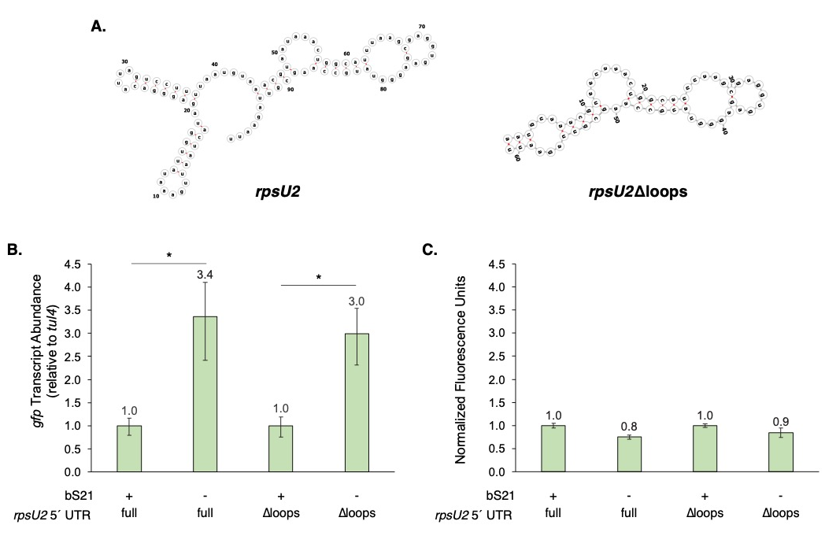
Figure 4. Predicted stem-loops in the rpsU2 mRNA are dispensable for control by bS21-2. (A) Secondary structure predictions of wild-type and modified rpsU2 5 ́ UTRs, generated by MXfold2. (B) Relative gfp transcript abundance for indicated translational fusions in cells with (+; wild-type) or without (-; ∆rpsU2) bS21-2. Quantitative RT-PCR was used to determine the relative transcript normalized to the tul4 gene. (C) Relative fluorescence of cells with indicated gfp translational fusions in cells with (+; wild-type) or without (−; ∆rpsU2) bS21-2. (B and C) Error bars represent 1 SD. Lines above bars indicate comparisons, *p < 0.05. Experiments were repeated at least twice in biological triplicate, and data from a representative experiment are shown.

bS21-2 may influence the stability of its own mRNA
The amount of any given transcript in a cell depends on two factors: the amount of new transcript produced and the rate of its degradation. Since we determined that the rpsU2 5´ UTR is sufficient for bS21-2-mediated changes in abundance, we considered that stability, rather than production, may be a key factor in regulating rpsU2 transcript abundance. We used cells with and without bS21-2 and used a transcription inhibition assay to determine the stability of the rpsU2 operon transcript. Specifically, we grew cells to mid-log phase, added the RNA polymerase inhibitor rifampicin to halt transcription initiation, and isolated RNA at several timepoints. We subsequently used qRT-PCR to determine the amount of RNA corresponding to the yqeY transcript at each timepoint. Using this approach, we have consistently found that the rpsU2 transcript has a longer half-life in cells lacking bS21-2 (~6 minutes compared to ~2.5 minutes; Fig 5). However, variability within these experiments precludes these results from being statistically significant, so we cannot conclusively say that the presence of bS21-2 destabilizes its own transcript.

Figure 5. The presence of bS21-2 may destabilize the rpsU2 mRNA. Left: Graph of rpsU2 operon transcript over time after transcription inhibition. C_{p}/-1 reflects qRT-PCR crossing point (Cp) divided by -1, and reflects total RNA amount; numbers closer to 0 represent more mRNA. Linear regression analysis was used to fit data (Prism), but slopes are not significantly different (p = 0.37). Error bars represent 1 SD. Right: Half-lives calculated from slope of best-fit values. Experiments were repeated at least twice in biological triplicate, and data from a representative experiment are shown.

Discussion
In this study, we investigate what factors allow coordinated production of bS21 homologs in F. tularensis. In particular, we determined that the presence of any of the three bS21 homologs can repress abundance of the transcript encoding bS21-2, rpsU2, but neither bS21-1 nor bS21-3 influence the abundance of their own transcripts. However, our work reveals that translation of the bS21-2 protein is further controlled by unknown factor(s), as large increases in rpsU2 transcript abundance in cells without bS21-2 do not lead to similar increases in protein abundance. We further identify that while the 5´ UTR of the rpsU2 transcript is sufficient to lead to regulation by bS21-2, two predicted stem-loops in the leader sequence are not required. Finally, our work suggests that bS21-2 may exert its effects on rpsU2 transcript abundance by altering mRNA stability. Together, these results reveal that coordinated production of bS21 homologs, and particularly bS21-2, in F. tularensis is complex and controlled at multiple steps.
The observation that the presence of any of the three bS21 homologs can reduce rpsU2 transcript abundance is consistent with a model in which r-proteins are regulators in a negative feedback loop. In particular, the abundance of an r-protein would be inversely correlated to the abundance of its mRNA (i.e., as the r-protein abundance decreases, its transcript increases). In this case, all three bS21-2 homologs can repress the transcript encoding bS21-2. These bS21 homologs are between 48-72% identical (Trautmann and Ramsey, 2022), and, given their similar influence on rpsU2 mRNA, it raises the possibility that the conserved residues in bS21 homologs are key for regulation of rpsU2, either directly or indirectly.
The logical extension of this negative feedback model is ultimately a balance in r-protein abundance, with lower amounts of an r-protein triggering production of more r-protein and higher amounts inhibiting excess production. Yet, despite a 3-fold increase in bS21-2-encoding transcript, we observed only about a 30% increase in bS21-2 protein using reporter systems and when examining control of genes in the native rpsU2 operon. Because the presence or absence of bS21-2 does not substantially alter the abundance of proteins encoded by the rpsU2 operon, we hypothesize that another factor is limiting translation initiation, even in the presence of abundant rpsU2 mRNA. This factor (or factors) remains to be identified.
While the 5´ UTR of the rpsU2 transcript is sufficient for regulation by bS21-2, the specific elements that permit regulation have yet to be identified. In examining the contribution of two predicted stem-loops in the leader sequence, we narrowed down the region sufficient to lead to regulation to 61 nucleotides. Additional work will be required to identify what sequence elements contribute to this regulation, as well as how bS21-2 exerts its regulatory effects.

Materials and Methods
Bacterial strains and growth conditions
F. tularensis subsp. holarctica LVS cells were grown in Mueller Hinton Broth supplemented with 0.025% iron pyrophosphate, 0.1% glucose, and 2% Isovitalex at 37°C shaking aerobically, or on cystine heart agar plates containing 1% hemoglobin (CHA-H) at 37°C. E. coli XL1-Blue and PIR1 cells were grown in LB media or on LB plates. The selective antibiotics kanamycin (kan), hygromycin (hyg), or nourseothricin (nat) was used to maintain plasmids in F. tularensis LVS at 5 µg/mL or in E. coli at 50 µg/mL.
Plasmid design and construction
Plasmids were first designed using SnapGene application (GSL Biotech LLC). Necessary gene components were amplified via PCR, then purified with the QIAquick Purification Kit. PCR products and pF backbones were then digested using restriction enzymes, electrophoresed, and extracted using the QIAquick Gel Extraction Kit. Gel-purified fragments were then ligated and used to transform E. coli via heat shock. Colonies that grew on the appropriate selective media were isolated with the QIAprep Spin Miniprep Kit and confirmed via Sanger sequencing through the INBRE Core Facility.
Integration of reporter constructs into the Tn7 site of F. tularensis
Reporter constructs were integrated into the Tn7 site of F. tularensis LVS as previously described (LoVullo et al., 2009). Briefly, LVS cells were made electrocompetent by washing with 10% sucrose. The Tn7 helper plasmid pMP720 was electroporated into electrocompetent cells with or without bS21-2, and plasmid-containing cells were selected on hygromycin B-containing media. Cells harboring the helper plasmid were electroporated with the appropriate mini-Tn7 plasmid and selected for on CHA-H plates with kanamycin. PCR was used to screen kanamycin-resistant colonies for plasmid integration at the attTn7 site and candidates were confirmed by amplification and sequencing of gDNA outside of the attTn7 site.
Plasmids
To generate plasmids in which the rpsU2 5´ UTR or Δloops 5´ UTR drive expression of gfp, pKR123 (unpublished) was digested with KpnI/NotI, resulting in a fragment containing the promoter of tul4 fused to the rpsU2 5´ UTR. Another plasmid, pKR183, containing the sfGFP gene codon-optimized for expression in F. tularensis LVS (Trautmann et al., 2023), was digested with KpnI/BamHI. Further, pKR123 (unpublished), containing the mini-Tn7 plasmid backbone was digested with NotI/BamHI, and all three of these fragments were ligated together forming the in-frame GFP reporter plasmid, pKR184 Tn7 Ptul4-rpsU2 5´ UTR-GFP.
To create Δloops 5´ UTR, primers were used to amplify from pKR184, deleting the stem loop structures in the first 38 nt of the rpsU2 5´ UTR. The first primer contained a PacI site with the last 22 nt of the promoter of tul4 on the 5´-end fused to the 32 nt, directly after the first 38 nt of the rpsU2 5´ UTR which are not encoded on the primer. The reverse primer located 152 bp upstream of the 3´ end of the gfp gene contained the MfeI cut site. The resultant fragment was ligated with PacI/MfeI digested pKR184, effectively deleting the stem loop structures and resulting in pKR191 Tn7 Ptul4-rpsU2 Δloops 5´ UTR-GFP.
Strains
The derivatives of F. tularensis subsp. holarctica LVS used in this study are found in Table 1.
Table 1. F. tularensis LVS strains used in this study
Strain | Genotype
KRLVS111 | LVS ΔrpsU2 Tn7::Ptul4-tul4 5'UTR-lacZ aphA
KRLVS112 | LVS Tn7::Ptul4-tul4 5'UTR-lacZ aphA
KRLVS148 | LVS ∆rpsU2 Tn7_PrpsU2_rpsU2 5'UTR_lacZ aphA
KRLVS149 | LVS Tn7_PrpsU2_rpsU2 5'UTR_lacZ aphA
KRLVS150 | LVS ∆rpsU2 Tn7_Ptul4_rpsU2 5'UTR_lacZ aphA
KRLVS151 | LVS Tn7_Ptul4_rpsU2 5'UTR_lacZ aphA
KRLVS179 | LVS Tn7::Ptul4-rpsU2 5'UTR-GFP
KRLVS180 | LVS ΔrpsU2 Tn7::Ptul4-rpsU2 5'UTR-GFP
KRLVS181 | LVS Tn7::Ptul4-rpsU2 mut5'UTR-GFP
KRLVS182 | LVS ΔrpsU2 Tn7::Ptul4-rpsU2 mut5'UTR-GFP

mRNA stability assay
The stability of mRNAs was assessed essentially as described (Nguyen et al., 2020). Briefly, strains of interest were grown to mid-log phase (OD₆₀₀ = 0.3 – 0.4) in triplicate, and rifampicin was added to a final concentration of 50 ug/mL. After 0, 1, 2, 4, and 8 minutes, 7 mL cultures were snap frozen using liquid nitrogen and stored at -80°C until purification.
RNA isolation and quantitative real-time PCR
F. tularensis LVS cells with and without bS21-2 (KRLVS148 and KRLVS149) were grown to mid-log (OD₆₀₀ = 0.3 – 0.4) in triplicate. Total nucleic acids were isolated using the Zymo Research Direct-zol RNA Kit following manufacturer’s protocols. Nucleic acids were treated with RQ1 DNase (Promega) and RNA was re-purified using the Zymo Research Direct-zol RNA Kit. cDNA was synthesized and quantitative real-time PCR was performed as previously described (Trautmann and Ramsey, 2022). Experiments were performed at least twice in biological triplicate.
β-Galactosidase assay
Indicated derivatives of F. tularensis LVS cells were grown to mid-log (OD₆₀₀ = 0.3 – 0.4) in triplicate and ß-galactosidase activity was measured as previously described (Charity et al., 2009). Reactions were stopped after 120 minutes if no significant yellow color developed. Experiments were performed at least twice in biological triplicate.
GFP assay
Indicated derivatives of F. tularensis LVS cells were grown to mid-log (OD₆₀₀ = 0.3 – 0.4) and 1 - 4mL were pelleted and resuspended in PBS. Optical density (OD₆₀₀) and fluorescence (excitation 495 nm, emission of 535 nm) were measured in technical triplicate using a SpectraMax® iD3 Multi-Mode Microplate Reader. Fluorescence readings were normalized to OD₆₀₀ and the fluorescence from LVS cells (containing an empty vector but no GFP reporter) was subtracted. Experiments were conducted at least twice in biological triplicate.
References

Charity JC, Blalock LT, Costante-Hamm MM, Kasper DL, Dove SL. 2009. Small molecule control of virulence gene expression in Francisella tularensis. Plos Pathog 5:e1000641. doi:10.1371/journal.ppat.1000641
Cheng-Guang H, Gualerzi CO. 2021. The Ribosome as a Switchboard for Bacterial Stress Response. Front Microbiol 11:619038. doi:10.3389/fmicb.2020.619038
Hu X-P, Dourado H, Schubert P, Lercher MJ. 2020. The protein translation machinery is expressed for maximal efficiency in Escherichia coli. Nat Commun 11:5260. doi:10.1038/s41467-020-18948-x
Jha V, Roy B, Jahagirdar D, McNutt ZA, Shatoff EA, Boleratz BL, Watkins DE, Bundschuh R, Basu K, Ortega J, Fredrick K. 2020. Structural basis of sequestration of the anti-Shine-Dalgarno sequence in the Bacteroidetes ribosome. Nucleic Acids Res 49:547–567. doi:10.1093/nar/gkaa1195
LoVullo ED, Molins-Schneekloth CR, Schweizer HP, Jr MSP. 2009. Single-copy chromosomal integration systems for Francisella tularensis. Microbiology 155:1152–1163. doi:10.1099/mic.0.022491-0
McNutt ZA, Roy B, Gemler BT, Shatoff EA, Moon K-M, Foster LJ, Bundschuh R, Fredrick K. 2023. Ribosomes lacking bS21 gain function to regulate protein synthesis in Flavobacterium johnsoniae. Nucleic Acids Res. doi:10.1093/nar/gkad047
Mizushima S, Nomura M. 1970. Assembly Mapping of 30S Ribosomal Proteins from E. coli. Nature 226:1214–1218. doi:10.1038/2261214a0
Nguyen TG, Vargas-Blanco DA, Roberts LA, Shell SS. 2020. The Impact of Leadered and Leaderless Gene Structures on Translation Efficiency, Transcript Stability, and Predicted Transcription Rates in Mycobacterium smegmatis. J Bacteriol 202. doi:10.1128/jb.00746-19
Nomura M, Gourse R, Baughman G. 1984. Regulation of the Synthesis of Ribosomes and Ribosomal Components. Annu Rev Biochem 53:75–117. doi:10.1146/annurev.bi.53.070184.000451
Ramsey KM, Osborne ML, Vvedenskaya IO, Su C, Nickels BE, Dove SL. 2015. Ubiquitous promoter-localization of essential virulence regulators in Francisella tularensis. Plos Pathog 11:e1004793. doi:10.1371/journal.ppat.1004793
Shin J-H, Helmann JD. 2016. Molecular logic of the Zur-regulated zinc deprivation response in Bacillus subtilis. Nat Commun 7:12612. doi:10.1038/ncomms12612
Takata R. 1978. Genetic studies of the ribosomal proteins in Escherichia coli XI. Mol Gen Genetics Mgg 160:151–155. doi:10.1007/bf00267476
Trautmann HS, Ramsey KM. 2022. A Ribosomal Protein Homolog Governs Gene Expression and Virulence in a Bacterial Pathogen. J Bacteriol e00268-22. doi:10.1128/jb.00268-22
Yutin N, Puigbo P, Koonin EV, Wolf YI. 2012. Phylogenomics of prokaryotic ribosomal proteins. Plos One 7:e36972. doi:10.1371/journal.pone.0036972

CHAPTER 3

Manuscript 2

Identification of conditions that lead to changes in bS21-1 and bS21-3 abundance in Francisella tularensis

Prepared for submission to the Journal of Bacteriology

Sierra S. Schmidt¹, Hannah S. Trautmann¹, and Kathryn M. Ramsey^{1,2,*}

¹Department of Cell and Molecular Biology, University of Rhode Island, Kingston, RI 02881, USA
²Department of Biomedical and Pharmaceutical Sciences, University of Rhode Island, Kingston, RI 02881, USA
Abstract
Francisella tularensis is a highly infectious, intracellular human pathogen that can cause fatal disease. We have recently found that ribosomes can contain one of the three homologs for the small ribosomal subunit protein bS21. The most abundant homolog, bS21-2, positively controls key virulence genes and intramacrophage replication. However, little is known about the less abundant homologs, bS21-1 and bS21-3, including what conditions might lead to their increased abundance. This study aimed to address this gap in knowledge, by evaluating the production of bS21-1 and bS21-3 after altering environmental factors known affect regulation of other proteins in F. tularensis. For most of these conditions, no significant change was observed in production of either bS21-1 or bS21-3. However, bS21-1 was found to be upregulated by exposure of cells to acid stress or growth in different complex media. Similarly, growth in different complex media resulted in increased bS21-3. While this study serves as an initial survey of factors that could impact bS21-1 and bS21-3 production, much remains to be learned about how these proteins are regulated and how they function in F. tularensis.
Introduction
Francisella tularensis, the causative agent of tularemia, is a Gram-negative, facultative intracellular bacterium with the potential to cause fatal human disease (Keim et al., 2007). Characteristic of an intracellular pathogen, F. tularensis has a reduced genome size. Previous work established that it contains three copies of the gene encoding the small subunit ribosomal protein bS21, but the function of these three different homologs is still being investigated (Trautmann & Ramsey, 2022).
The role of bS21 in the ribosome is linked to translation initiation across species (Chang & Craven, 1977; Van Duin & Robert, 1981). The F. tularensis chromosome encodes three homologs of bS21. The three homologs are bS21-1, bS21-2, and bS21-3, encoded by rpsU1, rpsU2, and rpsU3 respectively. Work studying the second homolog, bS21-2, has implicated it in the regulation of several virulence proteins and it has been demonstrated to be autogenously regulated (H. Trautmann & Ramsey, 2022; H. S. Trautmann et al., 2023). However, less is known about the other homologs, bS21-1 and bS21-3, in regard to both their function and their regulation. This lack of information is possibly related to the relatively low abundance of these two proteins in F. tularensis LVS grown under standard in vitro conditions; they are the bS21 homologs that are least abundant in ribosomes (H. Trautmann & Ramsey, 2022). Knowing that bS21-2 influences the F. tularensis proteome, we hypothesize that bS21-1 and bS21-3 may regulate the proteome when there are present and incorporated into ribosomes, in some yet-to-be determined conditions. In an effort to both understand what role they may have in the cell as well as to increase their abundance for easier study, we decided to screen a number of conditions looking for differences in bS21-1 and bS21-3 abundance.
While the environmental reservoir of F. tularensis is not known, it is often associated with water sources (Berrada & Telford III, 2011; Broman et al., 2010; Larson et al., 1955). When F. tularensis enters a host environment, human or mammal, it must survive within and escape from the phagosome, prior to cytosolic replication (Celli & Zahrt, 2013). Thus, it must be able to withstand environmental pressures and conditions prior to entering the host environment, withstanding host defenses and inconsistent nutrient states. This necessitates the ability of F. tularensis to have both efficient and effective regulatory mechanisms to survive in a variety of environments.
During the transition between environmental sources and a mammalian host, there is a significant change in temperature. Approximately 11% of F. tularensis genes are differently regulated during the transition from 26°C (representative of an environmental temperature) to 37°C. Several of these genes are virulence genes, suggesting that temperature-associated regulation is important for initiation of host colonization and virulence (Horzempa et al., 2008).
F. tularensis has been found to survive in brackish waters. The effects of sodium chloride concentration on gene regulation in F. tularensis has not been extensively studied. However F. tularensis Type A can survive longer in filter-sterilized brackish water compared to filter sterilized freshwater (Berrada & Telford III, 2011). Although it is not clear what leads to increased survival, at least one F. tularensis regulatory protein can mediate the response to salt stress. Specifically, the regulator Hfq, an RNA binding protein, is important for both stress response and virulence in mice. F. tularensis cells lacking Hfq are more sensitive to a high NaCl concentration (2%) (Meibom et al., 2009).
Changing pH can occur in a variety of environments, but most significantly affects F. tularensis after they are engulfed in phagosomes, as the phagosomes mature and acidify. With regard to gene regulation in response to pH, some is known, again, about specific proteins but not necessarily broadly. Specifically, the virulence gene iglA’s mRNA transcript and the general regulator, ppGpp, were both found to have decreased levels in acidified environments (pH 5.5), and increased abundance in alkalized environments (pH 8.5) (Faron et al., 2013). Meanwhile, a cytoplasmic membrane protein, RipA, was found to be necessary for growth at neutral pH and to have similar expression levels to IglA during host cell infection. It was also found to be reduced in its expression in lower pHs (Fuller et al., 2009).
F. tularensis is exposed to hydrogen peroxide within phagosomes inside host cells. A number of proteins of F. tularensis are differently regulated upon exposure to hydrogen peroxide. Global studies of F. tularensis found several proteins which were differently regulated after exposure to hydrogen peroxide, many of which are members of stress response protein families (Ericsson et al., 1994; Lenco et al., 2005).
Within the environment it is possible that F. tularensis encounters some UV exposure. It may respond to this stress similarly to other DNA damaging agents, however to the best of our knowledge, there are no current reports on the F. tularensis response UV-induced stress.
When inside the host, F. tularensis is exposed to an iron-starvation environment. A number of studies have evaluated the effects of iron starvation on gene expression in F. tularensis. A global analysis of gene expression found that at least 80 genes were either up- or down-regulated at least two-fold in iron poor environments. Some of these genes contain a Fur box, a 19 nucleotide consensus DNA sequence, upstream of the gene affecting expression. The Fur box is bound by the transcription factor Fur which represses gene expression in iron-replete conditions, when it coordinates ferrous iron. Among the genes regulated by Fur and increased in iron-depleted environments are those encoding a siderophore, a molecule important for iron acquisition. Additionally, some virulence genes were found to be up-regulated (Deng et al., 2006; Lenčo et al., 2007; Sullivan et al., 2006).
Similarly to iron, F. tularensis is exposed to a magnesium-poor environment within hosts. Two major genes have been identified to be differently regulated in magnesium-deplete environments in F. tularensis. Like with iron starvation, these genes appear to play a role in magnesium uptake. However, they have also been identified as important for virulence as deletion of these genes, fmvA and fmvB, led to attenuation in mice (Wu et al., 2016).
In the host environment, F. tularensis can be exposed to spermine, a natural polyamine used by eukaryotes for normal cell maintenance (Igarashi & Kashiwagi, 2019). A study looking at the effects of spermine on F. tularensis revealed that the presence of spermine influences gene expression. In particular, insertion sequence (IS) elements and nearby genes within the F. tularensis genome appeared to be induced by the presence of spermine (Carlson et al., 2009).
As with any microbe, a number of in vitro growth conditions have been explored for laboratory cultivation of F. tularensis. One of these in vitro growth media is Chamberlain’s Defined Medium (CDM). Growth in CDM has been found to generally increase the abundance of F. tularensis virulence proteins (Carlson et al., 2007; Meibom & Charbit, 2010).
Another medium commonly used in lab cultivation of F. tularensis is cysteine heart agar with hemoglobin (CHAH). To the best of our knowledge, there are no reports comparing gene regulation or response to growth on CHAH of F. tularensis as compared to other media types.
Results
bS21 homologs are not responsive to a number of conditions
In order to efficiently test multiple conditions to assess relative expression of bS21-1 and bS21-3, we constructed plasmids encoding fluorescent reporters. In particular, these reporters contained the predicted promoter region for either rpsU1 or rpsU3. Because rpsU1 is the second gene in an operon, the region predicted to encode the rpsU1 promoter is upstream of the first gene in the operon, cspC. The DNA including putative promoter regions (approximately 250 bp for rpsU1 and approximately 400 bp for rpsU3), up to the start codon of either cspC or rpsU3, is followed by DNA specifying a triple alanine linker in frame with the green fluorescent protein gene (gfp). These constructs were created on a multi-copy plasmid and transformed into wild-type F. tularensis LVS cells. Thus, we expect that fluorescence will report the relative abundances of either bS21-1 or bS21-3.
Screening for factors that influence expression of rpsU1
When F. tularensis cells containing the rpsU1 reporter were grown to mid-log phase and then exposed to either heat or cold-shock, there was no significant change in fluorescence, compared to cells grown at the standard temperature, 37°C, in standard growth medium (supplemented Mueller-Hinton Broth, sMHB) (Fig 1A). Similarly, there were no changes in fluorescence of cells grown in different salt concentrations (Fig 1B), or when exposed to either H₂O₂ or UV-stress (Fig 1C, D). The conditions tested on rpsU1 in CDM also showed no significant change in rpsU1 reported fluorescence in response to changes in iron, magnesium, or spermine concentrations (Fig 2A, B, C).
Figure 1. F. tularensis cells exposed to different temperatures, salt concentrations, or amounts of oxidative or UV stress do not appear to have changes in rpsU1 production. Relative fluorescence values (y-axis) versus environmental conditions (x-axis) of cells containing fluorescent rpsU1 reporter construct. Each dot represents one replicate, and horizontal bars indicate the average. (A) Cells exposed to temperatures of 4°C or 42°C as compared to standard growth temperature, 37°C. Experiment was completed in biological duplicate. (B) Cells grown in different salt concentrations. 0.5% NaCl and 1% NaCl were tested twice in biological duplicate, the rest were completed once in biological duplicate. (C) Cells grown to log-phase and then exposed to indicated concentrations of hydrogen peroxide (H₂O₂). All were completed once in biological duplicate. (D) Cells grown to log-phase and then exposed to indicated doses of UV light exposure. All were completed once in biological duplicate.
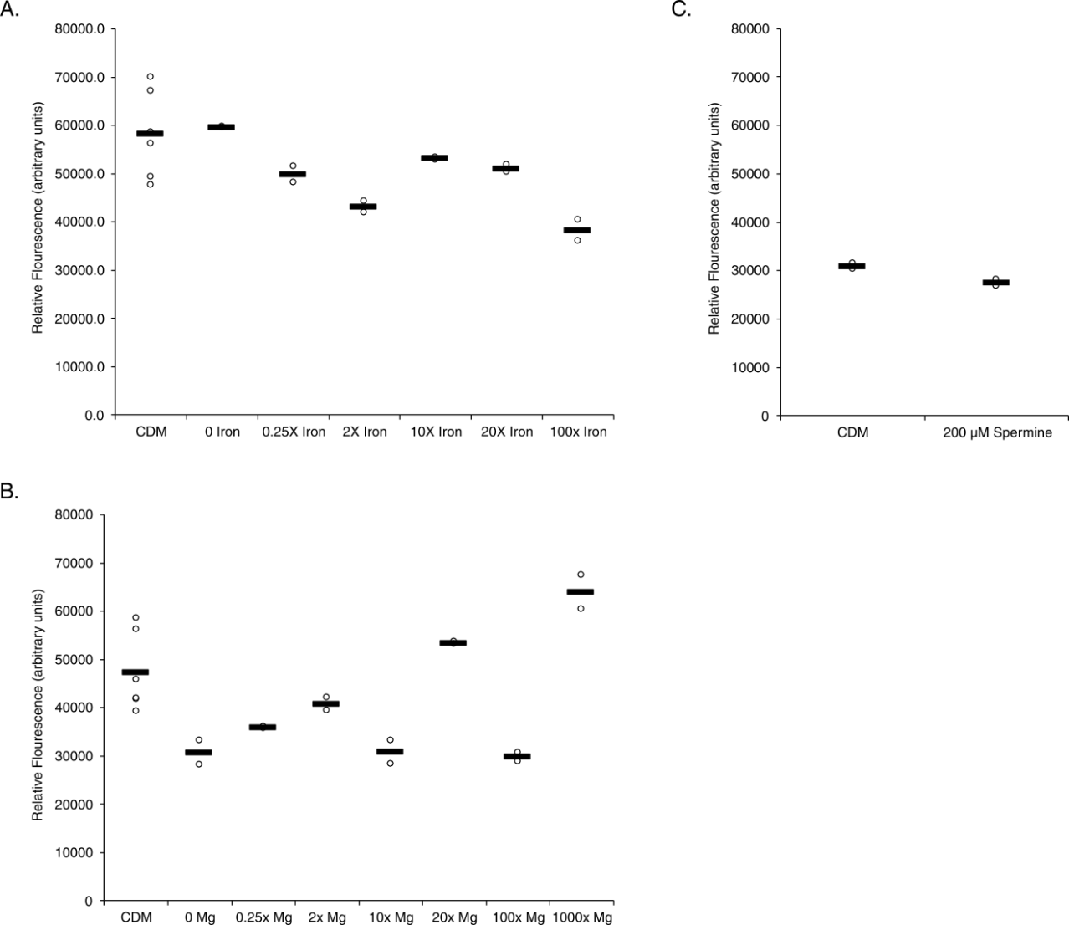
Figure 2. F. tularensis cells exposed to different iron, magnesium, or spermine concentrations do not appear to have changes in rpsU1 production. Relative fluorescence values (y-axis) versus environmental conditions (x-axis) of cells containing fluorescent rpsU1 reporter construct. Each dot represents one replicate, and horizontal bars indicate the average. (A) Cells exposed to CDM with indicated changes in iron concentration. Experiments were completed in biological duplicate. (B) Cells exposed to CDM with indicated changes in magnesium concentration. Experiments were completed in biological duplicate. (C) Cells exposed to standard CDM spermine tetrahydrochloride concentration (100.5 µM) or CDM with 200 µM spermine tetrahydrochloride. All were completed once in biological duplicate.
Screening for factors that influence expression of rpsU3
The same conditions were screened for changes in rpsU3 abundance. Again, significance was determined by at least a two-fold change between the averages of the test and standard conditions. And, again, there was no significant changes in the rpsU3 abundance when cells were exposed to cold or heat-shock, higher additional salt concentrations, H₂O₂ or UV stress (Fig 3A, B, C, D). The conditions tested on rpsU3 in CDM also showed no significant change in rpsU3 reported fluorescence in response to changes in iron, magnesium, or spermine concentrations (Fig 4A, B, C).
Figure 3. F. tularensis cells exposed to different temperatures, salt concentrations, or amounts of oxidative or UV stress do not appear to have changes in rpsU3 production. Relative fluorescence values (y-axis) versus environmental conditions (x-axis) of cells containing fluorescent rpsU3 reporter construct. Each dot represents one replicate, and horizontal bars indicate the average. (A) Cells exposed to temperatures of 4°C or 42°C as compared to standard growth temperature, 37°C. Experiment was completed in biological duplicate. (B) Cells grown in different salt concentrations. 0.5% NaCl and 1% NaCl were tested twice in biological duplicate, the rest were completed once in biological duplicate. (C) Cells grown to log-phase and then exposed to indicated concentrations of hydrogen peroxide (H₂O₂). All were completed once in biological duplicate. (D) Cells grown to log-phase and then exposed to indicated doses of UV light exposure. All were completed once in biological duplicate.
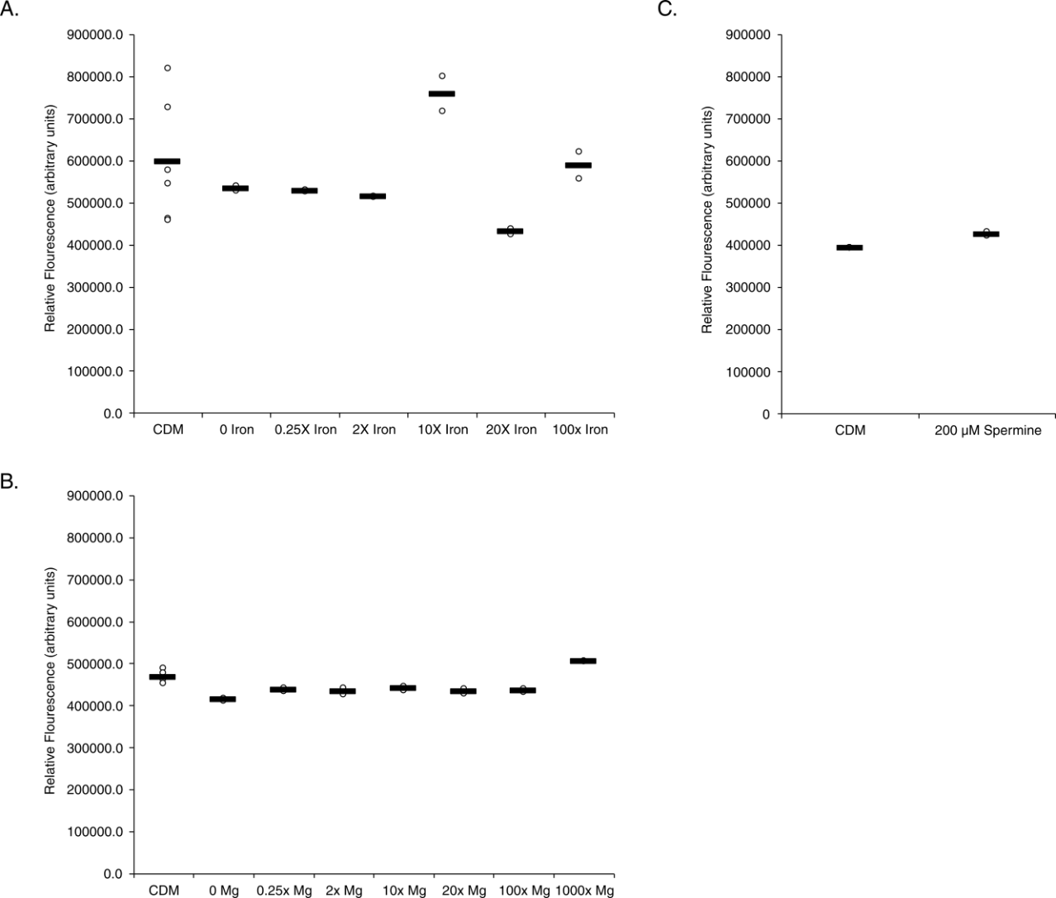
Figure 4. F. tularensis cells exposed to different iron, magnesium, or spermine concentrations do not appear to have changes in rpsU3 production. Relative fluorescence values (y-axis) versus environmental conditions (x-axis) of cells containing fluorescent rpsU1 reporter construct. Each dot represents one replicate, and horizontal bars indicate the average. (A) Cells exposed to CDM with indicated changes in iron concentration. (B) Cells exposed to CDM with indicated changes in magnesium concentration. (C) Cells exposed to standard CDM spermine tetrahydrochloride concentration (100.5 µM) or CDM with 200 µM spermine tetrahydrochloride. All were completed once in biological duplicate.
Growth in CDM or on CHAH changes bS21-1 abundance
Although cells containing the rpsU1 fluorescent reporter did not have significant changes in fluorescence when grown in CDM with altered levels of several components, there are differences in fluorescence when comparing cells grown in CDM to those grown in sMHB. Specifically, there was a 2.1-fold increase in fluorescence when cells with the rpsU1 reporter construct were grown in CDM compared to sMHB. (Fig 5A). Similarly, when grown on solid media (CHAH), cells containing the rpsU1 reporter construct had a 3.3-fold increase in fluorescence (Fig 5A). Conversely, when these cells were grown to stationary phase in sMHB there was a 75% decrease in fluorescence (Fig 5A).
To determine if the observed changes in rpsU1 reporter fluorescence reflect changes in bS21-1 production, we took advantage of cells containing a translational reporter already available in the laboratory. Specifically, these cells encode the lacZ gene, encoding ß-galactosidase, immediately downstream of the native rpsU1 gene on the chromosome. Thus, a β-galactosidase assay can be used to approximate bS21-1 production. We found that growth in both CDM and CHAH produced significantly increased bS21-1, as approximated by β-galactosidase activity, compared to sMHB. However, in cells grown in CDM compared to sMHB, the increase in bS21-1 was only 1.5-fold, compared to the 2.1-fold increase in fluorescence abundance (Fig 5B). However, in cells grown in CHAH, the abundance of bS21-1 was increased 3.1-fold (Fig 5C).
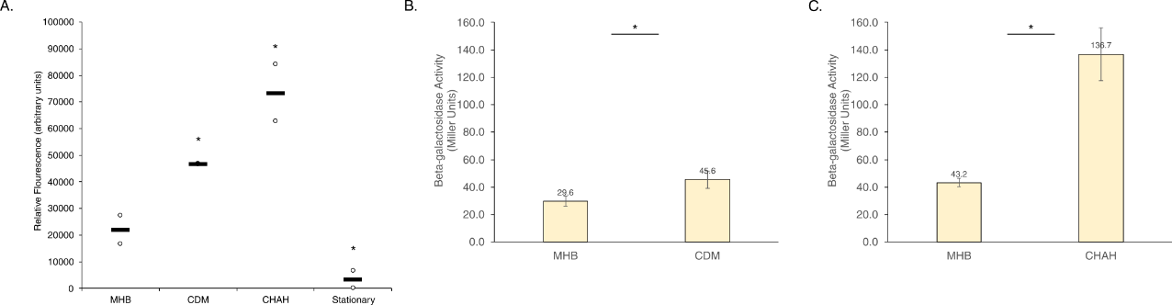
Figure 5. F. tularensis cells grown in CDM or on CHAH increases rpsU1 transcript and protein production. (A) Relative fluorescence values (y-axis) versus environmental conditions (x-axis) of cells containing fluorescent rpsU1 reporter construct. Cells were grown in CDM, on CHAH, or to stationary phase in sMHB, in biological duplicate. Each dot represents one replicate, and horizontal bars indicate the average. (B and C) β-galactosidase activity (Miller Units, y-axis) versus environmental conditions (x-axis) of cells containing a single copy lacZ fused to rpsU1, in the native locus. (B) Cells grown in CDM. Completed once in biological duplicate. (C) Cells grown on CHAH. Completed twice in biological triplicate. * p < 0.05 by two-tailed Student’s t test.
Growth in CDM or on CHAH changes bS21-3 abundance
When assessing changes in rpsU3 transcript and bS21-3 protein abundance in these same conditions, we found an increase in both transcript and protein abundance. However, these increases in fluorescence corresponding to rpsU3 transcript abundance did not meet our criteria for significance (>/= 2-fold altered). We found a 1.3-fold increase in cells grown in CDM compared to sMHB (Fig 6A), and only a 1.6-fold increase in fluorescence of cells grown on CHAH versus grown in sMHB (Fig 6A). We did not observe any change in in fluorescence corresponding to rpsU3 transcript abundance comparing cultures grown to stationary phase versus log phase (Fig 6A).
Although these fold-changes did not meet our criteria for significance, the abundance of bS21-3 under these conditions, as approximated by β-galactosidase activity, was tested alongside bS21-1. The translational reporter cells encode the lacZ gene, encoding ß-galactosidase, immediately downstream of the native rpsU3 gene on the chromosome. The change in β-galactosidase activity when grown in CDM was slightly higher than the fold-change in transcript, a 1.5-fold increase, but did not meet our criteria for significance (>/=2-fold) (Fig 6B). However, when cells with the translational reporter were grown on CHAH, the β-galactosidase activity increased 2-fold, and was statistically significantly different from cells grown in sMHB (Fig 6C).
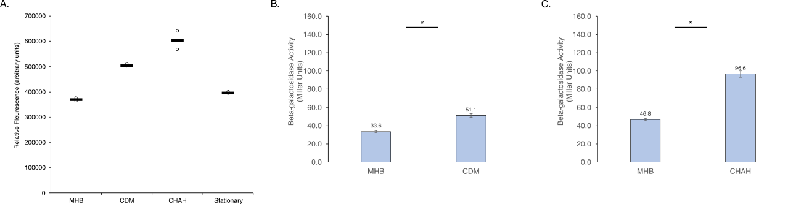
Figure 6. F. tularensis cells grown in CDM or on CHAH increases rpsU3 transcript and protein production. (A Relative fluorescence values (y-axis) versus environmental conditions (x-axis) of cells containing fluorescent rpsU3 reporter construct.) Cells grown in CDM, on CHAH, or to stationary phase in sMHB. Completed in biological duplicate. (B and C) β-galactosidase activity (Miller Units, y-axis) versus environmental conditions (x-axis) of cells containing a single copy lacZ fused to rpsU3, in the native locus. (B) Cells grown in CDM. Completed once in biological duplicate. (C) Cells grown on CHAH. Completed twice in biological triplicate, a representative example is shown. * p < 0.05 by two-tailed Student’s t test.
Low pH increases rpsU1 transcript, but not protein abundance
In order to assess the effects of pH on either rpsU1 or rpsU3 abundance, cells were grown to log-phase and then transferred into media with altered pH. Assessing the fluorescence of these cells revealed increased rpsU1 transcript abundance at lower pH (Fig 7A). Particularly, while several of the acidic pH values came close to our threshold of a 2-fold change, pH 3.5 was the only acidic culture to cross that mark, at a 2.3-fold increase (Fig 7A). Additionally, pH 10 showed a significant decrease in transcript abundance at a decrease of 94% fluorescence (Fig 7A).
Unlike the increase observed in transcript abundance at pH 3.5, there was no accordant increase in protein abundance of bS21-1 (Fig 7B). In fact, the reporter activity decreased to a level which may indicate that there is no functional β-galactosidase (Fig 7B). This was validated multiple times, including after the media was adjusted to neutral pH, suggesting that the low pH significantly interferes with the β-galactosidase reporter.
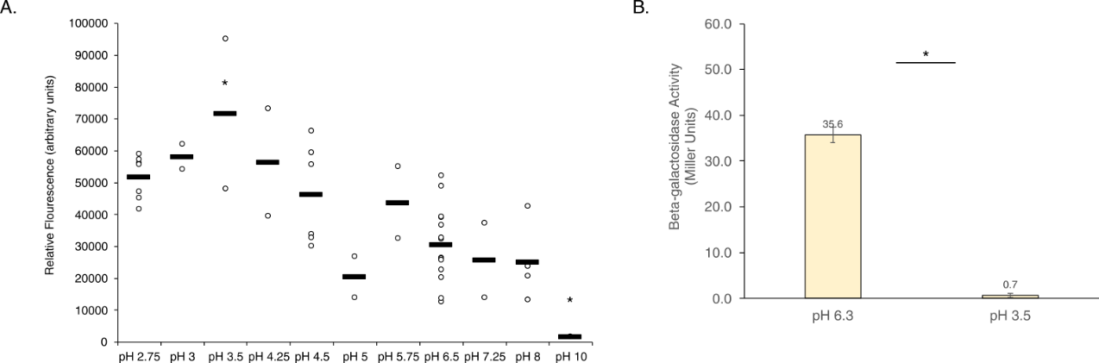
Figure 7. F. tularensis cells exposed to low pH increases rpsU1 transcript, but decreases protein production. (A) Relative fluorescence values (y-axis) versus environmental conditions (x-axis) of cells containing fluorescent rpsU1 reporter construct. Each dot represents one replicate, and horizontal bars indicate the average. Cells grown to log phase and then exposed to indicated pH values. (B) β-galactosidase activity (Miller Units, y-axis) versus environmental conditions (x-axis) of cells containing a single copy lacZ fused to rpsU1, in the native locus. Cells grown to log phase and then exposed to sMHB pH 3.5. Completed three times in biological triplicate, a representative example is shown. * p < 0.05 by two-tailed Student’s t test.
Changes in pH do not greatly affect rpsU3 transcript abundance, but decrease protein abundance
In contrast, the transcript abundance of rpsU3 did not seem to strongly react to changes in pH, whether acidic or basic (Fig 8A). Only at pH 2.75 was there a large change, at a decrease of 65% fluorescence (Fig 8A). Similar to the protein abundance observed at low pH of bS21-1, there is virtually no β-galactosidase activity at pH 3.5 when assessing the bS21-3 lacZ reporter (Fig 8B).
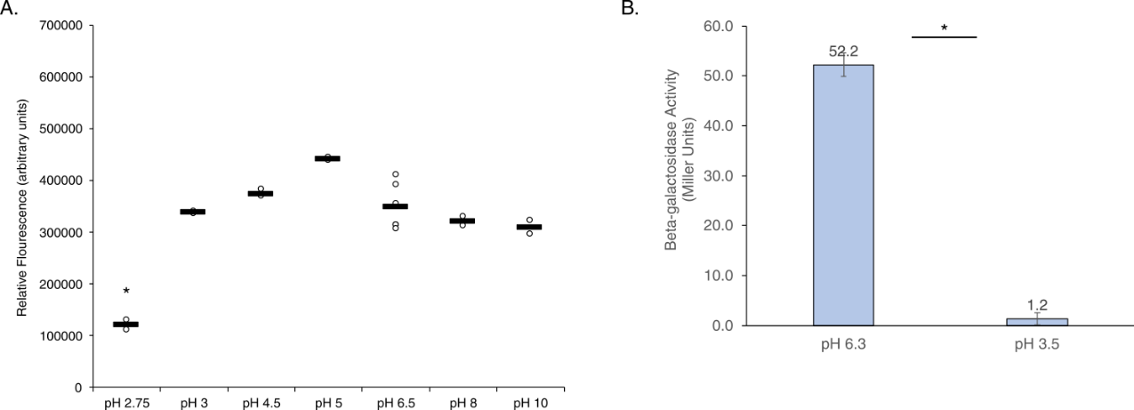
Figure 8. F. tularensis cells exposed to different pH do not greatly affect rpsU3 transcript, but decreases protein production. (A) Relative fluorescence values (y-axis) versus environmental conditions (x-axis) of cells containing fluorescent rpsU3 reporter construct. Each dot represents one replicate, and horizontal bars indicate the average. Cells grown to log phase and then exposed to indicated pH values. (B) β-galactosidase activity (Miller Units, y-axis) versus environmental conditions (x-axis) of cells containing a single copy lacZ fused to rpsU3, in the native locus. Cells grown to log phase and then exposed to sMHB pH 3.5. Completed three times in biological triplicate, a representative example is shown. * p < 0.05 by two-tailed Student’s t test.
Discussion
In this study we used reporter assays to investigate environmental factors that could lead to differential expression of the ribosomal proteins bS21-1 and bS21-3 in F. tularensis. For most of the conditions we examined, we did not observe any significant change in reporter activity. However, based on our transcriptional reporter, there is evidence of increased bS21-1 in response to low pH, growth in CDM, and growth on CHAH. Similarly, we found evidence of increased bS21-3 in cells grown in CDM or on CHAH. We subsequently assessed bS21-1 and bS21-3 production under these conditions using lacZ-based translational reporters. We could not validate the increase in bS21-1 in cells exposed to acidic pH, likely due to technical considerations. Finally, we observed an increase in both bS21-1 and bS21-3 in cells grown in CDM or on CHAH, but the magnitude of increase was lower than observed using the transcriptional reporter assay.
It is important to note that the transcription start sites of the genes encoding bS21-1 and bS21-3 (rpsU1 and rpsU3) are not known, so our transcriptional reporters include both the putative promoter and 5´ untranslated region (UTR). Thus, it is possible that the GFP reporter is subject to both transcriptional and post-transcriptional control. In addition, as rpsU1 is the second gene in an operon, its promoter corresponds to the sequence upstream of the gene cspA. We do not know if other regulatory elements differentially control production of rpsU1. Thus, it is possible that the transcriptional reporter activity corresponding to rpsU1 may more accurately reflect changes in abundance of cspA.
With respect to the impact of pH on bS21-1, we observed a disconnect between transcriptional and translational reporter protein abundance (Fig 7). It is possible that abundance of cspA is increased at low pH and other regulatory mechanisms limit bS21-1 production. However, the cells containing both the bS21-1 and bS21-3 lacZ translational reporters had a complete lack of β-galactosidase activity in the low pH condition. This raises the possibility that the low pH externally resulted in sufficiently low internal pH to permanently inactivate the β-galactosidase enzyme.
In considering the different in vitro growth media, their complex and undefined nature makes it difficult to determine which factors lead to the changes in bS21 homolog production. While future work could shed light on this topic, the observed differences were not large and other approaches may be more fruitful.
This study serves as a survey of environmental factors that influence gene expression in F. tularensis and were tested for their ability to influence the abundance of ribosomal proteins bS21-1 and bS21-3. While we determined that low pH may impact bS21-1 production and that production of both homologs is altered by different in vitro growth media, more questions remain. In particular, it is not clear how these conditions impact protein production nor what other conditions could lead to increased abundance of bS21 homologs. These questions, and how bS21-1 and bS21-3 influence the proteome, will be addressed in future work.

Materials and Methods
Bacterial Strains and Growth Conditions
For standard growth, F. tularensis subsp. holarctica LVS was grown in Mueller Hinton Broth supplemented with 0.025% iron pyrophosphate, 0.1% glucose, and 2% Isovitalex (sMHB) aerobically shaking at 37°C or on cystine heart agar plates containing 1% hemoglobin (CHAH) at 37°C . As indicated, LVS was grown in Chamberlain’s Defined Medium, CDM (Chamberlain, 1965). The selective antibiotic kanamycin (kan) was used to maintain plasmids in F. tularensis LVS at 5 µg/mL.
Plasmids
To generate plasmids in which the promoter region of either rpsU1 or rpsU3 drive expression of gfp, DNA upstream of the first gene in each operon was amplified with a forward primer specifying a 5´ KpnI site and a reverse primer specifying a 5´NotI site. For rpsU1, this fragment included the cspC start codon and 274 bp upstream. For rpsU3, this fragment included the rpsU3 start codon and 381 bp upstream. These fragments and the plasmid pKR145, which contains the sfGFP gene codon-optimized for expression in F. tularensis LVS (Trautmann et al., 2023), were digested with KpnI/NotI and ligated together. This resulted in replacement of the promoter region in pKR145 with either the rpsU1 or rpsU3 promoter region, in frame with the respective start codon, yielding pKR153 pF-rpsU1-GFP and pKR154 pF-rpsU3-GFP.
Strains
To screen environmental conditions that might alter expression of rpsU1 or rpsU3, we electroporated either pKR153 or pKR154 into F. tularensis LVS as previously described (Trautmann et al., 2023). For use in the β-galactosidase Assay, strains KRLVS28 and KRLVS75 were used. The genotypes of these strains were LVS rpsU1-lacZ and LVS rpsU3-lacZ respectively. These were previously created using allelic exchanged pEX-based plasmids, pKR34 (pEX_rpsU1_lacZ) or pKR38 (pEX_rpsU3_lacZ).
Screening for Environmental Conditions - Growth
Changes in temperature, salinity, pH, hydrogen peroxide (H₂O₂) stress, and UV stress were tested in sMHB. To test salinity and pH, cells were grown to early-log phase and transferred to fresh, modified sMHB for an additional 30-60 minute growth period. Alternatively, for temperature, H₂O₂, and UV stress, cultures were grown to mid-log phase, exposed to the stress, and allowed to recover for 30 minutes. sMHB versus CDM was tested by growing cultures to mid-log phase in sMHB or CDM. Changes in iron, magnesium, or spermine concentrations were tested in CDM by altering the recipe to reflect the concentrations tested, and allowing the cultures to grow to mid-log phase.
GFP Assay
After cultures were grown to mid-log phase, 1 - 4mL were pelleted and resuspended in 1xPBS. In technical triplicate, 250 uL was plated in a clear 96-well plate and the OD₆₀₀ was read by the SpectraMax® iD3 Multi-Mode Microplate Reader. 200 uL of the sample was then transferred to a black 96-well plate and fluorescence was measured (RFU). All fluorescence values were made relative to the OD₆₀₀; and relative fluorescence from LVS containing an empty vector (pF) in 1xPBS was subtracted from the relative fluorescence of our strains in the test conditions. The threshold for changes to be considered significant is a two-fold or greater change from fluorescence of control cells.
β-Galactosidase Assay
Assays were performed essentially as previously described (Trautmann, et al., 2023). Briefly, cultures were grown to early mid-log (OD₆₀₀ 0.3 – 0.35) in triplicate. Growth was halted by placing cultures on ice for at least 30 minutes before cells were added to tubes containing Z-buffer supplemented with β-mercaptoethanol. 0.1% SDS and chloroform were added, cultures were vortexed, then allowed to come to 28°C for 10 minutes prior to the addition of the substrate O-nitrophenyl-β-galactopyranoside (ONPG). Reactions were stopped upon reaching a yellow color, OD₄₂₀ 0.6-0.9, using sodium carbonate (Na₂CO₃).
References

Berrada, Z. L., & Telford III, S. R. (2011). Survival of Francisella tularensis Type A in brackish-water. Archives of Microbiology, 193(3), 223–226. https://doi.org/10.1007/s00203-010-0655-8
Broman, T., Thelaus, J., Andersson, A.-C., Bäckman, S., Wikström, P., Larsson, E., Granberg, M., Karlsson, L., Bäck, E., Eliasson, H., Mattsson, R., Sjöstedt, A., & Forsman, M. (2010). Molecular Detection of Persistent Francisella tularensis Subspecies holarctica in Natural Waters. International Journal of Microbiology, 2011, e851946. https://doi.org/10.1155/2011/851946
Carlson, P. E., Carroll, J. A., O’Dee, D. M., & Nau, G. J. (2007). Modulation of virulence factors in Francisella tularensis determines human macrophage responses. Microbial Pathogenesis, 42(5), 204–214. https://doi.org/10.1016/j.micpath.2007.02.001
Carlson, P. E., Horzempa, J., O’Dee, D. M., Robinson, C. M., Neophytou, P., Labrinidis, A., & Nau, G. J. (2009). Global Transcriptional Response to Spermine, a Component of the Intramacrophage Environment, Reveals Regulation of Francisella Gene Expression through Insertion Sequence Elements. Journal of Bacteriology, 191(22), 6855–6864. https://doi.org/10.1128/jb.00995-09
Celli, J., & Zahrt, T. C. (2013). Mechanisms of Francisella tularensis Intracellular Pathogenesis. Cold Spring Harbor Perspectives in Medicine, 3(4), a010314. https://doi.org/10.1101/cshperspect.a010314
Chang, C., & Craven, G. R. (1977). Identification of several proteins involved in the messenger RNA binding site of the 30 S ribosome by inactivation with 2-methoxy-5-nitrotropone. Journal of Molecular Biology, 117(2), 401–418. https://doi.org/10.1016/0022-2836(77)90135-8
Deng, K., Blick, R. J., Liu, W., & Hansen, E. J. (2006). Identification of Francisella tularensis Genes Affected by Iron Limitation. Infection and Immunity, 74(7), 4224–4236. https://doi.org/10.1128/iai.01975-05
Ericsson, M., Tärnvik, A., Kuoppa, K., Sandström, G., & Sjöstedt, A. (1994). Increased synthesis of DnaK, GroEL, and GroES homologs by Francisella tularensis LVS in response to heat and hydrogen peroxide. Infection and Immunity, 62(1), 178–183. https://doi.org/10.1128/iai.62.1.178-183.1994
Faron, M., Fletcher, J., Rasmussen, J., Long, M., Allen, L.-A., & Jones, B. (2013). The Francisella tularensis migR, trmE, and cphA Genes Contribute to F. tularensis Pathogenicity Island Gene Regulation and Intracellular Growth by Modulation of the Stress Alarmone ppGpp. Infection and Immunity, 81. https://doi.org/10.1128/IAI.00073-13
Fuller, J. R., Kijek, T. M., Taft-Benz, S., & Kawula, T. H. (2009). Environmental and intracellular regulation of Francisella tularensis ripA. BMC Microbiology, 9(1), 216. https://doi.org/10.1186/1471-2180-9-216
Horzempa, J., Carlson, P. E., O’Dee, D. M., Shanks, R. M., & Nau, G. J. (2008). Global transcriptional response to mammalian temperature provides new insight into Francisella tularensis pathogenesis. BMC Microbiology, 8(1), 172. https://doi.org/10.1186/1471-2180-8-172
Igarashi, K., & Kashiwagi, K. (2019). The functional role of polyamines in eukaryotic cells. The International Journal of Biochemistry & Cell Biology, 107, 104–115. https://doi.org/10.1016/j.biocel.2018.12.012
Keim, P., Johansson, A., & Wagner, D. M. (2007). Molecular Epidemiology, Evolution, and Ecology of Francisella. Annals of the New York Academy of Sciences, 1105(1), 30–66. https://doi.org/10.1196/annals.1409.011
Larson, C. L., Wicht, W., & Jellison, W. L. (1955). A new organism resembling P. tularensis isolated from water. Public Health Reports, 70(3), 253–258.
Lenčo, J., Hubálek, M., Larsson, P., Fučíková, A., Brychta, M., Macela, A., & Stulík, J. (2007). Proteomics analysis of the Francisella tularensis LVS response to iron restriction: Induction of the F. tularensis pathogenicity island proteins IglABC. FEMS Microbiology Letters, 269(1), 11–21. https://doi.org/10.1111/j.1574-6968.2006.00595.x
Lenco, J., Pavkova, I., Hubalek, M., & Stulik, J. (2005). Insights into the oxidative stress response in Francisella tularensis LVS and its mutant ΔiglC1 + 2 by proteomics analysis. FEMS Microbiology Letters, 246(1), 47–54. https://doi.org/10.1016/j.femsle.2005.03.040
Meibom, K. L., & Charbit, A. (2010). Francisella tularensis Metabolism and its Relation to Virulence. Frontiers in Microbiology, 1. https://doi.org/10.3389/fmicb.2010.00140
Meibom, K. L., Forslund, A.-L., Kuoppa, K., Alkhuder, K., Dubail, I., Dupuis, M., Forsberg, Å., & Charbit, A. (2009). Hfq, a Novel Pleiotropic Regulator of Virulence-Associated Genes in Francisella tularensis. Infection and Immunity, 77(5), 1866–1880. https://doi.org/10.1128/iai.01496-08
Sullivan, J. T., Jeffery, E. F., Shannon, J. D., & Ramakrishnan, G. (2006). Characterization of the Siderophore of Francisella tularensis and Role of fslA in Siderophore Production. Journal of Bacteriology, 188(11), 3785–3795. https://doi.org/10.1128/jb.00027-06
Trautmann, H., & Ramsey, K. (2022). A Ribosomal Protein Homolog Governs Gene Expression and Virulence in a Bacterial Pathogen. Journal of Bacteriology, 204(10), e00268-22. https://doi.org/10.1128/jb.00268-22
Trautmann, H. S., Schmidt, S. S., Gregory, S. T., & Ramsey, K. M. (2023). Ribosome heterogeneity results in leader sequence-mediated regulation of protein synthesis in Francisella tularensis. Journal of Bacteriology, 0(0), e00140-23. https://doi.org/10.1128/jb.00140-23
Van Duin, J., & Robert, W. (1981). The Function of Ribosomal Protein S21 in Protein Synthesis. European Journal of Biochemistry, 118(3), 615–619. https://doi.org/10.1111/j.1432-1033.1981.tb05563.x
Wu, X., Ren, G., Iii, W. T. G., Weaver, D. A., Kalinoski, A. L., Khuder, S. A., & Huntley, J. F. (2016). FmvB: A Francisella tularensis Magnesium-Responsive Outer Membrane Protein that Plays a Role in Virulence. PLOS ONE, 11(8), e0160977. https://doi.org/10.1371/journal.pone.0160977

CHAPTER 4

SUMMARY AND CONCLUSIONS
Chapter 2 Summary
As described in Chapter 2, the results of our transcriptomic analysis revealed that any of the three bS21 homologs of F. tularensis can repress the abundance of the rpsU2 operon transcript. However, bS21-1 and bS21-3 were not found to regulate their own expression, indicating that autoregulation of bS21-2 is unique among the three homologs.
We subsequently used the sequences upstream of rpsU2 and translational lacZ reporter fusions to further investigate the cis-factors that lead to bS21-2 autoregulation. Using qRT-PCR, we found that these reporters accurately recapitulated the regulation revealed by the transcriptomic data. In particular, the abundance of our reporter transcripts was several fold higher in cells lacking bS21-2 than in wild-type cells. Additionally, it was shown that the 5′ UTR of the rpsU2 transcript is sufficient to lead to this change in transcript abundance. Yet, when measuring the relative protein production, β-galactosidase assays showed that in cells lacking bS21-2, contrary to the increase in transcript abundance, reporter protein activity (and presumably bS21-2 protein abundance) did not similarly increase.
Secondary structures predicted in the 5′ UTR of rpsU2 were tested as a potential site of regulatory activity. Translational reporters using the 5′ UTR of rpsU2 fused to GFP were used to assess the contribution of these stem loops to both the transcript and protein abundances of rpsU2 and bS21-2. Our qRT-PCR results indicated that the first 38 nucleotides of the leader sequence are not required for regulation of transcript abundance. In addition, GFP assays also indicated that these nucleotides did not result in significant changes in fluorescence, suggesting that they were not required for regulation of translation of bS21-2.
Finally, we assessed how bS21-2 influences the stability of the rpsU2 transcript. We found that the half-life of the rpsU2 transcript was increased in cells lacking bS21-2 in multiple experiments. This suggests that bS21-2 destabilizes its own transcript. However, due to variability among the replicates, this change in transcript half-life was not statistically significant in any of the experiments. Thus, further testing would be required to confirm whether bS21-2 destabilizes its own transcript as the mode of autoregulation.
While this study examined some interesting aspects of regulation of the bS21 homologs, there are many questions remaining.
Chapter 3 Summary
In Chapter 3, I screened different growth conditions to identify stimuli that lead to altered abundance of bS21-1 or bS21-3. In particular, I used GFP reporter fusions to screen for potential changes in transcript abundance corresponding to either bS21-1 or bS21-3. While I tested eleven conditions, I identified only two in which there may be major altered abundance of bS21-1 and/or bS21-3.
When compared to cells grown in our standard culture media, supplemented Mueller-Hinton Broth (sMHB), cells grown on cystine heart agar plates with hemoglobin (CHA-H plates) had an increase in reporter activity corresponding to both bS21-1 and bS21-3. This was also true of the cells grown in Chamberlain's chemically defined liquid medium (CDM). Both findings were replicated using reporters of bS21-1 and bS21-3 protein abundance, cells in which the lacZ gene is present on the chromosome directly after the native rpsU1 or rpsU3 gene, respectively.
I also found that cells with the plasmid-based gfp reporter for bS21-1 had increased reporter gene expression in low pH MHB. This suggests that low pH could lead to an increased abundance of the rpsU1 transcript. However, these results could not be validated in cells containing the chromosomally-encoded bS21-1 lacZ reporter construct. In fact, there was nearly no reporter gene activity (ß-galactosidase activity) after cells were incubated for one hour in low pH.
The discordance between these reporters may be explained by a few options. First, the gfp reporter construct to assess bS21-1 production may more accurately reveal regulation of the first gene in the operon, the cold shock family protein, cpsC. It is possible that cspC is induced in low pH conditions, but that other regulatory mechanisms prevent additional production of bS21-1 (and thus, production of ß-galactosidase from the translational reporter). However, it seems more likely that the low pH conditions inactivated the ß-galactosidase enzyme. In particular, I also found that cells with the bS21-3 lacZ reporter construct had no reporter activity when tested in the same low pH condition.
Together, I found that F. tularensis cells grown in different growth media appear to have increased production of bS21-1 and bS21-3, and low pH may induce production of bS21-1. However, much remains to be found about how production of these ribosomal proteins are controlled.

FURTHER QUESTIONS
1. Does bS21-2 definitively affect the stability of its own transcript, and is this a direct interaction?
In Chapter 2, I explored the cis-encoded factors which lead to the regulation of the rpsU2 transcript by its own protein. Specifically, I established that the 5′ UTR of rpsU2 is sufficient to lead to regulation by bS21-2. This led me to investigate whether or not bS21-2 was impacting the stability of its own transcript. In multiple replicates of this experiment, the mRNA corresponding to the rpsU2 operon had increased stability in wild-type cells compared to cells lacking bS21-2. However, these differences were not statistically significant. This could have either resulted from stability simply not being the factor affected by bS21-2, or it could be due to a need to optimize the protocol to reduce variability amongst replicates. Thus, to determine if stability actually plays a role in the regulation of the rpsU2 transcript, it would be necessary to repeat the stability assay described in Chapter 2.
If stability leads to the autoregulation by bS21-2, then it would be interesting to determine the exact mechanism by which bS21-2 controls mRNA abundance. Given that the 5′ UTR of rpsU2 is sufficient for regulation, and that there are many examples in which a transcript is mediated by an interaction (directly or indirectly) with the leader sequence, it would be informative to determine what elements of the 5′ UTR are necessary for the bS21-2-mediated changes in mRNA abundance. As described in Chapter 2, the two stem-loops at the 5´ end of the 5′ UTR are not necessary for regulation by bS21-2. To identify which elements of the 5′ UTR are necessary, we could make similar reporters with various mutations or truncations of the 5′ UTR and assess their relative transcript abundance in cells with and without bS21-2 to identify mutants that are no longer responsive to bS21-2.
We could further determine whether bS21-2 exerts its effects by making direct contact with its own transcript using an electrophoresis mobility shift assay (EMSA). Specifically, we would purify bS21-2 and combine it with either its own transcript or a control (an mRNA unaffected by bS21-2). These samples are separated by size using gel electrophoresis. If bS21-2 stably binds directly to its own mRNA, we expect to see a band indicating that bS21-2 is forming a complex with its own mRNA transcript. In the control condition, we expect to see no evidence of bS21-2 complexing with the mRNA transcript. This would allow us to determine if bS21-2 binds directly to mRNA transcripts . In particular, we would test the ability of bS21-2 to bind to the rpsU2 5′ UTR compared to the tul4 5′ UTR, and any modified rpsU2 5′ UTRs that are unresponsive to bS21-2.
2. What controls the expression of bS21 protein abundance?
Apart from the transcriptional regulation of rpsU2 discussed in Chapter 2, I also demonstrated that there is a disconnect between rpsU2 transcript abundance and bS21-2 protein abundance. This suggests that there is another factor regulating the translation of the rpsU2 transcript. A few methods could be implemented to elucidate these other factor(s).
We could take an unbiased genetic approach to identify repressors of rpsU2 translation. First, we would construct a strain in which, at the native locus, GFP is inserted after the first six amino acids of the rpsU2 gene, replacing the rest of the gene. Then, we would utilize mariner transposon-led mutagenesis of the GFP reporter construct to indicate genes of interest. Presumably, were the transposon to interrupt a gene whose product represses bS21-2 then the GFP abundance would increase, and this will be observed as colony color changes. Individual mutants of interest will then be further verified through fluorescence readings. Subsequently, mutants with higher abundance of bS21-2 will be sequenced and analyzed to reveal potential regulatory proteins, particularly by determining where the transposon inserted in the genome. The interrupted gene would then, presumably, encode regulatory proteins.
In a biochemical approach, we could attempt to identify proteins that directly bind the rpsU2 5′ UTR. Specifically, we would obtain a synthesized version of the rpsU2 5′ UTR containing a 3´ biotin tag. We would incubate this with cell lysates and isolate any RNA-protein complexes by immunoprecipitation using streptavidin beads. Associated proteins will be identified using mass spectrometry, generating a list of proteins that interact with the bS21-2 transcript and may regulate the protein abundance of bS21-2. These can be further characterized through standard genetic knockout studies.
3. What genetic elements influence the production of bS21-1 and bS21-3?
In Chapter 3, I screened a number of growth conditions to identify significant changes in both transcript and protein abundance of bS21-1 and bS21-3. However, most of the environments screened did not result in any statistically or biologically significant changes in either or both transcript and protein abundance.
Another way to identify factors controlling expression of these bS21 homologs would be to take a genetic approach. In particular, I propose taking a transposon mutagenesis approach to screen for genes important for bS21 homolog production, using GFP as a reporter. Specifically, I would generate cells in which there are fusions of bS21-1 or bS21-3 with GFP, by adding gfp in-frame to the 3´ end of the native rpsU1 or rpsU3 gene on the chromosome. We would then mutagenize these cells and screen for colonies which produce more or less fluorescence. The subsequent analysis and interpretation would be similar as described above in future direction 2. In this case, we expect to identify genes that function to regulate bS21-1 or bS21-3 production.
It is important to mention that we do not know how strong the fluorescent signal for bS21-1-GFP or bS21-3-GFP would be. If, in otherwise wild-type cells, the signal is very low, we expect to only be able to detect increases in fluorescence. In this case, because this strategy relies on inactivation of gene products by transposon mutagenesis, we would expect to identify repressors of bS21-1 or bS21-3. We would be unlikely to find positive regulators of bS21-1 or bS21-3 expression (whose inactivation would lead to less fluorescence). However, this remains to be determined.

