EXAMINING THE REGULATION OF THE BS21 HOMOLOGS
IN FRANCISELLA TULARENSIS
BY
SIERRA SCHMIDT

A THESIS SUBMITTED IN PARTIAL FULFILLMENT OF THE
REQUIREMENTS FOR THE DEGREE OF
MASTER OF SCIENCE
IN
CELL AND MOLECULAR BIOLOGY

UNIVERSITY OF RHODE ISLAND
2023

MASTER OF SCIENCE IN CELL AND MOLECULAR BIOLOGY THESIS

OF

SIERRA SCHMIDT

APPROVED:

Thesis Committee:

Major Professor Kathryn Ramsey

Steven Gregory

David Rowley

Brenton DeBoef
DEAN OF THE GRADUATE SCHOOL

UNIVERSITY OF RHODE ISLAND
2023

TABLE OF CONTENTS

CHAPTER 3 4
Manuscript 2 4
Abstract 5
Importance 5
Introduction 5
Results 5
Discussion 5
Materials and Methods 7
REFERENCES 8

CHAPTER 3

Manuscript 2

Identification of conditions that lead to changes in bS21-1 and bS21-3 abundance in Francisella tularensis

Prepared for submission to Journal of Bacteriology

Sierra S. Schmidt¹, Hannah S. Trautmann¹, and Kathryn M. Ramsey^{1,2,*}

¹Department of Cell and Molecular Biology, University of Rhode Island, Kingston, RI 02881, USA
²Department of Biomedical and Pharmaceutical Sciences, University of Rhode Island, Kingston, RI 02881, USA

Abstract
Francisella tularensis is a highly infectious, intracellular human pathogen that can cause fatal disease. We have recently found that ribosomes can contain one of the three homologs for the small ribosomal subunit protein bS21. The most abundant homolog, bS21-2, positively controls key virulence genes and intramacrophage replication. However, little is known about the less abundant homologs, bS21-1 and bS21-3, including what conditions might lead to their increased abundance. This study aimed to address this gap in knowledge, by evaluating the production of bS21-1 and bS21-3 after altering environmental factors known affect regulation of other proteins in F. tularensis. For most of these conditions, no significant change was observed in production of either bS21-1 or bS21-3. However, bS21-1 was found to be upregulated by exposure of cells to acid stress or growth in different complex media. Similarly, growth in different complex media resulted in increased bS21-3. While this study serves as an initial survey of factors that could impact bS21-1 and bS21-3 production, much remains to be learned about how these proteins are regulated and how they function in F. tularensis.

Introduction
Francisella tularensis, the causative agent of tularemia, is a Gram-negative, facultative intracellular bacterium with the potential to cause fatal human disease (Keim et al., 2007). Characteristic of an intracellular pathogen, F. tularensis has a reduced genome size. Previous work established that it contains three copies of the gene encoding the small subunit ribosomal protein bS21, but the function of these three different homologs is still being investigated (H. Trautmann & Ramsey, 2022).
The role of bS21 in the ribosome is linked to translation initiation across species (Chang & Craven, 1977; Van Duin & Robert, 1981). The F. tularensis chromosome encodes three homologs of bS21. The three homologs are bS21-1, bS21-2, and bS21-3, encoded by rpsU1, rpsU2, and rpsU3 respectively. Work studying the second homolog, bS21-2 has implicated it in the regulation of several virulence proteins and it has been demonstrated to be autogenously regulated (H. Trautmann & Ramsey, 2022; H. S. Trautmann et al., 2023). However, less is known about the other homologs, bS21-1 and bS21-3 in regard to both their function and their regulation, possibly related to low abundance in F. tularensis LVS grown under standard in vitro conditions (H. Trautmann & Ramsey, 2022). Knowing that bS21-2 influences the F. tularensis proteome, we hypothesize that bS21-1 and bS21-3 may regulate the proteome in some conditions. In an effort to both understand what role they may have in the cell as well as to increase their abundance for easier study, we decided to screen a number of conditions looking for differences in bS21-1 and bS21-3 abundance.
The exact environmental reservoir of F. tularensis is not entirely defined, however it is often associated with water sources (Berrada & Telford III, 2011; Broman et al., 2010; Larson et al., 1955). It then enters a host environment, human or mammal, and enters an intracellular life stage within phagosome, prior to escape and replication (Celli & Zahrt, 2013). Thus, it must be able to withstand environmental pressures and conditions prior to entering the host environment, withstanding host defenses and inconsistent nutrient states. This necessitates the ability of F. tularensis to have both efficient and effective regulatory mechanisms to survive in a variety of environments.
During the transition between environmental sources and a mammalian host, there is a significant change in temperature. Approximately 11% of F. tularensis genes are differently regulated during the transition from 26°C (representative of an environmental temperature) to 37°C. Several of these genes are virulence genes, suggesting that temperature-associated regulation is important for initiation of host colonization and virulence (Horzempa et al., 2008).
F. tularensis has been identified within brackish waters. The effects of NaCl concentration on gene regulation in F. tularensis has not been greatly investigated. However, one report showed that F. tularensis Type A can survive longer in filter-sterilized brackish water versus filter sterilized freshwater (Berrada & Telford III, 2011). Additionally, a study evaluating the regulator Hfq, an RNA binding protein, showed that the protein was seemingly important for both stress response and virulence in mice. Particularly in the removal of the gene encoding Hfq, hfq, the strain was found to be more sensitive to a high NaCl concentration of 2% (Meibom et al., 2009).
Changing pH can occur in a variety of environments, but most poignantly affects F. tularensis upon entrance into phagosomes. With regard to gene regulation in response to pH, some is known, again, about specific proteins but not necessarily broadly. Specifically, the virulence gene iglA and the general regulator, ppGpp, were both found to have decreased mRNA transcript levels in acidified environments (pH 5.5), and increased abundance in alkalized environments (pH 8.5) (Faron et al., 2013). Meanwhile, a cytoplasmic membrane protein, RipA, was found to be necessary for growth at neutral pH and to have similar expression levels to IglA upon host cll infection. It was also found to be pH sensitive, expression decreasing in acidified pH (Fuller et al., 2009).
As an intracellular pathogen, upon host cell infection F. tularensis is necessarily exposed to hydrogen peroxide within phagosomes. Unsurprisingly, a number of proteins of F. tularensis are differently regulated upon exposure to hydrogen peroxide. Global studies of F. tularensis found several proteins which were differently regulated after exposure to hydrogen peroxide, unsurprisingly many of these were apart of stress response protein families (Ericsson et al., 1994; Lenco et al., 2005).
Within the environment it is possible that F. tularensis encounters some UV exposure. It may respond to this stress similarly to other DNA damaging agents, however to the best of our knowledge, there are no current reports on the F. tularensis response UV-induced stress.
Upon entrance into a host F. tularensis is exposed to an iron-starvation environment. A number of studies have evaluated the effects of iron starvation on gene expression in F. tularensis. A global analysis of gene expression found that at least 80 genes were either up- or down-regulated at least two-fold in iron poor environments. Some specific genes were found to have a Fur box upstream of the gene affecting expression. The Fur box is bound by Fur-protein and ferrous iron complexes, which subsequently can repress expression of downstream genes. The protein siderophore is up-regulated in iron-deplete environments, as it is an iron acquisitioning protein. Additionally, some virulence genes were found to be up-regulated (Deng et al., 2006; Lenčo et al., 2007; Sullivan et al., 2006).
Similarly to iron, F. tularensis is exposed to a magnesium-poor environment within hosts due to immune strategies. Two major genes have been identified to be differently regulated in magnesium-deplete environments in F. tularensis. Like with iron starvation, these genes appear to play a role in magnesium uptake. However, they have also been identified as important for virulence as deletion of these genes, fmvA and fmvB, led to attenuation in mice . (Wu et al., 2016)
Once again, as F. tularensis moves into a host environment, it can be exposed to spermine, a natural polyamine used by eukaryotes for normal cell maintenance (Igarashi & Kashiwagi, 2019). A study looking at the effects of spermine on F. tularensis, indicated that presence of spermine may act as a novel trigger of host environment infection. In particular, as related to gene expression, insertion sequence (IS) elements and nearby genes within the F. tularensis genome appeared to be triggered by the presence of spermine (Carlson et al., 2009).
Throughout its life stages, F. tularensis is exposed to a number of environments which vary in their nutrient availability and specific stressors. As with any microbe, a number of in vitro growth conditions have been explored for laboratory cultivation of F. tularensis. One of these in vitro growth medias is Chamberlain’s Defined Media (CDM). Growth in CDM has been found to generally increase virulence protein abundance in F. tularensis (Carlson et al., 2007; Meibom & Charbit, 2010).
Another growth media used in lab cultivation of F. tularensis is cysteine heart agar with hemoglobin (CHAH). To the best of our knowledge, there are currently no resports comparing gene regulation or response to growth on CHAH of F. tularensis, as compared to other media types.

Results
bS21 homologs are not responsive to a number of conditions
In order to efficiently test multiple conditions to assess relative expression of bS21-1 and bS21-3, we constructed plasmids encoding fluorescent reporters. In particular, these reporters contained the predicted promoter region for either rpsU1 or rpsU3. Because rpsU1 is the second gene in an operon, the region predicted to encode the rpsU1 promoter is upstream of the first gene in the operon, cspC. The DNA including putative promoter regions (approximately 250 bp for rpsU1 and approximately 400 bp for rpsU3) up to the start codon of either cspC or rpsU3 is followed by DNA specifying a triple alanine linker in frame with the green fluorescent protein gene (gfp). These constructs were created on a multi-copy plasmid and transformed into wild-type F. tularensis LVS cells. [Conclude by stating (rather obvious) expectation with respect to fluorescence and amount of bS21-1 or bS21-3]

Screening for factors that influence expression of rpsU1
When F. tularensis cells containing the rpsU1 reporter were grown to mid-log and then exposed to either heat or cold-shock, there was no significant change in fluorescence, compared to cells grown at the standard temperature, 37°C, in standard growth media (supplemented Mueller-Hinton Broth, sMHB) (Fig 1A). Similarly, there were no changes in fluorescence of cells grown in different salt concentrations (Fig 1B), or when exposed to either H₂O₂ or UV-stress (Fig 1C, D).
Figure 1. F. tularensis cells exposed to different temperatures, salt concentrations, or amounts of oxidative or UV stress do not appear to have changes in rpsU1 production. Relative fluorescence values (y-axis) versus environmental conditions (x-axis) of cells containing fluorescent rpsU1 reporter construct. Each dot represents one replicate, and horizontal bars indicate the average. (A) Cells exposed to temperatures of 4°C or 42°C as compared to standard growth temperature, 37°C. Experiment was completed in biological duplicate. (B) Cells grown in different salt concentrations. 0.5% NaCl and 1% NaCl were tested twice in biological duplicate, the rest were completed once in biological duplicate. (C) Cells grown to log-phase and then exposed to indicated concentrations of hydrogen peroxide (H₂O₂). All were completed once in biological duplicate. (D) Cells grown to log-phase and then exposed to indicated doses of UV light exposure. All were completed once in biological duplicate. The threshold for changes to be considered significant is a two-fold or greater change from fluorescence of control cells.
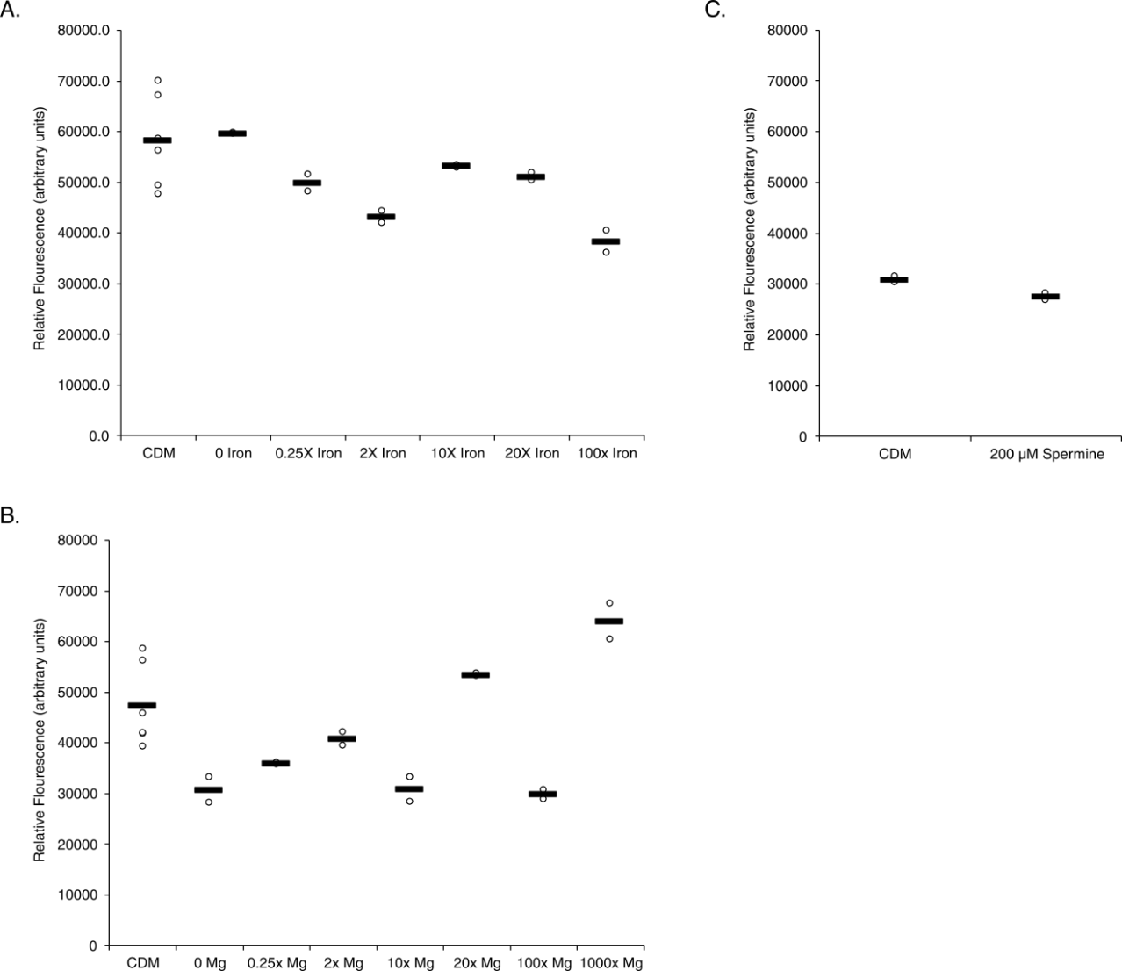
Figure 2. F. tularensis cells exposed to different iron, magnesium, or spermine concentrations do not appear to have changes in rpsU1 production. Relative fluorescence values (y-axis) versus environmental conditions (x-axis) of cells containing fluorescent rpsU1 reporter construct. Each dot represents one replicate, and horizontal bars indicate the average. (A) Cells exposed to CDM with indicated changes in iron concentration. (B) Cells exposed to CDM with indicated changes in magnesium concentration. (C) Cells exposed to standard CDM spermine tetrahydrochloride concentration (100.5 µM) or CDM with 200 µM spermine tetrahydrochloride. All were completed once in biological duplicate. The threshold for changes to be considered significant is a two-fold or greater change from fluorescence of control cells.
Screening for factors that influence expression of rpsU3
The same conditions were screened for changes in rpsU3 abundance. Again, significance was determined by at least a two-fold change between the averages of the test and standard conditions. And, again, there was no significant changes in the rpsU3 abundance when cells were exposed to cold or heat-shock, higher additional salt concentrations, H₂O₂ or UV stress (Fig 3A, B, C, D). The conditions tested on rpsU3 in CDM also showed no significant change in rpsU3 reported fluorescence in response to changes in iron, magnesium, or spermine concentrations (Fig 4A, B, C).
Figure 3. F. tularensis cells exposed to different temperatures, salt concentrations, or amounts of oxidative or UV stress do not appear to have changes in rpsU3 production. Relative fluorescence values (y-axis) versus environmental conditions (x-axis) of cells containing fluorescent rpsU1 reporter construct. Each dot represents one replicate, and horizontal bars indicate the average. (A) Cells exposed to temperatures of 4°C or 42°C as compared to standard growth temperature, 37°C. Experiment was completed in biological duplicate. (B) Cells grown in different salt concentrations. 0.5% NaCl and 1% NaCl were tested twice in biological duplicate, the rest were completed once in biological duplicate. (C) Cells grown to log-phase and then exposed to indicated concentrations of hydrogen peroxide (H₂O₂). All were completed once in biological duplicate. (D) Cells grown to log-phase and then exposed to indicated doses of UV light exposure. All were completed once in biological duplicate. The threshold for changes to be considered significant is a two-fold or greater change from fluorescence of control cells.
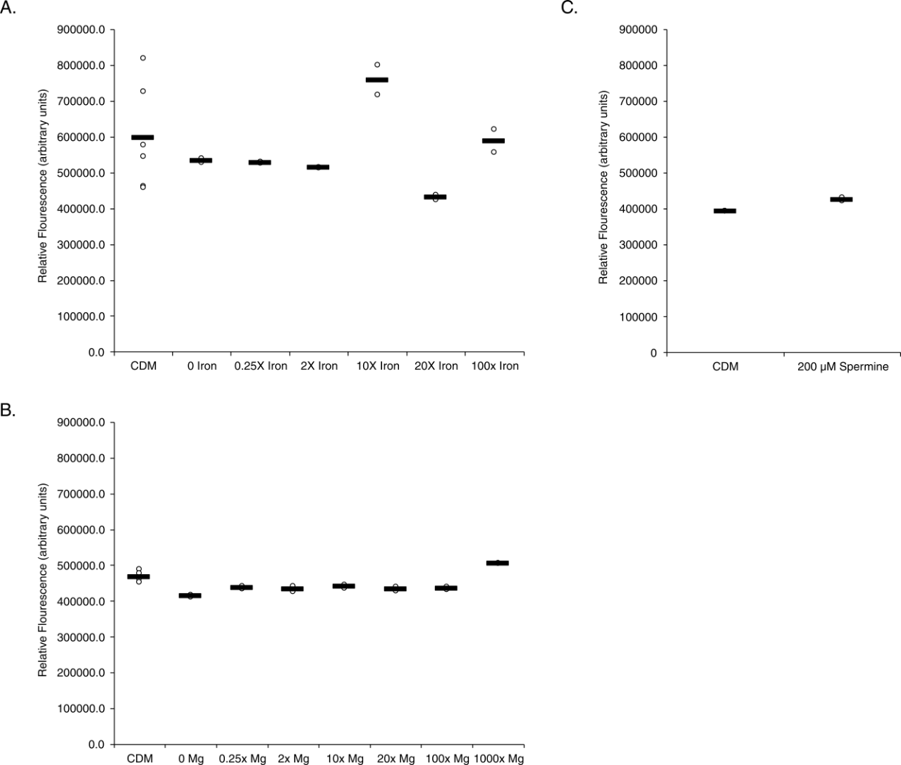
Figure 4. F. tularensis cells exposed to different iron, magnesium, or spermine concentrations do not appear to have changes in rpsU3 production. Relative fluorescence values (y-axis) versus environmental conditions (x-axis) of cells containing fluorescent rpsU1 reporter construct. Each dot represents one replicate, and horizontal bars indicate the average. (A) Cells exposed to CDM with indicated changes in iron concentration. (B) Cells exposed to CDM with indicated changes in magnesium concentration. (C) Cells exposed to standard CDM spermine tetrahydrochloride concentration (100.5 µM) or CDM with 200 µM spermine tetrahydrochloride. All were completed once in biological duplicate. The threshold for changes to be considered significant is a two-fold or greater change from fluorescence of control cells.
Growth in CDM or on CHAH changes bS21-1 abundance
Although cells containing the rpsU1 fluorescent reporter did not have significant changes in fluorescence when grown in CDM with altered levels of several components, there are differences in fluorescence when comparing cells grown in CDM to those grown in sMHB. Specifically, there was a 2.1-fold increase in fluorescence when cells with the rpsU1 reporter construct were grown in CDM compared to sMHB. (Fig 5A). Similarly, when grown on solid media (cystine hear agar with hemoglobin, CHAH), cells containing the rpsU1 reporter construct had a 3.3-fold increase in fluorescence (Fig 5A). Conversely, when these cells were grown to stationary phase in sMHB there was a 75% decrease in fluorescence (Fig 5A).
To determine if the observed changes in rpsU1 reporter fluorescence reflect changes in bS21-1 production, we took advantage of cells containing a translational reporter already available in the laboratory. Specifically, these cells encode the lacZ gene, encoding ß-galactosidase, immediately downstream of the native rpsU1 gene on the chromosome. Thus, using cells containing this reporter, a β-galactosidase assay can be used to approximate bS21-1 production. We found that growth in both CDM and CHAH produced significantly increased bS21-1, as approximated by β-galactosidase activity, compared to sMHB. However, in cells grown in CDM compared to sMHB, the increase in bS21-1 was only 1.5-fold, compared to the 2.1-fold increase in fluorescence abundance (Fig 5B). However, in cells grown in CHAH, the abundance of bS21-1 was increased 3.1-fold (Fig 5C).
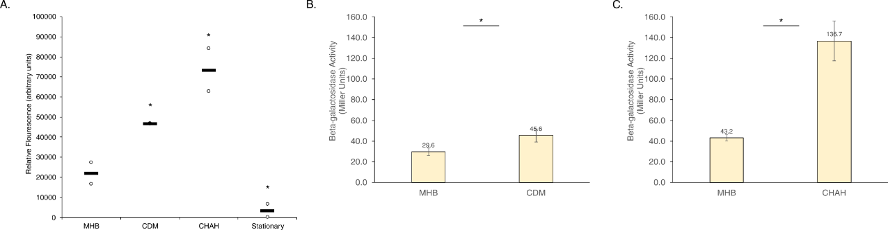
Figure 5. F. tularensis cells grown in CDM or on CHAH increases rpsU1 transcript and protein production. Relative fluorescence values (y-axis) versus environmental conditions (x-axis) of cells containing fluorescent rpsU1 reporter construct. Each dot represents one replicate, and horizontal bars indicate the average. (A) Cells grown in CDM, on CHAH, or to stationary phase in sMHB. Completed in biological duplicate. The threshold for changes to be considered significant is a two-fold or greater change from fluorescence of control cells. β-galactosidase activity (Miller Units, y-axis) versus environmental conditions (x-axis) of cells containing a single copy lacZ fused to rpsU1, in the native locus. (B) Cells grown in CDM. Completed once in biological duplicate. (C) Cells grown on CHAH. Completed twice in biological triplicate. Threshold for significance was p-value > 0.5.
Growth in CDM or on CHAH changes bS21-3 abundance
When screening rpsU3 and its subsequent protein, bS21-3, under these same conditions, there was an increase in both transcript and protein abundance. With specific regard to the reported transcript abundance, the fold-change did not meet our criteria for significance. There was only a 1.3-fold increase in rpsU3 transcript between cells grown in CDM versus sMHB (Fig 6A). Further, there was only a 1.6-fold increase in cells grown on CHAH versus grown in sMHB (Fig 6A). There was also no change in rpsU3 abundance between cultures grown to stationary phase versus log phase (Fig 6A).
Regardless that these fold-changes did not meet our criteria for significance, the protein abundance of bS21-3 under these conditions was tested alongside bS21-1. Again, a translational reporter already available in the lab was used in order to report approximate bS21-3 protein abundance by β-galactosidase activity. The change in β-galactosidase activity when grown in CDM was slightly higher than the fold-change in transcript, at a 1.5-fold increase (Fig 6B). Further, when grown on CHAH, the β-galactosidase activity increased to a 2-fold change, meeting our criteria for significance, beyond the statistical significance (Fig 6C).
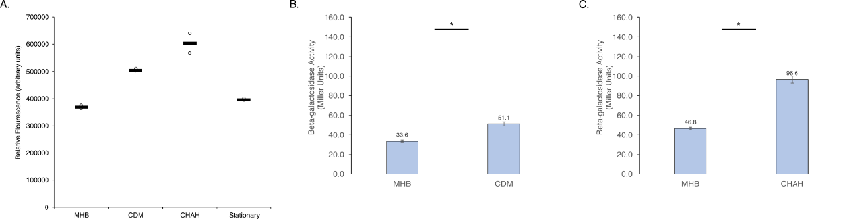
Figure 6. F. tularensis cells grown in CDM or on CHAH increases rpsU3 transcript and protein production. Relative fluorescence values (y-axis) versus environmental conditions (x-axis) of cells containing fluorescent rpsU3 reporter construct. (A) Cells grown in CDM, on CHAH, or to stationary phase in sMHB. Completed in biological duplicate. The threshold for changes to be considered significant is a two-fold or greater change from fluorescence of control cells. β-galactosidase activity (Miller Units, y-axis) versus environmental conditions (x-axis) of cells containing a single copy lacZ fused to rpsU3, in the native locus. (B) Cells grown in CDM. Completed once in biological duplicate. (C) Cells grown on CHAH. Completed twice in biological triplicate. Threshold for significance was p-value > 0.5.
Low pH increases rpsU1 transcript, but not protein abundance
In order to assess the effects of pH on either rpsU1 or rpsU3 abundance, cells were grown to log-phase and then transferred into media at the appropriate pH. Assessing the fluorescence of these cells revealed increased rpsU1 transcript abundance at lower pH (Fig 7A). Particularly, while several of the acidic pH values came close to our threshold of a 2-fold change, pH 3.5 was the only acidic culture to cross that mark, at a 2.3-fold increase (Fig 7A). Additionally, pH 10 showed a significant decrease in transcript abundance at a decrease of 94% fluorescence (Fig 7A).
Unlike the increase observed in transcript abundance at pH 3.5, there was no accordant increase in protein abundance of bS21-1 (Fig 7B). In fact, the protein abundance decreased to a level which may indicate that there is no β-galactosidase activity (Fig 7B). This was validated multiple times, ensuring that the low acidity was not interfering with the assay.
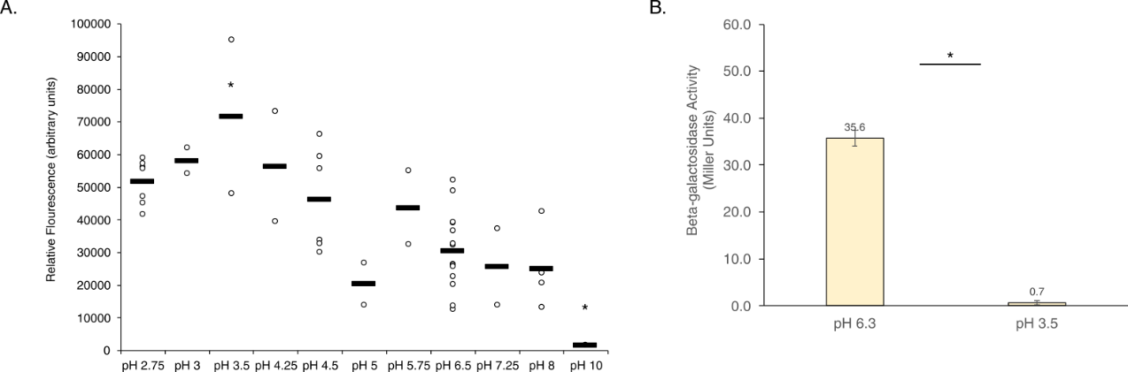
Figure 7. F. tularensis cells exposed to low pH increases rpsU1 transcript, but decreases protein production. Relative fluorescence values (y-axis) versus environmental conditions (x-axis) of cells containing fluorescent rpsU1 reporter construct. Each dot represents one replicate, and horizontal bars indicate the average. (A) Cells grown to log phase and then exposed to indicated pH values. The threshold for changes to be considered significant is a two-fold or greater change from fluorescence of control cells. β-galactosidase activity (Miller Units, y-axis) versus environmental conditions (x-axis) of cells containing a single copy lacZ fused to rpsU1, in the native locus. (B) Cells grown to log phase and then exposed to sMHB pH 3.5. Completed thrice in biological triplicate. Threshold for significance was p-value > 0.5.
Changes in pH do not greatly affect rpsU3 transcript abundance, but decrease protein abundance
In contrast, the transcript abundance of rpsU3 did not seem to strongly react to changes in pH, whether acidic or basic (Fig 8A). Only at pH 2.75 was there a significant change, at a decrease of 65% fluorescence ((Fig 8A). Similar to the protein abundance observed at low pH of bS21-1, bS21-3 shows virtually no β-galactosidase activity at pH 3.5 (Fig 8B).
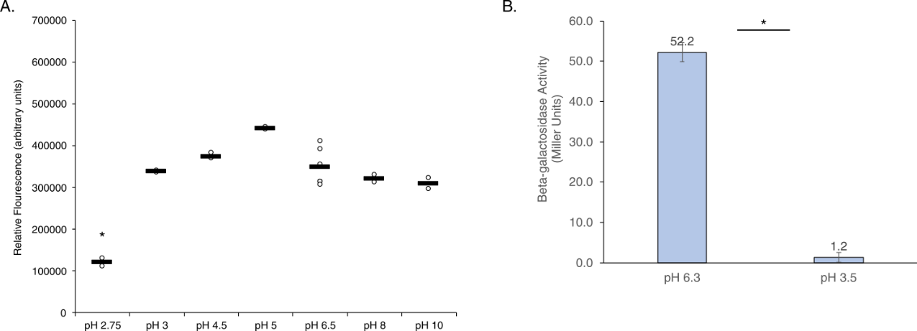
Figure 8. F. tularensis cells exposed to different pH do not greatly affect rpsU3 transcript, but decreases protein production. Relative fluorescence values (y-axis) versus environmental conditions (x-axis) of cells containing fluorescent rpsU3 reporter construct. Each dot represents one replicate, and horizontal bars indicate the average. (A) Cells grown to log phase and then exposed to indicated pH values. The threshold for changes to be considered significant is a two-fold or greater change from fluorescence of control cells. β-galactosidase activity (Miller Units, y-axis) versus environmental conditions (x-axis) of cells containing a single copy lacZ fused to rpsU3, in the native locus. (B) Cells grown to log phase and then exposed to sMHB pH 3.5. Completed thrice in biological triplicate. Threshold for significance was p-value > 0.5.

Discussion
In this study we used reporter assays to investigate environmental factors that could lead to differential expression of the ribosomal proteins bS21-1 and bS21-3 in F. tularensis. For most of the conditions we examined, we did not observe any significant change in reporter activity. However, based on our transcriptional reporter, there is evidence of increased bS21-1 in response to low pH, growth in CDM, and growth on CHAH. Similarly, we found evidence of increased bS21-3 in cells grown in CDM or on CHAH. We subsequently assessed bS21-1 and bS21-3 production under these conditions using lacZ-based translational reporters. We could not validate the increase in bS21-1 in cells exposed to acidic pH, possibly due to technical considerations. Finally, we observed an increase in both bS21-1 and bS21-3 in cells grown in CDM or on CHAH, but the magnitude of increase was lower than observed using the transcriptional reporter assay.
It is important to note that the transcription start sites of the genes encoding bS21-1 and bS21-3 (rpsU1 and rpsU3) are not known, so our transcriptional reporters include both the putative promoter and 5´ untranslated region (UTR). Thus, it is possible that the GFP reporter is subject to both transcriptional and post-transcriptional control. In addition, as rpsU1 is the second gene in an operon, its promoter corresponds to the sequence upstream of the gene cspA. We do not know if other regulatory elements differentially control production of rpsU1. Thus, it is possible that the transcriptional reporter activity corresponding to rpsU1 may more accurately reflect changes in abundance of cspA.
With respect to the impact of pH on bS21-1, we observed a disconnect between transcriptional and translational reporter protein abundance (cite figure). It is possible that abundance of cspA is increased at low pH and other regulatory mechanisms limit bS21-1 production. But, the cells containing both the bS21-1 and bS21-3 lacZ translational reporters had a complete lack of β-galactosidase activity in the low pH condition. This raises the possibility that the low pH externally resulted in sufficiently low internal pH to inactivate the β-galactosidase enzyme.
In considering the different in vitro growth medias, their complex and undefined nature makes it difficult to determine what factors lead to the changes in bS21 homolog production. While future work could shed light on this topic, the observed differences were not large and other approaches may be more fruitful.
This study serves as a survey of environmental factors that influence gene expression in F. tularensis and were tested for their ability to influence the abundance of ribosomal proteins bS21-1 and bS21-3. While we determined that low pH may impact bS21-1 production and that production of both homologs is altered by different in vitro growth media, more questions remain. In particular, it is not clear how these conditions impact protein production nor what other conditions could lead to increased abundance of bS21 homologs. These questions, and how bS21-1 and bS21-3 influence the proteome, will be addressed in future work.

Materials and Methods
Bacterial Strains and Growth Conditions
For standard growth, F. tularensis subsp. holarctica LVS was grown in Mueller Hinton Broth supplemented with 0.025% iron pyrophosphate, 0.1% glucose, and 2% Isovitalex (sMHB) aerobically shaking at 37°C or on cystine heart agar plates containing 1% hemoglobin (CHAH) at 37°C . As indicated, LVS was grown in Chamberlain’s Defined Media, CDM (Chamberlain, 1965). The selective antibiotic kanamycin (kan) was used to maintain plasmids in F. tularensis LVS at 5 µg/mL.
Strains
Four strains of F. tularensis subsp. holarctica LVS were used for the screening of rpsU1 and rpsU3 environmental conditions. For use in the GFP assays, strains KRLVS192 and KRLVS193 were used. The genotypes of these strains were LVS pF-PrpsU1-GFP and LVS pF-PrpsU3-GFP, respectively. These were previously created by electroporating the replicative pF-based plasmids containing the promoter regions of either rpsU1/cspC or rpsU3 to GFP. The plasmids used were pKR153 (pF-PrpsU1-GFP) or pKR154 (pF-PrspU3-GFP). For use in the β-Galactosidase Assay, strains KRLVS28 and KRLVS75 were used. The genotypes of these strains were LVS rpsU1-lacZ and LVS rpsU3-lacZ respectively. These were previously created using allelic exchanged pEX-based plasmids, pKR34 (pEX_rpsU1_lacZ) or pKR38 (pEX_rpsU3_lacZ).
Screening for Environmental Conditions - Growth
Changes in temperature, salinity, pH, hydrogen peroxide (H₂O₂) stress, and UV stress were tested in sMHB. To test salinity and pH, cells were grown to early-log phase and transferred to fresh, modified sMHB for an additional 30-60 minute growth period. Alternatively, for temperature, H₂O₂, and UV stress, cultures were grown to mid-log, exposed to the stress, and given 30 minutes to recover. sMHB versus CDM was tested by growing cultures to mid-log in sMHB or CDM. Changes in iron, magnesium, or spermine concentrations were tested in CDM by altering the recipe to reflect the concentrations tested, and allowing the cultures to grow to mid-log.
GFP Assay
After cultures were grown to mid-log, 1 - 4mL was pelleted and resuspended in 1xPBS. In technical triplicate, 250 uL was plated in a clear 96-well plate and the OD600 was read by the SpectraMax® iD3 Multi-Mode Microplate Reader. 200 uL of the sample was then transferred to a black 96-well plate and the fluorescent value was measured. Fluorescence was normalized to LVS containing an empty vector (pF) in 1xPBS and calculated relative to the corresponding OD600.
β-Galactosidase Assay
Cultures were grown to early mid-log (OD₆₀₀ 0.3 – 0.35) in triplicate. Growth was halted by placing cultures on ice for at least 30 minutes before cells were added to tubes containing Z-buffer supplemented with β-mercaptoethanol. 0.1% SDS and chloroform were added, cultures were vortexed, then allowed to come to 28°C for 10 minutes prior to the addition of the substrate O-nitrophenyl- β -galactopyranoside (ONPG). Reactions were stopped upon reaching a yellow color, OD₄₂₀ 0.6-0.9.

REFERENCES

