EXAMINING THE REGULATION OF THE BS21 HOMOLOGS
IN FRANCISELLA TULARENSIS
BY
SIERRA SCHMIDT

A THESIS SUBMITTED IN PARTIAL FULFILLMENT OF THE
REQUIREMENTS FOR THE DEGREE OF
MASTER OF SCIENCE
IN
CELL AND MOLECULAR BIOLOGY

UNIVERSITY OF RHODE ISLAND
2023

MASTER OF SCIENCE IN CELL AND MOLECULAR BIOLOGY THESIS

OF

SIERRA SCHMIDT

APPROVED:

Thesis Committee:

Major Professor Kathryn Ramsey

Steven Gregory

David Rowley

Brenton DeBoef
DEAN OF THE GRADUATE SCHOOL

UNIVERSITY OF RHODE ISLAND
2023

TABLE OF CONTENTS

CHAPTER 3 4
Manuscript 2 4
Abstract 5
Importance 5
Introduction 5
Results 5
Discussion 5
Materials and Methods 7
REFERENCES 8

CHAPTER 3

Manuscript 2

Identification of conditions that lead to changes in bS21-1 and bS21-3 abundance in Francisella tularensis

?????????????????

Sierra S. Schmidt¹, Hannah S. Trautmann¹, and Kathryn M. Ramsey^{1,2,*}

¹Department of Cell and Molecular Biology, University of Rhode Island, Kingston, RI 02881, USA
²Department of Biomedical and Pharmaceutical Sciences, University of Rhode Island, Kingston, RI 02881, USA

Abstract
Francisella tularensis is a highly infectious, intracellular human pathogen that can cause fatal disease. We have recently found that ribosomes can contain one of the three homologs for the small ribosomal subunit protein bS21. Most abundantly, bS21-2, positively controls key virulence genes and intramacrophage replication. In addition, the regulation of bS21-2 has been investigated with regards to transcriptional regulation. However, not nearly as much is known about the other two homologs, bS21-1 and bS21-3. Due to this gap in knowledge, the present study examined several environmental factors which are known to lead to differential gene regulation of other proteins in F. tularensis. For most of these conditions, no significant change was noted for either bS21-1 or bS21-3. However, bS21-1 was found to be up-regulated when exposed to acidified media, growth in CDM, or growth on CHAH. bS21-3 was found to be in higher abundance when grown in CDM or grown on CHAH. Different reporters were used to better characterize these changes in gene expression, which indicated similar results for growth in CDM or on CHAH for both proteins. However, this second reporter indicated no protein production for either protein when exposed to acidified media. This study served as a survey of conditions, however there are many more questions left to answer.

Introduction
Francisella tularensis, the causative agent of tularemia, is a Gram-negative, facultative intracellular bacterium with the potential to be a fatal human disease. Characteristic of an intracellular pathogen, F. tularensis has a reduced genome size. Yet, previous work established that it contains three copies of the ribosomal protein bS21 (Trautmann & Ramsey, 2022).
bS21 is implicated in the initiation of translation. When it is present in an organism, it is often encoded with other genes on the so-called macromolecules synthesis (MMS) operon. These other genes are important for the initiation of DNA synthesis (dnaG) and the initiation of transcription (rpoD). F. tularensis includes this operon with an additional gene, yqeY, specifically encoding its second bS21 homolog, bS21-2. This homolog has been studied extensively by the Ramsey Lab, implicating it in the regulation of several virulence proteins through preferential translation. Additionally, some information has been extrapolated about its regulation. However, less is known about the other homologs, bS21-1 and bS21-3 in regard to both their function and their regulation. In an effort to both understand what role they may have in the cell as well as to increase their abundance for easier study, we decided to screen a number of conditions looking for differences in bS21-1 and bS21-3 abundance.
F. tularensis not only survives in a host environment, but also in extracellular environmental niches, such as cold water streams and brackish water. Thus, it must be able to withstand environmental pressures and conditions prior to entering the host environment, withstanding host defenses and inconsistent nutrient states. This necessitates the ability of F. tularensis to have both efficient and effective regulatory mechanisms so as to precisely respond to the given environment, without otherwise wasting cellular resources. Knowing that bS21-2 is able to affect the F. tularensis proteome, we hope to find that bS21-1 and bS21-3 may interact with the proteome in some other environment. We will test temperature, salt concentration, pH, hydrogen peroxide stress, UV stress, CDM growth media, CHAH growth media, different iron concentrations, different magnesium concentrations, and a different spermine concentration. What is known about gene regulation in F. tularensis in response to these conditions will be discussed below:
Temperature
The most medically relevant transition in temperature that F. tularensis is subject to is moving from the environment to a human host. And, in fact, it was determined that ~11% of F. tularensis genes were differently regulated upon introduction to 37°C from an environmental 26°C. Several of these genes identified were virulence genes, indicating that temperature-associated regulation is important for virulence (Horzempa et al., 2008).
Salt Concentration
The effects of NaCl concentration on gene regulation in F. tularensis has not been greatly investigated. However, one report showed that F. tularensis Type A can survive longer in filter-sterilized brackish water versus filter sterilized freshwater (Berrada & Telford III, 2011). Additionally, a study evaluating the regulator Hfq, an RNA binding protein, showed that the protein was seemingly important for both stress response and virulence in mice. Particularly in the removal of the gene encoding Hfq, hfq, the strain was found to be more sensitive to a high NaCl concentration of 2% (Meibom et al., 2009).
pH
With regard to pH, some is known, again, about specific proteins but not necessarily broadly. Specifically, the virulence gene iglA and the general regulator, ppGpp, were both found to have decreased mRNA transcript levels in acidified environments (pH 5.5), and increased abundance in alkalized environments (pH 8.5) (Faron et al., 2013). Meanwhile, a cytoplasmic membrane protein, RipA, was found to be necessary for growth at neutral pH and to have similar expression levels to IglA upon host cll infection. It was also found to be pH sensitive, expression decreasing in acidified pH (Fuller et al., 2009).
H₂O₂ Stress
Unsurprisingly, a number of proteins of F. tularensis are differently regulated upon exposure to hydrogen peroxide. As an intraceullar pathogen, upon host cell infection F. tularensis is necessarily exposed to hydrogen peroxide within phagosomes. Global studies of F. tularensis found several proteins which were differently regulated after exposure to hydrogen peroxide, unsurprisingly many of these were apart of stress response protein families (Ericsson et al., 1994; Lenco et al., 2005).
UV Stress
At the time of writing this, there did not appear to be any literature examining the gene regulation of F. tularensis in response to UV-induced stress.
Chamberlain’s Defined Media (CDM)
Growth in Chamberlain’s Defined Media has been found to generally increase virulence protein abundance in F. tularensis (Carlson et al., 2007; Meibom & Charbit, 2010).
Cysteine Heart Agar with 2% Hemoglobin
At the time of writing this, there did not appear to be any literature examining the gene regulation of F. tularensis in response to growth on CHAH plates.
Iron Concentration
A number of studies have evaluated the effects of iron starvation on gene expression in F. tularensis. This is largely due to the iron staving conditions that any pathogen faces upon entering a host. A global analysis of gene expression found that at least 80 genes were either up- or down-regulated at least two-fold in iron poor environments. Some specific genes were found to have a Fur box upstream of the gene affecting expression. The Fur box is bound by Fur-protein and ferrous iron complexes, which subsequently can repress expression of downstream genes. The protein siderophore is up-regulated in iron-deplete environments, as it is an iron acquisitioning protein. Additionally, some virulence genes were found to be up-regulated (Deng et al., 2006; Lenčo et al., 2007; Sullivan et al., 2006).
Magnesium Concentration
Two major genes hae been identified to be differently regulated in magnesium-deplete environments in F. tularensis. Like with iron starvation, these genes appear to play arole in magnesium uptake. However, they have also been identified as important for virulence as deletion of these genes, fmvA and fmvB, led to attenua(Wu et al., 2016)tion in mice .
Spermine Concentration
A study looking at the effects of spermine on F. tularensis, indicated that presence of spermine may act as a novel trigger of host environment infection. In particular, as related to gene expression, insertion sequence (IS) elements and nearby genes within the F. tularensis genome appeared to be triggered by the presence of spermine (Carlson et al., 2009).

Results
bS21 homologs are not responsive to a number of conditions
In order to efficiently test multiple conditions to assess relative expression of bS21-1 and bS21-3, we constructed plasmids encoding fluorescent reporters. In particular, these reporters contained the predicted promoter region for either rpsU1 or rpsU3. Because rpsU1 is the second gene in an operon, the region predicted to encode the rpsU1 promoter is upstream of the first gene in the operon, cspC. The DNA including putative promoter regions (approximately 250 bp for rpsU1 and approximately 400 bp for rpsU3) up to the start codon of either cspC or rpsU3 is followed by DNA specifying a triple alanine linker in frame with the green fluorescent protein gene (gfp). These constructs were created on a multi-copy plasmid and transformed into wild-type F. tularensis LVS cells. [Conclude by stating (rather obvious) expectation with respect to fluorescence and amount of bS21-1 or bS21-3]

Screening for factors that influence expression of rpsU1
When F. tularensis cells containing the rpsU1 reporter were grown to mid-log and then exposed to either heat or cold-shock, there was no significant change in fluorescence, compared to cells grown at the standard temperature, 37°C, in standard growth media (supplemented Mueller-Hinton Broth, sMHB) (Fig 1A). Similarly, there were no changes in fluorescence of cells grown in different salt concentrations (Fig 1B), or when exposed to either H₂O₂ or UV-stress (Fig 1C, D).

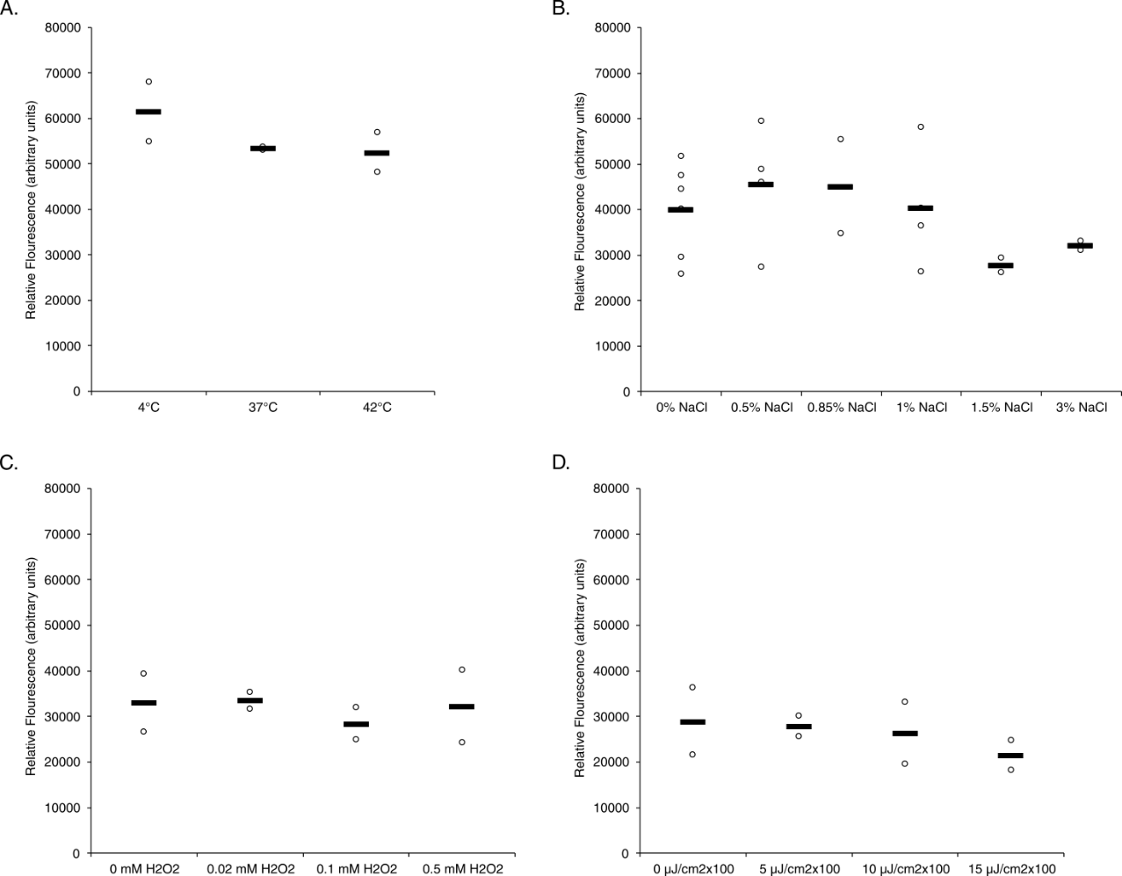
Figure 1. F. tularensis cells exposed to different temperatures, salt concentrations, or amounts of oxidative or UV stress do not appear to have changes in rpsU1 production. Relative fluorescence values (y-axis) versus environmental conditions (x-axis) of cells containing fluorescent rpsU1 reporter construct. (A) Cells exposed to temperatures of 4°C or 42°C as compared to standard growth temperature, 37°C. Experiment was completed in biological duplicate. (B) Cells grown in different salt concentrations. 0.5% NaCl and 1% NaCl were tested twice in biological duplicate, the rest were completed once in biological duplicate. (C) Cells grown to log-phase and then exposed to indicated concentrations of hydrogen peroxide (H₂O₂). All were completed once in biological duplicate. (D) Cells grown to log-phase and then exposed to indicated doses of UV light exposure. All were completed once in biological duplicate. The threshold for changes to be considered significant is a two-fold or greater change from fluorescence of control cells.
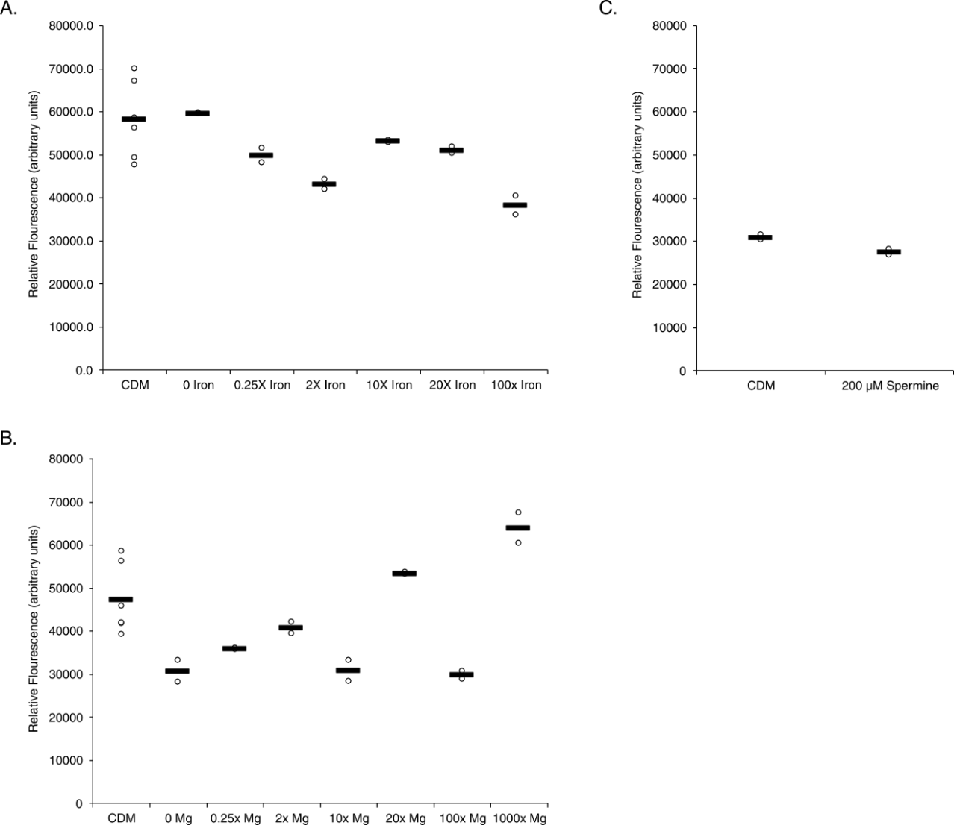
Figure 2. Various environmental conditions in CDM do not significantly affect transcript abundance of rpsU1. Relative fluorescence values (y-axis) versus environmental conditions (x-axis) of cells containing fluorescent rpsU1 reporter construct. (A) Cells grown in different iron concentrations, as compared to standard CDM (B Cells grown in different magnesium concentrations. (C) Cells grown in either 200µM spermine CDM or s CDM Significance was determined by an average fold-change of 2 as compared to standard growth.

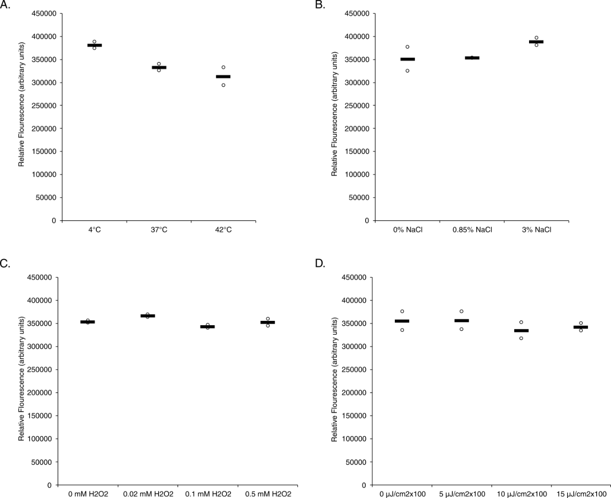
Figure 3. Various environmental conditions in MHB do not significantly affect transcript abundance of rpsU3. Relative fluorescence values (y-axis) versus environmental conditions (x-axis) of construct containing the leader sequence of rpsU3 fused to gfp, on a replicating plasmid. (A) Reporter strains exposed to temperatures of 4°C or 42°C as compared to standard growth temperature, 37°C. (B) Reporter strains grown in various percent additional salt concentrations. (C) Reporter strains grown to log-phase and then exposed to various final concentrations of hydrogen peroxide. (D) Reporter strains grown to log-phase and then exposed to various doses of UV light exposure. Significance was determined by an average fold-change of 2 as compared to standard growth.
The same conditions were screened for changes in rpsU3 abundance. Again, significance was determined by at least a two-fold change between the averages of the test and standard conditions. And, again, there was no significant changes in the rpsU3 abundance when cells were exposed to cold or heat-shock, higher additional salt concentrations, H₂O₂ or UV stress (Figure 3). The conditions tested on rpsU3 in CDM also showed no significant change in rpsU3 reported fluorescence in response to changes in iron, magnesium, or spermine concentrations (Figure 4).
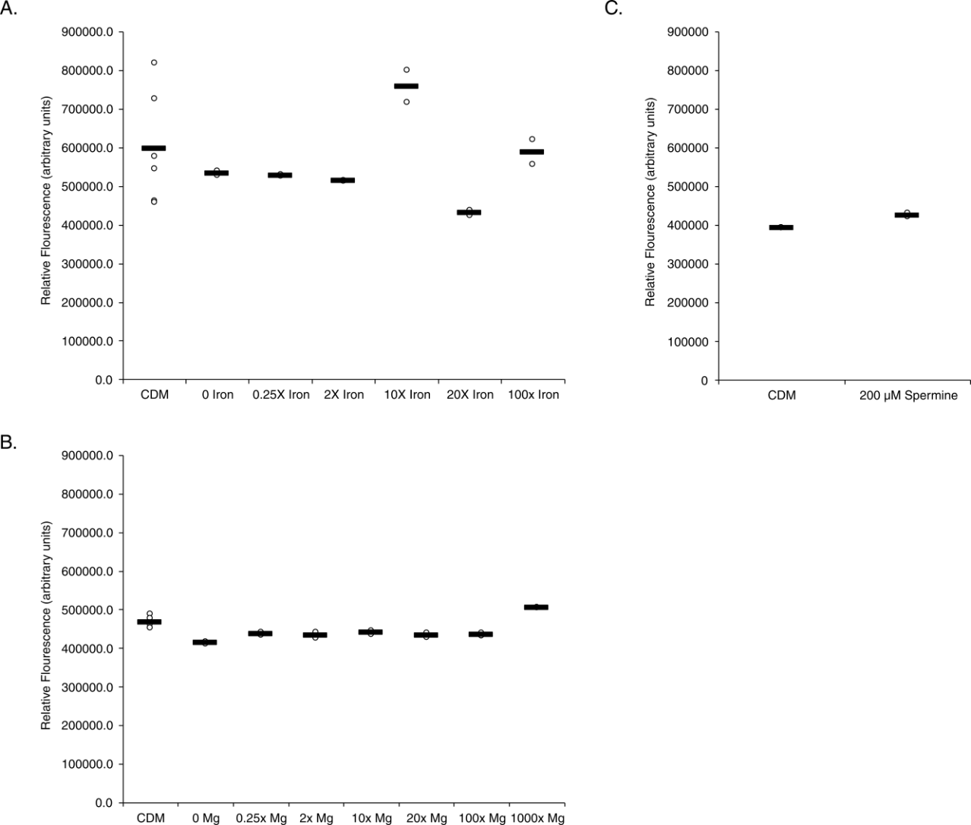
Figure 4. Various environmental conditions in CDM do not significantly affect transcript abundance of rpsU3. Relative fluorescence values (y-axis) versus environmental conditions (x-axis) of construct containing the leader sequence of rpsU3 fused to gfp, on a replicating plasmid. (A) Reporter strains grown in CDM with various increased concentrations of iron, compared to standard addition of iron. (B Reporter strains grown in CDM with various increased concentrations of magnesium, compared to standard addition of magnesium. (C) Reporter strains grown in CDM supplemented with 200µM spermine, compared to standard spermine concentration CDM Significance was determined by an average fold-change of 2 as compared to standard growth.
Growth in CDM or on CHAH changes bS21 homolog abundance
Although cells containing the rpsU1 fluorescent reporter did not have significant changes in fluorescence when grown in CDM with altered levels of several components, there are differences in fluorescence when comparing cells grown in CDM to those grown in sMHB. Specifically, there was a 2.1-fold increase in fluorescence when cells with the rpsU1 reporter construct were grown in CDM compared to sMHB. (Fig 5A). Similarly, when grown on solid media (cystine hear agar with hemoglobin, CHAH), cells containing the rpsU1 reporter construct had a 3.3-fold increase in fluorescence (Fig 5A). Conversely, when these cells were grown to stationary phase [in sMHB? CDM?], there was a 75% decrease in fluorescence (Fig 5A).
To determine if the observed changes in rpsU1 reporter fluorescence reflect changes in bS21-1 production, we took advantage of cells containing a translational reporter already available in the laboratory. Specifically, these cells encode the lacZ gene, encoding ß-galactosidase, immediately downstream of the native rpsU1 gene on the chromosome. Thus, using cells containing this reporter, a β-galactosidase assay can be used to approximate bS21-1 production. We found that growth in both CDM and CHAH produced significantly increased bS21-1, as approximated by β-galactosidase activity, compared to MHB. However, in cells grown in CDM compared to sMHB, the increase in bS21-1 was only 1.5-fold, compared to the 2.1-fold increase in fluorescence abundance (Fig 5B). However, in cells grown in CHAH, the abundance of bS21-1 was increased 3.1-fold (Fig 5C).
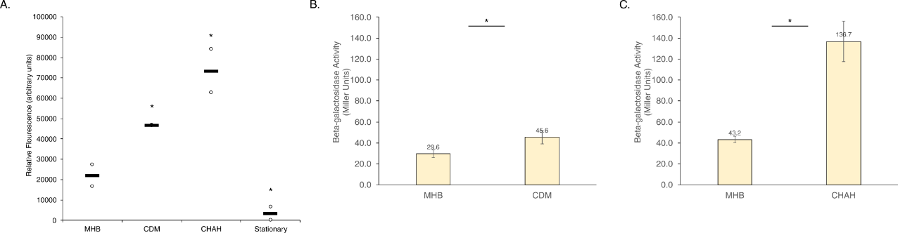
Figure 5. Growth in CDM or on CHAH increases rpsU1 transcript and protein. Relative fluorescence values (y-axis) versus environmental conditions (x-axis) of construct containing the leader sequence of rpsU1 fused to gfp, on a replicating plasmid, reporting changes in transcript abundance. Or, β-galactosidase activity (Miller Units, y-axis) of reporter containing lacZ fused to rpsU1, in the native locus, reporting protein abundance. (A) Fluorescent reporter strains grown in CDM or on CHAH, compared to strains grown in MHB. (B) lacZ activity of reporter strains grown in CDM, compared to strains grown in MHB. (C) lacZ activity of reporter strains grown on CHAH, compared to strains grown in MHB. *Significance was determined for fluorescence reporters by an average fold-change of 2 as compared to standard growth. Significance of lacZ activity was determined by p-value < 0.05.
When screening rpsU3 and its subsequent protein, bS21-3, under these same conditions, there was an increase in both transcript and protein abundance. With specific regard to the reported transcript abundance, the fold-change did not meet our criteria for significance. There was only a 1.3-fold increase in rpsU3 transcript between cells grown in CDM versus MHB. Further, there was only a 1.6-fold increase in cells grown on CHAH versus grown in MHB. There was also no change in rpsU3 abundance between cultures grown to stationary phase versus log phase (Figure 6).
Regardless that these fold-changes did not meet our criteria for significance, the protein abundance of bS21-3 under these conditions was tested alongside bS21-1. The change in bS21-3 protein abundance when grown in CDM was slightly higher than the fold-change in transcript, at a 1.5-fold increase. Further, when grown on CHAH, the protein abundance now showed a 2-fold increase, meeting our criteria for significance, beyond the statistical significance.
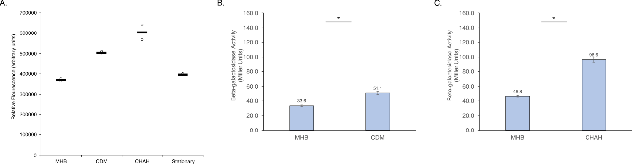
Figure 6. Growth in CDM or on CHAH increases rpsU3 transcript and protein. Relative fluorescence values (y-axis) versus environmental conditions (x-axis) of construct containing the leader sequence of rpsU3 fused to gfp, on a replicating plasmid, reporting changes in transcript abundance. Or, β-galactosidase activity (Miller Units, y-axis) of reporter containing lacZ fused to rpsU3, in the native locus, reporting protein abundance. (A) Fluorescent reporter strains grown in CDM or on CHAH, compared to strains grown in MHB. (B) lacZ activity of reporter strains grown in CDM, compared to strains grown in MHB. (C) lacZ activity of reporter strains grown on CHAH, compared to strains grown in MHB. *Significance was determined for fluorescence reporters by an average fold-change of 2 as compared to standard growth. Significance of lacZ activity was determined by p-value < 0.05.
Low pH increases rpsU1 transcript, but not protein abundance
In order to assess the affects of pH on either rpsU1 or rpsU3 abundance, cells were grown to log-phase and then transferred into media at the appropriate pH. Assessing the fluorescence of these cells revealed increased rpsU1 transcript abundance at lower pH. Particularly, while several of the acidic pH values came close to our threshold of a 2-fold change, pH 3.5 was the only acidic culture to cross that mark, at a 2.3-fold increase. Additionally, pH 10 showed a significant decrease in transcript abundance at a decrease of 94% fluorescence (Figure 7).
Unlike the increase observed in transcript abundance at pH 3.5, there was no accordant increase in protein abundance of bS21-1. In fact, the protein abundance decreased to a level which may indicate that there is no lacZ activity. This was validated multiple times, ensuring that the low acidity was not interfering with the assay (Figure 7).
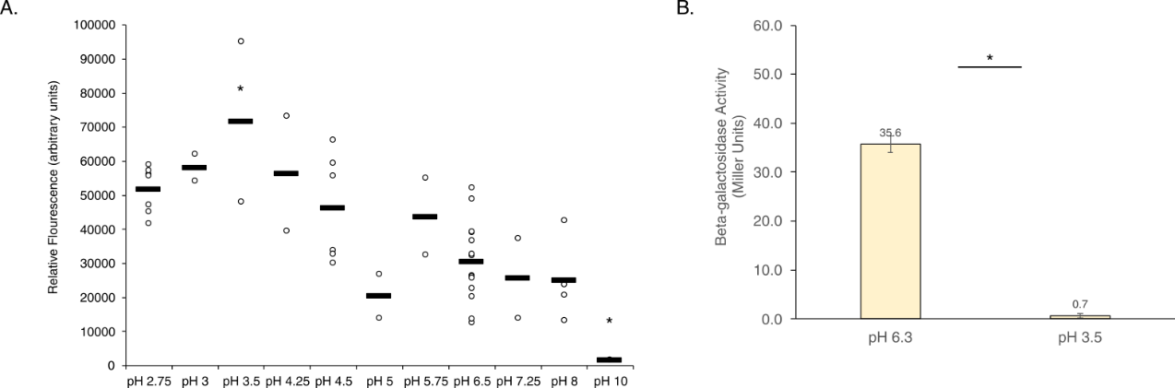
Figure 7. Growth in low pH increases rpsU1 transcript, but decreases protein. Relative fluorescence values (y-axis) versus environmental conditions (x-axis) of construct containing the leader sequence of rpsU1 fused to gfp, on a replicating plasmid, reporting changes in transcript abundance. Or, β-galactosidase activity (Miller Units, y-axis) of reporter containing lacZ fused to rpsU1, in the native locus, reporting protein abundance. (A) Fluorescent reporter strains grown to mid-log and then transferred to pH’d CDM, compared to strains grown in MHB. (B) lacZ activity of reporter strains grown to mid-log then transferred to CDM pH 3.5, compared to strains grown in standard pH CDM. *Significance was determined for fluorescence reporters by an average fold-change of 2 as compared to standard growth. Significance of lacZ activity was determined by p-value < 0.05.
In contrast, the transcript abundance of rpsU3 did not seem to strongly react to changes in pH, whether acidic or basic. Only at pH 2.75 was there a significant change, at a decrease of 65% fluorescence. Similar to the protein abundance observed at low pH of bS21-1, bS21-3 shows virtually no lacZ activity at pH 3.5 (Figure 8).
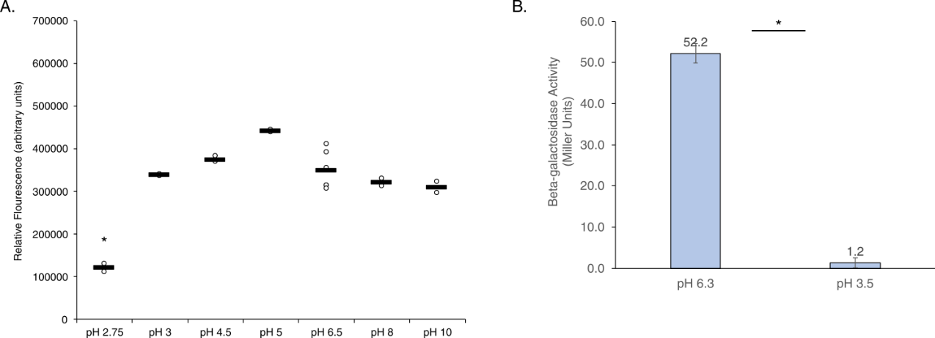
Figure 8. Growth in low pH either does not affect or lowers rpsU3 transcript, and decreases protein. Relative fluorescence values (y-axis) versus environmental conditions (x-axis) of construct containing the leader sequence of rpsU3 fused to gfp, on a replicating plasmid, reporting changes in transcript abundance. Or, β-galactosidase activity (Miller Units, y-axis) of reporter containing lacZ fused to rpsU3, in the native locus, reporting protein abundance. (A) Fluorescent reporter strains grown to mid-log and then transferred to pH’d CDM, compared to strains grown in MHB. (B) lacZ activity of reporter strains grown to mid-log then transferred to CDM pH 3.5, compared to strains grown in standard pH CDM. *Significance was determined for fluorescence reporters by an average fold-change of 2 as compared to standard growth. Significance of lacZ activity was determined by p-value < 0.05.

Discussion
In this study we investigated a number of environmental factors which could potentially cause differential gene expression of the ribosomal proteins bS21-1 and bS21-3 in F. tularensis. For most of the conditions we examined, there was no significant change according to the parameters we set. However, there seemed to be an increase of our proposed transcriptional reporter in response to low pH, growth in CDM, and growth on CHAH of bS21-1. Meanwhile, there appeared to be significant increases in our proposed transcriptional reporter of bS21-3 when grown in CDM or on CHAH. These proposed transcriptional reporters were then tested in a protein approximate reporter system utilizing lacZ. The protein abundance of these proteins was shown to be non-existent when exposed to acidic pH. Additionally, while there seemed to be some increase in both of these proteins when grown in CDM or grown on CHAH, they did not necessarily demonstrate the fold-incrase we determined for significance, a two-fold change.
It is important to note that while we believe the GFP reporters used to reflect transcript do accurately reflect transcript, the exact transcription start sites of these genes are unknown. In addition, rpsU1 in particular shares a leader sequence with the gene cspA, which necessarily indicates that the results seen for rpsU1 may more accurately reflected changes in abundance of that gene instead.
Regardless, on the subject of pH, if the transcriptional reporters are accurate then there seems to be a disconnect in the relative abundance of transcript versus protein. On the subject of the rpsU1 transcript abundance, it is possible that the increased abundance observed is more correlated to a response by cspA rather than rpsU1. If the increased transcript abundance at low pH observed is true to rpsU1, then there are a few reasons for the disconnect between transcript and protein abundance. For once, we cannot rule out the possibility with the given data that we were unable to solve the acidification of the β-galactosidase reaction and, consequently, deactivated the enzyme. It is also not clear from our data whether, perhaps, acidification to that low of a pH resulted in global halting of translation, thus resulting in the lack of protein abundance we observed for both bS21-1 and bS21-3. Finally, it is also possible that transcription and translation of bS21-1 are differently regulated. Other studies from our lab indicated that the other bS21 homolog, bS21-2, is differently regulated at the transcription and translational levels, and so this leaves the possibility that bS21-1 and bS21-3 are also differently regulated.
In considering the different in vitro growth medias, it is, again, unclear the exact mechanism for the slight increase we observed. One possibility raised is that the increase is due to the different types of iron present in these media. Namely, in MHB the iron source is iron pyrophosphate. CDM contains Iron(II) sulfate heptahydrate, while CHAH derives its iron from hemoglobin. CHAH is an otherwise undefined media, and so determining the exact differences it has from standard growth media MHB, is not necessarily straight forward. There is also the possibility that growth on solid media versus liquid media induces these proteins to some degree more, however, that would not then explain the increased expression in CDM.
This study serves as a broad survey of environmental factors which had the potential to affect the gene expression of the ribosomal proteins bS21-1 and bS21-3. While some information was obtained through this survey, several more questions are left to answer. Namely, what other conditions could potential lead to the increased abundance of these proteins, and why exactly do we see the changes that we do. Mechanistic questions also remain.

Materials and Methods
Bacterial Strains and Growth Conditions
For standard growth, F. tularensis subsp. holarctica LVS was grown in Mueller Hinton Broth supplemented with 0.025% iron pyrophosphate, 0.1% glucose, and 2% Isovitalex (sMHB) aerobically shaking at 37°C or on cystine heart agar plates containing 1% hemoglobin (CHAH) at 37°C . As indicated, LVS was grown in Chamberlain’s Defined Media, CDM (Chamberlain, 1965). The selective antibiotic kanamycin (kan) was used to maintain plasmids in F. tularensis LVS at 5 µg/mL.
Strains
Four strains of F. tularensis subsp. holarctica LVS were used for the screening of rpsU1 and rpsU3 environmental conditions. For use in the GFP assays, strains KRLVS192 and KRLVS193 were used. The genotypes of these strains were LVS pF-PrpsU1-GFP and LVS pF-PrpsU3-GFP, respectively. These were previously created by electroporating the replicative pF-based plasmids containing the promoter regions of either rpsU1/cspC or rpsU3 to GFP. The plasmids used were pKR153 (pF-PrpsU1-GFP) or pKR154 (pF-PrspU3-GFP). For use in the β-Galactosidase Assay, strains KRLVS28 and KRLVS75 were used. The genotypes of these strains were LVS rpsU1-lacZ and LVS rpsU3-lacZ respectively. These were previously created using allelic exchanged pEX-based plasmids, pKR34 (pEX_rpsU1_lacZ) or pKR38 (pEX_rpsU3_lacZ).
Screening for Environmental Conditions - Growth
Changes in temperature, salinity, pH, hydrogen peroxide (H₂O₂) stress, and UV stress were tested in sMHB. To test salinity and pH, cells were grown to early-log phase and transferred to fresh, modified sMHB for an additional 30-60 minute growth period. Alternatively, for temperature, H₂O₂, and UV stress, cultures were grown to mid-log, exposed to the stress, and given 30 minutes to recover. sMHB versus CDM was tested by growing cultures to mid-log in MHB or CDM. Changes in iron, magnesium, or spermine concentrations were tested in CDM by altering the recipe to reflect the concentrations tested, and allowing the cultures to grow to mid-log.
GFP Assay
After cultures were grown to mid-log, 1 - 4mL was pelleted and resuspended in 1xPBS. In technical triplicate, 250 uL was plated in a clear 96-well plate and the OD600 was read by the SpectraMax® iD3 Multi-Mode Microplate Reader. 200 uL of the sample was then transferred to a black 96-well plate and the fluorescent value was measured. Fluorescence was normalized to LVS containing an empty vector (pF) in 1xPBS and calculated relative to the corresponding OD600.
β-Galactosidase Assay
Cultures were grown to early mid-log (OD₆₀₀ 0.3 – 0.35) in triplicate. Growth was halted by placing cultures on ice for at least 30 minutes before cells were added to tubes containing Z-buffer supplemented with β-mercaptoethanol. 0.1% SDS and chloroform were added, cultures were vortexed, then allowed to come to 28°C for 10 minutes prior to the addition of the substrate O-nitrophenyl- β -galactopyranoside (ONPG). Reactions were stopped upon reaching a yellow color, OD₄₂₀ 0.6-0.9.

REFERENCES

