EXAMINING THE REGULATION OF THE BS21 HOMOLOGS
IN FRANCISELLA TULARENSIS
BY
SIERRA SCHMIDT

A THESIS SUBMITTED IN PARTIAL FULFILLMENT OF THE
REQUIREMENTS FOR THE DEGREE OF
MASTER OF SCIENCE
IN
CELL AND MOLECULAR BIOLOGY

UNIVERSITY OF RHODE ISLAND
2023

MASTER OF SCIENCE IN CELL AND MOLECULAR BIOLOGY THESIS

OF

SIERRA SCHMIDT

APPROVED:

Thesis Committee:

Major Professor Kathryn Ramsey

Steven Gregory

David Rowley

Brenton DeBoef
DEAN OF THE GRADUATE SCHOOL

UNIVERSITY OF RHODE ISLAND
2023

TABLE OF CONTENTS

CHAPTER 3 4
Manuscript 2 4
Abstract 5
Importance 5
Introduction 5
Results 5
Discussion 5
Materials and Methods 7
REFERENCES 8

CHAPTER 3

Manuscript 2

Environmental screening of bS21-1 and bS21-3 gene regulation in Francisella tularensis

Prepared for submission to Journal of Bacteriology

Sierra S. Schmidt¹, Hannah S. Trautmann¹, and Kathryn M. Ramsey^{1,2,*}

¹Department of Cell and Molecular Biology, University of Rhode Island, Kingston, RI 02881, USA
²Department of Biomedical and Pharmaceutical Sciences, University of Rhode Island, Kingston, RI 02881, USA

Abstract
Begin typing or pasting the rest of your chapter 3 text here. This template is best used for directly typing in your content. However, you can paste text into the document, but use caution as pasting can produce varying results

Introduction
Francisella tularensis, the causative agent of tularemia, is a Gram-negative, facultative intracellular bacterium with the potential to be a fatal human disease. Characteristic of an intracellular pathogen, F. tularensis has a reduced genome size. Yet, previous work established that it contains three copies of the ribosomal protein bS21 (Trautmann & Ramsey, 2022).
bS21 is implicated in the initiation of translation. When it is present in an organism, it is often encoded with other genes on the so-called macromolecules synthesis (MMS) operon. These other genes are important for the initiation of DNA synthesis (dnaG) and the initiation of transcription (rpoD). F. tularensis includes this operon with an additional gene, yqeY, specifically encoding its second bS21 homolog, bS21-2. This homolog has been studied extensively by the Ramsey Lab, implicating it in the regulation of several virulence proteins through preferential translation. Additionally, some information has been extrapolated about its regulation. However, less is known about the other homologs, bS21-1 and bS21-3 in regard to both their function and their regulation. In an effort to both understand what role they may have in the cell as well as to increase their abundance for easier study, we decided to screen a number of conditions looking for differences in bS21-1 and bS21-3 abundance.
F. tularensis not only survives in a host environment, but also in extracellular environmental niches, such as cold water streams and brackish water. Thus, it must be able to withstand environmental pressures and conditions prior to entering the host environment, withstanding host defenses and inconsistent nutrient states. This necessitates the ability of F. tularensis to have both efficient and effective regulatory mechanisms so as to precisely respond to the given environment, without otherwise wasting cellular resources. Knowing that bS21-2 is able to affect the F. tularensis proteome, we hope to find that bS21-1 and bS21-3 may interact with the proteome in some other environment. We will test temperature, salt concentration, pH, hydrogen peroxide stress, UV stress, CDM growth media, CHAH growth media, different iron concentrations, different magnesium concentrations, and a different spermine concentration. What is known about gene regulation in F. tularensis in response to these conditions will be discussed below:
Temperature
The most medically relevant transition in temperature that F. tularensis is subject to is moving from the environment to a human host. And, in fact, it was determined that ~11% of F. tularensis genes were differently regulated upon introduction to 37°C from an environmental 26°C. Several of these genes identified were virulence genes, indicating that temperature-associated regulation is important for virulence (Horzempa et al., 2008).
Salt Concentration

pH
Dkdk
H₂O₂ Stress
Dkdk
UV Stress
Dkdk
Chamberlain’s Defined Media (CDM)
Dkdk
Cysteine Heart Agar with 2% Hemoglobin
Dkdk
Iron Concentration
Dkdk
Magnesium Concentration
Dkdk
Spermine Concentration
Dkdk

Results
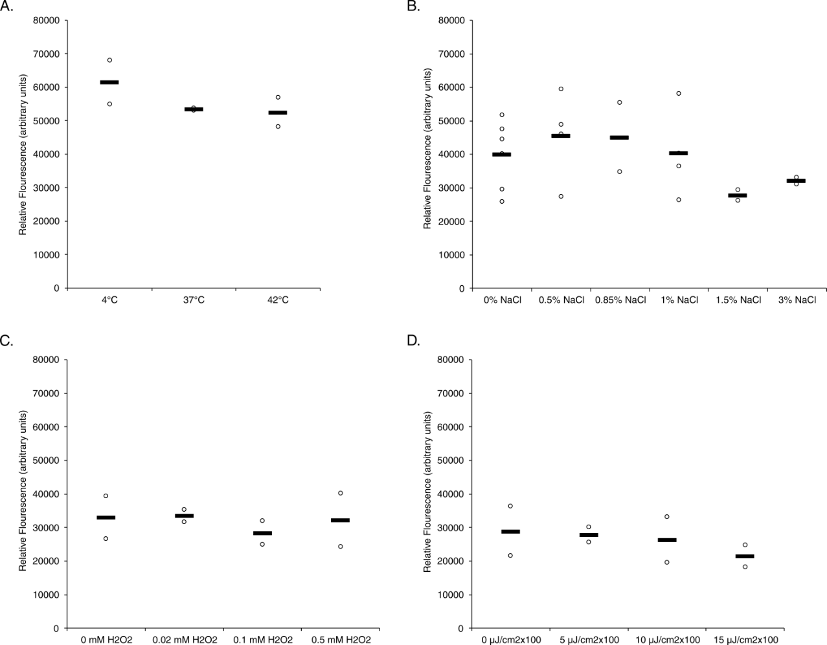
Figure 1. Various environmental conditions in MHB do not significantly affect transcript abundance of rpsU1. Relative fluorescence values (y-axis) versus environmental conditions (x-axis) of construct containing the leader sequence of rpsU1 fused to gfp, on a replicating plasmid. (A) Reporter strains exposed to temperatures of 4°C or 42°C as compared to standard growth temperature, 37°C. (B) Reporter strains grown in various percent additional salt concentrations. (C) Reporter strains grown to log-phase and then exposed to various final concentrations of hydrogen peroxide. (D) Reporter strains grown to log-phase and then exposed to various doses of UV light exposure. Significance was determined by an average fold-change of 2 as compared to standard growth.

bS21 homologs are not responsive to a number of conditions
In order to efficiently screen through several environments to assess the effect on expression of either bS21-1 or bS21-3, GFP reporter constructs were used as an approximation for changes in transcript abundance. These reporter constructs consisted of the promoter, leader sequence, and first six amino acids of either rpsU1 or rpsU3, fused to GFP. These constructs were created on a multi-copy plasmid and transformed into, otherwise, wild-type LVS cells.
A number of environmental conditions were considered and tested with respect to both homologs, across both the standard lab growth media, MHB, as well as Chamberlain’s Defined Media, CDM. Temperature, changes in salt concentration, change in media pH, hydrogen peroxide stress, and UV stress were all tested in MHB. Meanwhile, differing concentrations of iron, magnesium, and spermine were tested in CDM. In addition, growth in CDM, on CHAH, and to stationary phase were also tested and compared to standard growth in MHB. Significance was determined by there being at least a two-fold change in the test condition versus the standard condition.
When the rpsU1 construct was grown to mid-log and then exposed to either heat or cold-shock, there was no change in rpsU1 abundance. When the rpsU1 construct was grown in different salt concentrations, there was no change in abundance. Exposure to either H₂O₂ or UV-stress as compared to standard growth in MHB did not change rpsU1 abundance, either (Figure 1).
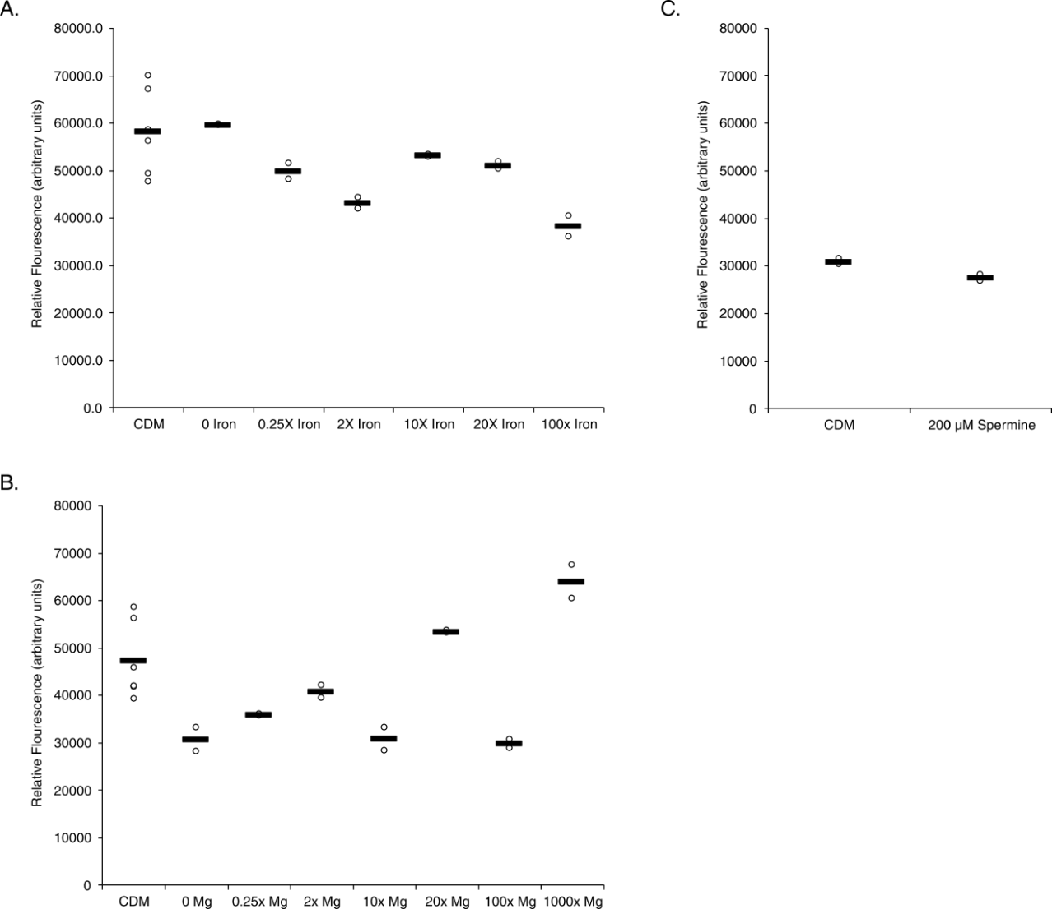
Figure 2. Various environmental conditions in CDM do not significantly affect transcript abundance of rpsU1. Relative fluorescence values (y-axis) versus environmental conditions (x-axis) of construct containing the leader sequence of rpsU1 fused to gfp, on a replicating plasmid. (A) Reporter strains grown in CDM with various increased concentrations of iron, compared to standard addition of iron. (B Reporter strains grown in CDM with various increased concentrations of magnesium, compared to standard addition of magnesium. (C) Reporter strains grown in CDM supplemented with 200µM spermine, compared to standard spermine concentration CDM Significance was determined by an average fold-change of 2 as compared to standard growth.
When the rpsU1 reporter construct was grown in differing iron concentrations there was no significant difference in its abundance as compared to standard growth in CDM. When grown in varying concnetrations of magnesium, there was also no change in rpsU1 abundance. A concentration of 200 µM spermine also did not significantly change the abundance of rpsU1 (Figure 2).
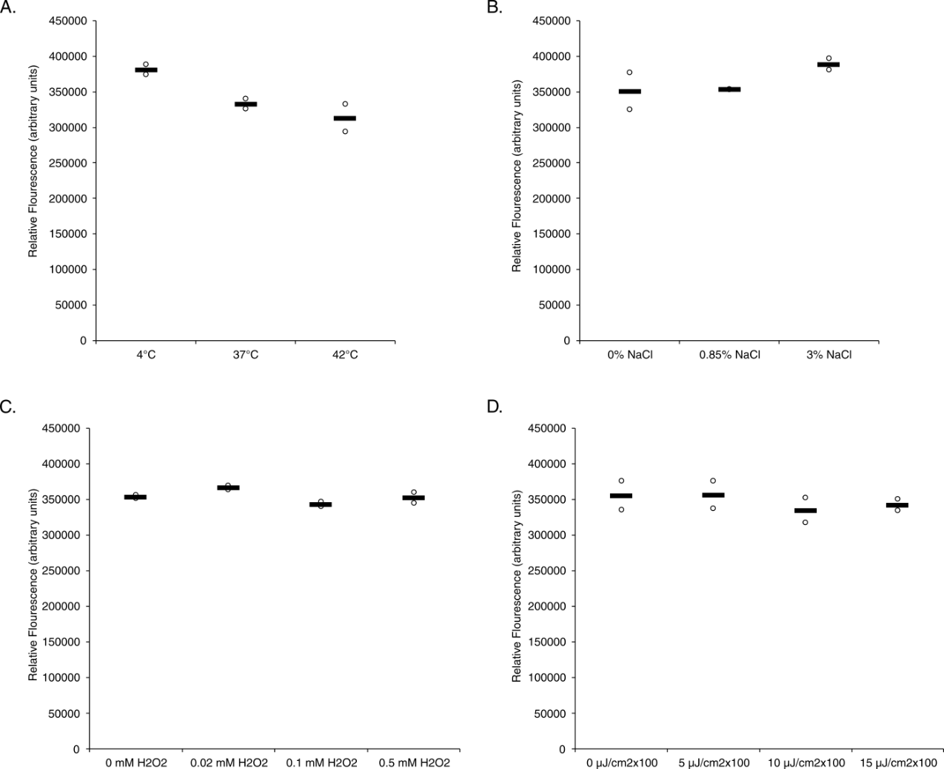
Figure 3. Various environmental conditions in MHB do not significantly affect transcript abundance of rpsU3. Relative fluorescence values (y-axis) versus environmental conditions (x-axis) of construct containing the leader sequence of rpsU3 fused to gfp, on a replicating plasmid. (A) Reporter strains exposed to temperatures of 4°C or 42°C as compared to standard growth temperature, 37°C. (B) Reporter strains grown in various percent additional salt concentrations. (C) Reporter strains grown to log-phase and then exposed to various final concentrations of hydrogen peroxide. (D) Reporter strains grown to log-phase and then exposed to various doses of UV light exposure. Significance was determined by an average fold-change of 2 as compared to standard growth.
The same conditions were screened for changes in rpsU3 abundance. Again, significance was determined by at least a two-fold change between the averages of the test and standard conditions. And, again, there was no significant changes in the rpsU3 abundance when cells were exposed to cold or heat-shock, higher additional salt concentrations, H₂O₂ or UV stress (Figure 3). The conditions tested on rpsU3 in CDM also showed no significant change in rpsU3 reported fluorescence in response to changes in iron, magnesium, or spermine concentrations (Figure 4).
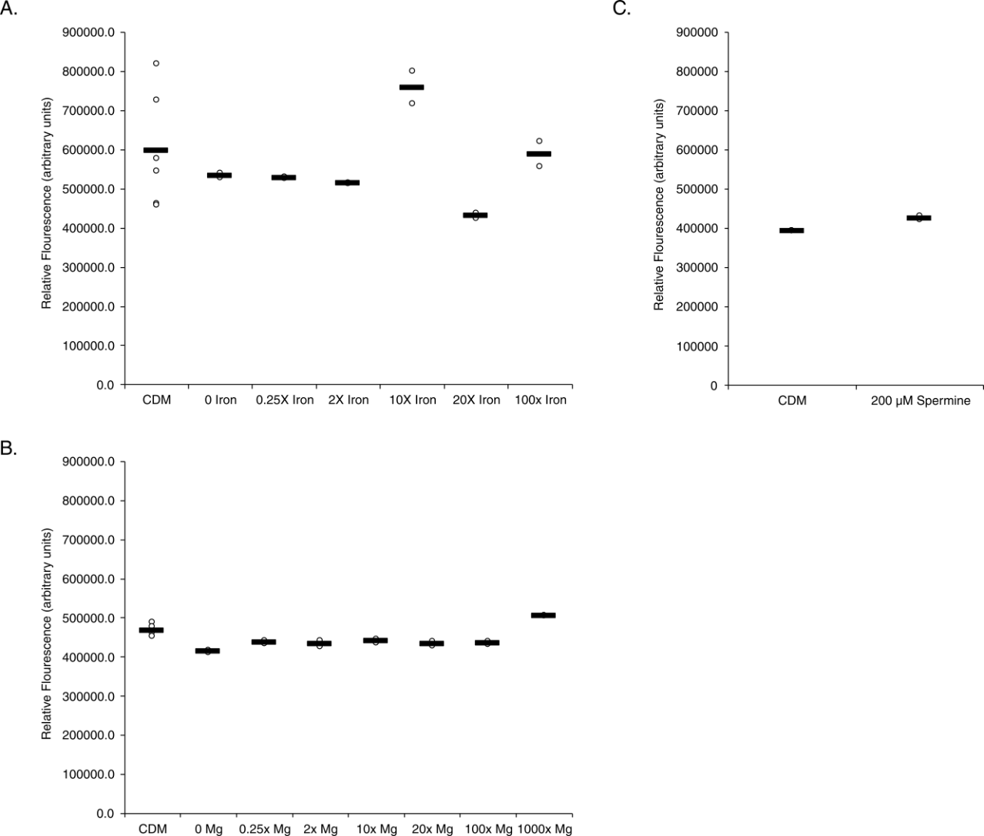
Figure 4. Various environmental conditions in CDM do not significantly affect transcript abundance of rpsU3. Relative fluorescence values (y-axis) versus environmental conditions (x-axis) of construct containing the leader sequence of rpsU3 fused to gfp, on a replicating plasmid. (A) Reporter strains grown in CDM with various increased concentrations of iron, compared to standard addition of iron. (B Reporter strains grown in CDM with various increased concentrations of magnesium, compared to standard addition of magnesium. (C) Reporter strains grown in CDM supplemented with 200µM spermine, compared to standard spermine concentration CDM Significance was determined by an average fold-change of 2 as compared to standard growth.
Growth in CDM or on CHAH changes bS21 homolog abundance
As mentioned above, the rpsU1 and rpsU3 reporter strains were also grown in CDM, on CHAH, and to stationary phase and compared to standard growth in MHB. The rpsU1 construct showed a significant increase in reported fluorescence under these conditions. Specifically, there was a 2.1-fold increase in rpsU1 when grown in CDM as compared to standard growth in MHB. This increase was larger when the cells were grown on solid CHAH and resuspended, showing a 3.3-fold increase in the average fluorescence. Alternatively, there was a 75% decrease in rpsU1 when grown to stationary phase rather than log phase (Figure 5).
In order to approximate changes in protein abundance of the bS21 homologs, different reporter constructs were used. These other reporters included lacZ fused to either rpsU1 or rpsU3 in the native locus. Thus, using these constructs, β-galactosidase assays were utilized to assess lacZ activity. A Student’s t-test was used to assess significance of lacZ activity, specifically with a p-value < 0.05. When assessed through this method, it was found that growth in both CDM and CHAH produced significantly increased rpsU1 as compared to MHB. However, the reported abundance of bS21-1 when grown in CDM was only 1.5-fold increased, as compared to the reported 2.1-fold increase in transcript abundance. The reported protein abundance of bS21-1 when grown on CHAH, as compared to MHB, was about 3.1-fold increased (Figure 5).
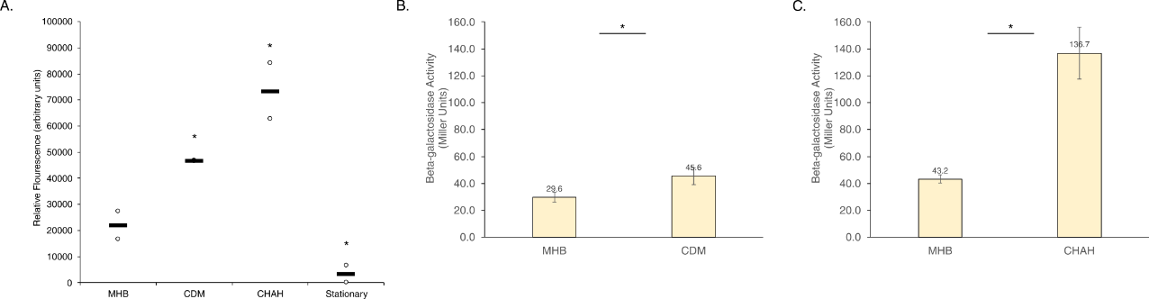
Figure 5. Growth in CDM or on CHAH increases rpsU1 transcript and protein. Relative fluorescence values (y-axis) versus environmental conditions (x-axis) of construct containing the leader sequence of rpsU1 fused to gfp, on a replicating plasmid, reporting changes in transcript abundance. Or, β-galactosidase activity (Miller Units, y-axis) of reporter containing lacZ fused to rpsU1, in the native locus, reporting protein abundance. (A) Fluorescent reporter strains grown in CDM or on CHAH, compared to strains grown in MHB. (B) lacZ activity of reporter strains grown in CDM, compared to strains grown in MHB. (C) lacZ activity of reporter strains grown on CHAH, compared to strains grown in MHB. *Significance was determined for fluorescence reporters by an average fold-change of 2 as compared to standard growth. Significance of lacZ activity was determined by p-value < 0.05.
When screening rpsU3 and its subsequent protein, bS21-3, under these same conditions, there was an increase in both transcript and protein abundance. With specific regard to the reported transcript abundance, the fold-change did not meet our criteria for significance. There was only a 1.3-fold increase in rpsU3 transcript between cells grown in CDM versus MHB. Further, there was only a 1.6-fold increase in cells grown on CHAH versus grown in MHB. There was also no change in rpsU3 abundance between cultures grown to stationary phase versus log phase (Figure 6).
Regardless that these fold-changes did not meet our criteria for significance, the protein abundance of bS21-3 under these conditions was tested alongside bS21-1. The change in bS21-3 protein abundance when grown in CDM was slightly higher than the fold-change in transcript, at a 1.5-fold increase. Further, when grown on CHAH, the protein abundance now showed a 2-fold increase, meeting our criteria for significance, beyond the statistical significance.
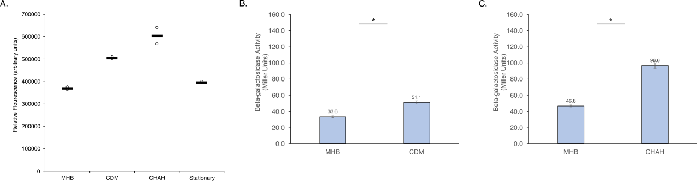
Figure 6. Growth in CDM or on CHAH increases rpsU3 transcript and protein. Relative fluorescence values (y-axis) versus environmental conditions (x-axis) of construct containing the leader sequence of rpsU3 fused to gfp, on a replicating plasmid, reporting changes in transcript abundance. Or, β-galactosidase activity (Miller Units, y-axis) of reporter containing lacZ fused to rpsU3, in the native locus, reporting protein abundance. (A) Fluorescent reporter strains grown in CDM or on CHAH, compared to strains grown in MHB. (B) lacZ activity of reporter strains grown in CDM, compared to strains grown in MHB. (C) lacZ activity of reporter strains grown on CHAH, compared to strains grown in MHB. *Significance was determined for fluorescence reporters by an average fold-change of 2 as compared to standard growth. Significance of lacZ activity was determined by p-value < 0.05.
Low pH increases rpsU1 transcript, but not protein abundance
In order to assess the affects of pH on either rpsU1 or rpsU3 abundance, cells were grown to log-phase and then transferred into media at the appropriate pH. Assessing the fluorescence of these cells revealed increased rpsU1 transcript abundance at lower pH. Particularly, while several of the acidic pH values came close to our threshold of a 2-fold change, pH 3.5 was the only acidic culture to cross that mark, at a 2.3-fold increase. Additionally, pH 10 showed a significant decrease in transcript abundance at a decrease of 94% fluorescence (Figure 7).
Unlike the increase observed in transcript abundance at pH 3.5, there was no accordant increase in protein abundance of bS21-1. In fact, the protein abundance decreased to a level which may indicate that there is no lacZ activity. This was validated multiple times, ensuring that the low acidity was not interfering with the assay (Figure 7).
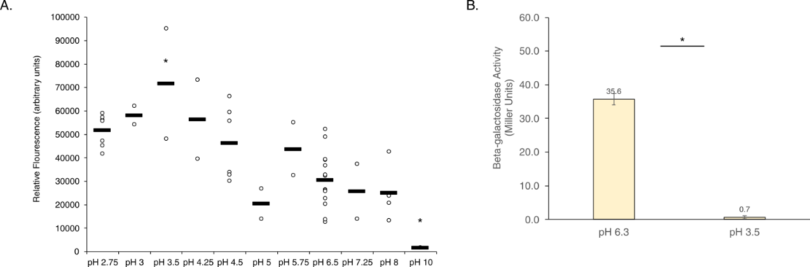
Figure 7. Growth in low pH increases rpsU1 transcript, but decreases protein. Relative fluorescence values (y-axis) versus environmental conditions (x-axis) of construct containing the leader sequence of rpsU1 fused to gfp, on a replicating plasmid, reporting changes in transcript abundance. Or, β-galactosidase activity (Miller Units, y-axis) of reporter containing lacZ fused to rpsU1, in the native locus, reporting protein abundance. (A) Fluorescent reporter strains grown to mid-log and then transferred to pH’d CDM, compared to strains grown in MHB. (B) lacZ activity of reporter strains grown to mid-log then transferred to CDM pH 3.5, compared to strains grown in standard pH CDM. *Significance was determined for fluorescence reporters by an average fold-change of 2 as compared to standard growth. Significance of lacZ activity was determined by p-value < 0.05.
In contrast, the transcript abundance of rpsU3 did not seem to strongly react to changes in pH, whether acidic or basic. Only at pH 2.75 was there a significant change, at a decrease of 65% fluorescence. Similar to the protein abundance observed at low pH of bS21-1, bS21-3 shows virtually no lacZ activity at pH 3.5 (Figure 8).
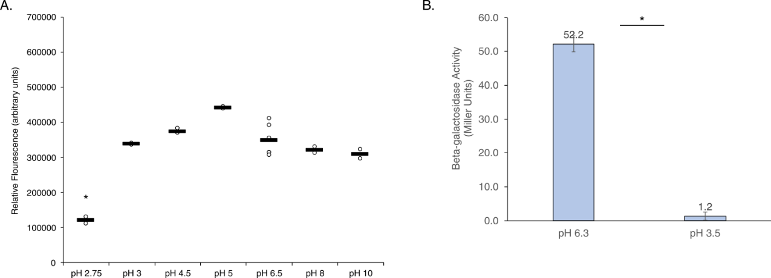
Figure 8. Growth in low pH either does not affect or lowers rpsU3 transcript, and decreases protein. Relative fluorescence values (y-axis) versus environmental conditions (x-axis) of construct containing the leader sequence of rpsU3 fused to gfp, on a replicating plasmid, reporting changes in transcript abundance. Or, β-galactosidase activity (Miller Units, y-axis) of reporter containing lacZ fused to rpsU3, in the native locus, reporting protein abundance. (A) Fluorescent reporter strains grown to mid-log and then transferred to pH’d CDM, compared to strains grown in MHB. (B) lacZ activity of reporter strains grown to mid-log then transferred to CDM pH 3.5, compared to strains grown in standard pH CDM. *Significance was determined for fluorescence reporters by an average fold-change of 2 as compared to standard growth. Significance of lacZ activity was determined by p-value < 0.05.

Discussion
Begin typing or pasting the rest of your chapter 3 text here. This template is best used for directly typing in your content. However, you can paste text into the document, but use caution as pasting can produce varying results

Materials and Methods
Bacterial Strains and Growth Conditions
Under standard or control growth, strains were grown as follows. F. tularensis subsp. holarctica LVS was grown in Mueller Hinton Broth (MHB), supplemented with 0.025% iron pyrophosphate, 0.1% glucose, and 2% Isovitalex at 37°C, for standard growth conditions in liquid media. Otherwise, it was grown in Chamberlain’s Defined Media, CDM (Chamberlain, 1965). For solid media growth, LVS was grown on cysteine heart agar plates containing 1% hemoglobin (CHAH) at 37°C. The selective antibiotic kanamycin (kan) was used to maintain plasmids in F. tularensis LVS at 5 µg/m.
Strains
Four strains of F. tularensis subsp. holarctica LVS were used for the screening of rpsU1 and rpsU3 environmental conditions. For use in the GFP assays, strains KRLVS192 and KRLVS193 were used. The genotypes of these strains were LVS pF-PrpsU1-GFP and LVS pF-PrpsU3-GFP, respectively. These were previously created by electroporating the replicative pF-based plasmids containing the promoter regions of either rpsU1/cspC or rpsU3 to GFP. The plasmids used were pKR153 (pF-PrpsU1-GFP) or pKR154 (pF-PrspU3-GFP). For use in the β-Galactosidase Assay, strains KRLVS28 and KRLVS75 were used. The genotypes of these strains were LVS rpsU1-lacZ and LVS rpsU3-lacZ respectively. These were previously created using allelic exchanged pEX-based plasmids, pKR34 (pEX_rpsU1_lacZ) or pKR38 (pEX_rpsU3_lacZ).
Screening for Environmental Conditions - Growth
Changes in temperature, salinity, pH, hydrogen peroxide (H₂O₂) stress, and UV stress were tested in MHB. To test salinity and pH, cells are grown to early-log phase and transferred to fresh, appropriately altered MHB for an additional 30-60 minute growth period. Alternatively, for temperature, H₂O₂, and UV stress, cultures are grown to mid-log, exposed to the condition, and given 30 minutes to recover. MHB versus CDM was tested by growing cultures to mid-log in MHB or CDM. Changes in iron, magnesium, or spermine concentrations were tested in CDM by altering the recipe to reflect the concentrations tested, and allowing the cultures to grow to mid-log.
GFP Assay
After cultures were grown to mid-log, 1 - 4mL was pelleted and resuspended in 1xPBS. In technical triplicate, 250 uL was plated in a clear 96-well plate and the OD600 was read by the SpectraMax® iD3 Multi-Mode Microplate Reader. 200 uL of the sample was then transferred to a black 96-well plate and the fluorescent value was measured. Fluorescence was normalized to LVS containing an empty vector (pF) in 1xPBS, and calculated relative to the corresponding OD600.
β-Galactosidase Assay
Cultures were grown to early mid-log (around OD600 0.3) in triplicate. Growth was halted by placing cultures on ice for at least 30 minutes before cells were added to tubes containing Z-buffer supplemented with β-mercaptoethanol. 0.1% SDS and chloroform were added, cultures were vortexed, then allowed to come to 28°C for 10 minutes prior to the addition of the substrate O-nitrophenyl- β -galactopyranoside (ONPG). Reactions were stopped upon reaching a yellow color, OD420 0.6-0.9.

REFERENCES

