Examining the Regulation of the bS21 Homologs
in Francisella tularensis

Sierra Schmidt
Advisor: Kathryn M. Ramsey
Thesis Proposal
30 November 2022
1.0 Statement of the problem
Required for protein synthesis, the ribosome is an essential component of cells and is composed of rRNA and ribosomal proteins (r-proteins). Generally, ribosomes are viewed as homogenous machines for constitutive protein production. However, it is well-established that ribosomes are frequently heterogenous in composition. One model suggests that heterogeneity permits ribosomes to act not just constitutively, but in a regulated manner (Byrgazov et al., 2013).
The presence of heterogenous ribosomes has recently been demonstrated in the Gram-negative intracellular pathogen Francisella tularensis (Trautmann & Ramsey, 2022). This pathogen is the causative agent of tularemia and its virulence is dependent on its ability to grow in macrophage. The genome of F. tularensis encodes three homologs of the ribosomal protein bS21 (bS21-1, bS21-2, and bS21-3), the incorporation of which has recently been shown to lead to ribosome heterogeneity in this bacteria. This study also provided evidence consistent with the potential of these ribosomes to have altered activity. Specifically, it was found that in cells lacking bS21-2, a number of proteins have altered abundance, but not altered abundance of the corresponding transcripts. Some of the affected proteins are essential for virulence and cells lacking bS21-2 have an intramacrophage growth defect, consistent with reduced virulence. These data are consistent with a model in which translation of specific proteins is regulated by bS21-2 (Trautmann & Ramsey, 2022).
This study suggests that specific incorporation of particular bS21 homologs into ribosomes governs gene expression. But what factors control production of bS21 homologs themselves are unknown. The Ramsey lab has demonstrated that bS21-1, bS21-2, and bS21-3 all seem to have a negative regulatory effect on the rpsU2 operon, which encodes bS21-2. Specifically, in cells lacking bS21-2, there is a significant increase in transcript abundance corresponding to the rpsU2 operon. Ectopic expression of any of the bS21 homologs (bS21-1, bS21-2, or bS21-3) in cells lacking bS21-2 reduces the transcript corresponding to this operon to wild-type levels or lower. The mechanism by which the bS21 homologs exert their effects on bS21-2 production is unknown, nor is it known what controls bS21-1 and bS21-3 production. However, given that bS21-2 is a regulator of virulence, the factors which control bS21-2 production become relevant for our understanding of F. tularensis pathogenicity. Additionally, since we have demonstrated that bS21-2 governs gene expression, we hypothesize that all three of the bS21 homologs might impact gene expression. How the cell coordinates the appropriate production of each homolog to permit ribosome heterogeneity and modulate gene expression is unknown. Given that our data reveal bS21-1 and bS21-3 impact production of bS21-2, it seems likely that production of bS21 homologs is subject to significant regulation. Thus, the overall goal of this study is to examine the regulation of bS21 homolog production in F. tularensis, which we expect will yield information about F. tularensis virulence and the regulation of ribosome heterogeneity.

2.0 Aims
Aim 1: Investigate how bS21-2 negatively regulates mRNA produced from its own operon. The sequence element(s) that permit regulation by bS21-2 will be tested using reporter fusion strains. I will individually examine the impact of bS21-2 on the transcript abundance of reporter fusions containing either the rpsU2 promoter or 5′ UTR using qRT-PCR. To further test the proposed models for r-protein regulation, attenuation or post-transcriptional regulation, RNA stability assays will be performed to determine the relative stability of the reporter transcript.
Aim 2: Investigate factors that influence the expression of bS21-1 and bS21-3.
2A. Determine if bS21-1 and bS21-3 are autogenously regulated. I will use qRT-PCR to evaluate mRNA transcript abundances of the bS21-1 and bS21-3 operons in cells with bS21-1 and bS21-3 deleted from the chromosome (respectively), with various configurations of ectopically expressed bS21 homologs.
2B. Identify environmental and genetic factors that regulate bS21-1 and bS21-3. This question will be addressed in two ways. First, using cells containing either the bS21-1 or bS21-3 promoters fused to GFP reporter, relative fluorescence will be compared among different growth conditions. Second, using cells which contain a lacZ gene inserted downstream of either the bS21-1 or bS21-3 gene (rpsU1 and rpsU3, respectively), transposon mutagenesis will be used to screen for mutants with altered production of lacZ.
3.0 Justification for the Study.
3.1 Ribosome heterogeneity
The ribosome is composed of both rRNAs and proteins and is generally thought to indiscriminately translate mRNAs. However, ribosome composition can be heterogenous, meaning that all ribosomes in an organism or even in a single cell may not all have precisely the same composition (Byrgazov et al., 2013). There are a number of factors which can contribute to ribosomes heterogeneity: multiple rRNA operons, post-transcriptional modifications of rRNA, post-transcriptional modifications of ribosomal proteins, or incorporation of one of multiple homologs of a given ribosomal protein. Ribosome heterogeneity has been demonstrated in multiple organisms, including well-studied organisms such as Escherichia coli . One example of ribosome heterogeneity in E. coli is incorporation of ribosomal RNA from distinct operons which have sequence variations (Byrgazov et al., 2013). Regardless, ribosome heterogeneity raises the possibility of specialized ribosomes, i.e., that ribosomes with altered composition have altered activity. If this is the case, it would suggest that ribosomes can function as regulators of gene expression (Byrgazov et al., 2013).
3.2 Ribosomal heterogeneity and gene expression in F. tularensis
bS21 is a small subunit ribosomal protein implicated in translation initiation in E. coli (Chang & Craven, 1977; Van Duin & Robert, 1981). This is consistent with its position in the ribosome, which is near where the 5′ untranslated region (5′ UTR) of mRNAs are located during translation initiation (Watson et al., 2020). It is thought to be a non-essential protein and is not encoded by all bacteria (Galperin et al., 2021). Interestingly, though, in bacteria which encode a bS21 homolog, its loss can lead to altered phenotypes, which suggests that bS21 may contribute to regulation of gene expression (Trautmann & Ramsey, 2022).
In the intracellular pathogen Francisella tularensis, there are three distinct bS21 homologs, bS21-1, bS21-2, and bS21-3, encoded by rpsU1, rpsU2, and rpsU3, respectively. This is immediately interesting due to the relatively limited size of the F. tularensis genome. In intracellular pathogens, which are often characterized by small, gene-rich genomes, the presence of genes encoding multiple homologs of a single protein is notable (Bobay & Ochman, 2017; Murray et al., 2022).
A recent study published by the Ramsey lab demonstrated that incorporation of one of these three bS21 homologs into the ribosome leads to ribosomal heterogeneity in F. tularensis. Furthermore, bS21-2 was implicated in the control of various genes including some critical virulence genes necessary for intramacrophage growth (Trautmann & Ramsey, 2022).

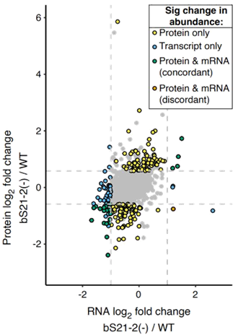
3.3 Impacts of bS21-2 on gene expression
To compare wild-type F. tularensis with cells lacking bS21-2, protein and transcript abundance differences were analyzed. This revealed that bS21-2 has an effect on 162 genes with respect to protein abundance but without a concordant change in transcript abundance, including a number of critical virulence genes (Trautmann & Ramsey, 2022) (Figure 1). This data also revealed that yqeY has the largest increase in transcript abundance but not an equivalent increase in protein abundance. yqeY encodes a protein thought to aid in accurately charging tRNAs (Deniziak et al., 2007). Notably, this gene is encoded in the rpsU2 operon, immediately downstream of rpsU2 (encoding bS21-2) and upstream of dnaG (encoding DNA primase) and rpoD (encoding RNA polymerase 𝜎⁷⁰) (Figure 2).
Figure 1. Cells lacking bS21-2 have changes in protein abundance that cannot be explained by changes in transcript abundance. Log₂ fold changes of RNA Seq reads versus log₂ fold change of protein abundance between wild-type and ΔrpsU2 cells. The gene yqeY is indicated in a red circle (Trautmann & Ramsey, 2022).

3.4 bS21 homologs regulate the rpsU2 operon
A closer look at the RNA-Seq data corresponding to the operon encoding bS21-2 (the rpsU2 operon) reveals a substantial increase in the transcript abundance of this operon in cells without bS21-2. This suggests that bS21-2 negatively regulates its own operon, as its loss leads to more of its own transcript. Additionally, when bS21-2 is ectopically expressed from a strong promoter, the transcript abundance appears to be even less than wild-type. bS21-1 and bS21-3 also have a similar negative regulatory effect on the rpsU2 operon, evidenced by their ectopic expression reducing the increased transcript abundance of cells lacking rpsU2. This is the first demonstration that one bS21 homolog negatively regulates its own operon as well as the first showing that multiple bS21 homologs can negatively regulate one bS21-encoding operon (Figure 2). Since it is not known how this regulation occurs, I will investigate the regulation of the rpsU2 operon as part of my thesis work.
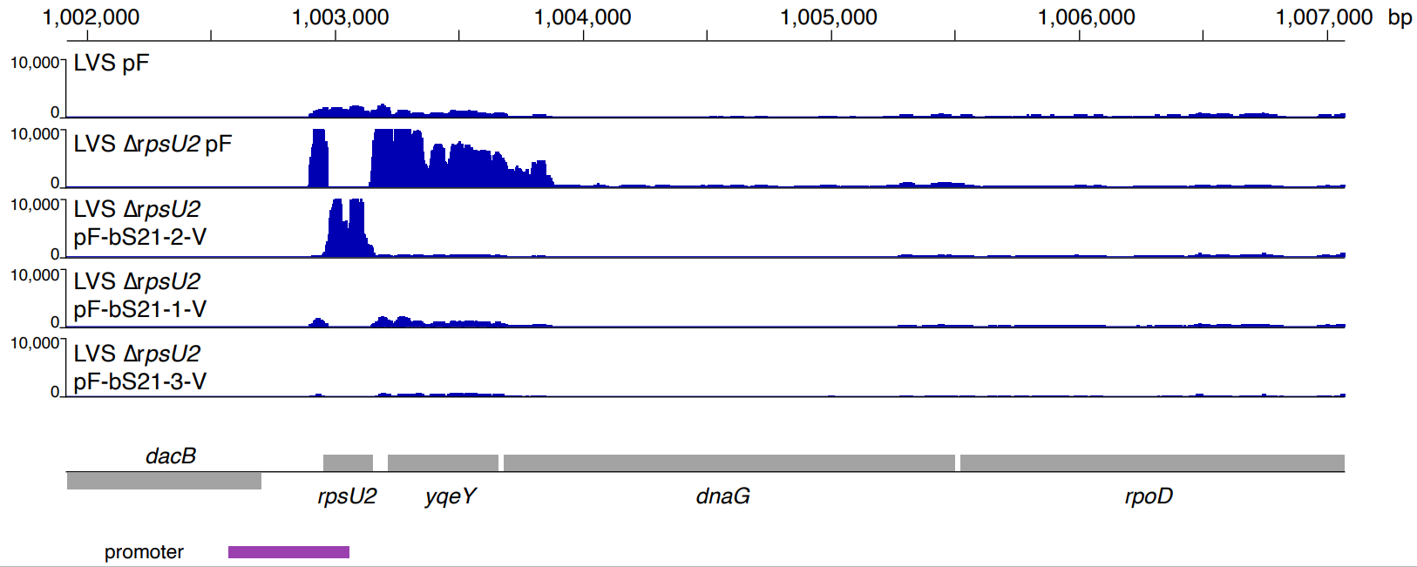
Figure 2. RNA Seq data suggests that bS21-2, bS21-1, and bS21-3 negatively regulate the rpsU2 operon. Normalized transcript abundance reads from RNA-Seq experiments mapped to the rpsU2 operon. Data from cells with bS21-2 (LVS pF), cells lacking bS21-2 (LVS ΔrpsU2 pF), and cells lacking bS21-2 but ectopically expressing either bS21-2, bS21-1, or bS21-3 (LVS ΔrpsU2 pF-bS21-2-V, pF-bS21-1-V, pF-bS21-3-V, respectively) from a heterologous strong promoter.
3.5 Canonical models of r-protein autoregulation
Cells generally attempt to maintain stoichiometric quantities of ribosomal components (rRNA and r-protein), which is important to maintain the proper allocation of cellular resources. In order to achieve this balance, many r-proteins negatively regulate their own expression when they are in excess. This regulation occurs through several well-described mechanisms that function at the transcript and protein level. Based on these known mechanisms, we propose to directly test two models for bS21-2 regulation in F. tularensis: attenuation and post-transcriptional control (Figure 3).
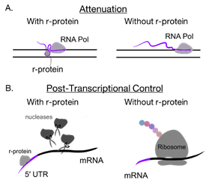
Figure 3. Two models for autogenous regulation by ribosomal proteins. A. Depicts attenuation, in which r-protein stalls the RNA polymerase when present in excess. B. Depicts post-transcriptional regulation, in which the r-protein interacts with its own transcript and recruits nucleases to degrade the mRNA transcript.
Control of r-protein production by attenuation occurs as RNA polymerase is transcribing the r-protein’s mRNA. As the nascent mRNA elongates from the RNA polymerase, it forms a secondary structure that the autoregulating r-protein can interact with, stalling transcription. This results in a termination of transcription. While these r-proteins are generally present, this mode of regulation occurs when the protein has been made in such abundance that there is r-protein not associated with any ribosome. With the r-protein freely available, it can interact with the 5′ UTR of its own elongating transcript. However, when the r-protein is in stoichiometric quantities with ribosomes, transcription is able to proceed normally, and the full-length transcript is synthesized (Figure 3A).
Another well-defined model for r-protein regulation is post-transcriptional regulation. In this model, RNA polymerase synthesizes the full mRNA transcript for the r-protein, but any excess r-protein interacts with the 5′ UTR of the transcript, resulting in several possible outcomes. One is as pictured in Figure 3B, in which the ribosomal protein may recruit nucleases, leading to degradation of the transcript. Alternatively, the excess r-proteins may sequester the Shine-Dalgarno sequence, stopping translation from initiating properly. Both outcomes lead to reductions in the r-protein generated. Without an excess of r-protein, the transcript will be translated normally, generating more r-protein (Figure 3B) (Burgos et al., 2017; Lindahl et al., 1983; Nomura et al., 1984; Zengel & Lindahl, 1994).
3.6 lacZ reporter fusions can test regulation by either the promoter and/or 5′ UTR
Importantly, both of the discussed models have been well-described in E. coli and rely on the 5′ UTR of the r-protein transcript. While regulation of r-protein production would be expected to work similarly in F. tularensis, it is possible that there are significant differences. So, it is first essential to determine if the 5′ UTR of the rpsU2 operon is required for regulation by the r-protein it encodes, bS21-2, in Francisella. To test whether this is true, we can fuse regulatory elements, the promoter and 5′ UTR, to the reporter gene lacZ (encoding β-galactosidase) and we can assess either the lacZ transcript or β-galactosidase abundance. Importantly, these regulatory elements are from rpsU2 or a known non-rpsU2-regulated gene, tul4. The fusions are integrated into the Tn7 site (a transposon insertion site present in many bacterial chromosomes) of cells containing or lacking bS21-2 (Figure 4).
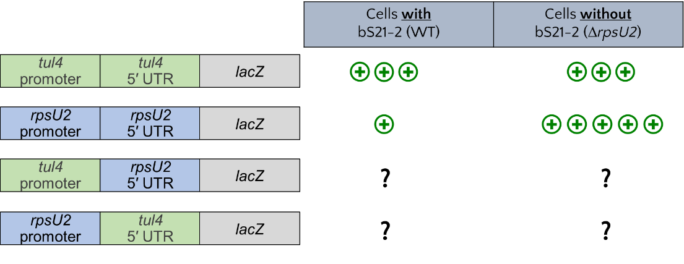
Based on the described models for r-protein regulation and the RNA-Seq data, we can make predictions about the abundance of lacZ transcript from various reporter constructs in cells with or without bS21-2. Given the negative regulation of the rpsU2 operon by bS21-2, we expect that cells containing the reporter fusion of the rpsU2 promoter and 5′ UTR will have higher transcript abundance of lacZ in cells without bS21-2 compared to wild-type cells (Figure 4, second line). Since the transcript and protein abundance from the tul4 gene are unaffected by bS21-2, we expect that cells containing the tul4 promoter and 5′ UTR fused to lacZ will have the same amount of lacZ transcript regardless of bS21-2 (Figure 4, first line). These are crucial controls to demonstrate that these constructs are valid reporters. If these expectations are met, then we can use the tul4 promoter and 5′ UTR as controls and test the specific requirement for the rpsU2 promoter and 5′ UTR in the negative regulation of the rpsU2 operon. If the 5′ UTR is sufficient to lead to regulation by bS21-2, then we expect to see an increase of lacZ transcript in the fusion testing the rpsU2 5′ UTR (see Figure 4, third line) in cells lacking bS21-2 as compared to cells containing bS21-2. The same expectation is true if the promoter is sufficient to cause regulation, in the reporter testing the rpsU2 promoter (see Figure 4, fourth line).
Figure 4: Diagram of the lacZ reporter fusions integrated into the Tn7 site of cells with or without bS21-2 and expected relative transcript abundances of the lacZ reporter gene.
3.7 Assessing the contribution of rpsU2 regulatory elements to the regulation of lacZ reporter fusions
I isolated RNA from cells containing and lacking bS21-2 with the reporter shown in Figure 4, Line 1, and conducted quantitative real-time PCR (qRT-PCR) on the resulting cDNA. Through this method, I was able to validate the tul4 control reporter fusion; we did not observe an increase in lacZ transcript abundance in cells lacking bS21-2 (Figure 5A). I also tested the contribution of the rpsU2 5′ UTR and promoter to regulation of lacZ transcript in cells with and without bS21-2 (Figure 5). Consistent with our previous results, I found that in cells lacking bS21-2, there was an increase in lacZ transcript. I also tested a fusion of the tul4 promoter and rpsU2 5′ UTR to lacZ. This demonstrated that the rpsU2 5′ UTR is sufficient for autogenous regulation, as we observe an increase in lacZ transcript in cells lacking bS21-2 (Figure 5B).
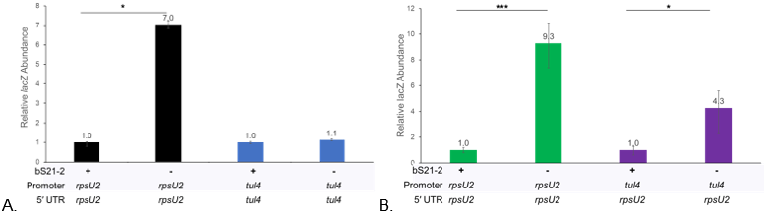
Figure 5. The lacZ reporter fusion assay is valid and the rpsU2 5′ UTR is sufficient for regulation. Relative lacZ transcript abundance between reporter fusion strains. A) The control strains confirming expected results, suggesting assay construction is valid. B) The 5′ UTR is sufficient for regulation by bS21-2. *** p-value < 0.002, * p-value < 0.03.
The use of lacZ as a reporter gene in these fusions allows us to easily compare abundance of transcripts using qRT-PCR and protein using β-galactosidase assays. We will test the amount of protein produced from lacZ for these reporter fusions using β-galactosidase assays.
3.10 Regulation of bS21-1 and bS21-3
The preceding data has largely focused on bS21-2, and not much on the contribution of bS21-1 and bS21-3 to the regulation of bS21-2 (Figure 2). These other two bS21 homologs are a bit more difficult to study due to their relatively lower incorporation into ribosomes in cells grown in our standard in vitro growth conditions (Trautmann & Ramsey, 2022). However, we hypothesize that there will be certain environmental or genetic conditions which lead to the up-regulation and utilization of these proteins, given that F. tularensis cells maintain the genetic information for all three bS21 homologs.
3.11 Conditions leading to changes in bS21-1 and bS21-3 abundance
In order to identify conditions that lead to changes in bS21-1 and bS21-3 protein abundance, I am using cells which harbor one of two plasmids encoding GFP reporters. These plasmids contain the promoter regions of either rpsU1 or rpsU3 driving expression of gfp, which encodes green fluorescent protein. To test various environmental conditions that might impact bS21-1 or bS21-3 production, I grow cells with these reporter plasmids in a test and control condition and measuring the fluorescence. To date, I have tested varying temperature, salinity, pH, hydrogen peroxide stress, UV stress, growth phase, growth in Chamberlain’s Defined Media (CDM), growth on solid media (cysteine heart agar plates with 1% hemoglobin [CHAH]), iron concentration, and magnesium concentration.
I have found an increase in GFP signal from the rpsU1 promoter reporter fusion in low pH conditions, suggesting up-regulation of rpsU1 (Figure 8). The increased promoter activity at low pH appears to be specific for the rpsU1 promoter-GFP fusion; I do not observe the same trend for the rpsU3 promoter-GFP fusion. Preliminary data suggests that rpsU1 is up-regulated when grown in CDM or grown on CHAH, as well as rpsU3, though to a lesser degree.
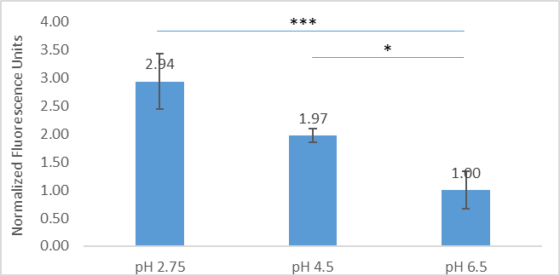
Figure 8. Low pH growth conditions result in a significant increase in GFP signal of the rpsU1 promoter-GFP reporter. Normalized fluorescence reads of GFP fused to the putative rpsU1 promoter. * p-value < 0.025, *** p-value < 0.004
3.12 Broader implications of this study and justification
The overall goal of this project seeks to examine the regulation of bS21 homologs within F. tularensis. Factors that contribute to the regulation of bS21-2 have downstream effects within the cell. In particular, bS21-2 governs gene expression and virulence (Trautmann & Ramsey, 2022), presumably via its role in the ribosome. Thus, understanding how the cell regulates the appropriate quantities and identities of bS21 homologs in the cell is important to understand gene regulation, particularly in the case of virulence genes. This research aims to contribute to the understanding of how r-proteins that lead to heterogeneity are regulated. Given that a particular bS21 homolog is important for virulence, it raises the possibility that targeting this homolog’s production with drugs might be an effective anti-virulence strategy. With the growing issue of antibiotic resistance, developing novel narrow-spectrum antibiotics is becoming increasingly vital (Murray et al., 2022). A better understanding of how heterogenous ribosomes are regulated may open a new avenue for the development of those drugs.
4.0 Methodology and Procedures
4.1 Bacterial Strains and Growth Conditions
The Live Vaccine Strain (LVS) is used to study F. tularensis; this strain is attenuated in humans but retains pathogenicity in mice. LVS is grown in Mueller Hinton Broth (MHB), supplemented with 0.025% iron pyrophosphate, 0.1% glucose, and 2% Isovitalex at 37°C, for standard growth conditions in liquid media. For solid media growth, LVS is grown on cysteine heart agar plates containing 1% hemoglobin (CHAH) at 37°C. E. coli, either XL1-Blue or PIR1 cells, is grown in LB media or on LB plates. Saccharomyces cerevisiae [psi-] is grown in or on YEPD media or in/on Synthetic Defined (SD) growth media without uracil. The selective antibiotics kanamycin (kan) or nourseothricin (nat) are used to maintain plasmids in F. tularensis LVS at 5 µg/mL or in E. coli at 50 µg/mL.
4.2 Plasmid Design and Construction.
Plasmids are first designed using SnapGene application (GSL Biotech LLC). Necessary gene components are amplified via PCR, then purified with the QIAquick Purification Kit. PCR products and pF or PYES2 backbones are then digested using restriction enzymes, run on a gel, and extracted using the QIAquick Gel Extraction Kit. Gel-purified fragments are then ligated and transformed into either E. coli or S. cerevisiae via heat shock or electroporation, respectively. Colonies that grow on the appropriate selective media are isolated with the QIAprep Spin Miniprep Kit or Zymoprep Yeast Plasmid Miniprep II kit and confirmed via Sanger sequencing through the INBRE Core Facility.
4.3 Integration of Reporter Constructs into the Tn7 Site of F. tularensis
Reporter constructs are integrated into the Tn7 site of F. tularensis LVS essentially as in (LoVullo et al., 2009). Briefly, electrocompetent LVS cells are prepared via multiple sucrose washes prior to electroporation. A Tn7 helper plasmid (pKR54) is electroporated into desired target cells, in order to help with the integration of the Tn7 sequence from the plasmid into the Tn7 site on the chromosome. Colonies are recovered from the electroporation and made into electrocompetent cells and electroporated with the designed Tn7 plasmid. The helper plasmid is cured from the strain by repeated passage and integration is confirmed via colony PCR using PrimeStar GXL polymerase. When the helper plasmid is confirmed to have been cured through cross-patching on alternative antibiotics, electrocompetent cells are made and electroporated with the Tn7 resolvase plasmid (pKR56) to excise the remaining antibiotic resistance. The resulting colonies are recovered and cured of the Tn7 resolvase plasmid.
4.4 RNA Purification and cDNA Synthesis
Strains of interest are grown to mid-log phase in triplicate, OD₆₀₀ 0.3-0.4, and then pelleted. Total nucleic acids are isolated using the Zymo Research Direct-zol RNA Kit. Nucleic acids are treated with RNase-free DNase and the RNA is re-purified using the Zymo Research Direct-zol RNA Kit. Non-specific primers, NS₅ primers, are annealed to normalized pure RNA, and the reverse transcriptase SuperScript III is used to generate cDNA. Weak base is used to remove RNA from the cDNA, and then neutralized with weak acid.
4.5 qRT-PCR
cDNA is diluted to a normalized concentration and mixed with the PowerUp™ SYBR™ Green Master Mix and one of each of the four primer pairs listed below to a final concentration of 0.25 µM per primer. Reactions containing each sample and primer pair combination are plated in technical triplicate on a 96-well plate. Samples are then amplified in a Roche 480 LightCycler, and the Crossing Point is used to calculate the relative abundance of transcript.
Primer Pair Name | Gene
KROL63/64 | tul4
KROL343/344 | rpsU2 5′ UTR
KROL399/400 | lacZ
KROL504/505 | Downstream of rpsU2

4.6 mRNA Stability Assay
The stability of mRNAs will be assessed essentially as (Nguyen et al., 2020). Briefly, strains of interest are grown to mid-log phase in triplicate, OD 0.3-0.4, and then rifampin is added to a final concentration of 50 ug/mL. After 0, 1, 2, and 4 minutes, 1.8 mL of culture is aliquoted and snap frozen in cryovials using liquid nitrogen. Samples are then thawed and mRNA is extracted, purified, and used to generate cDNA. qRT-PCR is conducted using primers corresponding to the transcript of interest, and a linear regression analysis is conducted on a plot of -C_{T} over time.
4.7 β-Galactosidase Assay
Cultures are grown to early mid-log (around OD₆₀₀ 0.3) in triplicate. Growth is halted by placing cultures on ice for at least 30 minutes before cells are added to tubes containing Z-buffer supplemented with BME. 0.1% SDS and chloroform are added, cultures are vortexed, then allowed to come to 28°C for 10 minutes prior to the addition of the substrate ONPG. Reactions are stopped upon reaching a yellow color, OD₄₂₀ 0.6-0.9.

4.8 Screening for Environmental Conditions - Growth
We are using a reporter-based approach to screen for environmental conditions which up-regulate rpsU1 or rpsU3 . Specifically, we have created two plasmids, one with each of the promoter regions of rpsU1 or rpsU3 driving expression of the gfp gene. These plasmids have been electroporated into F. tularensis LVS to generate strains KRLVS192 (P_{rpsU1}-GFP) and KRLVS193 (P_{rpsU3}-GFP). Cells are grown in one of two media to test environmental conditions: MHB or CDM. Changes in temperature, salinity, pH, hydrogen peroxide (H₂O₂) stress, and UV stress will be tested in MHB. To test salinity and pH, cells are grown to early-log phase and transferred to fresh, appropriately altered MHB for an additional 30-60 minute growth period. Alternatively, for temperature, H₂O₂, and UV stress, cultures are grown to mid-log, exposed to the condition, and given 30 minutes to recover. MHB versus CDM is tested by growing cultures to mid-log in MHB or CDM. We will test the impact of varying nutrients and other chemicals on cells grown in CDM.
4.9 GFP Assay
After cultures are grown to mid-log, 1-4mL is pelleted and resuspended in 1xPBS. In technical triplicate, 250 uL are plated in a clear 96-well plate and the OD₆₀₀ is read by the ID3 Plate Reader Spectrometer. 200 uL of the sample is transferred to a black 96-well plate and the fluorescent value is measured. Fluorescence is normalized to LVS containing an empty vector (pF) in PBS, and calculated relative to the corresponding OD₆₀₀.
4.10 Transposon Mutagenesis and Screening
To test for genetic conditions which up-regulate rpsU1 or rpsU3, I will use cells in which lacZ is integrated directly downstream of either the rpsU1 (KRLVS28) or rpsU3 (KRLVS75) on the chromosome. A plasmid (pKR141), which cannot replicate in F. tularensis, encoding a Mariner transposase and a separate transposon containing a kanamycin resistance gene is electroporated into electrocompetent reporter cells. Cells containing the transposon are selected via growth on CHAH with kanamycin. After single colonies appear, 10 mL of 0.7% soft agar supplemented with 25 μg/mL X-gal is overlaid on the plates and incubated again overnight. Colonies with qualitative differences in blue pigment production are recovered and altered production of β-Galactosidase is measured quantitatively via a β-Galactosidase assay.
4.11 gDNA Prep
Desired LVS strains are grown on CHAH plates, and patches are resuspended in MHB prior to the gDNA prep using the Lucigen MasterPure™ Complete DNA & RNA Purification Kit.
5.0 Resources Required.
The resources required to complete this project will come the Dr. Kathryn Ramsey lab with funding from an NIGMS CARTD-COBRE Pilot Project Award (P20GM121344-KMR), and USDA National Institute of Food and Agriculture, Hatch Formula project accession number 1017848. Additionally, Sanger sequencing services and the use of certain equipment will be provided by the RI-INBRE Core Facility.

Literature Cited

Bobay, L.-M., & Ochman, H. (2017). The Evolution of Bacterial Genome Architecture. Frontiers in Genetics, 8. https://www.frontiersin.org/articles/10.3389/fgene.2017.00072
Burgos, H. L., O’Connor, K., Sanchez-Vazquez, P., & Gourse, R. L. (2017). Roles of Transcriptional and Translational Control Mechanisms in Regulation of Ribosomal Protein Synthesis in Escherichia coli. Journal of Bacteriology, 199(21), e00407-17. https://doi.org/10.1128/JB.00407-17
Byrgazov, K., Vesper, O., & Moll, I. (2013). Ribosome heterogeneity: Another level of complexity in bacterial translation regulation. Current Opinion in Microbiology, 16(2), 133–139. https://doi.org/10.1016/j.mib.2013.01.009
Chang, C., & Craven, G. R. (1977). Identification of several proteins involved in the messenger RNA binding site of the 30 S ribosome by inactivation with 2-methoxy-5-nitrotropone. Journal of Molecular Biology, 117(2), 401–418. https://doi.org/10.1016/0022-2836(77)90135-8
Deniziak, M., Sauter, C., Becker, H. D., Paulus, C. A., Giegé, R., & Kern, D. (2007). Deinococcus glutaminyl-tRNA synthetase is a chimer between proteins from an ancient and the modern pathways of aminoacyl-tRNA formation. Nucleic Acids Research, 35(5), 1421–1431. https://doi.org/10.1093/nar/gkl1164
Lindahl, L., Archer, R., & Zengel, J. M. (1983). Transcription of the S10 Ribosomal Protein Operon Is Regulated by an Attenuator in the Leader. Cell, 33(1), 241–248. https://doi.org/10.1016/0092-8674(83)90353-7
LoVullo, E. D., Molins-Schneekloth, C. R., Schweizer, H. P., & Pavelka, M. S. (2009). Single-copy chromosomal integration systems for Francisella tularensis. Journal of General Microbiology, 155(4), 1152–1163. https://doi.org/10.1099/mic.0.022491-0
Murray, C. J., Ikuta, K. S., Sharara, F., Swetschinski, L., Robles Aguilar, G., Gray, A., Han, C., Bisignano, C., Rao, P., Wool, E., Johnson, S. C., Browne, A. J., Chipeta, M. G., Fell, F., Hackett, S., Haines-Woodhouse, G., Kashef Hamadani, B. H., Kumaran, E. A. P., McManigal, B., … Naghavi, M. (2022). Global burden of bacterial antimicrobial resistance in 2019: A systematic analysis. The Lancet, 399(10325), 629–655. https://doi.org/10.1016/S0140-6736(21)02724-0
Nguyen, T. G., Vargas-Blanco, D. A., Roberts, L. A., & Shell, S. S. (2020). The Impact of Leadered and Leaderless Gene Structures on Translation Efficiency, Transcript Stability, and Predicted Transcription Rates in Mycobacterium smegmatis. Journal of Bacteriology, 202(9), e00746-19. https://doi.org/10.1128/JB.00746-19
Nomura, M., Gourse, R., & Baughman, G. (1984). Regulation of the Synthesis of Ribosomes and Ribosomal Components. Annual Review of Biochemistry, 53(1), 75–117. https://doi.org/10.1146/annurev.bi.53.070184.000451
Trautmann, H., & Ramsey, K. (2022). A Ribosomal Protein Homolog Governs Gene Expression and Virulence in a Bacterial Pathogen. Journal of Bacteriology, 204(10), e00268-22. https://doi.org/10.1128/jb.00268-22
Van Duin, J., & Robert, W. (1981). The Function of Ribosomal Protein S21 in Protein Synthesis. European Journal of Biochemistry, 118(3), 615–619. https://doi.org/10.1111/j.1432-1033.1981.tb05563.x
Watson, Z. L., Ward, F. R., Méheust, R., Ad, O., Schepartz, A., Banfield, J. F., & Cate, J. H. (2020). Structure of the bacterial ribosome at 2 Å resolution. ELife, 9, e60482. https://doi.org/10.7554/eLife.60482
Zengel, J. M., & Lindahl, L. (1994). Diverse Mechanisms for Regulating Ribosomal Protein Synthesis in Escherichia coli. In Progress in Nucleic Acid Research and Molecular Biology (Vol. 47, pp. 331–370). Elsevier. https://doi.org/10.1016/S0079-6603(08)60256-1

