Examining the Regulation of the bS21 Homologs Expression in Francisella tularensis

Sierra Schmidt
Kathryn Ramsey
Thesis Proposal
17 November 2022

1.0 Statement of the problem.
Cellular life relies on and is described by the Central Dogma, the ability for the genetic information of the cell to shift through necessary states in order to result in actionable phenotypes. That is, DNA must be transcribed into RNA so that proteins can be synthesized, and cellular life can continue. Essential to this aim are several molecular machines, enzyme complexes, etc. One such essential component, the ribosome, is composed of rRNA and ribosomal proteins. Traditionally, it has been viewed as a machine for protein output, but not regulation. Recently, however, the idea that ribosomes may be specialized and have the ability to act not just as a machine, but as a center for regulation has arisen (Byrgazov). This concept of specialized ribosomes relies on the existence of heterogenous ribosomes, with differing compositions of ribosomal components, namely ribosomal proteins.
The presence of heterogenous ribosomes has recently been shown within the Gram-negative, intracellular pathogen Francisella tularensis (Trautmann and Ramsey). This pathogen is the causative agent of tularemia, and its virulence and ability to grow in macrophage is dependent on the Francisella Pathogenicity Island (FPI). The FPI is an approximately 30 kb region on the F. tularensis chromosome containing 16 genes, including those which encode its Type 6 Secretion System (T6SS) (Nano). In the Live Vaccine Strain (LVS), which has been attenuated for humans, the FPI is around 21.5 kb. Additionally, the LVS genome contains three homologs of the ribosomal protein, bS21. Data regarding these three homologs is consistent with the idea that there are heterogeneous ribosomes. The proposed model indicating that ribosomes may contain any one of, or none of, the three. This would lead to four potential ribosomal configurations, based solely on this one r-protein. (Trautmann and Ramsey). While the data was consistent with heterogenous ribosomes, it also was potentially consistent with that idea of specialized ribosomes, potentially linked to demonstrated regulation of some FPI proteins by bS21-2 (Trautmann and Ramsey).
These experiments also revealed that bS21-1, bS21-2, and bS21-3 all have a negative regulatory effect on the bS21-2 operon, demonstrating a higher transcript abundance in the absence of these proteins. It is unknown how the bS21 homologs exert their effects on bS21-2 production and what controls bS21-1 and bS21-3 production is also unknown. However, given the downstream regulatory implications of bS21-2 on some FPI proteins, the existence of this autogenous regulation raises the possibility of an interesting flow of responsive or regulatory events. This may offer a broader understanding of the role of the ribosome as an additional regulatory unit. It may also provide a greater understanding of virulence, which may contribute to novel targets for narrow-spectrum antimicrobials. Thus, the overall goal of this study is to examine the regulation of bS21 homolog production in the Live Vaccine Strain of Francisella tularensis.

2.0 Justification for the Study.
2.1 Ribosome Heterogeneity
The ribosome is a unique molecular structure composed of both rRNAs and proteins within all forms of cellular life, generally thought to indiscriminately translate mRNAs, barring regulation by other factors. However, it is well-known that ribosome populations can be heterogenous, driven by composition. Ergo, the unique rRNAs or ribosomal, r-, proteins, which associate within specific populations of ribosomes. A subsequent hypothesis is that of specialized ribosomes. This expands on the idea of differently composed ribosomes then leading to differing translation. This would, in effect, result in the ribosome operating as a regulatory structure (Byragazov). There are several different ribosomal proteins which may integrate into the small or large subunit, however it is those with multiple homologs encoded by more than one gene which can lead to heterogeneity.
2.2 Ribosomal Heterogeneity and Gene Expression in F. tularensis
bS21 is a small subunit ribosomal protein which is implicated in translation initiation. This is consistent with its position in the ribosome allowing it to interact with the 5′ UTR’s of incoming mRNAs. It is thought to be a non-essential protein and is not encoded by all bacteria, though, interestingly, in those bacteria it is encoded by, loss can often lead to different phenotypes (Trautmann and Hannah). In the intracellular pathogen Francisella tularensis, there are three bS21 homologs encoded by rpsU1, rpsU2, and rpsU3. This is of immediate intrigue due to the relatively limited size of the F. tularensis genome. It also lends to the potential of heterogeneous ribosomes containing one, or none, of the three homologs. In fact, in a recent study published by the Kathryn Ramsey lab, data was consistent with these three homologs resulting in ribosomal heterogeneity. Furthermore, bS21-2 was implicated in the control of various genes including some within the Francisella Pathogenicity Island (FPI), a set of genes encoding a Type 6 Secretion System (T6SS), necessary for intramacrophage growth (Trautmann and Hannah).
2.3 Proteomics and RNA Seq Data
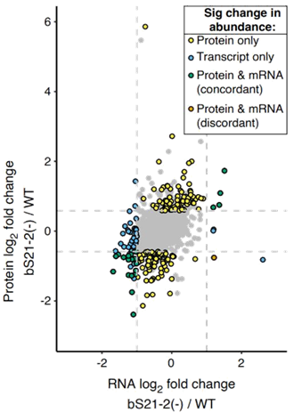
Protein abundance and transcript abundance differences were analyzed between wild-type F. tularensis and cells lacking bS21-2. According to this data, bS21-2 seems to have an effect on 185 genes in respect to their protein abundance, regulating a number of the FPI genes, (Trautmann and Ramsey) (Figure 1). This data, also revealed another point of interest, changes in the gene yqeY. Rather than an increase in protein but not transcript abundance, yqeY had the largest increase in transcript abundance, but not an equivalent increase in protein abundance. yqeY encodes a protein thought to aid in the correct charging of amino acids to tRNAs (deniziak). Incidentally, this gene is encoded immediately downstream of the rpsU2 gene, along with dnaG and rpoD (Figure 2).
Figure 1: log₂ fold changes of RNA Seq reads versus log₂ fold change of protein abundance between wild-type and ΔrpsU2 cells. (Trautmann and Hannah)

2.4 RNA Seq Data Suggests bS21 Regulation on the rpsU2 Operon
As seen in Figure 2, wild-type cells have some level of transcript present, however, the interesting extrapolation comes in the comparison to the ΔrpsU2 cells. Clearly, there is a very substantial increase in the transcript abundance of this operon without bS21-2 present, which is confirmed by the lack of transcript of the rpsU2 gene. This already lends itself to the idea that rpsU2 is negatively regulating its own operon, as its removal allows for more of its own transcript to be produced. Additionally, when rpsU2 is ectopically expressed with a strong promoter, not only is the wild-type phenotype restored, but, in fact, the transcript abundance appears to be even somewhat less than wild-type. bS21-1 and bS21-3 both also have a similar negative regulatory relationship on the rpsU2 operon. This is a novel discovery by the Ramsey lab, with no other prior study suggesting this regulation in F. tularensis known (Figure 2).
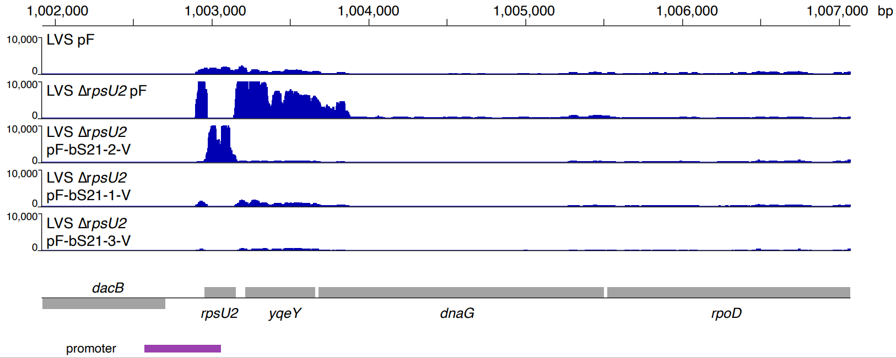
Figure 2: Normalized transcript abundance reads mapped to the rpsU2 operon. Shows wild-type, ΔrpsU2 cells, and ΔrpsU2 cells with either rpsU2, rpsU1, or rpsU3 ectopically expressed with a non-native promoter.
2.5 Canonical Models of r-Protein Autoregulation
Cells generally attempt to maintain stoichiometric quantities of ribosomal components (rRNA and r-protein), an important step to the proper allocation of cellular resources. In order to achieve this aim, many r-proteins do tend to regulate their own expression. There are several well-described for this, both at the transcript and protein level. There are two specific models which the proposed study will test directly. Those models are attenuation and post-transcriptional control.
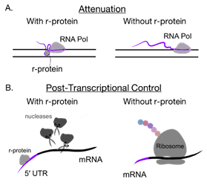
Figure 3: Depictions of two types of autogenous transcriptional regulation known to be used by ribosomal proteins.
2.5.1 Attenuation
Attenuation occurs as the RNA polymerase is transcribing DNA. The autoregulating ribosomal protein will then interact with the elongating mRNA to form a secondary structure that stalls the RNA polymerase. This results in a termination of transcription. Clearly, these ribosomal proteins are always within the cell, however, this mode of regulation occurs when the protein has been made in such abundance that there is ribosomal protein freely available, not associated with any ribosome. With the protein freely available, it allows it to interact with the 5′ UTR of its own elongating transcript. That said, then, when that ribosomal protein is in stoichiometric quantities with ribosomes, transcription is able to proceed normally, and the transcript is synthesized (Figure 3A).
2.5.2 Post-Transcriptional Control
Another well-defined model is that of post-transcriptional regulation, wherein RNA polymerase is first able to synthesize the mRNA transcript. However, the freely abundant r-protein is able to interact with the 5′ UTR of the completed transcript. As pictured, the ribosomal protein may recruit nucleases, to some effect, allowing the enzymes to degrade the transcript. Alternatively, those excess ribosomal proteins may, instead, sequester the Shine-Dalgarno sequence, not allowing translation to initiate properly. Thus, resulting in no protein generated. Without an excess of r-protein, the transcript will be translated normally, generating more r-protien (Figure 3B). (Burgos; Lindhal; Nomura; Zengel and Lindhal)
2.6 lacZ Reporter Fusions to Test the Promoter and 5′ UTR
Importantly, both of the discussed models rely on the 5′ UTR, and while it would be expected to work similarly in LVS, it is possible that some other mechanisms are acting. As such, to test these models it is first essential to ensure that the 5′ UTR is required for regulation. To test whether this is true, lacZ reporter fusions were and are being created, with a known non-rpsU2-regulated gene (Figure 4).
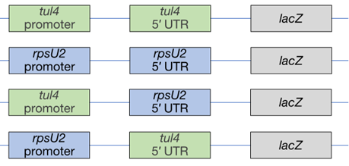
Figure 4: Depiction of the lacZ reporter fusions integrated into the Tn7 Site of either wild-type LVS or ΔrpsU2 cells.
2.6.1 Predictions Related to lacZ Reporter Fusions
Due to the negative regulation, in the reporter fusion containing both the rpsU2 promoter and 5′ UTR it was expected that in cells lacking bS21-2, the transcript of lacZ would be in higher abundance than wild-type cells. Additionally, in the context of the tul4 promoter and 5′ UTR it was expected that there would be no regulatory effect if these constructs were in fact valid reporters. If the 5′ UTR is necessary to cause regulation by bS21-2, then there would be an expected increase in lacZ transcript, and the same is true for the promoter.
2.7 qRT-PCR of lacZ Reporter Fusions
The contribution of the 5′ UTR and promoter were tested in these constructs utilizing qRT-PCR reactions (Figure 5). The control reporter fusion was validated (Figure 5A). The contribution of the 5′ UTR was tested using the reporter fusion with the tul4 promoter and rpsU2 5′ UTR, wherein it was shown as sufficient for autogenous regulation due to the increased abundance of lacZ transcript in cells lacking bS21-2 (Figure 5B). 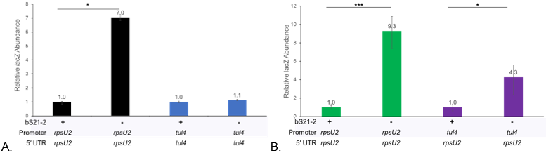
Figure 5: Relative lacZ transcript abundance between reporter fusion strains. A) The control strains confirming expected results, suggesting assay construction is valid. B) The 5′ UTR is sufficient for regulation by bS21-2. *** p-value < 0.002, * p-value < 0.03.
2.8 Preliminary Protein Abundance Data of lacZ Reporter Fusions
The protein abundance of lacZ in these reporter fusions was tested through a β-galactosidase assay. The results from this assay do show a mild increase of lacZ in cells lacking bS21-2, but not to the same fold increase as seen in transcript abundance. This then invites the question of why exactly the transcript increase does not correlate to a similar increase in protein abundance (Figure 6).
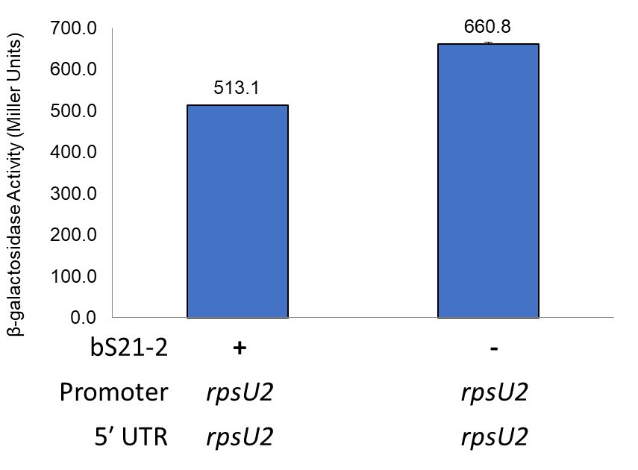
Figure 6: Preliminary data suggesting the same fold change of transcript abundance is not seen in protein abundance in cells with or without bS21-2.
2.10 Canonical Models of r-Protein Regulation at the Level of Translation
As previously stated, r-proteins may be autogenously regulated during either transcription or translation. In fact, both can be true for an r-protein simultaneously (Zengel and Lindhal). This added level of regulation allows for another level of precision in cellular response to stimuli. Regardless, the discrepancy observed in both Figure 1 and Figure 6 may be a result of this added level of regulation. Two canonical models for regulation at the level of translation both rely on interference in translation initiation. The first suggests that the autogenously regulated r-protein will binds the translation start site. This blocks initiation of the translation of that mRNA, and so no protein is generated. The other canonical model suggests that the r-protein interacts with the transcript resulting in conformational changes. This may result in mRNA secondary structures, preventing adequate binding for translation to initiate (Zengel and Lindhal). Though, it is also potentially interesting that, given the known heterogenous ribosomes of F. tularensis and the implication of bS21 in translation initiation, that bS21-2 may discriminate against its own transcript.
2.11 Abundance of rpsU1 and rpsU3 and Conditions to Up-Regulate bS21-1 and bS21-3
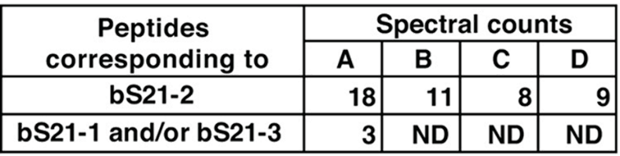
The preceding data has largely focused on bS21-2, not elucidating much on the contribution of bS21-1 and bS21-3 on the regulation of bS21-2 (Figure 2). However, bS21-1 and bS21-3 are a bit more difficult to study due to their relatively lower abundance in the cell (Figure 7). However, it is expected that there will be certain environmental or genetic conditions which lead to the up-regulation of these proteins, given the hypothesis of specialized ribosomes.
Figure 7: Spectral counts of each bS21 homolog as indicated by mass spectrometry data.
2.12 Preliminary Data for Conditions Leading to the Up-Regulation of rpsU1
A few conditions have been tested for the increased production of either rpsU1 or rpsU3 through a GFP reporter plasmid which includes the promoter or the proposed promoter region for these two homologs. Several conditions so far have been ruled out, however there is one that is promising for the up-regulation of rpsU1 (Figure 8). Interestingly, this relationship of increased rpsU1 promoter activity at low pH is not maintained for rpsU3. However, conditions which up-regulate rpsU3 are still to be determined.
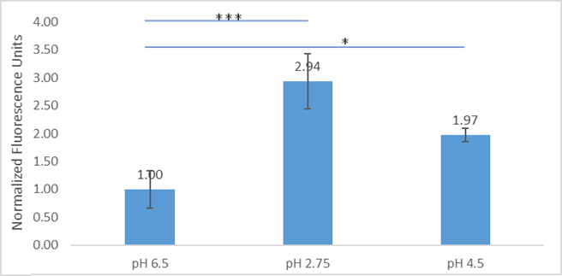
Figure 8: Normalized fluorescence reads of GFP fused to 100 bp upstream of rpsU1, the proposed promoter region. * p-value < 0.025, *** p-value < 0.004
2.13 Broader Implications of this Study and Justification
Whatever may contribute to the regulation of bS21-2 has downstream effects within the cell, as previously indicated. The implications later affect cell processes and characteristics such as virulence (Trautmann and Ramsey), via the ribosome, a conserved structure across all domains of life. This research aims to contribute to the understanding of a possible ribosomal function not well understood, heterogeneity. This may, then, yield more information in this regard, but also given how many antibiotics involve the ribosome in their mechanism of action, this also sets up potentially novel and interesting targets for those antibiotics. With the growing issue of antibiotic resistance, developing novel narrow-spectrum antibiotics is becoming increasingly vital (Murray). With the better understanding of heterogenous, and perhaps even specialized, ribosomes this may open a new avenue for the development of those drugs.
Reducing the focus again, to potentially one day contribute to this broader impact, the overall goal of this project seeks to examine the regulation of bS21 homologs within the live vaccine strain of F. tularensis.
3.0 Aims.
Specific Aim #1: Investigate how bS21-2 negatively regulates mRNA produced from its own operon. The target site for regulation from proposed canonical models will first be tested using reporter fusion strains with the promoter or 5′ UTR from the rpsU2 operon utilizing qRT-PCR. To further test two of the proposed canonical models, attenuation or post-transcriptional regulation, RNA stability assays will be performed with subsequent qRT-PCR to determine the transcript abundance over time, after rifampicin has allowed transcription to be halted.
Specific Aim #2: Investigate some factors that influence the expression of bS21-1 and bS21-3. In order to explore this aim, two individual questions will be addressed. First, the question of whether bS21-1 and bS21-3 are autogenously expressed. This will be completed by completing qRT-PCR to evaluate mRNA transcript abundances in strains with bS21-1 and bS21-3 deleted from the chromosome, with various configurations of ectopically expressed bS21 homologs. The second question addresses what environmental and genetic factors impact the regulation of bS21-1 and bS21-3. This question will be addressed in two ways. First, using GFP reporter strains, fluorescence will be compared within different growth conditions. Second, transposon mutagenesis will be used to screen for production of bS21-1 or bS21-3 in lacZ reporter strains.
4.0 Methodology and Procedures
4.1 Bacterial Growth Conditions.
For standard growth conditions in liquid media, LVS is grown in Mueller Hinton Broth (MHB), supplemented with 0.025% iron pyrophosphate, 0.1% glucose, and 2% Isovitalex at 37°C. For solid media growth, LVS is grown on cysteine heart agar plates containing 1% hemoglobin (CHAH) at 37°C. E. coli is grown in LB media, or on LB plates. Yeast is grown in or on YEPD media or in/on -ura.
4.2 Plasmid Design and Construction.
Plasmids are first designed utilizing the SnapGene (GSL Biotech LLC) application. Then, working from a theoretical map, necessary gene components are amplified via PCR, then purified with the QIAquick Purification Kit. PCR products and pF or PYES2 backbones are then digested using restriction enzymes, run on a gel, and extracted using the QIAquick Gel Extraction Kit. Gel purified fragments are then ligated and transformed into either Escherichia coli or Saccharomyces cerevisiae via heat shock or electroporation, respectively. Selected colonies are then isolated with the QIAprep Spin Miniprep Kit or Zymoprep Yeast Plasmid Miniprep II kit and confirmed via Sanger sequencing through the INBRE Core Facility.
4.3 Integration of Plasmid-Bound DNA into the Tn7 Site of F. tularensis
Electrocompetent LVS cells are prepared via multiple sucrose washes prior to electroporation. A Tn7 helper plasmid is electroporated into desired target cells, in order to help with the integration of the Tn7 sequence from the plasmid into the Tn7 site on the chromosome. Colonies are recovered from the electroporation and made into electrocompetent cells and electroporated with the designed Tn7 plasmid. The helper plasmid is cured from the strain and integration is confirmed via colony PCR, lysing and killing cells prior to PCR on lysates with PrimeStar GXL polymerase. When the helper plasmid is confirmed to have been cured through cross-patching on alternative antibiotics, electrocompetent cells are made and electroporated with the Tn7 resolvase plasmid to excise the remaining antibiotic resistance. The resulting colonies are recovered and cured of the Tn7 resolvase plasmid.
4.4 RNA Purification and cDNA Synthesis
Strains of interest are grown as per the conditions laid out in 3.1 to mid-log phase, OD 0.3-0.4, and then pelleted. Total nucleic acids are then isolated using the Zymo Research Direct-zol RNA Kit. A DNase treatment is applied to the eluted nucleic acids, degrading DNA, and the RNA is re-purified with use of the Zymo Research Direct-zol RNA Kit. Non-specific primers, NS₅ primers, are annealed to normalized pure RNA, and is reverse transcribed, both steps utilizing the Thermocycler. Weak base is used to remove RNA from the cDNA, and then neutralized with weak acid.
4.5 qRT-PCR
cDNA is diluted to a normalized concentration and prepared with the PowerUp™ SYBR™ Green Master Mix and one of each of the four primer pairs listed below, at 5 μM. Each sample and primer pair is plated in technical triplicate on a 96-well plate. Samples are then amplified in a two step process within a Roche 480 LightCycler, and the Crossing Point is used to calculate the relative abundance of transcript.
Primer Pair Name | Gene
KROL63/64 | tul4
KROL343/344 | rpsU2 5′ UTR
KROL399/400 | lacZ
KROL504/505 | Downstream of rpsU2

4.6 mRNA Stability Assay (Nguyen)
Strains of interest are grown as per the conditions laid out in 3.1 to mid-log phase, OD 0.3-0.4, and then rifampin is added to a final concentration of 50 ug/mL. After 0, 1, 2, and 4 minutes, 1.8 mL of culture is aliquoted and snap frozen in cryovials using liquid nitrogen. Samples are then thawed and mRNA is extracted and purified, and cDNA is synthesized as per 3.4. qRT-PCR is conducted, and a linear regression analysis is conducted on a plot of -C_{T} over time.
4.7 β-Galactosidase Assay
Cultures are grown to early mid-log (around OD600 0.3), according to the growth conditions (3.1). Growth is halted by placing cultures on ice for at least 30 minutes, and then added to tubes containing Z-buffer supplemented with BME. 0.1% SDS and chloroform are added, cultures are vortexed, then allowed to come to 28°C for 10 minutes prior to the addition of the substrate ONPG. Reactions are stopped upon reaching a yellow color, OD420 0.6-0.9.
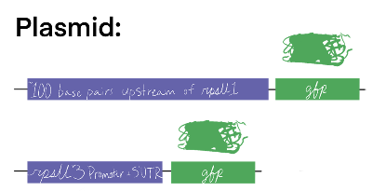
4.8 Screening for Environmental Conditions - Growth
To test for environmental conditions which up-regulate rpsU1 or rpsU3 GFP reporter strains, depicted to the right, have the promoter region (or proposed promoter region) fused to the gfp gene on a plasmid within LVS. Two media backgrounds will be the basis for the test of environmental conditions, the first, MHB, and the second, Chemically Defined Media (CDM). External environments will be tested in MHB, i.e.. temperature, salinity, pH, hydrogen peroxide (H₂O₂) stress, and UV stress. To test salinity and pH LVS is grown to early-log phase and completing a media transfer where cultures are spun down and resuspended in a small volume of MHB and added to new cultures containing the altered MHB environments. Alternatively, for temperature, H₂O₂, and UV stress, cultures are grown to mid-log, exposed to the condition, and given 30 minutes to recover. MHB versus CDM is tested by growing cultures to mid-log in MHB or CDM. Different chemical environments are tested by altering chemical component concentrations in CDM.
4.9 GFP Assay
After cultures are grown to mid-log, 1-4mL is pelleted and resuspended in 1xPBS and 250 mL are plated in technical triplicate in a clear 96-well plate and the OD600 is read by the ID3 Plate Reader Spectrometer. 200 mL of the sample is transferred to a black 96-well plate and the fluorescent value is measured. Fluorescence is normalized to LVS-pF in PBS, and calculated relative to the corresponding OD600.
4.10 Transposon Mutagenesis and Screening
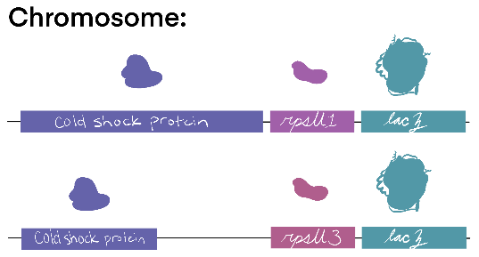
To test for genetic conditions which up-regulate rpsU1 or rpsU3 lacZ reporter strains, depicted to the right, lacZ is integrated next to either the rpsU1 or rpsU3 gene on the chromosome. A plasmid containing a cut-and-paste transposon is electroporated into electrocompetent cells prepared according to 3.3. Cells containing the transposon are selected via subsequent growth on CHAH + Kanamycin plates. After single colonies appear, 10 mL of 0.7% soft agar supplemented with 100 μg/mL X-gal is overlain on the plates and incubated again overnight. Dark blue colonies are recovered and high production of β-Galactosidase is measured quantitatively via the β-Galactosidase assay, 3.7.
4.11 gDNA Prep
Desired LVS strains are grown on CHAH plates, and patches are resuspended in MHB prior to the gDNA prep using the Invitrogen PureLInk Genomic DNA extraction kit.
5.0 Resources Required.
The resources required to complete this project will come the Dr. Kathryn Ramsey lab with funding from lol I forgot to ask for the grant info lets goooOOOO. Additionally, sequencing services and the use of certain equipment will be provided by the INBRE Core Facility.

Literature Cited
- Aseev, L. V., & Boni, I. V. (2011). Extraribosomal Functions of Bacterial Ribosomal Proteins. 45(5), 12.
- Burgos, H. L., O’Connor, K., Sanchez-Vazquez, P., & Gourse, R. L. (2017). Roles of Transcriptional and Translational Control Mechanisms in Regulation of Ribosomal Protein Synthesis in Escherichia coli. Journal of Bacteriology, 199(21), e00407-17. https://doi.org/10.1128/JB.00407-17
- Byrgazov, K., Vesper, O., & Moll, I. (2013). Ribosome heterogeneity: Another level of complexity in bacterial translation regulation. Current Opinion in Microbiology, 16(2), 133–139. https://doi.org/10.1016/j.mib.2013.01.009
- Deniziak, M., Sauter, C., Becker, H. D., Paulus, C. A., Giegé, R., & Kern, D. (2007). Deinococcus glutaminyl-tRNA synthetase is a chimer between proteins from an ancient and the modern pathways of aminoacyl-tRNA formation. Nucleic Acids Research, 35(5), 1421–1431. https://doi.org/10.1093/nar/gkl1164
- Lindahl, L., Archer, R., & Zengel, J. M. (1983). Transcription of the S10 Ribosomal Protein Operon Is Regulated by an Attenuator in the Leader. Cell, 33(1), 241–248. https://doi.org/10.1016/0092-8674(83)90353-7
- Murray, C. J., Ikuta, K. S., Sharara, F., Swetschinski, L., Robles Aguilar, G., Gray, A., Han, C., Bisignano, C., Rao, P., Wool, E., Johnson, S. C., Browne, A. J., Chipeta, M. G., Fell, F., Hackett, S., Haines-Woodhouse, G., Kashef Hamadani, B. H., Kumaran, E. A. P., McManigal, B., … Naghavi, M. (2022). Global burden of bacterial antimicrobial resistance in 2019: A systematic analysis. The Lancet, 399(10325), 629–655. https://doi.org/10.1016/S0140-6736(21)02724-0
- Nano, F. E., Zhang, N., Cowley, S. C., Klose, K. E., Cheung, K. K. M., Roberts, M. J., Ludu, J. S., Letendre, G. W., Meierovics, A. I., Stephens, G., & Elkins, K. L. (2004). A Francisella tularensis Pathogenicity Island Required for Intramacrophage Growth. Journal of Bacteriology, 186(19), 6430–6436. https://doi.org/10.1128/JB.186.19.6430-6436.2004
- Nguyen, T. G., Vargas-Blanco, D. A., Roberts, L. A., & Shell, S. S. (2020). The Impact of Leadered and Leaderless Gene Structures on Translation Efficiency, Transcript Stability, and Predicted Transcription Rates in Mycobacterium smegmatis. Journal of Bacteriology, 202(9), e00746-19. https://doi.org/10.1128/JB.00746-19
- Nomura, M., Gourse, R., & Baughman, G. (1984). Regulation of the Synthesis of Ribosomes and Ribosomal Components. Annual Review of Biochemistry, 53(1), 75–117. https://doi.org/10.1146/annurev.bi.53.070184.000451
- Trautmann, H., & Ramsey, K. (2022). A Ribosomal Protein Homolog Governs Gene Expression and Virulence in a Bacterial Pathogen. Journal of Bacteriology, 204(10), e00268-22. https://doi.org/10.1128/jb.00268-22
- Zengel, J. M., & Lindahl, L. (1994). Diverse Mechanisms for Regulating Ribosomal Protein Synthesis in Escherichia coli. In Progress in Nucleic Acid Research and Molecular Biology (Vol. 47, pp. 331–370). Elsevier. https://doi.org/10.1016/S0079-6603(08)60256-1

