Examining the Regulation of the bS21 Homologs Expression in Francisella tularensis

Sierra Schmidt
Kathryn Ramsey
Thesis Proposal
4 November 2022

1.0 Statement of the problem.
Cellular life relies on and is described by the Central Dogma, the ability for the genetic information of the cell to shift through necessary states in order to result in actionable phenotypes, that is DNA must be transcribed into RNA so that proteins can be synthesized and cellular life can continue. Essential to this aim are several molecular machines, enzyme complexes, etc. One such essential component, the ribosome, is composed of rRNA and ribosomal proteins, and has traditionally been viewed as a machine for protein output, but not regulation. However, in recent history, the idea that ribosomes may be specialized and have the ability to act not just as a machine, but as a center for regulation has arisen (Byrgazov). And, in fact, this very idea of heterogenous ribosomes has recently been shown to be true within the Gram-negative, intracellular pathogen Francisella tularensis (Trautmann and Ramsey). This pathogen is the causative agent of tularemia, and its virulence and ability to grow in macrophage is dependent on the Francisella Pathogenicity Island (FPI). The FPI is a 30 kb region on the F. tularensis chromosome containing 16 genes, including those which encode its Type 6 Secretion System (T6SS) (Nano). 12 of these genes were found to be regulated by the ribosomal protein, bS21-2, which is one of three homologs of this protein within the F. tularensis genome. Concurrently, it is this small subunit ribosomal protein which leads to the ribosomal heterogeneity within the pathogen (Trautmann and Ramsey). In the studies leading to this discovery, it was also indicated that bS21-1, bS21-2, and bS21-3 all have a negative regulatory effect on the bS21-2 operon at the level of transcription. These mechanisms are not well understood, nor are the contributions or regulatory environments for bS21-1 and bS21-3. However, given the downstream regulatory implications of bS21-2 on FPI proteins, the existence of this autogenous regulation raises an interesting flow of responsive or regulatory events within F. tularensis, which may offer a broader understanding of the role of the ribosome as an additional regulatory unit and a greater understanding of virulence, which may contribute to novel targets for narrow-spectrum antimicrobials.
1.1 Overall goal.
The overall goal of this study is to examine the regulation of bS21 homologs within the live vaccine strain of Francisella tularensis.
1.2 Aims.
Specific Aim #1: Investigate how bS21-2 negatively regulates its own, the rpsU2 operon’s, mRNA. The target site for regulation from proposed canonical models will first be tested using reporter fusion strains with the promoter or 5′ UTR from the rpsU2 operon utilizing qRT-PCR. To further test two of the proposed canonical models, attenuation or post-transcriptional regulation, RNA stability assays will be performed with subsequent qRT-PCR to determine the transcript abundance over time, after rifampicin has allowed transcription to be halted.
Specific Aim #2: Investigate some factors that influence the expression of bS21-1 and bS21-3. In order to explore this aim, two individual questions will be addressed. First, the question of whether bS21-1 and bS21-3 are autogenously expressed. This will be completed by completing qRT-PCR to evaluate mRNA transcript abundances in strains with bS21-1 and bS21-3 deleted from the chromosome, with various configurations of ectopically expressed bS21 homologs. The second question addresses what environmental and genetic factors impact the regulation of bS21-1 and bS21-3. This question will be addressed in two ways. First, using GFP reporter strains, fluorescence will be compared within different growth conditions. Second, transposon mutagenesis will be used to screen for production of bS21-1 or bS21-3 in lacZ reporter strains.
2.0 Justification for the Study.
The ribosome is a unique molecular structure composed of both rRNAs and proteins within all forms of cellular life, traditionally believed to indiscriminately translate mRNAs, barring regulation by other factors. However, research is beginning to understand that ribosome populations can be heterogenous, with specialized ribosomes having more or less affinity to certain mRNAs. This results in the ribosome operating as a regulatory structure, though this is not well understood as of now. This heterogeneity is driven by composition, ergo the unique rRNAs or ribosomal, r-, proteins which associate within specific populations of ribosomes (Byragazov). There are several different ribosomal proteins which may integrate into the small or large subunit, though not all are automatically entered into the pool of potentially leading to heterogeneity, however one protein, bS21, will be a topic of interest for the proposed study.
bS21 is a small subunit ribosomal protein which is implicated in translation initiation, its position within the mRNA exit channel offering it the prime ability to interact with incoming mRNAs. It is thought to be a non-essential protein and is not encoded by all bacteria, though, interestingly, in those bacteria it is encoded by, loss can often lead to different phenotypes (Trautmann and Hannah). Specifically with respect to our organism of interest, the intracellular pathogen Francisella tularensis, there are three bS21 homologs encoded by rpsU1, rpsU2, and rpsU3. This is of immediate intrigue due to the relatively limited size of the Francisella tularensis genome, and lends to the potential of heterogeneous ribosomes containing one of the three, or none of the homologs. In fact, in a recent study published by the lab, it was shown that these three homologs do lead to ribosomal heterogeneity, and furthermore bS21-2 has been implicated in the control of various genes including some within the Francisella Pathogenicity Island (FPI), a set of genes encoding a Type 6 Secretion System (T6SS), necessary for intramacrophage growth (Trautmann and Hannah).
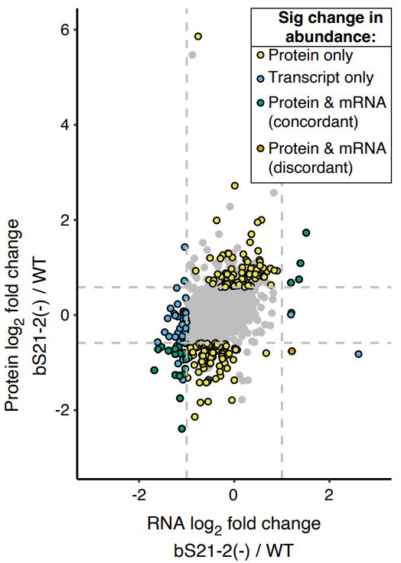
To approach this question of ribosomal heterogeneity and the possibility of bS21 leading to a regulatory affect of ribosomes, one step that was taken was to examine proteomics and RNA Seq data between wild-type F. tularensis versus cells lacking bS21-2. Pictured to the right in Figure x, the log fold change of protein abundance is shown on the y-axis, versus the log fold change of transcript abundance along the x-axis of individual genes pictured as individual data points. bS21-2 seems to have an effect on a number of genes in respect to their protein abundance, regulating a number of the FPI genes, which has been previously expanded upon in previous research (Trautmann and Ramsey). This data, however, also revealed another point of interest, the gene with the largest change in transcript abundance when bS21-2 is removed from the cell, yqeY, which has a significant change in transcript, but not protein abundance, as opposed to the trends otherwise seen. yqeY is the gene which produces a protein that potentially aids in the correct charging of amino acids to tRNAs (deniziak). Incidentally, this gene is encoded immediately downstream of the rpsU2 gene, on the same operon along with dnaG and rpoD, as pictured below.
Figure 1: log₂ fold changes of RNA Seq reads versus log₂ fold change of protein abundance between wild-type and ΔrpsU2 cells. (Trautmann and Hannah)
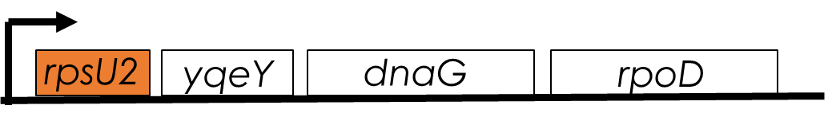
Figure 2: A depiction of the rpsU2 operon, containing the rpsU2 promoter and rpsU2, yqeY, dnaG, and rpoD genes.
With this in mind, the RNA Seq data was further analyzed with respect to the rpsU2 operon itself. This resulted in the following analyses, depicting normalized transcript reads along the operon of LVS with a pF plasmid, cells lacking bS21-2, cells lacking bS21-2 with the rpsU2 gene ectopically expressed, and the same for both rpsU1 and rpsU3, separately. In wild-type cells, some level of transcript is present, however, the interesting extrapolation comes in the comparison to the ΔrpsU2 cells. Clearly there is a very substantial increase in the transcript abundance of this operon without bS21-2 present. This already lends itself to the idea that rpsU2 is negatively regulating its own operon, as its removal allows for more of its transcript to be produced. Additionally, when rpsU2 is ectopically expressed with a strong promoter, not only is the wild-type phenotype restored, but, in fact, the transcript abundance appears to be even somewhat less than wild-type. Furthermore, given the similarities between homologs, the addition of plasmid-expressed rpsU1 and rpsU3 was also evaluated in cells lacking bS21-2, and it seems that both of these homologs also have a similar negative regulatory relationship on the rpsU2 operon. Less interesting, though informative, the deletion of rpsU2 is confirmed in all of the cells lacking bS21-2 given the noticeable gap in transcript reads, aside from the ectopically expressed rpsU2 which is mapped along the chromosomal operon, but is still only present on the plasmid.
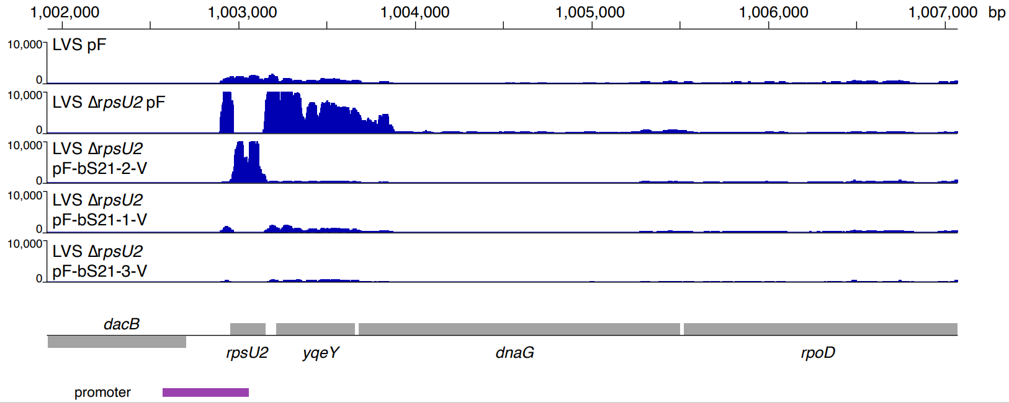
Figure 3: Normalized transcript abundance reads mapped to the rpsU2 operon. Shows wild-type, ΔrpsU2 cells, and ΔrpsU2 cells with either rpsU2, rpsU1, or rpsU3 ectopically expressed with a non-native promoter.
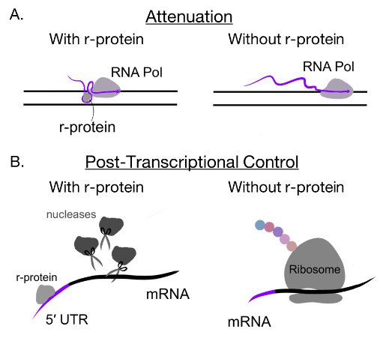
While it does seem that the bS21 homologs negatively regulate, at least, rpsU2, how exactly the regulation occurs is one question which will be answered by the specific aims of this project. The other important question, why this regulation exists, however, is one already canonically known for ribosomal proteins and their autoregulation. Which is to say that ribosomes and their subsequent ribosomal proteins are often maintained within stoichiometric quantities, so as to not waste cellular resources synthesizing several times more r-proteins than ribosomes present. There are several known ways in which ribosomal proteins will regulate their own expression at both the transcript and protein level, however, to first introduce models for regulation at the level of transcription, there are two specific models which the proposed study will test directly. Those models are attenuation and post-transcriptional control. Attenuation is understood to occur as the RNA polymerase is transcribing DNA actively, wherein the proposed autoregulating ribosomal protein will interact with the elongating mRNA such that it forms a secondary structure which will stall the RNA polymerase and terminate transcription. Clearly these ribosomal proteins are always within the cell, however, this relies on the idea that the protein has been made in such abundance that there is ribosomal protein freely available, not associated with any ribosome, thus allowing it to interact with the 5′ UTR of its own elongating transcript. That said, then, when that ribosomal protein is in stoichiometric quantities with ribosomes, transcription is able to proceed normally and the transcript is synthesized. Another well-defined model is that of post-transcriptional regulation, wherein RNA polymerase is able to fully create the mRNA transcript, however the freely accessibly r-protein is able to interact with the 5′ UTR of the mRNA, allowing for a few potential interactions to occur. As pictured, the ribosomal protein may recruit nucleases, to some effect, allowing the enzymes to degrade the transcript. Alternatively, those excess ribosomal proteins may, instead, sequester the Shine-Dalgarno sequence, not allowing translation to occur (Burgos; Lindhal; Nomura; Zengel and Lindhal).
Figure 4: Depictions of two types of autogenous transcriptional regulation known to be used by ribosomal proteins.
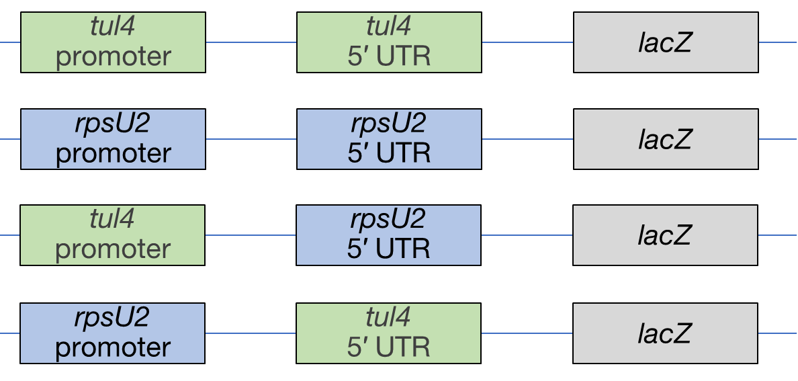
Importantly, both of these models rely on the 5′ UTR in order to proceed, and while it would be expected to work similarly in LVS, it is possible that some other mechanisms are present. As such, to test these models it is first essential to ensure that the 5′ UTR in fact plays a role in regulation. To test whether this is true, lacZ reporter fusions were and are being created, with a known non-rpsU2-regulated gene, tul4, as a control. As depicted above, two control constructs were created with both the rpsU2 promoter and 5′ UTR fused to lacZ within the LVS Tn7 site on the chromosome, in addition to either a test or control promoter paired with its counterpart 5′ UTR. Each of these reporter fusions are integrated into either wild-type or ΔrpsU2 strains. Then, the contribution of the 5′ UTR was tested utilizing these strains in a qRT-PCR reaction. Due to the negative regulation, in the reporter fusion containing both the rpsU2 promoter and 5′ UTR it was expected that in cells lacking bS21-2, the transcript of lacZ would be in higher abundance than wild-type cells. Additionally, in the context of the tul4 promoter and 5′ UTR it was expected that there would be no regulatory effect if these constructs were in fact valid reporters. This was confirmed via the aforementioned qRT-PCR reactions (Figure 6A). In the same fashion, the contribution of the 5′ UTR was tested using the reporter fusion with the tul4 promoter and rpsU2 5′ UTR, wherein it was sufficient for autogenous regulation due to the increased abundance of lacZ transcript reads in the cells lacking bS21-2 (Figure 6B). 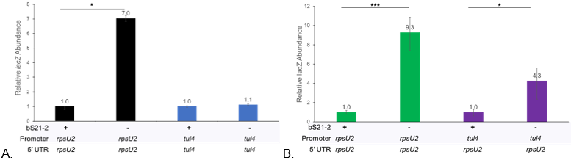
Figure 5: Depiction of the lacZ reporter fusions integrated into the Tn7 Site of either wild-type LVS or ΔrpsU2 cells.
Figure 6: Relative lacZ transcript abundance between reporter fusion strains. A) The control strains confirming expected results, suggesting assay construction is valid. B) The 5′ UTR is sufficient for regulation by bS21-2. *** p-value < 0.002, * p-value < 0.03.
Then, using these same strains, preliminary data was gathered regarding the protein abundance of lacZ. And, in fact, the same fold-increase between the reporter fusion within the wild-type context versus the ΔrpsU2 context is not observed, although there is some level of an increase in the protein abundance. This then invites the question of why exactly the transcript increase does not correlate to a similar increase in protein abundance.
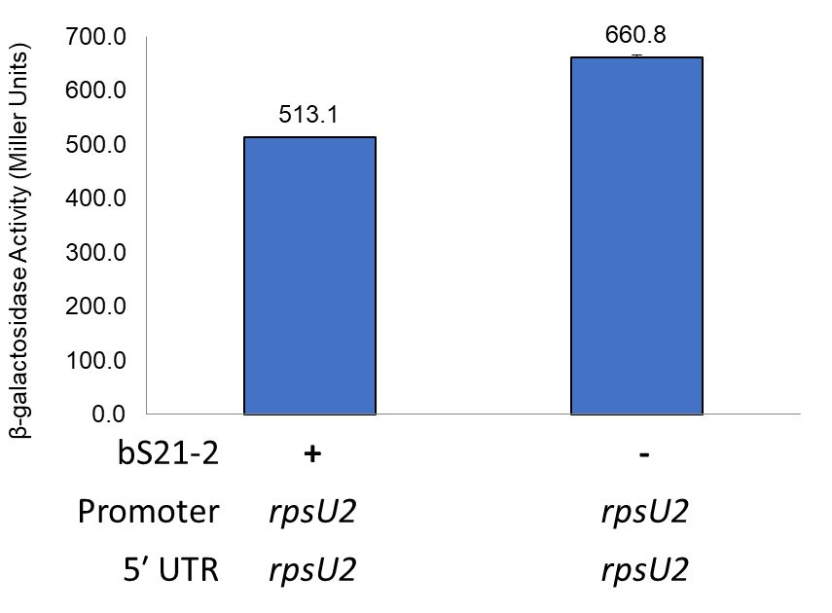
Figure 7: Preliminary data suggesting the same fold change of transcript abundance is not seen in protein abundance in cells with or without bS21-2.
As previously stated, r-proteins may be autogenously regulated in either the steps of transcription or translation, and in fact both can be true for an r-protein simultaneously (Zengel and Lindhal). This added level of regulation allowing for another level of precision in cellular responses to whatever stimuli. Regardless, the discrepancy observed in both Figure 1 and Figure 7 may be a result of this added level of regulation. Two canonical models for regulation at the level of translation both rely on interference in translation initiation. The first suggests that the autogenously regulated r-protein binds the translation start site, blocking initiation of the translation of that mRNA. The other canonical model suggests that the r-protein interacts with the transcript such that certain conformational changes result in secondary structures which prevent adequate binding for translation to occur (Zengel and Lindhal). Though, it is also potentially interesting that, given the known heterogenous ribosomes of F. tularensis and the implication of bS21 in translation initiation, that there may potentially be a discrimination against its own transcript during translation.
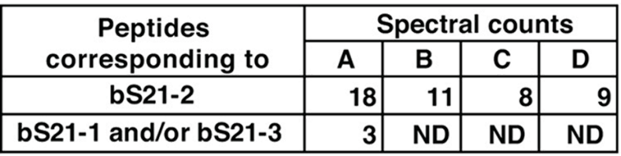
Clearly, there are many questions left unanswered. Much of the previous research in the lab has focused on bS21-2, however given the RNA Seq data it is clear that the first and third homolog also interplay with bS21-2, with interesting implications. This greater focus on the second homolog a result of the difficulty in studying bS21-1 and bS21-3 due to the relatively lower abundances at which they appear in the cell (see Figure 8, depicting the lower spectral counts of these homologs within ribosomes), which the second aim of this project will hopefully answer for. While the individual and discrete systems themselves may be interesting, they have broader implications within the context of the cell. Whatever conditions may contribute to the regulation of bS21-2 has downstream effects within the cell, namely on some of the virulence proteins of the T6SS within LVS (Trautmann and Ramsey). Additionally, as per my second aim, there may yet be interesting implications for what environments contribute to the regulation of bS21-1 and bS21-3. To that end, the overall goal of this project seeks to answer questions that have a broader implication for LVS and understanding its cellular processes from a few different angles.
Figure 8: Spectral counts of each bS21 homolog as indicated by mass spectrometry data.
Apart from the intrigue pertaining to LVS itself, there are broader implications that this research may have, down the line. Obviously, ribosomes are conserved structures across all domains of life, and this research is contributing to understanding a function of ribosomes currently not well understood, heterogeneity. This may, then, yield more information in this regard, but also given how many antibiotics target the ribosome for their mechanism of action, this also sets up potentially novel and interesting targets for those antibiotics. With the growing issue of antibiotic resistance, developing novel narrow-spectrum antibiotics is becoming increasingly vital (Murray). With the better understanding of specialized ribosomes, this may open a new avenue for the development of those drugs.
3.0 Methodology and Procedures
3.1 Bacterial Growth Conditions.
For standard growth conditions in liquid media, LVS is grown in Mueller Hinton Broth (MHB), supplemented with 0.025% iron pyrophosphate, 0.1% glucose, and 2% Isovitalex at 37°C. For solid media growth, LVS is grown on cysteine heart agar plates containing 1% hemoglobin (CHAH) at 37°C. E. coli is grown in LB media, or on LB plates. Yeast is grown in or on YEPD media or in/on -ura.
3.2 Plasmid Design and Construction.
Plasmids are first designed utilizing the SnapGene (GSL Biotech LLC) application. Then, working from a theoretical map, necessary gene components are amplified via PCR, then purified with the QIAquick Purification Kit. PCR products and pF or PYES2 backbones are then digested using restriction enzymes, run on a gel, and extracted using the QIAquick Gel Extraction Kit. Gel purified fragments are then ligated and transformed into either Escherichia coli or Saccharomyces cerevisiae via heat shock or electroporation, respectively. Selected colonies are then isolated with the QIAprep Spin Miniprep Kit or Zymoprep Yeast Plasmid Miniprep II kit and confirmed via Sanger sequencing through the INBRE Core Facility.
3.3 Integration of Plasmid-Bound DNA into the Tn7 Site of F. tularensis
Electrocompetent LVS cells are prepared via multiple sucrose washes prior to electroporation. A Tn7 helper plasmid is electroporated into desired target cells, in order to help with the integration of the Tn7 sequence from the plasmid into the Tn7 site on the chromosome. Colonies are recovered from the electroporation and made into electrocompetent cells and electroporated with the designed Tn7 plasmid. The helper plasmid is cured from the strain and integration is confirmed via colony PCR, lysing and killing cells prior to PCR on lysates with PrimeStar GXL polymerase. When the helper plasmid is confirmed to have been cured through cross-patching on alternative antibiotics, electrocompetent cells are made and electroporated with the Tn7 resolvase plasmid to excise the remaining antibiotic resistance. The resulting colonies are recovered and cured of the Tn7 resolvase plasmid.
3.4 RNA Purification and cDNA Synthesis
Strains of interest are grown as per the conditions laid out in 3.1 to mid-log phase, OD 0.3-0.4, and then pelleted. Total nucleic acids are then isolated using the Zymo Research Direct-zol RNA Kit. A DNase treatment is applied to the eluted nucleic acids, degrading DNA, and the RNA is re-purified with use of the Zymo Research Direct-zol RNA Kit. Non-specific primers, NS₅ primers, are annealed to normalized pure RNA, and is reverse transcribed, both steps utilizing the Thermocycler. Weak base is used to remove RNA from the cDNA, and then neutralized with weak acid.
3.5 qRT-PCR
cDNA is diluted to a normalized concentration and prepared with the PowerUp™ SYBR™ Green Master Mix and one of each of the four primer pairs listed below, at 5 μM. Each sample and primer pair is plated in technical triplicate on a 96-well plate. Samples are then amplified in a two step process within a Roche 480 LightCycler, and the Crossing Point is used to calculate the relative abundance of transcript.
Primer Pair Name | Gene
KROL63/64 | tul4
KROL343/344 | rpsU2 5′ UTR
KROL399/400 | lacZ
KROL504/505 | Downstream of rpsU2

3.6 mRNA Stability Assay (Nguyen)
Strains of interest are grown as per the conditions laid out in 3.1 to mid-log phase, OD 0.3-0.4, and then rifampin is added to a final concentration of 50 ug/mL. After 0, 1, 2, and 4 minutes, 1.8 mL of culture is aliquoted and snap frozen in cryovials using liquid nitrogen. Samples are then thawed and mRNA is extracted and purified, and cDNA is synthesized as per 3.4. qRT-PCR is conducted, and a linear regression analysis is conducted on a plot of -C_{T} over time.
3.7 β-Galactosidase Assay
Cultures are grown to early mid-log (around OD600 0.3), according to the growth conditions (3.1). Growth is halted by placing cultures on ice for at least 30 minutes, and then added to tubes containing Z-buffer supplemented with BME. 0.1% SDS and chloroform are added, cultures are vortexed, then allowed to come to 28°C for 10 minutes prior to the addition of the substrate ONPG. Reactions are stopped upon reaching a yellow color, OD420 0.6-0.9.
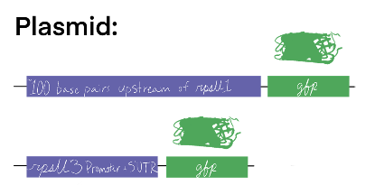
3.8 Screening for Environmental Conditions - Growth
To test for environmental conditions which up-regulate rpsU1 or rpsU3 GFP reporter strains, depicted to the right, have the promoter region (or proposed promoter region) fused to the gfp gene on a plasmid within LVS. Two media backgrounds will be the basis for the test of environmental conditions, the first, MHB, and the second, Chemically Defined Media (CDM). External environments will be tested in MHB, i.e.. temperature, salinity, pH, hydrogen peroxide (H₂O₂) stress, and UV stress. To test salinity and pH LVS is grown to early-log phase and completing a media transfer where cultures are spun down and resuspended in a small volume of MHB and added to new cultures containing the altered MHB environments. Alternatively, for temperature, H₂O₂, and UV stress, cultures are grown to mid-log, exposed to the condition, and given 30 minutes to recover. MHB versus CDM is tested by growing cultures to mid-log in MHB or CDM. Different chemical environments are tested by altering chemical component concentrations in CDM.
3.9 GFP Assay
After cultures are grown to mid-log, 1-4mL is pelleted and resuspended in 1xPBS and 250 mL are plated in technical triplicate in a clear 96-well plate and the OD600 is read by the ID3 Plate Reader Spectrometer. 200 mL of the sample is transferred to a black 96-well plate and the fluorescent value is measured. Fluorescence is normalized to LVS-pF in PBS, and calculated relative to the corresponding OD600.
3.10 Transposon Mutagenesis and Screening
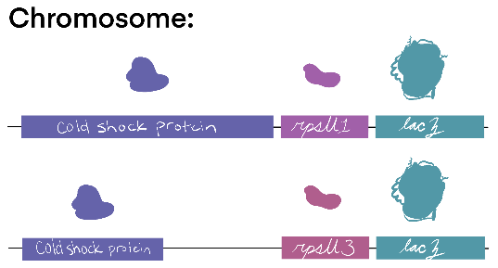
To test for genetic conditions which up-regulate rpsU1 or rpsU3 lacZ reporter strains, depicted to the right, lacZ is integrated next to either the rpsU1 or rpsU3 gene on the chromosome. A plasmid containing a cut-and-paste transposon is electroporated into electrocompetent cells prepared according to 3.3. Cells containing the transposon are selected via subsequent growth on CHAH + Kanamycin plates. After single colonies appear, 10 mL of 0.7% soft agar supplemented with 100 μg/mL X-gal is overlain on the plates and incubated again overnight. Dark blue colonies are recovered and high production of β-Galactosidase is measured quantitatively via the β-Galactosidase assay, 3.7.
3.11 gDNA Prep
Desired LVS strains are grown on CHAH plates, and patches are resuspended in MHB prior to the gDNA prep using the Invitrogen PureLInk Genomic DNA extraction kit.
4.0 Resources Required.
The resources required to complete this project will come the Dr. Kathryn Ramsey lab with funding from lol I forgot to ask for the grant info lets goooOOOO. Additionally, sequencing services and the use of certain equipment will be provided by the INBRE Core Facility.

Literature Cited
- Aseev, L. V., & Boni, I. V. (2011). Extraribosomal Functions of Bacterial Ribosomal Proteins. 45(5), 12.
- Burgos, H. L., O’Connor, K., Sanchez-Vazquez, P., & Gourse, R. L. (2017). Roles of Transcriptional and Translational Control Mechanisms in Regulation of Ribosomal Protein Synthesis in Escherichia coli. Journal of Bacteriology, 199(21), e00407-17. https://doi.org/10.1128/JB.00407-17
- Byrgazov, K., Vesper, O., & Moll, I. (2013). Ribosome heterogeneity: Another level of complexity in bacterial translation regulation. Current Opinion in Microbiology, 16(2), 133–139. https://doi.org/10.1016/j.mib.2013.01.009
- Deniziak, M., Sauter, C., Becker, H. D., Paulus, C. A., Giegé, R., & Kern, D. (2007). Deinococcus glutaminyl-tRNA synthetase is a chimer between proteins from an ancient and the modern pathways of aminoacyl-tRNA formation. Nucleic Acids Research, 35(5), 1421–1431. https://doi.org/10.1093/nar/gkl1164
- Lindahl, L., Archer, R., & Zengel, J. M. (1983). Transcription of the S10 Ribosomal Protein Operon Is Regulated by an Attenuator in the Leader. Cell, 33(1), 241–248. https://doi.org/10.1016/0092-8674(83)90353-7
- Murray, C. J., Ikuta, K. S., Sharara, F., Swetschinski, L., Robles Aguilar, G., Gray, A., Han, C., Bisignano, C., Rao, P., Wool, E., Johnson, S. C., Browne, A. J., Chipeta, M. G., Fell, F., Hackett, S., Haines-Woodhouse, G., Kashef Hamadani, B. H., Kumaran, E. A. P., McManigal, B., … Naghavi, M. (2022). Global burden of bacterial antimicrobial resistance in 2019: A systematic analysis. The Lancet, 399(10325), 629–655. https://doi.org/10.1016/S0140-6736(21)02724-0
- Nano, F. E., Zhang, N., Cowley, S. C., Klose, K. E., Cheung, K. K. M., Roberts, M. J., Ludu, J. S., Letendre, G. W., Meierovics, A. I., Stephens, G., & Elkins, K. L. (2004). A Francisella tularensis Pathogenicity Island Required for Intramacrophage Growth. Journal of Bacteriology, 186(19), 6430–6436. https://doi.org/10.1128/JB.186.19.6430-6436.2004
- Nguyen, T. G., Vargas-Blanco, D. A., Roberts, L. A., & Shell, S. S. (2020). The Impact of Leadered and Leaderless Gene Structures on Translation Efficiency, Transcript Stability, and Predicted Transcription Rates in Mycobacterium smegmatis. Journal of Bacteriology, 202(9), e00746-19. https://doi.org/10.1128/JB.00746-19
- Nomura, M., Gourse, R., & Baughman, G. (1984). Regulation of the Synthesis of Ribosomes and Ribosomal Components. Annual Review of Biochemistry, 53(1), 75–117. https://doi.org/10.1146/annurev.bi.53.070184.000451
- Trautmann, H., & Ramsey, K. (2022). A Ribosomal Protein Homolog Governs Gene Expression and Virulence in a Bacterial Pathogen. Journal of Bacteriology, 204(10), e00268-22. https://doi.org/10.1128/jb.00268-22
- Zengel, J. M., & Lindahl, L. (1994). Diverse Mechanisms for Regulating Ribosomal Protein Synthesis in Escherichia coli. In Progress in Nucleic Acid Research and Molecular Biology (Vol. 47, pp. 331–370). Elsevier. https://doi.org/10.1016/S0079-6603(08)60256-1

