Travel Authorization – Sierra Schmidt
Boston Bacterial Meeting 2023 Website showing dates: https://bostonbacterial.org/
Conference approved by PI: Kathryn Ramsey, kramsey@uri.edu
Proof of registration:
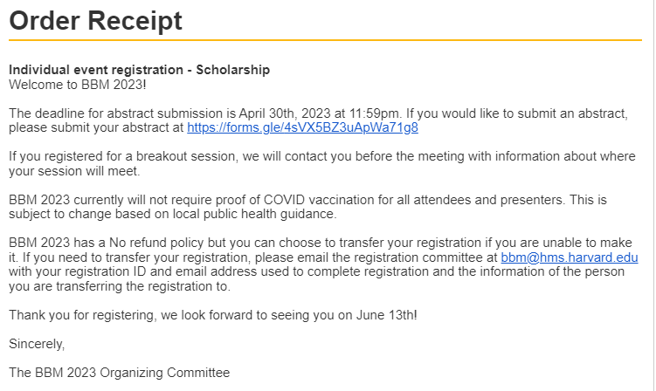
Proof of train fare cost:
