gDNA Sequence Analysis
KRLVS141
Contig 2 (Plasmid)
- Single nucleotide deletion indicated on pKR113 below, in promoter region.
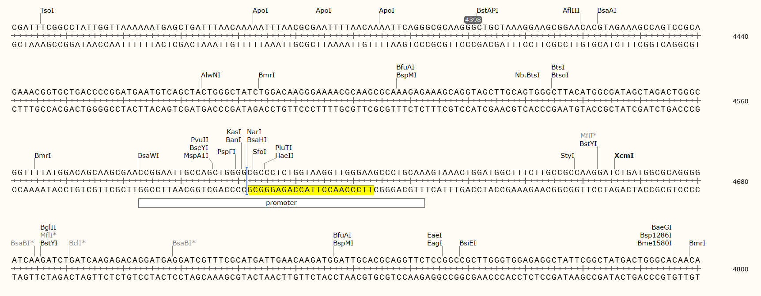
Contig 1 (Chromosome)
- Integrated pKR11 FT component has 100% alignment, with no gaps or insertions. Insertion point as compared to LVS genome:
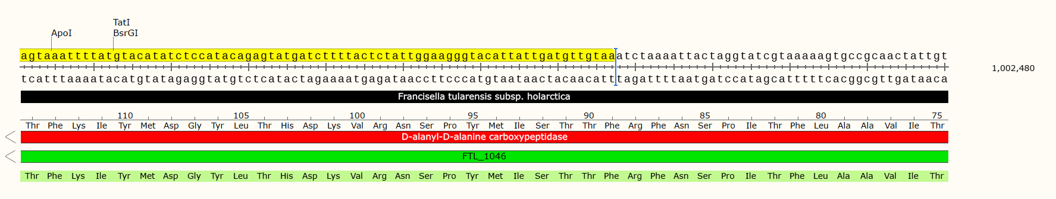
- Found no similar sequences to any of the rpsu homologs.

- Integration of 206 base pairs from the pKR113 plasmid at 607,639 in the KRLVS141 chromosome, including a single mismatched nucleotide (did not locate similar sequence in either LVS genome or integrated plasmid pKR11). Mismatch is of the first base pair in the correlated plasmid rpsu2 gene. (Integrated sequence with features from pKR113 plasmid shown below.) As shown, both a partial and full tetO site were integrated, along with the bfr promoter and three nucleotides from the rpsu2 gene.
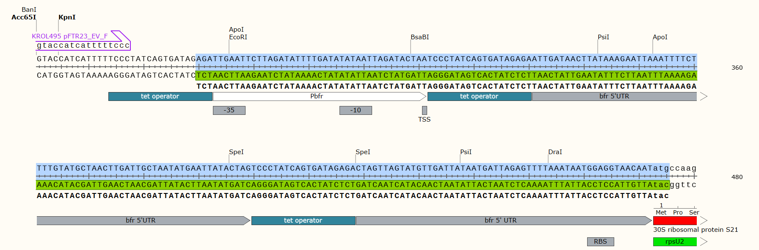
  - Insertion point of above, as compared to LVS genome:
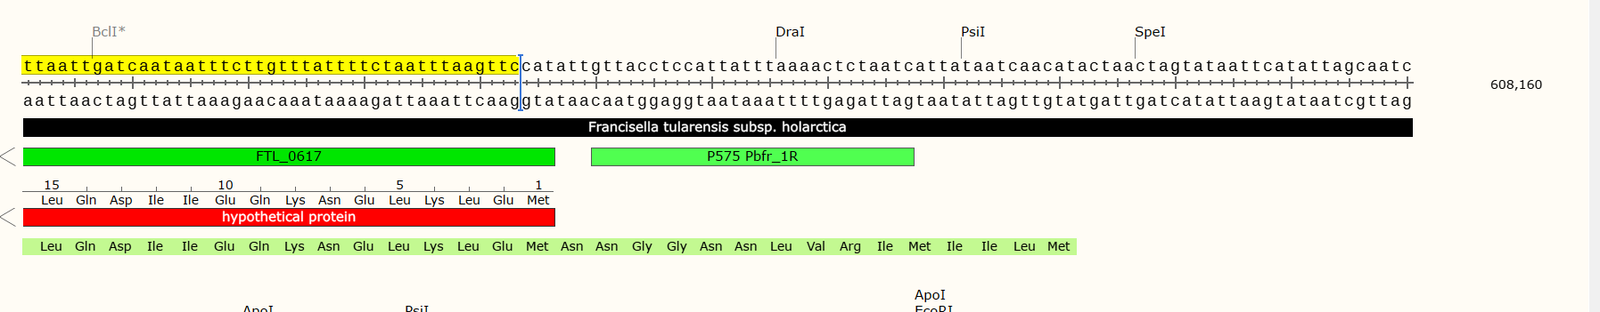

KRLVS156
Contig 2 (Plasmid)
- Single nucleotide deletion within promoter (indicated on pKR127 sequence):
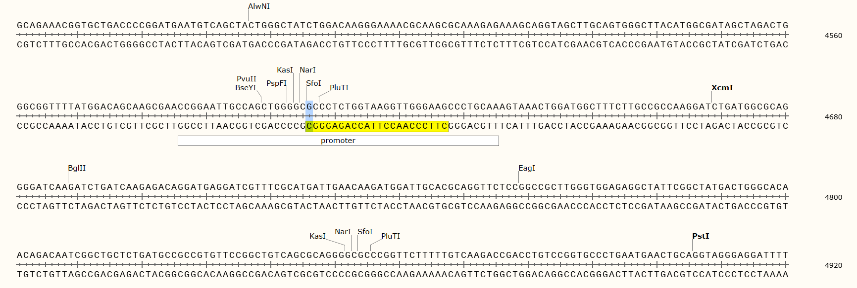
- Single nucleotide deletion in VSVG tag, location indicated on pKR127 plasmid below:
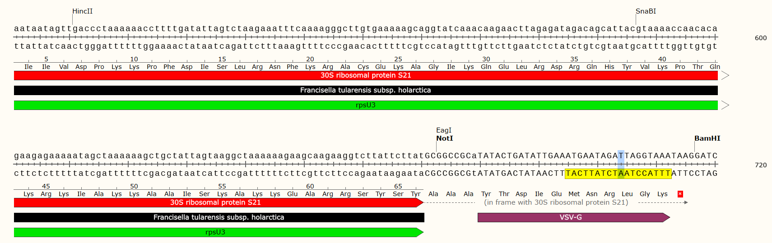
Contig 1 (Chromosome)
- Includes expected region of pKR11 integrated into the chromosome in the same location as KRLVS141 with no detection of any of the rpsu homologs.

- 333 bp integration of pKR7 (background strain contained this plasmid). Sequence from pKR7 indicated below:
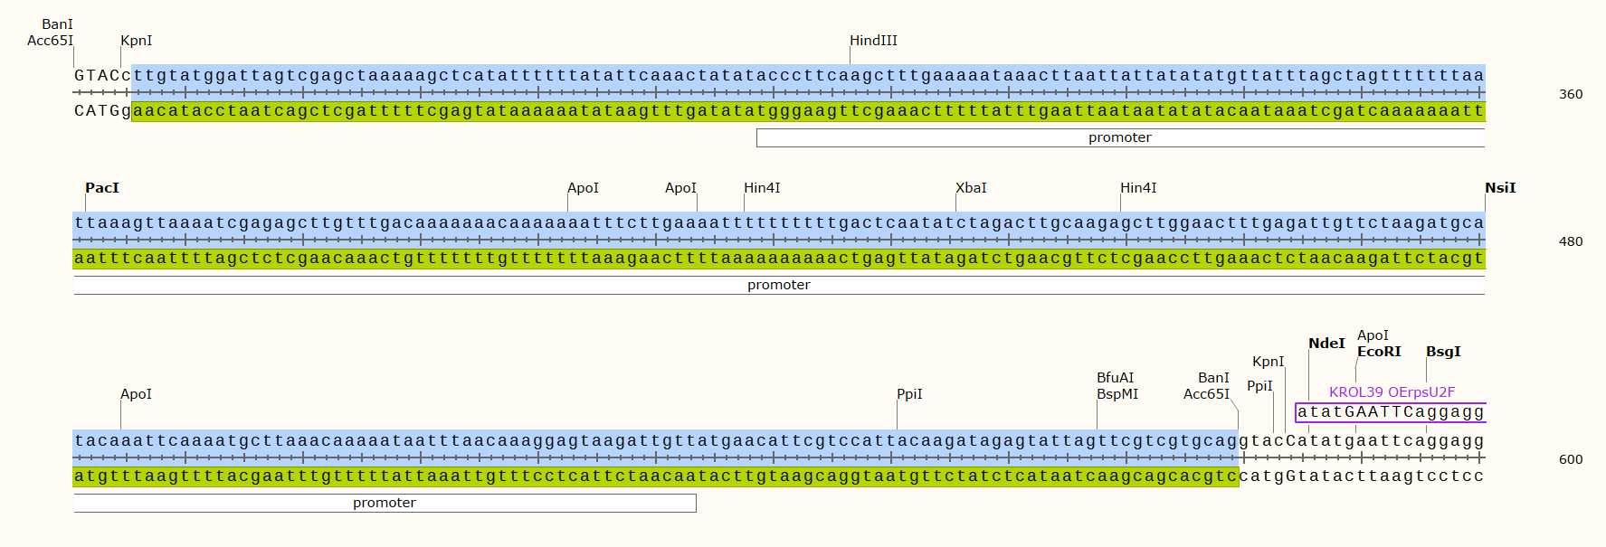
  - Insertion point of above, as compared to LVS genome:
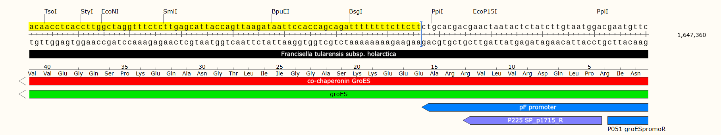
- Maintained integration of pKR113/pKR127 plasmid DNA at base pair 607,639.

KRLVS157
Contig 2 (Plasmid)
- Single nucleotide deletion within promoter (indicated on pKR126 sequence):
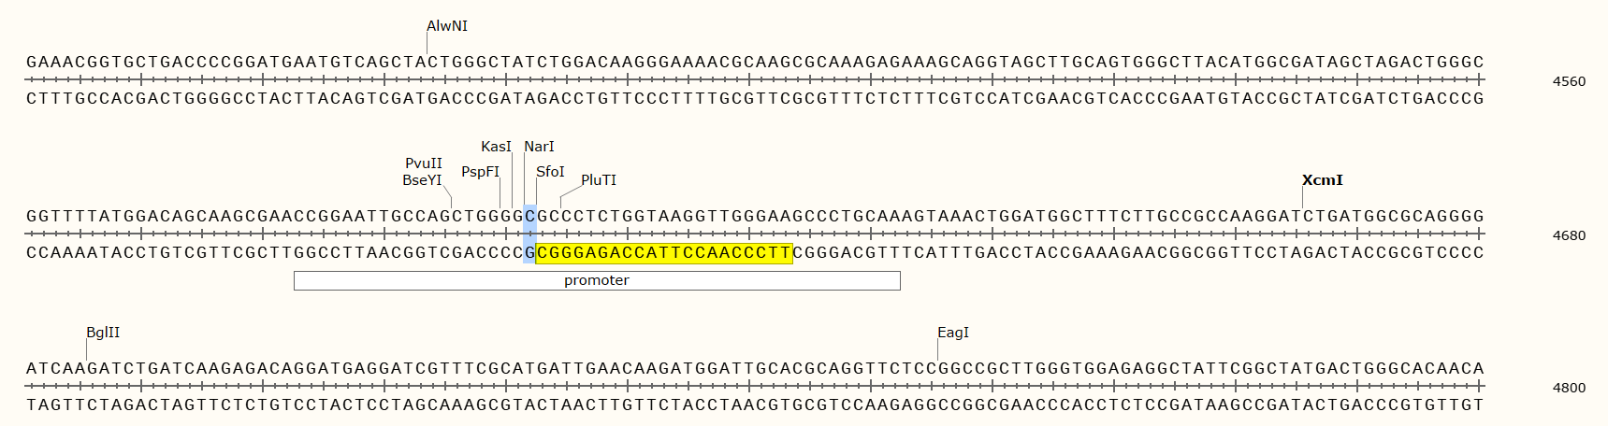
Contig 1 (Chromosome)
- Includes expected region of pKR11 integrated into the chromosome at same location as KRLVS141, containing one mismatch (indicated below on pKR11), with no detection of any of the rpsu homologs.
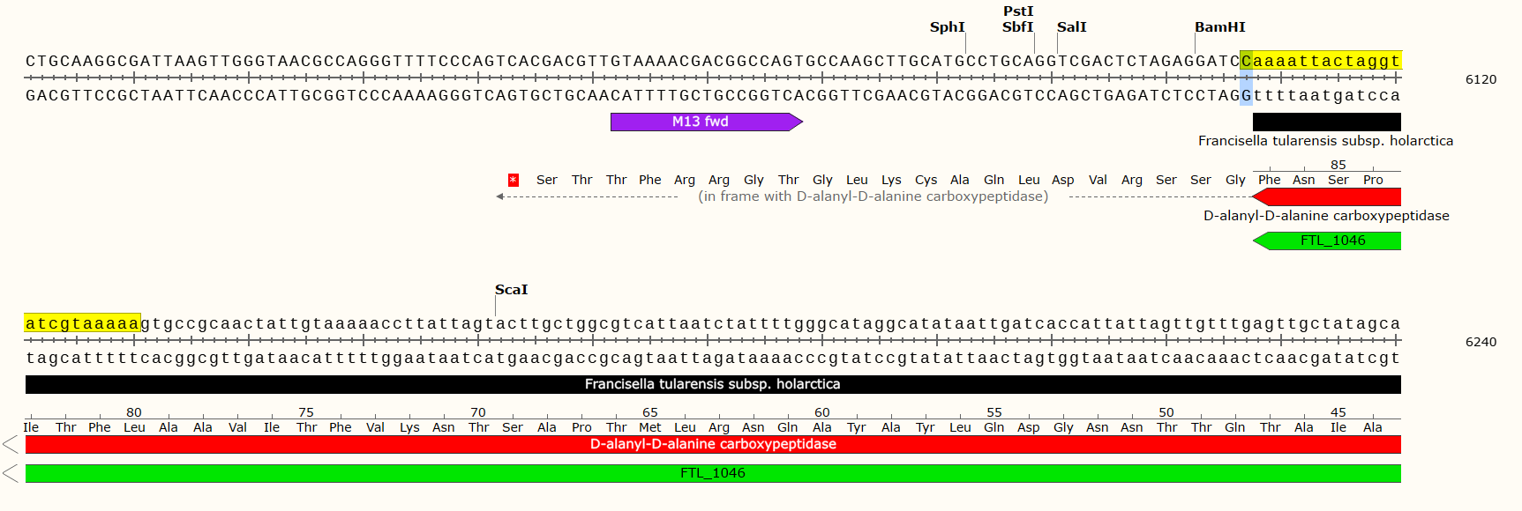
- Integration of pKR7 strain maintained as KRLVS156 (same background strain). Insertion point as related to LVS also maintained.

- 205 bp integration of pKR126, shown below on the pKR126 plasmid.
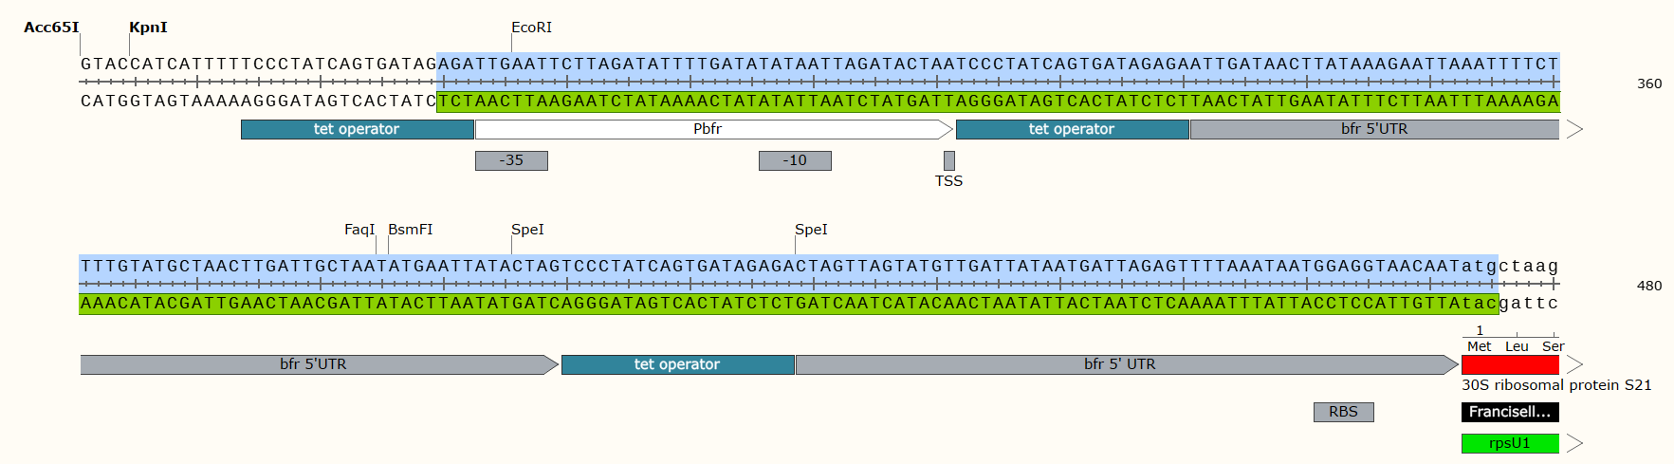
  - Insertion point of above, as compared to LVS:
