Mission Statement Draft
*Should be a living document!
Ideas from retreat brainstorm:
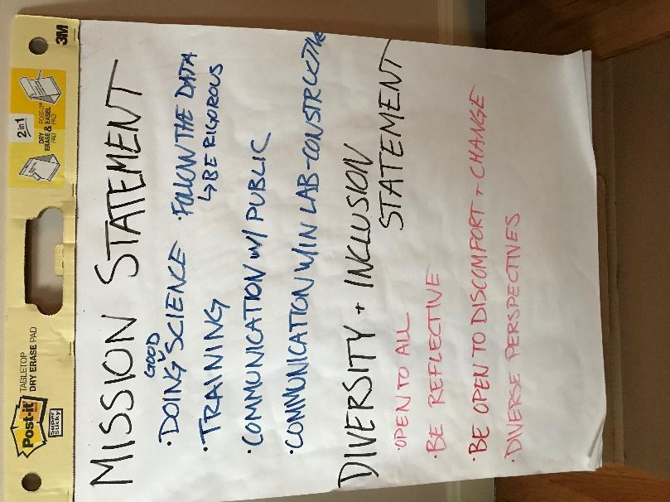

Principles and beliefs:
Doing rigorous scientific research
Following the data
Training new scientists
Collaborative and communicative group environment
Gaps that need to be filled
Communication with public
Gaps in scientific knowledge and questions that are unanswered
What are we doing to address these gaps and hold to our principles?
Creating and sustaining

Mission Statement
The Ramsey lab believes in addressing open scientific questions with rigorous research in the areas of gene regulation, particularly in pathogenic bacteria. We have a goal of training individuals at all levels to improve their scientific knowledge, laboratory skills, and help them become more independent, creative and critical thinkers. In this process, we aim to create and sustain a collaborative and communicative culture. We are committed to communicating what we learn to the broader scientific community and the public in openly accessible formats.

Future:
More teamwork
lack of hierarchy
Measurable specific outcomes
Create a lab website for communication with the public and other scientists

Open to all
Be reflective
Be open to discomfort and change
Be open to diverse perspectives and backgrounds

Justice, Equity, Diversity, and Inclusive (JEDI) Statement
The Ramsey lab encourages participation and collaboration with individuals from diverse backgrounds, including those from underrepresented communities. We are committed to fostering a culture that is inclusive, reflective, and can accept critiques of biases and adapt accordingly.
*Future versions: reference self-awareness?

Important resource:
https://www.showingupforracialjustice.org/white-supremacy-culture-characteristics.html

