Last Updated: November 27, 2018
Stacking Gel Protocol
- This protocol is for protein purification by a “stacking gel”, used for samples containing harsh mass spec contaminants. Precast gels are preferred and a home-poured stacking type gel is not required.
- Reagent/Equipment List
  - 4X Laemmli Sample Buffer Bio-Rad #161-0747
  - β-mercaptoethanol (BME) Fisher #BP176-100
  - Bio-Rad Dual Color standard Bio-Rad #161-0374
  - 10X Bio-Rad Tris/Glycine/SDS buffer Bio-Rad #161-0732
  - Mini-Protean TGX Stain-Free Gel, 4-20% Bio-Rad #456-8093
  - Bio-Safe Coomassie G-250 Stain Bio-Rad #161-0786
  - Distilled Water
  - Methanol or Ethanol
  - Gel Rig and power source
  - Gel Releaser or clean razor blade

- Important Notes
  - Prevent keratin contamination by always wearing gloves while handling samples, tying back long hair, and taking care not to breathe on the gel. Clean gel boxes, glassware etc. that have been left uncovered on benches with 70% Ethanol before use.
  - The exact products listed above are not required; comparable products are suitable.
PROTOCOL:
- Prepare sample and set up gel rig as usual (mix with sample loading buffer, boil at 95°C for 10 minutes). See the core SDS-PAGE protocol for more details.
- Run the gel at 200V for about 5 minutes.
  - Only run the gel long enough for all of the sample to embed into the gel. Stop running before the sample starts to separate too much. See the figure on page 2.
- Rinse the gel with water briefly. (The running buffer contains detergents.)
- Optional: Stain the gel with Coomassie blue to make it easier to cut the protein-containing region accurately.
- Cut out the samples from the gel. Gel bands should be no larger than 1cm x 0.5cm. Place in a clear tube, one gel band per tube.
  - Avoid dye front or stacking region of the gel (home-poured) when cutting the gel.
  - Leave each gel band intact. Do not chop or dice into tiny pieces.
  - Use LoBind tubes if they are available.
- Cover gel bands with water and rinse for 10 minutes. Remove water, repeat once.

Customers: Samples can be stored dry or in water at 4°C. If shipping, ship on wet ice or with ice packs.
Core Staff: Proceed to In-Gel Digestion protocol.

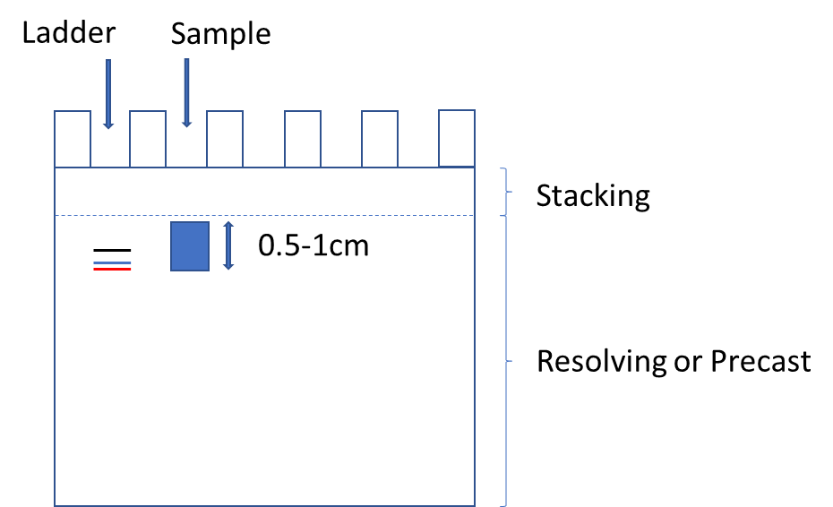
Figure

- Run 0.5-1cm into the precast (or resolving) gel, use protein ladder as a guide
- Stain with Coomassie (optional)
- Cut out protein-stained region, no dye front when possible
- A gel can be run further and sliced into multiple 0.5-1cm bands to submit as separate samples if you wish

