Codon Optimization
To make a codon-optimized DNA sequence: 1
Step 1 1
Step 2 2
Step 3 3
Step 4 4
Output 5

To make a codon-optimized DNA sequence:
Use this tool:
https://academic.oup.com/nar/article/35/suppl_2/W126/2920747 (paper describing tool)
http://genomes.urv.es/OPTIMIZER/ (web-based tool)

Step 1
Input the protein sequences desired (NOT fasta format, just the sequence. Example:
MIEKNFVITDPRLPDNPIIFASDGFLELTEYSREEILGRNARFLQGPETDQATVQKIRDAIRDQRETTVQLINYTKSGKKFWNLLHLQPVRDQKGELQYFIGVQLDGSDHVSGGGGSDYKDDDDK

Select “Protein”
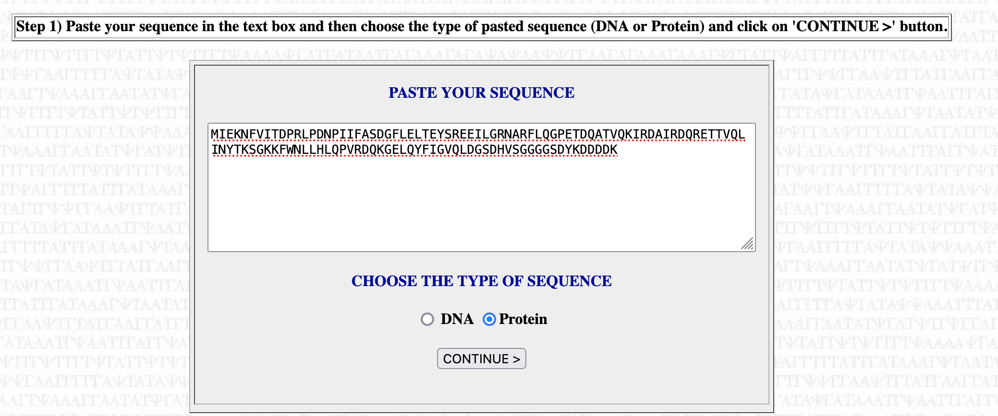

Step 2
Select “User data” and input the LVS codon usage table (which is from http://www.kazusa.or.jp/codon/) in this specific format (Codon Usage DB format):
UUU 41.6 ( 21663) UCU 17.5 ( 9103) UAU 34.6 ( 18029) UGU 9.0 ( 4708)
UUC 8.2 ( 4293) UCC 1.5 ( 766) UAC 7.3 ( 3815) UGC 2.3 ( 1203)
UUA 39.0 ( 20328) UCA 19.2 ( 9980) UAA 2.2 ( 1137) UGA 0.3 ( 172)
UUG 11.1 ( 5806) UCG 3.3 ( 1710) UAG 0.9 ( 445) UGG 9.0 ( 4693)

CUU 20.1 ( 10487) CCU 12.7 ( 6613) CAU 14.6 ( 7585) CGU 6.9 ( 3594)
CUC 3.0 ( 1564) CCC 0.8 ( 424) CAC 3.1 ( 1634) CGC 2.4 ( 1229)
CUA 19.5 ( 10142) CCA 15.2 ( 7893) CAA 28.3 ( 14745) CGA 1.9 ( 988)
CUG 3.2 ( 1673) CCG 2.1 ( 1114) CAG 8.6 ( 4480) CGG 0.3 ( 143)

AUU 41.7 ( 21719) ACU 23.4 ( 12204) AAU 45.6 ( 23761) AGU 19.0 ( 9899)
AUC 15.4 ( 8002) ACC 4.3 ( 2229) AAC 12.5 ( 6518) AGC 7.0 ( 3642)
AUA 36.0 ( 18750) ACA 20.1 ( 10484) AAA 59.9 ( 31198) AGA 18.7 ( 9733)
AUG 22.5 ( 11704) ACG 3.1 ( 1617) AAG 19.5 ( 10156) AGG 3.2 ( 1686)

GUU 28.8 ( 15013) GCU 34.8 ( 18123) GAU 48.9 ( 25462) GGU 32.0 ( 16647)
GUC 6.2 ( 3240) GCC 4.0 ( 2083) GAC 6.7 ( 3489) GGC 8.7 ( 4522)
GUA 20.7 ( 10755) GCA 24.4 ( 12731) GAA 34.5 ( 17957) GGA 12.3 ( 6427)
GUG 6.4 ( 3314) GCG 5.4 ( 2833) GAG 20.7 ( 10762) GGG 3.8 ( 1964)
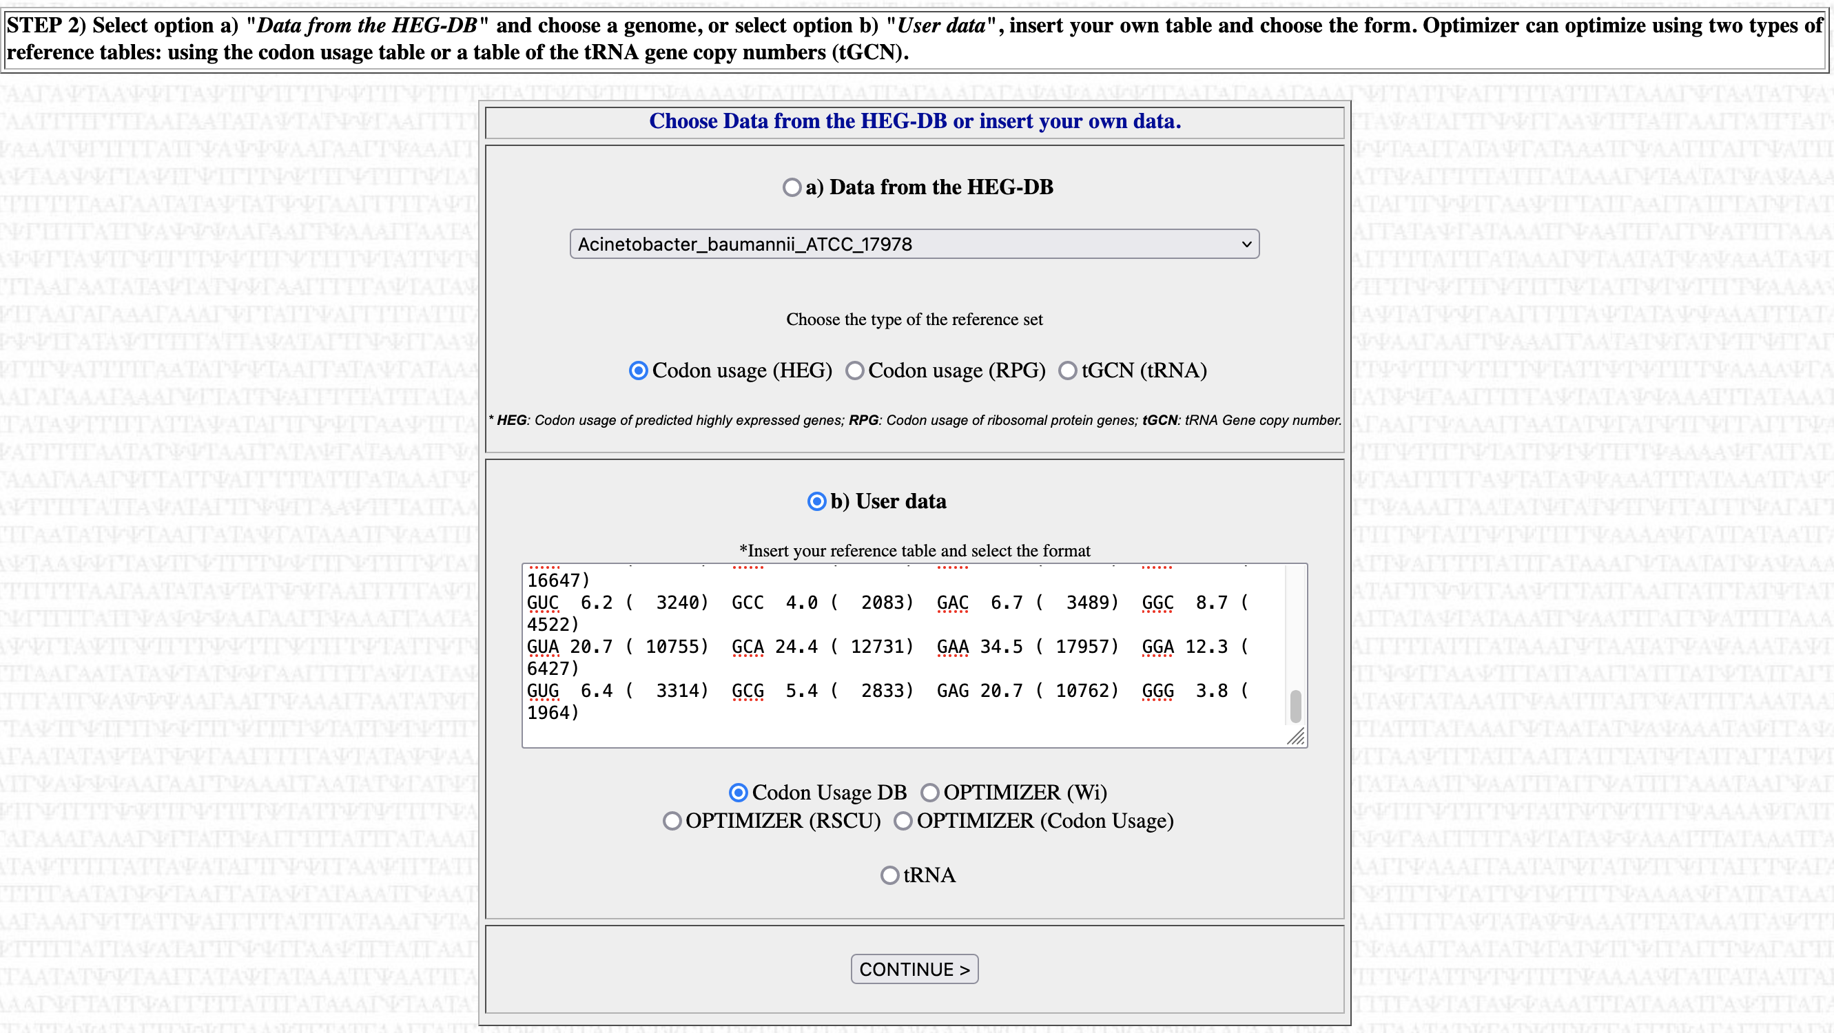

Step 3
Select the appropriate genetic code (11: Eubacterial)
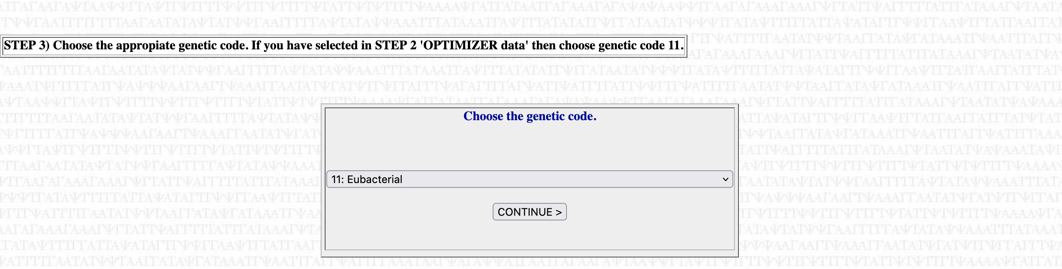

Step 4

Select how closely you want the generated sequence to match the codon usage in LVS.
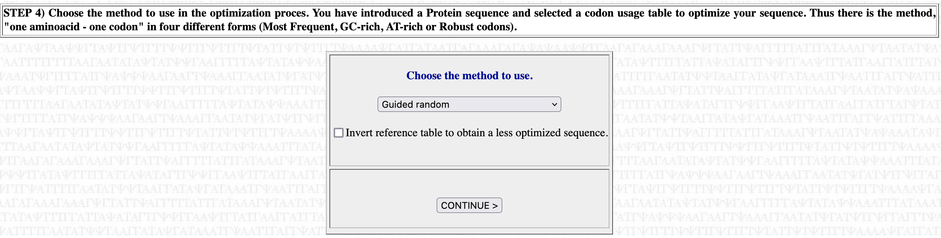
Options:
- One AA – one codon (Most frequent)
This will use the single more frequently used codon for one amino acid- there will be no variation in codon usage
- Guided random
This generally applies the frequencies at which each codon in the organism to the sequence. You can try this option multiple times and get different results.

For the following options, I think they are either less useful or have poor documentation and I have not seen them yield sequences close to the desired codon usage, so I would disregard them.
- One AA – one codon (GC rich)
- One AA – one codon (GC rich)
- One AA – one codon (Robust codons)

Output

A new window will pop up with the results. The “CAI” is codon adaptation index, which measures how codon-optimized the sequence is. It can range from 0 (bad) to 1 (only using the most commonly used codons). Using the setting “One AA – one codon (Most frequent)” will yield a CAI of 1. Using “guided random” seems to provide CAI of > 0.6 and up. These are examples of the CAI for highly expressed LVS proteins:
tul4: 0.735
bfr: 0.8
groES: 0.406 (!)

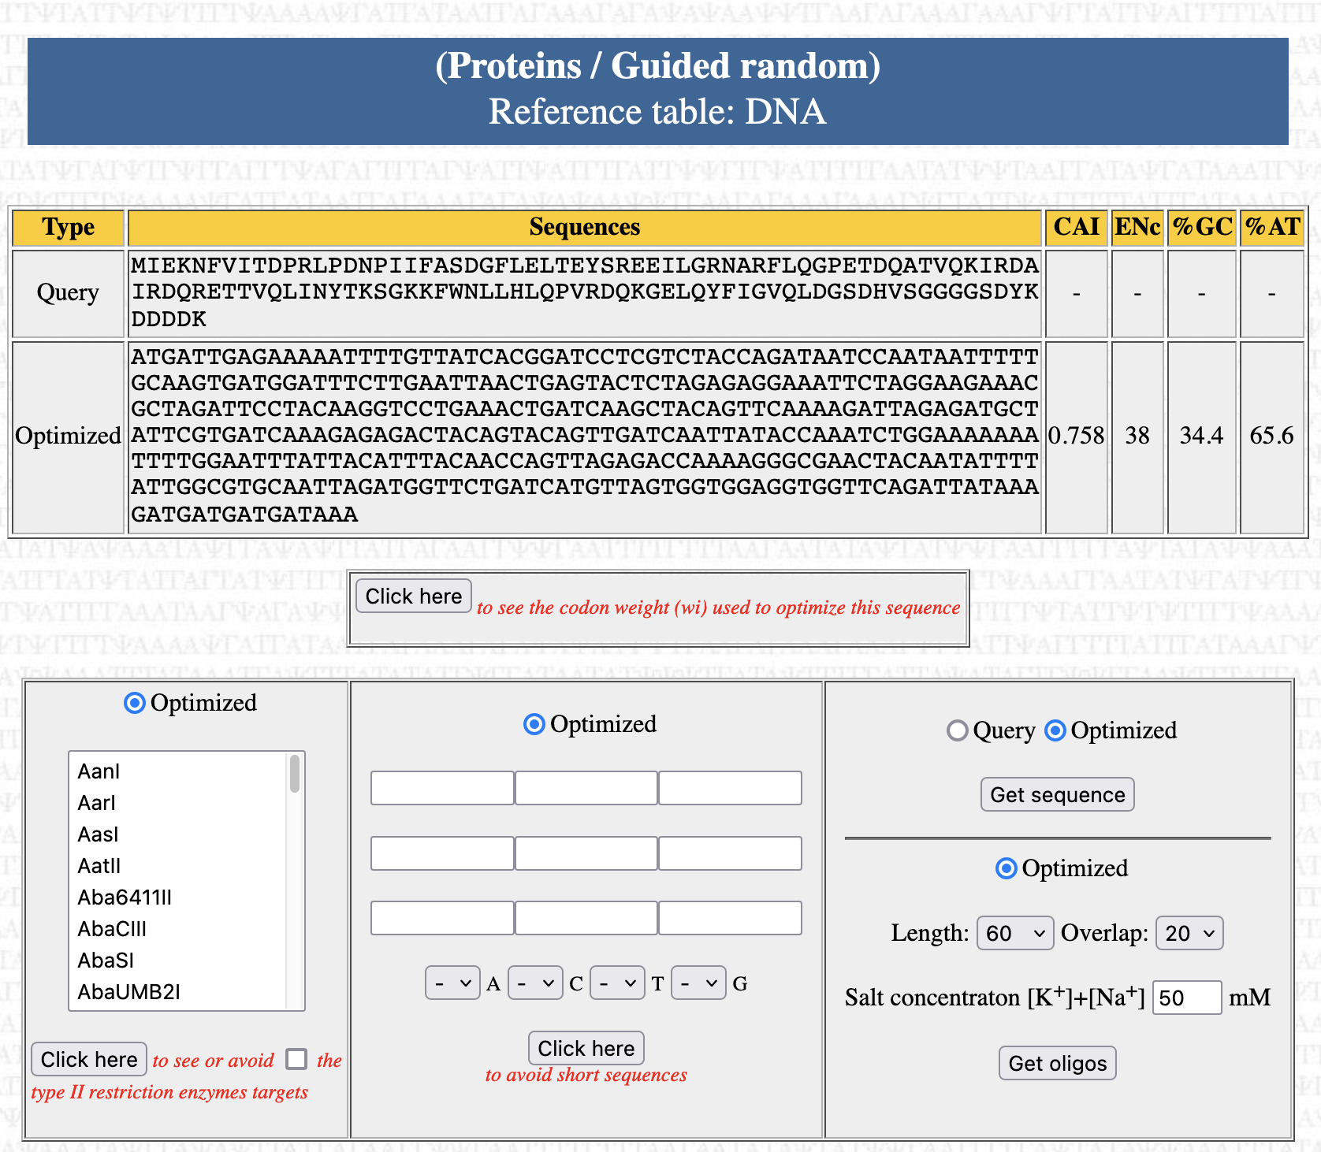
(screenshot continues on next page)
