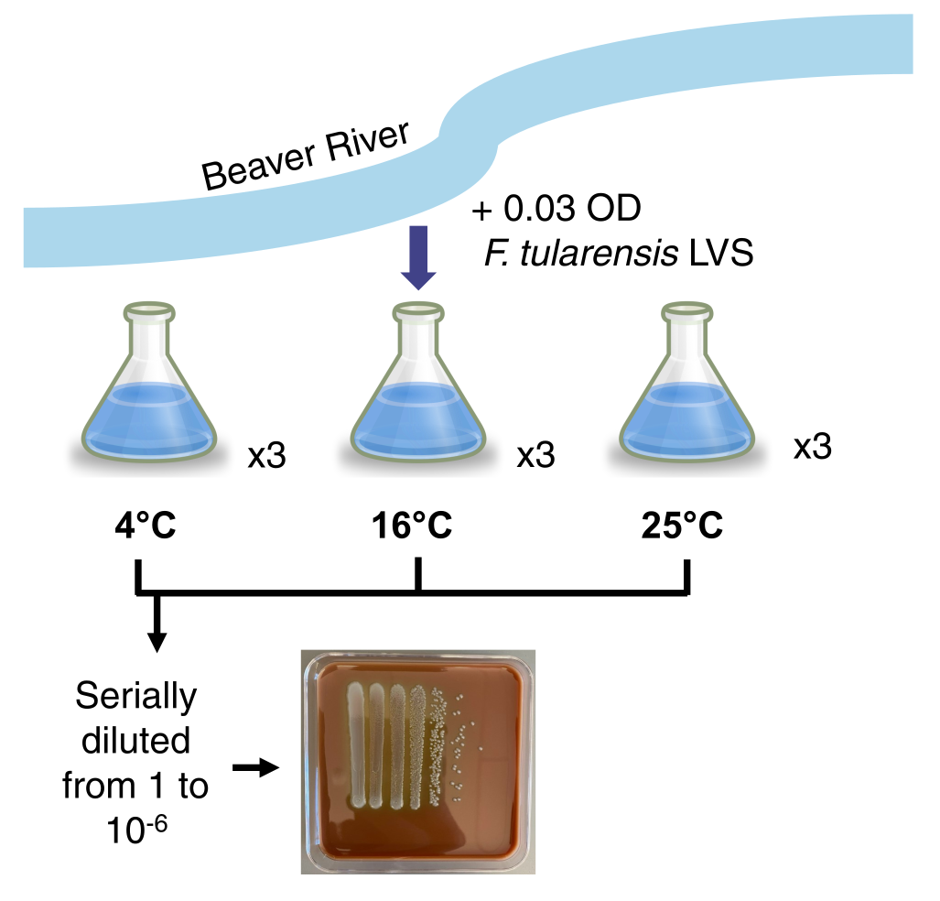
Fig 1. Development of method for survival assay. Water was retrieved from the Beaver River and was filter sterilized. F. tularensis LVS was grown to an optical density of 0.03. Inoculation of one flask was then distributed to nine flasks. Three flasks were each kept one temperature, either 4°C, 16°C, or 25°C. Each week the samples were serially diluted. A representative plate is shown.

This can be found in: 2202_Plate Counts
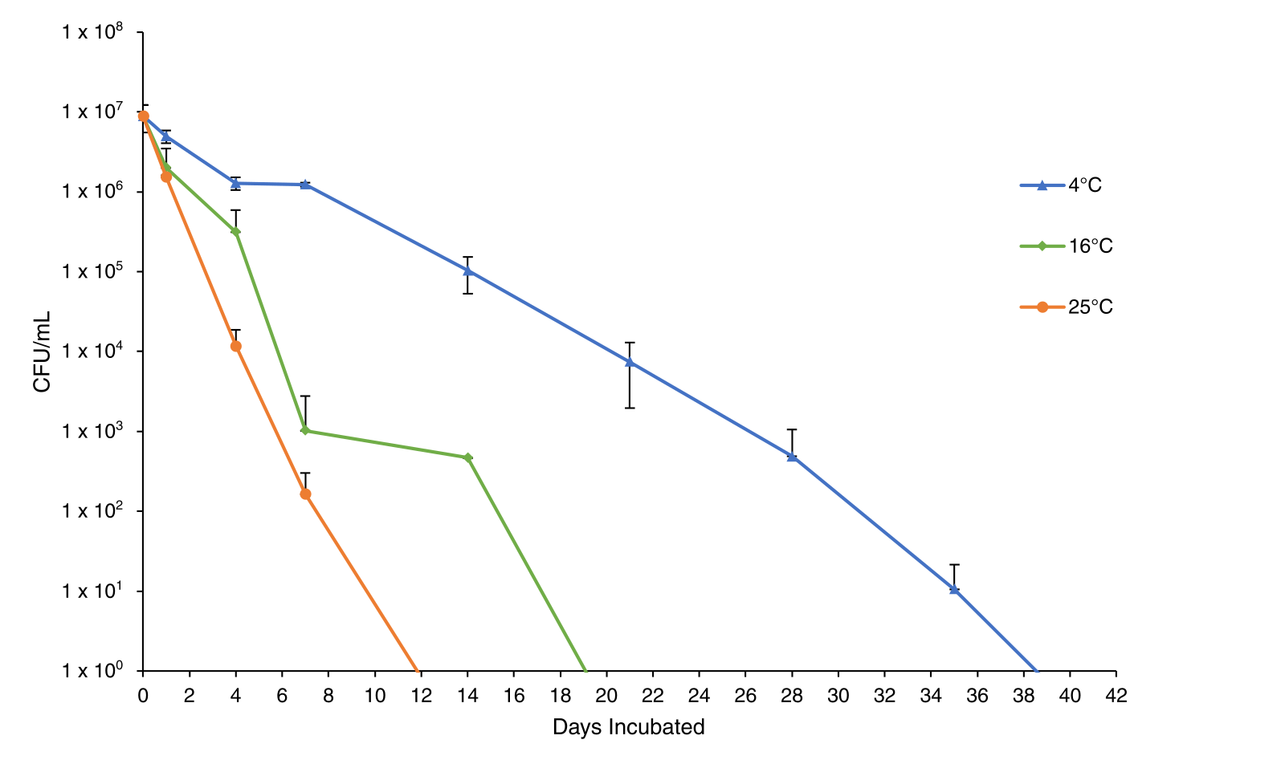
Fig 2. Survival of F. tularensis LVS in fresh water at various temperatures. Average colony forming units (CFU) per mL recovered at indicated time points. Cells remained viable for the longest time when incubated at 4 °C. Cells incubated at 4°C represented by blue circles, cells incubated at 16°C are represented by green circles, and cells incubated 25°C are represented by orange circles. Each point represents the average of biological triplicates. Error bars represent 1 SD.
- Font 10 for #, and 12 for labels, legend = 12
- Bigger markers

This can be found in: 22_Plating Comparisons
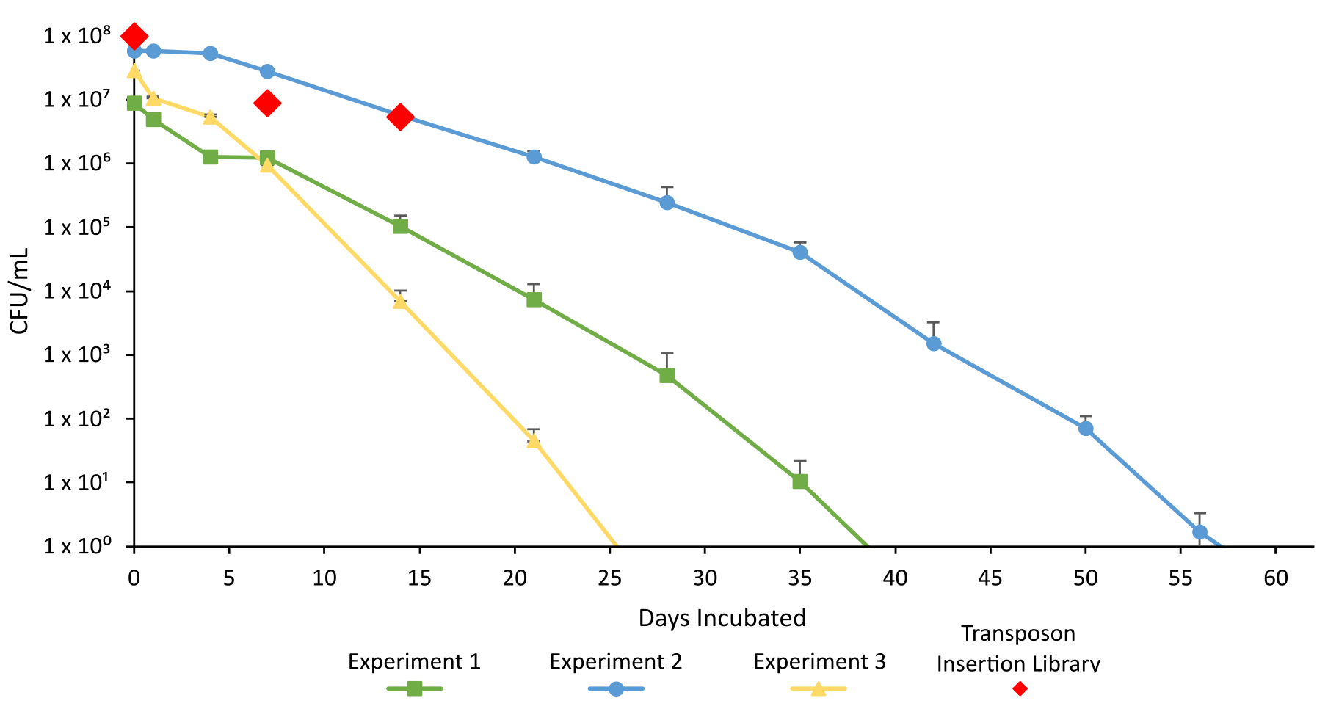
Fig 3. Survival of F. tularensis in 4°C fresh water. Average CFU per mL recovered at indicated time points for three experiments with cells incubated at 4°C. Experiment 1 data shown is from Figure 2. Cells remained viable for a maximum of 56 days (experiment 2). Cells grown in experiment 1 are represented by green squares. Cells incubated in experiment 2 are represented by blue circles. Cells incubated in experiment 3 are represented by yellow triangles. Cells from the transposon mutant library are indicated by red diamonds. This also indicate when cells were collected for analysis by transposon insertion sequencing (days 0, 7, and 14). Each point represents the average of biological triplicates. Error bar represents 1 SD.
- Darker red for the library, and outline in black
- Change font sizes
- Change exp. 1 to be blue
- And change exp. 3 to be orange
- Move legend
- Different shades of blue

Fig X. Tn-Seq Screening results?
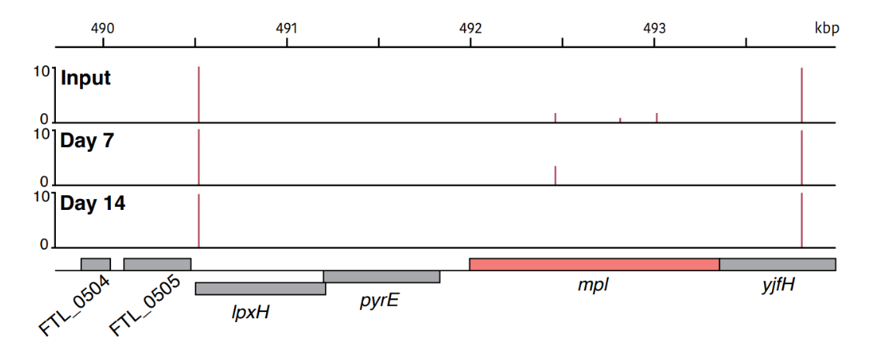
Fig X. Any specific read inputs/outputs for candidate gene

