Figure 1: Method for survival assay (?) probably not necessary but could be helpful

This can be found in: 2202_Plate Counts

Fig 2. Survival of F. tularensis in river water at various temperatures: Replicate 1. Average colony forming units (CFU) per mL recovered at indicated time points. The longest surviving viable cells were found at 4 °C. The blue dots are viable cells at 4°C, the green dots are the viable cells at 16°C, and the orange dots are the viable cells at 25°C. Each line represents the average of the biological triplicate at each temperature. Samples were plated for a following two weeks to ensure that were no viable cells. Error bars represent 1 SD between.

This can be found in: 22_Plating Comparisons
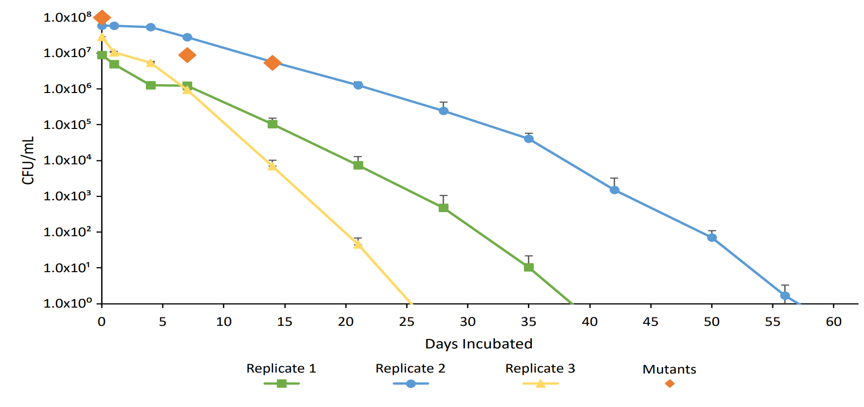
Fig 3. Average CFU per mL recovered at indicated time points for three replicate experiments, with cells incubated at 4°C. The longest survival was 56 days in replicate two. The green line (square markers) represents replicate one, which cells survive for 35 days. The blue line (circle markers) represents replicate two, which cells survive for 56 days. The yellow line (triangle markers) represents replicate three, which cells survive for 21 days. Each line is representative of the average of the three samples from the replicate. The orange diamonds represent the time points when gDNA extraction was performed (day 0, 7, and 14). Error bar represents 1 SD.

Fig 4. Tn-Seq Screening results?
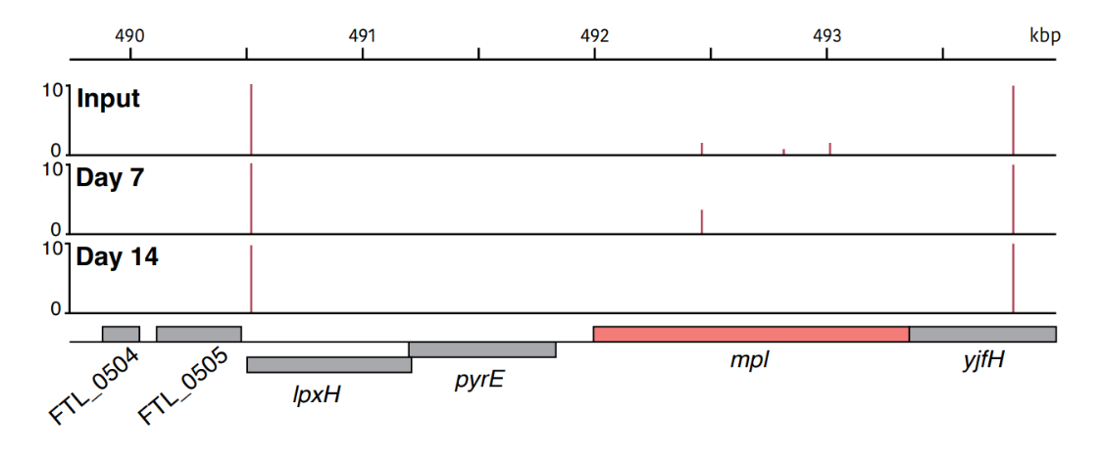
Fig 5. Any specific read inputs/outputs for candidate gene

