Introduction
Francisella tularensis is a Gram-negative intracellular pathogenic bacterium that is the causative agent of tularemia, a potential bioweapon. A mere 10-25 individual organisms can cause disease in humans (Saslaw, 1961). Without appropriate antibiotic treatments this disease can cause more than 50% mortality (Sjöstedt, 2007). We chose to investigate the environmental conditions and genetically-encoded factors that are required for aquatic survival of F. tularensis. There is a connection between the aquatic life cycle and two common vectors of tularemia, hares and mosquitoes, but the mechanism is unclear (Hennebique, 2019). Further study is beneficial as there have been recorded outbreaks in Norway, Koscovo, Bulgaria, Spain, and Turkey, all of which can be traced back to aquatic reservoirs. (Maurin & Gyuranecz, 2016)

Previous research has demonstrated lower temperatures, such as 20°C, have greater viability of the bacteria in the laboratory setting (Golovliov et al., 2021). For example, Forsman’s work showed F. tularensis was able to survive for 70 days at 8°C in freshwater (M. Forsman, 1999). While another study shows survival for 10 days in freshwater and 18 days in saline, both at 37°C (Berrada, 2011). To our understanding, there is one gene that is known as essential for the transition from aquatic to mammalian host, FTL_1753. This gene produces a MscS-type mechanosensitive channel, and it was found the channel can protect F. tularensis from hypoosmotic shock (Williamson, 2017).

We wanted to determine specific gene(s) involved in the survival of Francisella tularensis subsp. holarctica outside of the host in an aquatic context. Using a cell survival assay, we identified the optimal temperature of 4°C for F. tularensis survival in sterile freshwater. Next, we genetically screened using transposon mutagenesis to create a library to pass through the input and output conditions of initial inoculum at post seven and fourteen days. Through this In-sequencing screen we identified mpl as a potential gene candidate. Finally, we show that mpl is needed for the survival of F. tularensis in freshwater at 4°C.
Methods
Bacterial strains and growth conditions
Except where otherwise noted, Francisella tularensis subsp. holartica LVS were grown aerobically at 37°C on cystine heart agar (Difco) supplemented with 2% hemoglobin (CHAH). Escherichia coli strains PIR-1 were used in vector construction. For selection, antibiotics were used at the following concentrations: kanamycin 5 ug/mL (LVS) and carbenicillin 10 ug/mL (E. coli).
Cell Survival Assay
Fresh water was collected from the Beaver River in Rhode Island. The water was sterilized by filtration using a 0.22-micron filter. Wild-type LVS or transposon mutant library cells were grown to a confluent lawn on CHAH and resuspended in sterile water to a final OD₆₀₀ of 0.03. Cells in fresh water were incubated at indicated temperatures (4°C, 16°C, or 25°C) in triplicate. The cultures were serially diluted and plated on CHAH to determine the viable colony forming units (CFU) on indicated days and, for the wild-type cells, weekly for two weeks after detecting the last viable CFU. Plates were incubated at 37°C for 3-4 days or until single colonies could be counted. This cell survival assay was completed three times. Cells were removed from triplicate cultures of transposon mutant library cultures for gDNA isolation on the same day they were plated for CFU.
Vector Construction
The previously used transposon delivery vector, pKL91, was modified for compatibility with post-(2009?) Illumina P7 capture site, which is 24 bp (8 bp longer than the previous version). The pre-2009(?) P7 capture site is encoded within the end of the transposon in the pKL91 transposon delivery vector. A two-step process was used to add the additional 8 bp to both ends of the transposon. First, pKL91 was digested with KpnI and PacI to remove the DNA at one end of the transposon. A dsDNA fragment was synthesized by IDT that contains the sequence between the KpnI and PacI sites, modified only by the addition of the additional 8 bp necessary to encode the entire P7 capture site. The synthesized fragment was digested by KpnI and PacI and ligated into the digested pKL91 to yield pKR140. This process was repeated to modify the P7 capture site on the other end of the transposon, digesting pKR140 with PstI and BamHI and replacing the DNA with a synthesized fragment containing the full 24 bp P7 site. Both pKR140 and pKR141 were verified by Sanger sequencing (Rhode Island INBRE-CORE).
Transposon mutant library construction
To generate the transposon mutant library, F. tularensis LVS cells were transformed essentially as described (Maier et al., 2004) using one microgram of transposon delivery plasmid pKR141. Ten independent electroporations were performed and cells were plated on CHAH with 5 ug/mL kanamycin. After four days of incubation at 37°C and one day at room temperature, the kanamycin-resistant colonies were combined and frozen, an estimated 6,400 colonies. A single aliquot was spread on CHAH plate containing 5 ug/mL kanamycin and incubated at 37°C to a confluent lawn. These cells were resuspended in freshwater and used in the initial inoculation of the freshwater media for Tn-Seq experiment.
INSeq library construction and sequencing
Sequencing libraries were generated from three samples: (1) the initial mutants inoculated into freshwater, (2) mutants incubated in freshwater for 7 days at 4°C, and (3) mutants incubated in freshwater for 14 days at 4°C. Libraries were generated from isolated gDNA as Ramsey et al., 2020, based on Goodman et al., 2011. The input library was sequenced using a X kit on a MiSeq (Core) and the three samples were pooled and sequenced again.
Tn-Seq data analysis

Results
Assessing survival of F. tularensis in freshwater
Our overall goal was to determine which genes are important for survival in freshwater. To accomplish this, we needed to first identify the optimal laboratory conditions in which F. tularensis lives in freshwater. Determining the optimal temperature was our first focus, as we planned to use sterilized water from the environment.
To find what temperature would permit the most F. tularensis LVS survival in freshwater, we developed the following method. We inoculated F. tularensis LVS into filter sterilized water from the Beaver River from Rhode Island. Next, we distributed the inoculated water in triplicate, each at three different temperatures, 4°C, 16°C, and 25°C (Fig. 1). Over a series of days, we plated the cells, and counted the colonies using the drip method (Fig. 1). This was repeated two weeks after no colonies grew on the plate to ensure no viable cells were in the sample. We found that cells were viable through day 35 at 4°C, through day 14 at 16°C, and through day 7 at 25°C (Fig. 2). On day 7 the sample averages (CFU/mL) of the 4°C was about three-fold more than the warmer conditions. We observed a further drop off on day 14 with the sample averages (CFU/mL) of 4°C threefold higher.
Next, we wanted to determine if we could replicate how long the cells were able to survive at 4°C. To address this, we completed two additional independent experiments that tested the viability of F. tularensis LVS at 4°C. Overall, we found that F. tularensis LVS was able to remain viable in sterile freshwater at 4°C for 21 to 56 days. Even with this variability, we observed that the cells at 4°C were viable for a longer period of time than the cells incubated at 16°C or 25°C in all three independent experiments. It is important to note that the starting inoculums varied with the three experiments.
Generation of transposon mutant library.
We do not know which genes are necessary for survival in freshwater. The method we used was transposon insertion sequencing (Tn-Seq) experiments to compare wild-type to the mutant library under the condition of sterile freshwater at 4°C. This experiment was designed to show the essential genes in both wild-type and mutant libraries, and only the mutant library. This can be inferred by the transposon insertions that are measured across the genomes. We can use this data to find which genes are essential for F. tularensis LVS survival in freshwater at 4°C.
For this strategy, we needed to generate a transposon mutant library. First, we made modifications of previously used transposon vector because there were changes to the Illumina P7 capture site. This meant that we needed to add eight base pairs to the end of the transposon sequence for the transposon vector to be compatible with current Illumina MiSeq technology. These modifications resulted in pKR141 Ft_InSeq_Tn.
Assess transposon mutant library for ability to survive in freshwater.
We successfully made transposon mutant libraries following the protocol from Goodman et. al, 2011 (Goodman, 2011). First, ten electroporations were completed with the transposon plasmid, and three (?) days later all colonies were scraped to create the mutant libraries. To confirm the collected mutant libraries had the components necessary for a MiSeq protocol and had different complementary gDNA to the F. tularensis genome, we sanger sequenced randomly selected individual mutant colonies. With the sequence data, we confirmed the mutants were as designed, and then we inoculated the transposon mutant library into freshwater. gDNA was isolated on days 0, 7, and 14. The isolated gDNA was then prepared for MiSeq analysis. For each of the transposon mutant libraries, we identified ~500,000 reads corresponding to an estimated 6,400 mutants. We identified three transposon insertion mutants in the mpl gene at day 0 and one insertion at day 7 but did not recover DNA corresponding to any of those insertion mutants at day 14 (Fig. X). This suggests that mpl is important for survival in freshwater at 4°C.
- Not sure what else to include?
Testing the cells lacking mpl.
We designed and tested the cells lacking mpI viability in sterile freshwater at 4°C using the cell survival assay method previously described. We found the bacteria remained viable from XXX days to XXX days when the experiment was completed in triplicate. The cells with the ectopic expression of mpI restored this phenotype back to wild-type levels. We also constructed a deletion strain of FT_1753 and measured the viability of these cells in sterile freshwater at 4°C. These results indicate the gene mpI is important for the survival of F. tularensis LVS in freshwater at 4°C.
Discussion
We found that the optimal temperature of survival of F. tularensis to be 4°C in sterile freshwater, and a gene candidate mpl that is needed for survival under these conditions. This gene has been previously hit in a genetic screen as important for intramacrophage growth (Ramsey, 2020). This protein has been identified as a UDP-N-acetylmuramate--L-alanyl-gamma-D-glutamyl-meso-diaminopimelate ligase. To our knowledge, no pathways or mechanisms involving mpl and survival of F. tularensis have been found.
Previous works by Forsman and Golovliov align with our finding that F. tularensis LVS longest survival of up to 56 days in sterile freshwater at 4°C in comparison to 16°C and 25°C. It would be interesting to test the longest viability at specific temperatures between 4°C and 16°C in the future and compare the genetic output.
Comparing the three independent experiments completed, it is important to note the variability of survival of 21 to 56 days between experiments. This could be due to the variation in starting inoculum. Experiment 2 has the most starting inoculum and the longest survival of bacteria. This could mean that as the cells in the sample were dying, and the surviving cells were able to utilize the nutrition from the deceased cells.
This study has limitations with the coverage of the Tn-Seq screen. We found 6,671 TA nucleotide insertion sites with high confidence. This aligns with the number of mutants that were harvested but is only about 3% of the possible TA sites that could have an insertion.
We aimed to find the genetic context of the survival of F. tularensis subsp. holarctica outside of the host in an aquatic environment. This study highlights the need for continued research of gene regulation during the lifecycle of F. tularensis outside of the host. Future research could investigate mpl and its involvement specifically in F. tularensis. Other interesting research could be investigating the morphology throughout these time periods in regard to mpl. Previous work has shown that this gene encodes for a murein peptide ligase in E. coli as well as Psychobacter (CITE). In these organisms, it is found that mpl acts a recycler enzyme for the formation of the cell wall (CITE)f. If F. tularensis is outside of the host and enduring the harsh environment, more damage could be occurring on its cell wall. This would allow for the possible activation of Mpl to quickly repair the cell wall. Possible future experiments could include comparing the transcription levels of mpl and levels of abundance of Mpl before and after incubation at 4°C over a week and 14 days.
Figures

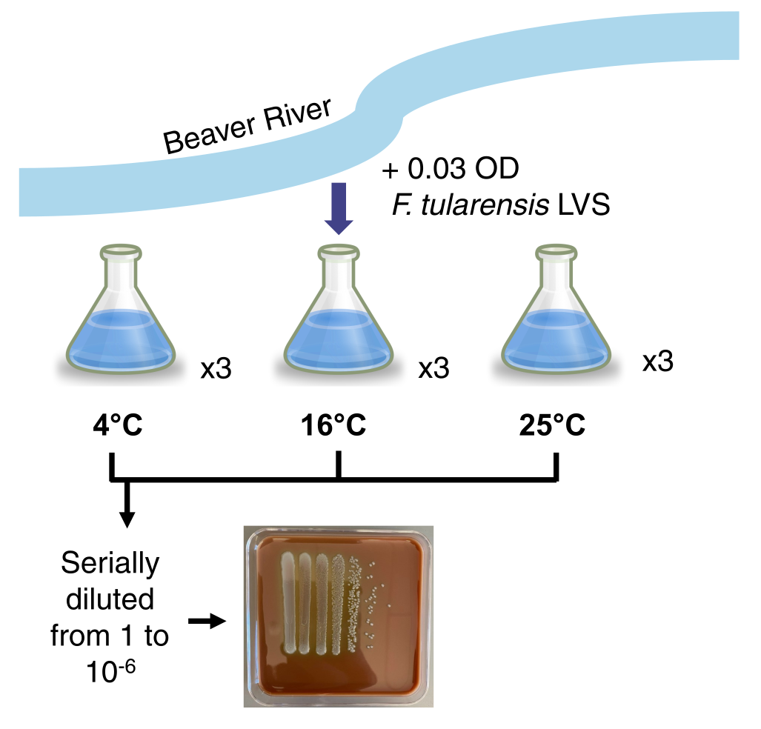
Fig 1. Development of method for survival assay. Water was retrieved from the Beaver River and was filter sterilized. F. tularensis LVS was grown to an optical density of 0.03. Inoculation of one flask was then distributed to nine flasks. Three flasks were each kept at one temperature, either 4°C, 16°C, or 25°C. Each week the samples were serially diluted. A representative plate is shown.

This can be found in: 2202_Plate Counts
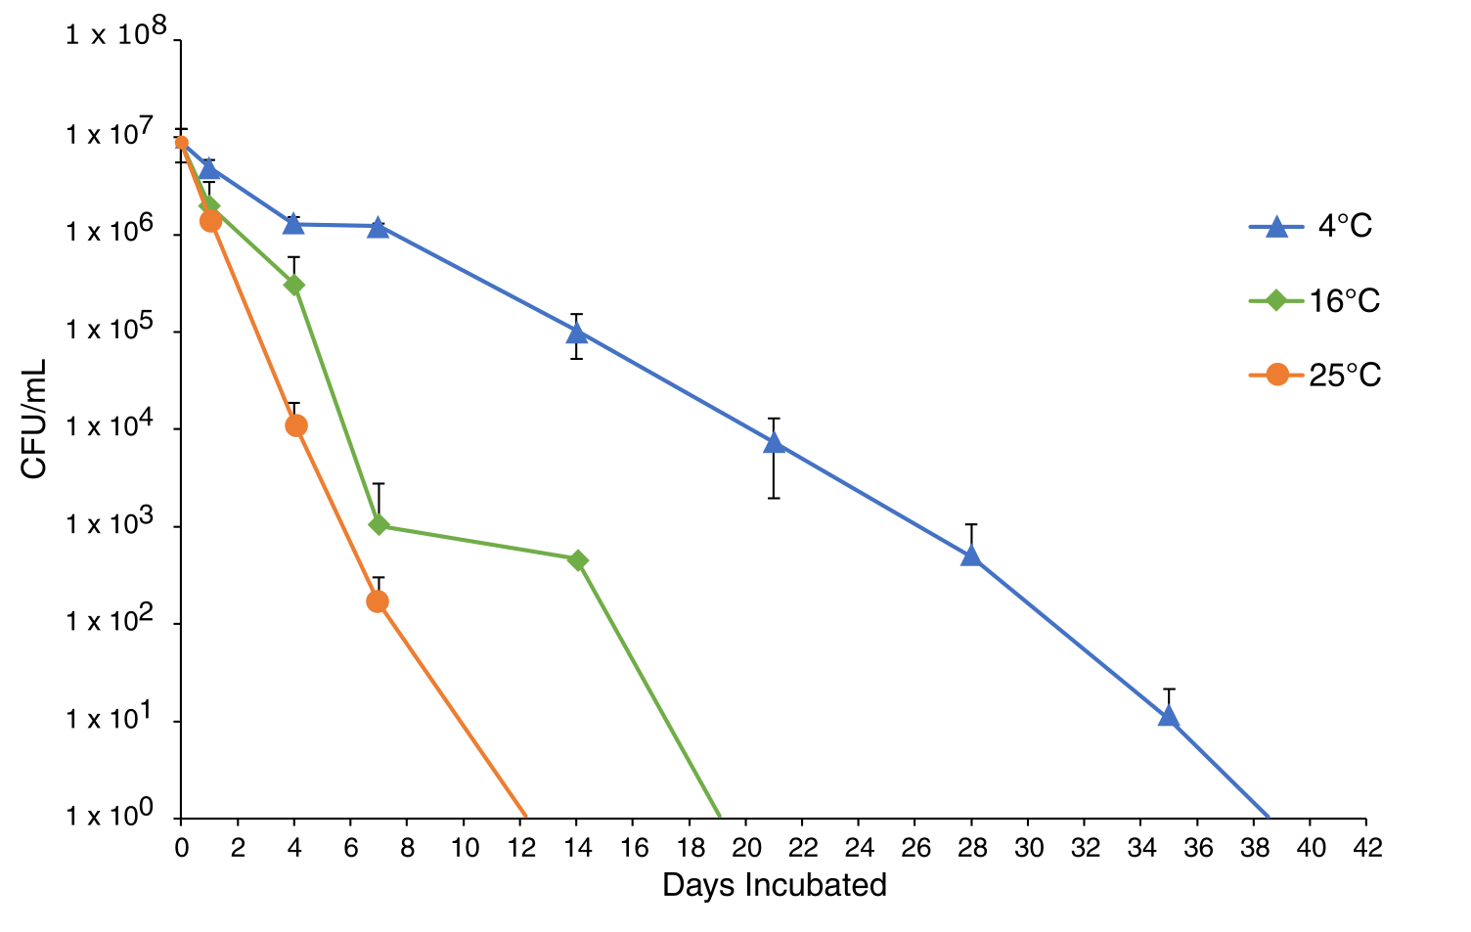
Fig 2. Survival of F. tularensis LVS in fresh water at various temperatures. Average colony forming units (CFU) per mL recovered at indicated time points. Cells remained viable for the longest time when incubated at 4 °C. Cells incubated at 4°C represented by blue circles, cells incubated at 16°C are represented by green circles, and cells incubated 25°C are represented by orange circles. Each point represents the average of biological triplicates. Error bars represent 1 SD.

This can be found in: 22_Plating Comparisons
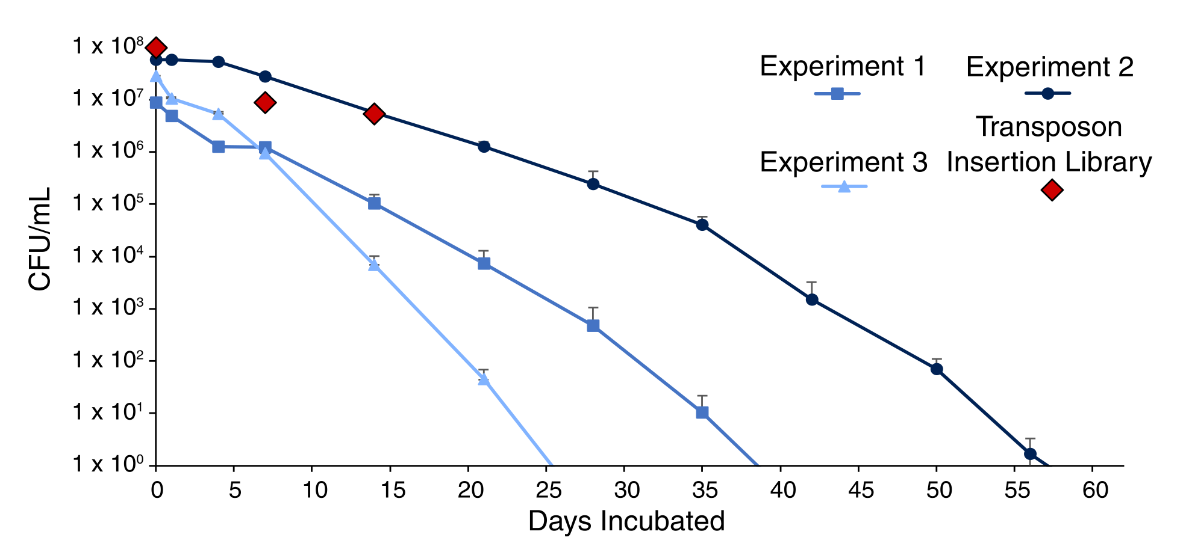
Fig 3. Survival of F. tularensis in 4°C fresh water. Average CFU per mL recovered at indicated time points for three experiments with cells incubated at 4°C. Experiment 1 data shown is from Figure 2. Cells remained viable for a maximum of 56 days (experiment 2). Cells grown in experiment 1 are represented by green squares. Cells incubated in experiment 2 are represented by blue circles. Cells incubated in experiment 3 are represented by yellow triangles. Cells from the transposon mutant library are indicated by red diamonds. This also indicate when cells were collected for analysis by transposon insertion sequencing (days 0, 7, and 14). Each point represents the average of biological triplicates. Error bar represents 1 SD.

Fig X. Tn-Seq Screening results?
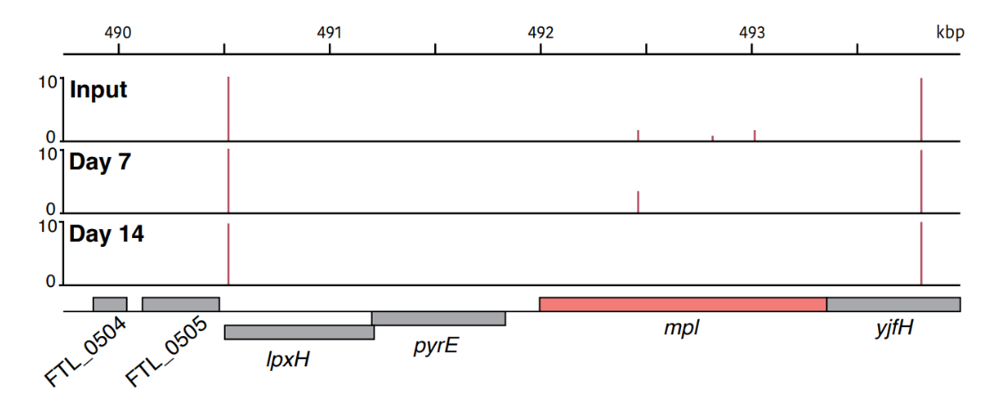
Fig X. Gene candidate mpl is required for F. tularensis LVS survival in 4°C freshwater. Transposon insertion profiles from the input, day 7, and day 14. Line height represents the relative abundance of sequencing reads at that position on a log scale.

Literature Cited
Francisella tularensis does not manifest virulence in viable but non-culturable state. Mats. Frosman. 1999.
Survival of Francisella tularensis Type A in brackish-water. Zenda Lea Berrada. 2011.
Tularemia as a waterborne disease: a review. Aurelie Hennebique. 2021.
Goodman, A.L., Wu, M., and Gordon, J.I. (2011). Identifying microbial fitness determinants by insertion sequencing using genome-wide transposon mutant libraries. Nat Protoc 6, 1969-1980.
Saslaw S, Eigelsbach HT, Wilson HE, Prior JA, Carhart S. Tularemia Vaccine Study: I. Intracutaneous Challenge. Arch Intern Med. 1961;107(5):689–701. doi:10.1001/archinte.1961.03620050055006
Sjöstedt A. (2007). Tularemia: history, epidemiology, pathogen physiology, and clinical manifestations. Annals of the New York Academy of Sciences, 1105, 1–29. https://doi.org/10.1196/annals.1409.009
Williamson DR, Dewan KK, Patel T, Wastella CM, Ning G, Kirimanjeswara GS. 2018. A single mechanosensitive channel protects Francisella tularensis subsp. holarctica from hypoosmotic shock and promotes survival in the aquatic environment. Appl Environ Microbiol 84:e02203-17. https://doi.org/10 .1128/AEM.02203-17
Ramsey, Kathryn M.; Ledvina, Hannah E.; Tresko, Tenayaann M.; Wandzilak, Jamie M.; Tower, Catherine A.; Tallo, Thomas; et al. (2020). Genes identified as important for intramacrophage growth of F. tularensis LVS using Con-ARTIST analysis. PLOS Pathogens. Dataset. https://doi.org/10.1371/journal.ppat.1008566.s007

