Table of Contents
October 2022 2
Disc Diffusion Assay – S. aureus Edited 5/27/22 2
Making Glycerol Stocks Protocol 10

October 2022

Week of October 17th
Research Objective:
Organism | Drug | Concentration | Repetition? | Description
SA | LB | 8mg/ml | First Time | Testing remaining SA mutants from library, potentially try to identify any mutants

Calendar:
Monday | Tuesday | Wednesday | Thursday | Friday
After 2 | After 1:30 | After 2 | After 1:30 | After 2
10 | 11 | 12 - Prep media | 13- DDA | 14 - I/A EC/SA
17- prep | 18-DDA | 19 | 20 - I/A | 21

Monday | Tuesday | Wednesday | Thursday | Friday
After 2 | After 1:30 | After 2 | After 1:30 | After 2
10 | 11 | 12 - Prep media | 13- DDA | 14 - I/A EC/SA

Tuesday, October 18th, 2022
To Do:
- Streak out SA113 and mutants
- Pour LB plates

Results and Data:

Disc Diffusion Assay – S. aureus Edited 5/27/22
- Pour fresh LB plates (24ml per plate) day before DDA to have more consistent results
- Resuspend cells (half of a loopful) for the strain being tested in about 400 µL of LB media. Measure the OD600.
  - Put 950 ul of MHB into cuvette and then 50 ul of the bacteria
- Aim for a final OD600 of 0.05. Dilute the appropriate amount of culture in a 50 mL conical or serially dilute in 1.5ml tubes that contains LB media to get required OD600, for a final volume of 1 mL. [Use C1V1=C2V2] Repeat steps 1 and 2 for a separate strain if necessary.
- Add 100 µL each of S. aureus cells at OD600 0.05 to 3 LB agar plates and spread with glass beads. Repeat this a second time with new plates if testing another strain. Allow plates to dry.
- Using sterile tweezers, add sterile filter paper discs to a sterile plate and then add 20 µL methanol and antimicrobial to respective discs. Allow these discs to dry for 20 minutes.
- Using sterile tweezers, transfer discs from sterile plate to LB agar plates that have been spread with S. aureus so that there is a water disc and antibiotic disc on each LB agar plate and gently press them into plate without breaking the agar.
- Place into incubator and take note when, needs ~24 hours
- Image and analyze plates

Testing 8 mutants and comparing to wild type. Need one plate per strain plus a few extra.
9 non abx plates and extra – depending on the amount of LB I can just make a full stack of non abx or ask someone in the Slack if they need any specific antibiotic plates.
Take nonabx LB plates from fridge place in incubator – if none are available will push prep to Wednesday and should be able to complete experiment by Friday worst case scenario.
Mutants being tested: LR1A-3, LR1B-3, LR2A-3, LR2B-3, LR3A-3, LR3B-3, LR4A-3, and LR4B-3
Poured non abx plates (plenty of excess) labeled 10.18
Struck out 4 mutants per plate (each from glycerol stock, took 2 stocks out at a time and struck out to avoid melting) and placed in incubator (2 plates of mutants) and struck out SA113 from single use aliquot made 5.26.22.

Wednesday, October 19th, 2022
To Do:
- DDA
- Make single use aliquots

Results and Data:
Initial experiment plan was unable to be executed – lack of laurenobiolide and issues with dry ice orders from the Bertin lab. New course of action: instead of testing the mutants today, I tested the increased concentration of tulipifera extract compared to the original. S. aureus was tested in triplicate of 100mg/ml tulipifera extract and in duplicate of 10mg/ml tulipifera extract. Control for both variables was methanol discs.
Scraped up cells, OD was .221. Needed 113.1ul into final volume tube of 1000. Diluted 1:10 before putting the correct volume of cells into final, then aliquoted 100ul onto each plate and spread with beads. One methanol disc and one extract disc per plate, placed into incubator around 3:15pm.
Made single use aliquots of SA113, as I was running low. 400ul of MHB, scraped up the rest of the cells I had left over from the plate I struck out yesterday/didn’t use for the disc diffusion today and resuspended. Added 400ul more of MHB and then 200ul of 75% glycerol and then aliquoted. Aliquots are labeled SA113 with today’s date of 10.19.22.
Many of my aliquots went missing so I created a new MHB aliquot, new methanol aliquot, and new 75% glycerol aliquot. MHB is in the large 4C fridge while the other aliquots are above the bench next to the spec.

Thursday, October 20th, 2022
To Do:
- Image
- Analyze

Results and Data:
When I took my plates out of the incubator, I noticed that on the 100mg plates, the extract seemed to have stained the bacteria a yellowish color beyond the zone of inhibition. Mainly I noticed the difference between the 10 and 100mg plates—the 10mg plates had a narrow zone of inhibition with a lesser concentration of bacteria growing inside the zone, while the 100mg plates had clear zones of inhibition with no bacteria growing inside.
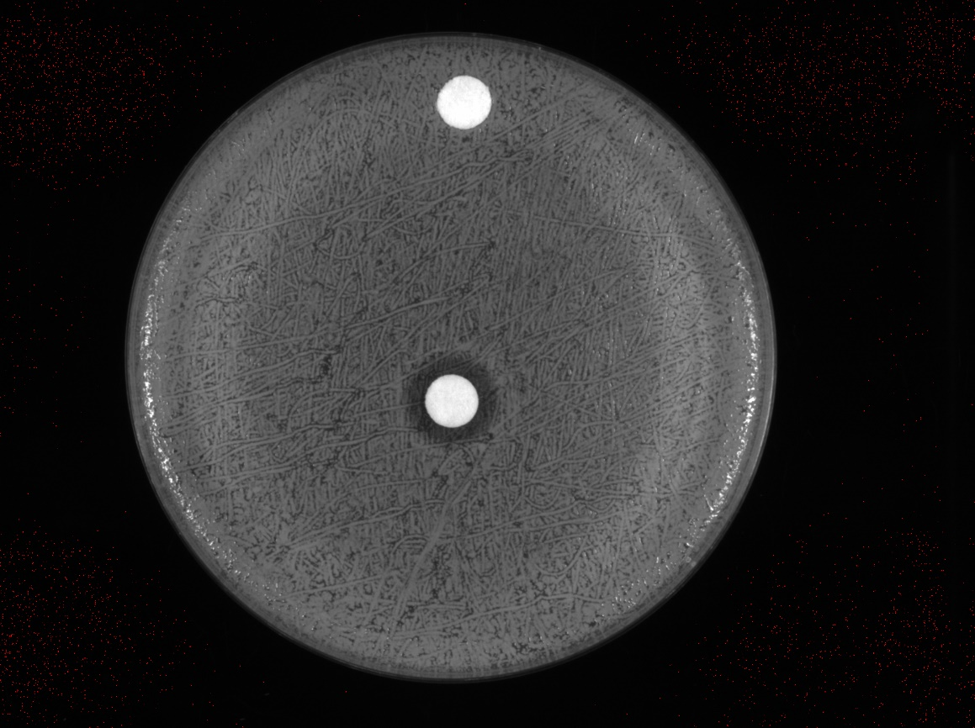
.05OD SA113 with 10mg/ml laurenobiolide and MeOH control

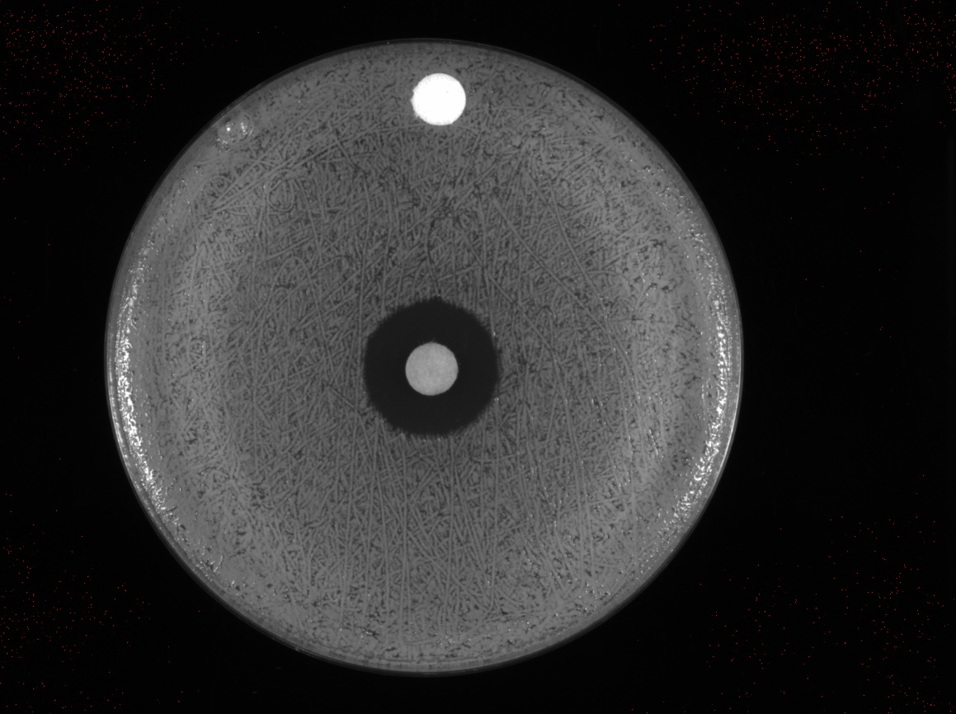
.05OD SA113 with 100mg/ml laurenobiolide and MeOH control
S. aureus | Rep 1 Zone (mm) | Rep 2 Zone (mm) | Rep 3 Zone (mm) | Average of Replicates | Std Dev
10mg/ml tulipifera | 11.352 | 11.369 |  | 11.3605 | 0.012020815
100mg/ml tulipifera | 18.212 | 18.72 | 18.516 | 18.48266667 | 0.255635157

Week of October 24th
Research Objective:
Organism | Drug | Concentration | Repetition? | Description
SA | LB | 8mg/ml | First Time | Testing remaining SA mutants from library, potentially try to identify any mutants

Calendar:
Monday | Tuesday | Wednesday | Thursday | Friday
After 2 | After 1:30 | After 2 | After 1:30 | After 2
10 | 11 | 12 - Prep media | 13- DDA | 14 - I/A EC/SA
17- prep | 18-DDA | 19 | 20 - I/A | 21

Monday | Tuesday | Wednesday | Thursday | Friday
After 2 | After 1:30 | After 2 | After 1:30 | After 2
10 | 11 | 12 - Prep media | 13- DDA | 14 - I/A EC/SA

Monday, October 24th, 2022
To Do:
- Streak out cells
- Pour LB plates

Results and Data:
Heated up the LB agar from 9/13 on a hot plate, however the flask had broken while it was being warmed which led to an unfortunate clean up process. ):
After I cleaned up the remnants with Hannah, I used the other LB agar that was more recently made and was able to pour plates. I poured 10 plates that were non abx, but since I know I have a lot of non abx plates in the fridge, I made LB-kan plates with the remaining LB agar. I let them sit on the bench to dry overnight.
I struck out SA113 from a single use aliquot that I had made last week (10/19/22) on one non-abx plate, and then I used two non-abx plates for streaking out the mutants. I sectioned them into four groups and each mutant was struck out from its glycerol stock and onto its part of the LB plate. After I finished streaking out, I placed them in the incubator.

Tuesday, October 25th, 2022
To Do:
- DDA mutant experiment

Results and Data:
I began by labeling my tubes and plates and then I resuspended each strain. I followed the protocol that is listed under Tuesday October 18th, yet except instead of doing 3 plates per strain, I only did one plate as this is a preliminary screening of each potential mutant to see if there is any differing data from the wild type. I ended up placing the finished plates in the incubator around 3pm.

Strain | Initial OD | 1:10 | mL of cells/MHB per 1000ul of
SA113 | .177 | Yes | 141.2mL
LR1A3 | .155 | Yes | 161.3mL
LR1B3 | .128 | Yes | 195.3mL
LR2A3 | .139 | yes | 179.85mL
LR2B3 | .09 | NO | 27.8mL
LR3A3 | .08 | NO | 31.25mL
LR3B3 | .083 | NO | 30.1mL
LR4A3 | .173 | yes | 144.5mL
LR4B3 | .073 | NO | 34.2mL

Wednesday, October 26th, 2022
To Do:
- Image and analyze plates

Results and Data:
Upon looking at my plates, they all seem very strange. I will be repeating this experiment next week because my main concern is that the cell density/concentrations of the cells were not lining up with the previous times I have plated lawns. For next time, I will ask Hannah or Sierra to check my concentrations and calculations to ensure a lower chance of making a mistake next time. All of the plates have background colonies within the zone of inhibition, but I decided with Hannah and Kathryn that it does not make sense to analyze/measure the ZoI’s because there is no distinct rings for the majority of the plates. However, I did notice on the LR4A3 plate that there was a large colony very close to the disc; I plan on streaking that to single colony and then making a glycerol stock of it.
Kathryn had also taken my plates from last week’s experiment and placed them into the 30C incubator in a container with wet paper towels to maintain humidity in hopes of potential resistant mutants popping up.
Struck 4A3 to single colony, but I think I got part of the small colony that was touching the large colony I was interested in – hopefully I can separate them tomorrow.
Tuesday, November 1st, 2022
To Do:
- Pour plates
- Streak out strains
- Patch out single colonies

Results and Data:
I poured about 20 plates of 24mL non abx LB and allowed to cool on the bench.
I picked about 4 colonies from the potential mutant plate that I got from the last experiment from plate LR4A3- I saved the plate and made notes on the 1-4 colonies that I had picked out from the plate. After I picked out each colony, I patched it out on a fresh non abx LB plate. I labeled each one M(mutant)1-4 corresponding from the order I picked them from.
I struck out the potential mutant strains, same as last week. I am redoing last week’s experiment and double-checking my math with Hannah or Sierra for the final OD for the lawns.
Wednesday, November 2nd, 2022
To Do:
- Redo Potential Mutant Screening DDA
- Freeze down LR4A3 potential mutants

Results and Data:
Followed disc diffusion protocol as last week, except I did all my preparation work first (including putting the methanol and compound on disc and letting it dry for longer) and I made sure I chose the driest plates to use for my lawns.
I made sure Hannah checked my calculations for the ODs before I made the volumes to be plated onto the lawns.
Strain | OD | Final volume to add
1A3 | .179 | 139.6ul
2A3 | .251 | 99.6ul
3A3 | .279 | 89.6ul
4A3 | .317 | 78.8ul
1B3 | .358 | 69.8ul
2B3 | .213 | 117.4ul
3B3 | .339 | 73.8ul
4B3 | .221 | 113.2ul
SA | .255 | 98.0ul

Thursday, November 3rd, 2022
To Do:
- Image and analyze staph preliminary screening
- Freeze down LR4A3 potential mutants

Results and Data:
Strain | Measurement mm | Notes
SA113 | 14.304 | WT
LR1A3 | 13.793 | Ns
LR1B3 | 12.53 | Ns
LR2A3 | 12.318 | Ns
LR2B3 | 9.231 | Significantly different than the rest of the measurements. Interesting, looks like there are two “strains” of bacteria; large colonies and then very small cfus that look like background. Need to isolate further and test to determine
LR3A3 | 12.524 | Ns
LR3B3 | 12.01 | Ns, a lot of background within the ring though. May look at further.
LR4A3 | 12.616 | Ns
LR4B3 | 12.528 | Ns

Many of the plates have an interesting looking ring around the zone of inhibition which typically includes a little bit of background or a lot of background within the zone of inhibition.
I measured 3B3 from the ring because the background was very close to the disc.
2B3 looks to have different types of bacteria so I would likely have to streak to single colony and then pick out the different colonies to separate them: the smaller CFUs seem more promising as they are the background that gets very close to the discs.

Making Glycerol Stocks Protocol

- Make 3 cryovials for each strain (permanent stocks), label!
- Prepare 2.4mL of MHB in a 50mL conical (adjust if you are also making single use stocks)
- Take at least half of a thickly spread plate and add cells to the MHB tube
- Resuspend until there are no clumps in the MHB
- Add 600ul of 75% glycerol to the 2.4mL mix by pipetting
- Aliquot 1mL per cryovial, freeze at -80
- For single use stocks follow the same protocol but pipet 50ul of solution to tubes
Made one glycerol stock for each new strain, titled LR4A3M1, LR4A3M2, LR4A3M3, LR4A3M4
Monday, November 7th, 2022
To Do:
- Pour plates
- Streak out cells

Results and Data:
Today I am interested in the 4 mutants that I struck out form

