Table of Contents
July 2022 2
Figure 1 2
Thoughts or questions. 2
Protocol 1 2
Reagents 2
File Formatting Protocol 2
July 2022 4
Bibliography 6

July 2022

Tuesday, July 5th, 2022
To Do:
- Streak out SA113 and LVS
- Pour LB plates
- Make CHAH plates
- XL1Blue conversation with Kathryn

Results and Data:

Figure 1
Figures are inserted as inline .png files when possible, .jpg, .gif, .tif otherwise are acceptable. Figure legends are always inserted in Word (right click – ‘insert caption’) and use “Heading 2” text to properly format in the TOC. Table legends are handled the same way. Figure images must be saved in a separate folder where the source data is saved.

Thoughts or questions. When you have a significant observation, question, confusing point or contradiction that you have identified in your data or protocol, use the “Heading 3” text heading on a descriptive brief title or single word heading so you can refer to it in your TOC later.

Protocol 1
1. This is the format for a protocol in your notebook.
2. The protocol title must be formatted in “Heading 2.”
3. Reagents which must be made for a specific protocol (buffers, solutions) should be listed in a “Reagents” Section, formatted in “Heading 3.”
4. The protocol must be in numerical steps.
5. Use standard notation and carefully describe units for your protocol.
6. Use ½” indent for protocol text.

Reagents
Specific buffers
For initial lab notebooks, write as much detail as possible. As time goes by you will be able to refer to written protocols by their heading and/or page number within the document. If you make any modifications to a protocol you must state how and why.

File Formatting Protocol
1. Filenames begin with your initials, an underscore, and the date, formatted as the last 2 digits of the year, the month, then the day, ex: “KMR_180920_Sample_file1v1.xls”
2. This ensures all files will be sorted by their creator and by their date. You must use this file formatting system for all data files (including photos) that will be shared with the lab.
Bibliography data will be saved as (author/date) and using Mendeley at this time with the TOC inserted by order cited at the end of the lab notebook in the Bibliography section.
Example is a recent publication (Ramsey and Dove, 2016).

July 2022

Tuesday, July 5th, 2022
To Do:
- Streak out SA113 and LVS
- Make CHAH plates
- XL1Blue conversation with Kathryn
Results and Data:
Struck out LVS from my stock from -80C freezer made on June 10th onto a non-antibiotic CHAH plate and placed in incubator.
*Due to incubator issues, LVS plate moved to another incubator in the cold room (25C)
Also struck out SA113 from personal stock made on May 26th onto non abx LB plate from freezer, but I forgot that S. aureus only takes one day to grow, meaning I will restreak tomorrow for a disc diffusion with SA113 on Thursday.
Made slide for lab meeting today.
Made and poured non-abx CHAH plates.
Wednesday, July 6th, 2022
To Do:
- Streak out SA113
- Pour LB plates
- XL1Blue conversation with Kathryn
- Streak out E. coli??
- LVS DDA
- Autoclave plate waste
Results and Data:
Today I did a disc diffusion with LVS and the four compounds that I received from the Bertin lab. I followed the same steps as I did in my last disc diffusion with LVS on June 28th, except I let the discs dry longer – my plates were very wet when I was spreading the bacteria with the beads, so I spent longer trying to spread and let the discs dry longer than usual. I also made sure to ethanol my tweezers every time between touching the compounds, however if it was a disc of the same compound, I found that there was no need (same compound, same bacteria, the results shouldn’t vary). I also took one of the extra plates I made from the stack from yesterday and put it in the incubator (in the 25C room, since ours is currently not functioning properly) with the rest of the disc diffusion plates. This is to see if I have any contamination in the media again. The initial OD was .079 so I needed 63.3ul of 1:10 dilution into the final tube which has a final volume of 1000ul.
Autoclaved plate waste on liquid 20.
Talked to Kathryn about verifying E. coli strain – need XL1Blue strain (ask Hannah?) and I struck out the ATCC strain that I have on non abx LB from the fridge. I also struck out SA113 on non abx LB and placed both in the incubator in the 25C room. Took the glycerol stock of the XL1Blue from the Miscellaneous E. coli box in 5E in the -80C, Hannah said it was the only stock that they had so to be careful. I took a little bit on a stick and struck it out on LB and put the stock back in the freezer, then put the plate in the incubator with the rest of the plates.
Poured LB plates the same way in previous days (ex June 27th). Did not have enough to make abx plates so I just made regular non abx plates. I’ll use them for tomorrow’s E. coli verification too so there won’t be too many in the fridge.

Thursday, July 7th, 2022
To Do:
- SA disc diffusion
- XL1 vs ATCC verification (Tet)
- XL1 blue aliquots?

Results and Data:
I checked on the control CHAH plate I put in the incubator with my DD plates from yesterday – there does not seem to be any contamination which is good. Hopefully, I’ll get viable results when I image and analyze tomorrow.
I did a disc diffusion the same way as I did yesterday except special conditions were considered when plating SA113 and the E. coli strains (concentration). Also, whenever the plates were wet, I let them dry next to the flame for a little bit after I plated the bacteria to get a little moisture out, then I would be sure to spread the beads around a little bit before I emptied the beads from the plates. The ODs for the bacteria were as such:
SA113 - .124 – need final OD of .05, so 201.6ul from the 1:10 dilution into the final volume for 100ul.
XL1Blue - .053 – need final OD of .005, 47.2ul from 1:10 dilution into final volume for 1000ul.
ATCC25922 - .066 – need final OD of .005, 37.9ul from 1:10 dilution into final volume for 1000ul.
The verification of ATCC25922 strain against XL1Blue is a disc diffusion with tetracycline on the disc. ATCC should be sensitive to it while XL1 should be resistant.
Tetracycline is soluble in methanol meaning my control will be CH3OH, there are smaller aliquots of Tet 10mg/ml in the antibiotics box in the -20C and one large conical covered in foil on the bottom shelf with no date labeled– do I need to cover the plates with tinfoil when and after I’ve aliquoted it onto a disc? Looked in Tala’s notebook since there was no date on the large conical so I figured that the most recent documentation is the day she made it – Jan 8th 2020.
When aliquoting the tetracycline on the discs, some of the tetracycline came out black and clumpy as if it had degraded.
Notes from meeting w/ Kathryn:
Repeat LVS and do the EC DDA – next week
Work on poster and abstract – looking ahead, work on the June 22 presentation
Looking at MIC protocol – SA in culture tubes (culture tube protocol instead of in 96 well plates)
How much drug at what concentration do I need – for Dr Bertin
Start SA at certain OD overnight (likely) in tubes in certain volume (triplicate) tubes with no drugs and then what concentrations I’m looking at
Never add more than .5% of drug in the total volume*
X concentration of drug in 5mL in triplicate – how much do I need
Put darobactin paper in SURF folder
Write out what authors did – try to be able to explain it
To evolve resistance
Aeration/baffled flask?

Friday, July 8th, 2022
To Do:
- Image and analyze SA + LVS
- Plan for next week
- Poster/abstract
Results and Data:
I imaged and analyzed the plates today and saw interesting results. When I first took the plates out of the incubator, the SA plates looked about the same as last week’s – no zones except for a zone of lightly grown bacteria in the tulipifera plates. What I was not expecting was to see a zone of inhibition for every single one of the LVS plates – is there another compound that is active in this sample besides laurenobiolide? Since it works on Francisella but does not work on S. aureus. I thought it was interesting to see, and I noticed that the tulipifera and the hybrid plates seemed to have the largest diameters in the zones of inhibition (where at least some of the laurenobiolide is present) and smaller zones in the chinense A and B plates despite the fact that there should not be any laurenobiolide in those compounds. What else is in this tree that is causing the antimicrobial activity to LVS?
I also looked at and imaged the XL1Blue vs the ATCC25922 E. coli strains and it seemed that the ATCC strain was more sensitive to the tetracycline than the XL1 Blue, but since the XL1 strain grew spottier and looked more colony-like rather than a lawn that I was aiming for, it is difficult to determine a proper diameter.
We took a look at the SA DDA plates (which seemed to have tiny colonies) and decided to incubate them over the weekend. Since they were a little old and had begun to crack, we put 6 plates that could show colonies and put them into plastic take out boxes with damp paper towels at the bottom (humidity purposes) and incubated them at the 30C incubator over the weekend (not 37 in case they grow a lot).

LVS w Chinense A
LVS w Chinense B
LVS w Hybrid
LVS w Tulipifera

LVS with compound | Rep 1 Zone (mm) | Rep 2 Zone (mm) | Rep 3 Zone (mm) | Average of Replicates | Std Dev
L. tulipifera | 20.571 | 19.326 | 19.454 | 19.78366667 | 0.684847672
L. hybrid | 19.894 | 20.074 | 20.982 | 20.31666667 | 0.583182076
L. chinense A | 14.405 | 14.775 | 14.355 | 14.51166667 | 0.229419557
L. chinense B | 16.617 | 14.675 | 14.041 | 15.111 | 1.342205647

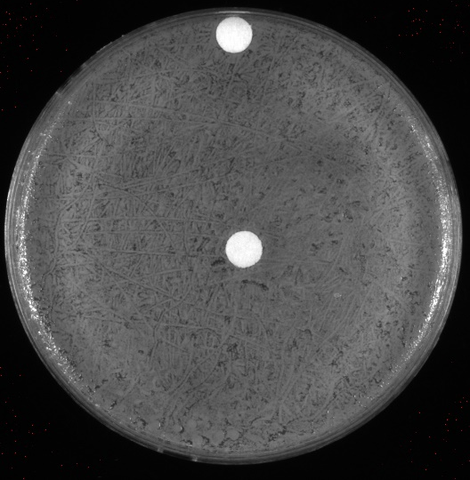
SA w Chinense A
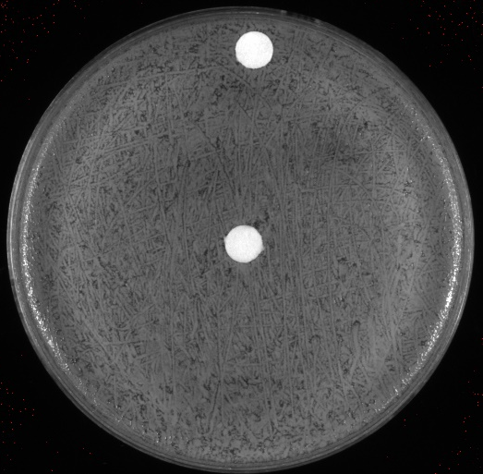
SA w Chinense B
SA w Hybrid
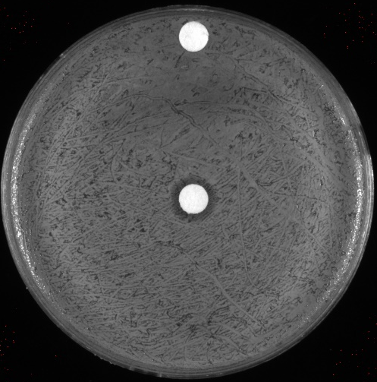
SA w Tulipifera

SA with compound | Rep 1 Zone (mm) | Rep 2 Zone (mm) | Rep 3 Zone (mm) | Average of Replicates | Std Dev
L. tulipifera | 10.108 | 10.231 | 10.259 | 10.19933333 | 0.080326417
L. hybrid | 0 | 0 | 0 | 0 | 0
L. chinense A | 0 | 0 | 0 | 0 | 0
L. chinense B | 0 | 0 | 0 | 0 | 0

Plans for the upcoming week:
Monday
Pour CHAH plates and streak out LVS
Meeting with Kathryn and Dr. Bertin? TBA
Tuesday
Lab meeting
LVS DDA
Pour LB and streak out ATCC
Wednesday
ATCC DDA
Thursday
Image and analyze plates
Meeting with Kathryn
Friday
Picnic
Come in if needed after picnic

Monday, July 11th, 2022
To Do:
- Make/Pour CHA plates
- Streak out LVS
- Restreak SA colonies to single colony
- Lab meeting slide
Work on Poster/Abstract
Results and Data:
When I came in, I checked on the plates in the 30C and the colonies within the zone of inhibition seemed to grow a little bit but not too much. Kathryn suggested that I should streak out 8-10 to single colony on LB plates. I’ll have Hannah help me because these colonies are so small, and it may be difficult for me. One colony per plate. I should take careful note of which plate each colony comes from and pick the largest one or two from each plate that I see them on.
Following this instruction, I placed 10 LB agar plates in the 37C incubator in the environmental room to warm up while I wait for Hannah to be available to assist me. In the meantime, I work on notebook/written tasks that I must complete such as the slide for tomorrow’s lab meeting.
Streaked potential mutants to single colony. Labels as follows: LR – laurenobiolide resistant(?)
1 – SA DDA Replicate 1 Plate from 6/16
2 – SA DDA Replicate 2 Plate from 6/16
3 – SA DDA Replicate 3 Plate from 6/16
4 – SA DDA Replicate 3 Plate from 6/21
A/B – one colony from each plate (circled on plate)
I made and poured CHAH plates (same way last Tuesday) and labeled them no antibiotic with today’s date. I also was able to streak out LVS from an aliquot I made on June 12th and then placed it in the incubator in the environmental room.
Tuesday, July 12th, 2022
To Do:
- Lab meeting
- LVS DDA – Verification
Results and Data:
Lab meeting
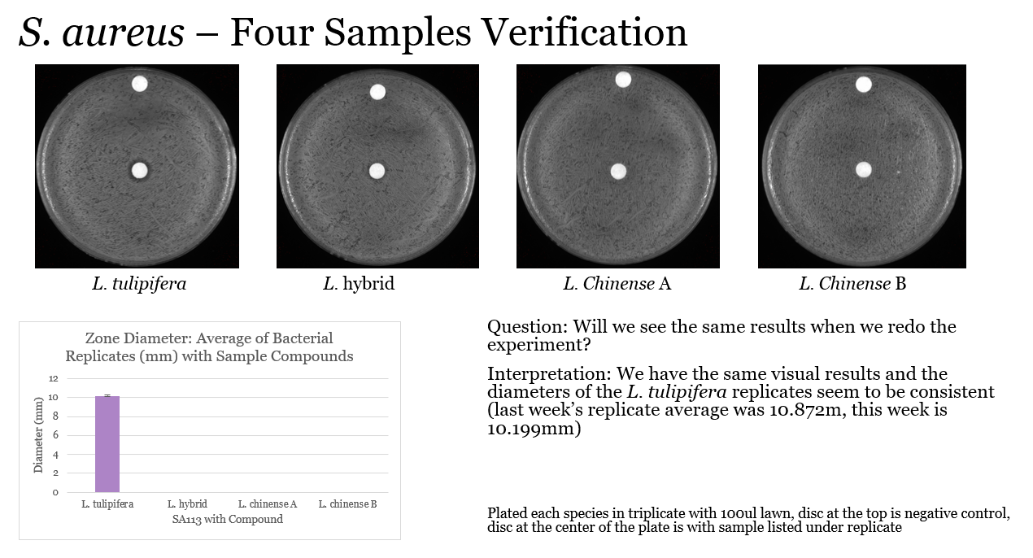
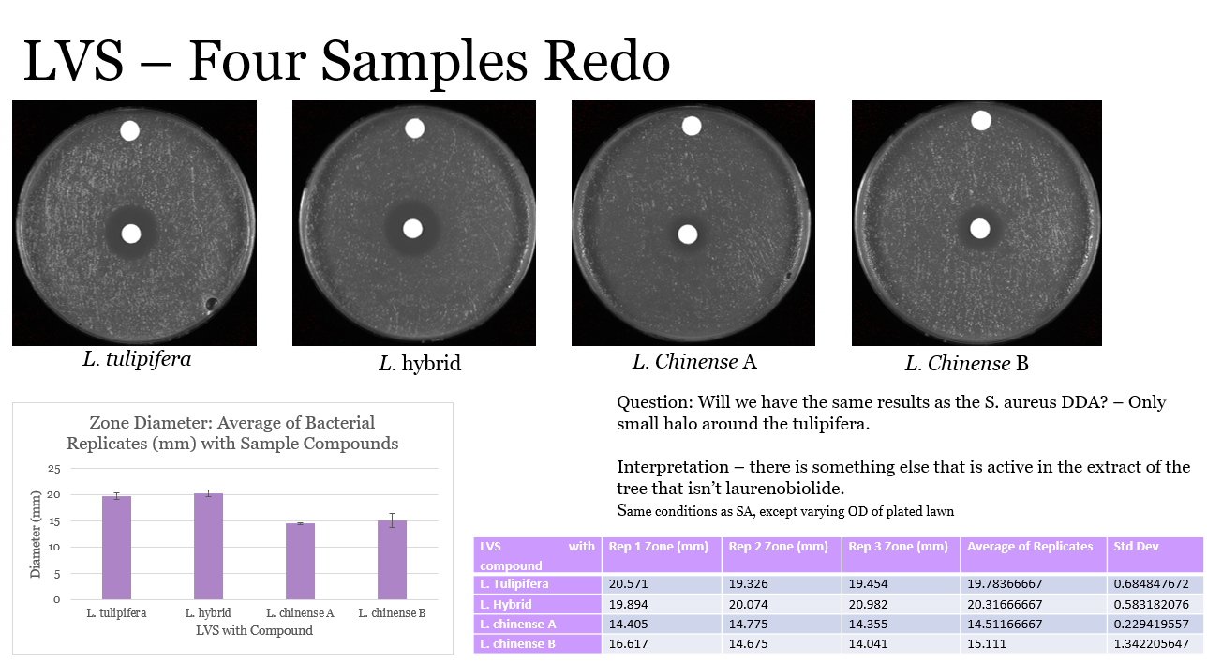
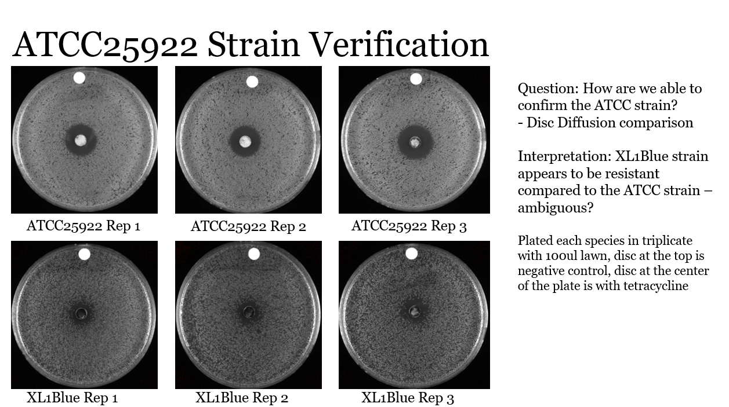
Completed DDA of LVS. Initial OD of .114, needing final OD of .01, 43.8ul from 1:10 dilution was taken and put into final tube volume of 1000ul. 100ul plated on lawn. Plates seemed to be drier than last time which is good, I made sure to take the plates from the bottom as they should be drier than the plates accumulating condensation at the top. I noticed that the plates that I had poured were not uniform – it looked like there were lighter colored chunks of agar despite mixing for several minutes before pouring the plates – should I have heated up the hot plate to 60?
Worked on a draft of the abstract and a mock up of the poster.

Wednesday, July 13th, 2022
To Do:
- Pour fresh LB plates
- Streak out ATCC25922 for DDA
- LR mutants – patch out
- Research Presentation 7/22
- Image SA plates
Results and Data:
I realized I forgot to put a control CHAH plate in the incubator with my disc diffusion. I checked the plates briefly and it does not look like there is any contamination.
Important Due Dates:
July 15th – Time sheet 3pm
July 15th – Picnic at RWU 9am
July 18th – Abstract Revision 10 am
July 19th – Lab meeting slide 10am
July 19th – Poster Draft to Kathryn 11 am
July 19th – Presentation draft 1pm – meeting with Kathryn
July 22nd – Abstract due to SURF Website 5pm
July 22nd – Research Presentation for Joint Lab meeting 10am
July 25th – Poster due to website 10 am
Notes from Meeting with Kathryn:
Abstract – less background, concise description of methods and results 250 words, more detail on what I’ll say at the end – address other extracts, what’s on poster should be explained in abstract – other big implication – highlights the utility at looking at natural compounds

LBR (laurenobiolide resistant) cells – 8 plates w/ single colonies (could have been mixed population)
For each plate, pick 3 colonies and patch on new plate – if size variety, get more than one size (1 of each, take good notes)
LRA (1,2,3) name patches. Make a single glycerol stock for each one of them. (24 glycerol stocks)
Today – patch out
Thursday – make glycerol stocks
Next week – plan resistant mutants
Grow cells, DDA on each isolated colony (once)
Primary screening – one plate per replicate. DDA with laurenobiolide, control is SA113
All plates poured on Monday, do 8 at a time (3 days)
Wild type each day I test the mutants
If no mutants – for Poster put the initial screening, and also take pictures of the SA DDA wbere I took the colonies from (could be breakthrough?)

Struck out ATCC25922 strain for E. coli DDA tomorrow with the four extracts. I made a few extra LB plates from the 500ml flask because I used the last of the no antibiotic plates (besides 1) to patch out the potential SA mutants. The poured plates were left to cool on the bench. I had 4 plates with 6 mutants patched out onto each plate – LR1A/B-1,2,3 were all patched out on the same plate and so on (LR2A/B-1,2,3 and so on) and placed in the incubator.
Started working on project presentation.
Thursday, July 14th, 2022
To Do:
- EC DDA
- Image and analyze LVS plates
- Make glycerol stocks of potential mutants
- Abstract
- Poster
- Research Presentation 7/22
Results and Data:

Making Glycerol Stocks Protocol

- Make 3 cryovials for each strain (permanent stocks), label!
- Prepare 2.4mL of MHB in a 50mL conical (adjust if you are also making single use stocks)
- Take at least half of a thickly spread plate and add cells to the MHB tube
- Resuspend until there are no clumps in the MHB
- Add 600ul of 75% glycerol to the 2.4mL mix by pipetting
- Aliquot 1mL per cryovial, freeze at -80
- For single use stocks follow the same protocol but pipet 50ul of solution to tubes

Made 24 glycerol stocks (1 stock per strain, otherwise too overwhelming). Did not follow the glycerol stocks protocol the same way, modified slightly - 800ul of LB initially aliquoted into each tube, then scraped up the full patch of each strain and resuspended into the LB, then add 200ul of glycerol and mixed by pipetting. I did one at a time and then stored all the glycerol stocks in my box #2 in the -80C.
Then did a disc diffusion for E. coli, following the .005 OD guideline for concentration. My initial OD was .071 which meant I needed to pipet about 38.2ul of cells into final volume of 1000ul LB (two tubes of 1ml) then spread on plate with beads, made sure every plate was dry before I placed the discs on, and made sure that every disc was dry before I placed each disc onto the agar. Incubated for about 24 hours and then imaged on Friday.
Imaged and analyzed LVS plates – the hybrid had the largest zones of inhibition.
LVS w LCA (L. Chinense A)
LVS w LCB (L Chinense B)
LVS w LH (L hybrid)
LVS w LT (L. tulipifera)

LVS with compound | Rep 1 Zone (mm) | Rep 2 Zone (mm) | Rep 3 Zone (mm) | Average of Replicates | Std Dev
L. tulipifera | 22.887 | 23.923 | 24.721 | 23.84366667 | 0.919570189
L. hybrid | 32.371 | 32.537 | 32.149 | 32.35233333 | 0.194672374
L. chinense A | 18.851 | 18.131 | 18.18 | 18.38733333 | 0.40229384
L. chinense B | 18.818 | 18.37 | 18.497 | 18.56166667 | 0.230894637

Looking ahead:
Monday
Pour LB plates, need 24 plates per mutant, 3 for SA control – need 27 plates – maybe pour a few extra?
Streak out -1s from glycerol stocks
Tuesday
-1 DDA
Streak out -2s
Wednesday
Image -1
-2 DDA
Streak out -3
Thursday
Image -2
-3 DDA
Friday
Image -3
Analyze all(?)

Friday, July 15th, 2022
To Do:
- Image and analyze EC disc diffusion
Results and Data:
Results as expected – no activity of the extracts on the E. coli plates

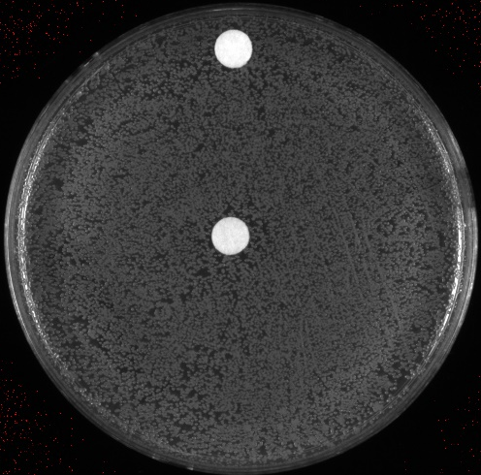
ECLCA
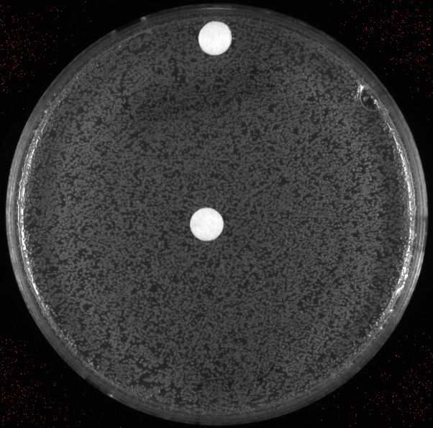
ECLCB
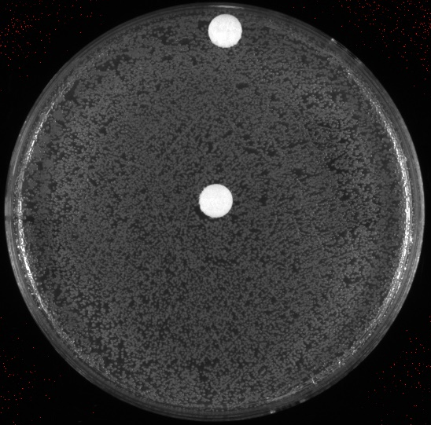
ECLH
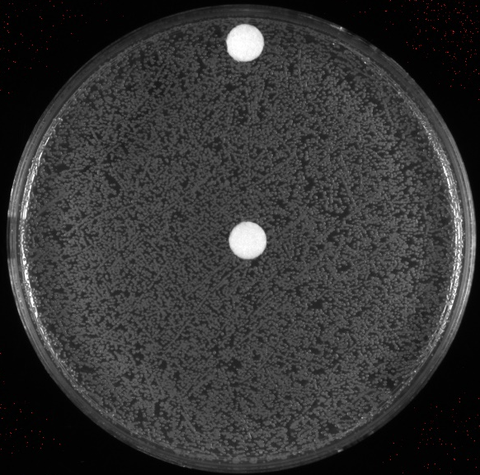
ECLT
Monday, July 18th, 2022
To Do:
- Pour LB plates for DDA (20 poured) – need more?
- Streak out A-1s from glycerol stocks onto plates
Results and Data:
For the abstract ; can I say that we may have found action of another sesquiterpene lactone that Is active in Francisella?
Need to make overnight cultures the night before making gDNA (take 500ul of culture and use for DNA purification)
Streaked out SA113 from SUA from 5.26, LR mutants struck out from glycerol stocks. Made sure to only take out one glycerol stock at a time and sprayed ethanol on hands and struck out quickly to prevent the glycerol stock from warming up too much, promptly placed in my box #2 in -80C freezer.

gDNA Materials Needed:
most stuff in DNA RNA box
Ice
150 ul Lysostaphin - -20C antibiotics box
1x Tissue and Cell Lysis Solution – box above water bath
Lysozyme crystals - in full plastic Tupperware dark round container
Proteinase K – furthest left enzyme box in front row (red)
RNAse A– furthest left enzyme box in front row (red)
MPC Protein Precipitation Reagent – box above water bath
Isopropanol
70% ethanol
.1X EB

Lysostaphin Preparation (10 mg/mL)
1. Make up ~30 ml of 20 mM sodium acetate in MQ water.
2. Adjust pH to 4.5 with acetic acid or NaOH as needed, adding dropwise.
3. Filter sterilize solution.
4. Dissolve whole vial of lysostaphin (5 mg) in 0.5 ml buffer.
5. Aliquot solution out into 65 ul aliquots in sterile eppendorf tubes.
6. Label and store at -20 (in antibiotics box). Avoid repeated freeze-thawing of aliquots.

DNA Purification Protocol – S. aureus
Cell Samples
1. Dilute lysostaphin in Tissue and Cell Lysis Solution solution to 1 mg/mL (i.e. 30 ul of 10 mg/ml stick in 270 ul TCL)
2. Add lysozyme crystals to 1 mg/mL and dissolve by pipetting up and down.
3. Pellet cells by centrifugation (0.5-1 x 106 mammalian cells; 0.1-0.5 ml of an overnight culture of E. coli) and discard the supernatant, leaving approximately 25 μl of liquid.
4. Vortex for 10 seconds to resuspend the cell pellet.
5. Add 300 ul of Tissue and Cell Lysis Solution containing the lysozyme and lysostaphin and mix thoroughly.
6. Incubate at 37°C for 30 minutes
7. Add 1 ul of Proteinase K to each sample and mix thoroughly.
8. Incubate at 65°C for 15 minutes; vortex every 5 minutes.
9. Cool the samples to 37°C and add 1 μl of 20 mg/ml RNase A to the sample; mix thoroughly.
10. Incubate at 37°C for 30 minutes. – start centrifuge cool down
11. Place the samples on ice for 3-5 minutes and then proceed with total DNA precipitation (below).
Precipitation of Total DNA (for all biological samples)
1. Add 150 μl of MPC Protein Precipitation Reagent to 300 μl of lysed sample and vortex vigorously for 10 seconds.
2. Pellet the debris by centrifugation at 4°C for 10 minutes at ≥10,000 x g in a microcentrifuge. If the resultant pellet is clear, small, or loose, add an additional 25 μl of MPC Protein Precipitation Reagent, mix, and pellet the debris again.
3. Transfer the supernatant to a clean microcentrifuge tube and discard the pellet.
4. Add 500 μl of isopropanol to the recovered supernatant. Invert the tube 30-40 times.
5. Pellet the DNA by centrifugation at 4°C for 10 minutes in a microcentrifuge.
6. Carefully pour off the isopropanol without dislodging the DNA pellet.
7. Rinse twice with 70% ethanol, being careful to not dislodge the pellet. Centrifuge briefly if the pellet is dislodged. Remove all of the residual ethanol with a pipet and let dry completely under hood.
8. Resuspend the DNA in 35 μl of 0.1x EB Buffer. Put on ice to help dissolve, and add 50 μl of additional buffer if DNA is very goopy.
9. Check concentration and purity by nanodrop.

Need more lysostaphin? – If I get to the gDNA part

Tuesday, July 19th, 2022
To Do:
- Work on abstract, poster, presentation
- Lab meeting
- Disc diffusion
Results and Data:
Lab meeting slides: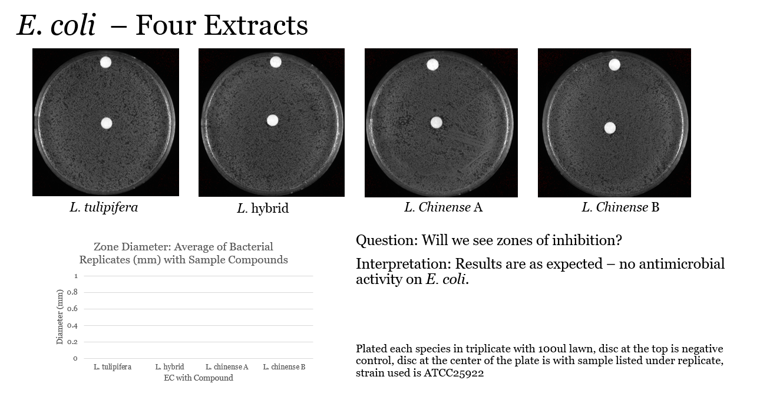
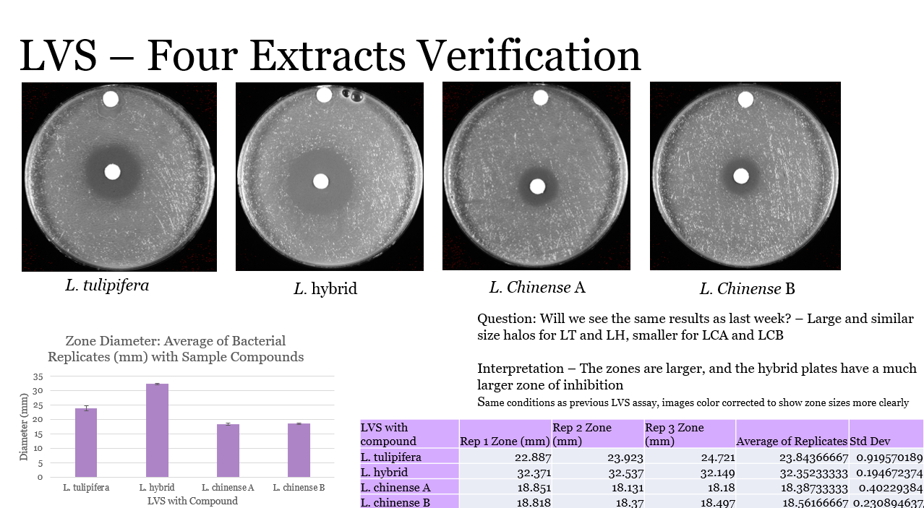
Spent majority of morning editing poster
Performed disc diffusion on four potential mutant library samples and wild type: SA113, LR1A1, LR2A1, LR3A1, and LR4A1. SA113 was used from single use aliquot from 5.26. Potential mutants (LR tagged) were all patched out from glycerol stocks.
ODs WT - .15 – 166.7ul of cells needed from 1:10 dilution into 1ml media
LR1A1 .125 – 200ul of cells needed from 1:10 dilution into 1ml media
LR2A1 .076 – 329 of cells needed from 1:10 dilution into 1ml media
LR3A1 .085 – 295.1 ul of cells needed from 1:10 dilution into 1ml media
LR4A1 .215 - 116.3ul of cells needed from 1:10 dilution into 1ml media
Each strain was kept apart by sanitizing hands, pipets, tweezers, and other materials when switching strains. All other disc diffusion protocol followed such as those in previous days. Discs weren’t autoclaved so I waited while they were on gravity cycle to start aliquoting compound and control onto the discs.

Wednesday, July 20th, 2022
To Do:
- Work on abstract, poster, presentation
- Image plates
Results and Data

20-Jul | Rep 1 Zone (mm)
SA113 | 14.365
LR1A1 | 14.809
LR2A1 | 15.097
LR3A1 | 15.468
LR4A1 | 14.213

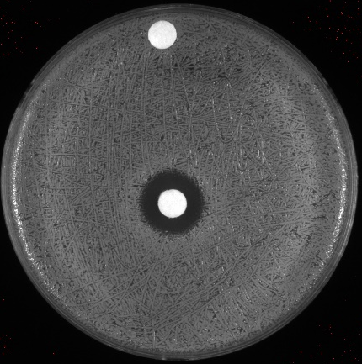
LR1A1
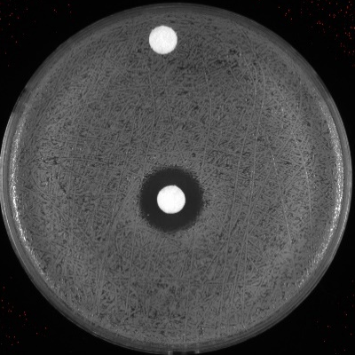
LR2A1

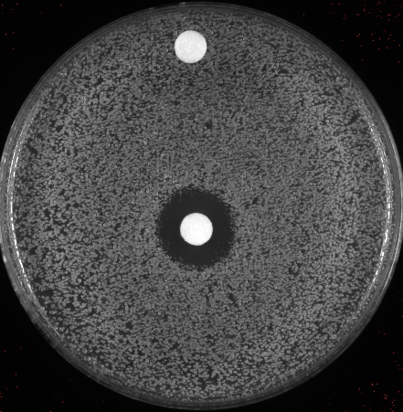
LR3A1

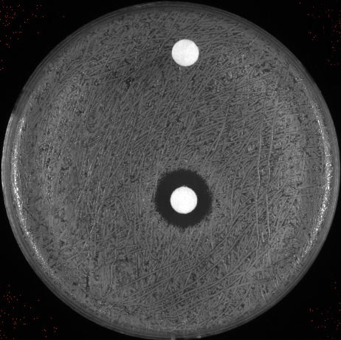
LR4A1
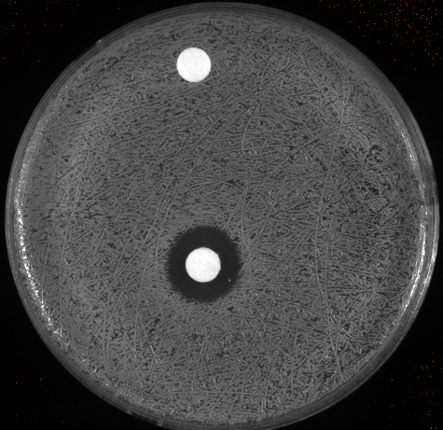
SA113 (Wild Type)
Not much difference quantitatively or visually, no mutants or anything potentially interesting to send for sequencing.
Thursday, July 21st, 2022
To Do:
- Streak out
- Meeting with Kathryn
- Disc Diffusion
- Work on poster and edit presentation

Results and Data:
Struck out in morning: SA113 from SUA from 5.26, LR mutants struck out from glycerol stocks. Made sure to only take out one glycerol stock at a time and sprayed ethanol on hands and struck out quickly to prevent the glycerol stock from warming up too much, promptly placed in my box #2 in -80C freezer.
Will be testing LR1B1, LR2B1, LR2B3, LR3B1, and LR4B1.
Met with Kathryn, notes from meeting: screen through all potential mutants
need 400 ul of laurenobiolide to test all- what is the expected tim line of getting more drug? ask Dr. Bertin
look at LVS plates? – no sign of mutants
prioritize screening thru mutant and updating lab notebook
poster:
first sentence bold of figure legend, then A/B are bold, no new paragraphs - block of text
need summary sentence of results for tree extracts

Worked on updating my poster and addressed issues in presentation.
Performed disc diffusion starting around 2:30 to allow for the cells to grow enough before I began, similar to how I did the disc diffusion on July 19th. Only difference is that I only made 1:10 dilutions for only a few strains that needed it rather than make dilutions for all.
Measured ODs:
SA113 -.196 – 127.6 ul of cells needed from 1:10 dilution into 1ml media
LR1B1 – .126 198.4 ul of cells needed from 1:10 dilution into 1ml media
LR2B1 - .151 – 165.6 ul of cells needed from 1:10 dilution into 1ml media
LR2B3 50 ul of cells needed from original resuspension into 1ml media
LR3B1 - .092 ul of cells needed from original resuspension into 1ml media
LR4B1 - .093 ul of cells needed from original resuspension into 1ml media

Friday, July 22nd, 2022
To Do:
- Image and analyze plates
- Joint lab meeting presentation
- Work on last few poster updates – send to Kathryn

Results and Data:
Presented my research to the joint Ramsey-Gregory lab meeting, goals for next week include practicing presenting my poster.
Imaged and analyzed plates.

22-Jul | Rep 1 Zone (mm)
SA113 | 18.523
LR1B1 | 18.717
LR2B1 | 17
LR2B3 | 17.223
LR3B1 | 17.019
LR4B1 | 17.595
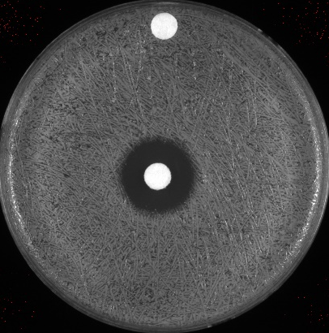
LR1B1

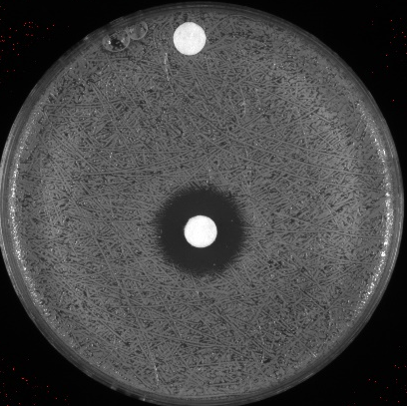
LR2B1
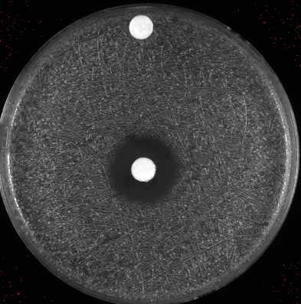
LR2B3

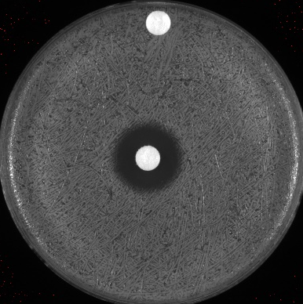
LR3B1
LR4B1
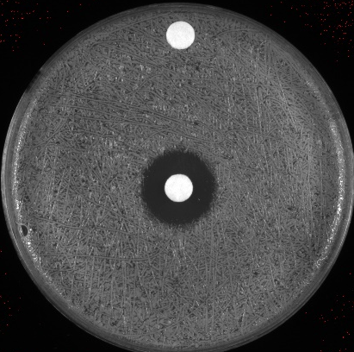
SA113
Plans for next week:
Practice poster presentation
Will we get more laurenobiolide?
If not, try the higher concentration of L. tulipifera on S. aureus and F. tularensis – mutant testing dependent on laurenobiolide
Make more single use aliquots of S. aureus

Monday, July 25th, 2022
To Do:
- Pour LB plates
- Address single colony plates

Results and Data:
Placed two of the 6 plates that I struck to single colony into the incubator because they didn’t grow. Then I patched out about 3 single colonies from each plate and labeled them -1,-2,-3, adding onto their previous name.
I also heated up LB because I will be making a few no abx LB plates as I only have 2 in the fridge and will make the rest as carb for Hannah. I made about 10 plates of non abx plates and then rest were 11 LB-carb.

Tuesday, July 26th, 2022
To Do:
- Glycerol stocks
- UV sterilize EP cuvettes
- Patch out
- Lab meeting

Results and Data:
Lab meeting at 10 AM, we practiced posters. Make sure I go over the method when presenting – key note “bigger the zone, higher sensitivity/lower resistance”. I Placed the freshly made plates in the fridge. Made one glycerol stock per strain. There were about 9. I started out by labeling all of the cryovials then aliquoted 800ul of LB into every cryovial. Then I scraped up each entire patch, making sure that the loop was sterile before and after scraping and inoculating. Then I resuspended one at a time. Afterwards I added 200ul of 75% glycerol to each cryovial one by one, mixing by pipetting and then changing tips every time I finished a cryovial. UV sterilized EP cuvettes and placed in the box underneath Hannah’s bench containing the rest of the EP cuvettes. One plate didn’t grow so I threw it out, then I patched out 3 single colonies from the other plate, adding on a -1,-2,-3 to the end of its name. I let it to sit on my bench to grow, since I will not be in lab until Thursday.

Wednesday, July 27th, 2022
Out of laboratory

Thursday, July 28th, 2022
To Do:
- Glycerol stocks
- Autoclave plate waste
- Lab cleanup
- Update lab notebook

Results and Data:

I noticed that the bacteria I had patched out on tuesday had not grown too much so I placed the plate into the incubator for a few hours in hopes that I would gt some more for glycerol stocks.
Updating lab notebook by including images of plates and data. Making mutant spreadsheet in excel with more information in the lab notebook regarding pictures. Most plates I took pictures of from where the mutants originated were before I threw out the plates that were collected on my bench top, whether they be LB (into autoclave waste) or CHAH (into plate waste box, which was subsequently dumped out into a double bagged autoclave bag and autoclaved at liquid 20). I tried to use the autoclave downstairs but I got error messages when I went to take it out – I emailed Dr. Liu and CC’d Kathryn. Hannah and I then went on a quest for an empty and working autoclave in CBLS – autoclaved on the 4th floor.

Bibliography

Ramsey, K. M. and Dove, S. L. (2016) ‘ A response regulator promotes Francisella tularensis intramacrophage growth by repressing an anti-virulence factor ’, Molecular Microbiology. doi: 10.1111/mmi.13418.

