Table of Contents
May 2022 2
Disc Diffusion Assay – S. aureus Edited 5/27/22 2
Single Use Aliquots 3
Making Glycerol Stocks Protocol 3
June 6
Making ready-to-load 1 Kb Plus DNA ladder stock 16
Disk Diffusion Assay – F. tularensis Edited 6/16/22 16
Making LB-agar plates 20
Bibliography 31

May 2022

Wednesday, May 25, 2022
To Do:
- Set up lab notebook
- Set up meeting with Kathryn and Dr. Bertin
- Pour LB plates
- Edit DDA protocol

Disc Diffusion Assay – S. aureus Edited 5/27/22
- Pour fresh LB plates (24ml per plate) day before DDA to have more consistent results
- Resuspend cells (half of a loopful) for the strain being tested in about 400 µL of LB media. Measure the OD600.
  - Put 950 ul of MHB into cuvette and then 50 ul of the bacteria
- Aim for a final OD600 of 0.05. Dilute the appropriate amount of culture in a 50 mL conical or serially dilute in 1.5ml tubes that contains LB media to get required OD600, for a final volume of 1 mL. [Use C1V1=C2V2] Repeat steps 1 and 2 for a separate strain if necessary.
- Add 100 µL each of S. aureus cells at OD600 0.05 to 3 LB agar plates and spread with glass beads. Repeat this a second time with new plates if testing another strain. Allow plates to dry.
- Using sterile tweezers, add sterile filter paper discs to a sterile plate and then add 20 µL methanol and antimicrobial to respective discs. Allow these discs to dry for 20 minutes.
- Using sterile tweezers, transfer discs from sterile plate to LB agar plates that have been spread with S. aureus so that there is a water disc and antibiotic disc on each LB agar plate and gently press them into plate without breaking the agar.
- Place into incubator and take note when, needs ~24 hours
- Image and analyze plates

Results and Data:
Poured non antibiotic LB plates. Struck out S. aureus from Hannah’s SA113 stock on two non-abx LB plates, the first plate was from the fridge and incubated at 12:12pm, while the second plate was poured 45 minutes prior to incubating and allowed to dry before streaking out, then incubated at 3:01 pm.

Notes from meeting:
DDA with compound laurenobiolide and staph aureus, plan for optimization of S. aureus concentration plating in triplicate
Test ODs of .005, .05, .1
100ul per lawn, check after 24 and 48 hours for growth and monitor set up conditions
Take antibiotic that works on S. aureus – DDA with positive control (chloramphenicol)
Make own glycerol stock, own single use aliquots, make LB plates, optimize growth on plate to establish for DDA
LB agar, use serological pipet, 24mL per plate
Staph can streak to single colony overnight *future reference
Thursday, May 26, 2022
To Do:
- Edit DDA protocol
- Make glycerol stocks
- Single use aliquots
- Staph optimization
- Register for BBM

Single Use Aliquots
- 1. Prepare 300uL of MHB in a 1.50mL tube
  - Prepare 9 labeled sterile tubes per strain
- Take at least half of a thickly spread plate using a sterile loop and add cells to the MHB tube
- Resuspend until there are no clumps in the MHB
- Add 500uL more of MHB
- Add 200ul of 75% glycerol to the 800uL mix by pipetting
- Aliquot 100uL per 1.5mL tube, freeze at -80 C,

Making Glycerol Stocks Protocol

- Make 3 cryovials for each strain (permanent stocks), label!
- Prepare 2.4mL of MHB in a 50mL conical (adjust if you are also making single use stocks)
- Take at least half of a thickly spread plate and add cells to the MHB tube
- Resuspend until there are no clumps in the MHB
- Add 600ul of 75% glycerol to the 2.4mL mix by pipetting
- Aliquot 1mL per cryovial, freeze at -80
- For single use stocks follow the same protocol but pipet 50ul of solution to tubes

Results and Data:
9 am; Made aliquots of MHB and 75% glycerol from original stocks for own use
Made single use aliquots of S. aureus, labeled as SA in -80C Box 2 in 9A. Scraped up about half a plate because the original tube holding bacteria appeared very dense with cells, not sure if it would have held more. Have another thickly spread plate in incubator for glycerol stocks
12 pm; prepared for optimization, resuspended one loopful of SA into 400ul of LB media from plate that was in incubator, less than half a plate allowed for very high ODs – tubes had to be diluted further. Originally 1:20 dilution showed .881 OD, needed to redo into a 1:20 dilution and showed .471 OD. Needed to dilute to .005, .05, and .1 concentrations and plate in triplicate.
Additional math/notes in physical lab notebook, C1V1=C2V2, needed to increase final volume to 1ml as 400ul was too small to dilute to. Serial dilution of 1:10 regarding 100 and 900 ul each for the .05 and .1 concentrations, and made 1:100 for the .005 concentration. 26.5 ul from 1:100 into the 973.5ul in .005 tube, 26.5 ul from 1:10 into the 973.5ul in .05 tube, and 53 ul from 1:10 into the 973.5ul in .1 tube. Plated with beads in triplicate and placed in incubator around 1:35pm.
Made glycerol stocks of SA and placed in own -80C box, labeled SA113.

Friday, May 27, 2022
To Do:
- Edit DDA protocol
- Read literature on laurenobiolide
- Image SA lawns

Results and Data:
Upon coming into the lab, took a brief look at the SA lawns – one from each concentration replicate. I was able to take them out of the incubator later, around 12pm to image and add to the Staph Optimization folder. At that point the plates were in the incubator for approximately 22-23 hours, close to 24. The plan for next Tuesday is to redo the plating and spread with a glass spreader compared to beads. Looking through the images, .005 seems too low of a concentration to use as a lawn as it seemed a little patchy, however .05 and .1 seem fairly indistinguishable from each other. Spreading the lawns with a glass spreader will give a better visual on which concentration to use.
Edited Disc Diffusion Protocol to make more sense in the context of using LB media/agar and S. aureus.
While waiting for lawns to be incubated for ~24 hrs, read literature on laurenobiolide from URI Digital Commons to familiarize myself with the compound.

Optimization of S. aureus, one plate of each replicate:
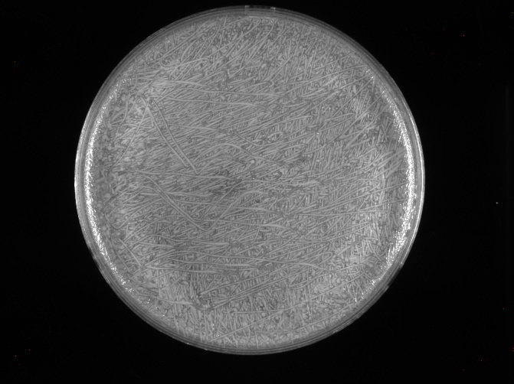
.1 concentration of S. aureus strain SA113 (beads)
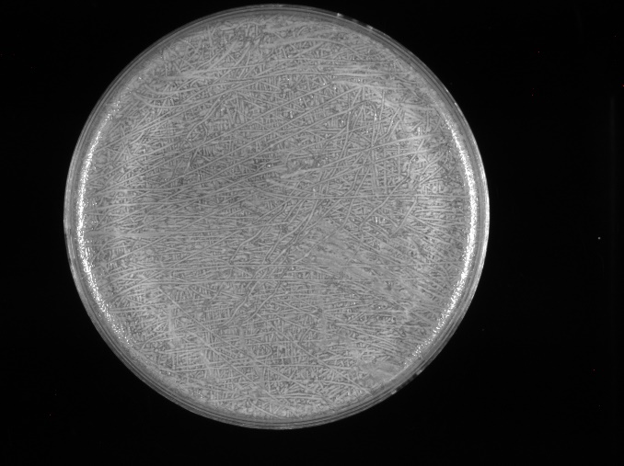
.05 concentration of S. aureus strain SA113 (beads)
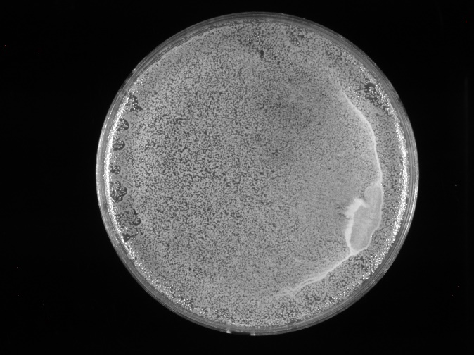
.005 concentration of S. aureus strain SA113 (beads)

Tuesday, May 31, 2022
To Do:
- Plate waste
- Streak out Staph
- Make powerpoint for lab meeting next week

Results and Data:
Struck out S. aureus SA113 on LB agar plate for repeat optimization experiment tomorrow, placed in incubator at 10AM.

Autoclaving plates
Autoclaved plate waste at liquid20. Only plates that need to be autoclaved are the CHA plates/LVS/Francisella plates. LB, MHB, and any other agar media plates can be thrown in the autoclave trash which will be incinerated.

June

Wednesday, June 1, 2022
To Do:
- Make powerpoint for lab meeting next week
- Staph optimization
- Streak out for DDA
- Pour plates for DDA

Results and Data:
Struck out S. aureus SA113 on a non abx LB plate for disc diffusion assay for Thursday. Used previously grown S. aureus for Staph Optimization experiment. Took half a loopful and had a concentration of .256, requiring me to serially dilute. For this repeat experiment, I used a glass spreader instead of glass beads to see whether there is a difference in coverage on the plate. I also was able to pour about 20 plates from one of the shelved LB agar flasks – 24 mL per plate. I let them sit out on the bench overnight and will flip them over/place them in the fridge tomorrow.

Thursday, June 2, 2022
To Do:
- Make powerpoint for lab meeting next week
- Image staph optimization plates
- Disc Diffusion Assay with Staph
- Lab tasks
Results and Data:
The Staph optimization plates got a lot less coverage with the glass spreader compared to the beads, which made me hesitant on using the spreader for the disc diffusion plates. After talking about it with Sierra, I decided to do the disc diffusion with 6 plates instead of 3, (same strain in triplicate, only difference is that 3 of them are plated with the beads and 3 are plated with the spreader. Same exact concentration, so this should give much more conclusive results on which plating method I should continue with in the future for these experiments.) Antibiotic used was chloramphenicol, 10mg/ml, 20 ul on disc
Refilled the DI water
Staph Optimization images with glass spreader:
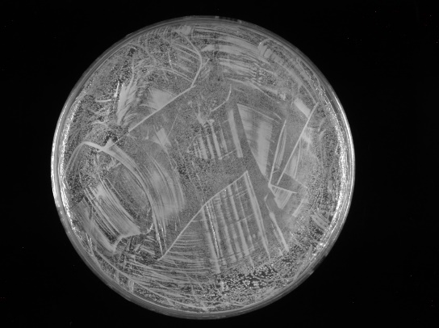
.1 concentration of S. aureus strain SA113 (spread plate)
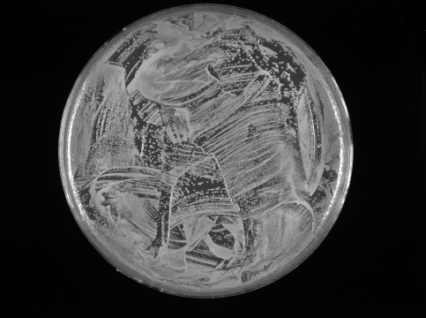
.05 concentration of S. aureus strain SA113 (spread plate)
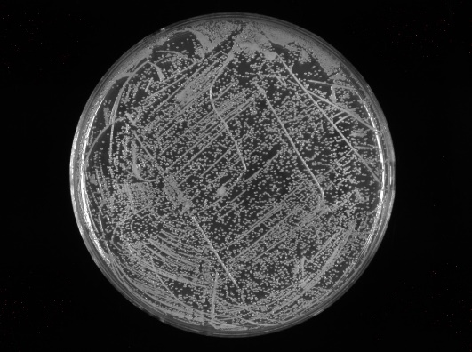
.005 concentration of S. aureus strain SA113 (spread plate)

Friday, June 3, 2022
To Do:
- Make powerpoint for lab meeting next week
- Image disc diffusion plates
Results and Data:
Imaged and analyzed the disc diffusion images, worked on the powerpoint for Tuesday’s meeting.
SA113 lawn plated on LB agar plate, water control and chloramphenicol on disc, plated with glass spreader
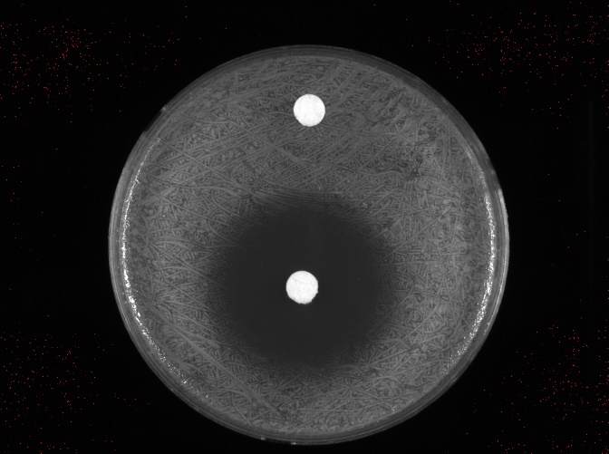
SA113 lawn plated on LB agar plate, water control with chloramphenicol on center disc, plated with glass beads.
I have one replicate of each spreader vs beads disc diffusion – I think I will go ahead and use the glass beads in the future as it allows for a more defined zone that I could measure. Can lead to more consistency.
To Do for next week:
Set up meeting with Kathryn and Dr. Bertin about laurenobiolide compound
Ask Kathryn about beads vs spread plate

Monday, June 6, 2022
To Do:
- Reconstitute E. coli
- Meeting with Kathryn

Results and Data:
Organized DDA image folder and finished slide for tomorrow’s meeting. Met with Kathryn to talk about further steps. Beads are decided to be the plating method, and an OD of .05 for SA (SA113) will be the ideal amount to plate in the future. Now need to optimize OD for E. coli- using a strain that is typically used In antibiotic susceptibility testing (ATCC25922) which needs to be reconstituted. Borrowed TSB and TSA (tryptic soy broth and tryptic soy agar) from MRamsey lab, made media and autoclaved. Poured 2 plates with TSA and allowed to solidify on bench. Resuspended E. coli ATCC25922 strain with .5mL TSB and added to a culture tube with 4mL of TSB. Allowed to sit in shaking incubator for ~40 minutes, then plated 100 ul onto each plate and placed culture tube back into shaking incubator for overnight.

Tuesday, June 7, 2022
To Do:
- Lab meeting 10am
- Glycerol stocks of E. coli
- Single use aliquots?
- Meeting with Kathryn and Dr. Bertin 2pm
- Streak out?
- Pour plates?
Results and Data:
Checked in incubator when I came in – the E. coli grew! Made 3 glycerol stocks, one for my own box in -80C and 2 for the strains box in 5E in case I need to pull from that stock. I was able to make 5 single use aliquots with the remaining glycerol/TSB in the 50mL conical (resuspended bacteria in 3.2mL TSB then added .8 mL glycerol, vortexed on low for 20 seconds once added glycerol) and immediately used one of those aliquots to streak out on a plate for tomorrow’s E. coli optimization (testing .005,.05 and .1 concentrations in triplicate). Bleached cells that were overnight in culture tube.
Presented my powerpoint (update on research regarding past two weeks) in the lab meeting, several things to move forward with. 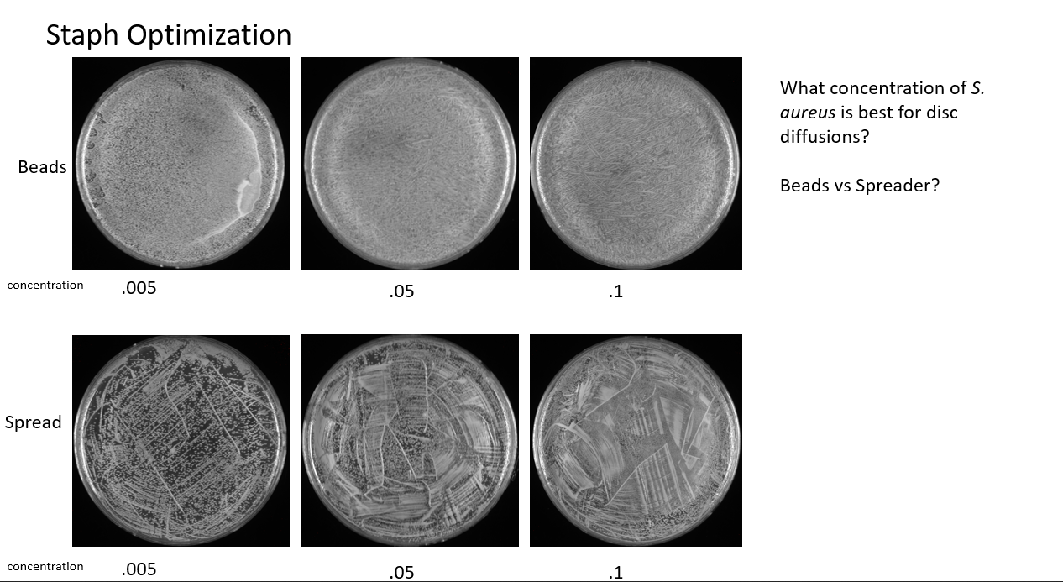
Slide 1, depicting my optimization experiment on S. aureus SA113 to determine optimal lawn growth concentration and plating method.
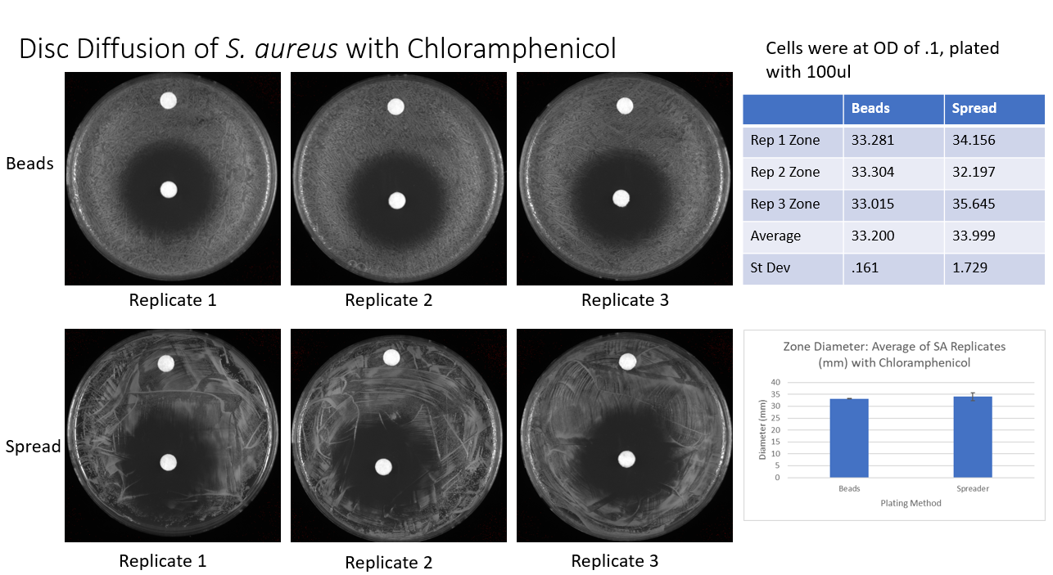
Slide 2 explaining my disc diffusion assay – needed to create a ‘preliminary’ assay specially to show Dr. Bertin the assay I’ll be using to test the compound.
Checked package room. Met with Kathryn and Dr. Bertin about the laurenobiolide compound, moving forward with 8mg/mL concentration for disc diffusion.
For DDA – what OD should I aim for with E. coli? – need to optimize
Poured 9 plates of LB agar and allowed to dry overnight on bench

Wednesday, June 8, 2022
To Do:
- E. coli optimization – make adjustments for new protocol
- Plate waste
Results and Data:
Checked package room
Measurements for E. Coli optimization:
ATCC25922 strain, when resuspended into the LB media, I used the OD from the spec to get the concentration of each .005, .05, and .1
.005 = 160.2ul from 1:100
.05 = 160.2ul from 1:10
.1 = 32ul from original
I saved the concentrations of .1, .05, and .005 in the fridge. Might need to replate, the plates that I poured yesterday and used today were extremely wet and would not dry. I worry that my plates will not give the best results, so I may use the dry plates in the fridge because the condensation on the plates may change the concentrations on the plates and not give me the results I’m looking for. If not using the fridge plates, I’ll pour plates on Thursday, and I may pour 1 or 2 extra so that the plates I’m using don’t have that much condensation on them which will prevent this issue from happening again

Avoiding wet plates
It helps to pour one or two extra plates (depending if you have enough media) so they can collect condensation and you don’t have to spend extra time plating until dry.
Autoclaved plate waste.
Thursday, June 9, 2022
To Do:
- E. coli optimization – image

Results and Data:
Imaged E. coli plates this morning. While looking at the plates, I saw that the .005 had pretty good coverage but there were still some less dense areas.
I may just replate tomorrow and come in early on Saturday and take a look at the plates to see if anything has changed. I’m only a little concerned because since you can’t see the pathway of the beads/the media just spread out by itself when it was too wet so it might not be evenly plated in terms of concentration.
Filled ethanol spray bottles a little bit more since all of them were looking low on ethanol.
Streaked out LVS to make new aliquots for the upcoming disc diffusions. Received laurenobiolide from Dr. Bertin to concentration (8 mg/mL) currently stored in the mini fridge’s freezer.
Labeled:
Laurenobiolide Pure
8.5672g
8mg/ml in CH3OH
05/04/22
Autoclaved plate waste.
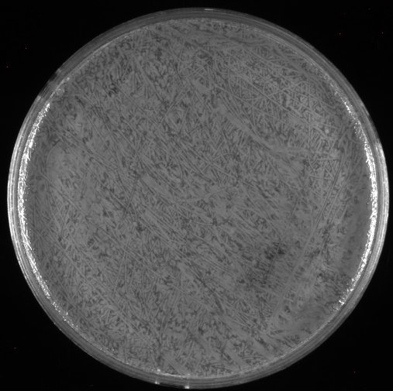
E. coli optimization - .1 OD 100ul lawn
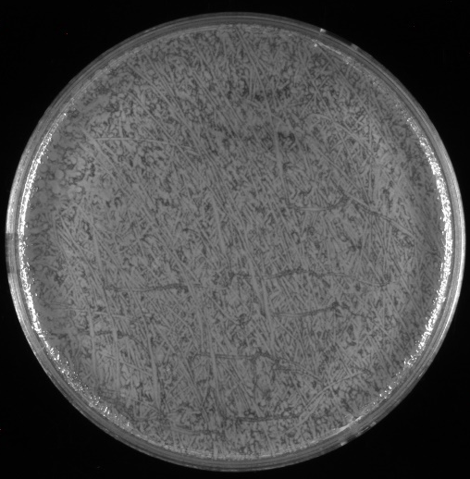
E. coli optimization - .05 OD 100ul lawn
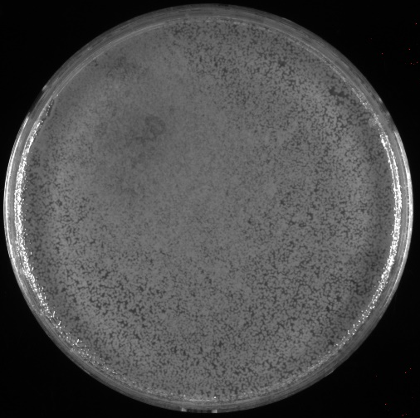
E. coli optimization - .005 OD 100ul lawn

Here is an example of a wet plate:
No distinct bead pathway, can’t really tell the thickness of how the bacteria is spread, not a very good lawn depiction.

Friday, June 10, 2022
To Do:
- LVS aliquots
Results and Data:
Used the LVS that was struck out the previous day to make single use aliquots. Stored in the -80C in box 2.
Meeting with Ramsey and Gregory labs, figured out schedule for presenting research.

Wednesday, June 15, 2022
To Do:
- Streak out E. coli, S. aureus, and F. tularensis
- Pour plates
Results and Data:
Struck out E. coli (ATCC25922), S. aureus (SA113), and F. tularensis (LVS) in preparation for disc diffusion tomorrow.
TSB got contaminated so I needed to bleach it:

Avoid wide topped glassware
It can be more prone to contamination due to the rim being far from the flame.
Melted down LB agar for E. coli and S. aureus plates for tomorrow, Hannah was making CHAH plates so I requested 3 from her. Future note: when only using half or a certain amount of LB agar, to label how many mL is left in case another person will use it in the future and needs to know the exact volume. OR, let whoever is making the LB know to make smaller flasks of LB such as 3 200mL flasks if I will only be making a few plates at a time.
I poured plates and made sure to leave them all in a stack so that the condensation will rise. I made sure to pour at least 8 plates because I needed 3 for SA, 3 for EC, and 2 extra to accumulate the condensation so the plates aren’t too wet when I plate the lawns.
Additional notes from Hannah: only CHAH plates need to be autoclaved (Francisella) otherwise all LB plates can be thrown in the regular autoclave trash which will be thrown in the incinerator
Kimwipes are above the freezer in a Kimtech box.
Bins for the autoclave should never be stacked while wet otherwise they won’t dry and breed mold.
Larger vials (such as the one containing my aliquot of the laurenobiolide compound) should be stored in the Tupperware-like container on the bottom shelf of the -20C on the right side.

Beads
After washing with ethanol (pour enough in tube to cover beads pour the beads into a glass culture tube and put towards the back of the rack (not sterile) especially if doing a lot of plating be cognizant of bead use.
If we run out of a big(ish) box soon, use as replacement for the clean glassware box.

Spoke to Dr. Bertin today – he suggested running two more types of assays depending on my results with the laurenobiolide. The first step is to run a disc diffusion on all three strains (EC, FT, SA) and then we go from there. If there is presence of a zone of inhibition, we want to go ahead and run an assay from a sample from the Asian tulip tree (which does not have the laurenobiolide compound) L. chinense to basically test it as a negative control (that the laurenobiolide does work and it’s not something else that has been active in the sample). Additionally, he would like me to test a sample that only contains one of the isomers of the compound also as a sort of negative control.
Talked to Kathryn about E. coli optimization from last week. .005 seemed to have pretty good coverage but was still slightly spotty, but .05 seemed to be too much. I talked to Sierra last week but it had slipped my mind to bring it up to Kathryn until today, but she suggested using a concentration in between .005 and .05 such as .02. She suggested to do the optimization first to try the intermediate concentration and see how it would look, and E. coli set up won’t take a long time. Since I already streaked out all three strains, I will be proceeding with tomorrow’s DDA with only S. aureus and F. tularensis, but I will be doing an optimization experiment with E. coli tomorrow, likely in duplicate because I did not pour enough plates. I will be testing .005 and .02 because I would like to see if it was the issue from last week with the wetness of the plates.
For the DDA, I will want to do S. aureus and F. tularensis separately so that I do not cross contaminate them.

Making ready-to-load 1 Kb Plus DNA ladder stock

Combine:
60 uL 1 Kb Plus DNA ladder
100 uL 6x Orange-G dye
140 uL water (molecular biology grade)
300 uL total volume
Load 10 uL ladder per lane

Made 6 aliquots of 1 kb plus ladder stock, stored in -20C. Looks like it’s the last one/box in the Tupperware container in the -20C, put on the to order list because I wasn’t sure if there was any more.
Thursday, June 16, 2022
To Do:
- DDA for S. aureus and F. tularensis
- E. coli optimization
Results and Data:
Lab meeting at 10am on Zoom, notes:
I need to double check that the strain of bacteria that I believe to be E. coli is actually E. coli (since TSB was found to be contaminated on Wednesday). I should find the antibiotic differences with the E. coli that we use and the lab and the E. coli that we got from ATCC. This way I could phenotypically distinguish the E. coli from each other. We should also double check with the genome sequence to be sure. The strain we use normally in the lab is called XL1 Blue, I can find information sheets including antibiotic susceptibility for both strains online.
The concentrations that I will be using for the disc diffusions today will be .05 for S. aureus and .1 for F. tularensis. Refer to DDA protocol for Staph in previous notebook entry.

Disk Diffusion Assay – F. tularensis Edited 6/16/22
- Pour fresh CHA plates day before DDA to have more consistent results
- Resuspend cells for the strain being tested in about 400 µL of MHB. Measure the OD600.
  - Put 950 ul of MHB into cuvette and then 50 ul of the strain
- Aim for an OD600 of 0.01. Dilute the appropriate amount of culture in a 1.5 mL tube that contains media to get required OD600, for a final volume of 1 mL. Serial dilution may be necessary (1:10, 1:100) depending on initial OD – this method uses less media [Use C1V1=C2V2] Repeat steps 1 and 2 for a separate strain if necessary.
- Add 100 µL each of LVS cells at OD600 0.01 to 3 CHAH plates and spread with beads. Repeat this a second time with new plates if testing another strain. Allow plates to dry.
- Using sterile tweezers, add sterile filter paper disks to a sterile plate with dividers and then add 20 µL water and laurenobiolide. Allow these disks to dry for 20 minutes.
- Using sterile tweezers, transfer disks from sterile plate to CHAH plates that have been spread with Francisella so that there is a water disk and a laurenobiolide disk on each CHAH plate and gently press them down without breaking the agar.
- Place into incubator and note when
I did the disc diffusion for S. aureus and F. tularensis and used the E. coli for an optimization experiment. The E. coli was plated in triplicate at .005 and .02 ODs and placed into the incubator. For the DDA, I made sure everything was to concentration and plated carefully. Placed into the incubator at 3:20.
Friday, June 17, 2022
To Do:
- Joint meeting 10 am
- Meeting with Kathryn
- Image + Analyze plates
Results and Data:
Lab meeting at 10am
Met with Kathryn to discuss the compact and project outline
Imaged S. aureus and E. coli plates but the F. tularensis plates were not ready yet so I need to come in on Saturday.
E. coli optimization plates:
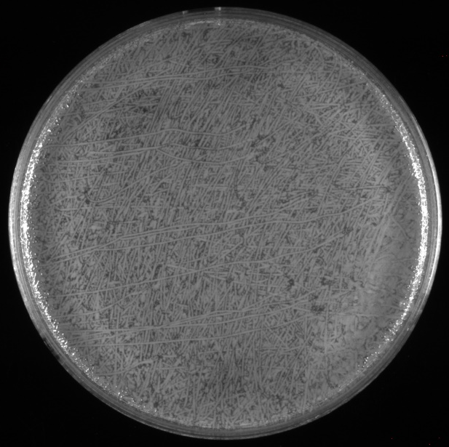
E. coli optimization replicate with .02 OD, 100ul lawn
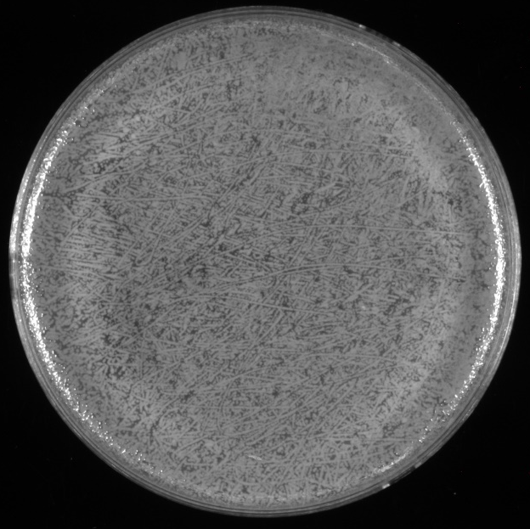
E. coli optimization replicate with .005 OD, 100ul lawn

.005 seems to be a good option – full coverage without being too thickly spread on the plate
SA113 results:
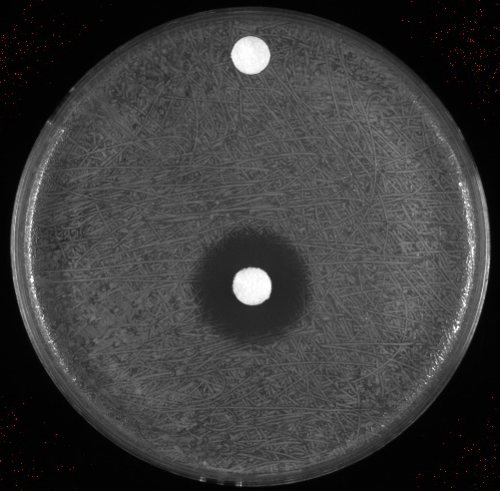
SA113 lawn, 100ul with .05 OD, 8mg/ml laurenobiolide with methanol control

Saturday, June 18, 2022
To Do:
- Image + Analyze F. tularensis plates
Results and Data:
Imaged LVS plates
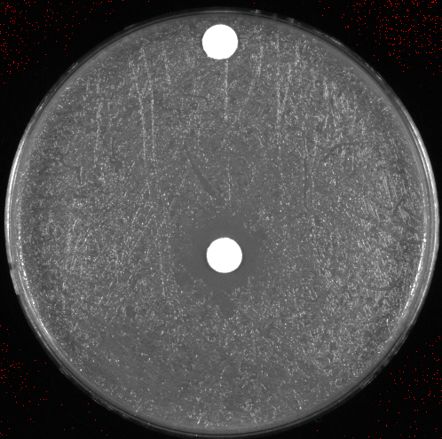
LVS lawn, 100ul with .01 OD, 8mg/mL laurenobiolide with methanol control
Although it did not show up as clearly in the photo, there is a zone of inhibition, but it is a lot smaller than the SA113 zones on average.
Data – quantitative
Species | Rep 1 Zone (mm) | Rep 2 Zone (mm) | Rep 3 Zone (mm) | Average of Replicates | Std Dev
S. aureus | 18.023 | 18.131 | 18.031 | 18.06166667 | 0.060177515
LVS | 12.645 | 13.685 | 14.147 | 13.49233333 | 0.769312247

Monday, June 20, 2022
To Do:
- Pour CHA and LB plates
- Methanol aliquot??
- Streak out all three bacterial species
Results and Data:
Struck out S. aureus SA113, E. coli ATCC25922, and LVS on respective media plates (CHA for LVS and LB for the other two). Made sure to ethanol hands between each species. Placed in the incubator.
Made two half flasks of LB agar and 100ml of CHA, autoclaved in the instant pot. Need hemoglobin for the CHAH plates.
Filled sodium chloride bottle from large bucket.
Poured LB plates, made enough for DDA tomorrow (6) plus a few extra, one was only at 12ml instead of 24 so I will likely use that one to streak out cells in the future.

Making LB-agar plates
Protocol written by KMR
Preparing LB-agar
- For 500 mL of LB-agar, weigh out the following components and add to a 1 L (non-baffled) flask:
  - 6 g agar
  - 5 g NaCl
  - 5 g Tryptone
  - 2.5 g Yeast extract
- Add stirbar to flask
- Add 500 mL ddiH20
- Mix on stirplate until components are dissolved
- Cover top of flask with foil and add a small piece of autoclave tape
- Autoclave on 30 minute liquid cycle

If pouring plates later:
Let LB-agar solidify and keep in lab. When you want to pour plates, heat up LB-agar on hotplate, stirring, until entirely melted (watch carefully so it doesn’t boil over! Don’t walk away). Let agar cool down or place in warm over (50°C) until ready to pour plates.
If pouring plates the same day:
After autoclaved, keep in warm oven (50°C) until ready to pour plates

Tuesday, June 21, 2022
To Do:
- Lab meeting
- DDA – 3 species
Results and Data:
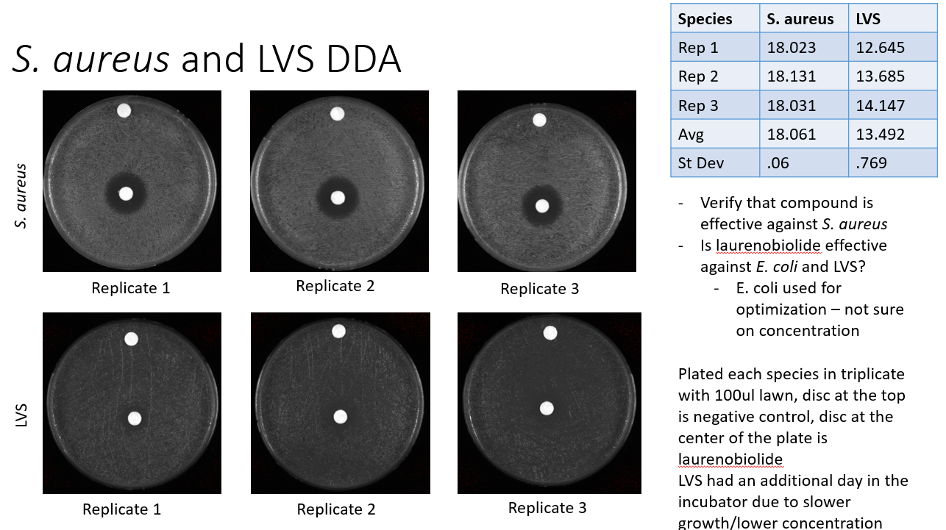
Slide 1 from lab meeting 6.16

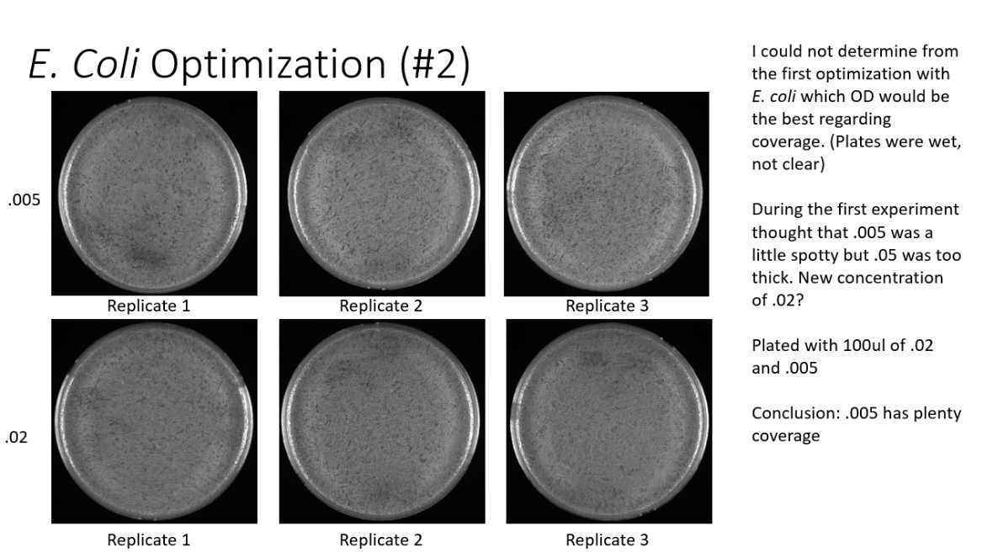
Slide 2 from lab meeting 6.16
The concentrations that I will be using for the disc diffusions today will be .05 for S. aureus (SA113), .005 for E. coli (ATCC25922), and .01 for LVS,
Resuspended LVS in MHB and SA and EC in LB media. Did not use a loopful, noticed that it would make too high of an OD when put in the spec. Used about half a loopful for each. For getting concentrations in the spec, diluted 1:20 or 50ul bacteria to 950ul MHB/LB (corresponding media to the bacteria; ex. MHB for LVS)
LVS - .103 OD
SA - .383 OD
EC - .090 OD
SA - Need 1:10 dilution for SA then take 65.3ul from serial dilution into 1ml final volume
LVS – Need 1:10 dilution for LVS then take 48.5ul from serial dilution into 1ml final volume
EC – Need 1:10 dilution for EC then take 27.8ul from serial dilution into 1ml final volume
Plate 100ul onto each, prepare discs
When plating, used beads
Wednesday, June 22, 2022
To Do:
- Image SA and EC plates
Results and Data:
Species | Rep 1 Zone (mm) | Rep 2 Zone (mm) | Rep 3 Zone (mm) | Average of Replicates | Std Dev
S. aureus | 15.532 | 14.616 | 14.577 | 14.90833333 | 0.540463073
LVS | 16.938 | 18.795 | 18.431 | 18.05466667 | 0.984038786
E. coli | 7.051 | 7.208 | 7.243 | 7.167333333 | 0.102256214

DDA images:
ATCC25922 replicate with 8mg/ml laurenobiolide
SA113 replicate with 8mg/ml laurenobiolide
LVS replicate with 8mg/ml laurenobiolide
Thursday, June 23, 2022
To Do:
- Image LVS plates
- Meet with Kathryn
- Create future plans for the next week
- Project Outline/Notebook
Results and Data:
The results for the LVS plates are in the previous day’s section. I just used copy and paste from my excel sheet and wanted to keep the results in all one place.
My plans for the next week include two disc diffusions, one regarding S. aureus and the other regarding LVS and the four compounds I received from the Bertin lab.

Monday, June 27, 2022
To Do:
- Pour CHA plates
- Streak out LVS
- dI water
- Project outline
Results and Data:
Tuesday I will be doing a disc diffusion assay with the four compounds that I received from the Bertin lab: L. hybrid, L. tulipifera, L. chinense A, and L. chinense B. I’ll be needing 12 plates of CHAH since I’m doing it in triplicate with the four compounds, plus a few extra plates to collect the condensation and ensure that the freshly poured plates that I am using for the experiment aren’t too wet for use (causing the plating to take longer, uneven distribution of bacteria, etc.). Each 600mL of CHAH is 25 plates. Instead of 30.6g or (10.2g/100mL) I need 20.4g CHA. 400mL will make about 16 plates so those extra will be placed in the bin and will be used by either myself or other lab members for non-time sensitive use. I made CHA (20.41g) with 200mL dI water and stirred on the hot plate. I noticed that there was a lot of the CHA that wasn’t dissolving into the water (it isn’t fully water soluble at room temp).

When making CHA
It needs 10 full minutes at 60C on the hot plate. If there are particles that didn’t dissolve by then, they won’t. Boiling longer than 10 minutes can cause the CHA to boil over so that needs to be avoided.
I’ll be using the remaining 150mL of the hemoglobin flask I used last week to make my plates and 50mL from a smaller flask (someone else used an awkward amount (from May)) but it ended up being perfect for me so I don’t have to take from a completely full flask of hemoglobin. I placed those in the water bath (60C) to heat up while the CHA was autoclaving on liq30 in the instant pot. Added the CHA flask into the water bath after autoclaving.
Regarding lab tasks, I refilled the dI water carboy. I noticed that there were two electroporation cuvettes that were drying but I may wait until there are more to UV sterilize. I also emptied the plate waste container and placed the bag next to the cardboard autoclave waste box. Note about plate waste: every time the container completely fills up, use a small autoclave bag and double bag it. You can fit two container/small autoclave bags worth of plates into a large bucket. This will let you autoclave less frequently.
Struck out LVS from a single use aliquot in my Box #2 made on June 10th. Only used 50 ul since I barely take half a loopful. Labeled that there was 50ul left in the SUA and placed back into my box.
Combined hemoglobin flasks and added the CHA flask into the 1L hemoglobin flask. Stirred on hot plate briefly, then poured 24mL per plate, 2/4 plates at a time. Made 14 full volume CHAH plates and 2 plates of 15mL.
Worked on Research Outline. Talked to Dr. Bertin about my hypothesis of laurenobiolide’s mode of action being related to oxidative phosphorylation and oxygen uptake.

Tuesday, June 28, 2022
To Do:
- Lab meeting
- Pour LB plates
- Streak out SA
- Disc diffusion
- Project outline
- Ask Dr. Bertin about preprint
Results and Data:
Heated up LB agar and placed in the water bath for pouring plates later. I need 12 LB plates for tomorrow’s S. aureus disc diffusion with SA113. Since I heated up a full flask of agar, Hannah suggested making Kan plates with the extra agar I had rather than cooling it back down or making more no antibiotic plates, since we have a lot still in the fridge. I also let Aisling know I was using LB.
I made my powerpoint slide for today’s lab meeting, using my data from the disc diffusion with SA, EC, and LVS from last week (June 22/23).
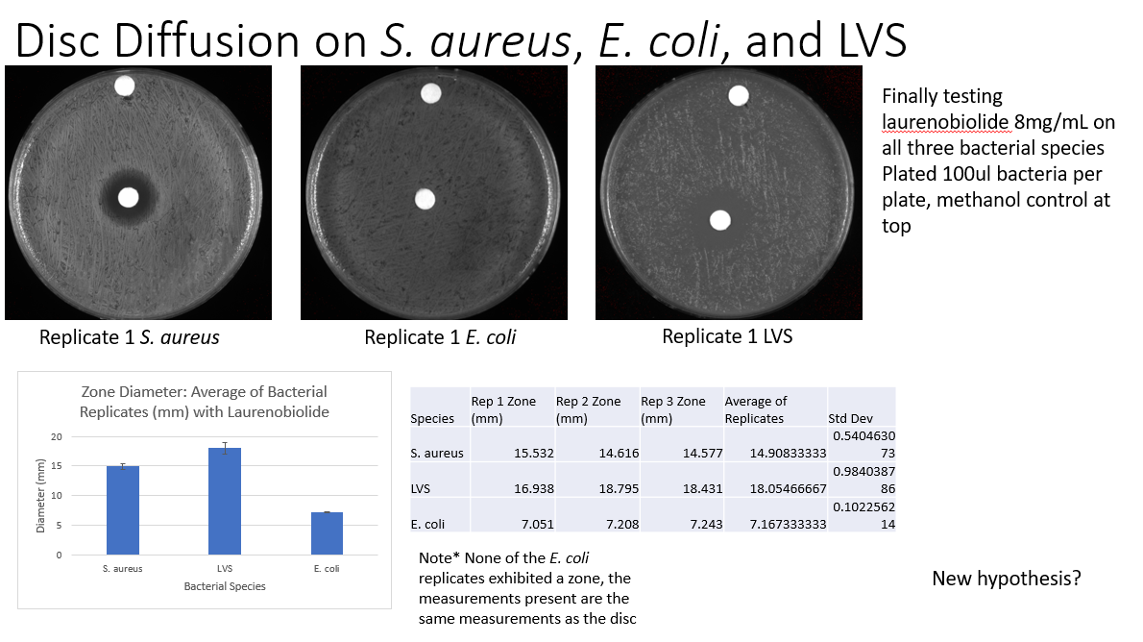
Notes from lab meeting: I should start making bar charts comparing SA zones by the day I plated them, such as Day 1, Day 2, and so forth. I also wanted to add that whenever I’m measuring the zones in ImageJ, I am measuring to the lighter ring rather than the darker ring. The lighter ring still indicates that there is some bacterial growth or at least a film of less densely grown bacteria. Regarding my hypothesis, I need to find and/or order a strain of E. coli that will only grow aerobically to test it.
In addition to my SA DDA tomorrow, I will be redoing the SA DDA from last week with the 8mg/ml laurenobiolide. The only difference between the SA DDA last week and the one I will be doing tomorrow is that I am changing the concentration/OD of SA113 to .01 rather than .05. The latter seems to be too dense and we would like to see if the light/dark rings still exist due to the density of the cells on the plate or not.
Starting today’s disc diffusion there are 4 compounds that are going to be tested in triplicate on LVS ONLY today. Taking a very small amount of cells after I flamed the loop, I resuspended in 400ul of MHB and put 50ul in a cuvette of 950ul MHB (1:20). I used parafilm to cover the cuvette and inverted it a few times to distribute the cells. The spec read that my OD was .057. I need a final OD of .01.
LVS od .057 at dilution factor of 1:20 -> final od needed is .01, need to take 87.7ul from 1:10 into volume of 1000ul
I diluted 1:10 in MHB and mixed by pipetting. I realized that since I have 12 plates and not 3, I needed a larger volume. Instead of changing my measurements, I just made two tubes of 1mL final volume at the same concentration, in case I drop one midway through and still have enough to plate for the rest of the plates.
I labeled the plates by the compound I was testing on them, corresponding to the labeled tubes from the Bertin lab that are from the -20 in the grey Tupperware on the bottom shelf. They are concentrated at 10mg/ml, wrapped in tinfoil, about 1ml in volume each so I have plenty of compound.
I poured beads on my plates and stacked them so the spreading process would be easier. I pipetted 100ul onto each plate, about 4 plates at a time, and then shook them as the beads were already in there. They seemed to take a bit longer to dry than normal, but Kathryn noted that the lab has been a little more humid recently so I’m assuming that’s why. Then I put 12 discs on a sterile plate and pipetted 20ul of methanol onto them for the control disc, making sure none of them touch in case some absorb more than others. Regarding the compound discs, I divided a sterile plate into four sections to keep the compounds apart, then pipetted each compound onto a sterile disc with 20ul per disc, 3 discs per compound, one disc per plate (corresponding label). I first put all the control discs onto the plates, and then I put the variable discs onto the plates. I cannot recall if I ethanol + flamed the tweezers every time between touching the different compound discs, but if I didn’t I think I will have to repeat the experiment next week and pay extra close attention to that part of the experiment. I placed all plates in the incubator by about 1:45pm.
I took the LB agar out of the water bath and sprayed ethanol on the sides before using the serological pipet to pour plates. I poured 24ml per sterile plate, and I needed to allocate at least 15 plates for my experiments for tomorrow, maybe one or two extra to collect the extra condensation. After I poured those necessary plates, it looked like I only had enough for about 3-4 Kan plates, so Hannah suggested that it didn’t make sense to make them with such a small volume of agar left, so I just poured them regularly and let them to dry on top of my plates. When they’re dry, I’ll put the extra in the fridge. I still have a good amount of LB plates in the fridge, so for future reference I will try to make antibiotic plates with whatever LB I have left so I don’t make too many extra non antibiotic plates.
Then I struck out SA113 from my single use aliquot that I made on 5.26. There was about 100ul so I pipetted about 50ul per side (left and right, not touching, in case one side has contamination or any other issues) of a refrigerated LB plate I made on 6.21. And then spread it with a sterile stick.
I also showed the plates I had on my bench to a member of the Bertin lab who is also working on a project with laurenobiolide.
Sent an email on behalf of the lab (asked by Hannah) requesting 3 gallons of 200 proof ethanol for the lab with the blanket PO. Need to pick up between 9 and 10 am on Thursday.

Wednesday, June 29, 2022
To Do:
- Disc diffusion with SA113
- Project outline
- Ask Dr. Bertin about preprint
Results and Data:
Disc diffusion for SA113. I labeled my LB plates with a format “SA [Compound] [Replicate] 6.29” to distinguish between the extracts. I resuspended a very thin loopful of SA113 from the plate I struck out yesterday into 400ul LB media. I made 4 other tubes: 2 “final” tubes that would contain the C2V2 product that I would end up plating, a 1:10 dilution that would be a dilution from the original tube, and a .01 final tube, which would contain the C2V2 product but of a .01 OD rather than the .05 OD that I would be using for the other four compounds. Respective volumes of LB media of 1000ul and 900ul. I added 50ul of resuspended bacteria into 950ul LB media into a spectrophotometer cuvette (1:20 dilution), inverted several times with a parafilm cover, with the addition of an LB blank and the OD was .088. For .05 OD SA113, I needed 28.4ul from the original resuspension in the final volume, so I took 28.4ul of plain LB media out from the final tubes and then added 28.4ul of bacteria and mixed by pipetting. The tube of an OD of .01 needed about 56.8ul from the 1:10 dilution tube, so after I added 100ul from the original tube to the dilution tube, mixed by pipetting, then did the same process as I did with the other “final” tubes.
I added sterile beads to the plates and then pipetted 100ul of the corresponding final tubes onto the plates and shook the plates until they dried. Then I picked out discs with sterile tweezers and added methanol to the control discs and a compound to the variable discs (L tulipifera 10mg/ml, L. hybrid 10mg/ml, L chinense A 10mg/ml, L chinense B 10mg/ml, laurenobiolide 8 mg/ml). I made sure that I sterilized the tweezers before I picked up a disc with a different compound loaded onto it than the previous one. Unfortunately, despite my best efforts to pick up single discs or separate discs that were stuck together, some of them did end up being stuck together and then causing issues when I would transfer them onto the lawn such as one of the discs falling onto a different part of the plate than where I placed the disc. My concern is that the full 20ul of compound that was supposed to be added to the disc was absorbed between the both of them so that can cause varying or smaller diameters than expected.
Found that my CHA plates that I poured on Monday became contaminated – had to take LVS disc diffusion plates out of the incubator and throw them away because of the media being contaminated.
Found the preprint that Dr. Bertin had referenced online (as I was looking for figures of the laurenobiolide and isomers), need to confirm this was the one.
Thursday, June 30, 2022
To Do:
- Pick up ethanol from stockroom
- Image and analyze staph plates
- Meeting with Kathryn
- Submit project outline
Results and Data:
Today I picked up 3 1-gallon containers of 200 proof ethanol from the Chemistry stockroom. I forwarded the email to Kathryn for records that the lab will be billed for the ethanol.
I looked at the revisions to my project outline and addressed them before meeting with Kathryn. I submitted the outline to the SURF submission form and have a copy in my folder.
I imaged my SA113 plates. Some of the plates have “divots” or areas where the growth is less than the growth around it- most of it is attributed to some discs falling and shifting around such as present in one of the hybrid plates.
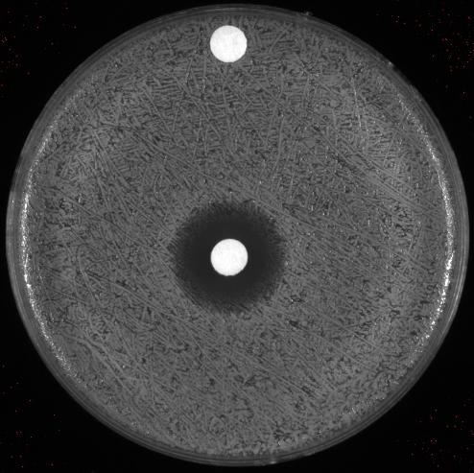
SA113 plate at .01 OD, concentration did not seem to make a difference between the light and dark rings
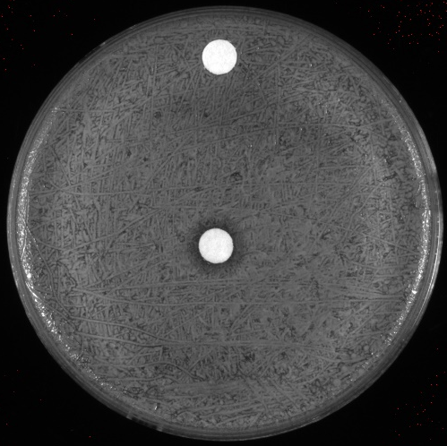
SA113 with the 10mg/ml L. tulipifera sample on disc
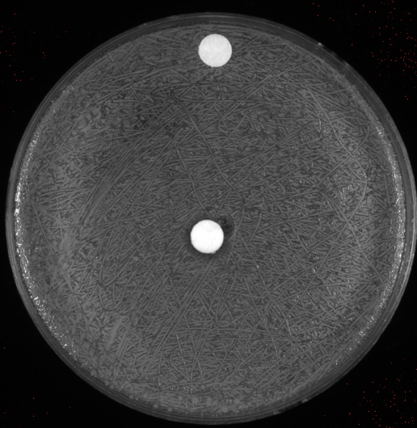
SA113 with the 10mg/ml L. hybrid sample on disc
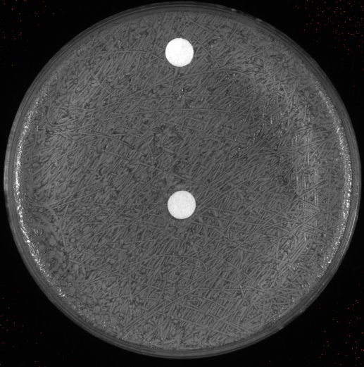
SA113 with the 10mg/ml L. chinense A sample on disc
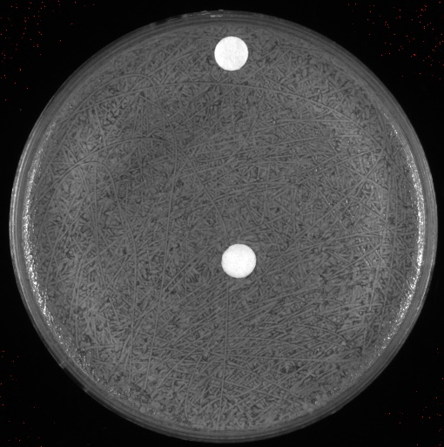
SA113 with the 10mg/ml L. chinense B sample on disc
Looking at next week
Monday off
Tuesday – Pour CHA plates, streak out LVS
Wednesday – LVS disc diffusion, pour LB plates, streak out the ATCC25922 and SA113
Thursday –ATCC25922 and SA113 disc diffusions
Friday – image/analyze LVS EC and SA plates

Tomorrow – notebook, look up e coli strain differences (antibiotic differences), read over paper from Kathryn methods are in the online resources of the paper (x4 MIC) , timesheet
Looking ahead – validate MIC,
Friday, July 1, 2022
To Do:
- Work on notebook
- Research E. coli strain differences
- Darobactin paper
- Timesheet
Results and Data:
Important note on E. coli strain differences (potentially test?): XL1 Blue has tetracycline resistance while ATCC25922 is susceptible to tetracycline.

Bibliography

Ramsey, K. M. and Dove, S. L. (2016) ‘ A response regulator promotes Francisella tularensis intramacrophage growth by repressing an anti-virulence factor ’, Molecular Microbiology. doi: 10.1111/mmi.13418.

