Francisella tularensis cDNA library preparation
- Firstly, I performed Qubit RNA quantitation of the 3 samples sent from Dr. Katherine’s lab, the concentrations were 26.28, 57.05, and 19.67ng/µl of samples 1, 2, and 3 respectively.

- Post quantitation performed a 10% TBE urea gel run to observe the quality of the RNA.

3 2 1 sample
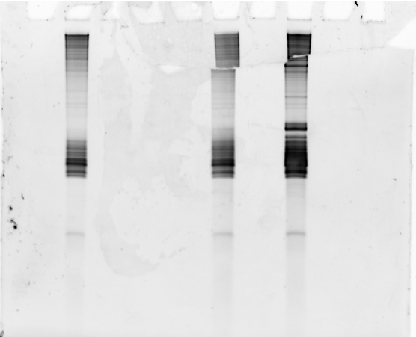
Fig 1 – Gel image of the RNAs.
(My apologies for the gel mishandling)

- For this library we initiated Poly A treatment of the RNAs before rRNA removal. I used 15µl from each of the samples for the Poly adenylation at the 3ʹ end. This was partly because the E. coli poly A polymerase kit (NEB) requires RNA from 1-10µg, and I was a bit confused about whether to consider Nanodrop readings or Qubit. Here is the protocol.

Components | Volume
ATP | 2µl
Buffer | 2µl
PAP | 1µl
RNA | 15µl
Total | 20µl

- Incubated 30 mins at 37 ͦc and then added 10µl Sodium acetate (3M, ph 5.5), 1µl glycogen (20mg/ml) & 300 µl EtOH (100%) for RNA precipitation. The precipitation step was at -80 overnight.
- Next day, centrifuged at 12600 rpm (centrifuge 5430R, Eppendorf) pelleted and washed once with 70% alcohol (750µl), and resuspended in 15µl of nuclease-free water after air drying the alcohol for 4mins.

- Post poly A treatment I proceeded with rRNA removal using the Microbe Express kit. I used the entire 15µl for this procedure. Followed the protocol to the teeth and then proceeded with RNA quantitation (Qubit) before using the Nanopore PCR cDNA sequencing kit (SQK-PCB109).
Sample 1 - 5 ng/µl
Sample 2 - 8.7 ng/µl
Sample 3 - 5.1 ng/µl

- Proceeded for Nanopore PCR cDNA sequencing kit protocol. For the cDNA preparation, I used 5µl of Poly A RNA from the previous step. The enzyme used for Reverse transcription and strand switching was MMLV (Moloney Murine Leukemia virus).

- Post cDNA preparation we proceeded to PCR with the barcoded primers. Samples 1, 2, and 3 had BP01, BP02, and BP03 primers respectively. Followed the protocol, the only point worth mentioning is that I did 14 cycles of PCR (as recommended by Nanopore in the protocol) and 10 mins for the extension step (within the cycle).

- After PCR there is Exo 1 digestion of the single-stranded primers followed by Ampure Beads washes, I used homemade SYPR DNA Beads for this part. The rest of the steps are as per protocol.

- Post Beads wash and retrieving the cDNA I quantified all the samples again and proceeded to gel imaging.

Sample 1 - 5.143 ng/µl (A little confused with sample 1, seems no loss)
Sample 2 - 3.8 ng/µl
Sample 3 - 3.4 ng/µl

- I have attached the gel image in a PowerPoint presentation* having proper labeling. Please let me know if you feel any discrepancy with the workflow.

- The Nanopore kit requires 20ng of cDNA material for sequencing so used 4, 5.4, and 6µl from samples 1, 2, and 3 respectively for adaptor ligation.

- One of the last steps before loading the samples on the flow cell involves mixing all 3 samples along with loading beads and sequencing buffer. The total volume of this solution was 78µl which is different than what Nanopore advised 75µl. It’s not a matter of concern otherwise 20ng for each sample was not possible.

This was all that was done, let me know if any part is confusing or needs further clarification.

The PowerPoint presentation for the gel images of each step is attached with the email.

