Table of Contents
May 2024 2
DNA Purification Protocol – S. aureus 2
Population Analysis Assay 6
Receiving Primers Protocol 7
DNA digest 11
Ligation Protocol 14
Transform chemically competent E. coli cells 15
Population Analysis Assay (microplate method) 19
Table 1: MICs of S. aureus wild-type and ∆rpsU mutant 21
Figure 1: Western Blot of HA-IP fractions 23
Immunoprecipitation with HA antibody 28
Figure 2: Silver Stain of HA-IP 5/20/24 31
June 2024 37
Figure 3: Western Blot of HA-IP 5/20/24 39
Sucrose counterselection: 42
Figure 4: MICs of Vancomycin against S. aureus strains 46
Immunoprecipitation with HA antibody 6/17/24 50
Figure 5: Silver Stain of HA-IP 6/17/24 53
Figure 7: Western Blot of HA-IP from 6/17/24 61
Population Analysis Assay (microplate method) 64
Figure 8: MICs of various antibiotics against S. aureus wild-type and ∆rpsU mutant 67
Bibliography 68

May 2024

Wednesday, May 1, 2024
To Do:
- Start overnight cultures
- Extract gDNA
- PCR
- Sequence reactions

DNA Purification Protocol – S. aureus
Cell Samples
1. Dilute lysostaphin in Tissue and Cell Lysis Solution to 1 mg/mL (i.e. 30 ul of 10 mg/ml stock in 270 ul TCL)
2. Add lysozyme crystals to 1 mg/mL and dissolve by pipetting up and down. (Made a 20 mg/mL stock solution and added 15ul of that stock to the TCL.)
3. Pellet 0.5 mL of an overnight culture by centrifugation and discard the supernatant, leaving approximately 25 µl of liquid.
4. Vortex for 10 seconds to resuspend the cell pellet.
5. Add 300 ul of Tissue and Cell Lysis Solution containing the lysozyme and lysostaphin and mix thoroughly. (added 315ul of the solution to include the stock solution of lysozyme)
6. Incubate at 37°C for 30 minutes
7. Add 1 ul of Proteinase K to each sample and mix thoroughly.
8. Incubate at 65°C for 15 minutes; vortex every 5 minutes.
9. Cool the samples to 37°C and add 1 µl of 20 mg/ml RNase A to the sample; mix thoroughly.
10. Incubate at 37°C for 30 minutes.
11. Place the samples on ice for 3-5 minutes and then proceed with total DNA precipitation (below).
Precipitation of Total DNA (for all biological samples)
1. Add 150 µl of MPC Protein Precipitation Reagent to 300 µl of lysed sample and vortex vigorously for 10 seconds.
2. Pellet the debris by centrifugation at 4°C for 10 minutes at ≥10,000 x g in a microcentrifuge. If the resultant pellet is clear, small, or loose, add an additional 25 µl of MPC Protein Precipitation Reagent, mix, and pellet the debris again.
3. Transfer the supernatant to a clean microcentrifuge tube and discard the pellet.
4. Add 500 µl of isopropanol to the recovered supernatant. Invert the tube 30-40 times.
5. Pellet the DNA by centrifugation at 4°C for 10 minutes in a microcentrifuge.
6. Carefully pour off the isopropanol without dislodging the DNA pellet.
7. Rinse twice with 70% ethanol, being careful to not dislodge the pellet. Centrifuge briefly if the pellet is dislodged. Remove all of the residual ethanol with a pipet and let dry completely under hood.
8. Resuspend the DNA in 35 µl of 0.1x EB Buffer. Put on ice to help dissolve, and add 50 µl of additional buffer if DNA is very goopy.
9. Check concentration and purity by nanodrop.

I pelleted all 9 cultures, but only performed the extraction on 3 (one from each colony). The other 6 I stored at -20ºC.

Staph gDNA Extraction
Reagent | Volume (ul) | Master Mix 3.5X
TCL | 270 | 945
Lysostaphin | 30 | 105
lysozyme | 15 | 52.5

Sample ID | Nucleic Acid | Unit | A260 (Abs) | A280 (Abs) | 260/280 | 260/230 | Sample Type | Factor
C1-A | 105.8 | ng/µl | 2.116 | 1.632 | 1.3 | 0.71 | DNA | 50
C2-A | 40.5 | ng/µl | 0.81 | 0.531 | 1.53 | 0.73 | DNA | 50
C3-A | 100.1 | ng/µl | 2.002 | 1.565 | 1.28 | 0.7 | DNA | 50

Not the best (especially C2), but hopefully fine for sequencing

PCR: use KROL 493 and 536

Reaction numbers | Sample | Expected size
1 | SA ∆rspU C1-A | 1977 bp
2 | SA ∆rspU C2-A | 1977 bp
3 | SA ∆rspU C3-A | 1977 bp
4 | SA wt | 2173 bp
5 | -DNA | no product

Total reaction volume | 100
Total number of reactions | 5
 |  |  |  | Factor
Component | Stock concentration | Final concentration | 1 rxn volume | 6
ddiH2O |  |  | 62.0 | 372
PrimeSTAR GXL Buffer | 5x | 1x | 20.0 | 120
dNTPs | 2.5 mM | 0.2 mM | 8.0 | 48
oligo F KROL 536 | 10 uM | 0.3 uM | 3.0 | 18
oligo R KROL 493 | 10 uM | 0.3 uM | 3.0 | 18
template | 100 ng/ul | 2 ng/ul | 2.0
PrimeSTAR GXL DNA Polymerase | 1.25 U/ul | 0.025 U/ul | 2.0 | 12
 |  | Total volume | 100 | 588

Sequencing: use KROL498

Friday, May 3, 2024
To Do:
- Extract gDNA
- PCR
- Sequence reactions
- Reconstitute vancomycin
- Make BHI plates

The sequencing reactions look fine, although there are some insertions at the ends.
I prepared a stock solution of vancomycin at 100mg/ml by adding 1g of antibiotic to 10ml of sterile water, then filter sterilizing and making 1.5ml aliquots. I added the info to the antibiotics stock solution spreadsheet.
I made BHI agar for the MIC assay but I messed up. The plan was for every 450ml of water, use 500ml worth of dry ingredients. I somehow misinterpreted my notes and my memory from the way Kathryn described it as making 500ml, then removing 50ml before autoclaving which makes absolutely no sense but it’s too late. I did not remove any media, instead I’ll just autoclave the 500ml volumes and use that for the first assay, which I’m calling a dress rehearsal.
I have to still make the different concentrations of antibiotics.

Saturday, May 4, 2024
To Do:
- Extract gDNA
- PCR
- Sequence reactions
- Reconstitute vancomycin
- Make BHI plates

Last night when I made the bad BHI plates it was too late to put them in the autoclave. Since I’m back here today and since I also remembered that I’m doing a “pilot” assay with 4 concentrations of antibiotics and only 1 replicate of each strain, I decided it was best to remake the BHI properly. For this test I only need 3 flasks.
Vancomycin concentrations setup:
C1 (ug/ml) | V1 (ul) | C2 (ug/ml) | V2 (ul)

C1 (ug/ml) | V1 (ul) | C2 (ug/ml) | V2 (ul)
100,000 | 16 | 32 | 50,000
100,000 | 8 | 16 | 50,000
100,000 | 4 | 8 | 50,000
100,000 | 2 | 4 | 50,000
100,000 | 1 | 2 | 50,000
100,000 | 0.5 | 1 | 50,000
100,000 | 0 | 0 | 50,000

Keeping it simple. The ones highlighted are the ones being tested today. I filter sterilized each concentration.
For 2 strains with 1 replicate each with 7 dilutions of bacteria tested with 4 concentrations of antibiotics I need 56 plates.
I am adding 2 ml of antibiotic at respective concentrations to each plate and adding 18 ml of agar.
I streaked out KRSA2 (wt) and KRSA12 (∆rpsU) for isolation.

Sunday, May 5, 2024
To Do:
- Reconstitute vancomycin
- Make BHI plates
- Start overnight cultures
I started overnight cultures of each S. aureus strain by taking a single colony and adding it to 5ml of TSB, incubating overnight at 37ºC.

Monday, May 6, 2024
To Do:
- Start overnight cultures
- Population analysis assay

Dilution of culture | 5.00E-02 | 5.00E-03 | 5.00E-04 | 5.00E-05 | 5.00E-06 | 5.00E-07 | 5.00E-08
 | 32 | 32 | 32 | 32 | 32 | 32 | 32
 | 8 | 8 | 8 | 8 | 8 | 8 | 8
 | 2 | 2 | 2 | 2 | 2 | 2 | 2
 | 0 | 0 | 0 | 0 | 0 | 0 | 0
 | Vancomycin concentration (ug/mL)
For now, this is the best way I can come up with the represent what I’m doing.
I am adding 50ul of each dilution to each antibiotic plate, but just to be extra cautious I will make each dilution 1ml. I will take 10ul of overnight culture and add to 990ul of TSB, and for the rest of the series I will take 100ul of culture and add to 900ul of TSB for a ten-fold dilution.

 | Measured OD600 | Actual OD600 | Final Volume (ul) | Starting Volume for OD600 0.3
KRSA2 | 0.04 | 0.8 | 1000 | 375
KRSA12 | 0.053 | 1.06 | 1000 | 283

Population Analysis Assay

Methods (to be done in triplicate):
- Prepare BHI plates with various concentrations of vancomycin (0-32ug/ml):
  - To a 1 liter flask, add 18.5 g of BHI powder and 7.5 g of agar, then add 450ml of DI water
  - To pour plates, add 2ml of respective concentration of vancomycin to plate, then add 18ml of agar. Use water for 0ug/ml.
- Grow overnight cultures of S. aureus strains.
- The next day, back-dilute cultures to an OD600 of 0.3 (protocol says OD578)
- Perform a ten-fold serial dilution of cultures by adding 10ul of overnight cultures to 990ul of TSB to create a 10⁻² dilution.
- Add 100ul of that dilution to 900ul of new TSB for a dilution of 10⁻³.
- Continue to add 100ul of previous dilution to 900ul of new TSB until a dilution of 10⁻⁸ is reached.
- Plate 50ul of each dilution onto prepared BHI plates with vancomycin.
- Spread culture on plates using sterile beads.
- Incubate at 37ºC for 48 hours.
While spread-plating I noticed that some of the plates weren’t mixed well with the antibiotic; these are probably the ones that were poured last and the agar was solidifying.

Tuesday, May 7, 2024
To Do:
- Population analysis assay
- Reconstitute primers
- Test PCR on primers
- PCR to amplify primers

Receiving Primers Protocol
By: Hannah Trautmann

- Spin primers at maximum speed in tabletop centrifuge for 3 minutes so dessicated primers go to the bottom of the tube.
- Add 0.1x EB to a final concentration of 100 uM. Calculate this by multiplying the reported nm by 10 and adding that volume in ul (i.e. 12.7 nmoles = add 127 uL of 0.1xEB).
- Put on 42°C heat block for 5 minutes to help primers dissolve
- Vortex and brief spin.
- Label tubes with KROL numbers on the top and put in the appropriate 100 uM stock box in the -20°C freezer.
- Optional: Make dilution for intended purpose of primer.
  - If a PCR primer, make a 10 uM stock by diluting 20 uL of the 100 uM stock into 180 uL of 0.1xEB. Label with purple sticker and put in appropriate freezer box.
  - If a sequencing primer, make a 2.5 uM stock by diluting 5 uL of the 100 uM stock into 195 uL of 0.1x EB. Label with blue sticker and put in appropriate freezer box.
- Put Certificate of Analysis sheet in “Oligos Spec Sheet” binder and shipping sheet in Invoices box.

Primer | nm | Volume to Add (ul)
KROL689 | 30.1 | 301
KROL690 | 18.2 | 182
KROL691 | 18.5 | 185
KROL692 | 31.0 | 310
KROL693 | 30.6 | 306
KROL694 | 17.3 | 173
KROL695 | 17.8 | 178
KROL696 | 21.4 | 214

PCR:
Reaction numbers | Sample | Primers | Expected size
1 | rpsU1-HA FR1 | KROL693 and KROL694 | 615 bp
2 | rpsU1-HA FR2 | KROL695 and KROL696 | 643 bp
3 | rpsU2-HA FR1 | KROL685 and KROL686 | 608 bp
4 | rpsU2-HA FR2 | KROL687 and KROL688 | 658 bp
5 | rpsU3-HA FR1 | KROL689 and KROL690 | 623 bp
6 | rpsU3-HA FR2 | KROL691 and KROL692 | 649 bp
7 | LVS gDNA | KROL15 and KROL16 | 456 bp
8 | -DNA | KROL693 and KROL694 | no product

Total reaction volume | 20
Total number of reactions | 8
 |  |  |  | Factor
Component | Stock concentration | Final concentration | 1 rxn volume | 9
ddiH2O |  |  | 12.4 | 111.6
PrimeSTAR GXL Buffer | 5x | 1x | 4.0 | 36
dNTPs | 2.5 mM | 0.2 mM | 1.6 | 14.4
oligo F | 10 uM | 0.3 uM | 0.6
oligo R | 10 uM | 0.3 uM | 0.6
template | 100 ng/ul | 2 ng/ul | 0.4 | 3.6
PrimeSTAR GXL DNA Polymerase | 1.25 U/ul | 0.025 U/ul | 0.4 | 3.6
 |  | Total volume | 20 | 169.2

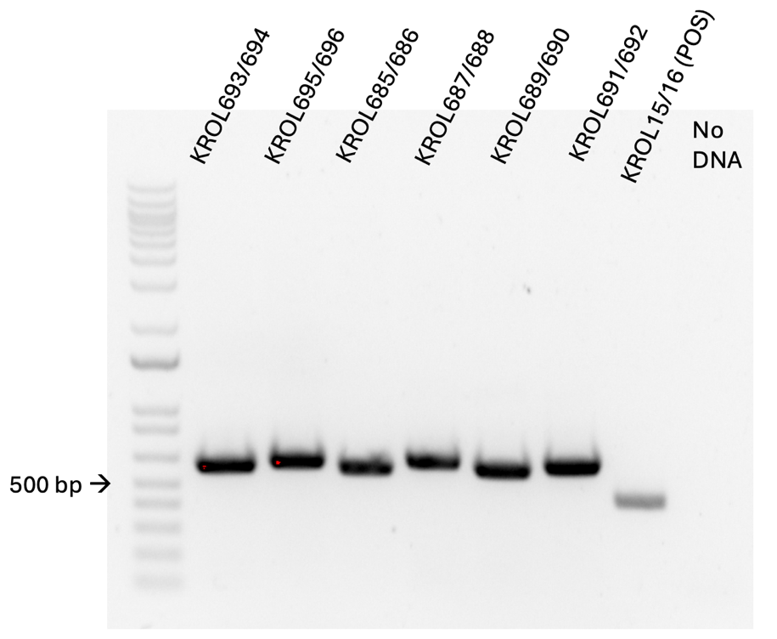
Everything looks good! Although the ladder is very faint.

Reaction numbers | Sample | Primers |  |  | Expected size
1 | rpsU1-HA FR1 | KROL693 and KROL694 |  |  | 615 bp
2 | rpsU1-HA FR2 | KROL695 and KROL696 |  |  | 643 bp
3 | rpsU2-HA FR1 | KROL685 and KROL686 |  |  | 608 bp
4 | rpsU2-HA FR2 | KROL687 and KROL688 |  |  | 658 bp
5 | rpsU3-HA FR1 | KROL689 and KROL690 |  |  | 623 bp
6 | rpsU3-HA FR2 | KROL691 and KROL692 |  |  | 649 bp
7 | -DNA | KROL691 and KROL692 |  |  | no product
Total reaction volume |  |  | 100
Total number of reactions |  |  | 7
 |  |  |  |  |  |  |  | Factor
Component |  |  | Stock concentration | Final concentration |  |  | 1 rxn volume | 8
ddiH2O |  |  |  |  |  |  | 62.0 | 496
PrimeSTAR GXL Buffer |  |  | 5x | 1x |  |  | 20.0 | 160
dNTPs |  |  | 2.5 mM | 0.2 mM |  |  | 8.0 | 64
oligo F |  |  | 10 uM | 0.3 uM |  |  | 3.0
oligo R |  |  | 10 uM | 0.3 uM |  |  | 3.0
template |  |  | 100 ng/ul | 2 ng/ul |  |  | 2.0 | 16
PrimeSTAR GXL DNA Polymerase |  |  | 1.25 U/ul | 0.025 U/ul |  |  | 2.0 | 16
 |  |  |  | Total volume |  |  | 100 | 739.6

Population analysis:
I took a preliminary look at the plates from yesterday. I see good colonies on the wild-type plates, but the mutant colonies are very small; therefore it is difficult to determine if there is a difference in MIC. I will let them incubate another day. Some notes: the wild-type van 32ug/ml plate had many colonies that were concentrated in the middle of the plate. At this point, none of the other 32 plates had growth for wt, so I think this is from a badly mixed plate. I think the antibiotic got concentrated to one side of the plate, allowing the bacteria to grow on the other side. For some of the mutant plates, I see large colonies that are probably contamination.

Wednesday, May 8, 2024
To Do:
- Reconstitute primers
- Test PCR on primers
- PCR to amplify primers
- PCR purification
- Digest
- Gel purification
- Overnight ligation
- Pour LB-Kan plates
Population analysis:
 | ∆rpsU
 | 0 ug/ml | 2 ug/ml | 8 ug/ml | 32 ug/ml
5.00E-02 | TNTC | lawn | TNTC | 588*
5.00E-03 | 1144 | 1300 | 1236 | 54
5.00E-04 | 92 | 443 | 289 | 147
5.00E-05 | 19 | 45 | 30 | 9
5.00E-06 | 7 | 12 | 3 | 3
5.00E-07 | 0 | 0 | 0 | 0
5.00E-08 | 0 | 0 | 0 | 0
 | wild-type
5.00E-02 | lawn | lawn | lawn | 0
5.00E-03 | TNTC | TNTC | TNTC** | TNTC*
5.00E-04 | 776 | 716 | 461 | 0
5.00E-05 | 93 | 124 | 31 | 0
5.00E-06 | 14 | 5 | 10 | 0
5.00E-07 | 0 | 1 | 0 | 0
5.00E-08 | 0 | 0 | 0 | 0
*Growth might be due to improper mixing of antibiotic when pouring plates.
**The growth was concentrated in the middle of the plate rather than throughout the whole plate, so there may be fewer colonies than lower concentrations but there were still too many colonies to count.
This is interesting because wild-type had more colonies compared to mutant at each concentration except at 32ug/ml. Except for 10³, each dilution had zero growth at that concentration. This indicates that there is a change in phenotype between mutant and wild-type. It seems that the mutant as a higher MIC. I only set up one replicate each, so this data must be taken with a grain of salt.

DNA digest
Protocol by John Church

- Make a reaction table with desired digests:
Tube | DNA | Enzyme(s) | DNA Volume (uL) | H₂O Volume (uL)
1 | Purified PCR rpsU1-HA FR1 | KpnI, NotI | 15 | -
2 | Purified PCR rpsU1-HA FR2 | NotI, BamHI | 15 | -
3 | Purified PCR rpsU2-HA FR1 | BamHI, NotI | 15 | -
4 | Purified PCR rpsU2-HA FR2 | NotI, KpnI | 15 | -
5 | Purified PCR rpsU3-HA FR1 | BamHI, NotI | 15 | -
6 | Purified PCR rpsU3-HA FR2 | NotI, KpnI | 15 | -
7 | Backbone pKR5 | BamHI, KpnI | 5 | 10

- Set up master mix table:

KpnI/NotI:
Components | Volumes in 1 reaction (uL) | Volumes in Master Mix 4x (uL)
H₂O | 10.8 | 43.2
10x Buffer* | 3.0 | 12.0
DNA | (15.0) | -
KpnI | 0.6 | 2.4
NotI | 0.6 | 2.4
Total | 30.0 (15.0 actual b/c of DNA)

BamHI/NotI:

Components | Volumes in 1 reaction (uL) | Volumes in Master Mix 4x (uL)
H₂O | 10.8 | 43.2
10x Buffer* | 3.0 | 12.0
DNA | (15.0) | -
BamHI | 0.6 | 2.4
NotI | 0.6 | 2.4
Total | 30.0 (15.0 actual b/c of DNA)

BamHI/KpnI:

Components | Volumes in 1 reaction (uL) | Volumes in Master Mix 2x (uL)
H₂O | 10.8 | 21.6
10x Buffer* | 3.0 | 6.0
DNA | (15.0) | -
BamHI | 0.6 | 1.2
KpnI | 0.6 | 1.2
Total | 30.0 (15.0 actual b/c of DNA)

*Cutsmart Buffer is used for all the “HF” enzymes. Check the NEB website for buffer compatibility with non-HF restriction enzymes.

- Add indicated amounts of H₂O and 10x buffer to master mix tube (MM).
- Add indicated amount of DNA or DNA+water (for backbone tubes) to individual tubes for digest (1.5 mL microfuge tubes for digests in incubator, PCR strip tubes for reactions incubated in the thermocycler).
- Add indicated amount of each enzyme (___uL) to the master mix tube (MM).
- Mix the master mix by pipetting up and down.
- Add master mix to individual tubes. Volume to add to each tube is the volume in 1 reaction minus the DNA volume (____ul).
- Incubate at 37°C for 1 hour or up to overnight.
- If using digest for plasmid construction then after incubation at 37°C, add 0.5ul of CIP enzyme to backbone tube, mix by pipetting and put back in 37°C incubator for 10 minutes. (this step removes the phosphates from the ends of the plasmid to prevent re-ligation). If using the new Quick CIP – add 1 uL, mix, incubate (at 37º) for 10 mins, then put at 80C for 2 minutes to inactivate the CIP.
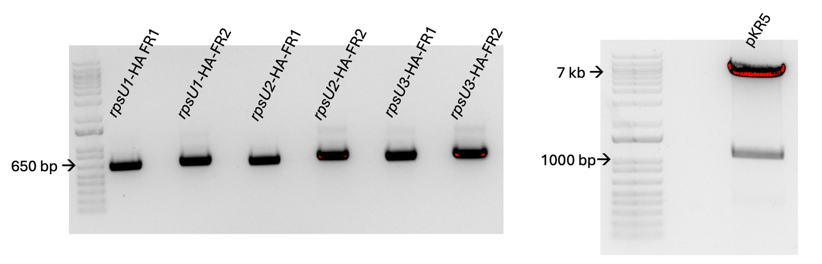

Gel purification:
 | Tube Weight (g) | Tube w/ Gel (g) | Gel Weight (mg) | QG Buffer Volume (ul) | Isopropanol Volume (ul)
Tube 1 | 1.13 | 1.55 | 420 | 1260 | 420
Tube 2 | 1.13 | 1.6 | 470 | 1410 | 470
Tube 3 | 1.12 | 1.61 | 490 | 1470 | 490
Tube 4 | 1.12 | 1.52 | 400 | 1200 | 400
Tube 5 | 1.13 | 1.51 | 380 | 1140 | 380
Tube 6 | 1.12 | 1.44 | 320 | 960 | 320
Tube 7 | 1.12 | 1.49 | 370 | 1110 | 370

Ligation Protocol
Protocol by John Church
The purpose of this is to ligate the cut plasmid backbone to the strand of PCR DNA.

- Make a reaction table with desired ligations. Always include a backbone only control for each plasmid backbone used.
Tube | Insert | Backbone
1 | BamHI, KpnI, NotI digested, purified PCR rpsU1-HA | BamHI, KpnI digested, purified pKR5
2 | BamHI, KpnI, NotI digested, purified PCR rpsU2-HA | BamHI, KpnI digested, purified pKR5
3 | BamHI, KpnI, NotI digested, purified rpsU3-HA | BamHI, KpnI digested, purified pKR5
4 | - | BamHI, KpnI digested, purified pKR5

- Set up master mix table:
Component | Reaction 1 (uL) | Reaction 2 (uL) | Reaction 3 (uL) | Reaction 4 (uL) | Master Mix (5x)
H₂O | 7.5 | 7.5 | 7.5 | 11.5 | 37.5
10x ligase buffer | 2.0 | 2.0 | 2.0 | 2.0 | 10
Insert 1 | 4.0 | 4.0 | 4.0 | - | -
Insert 2 | 4.0 | 4.0 | 4.0 |  | -
Backbone | 2.0 | 2.0 | 2.0 | 2.0 | 10
Ligase | 0.5 | 0.5 | 0.5 | 0.5 | 2.5
TOTAL | 20.0 | 20.0 | 20.0 | 20.0 | 100

- Obtain ice to assemble and keep the reactions on. This is important, as the reaction happens at 16°C and the ligase buffer (which contains ATP) needs to be kept cold in order to avoid degradation. Take a 10 uL aliquot of 10X ligase buffer from the miscellaneous buffers box in the -20C.
- Obtain and label PCR tubes for the reactions. Be sure to include the date and your initials.
- To the individual tubes, add indicated amounts of H₂O (___uL), 10x buffer (_____uL), insert (____uL), and backbone (____uL).
- Add indicated amount of ligase (___uL) to the individual tubes. Remember to keep the ligase in a mini cooler.
- After all of the components have been added, mix each tube with a pipette set to 18 uL.
- Place in the thermocycler or water bath overnight at 16ºC. Can do at room temp for 10 minutes if necessary.

Thursday, May 9, 2024
To Do:
- PCR purification
- Digest
- Gel purification
- Overnight ligation
- Pour LB-Kan plates
- E. coli transformation

Transform chemically competent E. coli cells

- Set up reaction table. Always include a positive and negative control for each antibiotic. If transforming plasmids (from previous plasmid prep), use 0.5 – 1 uL of plasmid. If transforming ligations, use 8 uL per ligation. If transforming plasmid, plate 20 uL and 100 uL. If transforming a ligation, plate 100 uL and remaining culture.
  - Note: The plasmid used for the positive control plates should be the regular circular plasmid, not the digest/purified one.
  - There should always be a backbone control if testing a ligation. This is the digested and ligated backbone with NO INSERT.

Reaction table
Tube number | Purpose | DNA | Volume of DNA | Final volume to plate | Number of kanamycin-containing plates
1 | (+) control | pKR5 | 1 uL | 20 ul, 100 ul | 2
2 | (-) control | None | 0 | 20 ul, 100 ul | 2
3 | Backbone Ligation | pKR5 (digested) | 8 uL | 100 uL, remaining | 2
4 | Ligation 1 | pKR220 | 8 uL | 100 uL, remaining | 2
5 | Ligation 2 | pKR218 | 8 uL | 100 uL, remaining | 2
6 | Ligation 3 | pKR219 | 8 uL | 100 uL, remaining | 2
Total number of plates |  |  |  |  | 12

- Check to be sure you have enough LB-Kan plates with appropriate antibiotic. If plates were stored at 4°C, warm at 37°C until needed.
- Obtain DNA and thaw on ice if necessary.
- Thaw appropriate number of competent cell tubes on ice (5 reactions per tube of competent cells)
- Label sterile tubes as indicated in reaction table. Add indicated volume of indicated DNA on ice.
- When competent cells are thawed (check by probing for frozen cells using a sterile pipette tip), gently pipette 100 uL of cells into each reaction tube directly onto DNA using aseptic technique.
- Incubate cells on ice for 20 minutes. During incubation, find or set heat block to 42°C.
- Place tubes with cells and DNA onto 42°C heat block for 30 seconds (heat shock step).
- After heat shock, place tubes back on ice until next step (don’t keep them here too long).
- Using aseptic technique, add 1 mL LB (no antibiotic) to each microfuge tube.
- Using autoclave tape, tape microfuge tubes down in shaking incubator set to 37°C.
- Allow cells to recover for 1 hour at 37°C, shaking. Place in a rack after shaking (NOT back on ice).
- Using aseptic technique, plate indicated amount of cells on appropriate antibiotic plates (LB-Kan), spreading until plates look dry. For “remaining” volume, spin tubes at max speed in benchtop centrifuge for 30 seconds. Remove 800 uL of media. Using 200 uL pipette, resuspend cells at bottom of tube and plate all the remaining culture.

Friday, May 10, 2024
To Do:
- E. coli transformation
- Set up overnight cultures

Cloning:
The transformations worked well:
 | 100ul | Remaining Volume
Ligation 1 | 10 | 130
Ligation 2 | 16 | 249
Ligation 3 | 3 | 74
Backbone only | 4 | 11
A lot of colonies on the positive control and no growth on the negative control.
Set up 5 colonies from each ligation as overnight cultures.

S. aureus:
Next steps for population analysis: set this up in a microplate rather than agar plates. Use higher concentrations of antibiotic (0-256ug/ml). I streaked new plates of mutant and wild-type and set them up in the 30ºC incubator over the weekend.

Saturday, May 11, 2024
To Do:
- Set up overnight cultures
- Make cell pellets
I made cell pellets of the overnight cultures and stored them in the -20ºC.

Monday, May 13, 2024
To Do:
- Make cell pellets
- Minipreps
- Set up sequencing
- Overnights of S. aureus
- Make BHI broth
- Patch LVS

Minipreps:
# | Sample ID | Nucleic Acid | Unit | A260 (Abs) | A280 (Abs) | 260/280 | 260/230 | Sample Type | Factor
1 | pKR220-A | 500.3 | ng/µl | 10.007 | 5.368 | 1.86 | 2.28 | DNA | 50
2 | pKR220-B | 449.9 | ng/µl | 8.997 | 4.803 | 1.87 | 2.24 | DNA | 50
3 | pKR220-C | 343.8 | ng/µl | 6.876 | 3.695 | 1.86 | 2.28 | DNA | 50
4 | pKR220-D | 316.3 | ng/µl | 6.326 | 3.371 | 1.88 | 2.26 | DNA | 50
5 | pKR220-E | 366.8 | ng/µl | 7.335 | 3.903 | 1.88 | 2.27 | DNA | 50
6 | pKR219-A | 447.2 | ng/µl | 8.944 | 4.762 | 1.88 | 2.27 | DNA | 50
7 | pKR219-B | 358.3 | ng/µl | 7.166 | 3.821 | 1.88 | 2.31 | DNA | 50
8 | pKR219-C | 338.1 | ng/µl | 6.761 | 3.596 | 1.88 | 2.32 | DNA | 50
9 | pKR219-D | 395.1 | ng/µl | 7.901 | 4.21 | 1.88 | 2.3 | DNA | 50
10 | pKR219-E | 421.5 | ng/µl | 8.429 | 4.498 | 1.87 | 2.26 | DNA | 50
11 | pKR218-A | 626 | ng/µl | 12.52 | 6.694 | 1.87 | 2.29 | DNA | 50
12 | pKR218-B | 530 | ng/µl | 10.6 | 5.655 | 1.87 | 2.31 | DNA | 50
13 | pKR218-C | 634.4 | ng/µl | 12.688 | 6.831 | 1.86 | 2.18 | DNA | 50
14 | pKR218-D | 572 | ng/µl | 11.44 | 6.083 | 1.88 | 2.3 | DNA | 50
15 | pKR218-E | 576.8 | ng/µl | 11.535 | 6.181 | 1.87 | 2.29 | DNA | 50

I diluted these to get better pipetting volumes for sequencing.

# | Sample ID | Nucleic Acid | Unit | A260 (Abs) | A280 (Abs) | 260/280 | 260/230 | Sample Type | Factor
1 | pKR220-A | 52.4 | ng/µl | 1.049 | 0.559 | 1.88 | 2.33 | DNA | 50
2 | pKR220-B | 82.3 | ng/µl | 1.645 | 0.87 | 1.89 | 2.76 | DNA | 50
3 | pKR220-C | 69.3 | ng/µl | 1.386 | 0.709 | 1.95 | 2.78 | DNA | 50
4 | pKR220-D | 65.4 | ng/µl | 1.308 | 0.687 | 1.9 | 2.92 | DNA | 50
5 | pKR220-E | 72.6 | ng/µl | 1.451 | 0.778 | 1.87 | 2.97 | DNA | 50
6 | pKR219-A | 71.6 | ng/µl | 1.432 | 0.761 | 1.88 | 2.69 | DNA | 50
7 | pKR219-B | 61.9 | ng/µl | 1.239 | 0.625 | 1.98 | 2.93 | DNA | 50
8 | pKR219-C | 61.2 | ng/µl | 1.225 | 0.628 | 1.95 | 2.83 | DNA | 50
9 | pKR219-D | 84.2 | ng/µl | 1.684 | 0.887 | 1.9 | 2.63 | DNA | 50
10 | pKR219-E | 75.3 | ng/µl | 1.506 | 0.809 | 1.86 | 2.91 | DNA | 50
11 | pKR218-A | 114 | ng/µl | 2.286 | 1.228 | 1.86 | 2.79 | DNA | 50
12 | pKR218-B | 53.9 | ng/µl | 1.078 | 0.58 | 1.86 | 2.25 | DNA | 50
13 | pKR218-C | 65.9 | ng/µl | 1.317 | 0.708 | 1.86 | 2.25 | DNA | 50
14 | pKR218-D | 63.4 | ng/µl | 1.267 | 0.673 | 1.88 | 2.23 | DNA | 50
15 | pKR218-E | 64 | ng/µl | 1.279 | 0.673 | 1.9 | 2.3 | DNA | 50

Sample number | Template Type | Template Name | Primer Nameª | A. | B. | E. | F.
 | (plasmid or PCR) |  |  | Template Size (bases) | Template Stock Conc. (ng/μl) | PLASMID template: | Volume H₂O needed
 |  |  |  |  |  | Volume =
 |  |  |  |  |  | 2x(~200 ÷ B)μl | (12 less D or E - 2.56)μl
KB1 | plasmid | pKR220 | KROL6 | 8073 | 52.4 | 7.63 | 1.81
KB2 | plasmid | pKR220 | KROL6 | 8073 | 82.3 | 4.86 | 4.58
KB3 | plasmid | pKR220 | KROL6 | 8073 | 69.3 | 5.77 | 3.67
KB4 | plasmid | pKR220 | KROL6 | 8073 | 65.4 | 6.12 | 3.32
KB5 | plasmid | pKR220 | KROL6 | 8073 | 72.6 | 5.51 | 3.93
KB6 | plasmid | pKR218 | KROL6 | 8081 | 71.6 | 5.59 | 3.85
KB7 | plasmid | pKR218 | KROL6 | 8081 | 61.9 | 6.46 | 2.98
KB8 | plasmid | pKR218 | KROL6 | 8081 | 61.2 | 6.54 | 2.90
KB9 | plasmid | pKR218 | KROL6 | 8081 | 84.2 | 4.75 | 4.69
KB10 | plasmid | pKR218 | KROL6 | 8081 | 75.3 | 5.31 | 4.13
KB11 | plasmid | pKR219 | KROL6 | 8087 | 114.3 | 3.50 | 5.94
KB12 | plasmid | pKR219 | KROL6 | 8087 | 53.9 | 7.42 | 2.02
KB13 | plasmid | pKR219 | KROL6 | 8087 | 65.9 | 6.07 | 3.37
KB14 | plasmid | pKR219 | KROL6 | 8087 | 63.4 | 6.31 | 3.13
KB15 | plasmid | pKR219 | KROL6 | 8087 | 64 | 6.25 | 3.19

Tuesday, May 14, 2024
To Do:
- Minipreps
- Set up sequencing
- Overnights of S. aureus
- Make BHI broth
- Patch LVS
- Population analysis

Population Analysis Assay (microplate method)
Based on Barnes et al, 2023
Methods:
- Grow overnight cultures of S. aureus strains.
- The next day, back-dilute cultures to an OD600 of 0.3 in BHI broth.
- Prepare BHI broth with antibiotics by making the medium 2X the highest drug concentration in test range.
- In a 96-well plate, add 100ul of BHI with antibiotics to each well in Row A using a multi-channel pipet.
- In Rows B-H add 50ul of BHI without antibiotics
- Perform a serial two-fold dilution by adding 50ul of BHI with antibiotics from wells in Row A to the Row B.
- Continue the serial dilution until Row F.
- Perform a ten-fold serial dilution of bacterial cultures by adding 10ul of overnight cultures to 990ul of TSB to create a 10⁻² dilution, then add 100ul of that dilution to 900ul of new TSB for a dilution of 10⁻³.
- Add 500ul of each bacterial dilution to the wells in the appropriate columns (i.e. 10⁻² to the wells in Columns 1 and 7).
- Incubate plate at 37ºC for 24 hours.
I may have messed this up. The protocol this is based on said to add 100ul of the 2X vanc BHI to the first row, which I did, and then serially dilute the antibiotic 2-fold down the column. However, doing it this way means the first row of antibiotics is at a concentration of 512 ug/ml, instead of 256 ug/ml, and all of the rows are off by a factor of 2 except for Row G which is at 0. So the range of vancomycin is 0, 16, 32, 64, 128, 256, 512 instead of 0, 8, 16, 32, 64,128.

Wednesday, May 15, 2024
To Do:
- Population analysis
- Start culture for LVS-pF pellet
- Western Blot
- Start overnights of Ligation 1
Population Analysis:
Wild-type:
 | 5e-2 | 5e-3 | 5e-4 | 5e-5 | 5e-6 | 5e-7 | 5e-2 | 5e-3 | 5e-4 | 5e-5 | 5e-6 | 5e-7
256 ug/ml | 0.049 | 0.049 | 0.048 | 0.05 | 0.048 | 0.049 | 0.05 | 0.05 | 0.048 | 0.05 | 0.049 | 0.047
128 ug/ml | 0.051 | 0.051 | 0.05 | 0.051 | 0.05 | 0.05 | 0.051 | 0.05 | 0.049 | 0.05 | 0.048 | 0.047
64 ug/ml | 0.051 | 0.05 | 0.051 | 0.05 | 0.051 | 0.05 | 0.051 | 0.05 | 0.05 | 0.05 | 0.05 | 0.048
32 ug/ml | 0.049 | 0.05 | 0.051 | 0.051 | 0.05 | 0.049 | 0.05 | 0.049 | 0.05 | 0.05 | 0.05 | 0.05
16 ug/ml | 0.049 | 0.05 | 0.05 | 0.049 | 0.05 | 0.048 | 0.05 | 0.05 | 0.051 | 0.05 | 0.051 | 0.051
8 ug/ml | 0.049 | 0.052 | 0.051 | 0.049 | 0.05 | 0.049 | 0.049 | 0.054 | 0.051 | 0.05 | 0.05 | 0.05
0 ug/ml | 0.909 | 0.644 | 0.705 | 0.738 | 0.358 | 0.369 | 0.68 | 0.696 | 0.667 | 0.653 | 0.614 | 0.429
Blank | 0.036 | 0.041 | 0.043 | 0.042 | 0.042 | 0.041 | 0.04 | 0.04 | 0.04 | 0.039 | 0.039 | 0.038

∆rpsU:
 | 5e-2 | 5e-3 | 5e-4 | 5e-5 | 5e-6 | 5e-7 | 5e-2 | 5e-3 | 5e-4 | 5e-5 | 5e-6 | 5e-7
256 ug/ml | 0.049 | 0.048 | 0.047 | 0.049 | 0.048 | 0.049 | 0.049 | 0.048 | 0.048 | 0.048 | 0.047 | 0.046
128 ug/ml | 0.05 | 0.05 | 0.05 | 0.049 | 0.049 | 0.05 | 0.05 | 0.05 | 0.051 | 0.05 | 0.048 | 0.047
64 ug/ml | 0.052 | 0.05 | 0.051 | 0.05 | 0.051 | 0.051 | 0.051 | 0.05 | 0.049 | 0.048 | 0.05 | 0.049
32 ug/ml | 0.05 | 0.05 | 0.05 | 0.051 | 0.05 | 0.05 | 0.051 | 0.049 | 0.05 | 0.048 | 0.05 | 0.048
16 ug/ml | 0.05 | 0.051 | 0.049 | 0.05 | 0.049 | 0.05 | 0.052 | 0.051 | 0.051 | 0.05 | 0.051 | 0.05
8 ug/ml | 0.056 | 0.05 | 0.048 | 0.049 | 0.049 | 0.049 | 0.057 | 0.049 | 0.05 | 0.05 | 0.05 | 0.051
0 ug/ml | 0.583 | 0.754 | 0.764 | 0.368 | 0.161 | 0.419 | 0.509 | 0.71 | 0.417 | 0.493 | 0.054 | 0.311
Blank | 0.046 | 0.041 | 0.046 | 0.049 | 0.053 | 0.049 | 0.064 | 0.062 | 0.056 | 0.047 | 0.045 | 0.04

Table 1: MICs of S. aureus wild-type and ∆rpsU mutant

Cloning:
The sequencing results came back. rpsU3-HA looks great, most of rpsU2-HA looks great, but rpsU1-HA doesn’t. One of the minipreps for that strain didn’t sequence, and 2 of the sequences came back with large insertions at the end of bS21-1 that looks like the ATAT addition and the NotI site. One of the sequences looks fine except for 3 nts that weren’t identified, but the peaks look fine. It is in the promoter region though, so I will re-sequence that miniprep with a different primer (KROL7), and in the meantime screen some more colonies from the transformation plate and also go back and repeat the digest.
The immediate focus for the next stage is getting allelic exchange for rpsU2-HA. Kathryn and I took another look at the latest sucrose gradient results and we are wondering if bS21-2 will be found in all three peaks or just in the 30S and 70S. I’m throwing those fractions on a Western. It’s possible that bS21-2 has dissociated and reattached at a secondary binding site in the 50S. In any case, it might be we see something different on the HA-tagged bS21 on the chromosome. It might be that since we’re overexpressing bS21-2-HA this might not be biologically relevant.

Western Blot:
Lane | Content | Volume
1 | WesternSure Ladder | 5 ul
2 | Fraction 8 | 15 ul
3 | Fraction 9 | 15 ul
4 | Fraction 10 | 15 ul
5 | Fraction 13 | 15 ul
6 | Fraction 14 | 15 ul
7 | Fraction 15 | 15 ul
8 | Fraction 16 | 15 ul
9 | Fraction 17 | 15 ul
10 | LVS pF-rpsU2-HA WCL | 10 ul
11 | LVS pF-rpsU2-V5 WCL | 10 ul
12 | 1X SLB | 10 ul
13 | 1X SLB | 10 ul
14 | 1X SLB | 10 ul
15 | 1X SLB | 10 ul

IP cell pellet:
Sample | Observed OD600 | Calculated OD600 | Starting Volume for OD600 0.003 (ul)
LVS pF | 0.156 | 3.12 | 77

Thursday, May 16, 2024
To Do:
- Start culture for LVS-pF pellet
- Western Blot
- Start overnights of Ligation 1
- Miniprep transformants
- Western Day 2
- Make IP cell pellet
- Patch LVS

IP cell pellet:
Sample | Observed OD600 | Calculated OD600 | Starting Volume for OD600 0.003 (ul) | OD600 10:50 am next day
LVS pF | 0.156 | 3.12 | 77 | 0.485

Dang it.
Back-diluted to OD 0.08 and will try again this afternoon. Added 13ml of overnight culture to 67ml of sMHB.
At 5:15 the OD was 0.339.

Minipreps:

# | Sample ID | Nucleic Acid | Unit | A260 (Abs) | A280 (Abs) | 260/280 | 260/230 | Sample Type | Factor
1 | pKR220-F | 540 | ng/µl | 10.789 | 5.847 | 1.85 | 2.21 | DNA | 50
2 | pKR220-G | 620 | ng/µl | 12.395 | 6.693 | 1.85 | 2.2 | DNA | 50
3 | pKR220-H | 541 | ng/µl | 10.828 | 5.874 | 1.84 | 2.25 | DNA | 50
4 | pKR220-I | 610 | ng/µl | 12.199 | 6.596 | 1.85 | 2.28 | DNA | 50
5 | pKR220-J | 603 | ng/µl | 12.059 | 6.509 | 1.85 | 2.28 | DNA | 50

Western:
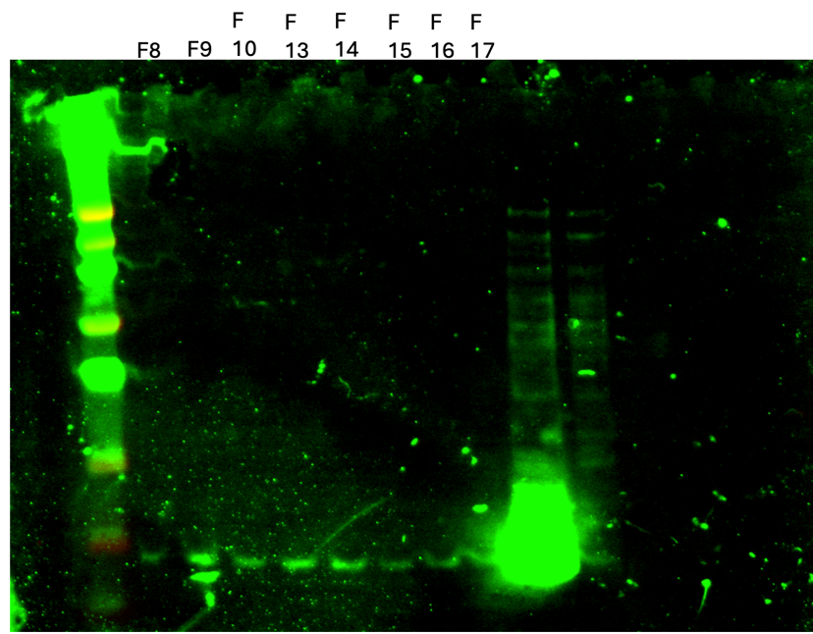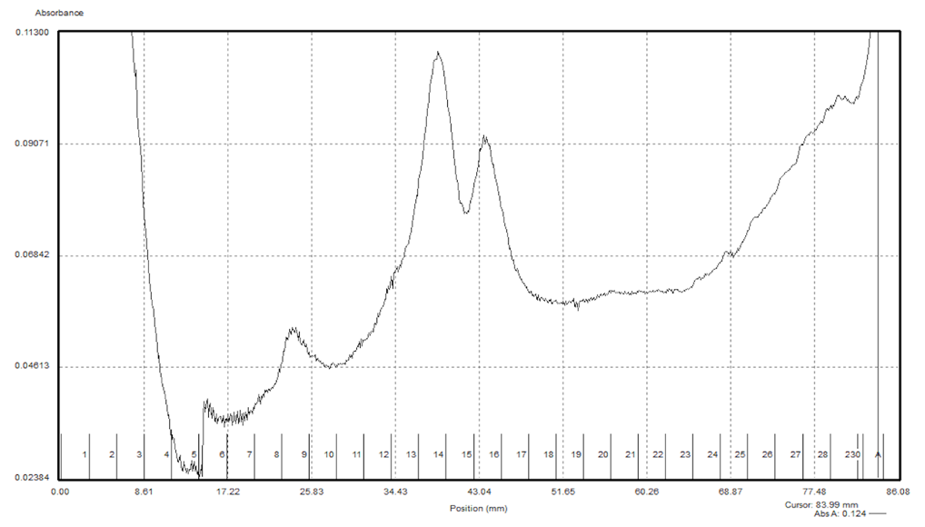

Figure 1: Western Blot of HA-IP fractions
bS21-2 appears to be in all of these fractions, which span 30S peak, presumptive 50S peak, and 70S peak. This suggests that bS21-2 may be dissociating from 30S and attaching to 50S at a secondary binding site, although if that’s the case why would bS21-2 be detected at all in the 30S fractions? I’m also not clear if that middle peak in the gradient is 50S.
I patched LVS to electroporate into tomorrow.
The MIC plates look the same as yesterday. I’m going to next try a different range of antibiotic concentrations.

Friday, May 17, 2024
To Do:
- Miniprep transformants
- Western Day 2
- Make IP cell pellet
- Patch LVS
- Electroporation
- Make sucrose plates
- Amplify flanking regions of rpsU1-HA

Prepare electrocompetent (EC) cells
-Scrape up entire plate of cells into 400 uL of sterile 10% sucrose and resuspend (alternately, cells can be grown to mid-log in MHB)
-Add 1.1 mL of 10% sucrose to a final volume of 1.5 mL
-Spin for 3 minutes at 10,000 rpm
-remove supernatant, throw out, and resuspend in fresh 1 mL 10% sucrose
-Repeat 3x-5x in 10% sucrose
-After final spin, remove all supernatant.
-Resuspend cells in 10% sucrose at high density (corresponding to ~1x10¹¹ cells /mL); these are EC cells by slowly adding 110 uL at a time. It should be about equal amounts of cells as sucrose.
-For any extra EC cells, aliquot ~110 μL / sterile tube (enough for 2 electroporations) and freeze at -80°C

Electroporate plasmid into EC cells*
-For each electroporation, aliquot 4 mL MHB into glass test tubes for recovery, warm in shaker at 37°C
-For each electroporation, in a 2 mm sterile electroporation cuvette, combine:
5 μL of pEX-based allelic exchange construct (mini-prep concentration, at least 100 ng/μL)
50 μL electrocompetent cells
-Have recovery media ready
-Electroporate using the following settings: 2.5 kV, 25 μF, and 600 Ω
-Immediately after individual electroporations, use 1 mL warm recovery media from test tube to wash cells out of cuvette and transfer cells to recovery test tube
-Recover cells for 4-8 hours, shaking at 37°C
-Pellet cells by centrifugation in sterile 2 mL tubes, 1’ at 10,000 x g.
Remove supernatant but leave 100-200ul and plate all of that
-Plate on CHAH-Kan plates, using 1 plate for each 2 mL tube (2 plates per electroporation)
-Incubate plates at 37°C for 3 days (or until single colonies appear)
I don’t recall the volume that is supposed to be plated after centrifugation. I vaguely remember Kathryn saying something about dumping supernatant and resuspending in what is left over, but all the liquid came out, so those plate are very dry and probably will have very little growth. The second tube I left about 300ul and resuspended the pellet. Hopefully something works.
*Always including a control electroporation with no plasmid. Eventually single break-through colonies may start appearing; at that point, single colonies on the experimental plates are also likely to just be break-through growth.

CHAH plates with 10% sucrose
Mix:
5 g Beef Heart Infusion
5 g Protease Peptone
5 g Glucose
0.5 g L-Cystine
7.5 g Agar
with 150 mL type I ddiH₂O. Stir on low heat until completely dissolved, about 10 minutes.
Autoclave 30’, being EXTREMELY careful media does not boil over
While autoclaving, warm 250 mL of 2% hemoglobin and sterilized 50% sucrose (in 50°C oven or in water bath at 55°C)
Place CHA flask in 50°C oven or in water bath at 55°C, let temperature equilibrate
Wipe down flask and bottles with ethanol and using sterile technique, pour hemoglobin into CHA flask
Add 100 mL 50% sucrose to CHA-hemoglobin flask
Mix media
Use sterile pipette, pour ~24 mL media per plate (~20 plates for 500 mL media)

PCR:
Reaction numbers | Sample | Primers | Expected size
1 | rpsU1-HA FR1 | KROL693 and KROL694 | 615 bp
2 | rpsU1-HA FR2 | KROL695 and KROL696 | 643 bp
3 | -DNA | KROL695 and KROL696 | no product

Total reaction volume | 100
Total number of reactions | 3
 |  |  |  | Factor
Component | Stock concentration | Final concentration | 1 rxn volume | 4
ddiH2O |  |  | 62.0 | 248
PrimeSTAR GXL Buffer | 5x | 1x | 20.0 | 80
dNTPs | 2.5 mM | 0.2 mM | 8.0 | 32
oligo F | 10 uM | 0.3 uM | 3.0 | 12
oligo R | 10 uM | 0.3 uM | 3.0 | 12
template | 100 ng/ul | 2 ng/ul | 2.0 | 8
PrimeSTAR GXL DNA Polymerase | 1.25 U/ul | 0.025 U/ul | 2.0 | 8
 |  | Total volume | 100 | 400

Monday, May 20, 2024
To Do:
- Electroporation
- Make sucrose plates
- Amplify flanking regions of rpsU1-HA
- Digest/gel extraction
- HA-IP

The transformation plates are contaminated, I will try again next week since I am out most of this week.

DNA digest:
Protocol by John Church

- Make a reaction table with desired digests:
Tube | DNA | Enzyme(s) | DNA Volume (uL) | H₂O Volume (uL)
1 | Purified PCR rpsU1-HA FR1 | KpnI, NotI | 15 | -
2 | Purified PCR rpsU1-HA FR2 | NotI, BamHI | 15 | -
3 | Backbone pKR5 | BamHI, KpnI | 5 | 10

- Set up master mix table:

rpsU1-HA FR1:
Components | Volumes in 1 reaction (uL) | Volumes in Master Mix 2x (uL)
H₂O | 10.8 | 21.6
10x Buffer* | 3.0 | 6.0
DNA | (15.0) | -
KpnI | 0.6 | 1.2
NotI | 0.6 | 1.2
Total | 30.0 (15.0 actual b/c of DNA)

rpsU1-HA FR2:
Components | Volumes in 1 reaction (uL) | Volumes in Master Mix 2x (uL)
H₂O | 10.8 | 21.6
10x Buffer* | 3.0 | 6.0
DNA | (15.0) | -
BamHI | 0.6 | 1.2
NotI | 0.6 | 1.2
Total | 30.0 (15.0 actual b/c of DNA)

pKR5 backbone:

Components | Volumes in 1 reaction (uL) | Volumes in Master Mix 2x (uL)
H₂O | 10.8 | 21.6
10x Buffer* | 3.0 | 6.0
DNA | (15.0) | -
BamHI | 0.6 | 1.2
KpnI | 0.6 | 1.2
Total | 30.0 (15.0 actual b/c of DNA)

*Cutsmart Buffer is used for all the “HF” enzymes. Check the NEB website for buffer compatibility with non-HF restriction enzymes.

- Add indicated amounts of H₂O and 10x buffer to master mix tube (MM).
- Add indicated amount of DNA or DNA+water (for backbone tubes) to individual tubes for digest (1.5 mL microfuge tubes for digests in incubator, PCR strip tubes for reactions incubated in the thermocycler).
- Add indicated amount of each enzyme (___uL) to the master mix tube (MM).
- Mix the master mix by pipetting up and down.
- Add master mix to individual tubes. Volume to add to each tube is the volume in 1 reaction minus the DNA volume (____ul).
- Incubate at 37°C for 1 hour or up to overnight.
- If using digest for plasmid construction then after incubation at 37°C, add 0.5ul of CIP enzyme to backbone tube, mix by pipetting and put back in 37°C incubator for 10 minutes. (this step removes the phosphates from the ends of the plasmid to prevent re-ligation). If using the new Quick CIP – add 1 uL, mix, incubate (at 37º) for 10 mins, then put at 80C for 2 minutes to inactivate the CIP.

Gel extraction:
I decided to cut the bands out of the gel and freeze them, then pick up the extraction when I come back.
IP:
I decided to do another IP since I need more data for my poster. This time, I am washing more times and rotating the samples for 2 minutes at each wash step, and I’m eluting at 4ºC for an hour (twice).

Immunoprecipitation with HA antibody
**Note this is scaled down from previous IPs
Prepare cell lysate (Day 3)
Required reagents:
Buffer A + PI + BB Bug Buster (see recipe at end)
DNase I (Lucigen Corporation # D9905K)
30 mL syringe
MillexGP 0.22 micrometer syringe filter
Nonsterile 50 mL conical tubes
Microfuge tubes

1M NH₄Cl
10% NP-40

- Check for stock solutions; make Buffer A+ PI +BB if not enough in freezer (~10 mL per sample), prepare Buffer B if not enough at 4°C.
- Write out samples in table:

Sample# Date Genotype of cells Volume of cells OD600 at harvest
1 04/19/2024 LVS pF-rpsU-HA 80 mL 0.328
2. 05/16/2024 LVS pF 80 mL 0.339

- Resuspend samples in 1.5 mL Buffer A + PI + BB by pipetting with P1000 pipette. Be sure no clumps remain.
- Add 1.5 uL DNase I (Lucigen/Epiceter), mix by pipetting.
- Incubate at 37°C for 30’. Cool down centrifuge while waiting.
- Spin conical tubes at 4°C for 20’ at max speed.
- Transfer lysates into new 1.5 mL micro centrifuge tubes, leaving behind insoluble material at bottom (okay to leave some behind; better than taking too much).
- Filter-sterilize lysates using 3mL syringe and syringe filter into new (nonsterile) 1.5mL microcentrifuge tube. Specifically, pull plunger out from 3mL syringe, thread tip of syringe onto syringe use filter (use MillexGP 0.22 micrometer filter, has 33mm diameter), pour/pipette lysate into syringe, insert plunger and recover filtered lysate into new (nonsterile) 1.5mL microcentrifuge tube.
- Obtain a good estimate of sample volume using pipette. (1ml for each)
- Adjust buffer concentration to Buffer B by adding to each sample:
10 uL 1M NH₄Cl / mL sample for final concentration of 100 mM NH₄Cl
1 uL 10% NP-40 /mL sample final concentration of 0.1% NP-40
- Remove 25 uL into microfuge tube for control analysis (LYS).

Immunoprecipitation with HA tag (based on ThermoFisher Pierce Anti-HA Magnetic Beads Product Info Sheet)

In cold room
- Cut tip of 1mL pipette tip slightly.
- Resuspend Anti-HA magnetic beads in storage solution by repeated inversion.
- Pipette 75 uL magnetic beads into 1.5ml microcentrifuge tube.
- Wash beads with 1 mL of Buffer B. Using the magnetic rack, wait until the beads have completely gone towards the magnet before removing the liquid.
- Invert tubes for 1 minute, discard supernatant.
- Add 1 sample per tube, close tube and make sure and it is not dripping liquid.
- Incubate samples with beads, rocking on their sides at 4°C, for 1 hour.

- After 1 hour incubation, place on magnetic rack.
- Save 25 uL aliquot of flow through in microfuge tube (FT1), discard remaining.
- Wash beads 5x with 1 mL Buffer B rotating for 2 minutes. Discard flow through but save 25 ul from each wash (FT2-6).
- Add 200 ul KBE-3 buffer with HA peptide.
- Incubate rocking at 4°C for 1 hour.

- Recover eluates by magnetic rack; aliquot 20ul (EL-1) and transfer remaining sample to a new, clearly labeled microfuge tube. Repeat elution (EL-2).
- Keep 50ul of beads and store in -20ºC.

I was going to set up the sequencing reactions but Kathryn is defrosting the -20, so I’ll put that off till I come back.

Friday, May 24, 2024
To Do:
- Digest/gel extraction
- HA-IP
- Silver Stain

Silver Stain:
Lane | Content | Volume
1 | BenchMark Ladder 1:10 | 10 ul
2 | LVS-pF-rpsU2-HA lysate | 10 ul
3 | LVS-pF lysate | 10 ul
4 | LVS-pF-rpsU2- HA FT6 | 10 ul
5 | LVS-pF FT6 | 10 ul
6 | LVS pF-rpsU2 - HA Anti-HA agarose beads | 10 ul
7 | LVS-pF Anti- HA Agarose Beads | 10 ul
8 | LVS-pF-rpsU2- HA EL1 new | 10 ul
9 | LVS-pF EL1 new | 10 ul
10 | LVS-pF-rpsU2- HA EL2 new | 10 ul
11 | LVS-pF EL2 new | 10 ul
12 | LVS-pF-rpsU2- HA EL2 old* | 10 ul
13 | LVS-pF EL1 old* | 10 ul
14 | LVS-pF-rpsU2- HA EL1 old | 10 ul
15 | LVS-pF EL1 old | 10 ul
16 | 1x SLB | 10 ul
17 | Hannah’s Ribosomes | 5 ul

I intended to include the old eluate samples from the most previous HA-IP but there wasn’t enough material, so I used samples from the first HA-IP.
Actually I seemed to have used EL2+ from 12/21/23 when I thought it was EL1+. I can’t find EL1+ from that date so for the second I used 11/20.
Update: found everything so it’s all accounted for.

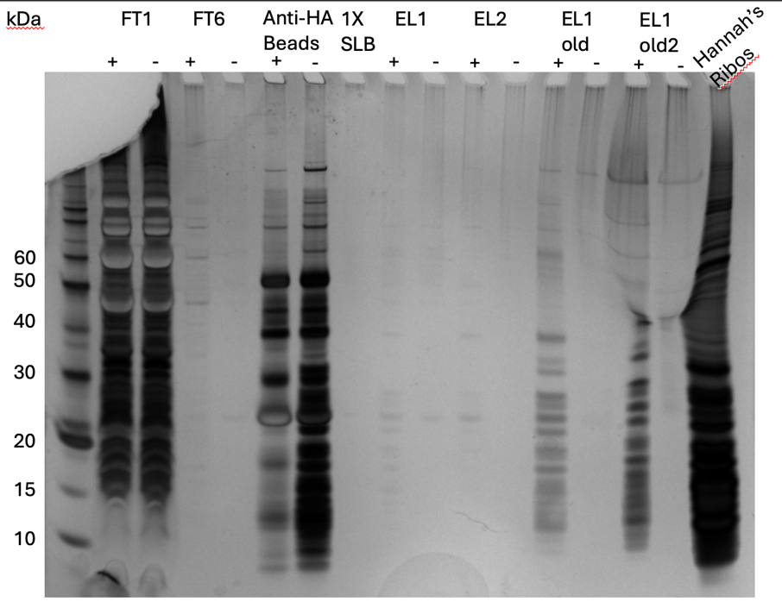

Figure 2: Silver Stain of HA-IP 5/20/24
I hate that it’s so faint but I can see more bands in the sample than the control. What is puzzling me is the old IP controls. In both of those, there are no bands showing up in the negative lanes! I looked back at those Silver stains and sure enough there was much more specificity in those IPs, especially the one that I did with the elution buffer only made of KHEPES and peptide (no salts). So I’m not yet sure what to think. Could it be the elution buffer that’s causing less specificity?
One change that I would like to make going forward is scaling the procedure back up again to the original volume of cells (500ml). I think that could increase yield. I also looked back at the User Manual for the Anti-HA beads and it says eluting at a lower temperature (<37ºC) could decrease yield.
I found a tube of 2.5 mM KROL676 lying out by the sink that maybe fell out of the box during all the craziness with the freezers. I threw it away and made a new one.

Wednesday, May 29, 2024
To Do:
- Silver Stain
- Set up sequencing
- Patch LVS pF and LVS pF-HA
- Streak KRSA2 and KRSA12
- Gel extraction
- Ligation/transformation

Sequencing:
I set up sequencing reactions for the second round of minipreps of pKR220. I diluted each miniprep ten-fold to get better pipetting volumes:
# | Sample ID | Nucleic Acid | Unit | A260 (Abs) | A280 (Abs) | 260/280 | 260/230 | Sample Type | Factor
1 | pKR220-F | 51.2 | ng/µl | 1.024 | 0.558 | 1.84 | 2.4 | DNA | 50
2 | pKR220-G | 56 | ng/µl | 1.12 | 0.607 | 1.84 | 2.36 | DNA | 50
3 | pKR220-H | 51.8 | ng/µl | 1.036 | 0.556 | 1.86 | 2.38 | DNA | 50
4 | pKR220-I | 56.7 | ng/µl | 1.135 | 0.6 | 1.89 | 2.5 | DNA | 50
5 | pKR220-J | 54.2 | ng/µl | 1.083 | 0.561 | 1.93 | 2.48 | DNA | 50

Sample number | Template Type | Template Name | Primer Nameª | A. | B. | E. | F.
 | (plasmid or PCR) |  |  | Template Size (bases) | Template Stock Conc. (ng/μl) | PLASMID template: | Volume H₂O needed
 |  |  |  |  |  | Volume =
 |  |  |  |  |  | 2x(~200 ÷ B)μl | (12 less D or E - 2.56)μl
KB1 | plasmid | pKR220 | KROL7 | 8073 | 51.2 | 7.81 | 1.63
KB2 | plasmid | pKR220 | KROL7 | 8073 | 56 | 7.14 | 2.30
KB3 | plasmid | pKR220 | KROL7 | 8073 | 51.8 | 7.72 | 1.72
KB4 | plasmid | pKR220 | KROL7 | 8073 | 56.7 | 7.05 | 2.39
KB5 | plasmid | pKR220 | KROL7 | 8073 | 54.2 | 7.38 | 2.06

Gel extraction:
 | Tube Weight (g) | Tube w/ Gel (g) | Gel Weight (mg) | QG Buffer Volume (ul) | Isopropanol Volume (ul)
Tube 1 | 1.11 | 1.41 | 300 | 900 | 300
Tube 2 | 1.10 | 1.35 | 250 | 750 | 250
Tube 3 | 1.11 | 1.46 | 350 | 1050 | 350

Ligation:
- Make a reaction table with desired ligations. Always include a backbone only control for each plasmid backbone used.
Tube | Insert | Backbone
1 | BamHI, KpnI, NotI digested, purified PCR rpsU1-HA | BamHI, KpnI digested, purified pKR5
2 | - | BamHI, KpnI digested, purified pKR5

- Set up master mix table:
Component | Reaction 1 (uL) | Master Mix (3x)
H₂O | 7.5 | 22.5
10x ligase buffer | 2.0 | 6
Insert 1 | 4.0 | -
Insert 2 | 4.0 | -
Backbone | 2.0 | 6
Ligase | 0.5 | 1.5
TOTAL | 20.0 | 36

- Obtain ice to assemble and keep the reactions on. This is important, as the reaction happens at 16°C and the ligase buffer (which contains ATP) needs to be kept cold in order to avoid degradation. Take a 10 uL aliquot of 10X ligase buffer from the miscellaneous buffers box in the -20C.
- Obtain and label PCR tubes for the reactions. Be sure to include the date and your initials.
- To the individual tubes, add indicated amounts of H₂O (___uL), 10x buffer (_____uL), insert (____uL), and backbone (____uL).
- Add indicated amount of ligase (___uL) to the individual tubes. Remember to keep the ligase in a mini cooler.
- After all of the components have been added, mix each tube with a pipette set to 18 uL.
- Place in the thermocycler or water bath overnight at 16ºC. Can do at room temp for 10 minutes if necessary.

Transformation:
- Set up reaction table. Always include a positive and negative control for each antibiotic. If transforming plasmids (from previous plasmid prep), use 0.5 – 1 uL of plasmid. If transforming ligations, use 8 uL per ligation. If transforming plasmid, plate 20 uL and 100 uL. If transforming a ligation, plate 100 uL and remaining culture.
  - Note: The plasmid used for the positive control plates should be the regular circular plasmid, not the digest/purified one.
  - There should always be a backbone control if testing a ligation. This is the digested and ligated backbone with NO INSERT.

Reaction table
Tube number | Purpose | DNA | Volume of DNA | Final volume to plate | Number of kanamycin-containing plates
1 | (+) control | pKR5 | 1 uL | 20 ul, 100 ul | 2
2 | (-) control | None | 0 | 20 ul, 100 ul | 2
3 | Backbone Ligation | pKR5 (digested) | 8 uL | 100 uL, remaining | 2
4 | Ligation 1 | pKR220 | 8 uL | 100 uL, remaining | 2
Total number of plates |  |  |  |  | 8

- Check to be sure you have enough LB-Kan plates with appropriate antibiotic. If plates were stored at 4°C, warm at 37°C until needed.
- Obtain DNA and thaw on ice if necessary.
- Thaw appropriate number of competent cell tubes on ice (5 reactions per tube of competent cells)
- Label sterile tubes as indicated in reaction table. Add indicated volume of indicated DNA on ice.
- When competent cells are thawed (check by probing for frozen cells using a sterile pipette tip), gently pipette 100 uL of cells into each reaction tube directly onto DNA using aseptic technique.
- Incubate cells on ice for 20 minutes. During incubation, find or set heat block to 42°C.
- Place tubes with cells and DNA onto 42°C heat block for 30 seconds (heat shock step).
- After heat shock, place tubes back on ice until next step (don’t keep them here too long).
- Using aseptic technique, add 1 mL LB (no antibiotic) to each microfuge tube.
- Using autoclave tape, tape microfuge tubes down in shaking incubator set to 37°C.
- Allow cells to recover for 1 hour at 37°C, shaking. Place in a rack after shaking (NOT back on ice).
- Using aseptic technique, plate indicated amount of cells on appropriate antibiotic plates (LB-Kan), spreading until plates look dry. For “remaining” volume, spin tubes at max speed in benchtop centrifuge for 30 seconds. Remove 800 uL of media. Using 200 uL pipette, resuspend cells at bottom of tube and plate all the remaining culture.

Thursday, May 30, 2024
To Do:
- Set up sequencing
- Patch LVS pF and LVS pF-HA
- Streak KRSA2 and KRSA12
- Gel extraction
- Ligation/transformation
- Start overnights of S. aureus strains
- Start overnights of transformants
- Make LVS pF single use aliquots
- Make cell pellets

I got the sequencing results back and they all look good! So I will not continue with the second round of cloning that I started for pKR220.
Rather than make pellets since I won’t be able to run an IP this week, I just made more single-use aliquots of LVS pF and LVS pF-rspU2-HA.
I didn’t exactly get to isolated colonies on the S. aureus plate but I tried my best to only pick one colony to start overnight cultures.

Friday, May 31, 2024
To Do:
- Start overnights of S. aureus strains
- Start overnights of transformants
- Make LVS pF single use aliquots
- Make cell pellets
- Western Blot
- Population Analysis

Population Analysis Assay (microplate method)
Based on Barnes et al, 2023
Methods:
- Grow overnight cultures of S. aureus strains.
- The next day, back-dilute cultures to an OD600 of 0.3 in BHI broth. (0.5)
- Prepare BHI broth with antibiotics by making the medium 2X the highest drug concentration in test range.
- In a 96-well plate, add 100ul of BHI with antibiotics to each well in Row A using a multi-channel pipet.
- In Rows B-H add 50ul of BHI without antibiotics
- Perform a serial two-fold dilution by adding 50ul of BHI with antibiotics from wells in Row A to the Row B.
- Continue the serial dilution until Row F.
- Perform a ten-fold serial dilution of bacterial cultures by adding 10ul of overnight cultures to 990ul of TSB to create a 10⁻² dilution, then add 100ul of that dilution to 900ul of new TSB for a dilution of 10⁻³.
- Add 50ul of each bacterial dilution to the wells in the appropriate columns (i.e. 10⁻² to the wells in Columns 1 and 7).
- Incubate plate at 37ºC for 24 hours.
I think I realize why the last pop analysis didn’t work: the OD600 was too low. When I went to set up the cultures today they were too high even after diluting the sample 1:20 in the cuvette, so I diluted them 1:5 at 1 ml and used that diluted culture as the starting culture for the serial dilutions. Since I wanted to be sure the OD was accurate after starting the culture, I made 3 ml of starting culture so I would have enough material to check the OD. Both cultures read around 0.04 which is too low by nearly a factor of 10. ed the rest of the. In the interest of time rather than starting over I simply added the rest of the 1ml culture to the 3 ml culture and I ended up with both strains being at 0.5. I figure this was fine as long as they’re at the same OD and they’re still in log phase. I’m cautiously optimistic that this will be more successful.

 |  |  | Bacteria Concentration
 |  |  | 5.0E-07 | 5.0E-02 | 5.0E-03 | 5.0E-04 | 5.0E-05 | 5.0E-06 | 5.0E-02 | 5.0E-03 | 5.0E-04 | 5.0E-05 | 5.0E-06 | 5.0E-07
 |  |  | 1 | 2 | 3 | 4 | 5 | 6 | 7 | 8 | 9 | 10 | 11 | 12
Antibiotic | 64 | A
Antibiotic | 32 | B
Antibiotic | 16 | C
Antibiotic | 8 | D
Antibiotic | 4 | E
Antibiotic | 2 | F
Antibiotic | 0 | G | BHI no antibiotic with bacteria
Antibiotic | Blank | H | BHI no antibiotic no bacteria
 |  |  | Replicate 1 |  |  |  |  |  | Replicate 2

This table show that I messed up loading the samples for Replicate 1 on the ∆rpsU plate (that’s why the concentrations are in bold).
Western Blot:
Lane | Content | Volume
1 | WesternSure Ladder | 5 ul
2 | LVS-pF-rpsU2-HA lysate | 10 ul
3 | LVS-pF lysate | 10 ul
4 | LVS-pF-rpsU2- HA FT3 | 10 ul
5 | LVS-pF FT3 | 10 ul
6 | LVS-pF-rpsU2- HA FT5 | 10 ul
7 | LVS-pF FT5 | 10 ul
8 | LVS-pF-rpsU2- HA FT6 | 10 ul
9 | LVS-pF FT6 | 10 ul
10 | LVS pF-rpsU2 - HA Anti-HA agarose beads | 10 ul
11 | LVS-pF Anti- HA Agarose Beads | 10 ul
12 | 1X SLB | 10 ul
13 | LVS-pF-rpsU2- HA EL1 | 10 ul
14 | LVS-pF EL1 | 10 ul
15 | LVS-pF-rpsU2- HA EL2 | 10 ul
16 | LVS-pF EL2 | 10 ul
17 | LVS pF-rpsU2-HA WCL | 10 ul

June 2024

Saturday, June 1, 2024
To Do:
- Western Blot
- Population Analysis
- Western Day 2
- Read pop analysis plates

 |  |  |  |  |  | Wild type
 | 5.00E-02 | 5.00E-03 | 5.00E-04 | 5.00E-05 | 5.00E-06 | 5.00E-07 | 5.00E-02 | 5.00E-03 | 5.00E-04 | 5.00E-05 | 5.00E-06 | 5.00E-07
64 | 0.047 | 0.044 | 0.043 | 0.046 | 0.044 | 0.045 | 0.047 | 0.046 | 0.044 | 0.045 | 0.045 | 0.043
32 | 0.045 | 0.046 | 0.046 | 0.046 | 0.044 | 0.045 | 0.046 | 0.046 | 0.046 | 0.044 | 0.043 | 0.044
16 | 0.048 | 0.046 | 0.047 | 0.046 | 0.046 | 0.046 | 0.047 | 0.047 | 0.045 | 0.046 | 0.045 | 0.045
8 | 0.046 | 0.045 | 0.046 | 0.046 | 0.045 | 0.045 | 0.045 | 0.045 | 0.044 | 0.045 | 0.045 | 0.045
4 | 0.045 | 0.046 | 0.045 | 0.046 | 0.045 | 0.044 | 0.047 | 0.046 | 0.045 | 0.045 | 0.046 | 0.046
2 | 0.044 | 0.045 | 0.046 | 0.046 | 0.046 | 0.044 | 0.046 | 0.045 | 0.046 | 0.046 | 0.046 | 0.046
0 | 0.887 | 0.784 | 0.713 | 0.62 | 0.634 | 0.358 | 0.795 | 0.772 | 0.73 | 0.702 | 0.521 | 0.696
Blank | 0.035 | 0.04 | 0.04 | 0.038 | 0.038 | 0.039 | 0.039 | 0.04 | 0.041 | 0.04 | 0.04 | 0.04

 |  |  |  |  |  | ∆rpsU
 | 5.00E-07 | 5.00E-02 | 5.00E-03 | 5.00E-04 | 5.00E-05 | 5.00E-06 | 5.00E-02 | 5.00E-03 | 5.00E-04 | 5.00E-05 | 5.00E-06 | 5.00E-07
64 | 0.044 | 0.05 | 0.044 | 0.044 | 0.045 | 0.045 | 0.046 | 0.044 | 0.045 | 0.043 | 0.043 | 0.041
32 | 0.046 | 0.047 | 0.044 | 0.044 | 0.05 | 0.045 | 0.046 | 0.044 | 0.045 | 0.043 | 0.043 | 0.041
16 | 0.045 | 0.046 | 0.046 | 0.045 | 0.045 | 0.045 | 0.046 | 0.048 | 0.044 | 0.043 | 0.044 | 0.043
8 | 0.045 | 0.048 | 0.046 | 0.045 | 0.045 | 0.046 | 0.047 | 0.044 | 0.045 | 0.045 | 0.045 | 0.044
4 | 0.044 | 0.047 | 0.045 | 0.046 | 0.045 | 0.044 | 0.047 | 0.046 | 0.045 | 0.046 | 0.045 | 0.045
2 | 0.044 | 0.554 | 0.058 | 0.044 | 0.045 | 0.045 | 0.428 | 0.045 | 0.045 | 0.046 | 0.045 | 0.045
0 | 0.043 | 0.535 | 0.602 | 0.378 | 0.11 | 0.045 | 0.533 | 0.5 | 0.36 | 0.161 | 0.045 | 0.045
Blank | 0.036 | 0.04 | 0.042 | 0.04 | 0.039 | 0.039 | 0.038 | 0.041 | 0.039 | 0.038 | 0.039 | 0.037

This is better than last time, but it’s only showing a very slight difference in MICs between mutant and wild type. I still consider this a change in phenotype.
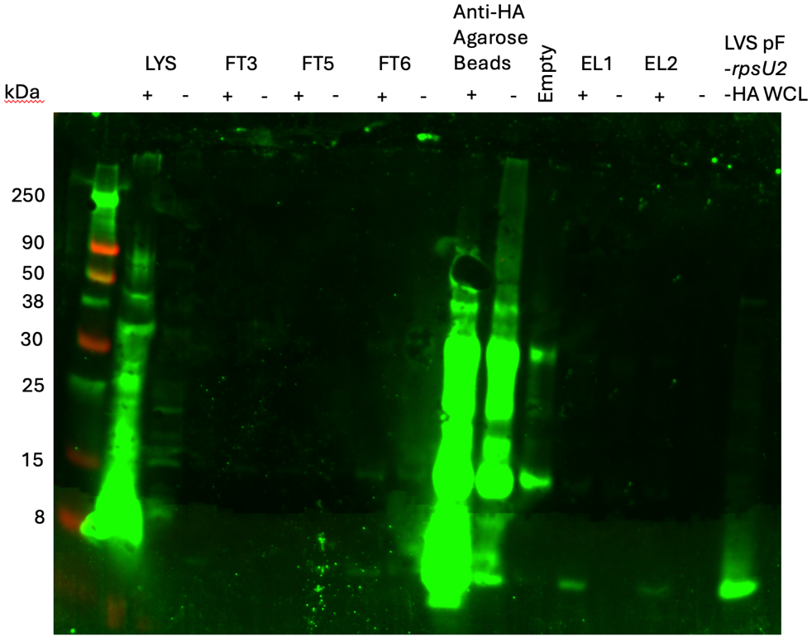

Figure 3: Western Blot of HA-IP 5/20/24
I think the small band that’s showing up in the negative control beads lane is really just spillover from the positive sample beads lane. It looks like bS21-2 is not getting washed away, (although I should have included the FT1 samples), but also there is still a lot remaining on the beads after elution. The faint band in the eluate lane is not surprising, however, given how faint the bands are in the Silver stain.

Wednesday, June 5, 2024
To Do:
- Western Day 2
- Read pop analysis plates
- Patch LVS pF and LVS pF-HA
In talking about the S. aureus MIC data with Kathryn today, I kind of figured out on my own why there is such a steep drop from resistance to sensitivity between the highest concentrated culture and the next concentrated culture for the 2mg/ml vancomycin condition: if vancomycin is overwhelmed by the amount of cells present in the sample, it blocks its own binding to the PG layer because of the “clogging effect” (Cui et al., 2006). Basically, it undergoes an unusual diffusion pattern that prevents more vancomycin from saturating the PG layer, in cooperation with a thicker cell wall. So these data suggest that the rpsU strain has a thicker cell wall!
Notes for next time: be consistent with timing. Read samples after the same amount of time for each assay, whether its 18 or 22 hours. It could be that the starting OD I used (0.5) had an effect on MICs. Go back to 0.3. Finally, start with a lower concentration of vancomycin: 0.5 mg/ml-8 mg/ml.
I patched out LVS pF and LVS pF-rpsU2-HA for more IP cell lysates.

Thursday, June 6, 2024
To Do:
- Patch LVS pF and LVS pF-HA
- Start overnight cultures
- Patch LVS

Sample | Observed OD600 | Calculated OD600 | Starting Volume for OD600 0.003 (ul)
LVS pF | 0.371 | 7.42 | 647
LVS pF-rpsU2-HA | 0.43 | 8.6 | 558
Set up at 5pm.

Friday, June 7, 2024
To Do:
- Start overnight cultures
- Patch LVS
- Transform LVS
- Make sucrose plates

The overnight cultures were contaminated.
I transformed LVS with pKR218. I’m worried that whatever contaminated the overnights will contaminate the recovered cultures.
At one point Ben changed the speed setting of the shaking incubator and then couldn’t remember what speed it was originally set at. Eventually, we got it to where it should be (200 rpm). He claims that the shaker was off when he did that but I have serious doubts. And if that’s the case, I don’t know how long the culture weren’t shaking. I am absolutely certain that the shaker was on when I put the electroporated cultures in. Hopefully this all works out.
CHAH plates with 10% sucrose
Mix:
5 g Beef Heart Infusion
5 g Protease Peptone
5 g Glucose
0.5 g L-Cystine
7.5 g Agar
with 150 mL type I ddiH₂O. Stir on low heat until completely dissolved, about 10 minutes.
Autoclave 30’, being EXTREMELY careful media does not boil over
While autoclaving, warm 250 mL of 2% hemoglobin and sterilized 50% sucrose (in 50°C oven or in water bath at 55°C)
Place CHA flask in 50°C oven or in water bath at 55°C, let temperature equilibrate
Wipe down flask and bottles with ethanol and using sterile technique, pour hemoglobin into CHA flask
Add 100 mL 50% sucrose to CHA-hemoglobin flask (added 83.8 ml of 60% sucrose)
Mix media
Use sterile pipette, pour ~24 mL media per plate (~20 plates for 500 mL media)

Monday, June 10, 2024
To Do:
- Transform LVS
- Make sucrose plates
- Streak KRSA2 and KRSA12
- Patch LVS pF and LVS pF-HA
- Make 2.5% iron pyrophosphate

The good news is that the transformation plates are not contaminated. The bad news is that there are colonies on all the plates, as in it seems to be more than just breakthrough on the negative control plates. I picked the largest ones and one small one (as a sort of control) and patched them onto CHAH-Kan for a total of 6. The only one I have any faith for is Patch 1.

I patched out LVS pF and LVS pF-HA to make more IP cell pellets. Let’s pray for no contamination. I streaked out KRSA2 and KRSA12 so I can prepare another MIC assay. I prepared 2.5% iron pyrophosphate to supplement MHB tomorrow.
Pro tip when making 50% sucrose: add a little bit of sucrose at a time to the water and let it dissolve before adding more to the water.

Tuesday, June 11, 2024
To Do:
- Streak KRSA2 and KRSA12
- Patch LVS pF and LVS pF-HA
- Make 2.5% iron pyrophosphate
- Set up sucrose selection
- Start overnights of LVS pF strains and KRSA strains

Allelic exchange:
3 out of 6 patches grew! Patches 1-3 grew and 4-6 did not. I set up sucrose selection for 1 and 2, and froze down 1, 2, and 3.

Sucrose counterselection:
To select for cross-outs using sucrose selection
-Scrape up small loop of cells and resuspend in sterile 1X PBS (1 ml)
-Dilute culture 1:10 in sterile PBS to 1x10⁻⁷
Perform first dilution 1:100 so first dilution tube is 1x10⁻², adding 10 uL of resuspended cells to 990 ul 1x PBS
Perform subsequent dilutions 1:10, diluting 50 uL cells into 450 uL 1X PBS
-Spread-plate 100 uL of last dilution (1x10⁻⁷) onto CHAH plates.
-Spread-plate 100 μL of each dilution 10⁻² – 10⁻⁷ on CHAH + 10% sucrose plates. If you have extra sucrose plates, can plate some or all dilutions twice.
-Incubate plates at 37°C for 3-4 days, or until single colonies appear. It is generally a good idea to test both large and smaller single colonies. Note that there should be many more colonies on the CHAH plate with the 1x10⁻⁷ dilution than on the sucrose plate with the corresponding dilution. If there seem to be similar numbers of colonies, the 1° integrant may have an inactivating mutation in sacB and is not worth keeping.

IP cell pellets:

Sample | Observed OD600 | Calculated OD600 | Starting Volume for OD600 0.003 (ul)
LVS pF | 0.084 | 1.68 | 143

I somehow switched the formula in excel so that it used the observed OD instead of the actual OD to calculate the starting volume. That explains why the cultures grew so quickly last time. Unfortunately, the LVS pF-rpsU2-HA plate was contaminated. It looked good at first until I realized it was the wrong shade of gray. I think all of the aliquots I made in the last batch are this way, so I went back to the glycerol stock and patched a new plate to make new aliquots and to start a culture tomorrow. I threw away the others.

The S. aureus plates had nice, isolated colonies; I set up overnight cultures.

Wednesday, June 12, 2024
To Do:
- Set up sucrose selection
- Start overnights of LVS pF strains and KRSA strains
- Make IP cell pellet
- MIC assay

Sample | Observed OD600 | Calculated OD600 | Starting Volume for OD600 0.003 (ul) | OD600 12:30 pm next day
LVS pF | 0.084 | 1.68 | 143 | 0.445

I had to do a poster presentation this morning so I checked the culture kind of late. Kathryn says it’s ok to harvest them, I should still be able to pull down 70S, although this is the negative control so I’m not too worried about it.
S. aureus MICs:
Figured out why the dilutions were so off on my last MICs: I accidentally had the actual OD set as Measured OD X 100 instead of X 10. No wonder I had barely any growth!

 | Measured OD600 | Actual OD600 | Final Volume (ul) | Starting Volume for OD600 0.3 | Final OD600
KRSA2 | 0.519 | 10.38 | 3000 | 86.7 | 0.323
KRSA12 | 0.173 | 3.46 | 3000 | 260.1 | 0.303
When checking the OD after adding starting volume, KRSA12 read at .403. I had about 2 ml of culture left, so I added 800ul of BHI and the OD read at 0.303.

Population Analysis Assay (microplate method)
Based on Barnes et al, 2023
Methods:
- Grow overnight cultures of S. aureus strains.
- The next day, back-dilute cultures to an OD600 of 0.3 in BHI broth.
- Prepare BHI broth with antibiotics by making the medium 2X the highest drug concentration in test range.
- In a 96-well plate, add 100ul of BHI with antibiotics to each well in Row A using a multi-channel pipet.
- In Rows B-H add 50ul of BHI without antibiotics
- Perform a serial two-fold dilution by adding 50ul of BHI with antibiotics from wells in Row A to the Row B.
- Continue the serial dilution until Row F.
- Perform a ten-fold serial dilution of bacterial cultures by adding 10ul of overnight cultures to 990ul of TSB to create a 10⁻² dilution, then add 100ul of that dilution to 900ul of new TSB for a dilution of 10⁻³.
- Add 50ul of each bacterial dilution to the wells in the appropriate columns (i.e. 10⁻² to the wells in Columns 1 and 7).
- Incubate plate at 37ºC for 24 hours.
MIC set up:

Thursday, June 13, 2024
To Do:
- Make IP cell pellet
- MIC assay
- Read MIC plates
- Start overnight of LVS pF-rpsU2-HA
- Make frozen aliquots of LVS pF-rpsU2-HA
- Make BHI

MICs:
A:

B:

Figure 4: MICs of Vancomycin against S. aureus strains
A: MIC of vancomycin against ∆rpsU appears to 4 ug/ml. The two lowest bacterial concentrations are completely sensitive. B: MIC of vancomycin against wild type. MIC appears to be 0.5 ug/ml. I think the growth of the highest concentration is an error.

Sample | Observed OD600 | Calculated OD600 | Starting Volume for OD600 0.003 (ul)
LVS pF-rpsU2-HA | 0.062 | 1.24 | 194

I set up 2 cultures from this.

Friday, June 14, 2024
To Do:
- Read MIC plates
- Start overnight of LVS pF-rpsU2-HA
- Make frozen aliquots of LVS pF-rpsU2-HA
- Make BHI
- Hopefully see colonies on the sucrose plates
- Make IP cell pellet
- Reconstitute primers

Sucrose plates:
I see colonies! But they are still small so I’ll check them again at the end of the day and if they’re still small I’ll wait until tomorrow.
IP cell pellets:
Sample | Observed OD600 | Calculated OD600 | Starting Volume for OD600 0.003 (ul) | OD600 10:30 am next day
LVS pF-rpsU2-HA (1) | 0.062 | 1.24 | 194 | 0.27
LVS pF-rpsU2-HA (2) | 0.062 | 1.24 | 194 | 1.17

One of the flasks (#2) I set up last night is contaminated, so I’m not moving forward with that one.
Sample | Observed OD600 | Calculated OD600 | Starting Volume for OD600 0.003 (ul) | OD600 10:30 am next day | OD600 at 1:30 pm
LVS pF-rpsU2-HA (1) | 0.062 | 1.24 | 194 | 0.27 | 0.403

I checked this later than I intended to (got distracted) but I think this will be fine.

Primer Reconstitution:
Primer | nm | Volume to Add (ul)
KROL702 | 21.9 | 219
KROL709 | 25.8 | 258
KROL710 | 26.2 | 262

Saturday, June 15, 2024
To Do:
- Hopefully see colonies on the sucrose plates
- Make IP cell pellet
- Reconstitute primers
- Cross patch potential 2º integrants

I patched out 8 colonies of each primary integrant onto CHA and CHA-Kan. There was some background on the 10² plate for P1, and a lot of background on the 10² and 10³ plates for P2. I did my best to avoid background when choosing colonies. I chose a variety of sizes. For P2-6, I messed up and only patched that one on CHA.

Sunday, June 16, 2024
To Do:
- Cross patch potential 2º integrants
- Boil prep colonies for PCR
All but one colony grew on CHA but not CHA-Kan. One colony from Patch1 grew on Kan but no CHA, so I did not proceed with that one. I diluted a loopful of colony in 100ul of NF water (I think I did 50ul last time) and boiled them at 95ºC for 10 minutes in the thermocycler, then put them in the -20ºC.

Monday, June 17, 2024
To Do:
- Boil prep colonies for PCR
- Colony PCR on presumptive 2º recombinants
- Cell lysis and IP

Colony PCR:
KROL343 and KROL148
Dilute KROL343 to 10mM

Total reaction volume | 20
Total number of reactions | 20
 |  |  |  | Factor
Component | Stock concentration | Final concentration | 1 rxn volume | 21
ddiH2O |  |  | 12.4 | 260.4
PrimeSTAR GXL Buffer | 5x | 1x | 4.0 | 84
dNTPs | 2.5 mM | 0.2 mM | 1.6 | 33.6
oligo F | 10 uM | 0.3 uM | 0.6 | 12.6
oligo R | 10 uM | 0.3 uM | 0.6 | 12.6
template | 100 ng/ul | 2 ng/ul | 0.4 | 8.4
PrimeSTAR GXL DNA Polymerase | 1.25 U/ul | 0.025 U/ul | 0.4 | 8.4
 |  | Total volume | 20 | 420

I didn’t think about what I was doing with this. Because HA is so small, there will be no way to distinguish between mutant and wild-type on PCR. Instead, I will have to do a diagnostic digest. But I don’t think I have enough material after this PCR because I set up 20ul reactions. After PCR cleanup I checked the concentration of one sample via Nanodrop and it was about 24ug/ul. So I repeated the PCR, this time setting up 50ul reaction.

Total reaction volume | 50
Total number of reactions | 18
 |  |  |  | Factor
Component | Stock concentration | Final concentration | 1 rxn volume | 19
ddiH2O |  |  | 31.0 | 589
PrimeSTAR GXL Buffer | 5x | 1x | 10.0 | 190
dNTPs | 2.5 mM | 0.2 mM | 4.0 | 76
oligo F | 10 uM | 0.3 uM | 1.5 | 28.5
oligo R | 10 uM | 0.3 uM | 1.5 | 28.5
template | 100 ng/ul | 2 ng/ul | 1.0 | 19
PrimeSTAR GXL DNA Polymerase | 1.25 U/ul | 0.025 U/ul | 1.0 | 19
 |  | Total volume | 50 | 950
I left them in the thermocycler overnight.

Immunoprecipitation with HA antibody 6/17/24
**Note this is scaled down from previous IPs
Prepare cell lysate (Day 3)
Required reagents:
Buffer A + PI + BB Bug Buster (see recipe at end)
DNase I (Lucigen Corporation # D9905K)
30 mL syringe
MillexGP 0.22 micrometer syringe filter
Nonsterile 50 mL conical tubes
Microfuge tubes

1M NH₄Cl
10% NP-40

- Check for stock solutions; make Buffer A+ PI +BB if not enough in freezer (~10 mL per sample), prepare Buffer B if not enough at 4°C.
- Write out samples in table:

Sample# Date Genotype of cells Volume of cells OD600 at harvest
1 06/14/2024 LVS pF-rpsU-HA 80 mL 0.403
2. 06/12/2024 LVS pF 80 mL 0.445

- Resuspend samples in 1.5 mL Buffer A + PI + BB by pipetting with P1000 pipette. Be sure no clumps remain.
- Add 1.5 uL DNase I (Lucigen/Epiceter), mix by pipetting.
- Incubate at 37°C for 30’. Cool down centrifuge while waiting.
- Spin conical tubes at 4°C for 20’ at max speed.
- Transfer lysates into new 1.5 mL micro centrifuge tubes, leaving behind insoluble material at bottom (okay to leave some behind; better than taking too much).
- Filter-sterilize lysates using 3mL syringe and syringe filter into new (nonsterile) 1.5mL microcentrifuge tube. Specifically, pull plunger out from 3mL syringe, thread tip of syringe onto syringe use filter (use MillexGP 0.22 micrometer filter, has 33mm diameter), pour/pipette lysate into syringe, insert plunger and recover filtered lysate into new (nonsterile) 1.5mL microcentrifuge tube.
- Obtain a good estimate of sample volume using pipette. HA=1ml, Neg=750ul
- Adjust buffer concentration to Buffer B by adding to each sample:
10 uL 1M NH₄Cl / mL sample for final concentration of 100 mM NH₄Cl HA=100ul, Neg=750ul
1 uL 10% NP-40 /mL sample final concentration of 0.1% NP-40 HA=10ul, Neg=7.5ul
- Remove 25 uL into microfuge tube for control analysis (LYS).

In cold room
- Cut tip of 1mL pipette tip slightly.
- Resuspend Anti-HA magnetic beads in storage solution by repeated inversion.
- Pipette 75 uL magnetic beads into 1.5ml microcentrifuge tube.
- Wash beads with 1 mL of Buffer B. Using the magnetic rack, wait until the beads have completely gone towards the magnet before removing the liquid.
- Invert tubes for 1 minute, discard supernatant.
- Add 1 sample per tube, close tube and make sure and it is not dripping liquid.
- Incubate samples with beads, rocking on their sides at 4°C, for 1 hour.
- After 1 hour incubation, place on magnetic rack.
- Save 25 uL aliquot of flow through in microfuge tube (FT1), discard remaining.
- Wash beads 5x with 1 mL Buffer B rotating for 2 minutes. Discard flow through but save 25 ul from each wash (FT2-6).
- Add 200 ul KBE-3 buffer with HA peptide.
- Incubate rocking at 4°C overnight.

- Recover eluates by magnetic rack; aliquot 20ul (EL-1) and transfer remaining sample to a new, clearly labeled microfuge tube. Repeat elution (EL-2). Store samples at -80ºC.
- Keep 50ul of beads and store in -20ºC.

Tuesday, June 18, 2024
To Do:
- Colony PCR on presumptive 2º recombinants
- Cell lysis and IP
- Silver Stain
- Digest

Silver Stain:
Lane | Content | Volume
1 | BenchMark Ladder 1:10 | 10 ul
2 | LVS-pF-rpsU2-HA lysate | 10 ul
3 | LVS-pF lysate | 10 ul
4 | LVS-pF-rpsU2- HA FT1 | 10 ul
5 | LVS-pF FT1 | 10 ul
6 | LVS-pF-rpsU2- HA FT5 | 10 ul
7 | LVS-pF FT5 | 10 ul
8 | LVS-pF-rpsU2- HA FT6 | 10 ul
9 | LVS-pF FT6 | 10 ul
10 | LVS pF-rpsU2 - HA Anti-HA agarose beads | 10 ul
11 | LVS-pF Anti- HA Agarose Beads | 10 ul
12 | 1x SLB | 10 ul
13 | LVS-pF-rpsU2- HA EL1 new | 10 ul
14 | LVS-pF EL1 new | 10 ul
15 | LVS-pF-rpsU2- HA EL1 old | 10 ul
16 | LVS-pF EL1 old | 10 ul
17 | Hannah’s Ribosomes | 3 ul

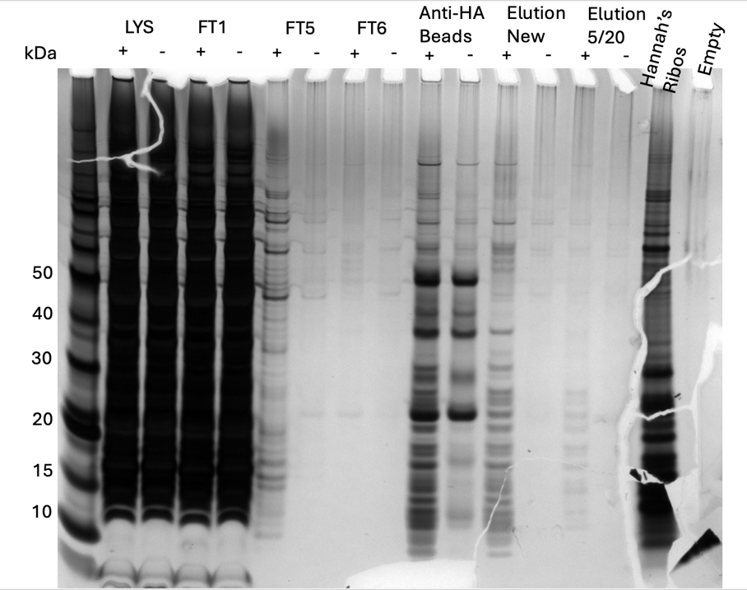

Figure 5: Silver Stain of HA-IP 6/17/24
This looks good! This is finally the specificity we have been looking for. There is still room for optimization of getting more material off of the beads, but Kathryn says it might be better to move forward with the strains where the HA is on the chromosome.

Allelic Exchange:
Because the difference between wild-type and the HA-tagged bS21 strains are so similar in size, colony PCR won’t be informative. Instead, I am doing a diagnostic digest using NotI, since I added the NotI between the 3’ end of rpsU(2) and the HA epitope.
Diagnostic Digest:
Tube | DNA | Enzyme(s) | DNA Volume (uL) | H₂O Volume (uL)
1-15 | PCR purified rpsU2-HA | Not1 | 2 | -

Components | Volumes in 1 reaction (uL) | Volumes in Master Mix 19x (uL)
H₂O | 15.0 | 294.5
10x Buffer* | 2.0 | 38
DNA | (2.0) | -
Enzyme 1 | 0.5 | 9.5
Enzyme 2 | N/A | -
Total | 20.0 (18.0 actual b/c of DNA) | 342

- Add indicated amounts of H₂O and 10x buffer to master mix tube (MM).
- Add indicated amount of DNA or DNA+water (for backbone tubes) to individual tubes for digest (1.5 mL microfuge tubes for digests in incubator, PCR strip tubes for reactions incubated in the thermocycler).
- Add indicated amount of each enzyme (___uL) to the master mix tube (MM).
- Mix the master mix by pipetting up and down.
- Add master mix to individual tubes. Volume to add to each tube is the volume in 1 reaction minus the DNA volume (____ul).
- Incubate at 37°C for 1 hour or up to overnight.
- If using digest for plasmid construction then after incubation at 37°C, add 0.5ul of CIP enzyme to backbone tube, mix by pipetting and put back in 37°C incubator for 10 minutes. (this step removes the phosphates from the ends of the plasmid to prevent re-ligation). If using the new Quick CIP – add 1 uL, mix, incubate (at 37º) for 10 mins, then put at 80C for 2 minutes to inactivate the CIP.

Since this is only a diagnostic digest, there is no need to add CIP.
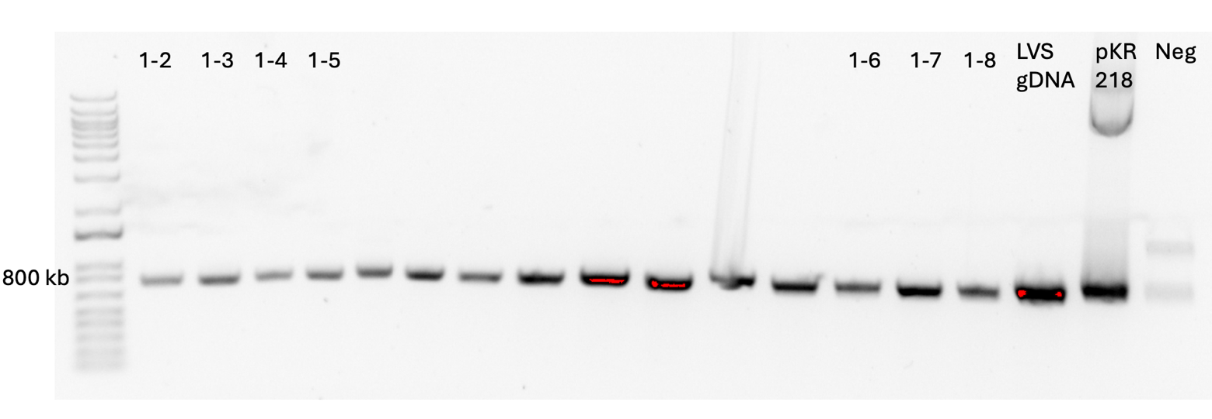

Figure 6a: Diagnostic Digest of potential secondary recombinants from Primary Integrant 1
There was loading error which is why the gel is split up this way. No mutants here.
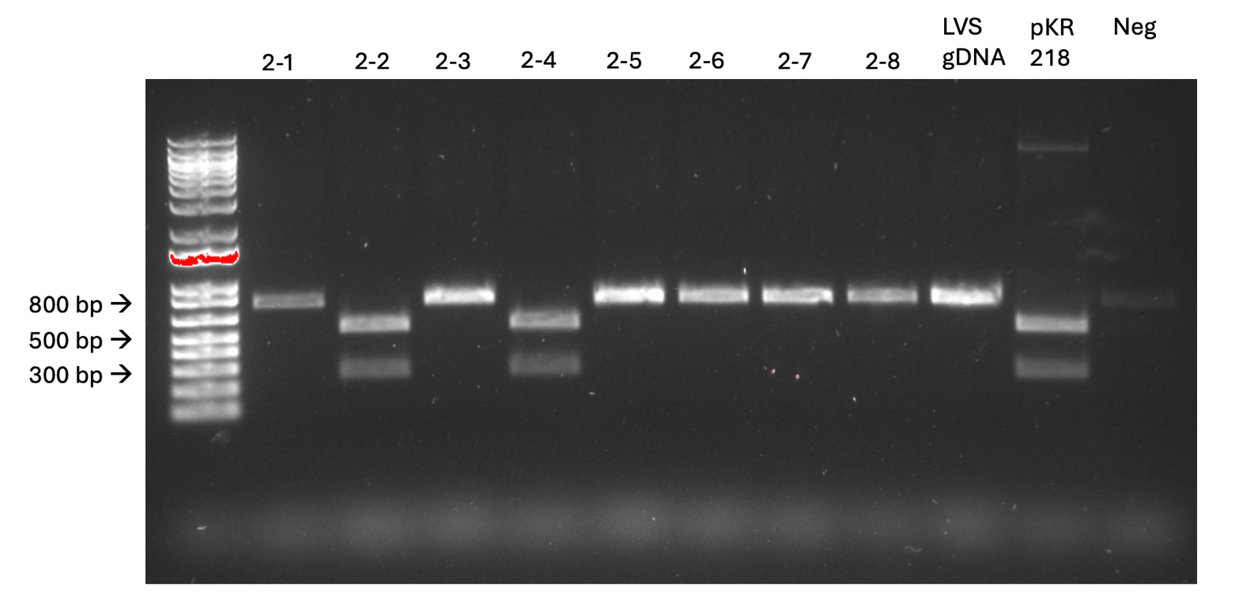

Figure 6b: Diagnostic Digest of potential secondary recombinants from Primary Integrant 2
There are 2 mutants! Not1 enzyme cuts the DNA into fragments size 264 bp and 535 bp if it has the HA tag. The wild-type DNA is 799 bp.
The patches that the mutants came from are a couple of days old. On Sunday I wrapped them in parafilm and kept them on the bench. I streaked them for isolation today and since I won’t be here the rest of the week I’m leaving them on the bench.

Monday, June 24, 2024
To Do:
- Silver Stain
- Digest
- Streak out KRSA2 and KRSA12
- Make LB agar and MHB
- Check PCR on SA rpsU complement primers

I don’t have too much to do today since I’ve been away for a while. The plates I streaked last week are growing but there aren’t single colonies yet. I moved them to 37ºC, hopefully I’ll have colonies tomorrow. Once I do, I’ll patch them and repeat the digest to make sure there wasn’t a mixed population.
Kathryn would like me to check the SA ∆rpsU mutant against other antibiotics to make sure that deleting this gene doesn’t universally affect resistance. I plan to start with these:

Antibiotic | Stock conc  mg/mL | Range of concs (mg/mL) | Antibiotic  Class
Carb | 100 | 0.25-128 | penicillin
Chlor | 25 | 1-512 | chloramphenicol
Gent | 50 | 0.125-64 | aminoglycoside
Kan | 50 | 0.5-256 | aminoglycoside
Tet | 35 | 0.125-4 | Protein synth inhibitor
Eryth | 20 | 0.125-64 | macrolide
Strep | 50 | 1-512 | aminoglycoside
Nat | 100
Ksg | 50 |  | aminoglycoside
Spec | 10 | 1-512 | aminocyclitol
Hyg | 54 |  | aminoglycoside
Vanc | 100 | 0.5-256 | glycopeptide

Check PCR:
I’m checking the primers I designed for complementing rpsU back in to the ∆rpsU mutant strain of S. aureus:

Reaction numbers | Sample | Primers | Expected size
1 | SA gDNA | KROL709 and KROL710 | 177 bp
2 | -DNA | KROL709 and KROL710 | 0 bp

Total reaction volume | 20
Total number of reactions | 2
 |  |  |  | Factor
Component | Stock concentration | Final concentration | 1 rxn volume | 3
ddiH2O |  |  | 12.4 | 37.2
PrimeSTAR GXL Buffer | 5x | 1x | 4.0 | 12
dNTPs | 2.5 mM | 0.2 mM | 1.6 | 4.8
oligo F KROL709 | 10 uM | 0.3 uM | 0.6 | 1.8
oligo R KROL710 | 10 uM | 0.3 uM | 0.6 | 1.8
template | 100 ng/ul | 2 ng/ul | 2 | 1.2
PrimeSTAR GXL DNA Polymerase | 1.25 U/ul | 0.025 U/ul | 0.4 | 1.2
 |  | Total volume | 20 | 60
I used the STN1 cycle and put the elongation time as 20 seconds. I left it in the thermocycler overnight.

Tuesday, June 25, 2024
To Do:
- Streak out KRSA2 and KRSA12
- Make LB agar and MHB
- Check PCR on SA rpsU complement primers
- Gel on PCR
- Start overnights on KRSA2 and KRSA12
- Western on HA-IP
- Patch potential LVS 2º recombinants if they grew

PCR gel:
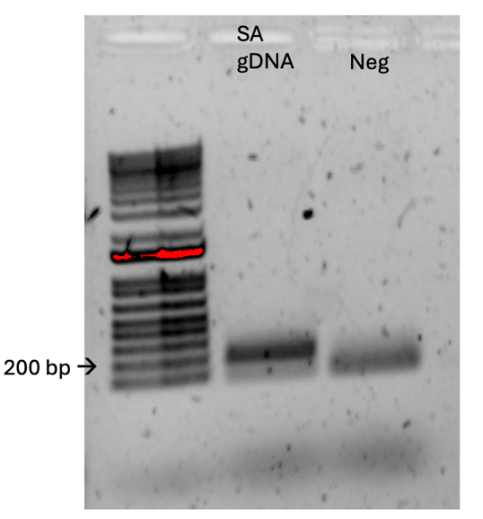
Well this is a mess. I need to find the source of contamination before I move on with this.

Western Blot:
Lane | Content | Volume
1 | WesternSure Ladder | 5 ul
2 | LVS-pF-rpsU2-HA lysate | 10 ul
3 | LVS-pF lysate | 10 ul
4 | LVS-pF-rpsU2- HA FT1 | 10 ul
5 | LVS-pF FT1 | 10 ul
6 | LVS-pF-rpsU2- HA FT5 | 10 ul
7 | LVS-pF FT5 | 10 ul
8 | LVS-pF-rpsU2- HA FT6 | 10 ul
9 | LVS-pF FT6 | 10 ul
10 | LVS pF-rpsU2 - HA Anti-HA agarose beads | 10 ul
11 | LVS-pF Anti- HA Agarose Beads | 10 ul
12 | LVS pF-rpsU2 - HA Anti-HA agarose beads (old) | 10 ul
13 | LVS-pF Anti- HA Agarose Beads (old) | 10 ul
14 | 1X SLB | 10 ul
15 | LVS-pF-rpsU2- HA EL1 new | 10 ul
16 | LVS-pF EL1 new | 10 ul
17 | LVS pF-rpsU2-HA WCL | 10 ul

I had some issues with layering everything on the transfer, so hopefully everything comes out clean.

I started overnights of KRSA2 and 12, but I’m keeping the LVS potential 2º recombinants in the incubator for one more night so I can get bigger colonies.

Wednesday, June 26, 2024
To Do:
- Gel on PCR
- Start overnights on KRSA2 and KRSA12
- Western on HA-IP
- Patch potential LVS 2º recombinants if they grew
- Western Day 2
- Redo PCR with new reagents

I see good colonies on the 2º recombinant plates. Patch 2-2 doesn’t have good isolation, but I was able to patch 3 separate colonies. Patch 2-4 looked great and I patched 3 colonies.
PCR
I repeated the PCR that I did yesterday with the same set up, except I decreased the elongation time to 15 seconds. I used all new reagents.
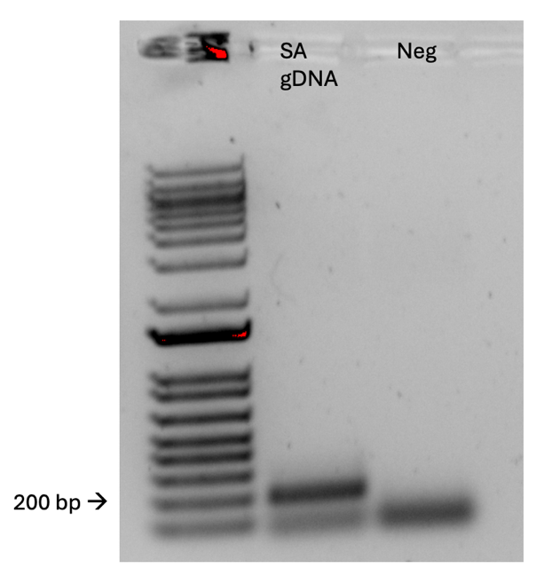

MICs
I might postpone the MICs until tomorrow. I would like to have more of a plan. I intend to test 6 antibiotics at time on each well plate, including vancomycin as a control each time. The STAR protocol that I am using as a model suggests setting up the antibiotics with a range of ten concentrations, but I think I should be fine to test 6 concentrations, at least to start.
Example set up:
 |  |  | Antibiotic
 |  |  | Abx 1 | Abx 2 | Abx 3 | Abx 4 | Abx 5 | Abx 6 | Abx 1 | Abx 2 | Abx 3 | Abx 4 | Abx 5 | Abx 6
 |  |  | 1 | 2 | 3 | 4 | 5 | 6 | 7 | 8 | 9 | 10 | 11 | 12
Antibiotic concentration | 16 | A
Antibiotic concentration | 8 | B
Antibiotic concentration | 4 | C
Antibiotic concentration | 2 | D
Antibiotic concentration | 1 | E
Antibiotic concentration | 0.5 | F
Antibiotic concentration | 0 | G | BHI no antibiotic with bacteria
Antibiotic concentration | Blank | H | BHI no antibiotic no bacteria
 |  |  | Replicate 1 |  |  |  |  |  | Replicate 2

# | Sample ID | Nucleic Acid | Unit | A260 (Abs) | A280 (Abs) | 260/280 | 260/230 | Sample Type | Factor
1 | pKR219-A | 58.4 | ng/µl | 1.169 | 0.624 | 1.87 | 2.42 | DNA | 50
2 | pKR219-B | 49.2 | ng/µl | 0.983 | 0.514 | 1.91 | 2.54 | DNA | 50
3 | pKR219-C | 67 | ng/µl | 1.34 | 0.705 | 1.9 | 2.39 | DNA | 50
4 | pKR219-D | 58.6 | ng/µl | 1.173 | 0.639 | 1.84 | 2.24 | DNA | 50
5 | pKR219-E | 62.9 | ng/µl | 1.257 | 0.679 | 1.85 | 2.25 | DNA | 50
6 | pKR218 | 40.2 | ng/µl | 0.804 | 0.445 | 1.81 | 2.34 | DNA | 50

Sample 6 was too low so I re-diluted it 1:5 and the new concentration is 75.8.
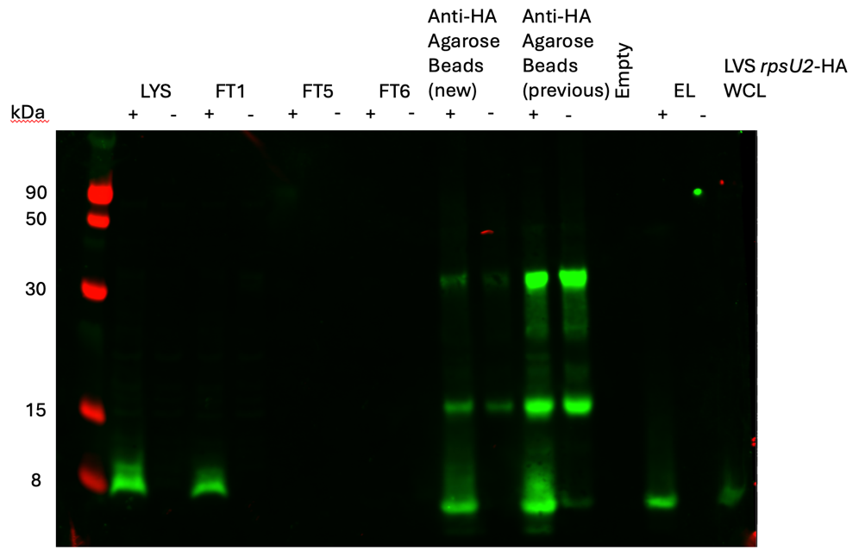

Figure 7: Western Blot of HA-IP from 6/17/24
I compared the beads from the current IP to the last IP and the faintness of the “new” beads compared to the “previous” beads suggests we were able to elute more material off the beads this last time. Yay!

Thursday, June 27, 2024
To Do:
- Patch potential LVS 2º recombinants if they grew
- Western Day 2
- Redo PCR with new reagents
- Colony PCR and digest on potential mutants
- MIC assay

Total reaction volume | 50
Total number of reactions | 9
 |  |  |  | Factor
Component | Stock concentration | Final concentration | 1 rxn volume | 10
ddiH2O |  |  | 31.0 | 310
PrimeSTAR GXL Buffer | 5x | 1x | 10.0 | 100
dNTPs | 2.5 mM | 0.2 mM | 4.0 | 40
oligo F KROL343 | 10 uM | 0.3 uM | 1.5 | 15
oligo R KROL148 | 10 uM | 0.3 uM | 1.5 | 15
template | 100 ng/ul | 2 ng/ul | 1.0 | 10
PrimeSTAR GXL DNA Polymerase | 1.25 U/ul | 0.025 U/ul | 1.0 | 10
 |  | Total volume | 50 | 500

I PCR purified these reactions to use for digest but also kept some for a gel to see if there’s still contamination in the negative control.
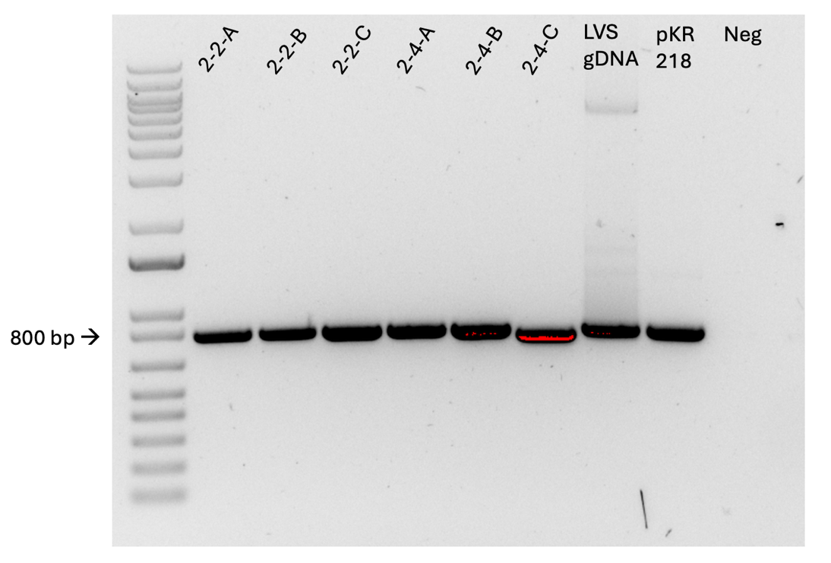
Diagnostic Digest:
Tube | DNA | Enzyme(s) | DNA Volume (uL) | H₂O Volume (uL)
1-6 | PCR purified rpsU2-HA | Not1 | 2 | -
7 | PCR purified LVS gDNA | Not1 | 2 | -
8 | PCR purified pKR218 | Not1 | 2 | -
9 | Negative | Not1 | - | 2

Components | Volumes in 1 reaction (uL) | Volumes in Master Mix 10x (uL)
H₂O | 15.0 | 150
10x Buffer* | 2.0 | 20
DNA | (2.0) | -
Enzyme 1 | 0.5 | 5
Enzyme 2 | N/A | -
Total | 20.0 (18.0 actual b/c of DNA) | 175

- Add indicated amounts of H₂O and 10x buffer to master mix tube (MM).
- Add indicated amount of DNA or DNA+water (for backbone tubes) to individual tubes for digest (1.5 mL microfuge tubes for digests in incubator, PCR strip tubes for reactions incubated in the thermocycler).
- Add indicated amount of each enzyme (___uL) to the master mix tube (MM).
- Mix the master mix by pipetting up and down.
- Add master mix to individual tubes. Volume to add to each tube is the volume in 1 reaction minus the DNA volume (____ul).
- Incubate at 37°C for 1 hour or up to overnight.
- If using digest for plasmid construction then after incubation at 37°C, add 0.5ul of CIP enzyme to backbone tube, mix by pipetting and put back in 37°C incubator for 10 minutes. (this step removes the phosphates from the ends of the plasmid to prevent re-ligation). If using the new Quick CIP – add 1 uL, mix, incubate (at 37º) for 10 mins, then put at 80C for 2 minutes to inactivate the CIP.

Since this is only a diagnostic digest, there is no need to add CIP.

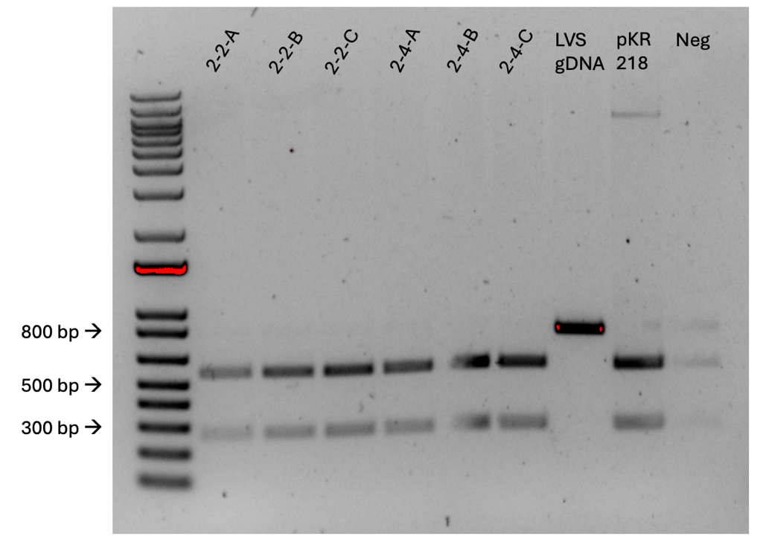

MICs:
Antibiotic | Stock conc  mg/mL | Range of concs (mg/mL) | Antibiotic  Class | Target
Carbenicllin | 100 | 0.25-128 | penicillin | Cell wall
Chloramphenicol | 50 | 1-512 | chloramphenicol | 50S subunit
Kanamycin | 50 | 0.5-256 | aminoglycoside | 30S subunit
Vancomycin | 100 | 0.5-256 | glycopeptide | Cell wall

Kathryn mentioned making sure to not go over 5% drug volume, because the diluent can maybe have effects on the bacteria. I am setting up volumes of 25ml for each antibiotic, which means 5% volume is 1.25ml. The antibiotics I’m testing today do not exceed that volume:
 | C1 (ug/ml) | V1 (ul) | C2 (ug/ml) | V2 (ul)
Carb | 100,000 | 2.56 | 256 | 1,000
Chlor | 50,000 | 20.48 | 1024 | 1,000
Kan | 50,000 | 10.24 | 512 | 1,000
Vanc | 100,000 | 5.12 | 512 | 1,000

Plate map:
 |  |  | Antibiotic Concentration
 |  |  | 1 | 2 | 3 | 4 | 5 | 6 | 7 | 8 | 9 | 10 | 11 | 12
 |  |  | Conc 1 | Conc 2 | Conc 3 | Conc 4 | Conc 5 | Conc 6 | Conc 7 | Conc 8 | Conc 9 | Conc 10 | No Abx | Blank
Antibiotic | A | Carb | 128 | 64 | 32 | 16 | 8 | 4 | 2 | 1 | 0.5 | 0.25 | 0 | Blank
Antibiotic | B | Chlor | 512 | 256 | 128 | 64 | 32 | 16 | 8 | 4 | 2 | 1 | 0 | Blank
Antibiotic | C | Kan | 256 | 128 | 64 | 32 | 16 | 8 | 4 | 2 | 1 | 0.5 | 0 | Blank
Antibiotic | D | Vanc | 256 | 128 | 64 | 32 | 16 | 8 | 4 | 2 | 1 | 0.5 | 0 | Blank
Antibiotic | E | Carb | 128 | 64 | 32 | 16 | 8 | 4 | 2 | 1 | 0.5 | 0.25 | 0 | Blank
Antibiotic | F | Chlor | 512 | 256 | 128 | 64 | 32 | 16 | 8 | 4 | 2 | 1 | 0 | Blank
Antibiotic | G | Kan | 256 | 128 | 64 | 32 | 16 | 8 | 4 | 2 | 1 | 0.5 | 0 | Blank
Antibiotic | H | Vanc | 256 | 128 | 64 | 32 | 16 | 8 | 4 | 2 | 1 | 0.5 | 0 | Blank

Population Analysis Assay (microplate method)
Based on Barnes et al, 2023
Methods:
- Grow overnight cultures of S. aureus strains.
- The next day, back-dilute cultures to an OD600 of 0.3 in BHI broth.
- Prepare BHI broth with antibiotics by making the medium 2X the highest drug concentration in test range.
- In a 96-well plate, add 100ul of BHI with antibiotics to each well in Column 1 using a multi-channel pipet.
- In Columns 2 through 12 add 50ul of BHI without antibiotics
- Perform a serial two-fold dilution by adding 50ul of BHI with antibiotics from wells in Column 1 to the Column 2, etc., stopping at Column 10.
- Perform a ten-fold serial dilution of bacterial cultures by adding 10ul of overnight cultures to 990ul of TSB to create a 10⁻² dilution, then add 100ul of that dilution to 900ul of new TSB for a dilution of 10⁻³. Prepare the bacterial culture by diluting it 1:100 (100ul in 10ml of BHI)
- Add 50ul of each bacterial culture to the wells in the appropriate columns (i.e. 10⁻² to the wells in Columns 1 and 7). (put the 10ml culture in a sterile reservoir and use a multichannel pipet to inoculate the wells)
- Incubate plates at 37ºC for 20 hours.

Friday, June 28, 2024
To Do:

- Colony PCR and digest on potential mutants
- MIC assay
- Supplement MHB
- Freeze mutants
- Read MIC plates

A:

B:

C:

D:

Figure 8: MICs of various antibiotics against S. aureus wild-type and ∆rpsU mutant
A: Vancomycin shows increased resistance for ∆rpsU mutant with MIC of 2 ug/ml and 0.5ug/ml for wild-type. B: Carbenicillin shows MIC of 1 ug/ml and 0.5 ug/ml for mutant and wild-type, respectively. C: Chloramphenicol MIC of 8 ug.ml for mutant compared to 2 ug/ml for wild-type. D: Kanamycin shows decrease in resistance of mutant at 4 ug/ml compared to 16 ug/ml for wild-type. Each condition was tested with bacterial concentrations of 5 x 10², incubated at 37ºC for ~20 hours, in duplicate.

Next steps:
Repeat with shorter and lower range (at least 2 concentrations), in triplicate.
Growth curves (in the plate reader if possible).
Make a chart template!
For mutants: westerns and isolate gDNA, send for sequencing.

Bibliography

Cui, L., Iwamoto, A., Lian, J.-Q., Neoh, H., Maruyama, T., Horikawa, Y., & Hiramatsu, K. (2006). Novel Mechanism of Antibiotic Resistance Originating in Vancomycin-Intermediate Staphylococcus aureus. Antimicrobial Agents and Chemotherapy, 50(2), 428–438. https://doi.org/10.1128/AAC.50.2.428-438.2006

