Table of Contents
January 2024 2
Making CHA Plates 2
LB Media 3
Mueller-Hinton broth protocol- by Jamie Wandzilak 3
Electroporation into LVS 4
Inoculating test tube cultures of Francisella tularensis protocol- by Jamie Wandzilak 6
Growth Curve: 7
Calculating Doubling Time: 8
Figure 1: Growth curve of LVS ∆rpsU2-pF-rpsU2-FLAG 9
Figure 2-4: 2-hour timepoints of LVS ∆rpsU2-pF-rpsU2-FLAG growth curve. 10
Prepare IP cell pellets 12
Figure 5: Growth curve of tagged bS21-2 strains of LVS with FLAG and HA 15
Figure 6: Generation time of tagged bS21-2 strains of LVS, hours 2-4. 15
February 2024 16
S. aureus Glycerol Stocks: 19
Sucrose Gradients 20
Fractionating 21
Figure 7: Sucrose gradients of HA-IP. 23
Figure 8: PCR on potential primary integrants of S. aureus pKFT-rpsU. 25
Figure 9: Growth curve of tagged bS21-2 strains of LVS with V5 and HA 28
Figure 10: Generation time of bS21-2 tagged strains of LVS with VSV-G, HA, and V5 29
Normalizing OD’s from Plates for Western Blot Protein Sample 30
Figure 11: Gradient PCR on S. aureus 34
Figure 12: Colony PCR on potential secondary integrants of S. aureus ∆rspU 36
Figure 13: Disappointing PCR on P19 39

January 2024

Making CHA Plates
- You are making 24 CHAH-Kan plates and 12 regular CHAH plates. These plates usually last 1 ½ to 2 weeks, and they expire after 2 weeks.
- Use three of the 500 mL narrow mouth flasks and save the wide mouth flasks for hemoglobin.
- Use 15.3 g of the CHA mix which is made from scratch. The crystals sometimes sink to the bottom, so give it a good shake before using.
- Add stir bars (biggest that we have) to all three flasks.
- Add 150 mL of diH2O with grad cylinder. When pouring water into flask, be gentle so CHA is not on side of flask, you can also use water to wash debris to bottom.
- Stir each flask for 10 min at 60C. The stir plate on Hannah’s bench can be set to 1 for heat and 4-5 for stirring, if stir bar gets stuck give it a gentle shake or turn stir up and down. Cover the flasks with tinfoil doubled over with autoclave tape.
- Put the flasks in Instant Pot with 1 L water (can be sink water) placed away from the locking mechanism and pressure cook for 30 min. Let it depressurize on its own for about 20 min afterwards. It should automatically keep warm, so it shouldn’t solidify, but time it. 25-30 min warming is still ok, manual release if taking out before 20 min should be done slowly as the change in pressure can cause the CHA to overflow.
- Put the hemoglobin in water bath at 56C (one with 300 mL and one with 150 mL). You will need 150 mL hemoglobin for each half-flask. You want hemoglobin and CHA to be at similar temp when combining them. Move CHA flasks to water bath with orange gloves for 15-20 min.
- When taking out of water bath, spray with ethanol, because water bath is not sterile.
- Combine 150 mL of CHA and 150 mL of hemoglobin. With 150 mL hemoglobin flask, pour into CHA by flame, want to reduce bubbles so pour both bottles at an angle, then flame the top of the flask that has everything, put foil back on and put back on stir plate for a minute or so to combine.
- When pouring 300 mL of hemoglobin, pull off 150 mL in 50 mL portions with pipettor.
- If not going to actively use hemoglobin put back in water bath.
- CHA sticks to bottom, so it’s easier to pour hem into CHA.
- This media is prone to contamination.
- Add Kan to two of the CHAH flasks for Kan plates (1/10 of volume in uL, total volume is 300 mL so add 30 uL of Kan). Spray pipette down with ethanol before, then when pipetting. Kan should be found in small fridge. Add Kan by flame, put foil on, and stir for 2 min.
- Set up plates in stacks of two. Use the ser pip to take up 48 uL, then pipette 24 uL in each plate. Ser pip will drip, but don’t drip on outside of plates, keep pipette in same place so it drips in one puddle. Take new stack of two and put on top of previous two and continue until plates are height of flame. Should get 12-13 plates per flask, can pour extra plate if more than 16 mL.
- For Kan plates draw line with blue marker.
- On top of each stack write CHAH-Kan or CHAH and today’s date.
- If pipette touches outside of flask, throw out that pipette.
- Cleanup:
  - Flasks with CHA rinse out in sink and put empty flask in wash bin.
  - Rinse stir bars.
  - Once a month, bleach all the stir bars (10% bleach for 10 min) because hemoglobin tends to accumulate on the stir bars.
  - Flasks with hemoglobin need to sit overnight in Citrinox (small glug, then add water) in wash bin.

LB Media
Protocol written by KMR
Preparing LB media
- For 250 mL of LB, weigh out the following components and add to a 500 mL bottle:
  - 2.5 g NaCl
  - 2.5 g Tryptone
  - 1.25 g Yeast extract
- Add 250 mL type I ddiH20
- Close tightly and shake to mix
- Loosen cap and add a small piece of autoclave tape with the date
- Autoclave on 30 minute liquid cycle
Sterile media can be stored indefinitely
**I doubled the recipe and make 1 bottle of 500ml

Mueller-Hinton broth protocol- by Jamie Wandzilak

For 500 mL of MHB
1. Weigh out 10.5g of Mueller-Hinton broth into 1L square-bottle
2. Add 500mL of ddiH₂O (type I)
4. Cool down to 37 ̊C or cooler
5. Can keep this sterile media indefinitely without supplements
** I doubled the recipe and made 2 bottles of 500 ml
I hope to perform at least one sucrose gradient experiment before I have to present at seminar in a few weeks.

Monday, January 22, 2024
To Do:
- Make CHA and CHA-Kan
- Make MHB and LB
- Patch out various LVS wt from various sources with JR

I want to double check whether the LVS EC cells I made with Johanyx last semester already have a plasmid in them, since her negative controls always had growth after a transformation. I’m worried that the glycerol stocks I have are LVS pF rather than LVS wt. She patched out 2 of my LVS wt aliquots: one on CHA-Kan and the other just on CHA. She also patched out Hannah’s LVS wt glycerol stock on CHA-Kan and CHA. I’m also going to patch out LVS EC cells from the last batch we made on CHA-Kan. Finally, I’m going so streak out my LVS wt glycerol stocks (not the aliquots) on CHA-Kan and Hannah’s wt stocks on CHA to make new stocks if I need to.
I talked to Kathryn about it and she says given my results in December when I plated LVS EC cells and LVS wt cells onto CHA-Kan and LVS wt didn’t grow, she suspects that it’s just a matter of sheer high concentration of the EC cells combined with the low concentration of Kan in the medium that allowed for the lawn.

On Thursday I plan on repeating the growth curves that Meagan set up during her rotation, so tomorrow I will patch out LVS ∆rpsU2-pF, LVS ∆rpsU2-pF-VSV-G, LVS ∆rpsU2-pF-FLAG and Wednesday I will patch out LVS pF.

Tuesday, January 23, 2024
To Do:
- Patch out various LVS wt from various sources with JR
- Electroporation
- Patch out LVS ∆rpsU2-pF, LVS ∆rpsU2-pF-VSV-G, LVS ∆rpsU2-pF-FLAG

Electroporation into LVS
From Allelic exchange protocol; Edited by Hannah Trautmann

Prepare electrocompetent (EC) cells
-Scrape up entire plate of cells into 400 uL of sterile 10% sucrose and resuspend (alternately, cells can be grown to mid-log in MHB)
-Add 1.1 mL of 10% sucrose to a final volume of 1.5 mL
-Spin for 3 minutes at 10,000 rpm
-remove supernatant, throw out, and resuspend in fresh 1 mL 10% sucrose
-Repeat 3x-5x in 10% sucrose
-After final spin, remove all supernatant.
-Resuspend cells in 10% sucrose at high density (corresponding to ~1x10¹¹ cells /mL); these are EC cells by slowly adding 110 uL at a time. It should be about equal amounts of cells as sucrose.
-For any extra EC cells, aliquot ~110 μL / sterile tube (enough for 2 electroporations) and freeze at -80°C

Electroporate plasmid into EC cells*
-For each electroporation, aliquot 4 mL MHB into glass test tubes for recovery, warm in shaker at 37°C
-For each electroporation, in a 2 mm sterile electroporation cuvette, combine:
5 μL of pEX-based allelic exchange construct or Tn7 plasmids (mini-prep concentration, at least 100 ng/μL)
*for pF-based plasmids, can use 3 ul
50 μL electrocompetent cells
-Have recovery media ready
-Electroporate using the following settings: 2.5 kV, 25 μF, and 600 Ω
-Immediately after individual electroporations, use 1 mL warm recovery media from test tube to wash cells out of cuvette and transfer cells to recovery test tube
-Recover cells for 4-8 hours, shaking at 37°C
*For pF-based plasmids, only recover 2-3 hours
-For pEX plasmids: pellet cells by centrifugation in sterile 2 mL tubes, 1’ at 10,000 x g. Plate on CHAH-Kan plates, using 1 plate for each 2 mL tube (2 plates per electroporation)
*For pF-plasmids: plate 10 ul and 100 ul on CHAH-kan plates
*For Tn7 plasmids: plate 100 ul and remaining on CHAH-kan plates
-Incubate plates at 37°C for 3 days (or until single colonies appear)

*Always include a control electroporation with no plasmid. Eventually single break-through colonies may start appearing; at that point, single colonies on the experimental plates are also likely to just be break-through growth.

Sample | Time
pKR200
pKL02
No DNA

I performed the electroporation and Ben spread-plated them.

Wednesday, January 24, 2024
To Do:
- Electroporation
- Patch out LVS ∆rpsU2-pF, LVS ∆rpsU2-pF-VSV-G, LVS ∆rpsU2-pF-FLAG
- Patch out LVS pF
The No DNA control plate already has a lawn.

Thursday, January 25, 2024
To Do:
- Patch out LVS pF
- Growth curve
Regarding the LVS electroporation negative control: Kathryn streaked out one of the colonies to a new plate along with LVS pF as a control. The next day, there was a lot of growth on the new plate and it didn’t look like LVS. We conclude that this is contamination, and Kathryn thinks that it probably came from the sterile microfuge tubes. I have since gotten a new container of tubes. I’m not sure when we’ll try again, I’ll talk to Ben to see if he can help out.

Inoculating test tube cultures of Francisella tularensis protocol- by Jamie Wandzilak

Note: Perform all following steps using aseptic technique
- Determine the starting OD600 you want for your test tube cultures
- Prepare sterile test tubes with desired volume supplemented MHB (S-MHB)
- Prepare a sterile 50mL conical with 3.5 mL S-MHB (large volumes) or a microfuge tube with 400 ul of S-MHB (small volumes)
- Obtain CHAH plates with heavily grown bacteria (grown at least overnight, depending on the strain)
- Using a loop, scrape cells off the plate until you have a clump
- Swirl the loop in the tube of MHB and dislodge the clump of cells from the loop
- Repeat steps 5 and 6, 2-3x to get enough bacteria into the culture
- Resuspend the pellets/clumps of cells using a p1000 pipet until there are no more clumps

Growth Curve:
Check OD600:
Dilute resuspended cells 1:10 in MHB (100 uL cells, 900 uL MHB)
Check OD600 using 1 mL MHB as blank
Calculate actual OD600 (measured OD600 multiplied by dilution factor [10])*
Calculate what volume of cells you need to obtain an OD600 of 0.08 in 10 mL*

For each sample, inoculate one glass culture tube so that the final OD600 is 0.08
Example:
OD600 of resuspended cells: 4.0
(9 mL )(0.08 OD600) / (4.0 OD600) = 0.18 mL resuspended cells (180 uL)
Either:
-Add 9 mL MHB per tube and add 820 uL more MHB and 180 uL resuspended cells
OR
-Add 10 mL MHB per tube, remove 180 uL, and add back 180 uL resuspended cells

Strain Genotype | Measured OD600 | Dilution Factor | Actual OD600 | Desired Volume mL | Desired OD | Volume of Resuspended Cells µL | OD at T0 | OD at T2 | OD at T4 | OD at T6
LVS pF | 0.473 | 10 | 4.73 | 9 | 0.08 | 152.2 | 0.085 | 0.172 | 0.302 | 0.453
LVS pF | 0.285 | 10 | 2.85 | 9 | 0.08 | 252.6 | 0.068 | 0.171 | 0.287 | 0.432
LVS pF | 0.485 | 10 | 4.85 | 9 | 0.08 | 148.5 | 0.077 | 0.184 | 0.325 | 0.477
LVS rpsU2-pF | 0.475 | 10 | 4.75 | 9 | 0.08 | 151.6 | 0.083 | 0.166 | 0.247 | 0.345
LVS rpsU2-pF | 0.535 | 10 | 5.35 | 9 | 0.08 | 134.6 | 0.076 | 0.141 | 0.224 | 0.32
LVS rpsU2-pF | 0.476 | 10 | 4.76 | 9 | 0.08 | 151.3 | 0.074 | 0.151 | 0.243 | 0.348
LVS rpsU2-pF-rpsU2-VSV-G | 0.5 | 10 | 5 | 9 | 0.08 | 144.0 | 0.063 | 0.151 | 0.258 | 0.395
LVS rpsU2-pF-rpsU2-VSV-G | 0.484 | 10 | 4.84 | 9 | 0.08 | 148.8 | 0.067 | 0.165 | 0.28 | 0.425
LVS rpsU2-pF-rpsU2-VSV-G | 0.559 | 10 | 5.59 | 9 | 0.08 | 128.8 | 0.073 | 0.139 | 0.247 | 0.383
LVS rpsU2-pF-rpsU2-FLAG | 0.517 | 10 | 5.17 | 9 | 0.08 | 139.3 | 0.067 | 0.136 | 0.21 | 0.319
LVS rpsU2-pF-rpsU2-FLAG | 0.461 | 10 | 4.61 | 9 | 0.08 | 156.2 | 0.065 | 0.14 | 0.228 | 0.341
LVS rpsU2-pF-rpsU2-FLAG | 0.446 | 10 | 4.46 | 9 | 0.08 | 161.4 | 0.054 | 0.151 | 0.244 | 0.363

Calculating Doubling Time:
b = # of bacteria at beginning of a time interval
B = # of bacteria at end of a time interval
t = time interval in hours or minutes
n = # of generations (how many times a cell population doubles within a time interval)
b = B x 2^{n}
solve for n:
logb = logB + nlog2
n = logb - logB/log2
n = logb – logB/0.301
n = 3.3 logb/B
G = t/n (generation time)
Solve for G:
t/3.3logb/B

Figure 1: Growth curve of LVS ∆rpsU2-pF-rpsU2-FLAG
I completely forgot to do a 24-hour timepoint.

Figure 2-4: 2-hour timepoints of LVS ∆rpsU2-pF-rpsU2-FLAG growth curve.
FLAG kept pace with WT at the beginning, slowed down between hours 2 and 4, and then recovered to match WT again. LVS ∆rpsU2-pF is the negative control (grows slower than wild-type), and LVS ∆rpsU2-pF-rpsU2-VSV-G is the positive control (complements the phenotype). This will have to be repeated.

This looks promising. Although the FLAG strain slowed down between hours 2 and 4, it caught up with LVS pF between hours 4-6. I’ll do this again, this time making sure to take a 24-hour timepoint, and I’ll try to include HA.

Monday, January 29, 2024
To Do:
- Growth curve
- Patch out strains for new growth curve
- Patch out LVS FLAG for more cell pellets
- Transform pKL into E coli with JR
- Transform pKR148 into KRSA2
- Pour TSA-Tet plates

I patched out LVS pF, LVS ∆rpsU2-pF, LVS ∆rpsU2-pF-VSV-G, LVS ∆rpsU2-pF-FLAG, and LVS ∆rpsU2-pF-HA for another growth curve. I patched out an extra plate of LVS ∆rpsU2-pF-FLAG to make cell pellets for IP. JK, there were only 5 CHA-Kan plates left, so hopefully I’ll have enough growth tomorrow to do a growth curve and start an overnight culture of FLAG.
For the S. aureus transformation I set up pKR148 into KRSA2 with a No DNA control

Staph Electroporation
Thaw out aliquots on ice for 5 min then place at room temperature for 5 min (and follow the rest of the protocol at RT).
Centrifuge at 5,000xg for 1 min. Discard the supernatant and resuspend the cells in 50 ul of 10% glycerol / 500 mM sucrose.
Add up to 5ug-purified plasmid to the cells, mix and add to 0.1 cm electroporation cuvette. Up to 5ul of plasmid (dialyzed 20’ against H₂O with Millipore filters). I added 3ul of pKR148
Pulse 21 kV/cm, 100 Ω and 25uF. Time constant usually about 2.0-2.4 ms. Used the StA setting, no arcs!
Immediately add 1ml of TSB + 500mM sucrose and mix. (Dissolve 6.85g of sucrose in 40ml TSB and filter sterilize)
Transfer to a new tube and incubate at adequate temperature for 1-1.5h. (30C for RN4220; 42C for HG003) Incubated at 37ºC for an hour and a half
Plate out on TSA + antibiotic. (3 ug/mL tet) Plated on both TSA+tet and TSA no tet: 100 ul, 100 ul of 10⁻¹ diluted, 100 ul of 10⁻² diluted, 100 ul of 10⁻³ diluted, 100 ul of 10⁻⁴ diluted

For Johanyx’s repeat transformation, we need to make more of the positive control pKL02. She is transforming E coli with it today.

Tuesday, January 30, 2024
To Do:
- Patch out strains for new growth curve
- Patch out LVS FLAG for more cell pellets
- Transform pKL into E coli with JR
- Transform pKR148 into KRSA2
- Growth curve
- Make MSB for o/n culture
- Set up overnight of FLAG
- Make more Buffer A + PI + BB

S. aureus transformants:
For both the pKR148 transformation and the negative control, all of the TSA-No-Tet have growth. Similarly, none of the TSA-Tet plates have growth. I will let them incubate for another day.

Prepare IP cell pellets
- For each strain, label a sterile microfuge tube and add 400 uL supplemented MHB (sMHB) aseptically.
- Scrape up ~1 loopful of cells and add to appropriate microfuge tube.
- Resuspend cells to homogeneity using a pipette (no clumps should be present).
- Add 500 uL more sMHB to each tube.
- Prepare cuvettes to check OD₆₀₀ by labeling one per sample and adding 900 uL sMHB (keep sMHB stock sterile- cuvettes and subsequent cell dilutions are not sterile)
- Add 100 uL resuspended cells to appropriate cuvette
- Check OD₆₀₀. Calculate OD₆₀₀ of resuspended cells (10x observed OD₆₀₀), record both observed and calculated OD.
  - If observed OD₆₀₀ < 0.01, add more cells from the plate and re-check the OD.
  - If observed OD₆₀₀ > 0.5, re-check the OD using a more dilute sample.
- For each sample, calculate volume of resuspended cells necessary to obtain a final OD₆₀₀ of 0.003 in 500 mL
(0.003 OD₆₀₀)*(500,000ul)/(sample OD₆₀₀) = x uL
  - If this volume is < 100 uL, dilute the resuspended cells and go back to step 7.
  - If this volume is larger than the volume of cells in the microfuge tube (~>800 uL), add more cells from the plate and re-check the OD.
- To appropriately labeled 500 mL flasks, add volume of resuspended cells calculated to obtain final OD₆₀₀ of 0.003.
- Incubate flasks at 37°C shaking overnight, noting time incubation started (after 4pm and before 6pm). Arrange flasks as equally as possible in the shaking incubator to keep the platform balanced.

Sample | Observed OD600 | Calculated OD600 | Starting Volume for OD600 0.003 (ul)
LVS pF-rpsU2-FLAG | 0.636 | 6.36 | 236

Wednesday, January 31, 2024
To Do:
- Growth curve
- Set up overnight of FLAG
- Take 24-hour time point
- Make FLAG pellet
IP cell pellet:
- In the morning, check the OD₆₀₀ of each sample and document. Ideally, continue when cells are in mid-log phase (OD₆₀₀ between 0.3 – 0.4).
- Pellet cells by centrifugation in 250 mL bottles (2 per sample, sterile not required), max speed in Sorvall X4 Pro, 4°C for 10 mins. Centrifuge can be pre-cooled or cool down during this step.
- Discard supernatant (into overnight flasks with bleach), resuspend pellets in ~10 mL sMHB (combining pellets from the same samples) and transfer to 50 mL conicals (sterile not required, label well- include sample number, descriptive name, date).
- Pellet cells by centrifugation in conicals, max speed in Sorvall X4 Pro, 4°C for 5 mins.
- Discard supernatant, freeze pellets at –80°C until ready for next step.

Sample | Observed OD600 | Calculated OD600 | Starting Volume for OD600 0.003 (ul) | OD600 at 10:30am | OD600 at 12:00pm | OD600 at 1:25pm | OD600 at 4:00pm
LVS pF-rpsU2-FLAG | 0.636 | 6.36 | 236 | 0.134 | 0.161 | 0.207 | 0.279

This culture isn’t growing. I made a new patch and I will inoculate a large culture in the morning starting at a higher OD (OD600 of 0.08), and hopefully I’ll be able to make a pellet in the afternoon/evening.
Growth curve:
Sample # | Strain Genotype | Measured OD600 | Dilution Factor | Actual OD600 | Desired Volume mL | Desired OD | Volume of Resuspended Cells µL | OD at T0 | OD at T2 | OD at T4 | OD at T6 | OD at T8 | OD at T24
KB1-A | LVS pF | 0.336 | 10 | 3.36 | 9 | 0.08 | 214.3 | 0.092 | 0.189 | 0.33 | 0.487 | 0.653 | 2.07
KB1-B | LVS pF | 0.432 | 10 | 4.32 | 9 | 0.08 | 166.7 | 0.065 | 0.144 | 0.273 | 0.411 | 0.584 | 1.86
KB1-C | LVS pF | 0.349 | 10 | 3.49 | 9 | 0.08 | 206.3 | 0.089 | 0.173 | 0.312 | 0.471 | 0.628 | 1.94
KB2-A | LVS rpsU2-pF | 0.326 | 10 | 3.26 | 9 | 0.08 | 220.9 | 0.071 | 0.125 | 0.206 | 0.289 | 0.393 | 0.91
KB2-B | LVS rpsU2-pF | 0.308 | 10 | 3.08 | 9 | 0.08 | 233.8 | 0.074 | 0.134 | 0.216 | 0.301 | 0.412 | 0.87
KB2-C | LVS rpsU2-pF | 0.35 | 10 | 3.5 | 9 | 0.08 | 205.7 | 0.066 | 0.123 | 0.207 | 0.28 | 0.374 | 0.79
KB3-A | LVS rpsU2-pF-rpsU2-VSV-G | 0.31 | 10 | 3.1 | 9 | 0.08 | 232.3 | 0.091 | 0.174 | 0.304 | 0.44 | 0.585 | 1.65
KB3-B | LVS rpsU2-pF-rpsU2-VSV-G | 0.391 | 10 | 3.91 | 9 | 0.08 | 184.1 | 0.076 | 0.139 | 0.241 | 0.362 | 0.501 | 1.54
KB3-C | LVS rpsU2-pF-rpsU2-VSV-G | 0.462 | 10 | 4.62 | 9 | 0.08 | 155.8 | 0.059 | 0.119 | 0.215 | 0.32 | 0.454 | 1.53
KB4-A | LVS rpsU2-pF-rpsU2-FLAG | 0.461 | 10 | 4.61 | 9 | 0.08 | 156.2 | 0.078 | 0.146 | 0.238 | 0.49 | 0.455 | 1.33
KB4-B | LVS rpsU2-pF-rpsU2-FLAG | 0.49 | 10 | 4.9 | 9 | 0.08 | 146.9 | 0.078 | 0.134 | 0.226 | 0.323 | 0.435 | 1.33
KB4-C | LVS rpsU2-pF-rpsU2-FLAG | 0.55 | 10 | 5.5 | 9 | 0.08 | 130.9 | 0.069 | 0.12 | 0.201 | 0.291 | 0.402 | 1.04
KB5-A | LVS rpsU2-pF-rpsU2-HA | 0.213 | 11 | 2.343 | 9 | 0.08 | 307.3 | 0.071 | 0.158 | 0.298 | 0.459 | 0.637 | 2.08
KB5-B | LVS rpsU2-pF-rpsU2-HA | 0.2 | 12 | 2.4 | 9 | 0.08 | 300.0 | 0.069 | 0.16 | 0.285 | 0.444 | 0.613 | 1.66
KB5-C | LVS rpsU2-pF-rpsU2-HA | 0.209 | 13 | 2.717 | 9 | 0.08 | 265.0 | 0.053 | 0.132 | 0.255 | 0.402 | 0.568 | 1.93

Results:

Figure 5: Growth curve of tagged bS21-2 strains of LVS with FLAG and HA
This shows that the negative control (LVS ∆rpsU2-pF) is slower than wild-type as expected, and the FLAG strain is faster than that but slower than wild-type. Controls: negative is LVS rpsU2-pF, positive are LVS pF and LVS ∆rpsU2-pF-rpsU2-VSV-G

Figure 6: Generation time of tagged bS21-2 strains of LVS, hours 2-4.
Unfortunately, it doesn’t look like FLAG will be a good candidate after all, since a growth defect is observed. The good news is that HA seems to have no effect on protein function. Before I perform IP on the V5 tag, I will set up a growth curve on that strain.
S. aureus transformants:
I see colonies! No growth on TSA-Tet for negative control, but I see good colonies on the TSA-Tet for pKR148, so we have selection. There are a few pinpoint colonies that don’t belong on the plates but I can avoid those and move forward. I picked 5 colonies and streaked for isolation on TSA-Tet and incubated at 30ºC.

February 2024

Thursday, February 1, 2024
To Do:
- Take 24-hour time point
- Make FLAG pellet
- Make XL1-blue competent cells
- Make sucrose buffers
- Make iron pyrophosphate

I won’t make the FLAG pellet today due to missing my alarm this morning.
Sucrose buffers:
IP elution buffer without the peptides or the detergent, with appropriate amount of sucrose.
Heavy Sucrose Buffer:
Composition | Stock solutions | For 250 mL
25mM KHEPES pH 7.9 | 1 M KHEPES | 6.25 mL
10 mM MgCl₂ | 1 M MgCl₂ | 2.5 mL
100 mM NH₄Cl | 1 M NH₄Cl | 25 mL
50% sucrose | 100% sucrose | 125 g
Sterile water | Up to 250 ml

Light Sucrose Buffer:
Composition | Stock solutions | For 250 mL
25mM KHEPES pH 7.9 | 1 M KHEPES | 6.25 mL
10 mM MgCl₂ | 1 M MgCl₂ | 2.5 mL
100 mM NH₄Cl | 1 M NH₄Cl | 25 mL
10% sucrose | 100% sucrose | 25 g
Sterile water | Up to 250 ml

Ben and I made XL1-Blu electrocompetent cells.

Friday, February 2, 2024
To Do:
- 6tMake FLAG pellet
- Make XL1-blue competent cells
- Make sucrose buffers
- Make iron pyrophosphate
- Transform LVS ∆rpsU2
- Start overnights of KRSA2

Electroporate plasmid into EC cells*
-For each electroporation, aliquot 4 mL MHB into glass test tubes for recovery, warm in shaker at 37°C
-For each electroporation, in a 2 mm sterile electroporation cuvette, combine:
5 μL of pEX-based allelic exchange construct or Tn7 plasmids (mini-prep concentration, at least 100 ng/μL)
*for pF-based plasmids, can use 3 ul
50 μL electrocompetent cells
-Have recovery media ready
-Electroporate using the following settings: 2.5 kV, 25 μF, and 600 Ω
-Immediately after individual electroporations, use 1 mL warm recovery media from test tube to wash cells out of cuvette and transfer cells to recovery test tube
-Recover cells for 4-8 hours, shaking at 37°C
*For pF-based plasmids, only recover 2-3 hours
-For pEX plasmids: pellet cells by centrifugation in sterile 2 mL tubes, 1’ at 10,000 x g. Plate on CHAH-Kan plates, using 1 plate for each 2 mL tube (2 plates per electroporation)
*For pF-plasmids: plate 10 ul and 100 ul on CHAH-kan plates
*For Tn7 plasmids: plate 100 ul and remaining on CHAH-kan plates
-Incubate plates at 37°C for 3 days (or until single colonies appear)
*Always include a control electroporation with no plasmid. Eventually single break-through colonies may start appearing; at that point, single colonies on the experimental plates are also likely to just be break-through growth.
I transformed LVS ∆rpsU2 with pKR192 (HA) and pKR195 (V5).
S. aureus:
The restreak plates I made the other day have good colonies now. I started overnight cultures of 2 colonies from each plate (10 cultures total). I added 15ul of Tet to 50ml of TSB and made 10 5ml aliquots, then inoculated each tube with an isolated colony.

Saturday, February 3, 2024
To Do:
- Transform LVS ∆rpsU2
- Start overnights of KRSA2
- Freeze overnights

Most of the cultures didn’t grow, and those that did didn’t grow well. I do see some sediment in the cultures. I’m going to let them keep growing and check tomorrow.
There’s been an ongoing issue with contamination on LVS transformation plates, specifically Johanyx’s. The last time I set one up for her the negative control had tons of colonies. Ben set up the most recent one and there were the same colonies on all the plates, not just the negative control. Ben plate a few different things to find the source of contamination. He tested the EC cells he prepared for the last transformation, some LVS single use aliquots (although it is unclear who they’re from, I have to ask), glycerol, and MHB. I checked the plates today and the EC plate has a lawn, but everything else looks good. Today I plated some of my 10% sucrose.
So far I don’t see any contamination on the LVS transformation plates I set up yesterday.

Sunday, February 4, 2024
To Do:
- Transform LVS ∆rpsU2
- Start overnights of KRSA2
- Freeze overnights of KRSA2
- Streak overnights for integration
- Patch LVS-FLAG
Transformation:
I still don’t see contamination on my transformation plates, thank goodness, and so far I don’t see anything on the 10% sucrose I plated yesterday.
S. aureus:
The Staph cultures look a lot better today, I made one frozen stock of each. I plated each culture onto TSA-Tet and incubated them at 42ºC for integration.

S. aureus Glycerol Stocks:
Use aseptic technique
Per strain, label 2 cryotubes with strain number. Include SA, strain number, genotype, date.
Add 200 uL sterile 75% glycerol to each tube (2 per strain).
In a sterile 2 mL tube (1 per strain), add 400 uL of LB
Resuspend patch (all of what you have) in LB to homogeneity
Correct volume to 1700 uL (add 2x 650 uL LB)
Transfer 800 uL to each cryotube (final volume should be 1 mL)
Vortex cryotube
Quickly spin (mini-fuge) to get liquid to the bottom of the tube
Freeze at -80°C in appropriate strain box
** pKR148-3-B had a lot of sediment that couldn’t be avoided and is now in the stock.

I patched FLAG onto CHA-Kan and supplemented a baffled flask of MHB so I can make a pellet tomorrow.

Monday, February 5, 2024
To Do:
- Freeze overnights of KRSA2
- Streak overnights for integration
- Patch LVS-FLAG
- Make LVS-FLAG pellet
- Patch LVS-HA and LVS-V5 for growth curves
- Patch KRSA2 42ºC plates

IP cell pellet:
Sample | Observed OD600 | Calculated OD600 | Starting Volume for OD600 0.003 (ul)
LVS pF-rpsU2-FLAG | 0.292 | 5.84 | 6849

There was not enough growth on the plate to yield a starting OD of 0.08. I looped everything off the plate and put it in about 4ml of MHB, then threw the entire volume in there. I checked the starting OD and it said 0.009 (should have been about 0.04), so I have very little confidence that the culture will get to 0.3 by end of day.
By 6:00pm it was at 0.171, which isn’t bad! But I’ll do a new one tomorrow.

Thee is good growth on the 42ºC S. aureus plates, although there are different size colonies. I don’t want to jump to conclusion that they’re mixed: it could be the plasmid integrating or not. I took 3 colonies from each plate and patched them out and incubated them at 42ºC.
My transformations look good, so I patched out LVS-HA and LVS-V5, although I forgot to patch out the control strains for the growth curve, so I’ll use what grows tomorrow to make glycerol stocks and prepare everything tomorrow for the growth curve on Wednesday.

Tuesday, February 6, 2024
To Do:
- Make LVS-FLAG pellet
- Patch LVS-HA and LVS-V5 for growth curves
- Patch KRSA2 42ºC plates
- Sucrose gradients

S. aureus:
The patches look good! Good growth for al of them. I can’t get to PCR today, so I parafilmed the plates and put them in the fridge.

Sucrose Gradients

- Have prepared a light solution (i.e. 10% sucrose) and a heavy solution (50% sucrose) that has been autoclaved and filter-sterilized. Sucrose solutions should be in the same buffer as your sample. Also prepare about 205 uL of your sample, diluted to 0.6 ug/ul.
- Put a tube in the marker block and draw a line at the top ledge
- With a 30mL syringe, push into light solution and pump the air bubbles out. Draw out light solution (about 8 mL per gradient) and plunge needle to the very bottom of the tube. Lift the needle as solution pours out, be careful to keep the tip of the needle just under the surface of the solution. Stop at just above the line.
- With a 10mL syringe, push into heavy solution and pump the air bubbles out. Draw out heavy solution, then wipe the needle and push a drop out, dabbing onto a kimwipe (making sure there’s no air). Holding the tube with thumb and middle finger, use forefinger as a guide as you plunge needle to bottom of tube, resting the needle along the wall, and push out gently just enough to form a pool. Keep pushing out solution as you draw up the needle, keeping the tip about 1 cm below the interface of the layers until there is about 2-3mm of space at the top. Make sure needle is resting against the wall of the tube as you quickly draw it out. There should be a visible line between the layers.
- Use light solution to adjust the top layers, making sure all samples are at the same level
- Cap the tubes, making sure the hole is the last part to seal. Some liquid should be visible inside the cap, if there is visible air or you can’t see liquid in cap add some more light solution.
- Turn on gradient station in back, select “GMST”
- Use the up and down keys on the gradient station and the level to level the plate. When level press “done”.
- Put tubes in tube holder (no need to balance); Go to exit -> gradient -> recent-> confirm rotor -> use (confirm 10:50) -> run (recent should be the 10-50% sucrose gradient because that’s the one we have been using. If you need to find a different one go to recent and scroll through)
- Put back in tube rack and refrigerate for 45 minutes. Now is a good time to cool down the ultracentrifuge.
- Take off caps, remove 40uL of top layer and weigh the samples. Using light solution, adjust as necessary until there is no more than .002 difference in weight.
- Use sample layering device to add 200uL of sample to the top (put tube in tube holder, use both hands for the device, press edge of syringe against farther tube wall and gently push the sample onto the top layer).
- Put samples on ice and bring to INBRE to spin on ultracentrifuge with rotor SW40 Ti. 40,000 rpm for 4 hours at 4C, using 5 for acceleration and deceleration.
- After spin, continue with fractionation protocol.

Fractionating

- Before launching the Triax software, turn fractionator on via button on side, then set fractionator to “scan”
- Choose the username, click “single UV OD scan”. Channel A Wavelength should be 260 nm
- On the bottom of the screen fill out Gradients necessary info (i.e. sample volume, gradient type, speed, etc)
- Under the rotor settings (SW40Ti) select “number of fractions” as the mode to fractionate by
- On the LED Power screen, make sure Channel A is reading between 800,000 and 900,000. Push water through the cell if it needs to be adjusted
- Go to scan set up, make sure everything is filled out correctly
- Go to graph. Pump water through the cell again to calibrate. Y axis should be close to 0, with at least two zeros following the decimal point (e.g. 0.002)
- Purge air through the system, then load the first sample. Cap the sample with the flow cell cap by turning and pushing down and put sample in the flow cell, using bottom lock. Slide it on the fractionator then rotate 90ºC to fix it in place (window should face front)
- Load microcentrifuge tubes in rack in the middle two rows, then put the rack on the fractionator. The 29 should face the back. The dispenser will make a U moving back then left then forwards, so load tubes accordingly.
- On software, hit “start scan”. When all of the tubes are filled, hit “end” to move the tubing to the back. Flush with water for 10 seconds then air for 10 seconds. Repeat for a total of 3 washes. Rinse screw-on cap with DI water.
- Save run as csv when prompted and graph via file -> save graph image.
- Repeat Step 9 for the remaining samples.
- When all of the samples are complete, push water through the flow cell, then flush 5 times with water, 3 times with 70% isopropyl alcohol, and 5 times with air only using the dry syringe. Switch metal lever down to assist with air flushes.
- Flush the line your sample goes through with DI water.
- Save fractions at -20C if interested in proteins, -80C if interested in RNA.

The fractionator got caught on itself when dispensing the fractions, so there were several fractions that ended up in one tube.

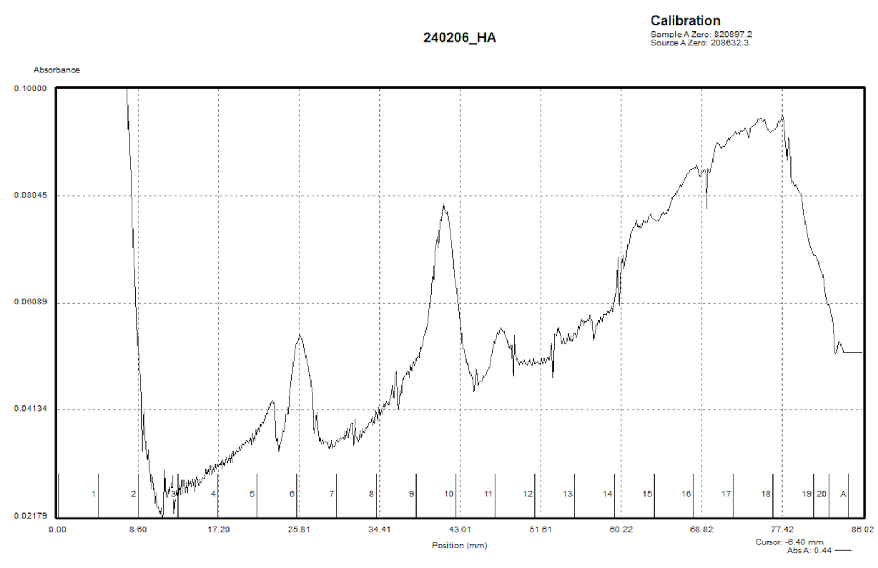
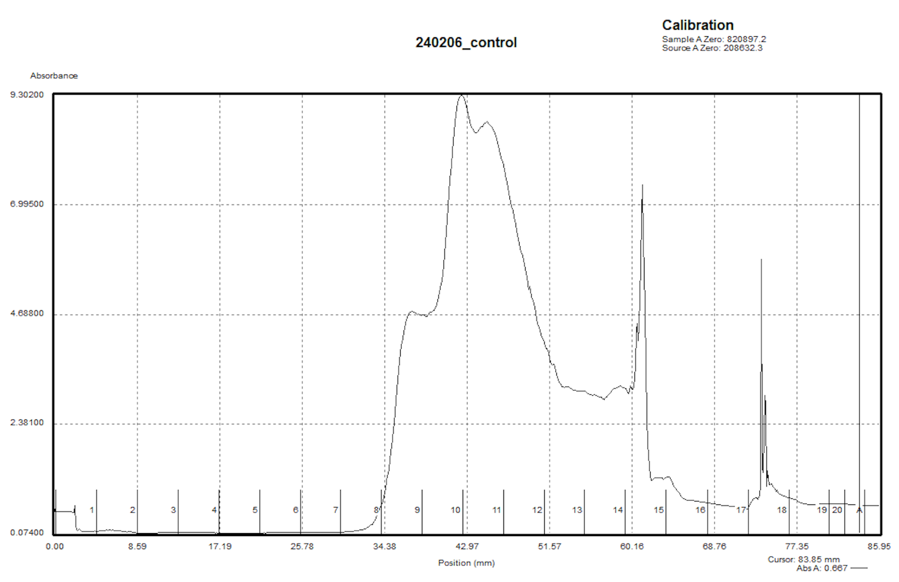

Figure 7: Sucrose gradients of HA-IP.
Top: Experimental sample of gradients on eluates of HA-IP. Potential 70S ribosome in fraction 10, with possible 30S in fraction in first half of fraction 6 and possible 50S in later half of fraction 6 and half of fraction 7. The Y scale had to be drastically scaled to see the peaks, likely due to very low concentration of ribosomes from IP.
Bottom: Control sample of Ben’s concentrated ribosomes purified via sucrose cushion. We think the peak in fraction 10 is 70S and the shoulder in fraction 11 could be 100S.

Wednesday, February 7, 2024
To Do:
- Sucrose gradients
- PCR on KRSA2 patches

S. aureus PCR:
I’m setting this up as colony PCR, so I scraped each patch into 50ul of sterile water, boiled them at 95ºC for about 10 minutes, then diluted those resuspensions 1:10 to use as the template DNA.
 |  |  |  | Factor
Component | Stock concentration | Final concentration | 1 rxn volume | 34
ddiH2O |  |  | 12.4 | 421.6
PrimeSTAR GXL Buffer | 5x | 1x | 4.0 | 136
dNTPs | 2.5 mM | 0.2 mM | 1.6 | 54.4
oligo F | 10 uM | 0.3 uM | 0.6 | 20.4
oligo R | 10 uM | 0.3 uM | 0.6 | 20.4
template | 100 ng/ul | 2 ng/ul | 0.4
PrimeSTAR GXL DNA Polymerase | 1.25 U/ul | 0.025 U/ul | 0.4 | 13.6
 |  | Total volume | 20 | 666.4
Even though I added 1ul instead 0.4ul to each PCR tube and aliquoted 19ul of master mix, there still wasn’t enough for one of the samples (#19). For the next set, I’ll increase the factor to 35.

 |  |  |  | Factor
Component | Stock concentration | Final concentration | 1 rxn volume | 35
ddiH2O |  |  | 12.4 | 434
PrimeSTAR GXL Buffer | 5x | 1x | 4.0 | 140
dNTPs | 2.5 mM | 0.2 mM | 1.6 | 56
oligo F | 10 uM | 0.3 uM | 0.6 | 21
oligo R | 10 uM | 0.3 uM | 0.6 | 21
template | 100 ng/ul | 2 ng/ul | 0.4
PrimeSTAR GXL DNA Polymerase | 1.25 U/ul | 0.025 U/ul | 0.4 | 14
 |  | Total volume | 20 | 686

Primers | Integration into FR1 | Integration into FR2
KROL493  (outside FR1 on genome)  +  KROL458  (outside FR2 on plasmid) | 0 | 2100
KROL536  (outside FR2 on genome)  +  KROL460  (outside FR1 on plasmid) | 2050 | 0
Controls: 1:10 SA gDNA, water, and 1:1000 pKR148.

Thursday, February 8, 2024
To Do:
- Sucrose gradients
- PCR on KRSA2 patches
- Analyze PCR
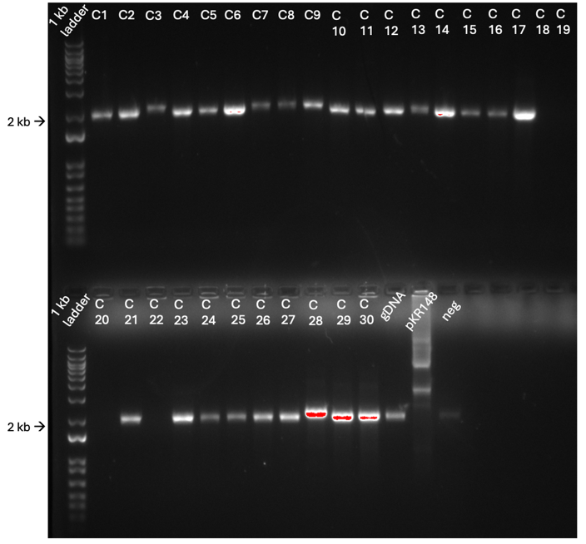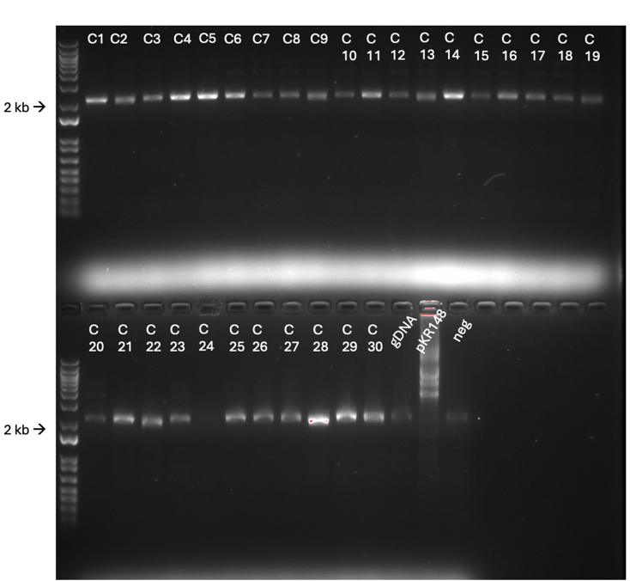

Figure 8: PCR on potential primary integrants of S. aureus pKFT-rpsU.
Left: amplification of flanking region 1. Right: amplification of flanking region 2. Controls: gDNA positive, pKR148 and water as negative.

Kathryn and I went over the size of bands to expect and then picked which colonies to move forward with. I froze down C1, C2, C3, C4, C7, C8, C9, C13, and C28. We think that C28 is the best candidate for an integration event at both flanking regions so that is the one I will set up for secondary recombination. I am concerned that I waited too long to freeze these patches down. As it happens, the C28 patch yielded the least amount of cells due to it being plated on a watery plate.
**added 4/10/24: I want to focus on the colonies that one integration event. If the integration event happened on flanking region 2, then we expect a 2166 bp band using primers KROL460 (plasmid} and KROL536 (genome).
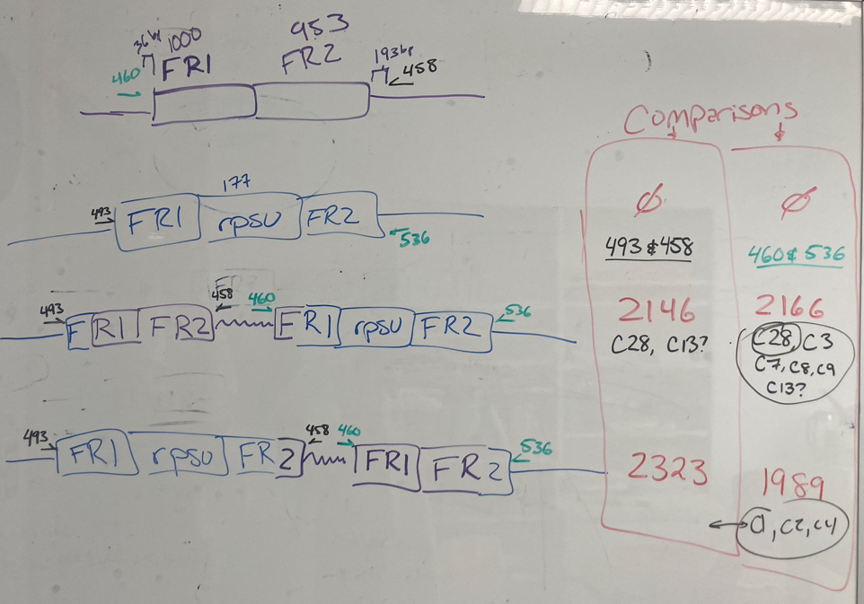
Saturday, February 10, 2024
To Do:
- PCR on KRSA2 patches
- Analyze PCR
- Streak plates
I streaked from frozen C28 onto TSA with tet and without and left in on the bench for the weekend. I patched out 2 plates of LVS pF-rpsU2-FLAG to make a cell pellet for IP on Monday.

Monday, February 12, 2024
To Do:
- Streak plates
- Make FLAG pellet
- Patch out strains for growth curve

Sample | Observed OD600 | Calculated OD600 | Starting Volume for OD600 0.08 (ul)
LVS pF-rpsU2-FLAG | 0.761 | 15.22 | 2628

This only brought the culture to 0.028, so I scraped the second plate into 2ml of sMHB and added it to the culture, and it was at 0.076. It went into the incubator at ~10:10.

The C28 plates didn’t grow. Unsure if it’s because I left them at RT and it’s only been 2 days or if the stock is unviable. I moved them to 37ºC.
Update: at the end of the day there were colonies on both plates! Since there’s a snow day tomorrow, I took them out of the incubator and left them on the bench (since they’re still pin point).

Wednesday, February 14, 2024
To Do:
- Make FLAG pellet
- Patch out strains for growth curve
- Growth curve

Strain Genotype | Measured OD600 | Dilution Factor | Actual OD600 | Desired Volume mL | Desired OD | Volume of Resuspended Cells µL | OD at T0 | OD at T2 | OD at T4 | OD at T6
LVS pF | 0.377 | 20 | 7.54 | 9 | 0.08 | 95.5 | 0.054 | 0.086 | 0.178 | 0.241
LVS pF | 0.347 | 20 | 6.94 | 9 | 0.08 | 103.7 | 0.062 | 0.108 | 0.226 | 0.289
LVS pF | 0.408 | 20 | 8.16 | 9 | 0.08 | 88.2 | 0.056 | 0.09 | 0.179 | 0.245
LVS rpsU2-pF | 0.434 | 20 | 8.68 | 9 | 0.08 | 82.9 | 0.042 | 0.068 | 0.114 | 0.13
LVS rpsU2-pF | 0.302 | 20 | 6.04 | 9 | 0.08 | 119.2 | 0.059 | 0.095 | 0.151 | 0.165
LVS rpsU2-pF | 0.35 | 20 | 7 | 9 | 0.08 | 102.9 | 0.052 | 0.079 | 0.137 | 0.158
LVS rpsU2-pF-rpsU2-VSV-G | 0.478 | 20 | 9.56 | 9 | 0.08 | 75.3 | 0.047 | 0.084 | 0.156 | 0.203
LVS rpsU2-pF-rpsU2-VSV-G | 0.436 | 20 | 8.72 | 9 | 0.08 | 82.6 | 0.057 | 0.094 | 0.187 | 0.227
LVS rpsU2-pF-rpsU2-VSV-G | 0.419 | 20 | 8.38 | 9 | 0.08 | 85.9 | 0.065 | 0.091 | 0.171 | 0.225
LVS rpsU2-pF-rpsU2-HA | 0.324 | 20 | 6.48 | 9 | 0.08 | 111.1 | 0.075 | 0.105 | 0.233 | 0.297
LVS rpsU2-pF-rpsU2-HA | 0.4 | 20 | 8 | 9 | 0.08 | 90.0 | 0.041 | 0.092 | 0.196 | 0.262
LVS rpsU2-pF-rpsU2-HA | 0.366 | 20 | 7.32 | 9 | 0.08 | 98.4 | 0.069 | 0.1 | 0.211 | 0.289
LVS rpsU2-pF-rpsU2-V5 | 0.493 | 20 | 9.86 | 9 | 0.08 | 73.0 | 0.048 | 0.098 | 0.205 | 0.269
LVS rpsU2-pF-rpsU2-V5 | 0.452 | 20 | 9.04 | 9 | 0.08 | 79.6 | 0.048 | 0.1 | 0.215 | 0.288
LVS rpsU2-pF-rpsU2-V5 | 0.448 | 20 | 8.96 | 9 | 0.08 | 80.4 | 0.04 | 0.108 | 0.218 | 0.294

Thursday, February 15, 2024
To Do:
- Make FLAG pellet
- Patch out strains for growth curve
- Growth curve
- Setup RT overnight of S. aureus

Figure 9: Growth curve of tagged bS21-2 strains of LVS with V5 and HA

Figure 10: Generation time of bS21-2 tagged strains of LVS with VSV-G, HA, and V5
No growth defect with HA and V5, therefore they don’t appear to affect protein function. So far, HA and V5 are good candidates for bS21 pulldown, and since His6 isn’t specific enough on IP and FLAG has a growth defect, AND there is now an antibody to VSV-G, VSV-G is the other candidate epitope.
S. aureus:
I started a 5ml overnight culture of C28 in TSB with no antibiotic.

Friday, February 16, 2024
To Do:
- Setup RT overnight of S. aureus
- Subculture RT overnight
- Patch out VSV-G
- Make 1X SLB
I prepared 2 baffled flasks of MHB to make cell pellets of HA and V5 for IP. I need to prepare whole cell lysates of VSV-G and test the antibody on Western before I set up the IP. I need more 1x SLB:
Sample Loading Buffer Recipe
Makes 20 mL of 1X SLB
- Add 5 mL of 4x loading dye (LDS) to a 50 mL conical
- Add 2 mL of 0.5M DTT (10%)
- Bring up to 20 mL with Type I ddiH2O (13 mL)
Makes 10 mL of 2X SLB
- Add 5 mL of 4x loading dye (LDS) to a 15 mL conical
- Add 1 mL of 0.5M DTT (10%)
- Bring up to 10 mL with Type I ddiH2O (4 mL)
Makes 10 mL of 3XSLB
- Add 7.5 mL of 4x loading dye (LDS) to a 15 mL conical
- Add 1 mL of 0.5M DTT (10%)
- Bring up to 10 mL with Type I ddiH2O (1.5 mL)
S. aureus:
I subcultured the overnight that grew at 25ºC. Because it grew so slowly at this temperature, I’m continuing to incubate the first culture in case the subculture is too dilute for the spread plates.

Saturday, February 17, 2024
To Do:
- Subculture RT overnight
- Patch out VSV-G
- Make 1X SLB
- Make whole cell lysates of VSV-G
- Plate potential 2º recombinants
- Pour TSA with tet plates
Whole cell lysates:

Normalizing OD’s from Plates for Western Blot Protein Sample
- In 400 uL of liquid (PBS or MHB), resuspend a loopful of a patch using aseptic technique
- Resuspend by pipetting up and down, vortex, and briefly spin in minifuge
- Gather cuvettes and add 950 mL of either clean PBS or MHB, add 50uL of your resuspension and pipet up and down to mix
- Check OD in spectrophotometer, remember to multiply by 20
- Use C1V1=C2V2 to calculate an OD of 0.3, make dilution in a total of 1 mL
- Spin down 1 mL dilution of OD 0.3 for 3 minutes at 13000 rpm and resuspend in 1 OD per 1 mL 1x Sample Loading Buffer, ie. 300 uL
- Boil in 95°C heat block for 5-10 minutes, then place in -20°C freeze

Sample | Strain | Measured OD | C1 (actual OD) | V1 of culture (ml) | C2 | V2 (ml) | V of diluent (ml)
1 | LVS-pF-rpsU2-VSV-G | 0.164 | 3.28 | 0.09 | 0.3 | 1 | 0.91

S. aureus:
I plated both liquid cultures (the 48 hour and the 24 hour). I set up 1:10 serial dilutions for each and plated 6 dilutions for each (10⁻³ to 10⁻⁸). I incubated them at 42ºC.

Sunday, February 18, 2024
To Do:
- Make whole cell lysates of VSV-G
- Plate potential 2º recombinants
- Cross patch potential 2º recombinants

Both sets of plates had colonies, but the ones from the 48 hour overnight had more of a mix of small and large colonies. I cross picked about 70 colonies from the 24 hour overnight. I parafilmed and refrigerated plates that have a reasonable amount of colonies from both sets.

Monday, February 19, 2024
To Do:
- Cross patch potential 2º recombinants
- PCR
61 of the patches only grew on TSA without tet!
Use primers KROL536 (F) and KROL493 (R). Before deletion is 2174 bps, after is 1997 bps.

Total reaction volume | 20
Total number of reactions | 65
 |  |  |  | Factor
Component | Stock concentration | Final concentration | 1 rxn volume | 66
ddiH2O |  |  | 12.4 | 818.4
PrimeSTAR GXL Buffer | 5x | 1x | 4.0 | 264
dNTPs | 2.5 mM | 0.2 mM | 1.6 | 105.6
oligo F | 10 uM | 0.3 uM | 0.6 | 39.6
oligo R | 10 uM | 0.3 uM | 0.6 | 39.6
template | 100 ng/ul | 2 ng/ul | 0.4
PrimeSTAR GXL DNA Polymerase | 1.25 U/ul | 0.025 U/ul | 0.4 | 26.4
 |  | Total volume | 20 | 1293.6
I included a Staph gDNA control and a No DNA control. I used the SA PCR protocol with annealing temp set to 68ºC.

Tuesday, February 20, 2024
To Do:
- PCR
- Run gel on PCR

While the gel was running I noticed that the dye looked a little weird while migrating, and when I took the gels out to image them the bottoms were eroded.
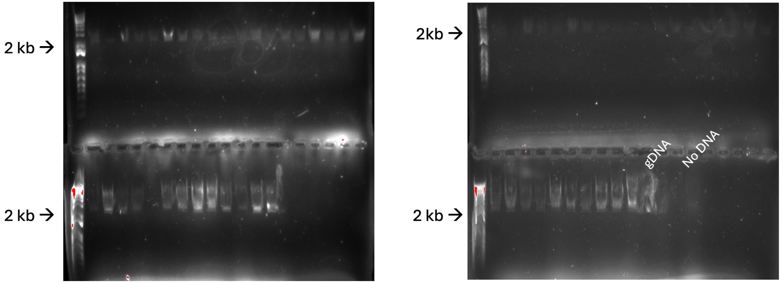
I’m not even going to bother to annotate these because they’re so bad. Before I repeat this PCR, I’m going to do a test run on S. aureus gDNA and negative control testing different annealing temperatures with a gradient PCR. What we use works very well for LVS, but we need to optimize this for Staph.

Thursday, February 22, 2024
To Do:
- Run gel on PCR
- Gradient PCR

Total reaction volume | 20
Total number of reactions | 16
 |  |  |  | Factor
Component | Stock concentration | Final concentration | 1 rxn volume | 17
ddiH2O |  |  | 12.4 | 210.8
PrimeSTAR GXL Buffer | 5x | 1x | 4.0 | 68
dNTPs | 2.5 mM | 0.2 mM | 1.6 | 27.2
oligo F | 10 uM | 0.3 uM | 0.6 | 10.2
oligo R | 10 uM | 0.3 uM | 0.6 | 10.2
template | 100 ng/ul | 2 ng/ul | 0.4
PrimeSTAR GXL DNA Polymerase | 1.25 U/ul | 0.025 U/ul | 0.4 | 6.8
 |  | Total volume | 20 | 333.2

Set up a gradient PCR on SA gDNA and negative control with a range of 50ºC-70ºC for annealing temperature. I used SAGRAD program on the thermocycler.
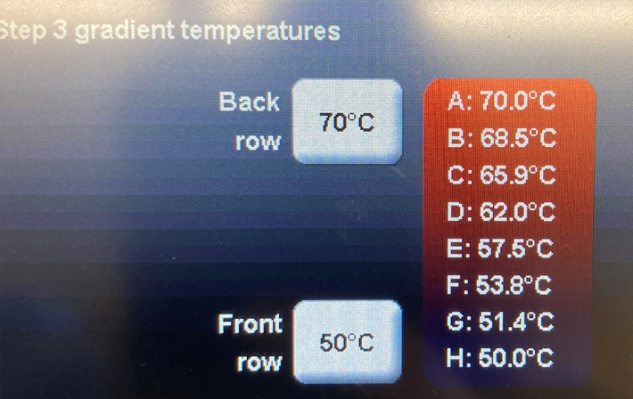

Friday, February 23, 2024
To Do:
- Gradient PCR
- Run gel on gradient PCR
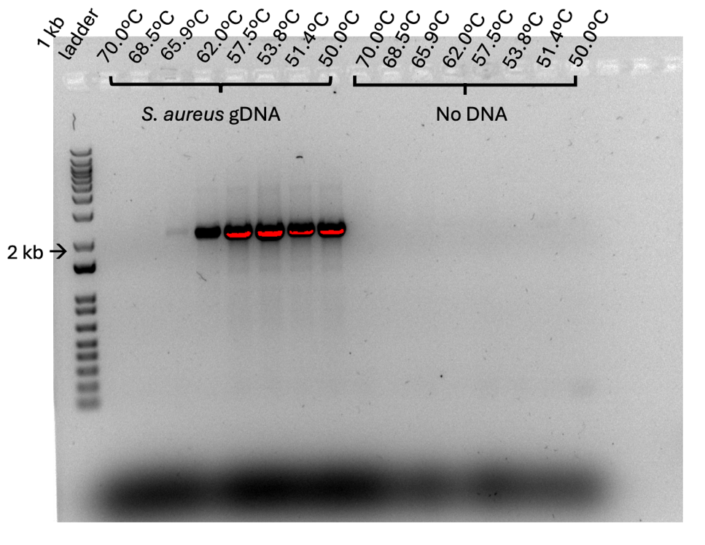

Figure 11: Gradient PCR on S. aureus
Everything between 50ºC and 57.5ºC look great!

Monday, February 26, 2024
To Do:
- Run gel on gradient PCR
- Repeat PCR
- Patch out LVS pF-rpsu2-HA and LVS pF-rpsU2-V5

PCR:
Total reaction volume | 20
Total number of reactions | 66
 |  |  |  | Factor
Component | Stock concentration | Final concentration | 1 rxn volume | 67
ddiH2O |  |  | 12.4 | 830.8
PrimeSTAR GXL Buffer | 5x | 1x | 4.0 | 268
dNTPs | 2.5 mM | 0.2 mM | 1.6 | 107.2
oligo F | 10 uM | 0.3 uM | 0.6 | 40.2
oligo R | 10 uM | 0.3 uM | 0.6 | 40.2
template | 100 ng/ul | 2 ng/ul | 0.4
PrimeSTAR GXL DNA Polymerase | 1.25 U/ul | 0.025 U/ul | 0.4 | 26.8
 |  | Total volume | 20 | 1313.2

Slight change of plan. There is not enough of either primer to run all the samples and I don’t really have time to thaw out the stocks to make more, so I’ll run half of them (#33-#61 plus controls):
Total reaction volume | 20
Total number of reactions | 32
 |  |  |  | Factor
Component | Stock concentration | Final concentration | 1 rxn volume | 33
ddiH2O |  |  | 12.4 | 409.2
PrimeSTAR GXL Buffer | 5x | 1x | 4.0 | 132
dNTPs | 2.5 mM | 0.2 mM | 1.6 | 52.8
oligo F | 10 uM | 0.3 uM | 0.6 | 19.8
oligo R | 10 uM | 0.3 uM | 0.6 | 19.8
template | 100 ng/ul | 2 ng/ul | 0.4
PrimeSTAR GXL DNA Polymerase | 1.25 U/ul | 0.025 U/ul | 0.4 | 13.2
 |  | Total volume | 20 | 646.8
I included S. aureus gDNA, pKR148, and No DNA as controls. Ran them on SA1 with a 58ºC annealing temp.
I ended up making more 10uM stock of KROL 493 and KROL536 but couldn’t run PCR on #1-#32 because someone else was using the other thermocycler.
I patched out LVS-pF-rspU2-HA, -V5, and -VSV-G.

Tuesday, February 27, 2024
To Do:
- Repeat PCR
- Patch out LVS pF-rpsu2-HA and LVS pF-rpsU2-V5
- Run PCR gel
- Start large overnight culture

Total reaction volume | 20
Total number of reactions | 35
 |  |  |  | Factor
Component | Stock concentration | Final concentration | 1 rxn volume | 36
ddiH2O |  |  | 12.4 | 446.4
PrimeSTAR GXL Buffer | 5x | 1x | 4.0 | 144
dNTPs | 2.5 mM | 0.2 mM | 1.6 | 57.6
oligo F | 10 uM | 0.3 uM | 0.6 | 21.6
oligo R | 10 uM | 0.3 uM | 0.6 | 21.6
template | 100 ng/ul | 2 ng/ul | 0.4
PrimeSTAR GXL DNA Polymerase | 1.25 U/ul | 0.025 U/ul | 0.4 | 14.4
 |  | Total volume | 20 | 705.6

Sample | Observed OD600 | Calculated OD600 | Starting Volume for OD600 0.08 (ul)
LVS pF-rpsU2-V5 | 0.475 | 4.75 | 316

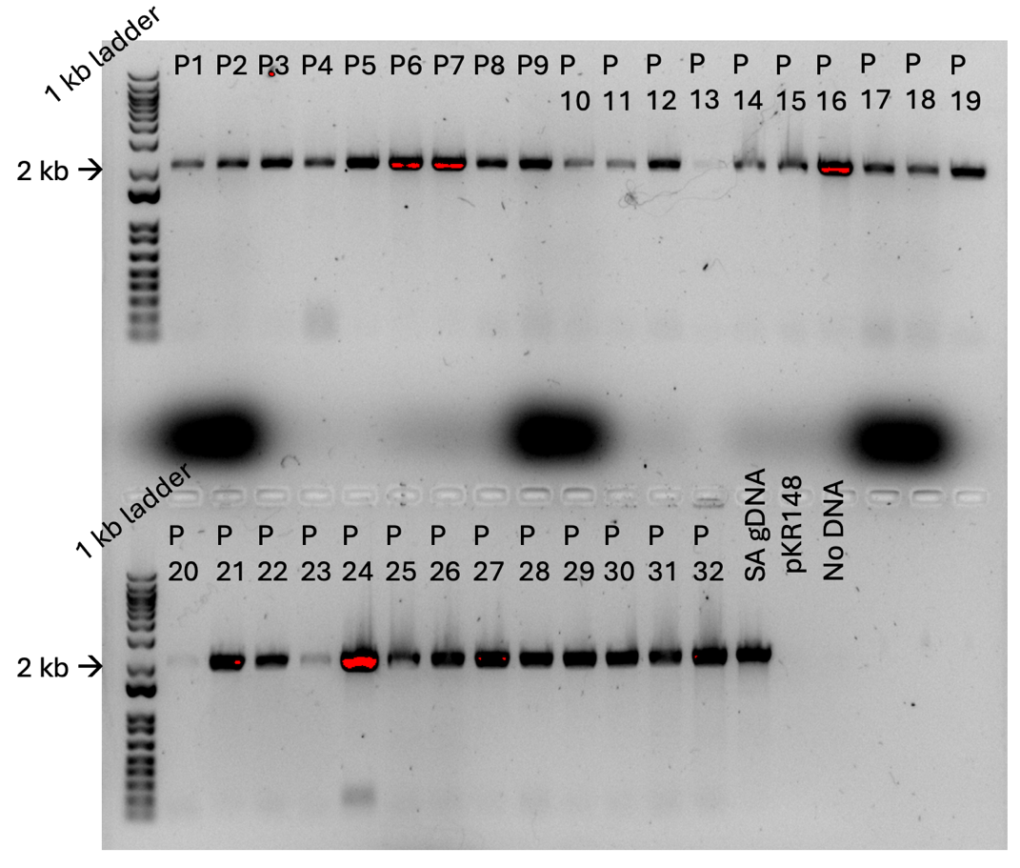

Figure 12: Colony PCR on potential secondary integrants of S. aureus ∆rspU
Looks like it’s a lot of wild-type, but I’m cautiously optimistic that P19 could be the mutant. I should run the gel longer next time.

I set up a large overnight culture of LVS pF-rpsU2-V5.
Sample | Observed OD600 | Calculated OD600 | Starting Volume for OD600 0.08 (ul)
LVS pF-rpsU2-V5 | 0.475 | 4.75 | 316

Wednesday, February 28, 2024
To Do:
- Repeat PCR
- Run PCR gel
- Start large overnight culture
- PCR on P19
LVS:
Overnight stopped growing:
Sample | Observed OD600 | Calculated OD600 | Starting Volume for OD600 0.08 (ul) | OD600 at 11:45am | OD600 at 1:45pm
LVS pF-rpsU2-V5 | 0.475 | 4.75 | 316 | 0.151 | 0.154

I will patch out plates and try this again setting them up at a higher OD in the morning with hopes that they’ll reach target OD by EOD.

S. aureus:
I am repeating the PCR just for P19 and then I’m going to let the gel run for a really long time to see if we can unequivocally tell if the band size is different from wild-type.
Total reaction volume | 20
Total number of reactions | 3
 |  |  |  | Factor
Component | Stock concentration | Final concentration | 1 rxn volume | 4
ddiH2O |  |  | 12.4 | 49.6
PrimeSTAR GXL Buffer | 5x | 1x | 4.0 | 16
dNTPs | 2.5 mM | 0.2 mM | 1.6 | 6.4
oligo F | 10 uM | 0.3 uM | 0.6 | 2.4
oligo R | 10 uM | 0.3 uM | 0.6 | 2.4
template | 100 ng/ul | 2 ng/ul | 0.4
PrimeSTAR GXL DNA Polymerase | 1.25 U/ul | 0.025 U/ul | 0.4 | 1.6
 |  | Total volume | 20 | 78.4

Thursday, February 29, 2024
To Do:
- PCR on P19
- Run gel
- Set up large cultures

Large cultures:

Sample | Observed OD600 | Calculated OD600 | Starting Volume for OD600 0.08 (ul) | OD600 at 11am after inoculation | OD600 at 4pm | OD600 5:30pm | OD600 at 7:30pm
LVS pF-rpsU2-HA | 0.44 | 4.4 | 9091 | 0.024 | 0.16 | 0.227 | 0.288
LVS pF-rpsU2-V5 | 0.559 | 5.59 | 7156 | 0.035 | 0.212 | 0.251 | 0.304
I’ve reached the limit of how late I can stay so I gave up on HA and proceeded to make a pellet with V5.

A while ago Kathryn and I talked about ways to optimize the HA IP so that I get more product (this was after sucrose gradients). We have a plan:
Lysis:
20 ml culture into 1 ml lysis buffer, keep same amount of beads. This is to insure that the beads are not overwhelmed by too much material and therefore ribosomes are getting lost during flowthrough. Since we see such dark bands in the lysis and first flowthrough lanes on the Silver Stains, this could be a possibility. 1 ml washes.
More HA peptide in elution buffer (2 mg/ml).
3 elutions 200ul each
Analyze each.
*It’s just as well that I wasn’t able to make the pellet for HA, since with this new optimization I’ll be setting up a much smaller volume for the liquid culture.

PCR:
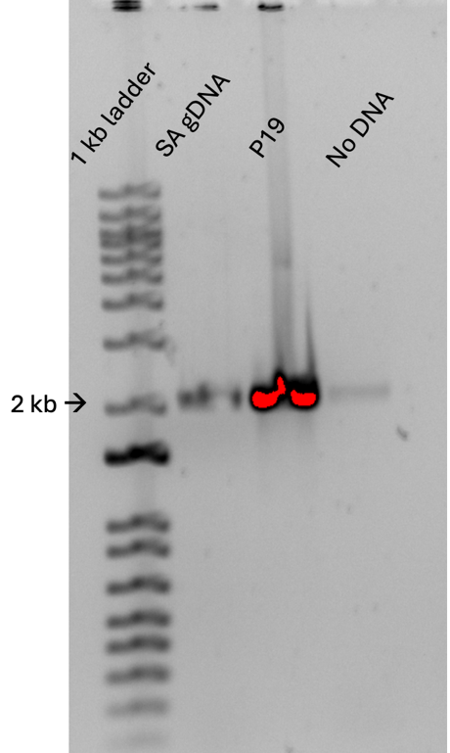

Figure 13: Disappointing PCR on P19
Alas, not a mutant, and there’s some contamination in the negative control.

Kathryn and I talked about the possibility that the deletion of rpsU causes a growth defect similar to how ∆rpsU2 does so in LVS. I’m going to take a few steps back and repeat the integration step at 42ºC but let them incubate for 48 hours instead of 24 hours. I am going to look for small colonies; that indicates a growth defect.
I patched out C28 onto TSA with tet.

