Table of Contents
November 2023 2
Figure 1. Gel of PCR amplifying flanking regions of rplU in S. aureus 5
Electroporation into LVS 5
Immunoprecipitation with His tag 11.6.23 8
Silver Stain Setup 11/7/23: 9
Figure 2. Silver Stain of 11/6/23 IP with His tag. 11
Coomassie Setup 11/8/23: 11
Western Setup 11/8/23 12
Coomassie Stain of 11/6/23 IP: 16
Figure 3. Western Blot of 11/6/23 IP 17
FLAG IP 11/15/23 20
Transform chemically competent E. coli cells 22
Making Glycerol Stocks Protocol 24
Figure 4: Coomassie of FLAG-IP 11/15/23: 25
Figure 5: Silver Stain of FLAG-IP 11/15/23 28
Figure 6: Western Blot of FLAG-IP 11/15/23 28
HA IP 11/30/23 38
December 2023 40
HA-IP Silver Stain: 41
Figure 7: Silver stain of HA IP 11/30/23: 42
10X PBS recipe 45
Figure 8: Western Blot of HA-IP 11/30/23: 46
Figure 9: Coomassie Stain of HA-IP 11/30/23 47
Staph Minipreps: 58
IP on LVS pF-rpsU2-HA 12/21/23 59
Figure 10: Silver Stain of IP with HA 12/21/23: 63
Figure 11: Western Blot of HA-IP 12/21/23: 63

November 2023

Wednesday, November 1, 2023
To Do:
- PCR to amplify rplU flanking regions with Alex
- Finish Westerns and image
- Digest of ∆mpl with Johanyx
- Image Silver Stain on the GelDoc
- Gel purify with Johanyx
- Run gel and maybe digest with Alex
- Read through Hannah’s notebooks to see what she did with Staph
- Make buffers for the rest of the IPs

Johanyx performed the gel purification on her fragments and backbone. We’ll do ligations tomorrow.
I ran Alex’s PCR gel and it looked good except there was a very faint band in the negative control for her F2 sample. She repeated the PCR for F2 and I ran the gel. I was a little impatient and I don’t think the gel was all the way set when I loaded the samples.

Pos Control rplU F2 Neg Control
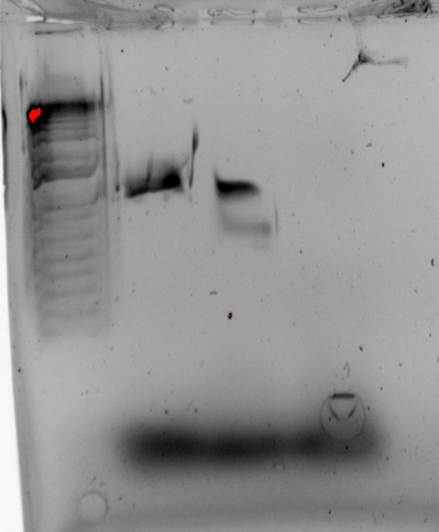
I’m not sure about that double band in the F2 lane. I’ll rerun the gel tomorrow.
IP buffers:

Buffer A + PI +BB
Final composition | Stock solutions | For 25 mL
25 mM KHEPES pH 7.9 | 1 M KHEPES | 625 uL
10 mM MgCl₂ | 1 M MgCl₂ | 250 uL
10 mM NH₄Cl | 1 M NH₄Cl | 250 uL
0.5 mM DTT | 0.5 M DTT | 25 uL
1X Bug Buster | 10X Bug Buster | 2.5 mL
10% glycerol | 75% glycerol | 3.3 mL
Water |  | 18 mL
 | + 2 tablets protease inhibitor
- Protease inhibitor tablets: cOmplete Mini EDTA-free Protease Inhibitor Cocktail Tablets, Sigma cat # 11836170001
- After protease inhibitor has been added, store at -20°C (overnight up to 1 year)

Buffer B (modified buffer IPP150)
Final composition | Stock solutions | For 150 mL
25 mM KHEPES pH 7.9 | 1 M KHEPES | 3.75 mL
10 mM MgCl₂ | 1 M MgCl₂ | 1.5 mL
100 mM NH₄Cl | 1 M NH₄Cl | 15 mL
0.1% NP-40 | 10% NP-40 | 1.5 mL
Water |  | 124.5 mL

Elution Buffer (TEV Cleavage Buffer MOD)
Composition | Stock solutions | For 30 mL
25 mM KHEPES pH 7.9 | 1 M KHEPES | 750 uL
10 mM MgCl₂ | 1 M MgCl₂ | 300 uL
100 mM NH₄Cl | 1 M NH₄Cl | 3000 uL
0.1% NP40 | 10% NP-40 | 30 uL
1 mM DTT | 0.5 M DTT | 60 uL
Water |  | 25.59 mL

I should be able to use the same buffers for the rest of the epitope tags (minus the imidazole) however the manual for the Pierce Anti-FLAG magnetic agarose and the Anti-HA magnetic beads says not to put DTT in the lysate because it can denature the FLAG and HA antibodies and cause them to leach from the beads, so I’ll use ß-MP instead.

Thursday, November 2, 2023
To Do:
- Gel purify with Johanyx
- Run gel and maybe digest with Alex
- Read through Hannah’s notebooks to see what she did with Staph
- Ligation and transformation with Johanyx
- Streak out LVS-∆rpsU2
- Make iron pyrophosphate
I copied all of Hannah’s notes relevant to rpsU in Staph and made a new document.
I streaked out 2 aliquots of LVS-∆rpsU2 to make electrocompetent cells tomorrow. Kathryn and I had talked a while ago about making strains of LVS-∆rpsU2 complemented with epitope-tagged rpsU2, and it’s time that I get on that.
Staph rplU:
I reran Alex’s PCR on a gel and it looks better:

Pos control rplU_FR Neg control
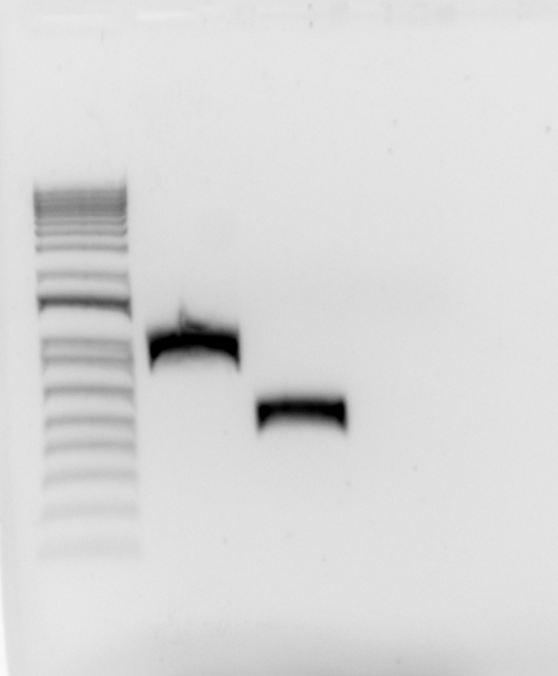

Figure 1. Gel of PCR amplifying flanking regions of rplU in S. aureus
No contamination!
I purified the new F2 fragment. I wanted to proceed to digest but it doesn’t look like there’s enough pIMAY-Z (maybe between 5-10ul). I’ll have to transform some more and miniprep it, maybe next week.
I made 2.5% iron pyrophosphate so I can supplement MHB tomorrow.
I was going to make the other IP buffers but I’d like to confer with Kathryn first about whether or not bS21 dissociated from the ribosome.

Friday, November 3, 2023
To Do:
- Read through Hannah’s notebooks to see what she did with Staph
- Ligation and transformation with Johanyx
- Streak out LVS-∆rpsU2
- Make LVS-∆rpsU2 electrocompetent cells
- Transformation of epitope-tagged strains into LVS-∆rpsU2

Electroporation into LVS
From Allelic exchange protocol; Edited by Hannah Trautmann
Prepare electrocompetent (EC) cells
-Scrape up entire plate of cells into 400 uL of sterile 10% sucrose and resuspend (alternately, cells can be grown to mid-log in MHB)
-Add 1.1 mL of 10% sucrose to a final volume of 1.5 mL
-Spin for 3 minutes at 10,000 rpm
-remove supernatant, throw out, and resuspend in fresh 1 mL 10% sucrose
-Repeat 3x-5x in 10% sucrose
-After final spin, remove all supernatant.
-Resuspend cells in 10% sucrose at high density (corresponding to ~1x10¹¹ cells /mL); these are EC cells by slowly adding 110 uL at a time. It should be about equal amounts of cells as sucrose.
-For any extra EC cells, aliquot ~110 μL / sterile tube (enough for 2 electroporations) and freeze at -80°C
Electroporate plasmid into EC cells*
-For each electroporation, aliquot 4 mL MHB into glass test tubes for recovery, warm in shaker at 37°C
-For each electroporation, in a 2 mm sterile electroporation cuvette, combine:
5 μL of pEX-based allelic exchange construct or Tn7 plasmids (mini-prep concentration, at least 100 ng/μL)
*for pF-based plasmids, can use 3 ul
50 μL electrocompetent cells
-Have recovery media ready
-Electroporate using the following settings: 2.5 kV, 25 μF, and 600 Ω
-Immediately after individual electroporations, use 1 mL warm recovery media from test tube to wash cells out of cuvette and transfer cells to recovery test tube
-Recover cells for 4-8 hours, shaking at 37°C
*For pF-based plasmids, only recover 2-3 hours
-For pEX plasmids: pellet cells by centrifugation in sterile 2 mL tubes, 1’ at 10,000 x g. Plate on CHAH-Kan plates, using 1 plate for each 2 mL tube (2 plates per electroporation)
*For pF-plasmids: plate 10 ul and 100 ul on CHAH-kan plates
*For Tn7 plasmids: plate 100 ul and remaining on CHAH-kan plates
-Incubate plates at 37°C for 3 days (or until single colonies appear)
*Always include a control electroporation with no plasmid. Eventually single break-through colonies may start appearing; at that point, single colonies on the experimental plates are also likely to just be break-through growth.
I prepared the LVS-∆rpsU2 EC cells.

I electroporated pKR192 and pKR193 into the EC LVS-∆rps cells. pKR7 was the positive control and a no DNA negative control. There were no arcs. They recovered for 2.5 hours.
# | Sample
1 | pKR7 (positive control) | No arc
2 | No DNA (negative control) | No arc
3 | pKR192 | No arc
4 | pKR193 | No arc

Each sample was plated 10ul and 100ul on CHA-Kan. I was talking to Johanyx while spreadplating, so hopefully I didn’t contaminate anything.

Monday, November 6, 2023
To Do:

- Make LVS-∆rpsU2 electrocompetent cells
- Transformation of epitope-tagged strains into LVS-∆rpsU2
- Miniprep pKR200 with Johanyx
- Set up sequencing with Johanyx
- Patch out more LVS-∆rpsU2
- Immunoprecipitation with His-tagged LVS-rpsU2

Transformation:
I contaminated everything. That’s too bad because other than that it worked very well for both plasmids. The new rotating student Megan will most likely be doing these complements so I will leave it for her to do. I patched out some more so she can jump right into it when she starts.
IP:
We talked about my Western (from 10/31/23) in lab meeting. Because I have a lot of material in the lysate and first flowthrough column, it’s safe to say that the ribosome never bound to the beads, and only bS21-2 was recovered. We talked about ways to optimize and ruled out changing the buffers because they were not significantly different from Ben’s IP buffers. I will run one more IP and this time bind overnight. Given that the band is so faint, depending on if the longer binding results in a stronger signal we probably won’t pursue this epitope tag.

Sample # | Date | Genotype of Cells | Volume of Cells | OD600 at Harvest
1 | 10/24/23 | LVS-pF-rpsU2-His-2 | 500 ml | 0.314
2 | 9/2/23 | LVS-pF-4 | 500 ml | 0.358

- Resuspend samples in 10 mL Buffer A + PI + BB by pipetting with 5 mL pipette. Be sure no clumps remain.
- Add 10 uL DNase I (Lucigen/Epiceter), mix by pipetting.
- Incubate at 37°C for 30’. Cool down centrifuge while waiting.
- Spin conical tubes at 4°C for 20’ at max speed (14635xg).
- Transfer lysates into new 50 mL conical tubes, leaving behind insoluble material at bottom (okay to leave some behind; better than taking too much).
- Filter-sterilize lysates using 30mL syringe and syringe filter into new (nonsterile) 50mL conical tube. Specifically, pull plunger out from 30mL syringe, thread tip of syringe onto syringe use filter (use MillexGP 0.22 micrometer filter, has 33mm diameter), pour/pipette lysate into syringe, insert plunger and recover filtered lysate into new (nonsterile) 50mL conical tube.
- Obtain a good estimate of sample volume using pipette. 7.5 ml for both samples
- Adjust buffer concentration to Buffer B by adding to each sample:
100 uL 1M NH₄Cl / mL sample for final concentration of 100 mM NH₄Cl 750 ul for both samples
10 uL 10% NP-40 /mL sample final concentration of 0.1% NP-40 75 ul for both samples
- Remove 50 uL into microfuge tube for control analysis (LYS).

Immunoprecipitation with His tag 11.6.23
In cold room
- Cut tip of 1mL pipette tip slightly.
- Resuspend Ni-NTA magnetic beads in storage solution.
- Pipette 200 uL magnetic beads into 50 ml conical.
- Wash beads with 3 mL of Buffer B with 10mM imidazole 3 times. Using the magnetic rack, wait until the beads have completely gone towards the magnet before removing the liquid.
- Add 1 sample per tube, close tube and make sure and it is not dripping liquid.
- Incubate samples with beads, rocking on their sides at 4°C, overnight.

Johanyx’s project:
Johanyx’s ligation and transformation last week were successful, so yesterday she came in and started 5 overnight cultures out of 5 colonies she picked of pKR200. Today she miniprepped the samples and sent them to sequencing. MP2 had no DNA so that was discarded. She set up the sequencing reactions with KROL6 (F) and KROL7 (R). These are sequencing primers for pEX plasmids.
Staph:
I compiled all of Hannah’s notes regarding Staph into one document. She ultimately ended up with 3 potential 1º integrants (pKR148 in KRSA3). She started off using pIMAY-Z as the backbone (from the Monk paper), but ultimately went with a plasmid from M Ramsey (pKFT) that has a tetR gene and a temperature selection. There are several primers to use to check for plasmid presence and integration.

Tuesday, November 7, 2023
To Do:

- Miniprep pKR200 with Johanyx
- Set up sequencing with Johanyx
- Patch out more LVS-∆rpsU2
- Immunoprecipitation with His-tagged LVS-rpsU2
- Silver stain
IP:

- After overnight incubation, place on magnetic rack.
- Save 50 uL aliquot of flow through in microfuge tube (FT1), discard remaining.
- Wash beads 3x with 5 mL Buffer B with 20mM imidazole, discard flow through but save 50 ul from each wash (FT2-4).
- Add 2 mL KBE-1 buffer with 500 mM imidazole
- Incubate rocking at 4°C for 5 minutes.

- Recover eluates by magnetic rack (~2 mL) and put in new 50 ml conical.
- Rinse beads with additional 300 μl of Elution Buffer and add that to the 50 ml conical (I added 200ul and used the remaining to get a 50ul of beads).
- Aliquot 50 uL of each recovered sample into microfuge tube, 4x, for later analysis. Transfer remaining samples into clearly labeled microfuge tubes (2 per sample) and store all samples at -80°C.

- Keep 50ul of beads from each sample and store in -20ºC.

Silver Stain Setup 11/7/23:
Lane | Content | Volume
1 | Benchmark Ladder 1:10 | 10 ul
2 | LVS-pF-rpsU2-His lysate | 10 ul
3 | LVS-pF lysate | 10 ul
4 | LVS-pF-rpsU2-His FT1 | 10 ul
5 | LVS-pF FT1 | 10 ul
6 | LVS-pF-rpsU2-His FT2 | 10 ul
7 | LVS-pF FT2 | 10 ul
8 | LVS-pF-rpsU2-His FT3 | 10 ul
9 | LVS-pF FT3 | 10 ul
10 | LVS-pF-rpsU2-His FT4 | 10 ul
11 | LVS-pF FT4 | 10 ul
12 | LVS pF-rpsU2 -His Ni-NTA Beads | 10 ul
13 | LVS-pF Ni-NTA Beads | 10 ul
14 | 1X SLB | 10 ul
15 | LVS-pF-rpsU2-His Eluate | 10 ul
16 | LVS-pF Eluate | 10 ul
17 | Hannah’s Ribosomes | 5 ul

**I mistakenly mixed the IP samples 1:1 with 50ul 1X SLB instead of 2X. I rectified it by adding 100ul of 2X SLB. I think that ends up with them being 1.5X. Maybe. Hopefully it’s enough to see something on the gel and I didn’t ruin everything.
Running the gel
- Prepare 1x Loading buffer
  - 250 uL NuPage LDS sample buffer (4x, room temp)
  - 100 uL 0.5 M DTT (-20C)
  - 650 uL dH2O
- Resuspend pellet in 1x loading buffer
  - Normalize to ODs
- Dilute IP samples 1:1 with 2XSLB (see above note**)
- Heat at 98C for 10 min
- Assemble gel chamber
  - Use pre-cast NuPAGE 4-12% Bis-Tris gel (we also have 10% and 12% gels as necessary)
  - Words on cassette should face towards back of chamber
- Make running buffer – 400 mL for 1 gel, 800 mL for 2 gels
  - 1 x MOPS for large proteins
  - 1x MES for <50 kD proteins
    - 380 mL ddiH2O (added 390 ml because I read the graduated cylinder wrong, so this is slightly diluted)
    - 20 mL 20x MES
    - 1 mL NuPAGE antioxidant
  - Make sure front section is full so that gels are covered in liquid. Back section does not need to be completely full.
- Use 200 ul pipet to wash wells of gel (added 1XSLB to visualize the wells)
- Load 6-10 uL of each sample, based on linear range calculations for each antibody.
As of 2022, we use 5 ul of WesternSure ladder from LiCor which is brighter to see if you are cutting the blot (in -20C freezer). If not cutting, can use 1 uL 1:10 diluted BioRad Precision Plus Dual Color Protein Ladder (#161-0374) for the ladder (in 4C fridge).
- Run at 150V until the blue dye front reaches the bottom ridge of the gel (45 mins to 1 hour, depending on running buffer) (Ran at 90V for about an hour and a half, then increased it to 100V for another 15 minutes)
The ladder was barely visible.
Image:

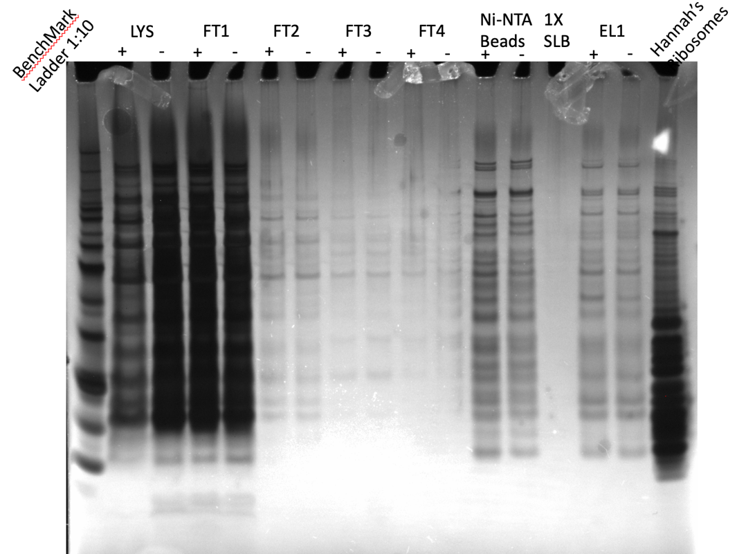

Figure 2. Silver Stain of 11/6/23 IP with His tag.
It seems the extended binding incubation resulted in more retention of proteins tagged with His. The Ni-NTA beads columns show more intense bands in the + sample than the negative control, as do the eluate columns. The lesser intensity in the LYS + column is probably due to a pipetting error.

Wednesday, November 8, 2023
To Do:

- Immunoprecipitation with His-tagged LVS-rpsU2
- Silver stain
- Western and Coomassie on last IP
- Make LVS-∆rpsU2 competent cells

Coomassie Setup 11/8/23:
Lane | Content | Volume
1 | Benchmark Ladder | 10 ul
2 | LVS-pF-rpsU2-His lysate | 10 ul
3 | LVS-pF lysate | 10 ul
4 | LVS-pF-rpsU2-His FT1 | 10 ul
5 | LVS-pF FT1 | 10 ul
6 | LVS-pF-rpsU2-His FT2 | 10 ul
7 | LVS-pF FT2 | 10 ul
8 | LVS-pF-rpsU2-His FT3 | 10 ul
9 | LVS-pF FT3 | 10 ul
10 | LVS-pF-rpsU2-His FT4 | 10 ul
11 | LVS-pF FT4 | 10 ul
12 | LVS pF-rpsU2 -His Ni-NTA Beads | 10 ul
13 | LVS-pF Ni-NTA Beads | 10 ul
14 | 1X SLB | 10 ul
15 | LVS-pF-rpsU2-His Eluate | 10 ul
16 | LVS-pF Eluate | 10 ul
17 | Hannah’s Ribosomes | 5 ul

Gel ran for an hour and 15 minutes, then was fixed for ten and stained with Staining Solution without Stain B for ten minutes, then Stain B was added and gel rocked for 4 hours. I left in rocking in water overnight.

Western Setup 11/8/23
Lane | Content | Volume
1 | WesternSure Ladder | 5 ul
2 | LVS-pF-rpsU2-His lysate | 10 ul
3 | LVS-pF lysate | 10 ul
4 | LVS-pF-rpsU2-His FT1 | 10 ul
5 | LVS-pF FT1 | 10 ul
6 | LVS-pF-rpsU2-His FT2 | 10 ul
7 | LVS-pF FT2 | 10 ul
8 | LVS-pF-rpsU2-His FT3 | 10 ul
9 | LVS-pF FT3 | 10 ul
10 | LVS-pF-rpsU2-His FT4 | 10 ul
11 | LVS-pF FT4 | 10 ul
12 | LVS pF-rpsU2 -His Ni-NTA Beads | 10 ul
13 | LVS-pF Ni-NTA Beads | 10 ul
14 | 1X SLB | 10 ul
15 | LVS-pF-rpsU2-His Eluate | 10 ul
16 | LVS-pF Eluate | 10 ul
17 | LVS-pF-rpsU2-His WCL | 10 ul

Running the gel
- Prepare 1x Loading buffer
  - 250 uL NuPage LDS sample buffer (4x, room temp)
  - 100 uL 0.5 M DTT (-20C)
  - 650 uL dH2O
- Resuspend pellet in 1x loading buffer
  - Normalize to ODs
- Heat at 98C for 10 min
- Assemble gel chamber
  - Use pre-cast NuPAGE 4-12% Bis-Tris gel (we also have 10% and 12% gels as necessary)
  - Words on cassette should face towards back of chamber
- Make running buffer – 400 mL for 1 gel, 800 mL for 2 gels
  - 1 x MOPS for large proteins
  - 1x MES for <50 kD proteins
    - 380 mL ddiH2O
    - 20 mL 20x MES
    - 1 mL NuPAGE antioxidant
  - Make sure front section is full so that gels are covered in liquid. Back section does not need to be completely full.
- Use 200 ul pipet to wash wells of gel added 1x SLB to see the wells
- Load 6-10 uL of each sample, based on linear range calculations for each antibody.
As of 2022, we use 5 ul of WesternSure ladder from LiCor which is brighter to see if you are cutting the blot (in -20C freezer). If not cutting, can use 1 uL 1:10 diluted BioRad Precision Plus Dual Color Protein Ladder (#161-0374) for the ladder (in 4C fridge).
- Run at 150V until the blue dye front reaches the bottom ridge of the gel (45 mins to 1 hour, depending on running buffer) Ran at 90V for a little over an hour
Wet transfer
- Make transfer buffer in a 1 L bottle.
For transferring 1 gel:
50 mL methanol
25 mL NuPAGE 20x transfer buffer
water to 500 L
For transferring 2 gels, double above.

- Store in freezer to chill until the gel has stopped running.
- When the gel has about 10 minutes remaining, begin setting up the transfer.
- Remove transfer buffer from freezer and add 0.5 mL NuPAGE antioxidant (1 mL for 2 gels)
- Activate PVDF membrane (must use Millipore Immobilon-FL #IPFL00010) in ethanol (can do in a tip box). For a full gel, cut to approximately 6 cm x 8 cm using pre-made guide.
- In a large container (9”x9” Pyrex baking dish, for example), presoak membrane, 2 filter papers cut to membrane size, and 2-3 sponges (per gel) in transfer buffer. Use a roller to push bubbles out of the sponges.
- Open gel case, cut off wells and at the bottom ridge on the gel (including any blue dye leftover) and place wet sheet of filter paper on the gel.
- Peel gel and filter paper off and place wet membrane on gel.
- Place other filter paper on membrane and roll out bubbles
- Dunk the transfer cassette halves in the transfer buffer and begin assembling sandwich:
1 sponge
filter/membrane/gel/filter sandwich so that the membrane is on top of the gel. Follow the guide on the cassette.
1 more sponge
*if sponges are old and thin, may need to use 3 total. You want the transfer apparatus to have a very tight seal, so if it doesn’t add another sponge.
- Close transfer apparatus and clamp into the gel box.
- Fill the inside chamber with transfer buffer so that it is completely full. Should use remaining transfer buffer from the Pyrex dish. Place the gel box into a large rectangular freezer bucket. Close the lid tightly, and cover the whole gel box with ice.
- Run at 20V for 1 hour.
- Complete No-Stain total protein quantification protocol now, if applicable
Blocking and probing
- Block the membrane with Li-Cor Intercept Blocking Buffer (PBS) diluted 1:5 in PBS. Use ~25 mL or enough to cover the membrane and rock for 1 hour or overnight at room temperature. DO NOT add any detergents (Surfact-Amps, Tween, SDS) to the blocking buffer. Blocking overnight.
- Store diluted blocking buffer at 4C.

Staph:
The rotating student Megan is sick and we’re not sure when she will be in so I made the LVS-∆rpsU2 electrocompetent cells and they can be used when she comes back.

Thursday, November 9, 2023
To Do:

- Western and Coomassie on last IP
- Make LVS-∆rpsU2 competent cells
- Finish Western and Image
- Image Coomassie
- Design primers for LVS-pF-rpsU2-FLAG3X
- Make TSB/TSA

TSB: Need 112, make 250 mL
-7.5 g of TSB to 250 mL water
-autoclave liquid 30’
TSA w/ 3 ug/mL tet: Make 500 mL
-15 g of TSB + 7.5 g agar + 500 mL water
-autoclave liquid 30’
-add 150 ul of 10 mg/mL tet
-pour plates, protect from light

- Add antibodies (must be from two different species, such as mouse and rabbit, eg, rabbit anti-VSVG and mouse anti-sigma⁷⁰) in 10 mL of blocking buffer (no detergent). Rotate for 1 hour at room temperature. Used anti-His at 1:1000
- Meanwhile, make wash buffers: (this recipe is sufficient for 3-4 blots, scale up or down accordingly)
1x Wash Buffer (500 mL)
50 mL 10X PBS
450 mL dH20
- Split into two separate bottles, 400 mL and 100 mL.
- To the 400 mL bottle, add 2 mL Surfact-Amps. This is your primary wash buffer. The remaining 100 mL will be for the final two washes after the secondary antibody, to remove traces of detergent, which may show up as background on the Li-Cor.
- Wash 4x on rotator for 10 minutes each, using 10-20 mL wash buffer per wash.
- Use 10-20 mL diluted blocking buffer and block again, for 15-30 min. I blocked for 30 minutes
- Add 1 uL of each IRDye secondary antibody to 10 mL wash buffer (the one with Surfact-Amps, aka PBS-T). Also add 0.01% SDS to the wash buffer (10 uL of 10% SDS). These secondary antibodies are stored at 4C. Used mouse antibody
Note from Dove lab: use 800CW [green channel] if only detecting one protein; if detecting two proteins, use 800CW for the less abundant protein

- Label for 1 hour on rocker at room temperature. Cover the box with foil or use a black box (the secondary antibodies are light sensitive).
- Wash 4x on rotator for 10 minutes each, using 10-20 mL wash buffer per wash.
- Wash 2x on rotator for 10 minutes each, using 10-20 mL of wash buffer WITHOUT detergent.
- If faint bands are expected, do a quick methanol rinse by dunking the blot in methanol for 2 seconds then letting air dry for 2 minutes prior to imaging.
Imaging
- Leave the membrane in the box containing the final wash buffer. Bring the box, gloves, forceps, and a timer to the imager in the INBRE facility.
- For imaging, use 84 uM resolution and “high”clarity. Select both 700 and 800 channel

Coomassie Stain of 11/6/23 IP:
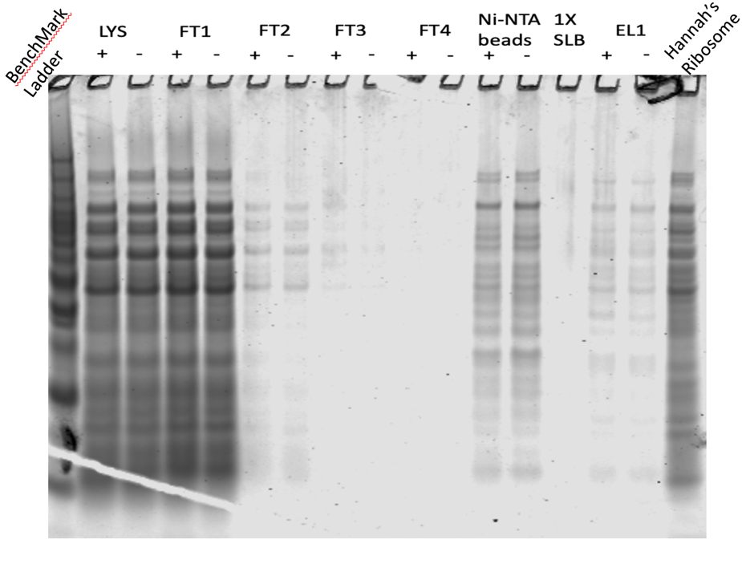
Looks a lot like the Silver Stain.
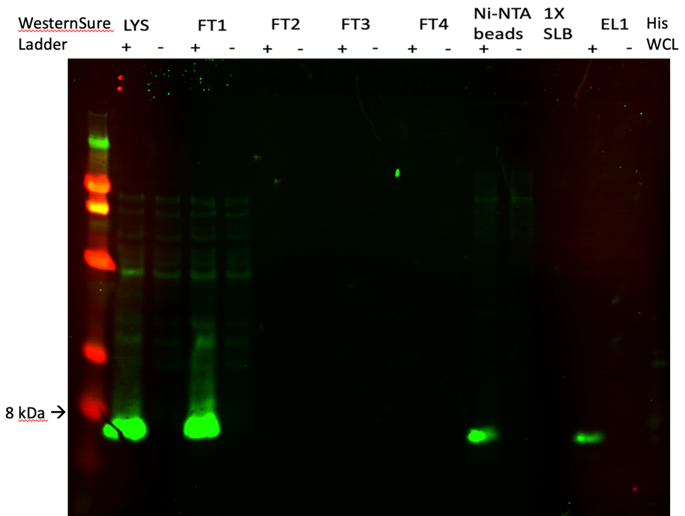

Figure 3. Western Blot of 11/6/23 IP
The bands in the experimental eluate sample and the Ni-NTA beads sample look a lot better. This tag is being shelved for now until we see how the rest behave. Note that His WCL control can’t be seen but it is there. The band broke up somehow and can be seen at high contrast.

Monday, November 13, 2023
To Do:

- Finish Western and Image
- Image Coomassie
- Design primers for LVS-pF-rpsU2-FLAG3X
- Make TSB/TSA
- Make buffers for FLAG IP
- Streak out KRSA3
- Patch out LVS wt
- Pour TSA plates
IP FLAG buffers:
I have to make the FLAG version of the buffers for IP. According to the product information sheet for the Pierce Anti-FLAG magnetic agarose, I should not include reducing agents because that could cause leaching of the FLAG antibody to leach from the beads. I also need to figure out the proper concentration for the peptide. I have 5mg of lyophilized peptide. ThermoFisher says to prepare peptide at 1.5 mg/ml in PBS (I’ll do that in KHEPES) and add 100ul of that to the beads. However, in my notes in talking with Kathryn a while ago it looks like we talked about adding 100ul of resuspended peptide to 1 ml of elution buffer, then I have a note about how many IPs I’d get with different concentrations, and something about 300ul elution. I need to sort this out.
Ok spoke to Kathryn about it. I will make a 1.5 mg/ml solution of peptide in KHEPES and add 400ul of that to the beads.
Buffer A + PI +BB (Lysis) for FLAG:
Final composition | Stock solutions | For 25 mL | For 50 mL
25 mM KHEPES pH 7.9 | 1 M KHEPES | 625 uL | 1250 uL
10 mM MgCl₂ | 1 M MgCl₂ | 250 uL | 500 uL
10 mM NH₄Cl | 1 M NH₄Cl | 250 uL | 500 uL
1X Bug Buster | 10X Bug Buster | 2.5 mL | 5 mL
10% glycerol | 75% glycerol | 3.3 mL | 6.6 mL
Water |  | 18 mL | 36 mL
 | + 2 tablets protease inhibitor for 25 mL and 4 tablets for 50 mL

Buffer B Wash Buffer for FLAG
Final composition | Stock solutions | For 150 mL
25 mM KHEPES pH 7.9 | 1 M KHEPES | 3.75 mL
10 mM MgCl₂ | 1 M MgCl₂ | 1.5 mL
100 mM NH₄Cl | 1 M NH₄Cl | 15 mL
0.1% NP-40 | 10% NP-40 | 1.5 mL
Water |  | 128.25 mL

Elution Buffer for FLAG:
I’m going to make a stock solution of the 5mg 3XFLAG peptide in 1ml in 1M KHEPES pH 7.9 (5mg/ml). I will then take 450ul of that stock solution and add it to 1050ul of KHEPES for a total volume of 1500ul at final concentration of 1.5mg/ml. Stored at -20ºC.

1M NH₄Cl:
2.67g of NH₄Cl, water up to 50ml.

Tuesday, November 14, 2023
To Do:

- Make buffers for FLAG IP
- Patch out LVS wt
- Pour TSA plates
- Patch out LVS-pF-∆rpsU2 with Meagan

Meagan’s Project:
Meagan will be doing growth curves on strains of LVS that are complemented with tags to assess whether these tags interfere with function of bS21. To start she will set up duplicates of LVS-pF, LVS-pF-∆rpsU2, and LVS-∆rpsU2-pF-rpsU2-VSV-G. Next week she will add LVS-∆rpsU2-pF-rpsU2-FLAG.
Plan:
Today (Tuesday): Patch out LVS-pF-∆rpsU2 (LVS121)*
Wednesday: Patch out LVS-pF (LVS120)* and LVS-∆rpsU2-pF-rpsU2-VSV-G (LVS124)*
Thursday: Make electrocompetent cells of LVS-∆rpsU2. Growth curve on LVS-pF 120, LVS-pF-∆rspU2 121,
LVS-∆rpsU2-pF-rpsU2-VSV-G 123/124
Friday: Electroporate FLAG into LVS-∆rpsU2 LVS9. Streak out the rest of the strains for isolation
Monday: Make patches out of single colonies of all strains
Tuesday: Growth curve on all strains
*These strains are found in Box 5 of LVS strain collection

S. aureus:
Johanyx will be out all week because she’s going to a conference, so I’d like to make some progress with bS21 in S. aureus. I was going to pick up from where Hannah left off in repeating electroporating pKR148 into KRSA3 (after passing it through KRSA2), but there is very little left, like <5ul. I’m also not sure if what’s in the plasmid box is what came from E coli or KRSA2. Tomorrow I’ll make more pKR148 by transforming it into E coli and miniprepping it.

Wednesday, November 15, 2023
To Do:

- Patch out LVS-pF-∆rpsU2 with Meagan
- Streak out KRSA3
- Patch out LVS-pF and LVS-∆rpsU2-pF-rpsU2-VSV-G with Meagan
- IP on LVS-pF-rpsU2-FLAG
- Silver Stain or Coomassie
- Western (if time)
- Transform pKR148 into E coli (use DH5a)

FLAG IP 11/15/23

Sample # | Date | Genotype of Cells | Volume of Cells | OD600 at Harvest
1 | 8/18/23 | LVS-pF-rpsU2-FLAG- | 500 ml | 0.301
2 | 9/2/23 | LVS-pF-2 | 500 ml | 0.342

Prepare cell lysate (Day 3)
Required reagents:
Buffer A + PI + BB Bug Buster (see recipe at end)
DNase I (Lucigen Corporation # D9905K)
30 mL syringe
MillexGP 0.22 micrometer syringe filter
Nonsterile 50 mL conical tubes
Microfuge tubes

1M NH₄Cl
10% NP-40

- Check for stock solutions; make Buffer A+ PI +BB if not enough in freezer (~10 mL per sample), prepare Buffer B if not enough at 4°C.
- Write out samples in table:

Sample# Date Genotype of cells Volume of cells OD600 at harvest
1 xx/xx/xxxx X XXX mL 0.XXX

- Resuspend samples in 10 mL Buffer A + PI + BB by pipetting with 5 mL pipette. Be sure no clumps remain.
- Add 10 uL Dnase I (Lucigen/Epiceter), mix by pipetting.
- Incubate at 37°C for 30’. Cool down centrifuge while waiting.
- Spin conical tubes at 4°C for 20’ at max speed (14635xg).
- Transfer lysates into new 50 mL conical tubes, leaving behind insoluble material at bottom (okay to leave some behind; better than taking too much).
- Filter-sterilize lysates using 30mL syringe and syringe filter into new (nonsterile) 50mL conical tube. Specifically, pull plunger out from 30mL syringe, thread tip of syringe onto syringe use filter (use MillexGP 0.22 micrometer filter, has 33mm diameter), pour/pipette lysate into syringe, insert plunger and recover filtered lysate into new (nonsterile) 50mL conical tube.
- Obtain a good estimate of sample volume using pipette.
- Adjust buffer concentration to Buffer B by adding to each sample: FLAG lysate = 8 ml, Neg lysate = 7.5 ml
100 uL 1M NH₄Cl / mL sample for final concentration of 100 mM NH₄Cl
FLAG = 800ul, Neg = 750 ul
10 uL 10% NP-40 /mL sample final concentration of 0.1% NP-40
FLAG = 80 ul, Neg = 75 ul
- Remove 50 uL into microfuge tube for control analysis (LYS).

Immunoprecipitation with FLAG tag (based on ThermoFisher Pierce 3X Anti-DYKDDDDK Magnetic Agarose Product Info Sheet)

In cold room
- Before use, equilibrate magnetic agarose to room temp (note: IP will be conducted cold)
- Cut tip of 1mL pipette tip slightly.
- Resuspend Anti-FLAG magnetic agarose in storage solution.
- Pipette 200 uL magnetic agarose into 50 ml conical.
- Wash beads with 1.8 mL of Buffer B two times. Using the magnetic rack, wait until the beads have completely gone towards the magnet before removing the liquid.
- Add 1 sample per tube, close tube and make sure and it is not dripping liquid.
- Incubate samples with beads, rocking on their sides at 4°C, for 1 hour.

- After 1 hour incubation, place on magnetic rack.
- Save 50 uL aliquot of flow through in microfuge tube (FT1), discard remaining.
- Wash beads 2x with 2 mL Buffer B, discard flow through but save 50 ul from each wash (FT2-3).
- Add 400 ul KBE-2 buffer with FLAG peptide
- Incubate rocking at 4°C for 10 minutes.

- Recover eluates by magnetic rack (EL-1).

- Elute again with 300 μl of Elution Buffer (EL-2).
- Aliquot 50 uL of each recovered sample into microfuge tube, 4x, for later analysis. Transfer remaining samples into clearly labeled microfuge tubes (2 per sample) and store all samples at -80°C.

- Keep 50ul of beads and store in -20ºC.

- Keep rest of beads and store at 4ºC in case they are to be regenerated

Coomassie Stain Setup:
Lane | Content | Volume
1 | Benchmark Ladder | 10 ul
2 | LVS-pF-rpsU2-FLAG lysate | 10 ul
3 | LVS-pF lysate | 10 ul
4 | LVS-pF-rpsU2- FLAG FT1 | 10 ul
5 | LVS-pF FT1 | 10 ul
6 | LVS-pF-rpsU2- FLAG FT2 | 10 ul
7 | LVS-pF FT2 | 10 ul
8 | LVS-pF-rpsU2- FLAG FT3 | 10 ul
9 | LVS-pF FT3 | 10 ul
10 | LVS pF-rpsU2 -FLAG Agarose Beads | 10 ul
11 | LVS-pF Agarose Beads | 10 ul
12 | LVS-pF-rpsU2- FLAG EL1 | 10 ul
13 | LVS-pF EL1 | 10 ul
14 | LVS-pF-rpsU2- FLAG EL2 | 10 ul
15 | LVS-pF EL2 | 10 ul
16 | 1X SLB | 10 ul
17 | Hannah’s Ribosomes | 5 ul

I had Meagan resuspend the IP samples in what I thought was 2X SLB, but instead it was 1X SLB. Again. It was in the 2X section. I decided to just go for it but it is very light in the wells. It doesn’t really matter anyway because as I was about to start the staining I realized I don’t have enough time for the staining. I’ll set it up again tomorrow.

Transform chemically competent E. coli cells

- Set up reaction table. Always include a positive and negative control for each antibiotic. If transforming plasmids (from previous plasmid prep), use 0.5 – 1 uL of plasmid. If transforming ligations, use 8 uL per ligation. If transforming plasmid, plate 20 uL and 100 uL. If transforming a ligation, plate 100 uL and remaining culture.
  - Note: The plasmid used for the positive control plates should be the regular circular plasmid, not the digest/purified one.
  - There should always be a backbone control if testing a ligation. This is the digested and ligated backbone with NO INSERT.

Reaction table
Tube number | Purpose | DNA | Volume of DNA | Final volume to plate | Number of kanamycin-containing plates | Number of carbenicillin-containing plates
1 | (+) control | pKFT | 1 uL | 20 ul, 100 ul |  | 2
2 | (-) control | None | 0 | 20 ul, 100 ul |  | 2
3 | pKR148 | pKFT (digested) | 1 uL | 20, 100 uL, remaining |  | 3
Total number of plates |  |  |  |  |  | 7

- Check to be sure you have enough LB-Kan plates with appropriate antibiotic. If plates were stored at 4°C, warm at 37°C until needed.
- Obtain DNA and thaw on ice if necessary.
- Thaw appropriate number of competent cell tubes on ice (5 reactions per tube of competent cells)
- Label sterile tubes as indicated in reaction table. Add indicated volume of indicated DNA on ice.
- When competent cells are thawed (check by probing for frozen cells using a sterile pipette tip), gently pipette 100 uL of cells into each reaction tube directly onto DNA using aseptic technique.
- Incubate cells on ice for 20 minutes. During incubation, find or set heat block to 42°C.
- Place tubes with cells and DNA onto 42°C heat block for 30 seconds (heat shock step).
- After heat shock, place tubes back on ice until next step (don’t keep them here too long).
- Using aseptic technique, add 1 mL LB (no antibiotic) to each microfuge tube.
- Using autoclave tape, tape microfuge tubes down in shaking incubator set to 37°C.
- Allow cells to recover for 1 hour at 37°C, shaking. Place in a rack after shaking (NOT back on ice).
- Using aseptic technique, plate indicated amount of cells on appropriate antibiotic plates (LB-Kan), spreading until plates look dry. For “remaining” volume, spin tubes at max speed in benchtop centrifuge for 30 seconds. Remove 800 uL of media. Using 200 uL pipette, resuspend cells at bottom of tube and plate all the remaining culture.

DH5a cells aren’t as concentrated as the electrocompetent cells we make and I’m nervous about that.

Thursday, November 16, 2023
To Do:

- Patch out LVS-pF and LVS-∆rpsU2-pF-rpsU2-VSV-G with Meagan
- IP on LVS-pF-rpsU2-FLAG
- Transform pKR148 into E coli (use DH5a)
- Silver Stain or Coomassie
- Growth curves with Meagan
- Set up overnights of transformations for miniprep

Transformation:

The transformation was very efficient; the 20ul plate was nearly a lawn! But I’m able to see single colonies that I can use to set up overnight cultures. I chose 5.

Growth curves:

Meagan set up growth curves on LVS-pF and LVS-∆rpsU2-pF. The VSV-G tagged strain didn’t grow enough for her to set it up today.

Making Glycerol Stocks Protocol

For single use stocks: follow steps 2 - 5 but instead of step 6, pipet 50 – 100 ul of cells to sterile labeled microfuge tubes. Note that if you don’t have many cells, you can reduce the volume of MHB and glycerol (keep the same ratio, with a final concentration of glycerol of 15%. E.g. 800 uL MHB and 200 uL 75% glycerol).

- Make 3 cryovials for each strain (permanent stocks), label!
- Prepare 2.4mL of MHB in a 50mL conical (adjust if you are also making single use stocks)
- Take at least half of a thickly spread plate and add cells to the MHB tube
- Resuspend until there are no clumps in the MHB
- Add 600ul of 75% glycerol to the 2.4mL mix by pipetting
- Aliquot 1mL per cryovial, freeze at -80
I’m making single use aliquots so I did 3.2 ml and 800 ul. Made stocks of LVS-pF and LVS-∆rpsU2-pF

I need to supplement MHB tomorrow so I prepared more iron pyrophosphate:
2.5% Iron pyrophosphate (1.25g iron pyrophosphate in 50mL of ddiH₂O (type 1), dissolved overnight, fresh solution every 2 weeks (filter-sterilized)

Friday, November 17, 2023
To Do:

- Silver Stain or Coomassie
- Growth curves with Meagan
- Set up overnights of transformations for miniprep
- Make pellets for miniprep
- Image Coomassie
- Run gel and transfer for WB
- Supplement MHB
- Make LVS-∆rpsU2 electrocompetent cells
- Transform FLAG tag into LVS-∆rpsU2

Minipreps:
I don’t have time to do then today so I pelleted the cultures and stored them in the -80 (maybe do them tomorrow).

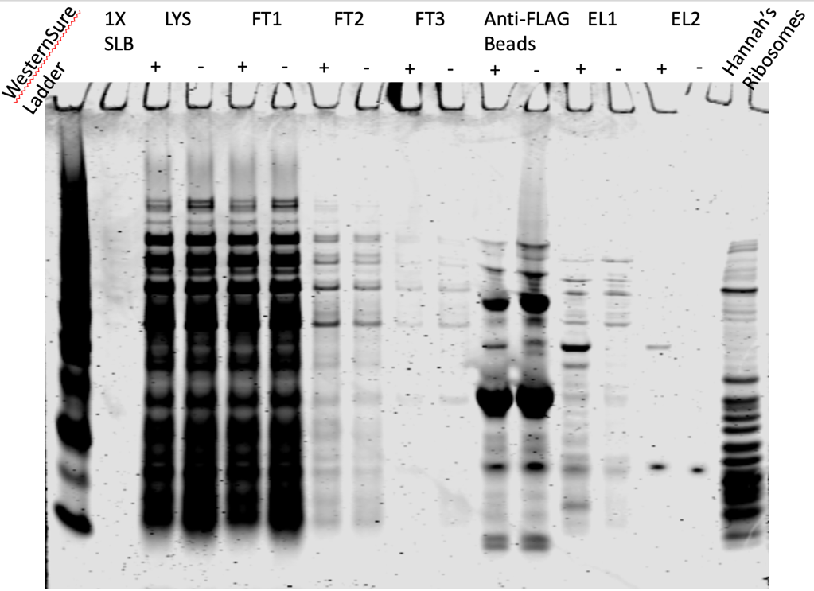

Figure 4: Coomassie of FLAG-IP 11/15/23:
This looks promising! The banding patterns are not the same between + and -.
Western Setup 11/17/23
Lane | Content | Volume
1 | WesternSure Ladder | 5 ul
2 | LVS-pF-rpsU2-FLAG lysate | 10 ul
3 | LVS-pF lysate | 10 ul
4 | LVS-pF-rpsU2- FLAG FT1 | 10 ul
5 | LVS-pF FT1 | 10 ul
6 | LVS-pF-rpsU2- FLAG FT2 | 10 ul
7 | LVS-pF FT2 | 10 ul
8 | LVS-pF-rpsU2- FLAG FT3 | 10 ul
9 | LVS-pF FT3 | 10 ul
10 | LVS pF-rpsU2 -FLAG Agarose Beads | 10 ul
11 | LVS-pF Agarose Beads Beads | 10 ul
12 | 1X SLB | 10 ul
13 | LVS-pF-rpsU2-FLAG EL1 | 10 ul
14 | LVS-pF EL1 | 10 ul
15 | LVS-pF-rpsU2-FLAG EL2 | 10 ul
16 | LVS-pF EL2 | 10 ul
17 | LVS-pF-rpsU2-FLAG WCL | 10 ul

Electrocompetent cells and transformation:
Meagan and I made LVS-∆rpsU2 electro competent cells and then transformed them with the FLAG tag (pKR194). We set up a no DNA control as well. We didn’t have enough CHA-Kan plates to have 2 plates each so we plated 20 ul and 100ul of pKR194 and 300ul of negative control. She also needed to streak out plates so they will be ready for her growth curves on Tuesday. LVS-pF and LVS-∆rpsU2-pF had to be streaked onto CHA without abx.

Saturday, November 18, 2023
To Do:

- Make pellets for miniprep
- Image Coomassie
- Run gel and transfer for WB
- Supplement MHB
- Make LVS-∆rpsU2 electrocompetent cells
- Transform FLAG tag into LVS-∆rpsU2
- Finish and image Western
- Run Silver Stain
- Miniprep pKR148

Silver Stain Setup:
Lane | Content | Volume
1 | Benchmark Ladder | 10 ul
2 | LVS-pF-rpsU2-FLAG lysate | 10 ul
3 | LVS-pF lysate | 10 ul
4 | LVS-pF-rpsU2- FLAG FT1 | 10 ul
5 | LVS-pF FT1 | 10 ul
6 | LVS-pF-rpsU2- FLAG FT2 | 10 ul
7 | LVS-pF FT2 | 10 ul
8 | LVS-pF-rpsU2- FLAG FT3 | 10 ul
9 | LVS-pF FT3 | 10 ul
10 | LVS pF-rpsU2 -FLAG Agarose Beads | 10 ul
11 | LVS-pF Agarose Beads | 10 ul
12 | 1X SLB | 10 ul
13 | LVS-pF-rpsU2- FLAG EL1 | 10 ul
14 | LVS-pF EL1 | 10 ul
15 | LVS-pF-rpsU2- FLAG EL2 | 10 ul
16 | LVS-pF EL2 | 10 ul
17 | Hannah’s Ribosomes | 5 ul

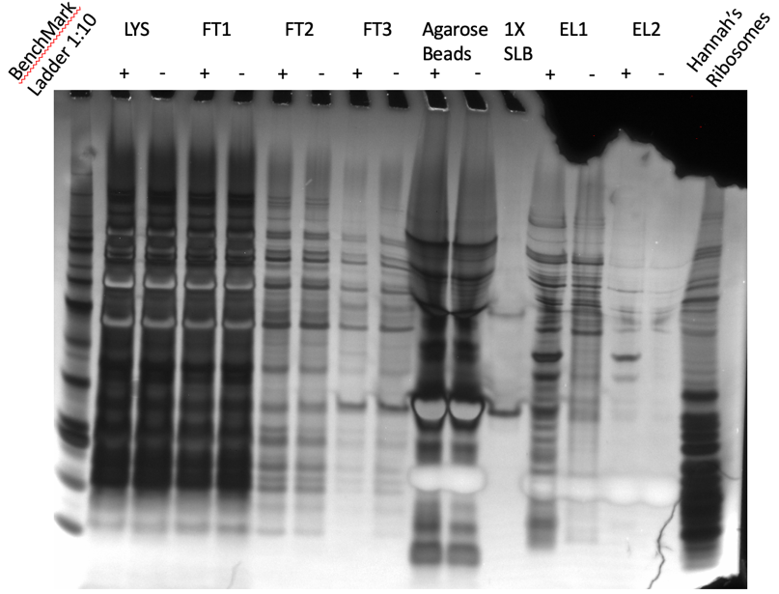

Figure 5: Silver Stain of FLAG-IP 11/15/23
This looks very promising!

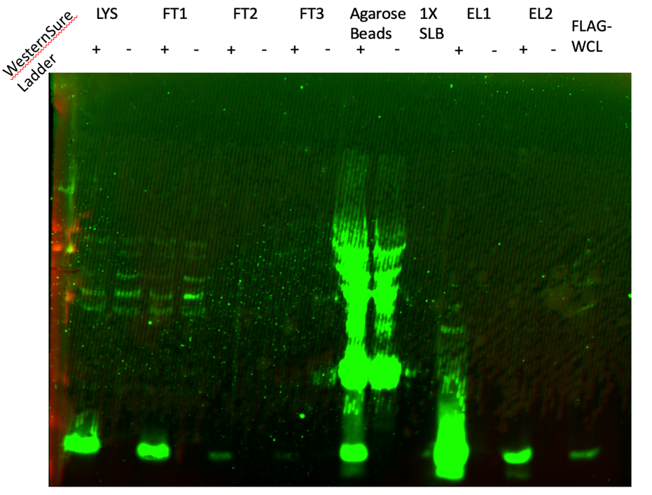

Figure 6: Western Blot of FLAG-IP 11/15/23
Although there is still a lot of bS21-2 that didn’t get captured on the beads (see LYS and FT1 lanes), the band in the EL1 lane looks really good. Next step is to run these on sucrose gradients to make sure I captured the whole 70S.

Minipreps:
# | Sample ID | Nucleic Acid | Unit | A260 (Abs) | A280 (Abs) | 260/280 | 260/230 | Sample Type | Factor
1 | pKR148 MP-1 | 222.3 | ng/µl | 4.446 | 2.253 | 1.97 | 2.75 | DNA | 50
2 | pKR148 MP-2 | 295.7 | ng/µl | 5.914 | 3.067 | 1.93 | 2.62 | DNA | 50
3 | pKR148 MP-3 | 216.8 | ng/µl | 4.335 | 2.196 | 1.97 | 2.77 | DNA | 50
4 | pKR148 MP-4 | 255.7 | ng/µl | 5.115 | 2.581 | 1.98 | 2.67 | DNA | 50
5 | pKR148 MP-5 | 229 | ng/µl | 4.58 | 2.356 | 1.94 | 2.53 | DNA | 50

Very consistent. Minipreps were consolidated and stored in the plasmid box in the -20.

Monday, November 20, 2023
To Do:

- Finish and image Western
- Run Silver Stain
- Miniprep pKR148
- Transform pKR148 into KRSA2
- Streak out plate of KRSA3
I’m transforming pKR148 into KRSA2. I also set up a no DNA control.

Electroporation
Thaw out aliquots on ice for 5 min then place at room temperature for 5 min (and follow the rest of the protocol at RT).
Centrifuge at 5,000xg for 1 min. Discard the supernatant and resuspend the cells in 50 ul of 10% glycerol / 500 mM sucrose.
Add up to 5ug-purified plasmid to the cells, mix and add to 0.1 cm electroporation cuvette. Up to 5ul of plasmid (dialyzed 20’ against H₂O with Millipore filters). I added 2ul of pKR148
Pulse 21 kV/cm, 100 Ω and 25uF. Time constant usually about 2.0-2.4 ms. Used the StA setting, no arcs!
Immediately add 1ml of TSB + 500mM sucrose and mix. (Dissolve 6.85g of sucrose in 40ml TSB and filter sterilize)
Transfer to a new tube and incubate at adequate temperature for 1-1.5h. (30C for RN4220; 42C for HG003) Incubated at 37ºC
Plate out on TSA + antibiotic. (3 ug/mL tet) Plated 20ul, 100ul, and remaining volume. Plates were incubated at 30ºC.
The plates that Meagan and I streaked out on Friday look good although ∆rpsU2-pF didn’t grow as robustly as the others (to be expected). We patched out the plates on CHA-Kan to set up growth curve tomorrow.
Tuesday, November 21, 2023
To Do:

- Transform pKR148 into KRSA2
- Streak out plate of KRSA3
- Set up overnights of KRSA2 transformants and KRSA3

When I came in this morning at 9:30 there was no growth on the transformation plates. I’ll give it more time. One thing that could have gone wrong is that I had recovered them at 37ºC, and I probably should have recovered them at 30ºC.
I started 2 overnight cultures of KRSA3 in TSB.
Meagan set up another growth curve, this time including LVS-∆rpsU2-pF-rpsU2-FLAG and LVS-∆rpsU2-pF-rpsU2-VSV-G

Wednesday, November 22, 2023
To Do:

- Set up overnights of KRSA2 transformants and KRSA3
- Make KRSA3 electrocompetent cells
- Make glycerol stocks of LVS-∆rpsU2-pF-rpsU2-FLAG
- Streak out KRSA2 to check for true resistance

Surprisingly, there are colonies on the 100ul transformation plate! There is still no growth on 20ul or remaining, other than a lawn. No growth on negative control plates. I’m going to leave them on the bench for Thanksgiving and then start overnight cultures on Friday to do minipreps on Saturday. I patched out a couple colonies to a new TSA-Tet plate to make sure these colonies are truly resistance since they are a little small.

Competent cells
Overnight culture in TSB at 37°C with shaking. 4ml in 30ml tube.
Dilute overnight culture of S. aureus back to about an OD600nm of 0.5 in 50ml of
prewarmed TSB. Approx.: 3 ml of overnight culture + 47ml prewarmed TSB.
Re-incubate for 30 min. After 30 min the culture is usually between OD600nm 0.8-0.9. Checked OD after 45 minutes; they were at 0.5. Checked an hour and 15 later; #1 is 0.71, #2 is 0.9
Transfer to 50ml tubes and let in ice-water slurry for 10 min (keep cold from now on).
Harvest the cells in centrifuge at 4105 x g for 10 minutes at 4°C.
Discard the supernatant, add 45ml sterile ice cold milliQ water. No need to resuspend the pellet yet.
Harvest the cells in centrifuge at 4105 x g for 10 minutes at 4°C.
Discard the supernatant, resuspended the pellet in 10ml sterile ice cold 10% glycerol.
Harvest the cells in centrifuge at 4105 x g for 10 minutes at 4°C.
Discard the supernatant, resuspended the pellet in 1.8ml sterile ice cold 10% glycerol. Transfer to 2ml tubes.
Harvest the cells in microcentrifuge (12000rpm) for 2 minutes at 4°C.
Discard the supernatant, resuspended the pellet in 1ml sterile ice cold 10% glycerol. Transfer to 2ml tubes.
Harvest the cells in microcentrifuge (12000rpm) for 2 minutes at 4°C.
Discard the supernatant, resuspended the pellet in 250ul sterile ice cold 10% glycerol.
Dispense 5 x 50ul aliquots and freeze at -80°C.

Yielded 11 aliquots.

I made glycerol stocks of LVS-∆rpsU2-pF-rpsU2-FLAG aka LVS288. I updated the KRLVS spreadsheet and stored them in Box 10 in the -80ºC.

Friday, November 24, 2023
To Do:

- Make KRSA3 electrocompetent cells
- Make glycerol stocks of LVS-∆rpsU2-pF-rpsU2-FLAG
- Streak out KRSA2 to check for true resistance
- Start overnight cultures of KRSA2 with pKR148

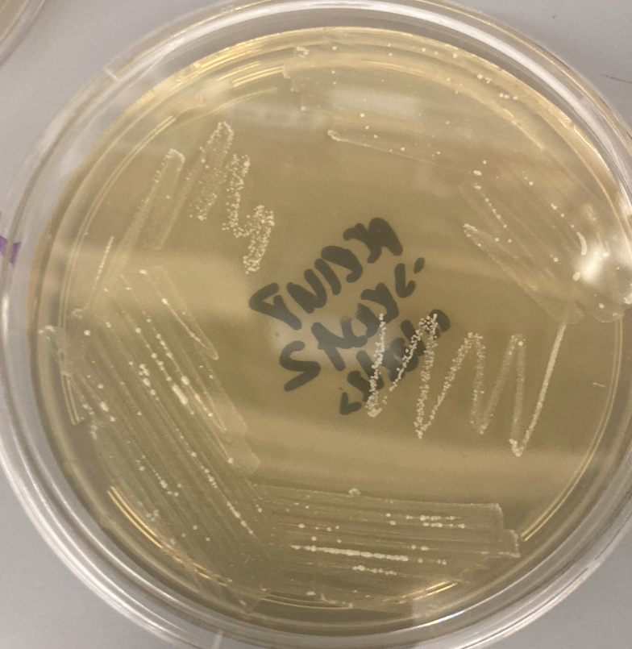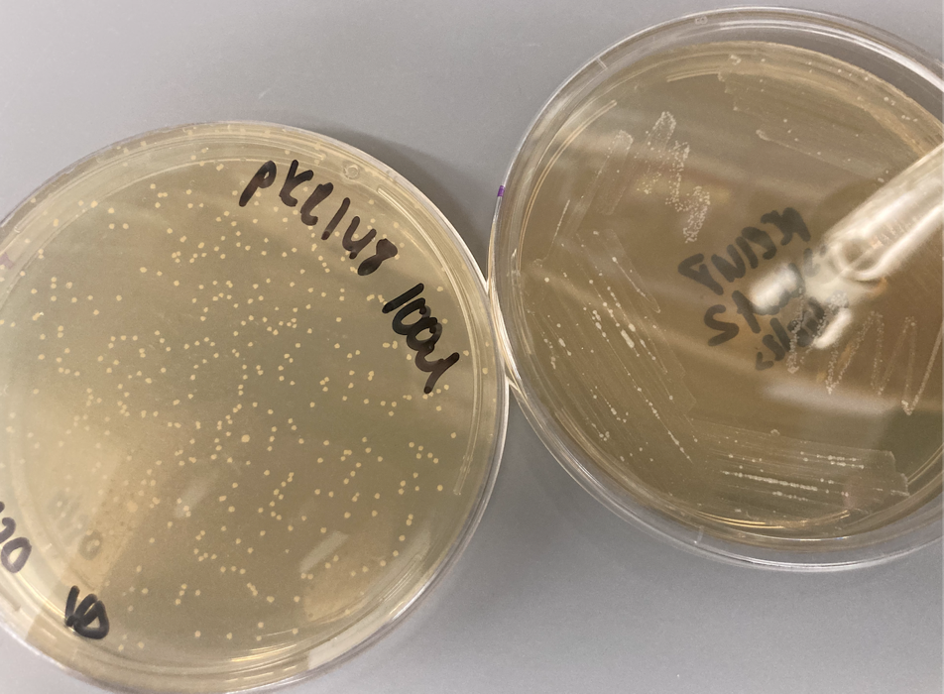
This isn’t a good sign. It looks like what grew on the streak plates from Wednesday is contamination. There is no growth in the heavy quadrants except for white colonies popping up. Compared to the spread plate which has off-white colonies. It looks like the colonies that popped up on the transformation plate are not truly resistant, but since I’m here I’m setting up cultures anyway. I set up 4 5ml cultures with 1.5ul of tet in each.
I streaked out KRSA2 from frozen and left it on the bench over the weekend in hopes that it will be at appropriate growth on Monday. I need to make single use glycerol stocks for myself and make more competent cells.

Saturday, November 25, 2023
To Do:

- Start overnight cultures of KRSA2 with pKR148
- Miniprep pKR148 out of KRSA2
The cultures grew but they all have a white precipitate that is probably the same contaminant as the white growth on the streak plates.

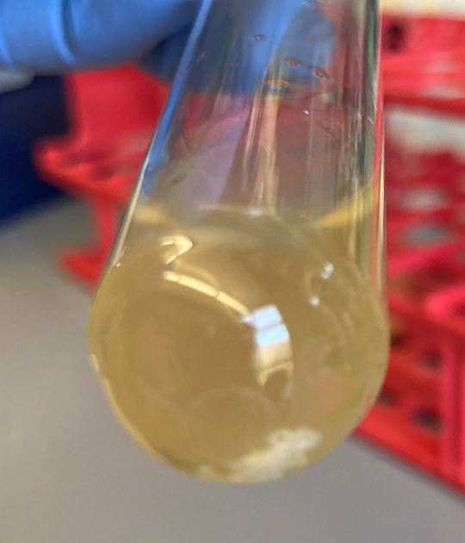

I’m going to start over on Monday. There is no growth yet on the KRSA2 plate I streaked yesterday, hopefully there will be by Monday. If so, I will make new competent cells on Tuesday. As a backup, I streaked out another plate of KRSA2 and put it in the 30ºC incubator.
I should have streaked out the LVS strains for Meagan’s project yesterday but I forgot, so I did it today. If they don’t grow enough by Monday, we can push her growth curve to Thursday.

Monday, November 27, 2023
To Do:

- Miniprep pKR148 out of KRSA2
- Start overnight of KRSA2 to make more EC cells
- Make MHB for large LVS cultures
- Patch out LVS-pF

There is barely any growth on the KRSA2 plate that I left at RT over the weekend, but the plate I streaked on Saturday and incubated at 30ºC looks good. Interestingly, the 2 streaks I made last week are now taking on the same yellow tone as the transformation plate:
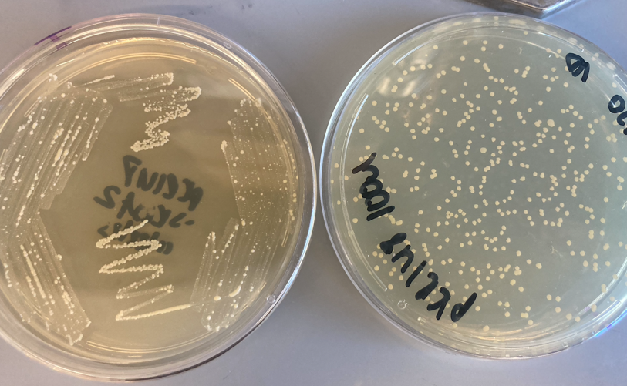
I also noticed that the 30ºC plate is growing similarly to how the streaks grew:

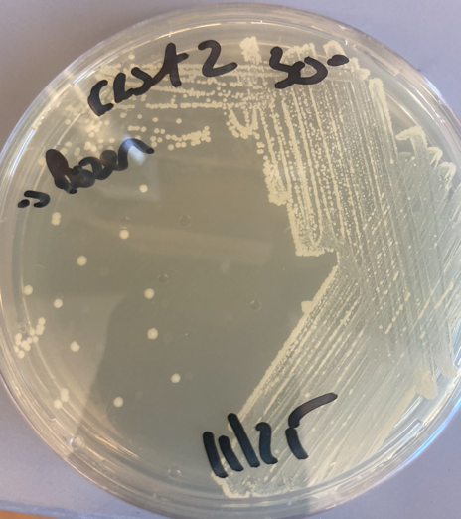
Specifically, the growth in the first 2 quadrants have colonies popping up on the lawn, just like in the dual streak plate. These colonies are still white, but I’m sure they’ll eventually turn yellow. So maybe this is just how KRSA2 grows at 30ºC, but it doesn’t explain the white precipitate in the liquid cultures.
In lab meeting Kathryn suggested I look at these under the microscope to make see if they really are S. aureus rather than a contaminant. I am also going to streak out a colony from the transformation plate and grow it at 37ºC and 30ºC and see if there’s a significant difference in growth.
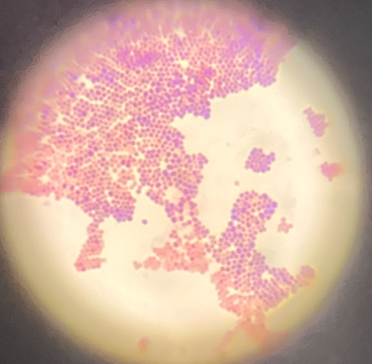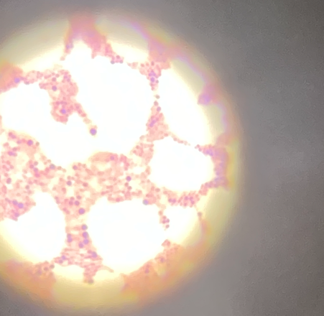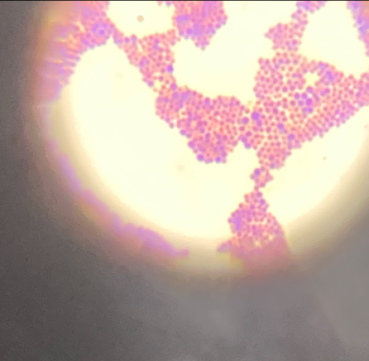
From left to right: KRSA2 from glycerol stock, KRSA2 transformation plate, KRSA2 restreak from transformation plate. Although I need to brush up on my Gram stain technique, all 3 are clearly Gram positive cocci that bunch together like grapes, suggesting that these are Staph.
The LVS plates I streaked out on Saturday are growing but they don’t have single colonies yet, so I think we’ll push off Meagan’s growth curve. In the meantime, she made glycerol stocks of those 4 strains.
Johanyx patched 2 plates of LVS wt for the EC cells and to make glycerol stocks.

Tuesday, November 28, 2023
To Do:

- Start overnight of KRSA2 to make more EC cells
- Make MHB for large LVS cultures
- Patch out LVS-pF
- Make KRSA2 EC cells and glycerol stocks
- Start large overnights of LVS-pF
- Make LVS EC cells and transform pKR200 for Johanyx
- Set up overnights of KRSA2 transformants

The plates I streaked out yesterday from the KRSA2 transformation plate are growing faster at 37ºC than at 30ºC, so there’s nothing special about them. I am going to attempt another miniprep on the transformation colonies and hope I don’t see that white precipitate again. Since the plates are old, I’ll confirm with sequencing. I set up 4 cultures.
KRSA2 EC cells:
Set up 2 overnight cultures. Back-diluted at 10am, at 11am they were 0.7 and 0.6. At 11:15 they were 0.91 and 0.93. I got 14 aliquots and they are stored in the KRSA electrocompetent cells box in the -80ºC. I also made my own glycerol stocks of KRSA2 and single-use aliquots.
Johanyx’s project:
Because of her current class schedule, there’s no way that Johanyx will be able to see the making of the LVS electrocompetent cells nor the electroporation, because pEX plasmids must be transformed into freshly made EC cells. I made the cells and transformed pKR200 into LVS. They went into the incubator at 11:45, and I’ll take them out between 4:30 and 5 to set up spread plates (or Johanyx will).

LVS-pF IP Pellets:
Sample | Observed OD600 | Calculated OD600 | Starting Volume for OD600 0.003 (ul)
LVS-pF-1 | 0.284 | 5.68 | 264
LVS-pF-2 | 0.304 | 6.08 | 247
Went into the shaker at ~5:15pm

Wednesday, November 29, 2023
To Do:

- Make KRSA2 EC cells and glycerol stocks
- Start large overnights of LVS-pF
- Make LVS EC cells and transform pKR200 for Johanyx
- Set up overnights of KRSA2 transformants
- Make LVS-pF cell pellets
- Set up HA IP if time
- Miniprep KRSA2 and transform into KRSA3 if time

LVS-pF pellets:
Sample | Observed OD600 | Calculated OD600 | Starting Volume for OD600 0.003 (ul) | OD600 at Harvest
LVS-pF-1 | 0.284 | 5.68 | 264 | 0.35
LVS-pF-2 | 0.304 | 6.08 | 247 | 0.38
Cultures came off shaker at ~10:15am.

KRSA2 Minipreps:
Methods:
- Grow 1-5 ml broth culture S. aureus overnight.
- Move liquid cultures to sterile 1.5ml microfuge tubes 1 ml at a time.
- Spin 1 ml culture at 4000 rpm for 10 min.
- Remove supernatant and add more culture (if using more than 1 ml).
- Repeat Step 4 until desired amount is used.
- Add 700 μl 1X TE and resuspend the pellet.
- Add 500 μl cold Acetone mix (50% acetone, 50% absolute ETOH, kept in freezer).
- Incubate 5 min on ice.
- Spin 2 min at 14000 rpm, discard supernatant.
- Wash the pellet with 1 ml 1X TE (it helps to completely resuspend the pellet), spin again for 2 minutes at 14000 rpm and discard supernatant.
- Vortex the dry pellet briefly (seems to help lysis), then add 3 μl 10 mg/mL lysostaphin to the cell pellet.
- Resuspend pelleted bacterial cells in 250 μl of Buffer P1 (supplemented with RNAse, kept in refrigerator).
- Incubate at 37° C for at least 1 hr. (Check for clearing).
- Proceed with QIAprep protocol at step 3 (buffer P2)

**Samples 3 and 4 did not clear after addition of P2
I got distracted talking to Meagan and eluted the samples into the collection tubes rather than new clean tubes. I repeated the elution but I’m sure this is why my yield is so low:
# | Sample ID | Nucleic Acid | Unit | A260 (Abs) | A280 (Abs) | 260/280 | 260/230 | Sample Type | Factor
1 | KRSA2_pKR148-1 | 11.5 | ng/µl | 0.229 | 0.134 | 1.71 | 0.76 | DNA | 50
2 | KRSA2_pKR148-2 | 5.3 | ng/µl | 0.106 | 0.071 | 1.49 | 1.03 | DNA | 50
3 | KRSA2_pKR148-3 | 6.4 | ng/µl | 0.128 | 0.071 | 1.82 | 1.05 | DNA | 50
4 | KRSA2_pKR148-4 | -5.1 | ng/µl | -0.101 | -0.055 | 1.85 | 0.31 | DNA | 50

These are horrible. I don’t think the transformation will be successful.
Discarded sample 4.

Elution Buffer with HA peptide
Composition | Stock solutions | For 1.5 ml
25mM KHEPES pH 7.9 | 1 M KHEPES | 900 uL
Pierce Anti-HA peptide 2 mg/ml | 5 mg/ml | 600 ul

I need to make more 1M KHEPES.
MW = 276.39g/mol
13.8g into 50ml of water
pH to 7.9
filter sterilize

Thursday, November 30, 2023
To Do:

- Make LVS-pF cell pellets
- Miniprep KRSA2
- Set up HA IP
- Make CHA with sucrose with JR
- Make TSA
- Growth curve with Meagan

HA IP 11/30/23

Sample # | Date | Genotype of Cells | Volume of Cells | OD600 at Harvest
1 | 7/20/23 | LVS-pF-rpsU2-HA | 500 ml | 0.31
2 | 11/29/23 | LVS-pF-1 | 500 ml | 0.35

Buffer A + PI +BB (Lysis) for HA:
Final composition | Stock solutions | For 25 mL | For 50 mL
25 mM KHEPES pH 7.9 | 1 M KHEPES | 625 uL | 1250 uL
10 mM MgCl₂ | 1 M MgCl₂ | 250 uL | 500 uL
10 mM NH₄Cl | 1 M NH₄Cl | 250 uL | 500 uL
1X Bug Buster | 10X Bug Buster | 2.5 mL | 5 mL
10% glycerol | 75% glycerol | 3.3 mL | 6.6 mL
Water |  | 18 mL | 36 mL
 | + 2 tablets protease inhibitor for 25 mL and 4 tablets for 50 mL

Immunoprecipitation with HA tag (based on ThermoFisher Pierce Anti-HA Magnetic Beads Product Info Sheet)

In cold room
- Cut tip of 1mL pipette tip slightly.
- Resuspend Anti-HA magnetic beads in storage solution by repeated inversion.
- Pipette 200 uL magnetic beads into 50 ml conical.
- Wash beads with 1225 uL of Buffer B. Using the magnetic rack, wait until the beads have completely gone towards the magnet before removing the liquid.
- Wash beads with 2 ml of Buffer B. Invert tubes for 1 minute, discard supernatant.
- Add 1 sample per tube, close tube and make sure and it is not dripping liquid.
- Incubate samples with beads, rocking on their sides at 4°C, for 1 hour.

- After 1 hour incubation, place on magnetic rack.
- Save 50 uL aliquot of flow through in microfuge tube (FT1), discard remaining.
- Wash beads 3x with 2 mL Buffer B, discard flow through but save 50 ul from each wash (FT2-4).
- Add 400 ul KBE-3 buffer with HA peptide
- Incubate rocking at 37°C for 10 minutes.

- Recover eluates by magnetic rack (EL-1). Repeat elution (EL-2). *I added 300ul here
- Aliquot 50 uL of each recovered sample into microfuge tube, 4x, for later analysis. Transfer remaining samples into clearly labeled microfuge tubes (2 per sample) and store all samples at -80°C.

- Keep 50ul of beads and store in -20ºC.

The reconstituted beads make a brown slurry. I decided to let the separation go for a lot longer because it wasn’t as easy to tell if they were fully separated. The liquid never got to the point of being completely clear, there was always a slight orange tint, even after leaving the sample for several minutes. I gauged that it was ready when I no longer saw any orange on the surface/bubbles. Note that this was in the 50ml conicals; the separation happened much faster in the 1.5ml tubes during elution.

KRSA3 transformation:
I’m pushing off the transformation for some other day because Meagan needs the shaker at 37ºC for her growth curves.

CHA with sucrose:
Johanyx and I are making CHA with sucrose plates for her allelic exchange.
CHAH plates with 10% sucrose
Mix:
5 g Beef Heart Infusion
5 g Protease Peptone
5 g Glucose
0.5 g L-Cystine
7.5 g Agar
with 150 mL type I ddiH₂O. Stir on low heat until completely dissolved, about 10 minutes.
Autoclave 30’, being EXTREMELY careful media does not boil over
While autoclaving, warm 250 mL of 2% hemoglobin and sterilized 50% sucrose (in 50°C oven or in water bath at 55°C)
Place CHA flask in 50°C oven or in water bath at 55°C, let temperature equilibrate
Wipe down flask and bottles with ethanol and using sterile technique, pour hemoglobin into CHA flask
Add 100 mL 50% sucrose to CHA-hemoglobin flask
Mix media
Use sterile pipette, pour ~24 mL media per plate (~20 plates for 500 mL media)

2% hemoglobin (can make ahead and store at 4°C)
Mix 6 g freeze-dried hemoglobin with 300 mL type I ddiH₂O in 1 L flask
Autoclave 20’
Can make extra and aliquot to sterilized 100 mL bottles for later use
We are making 250ml, so 5g of hemoglobin into 250ml of type I ddiH₂O.
50% sucrose
Combine 360 g of sucrose and enough type I ddiH₂O to make 720 mL.
Autoclave for 20’.
Suggested method: in 1 L beaker, add ~100 g increments of sucrose into ~250 mL type I ddiH₂O, heating slightly (below boiling point!) and waiting for each addition to be completely dissolved before adding next mass of sucrose. Measure final volume in graduated cylinder and add type I ddiH₂O until volume is 720 mL.
This is already made.

December 2023

Friday, December 1, 2023
To Do:

- Set up HA IP
- Make CHA with sucrose with JR
- Growth curve with Meagan
- Make TSA
- Silver stain

HA-IP Silver Stain:

Lane | Content | Volume
1 | Benchmark Ladder 1:10 | 10 ul
2 | LVS-pF-rpsU2-HA lysate | 10 ul
3 | LVS-pF lysate | 10 ul
4 | LVS-pF-rpsU2- HA FT1 | 10 ul
5 | LVS-pF FT1 | 10 ul
6 | LVS-pF-rpsU2- HA FT2 | 10 ul
7 | LVS-pF FT2 | 10 ul
8 | LVS-pF-rpsU2- HA FT3 | 10 ul
9 | LVS-pF FT3 | 10 ul
10 | LVS pF-rpsU2 - HA Agarose Beads | 3 ul
11 | LVS-pF Agarose Beads | 3 ul
12 | 1X SLB | 10 ul
13 | LVS-pF-rpsU2- HA EL1 | 10 ul
14 | LVS-pF EL1 | 10 ul
15 | LVS-pF-rpsU2- HA EL2 | 10 ul
16 | LVS-pF EL2 | 10 ul
17 | Hannah’s Ribosomes | 5 ul

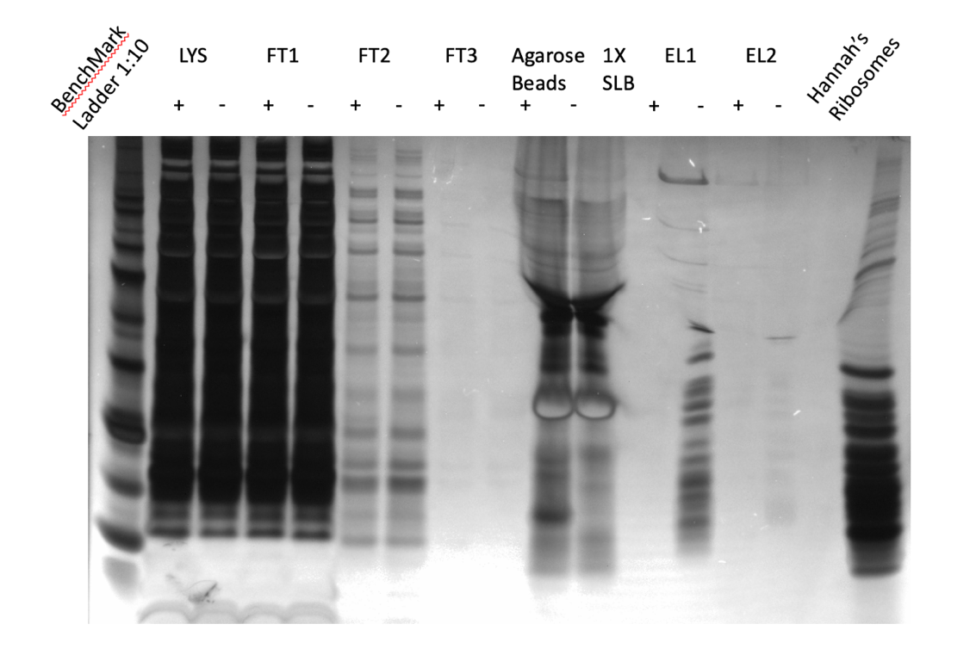

Figure 7: Silver stain of HA IP 11/30/23:
This is the best one yet! Virtually no bands showed up in the negative control elution lanes.

HA-IP Western Blot 12/1/23:

Lane | Content | Volume
1 | BenchMark Ladder | 10 ul
2 | LVS-pF-rpsU2-HA lysate | 10 ul
3 | LVS-pF lysate | 10 ul
4 | LVS-pF-rpsU2- HA FT1 | 10 ul
5 | LVS-pF FT1 | 10 ul
6 | LVS-pF-rpsU2- HA FT2 | 10 ul
7 | LVS-pF FT2 | 10 ul
8 | LVS-pF-rpsU2- HA FT3 | 10 ul
9 | LVS-pF FT3 | 10 ul
10 | LVS pF-rpsU2 - HA Agarose Beads | 10 ul
11 | LVS-pF Agarose Beads | 10 ul
12 | 1X SLB | 10 ul
13 | LVS-pF-rpsU2- HA EL1 | 10 ul
14 | LVS-pF EL1 | 10 ul
15 | LVS-pF-rpsU2- HA EL2 | 10 ul
16 | LVS-pF EL2 | 10 ul
17 | LVS-pF-rpsU2- HA WCL | 10 ul
I ran the gel and transferred it. When I took the membrane off the gel I didn’t see any ladder bands, but I did see some blue at the edge of the gel. I realized that I used the wrong ladder; I used BenchMark instead of WesternSure. That was so dumb. Given that it’s the weekend, I decided to abandon this and repeat it on Monday.

Monday, December 4, 2023
To Do:

- Silver stain
- Make TSA
- Western and Coomassie
- Streak out LVS-∆mpl patches with JR

I will repeat the miniprep out of KRSA2 at another time, so I put the plate in the fridge wrapped in parafilm until then.
Western Blot:

Lane | Content | Volume
1 | Benchmark Ladder | 10 ul
2 | LVS-pF-rpsU2-HA lysate | 10 ul
3 | LVS-pF lysate | 10 ul
4 | LVS-pF-rpsU2- HA FT1 | 10 ul
5 | LVS-pF FT1 | 10 ul
6 | LVS-pF-rpsU2- HA FT2 | 10 ul
7 | LVS-pF FT2 | 10 ul
8 | LVS-pF-rpsU2- HA FT3 | 10 ul
9 | LVS-pF FT3 | 10 ul
10 | LVS pF-rpsU2 - HA Anti-HA Agarose Beads | ~3 ul
11 | LVS-pF Anti-HA Agarose Beads | ~3 ul
12 | 1X SLB | 10 ul
13 | LVS-pF-rpsU2- HA EL1 | 10 ul
14 | LVS-pF EL1 | 10 ul
15 | LVS-pF-rpsU2- HA EL2 | 10 ul
16 | LVS-pF EL2 | 10 ul
17 | Hannah’s Ribosomes | 5 ul

Coomassie:

Lane | Content | Volume
1 | WesternSure Ladder | 10 ul
2 | LVS-pF-rpsU2-HA lysate | 10 ul
3 | LVS-pF lysate | 10 ul
4 | LVS-pF-rpsU2- HA FT1 | 10 ul
5 | LVS-pF FT1 | 10 ul
6 | LVS-pF-rpsU2- HA FT2 | 10 ul
7 | LVS-pF FT2 | 10 ul
8 | LVS-pF-rpsU2- HA FT3 | 10 ul
9 | LVS-pF FT3 | 10 ul
10 | LVS pF-rpsU2 - HA Anti-HA Agarose Beads | ~3 ul
11 | LVS-pF Anti-HA Agarose Beads | ~3 ul
12 | 1X SLB | 10 ul
13 | LVS-pF-rpsU2- HA EL1 | 10 ul
14 | LVS-pF EL1 | 10 ul
15 | LVS-pF-rpsU2- HA EL2 | 10 ul
16 | LVS-pF EL2 | 10 ul
17 | LVS-pF-rpsU2- HA WCL | 10 ul
I made 2 half liters of TSA.

Tuesday, December 5, 2023
To Do:

- Make TSA
- Western and Coomassie
- Repeat electroporation of pKR200 into LVS with JR
- Day 2 of Western
- Image Western and Coomassie
- Start overnights of KRSA2 transformants

LVS electroporation with Johanyx:
We’re repeating the transformation of LVS with pKR200, since it seems that the cells we saw on the plates last time aren’t truly Kan resistant. Johanyx made more LVS EC cells, but she lost a lot of cells in the process. She had initially scraped up a good bit from the plate into 400ul of 10% sucrose so that it was more than half culture, but throughout the spinning many cells probably got dumped with the supernatant. She ended up with about 125ul of EC cells. I had hoped that we could set up the electroporation in duplicate, but instead we set them up in singles. I demonstrated the electroporation; there were no arcs. We let them recover for about 6 hours. Johanyx did the spread plates.
Western:
For the primary antibody I added HA antibody diluted 1:5000.
I ran low on wash buffer so needed to make more but didn’t have enough 10X PBS to make a full half liter. I had 20ml of 10X PBS that I put into 180ml of water and then added 900 ul of Surfact-Amps. That’s plenty for today’s western, but I’ll need to make more 10X PBS:
10X PBS recipe
Start with 800 ml of distilled water:
Add 80 g of NaCl.
Add 2 g of KCl.
Add 14.4 g of Na2HPO4 (dibasic).
Add 2.4 g of KH2PO4 (monobasic).
Adjust the pH to 7.4 with HCl or NaOH.
Add distilled water to a total volume of 1 liter.

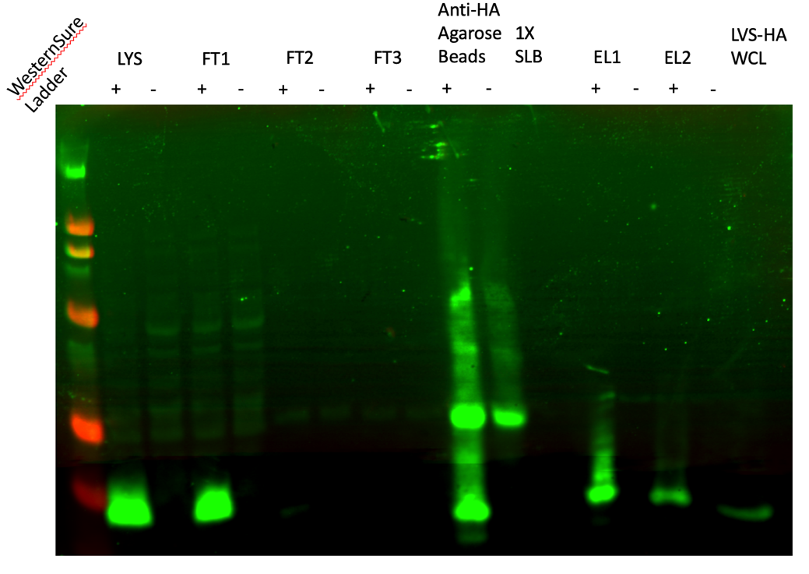

Figure 8: Western Blot of HA-IP 11/30/23:
A protein was pulled down but I’m not sure about the other bands in EL1 (or is it just blurry?) and the bands in EL1 and EL2 look like they’re slightly bigger than the control.

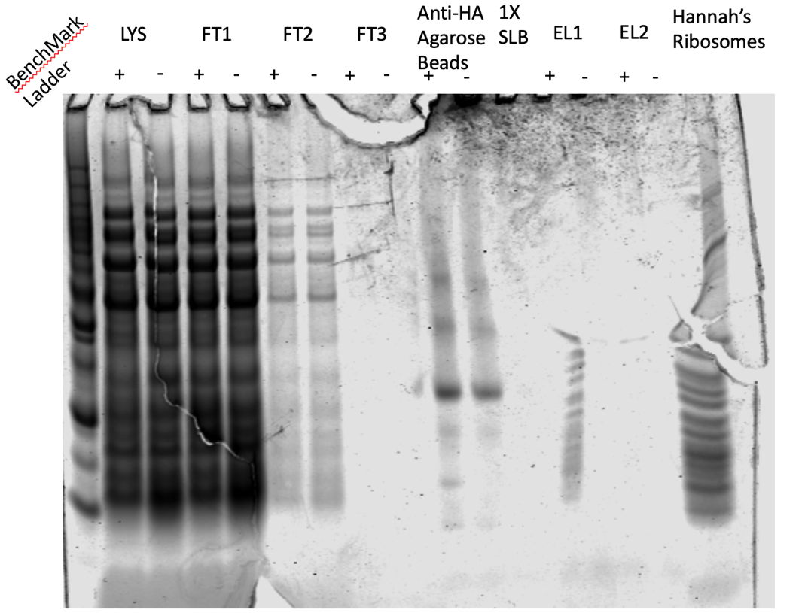

Figure 9: Coomassie Stain of HA-IP 11/30/23
Weird bubble but clearly there’s good specificity

Wednesday, December 6, 2023
To Do:

- Repeat electroporation of pKR200 into LVS with JR
- Day 2 of Western
- Image Western and Coomassie
- Start overnights of KRSA2 transformants
- Transform KRSA2
The white precipitate is back in the KRSA2 overnights. I’m going to take a step back and repeat the transformation of pKR148 into KRSA2. I think the plate is too old now, and I want to be sure that this time they recover at 30ºC.

Electroporation 12/6/23
Thaw out aliquots on ice for 5 min then place at room temperature for 5 min (and follow the rest of the protocol at RT).
Centrifuge at 5,000xg for 1 min. Discard the supernatant and resuspend the cells in 50 ul of 10% glycerol / 500 mM sucrose.
Add up to 5ug-purified plasmid to the cells, mix and add to 0.1 cm electroporation cuvette. Up to 5ul of plasmid (dialyzed 20’ against H₂O with Millipore filters). I added 3ul of pKR148
Pulse 21 kV/cm, 100 Ω and 25uF. Time constant usually about 2.0-2.4 ms. Used the StA setting, no arcs!
Immediately add 1ml of TSB + 500mM sucrose and mix. (Dissolve 6.85g of sucrose in 40ml TSB and filter sterilize)
Transfer to a new tube and incubate at adequate temperature for 1-1.5h. (30C for RN4220; 42C for HG003) Incubated at 30ºC
Plate out on TSA + antibiotic. (3 ug/mL tet) Plated 20ul, 100ul, and remaining volume on TSA-Tet. Plates were incubated at 30ºC.

Kathryn and I talked about the Coomassie Stain the Western Blot and how there’s weird migration in the elution samples. We looked over how I set up the elution buffers and she suggested that I should include the salts like I used for the His-tag. I had been going fairly literally from the product info sheets that had simply said to reconstitute the peptides in a buffer. I hadn’t considered that the salts are necessary to keep the ribosome intact. I will reconfigure the elution buffers for the peptides so that I use less concentrated KHEPES and include the salts:
Elution Buffer
Composition | Stock solutions | For 3 mL
25mM KHEPES pH 7.9 | 1 M KHEPES | 75 uL
10 mM MgCl₂ | 1 M MgCl₂ | 30 uL
100 mM NH₄Cl | 1 M NH₄Cl | 300 uL
0.1% NP40 | 10% NP-40 | 3 uL
1.5 mg/ml peptide | 5 mg/ml FLAG peptide | 900 uL
Water |  | mL

This isn’t right, I already diluted the peptide in 1M KHEPES so I need to redo the math.
Friday, December 8, 2023
To Do:

- Transform KRSA2
- Start overnights of KRSA2 transformants
I let the plates incubate for 2 days at 30ºC. Today I see many colonies on the 20ul and 100ul plates, but no isolated colonies on the remaining plate; just a confluent lawn. There are TNTC on both the 20ul and 100ul, but it’s obvious that there is more on the 100ul than the 20ul. The 100ul plate has 2 contamination colonies and the 20ul has one. It will be easy to avoid it when picking colonies to set up overnights. I set up 4 cultures, and I put the plate in the fridge with parafilm afterwards.

Saturday, December 9, 2023
To Do:

- Start overnights of KRSA2 transformants
- Make cell pellets of KRSA2 transformants

I made cell pellets today and will proceed with miniprep on Monday. One of the cultures didn’t grow, so I now have 3 samples. There was some sort of precipitate in the tubes again but different from last time:

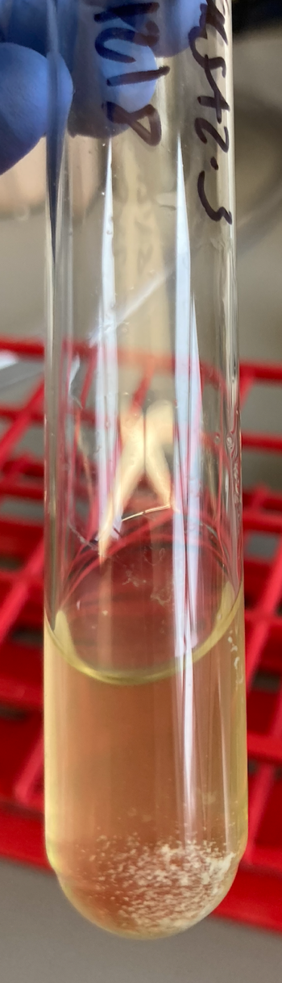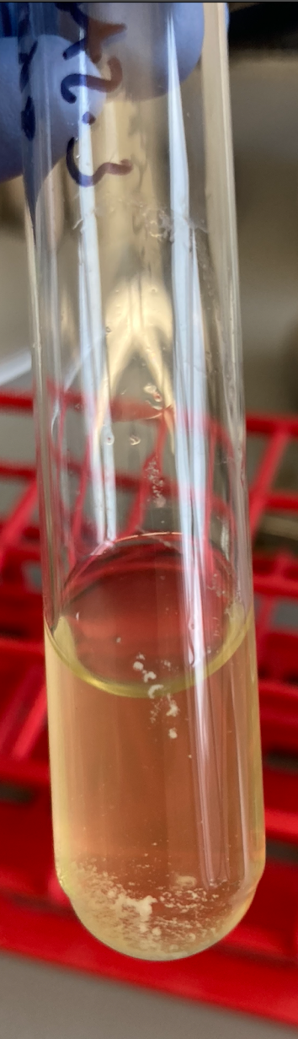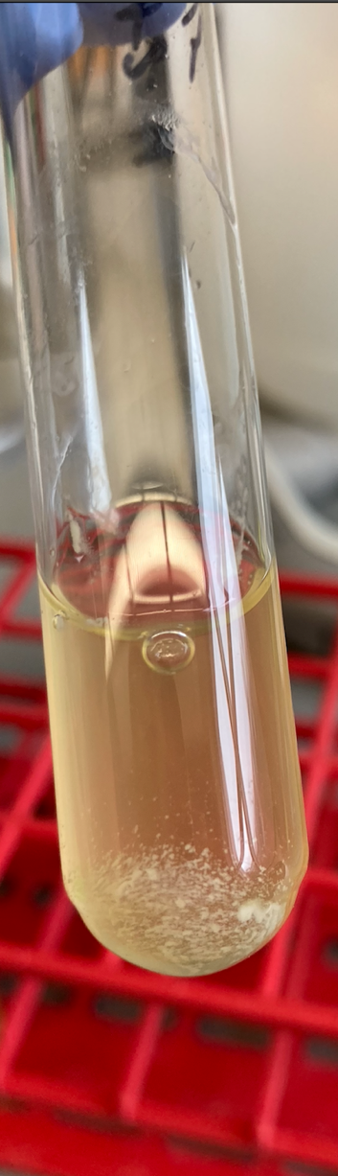
When I shook the tubes it didn’t incorporate into the solution, so I proceeded with making pellets and I hope for the best.
Correction: when I went to get moe culture after the first spin, precipitate started to come up into the pipet tip. I’m still proceeding.
Also worth noting that the pellets are as big as usual. I’m going to set up more liquid cultures and let them grow 48 hours.
As controls to see what this precipitate is, I’m setting up a tube of uninoculated TSB, and a tube of uninoculated TSB after putting a stick in it straight from the container (hasn’t touched a colony).

Monday, December 11, 2023
To Do:

- Start overnights of KRSA2 transformants
- Make cell pellets of KRSA2 transformants
- Miniprep KRSA2 transformants
- Set up liquid cultures of KRSA2 transformants in LB

At lab meeting today we talked about the precipitate in my liquid cultures and Kathryn suspects that the cells have lysed. We looked over the plasmid in SnapGene and there are 2 other genes that in the flanking regions that could be expressing something toxic. I checked the ORFs from each flanking region in NCBI conserved domain search and found that the ORF is F1 has an MiaB superfamily (tRNA modification) and the ORF is F2 has an NfeD superfamily (ClpP, a protease). ClpP is probably what’s causing all the havoc.
We double checked that the cells are in fact lysing by adding ethanol to one of the cultures and looking for precipitation, which is what we observed.
I’m proceeding with minipreps and I’ll send some to sequencing. I’m also going to set up cultures in LB to see if the medium has an effect, and if I can find a RT shaker I’ll set up cultures for that.

Methods:
- Grow 1-5 ml broth culture S. aureus overnight.
- Move liquid cultures to sterile 1.5ml microfuge tubes 1 ml at a time.
- Spin 1 ml culture at 4000 rpm for 10 min.
- Remove supernatant and add more culture (if using more than 1 ml).
- Repeat Step 4 until desired amount is used.
- Add 700 μl 1X TE (10 mM TrisCl, pH 8.0, 1 mM EDTA).
- and resuspend the pellet.
- Add 500 μl cold Acetone mix (50% acetone, 50% absolute ETOH, kept in freezer).
- Incubate 5 min on ice.
- Spin 2 min at 14000 rpm, discard supernatant.
- Wash the pellet with 1 ml 1X TE (it helps to completely resuspend the pellet), spin again for 2 minutes at 14000 rpm and discard supernatant.
- Vortex the dry pellet briefly (seems to help lysis), then add 3 μl 10 mg/mL lysostaphin to the cell pellet.
- Resuspend pelleted bacterial cells in 250 μl of Buffer P1 (supplemented with RNAse, kept in refrigerator).
- Incubate at 37° C for at least 1 hr. (Check for clearing).
- Proceed with QIAprep protocol at step 3 (buffer P2)

# | Sample ID | Nucleic Acid | Unit | A260 (Abs) | A280 (Abs) | 260/280 | 260/230 | Sample Type | Factor
1 | KRSA2_pKR148-1 | 6.1 | ng/µl | 0.122 | 0.073 | 1.68 | 2.58 | DNA | 50
2 | KRSA2_pKR148-2 | -0.5 | ng/µl | -0.01 | -0.007 | 1.57 | 0.15 | DNA | 50
3 | KRSA2_pKR148-3 | 4.3 | ng/µl | 0.086 | 0.03 | 2.91 | 1.99 | DNA | 50
4 | KRSA2_pKR148-4 | 30 | ng/µl | 0.6 | 0.273 | 2.2 | 2.89 | DNA | 50
5 | KRSA2_pKR148-5 | 37.9 | ng/µl | 0.759 | 0.389 | 1.95 | 2.02 | DNA | 50
6 | KRSA2_pKR148-6 | 33.4 | ng/µl | 0.667 | 0.318 | 2.1 | 2.43 | DNA | 50

Sigh.
I set up four more cultures, this time in LB.

Tuesday, December 12, 2023

To Do:
- Miniprep KRSA2 transformants
- Set up liquid cultures of KRSA2 transformants in LB
- Pellet LB transformants

The LB cultures didn’t grow very well yet this morning and there is some precipitate but, and this may be wishful thinking, it doesn’t seem to have as much as in TSB. I’m going to leave them growing until this afternoon and then pellet them.
I’ve been looking over Hannah’s notes again and she also saw precipitate and what she described as a “chunky mucus-y pellet” and mentioned sedimentation on the bottom, so that’s a bit encouraging.
Something maybe worth trying if this set doesn’t work:
I want to try to get more DNA for electroporating, so I’m going to try miniprepping 4 cultures form a single colony. Using the plates that I had from last Friday with pKR148 in RN4220, I picked a single colony into 4 mL of LB+tet. I let shake all together for half an hour at 30C, then split into 4 tubes and added 4 mL more of LB+tet so there was a total of 5 mL in each tube. I did this in duplicate such that I had 8 tubes altogether. Left shaking at 30C overnight. 45 mL LB + 13.5 ul tet.
I miniprepped using Error! Reference source not found. protocol with 8 ul of lysostaphin. I let sit at 37C for 1.25 hours. Then I continued with the protocol, combining the 4 clonal replicates at the stage of putting the lysate on the column. I checked by nanodrop and they were better than last time:
Sample ID | Nucleic Acid | Unit
sa 148-3 | 265.8 | ng/µl
sa 148-4 | 367.6 | ng/µl

Another time when Hannah did this she only got about 90 ng/ul.
I could also run my minipreps on a gel or do a digest with KpnI and BamHI.

At around 2:30 the LB cultures look a lot better. There is still some of the precipitate but it’s mimimal. I made pellets and stored them in the -80ºC.

Wednesday, December 13, 2023
To Do:
- Pellet LB transformants
- Miniprep pKR148
- Make new elution buffer

Methods:
- Grow 1-5 ml broth culture S. aureus overnight.
- Move liquid cultures to sterile 1.5ml microfuge tubes 1 ml at a time.
- Spin 1 ml culture at 4000 rpm for 10 min.
- Remove supernatant and add more culture (if using more than 1 ml).
- Repeat Step 4 until desired amount is used.
- Add 700 μl 1X TE (10 mM TrisCl, pH 8.0, 1 mM EDTA) and resuspend the pellet.
- Add 500 μl cold Acetone mix (50% acetone, 50% absolute ETOH, kept in freezer).
- Incubate 5 min on ice.
- Spin 2 min at 14000 rpm, discard supernatant.
- Wash the pellet with 1 ml 1X TE (it helps to completely resuspend the pellet), spin again for 2 minutes at 14000 rpm and discard supernatant.
- Vortex the dry pellet briefly (seems to help lysis), then add 3 μl 10 mg/mL lysostaphin to the cell pellet.
- Resuspend pelleted bacterial cells in 250 μl of Buffer P1 (supplemented with RNAse, kept in refrigerator).
- Incubate at 37° C for at least 1 hr. (Check for clearing).
- Proceed with QIAprep protocol at step 3 (buffer P2)

# | Sample ID | Nucleic Acid | Unit | A260 (Abs) | A280 (Abs) | 260/280 | 260/230 | Sample Type | Factor
1 | pKR148_KRSA2_MP-8 | 20.2 | ng/µl | 0.404 | 0.232 | 1.74 | 1.21 | DNA | 50
2 | pKR148_KRSA2_MP-9 | 7 | ng/µl | 0.14 | 0.074 | 1.88 | -146.6 | DNA | 50
3 | pKR148_KRSA2_MP-10 | 18.4 | ng/µl | 0.369 | 0.194 | 1.9 | 2.86 | DNA | 50
4 | pKR148_KRSA2_MP-11 | 9.2 | ng/µl | 0.183 | 0.098 | 1.88 | 10.7 | DNA | 50

Welp.
I will try Hannah’s trick of making 4 liquid cultures out of one colony, and then pooling the lysates during miniprep. First, I’ll pick a single colony and incubate it in 4ml of LB with tet for about a half hour at 30ºC, then split that culture into 4 new tubes, 1 ml each, and add 4 more mls of LB with tet so that each tube has 5 ml and let them grow overnight.
IP:
We got more FLAG and HA peptide so I need to remake the elution buffers to include everything in the below table.
New Peptides Elution Buffer
Composition | Stock solutions | For 3 mL
25mM KHEPES pH 7.9 | 1 M KHEPES | 52.5 uL
10 mM MgCl₂ | 1 M MgCl₂ | 30 uL
100 mM NH₄Cl | 1 M NH₄Cl | 300 uL
0.1% NP40 | 10% NP-40 | 3 uL
1.5 mg/ml peptide | 5 mg/ml FLAG peptide | 900 uL
Water |  | 1715 uL

But first I have to dilute the new peptide in 25mM KHEPES instead of 1M KHEPES.
So I will add 25ul of 1M KHEPES to 975 ul of nuclease free water and then add 5mgs of peptide to that solution to get 5mg/ml of peptide. Since I now have some KHEPES in the buffer from the peptide at the correct concentration, I will only need to add 52.5 ul of 1M KHEPES instead of 75ul.

To make 25ml of 25mM KHEPES, I took 625 ul of the 1M KHEPES and added it to 25ml of DI water and filter sterilized. Probably didn’t need to sterilize again, but can’t hurt.
Ahhh I realized too late after I made them both that the HA peptide is supposed to be 2 mg/ml, not 1.5 mg/ml. I hope it still works.

Thursday, December 14, 2023
To Do:
- Miniprep pKR148
- Make new elution buffer
- Make glycerol stocks of LVS ∆rpsU2 pF-rpsU2-VSV-G and LVS ∆rpsU2 pF-rpsU2-FLAG
- Make iron pyrophosphate
- Pellet KRSA2 transformants

I spent most of my day preparing the finals for A and P so I didn’t get to the IPs.

Glycerol Stocks:
For single use stocks: follow steps 2 - 5 but instead of step 6, pipet 50 – 100 ul of cells to sterile labeled microfuge tubes. Note that if you don’t have many cells, you can reduce the volume of MHB and glycerol (keep the same ratio, with a final concentration of glycerol of 15%. E.g. 800 uL MHB and 200 uL 75% glycerol).

- Make 3 cryovials for each strain (permanent stocks), label!
- Prepare 2.4mL of MHB in a 50mL conical (adjust if you are also making single use stocks)
- Take at least half of a thickly spread plate and add cells to the MHB tube
- Resuspend until there are no clumps in the MHB
- Add 600ul of 75% glycerol to the 2.4mL mix by pipetting
- Aliquot 1mL per cryovial, freeze at -80

KRSA2 Transformants:
The 8 cultures that I set up last night (4 from single colony) looked good by ~3:15pm. B-3 had me a little nervous because it was more turbid than the others and that’s the one I dropped on the bench yesterday. But ultimately it doesn’t matter because I mixed up the samples while I was making pellets. So I’ll proceed with this but I’ll send them to sequencing before I use them. I’ll do minipreps tomorrow.
Made iron pyrophosphate:
2.5% Iron pyrophosphate (1.25g iron pyrophosphate in 50mL of ddiH₂O (type 1), dissolved overnight, fresh solution every 2 weeks (filter-sterilized)

Friday, December 15, 2023
To Do:
- Make glycerol stocks of LVS ∆rpsU2 pF-rpsU2-VSV-G and LVS ∆rpsU2 pF-rpsU2-FLAG
- Make iron pyrophosphate
- Pellet KRSA2 transformants
- Supplement MHB

I took a look at the electroporation plates that Johanyx set up on Tuesday and all of the plates, including negative control, have growth. I’m going to plate an aliquot of competent cells (without electroporating) and the single use glycerol stocks of LVS on CHA-Kan.

Tuesday, December 19, 2023
To Do:
- Supplement MHB
- Make MHB for cultures
- Set up overnight cultures of LVS tagged strains
- Miniprep KRSA2
The unelectroporated competent cells I put on CHA-Kan grew into a lawn, while the LVS wt control had no growth, so obviously somehow a plasmid got in to the EC cells. They were made from my LVS wt stock, the same that I used as a control, so I don’t know how this happened.
Staph Minipreps:
Methods:
- Grow 1-5 ml broth culture S. aureus overnight.
- Move liquid cultures to sterile 1.5ml microfuge tubes 1 ml at a time.
- Spin 1 ml culture at 4000 rpm for 10 min.
- Remove supernatant and add more culture (if using more than 1 ml).
- Repeat Step 4 until desired amount is used.
- Add 700 μl 1X TE (10 mM TrisCl, pH 8.0, 1 mM EDTA) and resuspend the pellet. Pellet isn’t fully incorporating
- Add 500 μl cold Acetone mix (50% acetone, 50% absolute ETOH, kept in freezer).
- Incubate 5 min on ice.
- Spin 2 min at 14000 rpm, discard supernatant.
- Wash the pellet with 1 ml 1X TE (it helps to completely resuspend the pellet), spin again for 2 minutes at 14000 rpm and discard supernatant. The “pellets” are not breaking down. I vortexed the samples and removed what didn’t incorporate.
- Vortex the dry pellet briefly (seems to help lysis), then add 3 μl 10 mg/mL lysostaphin to the cell pellet. Added 6ul to each pellet
- Resuspend pelleted bacterial cells in 250 μl of Buffer P1 (supplemented with RNAse, kept in refrigerator).
- Incubate at 37° C for at least 1 hr. (Check for clearing). Incubated 1.5 hours
- Proceed with QIAprep protocol at step 3 (buffer P2)
  - I accidentally washed with 750 ul of Buffer PB instead of 500 ul
  - I eluted 40 ul of sample (on purpose)

# | Sample ID | Nucleic Acid | Unit | A260 (Abs) | A280 (Abs) | 260/280 | 260/230 | Sample Type | Factor
1 | pKR148_KRSA2_A | 28.2 | ng/µl | 0.565 | 0.306 | 1.84 | 2.62 | DNA | 50
2 | pKR148_KRSA2_B | 32.7 | ng/µl | 0.654 | 0.348 | 1.88 | 2.94 | DNA | 50

The purity is great and the peaks looked good but these concentrations are still too low. I might send these to plasmidsaurus, and I think I should consider trying a midi or maxiprep.

Prepare cell pellets (Days 0 – 1)
- For each strain, label a sterile microfuge tube and add 500 uL supplemented MHB (sMHB) aseptically.
- Scrape up ~1 loopful of cells and add to appropriate microfuge tube.
- Resuspend cells to homogeneity using a pipette (no clumps should be present).
- Add 500 uL more sMHB to each tube.
- Prepare cuvettes to check OD₆₀₀ by labeling one per sample and adding 900 uL sMHB (keep sMHB stock sterile- cuvettes and subsequent cell dilutions are not sterile)
- Add 100 uL resuspended cells to appropriate cuvette
- Check OD₆₀₀. Calculate OD₆₀₀ of resuspended cells (10x observed OD₆₀₀), record both observed and calculated OD.
  - If observed OD₆₀₀ < 0.01, add more cells from the plate and re-check the OD.
  - If observed OD₆₀₀ > 0.5, re-check the OD using a more dilute sample.
- For each sample, calculate volume of resuspended cells necessary to obtain a final OD₆₀₀ of 0.003 in 500 mL
(0.003 OD₆₀₀)*(500,000ul)/(sample OD₆₀₀) = x uL
  - If this volume is < 100 uL, dilute the resuspended cells and go back to step 7.
  - If this volume is larger than the volume of cells in the microfuge tube (~>800 uL), add more cells from the plate and re-check the OD.
- To appropriately labeled 500 mL flasks, add volume of resuspended cells calculated to obtain final OD₆₀₀ of 0.003.
- Incubate flasks at 37°C shaking overnight, noting time incubation started (after 4pm and before 6pm). Arrange flasks as equally as possible in the shaking incubator to keep the platform balanced.

Sample | Observed OD600 | Calculated OD600 | Starting Volume for OD600 0.003 (ul)
LVS pF-1 | 0.162 | 3.24 | 463*
LVS pF-2 | 0.162 | 3.24 | 463*
LVS pF-rpsU2-HA | 0.185 | 3.7 | 405
LVS pF-rpsU2-FLAG | 0.197 | 3.94 | 381
*I only had ~900ul left of the dilution for LVS pF so I split it between the 2 flasks. #1 had 450ul and #2 had <450ul.

Wednesday, December 20, 2023
To Do:
- Make MHB for cultures
- Set up overnight cultures of LVS tagged strains
- Miniprep KRSA2
- Make IP cell pellets
- Set up overnights of KRSA2 transformants at 37ºC
- Ship minipreps to plasmidsaurus

Prepare cell pellets (Day 2)
- In the morning, check the OD₆₀₀ of each sample and document. Ideally, continue when cells are in mid-log phase (OD₆₀₀ between 0.3 – 0.4).
- Pellet cells by centrifugation in 250 mL bottles (2 per sample, sterile not required), max speed in Sorvall X4 Pro, 4°C for 10 mins. Centrifuge can be pre-cooled or cool down during this step.
- Discard supernatant (into overnight flasks with bleach), resuspend pellets in ~10 mL sMHB (combining pellets from the same samples) and transfer to 50 mL conicals (sterile not required, label well- include sample number, descriptive name, date).
- Pellet cells by centrifugation in conicals, max speed in Sorvall X4 Pro, 4°C for 5 mins.
- Discard supernatant, freeze pellets at –80°C until ready for next step.

Sample | Observed OD600 | Calculated OD600 | Starting Volume for OD600 0.003 (ul) | OD600 at 10:30am | OD600 at 12:00pm | OD600 at 1:25pm | OD600 at 2:15pm
LVS pF_1 | 0.162 | 3.24 | 463 | 0.205 | 0.278 | 0.328
LVS pF_2 | 0.162 | 3.24 | 463 | 0.198 | 0.257 | 0.315
LVS pF-rpsU2-HA | 0.185 | 3.7 | 405 | 0.253 | 0.319
LVS pF-rpsU2-FLAG | 0.197 | 3.94 | 381 | 0.093 | 0.12 |  | 0.162

I set up the 2 pF controls and the HA and gave up on the FLAG. I forgot that I had let them grow over the weekend on the bench but didn’t start the cultures until yesterday, so they’re not at their most robust.
Plasmidsaurus:
I shipped the last round of minipreps to plasmidsaurus: KRSA2-pKR148-A and -B from 12/19/23.

I’m going to try growing up the transformants at 37ºC overnight in both LB and TSB to see if that will mitigate the premature lysing of cells. Kathryn is concerned that at that temperature the plasmid will integrate, but since 42ºC is the non-permissive temperature for the plasmid I think it’s worth trying. It may be that some plasmid integrates but I might be able to recover some.

Thursday, December 21, 2023
To Do:
- Make IP cell pellets
- Set up overnights of KRSA2 transformants at 37ºC
- Ship minipreps to plasmidsaurus
- IP on HA

Staph Minipreps:
Methods:
- Grow 1-5 ml broth culture S. aureus overnight.
- Move liquid cultures to sterile 1.5ml microfuge tubes 1 ml at a time.
- Spin 1 ml culture at 4000 rpm for 10 min.
- Remove supernatant and add more culture (if using more than 1 ml).
- Repeat Step 4 until desired amount is used.
- Add 700 μl 1X TE (10 mM TrisCl, pH 8.0, 1 mM EDTA) and resuspend the pellet.
- Add 500 μl cold Acetone mix (50% acetone, 50% absolute ETOH, kept in freezer).
- Incubate 5 min on ice.
- Spin 2 min at 14000 rpm, discard supernatant.
- Wash the pellet with 1 ml 1X TE (it helps to completely resuspend the pellet), spin again for 2 minutes at 14000 rpm and discard supernatant.
- Vortex the dry pellet briefly (seems to help lysis), then add 3 μl 10 mg/mL lysostaphin to the cell pellet.
- Resuspend pelleted bacterial cells in 250 μl of Buffer P1 (supplemented with RNAse, kept in refrigerator).
- Incubate at 37° C for at least 1 hr. (Check for clearing). Incubated 1.5 hours
- Proceed with QIAprep protocol at step 3 (buffer P2)

  - I eluted 40 ul of sample

IP on LVS pF-rpsU2-HA 12/21/23

Prepare cell lysate (Day 3)
Required reagents:
Buffer A + PI + BB Bug Buster (see recipe at end)
DNase I (Lucigen Corporation # D9905K)
30 mL syringe
MillexGP 0.22 micrometer syringe filter
Nonsterile 50 mL conical tubes
Microfuge tubes

1M NH₄Cl
10% NP-40

- Check for stock solutions; make Buffer A+ PI +BB if not enough in freezer (~10 mL per sample), prepare Buffer B if not enough at 4°C.
- Write out samples in table:

Sample # | Date | Genotype of Cells | Volume of Cells | OD600 at Harvest
1 | 12/20/23 | LVS-pF-rpsU2-HA | 500 ml | 0.319
2 | 12/20/23 | LVS-pF_1 | 500 ml | 0.328

- Resuspend samples in 10 mL Buffer A + PI + BB by pipetting with 5 mL pipette. Be sure no clumps remain.
- Add 10 uL DNase I (Lucigen/Epiceter), mix by pipetting.
- Incubate at 37°C for 30’. Cool down centrifuge while waiting.
- Spin conical tubes at 4°C for 20’ at max speed (14635xg).
- Transfer lysates into new 50 mL conical tubes, leaving behind insoluble material at bottom (okay to leave some behind; better than taking too much).
- Filter-sterilize lysates using 30mL syringe and syringe filter into new (nonsterile) 50mL conical tube. Specifically, pull plunger out from 30mL syringe, thread tip of syringe onto syringe use filter (use MillexGP 0.22 micrometer filter, has 33mm diameter), pour/pipette lysate into syringe, insert plunger and recover filtered lysate into new (nonsterile) 50mL conical tube.
- Obtain a good estimate of sample volume using pipette. HA = 8ml, neg = 6.9ml
- Adjust buffer concentration to Buffer B by adding to each sample:
100 uL 1M NH₄Cl / mL sample for final concentration of 100 mM NH₄Cl
10 uL 10% NP-40 /mL sample final concentration of 0.1% NP-40
- Remove 50 uL into microfuge tube for control analysis (LYS).

Immunoprecipitation with HA tag (based on ThermoFisher Pierce Anti-HA Magnetic Beads Product Info Sheet)

In cold room
- Cut tip of 1mL pipette tip slightly.
- Resuspend Anti-HA magnetic beads in storage solution by repeated inversion.
- Pipette 200 uL magnetic beads into 50 ml conical.
- Wash beads with 1225 uL of Buffer B. Using the magnetic rack, wait until the beads have completely gone towards the magnet before removing the liquid.
- Wash beads with 2 ml of Buffer B. Invert tubes for 1 minute, discard supernatant.
- Add 1 sample per tube, close tube and make sure and it is not dripping liquid.
- Incubate samples with beads, rocking on their sides at 4°C, for 1 hour.

- After 1 hour incubation, place on magnetic rack.
- Save 50 uL aliquot of flow through in microfuge tube (FT1), discard remaining.
- Wash beads 3x with 2 mL Buffer B, discard flow through but save 50 ul from each wash (FT2-4).
- Add 400 ul KBE-3 buffer with HA peptide.
- Incubate rocking at 37°C for 10 minutes.

- Recover eluates by magnetic rack; aliquot 50ul (EL-1) and transfer remaining sample to a new, clearly labled microfuge tube. Repeat elution (EL-2).
- Store all samples at -80°C.

- Keep 50ul of beads and store in -20ºC.

Tuesday, December 26, 2023
To Do:
- IP on HA
- Westerns and stains on HA-IP

Silver Stain:

Lane | Content | Volume
1 | 1:10 BenchMark  Ladder | 10 ul
2 | LVS-pF-rpsU2-HA lysate | 10 ul
3 | LVS-pF lysate | 10 ul
4 | LVS-pF-rpsU2- HA FT1 | 10 ul
5 | LVS-pF FT1 | 10 ul
6 | LVS-pF-rpsU2- HA FT2 | 10 ul
7 | LVS-pF FT2 | 10 ul
8 | LVS-pF-rpsU2- HA FT3 | 10 ul
9 | LVS-pF FT3 | 10 ul
10 | LVS-pF-rpsU2- HA FT4 | 10 ul
11 | LVS-pF FT4 | 10 ul
12 | LVS pF-rpsU2 - HA Anti-HA Agarose Beads | 5 ul
13 | LVS-pF Anti-HA Agarose Beads | 5 ul
14 | 1X SLB | 10 ul
15 | LVS-pF-rpsU2- HA EL1 | 10 ul
16 | LVS-pF EL1 | 10 ul
17 | Hannah’s Ribosomes | 5 ul

Western Blot:

Lane | Content | Volume
1 | WesternSure Ladder | 5 ul
2 | LVS-pF-rpsU2-HA lysate | 10 ul
3 | LVS-pF lysate | 10 ul
4 | LVS-pF-rpsU2- HA FT1 | 10 ul
5 | LVS-pF FT1 | 10 ul
6 | LVS-pF-rpsU2- HA FT2 | 10 ul
7 | LVS-pF FT2 | 10 ul
8 | LVS-pF-rpsU2- HA FT3 | 10 ul
9 | LVS-pF FT3 | 10 ul
10 | LVS-pF-rpsU2- HA FT4 | 10 ul
11 | LVS-pF FT4 | 10 ul
12 | LVS pF-rpsU2 - HA Anti-HA Agarose Beads | 5 ul
13 | LVS-pF Anti-HA Agarose Beads | 5 ul
14 | 1X SLB | 10 ul
15 | LVS-pF-rpsU2- HA EL1 | 10 ul
16 | LVS-pF EL1 | 10 ul
17 | LVS-pF-rpsU2- HA WCL | 10 ul

I had planned on including the second eluates in these gels but I miscounted the samples. I should have left out the FT4s. Oh well.

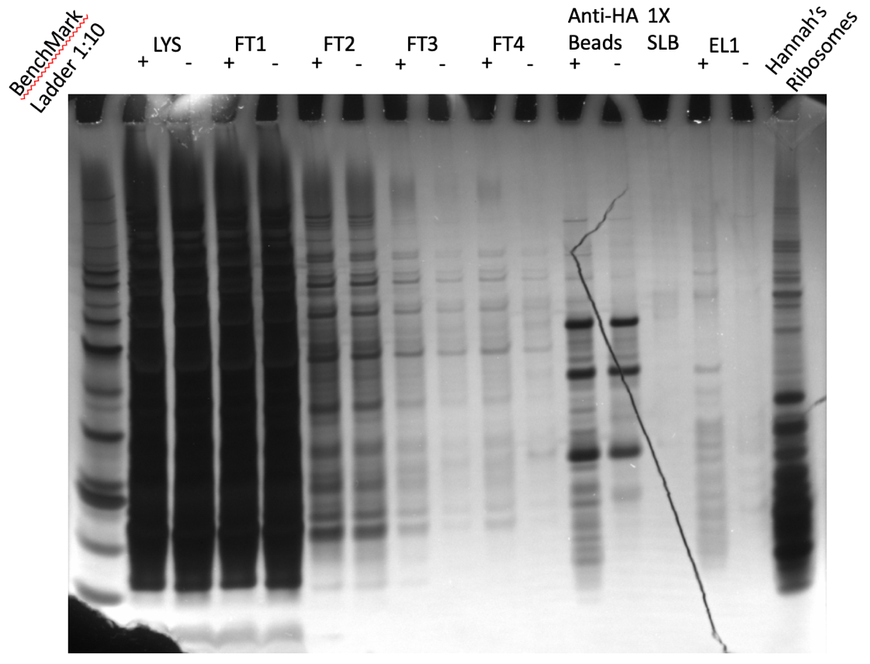

Figure 10: Silver Stain of IP with HA 12/21/23:
Although it is clear that there is good pulldown and the HA tag is specific (no bands in the LVS pF EL1 lane), as I suspected, the lower concentration elution buffer didn’t capture a lot of protein.

Note to myself that I need to make more 2X SLB but first I need to find the LDS.

Wednesday, December 27, 2023
To Do:
- Westerns and stains on HA-IP
- Image Western

Western:
For the primary antibody I added HA antibody diluted 1:1000 (because I’m worried I didn’t capture a lot of it with the low concentration elution buffer).

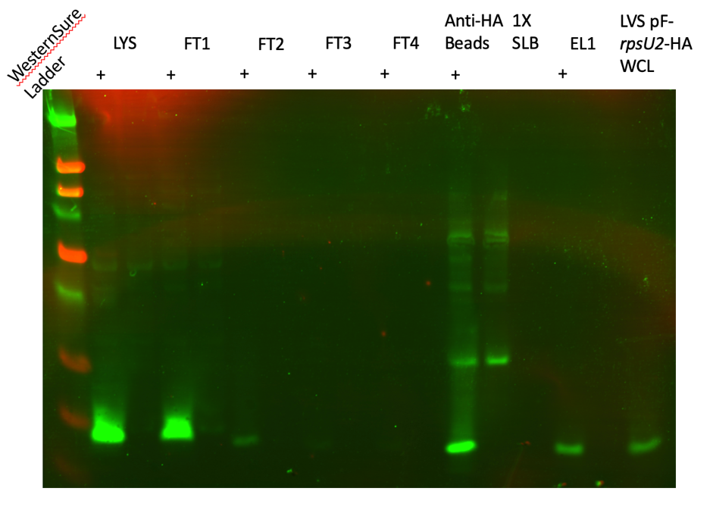

Figure 11: Western Blot of HA-IP 12/21/23:
As I suspected, the band isn’t showing very vividly in the EL1 + column

