Table of Contents
Table of Contents 1
September 2023 3
Staph PCR: 3
OD600 of LVS-pF for cell pellets at setup: 5
OD600 of LVS-pF for cell lysates at harvest: 5
Figure 1. PCR gel 6
Coomassie Stain Set up: 6
Figure 2. Coomassie Stain of IP with His 8
Silver Stain Setup: 8
Figure 3. Silver Stain of IP with His 9
Sequencing of KRSA mutants: 10
Western Blot Set up: 10
Figure 4. Western Blot of IP with His 11
Western Blot Set up: 12
Figure 5. Repeat Western Blot of with LVS-pF-rpsU2-His 13
Normalizing OD’s from Plates for Western Blot Protein Sample 14
OD Table: 15
Western Set up: 15
Figure 6. Gel of ∆FTL_0508 Fragments PCR 15
Figure 7. Gel of Repeat PCR of ∆FTL_0508 Fragments 17
Figure 8. Western Blot of New His-tagged LVS whole cell proteins 18
Figure 9: PCR gel of Flanking regions of ∆FTL_0508 with Negative and Positive Controls. 19
October 2023 20
DNA Purification Protocol – S. aureus 21
In Vitro Assay 10/25/23 24
PureExpress Delta Ribosome Kit Protocol 24
Nano-Glo® Luciferase Assay Protocol 26
Figure 10. Results of NanoGlow Luciferase Assay 27
Prepare cell lysate (Day 3) 10/26/23 28
Immunoprecipitation with His tag 10.26.23 29
Figure 11. Alignment of bL21 protein sequences of S. aureus, F. tularensis, and E. coli: 30
Silver Stain Setup: 30
Figure 12: Silver Stain of IP on LVS-pF-rpsU-His (10/26/23) 31
Figure 13: 10/27/23 Silver Stain imaged on GelDoc 36
Figure 14: Image of Western Blot on 10/27/23 IP 38

September 2023

Friday, September 1, 2023
To Do:
- Modify buffers for His IP
- Streak out LVS-pF
- Repeat His IP with new buffers
- Make MHB
- Start large overnights of LVS-pF
- Repeat KRSA PCR

The sequencing reactions had no signal and it is because I used the wrong primers to amplify the gene. I will repeat the PCR using the sequencing primers to amplify rplU.

Staph PCR:
Reaction numbers | Sample | Expected size
1 | KRSA1 gDNA | 546 bp
2 | KRSA4 gDNA ** | 546 bp
3 | KRSA1-PLBR-B gDNA | ~546 bp
4 | KRSA1-PLBR-C gDNA | ~546 bp
5 | -DNA (water) | no product

Reaction Number | Plasmid/Region | Source DNA | Primers | Length (bps)
1 | + control rplU | KRSA1 gDNA | KROL675, KROL676 | 546
2 | rplU | KRSA4 gDNA | KROL675, KROL676 | 546
3 | rplU | KRSA1_PLBR-B gDNA | KROL675, KROL676 | 546
4 | rplU | KRSA1_PLBR-C gDNA | KROL675, KROL676 | 546
5 | - control | water | KROL675, KROL676 | -

Total reaction volume | 50
Total number of reactions | 5
 |  |  |  | Factor
Component | Stock concentration | Final concentration | 1 rxn volume | 6
ddiH2O |  |  | 31.0 | 186
PrimeSTAR GXL Buffer | 5x | 1x | 10.0 | 60
dNTPs | 2.5 mM | 0.2 mM | 4.0 | 24
oligo F | 10 uM | 0.3 uM | 1.5 | 9
oligo R | 10 uM | 0.3 uM | 1.5 | 9
template | 100 ng/ul | 2 ng/ul | 1.0
PrimeSTAR GXL DNA Polymerase | 1.25 U/ul | 0.025 U/ul | 1.0 | 6
 |  | Total volume | 50 | 294

OD600 of LVS-pF for cell pellets at setup:
Sample | Observed OD600 | Calculated OD600 | Starting Volume for OD600 0.003 (ul)
LVS-pF1-1 | 0.555 | 11.1 | 135
LVS-pF1-2 | 0.626 | 12.52 | 120
LVS-pF1-3 | 0.773 | 15.46 | 97
LVS-pF1-4 | 0.76 | 15.2 | 99
These went in shaker at 7 pm.

Saturday, September 2, 2023
To Do:
- Repeat His IP with new buffers
- Make MHB
- Start large overnights of LVS-pF
- Repeat KRSA PCR
- Make LVS-pF cell pellets

OD600 of LVS-pF for cell lysates at harvest:
Sample | Observed OD600 | Calculated OD600 | Starting Volume for OD600 0.003 (ul) | OD600 at Harvest
LVS-pF1-1 | 0.555 | 11.1 | 135 | 0.348
LVS-pF1-2 | 0.626 | 12.52 | 120 | 0.342
LVS-pF1-3 | 0.773 | 15.46 | 97 | 0.337
LVS-pF1-4 | 0.76 | 15.2 | 99 | 0.358
These were harvested at ~1 pm.

Monday, September 4, 2023
To Do:
- Make LVS-pF cell pellets
- Run KRSA PCR gel and purify
- Set up sequencing reactions
- Set up Coomassie/Silver stain on His

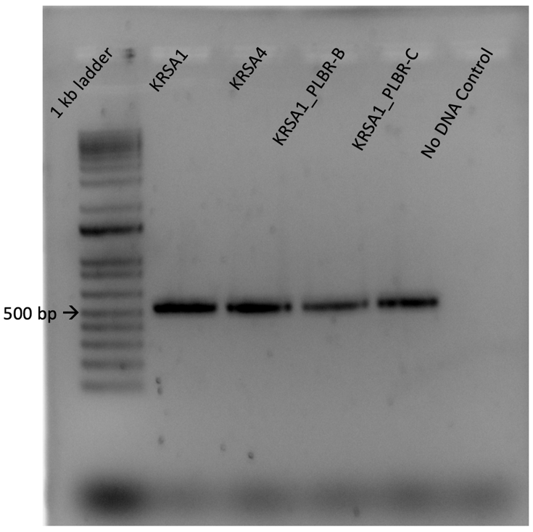

Figure 1. PCR gel
rplU is 546 bps; these bands are the correct size.
Nanodrop of KRSA_PLBR strains:
# | Sample ID | Nucleic Acid | Unit | A260 (Abs) | A280 (Abs) | 260/280 | 260/230 | Sample Type | Factor
1 | KRSA1 | 70 | ng/µl | 1.401 | 0.74 | 1.89 | 2.23 | DNA | 50
2 | KRSA4 | 65.6 | ng/µl | 1.312 | 0.703 | 1.87 | 2.46 | DNA | 50
3 | KRSA1_PLBR-B | 44 | ng/µl | 0.881 | 0.471 | 1.87 | 2.46 | DNA | 50
4 | KRSA1_PLBR-C | 49.5 | ng/µl | 0.991 | 0.545 | 1.82 | 2.43 | DNA | 50

I diluted these 1:10 to get better pipetting volumes:
# | Sample ID | Nucleic Acid | Unit | A260 (Abs) | A280 (Abs) | 260/280 | 260/230 | Sample Type | Factor
1 | KRSA1 | 6 | ng/µl | 0.12 | 0.071 | 1.7 | 5.04 | DNA | 50
1 | KRSA4 | 5 | ng/µl | 0.099 | 0.056 | 1.77 | 8.48 | DNA | 50
1 | KRSA1_PLBR-B | 3.9 | ng/µl | 0.078 | 0.043 | 1.8 | 2.6 | DNA | 50
1 | KRSA1_PLBR-C | 4.3 | ng/µl | 0.086 | 0.064 | 1.35 | -2.68 | DNA | 50

See file 20230904_KB_SequencingSubmission.

Coomassie Stain Set up:
Lane | Content | Volume
1 | Benchmark Ladder | 10 ul
2 | LVS-pF-rpsU2-His lysate | 10 ul
3 | LVS-pF lysate | 10 ul
4 | LVS-pF-rpsU2-His FT1 | 10 ul
5 | LVS-pF FT1 | 10 ul
6 | LVS-pF-rpsU2-His FT2 | 10 ul
7 | LVS-pF FT2 | 10 ul
8 | LVS-pF-rpsU2-His FT3 | 10 ul
9 | LVS-pF FT3 | 10 ul
10 | LVS-pF-rpsU2-His FT4 | 10 ul
11 | LVS-pF FT4 | 10 ul
12 | LVS pF-rpsU2 -His Ni-NTA Beads | 10 ul
13 | LVS-pF Ni-NTA Beads | 10 ul
14 | 1X SLB | 10 ul
15 | LVS-pF-rpsU2-His Eluate | 10 ul
16 | LVS-pF Eluate | 10 ul
17 | Hannah’s Ribosomes | 10 ul
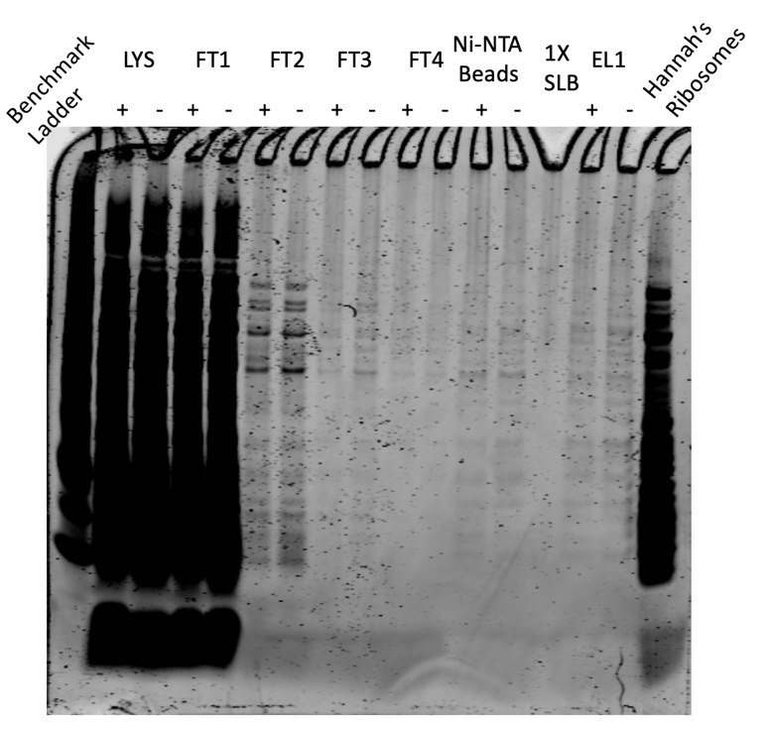

Figure 2. Coomassie Stain of IP with His
The contrast had to be turned up very high in order to see any bands beyond FT1. It is difficult to tell in this image if there is a difference between the eluate with His tag and the eluate without.

Tuesday, September 5, 2023
To Do:
- Run KRSA PCR gel and purify
- Set up sequencing reactions
- Set up Coomassie/Silver stain on His
- Set up Silver Stain on His
- Maybe make buffers for FLAG IP

Silver Stain Setup:
Lane | Content | Volume
1 | Benchmark Ladder 1:10 | 10 ul
2 | LVS-pF-rpsU2-His lysate | 10 ul
3 | LVS-pF lysate | 10 ul
4 | LVS-pF-rpsU2-His FT2 | 10 ul
5 | LVS-pF FT2 | 10 ul
6 | LVS-pF-rpsU2-His FT3 | 10 ul
7 | LVS-pF FT3 | 10 ul
8 | LVS-pF-rpsU2-His FT4 | 10 ul
9 | LVS-pF FT4 | 10 ul
10 | LVS pF-rpsU2 -His Ni-NTA Beads | 10 ul
11 | LVS-pF Ni-NTA Beads | 10 ul
12 | 1X SLB | 10 ul
13 | LVS-pF-rpsU2-His Eluate | 10 ul
14 | LVS-pF Eluate | 10 ul
15 | Hannah’s Ribosomes | 5 ul
We are out of the 17 well gels so for today I won’t include FT1.

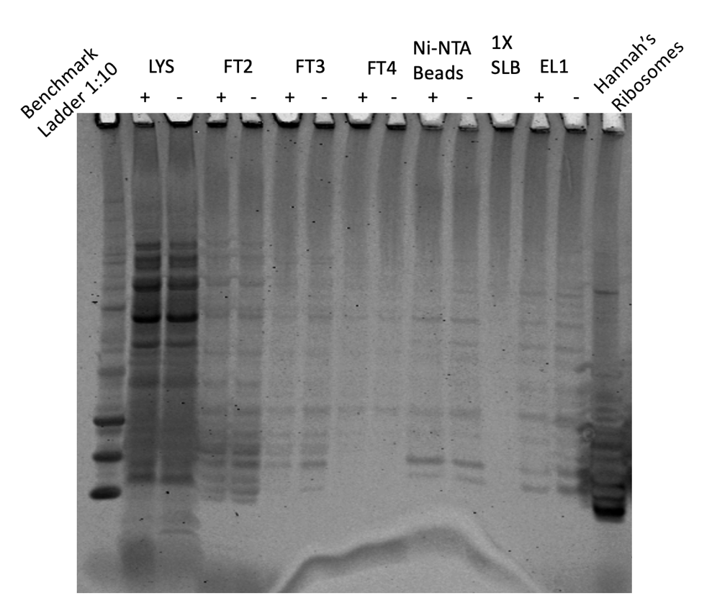

Figure 3. Silver Stain of IP with His

Wednesday, September 6, 2023
To Do:
- Set up Silver Stain on His
- Maybe make buffers for FLAG IP
- Analyze sequencing results
- Work on retreat presentation
- Western Blot on His-tag IP

Sequencing of KRSA mutants:
The sequencing results of the KRSA_PLBR mutants reveal a point mutation in the 9th amino acid of rplU, changing the amino acid from a glycine to an arginine. See file KB_230905 in Sequencing/Results folder. Kathryn and I went over the data with Steve and we are excited because the contact point to 23S rRNA is Helix 40 which to our knowledge is not a known site for antibiotic resistance. There is a ton of work to do; first and foremost is repeating the disk diffusions when we get more laurenobiolide. We would also like to get structures of the mutants by either cryo EM or X-ray crystallography (or both).
His-tag IP:
Since it still looks like the ribosome hasn’t been pulled down (there’s no difference between the His-tagged lanes and the pF-only lanes), I will run a Western to see if bS21 is still there.

Western Blot Set up:
Lane | Content | Volume
1 | WesternSure Ladder | 5 ul
2 | LVS-pF-rpsU2-His lysate | 10 ul
3 | LVS-pF lysate | 10 ul
4 | LVS-pF-rpsU2-His FT2 | 10 ul
5 | LVS-pF FT2 | 10 ul
6 | LVS-pF-rpsU2-His FT3 | 10 ul
7 | LVS-pF FT3 | 10 ul
8 | LVS-pF-rpsU2-His FT4 | 10 ul
9 | LVS-pF FT4 | 10 ul
10 | LVS pF-rpsU2 -His Ni-NTA Beads | 10 ul
11 | LVS-pF Ni-NTA Beads | 10 ul
12 | 1X SLB | 10 ul
13 | LVS-pF-rpsU2-His Eluate | 10 ul
14 | LVS-pF Eluate | 10 ul
15 | Hannah’s Ribosomes | 10 ul

Thursday, September 7, 2023
To Do:
- Maybe make buffers for FLAG IP
- Analyze sequencing results
- Western Blot on His-tag IP
- Wash and Image Western
- Work on retreat presentation

I am using the anti-His antibody at 1:500 (10ul in 5mL of blocking buffer).

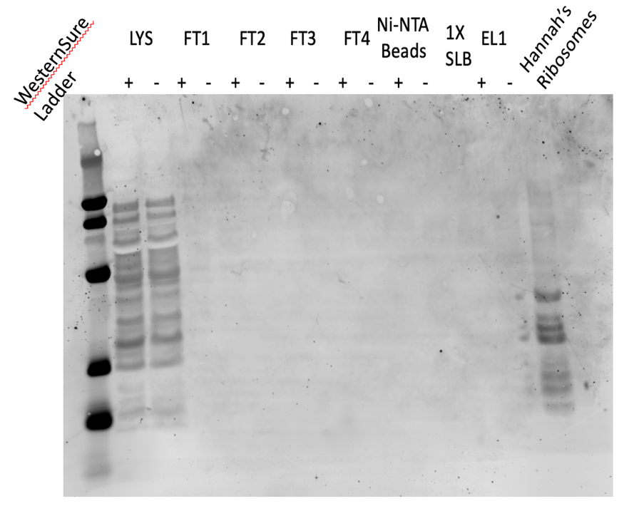

Figure 4. Western Blot of IP with His
No band for bS21.

Monday, September 11, 2023
To Do:
- Wash and Image Western
- Work on retreat presentation
- Repeat Western with whole cell protein control
Since there is no way to know if the Western went correctly, today I’m repeating it but including the whole cell proteins that I ran the original Westerns on.

Western Blot Set up:
Lane | Content | Volume
1 | WesternSure Ladder | 5 ul
2 | LVS-pF-rpsU2-His lysate | 10 ul
3 | LVS-pF lysate | 10 ul
4 | LVS-pF-rpsU2-His FT2 | 10 ul
5 | LVS-pF FT2 | 10 ul
6 | LVS-pF-rpsU2-His FT3 | 10 ul
7 | LVS-pF FT3 | 10 ul
8 | LVS-pF-rpsU2-His FT4 | 10 ul
9 | LVS-pF FT4 | 10 ul
10 | LVS pF-rpsU2 -His Ni-NTA Beads | 10 ul
11 | LVS-pF Ni-NTA Beads | 10 ul
12 | LVS-pF-rpsU2-His whole cell lysate-A | 10 ul
13 | LVS-pF-rpsU2-His whole cell lysate-B | 10 ul
14 | LVS-pF-rpsU2-His whole cell lysate-C | 10 ul
15 | LVS-pF-rpsU2-His Eluate | 10 ul
16 | LVS-pF Eluate | 10 ul
17 | Hannah’s Ribosomes | 10 ul

Tuesday, September 12, 2023
To Do:
- Repeat Western with whole cell protein control
- Label and image Western
- Start overnight cultures of LVS-pF-rpsU2-His for cell pellets
- Make MHB

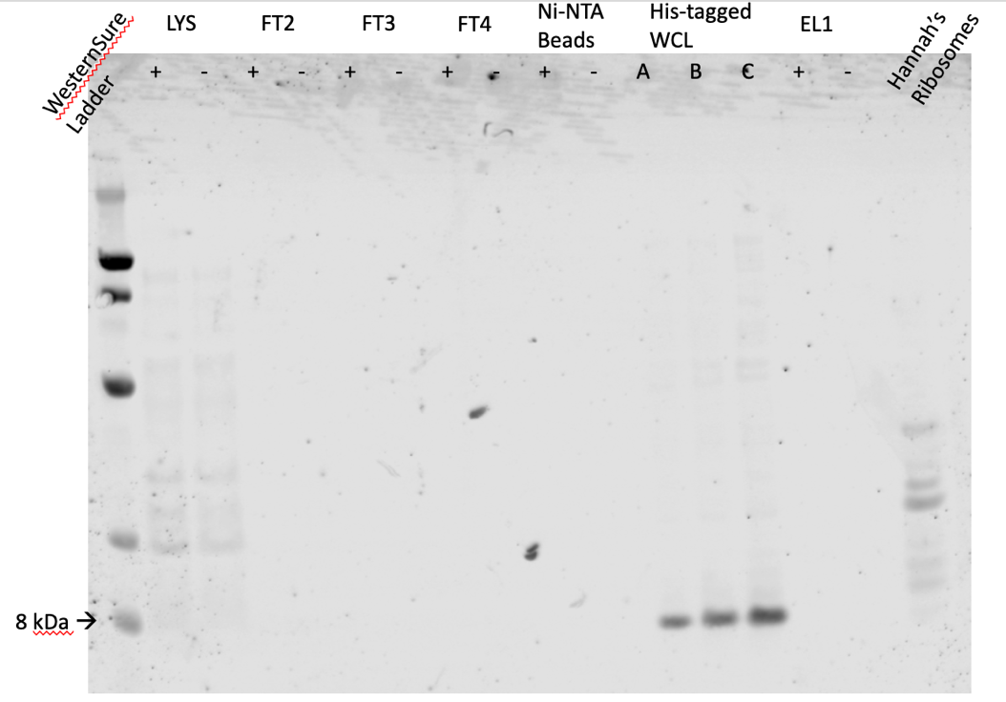

Figure 5. Repeat Western Blot of with LVS-pF-rpsU2-His
This time I included the His-tagged whole cell lysates as a control to make sure the Western was working properly. It was; bS21-2 was not pulled down during IP. Next steps are make new His whole cell lysates from frozen stock and run another Western to make sure my stocks are labeled correctly.

Wednesday, September 13, 2023
To Do:
- Label and image Western
- Start overnight cultures of LVS-pF-rpsU2-His for cell pellets
- Make MHB
- PCR with Johanyx
- Patch out LVS-His for new Western proteins
- Make iron pyrophosphate

Iron pyrophosphate:
2.5% Iron pyrophosphate (1.25g iron pyrophosphate in 50mL of ddiH₂O (type 1), dissolved overnight, fresh solution every 2 weeks (filter-sterilized)

Thursday, September 14, 2023
To Do:
- PCR with Johanyx
- Patch out LVS-His for new Western proteins
- Make iron pyrophosphate
- Supplement MHB
- Make WB proteins
- Start Western
- Run gel and PCR purify with Johanyx
- Repeat PCR
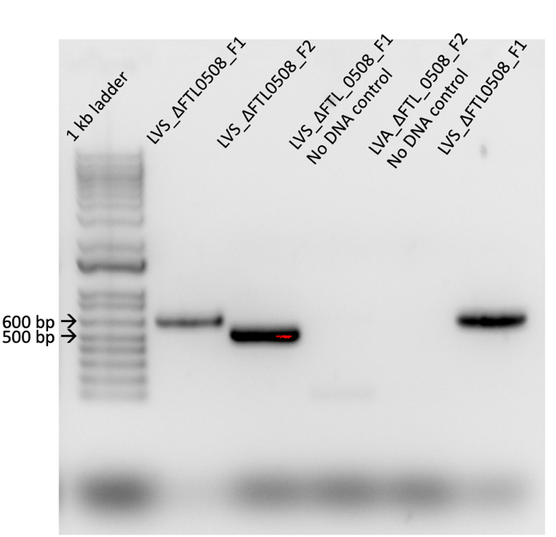
500 ml of MHB was supplemented with 5ml of 10% glucose, 5 ml of 2.5% iron pyrophosphate, and 10ml of IsoVitalex. Stored in refrigerator.

Normalizing OD’s from Plates for Western Blot Protein Sample
- In 400 uL of liquid (PBS or MHB), resuspend a loopful of a patch using aseptic technique
- Resuspend by pipetting up and down, vortex, and briefly spin in minifuge
- Gather cuvettes and add 950 mL of either clean PBS or MHB, add 50uL of your resuspension and pipet up and down to mix
- Check OD in spectrophotometer, remember to multiply by 20
- Use C1V1=C2V2 to calculate an OD of 0.3, make dilution in a total of 1 mL
- Spin down 1 mL dilution of OD 0.3 for 3 minutes at 13000 rpm and resuspend in 1 OD per 1 mL 1x Sample Loading Buffer, ie. 300 uL
- Boil in 95°C heat block for 5-10 minutes, then place in -20°C freeze

OD Table:
Sample # | Strain | Measured OD | C1 (actual OD) | V1 of culture (ml) | C2 | V2 (ml) | V of diluent (ml)
1 | LVS-pF-rpsU2-His-A | 0.179 | 3.58 | 0.08 | 0.3 | 1 | 0.92
2 | LVS-pF-rpsU2-His-B | 0.105 | 2.1 | 0.14 | 0.3 | 1 | 0.86
3 | LVS-pF-rpsU2-His-C | 0.205 | 4.1 | 0.07 | 0.3 | 1 | 0.93

Western Set up:
Lane | Content | Volume
1 | WesternSure Ladder | 5 ul
2 | LVS-pF-rpsU2-His-A | 10 ul
3 | LVS-pF-rpsU2-His-B | 10 ul
4 | LVS-pF-rpsU2-His-C | 10 ul
5 | LVS-pF-rpsU2-His-A control | 10 ul
6 | LVS-pF-rpsU2-His-B control | 10 ul
7 | LVS-pF-rpsU2-His-C control | 10 ul
8 | 1X SLB | 10 ul
9 | 1X SLB | 10 ul
10 | 1X SLB | 10 ul

PCR:

Figure 6. Gel of ∆FTL_0508 Fragments PCR
A couple of issues: there is the faintest of bands in Lane 3 (Fragment 1 negative control) at 100 bp, which is probably just a primer dimer, so not the worst thing. However, it seems there was a potential mislabeling or some other mix up because the fragments are the opposite sizes.

Given the issues with the PCR, I re-diluted the primers (and threw away the first ones) and ran PCR again:

Reaction Number | Plasmid/Region | Source DNA | Primers | Length (bps)
1 | FTL_∆0508_F1 | LVS gDNA | KROL660 and KROL661 | 531
2 | FTL_∆0508_F2 | LVS gDNA | KROL662, KROL663 | 660
3 | - control F1 | - | KROL660, KROL661 | -
4 | - control F2 | - | KROL662, KROL663 | -

Master Mix Table
Total reaction volume | 100
Total number of reactions | 4
 |  |  |  | Factor
Component | Stock concentration | Final concentration | 1 rxn volume | 5
ddiH2O |  |  | 62.0 | 310
PrimeSTAR GXL Buffer | 5x | 1x | 20.0 | 100
dNTPs | 2.5 mM | 0.2 mM | 8.0 | 40
oligo F | 10 uM | 0.3 uM | 3.0 | 15
oligo R | 10 uM | 0.3 uM | 3.0 | 15
template | 100 ng/ul | 2 ng/ul | 2.0
PrimeSTAR GXL DNA Polymerase | 1.25 U/ul | 0.025 U/ul | 2.0 | 10
 |  | Total volume | 100 | 490

Friday, September 15, 2023
To Do:
- Supplement MHB
- Make WB proteins
- Start Western
- Run gel and PCR purify with Johanyx
- Repeat PCR
- Purify PCR and run gel
- Wash and image Western

PCR:
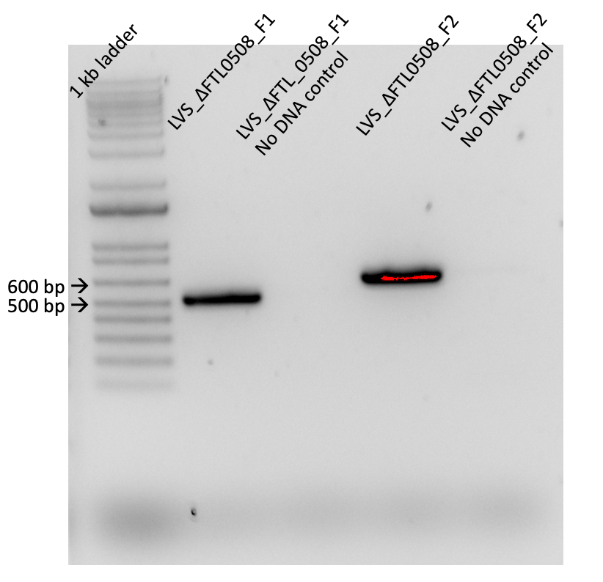

Figure 7. Gel of Repeat PCR of ∆FTL_0508 Fragments
The fragments are the correct size and there is no contamination in the No DNA control. However, there is no positive control.

Western:
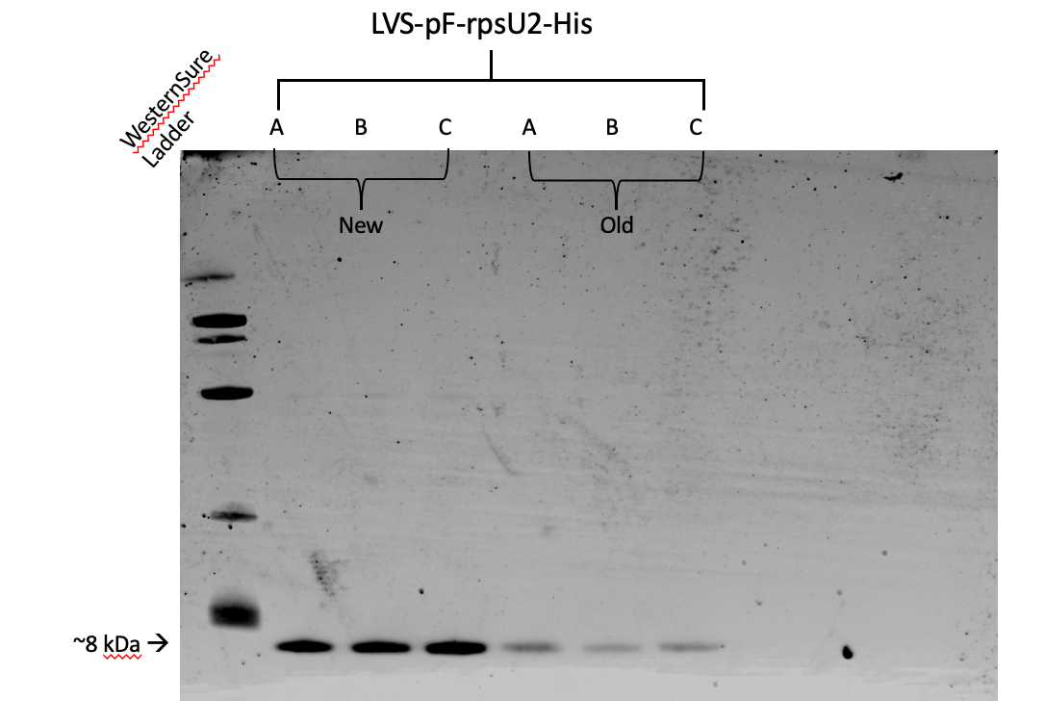

Figure 8. Western Blot of New His-tagged LVS whole cell proteins
Both the old and the new whole cell proteins are showing bands at the appropriate size for bS21-2, indicating that the glycerol stocks of LVS-pF-rpsU2-His are properly labeled.

Monday, September 18, 2023
To Do:
- Purify PCR and run gel
- Wash and image Western
- Repeat PCR with Johanyx and Christina (separately)
- Streak out LVS-pF-rpsU2-His for cell pellets
- Make MHB for large cultures

Johanyx and Christina redid their PCR, but this time they each did a set on their own. Johanyx did Fragment 1 and Christina did Fragment 2. They each included a negative control and Christina included a positive control with primers KROL3 and KROL4.

Tuesday, September 19, 2023
To Do:
- Repeat PCR with Johanyx and Christina (separately)
- Streak out LVS-pF-rpsU2-His for cell pellets
- Make MHB for large cultures
- Supplement MHB for large cultures
- Start large overnights of LVS-His
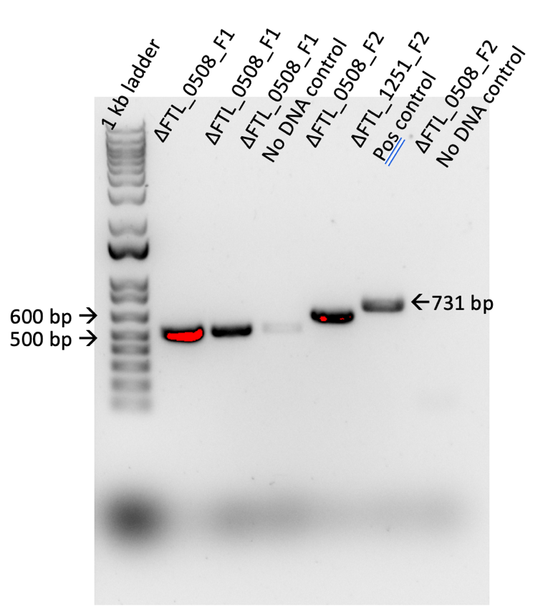

Figure 9: PCR gel of Flanking regions of ∆FTL_0508 with Negative and Positive Controls.
The PCR for Fragment 2 was successful but there is contamination for the No DNA control for Fragment 1.

Sample | Observed OD600 | Calculated OD600 | Starting Volume for OD600 0.003 (ul)
LVS-pF-rpsU2-His-A | 0.381 | 3.81 | 394
LVS-pF-rpsU2-His-B | 0.521 | 5.21 | 288
LVS-pF-rpsU2-His-C | 0.578 | 5.78 | 260
These went in the shaker at ~6pm.
Wednesday, September 20, 2023
To Do:
- Supplement MHB for large cultures
- Start large overnights of LVS-His
- Make cell pellets of LVS-His

Sample | Observed OD600 | Calculated OD600 | Starting Volume for OD600 0.003 (ul) | OD600 at Harvest
LVS-pF-rpsU2-His-A | 0.381 | 3.81 | 394 | 0.32
LVS-pF-rpsU2-His-B | 0.521 | 5.21 | 288 | 1.258
LVS-pF-rpsU2-His-C | 0.578 | 5.78 | 260 | 1.189
There was definitely contamination; the flasks for B and C were very foamy and smelly, and obviously they grew very fast. Those cultures were discarded, but I continued with Culture A to make a pellet.
The culture was harvested at 10:00am.
In addition, Johanyx repeated her PCR and Christina performed PCR on the GFP fragment for pKR201.

Thursday, September 21, 2023
To Do:
- Make cell pellets of LVS-His
- IP
After preparing the cell lysates for LVS-pF-rpsU2-His and LVS-pF, I realized I don’t have enough magnetic beads (<200ul).

October 2023

Wednesday, October 18, 2023
To Do:
- Help Alex with DDA
After a long absence due to travel and Covid, I am back in the lab. I am helping Alex, a rotating graduate student, with DDA looking for more laurenobiolide resistant mutants in S. aureus. She took the glycerol stocks I made of the colonies I froze from the last DDA (KRSA8 and KRSA9) that was done over the summer, streaked them out to single colony, and then took 3 colonies from each and froze them and started overnight cultures. Today, she is performing the DDA. She is using KRSA1 and KRSA4 as controls and she is aiming to test 2 of the colonies of each experimental sample and 1 of each control because we have very little laurenobiolide left.

Friday, October 20, 2023
To Do:
- Help Alex with DDA
- Design primers
I showed Alex how to design primers for a clean deletion of rplU in S. aureus. Briefly: we want to insert the 2 flanking regions between KpnI and BamHI with a NotI site in between the fragments. To get a NotI site, we designed an alanine linker of 3 alanines.

Sunday, October 22, 2023
To Do:
- Design primers
- Patch out LVS-pF-rpsU_his

Monday, October 23, 2023
To Do:
- Patch out LVS-pF-rpsU-His
- Order primers
- Extract S. aureus gDNA
- Repeat ligation with Johanyx
- Start large overnight cultures of LVS-pF-rspU-His

DNA Purification Protocol – S. aureus
Cell Samples
1. Dilute lysostaphin in Tissue and Cell Lysis Solution to 1 mg/mL (i.e. 30 ul of 10 mg/ml stock in 270 ul TCL)
2. Add lysozyme crystals to 1 mg/mL and dissolve by pipetting up and down. (Made a 20 mg/mL stock solution and added 15ul of that stock to the TCL.)
3. Pellet 0.5 mL of an overnight culture by centrifugation and discard the supernatant, leaving approximately 25 µl of liquid.
4. Vortex for 10 seconds to resuspend the cell pellet.
5. Add 300 ul of Tissue and Cell Lysis Solution containing the lysozyme and lysostaphin and mix thoroughly. (We added 315ul of the solution to include the stock solution of lysozyme)
6. Incubate at 37°C for 30 minutes
7. Add 1 ul of Proteinase K to each sample and mix thoroughly.
8. Incubate at 65°C for 15 minutes; vortex every 5 minutes.
9. Cool the samples to 37°C and add 1 µl of 20 mg/ml RNase A to the sample; mix thoroughly.
10. Incubate at 37°C for 30 minutes. Cool down the centrifuge.
11. Place the samples on ice for 3-5 minutes and then proceed with total DNA precipitation (below).
Precipitation of Total DNA (for all biological samples)
1. Add 150 µl of MPC Protein Precipitation Reagent to 300 µl of lysed sample and vortex vigorously for 10 seconds.
2. Pellet the debris by centrifugation at 4°C for 10 minutes at ≥10,000 x g in a microcentrifuge. If the resultant pellet is clear, small, or loose, add an additional 25 µl of MPC Protein Precipitation Reagent, mix, and pellet the debris again.
3. Transfer the supernatant to a clean microcentrifuge tube and discard the pellet.
4. Add 500 µl of isopropanol to the recovered supernatant. Invert the tube 30-40 times.
5. Pellet the DNA by centrifugation at 4°C for 10 minutes in a microcentrifuge.
6. Carefully pour off the isopropanol without dislodging the DNA pellet.
7. Rinse twice with 1 ml 70% ethanol, being careful to not dislodge the pellet. Centrifuge briefly if the pellet is dislodged. Remove all of the residual ethanol with a pipet and let dry completely under hood.
8. Resuspend the DNA in 35 µl of 0.1x EB Buffer. Put on ice to help dissolve and add 50 µl of additional buffer if DNA is very goopy.
9. Check concentration and purity by nanodrop.

Staph gDNA Extraction
Reagent | Volume (ul) | Master Mix 3.5X
TCL | 270 | 945
Lysostaphin | 30 | 105
lysozyme | 15 | 52.5
Total volume | 315 | 1102.5

Sample | Observed OD600 | Calculated OD600 | Starting Volume for OD600 0.003 (ul)
LVS-pF-rpsU2-His-1 | 0.626 | 6.26 | 240
LVS-pF-rpsU2-His-2 | 0.529 | 5.29 | 284
LVS-pF-rpsU2-His-3 | 0.741 | 7.41 | 202

Tuesday, October 24, 2023
To Do:
- Order primers
- Start large overnight cultures of LVS-pF-rspU-His
- Make IP cell pellets
- Repeat ligation and transformation with Johanyx
- Start overnights of S aureus colonies

IP cell pellets:
Sample | Observed OD600 | Calculated OD600 | Starting Volume for OD600 0.003 (ul) | OD600 at Harvest
LVS-pF-rpsU2-His-1 | 0.626 | 6.26 | 240 | 0.32
LVS-pF-rpsU2-His-2 | 0.529 | 5.29 | 284 | 0.314
LVS-pF-rpsU2-His-3 | 0.741 | 7.41 | 202 | 0.308
These incubated from 6:15pm to 9:45am
Johanyx’s ligation and transformation:
Johanyx’s first ligation didn’t work (no growth on the transformation plates), so we are trying a different molar ratio. We set up 2 ligations: one with a 3X reaction and the other with 5X. She made a master mix for each ratio and set up a ligation reaction and a vector only control for each. We did a bench top ligation where they incubated at RT for 10 minutes. We immediately proceeded to transformation, but there were only enough LB-Kan plates to set up the 3X reaction with a positive and negative control. We poured new LB-Kan plates and we will perform the 5X reaction later this week.
I started overnight cultures of the new LB-resistant KRSA colonies: KRSA8B1.1-A, KRSA8B1.1-B, KRSA8B-1.2-A, KRSA8B1.2-B.

Wednesday, October 25, 2023
To Do:
- Make IP cell pellets
- Repeat ligation and transformation with Johanyx
- Start overnights of S aureus colonies
- In vitro translation assay with laurenobiolide
- 5X transformation with Johanyx
- Make glycerol stocks and cell pellets of S. aureus cultures

Johanyx’s Transformations:
The 3X ligation didn’t work. There was growth on the positive control and no growth on the negative control, and no growth on any ligation or vector only plates. She is setting up a transformation on the 5X today, and if that doesn’t work and they will go back a few steps and repeat the digest.

In vitro translation assay:
We want to begin investigating the mechanism of antibiotic resistance of laurenobiolide, so Alex and Ben and I are performing an in vitro translation assay so we can see if laurenobiolide halts translation. We are using ribosomes that Ben isolated from E coli, which is resistant to laurenobiolide in vivo, but we want to know if translation will be inhibited if we directly deliver the antibiotic to the ribosome. Thiostrepton is a ribosome targeting antibiotic that has been demonstrated to halt translation in this particular protocol, so we are using that as a positive control. We are testing laurenobiolide activity at 2 concentrations: 45.8 mM and 4.58 mM.

In Vitro Assay 10/25/23

PureExpress Delta Ribosome Kit Protocol
- Set up PCR reaction tubes.
Tube | Purpose
1 | No abx
2 | Methanol
3 | Thiostrepton (50 uM)
4 | Laurenobiolide high (45.8 uM)
5 | Laurenobiolide low (4.58 uM)
6 | DMSO
7 | No ribosomes
- Thaw all components on ice. Pulse-spin in microfuge to collect solutions to bottom of tubes. If Solution A has precipitates, mix well prior to assembling reaction. Do not vortex Solution B.
  - Solution A
  - Factor Mix
  - Phenol-chloroform purified pKR144
  - Kit ribosomes
  - Laurenobiolide
  - Thiostrepton
- Dilute DNA in 0.1xEB to a concentration of 125 ng/uL.
Sample | Concentration (C1) | Desired Conc. (C2) | Desired Volume (V2) | Sample Volume (V1) | Buffer Volume
Phenol:chloroform purified pKR144 | 457.4 ng/uL | 125 ng/uL | 20 uL | 5.47 uL | 14.53 uL
- Prepare stocks of Laurenobiolide, Thiostrepton, and DMSO
- Add components in the following order:
Solution A | 10 uL
Factor Mix | 3 uL
Ribosomes | 5.62 uL (59.85 pmol/reaction)
Template DNA | 2 uL
Treatment | 0.5 uL
Water | 8.88 uL
Total | 30 uL

Tube | Solution A | Factor Mix | Ribosomes | DNA (125 ng/uL) | Treatment | Water
1 | 10 uL | 3 uL | 5.62 uL 6/7 E. coli 2 | 2 uL Phenol:chloroform purified pKR144 | - | 9.38 uL
2 | 10 uL | 3 uL | 5.62 uL 6/7 E. coli 2 | 2 uL Phenol:chloroform purified pKR144 | 0.5 uL Methanol | 8.88 uL
3 | 10 uL | 3 uL | 5.62 uL 6/7 E. coli 2 | 2 uL Phenol:chloroform purified pKR144 | 0.5 uL Thiostrepton | 8.88 uL
4 | 10 uL | 3 uL | 5.62 uL 6/7 E. coli 2 | 2 uL Phenol:chloroform purified pKR144 | 0.5 uL Laurenobiolide (45.8 uM) | 8.88 uL
5 | 10 uL | 3 uL | 5.62 uL 6/7 E. coli 2 | 2 uL Phenol:chloroform purified pKR144 | 0.5 uL 1:10 Laurenobiolide (4.58 uM) | 8.88 uL
6 | 10 uL | 3 uL | 5.62 uL 6/7 E. coli 2 | 2 uL Phenol:chloroform purified pKR144 | 0.5 uL DMSO | 8.88 uL
7 | 10 uL | 3 uL | - | 2 uL Phenol:chloroform purified pKR144 | - | 15 uL
- Mix gently and pulse-spin in microfuge to collect mixture at the bottom of the tube
- Incubate at 37C for 2 hours in thermocycler
- Stop the reaction by placing tubes on ice, spin them down first.
- Freeze at -20C.

Nano-Glo® Luciferase Assay Protocol
- Prepare plate map and list samples and controls (the samples are spaced apart because the fluorescence tends to bleed)
 | 1 | 2 | 3 | 4 | 5 | 6 | 7 | 8 | 9 | 10 | 11 | 12
A | Rxn 1 |  |  |  |  | Rxn 2 |  |  |  |  | Rxn 3
B
C
D
E | Rxn 4 |  |  |  |  | Rxn 5 |  |  |  |  | Rxn 6
F
G
H |  |  |  | Rxn 7 |  |  |  |  | Buff and Sub |  |  | Buff
- Thaw reactions on ice
- Thaw Nano-Glo® Luciferase Assay Buffer and Nano-Glo® Luciferase Assay Substrate on ice – mix by pipetting
- Prepare appropriate volume of reconstituted reagent by combining 1 volume of substrate with 50 volumes of buffer and mix by pipetting
  - Add 2 to the number of reactions you will need to run, this will be the volume of substrate
  - Multiply this number by 50 to get volume of buffer
  - For 450 uL of reagent mix 450 uL of buffer with 9 uL of substrate
- Bring 96-well plate, an aliquot of H10M10A50 buffer, the reconstituted reagent, a small waste beaker, the flash drive, and the reactions on ice as well as a 200 uL pipettor and tips to the plate reader
- Add reactions to designated wells
- Turn on the plate reader and wait for it to initialize
- Select appropriate protocol
- Add equal volume of assay substrate to reaction volume (30 uL) – mix by pipetting
- Set timer for 3 minutes
- Read the plate on the appropriate settings
Note: Ensure luminescence values remain within the linear range of 10^3 and 10^8
- Export data as Excel file and save to flash drive
- Save reactions in 1.5 mL microcentrifuge tubes in -20C for future Western blots
Results:

Figure 10. Results of NanoGlow Luciferase Assay
When we read the plate the first time, the exposure was too high (Gain135), so we lowered it to 100. Thiostrepton was a successful control, the signal was much lower than any other reading (Well 11). The laurenobiolide did not inhibit translation at either concentration. It could be that E. coli truly is resistant to laurenobiolide, or we need to increase the concentration of the antibiotic.

S. aureus:
I made glycerol stocks of the overnight cultures by mixing 800ul of culture into 200 ul of 75% glycerol. I made 2 stocks per culture. The rest of the culture was used to make cell pellets for subsequent gDNA extraction by spinning about 1.5ml of culture at max speed for 1 minute, discarding the supernatant, and spinning until all culture is in a pellet. Glycerol stocks are stored in KRSA strains box 1 in -80 (5G). The pellets are stored in my Staph box 3 8C.

Thursday, October 26, 2023
To Do:
- In vitro translation assay with laurenobiolide
- 5X transformation with Johanyx
- Make glycerol stocks and cell pellets of S. aureus cultures
- Immunoprecipitation of LVS-rpsU2-His
- Align bL21 sequences
Immunoprecipitation:
Today I am performing IP on LVS-pF-rpsU2-His and this time I am going to increase the imidazole concentration in each step.
Reagent | Total Volume Needed for Protocol
Buffer A + PI + BB | 20 ml
DNAse | 20 ul
1 M NH4Cl | ~800 ul
10 % NP-40 | ~80 ul
Ni-NTA Beads | 400 ul
Buffer B 10 mM Imidazole | 18 ml
Buffer B 20 mM Imidazole | 30 ml
Elution Buffer 500 mM Imidazole | 5 ml

Prepare cell lysate (Day 3) 10/26/23
Required reagents:
Buffer A + PI + BB Bug Buster (see recipe at end)
DNase I (Lucigen Corporation # D9905K)
30 mL syringe
MillexGP 0.22 micrometer syringe filter
Nonsterile 50 mL conical tubes
Microfuge tubes

1M NH₄Cl
10% NP-40

- Check for stock solutions; make Buffer A+ PI +BB if not enough in freezer (~10 mL per sample), prepare Buffer B if not enough at 4°C.
- Write out samples in table:

Sample # | Date | Genotype of Cells | Volume of Cells | OD600 at Harvest
1 | 10/24/23 | LVS-pF-rpsU2-His-1 | 500 ml | 0.32
2 | 9/2/23 | LVS-pF-3 | 500 ml | 0.337

- Resuspend samples in 10 mL Buffer A + PI + BB by pipetting with 5 mL pipette. Be sure no clumps remain.
- Add 10 uL DNase I (Lucigen/Epiceter), mix by pipetting. DNase I went in ~ 5 minutes after lysis buffer due to still being frozen
- Incubate at 37°C for 30’. Cool down centrifuge while waiting.
- Spin conical tubes at 4°C for 20’ at max speed (14635xg).
- Transfer lysates into new 50 mL conical tubes, leaving behind insoluble material at bottom (okay to leave some behind; better than taking too much).
- Filter-sterilize lysates using 30mL syringe and syringe filter into new (nonsterile) 50mL conical tube. Specifically, pull plunger out from 30mL syringe, thread tip of syringe onto syringe use filter (use MillexGP 0.22 micrometer filter, has 33mm diameter), pour/pipette lysate into syringe, insert plunger and recover filtered lysate into new (nonsterile) 50mL conical tube.
- Obtain a good estimate of sample volume using pipette. 7.5 ml for both samples
- Adjust buffer concentration to Buffer B by adding to each sample:
100 uL 1M NH₄Cl / mL sample for final concentration of 100 mM NH₄Cl 750 ul for both samples
10 uL 10% NP-40 /mL sample final concentration of 0.1% NP-40 75 ul for both samples
- Remove 50 uL into microfuge tube for control analysis (LYS).

Immunoprecipitation with His tag 10.26.23
In cold room
- Cut tip of 1mL pipette tip slightly.
- Resuspend Ni-NTA magnetic beads in storage solution.
- Pipette 200 uL magnetic beads into 50 ml conical.
- Wash beads with 3 mL of Buffer B with 10mM imidazole 3 times. Using the magnetic rack, wait until the beads have completely gone towards the magnet before removing the liquid.
- Add 1 sample per tube, close tube and make sure and it is not dripping liquid.
- Incubate samples with beads, rocking on their sides at 4°C, for 1 hour.

- After 1 hour incubation, place on magnetic rack. Tubes fell off rotator for an unknown period of time, but the beads were soaking in the buffer
- Save 50 uL aliquot of flow through in microfuge tube (FT1), discard remaining.
- Wash beads 3x with 5 mL Buffer B with 20mM imidazole, discard flow through but save 50 ul from each wash (FT2-4).
- Add 2 mL KBE-1 buffer with 500 mM imidazole
- Incubate rocking at 4°C for 5 minutes.

- Recover eluates by magnetic rack (~2 mL) and put in new 50 ml conical.
- Rinse beads with additional 300 μl of Elution Buffer and add that to the 50 ml conical.
- Aliquot 50 uL of each recovered sample into microfuge tube, 4x, for later analysis. Transfer remaining samples into clearly labeled microfuge tubes (2 per sample) and store all samples at -80°C.

- Keep 50ul of beads from each sample and store in -20ºC. The bead aliquot with LVS-pF-rpsU2-His are less concentrated than the negative control bead aliquot

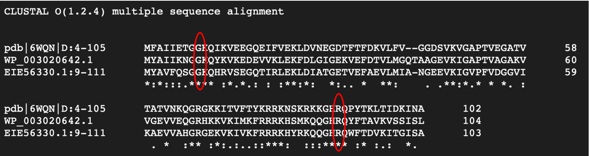

Figure 11. Alignment of bL21 protein sequences of S. aureus, F. tularensis, and E. coli:
The mutations observed so far in rplU in S. aureus are in amino acids 9 and 89. I aligned the protein sequences of bL21 from S. aureus, F. tularensis, and E. coli using Clustal Omega to see if there is a difference between bL21 protein of Staph and LVS, which are susceptible to laurenobiolide, and E. coli, which is resistant (in vivo). In all 3 species those amino acids are the same at those positions. These results suggest that perhaps E. coli is susceptible after all and we need a higher concentration of laurenobiolide to see an effect in vitro.

Friday, October 27, 2023
To Do:
- Immunoprecipitation of LVS-rpsU2-His
- Align bL21 sequences
- Make 75% glycerol
- Show Alex how to reconstitute primers
- Silver Stain on His IP

Silver Stain Setup:
Lane | Content | Volume
1 | Benchmark Ladder 1:10 | 10 ul
2 | LVS-pF-rpsU2-His lysate | 10 ul
3 | LVS-pF lysate | 10 ul
4 | LVS-pF-rpsU2-His FT1 | 10 ul
5 | LVS-pF FT1 | 10 ul
6 | LVS-pF-rpsU2-His FT2 | 10 ul
7 | LVS-pF FT2 | 10 ul
8 | LVS-pF-rpsU2-His FT3 | 10 ul
9 | LVS-pF FT3 | 10 ul
10 | LVS-pF-rpsU2-His FT4 | 10 ul
11 | LVS-pF FT4 | 10 ul
12 | LVS pF-rpsU2 -His Ni-NTA Beads | 10 ul
13 | LVS-pF Ni-NTA Beads | 10 ul
14 | 1X SLB | 10 ul
15 | LVS-pF-rpsU2-His Eluate | 10 ul
16 | LVS-pF Eluate | 10 ul
17 | Hannah’s Ribosomes | 5 ul

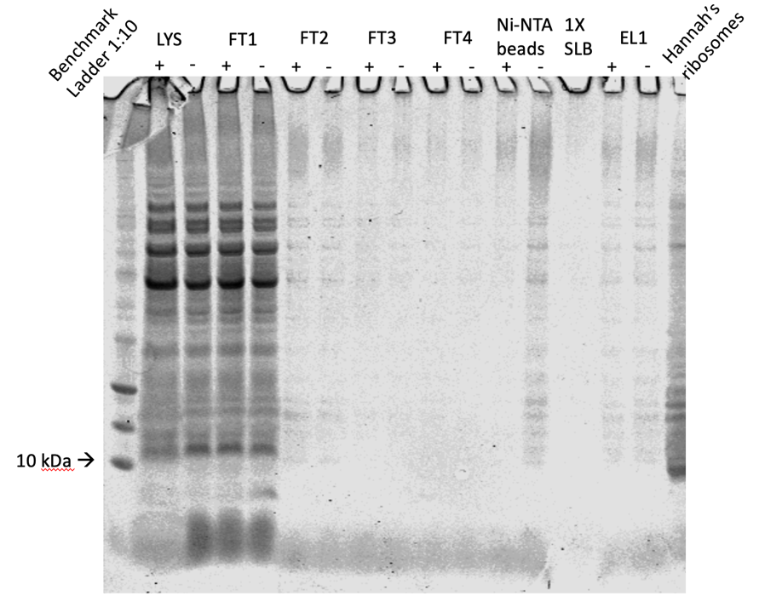

Figure 12: Silver Stain of IP on LVS-pF-rpsU-His (10/26/23)
The bands are very faint, but it looks like the eluates for both LVS-pF-rpsU2-His and LVS-pF have identical banding patterns. In lab meeting we discussed the possibility that bS21-2 may have been pulled down but it is not complexed to the ribosome. I will run Westerns on these samples to see if at least bS21-2 was pulled down.

I made 50 ml of 75% glycerol.
Alex successfully reconstituted the rplU primers and made the diluted concentrations.

Monday, October 30, 2023
To Do:
- Make 75% glycerol
- Show Alex how to reconstitute primers
- Westerns on IP samples (gel and transfer)
- PCR check on rplU flanking region primers with Alex

Western Blot Gel Setup:
Lane | Content | Volume
1 | WesternSure Ladder | 5 ul
2 | LVS-pF-rpsU2-His lysate | 10 ul
3 | LVS-pF lysate | 10 ul
4 | LVS-pF-rpsU2-His FT1 | 10 ul
5 | LVS-pF FT1 | 10 ul
6 | LVS-pF-rpsU2-His FT2 | 10 ul
7 | LVS-pF FT2 | 10 ul
8 | LVS-pF-rpsU2-His FT3 | 10 ul
9 | LVS-pF FT3 | 10 ul
10 | LVS-pF-rpsU2-His FT4 | 10 ul
11 | LVS-pF FT4 | 10 ul
12 | LVS pF-rpsU2 -His Ni-NTA Beads | 10 ul
13 | LVS-pF Ni-NTA Beads | 10 ul
14 | LVS-pF-rpsU2-His Eluate | 10 ul
15 | LVS-pF Eluate | 10 ul
16 | His-tagged WCL | 10 ul
17 | 1X SLB | 10 ul

Running the gel
- Prepare 1x Loading buffer
  - 250 uL NuPage LDS sample buffer (4x, room temp)
  - 100 uL 0.5 M DTT (-20C)
  - 650 uL dH2O
- Resuspend pellet in 1x loading buffer
  - Normalize to ODs
- Heat at 98C for 10 min
- Assemble gel chamber
  - Use pre-cast NuPAGE 4-12% Bis-Tris gel (we also have 10% and 12% gels as necessary)
  - Words on cassette should face towards back of chamber
- Make running buffer – 400 mL for 1 gel, 800 mL for 2 gels
  - 1 x MOPS for large proteins
  - 1x MES for <50 kD proteins
    - 380 mL ddiH2O
    - 20 mL 20x MES
    - 1 mL NuPAGE antioxidant
  - Make sure front section is full so that gels are covered in liquid. Back section does not need to be completely full.
- Use 200 ul pipet to wash wells of gel added 1x SLB to see the wells
- Load 6-10 uL of each sample, based on linear range calculations for each antibody.
As of 2022, we use 5 ul of WesternSure ladder from LiCor which is brighter to see if you are cutting the blot (in -20C freezer). If not cutting, can use 1 uL 1:10 diluted BioRad Precision Plus Dual Color Protein Ladder (#161-0374) for the ladder (in 4C fridge).
- Run at 150V until the blue dye front reaches the bottom ridge of the gel (45 mins to 1 hour, depending on running buffer) Ran at 90V for a little over an hour
Wet transfer
- Make transfer buffer in a 1 L bottle.
For transferring 1 gel:
50 mL methanol
25 mL NuPAGE 20x transfer buffer
water to 500 L
For transferring 2 gels, double above.

- Store in freezer to chill until the gel has stopped running.
- When the gel has about 10 minutes remaining, begin setting up the transfer.
- Remove transfer buffer from freezer and add 0.5 mL NuPAGE antioxidant (1 mL for 2 gels)
- Activate PVDF membrane (must use Millipore Immobilon-FL #IPFL00010) in ethanol (can do in a tip box). For a full gel, cut to approximately 6 cm x 8 cm using pre-made guide.
- In a large container (9”x9” Pyrex baking dish, for example), presoak membrane, 2 filter papers cut to membrane size, and 2-3 sponges (per gel) in transfer buffer. Use a roller to push bubbles out of the sponges.
- Open gel case, cut off wells and at the bottom ridge on the gel (including any blue dye leftover) and place wet sheet of filter paper on the gel.
- Peel gel and filter paper off and place wet membrane on gel.
- Place other filter paper on membrane and roll out bubbles
- Dunk the transfer cassette halves in the transfer buffer and begin assembling sandwich:
1 sponge
filter/membrane/gel/filter sandwich so that the membrane is on top of the gel
1 more sponge
*if sponges are old and thin, may need to use 3 total. You want the transfer apparatus to have a very tight seal, so if it doesn’t add another sponge.
- Close transfer apparatus and clamp into the gel box.
- Fill the inside chamber with transfer buffer so that it is completely full. Should use remaining transfer buffer from the Pyrex dish. Place the gel box into a large rectangular freezer bucket. Close the lid tightly, and cover the whole gel box with ice.
- Run at 20V for 1 hour.
- Complete No-Stain total protein quantification protocol now, if applicable
Blocking and probing
- Block the membrane with Li-Cor Intercept Blocking Buffer (PBS) diluted 1:5 in PBS. Use ~25 mL or enough to cover the membrane and rock for 1 hour or overnight at room temperature. DO NOT add any detergents (Surfact-Amps, Tween, SDS) to the blocking buffer.
- Store diluted blocking buffer at 4C.

rpsU in S. aureus:
pKR95 is the plasmid that was designed to delete rpsU from S. aureus
F1 primers are KROL419 and 420 (1015 bp)
F2 primers are KROL421 and 411 (969 bp)
Primers were validated by HT on 1/27/22
Fragments were digested by DF on 2/11/22
Ligations were repeated several times, adjusting the ratios
Transformations were repeated several times, adjusting Cm concentration
Used Xgal to see plasmid
Initial transformations were into E. coli IMO8B
First successful ligation was transformed into DH5-α on 3/5/22
Sent to sequencing; unclear if they got the results
Seems that Dan may have gotten a single 1º integrant after several transformations, this is where the project pauses.

Tuesday, October 31, 2023
To Do:
- Westerns on IP samples (gel and transfer)
- PCR check on rplU flanking region primers with Alex
- PCR to amplify rplU flanking regions with Alex
- Finish Westerns and image
- Digest of ∆mpl with Johanyx
- Image Silver Stain on the GelDoc

Alex’s test PCR looks good, next she’s amplifying the flanking regions of rplU.
Kathryn told me it’s better to image Silver Stain gels on our GelDoc rather than going to Inbre to use the LiCor. My gel from last week had been hanging out in water so I was able to get an image on the GelDoc:
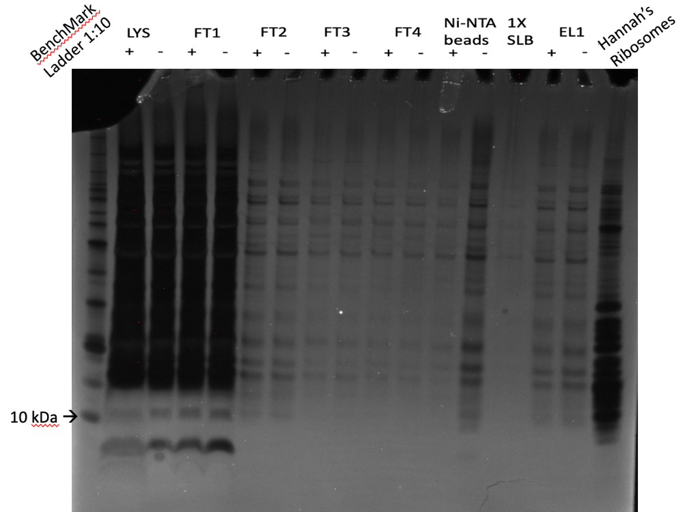

Figure 13: 10/27/23 Silver Stain imaged on GelDoc
Although it is a lot easier to see the bands in each lane, this image does not reassure me because EL1 + and EL1 – still look identical.
Westerns:
I made more diluted blocking buffer by adding 100ml of Intercept blocking buffer to 400ml of sterile 1X PBS.
Next day:
- Add antibodies (must be from two different species, such as mouse and rabbit, eg, rabbit anti-VSVG and mouse anti-sigma⁷⁰) in 10 mL of blocking buffer (no detergent). Rotate for 1 hour at room temperature. Used anti-His at 1:1000
- Meanwhile, make wash buffers: (this recipe is sufficient for 3-4 blots, scale up or down accordingly)
1x Wash Buffer (500 mL)
50 mL 10X PBS
450 mL dH20
- Split into two separate bottles, 400 mL and 100 mL.
- To the 400 mL bottle, add 2 mL Surfact-Amps. This is your primary wash buffer. The remaining 100 mL will be for the final two washes after the secondary antibody, to remove traces of detergent, which may show up as background on the Li-Cor.
- Wash 4x on rotator for 10 minutes each, using 10-20 mL wash buffer per wash.
- Use 10-20 mL diluted blocking buffer and block again, for 15-30 min. I blocked for 30 minutes
- Add 1 uL of each IRDye secondary antibody to 10 mL wash buffer (the one with Surfact-Amps, aka PBS-T). Also add 0.01% SDS to the wash buffer (10 uL of 10% SDS). These secondary antibodies are stored at 4C. Used mouse antibody
Note from Dove lab: use 800CW [green channel] if only detecting one protein; if detecting two proteins, use 800CW for the less abundant protein

- Label for 1 hour on rocker at room temperature. Cover the box with foil or use a black box (the secondary antibodies are light sensitive).
- Wash 4x on rotator for 10 minutes each, using 10-20 mL wash buffer per wash.
- Wash 2x on rotator for 10 minutes each, using 10-20 mL of wash buffer WITHOUT detergent.
- If faint bands are expected, do a quick methanol rinse by dunking the blot in methanol for 2 seconds then letting air dry for 2 minutes prior to imaging.
Imaging
- Leave the membrane in the box containing the final wash buffer. Bring the box, gloves, forceps, and a timer to the imager in the INBRE facility.
- For imaging, use 84 uM resolution and “high”clarity. Select both 700 and 800 channel

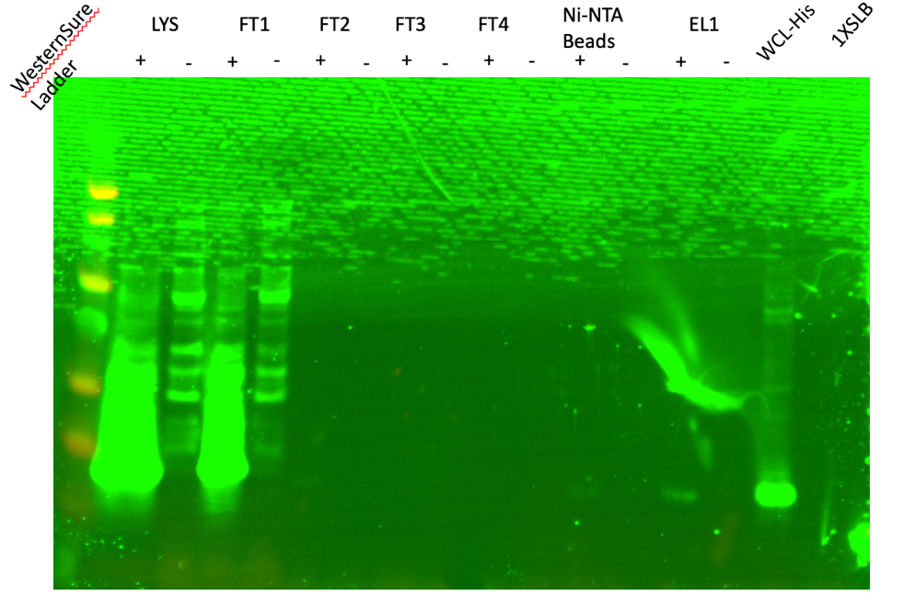

Figure 14: Image of Western Blot on 10/27/23 IP
It is so faint but bS21 is there in the eluate and not there in the negative control!!! Given that the eluates look identical on the Silver Stain it’s possible that only bS21 was pulled down without the ribosome. I might have to adjust the buffers and see if that will help get the whole ribosome.

Repeat Digest of mpl fragments:
Johanyx is going to repeat the digest for ∆mpl (fka FTL_∆0508). The intention is not to go so long between digest and gel extraction like we did last time (~2-3 weeks). All 3 restriction enzymes in these reactions are Time Saver qualified, which means we can incubate the reactions for 5-15 minutes (per NEB website)

