Table of Contents
July 2023 2
Disk Diffusion Assay for Staph 3
Figure 1. Test Disk Diffusion Assay 6
Figure 2. Disk Diffusion Results of Colony that Grew in Zone of Inhibition of KRSA1 14
August 2023 14
Prepare cell lysate 14
Immunoprecipitation with His tag 15
Coomassie Stain 16
Imaging Coomassie Stain 19
Figure 3. Coomassie Stain of LVS-pF-rpsU2-His 19
Figure 4. Silver Stain of LVS-pF-rpsU2-His 20
DNA Purification Protocol – S. aureus 21
Figure 5. Better Silver Stain of LVS-pF-rpsU2-His 23
Lysostaphin Preparation (10 mg/mL) 24
Figure 6: Coomassie Stain of second 6XHis IP 29
Figure 7: Gel of KRSA PCR 31
Figure 8: Silver Stain of IP with His 33

July 2023

Wednesday, July 5 2023
To Do:
- Make KRSA-1 competent cells
- Miniprep pKR198
- Patch out pKR185 frozen aliquots
- Prepare sequencing reaction for pKR198
- Prepare media for large cultures
- Patch out tagged LVS strains for large cultures
- Transform pKR186 into KRSA1
- Repeat transformation of pKR198

I was supposed to have set up the pKR198 transformation into E coli and incubate them at RT, not 37ºC. Although I’ll still send the miniprep to sequencing, I will repeat the transformation:

Reaction table
Tube number | Purpose | DNA | Volume of DNA | Final volume to plate | Number of carbenicillin-containing plates
1 | (+) control | pEPSA5 | 1 uL | 20 ul, 100 ul | 2
2 | (-) control | None | 0 | 20 ul, 100 ul | 2
3 | Backbone Ligation | pEPSA5 (digested) | 8 uL | 100 uL, remaining | 2
4 | Ligation 1 | rplU wt | 8 uL | 100 uL, remaining | 2
Total number of plates |  |  |  |  | 8

**Incubate at room temp.
Adja set up the transformation of pKR186 into KRSA1.

Thursday, July 6 2023
To Do:
- Patch out pKR185 frozen aliquots
- Prepare sequencing reaction for pKR198
- Prepare media for large cultures
- Patch out tagged LVS strains for large cultures
- Transform pKR186 into KRSA1
- Repeat transformation of pKR198
- Disc diffusion practice
- Start overnight cultures and patches of KRSA6 and KRSA5 for miniprep and sequencing
- Patch out KRSA1 for disk diffusion practice
- Start large overnight cultures of LVS

Adja’s transformation went well. We now have pKR186 into KRSA1: this strain is now called KRSA6. I set up 4 overnight cultures for miniprep tomorrow and patches to make frozen aliquots.

Disk Diffusion Assay for Staph
S. aureus Edited 7/5/23
- Pour fresh LB plates (24ml per plate) day before DDA to have more consistent results
- Resuspend cells (half of a loopful) for the strain being tested in about 400 µL of LB media. Measure the OD600.
  - Put 950 ul of LB into cuvette and then 50 ul of the bacteria
- Aim for a final OD600 of 0.05. Dilute the appropriate amount of culture in a 50 mL conical or serially dilute in 1.5ml tubes that contains LB media to get required OD600, for a final volume of 1 mL. [Use C1V1=C2V2] Repeat steps 1 and 2 for a separate strain if necessary.
- Add 100 µL each of S. aureus cells at OD600 0.05 to 3 LB agar plates and spread with glass beads. Repeat this a second time with new plates if testing another strain. Allow plates to dry.
- Using sterile tweezers, add sterile filter paper discs to a sterile plate and then add 20 µL methanol and antimicrobial to respective discs. Allow these discs to dry for 20 minutes.
- Using sterile tweezers, transfer discs from sterile plate to LB agar plates that have been spread with S. aureus so that there is a water disc and antibiotic disc on each LB agar plate and gently press them into plate without breaking the agar.
- Place into incubator and take note when, needs ~24 hours
Image and analyze plates
Adja and I practiced disk diffusion assays. We didn’t get to do the actual assay, instead we worked on getting the cultures to the correct OD through serial dilutions. We are going to practice with kanamycin since we don’t have an abundance of laurenobiolide. I made a diluted stock of kan at 10mg/ml to use.

 | Observed OD600 | Calculated OD600 | Starting Volume for OD600 0.003 (ul)
HA | 0.286 | 2.86 | 524
FLAG | 0.193 | 1.93 | 777

It was getting late and I didn’t have enough volume so I added a bit more culture and threw what I had in the flasks. Hopefully it works.
I don’t think these strains are growing very well on the plates when I make patches. I patched out His and V5 just to see how they grow.

Friday, July 7 2023
To Do:
- Disc diffusion practice
- Start overnight cultures and patches of KRSA6 and KRSA5 for miniprep and sequencing
- Patch out KRSA1 for disk diffusion practice
- Start large overnight cultures of LVS
- Make frozen aliquots of KRSA6
- Miniprep KRSA5 and KRSA6
The OD600 of the HA culture was at 0.23 at 9:30 and the FLAG culture was at 0.1 something. I left them for about an hour and a half and then checked again: the HA culture was at 0.27 and the FLAG didn’t appreciably grow more. I set up to continue with pelleting the HA, but I didn’t realize the O-ring wasn’t properly fitted and it spilled in the centrifuge. I cleaned it up and will set it up again next week. The O-ring didn’t look like it was out of place even after the spill, so I’m not sure how to prevent this next time.
Adja pelleted the KRSA cultures to be miniprepped at a later date. I made frozen aliquots of 3 of the KRSA6 strains: one of the patches was only single colonies; I started an overnight culture from one og those colonies to make a glycerol stock with tomorrow.
The His and V5 patches are growing about the same rate as the others. I’m leaving them in the incubator for one more night to see how they do.
I will need more supplemented MHB for future LVS cultures so I made some more.
I don’t see any colonies on the RT transformation yet.

Saturday, July 8 2023
To Do:
- Make frozen aliquots of KRSA6
- Miniprep KRSA5 and KRSA6
- Disk diffusion practice

 | Observed OD600 | Calculated OD600 | Starting Volume for OD600 0.05 (ul)
LVS-V5 | 0.144 | 2.88 | 2
SA | 0.479 | 9.58 | 1
I used Kanamycin at 10 mg/ml
# | Sample ID | Nucleic Acid | Unit | A260 (Abs) | A280 (Abs) | 260/280 | 260/230 | Sample Type | Factor
1 | KRSA5-S | 73.9 | ng/µl | 1.478 | 0.795 | 1.86 | 2.06 | DNA | 50
2 | KRSA5-L | 102.3 | ng/µl | 2.047 | 1.096 | 1.87 | 1.93 | DNA | 50
3 | KRSA6-A | 46.9 | ng/µl | 0.937 | 0.498 | 1.88 | 1.81 | DNA | 50
4 | KRSA6-B | -2.2 | ng/µl | -0.044 | -0.028 | 1.55 | 0.38 | DNA | 50
5 | KRSA6-C | 50.7 | ng/µl | 1.015 | 0.526 | 1.93 | 2.43 | DNA | 50
6 | KRSA6-D | 15.7 | ng/µl | 0.314 | 0.159 | 1.97 | 1.87 | DNA | 50

Sunday, July 9 2023
To Do:
- Make frozen aliquots of KRSA6
- Miniprep KRSA5 and KRSA6
- Disk diffusion practice

Disk Diffusion:
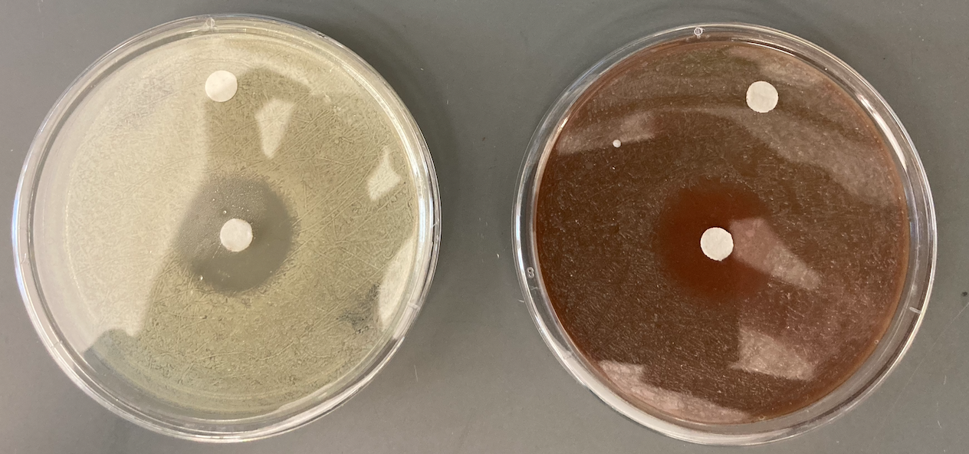

Figure 1. Test Disk Diffusion Assay
KRSA1 (left) and LVS-pF-rpsU2-V5 (right) disk diffusion assays against Kn¹⁰ with water control

I was concerned by that zone of inhibition on LVS, because that should have been resistant, but it was explained that we usually use a lower concentration of kanamycin for LVS (5 mg/ml), so this isn’t alarming.

Monday, July 10 2023
To Do:
- Make frozen aliquots of KRSA6
- Miniprep KRSA5 and KRSA6
- Disk diffusion practice
- Miniprep pKR198
- Sequencing reactions

Minipreps:
# | Sample ID | Nucleic Acid | Unit | A260 (Abs) | A280 (Abs) | 260/280 | 260/230 | Sample Type | Factor
1 | pKR198A | 226 | ng/µl | 4.521 | 2.516 | 1.8 | 1.39 | DNA | 50
2 | pKR198B | 152 | ng/µl | 3.043 | 1.611 | 1.89 | 2.48 | DNA | 50

Disk Diffusion:
Adja and I set up a practice disk diffusion with Staph. We set up 2 plates.
 | Observed OD600 | Calculated OD600 | Starting Volume for OD600 0.05 (ul)
SA | 0.029 | 0.58 | 9

I sent 10 reactions for sequencing, see Order 230710_KB_SequencingSubmission.

Tuesday, July 11 2023
To Do:
- Disk diffusion practice
- Miniprep pKR198
- Sequencing reactions
- Start overnight cultures of LVS
- Make single-use aliquots of LVS tagged strains

Monday, July 17 2023
To Do:

- Patch out LVS tagged strains
- Make single-use aliquots of LVS tagged strains
- Transform pEPSA5 into KRSA1
For Adja’s disk diffusion assays we will need empty vector controls, so last week I transformed pPEPSA5into KRSA2, completely forgetting that there is no Staph DNA in there so I could have transformed it directly into KRSA1. Today, Adja and I transformed it into KRSA1, and I forgot about KRSA4, so we’ll do that tomorrow.

# | Sample ID | Nucleic Acid | Unit | A260 (Abs) | A280 (Abs) | 260/280 | 260/230 | Sample Type | Factor
1 | pEPSA5 (SAMP) | 387 | ng/µl | 7.743 | 4.052 | 1.91 | 2.36 | DNA | 50

There’s a lot of DNA in there so we added 2ul to the competent cells.

Tuesday, July 18 2023
To Do:

- Patch out LVS tagged strains
- Make single-use aliquots of LVS tagged strains
- Transform pEPSA5 into KRSA1
- Pour LB with xylose plates
- Streak out KRSA strains for DD
- Start overnights of LVS-tagged strains
- Transform pEPSA5 into KRSA4
Transformation:
of pEPSA5 into KRSA went great.
IP Cell Pellets:
Preparation of overnight cultures:
 | Observed OD600 | Calculated OD600 | Starting Volume for OD600 0.003 (ul)
His | 0.156 | 3.12 | 481
V5 | 0.149 | 2.98 | 503

Wednesday, July 19 2023
To Do:

- Pour LB with xylose plates
- Streak out KRSA strains for DD
- Start overnights of LVS-tagged strains
- Transform pEPSA5 into KRSA4
- Make cell pellets
- Disk diffusion assays
LVS-His is at 0.297 and LVS-V5 is at 0.337 at 10:45 am. Pellets are made!

We won’t do the disk diffusion today, because when we made the LB with xylose we added it as a powder and some of it got caramelized. I made a sterile 25% stock solution (12.5g into 50ml) and added 10ml of the stock to 500ml of agar.

I reconstituted 5mg of laurenobiolide into 625ul of methanol for a concentration of 8 mg/ml. Even though I spun the vial down before adding the methanol, there was still some residue along the sides of the vial. I vortexed it and let it sit at RT for a while in hopes that it would eventually dissolve. I was able to scrape some of it down with a pipet tip. I stored it in the -20 overnight.

Thursday, July 20 2023
To Do:
- Make cell pellets
- Disk diffusion assays

This morning at first check the HA was at OD600 of 0.273, but the FLAG was only at 0.172. About a half hour later, HA is at 0.310. I proceeded to make that pellet.

I asked Andrew about the laurenobiolide residue, and he said it’s fine, it happens all the time, and that it’s not a significant amount.

Disk Diffusion:

 | Observed OD600 | Calculated OD600 | Starting Volume for OD600 0.05 (ul) | times 5 | Medium volume (ul)
KRSA1 | 0.357 | 7.14 | 0.7 | 3.5 | 496.5
KRSA4 | 0.135 | 2.7 | 1.9 | 9.3 | 490.7
KRSA5 | 0.143 | 2.86 | 1.7 | 8.7 | 491.3
KRSA6 | 0.153 | 3.06 | 1.6 | 8.2 | 491.8
KRSA8 | 1.004 | 20.08 | 0.2 | 1.2 | 498.8
KRSA1-pEPSA | 0.939 | 18.78 | 0.3 | 1.3 | 498.7
KRSA4-pEPSA | 0.936 | 18.72 | 0.3 | 1.3 | 498.7

We made some adjustments:

 | Observed OD600 | Calculated OD600 | Starting Volume for OD600 0.05 (ul) | times 5 | medium
KRSA1 | 0.168 | 3.36 | 1.5 | 7.4 | 492.6
KRSA4 | 0.135 | 2.7 | 1.9 | 9.3 | 490.7
KRSA5 | 0.143 | 2.86 | 1.7 | 8.7 | 491.3
KRSA6 | 0.153 | 3.06 | 1.6 | 8.2 | 491.8
KRSA8 | 0.124 | 2.48 | 2.0 | 10.1 | 489.9
KRSA1-pEPSA | 0.208 | 4.16 | 1.2 | 6.0 | 494.0
KRSA4-pEPSA | 0.232 | 4.64 | 1.1 | 5.4 | 494.6

Friday, July 21 2023
To Do:
- Make cell pellets
- Disk diffusion assays
- Read disk diffusions
- Patch out mutants from DDA

Adja’s Disk Diffusion Results:
Strain | Rep 1 Zone (mm) | Rep 2 Zone (mm) | Rep 3 Zone (mm) | Average of Replicates
KRSA-1 | 2.969 | 3.05 | 3.12 | 3.05
KRSA-4 | 2.011 | 2.7346 | 2.006 | 2.25
KRSA-5 | 2.012 | 1.988 | 1.968 | 1.99
KRSA-6 | 3.557 | 3.419 | 3.677 | 3.55
KRSA-8 | 2.152 | 2.213 | 2.05 | 2.14
KRSA-9 | 3.446 | 3.317 | 3.43 | 3.40
KRSA-10 | 1.973 | 1.893 | 1.992 | 1.95

KRSA8 restored resistance in the wildtype strain! But there was a double zone of inhibition, so we picked some colonies in that zone to look at later. There were also a couple of colonies that grew in the ZOI on KRSA9 (KRSA1 with empty pEPSA5), so we picked those too.

Saturday, July 22 2023
To Do:
- Read disk diffusions
- Patch out mutants from DDA
- Make glycerol stocks of SA DDA mutants
Adja patched out some colonies from KRSA8 and KRSA9, and I froze them down. Note: she didn’t do a very heavy streak so for the KRSA8 plates especially there weren’t lawns but a lot of single colonies.

Monday, July 24 2023
To Do:
- Make glycerol stocks of SA DDA mutants
- Make buffers for IP
- Make lab media
I made LB agar and MH broth. I made a 1M stock solution of imidazole and attempted to pH it to 7.5, which came from this protocol:

https://www.med.upenn.edu/robertsonlab/assets/user-content/documents/Roche%20NiNTA%20protocol.pdf.pdf

However, it took a lot (a few mls) oh HCl to get it down to 7.9, where I stopped. I used 1N HCl because the 5N HCl wasn’t very effective. I’m not even sure if 7.5 is the appropriate pH. I haven’t seen specific pH of imidazole in buffers except for in the above protocol. Many commercial stock solutions of imidazole are at a pH of 8. I was going to filter sterilize it, but decided to wait until I can verify the appropriate pH.

It is wrapped in foil and stored in the fridge.

Friday, July 28 2023
To Do:
- Make buffers for IP
Kathryn says that the pH of imidazole is probably fine.

For the wash Buffer B, I’m adding 10mM of imidazole. For the Elution Buffer, I added 250mM imidazole.

Staph:

Kathryn found a colony on the KRSA1 no plasmid control plate. She streaked it out to isolation and is coming in over the weekend to do DDA. I set up 6 overnight colonies from the plate and she will freeze then down and set up the DDA.

Monday, July 31 2023
To Do:
- Make buffers for IP
- Read DDA plates

Buffers for IP with His tag:
Store all buffers at 4°C unless otherwise noted

Buffer A + PI +BB (Lysis)
Final composition | Stock solutions | For 25 mL
25 mM KHEPES pH 7.9 | 1 M KHEPES | 625 uL
10 mM MgCl₂ | 1 M MgCl₂ | 250 uL
10 mM NH₄Cl | 1 M NH₄Cl | 250 uL
0.5 mM DTT | 0.5 M DTT | 25 uL
1X Bug Buster | 10X Bug Buster | 2.5 mL
10% glycerol | 75% glycerol | 3.3 mL
Water |  | 18 mL
 | + 2 tablets protease inhibitor
- Protease inhibitor tablets: cOmplete Mini EDTA-free Protease Inhibitor Cocktail Tablets, Sigma cat # 11836170001
- After protease inhibitor has been added, store at -20°C (overnight up to 1 year)

Buffer B (modified buffer IPP150) Wash with Imidazole
Final composition | Stock solutions | For 150 mL
25 mM KHEPES pH 7.9 | 1 M KHEPES | 3.75 mL
10 mM MgCl₂ | 1 M MgCl₂ | 1.5 mL
100 mM NH₄Cl | 1 M NH₄Cl | 15 mL
0.1% NP-40 | 10% NP-40 | 1.5 mL
10mM Imidazole | 1M Imidazole | 1.5 mL
Water |  | 126 mL

Elution Buffer with Imidazole
Composition | Stock solutions | For 30 mL
25mM KHEPES pH 7.9 | 1 M KHEPES | 750 uL
10 mM MgCl₂ | 1 M MgCl₂ | 300 uL
100 mM NH₄Cl | 1 M NH₄Cl | 3 mL
0.1% NP40 | 10% NP-40 | 30 uL
2 mM ß-MP | 14.3 M ß-MP | 4.2 uL
250mM Imidazole | 1M Imidazole | 7.5 mL
Water |  | 18.5 mL

DDA results:
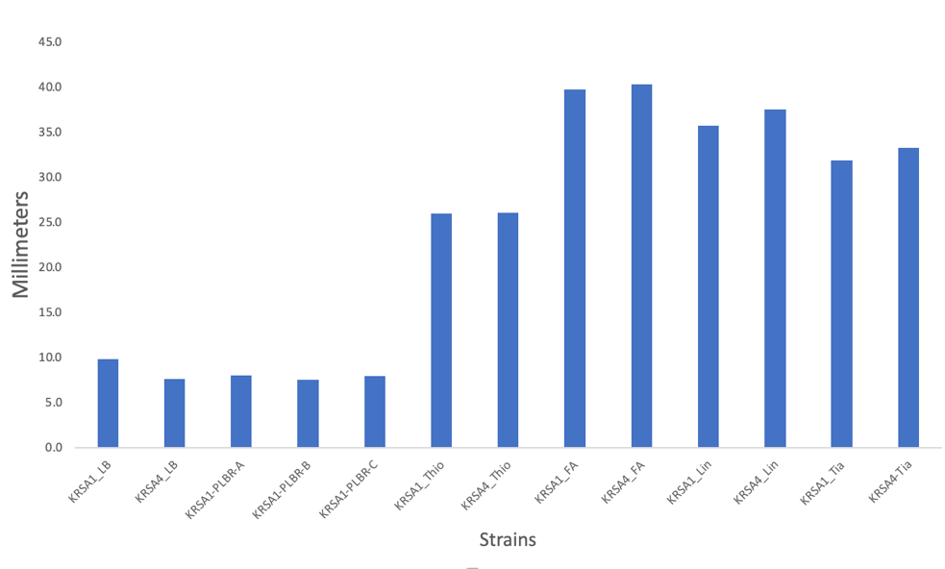

Figure 2. Disk Diffusion Results of Colony that Grew in Zone of Inhibition of KRSA1
All 3 colonies that were tested against laurenbiolide are resistant to it. KRSA1 and KRSA4 show no resistance to the other ribosome-targeting antibiotics.

August 2023

Monday, August 7, 2023
To Do:
- Make buffers for IP
- Read DDA plates
- IP on LVS-pF-rpsU2-His

Prepare cell lysate
Required reagents:
Buffer A + PI + BB Bug Buster (see recipe at end)
DNase I (Lucigen Corporation # D9905K)
30 mL syringe
MillexGP 0.22 micrometer syringe filter
Nonsterile 50 mL conical tubes
Microfuge tubes

1M NH₄Cl
10% NP-40

- Check for stock solutions; make Buffer A+ PI +BB if not enough in freezer (~10 mL per sample), prepare Buffer B if not enough at 4°C. Fresh TEV cleavage buffer can be made now or during incubation.
- Write out samples in table:

Sample# Date Genotype of cells Volume of cells OD600 at harvest
1 xx/xx/xxxx X XXX mL 0.XXX

- Resuspend samples in 10 mL Buffer A + PI + BB by pipetting with 5 mL pipette. Be sure no clumps remain.
- Add 10 uL DNase I (Lucigen/Epiceter), mix by pipetting.
- Incubate at 37°C for 30’. Cool down centrifuge while waiting.
- Spin conical tubes at 4°C for 20’ at max speed (14635xg).
- Transfer lysates into new 50 mL conical tubes, leaving behind insoluble material at bottom (okay to leave some behind; better than taking too much).
- Filter-sterilize lysates using 30mL syringe and syringe filter into new (nonsterile) 50mL conical tube. Specifically, pull plunger out from 30mL syringe, thread tip of syringe onto syringe use filter (use MillexGP 0.22 micrometer filter, has 33mm diameter), pour/pipette lysate into syringe, insert plunger and recover filtered lysate into new (nonsterile) 50mL conical tube.
- Obtain a good estimate of sample volume using pipette. **Note: about 8mL
- Adjust buffer concentration to Buffer B by adding to each sample:
100 uL 1M NH₄Cl / mL sample for final concentration of 100 mM NH₄Cl
10 uL 10% NP-40 /mL sample final concentration of 0.1% NP-40
- Remove 50 uL into microfuge tube for control analysis (LYS).

Immunoprecipitation with His tag

In cold room
- Cut tip of 1mL pipette tip slightly.
- Resuspend magnetic beads in storage solution.
- Pipette 200 uL magnetic beads into 50 ml conical.
- Wash beads with 3 mL of Buffer B 3 times (no imidazole [NEB says with imidazole]).
- Add 1 sample per tube, close cap to close (make sure tube is closed completely and is not dripping liquid).
- Incubate samples with beads, rocking at 4°C, for 1 hour (lay tube on its side).

- After 1 hour incubation, place on magnetic rack.
- Save 50 uL aliquot of flow through in microfuge tube (FT1), discard remaining.
- Wash beads 3x with 5 mL Buffer B (with low conc imidazole), discard flow through but save some from each wash (FT2-4 50 ul).
- Add 2 mL KBE-1 buffer (high conc imidazole)
- Incubate rocking at 4°C 5 minutes.

Recover eluates by magnetic rack and place in new 50 mL conical tube. Rinse beads with additional 300 μl of Elution Buffer and add the liquid to the 50 mL conical.
- Aliquot 50 uL of each recovered sample into microfuge tube, 4x, for later analysis. Transfer remaining samples into clearly labeled microfuge tubes (2 per sample) and store all samples at -80°C.

Tuesday, August 8, 2023
To Do:
- IP on LVS-pF-rpsU2-His
- Coomassie stain on LVS-pF-rpsU2-His
Next time I run IP I must include a negative control (LVS-pF)!!!!

Coomassie Stain

Gel Set-up:

Lane | Content | Volume
1 | Benchmark Ladder | 10 ul
2 | LVS-pF-rpsU2-His lysate | 10 ul
3 | LVS-pF-rpsU2-His FT1 | 10 ul
4 | LVS-pF-rpsU2-His FT2 | 10 ul
5 | LVS-pF-rpsU2-His FT3 | 10 ul
6 | LVS-pF-rpsU2-His FT4 | 10 ul
7 | Ni-NTA Beads | 10 ul
8 | 1x SLB ** | 10 ul
9 | LVS-pF-rpsU2-His Eluate | 10 ul
10 | Hannah's Ribosome * | 10 ul

* I took 6ul of Hannah’s ribosomes and added 6ul of 2XSLB, but when I took the samples out of the heat block the cap was open, and I think most of the sample evaporated. Instead, I put 2XSLB** in Lane 10.
** Was supposed to be 1XSLB.

Coomassie stain protocol starts with running the gel the same as for a Western Blot with some modifcations:

Running the gel:
- Prepare samples by adding 1:1 volume of 2X SLB
- Heat at 98C for 10 min
- Assemble gel chamber
  - Use pre-cast NuPAGE 4-12% Bis-Tris gel (we also have 10% and 12% gels as necessary)
  - Words on cassette should face towards back of chamber
- Make running buffer – 400 mL for 1 gel, 800 mL for 2 gels
  - 1 x MOPS for large proteins
  - 1x MES for <50 kD proteins
    - 380 mL ddiH2O
    - 20 mL 20x MES
    - 1 mL NuPAGE antioxidant
  - Make sure front section is full so that gels are covered in liquid. Back section does not need to be completely full.
- Use 200 ul pipet to wash wells of gel
- Load 10 uL of each sample. Use Benchmark Protein Ladder.
- Run at 90V until the blue dye front reaches the bottom ridge of the gel (45 mins to 1 hour, depending on running buffer)
Note: It was taking a while so I increased the voltage to 120 for the last ten minutes

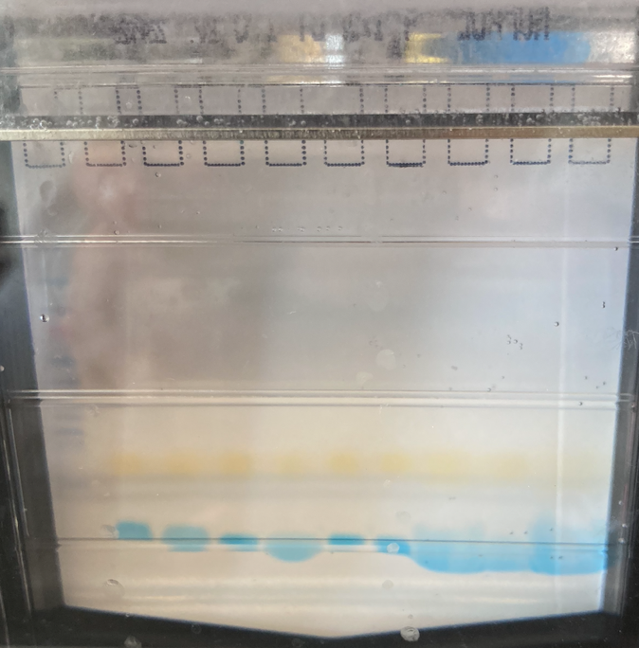
I’m worried about the blurring in the last 3 lanes, which is definitely because I put 2xSLB instead of 1XSLB in Lanes 8 and 10 but since it’s only SLB and no protein it won’t affect the gel.
Preparing Solutions (from Invitrogen Colloidal Blue Staining Kit):

Fixing Solution | 1 Gel
Deionized Water | 40 ml
Methanol | 50 ml
Acetic Acid | 10 ml

Staining Solution | 1 Gel
Deionized Water | 55 ml
Methanol | 20 ml
Stainer A | 20 ml
Stainer B ** | 5 ml
**Do not add Stainer B to Staining Solution until the long incubation step

Staining (from Invitrogen Colloidal Blue Staining Kit):

- Rinse gel in deionized water before fixing
- Rock gel in the Fixing Solution for 10 minutes at RT, then discard the Fixing Solution
- Rock gel in the Staining Solution without Stainer B for 10 minutes at RT
- Add Stainer B to Staining Solution in appropriate volume (see above table)
- Rock gel in Staining Solution with Stainer B for at least 3 hours and up to 12 hours
- Decant Staining Solution and replace it with 200 ml of deionized water. Rock gel in water for at least 7 hours (gel will have a clear background after 7 hours)
Gels can be left in water for up to 3 days

I gave Sierra my last single use aliquot of LVS so I need to make more.

Wednesday, August 9, 2023
To Do:
- Coomassie stain on LVS-pF-rpsU2-His
- Image Coomassie stain
- Silver stain on LVS-pF-rpsU-His

Imaging Coomassie Stain
- Image Studio
- KRamsey Lab workgroup
- Acquire
- Channel intensity: 700
- Resolution: 169 µm
- Quality: medium
- Focus offset: 0.5 mm

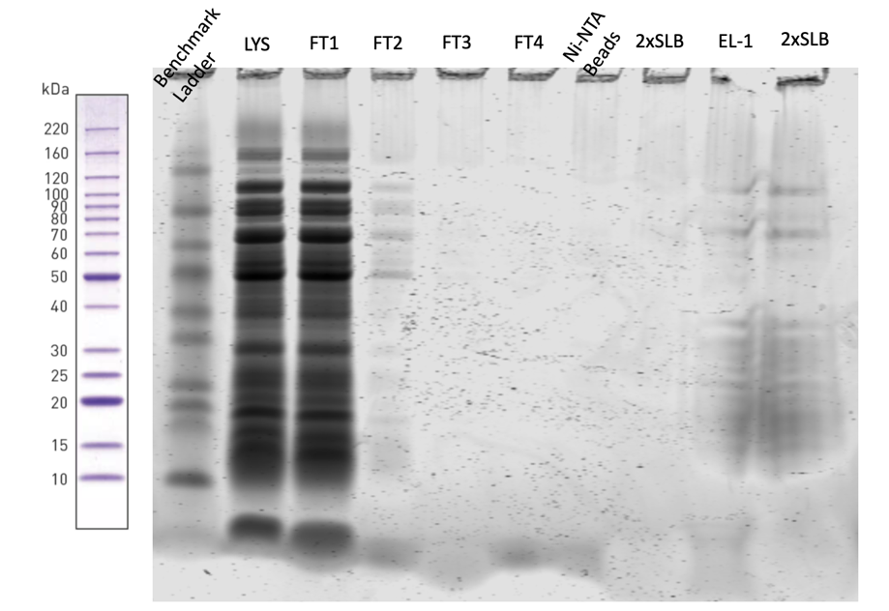

Figure 3. Coomassie Stain of LVS-pF-rpsU2-His

Silver Stain Gel Set-up:

Lane | Content | Volume
1 | Benchmark Ladder 1:10 | 10 ul
2 | LVS-pF-rpsU2-His lysate | 10 ul
3 | LVS-pF-rpsU2-His FT1 | 10 ul
4 | LVS-pF-rpsU2-His FT2 | 10 ul
5 | LVS-pF-rpsU2-His FT3 | 10 ul
6 | LVS-pF-rpsU2-His FT4 | 10 ul
7 | Ni-NTA Beads | 10 ul
8 | 1x SLB | 10 ul
9 | LVS-pF-rpsU2-His Eluate | 10 ul
10 | Hannah's Ribosome 1:10 | 10 ul

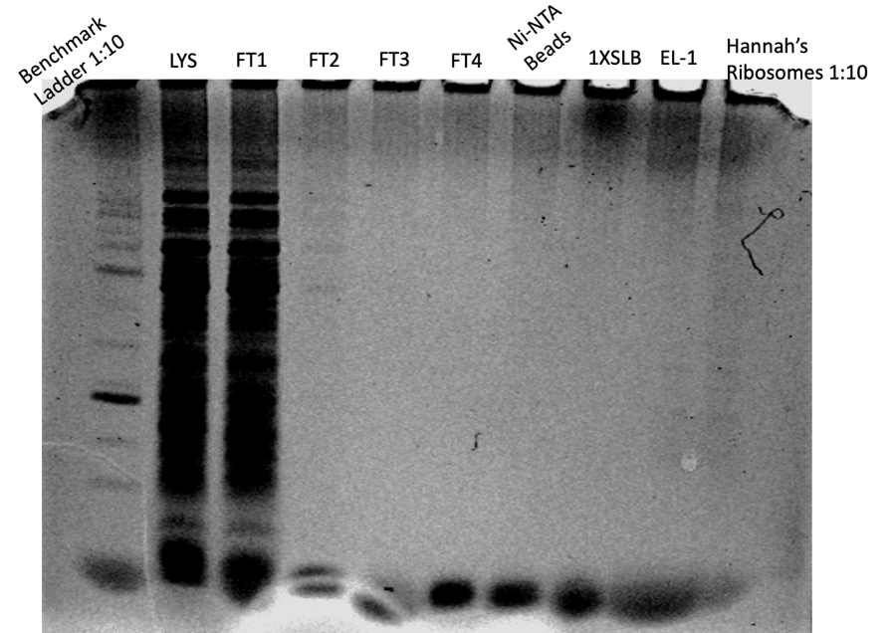

Figure 4. Silver Stain of LVS-pF-rpsU2-His
For some reason it’s not showing up on the image but bands in the EL-1 lane are visible on the gel itself.

Thursday, August 10, 2023
To Do:
- Image Coomassie stain
- Silver stain on LVS-pF-rpsU-His
- Repeat Silver Stain
- Extract gDNA

Staph gDNA Materials Needed:
most stuff in DNA RNA box
Ice
150 ul Lysostaphin - -20C antibiotics box
1x Tissue and Cell Lysis Solution – box above water bath
Lysozyme crystals - in full plastic Tupperware dark round container
Proteinase K – furthest left enzyme box in front row (red)
RNAse A– furthest left enzyme box in front row (red)
MPC Protein Precipitation Reagent – box above water bath
Isopropanol
70% ethanol
0.1X EB

DNA Purification Protocol – S. aureus
Cell Samples
1. Dilute lysostaphin in Tissue and Cell Lysis Solution to 1 mg/mL (i.e. 30 ul of 10 mg/ml stock in 270 ul TCL)
2. Add lysozyme crystals to 1 mg/mL and dissolve by pipetting up and down. (Made a 20 mg/mL stock solution and added 15ul of that stock to the TCL.)
3. Pellet 0.5 mL of an overnight culture by centrifugation and discard the supernatant, leaving approximately 25 µl of liquid.
4. Vortex for 10 seconds to resuspend the cell pellet.
5. Add 300 ul of Tissue and Cell Lysis Solution containing the lysozyme and lysostaphin and mix thoroughly.
6. Incubate at 37°C for 30 minutes
7. Add 1 ul of Proteinase K to each sample and mix thoroughly.
8. Incubate at 65°C for 15 minutes; vortex every 5 minutes.
9. Cool the samples to 37°C and add 1 µl of 20 mg/ml RNase A to the sample; mix thoroughly.
10. Incubate at 37°C for 30 minutes. Cool down the centrifuge.
11. Place the samples on ice for 3-5 minutes and then proceed with total DNA precipitation (below). **Note: this step was missed by accident
Precipitation of Total DNA (for all biological samples)
1. Add 150 µl of MPC Protein Precipitation Reagent to 300 µl of lysed sample and vortex vigorously for 10 seconds.
2. Pellet the debris by centrifugation at 4°C for 10 minutes at ≥10,000 x g in a microcentrifuge. If the resultant pellet is clear, small, or loose, add an additional 25 µl of MPC Protein Precipitation Reagent, mix, and pellet the debris again.
3. Transfer the supernatant to a clean microcentrifuge tube and discard the pellet.
4. Add 500 µl of isopropanol to the recovered supernatant. Invert the tube 30-40 times.
5. Pellet the DNA by centrifugation at 4°C for 10 minutes in a microcentrifuge.
6. Carefully pour off the isopropanol without dislodging the DNA pellet. The pellet for Sample A was very difficult to see
7. Rinse twice with 1 ml 70% ethanol, being careful to not dislodge the pellet. Centrifuge briefly if the pellet is dislodged. Remove all of the residual ethanol with a pipet and let dry completely under hood.
8. Resuspend the DNA in 35 µl of 0.1x EB Buffer. Put on ice to help dissolve, and add 50 µl of additional buffer if DNA is very goopy.
9. Check concentration and purity by nanodrop.

# | Sample ID | Nucleic Acid | Unit | A260 (Abs) | A280 (Abs) | 260/280 | 260/230 | Sample Type | Factor
1 | KRSA1-PLBR-A | -0.2 | ng/µl | -0.005 | -0.019 | 0.24 | 0.26 | DNA | 50
2 | KRSA1-PLBR-B | 263 | ng/µl | 5.261 | 3.119 | 1.69 | 1.04 | DNA | 50

KRSA1-PLBR-A didn’t work. I think I lost or never got a pellet after the addition of isopropanol.

Silver Stain Gel Set-up:

Lane | Content | Volume
1 | Benchmark Ladder 1:10 | 10 ul
2 | LVS-pF-rpsU2-His lysate | 10 ul
3 | LVS-pF-rpsU2-His FT1 | 10 ul
4 | LVS-pF-rpsU2-His FT2 | 10 ul
5 | LVS-pF-rpsU2-His FT3 | 10 ul
6 | LVS-pF-rpsU2-His FT4 | 10 ul
7 | Ni-NTA Beads | 10 ul
8 | Ben’s Ribosome 1:5 | 10 ul
9 | LVS-pF-rpsU2-His Eluate | 10 ul
10 | Hannah's Ribosome 1:10 | 10 ul
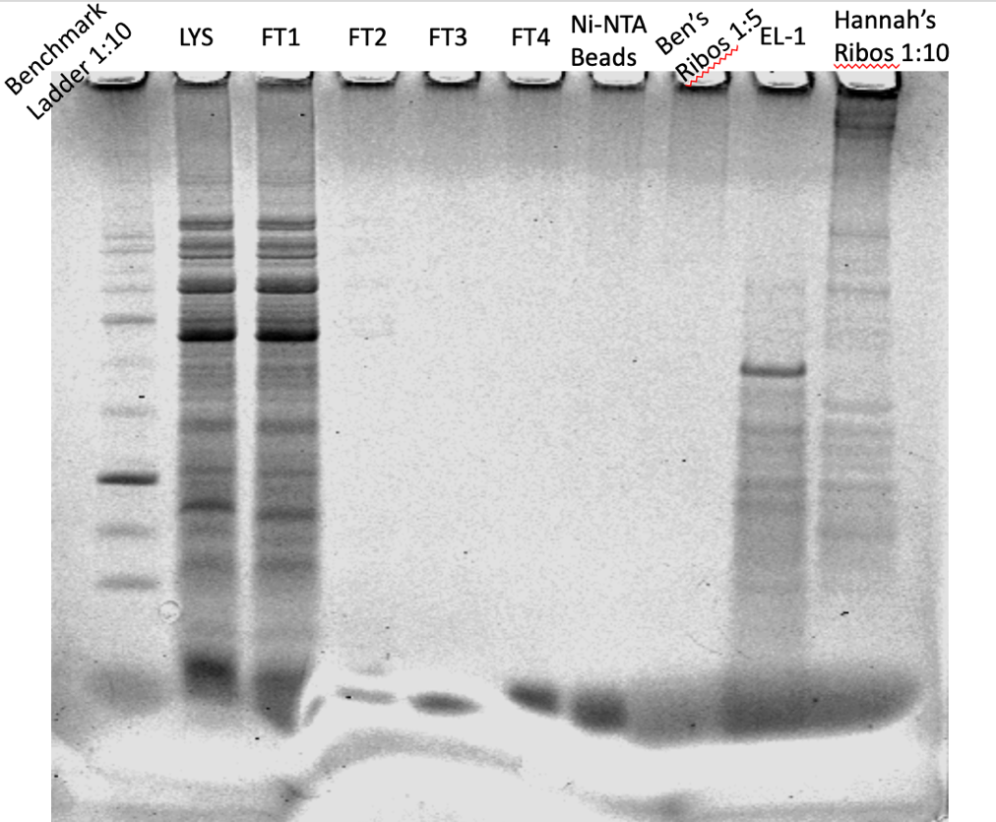

Figure 5. Better Silver Stain of LVS-pF-rpsU2-His
There are proteins being pulled down but it is difficult to tell if bS21 was pulled down because the bottom of the gel is messed up. Ben’s ribosome didn’t show up; maybe it was diluted too much.

Monday, August 14, 2023
To Do:
- Repeat Silver Stain
- Extract gDNA
- Prep stuff to make new large cultures of His, FLAG, and LVS-pF
- Patch out LVS-wt to make more single use aliquots
- Patch out LVS-His and FLAG and pF empty vector
- Maybe extract Staph gDNA
Made 4 half liters of MHB, streaked out one plate of LVS-His-A, 2 plates of LVS-FLAG-C, 1 plate of LVS-wt, and 2 plates of LVS-pF.

Tuesday, August 15, 2023
To Do:
- Prep stuff to make new large cultures of His, FLAG, and LVS-pF
- Patch out LVS-wt to make more single use aliquots
- Patch out LVS-His and FLAG and pF empty vector
- Maybe extract Staph gDNA
- Make more lysostaphin stock
- Make glycerol stocks

Lysostaphin Preparation (10 mg/mL)
1. Make up ~30 ml of 20 mM sodium acetate in MQ water.
2. Adjust pH to 4.5 with acetic acid or NaOH as needed, adding dropwise.
3. Filter sterilize solution.
4. Dissolve whole vial of lysostaphin (5 mg) in 0.5 ml buffer.
5. Aliquot solution out into 65 ul aliquots in sterile Eppendorf tubes.
6. Label and store at -20 (in antibiotics box). Avoid repeated freeze-thawing of aliquots.
Can’t find sodium acetate or lysostaphin, so will have to put this off.
Also can’t make glycerol stocks of LVS strains because there is no supplemented MHB. Ben will make that tomorrow. In the meantime I streaked out more His and FLAG.
Staph gDNA extraction:
# | Sample ID | Nucleic Acid | Unit | A260 (Abs) | A280 (Abs) | 260/280 | 260/230 | Sample Type | Factor
1 | KRSA1-PLBR-C | 175 | ng/µl | 3.494 | 2.385 | 1.46 | 0.85 | DNA | 50

I’ll take it.

Wednesday, August 16, 2023
To Do:
- Maybe extract Staph gDNA
- Make more lysostaphin stock
- Make glycerol stocks
- Start large overnights of His and FLAG
- Make glycerol stocks of LVSwt and LVS-pF
- Patch LVS-pF
The plates of LVS wt and LVS-pF that I streaked on Monday didn’t grow all that well overnight, so I left them out on my bench last night. After looking at them today, I decided that there was enough growth to make glycerol stocks. I made two 1 ml glycerol stocks of LVS-pF and ten 50ul aliquots. I made ten 50ul aliquots of LVS wt.
Overnight Cultures:
 | Observed OD600 | Calculated OD600 | Starting Volume for OD600 0.003 (ul)
His | 0.537 | 10.74 | 140
FLAG | 0.693 | 13.86 | 108
Went in at 5:35pm.

Thursday, August 17, 2023
To Do:
- Start large overnights of His and FLAG
- Make glycerol stocks of LVSwt and LVS-pF
- Patch LVS-pF
- Make cell pellets
- Start large overnights of LVS-pF

Overnight Cultures:
Checked OD600 at 10:30 am:
His: 0.290
FLAG: 0.123
I could keep FLAG in for longer but this has happened everytime I’ve set it up; it just won’t grow that fast in liquid.
At 11:10 am:
His: 0.308
FLAG: 0.136
At 11:41 am:
His: 0.330
FLAG: 0.148
At this point I will proceed with making the His pellet, and I’ll keep FLAG growing.
At 1:40 pm:
FLAG: 0.204
At 2:33 pm:
FLAG: 0.229
At 3:55 pm:
FLAG: 0.268
At 5:05 pm:
FLAG: 0.301
I’m going to proceed with making the pellet.

Large overnights for LVS-pF:
Sample | Observed OD600 | Calculated OD600 | Starting Volume for OD600 0.003 (ul)
LVS-pF1 | 0.6 | 12 | 125
LVS-pF2 | 0.703 | 14.06 | 107
Went in at 6:00 pm.

Staph gDNA for sequencing:
Sending 40ul of 50ng/ul gDNA for sequencing:
# | Sample ID | Nucleic Acid | Unit | A260 (Abs) | A280 (Abs) | 260/280 | 260/230 | Sample Type | Factor | Volume (ul) | Desired Concentration (ng/ul) | Desired Volume (ul) | Starting Volume (ul) | Volume of 0.1X EB (ul)
1 | KRSA1-PLBR-B | 263 | ng/µl | 5.261 | 3.119 | 1.69 | 1.04 | DNA | 50 | ~33 | 50 | 40 | 7.6 | 32.4
2 | KRSA1-PLBR-C | 175 | ng/µl | 3.494 | 2.385 | 1.46 | 0.85 | DNA | 50 | ~33 | 50 | 40 | 11.4 | 28.6

These are diluted in 0.1x EB.

Friday, August 18, 2023
To Do:
- Make cell pellets
- Start large overnights of LVS-pF
- Make LVS-pF cell pellets
- Dilute KRSA-PLBR samples
- Make 10% glucose

Cell pellets:
At 10:10 am:
LVS-pF1: 0.246
LVS-pF2: 0.271
At 10:57 am:
LVS-pF1: 0.278
LVS-pF2: 0.306
At 11:38
LVS-pF1: 0.307
LVS-pF2: 0.335

The 2 pellets of LVS-pF are made.

Immunoprecipitation:
Unfortunately, I didn’t freeze the Buffer A+PI+BB after adding the protease tablets, so I made more, and doubled the recipe since I’ll be running a lot of IP over the next few weeks. I made sure to put it in the -20º after I used it.

Monday, August 21, 2023
To Do:
- Make LVS-pF cell pellets
- Dilute KRSA-PLBR samples
- Make 10% glucose
- Set up Coomassie stain
- Send out KRSA_PLBR strains

Coomassie Gel Set-up:

Lane | Content | Volume
1 | Benchmark Ladder | 10 ul
2 | LVS-pF-rpsU2-His lysate | 10 ul
3 | LVS-pF lysate | 10 ul
4 | LVS-pF-rpsU2-His FT1 | 10 ul
5 | LVS-pF FT1 | 10 ul
6 | LVS-pF-rpsU2-His FT2 | 10 ul
7 | LVS-pF FT2 | 10 ul
8 | LVS-pF-rpsU2-His FT3 | 10 ul
9 | LVS-pF FT3 | 10 ul
10 | LVS-pF-rpsU2-His FT4 | 10 ul
11 | LVS-pF FT4 | 10 ul
12 | LVS pF-rpsU2 -His Ni-NTA Beads | 10 ul
13 | LVS-pF Ni-NTA Beads | 10 ul
14 | LVS-pF-rpsU2-His Eluate | 10 ul
15 | LVS-pF Eluate | 10 ul
16 | Ben’s Ribosomes | 10 ul
17 | Hannah’s Ribosomes | 10 ul

Tuesday, August 22, 2023
To Do:
- Set up Coomassie stain
- Send out KRSA_PLBR strains
- Image Coomassie
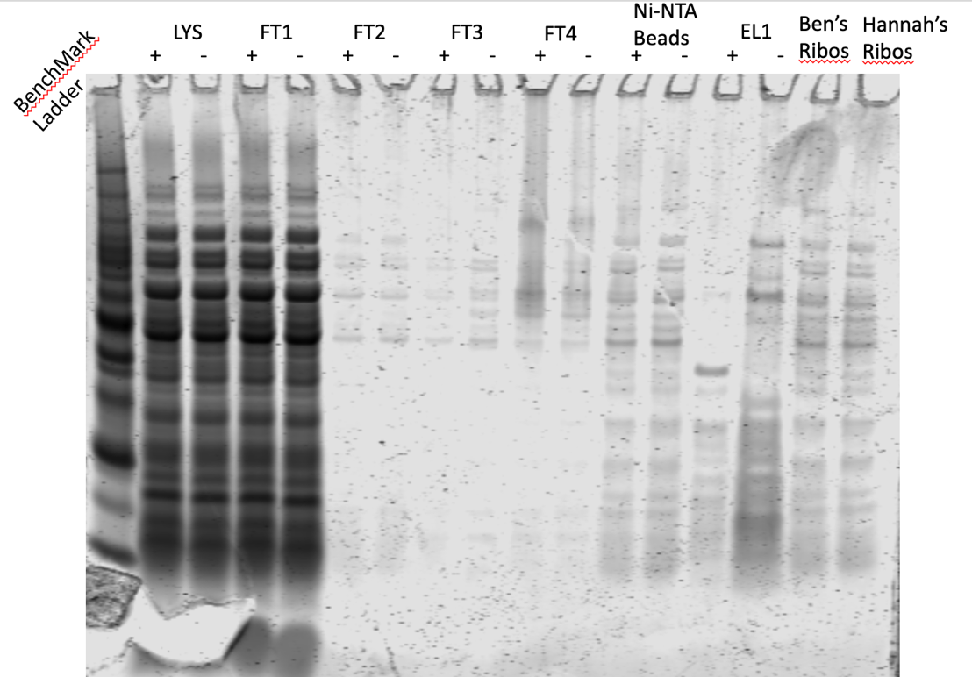

Figure 6: Coomassie Stain of second 6XHis IP

Tuesday, August 29, 2023
To Do:
- Image Coomassie
- Reconstitute sequencing primers
- PCR on LBR Staph strains

Sequencing primer reconstitution:
Primer | nm | Volume to Add (ul)
KROL675 | 33 | 330
KROL676 | 34.8 | 348

The 100mM stocks are in a box called “extra primers” because there doesn’t seem to be a current box yet.

PCR:
Reaction numbers | Sample | Expected size
1 | KRSA1 gDNA | 309 bp
2 | KRSA4 gDNA ** | 309 bp
3 | KRSA1-PLBR-B gDNA | ~309 bp
4 | KRSA1-PLBR-C gDNA | ~309 bp
5 | -DNA (water) | no product

Reaction Number | Plasmid/Region | Source DNA | Primers | Length (bps)
1 | + control rplU | KRSA1 gDNA | KROL656, KROL657 | 309
2 | rplU | KRSA4 gDNA | KROL656, KROL657 | 309
3 | rplU | KRSA1_PLBR-B gDNA | KROL656, KROL657 | 309
4 | rplU | KRSA1_PLBR-C gDNA | KROL656, KROL657 | 309
5 | - control | water | KROL656, KROL657 | -

Total reaction volume | 50
Total number of reactions | 5
 |  |  |  | Factor
Component | Stock concentration | Final concentration | 1 rxn volume | 6
ddiH2O |  |  | 31.0 | 186
PrimeSTAR GXL Buffer | 5x | 1x | 10.0 | 60
dNTPs | 2.5 mM | 0.2 mM | 4.0 | 24
oligo F | 10 uM | 0.3 uM | 1.5 | 9
oligo R | 10 uM | 0.3 uM | 1.5 | 9
template | 100 ng/ul | 2 ng/ul | 1.0
PrimeSTAR GXL DNA Polymerase | 1.25 U/ul | 0.025 U/ul | 1.0 | 6
 |  | Total volume | 50 | 294

It’s difficult to discern what’s going on in Oli’s cloning box. I saw tubes labeled “Wt PCR purified” and “rplU 4A3M1 PCR purified” **, so I pulled those. I also found “SA113 gDNA” and a tube with a label that might say “3A4M1” (doesn’t say gDNA). I’m not sure if she flipped the 3 and 4 because her numbering system is a little complex. I’m going to assume it is 4A3M1, which I have since renamed KRSA4, gDNA. I will run PCR on that and the SA113 (KRSA1) and my mutants. If they are not that, then at least she might have made the KRSA4 PCR reaction that I can use for sequencing.

Wednesday, August 30, 2023
To Do:
- Reconstitute sequencing primers
- PCR on LBR Staph strains
- PCR cleanup and gel
- Set up sequencing
- Silver stain
PCR:
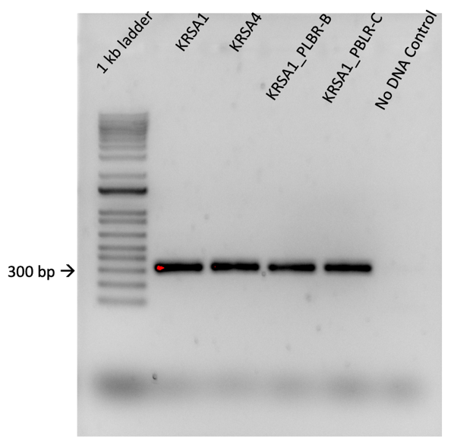

Figure 7: Gel of KRSA PCR
Everything looks good; all of the bands are the correct size and there is no contamination.

# | Sample ID | Nucleic Acid | Unit | A260 (Abs) | A280 (Abs) | 260/280 | 260/230 | Sample Type | Factor
1 | KRSA1 | 84.6 | ng/µl | 1.693 | 0.916 | 1.85 | 2.52 | DNA | 50
2 | KRSA4 | 87 | ng/µl | 1.74 | 0.946 | 1.84 | 2.53 | DNA | 50
3 | KRSA1_PLBR-B | 62.5 | ng/µl | 1.25 | 0.651 | 1.92 | 2.49 | DNA | 50
4 | KRSA1_PLBR-C | 68 | ng/µl | 1.36 | 0.707 | 1.92 | 2.77 | DNA | 50

Diluted to accommodate sequencing:
# | Sample ID | Nucleic Acid | Unit | A260 (Abs) | A280 (Abs) | 260/280 | 260/230 | Sample Type | Factor
1 | KRSA1 | 4.7 | ng/µl | 0.095 | 0.043 | 2.18 | 22.61 | DNA | 50
2 | KRSA4 | 3.6 | ng/µl | 0.073 | 0.035 | 2.08 | -5.96 | DNA | 50
3 | KRSA1_PLBR-B | 3.7 | ng/µl | 0.074 | 0.031 | 2.42 | 2.79 | DNA | 50
4 | KRSA1_PLBR-C | 3.3 | ng/µl | 0.067 | 0.02 | 3.42 | -13.12 | DNA | 50

See Order 230831_KB_SequencingSubmission in the Orders folder.
Silver Stain setup:
Lane | Content | Volume
1 | Benchmark Ladder 1:10 | 10 ul
2 | LVS-pF-rpsU2-His lysate | 10 ul
3 | LVS-pF lysate | 10 ul
4 | LVS-pF-rpsU2-His FT1 | 10 ul
5 | LVS-pF FT1 | 10 ul
6 | LVS-pF-rpsU2-His FT2 | 10 ul
7 | LVS-pF FT2 | 10 ul
8 | LVS-pF-rpsU2-His FT3 | 10 ul
9 | LVS-pF FT3 | 10 ul
10 | LVS-pF-rpsU2-His FT4 | 10 ul
11 | LVS-pF FT4 | 10 ul
12 | LVS pF-rpsU2 -His Ni-NTA Beads | 10 ul
13 | LVS-pF Ni-NTA Beads | 10 ul
14 | 1X SLB | 10 ul
15 | Hannah’s Ribosomes | 5 ul
16 | LVS-pF-rpsU2-His Eluate | 10 ul
17 | LVS-pF Eluate | 10 ul

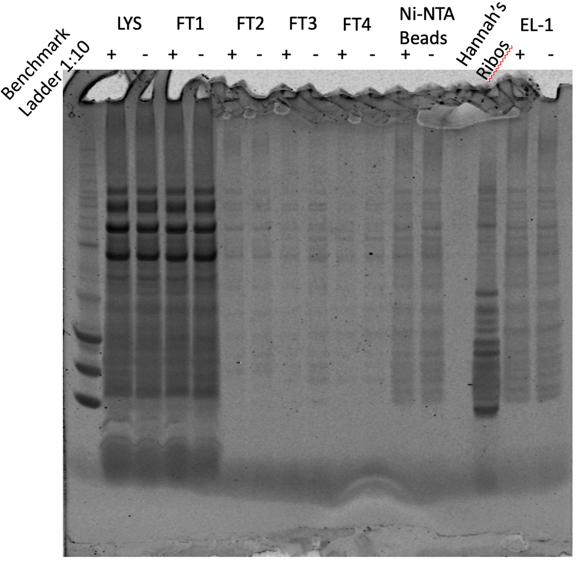

Figure 8: Silver Stain of IP with His
Both the His and no-His eluates have the same profile, which closely matches the Ni-NTA beads profiles. There’s some non-specific binding happening.

Thursday, August 31, 2023
To Do:
- PCR cleanup and gel
- Set up sequencing
- Silver stain
- Modify buffers for His IP
- Streak out LVS-pF

I will repeat the His IP, but this time I will add imidazole to all the buffers and I will increase the imidazole concentration in the wash and the elution buffers at the concentrations suggested by NEB:
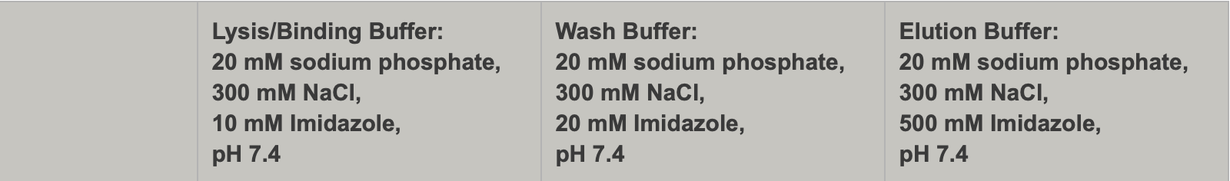

Buffer A + PI +BB (Lysis)
Final composition | Stock solutions | For 25 mL | For 50 mL
25 mM KHEPES pH 7.9 | 1 M KHEPES | 625 uL | 1250 uL
10 mM MgCl₂ | 1 M MgCl₂ | 250 uL | 500 uL
10 mM NH₄Cl | 1 M NH₄Cl | 250 uL | 500 uL
2 mM ß-MP | 14.3 M ß-MP | 3.5 uL | 7 uL
1X Bug Buster | 10X Bug Buster | 2.5 mL | 5 mL
10% glycerol | 75% glycerol | 3.3 mL | 6.6 mL
10mM Imidazole | 1M Imidazole | 250 uL | 500 uL
Water |  | 17.8 mL | 35.6 mL
 | + 2 tablets protease inhibitor** for 25 mL and 4 tablets for 50 mL
**Store in -20ºC after addition of protease inhibitor
Buffer B (modified buffer IPP150) Wash with Imidazole
Final composition | Stock solutions | For 150 mL
25 mM KHEPES pH 7.9 | 1 M KHEPES | 3.75 mL
10 mM MgCl₂ | 1 M MgCl₂ | 1.5 mL
100 mM NH₄Cl | 1 M NH₄Cl | 15 mL
0.1% NP-40 | 10% NP-40 | 1.5 mL
20mM Imidazole | 1M Imidazole | 3 mL
Water |  | 125.25 mL

KBE-1 Elution Buffer with Imidazole
Composition | Stock solutions | For 30 mL
25mM KHEPES pH 7.9 | 1 M KHEPES | 750 uL
10 mM MgCl₂ | 1 M MgCl₂ | 300 uL
100 mM NH₄Cl | 1 M NH₄Cl | 3 mL
0.1% NP40 | 10% NP-40 | 30 uL
2 mM ß-MP | 14.3 M ß-MP | 4.2 uL
500mM Imidazole | 1M Imidazole | 15 mL
Water |  | 11 mL

