Table of Contents
May, 2023 3
Sequencing: 3
Electroporation into S. aureus 4
Electroporation into LVS 6
Staph: 7
Electroporation 7
Colony PCR 8
Reaction Table 10
Figure 1: Gel of PCR of the epitope tags after integration onto the plasmid in LVS 12
Normalizing OD’s from Plates for Western Blot Protein Sample 12
OD Normalization Table: 13
Making Glycerol Stocks Protocol 13
Quantitative Western Blots with Near-Infrared dyes 14
Western Blot Loading Table: 17
Repeat Staph electroporation 18
Western Blot Day 2 18
Flgure 2. Western Blot of bS21 tagged with FLAG at various dilutions of anti-FLAG antibody 19
Figure 3. Staph electroporation 20
Figure 4. Gel of PCR looking for source of contamination 21
LiCor Imaging 25
Figure 5. WB of anti-HA at various dilutions 26
Figure 6. Second PCR looking for source of contamination 30
Figure 7. WB of anti-His at various dilutions 31
Figure 8. WB of anti-V5 at various dilutions 32
Purification of plasmid DNA from S. aureus by alkaline Lysis 34
S. aureus Glycerol Stocks: 35
Figure 9. Transformation of pKR185 into KRSA1 37
Figure 10. Different morphologies of KRSA-pKR185 38
Figure 11 a. WB of all tagged LVS strains with specific antibodies (HA and His) 41
Figure 11 b. WB of all tagged LVS strains with specific antibodies (FLAG and V5) 41
Ribosome purification - IgG IP (F. tularensis LVS) 42
Figure 12. Gel excision of pEPSA5 44
Figure 13. Digest and Gel excision of rplU and pEPSA5 47
Transform E. coli 49

May, 2023

Monday, May 1, 2023
To Do:
- Minipreps
- Set up sequencing reactions
- Start overnight culture of Staph
- Help Oli with her stuff
Oli’s stuff:
Gel Extraction
 | Tube Weight (g) | Tube w/ Gel (g) | Gel Weight (mg) | QG Buffer Volume (ul) | Isopropanol Volume (ul)
Tube 1 | 1.13 | 1.36 | 230 | 690 | 230
Tube 2 | 1.13 | 1.42 | 290 | 870 | 290
Tube 3 | 1.1 | 1.29 | 190 | 570 | 190
Tube 4 | 1.12 | 1.29 | 170 | 510 | 170
Tube 5 | 1.13 | 1.31 | 180 | 540 | 180

Component | Reaction 1 (uL) | Reaction 2 (uL) | Reaction 3 (uL) | Reaction 4 (uL) | Master Mix (6x)
H₂O | 11.5 | 11.5 | 11.5 | 11.5 | 69
10x ligase buffer | 2.0 | 2.0 | 2.0 | 2.0 | 12
Insert | 4.0 | 4.0 | 4.0 | 4.0 | -
Backbone | 2.0 | 2.0 | 2.0 | 2.0 | 12
Ligase | 0.5 | 0.5 | 0.5 | 0.5 | 3
TOTAL | 20.0 | 20.0 | 20.0 | 20.0 | 96

Sequencing:

See Sequencing order 230501_KB_SequencingSubmission.
I set up the reactions and submitted them to Janet for her to run tomorrow.

Tuesday, May 2, 2023
To Do:
- Set up sequencing reactions
- Help Oli with her stuff
- Start overnight culture of Staph

I started a 5ml culture of KRSA-2 in LB with no antibiotics

Wednesday, May 3, 2023
To Do:
- Start overnight culture of Staph
- Analyze sequencing results
I need to be more prepared to do the electrocompetent protocol, so it’s postponed until tomorrow. In the meantime, I made 50ml of filter-sterile 10% glycerol and 50ml of filter-sterile TSB with 500mM sucrose.
Note for overnight ligation: incubate, hold time = infinity, block temp is 16ºC, and top temp is off.
Plasmid sequencing results are good! All 4 plasmids have been confirmed. All 5 minipreps of HA are good. 4 of His-6 (one did work), 4 of FLAG (one had a frameshift), and 4 of V5 (one had a point deletion). See Sequencing results KB_230502.
I consolidated each respective miniprep into one tube for storage in -20ºC (yellow sticker), and took 5ul of each of those to store in the Permanent Plasmid stocks in the -80ºC (green sticker).

Thursday, May 4, 2023
To Do:
- Start overnight culture of Staph
- Analyze sequencing results
- Make Staph electrocompetent

Electroporation into S. aureus
From: Matthew Ramsey
Edited by: Hannah Trautmann 8/8/2022

Competent cells
Overnight culture in TSB at 37°C with shaking. 4ml in 30ml tube.
Dilute overnight culture of S. aureus back to about an OD600nm of 0.5 in 50ml of
prewarmed TSB. Approx.: 3 ml of overnight culture + 47ml prewarmed TSB.
Re-incubate for 30 min. After 30 min the culture is usually between OD600nm 0.8-0.9.
Transfer to 50ml tubes and let in ice-water slurry for 10 min (keep cold from now on).
Harvest the cells in centrifuge at 4105 x g for 10 minutes at 4°C.
Discard the supernatant, add 45ml sterile ice cold milliQ water. No need to resuspend the pellet yet.
Harvest the cells in centrifuge at 4105 x g for 10 minutes at 4°C.
Discard the supernatant, resuspended the pellet in 10ml sterile ice cold 10% glycerol.
Harvest the cells in centrifuge at 4105 x g for 10 minutes at 4°C.
Discard the supernatant, resuspended the pellet in 1.8ml sterile ice cold 10% glycerol. Transfer to 2ml tubes.
Harvest the cells in microcentrifuge (12000rpm) for 2 minutes at 4°C.
Discard the supernatant, resuspended the pellet in 1ml sterile ice cold 10% glycerol. Transfer to 2ml tubes.
Harvest the cells in microcentrifuge (12000rpm) for 2 minutes at 4°C.
Discard the supernatant, resuspended the pellet in 250ul sterile ice cold 10% glycerol.
Dispense 5 x 50ul aliquots and freeze at -80°C.

Electroporation
Thaw out aliquots on ice for 5 min then place at room temperature for 5 min (and follow the rest of the protocol at RT).
Centrifuge at 5,000xg for 1 min. Discard the supernatant and resuspend the cells in 50 ul of 10% glycerol / 500 mM sucrose.
Add up to 5ug-purified plasmid to the cells, mix and add to 0.1 cm electroporation cuvette. Up to 5ul of plasmid (dialyzed 20’ against H₂O with Millipore filters).
Pulse 21 kV/cm, 100 Ω and 25uF. Time constant usually about 2.0-2.4 ms.
Immediately add 1ml of TSB + 500mM sucrose and mix. (Dissolve 6.85g of sucrose in 40ml TSB and filter sterilize)
Transfer to a new tube and incubate at adequate temperature for 1-1.5h. (30C for RN4220; 42C for HG003)
Plate out on TSA + antibiotic. (3 ug/mL tet)

I’m scaling this down because this is a test run. I did not back dilute properly (I put 10ul of overnight culture into 10ml of LB instead of 1ml into 10ml), so it will take all day for the Staph to get to the right OD.
The cells are stored in the -80ºC in shelf 4G.

Friday, May 5, 2023
To Do:
- Make Staph electrocompetent
- Make LVS electrocompetent
- Transform plasmids into LVS

Electroporation into LVS
From Allelic exchange protocol; Edited by Hannah Trautmann
Prepare electrocompetent (EC) cells
-Scrape up entire plate of cells into 400 uL of sterile 10% sucrose and resuspend (alternately, cells can be grown to mid-log in MHB)
-Add 1.1 mL of 10% sucrose to a final volume of 1.5 mL
-Spin for 3 minutes at 10,000 rpm
-remove supernatant, throw out, and resuspend in fresh 1 mL 10% sucrose
-Repeat 3x-5x in 10% sucrose
-After final spin, remove all supernatant.
-Resuspend cells in 10% sucrose at high density (corresponding to ~1x10¹¹ cells /mL); these are EC cells by slowly adding 110 uL at a time. It should be about equal amounts of cells as sucrose.
-For any extra EC cells, aliquot ~110 μL / sterile tube (enough for 2 electroporations) and freeze at -80°C
Electroporate plasmid into EC cells*
-For each electroporation, aliquot 4 mL MHB into glass test tubes for recovery, warm in shaker at 37°C
-For each electroporation, in a 2 mm sterile electroporation cuvette, combine:
5 μL of pEX-based allelic exchange construct or Tn7 plasmids (mini-prep concentration, at least 100 ng/μL)
*for pF-based plasmids, can use 3 ul
50 μL electrocompetent cells
-Have recovery media ready
-Electroporate using the following settings: 2.5 kV, 25 μF, and 600 Ω
-Immediately after individual electroporations, use 1 mL warm recovery media from test tube to wash cells out of cuvette and transfer cells to recovery test tube
-Recover cells for 4-8 hours, shaking at 37°C
*For pF-based plasmids, only recover 2-3 hours
-For pEX plasmids: pellet cells by centrifugation in sterile 2 mL tubes, 1’ at 10,000 x g. Plate on CHAH-Kan plates, using 1 plate for each 2 mL tube (2 plates per electroporation)
*For pF-plasmids: plate 10 ul and 100 ul on CHAH-kan plates
*For Tn7 plasmids: plate 100 ul and remaining on CHAH-kan plates
-Incubate plates at 37°C for 3 days (or until single colonies appear)
*Always include a control electroporation with no plasmid. Eventually single break-through colonies may start appearing; at that point, single colonies on the experimental plates are also likely to just be break-through growth.
I prepared the LVS EC cells and then electroporated each plasmid with a purified pKR7 as the positive control and a no DNA negative control. There were no arcs. They recovered for 2 hours.

Monday, May 8, 2023
To Do:
- Make LVS electrocompetent
- Transform plasmids into LVS
- Patch out colonies
- Transform pEPSA5 into SA

LVS Cloning:
The transformation was maybe a little too efficient; it was difficult to pick out single colonies from the 10ul plates. Unfortunately, there were a few LVS colonies on the negative control plates. I patched out 3 isolated colonies from each strain to make glycerol stocks and whole cell lysates.

Staph:

Electroporation
Thaw out aliquots on ice for 5 min then place at room temperature for 5 min (and follow the rest of the protocol at RT).
Centrifuge at 5,000xg for 1 min. Discard the supernatant and resuspend the cells in 50 ul of 10% glycerol / 500 mM sucrose.
Add up to 5ug-purified plasmid to the cells, mix and add to 0.1 cm electroporation cuvette. Up to 5ul of plasmid (dialyzed 20’ against H₂O with Millipore filters). not doing this. I added 3 ul of plasmid.
Pulse 21 kV/cm, 100 Ω and 25uF. Time constant usually about 2.0-2.4 ms. I used the StA setting.
Immediately add 1ml of TSB + 500mM sucrose and mix. (Dissolve 6.85g of sucrose in 40ml TSB and filter sterilize)
Transfer to a new tube and incubate at adequate temperature for 1-1.5h. (30C for RN4220; 42C for HG003). Incubating at 37ºC.
Plate out on TSA + antibiotic. (3 ug/mL tet) Using LB + 100 ug/mL carb. I plated 20ul, 200 ul, and the remaining volume for each sample.

**pEPSA5 is 78.9 ug/ml

Tuesday, May 9, 2023
To Do:
- Patch out colonies
- Transform pEPSA5 into SA
- Colony PCR on patches

Although I will be doing Western Blots on the strains, in the meantime I’m doing colony PCR and then sequencing to see if the tags are there.
I performed a boil prep on colonies from each patch. I added the colonies to 50ul water in strip tubes and then incubated them for 10 minutes at 95ºC.

Colony PCR

-Take small amounts of each cross-out patch and resuspend in sterile water.
-Heat samples at 95°C for 10’ to lyse and kill cells
-Dilute lysates 1:10
-Use 1-2 μL of heat-killed cells as template in colony PCR to check for desired mutation. As of August 2019, the KRamsey lab is primarily using PrimeStar GXL polymerase (Takara Bio). For controls, use LVS cells, LVS gDNA, the pEX-based allelic exchange vector, and water only.
Example colony PCR using KOD (use a master mix):
Water 4.0 μL
2X KOD Buffer 10.0 μL
2 mM dNTPs 4.0 μL
Forward primer (10 μM) 0.6 μL
Reverse primer (10 μM) 0.6 μL
KOD enzyme 0.4 μL
Cell lysate 1.00 μL
Total volume ~20.00 μL
Example colony PCR using PrimeSTAR GXL DNA Polymerase (use a master mix):
Water 12.5 μL
5X PrimeStar GXL buffer 4.0 μL
2.5 mM dNTPs 1.6 μL
Forward primer (10 μM) 0.6 μL
Reverse primer (10 μM) 0.6 μL
Primestar enzyme 0.4 μL
Cell lysate 1.00 μL
Total volume ~20.00 μL

-Use PCR program:
1. 94°C 2'
2. 94°C 20"
3. 50°C 30"
4. 68°C (1' per kb)
5. Go to step 2, rep 32x
6. 68°C 5'
7. Hold 12°C

-If necessary, PCR purify and digest only LVS gDNA control and your potential mutants. Diagnostic digest should be 20 uL per reaction with 0.5 uL of enzyme.
-For cross-outs which appear to have the desired mutation (maximum 4), streak to single colony on CHAH plates, incubate at 37° for 3 days (or until single colonies appear).
Reaction Table: | Number of samples | 17
 | Master mix factor | 18
Components | Volumes in 1 reaction (uL) | Volumes in Master Mix (uL)
H₂O | 11.8 | 212.4
5X Primestar GXL buffer | 4 | 72
2.5 mM dNTPS | 1.6 | 28.8
KROL43 Forward primer (10 uM) | 0.6 | 10.8
KROL44 Reverse primer (10 uM) | 0.6 | 10.8
Primestar DNA polymerase | 0.4 | 7.2
Cell lysate | 1
Total | 20 | 342

NanoDrop:

# | Sample ID | Nucleic Acid | Unit | A260 (Abs) | A280 (Abs) | 260/280 | 260/230 | Sample Type | Factor
1 | HA-A | -36.3 | ng/µl | -0.727 | -0.319 | 2.28 | 2.36 | DNA | 50
2 | HA-B | -35.1 | ng/µl | -0.701 | -0.317 | 2.21 | 2.17 | DNA | 50
3 | HA-C | -29.7 | ng/µl | -0.594 | -0.25 | 2.38 | 3.11 | DNA | 50
4 | His6-A | -34.4 | ng/µl | -0.687 | -0.307 | 2.24 | 1.8 | DNA | 50
5 | His6-B | -40.1 | ng/µl | -0.802 | -0.362 | 2.22 | 1.83 | DNA | 50
6 | His6-C | -30.9 | ng/µl | -0.618 | -0.277 | 2.23 | 1.85 | DNA | 50
7 | FLAG-A | -37.3 | ng/µl | -0.745 | -0.35 | 2.13 | 1.81 | DNA | 50
8 | FLAG-B | -43.6 | ng/µl | -0.871 | -0.398 | 2.19 | 1.79 | DNA | 50
9 | FLAG-C | -37.3 | ng/µl | -0.747 | -0.325 | 2.3 | 2.28 | DNA | 50
10 | V5-A | -45.5 | ng/µl | -0.91 | -0.438 | 2.08 | 1.77 | DNA | 50
11 | V5-B | -41.9 | ng/µl | -0.838 | -0.398 | 2.1 | 1.38 | DNA | 50
12 | V5-C | -42.5 | ng/µl | -0.85 | -0.4 | 2.12 | 1.95 | DNA | 50
13 | LVS-WT | -55 | ng/µl | -1.1 | -0.544 | 2.02 | 1.88 | DNA | 50

It didn’t work the first time. Kathryn had said if they look turbid, dilute them 1:10. They didn’t look turbid, so I didn’t dilute them. The second time, I diluted them.

Wednesday, May 10, 2023
To Do:
- Colony PCR on patches
- Make glycerol stocks of LVS strains
- Make cell lysates of LVS strains
- Set up sequencing reactions on colony PCR
- Pour plates for Staph transformation

NanoDrop:

# | Sample ID | Nucleic Acid | Unit | A260 (Abs) | A280 (Abs) | 260/280 | 260/230 | Sample Type | Factor
1 | HA-A | 41.7 | ng/µl | 0.834 | 0.504 | 1.66 | 1.49 | DNA | 50
2 | HA-B | 36.5 | ng/µl | 0.73 | 0.391 | 1.87 | 1.67 | DNA | 50
3 | HA-C | 36.6 | ng/µl | 0.732 | 0.432 | 1.7 | 1.75 | DNA | 50
4 | His6-A | 34.7 | ng/µl | 0.694 | 0.412 | 1.68 | 3.77 | DNA | 50
5 | His6-B | 41.3 | ng/µl | 0.825 | 0.448 | 1.84 | 2.68 | DNA | 50
6 | His6-C | 30.2 | ng/µl | 0.605 | 0.333 | 1.81 | 1.93 | DNA | 50
7 | FLAG-A | 28.3 | ng/µl | 0.566 | 0.31 | 1.83 | 2.21 | DNA | 50
8 | FLAG-B | 16.8 | ng/µl | 0.337 | 0.18 | 1.87 | 2.49 | DNA | 50
9 | FLAG-C | 30.9 | ng/µl | 0.617 | 0.35 | 1.77 | 1.29 | DNA | 50
10 | V5-A | 34.6 | ng/µl | 0.692 | 0.36 | 1.92 | 2.03 | DNA | 50
11 | V5-B | 37.7 | ng/µl | 0.755 | 0.413 | 1.83 | 1.68 | DNA | 50
12 | V5-C | 32.5 | ng/µl | 0.65 | 0.362 | 1.8 | 1.65 | DNA | 50

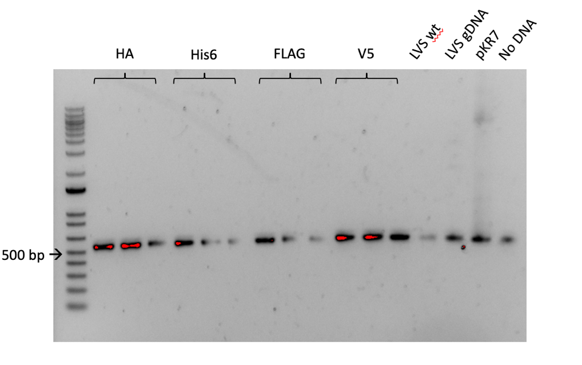

Figure 1: Gel of PCR of the epitope tags after integration onto the plasmid in LVS
Confirmation that each tag was attached to the 3’ end of rpsU2. Unfortunately, there is a band in the No DNA control lane.

Thursday, May 11, 2023
To Do:
- Make glycerol stocks of LVS strains
- Make cell lysates of LVS strains
- Pour plates for Staph transformation

Normalizing OD’s from Plates for Western Blot Protein Sample
- In 400 uL of liquid (PBS or MHB), resuspend a loopful of a patch using aseptic technique
- Resuspend by pipetting up and down, vortex, and briefly spin in minifuge
- Gather cuvettes and add 950 mL of either clean PBS or MHB, add 50uL of your resuspension and pipet up and down to mix
- Check OD in spectrophotometer, remember to multiply by 20
- Use C1V1=C2V2 to calculate an OD of 0.3, make dilution in a total of 1 mL
- Spin down 1 mL dilution of OD 0.3 for 3 minutes at 13000 rpm and resuspend in 1 OD per 1 mL 1x Sample Loading Buffer, ie. 300 uL
- Boil in 95°C heat block for 5-10 minutes, then place in -20°C freeze

All of the antibodies arrived:
Anti-FLAG: monoclonal mouse
Anti-His6: monoclonal mouse
Anti-HA: monoclonal mouse
Anti-V5: monoclonal rabbit

OD Normalization Table:

Sample # | Sample  Name | Measured OD | C1 (actual OD) | V1 (ml) | C2 (Target OD) | V2 (ml) | V of diluent
1 | HA-A | 0.099 | 1.98 | 0.15 | 0.3 | 1 | 0.85
2 | HA-B | 0.184 | 3.68 | 0.08 | 0.3 | 1 | 0.92
3 | HA-C | 0.122 | 2.44 | 0.12 | 0.3 | 1 | 0.88
4 | His6-A | 0.188 | 3.76 | 0.08 | 0.3 | 1 | 0.92
5 | His6-B | 0.122 | 2.44 | 0.12 | 0.3 | 1 | 0.88
6 | His6-C | 0.188 | 3.76 | 0.08 | 0.3 | 1 | 0.92
7 | FLAG-A | 0.191 | 3.82 | 0.08 | 0.3 | 1 | 0.92
8 | FLAG-B | 0.184 | 3.68 | 0.08 | 0.3 | 1 | 0.92
9 | FLAG-C | 0.138 | 2.76 | 0.11 | 0.3 | 1 | 0.89
10 | V5-A | 0.202 | 4.04 | 0.07 | 0.3 | 1 | 0.93
11 | V5-B | 0.123 | 2.46 | 0.12 | 0.3 | 1 | 0.88
12 | V5-C | 0.116 | 2.32 | 0.13 | 0.3 | 1 | 0.87

Making Glycerol Stocks Protocol

For single use stocks: follow steps 2 - 5 but instead of step 6, pipet 50 – 100 ul of cells to sterile labeled microfuge tubes. Note that if you don’t have many cells, you can reduce the volume of MHB and glycerol (keep the same ratio, with a final concentration of glycerol of 15%. E.g. 800 uL MHB and 200 uL 75% glycerol).

- Make 3 cryovials for each strain (permanent stocks), label!
- Prepare 2.4mL of MHB in a 50mL conical (adjust if you are also making single use stocks)
- Take at least half of a thickly spread plate and add cells to the MHB tube
- Resuspend until there are no clumps in the MHB
- Add 600ul of 75% glycerol to the 2.4mL mix by pipetting
- Aliquot 1mL per cryovial, freeze at -80

**I only made 1 stock of each strain; I’ll make more once they’re confirmed.

Friday, May 12, 2023
To Do:
- Make glycerol stocks of LVS strains
- Make cell lysates of LVS strains
- Pour plates for Staph transformation
I used the wrong antibiotic on the Staph transformation, so I made new LB with Cm¹⁰.

Monday, May 15, 2023
To Do:
- Pour plates for Staph transformation
- Practice Western Blot Day 1
- Staph electroporation
- Patch LVS wt and V5
- Run test PCR to find contamination
- Streak out new Staph plate

Quantitative Western Blots with Near-Infrared dyes
Dove lab protocol from Tracy Kambara and Mike Gebhardt
URI modifications from KMRamsey 8/19/19
Updated most recently 12/2022

Running the gel
- Prepare 1x Loading buffer
  - 250 uL NuPage LDS sample buffer (4x, room temp)
  - 100 uL 0.5 M DTT (-20C)
  - 650 uL dH2O
- Resuspend pellet in 1x loading buffer
  - Normalize to ODs
- Heat at 98C for 10 min
- Assemble gel chamber
  - Use pre-cast NuPAGE 4-12% Bis-Tris gel (we also have 10% and 12% gels as necessary)
  - Words on cassette should face towards back of chamber
- Make running buffer – 400 mL for 1 gel, 800 mL for 2 gels
  - 1 x MOPS for large proteins
  - 1x MES for <50 kD proteins
    - 380 mL ddiH2O
    - 20 mL 20x MES
    - 1 mL NuPAGE antioxidant
  - Make sure front section is full so that gels are covered in liquid. Back section does not need to be completely full.
- Use 200 ul pipet to wash wells of gel
- Load 6-10 uL of each sample, based on linear range calculations for each antibody.
As of 2022, we use 5 ul of WesternSure ladder from LiCor which is brighter to see if you are cutting the blot (in -20C freezer). If not cutting, can use 1 uL 1:10 diluted BioRad Precision Plus Dual Color Protein Ladder (#161-0374) for the ladder (in 4C fridge).
- Run at 150V until the blue dye front reaches the bottom ridge of the gel (45 mins to 1 hour, depending on running buffer)
Wet transfer
- Make transfer buffer in a 1 L bottle.
For transferring 1 gel:
50 mL methanol
25 mL NuPAGE 20x transfer buffer
water to 500 L
For transferring 2 gels, double above.

- Store in freezer to chill until the gel has stopped running.
- When the gel has about 10 minutes remaining, begin setting up the transfer.
- Remove transfer buffer from freezer and add 0.5 mL NuPAGE antioxidant (1 mL for 2 gels)
- Activate PVDF membrane (must use Millipore Immobilon-FL #IPFL00010) in ethanol (can do in a tip box). For a full gel, cut to approximately 6 cm x 8 cm using pre-made guide.
- In a large container (9”x9” Pyrex baking dish, for example), presoak membrane, 2 filter papers cut to membrane size, and 2-3 sponges (per gel) in transfer buffer. Use a roller to push bubbles out of the sponges.
- Open gel case, cut off wells and at the bottom ridge on the gel (including any blue dye leftover) and place wet sheet of filter paper on the gel.
- Peel gel and filter paper off and place wet membrane on gel.
- Place other filter paper on membrane and roll out bubbles
- Dunk the transfer cassette halves in the transfer buffer and begin assembling sandwich:
1 sponge
filter/membrane/gel/filter sandwich so that the membrane is on top of the gel
1 more sponge
*if sponges are old and thin, may need to use 3 total. You want the transfer apparatus to have a very tight seal, so if it doesn’t add another sponge.
- Close transfer apparatus and clamp into the gel box.
- Fill the inside chamber with transfer buffer so that it is completely full. Should use remaining transfer buffer from the Pyrex dish. Place the gel box into a large rectangular freezer bucket. Close the lid tightly, and cover the whole gel box with ice.
- Run at 20V for 1 hour.
- Complete No-Stain total protein quantification protocol now, if applicable**
Blocking and probing
- Block the membrane with Li-Cor Intercept Blocking Buffer (PBS) diluted 1:5 in PBS. Use ~25 mL or enough to cover the membrane and rock for 1 hour or overnight at room temperature. DO NOT add any detergents (Surfact-Amps, Tween, SDS) to the blocking buffer.
- Store diluted blocking buffer at 4C.
Next day:
- Add antibodies (must be from two different species, such as mouse and rabbit, eg, rabbit anti-VSVG and mouse anti-sigma⁷⁰) in 10 mL of blocking buffer (no detergent). Rotate for 1 hour at room temperature.
- Meanwhile, make wash buffers: (this recipe is sufficient for 3-4 blots, scale up or down accordingly)
1x Wash Buffer (500 mL)
50 mL 10X PBS
450 mL dH20
- Split into two separate bottles, 400 mL and 100 mL.
- To the 400 mL bottle, add 2 mL Surfact-Amps. This is your primary wash buffer. The remaining 100 mL will be for the final two washes after the secondary antibody, to remove traces of detergent, which may show up as background on the Li-Cor.
- Wash 4x on rotator for 10 minutes each, using 10-20 mL wash buffer per wash.
- Use 10-20 mL diluted blocking buffer and block again, for 15-30 min.
- Add 1 uL of each IRDye secondary antibody to 10 mL wash buffer (the one with Surfact-Amps, aka PBS-T). Also add 0.01% SDS to the wash buffer (10 uL of 10% SDS). These secondary antibodies are stored at 4C.
Note from Dove lab: use 800CW [green channel] if only detecting one protein; if detecting two proteins, use 800CW for the less abundant protein

- Label for 1 hour on rocker at room temperature. Cover the box with foil or use a black box (the secondary antibodies are light sensitive).
- Wash 4x on rotator for 10 minutes each, using 10-20 mL wash buffer per wash.
- Wash 2x on rotator for 10 minutes each, using 10-20 mL of wash buffer WITHOUT detergent.
- If faint bands are expected, do a quick methanol rinse by dunking the blot in methanol for 2 seconds then letting air dry for 2 minutes prior to imaging.
Imaging
- Leave the membrane in the box containing the final wash buffer. Bring the box, gloves, forceps, and a timer to the imager in the INBRE facility.
- For imaging, use 84 uM resolution and “high” clarity.

**Note I am not conducting the protein quantification step, just seeing if they are present.

Western Blot Loading Table:

Lane | Volume (ul) | Sample
1 | 5 | ladder
2 | 10 | FLAG-A
3 | 10 | HA-A
4 | 10 | SLB
5 | 5 | ladder
6 | 10 | FLAG-A
7 | 10 | HA-A
8 | 10 | SLB
9 | 5 | ladder
10 | 10 | FLAG-A
11 | 10 | HA-A
12 | 10 | SLB
13 | 5 | ladder
14 | 10 | FLAG-A
15 | 10 | HA-A

We are testing to see which concentration of FLAG antibody works the best. Documentation says 1:500 and 1:1000 were tested. We will try 4 concentrations; 1:500, 1:1000, 1:5000, and 1:10000, each on a FLAG-tagged strain (#7), and an HA-tagged strain (#1). Adding a lane of SLB prevents the gel from getting weird.

Repeat Staph electroporation
I made new LB plates with Cm¹⁰. I repeated the electroporation protocol as before (see Electroporation into Staph protocol in Protocol Folder). Note that in the MRamsey protocol, it says to set the pulser to 2.1kV, and the default setting for Staph is 1.8kV. I transformed with both settings to see how they compare, but I only had enough cells to do one negative control, which I did at default settings.

Tuesday, May 16, 2023
To Do:
- Practice Western Blot Day 1
- Staph electroporation
- Patch LVS wt and V5
- Practice Western Blot day 2
- Run test PCR to find contamination
- Streak out new Staph plate

Western Blot Day 2
A bunch of washing steps and hopefully imaging. The secondary antibody was not reconstituted so that prolonged the second blocking. To reconstitute, add 0.5 molecular-grade water and let sit for 30 minutes. The blocking step therefore went on for 50 minutes total.
Image:
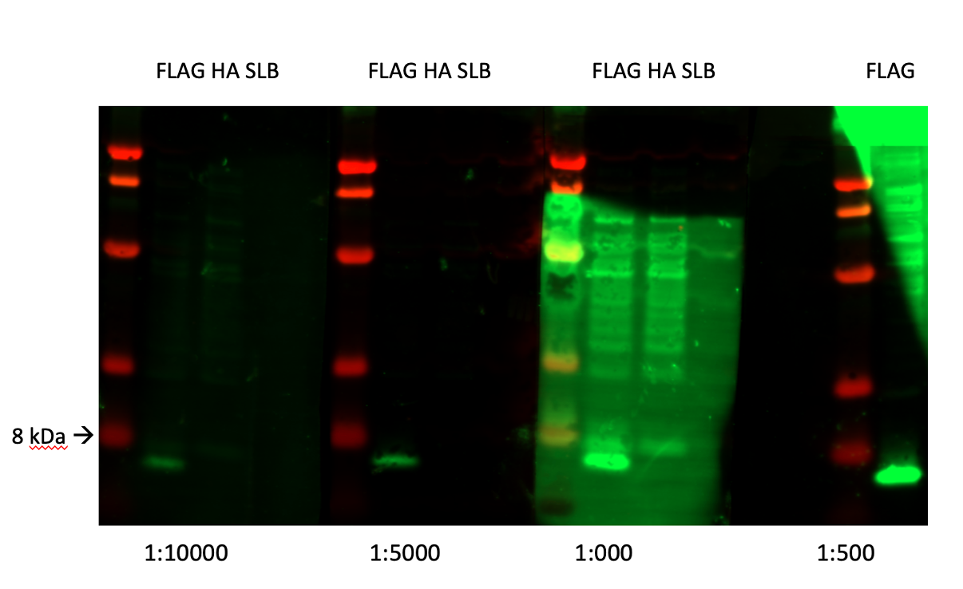

Flgure 2. Western Blot of bS21 tagged with FLAG at various dilutions of anti-FLAG antibody
We are not sure where the background is coming from, I made sure to add SDS to all boxes. Nonetheless, we are happy with how they turned out. The bands are the right size and nothing showed up in the negative control lanes. We will use the 1:1000 dilution for FLAG going forward.

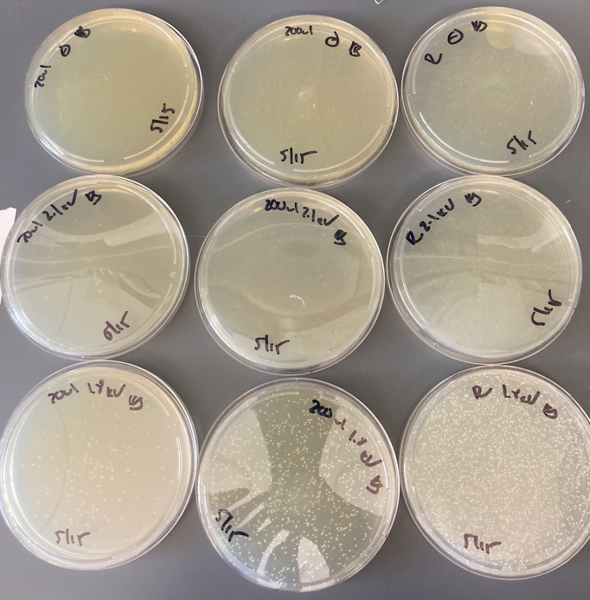

Figure 3. Staph electroporation
Looks good, the transformation worked with the default settings. Nothing grew in negative control or on the 21kV plates. Next step is to make more competent cells (with KRSA-1) and try again.
PCR:
I threw away all of the aliquots of buffer, dTNPs, and polymerase (didn’t throw away polymerase, just opened a new one, if everything works, I’ll repeat PCR with old polymerase to make sure it’s not contaminated).
Reaction numbers | Sample | Condition | Expected size
1 | water | KROL39 and 636 | no product
2 | LVS gDNA | KROL39 and 636 | `260 bp
3 | water | KROL39 and 639 | no product
4 | LVS gDNA | KROL39 and 639 | ~280 bp
Total reaction volume | 20
Total number of reactions | 4
 |  |  |  | Factor
Component | Stock concentration | Final concentration | 1 rxn volume | 5
ddiH2O |  |  | 12.4 | 62
PrimeSTAR GXL Buffer | 5x | 1x | 4.0 | 20
dNTPs | 2.5 mM | 0.2 mM | 1.6 | 8
oligo F | 10 uM | 0.3 uM | 0.6 | 3
oligo R | 10 uM | 0.3 uM | 0.6 | 3
template | 100 ng/ul | 2 ng/ul | 0.4
PrimeSTAR GXL DNA Polymerase | 1.25 U/ul | 0.025 U/ul | 0.4 | 2
 |  | Total volume | 20 | 98

Wednesday, May 17, 2023
To Do:
- Practice Western Blot day 2
- Run test PCR to find contamination
- Streak out new Staph plate
- Run gel on PCR
- Start overnight cultures of Staph for minipreps
- Start overnight culture of KRSA-1

Staph:

Oli had some trouble getting good concentration out of the minipreps she set up on her ligations of pEPSA5 with rplU and methyltransferase (MT). Kathryn showed me a note that some researchers had done when they were trying to get more out of a low copy plasmid (such as pPEPSA5): I am setting up overnights on 3 colonies. Each overnight will be 5 ml, and in the morning I will set up a second 5 ml culture for each and add 250ul Cm. I will combine the overnight culture with the new culture (now 10 ml) and let them shake for a couple of hours. After that, I will split the 10ml culture back into two 5ml cultures which I will use for minipreps. Each pair of cultures will be pooled on the same column during miniprep.

PCR:
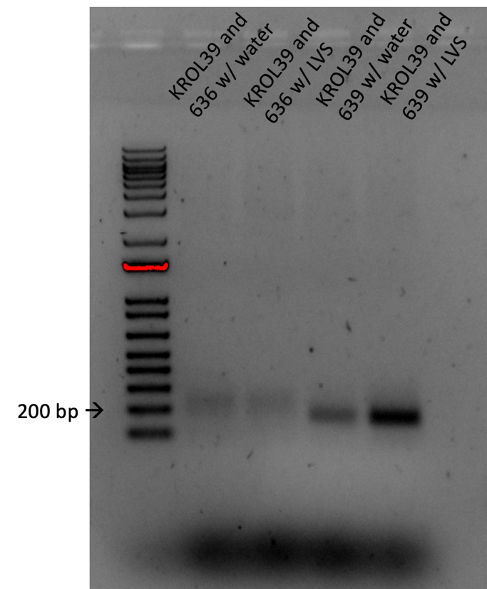

Figure 4. Gel of PCR looking for source of contamination
This is a mess. DNA showed up in both negative controls, the negative and positive controls have about the same band intensity for KROL39/636, and none of the bands are the correct size.

Thursday, May 18, 2023
To Do:
- Run gel on PCR
- Start overnight cultures of Staph for minipreps
- Start overnight culture of KRSA-1
- Miniprep Staph pKR185
- Make KRSA-1 competent cells
- KRSA-1 transformation
- Start overnight of XL1-blue
- Streak plates for Sierra

Staph:
I made new tubes of 5ml LB with 250ul of Cm, and added the overnight cultures to the new tubes. I let the tubes shake for 2 hours, then split them up into two 5ml cultures, which were then pooled during miniprep.

# | Sample ID | Nucleic Acid | Unit | A260 (Abs) | A280 (Abs) | 260/280 | 260/230 | Sample Type | Factor
1 | pKR185-1 MP | 113.1 | ng/µl | 2.262 | 1.394 | 1.62 | 0.89 | DNA | 50
2 | pKR185-2 MP | 116.8 | ng/µl | 2.336 | 1.42 | 1.64 | 0.92 | DNA | 50
3 | pKR185-3 MP | 74.3 | ng/µl | 1.486 | 0.835 | 1.78 | 1.44 | DNA | 50

Minipreps of the 3 colonies look good, will send them to sequencing next week using the primer KROL664.
KRSA-1
I made new competent cells with KRSA-1. I did the same scaled down protocol as last time. I transformed a positive and a negative and plated 200ul and remaining volume on LBCarb¹⁰ plates.
Some notes:
- I misread the initial OD reading as 1.4 instead of .14, so I took those cultures out of the shaker and back-diluted them. About an hour later I realized my mistake and put the first culture back on until they reached 0.9 and 1.1 (hopefully it’s not too high)
- On the next to last spin I didn’t notice that my flame was off when I was resuspending; hopefully there’s no contamination

Friday, May 19 2023
To Do:
- Miniprep Staph pKR185
- Make KRSA-1 competent cells
- KRSA-1 transformation
- Start overnight of XL1-blue
- Streak plates for Sierra
- Make chemically competent XL1-B cells

KRSA-1 Transformation:
Didn’t work; could be for any number of reasons that I listed yesterday. Will try again next week.
XL1-Blu Competent Cells:
I will run a test transformation next week.

Monday, May 22 2023
To Do:
- Streak plates for Sierra
- Make chemically competent XL1-B cells
- Transformation of XL1-blue
- Prep sequencing reactions
- Make LB
- Refill DI water
- Start overnight of KRSA-1
- Western on HA tag running and transfer

XL1-Blue:
Sierra took care of the test transformation because she was transforming anyway.
Sequencing reactions:
See 230523_KB_SequencingSubmission in the Orders folder.
Western:
Lane | Volume (ul) | Sample
1 | 5 | Ladder
2 | 10 | HA-B
3 | 10 | His6-B (neg)
4 | 10 | SLB
5 | 5 | Ladder
6 | 10 | HA-B
7 | 10 | His6-B (neg)
8 | 10 | SLB
9 | 5 | Ladder
10 | 10 | HA-B
11 | 10 | His6-B (neg)
12 | 10 | SLB
13 | 5 | Ladder
14 | 10 | HA-B**
15 | 10 | His6-B (neg)**
**loading error
I set up a Western to test the HA antibody. I set it up the same way as last week; in quadruplicate with a ladder, the HA whole cell lysate, the His-6 whole cell lysate (as negative control), and SLB. On the last round, there was a loading error for HA; it looks as if there may have been a tear in the well and sample leaked out. I added HA to the last lane, so there is no negative control in that setup. I loaded 10ul of each sample and 5ul of the ladder.
Note that I had to open a new bottle of NuPage antioxidant and it was both expired and crystallized.
Note that I trimmed the membrane after the transfer so that it would fit in the box during rocking, and I used a razor on the bench. Sierra is concerned that if there were any proteins on the bench, they may have transferred to the membrane, but that is how I did it last time. Hopefully it is ok.
I didn’t cut the membrane before rocking; I will cut it before adding the different dilutions. The membrane is rocking overnight at RT. Kathryn says it should be 4º, but Sierra says she and Hannah always did it at RT. This is a change from what I did last time, which is let it sit overnight in the refrigerator, no rocking.

Tuesday, May 23 2023
To Do:
- Transformation of XL1-blue
- Prep sequencing reactions
- Make LB
- Refill DI water
- Start overnight of KRSA-1
- Western on HA tag running and transfer
- Western washes and imaging
- Transformation of KRSA-1
- Make new 10mM aliquot pKR39 and re-run PCR
XL1-Blue:
The cells are competent per Sierra’s transformation.
Anti- HA Western Blot:
I’m testing dilutions for the anti-HA antibody. Documentation says 0.1-0.2 ug/ml (1:10000/1:5000) were tested. The antibody is at a concentration of 1mg/ml. I will test the following:
Dilution, 1: | Dilution factor (Compared to 1:1,000) | Desired final volume | Volume of 1:1,000 dilution (mL) | Volume of buffer (mL)
1000 |  | 5 | 6.6
5000 | 5 | 5 | 1 | 4
10000 | 10 | 5 | 0.5 | 4.5
50000 | 50 | 5 | 0.1 | 4.9

I used the 1:1000 dilution to make the other dilutions.
I should have cut the membrane last night, because now I’m not sure which side is which. In hope I cut them properly, if not some sample lanes will be missing.

LiCor Imaging
- Leave the membrane in the box containing the final wash buffer. Bring the box, gloves, forceps, and a timer to the imager in the INBRE facility.
- Open the Li-Cor and cleaned the surface of the scanning apparatus.
- Place membrane face down in the bottom left hand corner. Note the size of the membrane using the grid (usually about 8x8 or smaller).
- Set Image Quality to High and press ‘Start’
- Adjust the brightness and contrast on each channel until image appears the best. Using the black bands on white background setting is typically best.
- Save image as Image Work File
- Under IS tab, go to Save As -> Export-> Images for Print and export as Tiff (600 dpi)
- Remove your membrane and spray down the glass surface of the scanner with ethanol and kimwipes (provided there).
- For quantification, click on Analyze. Either use “Add Rectangle” or “Draw Rectangle” features to instantly quantify the density of each band.

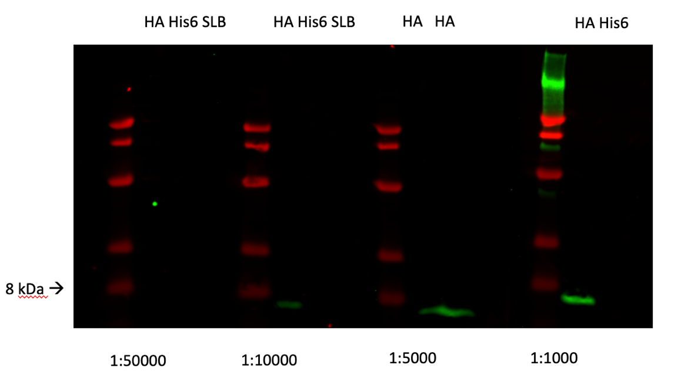

Figure 5. WB of anti-HA at various dilutions
They look great! I will use the 1:5000 dilution going forward.
KRSA-1 Transformation:
I made new KRSA-1 competent cells. They took about an hour to get to an OD600 of 0.8.
I will push this off till tomorrow, there were mistakes that were made because I was trying to do too many things at once.

Wednesday, May 24 2023
To Do:
- Western washes and imaging
- Transformation of KRSA-1
- Make new 10mM aliquot pKR39 and re-run PCR
Sequencing:
The sequencing results on the wt methyltransferase gene came out great. See file KB_230422B in the Sequencing Results folder. Next step is to make the mutant Staph strain competent so I can complement this gene back in.
KRSA-1:
I tried the protocol again. This time, I back diluted the overnight culture into 2 10ml cultures and split them into two 5ml cultures for the ~30 minute re-incubation. They started at an OD600 of about 0.5 and took nearly an hour to get to about 0.9 (a little over). The rest of the protocol went as expected. I stored the aliquots in the -80º, then took 2 out to try the electroporation. I did a positive and a negative control.

Thursday, May 25 2023
To Do:
- Transformation of KRSA-1
- Make new 10mM aliquot pKR39 and re-run PCR
- Western blots on His6 and V5
Western Blots:
His6
Lane | Volume (ul) | Sample
1 | 5 | Ladder
2 | 10 | His6-A
3 | 10 | V5-C (neg)
4 | 10 | SLB
5 | 5 | Ladder
6 | 10 | His6-A
7 | 10 | V5-C (neg)
8 | 10 | SLB
9 | 5 | Ladder
10 | 10 | His6-A
11 | 10 | V5-C (neg)
12 | 10 | SLB
13 | 5 | Ladder
14 | 10 | His6-A
15 | 10 | V5-C (neg)

V5
Lane | Volume (ul) | Sample
1 | 5 | Ladder
2 | 10 | V5-A
3 | 10 | FLAG-C (neg)
4 | 10 | SLB
5 | 5 | Ladder
6 | 10 | V5-A
7 | 10 | FLAG-C (neg)
8 | 10 | SLB
9 | 5 | Ladder
10 | 10 | V5-A
11 | 10 | FLAG-C (neg)
12 | 10 | SLB
13 | 5 | Ladder
14 | 10 | V5-A
15 | 10 | FLAG-C (neg)

I am setting up the last 2 tags simultaneously. Documentation says that for His6, 1:1000 and 1:3000 were tested. For V5, 1:1000 was tested. I will test 1:500, 1:1000, 1:5000, 1:10000 for both.
In the His6 gel there was a loading error in lane 7 and in V5 there was a loading error in lane 2.
I don’t think the transfer will go well; I had a tough time cutting the gel (lopped off the top of one of the ladders on the His6 gel), and the gel was moving around on the filter paper/membrane.
It didn’t work. I should probably only set up one at a time until I’m really comfortable with the protocol.
The Staph cells didn’t grow after the transformation.

Friday, May 26 2023
To Do:
- Make new 10mM aliquot pKR39 and re-run PCR
- Western blots on His6
KRSA-1:
I had left the Staph transformation plates in the incubator overnight and surprisingly, I see some colonies, but it was not efficient. There are no colonies on the 20ul plate, there is 1 colony on the 200ul plate, and there are 5 colonies on the remaining plate. No growth on any of the negative control plates. I wonder if should try this at a lower temperature.
Western Blot:
Only going to set up a WB on His6 today. I am using V5-B as the negative control because I lost a lot of V5-C yesterday (it spilled) and I want to save it for the actual WB.
Sierra helped me with the transfer this time, and I was feeling optimistic, but it didn’t work again. I only saw very faint bands on the membrane, there were still a lot of the bands left on the gel. I wonder if I need to increase the time. One website suggested setting up membranes on either side of the gel in case the power supply is wonky. That’s something to keep in mind, but I don’t think that is the problem since there were faint bands on the membrane. I’m going to use a different power source next time, and triple check that there are no bubbles in the sandwich.
PCR:
Reaction numbers | Sample | Condition | Expected size
1 | water | KROL39 and 636 | no product
2 | LVS gDNA | KROL39 and 636 | `260 bp
3 | water | KROL39 and 639 | no product
4 | LVS gDNA | KROL39 and 639 | ~280 bp
Total reaction volume | 20
Total number of reactions | 4
 |  |  |  | Factor
Component | Stock concentration | Final concentration | 1 rxn volume | 5
ddiH2O |  |  | 12.4 | 62
PrimeSTAR GXL Buffer | 5x | 1x | 4.0 | 20
dNTPs | 2.5 mM | 0.2 mM | 1.6 | 8
oligo F | 10 uM | 0.3 uM | 0.6 | 3
oligo R | 10 uM | 0.3 uM | 0.6 | 3
template | 100 ng/ul | 2 ng/ul | 0.4
PrimeSTAR GXL DNA Polymerase | 1.25 U/ul | 0.025 U/ul | 0.4 | 2
 |  | Total volume | 20 | 98

Take 2: I made a new 10mM aliquot of KROL39.

Tuesday, May 30 2023
To Do:
- Make new 10mM aliquot pKR39 and re-run PCR
- Western blots on His6
- Run gel on PCR
- Streak plate of KRSA-2

PCR:
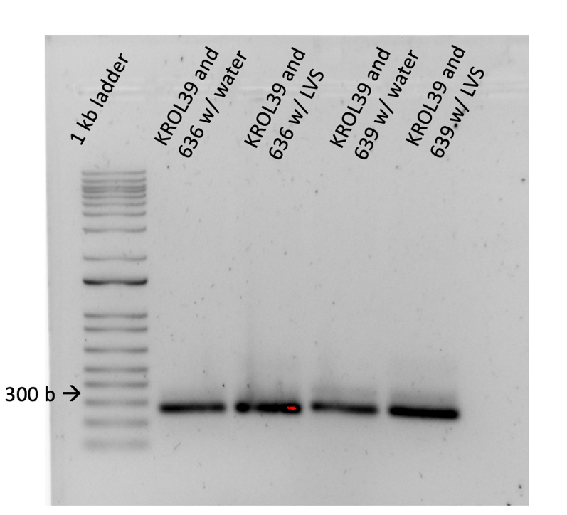

Figure 6. Second PCR looking for source of contamination
Still contamination! And those bands are very bright. I put my aliquot of water (a new one I had made for this PCR) on the NanoDrop, and fortunately no DNA showed up. I used Sierra’s aliquot as a blank. So it could be that the 100mM aliquot of KROL39 is the source of contamination. I will use a different forward primer (KROL601) with these reverse primers next time.
Western Blot:
I got a transfer this time! I had talked to Kathryn about what could be going on and my guess was the power supply, and she said that because there was still dye on the gel, that indicates that the membrane was on the correct side. She suggested that I make sure there are bubbles before I add ice. I tried that, but I couldn’t see bubbles. I used the power supply on Ben’s bench, the same as we used the first time, and I think that one is more reliable.
Staph:
Kathryn and I also talked about KRSA-1. We agree that the colonies that came up 48 hours later after transformation might not be what we want. She suggested a different approach; transform the plasmid into KRSA-2, since it readily accepts exogenous DNA, then purify the plasmid and transform it into KRSA-1. We’re hoping we can “trick” KRSA-1 into recognizing the purified plasmid from KRSA-2 as self-DNA. I streaked out a plate.

Wednesday, May 31 2023
To Do:
- Western blots on His6
- Run gel on PCR
- Streak plate of KRSA-2
- Wash and image His6 Western
- Western blots on V5
- Start overnight of KRSA-2

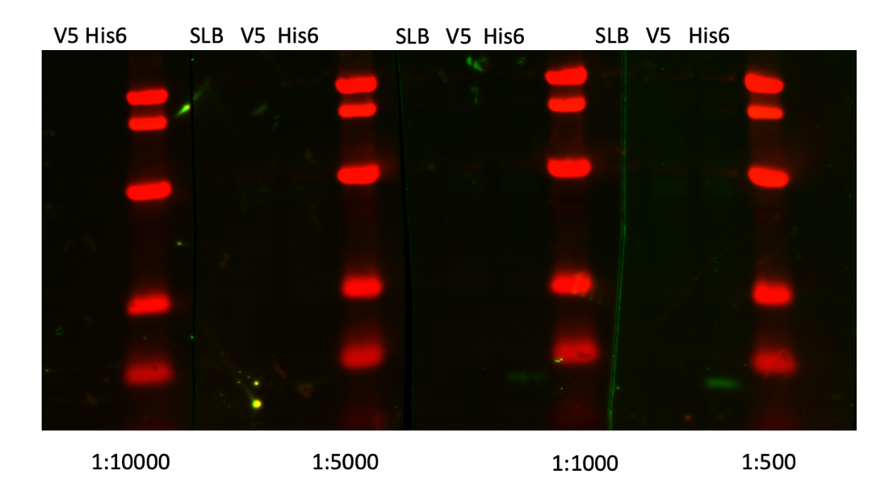

Figure 7. WB of anti-His at various dilutions
This one isn’t as strong as the previous 2, but there are bands.

Thursday, June 1 2023
To Do:
- Wash and image His6 Western
- Western blots on V5
- Start overnight of KRSA-2
- Wash and image V5 Western
- Make KRSA-2 competent cells
- Test transformation on KRSA-2 comp cells
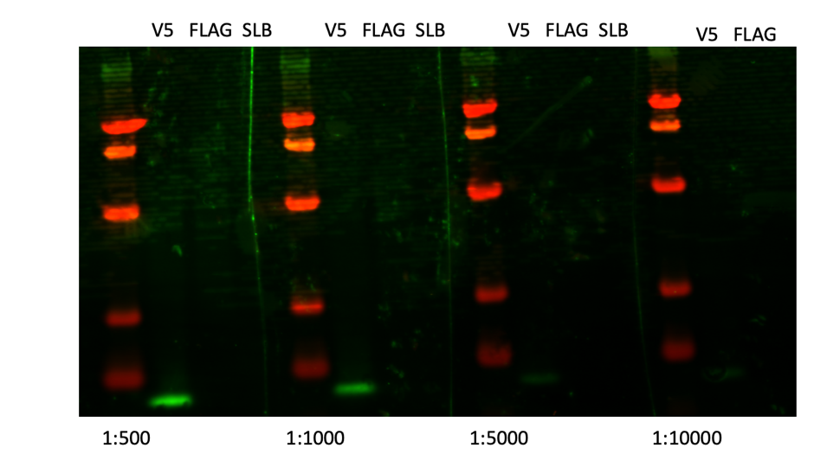

Figure 8. WB of anti-V5 at various dilutions
I turned up the brightness on the green which is why it looks like there’s background. I’m a little surprised by the difference between 1:1000 and 1:5000.
KRSA-2:
Adja and I made KRSA-2 competent cells, this time following the protocol as written (meaning not scaled down). We performed an electroporation on an empty pEPSA5 vector and a no DNA control.

Friday, June 2 2023
To Do:

- Wash and image V5 Western
- Make KRSA-2 competent cells
- Test transformation on KRSA-2 comp cells

I didn’t do much today. The transformation of KRSA-2 was successful.

Monday, June 5 2023
To Do:

- Wash and image V5 Western
- Make KRSA-2 competent cells
- Test transformation on KRSA-2 comp cells
- Transform laurenobiolide plasmids into KRSA-2
- Pour LBCm¹⁰ plates

Transformation:
Setting up pKR185 (wt MT strain of SA) for transformation. Concentration is 74.3 ng/ul, so I’ll add 3ul to the competent cells. Also set up a no DNA control. See Electroporation into S. aureus protocol. Each strain was plated as 20ul and 200ul onto LBCm¹⁰ plates. **Note that the shaker was not turned on when we went to put the recovery samples in, so they started shaking at 23ºC.
I made sure to consolidate the pKR185 minipreps into one tube for storage in -20ºC and made a 5ul aliquot for storage in -80ºC permanent stocks.
There are minipreps of mutant MT and rplU in Oli’s cloning box, they will get transformed into KRSA-2 tomorrow. Later on in the week we have to repeat the ligation of wt rplU into pEPSA5.
Adja and I poured more LBCm¹⁰ plates for future transformations.
Adja and I patched out the LR mutant strains and wt of Staph so she can make frozen aliquots. I also streaked a plate of LR-M1 to be used to make them competent.
It was difficult to discern what tubes were the plasmids we need, but after digging around in Oli’s cloning box and her notes, I have surmised that the tubes labeled beginning with a 2 are the mutant MT (pKR186), and the tubes beginning with a 4 are the mutant rplU (pKR199). We will have to repeat the ligation for pKR198 (wt rplU).

Tuesday, June 6 2023
To Do:

- Transform laurenobiolide plasmids into KRSA-2
- Pour LBCm¹⁰ plates
- Consolidate the pEPSA5 plasmids and make a permanent stock
- Transform pKR186 and pKR199 into KRSA-2
- Patch and start overnights of pKR185 transformation colonies

The pKR185 transformation plates only had 4 colonies on the 200ul. This decrease in efficiency compared to the empty vector test could be due to the shaker not being at the appropriate temp when the recovering samples went in.
Just to be safe, for the transformation of pKR186 and pKR199 today, I will plate them on 20ul, 200ul, and the remaining volume. I also made sure the shaker was on and at the right temp before starting the protocol. Adja performed the actual transformation, and I did the spread plating.
I patched out the 4 transformation colonies for pKR185 to make frozen stocks with, and also started overnight cultures for minipreps tomorrow. There was no growth on the negative control plates.

Wednesday, June 7 2023
To Do:

- Pour LBCm¹⁰ plates
- Consolidate the pEPSA5 plasmids and make a permanent stock
- Transform pKR186 and pKR199 into KRSA-2
- Patch and start overnights of pKR185 transformation colonies
- Miniprep pKR185 overnight cultures
- Make SA-LR-M1 competent cells
- Patch and start overnights of pKR186 and pKR199

Extracting the plasmid out of Staph requires additional steps:

Purification of plasmid DNA from S. aureus by alkaline Lysis
Birnbiom, H. C. 1983. A rapid alkaline extraction method for the isolation of plasmid DNA Methods Enzymol 100:243-255.
QIAprep Spin Miniprep Kit Protocol adapted to S. aureus (Marco Palma)
- This protocol is designed for purification of up to 20 μg of high-copy plasmid DNA from 1-5 ml overnight cultures of S. aureus. (Overloading the system with too many cells will reduce the yield.)
- Grow 5 ml broth culture or plate of S. aureus.
- Spin culture at 4000 rpm for 10 min. Remove supernatant and add, (OR, suspend 2 loops of culture from a plate in) 700 μl TE (10 mM TrisCl, pH 8.0, 1 mM EDTA)
- Add 500 μl cold Acetone mix (50% acetone, 50% absolute ETOH, kept in freezer).
- Incubate 5 min on ice
- Spin 2 min at 14000 rpm
- Wash the pellet with 1 ml TE (it helps to completely resuspend the pellet), spin and discard sup.
- Add 3 μl 10 mg/mL lysostaphin to the cell pellet. (Vortexing the dry pellet briefly at this point helps resuspend the pellet when buffer is added, and seems to help lysis).
- Resuspend pelleted bacterial cells in 250 μl of Buffer P1 and transfer to a microcentrifuge tube.
- Incubate at 37° C for at least 1 hr. (Check for clearing)
- Proceed with QIAprep protocol at step 2:
“Add 250 μl of buffer P2 and gently invert the tube 4-6 times to mix, or until the solution becomes viscous and slightly clear.” Do not allow the lysis reaction to proceed for more than 5 min.
etc.

I spun down 2 mls of culture since they had grown pretty turbid overnight.
# | Sample ID | Nucleic Acid | Unit | A260 (Abs) | A280 (Abs) | 260/280 | 260/230 | Sample Type | Factor
1 | SA pKR185-1 | 150 | ng/µl | 2.999 | 1.335 | 2.25 | 1.78 | DNA | 50
2 | SA pKR185-2 | 145.5 | ng/µl | 2.91 | 1.537 | 1.89 | 2.4 | DNA | 50
3 | SA pKR185-3 | 172.5 | ng/µl | 3.449 | 1.796 | 1.92 | 2.4 | DNA | 50
4 | SA pKR185-4 | 163.5 | ng/µl | 3.27 | 1.743 | 1.88 | 2.1 | DNA | 50

These are good concentrations. SA-pKR185-1 had a weird, jagged peak and 260/280 ratio isn’t great, so I’m going to keep an eye on that one going forward.
Staph competent cells:
Adja made the SA-LR-M1 strain competent, and performed a transformation with empty pEPSA5.

S. aureus Glycerol Stocks:
Use aseptic technique
Per strain, label 2 cryotubes with strain number. Include SA, strain number, genotype, date.
Add 200 uL sterile 75% glycerol to each tube (2 per strain).
In a sterile 2 mL tube (1 per strain), add 400 uL of LB
Resuspend patch (all of what you have) in LB to homogeneity
Correct volume to 1700 uL (add 2x 650 uL LB)
Transfer 800 uL to each cryotube (final volume should be 1 mL)
Vortex cryotube
Quickly spin (mini-fuge) to get liquid to the bottom of the tube
Freeze at -80°C in appropriate strain box

Thursday, June 8 2023
To Do:

- Miniprep pKR185 overnight cultures
- Make SA-LR-M1 competent cells
- Patch and start overnights of pKR186 and pKR199
- Miniprep pKR186 and pKR199
- Make frozen stocks of pKR186 and pKR199
- Set up transformation of SA-pKR185 into SA-LR-M1

SA-LR-M1 competent cells
No growth on any of the plates yet, but since this a mutant strain of KRSA-1, I’m not surprised or worried.
Staph minipreps:
Adja and I prepared minipreps of pKR186 and pKR199. She did pKR186 and I did pKR199.
Nanodrop:
# | Sample ID | Nucleic Acid | Unit | A260 (Abs) | A280 (Abs) | 260/280 | 260/230 | Sample Type | Factor
1 | pKR199-1 | 85.1 | ng/µl | 1.702 | 0.91 | 1.87 | 2.65 | DNA | 50
2 | pKR199-2 | 71.3 | ng/µl | 1.427 | 0.727 | 1.96 | 2.01 | DNA | 50
3 | pKR199-3 | 93.2 | ng/µl | 1.865 | 0.977 | 1.91 | 2.59 | DNA | 50
4 | pKR199-4 | 70.8 | ng/µl | 1.416 | 0.722 | 1.96 | 2.87 | DNA | 50
5 | pKR186-1 | 43.2 | ng/µl | 0.864 | 0.472 | 1.83 | 1.84 | DNA | 50
6 | pKR186-2 | 66.4 | ng/µl | 1.328 | 0.728 | 1.82 | 1.93 | DNA | 50
7 | pKR186-3 | 48.2 | ng/µl | 0.964 | 0.531 | 1.82 | 1.89 | DNA | 50
8 | pKR186-4 | 45 | ng/µl | 0.899 | 0.491 | 1.83 | 1.85 | DNA | 50

Not sure why the yields are lower than pKR185; could be due to us incubating them for less time than I did the first time.
Transformation:
I suspect that the first transformation that I set up yesterday didn’t work because I used a plasmid that was purified out of E coli. Today, I transformed pKR185 that was purified out of KRSA-2 into the mutant Staph strain.

Friday, June 9 2023
To Do:

- Miniprep pKR186 and pKR199
- Make frozen stocks of pKR186 and pKR199
- Set up transformation of SA-pKR185 into SA-LR-M1
- Patch out transformation colonies
The transformation of pKR185 into SA-LR-M1 (heretofore known as KRSA-4, added to Strains list) worked!
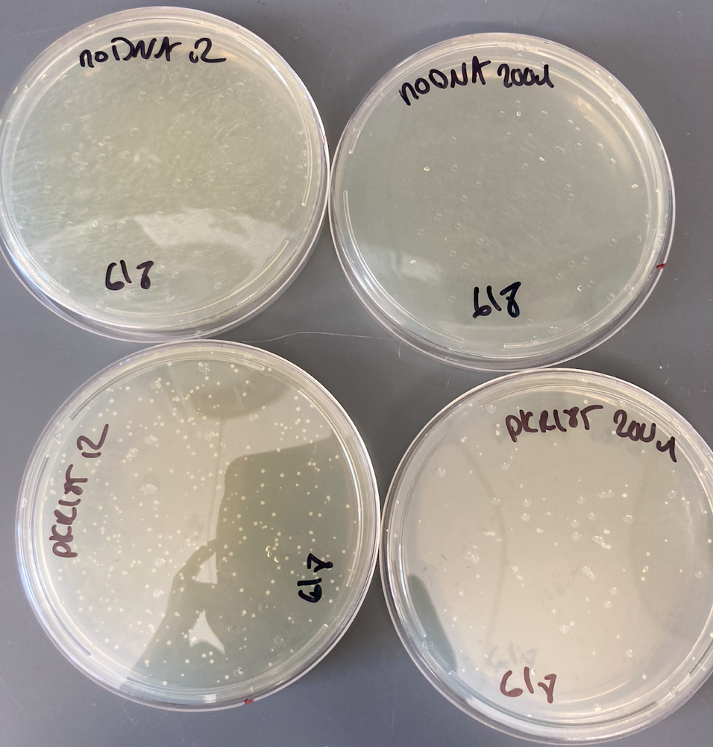

Figure 9. Transformation of pKR185 into KRSA1
There are both small and large colonies that concern me a bit, but there is no growth on the No DNA control plates. I patched out 2 large and 2 small colonies, and at a later date I will grow them up, miniprep them, and send the plasmids for sequencing. I streaked them for isolation to see if this is pleiomorphism or if something else is going on.

Saturday, June 10 2023
To Do:

- Patch out transformation colonies
- Set up glycerol stocks of patches

The patches for the large colonies look fine but one of the small ones didn’t grow as robustly, and the other one only had some breakthrough colonies. Furthermore, there is difference in growth between large and small colony streak plates.

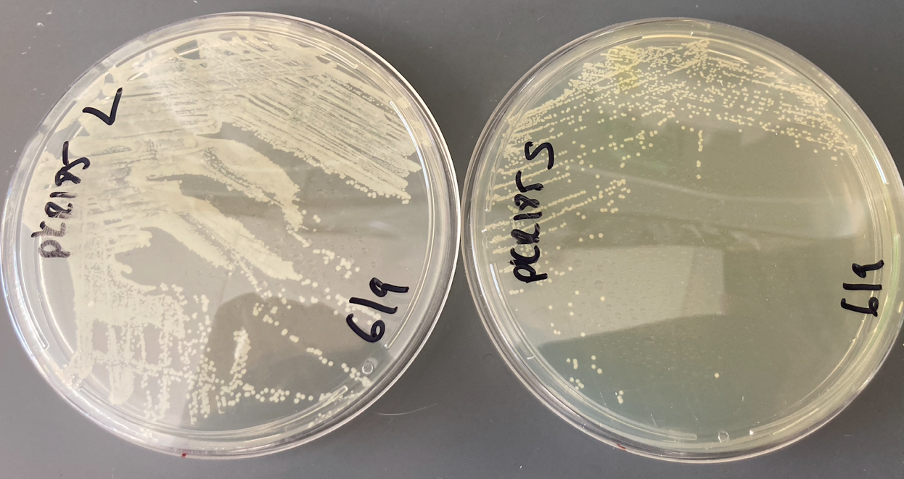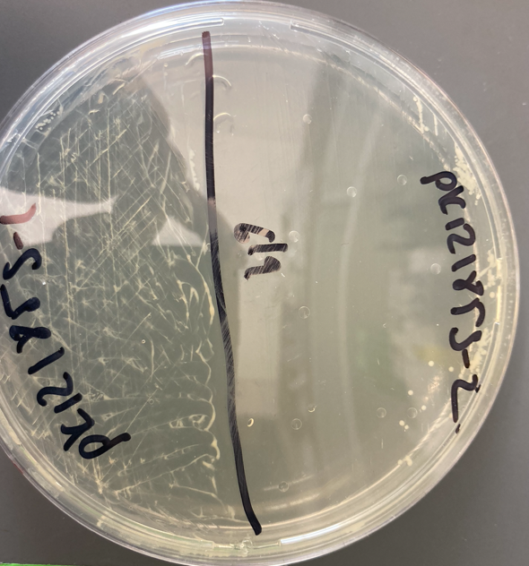

Figure 10. Different morphologies of KRSA-pKR185
I made frozen aliquots of both large colony patches and the one small colony patch. For now, they are stored in KRSA Box 1 in the -80ºC.

Wednesday, June 14 2023
To Do:
- Set up glycerol stocks of patches
- Set up large Westerns
- Pour LBCm¹⁰ plates

Setting this up 4X:
Lane | Volume (ul) | Sample
1 | 5 | Ladder
2 | 10 | HA-A
3 | 10 | HA-B
4 | 10 | HA-C
5 | 5 | Ladder
6 | 10 | His6-A
7 | 10 | His6-B
8 | 10 | His6-C
9 | 5 | Ladder
10 | 10 | FLAG-A
11 | 10 | FLAG-B
12 | 10 | FLAG-C
13 | 5 | Ladder
14 | 10 | V5-A
15 | 10 | V5-B
16 | 10 | V5-C
17 | 10 | SLB

Thursday, June 15 2023
To Do:
- Set up large Westerns
- Pour LBCm¹⁰ plates
- Set up transformation from KRSA-2 to KRSA-1 with Adja
- Wash and image Westerns

I reused the primary antibodies from last time except for His6, which had to be made fresh because I threw out the first one.
Dilutions:
HA: 1:5000
His6: 1:500
FLAG: 1:5000
V5: 1:1000

Images:
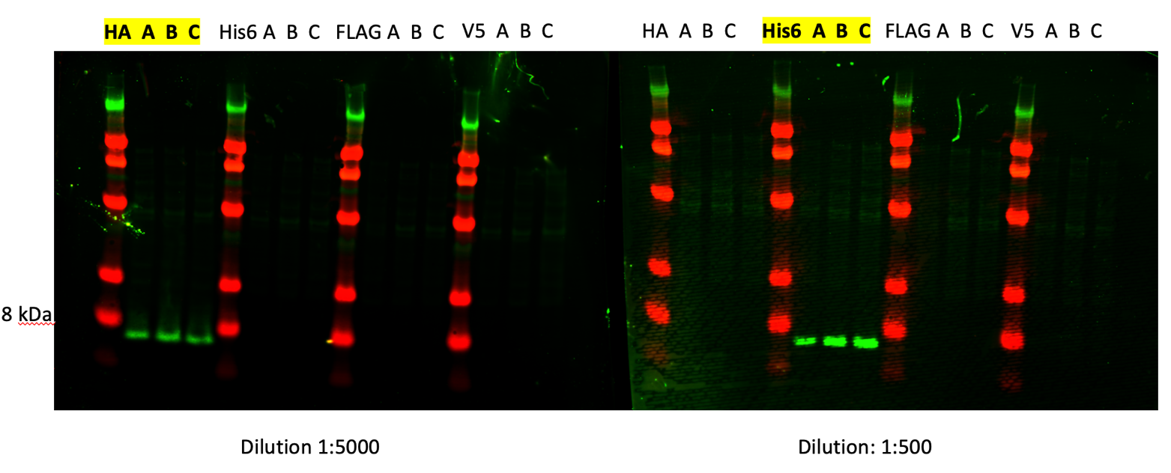

Figure 11 a. WB of all tagged LVS strains with specific antibodies (HA and His)
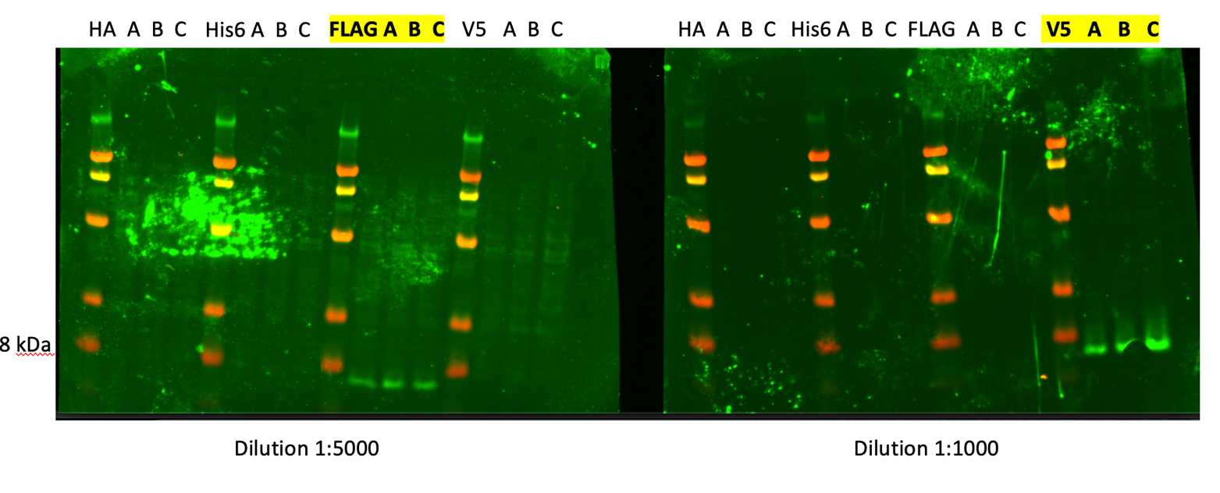

Figure 11 b. WB of all tagged LVS strains with specific antibodies (FLAG and V5)

No cross reactivity with other antibodies, but FLAG and V5 came out so faint I had to crank the brightness on the green in order for the bands to be visible.

Transformations:
Adja set up transformations with pKR186 and pKR199 into KRSA1. She also set up an empty vector control and a no DNA control.

Tuesday, June 20 2023
To Do:
- Set up transformation from KRSA-2 to KRSA-1 with Adja
- Wash and image Westerns
- Transformation into KRSA-1
- Start thinking about IP cell pellet prep
- Start overnights of large and small pKR185 colonies
Adja’s transformations didn’t work. She had colonies on the no DNA plates but on nothing else (I think she just switched the no DNA with the EV). We will do more transformations with only one plasmid at a time.
For the week on the Staph project:
- Repeat the transformations into KRSA-1
- Make more pEPSA5 gel extract
- Repeat the ligation of pKR198
- Miniprep pKR185 out of KRSA-1 and send to sequencing

For the ribosome project:
- Prepare cell pellets for IP

Wednesday, June 21 2023
To Do:
- Transformation into KRSA-1
- Start thinking about IP cell pellet prep
- Start overnights of large and small pKR185 colonies
- Patch out pF-LVS-rpsU2-FLAG-A for cell pellet
We began the miniprep protocol for Staph but we had to stop because the wrong reagent was added. We were able to subculture the 6 cultures, so we’ll try again tomorrow.
I plan on starting the large overnight culture of pF-LVS-rpsU2-FLAG-A to prepare cell pellets tomorrow, so I patched out the strain and made new iron pyrophosphate for the supplemented MHB. Tomorrow I will make 500 ml of MHB directly into a 1 L baffled flask, autoclave it, then supplement it.

Ribosome purification - IgG IP (F. tularensis LVS)

Required reagents:
Plates with cells corresponding to each sample, grown overnight
Culture media
Baffled flasks (1L) with sterile and supplemented Mueller Hinton Broth (sMHB) (500 mL)
Supplement for each 500 mL MHB flask:
10 mL BBL IsoVitaleX
5 mL 10% glucose
5 mL 2.5% iron pyrophosphate
Extra media for cell prep and OD determination
Sterile microfuge tubes
Cuvettes
250 mL centrifuge bottles (2/sample)
Nonsterile 50 mL conical tubes

Prepare cell pellets (Days 0 – 2)
- For each strain, label a sterile microfuge tube and add 400 uL supplemented MHB (sMHB) aseptically.
- Scrape up ~1 loopful of cells and add to appropriate microfuge tube.
- Resuspend cells to homogeneity using a pipette (no clumps should be present).
- Add 500 uL more sMHB to each tube.
- Prepare cuvettes to check OD₆₀₀ by labeling one per sample and adding 900 uL sMHB (keep sMHB stock sterile- cuvettes and subsequent cell dilutions are not sterile)
- Add 100 uL resuspended cells to appropriate cuvette
- Check OD₆₀₀. Calculate OD₆₀₀ of resuspended cells (10x observed OD₆₀₀), record both observed and calculated OD.
  - If observed OD₆₀₀ < 0.01, add more cells from the plate and re-check the OD.
  - If observed OD₆₀₀ > 0.5, re-check the OD using a more dilute sample.
- For each sample, calculate volume of resuspended cells necessary to obtain a final OD₆₀₀ of 0.003 in 500 mL
(0.003 OD₆₀₀)*(500,000ul)/(sample OD₆₀₀) = x uL
  - If this volume is < 100 uL, dilute the resuspended cells and go back to step 7.
  - If this volume is larger than the volume of cells in the microfuge tube (~>800 uL), add more cells from the plate and re-check the OD.
- To appropriately labeled 500 mL flasks, add volume of resuspended cells calculated to obtain final OD₆₀₀ of 0.003.
- Incubate flasks at 37°C shaking overnight, noting time incubation started (after 4pm and before 6pm). Arrange flasks as equally as possible in the shaking incubator to keep the platform balanced.
- In the morning, check the OD₆₀₀ of each sample and document. Ideally, continue when cells are in mid-log phase (OD₆₀₀ between 0.3 – 0.4).
- Pellet cells by centrifugation in 250 mL bottles (2 per sample, sterile not required), max speed in Sorvall X4 Pro, 4°C for 10 mins. Centrifuge can be pre-cooled or cool down during this step.
- Discard supernatant (into overnight flasks with bleach), resuspend pellets in ~10 mL sMHB (combining pellets from the same samples) and transfer to 50 mL conicals (sterile not required, label well- include sample number, descriptive name, date).
- Pellet cells by centrifugation in conicals, max speed in Sorvall X4 Pro, 4°C for 5 mins.
- Discard supernatant, freeze pellets at –80°C until ready for next step.

Thursday, June 22 2023
To Do:
- Start thinking about IP cell pellet prep
- Start overnights of large and small pKR185 colonies
- Patch out pF-LVS-FLAG-A for cell pellet
- Miniprep pKR185 large and small
- Cast gel for pEPSA5 digest
- Gel purify pEPSA5
- Repeat ligation
- Transform pKR199 into KRSA-1
- Start large overnight culture of pF-LVS-rpsU2-FLAG-A

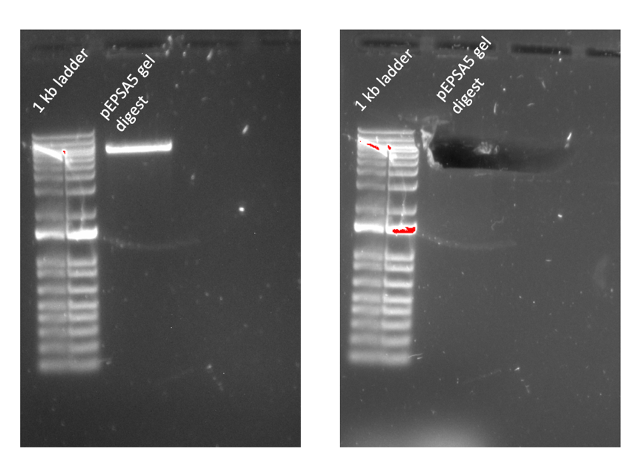

Figure 12. Gel excision of pEPSA5

Gel Extraction
 | Tube Weight (g) | Tube w/ Gel (g) | Gel Weight (mg) | QG Buffer Volume (ul) | Isopropanol Volume (ul)
Tube 1 | 0.96 | 1.36 | 400 | 1200 | 400

# | Sample ID | Nucleic Acid | Unit | A260 (Abs) | A280 (Abs) | 260/280 | 260/230 | Sample Type | Factor
1 | pEPSA5 gel extract | 17.9 | ng/µl | 0.358 | 0.086 | 4.14 | 0.05 | DNA | 50

I have serious doubts that this is DNA considering the ratio. The peak was around 230-240. I will re-digest the plasmid.
Cell Pellets:
 | Observed OD600 | Calculated OD600 | Starting Volume (ul) for starting OD600 of 0.003
Tube 1 | 0.152 | 1.52 | 987

I didn’t have that volume in the tube so I added the rest (about 800ul). The culture was started at 6:20.

Last minute decided to do a transformation of pKR199.

Friday, June 23 2023
To Do:
- Miniprep pKR185 large and small
- Cast gel for pEPSA5 digest
- Gel purify pEPSA5
- Transform pKR199 into KRSA-1
- Start large overnight culture of pF-LVS-rpsU2-FLAG-A
- Repeat pEPSA5 and rplU digest

Transformation:
It didn’t work. Every plate had colonies. I streaked out new KRSA-1 onto an LB with no abx and an LB with Cm to see if we need to increase the abx concentration. I’m concerned that the agar was too hot when we added Cm, but Kathryn didn’t seem to think that was the problem. But this is the first time Cm¹⁰ hasn’t worked.
Cell pellets:
I came in at 9:30 and checked the OD; it was 0.1. An hour and half later it was about 0.12. I discarded the culture and will set it up again next week.
Digest:
Adja and I performed a digest on the wt rplU gene and pEPSA5 backbone.
Reaction table:
Tube | DNA | Enzyme(s) | DNA Volume (uL) | H₂O Volume (uL)
1 | WT rplU Purified PCR | BamHI, KpnI | 15 | -
2 | pEPSA5 Backbone | BamHI, KpnI | 5 | 10

Monday, June 26 2023
To Do:
- Repeat pEPSA5 and rplU digest
- Run gel on digests and gel purify
- Ligation
- Sequencing reactions
- Streak out KRSA-1
- Patch pF-LVS-rpsU2-FLAG

Gel Purification:
Gel Extraction
 | Tube Weight (g) | Tube w/ Gel (g) | Gel Weight (mg) | QG Buffer Volume (ul) | Isopropanol Volume (ul)
Tube 1 | 1.13 | 1.36 | 230 | 690 | 230
Tube 2 | 1.13 | 1.33 | 200 | 600 | 200

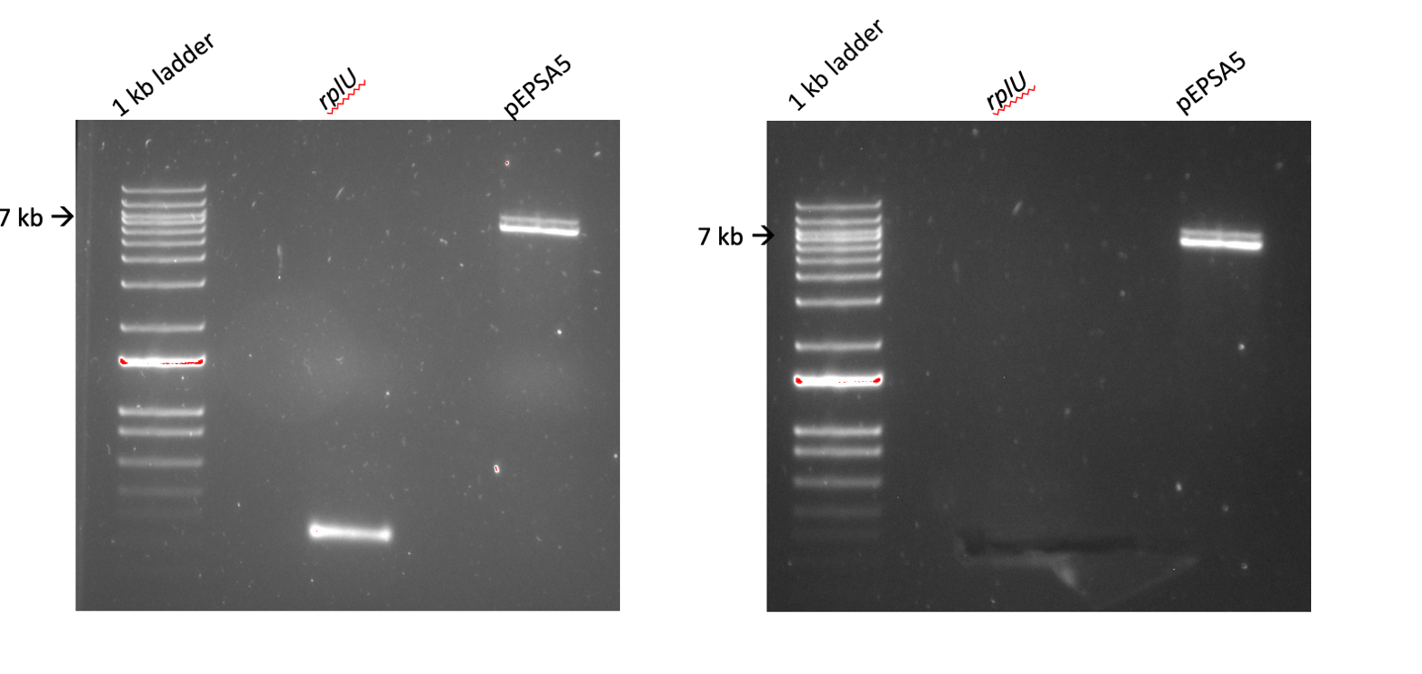
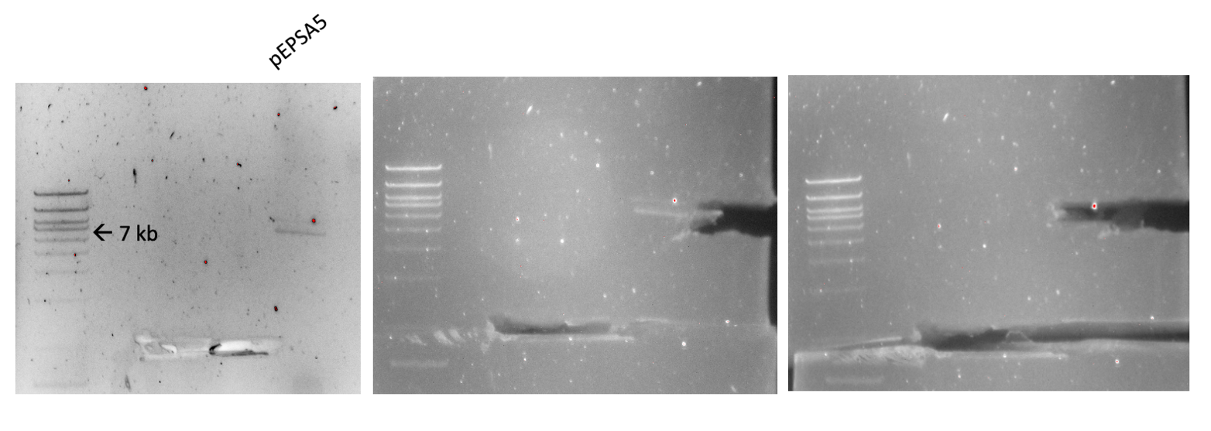

Figure 13. Digest and Gel excision of rplU and pEPSA5
That double band in the pEPSA5 lane concerns me, so I let the gel run for longer after I cut out rplU to separate it. I hope I got it, I had an extraordinarily hard time seeing the band because it had faded so much.
# | Sample ID | Nucleic Acid | Unit | A260 (Abs) | A280 (Abs) | 260/280 | 260/230 | Sample Type | Factor
1 | rplU | -5.1 | ng/µl | -0.101 | 0.067 | -1.52 | 0.17 | DNA | 50
2 | pEPSA5 | 24.1 | ng/µl | 0.482 | 0.042 | 11.53 | 0.38 | DNA | 50

KRSA-1
Over the weekend KRSA-1 from frozen grew on the plate without abx, and did not grow on the plate with Cm. Tonight I plated the KRSA-1 competent cells on the same plates.

Tuesday, June 27 2023
To Do:
- Run gel on digests and gel purify
- Ligation
- Sequencing reactions
- Streak out KRSA-1
- Patch pF-LVS-rpsU2-FLAG
- Prep media for large culture of LVS
- Start large overnight culture of LVS
- Ligation
- Transformation
- Overnight cultures of KRSA-1

KRSA-1/transformation
The competent cells grew as expected on plates with no abx, and did not grow on plates with Cm, so the competent cells are ok. I did a transformation with the remaining 2 aliquots on pKR199 and a no DNA control. The pKR199 sample arced during electroporation.
Ligation:
Tube | Insert | Backbone
1 | BamHI, KpnI digested, purified PCR pKR185 | BamHI, KpnI digested, purified pEPSA5
2 | - | BamHI, KpnI digested, purified pEPSA5

- Set up master mix table:
Component | Reaction 1 (uL) | Reaction 2 (uL) | Master Mix (3x)
H₂O | 11.5 | 11.5 | 34.5
10x ligase buffer | 2.0 | 2.0 | 6
Insert | 4.0 | - | -
Backbone | 2.0 | 2.0 | 6
Ligase | 0.5 | 0.5 | 1.5
TOTAL | 20.0 | 20.0 | 48

Set this at 16ºC overnight.
LVS overnight culture:
 | Observed OD600 | Calculated OD600 | Starting Volume for OD600 0.003 (ul)
Tube 1 | 0.337 | 3.37 | 445

Wednesday, June 28 2023
To Do:
- Prep media for large culture of LVS
- Start large overnight culture of LVS
- Ligation
- Transformation
- Overnight cultures of KRSA-1
- Transform pKR185 into E coli
- Make KRSA-1 single use aliquot stocks
- Overnight of pKR199 from KRSA-1 to make frozen stocks

LVS:
The overnight culture didn’t grow. Next time I’ll set it up with a different tag to see if this is a FLAG-tag issue.
Staph transformation:
It worked! No growth on negative control.
Sequencing Results:
The 6 reactions we sent for sequencing came back, and the first 3 have a single nt deletion. These samples correspond to the small colonies. Reactions 4 and 5 match the original gene, and the 3rd one had a single N. Results can be found at AC_230627A.
So far we have pKR185 in KRSA-4 (KRSA-5) , and pKR199 in KRSA-1 (KRSA-8). We still need to get pKR186 into KRSA-1(KRSA-6) and if we finish making pKR198, get that into KRSA-4 (KRSA-7).

Transform E. coli

Reaction table
Tube number | Purpose | DNA | Volume of DNA | Final volume to plate | Number of carbenicillin-containing plates
1 | (+) control | pEPSA5 | 1 uL | 20 ul, 100 ul | 2
2 | (-) control | None | 0 | 20 ul, 100 ul | 2
3 | Backbone Ligation | pEPSA5 (digested) | 8 uL | 100 uL, remaining | 2
4 | Ligation 1 | rplU wt | 8 uL | 100 uL, remaining | 2
Total number of plates |  |  |  |  | 8

Thursday, June 29 2023
To Do:
- Transform pKR185 into E coli
- Make KRSA-1 single use aliquot stocks
- Overnight of pKR199 from KRSA-1 to make frozen stocks
- Make frozen stocks of KRSA8 (KRSA1 with pKR199)
- Start overnights of KRSA-1 and the pKR198 transformants

Transformation:
There is one single colony on the rplU Remaining plate, I split it into 2 overnight cultures.

Friday, June 30 2023
To Do:
- Make frozen stocks of KRSA8 (KRSA1 with pKR199)
- Start overnights of KRSA-1 and the pKR198 transformants
- Make KRSA-1 competent cells
- Miniprep pKR198
Minipreps:
Reminder:
Each overnight will be 5 ml, and in the morning I will set up a second 5 ml culture for each and add 250ul Cm. I will combine the overnight culture with the new culture (now 10 ml) and let them shake for a couple of hours. After that, I will split the 10ml culture back into two 5ml cultures which I will use for minipreps. Each pair of cultures will be pooled on the same column during miniprep.

# | Sample ID | Nucleic Acid | Unit | A260 (Abs) | A280 (Abs) | 260/280 | 260/230 | Sample Type | Factor
1 | pKR198-A | 280.7 | ng/µl | 5.615 | 2.99 | 1.88 | 2.18 | DNA | 50
2 | pKR198-B | 238.6 | ng/µl | 4.772 | 2.584 | 1.85 | 1.97 | DNA | 50

Note that these came from the same colony.

I made KRSA-1 competent cells, I will test them next week.

