Table of Contents
March 2023 2
April 2023 5
Design Plasmids 5
Order Primers 6
Receiving Primers Protocol 7
PCR Protocol (updated 7/1/19) 8
Figure 1: Gel of check PCR of epitope-tagged rpsU2 amplification 11
Figure 2: Gel of epitope-tagged rpsU2 amplification 12
Reagents for IP: 12
DNA digest 14
Figure 3: Digest Gel of epitope-tagged rpsU2 strains 16
PCR: 16
Figure 4: Gel of repeat PCR of epitope-tagged rpsU2 strains 17
Figure 5: Digest gel of epitope-tagged rpsU2 strains 18
Gel Purification 19
Ligation Protocol 20
Transformation Protocol 22
Reaction Table: 23
Minipreps: 23

March 2023

Tuesday, March 21, 2023
To Do:
- Start researching potential epitope tags for ribosome profiling

The overarching question of my project is “what transcripts are translated by different bS21 homologs?”.
I’m going to begin my investigation by determining how to specifically identify translation by ribosomes with different bS21 homologs. I will do that using immunoprecipitation (IP) of ribosomal homologs tagged with epitopes at their native loci. I first have to identify tags that are appropriate. We know that we can IP ribosomes with TAP, but it gave a double band reactive to CBP, and it is too big. Vsvg has been used in the past (unclear if for ribosomes), but there was an issue with getting it off the beads. I need to find about 3-5 potential tags to use in IP.

Key characteristics:
- Small size
- Have an antibody good for IP
- Have a way to purify ab-epi-ribo complex from lysate
- Able to purify intact proteins from IP (get stuff off column using an accessible reagent)
- Needs to work in a buffer with 10 mM MgCl₂⁺

Buffer:
KHEPES pH 7.9 25 mM
MgCl₂ 10 mM
NH₄Cl 50 mM

Look at ribosome profiling papers to assess their requirements. Specifically, look for papers where successful purification of protein complexes has been done, with protocols such as NET-Seq. Look for antibodies to RNAP. Look at vendor and commercial websites.

Protocol for Ribosome Profiling in Bacteria:
https://www.ncbi.nlm.nih.gov/pmc/articles/PMC7079819/

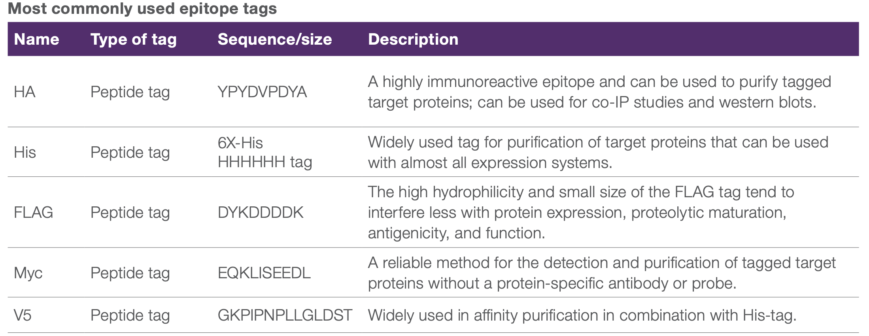
HA, His6, and FLAG are the top candidates.

Friday, March 24, 2023
To Do:
- Start researching potential epitope tags for ribosome profiling

From the Illumina Website:
Advantages of Ribosome Profiling:
- Investigate translational control and measure gene expression
- Identify translation start sites
- Determine rate of protein synthesis
- Predict protein abundance
They use size exclusion chromatography rather than sucrose cushion or gradient for library prep.
Protocol article:
https://www.ncbi.nlm.nih.gov/pmc/articles/PMC3535016/
Immunoprecipitation protocol by Abcam:
https://www.abcam.com/protocols/immunoprecipitation-protocol-1
Useful tips for IP:
https://www.ptglab.com/news/blog/8-top-tips-for-immunoprecipitation/

Monday, March 27, 2023
To Do:
- Start researching potential epitope tags for ribosome profiling

I’m going with HA, FLAG, and His6 for my epitopes with V5 as a backup. Kathryn says for FLAG we might need to find a 2X because sometimes the affinity is weak.

Wednesday, March 29, 2023
To Do:
- Start researching potential epitope tags for ribosome profiling
- Design plasmids with epitope tags
- Find reagents
I designed the 4 plasmids using pKR7 as a template, which has a VSV-G tag at the NotI site. I removed the VSV-G tag and replaced it with each respective new tag. They are saved in the Plasmids folder in the drive.
Tag | Plasmid
HA | pKR192
His6 | pKR193
FLAG | pKR194
V5 | pKR195

For the HA tag, this paper used A/G beads:
https://currentprotocols.onlinelibrary.wiley.com/doi/abs/10.1002/cpns.77
For FLAG and V5: magnetic microbeads
His6: Ni-NTA with imidazole beads

Friday, March 31, 2023
To Do:
- Start researching potential epitope tags for ribosome profiling
- Design plasmids with epitope tags
- Design primers
- Find reagents for purification

Top epitope candidates are His-6, HA, FLAG, and V5 as a backup.
His-6: make sure the elution doesn’t chelate the divalent cations.
Possible reagents: Ni-NTA beads
FLAG: might need 2 to strengthen the affinity; don’t go more than that.
I used Takara Bio Primer Design Tool to design the primers. I need to go over these with Kathryn.

April 2023

Monday, April 3, 2023
To Do:
- Start researching potential epitope tags for ribosome profiling
- Design plasmids
- Find reagents for purification

Design Plasmids

Kathryn went over how to use SnapGene to design plasmids. I highlight a segment of the 3’ end of rpsU2 gene to design the reverse primer, copy it into the Designing Primers spreadsheet to see if it’s within range, and make necessary adjustments. I then extend it to include the tag at the end. In SnapGene, I manually deleted the VSV-G tag and added the appropriate tag. I then added that inserted tag into the reverse primer. The forward primer is one that is already in use and therefore doesn’t need to be designed (KROL39).
Next, I open the LVS with primers file and click on the PCR tab under Actions. I input the 2 primers and another file called “amplified.dna” will be created. In this file, I click on the Restriction and Insert Cloning: Insert Fragment under Actions. I put pKR7 as the vector and the “amplified.dna” as the insert. I choose the restriction sites for each and then another file called “cloned.dna” is created. I rename this to fit in with the rest of the plasmids in the folder.
Be sure to add the primers to the RamseyLabOligos spreadsheet.
Kathryn said to check the codon usage table for the tags to make sure LVS will like them. There is a webtool here:
http://www.kazusa.or.jp/codon/cgi-bin/showcodon.cgi?species=376619&aa=11&style=N
Try to find codons that have a score of 0.6 or higher.
For several of the AAs in the V5 tag, the scores were low.

Tuesday, April 4, 2023
To Do:
- Design plasmids
- Find reagents for purification

I designed the plasmids and made sure all the codons were optimized. Subject to Kathryn’s approval.

Wednesday, April 5, 2023
To Do:
- Design primers
- Find reagents for purification
- Order primers

Order Primers

Order primers at ThermoFisher. Follow the instructions on the How to Order Oligos doc found in the Oligos folder on the drive. Add name and dollar amount to the PO spreadsheet.
Primers for Tags:
Plasmid | Reverse Primer
pKR193 | KROL636
pKR194 | KROL637
pKR195 | KROL638
pKR196 | KROL639

Monday, April 10, 2023
To Do:
- Find reagents for purification
- Order primers
- Reconstitute primers
Primers arrived.

Receiving Primers Protocol
By: Hannah Trautmann

- Spin primers at maximum speed in tabletop centrifuge for 3 minutes so dessicated primers go to the bottom of the tube.
- Add 0.1x EB to a final concentration of 100 uM. Calculate this by multiplying the reported nm by 10 and adding that volume in ul (i.e. 12.7 nmoles = add 127 uL of 0.1xEB).
- Put on 42°C heat block for 5 minutes to help primers dissolve
- Vortex and brief spin.
- Label tubes with KROL numbers on the top and put in the appropriate 100 uM stock box in the -20°C freezer.
- Optional: Make dilution for intended purpose of primer.
  - If a PCR primer, make a 10 uM stock by diluting 20 uL of the 100 uM stock into 180 uL of 0.1xEB. Label with purple sticker and put in appropriate freezer box.
  - If a sequencing primer, make a 2.5 uM stock by diluting 5 uL of the 100 uM stock into 195 uL of 0.1x EB. Label with blue sticker and put in appropriate freezer box.
- Put Certificate of Analysis sheet in “Oligos Spec Sheet” binder and shipping sheet in Invoices box.

Primer | nm | Volume to Add (ul)
KROL636 | 16 | 160
KROL637 | 13.7 | 137
KROL638 | 15.3 | 153
KROL639 | 13.8 | 138

I made 10mM aliquots as well by adding 20ul of 100mM primer to 180ul of 0.1X EB.

Thursday, April 13, 2023
To Do:
- Reconstitute primers
- Check PCR on primers
- Find reagents for purification
- Set up a cloning box
I made a cloning box where I’ll keep aliquots of PCR reagents such as 200ul GXL buffer, 25ul Primestar taq polymerase, 100ul dNTPs, and 100ul LVSgDNA.

PCR Protocol (updated 7/1/19)
- Acquire and label PCR tubes. Be sure to include at least 1 positive and 1 negative control for each PCR experiment.
- Get a container of ice to keep the components on
- Acquire the following components and put them on ice, labeling tubes if necessary:
  - Molecular grade H2O in 1.5 mL microfuge tube
  - KOD/primestar buffer
  - dNTPs
  - oligo F (10uM)
  - oligo R (10uM)
  - template (eg. LVS gDNA, plasmid, colony, etc.)
  - Note: KOD/primestar enzyme should be kept in the freezer until it is used as it is expensive and should be added last
- Centrifuge the microfuge tubes to get any solution out of the microfuge tube cover
- If any of the solutions are frozen, be sure to vortex the microfuge tube in order to dissolve it (tubes with frozen components may not be homogenized)
  - DO NOT vortex the enzyme itself or any solution with enzyme because vortexing will expose it to oxygen and degrade it
- Use PCR_worksheet.xlsx to make establish the specifics of what will be added
  - The file is located in the Protocols folder
  - Also setup table below to specify which primers and source DNA will be used
- Add appropriate volume (based on PCR worksheet) of each experiment specific primer (forward and reverse) to PCR tubes
- Add ddi H2O to negative control tube
  - Template volume for 1 reaction
- Prepare a master-mix in a 1.5 mL microfuge tube by adding the following according to the worksheet and using micropipettes:
  - Add ddi H2O
  - Add dNTPs
  - Add KOD buffer
  - Add KOD enzyme
- Mix the master-mix solution by pipetting up and down
  - Do not vortex to mix
- Add appropriate volume of master-mix to negative control PCR tube
- Add template to Master Mix
  - Factor template volume minus 1 template reaction volume
- Add appropriate volume of master mix to each PCR tube (except negative control) and pipette up and down to mix (conserves tips)
- Close PCR Tubes until the caps are tight
- Place the PCR Tubes in the thermocycler on STN 1 – the following settings should be in place:
  - Heat at 94 degrees for 2 minutes,
  - 94 degrees C for 20 seconds
  - 50 degrees C for 30 seconds
  - 68 degrees C for 1 minute/kb (adjust based on expected size of product)
  - Go back to step 2
  - Repeat 32x
  - 68 degrees C for 5 minutes
  - 12 degrees C for infinity
Reaction Number | Plasmid/Region | Source DNA | Primers | Length (bps)
1 | rpsU2-HA | LVS gDNA | KROL39, KROL636 | 265
2 | rpsU2-His6 | LVS gDNA | KROL39, KROL637 | 256
3 | rpsU2-FLAG | LVS gDNA | KROL39, KROL638 | 262
4 | rpsU2-V5 | LVS gDNA | KROL39, KROL639 | 281
5 | No DNA control-HA | - | KROL39, KROL636 | -
6 | No DNA control-His6 | - | KROL39, KROL637 | -
7 | No DNA control-FLAG | - | KROL39, KROL638 | -
8 | No DNA control-V5 | - | KROL39, KROL639 | -

Master Mix:
Total reaction volume | 20
Total number of reactions | 8
 |  |  |  | Factor
Component | Stock concentration | Final concentration | 1 rxn volume | 9
ddiH2O |  |  | 12.4 | 111.6
PrimeSTAR GXL Buffer | 5x | 1x | 4.0 | 36
dNTPs | 2.5 mM | 0.2 mM | 1.6 | 14.4
oligo F | 10 uM | 0.3 uM | 0.6 | 5.4
oligo R | 10 uM | 0.3 uM | 0.6 | -
template | 100 ng/ul | 2 ng/ul | 0.4 | 3.2
PrimeSTAR GXL DNA Polymerase | 1.25 U/ul | 0.025 U/ul | 0.4 | 3.6
 |  | Total volume | 20 | 176.4

Reverse primers aren’t going in the master mix, but the forward primer is the same for all reactions.
Unfortunately, the PCR didn’t work, and I strongly suspect I didn’t add the gDNA. All I saw were primer dimers in all lanes. I thought I saved the gel to the drive but I don’t see it. I will repeat the PCR over the weekend.

Friday, April 14, 2023
To Do:
- Check PCR on primers
- Find reagents for purification
- Set up a cloning box
- Repeat PCR
Doing the same as yesterday and making sure to add gDNA and I set the elongation time for 20 seconds rather than 15.

Sunday, April 16, 2023
To Do:
- Repeat PCR
- Run gel
- PCR amplification of fragments
- PCR purification

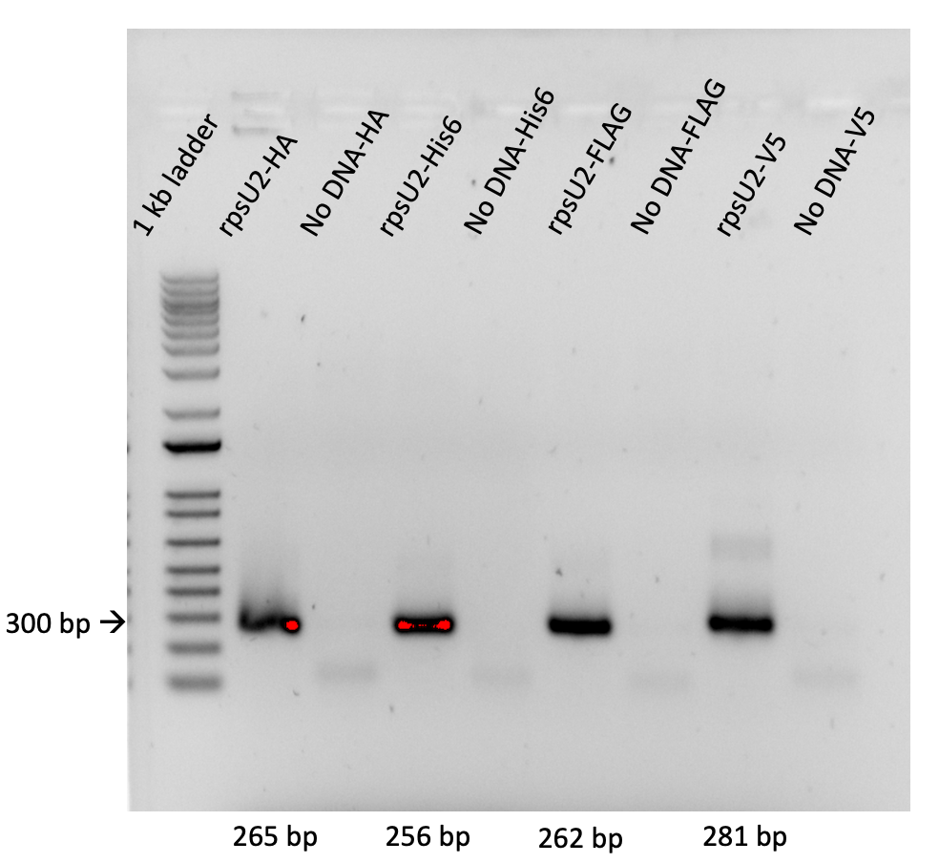

Figure 1: Gel of check PCR of epitope-tagged rpsU2 amplification
Difficult to tell each size but generally they are all in the right spot. I see some primer dimers in the negative controls, and I’m not sure what that shadow band is in V5. Proceeding with amplification of the fragments.
Fragment Amplification:
Total reaction volume | 100
Total number of reactions | 8
 |  |  |  | Factor
Component | Stock concentration | Final concentration | 1 rxn volume | 9
ddiH2O |  |  | 62.0 | 558
PrimeSTAR GXL Buffer | 5x | 1x | 20.0 | 180
dNTPs | 2.5 mM | 0.2 mM | 8.0 | 72
oligo F | 10 uM | 0.3 uM | 3.0 | 27
oligo R | 10 uM | 0.3 uM | 3.0 | -
template | 100 ng/ul | 2 ng/ul | 2.0 | 8
PrimeSTAR GXL DNA Polymerase | 1.25 U/ul | 0.025 U/ul | 2.0 | 18
 |  | Total volume | 100 | 882
**I realized at this point that I had added 2x the gDNA that I needed for the check PCR on Friday, luckily it worked.
# | Sample ID | Nucleic Acid | Unit | A260 (Abs) | A280 (Abs) | 260/280 | 260/230 | Sample Type | Factor
1 | 1-HA | 117.4 | ng/µl | 2.348 | 1.307 | 1.8 | 2.48 | DNA | 50
2 | 2-His6 | 105.1 | ng/µl | 2.102 | 1.154 | 1.82 | 2.69 | DNA | 50
3 | 3-FLAG | 110.7 | ng/µl | 2.215 | 1.191 | 1.86 | 2.51 | DNA | 50
4 | 4-V5 | 117.1 | ng/µl | 2.343 | 1.298 | 1.81 | 2.39 | DNA | 50
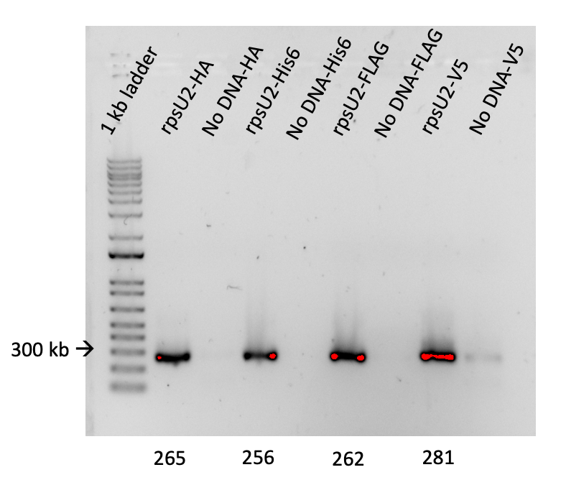

Figure 2: Gel of epitope-tagged rpsU2 amplification
Bands are great except for that V5 No DNA control. I imagine that happened during loading. I set up the loading dye on parafilm and then add the DNA before loading the gel. Perhaps the dyes weren’t far enough apart between rpsU2-V5 and No DNA-V5. I think it’s unlikely that this happened before PCR. The strip tubes were nowhere near each other. It’s possible though. Must be very careful next time.

Reagents for IP:

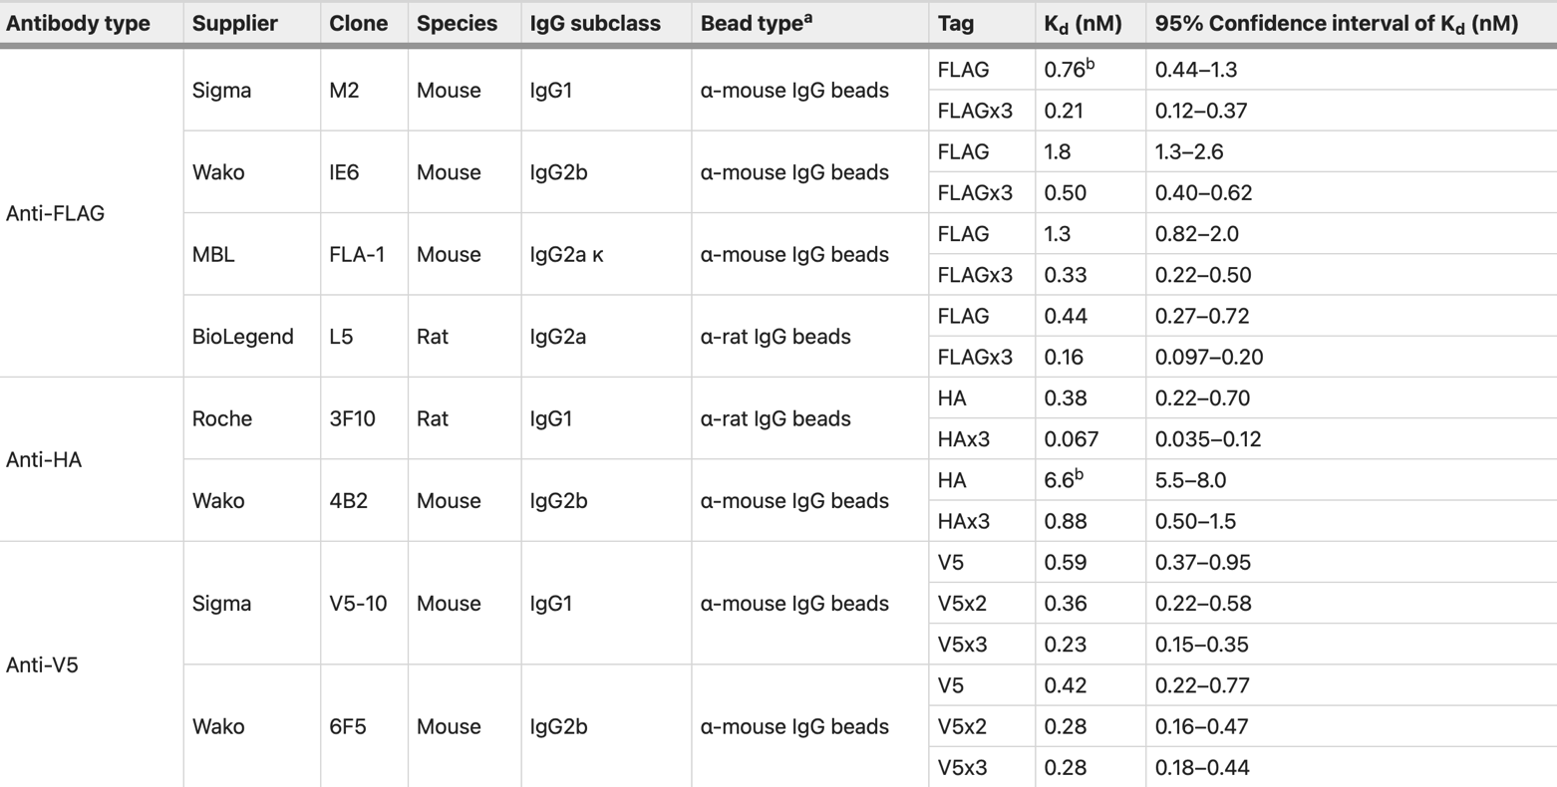
From this paper:
https://www.nature.com/articles/s41598-019-43319-y#Tab2
Describes a method for determining efficiency of epitope tags based off of K_{d}.
This is what I’ve decided to go with:
Pre-conjugated magnetic beads:
- His6 Tag:
NEB Ni-NTA 1 ml $196
- HA:
Cell Signal 400 ul $366
Thermofisher Pierce 1ml $341
- FLAG:
Sigma Anti-FLAG M2 5ug $134 20ug $465
Thermofisher Pierce 1ml $464
- V5:
Cell signal 400ul $366
Sigma (polyclonal) 1ml $250

Magnetic separation rack:
- NEBNext $557
- NEB 12-tube $336
- ThermoFisher MagJET $ $395

Monday, April 17, 2023
To Do:
- Run gel
- PCR amplification of fragments
- PCR purification
- Digest
- Run gel
- Gel purification
Digested each rpsU2-tagged insert and the pKR7 backbone.

DNA digest
Protocol by John Church

- Make a reaction table with desired digests:
Tube | DNA | Enzyme(s) | DNA Volume (uL) | H₂O Volume (uL)
1 | Purified PCR | Ex: enzyme1,enzyme2 | 15 | -
2 | Backbone | Ex: enzyme1,enzyme2 | 5 | 10

- Set up master mix table:
Components | Volumes in 1 reaction (uL) | Volumes in Master Mix 4x (uL)
H₂O | 10.8 | 43.2
10x Buffer* | 3.0 | 12.0
DNA | (15.0) | -
Enzyme 1 | 0.6 | 2.4
Enzyme 2 | 0.6 | 2.4
Total | 30.0 (15.0 actual b/c of DNA)
*Cutsmart Buffer is used for all the “HF” enzymes. Check the NEB website for buffer compatibility with non-HF restriction enzymes.

- Add indicated amounts of H₂O and 10x buffer to master mix tube (MM).
- Add indicated amount of DNA or DNA+water (for backbone tubes) to individual tubes for digest (1.5 mL microfuge tubes for digests in incubator, PCR strip tubes for reactions incubated in the thermocycler).
- Add indicated amount of each enzyme (___uL) to the master mix tube (MM).
- Mix the master mix by pipetting up and down.
- Add master mix to individual tubes. Volume to add to each tube is the volume in 1 reaction minus the DNA volume (____ul).
- Incubate at 37°C for 1 hour or up to overnight.
- If using digest for plasmid construction then after incubation at 37°C, add 0.5ul of CIP enzyme to backbone tube, mix by pipetting and put back in37°C incubator for 10 minutes. (this step removes the phosphates from the ends of the plasmid to prevent re-ligation). If using the new Quick CIP – add 1 uL, mix, incubate for 10 mins, then put at 80C for 2 minutes to inactivate the CIP.
Reaction Table:
Tube | DNA | Enzyme(s) | DNA Volume (uL) | H₂O Volume (uL)
1 | rpsU2-HA insert | EcoRI, BamHI | 15 | -
2 | rpsU2-His6 insert | EcoRI, BamHI | 15 | -
3 | rpsU2-FLAG insert | EcoRI, BamHI | 15 | -
4 | rpsU2-V5 insert | EcoRI, BamHI | 15 | -
5 | pKR7 backbone | EcoRI, BamHI | 5 | 10

The digest went fine, but I should not have put the fragments so close together on the gel since they are virtually the same size. I will repeat the PCR and digest and make sure to keep them separated on the gel. The pKR7 should be fine; I managed to get that red bit that’s falling off the gel into the tube.
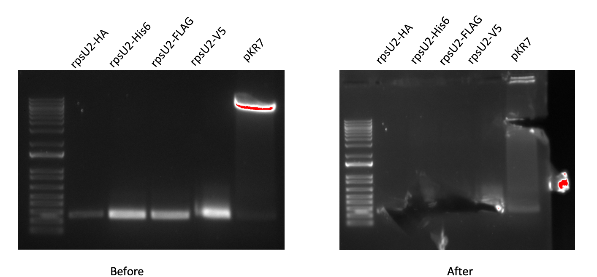

Figure 3: Digest Gel of epitope-tagged rpsU2 strains

Tuesday, April 18, 2023
To Do:
- Digest
- Run gel
- Gel purification
- Repeat PCR, digest, gel
- Gel extraction

PCR:

Total reaction volume | 100
Total number of reactions | 5
 |  |  |  | Factor
Component | Stock concentration | Final concentration | 1 rxn volume | 6
ddiH2O |  |  | 62.0 | 372
PrimeSTAR GXL Buffer | 5x | 1x | 20.0 | 120
dNTPs | 2.5 mM | 0.2 mM | 8.0 | 48
oligo F | 10 uM | 0.3 uM | 3.0 | 18
oligo R | 10 uM | 0.3 uM | 3.0 | 18
template | 100 ng/ul | 2 ng/ul | 2.0 | 10
PrimeSTAR GXL DNA Polymerase | 1.25 U/ul | 0.025 U/ul | 2.0 | 12
 |  | Total volume | 100 | 588

Reaction Number | Plasmid/Region | Source DNA | Primers | Length (bps)
1 | rpsU2-HA | LVS gDNA | KROL39, KROL636 | 265
2 | rpsU2-His6 | LVS gDNA | KROL39, KROL637 | 256
3 | rpsU2-FLAG | LVS gDNA | KROL39, KROL638 | 262
4 | rpsU2-V5 | LVS gDNA | KROL39, KROL639 | 281
5 | No DNA control | - | KROL39, KROL639 | -
See PCR Protocol_new.docx under the Protocols folder in the KRamseyLab drive.

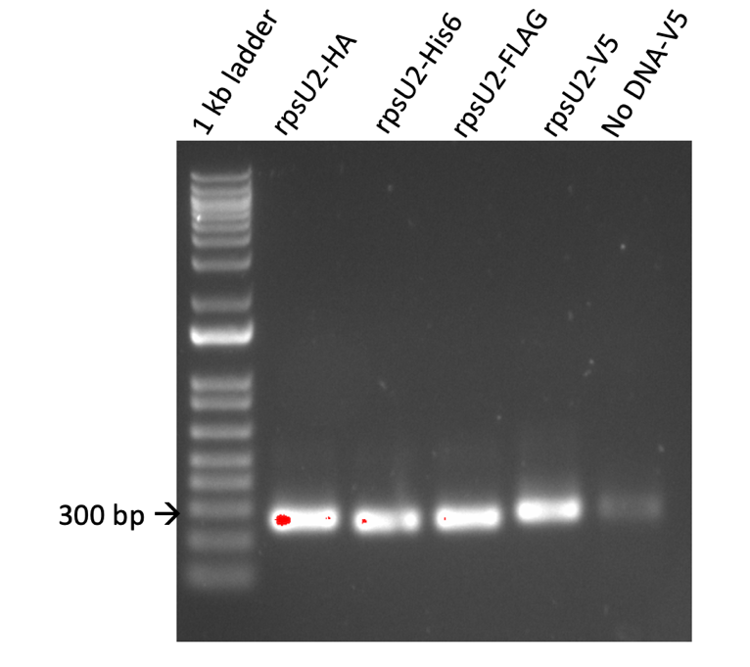

Figure 4: Gel of repeat PCR of epitope-tagged rpsU2 strains
That band in the No-DNA control is still there; it’s a good thing I chose KROL696 as the primer for the negative control. I discarded the 10mM aliquot of KROL639 and made a new one.
Digest:

Tube | DNA | Enzyme(s) | DNA Volume (uL) | H₂O Volume (uL)
1 | rpsU2-HA insert | EcoRI, BamHI | 10 | 5
2 | rpsU2-His6 insert | EcoRI, BamHI | 10 | 5
3 | rpsU2-FLAG insert | EcoRI, BamHI | 10 | 5

Components | Volumes in 1 reaction (uL) | Volumes in Master Mix 4x (uL)
H₂O | 10.8 | 43.2
10x Buffer* | 3.0 | 12.0
DNA | (15.0) | -
Enzyme 1 | 0.6 | 2.4
Enzyme 2 | 0.6 | 2.4
Total | 30.0 (15.0 actual b/c of DNA)

I’m running this as an overnight. See DNA Digest Protocol.

Wednesday, April 19, 2023
To Do:
- Repeat PCR, digest, gel
- Repeat digest
- Gel extraction

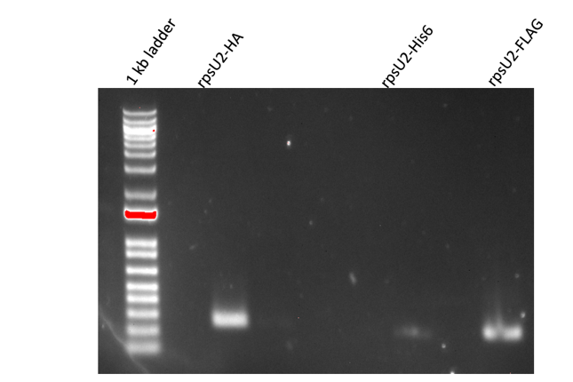

Figure 5: Digest gel of epitope-tagged rpsU2 strains
I have to repeat digest on His6, I had a loading error.
Digest:
See DNA Digest Protocol:
Tube | DNA | Enzyme(s) | DNA Volume (uL) | H₂O Volume (uL)
1 | rpsU2-His6 insert | EcoRI, BamHI | 10 | 5

Components | Volumes in 1 reaction (uL) | Volumes in Master Mix 3x (uL)
H₂O | 10.8 | 32.4
10x Buffer* | 3.0 | 9
DNA | (15.0) | -
Enzyme 1 | 0.6 | 1.8
Enzyme 2 | 0.6 | 1.8
Total | 30.0 (15.0 actual b/c of DNA)

I realized too late that I could have waited until I made new V5 PCR product and then digested them together.

V5 PCR:
Total reaction volume | 100
Total number of reactions | 2
 |  |  |  | Factor
Component | Stock concentration | Final concentration | 1 rxn volume | 3
ddiH2O |  |  | 62.0 | 186
PrimeSTAR GXL Buffer | 5x | 1x | 20.0 | 60
dNTPs | 2.5 mM | 0.2 mM | 8.0 | 24
oligo F | 10 uM | 0.3 uM | 3.0 | 9
oligo R | 10 uM | 0.3 uM | 3.0 | 9
template | 100 ng/ul | 2 ng/ul | 2.0
PrimeSTAR GXL DNA Polymerase | 1.25 U/ul | 0.025 U/ul | 2.0 | 6
 |  | Total volume | 100 | 294

Components | Volumes in 1 reaction (uL) | Volumes in Master Mix 3x (uL)
H₂O | 10.8 | 21.6
10x Buffer* | 3.0 | 6
DNA | (15.0) | -
Enzyme 1 | 0.6 | 1.2
Enzyme 2 | 0.6 | 1.2
Total | 30.0 (15.0 actual b/c of DNA)

Thursday, April 20, 2023
To Do:
- Repeat digest
- Gel extraction
- Ligation

Gel Purification

*See Qiagen Gel Extraction Kit package insert for protocol, note for Step 3 the 42ºC heat block is sufficient.
Gel Extraction
 | Tube Weight (g) | Tube w/ Gel (g) | Gel Weight (mg) | QG Buffer Volume (ul) | Isopropanol Volume (ul)
Tube 1 HA | 1.38 | 1.55 | 170 | 510 | 170
Tube 2 His6 | 1.55 | 1.77 | 220 | 660 | 220
Tube 3 FLAG | 1.38 | 1.6 | 220 | 660 | 220
Tube 4 V5 | 1.54 | 1.99 | 450 | 1350 | 450
Tube 5 pKR7 | 1.37 | 1.69 | 320 | 960 | 320
Tube 6 pKR7 | 1.35 | 1.7 | 350 | 1050 | 350

Tube 4 will be split onto 2 columns.

Note: I had to stop in the middle of the protocol after spinning the samples to bind the DNA and before washing in PE. There was an hour before the protocol was resumed.
# | Sample ID | Nucleic Acid | Unit | A260 (Abs) | A280 (Abs) | 260/280 | 260/230 | Sample Type | Factor
1 | HA | 17.6 | ng/µl | 0.351 | 0.187 | 1.87 | 0.04 | DNA | 50
2 | His6 | 5.9 | ng/µl | 0.118 | 0.048 | 2.46 | 0.01 | DNA | 50
3 | FLAG | 7.8 | ng/µl | 0.156 | 0.07 | 2.22 | 0.02 | DNA | 50
4 | V5 | 35.1 | ng/µl | 0.702 | 0.363 | 1.94 | 0.07 | DNA | 50
5 | pKR7 | 33.7 | ng/µl | 0.674 | 0.357 | 1.88 | 0.09 | DNA | 50

Happy to see that 3 of them look good. Might have to redo His6 and FLAG.

Monday, April 24, 2023
To Do:
- Gel extraction
- Ligation
- Pour LBKan plates

For the ligations the general rule of thumb is to use 4ul of insert to 2ul of backbone, regardless of DNA concentration. If they don’t work, we can revisit and troubleshoot.

Ligation Protocol
Protocol by John Church
The purpose of this is to ligate the cut plasmid backbone to the strand of PCR DNA.

- Make a reaction table with desired ligations. Always include a backbone only control for each plasmid backbone used.
Tube | Insert | Backbone
1 | BamHI, EcoRI digested, purified rspU2-HA PCR | BamHI, EcoRI digested, purified pKR7
2 | BamHI, EcoRI digested, purified rspU2-His6 PCR | BamHI, EcoRI digested, purified pKR7
3 | BamHI, EcoRI digested, purified rspU2-FLAG PCR | BamHI, EcoRI digested, purified pKR7
4 | BamHI, EcoRI digested, purified rspU2-V5 PCR | BamHI, EcoRI digested, purified pKR7
5 | - | BamHI, EcoRI digested, purified pKR7

- Set up master mix table:
Component | Reaction 1 (uL) | Reaction 2 (uL) | Reaction 3  (uL) | Reaction 4  (uL) | Reaction 5  (uL) | Master Mix (6x)
H₂O | 11.5 | 11.5 | 11.5 | 11.5 | 11.5 | 69
10x ligase buffer | 2.0 | 2.0 | 2.0 | 2.0 | 2.0 | 12
Insert | 4.0 | 4.0 | 4.0 | 4.0 | - | -
Backbone | 2.0 | 2.0 | 2.0 | 2.0 | 2.0 | 12
Ligase | 0.5 | 0.5 | 0.5 | 0.5 | 0.5 | 3
TOTAL | 20.0 | 20.0 | 20.0 | 20.0 | 20.0 | 96

- Obtain ice to assemble and keep the reactions on. This is important, as the reaction happens at 16°C and the ligase buffer (which contains ATP) needs to be kept cold in order to avoid degradation. Take a 10 uL aliquot of 10X ligase buffer from the miscellaneous buffers box in the -20C.
- Obtain and label PCR tubes for the reactions. Be sure to include the date and your initials.
- To the individual tubes, add indicated amounts of H₂O (___uL), 10x buffer (_____uL), insert (____uL), and backbone (____uL).
- Add indicated amount of ligase (___uL) to the individual tubes. Remember to keep the ligase in a mini cooler.
- After all of the components have been added, mix each tube with a pipette set to 18 uL.
- Place in the thermocycler or water bath overnight at 16ºC. Can do at room temp for 10 minutes if necessary.
Note: I did the 10 minute RT ligation.

Tuesday, April 25, 2023
To Do:
- Ligation
- Pour LBKan plates
- Transform into E. coli

Transformation Protocol

Transform chemically competent E. coli cells

- Set up reaction table. Always include a positive and negative control for each antibiotic. If transforming plasmids (from previous plasmid prep), use 0.5 – 1 uL of plasmid. If transforming ligations, use 8 uL per ligation. If transforming plasmid, plate 20 uL and 100 uL. If transforming a ligation, plate 100 uL and remaining culture.
  - Note: The plasmid used for the positive control plates should be the regular circular plasmid, not the digest/purified one.
  - There should always be a backbone control if testing a ligation. This is the digested and ligated backbone with NO INSERT.

Reaction table
Tube number | Purpose | DNA | Volume of DNA | Final volume to plate | Number of kanamycin-containing plates | Number of carbenicillin-containing plates
1 | (+) control | pKL02 | 1 uL | 20 ul, 100 ul | 2
2 | (-) control | None | 0 | 20 ul, 100 ul | 2
3 | Backbone Ligation | pEX (digested) | 8 uL | 100 uL, remaining | 2
4 | Ligation 1 | pKR2 | 8 uL | 100 uL, remaining | 2
5 | (+) control | pUC19 | 1 uL | 20 ul, 100 ul |  | 2
6 | (-) control | None | 0 | 20 ul, 100 ul |  | 2
7 | Backbone Ligation | pEX-Carb (digested) | 8 uL | 100 uL, remaining |  | 2
8 | Ligation 2 | pKR4 | 8 uL | 100 uL, remaining |  | 2
Total number of plates |  |  |  |  | 8 | 8

- Check to be sure you have enough LB-Kan plates with appropriate antibiotic. If plates were stored at 4°C, warm at 37°C until needed.
- Obtain DNA and thaw on ice if necessary.
- Thaw appropriate number of competent cell tubes on ice (5 reactions per tube of competent cells)
- Label sterile tubes as indicated in reaction table. Add indicated volume of indicated DNA on ice.
- When competent cells are thawed (check by probing for frozen cells using a sterile pipette tip), gently pipette 100 uL of cells into each reaction tube directly onto DNA using aseptic technique.
- Incubate cells on ice for 20 minutes. During incubation, find or set heat block to 42°C.
- Place tubes with cells and DNA onto 42°C heatblock for 30 seconds (heat shock step).
- After heat shock, place tubes back on ice until next step (don’t keep them here too long).
- Using aseptic technique, add 1 mL LB (no antibiotic) to each microfuge tube.
- Using autoclave tape, tape microfuge tubes down in shaking incubator set to 37°C.
- Allow cells to recover for 1 hour at 37°C, shaking. Place in a rack after shaking (NOT back on ice).
- Using aseptic technique, plate indicated amount of cells on appropriate antibiotic plates (LB-Kan), spreading until plates look dry. For “remaining” volume, spin tubes at max speed in benchtop centrifuge for 30 seconds. Remove 800 uL of media. Using 200 uL pipette, resuspend cells at bottom of tube and plate all the remaining culture.

Reaction Table:

Tube number | Purpose | DNA | Volume of DNA | Final volume to plate | Number of kanamycin-containing plates
1 | (+) control | pKR7 | 1 uL | 20 ul, 100 ul | 2
2 | (-) control | None | 0 | 20 ul, 100 ul | 2
3 | Backbone Ligation | pKR7 (digested) | 8 uL | 100 uL, remaining | 2
4 | Ligation 1 | rpsU2-HA | 8 uL | 100 uL, remaining | 2
5 | Ligation 2 | rpsU2-His6 | 8 uL | 100 uL, remaining | 2
6 | Ligation 3 | rpsU2-FLAG | 8 uL | 100 uL, remaining | 2
7 | Ligation 4 | rpsU2-V5 | 8 uL | 100 uL, remaining | 2
Total number of plates |  |  |  |  | 14
Note: Shaking incubator wasn’t turned on, I put the tubes in the stationary 37ºC incubator until it got to temp (~5 min).

Wednesday, April 26, 2023
To Do:
- Transform into E. coli
- Streak plate of Staph
- Start overnight cultures from transformant colonies
Transformation:
The plates look good! There is good growth on all 4 ligations and the positive control, just a few colonies on the backbone only plates, and no growth on the negative control. I set up five 5ml overnight cultures of each tag transformation to be miniprepped tomorrow.
Staph:
For Oli’s project: I streaked KRSA-2 onto LB with no antibiotics.

Thursday, April 27, 2023
To Do:
- Streak plate of Staph
- Start overnight cultures from transformant colonies
- Minipreps

Minipreps:
*See Qiagen Miniprep Kit protocol

# | Sample ID | Nucleic Acid | Unit | A260 (Abs) | A280 (Abs) | 260/280 | 260/230 | Sample Type | Factor
1 | HA-1 | 682 | ng/µl | 13.641 | 7.172 | 1.9 | 2.34 | DNA | 50
2 | HA-2 | 600.7 | ng/µl | 12.014 | 6.396 | 1.88 | 2.31 | DNA | 50
3 | HA-3 | 479.5 | ng/µl | 9.59 | 5.106 | 1.88 | 2.26 | DNA | 50
4 | HA-4 | 381.9 | ng/µl | 7.638 | 4.002 | 1.91 | 2.42 | DNA | 50
5 | HA-5 | 570.7 | ng/µl | 11.415 | 6.02 | 1.9 | 2.37 | DNA | 50
6 | His6--1 | 518.8 | ng/µl | 10.375 | 5.482 | 1.89 | 2.33 | DNA | 50
7 | His6--2 | 469.7 | ng/µl | 9.394 | 5.045 | 1.86 | 2.22 | DNA | 50
8 | His6--3 | 592.1 | ng/µl | 11.843 | 6.265 | 1.89 | 2.32 | DNA | 50
9 | His6--4 | 505.7 | ng/µl | 10.113 | 5.43 | 1.86 | 2.35 | DNA | 50
10 | His6--5 | 507.2 | ng/µl | 10.144 | 5.435 | 1.87 | 2.31 | DNA | 50
11 | FLAG-1 | 547 | ng/µl | 10.941 | 5.791 | 1.89 | 2.34 | DNA | 50
12 | FLAG-2 | 489.5 | ng/µl | 9.79 | 5.18 | 1.89 | 2.3 | DNA | 50
13 | FLAG-3 | 615.5 | ng/µl | 12.31 | 6.538 | 1.88 | 2.29 | DNA | 50
14 | FLAG-4 | 543.9 | ng/µl | 10.879 | 5.819 | 1.87 | 2.26 | DNA | 50
15 | FLAG-5 | 606.8 | ng/µl | 12.136 | 6.495 | 1.87 | 2.36 | DNA | 50
16 | V5-1 | 464.4 | ng/µl | 9.288 | 4.961 | 1.87 | 2.42 | DNA | 50
17 | V5-2 | 556.7 | ng/µl | 11.133 | 5.918 | 1.88 | 2.29 | DNA | 50
18 | V5-3 | 483.7 | ng/µl | 9.675 | 5.102 | 1.9 | 2.35 | DNA | 50
19 | V5-4 | 514.6 | ng/µl | 10.291 | 5.454 | 1.89 | 2.24 | DNA | 50
20 | V5-5 | 477.2 | ng/µl | 9.544 | 5.082 | 1.88 | 2.29 | DNA | 50
These look good!

