A. Title of the Study
Exploring the molecular mechanisms of bS21 function in bacterial pathogens

B. Statement of the Problem
The purpose of this study is to determine how the ribosomal protein bS21 impacts translation in Francisella tularensis and Staphylococcus aureus. Although both organisms are pathogens, manipulation of bS21 results in different phenotypes in each species. In the Gram-negative intracellular pathogen F. tularensis, which encodes three distinct bS21 homologs, one homolog is key for expression of an essential virulence factor, a type six secretion system, and intramacrophage survival. In the Gram-positive opportunistic human pathogen S. aureus, bS21 appears to impact antibiotic resistance. The goal of the proposed work is to establish how these bS21 homologs exert their effects. Specifically, I will determine whether each homolog translates certain mRNAs preferentially in F. tularensis using ribosome profiling, and I will ascertain if loss of bS21 in S. aureus leads to antibiotic resistance due to effects on regulation of cell wall synthesis.

C. Justification for the Study
Ribosome heterogeneity may contribute to bacterial gene regulation
The central dogma of molecular biology dictates that the genetic information is stored in DNA, which is transcribed into mRNA, which in turn is translated into protein, with regulation occurring at each step. Post-transcriptional regulation can be due to the effects of mRNA, sRNAs, RNA binding proteins, and ribosome binding proteins (Duval et al., 2015). A somewhat understudied aspect of gene regulation is how the composition of the ribosome contributes to gene expression. The ribosome is the site of protein synthesis and is composed of three ribosomal RNA (rRNA) molecules and several ribosomal proteins (r-proteins). The ribosome is often viewed as a static entity, however there is evidence that ribosomes with varying compositions can exist in the same cell (Byrgazov et al., 2013; Lilleorg et al., 2019; Sauert et al., 2015). This raises the possibility that not all ribosomes function identically and ribosome composition may play a role in post-transcriptional regulation (Byrgazov et al., 2013; Sauert et al., 2015).
There are multiple sources of ribosomal heterogeneity, including the absence of one or more r-proteins, post-transcriptional or post-translational modification of rRNA or r-proteins, and the incorporation of different homologs of r-proteins (Sauert et al., 2015). Several bacteria, including Mycobacterium smegmatis and Bacillus subtilis, have duplicated genes that encode paralogs of r-proteins that either coordinate zinc or do not (Dow & Prisic, 2018; Gabriel & Helmann, 2009). When zinc is depleted in the environment, the zinc-independent paralogs under the control of Zur (zinc uptake regulator) are expressed and incorporated into the ribosome(Gabriel & Helmann, 2009). A phylogenic analysis reveals many other bacteria withparalogs of r-proteins that either contain zinc-binding residues or do not that are encoded by duplicated genes (Makarova et al., 2001). , . While it is clear that there is a mechanism in place that can allow modulation of zinc concentration in the cell, the molecular mechanism of how protein synthesis is affected by the coordination of zinc has yet to be determined.The possibility that cells use non zinc-binding r-protein paralogs as a way to store and liberate zinc in response to a change in environment cannot be ruled out. Although there are studies that suggest that different compositions of ribosomes have altered translation of these r-rproteins (Chen et al., 2020; Lilleorg et al., 2020), whether or not ribosomal heterogeneity due to homologous r-proteins directly affects translation has yet to be demonstrated.
The role of bS21 in translation
bS21 is a small 30S subunit ribosomal protein encoded by the gene rpsU that is involved in translation initiation (Van Duin & Wijnands, 1981). Although its precise function in translation is unclear, its positioning near the mRNA exit channel suggests that bS21 can interact with the 5’ UTR of mRNAs and, at least in some E. coli ribosomes, can contact the anti-Shine-Dalgarno sequence of 16S rRNA (Figure 1; Berk et al., 2006). Many species lack bS21, therefore it is not considered essential for function or assembly (Chang & Craven, 1977; Van Duin & Wijnands, 1981). Species that encode bS21 show a variety of phenotypes upon loss of the r-protein. In S. aureus, cells containing mutations in bS21 have altered susceptibility to antibiotics (Basco et al., 2019; Friedman et al., 2006). In Bacillus subtilis, loss of bS21 results in cells with defects in motility and biofilm formation (Takada et al., 2014), while Listeria monocytogenes can withstand increased acid stress when bS21 is mutated (Metselaar et al., 2015). In Flavobacterium johnsoniae, ribosomes that lack bS21 increase the initiation of rpsU mRNA translation, a result of efficient base-pairing between the anti-Shine Dalgarno sequence (ASD) encoded by the 16S rRNA and strong Shine-Dalgarno (SD) sequence present in the rpsU mRNA (McNutt et al., 2023). This can only occur in the absence of bS21 because in Bacteroides species like Flavobacterium johnsoniae, bS21 homologs have a specific C-terminal sequence that plays a role in sequestering the ASD (McNutt et al., 2023). Since bS21 homologs encoded by species outside of the Bacteroides phylum (including those in F. tularensis and S. aureus) do not have the same C-terminal sequence, bS21 function is not likely to be the same. Because loss or mutation of bS21 leads to a variety of distinct phenotypes in different organisms, it raises the possibility that this protein could play a regulatory role in translation.
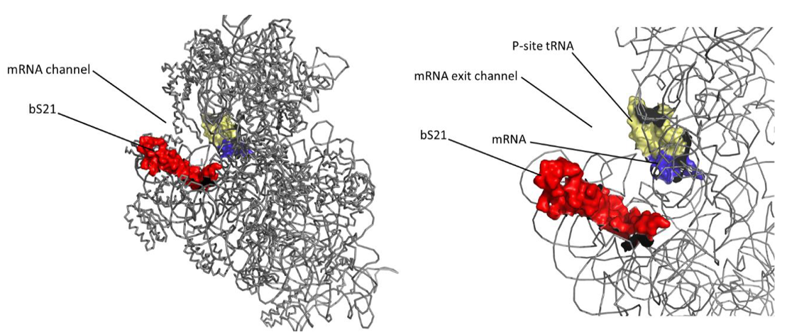
Figure 1. The location of bS21 in the ribosome. Left: Structure of the 30S subunit of E. coli ribosome as determined by cryo-EM. All of the rRNA and r-proteins are depicted in gray ribbons, except for bS21 in red. The mRNA is colored purple and the tRNA anti-codon stem loop is in yellow in the P-site. Right: close-up of bS21, highlighting its proximity to the mRNA exit channel. PDB entry 45V0.

Given that bS21 has a limited role in translation but may function as a regulator of translation initiation, it is an ideal r-protein to use when studying how ribosome composition impacts ribosome function. In my proposed dissertation work, I will investigate how ribosome heterogeneity influences translation in the following aims:
Specific Aim 1. Determine how incorporation of specific F. tularensis bS21 homologs into the ribosome influences translation initiation on transcripts, genome-wide.
Specific Aim 2. Investigate why the loss of bS21 in S. aureus leads to resistance to cell wall-targeting antibiotics.

The role of distinct bS21 homologs in F. tularensis
Francisella tularensis is a facultative intracellular pathogen that causes the disease tularemia. As it can be aerosolized, has a low infectious dose (as few as 10 cells), and a high mortality rate (up to 60% if left untreated), F. tularensis is considered a potential bioweapon (Celli & Zahrt, 2013). It encodes three distinct homologs of bS21 (Trautmann & Ramsey, 2022). As one of the last proteins to be incorporated into the ribosome (Mizushima & Nomura, 1970), bS21 is loosely associated and as such, there is the potential that different homologs of the protein can be swapped out (Robertson et al., 1977). Wild-type cells of F. tularensis can incorporate all three homologs of bS21 into the ribosomes (Trautmann & Ramsey, 2022). The loss of a particular homolog, bS21-2, leads to changes in abundance for about 160 proteins that cannot be explained by changes in transcript abundance (Trautmann & Ramsey, 2022). This suggests that regulation is happening at the level of translation. Cells lacking bS21-2 also exhibit a reduction in protein abundance for a key virulence factor, the type six secretion system (T6SS), a decrease in intramacrophage survival, and to a growth defect in vitro (Trautmann & Ramsey, 2022). Notably, while adding bS21-1 or bS21-3 to these cells can influence or two of these phenotypes, only the reintroduction of bS21-2 can complement all of them (Trautmann & Ramsey, 2022). These data raise the possibility that each bS21 homolog may control the expression of different genes, possibly by preferentially promoting translation initiation of different transcripts. We will use ribosome profiling to ascertain which transcripts are being translated by ribosomes containing each of the F. tularensis bS21 homologs. This will allow us to determine whether each bS21 homolog preferentially translates a specific subclass of mRNAs and will provide insight into the role of bS21 in translation initiation. We hypothesize the different populations of ribosomes in F. tularensis will preferentially translate specific mRNAs.
A connection between bS21 and antibiotic resistance in S. aureus
S. aureus is a commensal bacterium ubiquitous in the environment and found on the skin of humans and other animals. Although it is usually harmless, it can cause skin infections, foodborne illness, and septicemia (Grace & Fetsch, 2018). In S. aureus, resistance to antibiotics is an increasing threat to public health (Sader et al., 2009). Methicillin-resistant S. aureus (MRSA) is a multi-drug resistant strain whose drug susceptibility profile is constantly evolving. MRSA has given way to VSSA and VRSA (vancomycin-intermediate and vancomycin-resistant S. aureus, respectively) (Cui et al., 2006; Hanaki et al., 1998). Independent studies looking into the acquisition of vancomycin-resistance identified mutations in the gene encoding bS21, rpsU (Basco et al., 2019; Cameron et al., 2012; Friedman et al., 2006; Matsuo et al., 2013). Additionally, a transposon insertion was found upstream of rpsU that led to reduced susceptibility to vancomycin and daptomycin (Blake & O’Neill, 2013).
Vancomycin and daptomycin are two antibiotics that are considered “last resort” therapies against an increasing threat of resistant S. aureus (Cui et al., 2006; Miller et al., 2016). Vancomycin is a glycopeptide that disrupts the peptidoglycan layer of Gram-positive bacteria by blocking substrates for its synthesis (Cui et al., 2006; Howden et al., 2010). Specifically, vancomycin binds to the D-alanyl-D-alanine residue (DDR) of lipid II precursor and prevents it from being used by glycosyltransferase to synthesize peptidoglycan. Daptomycin is a lipopeptide that is often used when vancomycin fails. Its mechanism of action is still unclear, but it also disrupts cell wall synthesis (Miller et al., 2016; Müller et al., 2016). It is remarkable that loss of a ribosomal protein, bS21, leads to increased resistance to these two cell-wall-targeting antibiotics. It suggests that loss of bS21 may lead to downstream effects on gene expression that impact antibiotic resistance. One mechanism of resistance against these cell-wall-targeting drugs that S. aureus employs is a thickened cell wall. Thus, it is possible that bS21 is involved in the regulation of cell wall synthesis. We will first validate that loss of bS21 leads to antibiotic resistance, then we will measure the thickness of walls of cells lacking bS21 to determine if bS21 influences cell wall synthesis.

D. Methodology and Procedures
Specific Aim 1. Determine how incorporation of specific F. tularensis bS21 homologs into the ribosome influences translation initiation on transcripts, genome-wide.
Overall strategy
Ribosome profiling will allow us to see which transcripts are translated by different classes of ribosomes in F. tularensis. Ribosome profiling is a technique that sequences mRNA footprints protected by actively translating ribosomes (Figure 2). The measured density of ribosomes present on a given transcript is representative of protein synthesis, allowing for a global snapshot of what is being translated across the genome (Brar & Weissman, 2015; Johnson & Li, 2018; Mohammad & Buskirk, 2019). A parallel analysis of mRNA abundance using RNA Seq will allow us identify which transcripts are present in the cell.
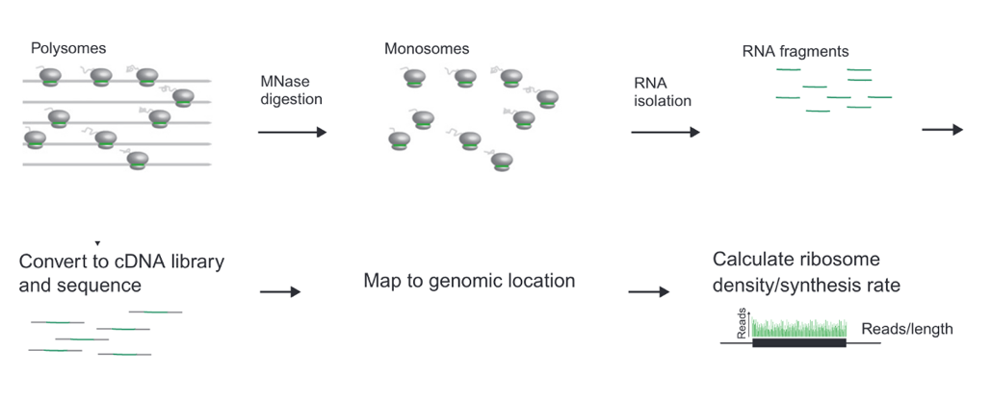
Figure 2. Workflow of ribosome profiling from isolation of ribosomes to library preparation to analysis (Johnson & Li, 2018).

The workflow diagrammed in Figure 2 will be used to capture all of the ribosomes in a cell. In order to assess which ribosomes containing a specific bS21 homolog are translating which mRNAs, we will isolate each class of ribosomes via immunoprecipitation. We will immunoprecipitate 70S ribosomes containing each homolog individually using a different epitope attached to the C-terminus of each bS21 homolog under the control of its native promoter. To minimally perturb total ribosome amounts, we will construct a strain of F. tularensis that contains each homolog with its respective tag (Figure 3).

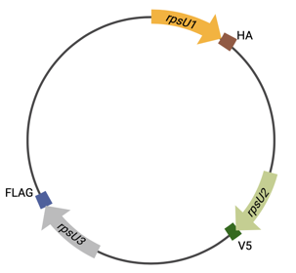

Figure 3. Diagram of F. tularensis chromosome encoding tagged bS21 homologs. Each copy of rpsU has been modified at its native locus to include DNA specifying a different epitope for immunoprecipitation at the 3´ end of the gene.

Prior to ribosome profiling, we will validate and optimize isolation of 70S ribosomes using epitope tagged bS21 homologs. In order to test the efficiency of immunoprecipitation using different tags, I have constructed four plasmids that harbor rpsU2 with a different small epitope tag attached to the 3’ end of the gene (Table 1).
Table 1 Selected epitope tags to be tested for pulldown efficiency of immunoprecipitation.
Epitope Tag | Size | Plasmid
HA | 1.1 kDa | pKR192 pF-rpsU2-HA
6X His | 0.8 kDa | pKR193 pF-rpsU2-His
FLAG | 1 kDa | pKR194 pF-rpsU2-FLAG
V5 | 1.4 kDa | pKR195 pF-rpsU2-V5

Plasmid construction
Plasmids for F. tularensis that encode bS21-2 in frame with each epitope tag to be tested are derived from pKR7, pF-rpsU2-V (Trautmann & Ramsey, 2022). In pKR7, the gene rpsU2 is flanked by the restriction sites EcoRI on the 5’ end and the BamHI on the 3’ end with the VSV-G epitope tag attached to the 3’ end of rpsU2 between the NotI site and the BamHI site. For pKR192-pKR195, the new epitope tags are attached at the same NotI site in rpsU2, essentially replacing the VSV-G tag. . After ligation and confirmation by sequencing, the plasmids were introduced into wild-type F. tularensis.

For each epitope tag, I validated the antibody reactivity and specificity by Western blots. I have begun testing the efficiency of pulldown of ribosomes with tagged bS21 via immunoprecipitation (Figure 4). Once each epitope tag has been evaluated, I will choose which one should be added to each bS21 homolog and add DNA specifying the appropriate tag to the 3´ end of each bS21-encoding genes on the chromosome using allelic exchange

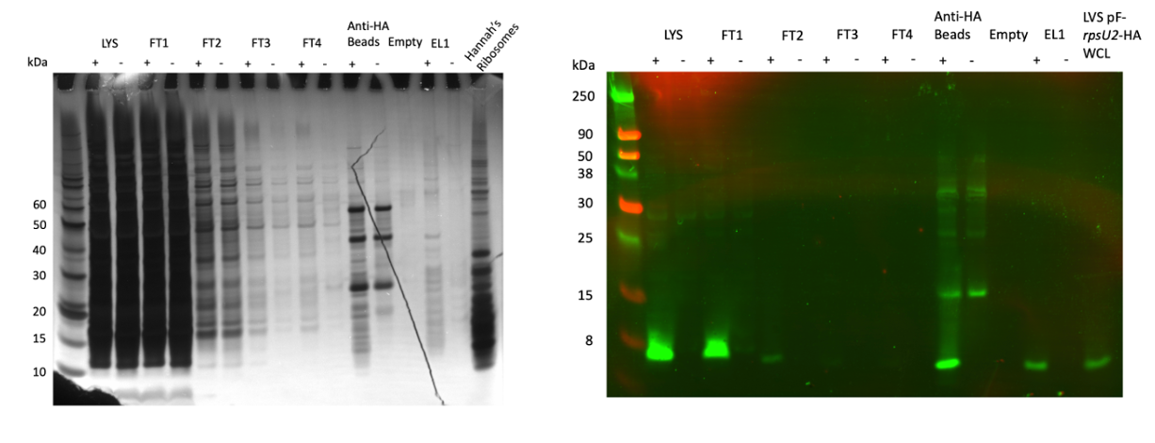
Figure 4. Immunoprecipitation of bS21-2-HA. Left: Silver stain shows many bands in the eluate lane from samples with bS21-2-HA (EL1, “+”) suggesting bS21-2-HA associated with a 70S ribosome is immunoprecipitated. Right: Western Blot using antibody against the HA epitope shows bS21-2-HA is detected in the eluted sample. “+” refers to sample derived from cells harboring the pF-rpsU2-HA plasmid and “-” refers to samples derived from cells harboring the empty vector, pF. LYS = lysate; FT = flowthrough; EL = eluate; WCL = whole cell lysate.

Ribosome profiling
As described previously, to ensure that we are capturing each class of ribosome at biologically relevant abundances, we will perform ribosome profiling on strains that encode tagged versions of all three bS21 homologs. However, we will prepare independent biological samples for each immunoprecipitation rather than performing parallel immunoprecipitation on the same lysates. For each class of ribosome to be immunoprecipitated, we will grow and harvest three cultures in order to perform each ribosome profiling experiment in triplicate.
The following methods for ribosome profiling are based on protocols by Mohammad and Buskirk (2019) and Johnson and Li (2018). We will halt actively translating ribosomes by flash-freezing whole cultures and then grinding them in a buffer with a high concentration of MgCl₂ to mitigate artifacts such as strong pauses or build-up of ribosomes at the 5’ end of ORFs (Mohammad & Buskirk, 2019). We will pellet the lysates over sucrose cushions and then degrade mRNAs unprotected by the ribosome with micrococcal nuclease (MNase). As a control at this step, we will assess the purity and integrity of 70S ribosomes by analyzing a small portion of the samples by sucrose gradient fractionation, as well as a fraction of the digested polysomes to ensure that our starting material included polysomes and that we isolated intact 70S particles. From these purified monosome samples, we will isolate each class of ribosomes (containing either tagged bS21-1, bS21-2, or bS21-3) by immunoprecipitation. We will extract the mRNA footprints and convert them to cDNA to generate the sequencing library. Briefly, we will ligate a DNA adapter to the 3’ end of RNA fragments, then we will convert the ligated RNA into cDNA with reverse transcriptase. We will run a control oligo during the ligation step to measure ligation efficiency. We will circularize the cDNA and deplete contaminating rRNA before we PCR amplify the sequencing library. While we prepare the ribosome profiling library, we will also use this protocol to generate an RNA-Seq library to assess transcript abundance.
The ribosome profiling and RNA-Seq samples will be sequenced by Illumina NovaSeq 6000. We will process the data using Cutadapt for removal of DNA adapters and Bowtie2 for alignment to the F. tularensis genome. When aligning, we will allow 2 mismatches and will require the reads to only map to a unique genomic site. We will analyze the ribosome footprints with RiboProfiling, and for the RNA-Seq data we will count reads with HTSeq-Count and analyze them with DESeq2.

Specific Aim 2. Investigate why the loss of bS21 in S. aureus leads to resistance to cell wall-targeting antibiotics.
Overall strategy
We will begin this investigation by making a clean deletion of rpsU from S. aureus. We will assess the antibiotic susceptibility profile of this mutant using a population analysis protocol adapted by Hanaki and Hiramatsu (2001) against vancomycin and daptomycin. We will investigate whether a lack of bS21 results in a thicker cell envelope using transmission electron microscopy (TEM).
Strain construction
The following methods for gene deletion in S. aureus are based on the protocol by Kato and Sugai (2011). We will construct a plasmid for allelic exchange based on pKFT, fusing about 600 bp of DNA from upstream of the S. aureus rpsU gene to 600 bp of DNA from downstream of rpsU (Kato & Sugai, 2011). pKFT is a vector that has a multicloning site, encodes ampicillin and tetracycline resistance, an origin of replication for E. coli, and a temperature-sensitive origin of replication for S. aureus. The plasmid will replicate at30°C or below. Integration into the chromosome occurs at 42°C, a temperature that is nonpermissive for the plasmid.. We will construct the plasmid in E. coli and confirm by Sanger sequencing. The plasmid will first be transformed into RN4220, a strain of S. aureus that has been engineered to readily accept foreign DNA, at 30°C to encourage plasmid replication, before being transformed into the target strain of S. aureus for the deletion, SA113. We will grow SA113 colonies containing the plasmid at 42°C to promote integration into the chromosome. We will screen for the integration of the plasmid into the chromosome by colony PCR on colonies that grow in the presence of tetracycline, using primers that are located outside rpsU. To encourage allelic replacement, we will grow the primary integrants in TSB without antibiotics overnight at 25°C, then subculture into fresh TSB without antibiotics and grow at 25°C again. Passaging of the culture at this temperature promotes a double-crossover event . We will plate cultures on TSA with and without tetracycline and screen for colonies that grow only on the plates with no antibiotic. We will confirm deletion of rpsU by colony PCR and sequencing.
Determining MIC of vancomycin and daptomycin against S. aureus
We will grow wild-type and ∆rpsU cells shaking overnight in TSB at 37°C. We will normalize the cultures to A₅₇₈=0.3 so that all plates start with approximately 10⁸ CFUs (colony forming units). We will perform a series of ten-fold dilutions for a total of 6 dilutions such that the range of concentrations is 10⁸ CFUs to 10² CFUs. We will prepare BHI (Brain Heart Infusion) plates with 1:2 serial dilutions of each antibiotic for a total of 8 dilutions per antibiotic. We will spread each dilution of bacterial cells onto plates of each antibiotic concentration in triplicate, allow them to dry, and incubate them at 37°C for 48 hours. We will determine the MIC to be the lowest concentration of antibiotic that produces no colonies. We expect that the ∆rpsU strain will have higher minimum inhibitory concentration (MICs) compared to wild-type.
TEM preparation to measure cell wall thickness
We will grow wild-type and ∆rpsU cells to logarithmic phase in BHI broth shaking at 37°C. We will fix the cells in 2% glutaraldehyde in 0.1 M sodium phosphate buffer pH 7.4, incubating for 2 hours. We will stain the cells with 1% osmium tetroxide for 2 hours at 4°C, then dehydrate in ethanol and embed in resin, preparing thin sections. We will stain the sections with uranyl acetate and lead citrate before analyzing under a transmission electron microscope. We will set the magnification to X30,000.
In the event that we do not see thicker cell walls, we will consider what other mechanisms may be at play. To determine this, we will take an unbiased, systems-level approach and compare the proteome and transcriptome of wild-type cells compared to those lacking bS21 (similar to Trautman et al., 2022). This will allow us to identify the transcripts and proteins that are differentially expressed between the two conditions.
Bacterial strains and growth conditions:
Francisella tularensis subspecies holarctica Live Vaccine Strain (LVS) and derivatives will be grown in Mueller-Hinton broth supplemented with 10% glucose, 2.5% iron pyrophosphate, and 2% IsoVitalex, shaking aerobically at 37°. On solid medium strains will be grown on cysteine-heart agar supplemented with hemoglobin and incubated at 3°C. E coli strain XL1 Blue will be grown in lysogeny broth or agar aerobically at 37°C. Staphylococcus aureus strains will be grown in tryptic soy broth (TSB) or agar (TSA) aerobically at 37°C.

E. Resources Required
The majority of the resources required for these experiments will come from Dr. Kathryn Ramsey’s laboratory. Sanger sequencing and equipment for Western blot imaging will be provided by the Rhode Island INBRE Core facility. Microscopy will be carried out with resources from the Rhode Island Consortium for Nanoscience and Nanotechnology.

References

Basco, M. D. S., Kothari, A., McKinzie, P. B., Revollo, J. R., Agnihothram, S., Azevedo, M. P., Saccente, M., & Hart, M. E. (2019). Reduced vancomycin susceptibility and increased macrophage survival in Staphylococcus aureus strains sequentially isolated from a bacteraemic patient during a short course of antibiotic therapy. Journal of Medical Microbiology, 68(6), 848–859. https://doi.org/10.1099/jmm.0.000988
Berk, V., Zhang, W., Pai, R. D., & Cate, J. H. D. (2006). Structural basis for mRNA and tRNA positioning on the ribosome. Proceedings of the National Academy of Sciences of the United States of America, 103(43), 15830–15834. https://doi.org/10.1073/pnas.0607541103
Blake, K. L., & O’Neill, A. J. (2013). Transposon library screening for identification of genetic loci participating in intrinsic susceptibility and acquired resistance to antistaphylococcal agents. Journal of Antimicrobial Chemotherapy, 68(1), 12–16. https://doi.org/10.1093/jac/dks373
Brar, G. A., & Weissman, J. S. (2015). Ribosome profiling reveals the what, when, where, and how of protein synthesis. Nature Reviews. Molecular Cell Biology, 16(11), 651–664. https://doi.org/10.1038/nrm4069
Byrgazov, K., Vesper, O., & Moll, I. (2013). Ribosome heterogeneity: Another level of complexity in bacterial translation regulation. Current Opinion in Microbiology, 16(2), 133–139. https://doi.org/10.1016/j.mib.2013.01.009
Cameron, D. R., Ward, D. V., Kostoulias, X., Howden, B. P., Moellering, R. C., Eliopoulos, G. M., & Peleg, A. Y. (2012). Serine/Threonine Phosphatase Stp1 Contributes to Reduced Susceptibility to Vancomycin and Virulence in Staphylococcus aureus. The Journal of Infectious Diseases, 205(11), 1677–1687. https://doi.org/10.1093/infdis/jis252
Celli, J., & Zahrt, T. C. (2013). Mechanisms of Francisella tularensis Intracellular Pathogenesis. Cold Spring Harbor Perspectives in Medicine, 3(4), a010314. https://doi.org/10.1101/cshperspect.a010314
Chang, C., & Craven, G. R. (1977). Identification of several proteins involved in the messenger RNA binding site of the 30 S ribosome by inactivation with 2-methoxy-5-nitrotropone. Journal of Molecular Biology, 117(2), 401–418. https://doi.org/10.1016/0022-2836(77)90135-8
Chen, Y.-X., Xu, Z., Ge, X., Hong, J.-Y., Sanyal, S., Lu, Z. J., & Javid, B. (2020). Selective translation by alternative bacterial ribosomes. Proceedings of the National Academy of Sciences, 117(32), 19487–19496. https://doi.org/10.1073/pnas.2009607117
Cui, L., Iwamoto, A., Lian, J.-Q., Neoh, H., Maruyama, T., Horikawa, Y., & Hiramatsu, K. (2006). Novel Mechanism of Antibiotic Resistance Originating in Vancomycin-Intermediate Staphylococcus aureus. Antimicrobial Agents and Chemotherapy, 50(2), 428–438. https://doi.org/10.1128/AAC.50.2.428-438.2006
Duval, M., Simonetti, A., Caldelari, I., & Marzi, S. (2015). Multiple ways to regulate translation initiation in bacteria: Mechanisms, regulatory circuits, dynamics. Biochimie, 114, 18–29. https://doi.org/10.1016/j.biochi.2015.03.007
Friedman, L., Alder, J. D., & Silverman, J. A. (2006). Genetic Changes That Correlate with Reduced Susceptibility to Daptomycin in Staphylococcus aureus. Antimicrobial Agents and Chemotherapy, 50(6), 2137–2145. https://doi.org/10.1128/aac.00039-06
Gabriel, S. E., & Helmann, J. D. (2009). Contributions of Zur-Controlled Ribosomal Proteins to Growth under Zinc Starvation Conditions. Journal of Bacteriology, 191(19), 6116–6122. https://doi.org/10.1128/JB.00802-09
Grace, D., & Fetsch, A. (2018). Chapter 1 - Staphylococcus aureus—A Foodborne Pathogen: Epidemiology, Detection, Characterization, Prevention, and Control: An Overview. In A. Fetsch (Ed.), Staphylococcus aureus (pp. 3–10). Academic Press. https://doi.org/10.1016/B978-0-12-809671-0.00001-2
Hanaki, H., Kuwahara-Arai, K., Boyle-Vavra, S., Daum, R. S., Labischinski, H., & Hiramatsu, K. (1998). Activated cell-wall synthesis is associated with vancomycin resistance in methicillin-resistant Staphylococcus aureus clinical strains Mu3 and Mu50. Journal of Antimicrobial Chemotherapy, 42(2), 199–209. https://doi.org/10.1093/jac/42.2.199
Howden, B. P., Davies, J. K., Johnson, P. D. R., Stinear, T. P., & Grayson, M. L. (2010). Reduced Vancomycin Susceptibility in Staphylococcus aureus, Including Vancomycin-Intermediate and Heterogeneous Vancomycin-Intermediate Strains: Resistance Mechanisms, Laboratory Detection, and Clinical Implications. Clinical Microbiology Reviews, 23(1), 99–139. https://doi.org/10.1128/CMR.00042-09
Johnson, G. E., & Li, G.-W. (2018). Chapter Ten—Genome-Wide Quantitation of Protein Synthesis Rates in Bacteria. In A. J. Carpousis (Ed.), Methods in Enzymology (Vol. 612, pp. 225–249). Academic Press. https://doi.org/10.1016/bs.mie.2018.08.031
Kato, F., & Sugai, M. (2011). A simple method of markerless gene deletion in Staphylococcus aureus. Journal of Microbiological Methods, 87(1), 76–81. https://doi.org/10.1016/j.mimet.2011.07.010
Lilleorg, S., Reier, K., Pulk, A., Liiv, A., Tammsalu, T., Peil, L., Cate, J. H. D., & Remme, J. (2019). Bacterial ribosome heterogeneity: Changes in ribosomal protein composition during transition into stationary growth phase. Biochimie, 156, 169–180. https://doi.org/10.1016/j.biochi.2018.10.013
Lilleorg, S., Reier, K., Volõnkin, P., Remme, J., & Liiv, A. (2020). Phenotypic effects of paralogous ribosomal proteins bL31A and bL31B in E. coli. Scientific Reports, 10(1), Article 1. https://doi.org/10.1038/s41598-020-68582-2
Makarova, K. S., Ponomarev, V. A., & Koonin, E. V. (2001). Two C or not two C: Recurrent disruption of Zn-ribbons, gene duplication, lineage-specific gene loss, and horizontal gene transfer in evolution of bacterial ribosomal proteins. Genome Biology, 2(9), research0033.1-research0033.14.
Matsuo, M., Cui, L., Kim, J., & Hiramatsu, K. (2013). Comprehensive Identification of Mutations Responsible for Heterogeneous Vancomycin-Intermediate Staphylococcus aureus (hVISA)-to-VISA Conversion in Laboratory-Generated VISA Strains Derived from hVISA Clinical Strain Mu3. Antimicrobial Agents and Chemotherapy, 57(12), 5843–5853. https://doi.org/10.1128/AAC.00425-13
McNutt, Z. A., Roy, B., Gemler, B. T., Shatoff, E. A., Moon, K.-M., Foster, L. J., Bundschuh, R., & Fredrick, K. (2023). Ribosomes lacking bS21 gain function to regulate protein synthesis in Flavobacterium johnsoniae. Nucleic Acids Research, 51(4), 1927–1942. https://doi.org/10.1093/nar/gkad047
Metselaar, K. I., den Besten, H. M. W., Boekhorst, J., van Hijum, S. A. F. T., Zwietering, M. H., & Abee, T. (2015). Diversity of acid stress resistant variants of Listeria monocytogenes and the potential role of ribosomal protein S21 encoded by rpsU. Frontiers in Microbiology, 6, 422. https://doi.org/10.3389/fmicb.2015.00422
Miller, W. R., Bayer, A. S., & Arias, C. A. (2016). Mechanism of Action and Resistance to Daptomycin in Staphylococcus aureus and Enterococci. Cold Spring Harbor Perspectives in Medicine, 6(11), a026997. https://doi.org/10.1101/cshperspect.a026997
Mizushima, S., & Nomura, M. (1970). Assembly Mapping of 30S Ribosomal Proteins from E. coli. Nature, 226(5252), Article 5252. https://doi.org/10.1038/2261214a0
Mohammad, F., & Buskirk, A. R. (2019). Protocol for Ribosome Profiling in Bacteria. Bio-Protocol, 9(24), e3468. https://doi.org/10.21769/BioProtoc.3468
Müller, A., Wenzel, M., Strahl, H., Grein, F., Saaki, T. N. V., Kohl, B., Siersma, T., Bandow, J. E., Sahl, H.-G., Schneider, T., & Hamoen, L. W. (2016). Daptomycin inhibits cell envelope synthesis by interfering with fluid membrane microdomains. Proceedings of the National Academy of Sciences of the United States of America, 113(45), E7077. https://doi.org/10.1073/pnas.1611173113
Robertson, W. R., Dowsett, S. J., & Hardy, S. J. S. (n.d.). Exchange of Ribosomal Proteins among the Ribosomes of Escherichia coil.
Sader, H. S., Fey, P. D., Fish, D. N., Limaye, A. P., Pankey, G., Rahal, J., Rybak, M. J., Snydman, D. R., Steed, L. L., Waites, K., & Jones, R. N. (2009). Evaluation of Vancomycin and Daptomycin Potency Trends (MIC Creep) against Methicillin-Resistant Staphylococcus aureus Isolates Collected in Nine U.S. Medical Centers from 2002 to 2006. Antimicrobial Agents and Chemotherapy, 53(10), 4127. https://doi.org/10.1128/AAC.00616-09
Sauert, M., Temmel, H., & Moll, I. (2015). Heterogeneity of the translational machinery: Variations on a common theme. Biochimie, 114, 39–47. https://doi.org/10.1016/j.biochi.2014.12.011
Takada, H., Morita, M., Shiwa, Y., Sugimoto, R., Suzuki, S., Kawamura, F., & Yoshikawa, H. (2014). Cell motility and biofilm formation in Bacillus subtilis are affected by the ribosomal proteins, S11 and S21. Bioscience, Biotechnology, and Biochemistry, 78(5), 898–907. https://doi.org/10.1080/09168451.2014.915729
Trautmann, H. S., & Ramsey, K. M. (2022). A Ribosomal Protein Homolog Governs Gene Expression and Virulence in a Bacterial Pathogen. Journal of Bacteriology, 204(10), e00268-22. https://doi.org/10.1128/jb.00268-22
Van Duin, J., & Wijnands, R. (1981). The Function of Ribosomal Protein S21 in Protein Synthesis. European Journal of Biochemistry, 118(3), 615–619. https://doi.org/10.1111/j.1432-1033.1981.tb05563.x

