A. Title of the Study
Exploring the molecular mechanisms of bS21 in bacterial pathogens

B. Statement of the Problem
The purpose of this study is to determine how the ribosomal protein bS21 impacts translation in Francisella tularensis and Staphylococcus aureus. Although both organisms are pathogens, manipulation of bS21 results in different phenotypes in each species. In the Gram-negative intracellular pathogen F. tularensis, which encodes three distinct bS21 homologs, one homolog is key for expression of an essential virulence factor, a type six secretion system and intramacrophage survival. In the Gram-positive opportunistic human pathogen S. aureus, bS21 appears to impact antibiotic resistance. The goal of the proposed work is to establish how these bS21 homologs exert their effects. Specifically, I will determine whether each homolog translates certain mRNAs preferentially in F. tularensis using ribosome profiling, and I will ascertain if a loss of bS21 impacts cell wall synthesis in S. aureus that could lead to antibiotic resistance.

C. Justification for the Study
Ribosome heterogeneity may contribute to bacterial gene regulation
The central dogma of molecular biology dictates that the genetic information is stored in DNA, which is transcribed into mRNA, which in turn is translated into protein. Much of the focus of gene regulation is attributed to transcription, but regulation also occurs at the level of translation. Regulation at this level can be due to the effects of mRNA, sRNAs, RNA binding proteins, and ribosome binding proteins (Duval et al., 2015). A somewhat understudied aspect of gene regulation is how the composition of the ribosome contributes to gene expression. The ribosome is the site of protein synthesis composed of three ribosomal RNA (rRNA) molecules and several ribosomal proteins (r-proteins). The ribosome is often viewed as a static entity, however there is evidence that alternate compositions of the ribosome can exist in the same cell. This suggests that not all ribosomes function identically and ribosome composition may play a role in post-transcriptional regulation (Byrgazov et al., 2013; Sauert et al., 2015).
There are multiple sources of ribosomal heterogeneity, including the absence of or multiplicity of r-proteins, post-transcriptional or post-translational modification of rRNA or r-proteins, and the incorporation of different homologs of r-proteins (Sauert et al., 2015). In several bacteria, including Mycobacterium smegmatis and Bacillus subtilis, paralogs of r-proteins that coordinate zinc are “substituted” by paralogs of the same r-proteins that do not coordinate zinc in a low zinc environment (Dow & Prisic, 2018; Gabriel & Helmann, 2009). In Bacillus subtilis , a duplication of two genes that encode r-proteins leads to two different paralogs; one which can coordinate zinc and another which cannot, perhaps as a stress response to a limit of zinc in the environment (Gabriel & Helmann, 2009). In Mycobacterium smegmatis, four zinc-independent alternative r-proteins are expressed when zinc is depleted (Dow & Prisic, 2018) This suggests that ribosomes with various compositions due to multiple versions of certain r-proteins result in different phenotype in the context of survival in a low zinc environment. The molecular mechanism of how protein synthesis is affected by the coordination of zinc has yet to be determined. Whether or not ribosomal heterogeneity due to homologous r-proteins directly affects translation has yet to be demonstrated.

The role of bS21 in translation
bS21 is a small 30S subunit ribosomal protein encoded by the gene rpsU that is involved in translation initiation (Van Duin & Wijnands, 1981). Although the precise mechanism of its involvement in translation is unclear, its positioning near the mRNA exit channel (Figure 1) suggests that bS21 can interact with the 5’ UTR of mRNAs and, at least in some E. coli ribosomes, can contact the anti-Shine-Dalgarno sequence of 16S rRNA (Berk et al., 2006). Many species lack bS21, therefore it is not considered essential for function or assembly (Van Duin & Wijnands, 1981).. Species that encode bS21 show a variety of phenotypes. In S. aureus, cells containing mutations in bS21 have altered susceptibility to antibiotics (Basco et al., 2019; Friedman et al., 2006). In Bacillus subtilis, loss of bS21 results in cells with defects in motility and biofilm formation (Takada et al., 2014), while Listeria monocytogenes can withstand increased acid stress when bS21 is mutated (Metselaar et al., 2015). In Flavobacterium johnsoniae, ribosomes that lack bS21 increase the initiation of rpsU mRNA translation (McNutt et al., 2023). Because bS21 has been implicated in a variety of phenotypes when it is lost or mutated, it is likely that this protein serves a regulatory role in translation.
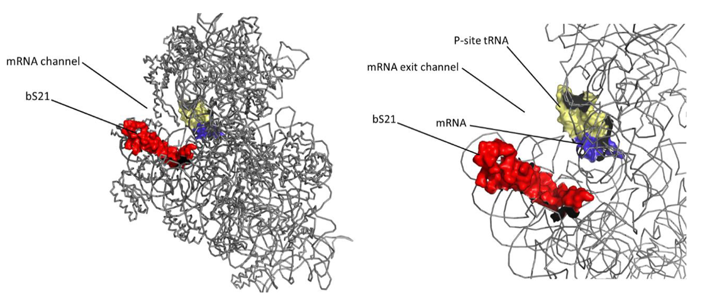
Figure 1. The location of bS21 in the ribosome. Left: Cryo-EM image of 30S subunit of E. coli ribosome with all rRNA and r-proteins grayed out except for bS21 highlighted in red with mRNA in purple base-paired with tRNA in yellow at the P-site. Right: close-up of bS21 focuses on its proximity to the mRNA exit channel. PDB entry 45V0

With bS21 having a limited role in translation but a potential to function as a regulator of translation initiation, it is an ideal r-protein to use when studying how ribosome composition governs ribosome function. In my proposed dissertation work, I will investigate how ribosome heterogeneity influences translation in the following aims:
Specific Aim 1. In F. tularensis, does incorporation of specific bS21 homologs into the ribosome lead to preferential translation of specific transcripts??
Specific Aim 2. Does the loss of bS21 in S. aureus lead to changes in gene expression that allow for antibiotic resistance, possibly by resulting in an increase in cell wall thickness?

The role of distinct bS21 homologs in F. tularensis
Francisella tularensis is a facultative intracellular pathogen that causes the disease tularemia. As it can be aerosolized, has a low infectious dose (as few as 10 cells), and a high mortality rate (up to 60% if left untreated), F. tularensis is considered a potential bioweapon (Celli & Zahrt, 2013). It encodes three distinct homologs of bS21 (Trautmann & Ramsey, 2022). As one of the last proteins to be incorporated into the ribosome (Mizushima & Nomura, 1970), bS21 is loosely associated and as such, there is the potential that different homologs of the protein can be swapped out (Robertson et al., n.d.). Wild-type cells of F. tularensis can incorporate all three homologs of bS21 into the ribosomes (Trautmann & Ramsey, 2022). The loss of a particular homolog, bS21-2, leads to changes in abundance for about 160 proteins that cannot be explained by changes in transcript abundance (Trautmann & Ramsey, 2022). Changes in phenotype seen in the ∆rpsU2 strain include a reduction in protein abundance for a key virulence factor, the type six secretion system (T6SS), a decrease in intramacrophage survival, and to a growth defect in vitro (Trautmann & Ramsey, 2022). While these phenotypes can be complemented with the reintroduction of bS21-2, they cannot by complemented by bS21-1 or bS21-3 ((Trautmann & Ramsey, 2022). These data raise the possibility that each bS21 homolog may control the expression of different genes, possibly by preferentially promoting translation initiation of different transcripts. [We will determine which transcripts are being actively translated by ribosomes with different bS21 homologs using ribosome profiling, as discussed in methods.]
Rational: Using ribosome profiling to ascertain whether each bS21 homolog preferentially translates a specific subclass of mRNAs will provide insight into the mechanism of bS21’s role in translation initiation. We hypothesize the different populations of ribosomes in F. tularensis will preferentially translate mRNAs.
A connection between bS21 and antibiotic resistance in S. aureus
S. aureus is a commensal bacterium ubiquitous in the environment and found on the skin of humans and other animals. Although it is usually harmless, it can cause skin infections, foodborne illness, and septicemia (Grace & Fetsch, 2018). In S. aureus, resistance to antibiotics is an increasing threat to public health (Sader et al., 2009). Methicillin-resistant S. aureus (MRSA) is a multi-drug resistant strain whose drug susceptibility profile is constantly evolving. MRSA has given way to VSSA and VRSA (vancomycin-intermediate and vancomycin-resistant S. aureus, respectively) (Cui et al., 2006; Hanaki et al., 1998). Independent studies looking into the acquisition of vancomycin-resistance identified mutations in the gene encoding bS21, rpsU (Basco et al., 2019; Cameron et al., 2012; Friedman et al., 2006; Matsuo et al., 2013). Additionally, a transposon insertion was found upstream of rpsU that led to reduced susceptibility to vancomycin and daptomycin (Blake & O’Neill, 2013).
Vancomycin and daptomycin are two antibiotics that are considered “last resort” therapies against an increasing threat of resistant S. aureus (Cui et al., 2006; Miller et al., 2016). Vancomycin is a glycopeptide that disrupts the peptidoglycan layer of Gram-positive bacteria by blocking substrates for its synthesis (Cui et al., 2006; Howden et al., 2010). Specifically, it targets the D-alanyl-D-alanine residue (DDR) of lipid II precursor. Daptomycin is a lipopeptide that is often used when vancomycin fails. Its mechanism of action is still unclear, but it also disrupts cell wall synthesis (Miller et al., 2016; Müller et al., 2016). It is remarkable that loss of a ribosomal protein, bS21, leads to increased resistance to these two cell-wall-targeting antibiotics. It suggests that loss of bS21 may lead to downstream effects on gene expression that impact antibiotic resistance. In particular, it is possible that bS21 is involved in the regulation of cell wall synthesis. One mechanism of resistance against these cell-wall-targeting drugs that S. aureus employs is a thickened cell wall. We will discern if bS21 influences cell wall synthesis in S. aureus by creating a clean deletion strain and assessing its antibiotic susceptibility profile and use microscopy the measure its cell wall thickness.
Rationale: Vancomycin and daptomycin are antibiotics that attack the bacterial cell envelope. Strains of S. aureus that show resistance to vancomycin and daptomycin have thicker cell walls. Mutations in rpsU have been observed in these resistant strains (Howden et al., 2010). We hypothesize that a loss of bS21 may result in a thicker cell envelope.

D. Methodology and Procedures
Specific Aim 1. In F. tularensis, does incorporation of specific bS21 homologs into the ribosome lead to preferential translation of specific transcripts?
Overall strategy:
Ribosome profiling will allow us to see which transcripts are translated by which class of ribosomes in F. tularensis. Ribosome profiling is a technique that sequences mRNA footprints protected by actively translating ribosomes (Figure 2). The measured density of ribosomes halted on a given transcript is representative of protein synthesis, allowing for a global snapshot of what is being translated across the genome (Brar & Weissman, 2015; Johnson & Li, 2018; Mohammad & Buskirk, 2019). A parallel analysis of mRNA abundance using RNA Seq will allow us identify which transcripts are present in the cell.
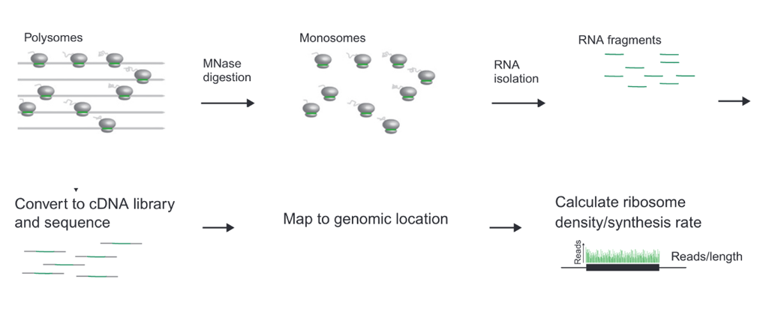
Figure 2. Workflow of ribosome profiling from isolation of ribosomes to library preparation to analysis (Johnson & Li, 2018).

In order to assess which homolog is translating which mRNAs, we will first immunoprecipitate each homolog with a different epitope attached to the C-terminus of bS21 under the control of its native promoter to maintain stoichiometric amounts of each class of ribosome.
Before ribosome profiling can begin, isolation of the ribosome with epitope tags attached to bS21 homologs must be optimized. In order to test the efficiency of immunoprecipitation using different tags, I have constructed four plasmids that harbor rpsU2 at its native genomic loci with a different small epitope tag attached to the 3’ end of the gene (Table 1).
Plasmid construction:
Plasmids for LVS that encode bS21-2 in frame with each epitope tag to be tested are derived from pKR7, pF-rpsU2-V (Trautmann & Ramsey, 2022) . The VSV-G epitope tag at the 3’ end of rpsU2 was deleted and replaced by each epitope at the EcoRI site on the 5’ end and the BamHI site on the 3’ end. After ligation and transformation into wild-type F. tularensis, the plasmids were confirmed by sequencing with the reverse sequencing primer for the pF plasmid KROL44.
Epitope Tag | Size | Plasmid
HA | 1.1 kDa | pKR192 pF-rpsU2-HA
6X His | 0.8 kDa | pKR193 pF-rpsU2-His
FLAG | 1 kDa | pKR194 pF-rpsU2-FLAG
V5 | 1.4 kDa | pKR195 pF-rpsU2-V5
Table 1 Selected epitope tags to be tested for pulldown efficiency of immunoprecipitation.

For each epitope tag, I have set up Western Blots with 4 dilutions of the appropriate antibody to assess the optimal concentration of the antibody. I have also set up Western Blots testing each epitope tag against the other antibodies and observed no cross-reactivity. I have begun testing the efficiency of pulldown of each epitope via immunoprecipitation (Figure 4). Once each epitope has been evaluated, I will choose which epitope tag should be added to each homolog and incorporate them onto the chromosome (Figure 3).
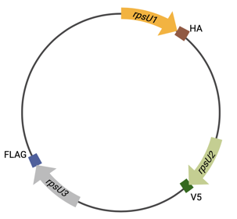
Figure 3. Diagram of F. tularensis chromosome encoding tagged bS21 homologs. Each copy of rpsU has been modified at its native locus to include DNA specifying a different epitope for immunoprecipitation at the 3´ end of the gene.
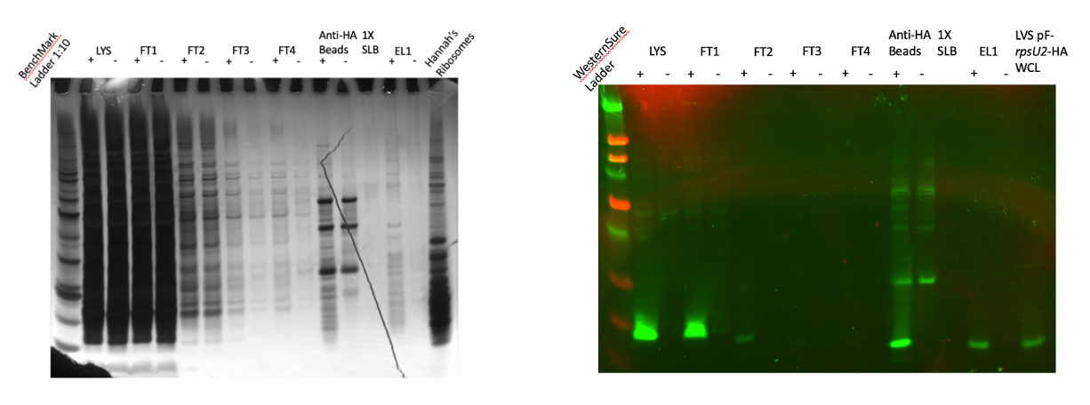
Figure 4. Immunoprecipitation of bS21-2 with HA epitope tag. Left: Silver Stain shows many bands in the eluate lane from samples with bS21-2-HA (EL1, “+”) suggesting bS21-2 associated with a 70S ribosome is immunoprecipitated. Right: Western Blot using antibody against the HA tag shows bS21-2 is detected in the eluted sample. LYS = lysate; FT = flowthrough; EL = eluate.

Ribosome profiling:
The following methods for ribosome profiling are based on protocols by Mohammad and Buskirk (2019) and Johnson and Li (2018): We will halt actively translating ribosomes with a high concentration of MgCl₂ to mitigate artifacts such as strong pauses or build-up of ribosomes at the 5’ end of ORFs (Mohammad & Buskirk, 2019). We will degrade mRNAs unprotected by the ribosome with Micrococcal nuclease (MNase) and assess the purity and integrity of 70S ribosomes with sucrose gradients. As a control at this step we will run polysomes untreated by MNase in parallel with the samples to ensure that intact 70S particles are isolated. We will extract the mRNA footprints and convert them to cDNA to establish the sequencing library. Briefly, we will ligate a DNA adapter to the 3’ end of RNA fragments, then we will convert the ligated RNA into cDNA with reverse transcriptase. We will run a control oligo during the ligation step to measure ligation efficiency. We will circularize the cDNA and deplete contaminating rRNA before we PCR amplify the sequencing library.
While we prepare the ribosome profiling library, we will also build an RNA-Seq library to assess transcript abundance. Both sets of samples will be sequenced by Illumina NovaSeq 6000, prepared as 2nM of multiplexed samples, set for 50 cycles as single-end sequencing. We will analyze the data with Cutadapt for removal of DNA adapters and Bowtie2 for alignment to the F. tularensis genome. When aligning, we will allow 2 mismatches and will require the reads to only map to a unique genomic site. We will analyze the ribosome footprints with RiboProfiling, and for the RNA-Seq data we will count reads with HTSeq-Count and analyze them with DESeq2.
Bacterial strains and growth conditions:
Francisella tularensis subspecies holarctica Live Vaccine Strain (LVS) and derivatives will be grown in Mueller-Hinton broth supplemented with 10% glucose, 2.5% iron pyrophosphate, and 2% IsoVitalex, shaking aerobically at 37ºC. On solid medium strains will be grown on cysteine-heart agar supplemented with hemoglobin and incubated at 37ºC. E coli strain XL1 Blue will be grown in lysogeny broth or agar aerobically at 37ºC. Staphylococcus aureus strains will be grown in tryptic soy broth or agar aerobically at 37ºC.

Specific Aim 2. Does the loss of bS21 in S. aureus lead to changes in gene expression that allow for antibiotic resistance, possibly by resulting in an increase in cell wall thickness?
Overall strategy:
We will begin this investigation by making a clean deletion of rpsU from S. aureus. We will assess the antibiotic susceptibility profile of this mutant using disk diffusion assays against vancomycin and daptomycin. We will investigate whether a lack of bS21 results in a thicker cell envelope using transmission electron microscopy (TEM).
Strain construction:
The following methods for gene deletion in S. aureus are based on the protocol by Kato and Sugai (2011).
We will construct a plasmid fusing about 600 bp upstream of rpsU to 600 bp downstream We will PCR amplify the DNA fragments and digest them with SalI and BamHI and ligate onto the backbone pKFT which has the same restriction sites. pKFT is a vector that has a multicloning site, ampR, tetL, an origin of replication for E. coli, and a temperature-sensitive origin of replication for S. aureus. We will transform the plasmid into E. coli via heat shock, then purify it and confirm it by Sanger sequencing. The plasmid will first be transformed into RN4220, a strain of S. aureus that has been engineered to readily accept foreign DNA, before being transformed into HG003, the terminal strain of S. aureus. We will transform the plasmid into HG003 via electroporation and incubate at 30ºC, the temperature that allows for plasmid replication, before growing colonies at 42ºC to allow for integration onto the chromosome We will run colony PCR on colonies that only grow in the presence of tetracycline, using primers that are located outside rpsU. To encourage allelic replacement, we will grow the primary integrants in TSB without antibiotics overnight at 25ºC, then subculture into fresh TSB without antibiotics and grow at 25ºC again. Passaging of the culture at this temperature eradicates any residual replicating plasmid. We will plate cultures on TSA with and without tetracycline and screen for colonies that grow only on the plates with no antibiotic. We will confirm deletion of rpsU by colony PCR and sequencing.
Determining MIC of vancomycin and daptomycin against S. aureus:
We will grow the wild-type strain and the ∆rpsU strain shaking overnight in TSB at 37ºC. We will normalize the cultures to A₅₇₈=0.3 so that all plates start with approximately 10⁸ CFUs (colony forming units). We will perform a series of ten-fold dilutions for a total of 6 dilutions such that the range of concentrations is 10⁸ CFUs to 10² CFUs. We will prepare BHI (Brain Heart Infusion) plates with 1:2 serial dilutions of each antibiotic for a total of 8 dilutions per antibiotic. We will spread each dilution of bacterial cells onto plates of each antibiotic concentration in triplicate, allow them to dry, and incubate them at 37ºC for 48 hours. We will determine the MIC to be the lowest concentration of antibiotic that produces no colonies. We expect that the ∆rpsU strain will have higher minimum inhibitory concentration (MICs) compared to wild-type.
TEM preparation to measure cell wall thickness:
We will grow wild-type and ∆rpsU strains to logarithmic phase in BHI broth shaking at 37ºC. We will fix the cells in 2% glutaraldehyde in 0.1 M sodium phosphate buffer pH 7.4, incubating for 2 hours. We will stain the cells with 1% osmium tetroxide for 2 hours at 4ºC, then dehydrate in ethanol and embed in resin, preparing thin sections. We will stain the sections with uranyl acetate and lead citrate before analyzing under a transmission electron microscope. We will set the magnification to X30,000.

E. Resources Required
The majority of the resources required for these experiments will come from Dr. Kathryn Ramsey’s laboratory. Additionally, Sanger sequencing and the use of other equipment will occur at the Rhode Island INBRE Core facility. Microscopy will be carried out with resources from the Rhode Island Consortium for Nanoscience and Nanotechnology.

References

Basco, M. D. S., Kothari, A., McKinzie, P. B., Revollo, J. R., Agnihothram, S., Azevedo, M. P., Saccente, M., & Hart, M. E. (2019). Reduced vancomycin susceptibility and increased macrophage survival in Staphylococcus aureus strains sequentially isolated from a bacteraemic patient during a short course of antibiotic therapy. Journal of Medical Microbiology, 68(6), 848–859. https://doi.org/10.1099/jmm.0.000988
Berk, V., Zhang, W., Pai, R. D., & Cate, J. H. D. (2006). Structural basis for mRNA and tRNA positioning on the ribosome. Proceedings of the National Academy of Sciences of the United States of America, 103(43), 15830–15834. https://doi.org/10.1073/pnas.0607541103
Blake, K. L., & O’Neill, A. J. (2013). Transposon library screening for identification of genetic loci participating in intrinsic susceptibility and acquired resistance to antistaphylococcal agents. Journal of Antimicrobial Chemotherapy, 68(1), 12–16. https://doi.org/10.1093/jac/dks373
Brar, G. A., & Weissman, J. S. (2015). Ribosome profiling reveals the what, when, where, and how of protein synthesis. Nature Reviews. Molecular Cell Biology, 16(11), 651–664. https://doi.org/10.1038/nrm4069
Byrgazov, K., Vesper, O., & Moll, I. (2013). Ribosome heterogeneity: Another level of complexity in bacterial translation regulation. Current Opinion in Microbiology, 16(2), 133–139. https://doi.org/10.1016/j.mib.2013.01.009
Cameron, D. R., Ward, D. V., Kostoulias, X., Howden, B. P., Moellering, R. C., Eliopoulos, G. M., & Peleg, A. Y. (2012). Serine/Threonine Phosphatase Stp1 Contributes to Reduced Susceptibility to Vancomycin and Virulence in Staphylococcus aureus. The Journal of Infectious Diseases, 205(11), 1677–1687. https://doi.org/10.1093/infdis/jis252
Celli, J., & Zahrt, T. C. (2013). Mechanisms of Francisella tularensis Intracellular Pathogenesis. Cold Spring Harbor Perspectives in Medicine, 3(4), a010314. https://doi.org/10.1101/cshperspect.a010314
Cui, L., Iwamoto, A., Lian, J.-Q., Neoh, H., Maruyama, T., Horikawa, Y., & Hiramatsu, K. (2006). Novel Mechanism of Antibiotic Resistance Originating in Vancomycin-Intermediate Staphylococcus aureus. Antimicrobial Agents and Chemotherapy, 50(2), 428–438. https://doi.org/10.1128/AAC.50.2.428-438.2006
Dow, A., & Prisic, S. (2018). Alternative ribosomal proteins are required for growth and morphogenesis of Mycobacterium smegmatis under zinc limiting conditions. PLOS ONE, 13(4), e0196300. https://doi.org/10.1371/journal.pone.0196300
Duval, M., Simonetti, A., Caldelari, I., & Marzi, S. (2015). Multiple ways to regulate translation initiation in bacteria: Mechanisms, regulatory circuits, dynamics. Biochimie, 114, 18–29. https://doi.org/10.1016/j.biochi.2015.03.007
Friedman, L., Alder, J. D., & Silverman, J. A. (2006). Genetic Changes That Correlate with Reduced Susceptibility to Daptomycin in Staphylococcus aureus. Antimicrobial Agents and Chemotherapy, 50(6), 2137–2145. https://doi.org/10.1128/aac.00039-06
Gabriel, S. E., & Helmann, J. D. (2009). Contributions of Zur-Controlled Ribosomal Proteins to Growth under Zinc Starvation Conditions. Journal of Bacteriology, 191(19), 6116–6122. https://doi.org/10.1128/JB.00802-09
Grace, D., & Fetsch, A. (2018). Chapter 1 - Staphylococcus aureus—A Foodborne Pathogen: Epidemiology, Detection, Characterization, Prevention, and Control: An Overview. In A. Fetsch (Ed.), Staphylococcus aureus (pp. 3–10). Academic Press. https://doi.org/10.1016/B978-0-12-809671-0.00001-2
Hanaki, H., Kuwahara-Arai, K., Boyle-Vavra, S., Daum, R. S., Labischinski, H., & Hiramatsu, K. (1998). Activated cell-wall synthesis is associated with vancomycin resistance in methicillin-resistant Staphylococcus aureus clinical strains Mu3 and Mu50. Journal of Antimicrobial Chemotherapy, 42(2), 199–209. https://doi.org/10.1093/jac/42.2.199
Howden, B. P., Davies, J. K., Johnson, P. D. R., Stinear, T. P., & Grayson, M. L. (2010). Reduced Vancomycin Susceptibility in Staphylococcus aureus, Including Vancomycin-Intermediate and Heterogeneous Vancomycin-Intermediate Strains: Resistance Mechanisms, Laboratory Detection, and Clinical Implications. Clinical Microbiology Reviews, 23(1), 99–139. https://doi.org/10.1128/CMR.00042-09
Johnson, G. E., & Li, G.-W. (2018). Chapter Ten—Genome-Wide Quantitation of Protein Synthesis Rates in Bacteria. In A. J. Carpousis (Ed.), Methods in Enzymology (Vol. 612, pp. 225–249). Academic Press. https://doi.org/10.1016/bs.mie.2018.08.031
Matsuo, M., Cui, L., Kim, J., & Hiramatsu, K. (2013). Comprehensive Identification of Mutations Responsible for Heterogeneous Vancomycin-Intermediate Staphylococcus aureus (hVISA)-to-VISA Conversion in Laboratory-Generated VISA Strains Derived from hVISA Clinical Strain Mu3. Antimicrobial Agents and Chemotherapy, 57(12), 5843–5853. https://doi.org/10.1128/AAC.00425-13
McNutt, Z. A., Roy, B., Gemler, B. T., Shatoff, E. A., Moon, K.-M., Foster, L. J., Bundschuh, R., & Fredrick, K. (2023). Ribosomes lacking bS21 gain function to regulate protein synthesis in Flavobacterium johnsoniae. Nucleic Acids Research, 51(4), 1927–1942. https://doi.org/10.1093/nar/gkad047
Metselaar, K. I., den Besten, H. M. W., Boekhorst, J., van Hijum, S. A. F. T., Zwietering, M. H., & Abee, T. (2015). Diversity of acid stress resistant variants of Listeria monocytogenes and the potential role of ribosomal protein S21 encoded by rpsU. Frontiers in Microbiology, 6, 422. https://doi.org/10.3389/fmicb.2015.00422
Miller, W. R., Bayer, A. S., & Arias, C. A. (2016). Mechanism of Action and Resistance to Daptomycin in Staphylococcus aureus and Enterococci. Cold Spring Harbor Perspectives in Medicine, 6(11), a026997. https://doi.org/10.1101/cshperspect.a026997
Mizushima, S., & Nomura, M. (1970). Assembly Mapping of 30S Ribosomal Proteins from E. coli. Nature, 226(5252), Article 5252. https://doi.org/10.1038/2261214a0
Mohammad, F., & Buskirk, A. R. (2019). Protocol for Ribosome Profiling in Bacteria. Bio-Protocol, 9(24), e3468. https://doi.org/10.21769/BioProtoc.3468
Müller, A., Wenzel, M., Strahl, H., Grein, F., Saaki, T. N. V., Kohl, B., Siersma, T., Bandow, J. E., Sahl, H.-G., Schneider, T., & Hamoen, L. W. (2016). Daptomycin inhibits cell envelope synthesis by interfering with fluid membrane microdomains. Proceedings of the National Academy of Sciences of the United States of America, 113(45), E7077. https://doi.org/10.1073/pnas.1611173113
Robertson, W. R., Dowsett, S. J., & Hardy, S. J. S. (n.d.). Exchange of Ribosomal Proteins among the Ribosomes of Escherichia coil.
Sader, H. S., Fey, P. D., Fish, D. N., Limaye, A. P., Pankey, G., Rahal, J., Rybak, M. J., Snydman, D. R., Steed, L. L., Waites, K., & Jones, R. N. (2009). Evaluation of Vancomycin and Daptomycin Potency Trends (MIC Creep) against Methicillin-Resistant Staphylococcus aureus Isolates Collected in Nine U.S. Medical Centers from 2002 to 2006. Antimicrobial Agents and Chemotherapy, 53(10), 4127. https://doi.org/10.1128/AAC.00616-09
Sauert, M., Temmel, H., & Moll, I. (2015). Heterogeneity of the translational machinery: Variations on a common theme. Biochimie, 114, 39–47. https://doi.org/10.1016/j.biochi.2014.12.011
Takada, H., Morita, M., Shiwa, Y., Sugimoto, R., Suzuki, S., Kawamura, F., & Yoshikawa, H. (2014). Cell motility and biofilm formation in Bacillus subtilis are affected by the ribosomal proteins, S11 and S21. Bioscience, Biotechnology, and Biochemistry, 78(5), 898–907. https://doi.org/10.1080/09168451.2014.915729
Trautmann, H. S., & Ramsey, K. M. (2022). A Ribosomal Protein Homolog Governs Gene Expression and Virulence in a Bacterial Pathogen. Journal of Bacteriology, 204(10), e00268-22. https://doi.org/10.1128/jb.00268-22
Van Duin, J., & Wijnands, R. (1981). The Function of Ribosomal Protein S21 in Protein Synthesis. European Journal of Biochemistry, 118(3), 615–619. https://doi.org/10.1111/j.1432-1033.1981.tb05563.x

