Title:
Exploring the role of bS21 in bacterial gene regulation
Statement of the Problem:
The purpose of this study is to determine how the incorporation of different homologs of the ribosomal protein bS21 impacts translation in Francisella tularensis and Staphylococcus aureus. Although both organisms are pathogens, manipulation of bS21 results in different phenotypes in each species. In F. tularensis, bS21 is shown to be involved in the expression of the virulence factor Type Six Secretion System (T6SS), while in S. aureus it may have a role in antibiotic resistance. In F. tularensis, bS21 presents as three distinct homologs present in different abundances. The goal of this proposed investigation is to establish whether each homolog translates certain mRNAs preferentially in F. tularensis, and to recognize if a loss of bS21 impacts cell wall synthesis in S. aureus that could lead to antibiotic resistance.
Justification for the Study
Heterogeneity of the ribosome may contribute to bacterial gene regulation:
The central dogma of molecular biology dictates that the genetic information is stored in DNA, which is transcribed into mRNA, which in turn is translated into proteins. Much of the focus of gene regulation is attributed to transcription, but regulation also occurs at the level of translation. Regulation at this level is often due to the effects of mRNA, sRNAs, RNA binding proteins, and ribosome binding proteins (Duval et al., 2015). A somewhat understudied aspect of gene regulation is how the composition of the ribosome contributes to gene expression. The complex is often viewed as a single entity, however there is evidence that alternate versions of the ribosome can exist in the same cell, suggesting that the ribosome is a key figure in post-transcriptional regulation (Byrgazov et al., 2013; Sauert et al., 2015).
There are multiple sources of ribosomal heterogeneity such as stoichiometry of r-proteins, modification of rRNA or r-proteins, and multiple homologs of r-proteins (Sauert et al., 2015). Recent work in organisms such as Mycobacterium smegmatis and Bacillus subtilis demonstrates that ribosomes with various compositions due to multiple versions of certain r-proteins result in different phenotype in the context of survival in a low zinc environement (Dow & Prisic, 2018; Gabriel & Helmann, 2009). In Bacillus subtilis , a duplication of two genes that encode r-proteins leads to two different paralogs; one which can coordinate zinc and the another which cannot, perhaps as a stress response to a limit of zinc in the environment (Gabriel & Helmann, 2009). In Mycobacterium smegmatis, four zinc-independent alternative r-proteins are expressed when zinc is depleted (Dow & Prisic, 2018) The molecular mechanism of how protein synthesis is affected by the coordination of zinc has yet to be determined. Whether or not ribosomal heterogeneity due to homologous r-proteins directly affects translation has yet to be demonstrated.

Role of bS21 in translation:
bS21 is a small 30S subunit ribosomal protein encoded by the gene rpsU that is involved in translation initiation (Van Duin & Wijnands, 1981). Although the precise mechanism of its involvement in translation is unclear, its positioning near the mRNA exit channel suggests that bS21 can interact with the 5’ UTR of mRNAs and contact the anti-Shine-Dalgarno sequence of 16S rRNA (Berk et al., 2006). Many species lack bS21, therefore it is not considered essential for function or assembly, however its amino acid sequence is highly conserved. Species that do harbor it show a variety of phenotypes. In S. aureus, mutations in bS21 show altered susceptibility to antibiotics (Basco et al., 2019; Friedman et al., 2006). In Bacillus subtilis, homologs of bS21 show defects in biofilm formation (Takada et al., 2014), while Listeria monocytogenes can withstand increased acid stress when bS21 is mutated (Metselaar et al., 2015). In Flavobacterium johnsoniae, ribosomes that lack bS21 increase the initiation of rpsU mRNA translation (McNutt et al., 2023).
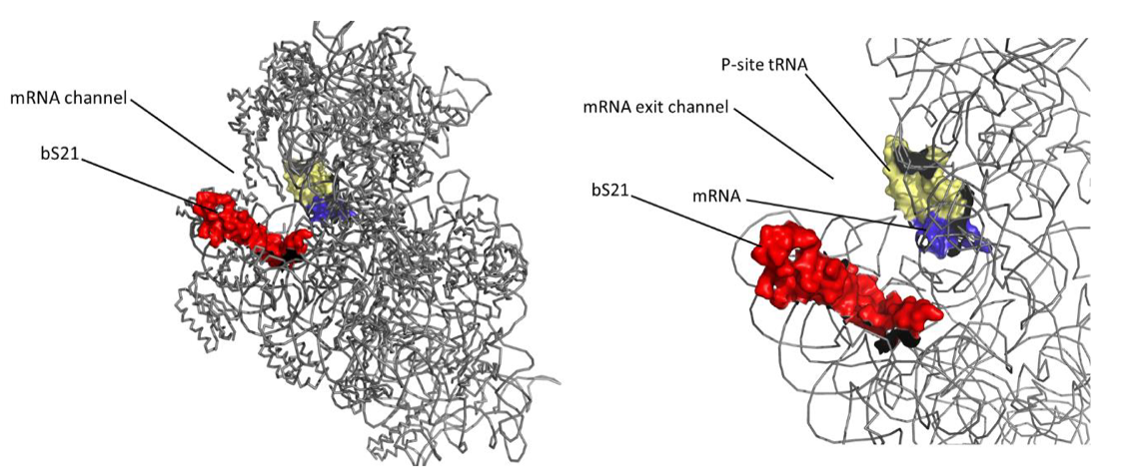
Figure 1 Left: 30S subunit of E. coli highlighting bS21 in red. Right: close-up of bS21 focuses on its proximity to the mRNA exit channel

Francisella tularensis encodes three distinct homologs of bS21 (Trautmann & Ramsey, 2022). As one of last proteins to be incorporated into the ribosome (Mizushima & Nomura, 1970), bS21 is loosely associated and as such, there is the potential that different homologs of the protein can be swapped out (Robertson et al., n.d.). Wild-type cells of F. tularensis can incorporate all three homologs of bS21 into the ribosomes (Trautmann & Ramsey, 2022). The loss of a particular homolog, bS21-2, leads to a difference in protein abundance of T6SS compared to wild-type, a decrease in intramacrophage survival, and to a growth defect in vitro (Trautmann & Ramsey, 2022). Complementing strains of F. tularensis that lack bS21-2 with bS21-2 or bS21-3 restore protein abundance of T6SS, but bS21-1 does not (Trautmann & Ramsey, 2022). bS21-1 restores wild-type level growth in ∆rpsU2 strains (the gene that encodes bS21-2), but bS21-3 does not (Trautmann & Ramsey, 2022). Finally, neither bS21-1 nor bS21-3 restore intramacrophage survival in cells lacking bS21-2 (Trautmann & Ramsey, 2022). These data suggest that each homolog is preferentially involved with the initiation of translation of different transcripts.
Broadly, it is unclear how changes in the composition of ribosomes affects protein synthesis. While we see that a deletion of bS21-2 leads to a change in phenotype in F. tularensis, it has not been determined if all three homologs preferentially translate a different subset of mRNAs.

Specific Aim #1:
Is there specificity of translation among the three homologs of the ribosomal protein bS21 in F. tularensis?
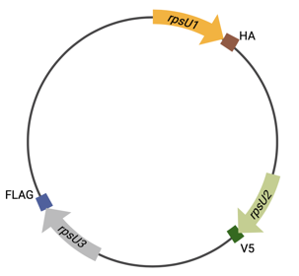
Overall strategy: Ribosome profiling is a technique that sequences mRNA footprints that are protected by actively translating ribosomes. The measured density of ribosomes halted on a given transcript is representative of protein synthesis, allowing for a global snapshot of what is being translated across the genome (Brar & Weissman, 2015; Johnson & Li, 2018; Mohammad & Buskirk, 2019). A parallel analysis of RNA Seq data will also allow us to delve into any discrepancy (not the right thing I’m trying to say here) between transcript abundance and protein abundance In order to assess which homolog is translating which mRNAs, we will first immunoprecipitate each homolog with a different epitope attached to the C-terminus of bS21 under the control of its native promoter to maintain stoichiometric amounts of each class of ribosome. We will degrade RNAs unprotected by the ribosome and assess the purity and integrity of 70S ribosomes with sucrose gradients. We will extract the mRNA footprints and convert them to cDNA to establish the sequencing library. While we prepare the ribosome profiling library, we will also build an RNA-Seq library to assess transcript abundance. Both sets of samples will be sequenced by Illumina NovaSeq 6000, and we will analyze the data with Cutadapt for removal of DNA adapters and Bowtie2 for alignment to the F. tularensis genome. We will analyze the ribosome footprints with RiboProfiling, and for the RNA-Seq data we will count reads with HTSeq-Count and analyze them with DESeq2.
Figure 2 Proposed model of F. tularensis chromosome with each copy of rpsU tagged with an epitope at the 3' end
Rational. Using ribosome profiling to ascertain whether each bS21 homolog preferentially translates a specific subclass of mRNAs will provide insight into the mechanism of bS21’s role in translation initiation. We hypothesize the different populations of ribosomes in F. tularensis will preferentially translate mRNAs.
Figure 3 Workflow of ribosome profiling from library preparation to analysis

A putative connection between bS21 and cell wall synthesis:
In Staphylococcus. aureus, resistance to antibiotics is an increasing threat to public health (Sader et al., 2009). Methicillin-resistant S. aureus (MRSA) is a multi-drug resistant strain whose drug susceptibility profile is constantly evolving. MRSA has given way to VSSA and VRSA (vancomycin-intermediate and vancomycin-resistant S. aureus, respectively)(Cui et al., 2006; Hanaki et al., 1998). Independent studies looking into this shift in resistance have revealed mutations in rpsU (Basco et al., 2019; Friedman et al., 2006) . Additionally, a transposon insertion was found upstream of rpsU that led to reduced susceptibility to daptomycin (Blake & O’Neill, 2013) .
Vancomycin and daptomycin are two antibiotics that are considered “last resort” therapies against an increasing threat of resistant S. aureus (Cui et al., 2006; Miller et al., 2016). Vancomycin is a glycopeptide that disrupts the peptidoglycan layer of Gram-positive bacteria by blocking substrates for its synthesis (Cui et al., 2006; Howden et al., 2010). Specifically, it targets the D-alanyl-D-alanine residue (DDR) of lipid II precursor. Daptomycin is a lipopeptide that is often used when vancomycin fails. Its mechanism of action is still unclear, but it also disrupts cell wall synthesis (Miller et al., 2016; Müller et al., 2016). Independent studies examining the increase in resistance against vancomycin and daptomycin by S. aureus have uncovered loss-of-function mutations in rpsU (Basco et al., 2019; Friedman et al., 2006). That these two cell-wall-targeting rather than ribosome-targeting antibiotics show an effect on a ribosomal protein is surprising. It suggests that bS21 may be involved in the regulation of cell wall synthesis. In order to slow down the loss of efficacy of these antibiotics, it is critical to understand the mechanism of resistance against these therapies.

Specific Aim #2:
Does the deletion of rpsU in S. aureus account for an increase in cell wall thickness that could lead to antibiotic resistance?
Overall strategy: We will begin this investigation by making a clean deletion of rpsU from S. aureus. We will assess the antibiotic susceptibility profile of this mutant using disk diffusion assays against vancomycin and daptomycin. We will investigate whether a lack of bS21 results in a thicker cell envelope using transmission electron microscopy (TEM).
Rationale: Vancomycin and daptomycin are antibiotics that attack the bacterial cell envelope. Strains of S. aureus that show resistance to vancomycin and daptomycin have thicker cell walls. Mutations in rpsU have been observed in these resistant strains (Howden et al., 2010). We hypothesize that a loss of bS21 may result in a thicker cell envelope.

Methods:
Bacterial strains and growth conditions:
Francisella tularensis subspecies holarctica Live Vaccine Strain (LVS) and derivatives will be grown in Mueller-Hinton broth supplemented with 10% glucose, 2.5% iron pyrophosphate, and 2% IsoVitalex, shaking aerobically at 37ºC. On solid medium strains will be grown on cysteine-heart agar supplemented with hemoglobin and incubated at 37ºC. E coli strain XL1 Blue will be grown in lysogeny broth or agar aerobically at 37ºC. Staphylococcus aureus strains will be grown in tryptic soy broth or agar aerobically at 37ºC.

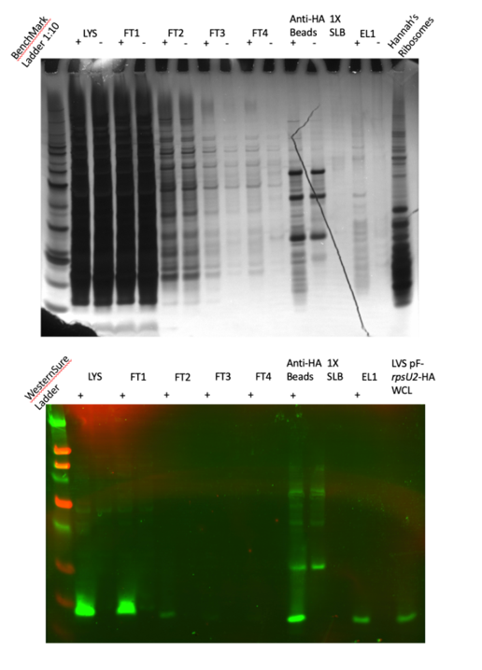
Ribosome Profiling:
Before ribosome profiling can begin, isolation of the ribosome with epitope tags attached to bS21 homologs must be optimized. To that end, I have constructed four plasmids that harbor rpsU2 under the control of its native promoter with a different small epitope tag attached to the 3’ end of the gene. I have confirmed the presence of each epitope tag at the site of bS21 through Western Blot. I have begun testing the efficiency of pulldown of each epitope via immunoprecipitation. Once each epitope has been evaluated, I will choose which homolog should get which tag and incorporate them onto the chromosome.

Figure 4 Immunoprecipitation of bS21-2 with HA epitope tag. Top: Silver Stain shows several bands in the Eluate lane (EL1) suggesting a ribosome is pulled down. Bottom: Western Blot shows bS21-2 is pulled down.

The following methods for ribosome profiling are based on protocols by Mohammad and Buskirk and Johnson and Li:

Plasmid construction:
Plasmids for LVS complemented with each epitope tag are derived from pKR7 (pF-rpsU2-V). The epitope tag VSV-G that was situated on the 3’ end of rpsU2 was deleted and replaced by each epitope at the EcoRI site on the 5’ end and the BamHI site on the 3’ end.
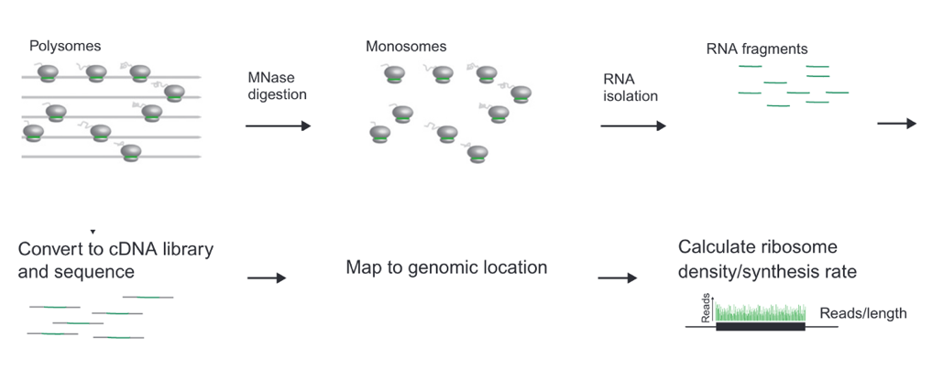
Epitope Tag | Size | Plasmid
HA | 1.1 kDa | pKR192
6X His | 0.8 kDa | pKR193
FLAG | 1 kDa | pKR194
V5 | 1.4 kDa | pKR195
Table 1 Selected epitope tags to be tested for pulldown efficiency of immunoprecipitation

Lysates:
Strains of LVS pF-rpsU2-epitope tags were pelleted by spinning overnight cultures at 4ºC. Lysates were prepared by resuspending the pellets in Buffer A + PI +BB with DNase, filtering the lysates, and then adding 100mM NH4Cl, and 0.1% NP-40.

Sucrose Cushion:
We will pre-clear the lysate by spinning at 9000 x g for 10 minutes at 4ºC. We will later 22ml of lysate on top of pre-chilled pelleting buffer twice. We will spin samples at 60,000 rpm for 1.5 hours at 4ºC using a Ti 70 rotor. We will remove the supernatant and wash the pellet in 150ul of pre-chilled resuspension buffer. We will add 100ul of resuspension buffer to the resuspended pellet and gently vortex for 5 minutes until it is fully dissolved. We will measure the A₂₆₀ of a 1:100 dilution and calculate the volume needed for 12.5 AU.

Nuclease Digestion:
To the 200ul sample of 12.5 AU we will add 6 ul of SUPERase-in, 2 ul of 375 U/ul MNase. And incubate for 1 hour shaking (1400 rpm on thermomixer) at 25ºC. The reaction will be quenched with 2ul of 0.5M EDTA pH 8.

Immunoprecipitation:
For each bS21 homolog with their respective epitope tags, the samples will be immunoprecipitated with magnetic beads. Beads are resuspended in storage solution and then washed two to three times in Buffer B. Sample are added to the beads and incubated rocking at 4ºC for one hour. After incubation, beads are washed two to three times with Buffer B. Flow-throughs are collected after each wash step. The beads are incubated in Elution Buffer rocking at 4ºC for 5 minutes or at 37ºC for 10 minutes. Eluates are collected. Samples are analyzed via Coomassie Stain, Silver Stain and Western Blot.

Sucrose Gradients:
For the ribosomes with no bS21 homologs, we will purify 70S ribosomes by diluting immunoprecipitation samples to 0.6 ug/ul. We will fill SW41 tubes with about 8 ml of 10% (light) sucrose solution over 50% (heavy) sucrose solution. We will layer 200ul of sample on top of the sucrose solutions and centrifuge at 40,000 rpm for 4 hours at 4ºC, using 5 for acceleration and deceleration. We will collect fractions at 350ul.

RNA Extraction (phenol-chloroform):
We will pre-warm 750ul of phenol to 65ºC. We will add 57.1 ul of 20% SDS to 1 ml of sample and add it to the warm phenol. We will incubate the sample at 1400 rpm in the thermomixer at 65ºC for 5 minutes shaking. We will then chill the samples on ice for 5 minutes before spinning the samples for 2 minutes. We will add the bottom aqueous layer and add it to 700 ul of RT phenol. We will vortex the sample for 5 minutes, then spin it for 2 minutes. We will take the bottom aqueous layer and add it to 600 ul chloroform. We will vortex the sample for 30 seconds then spin it for 2 minutes. We will take the top aqueous layer and and dilute 1:1 volume with MilliQ water. We will add 3 M sodium acetate and equal volume of isopropanol. We will precipitate the RNA overnight in -20ºC. We will spin the sample at 12000 x g for 30 minutes at 4ºC. After removing as much liquid as possible, we will let air dry in the hood. We will resuspend the samples in 40ul of MilliQ water and measure the A₂₆₀.

Size Selection:
We will prepare 20 ug of sample to run on a gel. We will heat the samples and the ladder at 80ºC for 2 minutes, then put them on ice. We will prepare 15% TBE Urea 1.0 mm (12 + 2) 45 ul gel. We will run samples at 15W for 17 minutes, then remove gels from plates and place in SYBR-gold stain for 5 minutes. We will remove the gel from the stain and place on transparency film, and cover with saran wrap. We will image the gel using fluorescence setting for SYBR-gold. We will cut out 15nt and 45nt markers to be used as controls. We will elute the sample by crushing the gel cutout into PCR tubes with holes at the bottom set into a microfuge tube for collection. We will spin the gels for 5 minutes (what speed?) until the entire gel exudes out the bottom.

Gel Extraction/Dephosphorylation:
To the eluates from the size selection gel we will add 500 ul of RNA Elution Buffer and 2.5 ul of SUPERase-Inhibitor. We will shake the samples overnight in a Thermomixer at 1400 rpm at 4ºC. We will briefly spin the samples and transfer the gel slurry to Spin-X columns and spin at 20,000 x g for 3 minutes at room temperature. We will put each eluate into a new 1.5 ml tube and add 2 ul of GlycoBlue and 650 ul of isopropanol. We will precipitate the samples on dry ice for 40 minutes, then spin them at 10,000 x g for 30 minutes at 4ºC. We will remove the supernatant and wash with about 100 ul of 80% cold ethanol. We will dry the pellets in a speed vac for 10 minutes, then resuspend the pellet in 5 ul of MilliQ water. To dephosphorylate the samples, we will heat the samples at 80ºC for 2 minutes and then put them in ice. We will add 4 ul of Reaction Mix, and 1 ul of PNK, then incubate at 37ºC for one hour.

Linker Ligation:
We will add 9 ul of Ligation Reaction Mix and 1 ul of T4 RNA ligase 2 truncated to the samples and incubate at 37ºC for 3 hours. We will clean up the samples with oligo and concentration kit and elute the samples in 15 ul MilliQ water.

rRNA Depletion:
We will use the Illumina Ribo-Zero kit or an equivalent. We will purify the samples with oligo and concentration kit and elute in 15 ul of MilliQ water.

Reverse Transcription:
We will add 1.25 ul of 10 uM RT primer NI-NI-9 and heat the sample to 80ºC for 2 minutes, then place on ice. We will add 7 ul of RT Reaction Mix and 1 ul of Superscript III RT to each sample and incubate at 48ºC for 30 minutes. We will add 2.2 ul of 1M NaOH to each sample and heat at 98ºC for 20 minutes. We will purify the samples with oligo and concentration kit (?) and elute in 10 ul of MilliQ water.

RT Gel:
We will prepare the cDNA samples by adding 10ul of 2X RNA Loading Dye to 10ul of sample. We will heat the samples at 80ºC for 2 minutes and then put them on ice. We will prepare a 10% TBE Urea 1.0 mm (18 + 2) 30 ul gel. We will run the gel at 15 W for about 40 minutes (until the xylene cyanol runs off the gel). We will remove the gels from plates and place in 100 ml of SYBR-gold stain for 5 minutes. We will remove the gels from the stain, then image the gel. We will cut the gel from the 45 nt control to the 15 nt control. We will elute the gel by crushing it through the bottom of a PCR tube with holes poked through the bottom by an 18 G needle. We will place the PCR tubes in 1.5 ml micro centrifuge tubes to collect the eluate. We will spin the samples for 4 minutes (max speed?).

RT Gel Extraction:
We will add 500 ul DNA Elution Buffer to each sample. We will shake the samples overnight in a thermomixer at 1,050 rpm at 25ºC. After shaking, we will briefly spin the samples (speed?) and transfer gel slurry to into Spin-X columns. We will spin the samples for 3 minutes and put eluate in new microfuge tube. We will add 2 ul of GlycoBlue and 650 ul of isopropanol and precipitate the samples for about 40 minutes on dry ice, then spin the samples for 30 minutes at 10,000 x g at 4ºC. We will remove the supernatant and gently wash the pellets with 100 ul of cold 80% ethanol. We will dry the pellets in a speed vac for 10 minutes. We will resuspend the pellets in 15 ul of 10 mM Tris pH 8.

Circularization of DNA:
We will add 4 ul of Circularization Reaction Mix and 1 ul of Circ ligase to each sample and incubate at 60ºC for one hour, then incubate at 80ºC for ten minutes, then put the samples on ice.

Pilot PCR and Gel:
We will perform a series of PCR amplifications to determine the number of PCR cycles that are necessary for proper amplification while minimizing bias/over-amplification. We will set up a reaction mix with the sample and divide the mix into 3 aliquots. We will run the PCR protocol for 9 cycles repeating Steps 2-5 eight times. Aliquots will he collected at Step 5 after 5, 7, and 9 cycles and be placed immediately on ice. We will add 2 ul of 6X DNA Loading Dye to 9 ul of PCR samples. We will prepare a 10% TBE Native 1.0 mm (12 + 2) 45 ul gel. We will run the gels for 40 minutes at 15 W until xylene cyanol runs off the gel. We will remove the gels from the plates and place in SYBR-gold stain for 5 minutes, then image the gel. The appropriate number of cycles for preparative PCR will be the one that has a good band at about 150-190 bp with no higher molecular weight products.

Preparative PCR, Gel, and Extraction:
We will prepare the reaction mix and run the PCR at the proper cycle (minus one from pilot PCR). We will prepare the PCR samples by adding 6 ul of 6X DNA Loading Dye to 30 ul of sample. We will prepare a 10% TBE Native 1.0 mm (12 + 2) 45 ul gel. We will run the gels for 40 minutes at 15 W until xylene cyanol runs off the gel. We will remove the gels from the plates and place in SYBR-gold stain for 5 minutes, then image the gel. We will elute the gel by crushing it through the bottom of a PCR tube with holes poked through the bottom by an 18 G needle. We will place the PCR tubes in 1.5 ml micro centrifuge tubes to collect the eluate. We will spin the samples for 5 minutes. We will add 500 ul of DNA Elution Buffer to each sample and shake overnight in a thermomixer at 1050 rpm at 25ºC. After shaking, we will briefly spin the samples and transfer gel slurry to into Spin-X columns. We will spin the samples for 3 minutes at 20,000 x g at room temperature and put eluate in new microfuge tube. We will add 2 ul of GlycoBlue and 650 ul of isopropanol and precipitate the samples for about 40 minutes on dry ice, then spin the samples for 30 minutes at 10,000 x g at 4ºC. We will remove the supernatant and gently wash the pellets with 100 ul of cold 80% ethanol. We will dry the pellets in a speed vac for 10 minutes. We will resuspend the pellets in 10 ul of 10 mM Tris pH 8. We will check the size and concentration of the samples in a BioAnalyzer.

Sequencing and Data analysis:
We will dilute each sample to 2 nM and submit 10 ul of 2 nM multiplexed samples for 50 cycle, single-end sequencing on Illumina HiSeq2500. We will analyze the sequencing data using tools from https://github.com/greenlabjhmi/2018_Bacterial_Pipeline_riboseq. We will remove the linker sequences from the 3’ end of reads using Skewer version 0.2.2. We will use Bowtie version 0.12.7 for alignment, then map the reads to Francisella tularensis susbsp holarctica genome (GCA_000009245). We will write out ribosome density as a WIG file, a binary file, and a size separated dictionary using the 3’end of reads to assign ribosome position. We will draw plots of average ribosome density at start and stop codons, calculation of pause scores at specific codons, and asymmetry scores using scripts from the Jupyter notebook Github-Ribo-Analysis.ipynb.

Deletion of rpsU in S. aureus

The following methods for gene deletion in S. aureus are based on the protocol by Kato and Sugai.

We will construct a plasmid fusing about 600 bp upstream of rpsU to 600 bp downstream (this is what Hannah did but I’ll probably redesign the plasmid). We will PCR amplify the DNA fragments and digest them with SalI and BamHI and ligate onto the backbone pKFT which has the same restriction sites. pKFT is a vector that has a multicloning site, ampR, tetL, an origin of replication for E. coli, and a temperature-sensitive origin of replication for S. aureus. We will transform the construct into E coli XL1-Blu cells by heat shock at 42ºC and allow them to recover for an hour at 37ºC. We will plate the recovered cultures on LB agar with 100 ug/ml ampicillin and incubate overnight at 37ºC. We will use the Qiagen Miniprep kit to purify the plasmid and send them to sequencing at INBRE for verification. Confirmed plasmids will first be transformed into RN4220, strain of S aureus that has been engineered to readily accept foreign DNA, before being transformed into HG003, the terminal strain of S aureus. We will transform the plasmids into RN4220 by electroporation and allow it to recover in LB or TSB for about one and a half hours at 30ºC, then the cultures will be plated on TSA with 3 ug/ml tetracycline. We will pick colonies and inoculate cultures in 5 ml of TSB with 1.5 ul of tetracycline, then we will use the Qiagen Miniprep kit to purify the plasmids after treating them with lysostaphin to ease lysis. We will transform the plasmid into HG003 via electroporation and incubate at 30ºC, the temperature that allows for plasmid replication. We will pick colonies and grow them in LB or TSB at 30ºC, then plate them on TSB with and without tetracycline and grow them at 42ºC, the temperature that encourages integration of the plasmid into genomic DNA. We will pick colonies from the plates with antibiotic and run colony PCR using primers that are located outside rpsU. Once confirmed that the plasmid has integrated in the correct location, we will grow the primary integrants in TSB without antibiotics overnight at 25ºC, then subculture into fresh TSB without antibiotics and grow at 25ºC again. Passaging of the culture at this temperature eradicates any residual replicating plasmid. We will plate cultures on TSA with and without tetracycline and screen for colonies that grow only on the plates with no antibiotic. We will confirm deletion of rpsU by colony PCR and sequencing.

Determining MIC of vancomycin and daptomycin against S. aureus:
We will grow the wild type strain and the ∆rpsU strain shaking overnight in TSB at 37ºC. We will normalize the cultures to A₅₇₈=0.3 so that all plates start with approximately 10⁸ CFUs (colony forming units). We will perform a series of ten-fold dilutions for a total of 6 dilutions such that the range of concentrations is 10⁸ CFUs to 10² CFUs. We will prepare BHI (Brain Heart Infusion) plates with 1:2 serial dilutions of each antibiotic for a total of 8 dilutions per antibiotic. For vancomycin, we will begin with 10 ug/ml down to 0.078 ug/ml, and for daptomycin, we will begin with 5 ug/ml to 0.029 ug/ml. These concentrations are based on published MICs (minimum inhibitory concentration) of these antibiotics against clinical isolates of MRSA. We will spread each dilution of bacterial cells onto plates of each antibiotic concentration in triplicate, allow them to dry, and incubate them at 37ºC for 48 hours. We will determine the MIC to be the lowest concentration of antibiotic that produces no colonies. We expect that the ∆rpsU strain will have higher MICs compared to wild-type.

TEM preparation to measure cell wall thickness:
We will grow wild-type and ∆rpsU strains to logarithmic phase in BHI broth shaking at 37ºC. We will fix the cells in 2% glutaraldehyde in 0.1 M sodium phosphate buffer pH 7.4, incubating for 2 hours. We will stain the cells with 1% osmium tetroxide for 2 hours at 4ºC, then dehydrate in ethanol and embed in resin, preparing thin sections. We will stain the sections with uranyl acetate and lead citrate before analyzing under a transmission electron microscope. We will set the magnification to X30,000.

References
Basco, M. D. S., Kothari, A., McKinzie, P. B., Revollo, J. R., Agnihothram, S., Azevedo, M. P., Saccente, M., & Hart, M. E. (2019). Reduced vancomycin susceptibility and increased macrophage survival in Staphylococcus aureus strains sequentially isolated from a bacteraemic patient during a short course of antibiotic therapy. Journal of Medical Microbiology, 68(6), 848–859. https://doi.org/10.1099/jmm.0.000988
Berk, V., Zhang, W., Pai, R. D., & Cate, J. H. D. (2006). Structural basis for mRNA and tRNA positioning on the ribosome. Proceedings of the National Academy of Sciences of the United States of America, 103(43), 15830–15834. https://doi.org/10.1073/pnas.0607541103
Blake, K. L., & O’Neill, A. J. (2013). Transposon library screening for identification of genetic loci participating in intrinsic susceptibility and acquired resistance to antistaphylococcal agents. Journal of Antimicrobial Chemotherapy, 68(1), 12–16. https://doi.org/10.1093/jac/dks373
Brar, G. A., & Weissman, J. S. (2015). Ribosome profiling reveals the what, when, where, and how of protein synthesis. Nature Reviews. Molecular Cell Biology, 16(11), 651–664. https://doi.org/10.1038/nrm4069
Byrgazov, K., Vesper, O., & Moll, I. (2013). Ribosome heterogeneity: Another level of complexity in bacterial translation regulation. Current Opinion in Microbiology, 16(2), 133–139. https://doi.org/10.1016/j.mib.2013.01.009
Cui, L., Iwamoto, A., Lian, J.-Q., Neoh, H., Maruyama, T., Horikawa, Y., & Hiramatsu, K. (2006). Novel Mechanism of Antibiotic Resistance Originating in Vancomycin-Intermediate Staphylococcus aureus. Antimicrobial Agents and Chemotherapy, 50(2), 428–438. https://doi.org/10.1128/AAC.50.2.428-438.2006
Dow, A., & Prisic, S. (2018). Alternative ribosomal proteins are required for growth and morphogenesis of Mycobacterium smegmatis under zinc limiting conditions. PLOS ONE, 13(4), e0196300. https://doi.org/10.1371/journal.pone.0196300
Duval, M., Simonetti, A., Caldelari, I., & Marzi, S. (2015). Multiple ways to regulate translation initiation in bacteria: Mechanisms, regulatory circuits, dynamics. Biochimie, 114, 18–29. https://doi.org/10.1016/j.biochi.2015.03.007
Friedman, L., Alder, J. D., & Silverman, J. A. (2006). Genetic Changes That Correlate with Reduced Susceptibility to Daptomycin in Staphylococcus aureus. Antimicrobial Agents and Chemotherapy, 50(6), 2137–2145. https://doi.org/10.1128/aac.00039-06
Gabriel, S. E., & Helmann, J. D. (2009). Contributions of Zur-Controlled Ribosomal Proteins to Growth under Zinc Starvation Conditions. Journal of Bacteriology, 191(19), 6116–6122. https://doi.org/10.1128/JB.00802-09
Hanaki, H., Kuwahara-Arai, K., Boyle-Vavra, S., Daum, R. S., Labischinski, H., & Hiramatsu, K. (1998). Activated cell-wall synthesis is associated with vancomycin resistance in methicillin-resistant Staphylococcus aureus clinical strains Mu3 and Mu50. Journal of Antimicrobial Chemotherapy, 42(2), 199–209. https://doi.org/10.1093/jac/42.2.199
Howden, B. P., Davies, J. K., Johnson, P. D. R., Stinear, T. P., & Grayson, M. L. (2010). Reduced Vancomycin Susceptibility in Staphylococcus aureus, Including Vancomycin-Intermediate and Heterogeneous Vancomycin-Intermediate Strains: Resistance Mechanisms, Laboratory Detection, and Clinical Implications. Clinical Microbiology Reviews, 23(1), 99–139. https://doi.org/10.1128/CMR.00042-09
Johnson, G. E., & Li, G.-W. (2018). Chapter Ten—Genome-Wide Quantitation of Protein Synthesis Rates in Bacteria. In A. J. Carpousis (Ed.), Methods in Enzymology (Vol. 612, pp. 225–249). Academic Press. https://doi.org/10.1016/bs.mie.2018.08.031
McNutt, Z. A., Roy, B., Gemler, B. T., Shatoff, E. A., Moon, K.-M., Foster, L. J., Bundschuh, R., & Fredrick, K. (2023). Ribosomes lacking bS21 gain function to regulate protein synthesis in Flavobacterium johnsoniae. Nucleic Acids Research, 51(4), 1927–1942. https://doi.org/10.1093/nar/gkad047
Metselaar, K. I., den Besten, H. M. W., Boekhorst, J., van Hijum, S. A. F. T., Zwietering, M. H., & Abee, T. (2015). Diversity of acid stress resistant variants of Listeria monocytogenes and the potential role of ribosomal protein S21 encoded by rpsU. Frontiers in Microbiology, 6, 422. https://doi.org/10.3389/fmicb.2015.00422
Miller, W. R., Bayer, A. S., & Arias, C. A. (2016). Mechanism of Action and Resistance to Daptomycin in Staphylococcus aureus and Enterococci. Cold Spring Harbor Perspectives in Medicine, 6(11), a026997. https://doi.org/10.1101/cshperspect.a026997
Mizushima, S., & Nomura, M. (1970). Assembly Mapping of 30S Ribosomal Proteins from E. coli. Nature, 226(5252), Article 5252. https://doi.org/10.1038/2261214a0
Mohammad, F., & Buskirk, A. R. (2019). Protocol for Ribosome Profiling in Bacteria. Bio-Protocol, 9(24), e3468. https://doi.org/10.21769/BioProtoc.3468
Müller, A., Wenzel, M., Strahl, H., Grein, F., Saaki, T. N. V., Kohl, B., Siersma, T., Bandow, J. E., Sahl, H.-G., Schneider, T., & Hamoen, L. W. (2016). Daptomycin inhibits cell envelope synthesis by interfering with fluid membrane microdomains. Proceedings of the National Academy of Sciences of the United States of America, 113(45), E7077. https://doi.org/10.1073/pnas.1611173113
Robertson, W. R., Dowsett, S. J., & Hardy, S. J. S. (n.d.). Exchange of Ribosomal Proteins among the Ribosomes of Escherichia coil.
Sader, H. S., Fey, P. D., Fish, D. N., Limaye, A. P., Pankey, G., Rahal, J., Rybak, M. J., Snydman, D. R., Steed, L. L., Waites, K., & Jones, R. N. (2009). Evaluation of Vancomycin and Daptomycin Potency Trends (MIC Creep) against Methicillin-Resistant Staphylococcus aureus Isolates Collected in Nine U.S. Medical Centers from 2002 to 2006. Antimicrobial Agents and Chemotherapy, 53(10), 4127. https://doi.org/10.1128/AAC.00616-09
Sauert, M., Temmel, H., & Moll, I. (2015). Heterogeneity of the translational machinery: Variations on a common theme. Biochimie, 114, 39–47. https://doi.org/10.1016/j.biochi.2014.12.011
Takada, H., Morita, M., Shiwa, Y., Sugimoto, R., Suzuki, S., Kawamura, F., & Yoshikawa, H. (2014). Cell motility and biofilm formation in Bacillus subtilis are affected by the ribosomal proteins, S11 and S21. Bioscience, Biotechnology, and Biochemistry, 78(5), 898–907. https://doi.org/10.1080/09168451.2014.915729
Trautmann, H. S., & Ramsey, K. M. (2022). A Ribosomal Protein Homolog Governs Gene Expression and Virulence in a Bacterial Pathogen. Journal of Bacteriology, 204(10), e00268-22. https://doi.org/10.1128/jb.00268-22
Van Duin, J., & Wijnands, R. (1981). The Function of Ribosomal Protein S21 in Protein Synthesis. European Journal of Biochemistry, 118(3), 615–619. https://doi.org/10.1111/j.1432-1033.1981.tb05563.x

