Table of Contents
July 2024 2
Sucrose counterselection: 6
DNA digest 8
Concentrating Samples with 100 K MWCO 13
S. aureus Growth Curve: 15
Figure 1: Sucrose Gradient of HA-IP 6/17/24 16
Immunoprecipitation with HA antibody 7/18/24 17
Figure 2: Sliver Stain of HA-IP 7/17/24 20
LVS Growth Curve: 21
Figure 3: Doubling time of KRSA2 wild-type vs KRSA12 ∆rpsU mutant 24
Figure 4: Sucrose gradient of LVS rpsU2-HA 25
August 2024 25
Population Analysis Assay (microplate method) 27
Bibliography 28

July 2024

Monday, July 1, 2024
To Do:

- Supplement MHB
- Freeze mutants
- Read MIC plates
- Patch LVS
I patched out LVS so that I can make the rpsU3-HA mutant.
Protocol:
Day 1:
-Patch entire plate with recipient LVS strain on CHAH

Tuesday, July 2, 2024
To Do:

- Patch LVS
- Transform LVS
- Investigate primer contamination
- Set up sequencing
I’m transforming LVS with pKR219 (rpsU3-HA).
Day 2:
Prepare electrocompetent (EC) cells
-Scrape up entire plate of cells into 400 uL of sterile 10% sucrose and resuspend (alternately, cells can be grown to mid-log in MHB)
-Add 1.1 mL of 10% sucrose to a final volume of 1.5 mL
-Spin for 3 minutes at 10,000 rpm
-remove supernatant, throw out, and resuspend in fresh 1 mL 10% sucrose
-Repeat 3x-5x in 10% sucrose
-After final spin, remove all supernatant.
-Resuspend cells in 10% sucrose at high density (corresponding to ~1x10¹¹ cells /mL); these are EC cells by slowly adding 110 uL at a time. It should be about equal amounts of cells as sucrose.
-For any extra EC cells, aliquot ~110 μL / sterile tube (enough for 2 electroporations) and freeze at -80°C

Electroporate plasmid into EC cells*
-For each electroporation, aliquot 4 mL MHB into glass test tubes for recovery, warm in shaker at 37°C
-For each electroporation, in a 2 mm sterile electroporation cuvette, combine:
5 μL of pEX-based allelic exchange construct (mini-prep concentration, at least 100 ng/μL)
50 μL electrocompetent cells
-Have recovery media ready
-Electroporate using the following settings: 2.5 kV, 25 μF, and 600 Ω
-Immediately after individual electroporations, use 1 mL warm recovery media from test tube to wash cells out of cuvette and transfer cells to recovery test tube
-Recover cells for 4-8 hours, shaking at 37°C
-Pellet cells by centrifugation in sterile 2 mL tubes, 1’ at 10,000 x g. Decant supernatant leaving about 200ul and resuspend cells.
-Plate on CHAH-Kan plates, using 1 plate for each 2 mL tube (2 plates per electroporation).
-Incubate plates at 37°C for 3 days (or until single colonies appear)

*Always including a control electroporation with no plasmid. Eventually single break-through colonies may start appearing; at that point, single colonies on the experimental plates are also likely to just be break-through growth.
I probably should have set this up in multiples but let’s hope for the best.
PCR:
Total reaction volume | 20
Total number of reactions | 2
 |  |  |  | Factor
Component | Stock concentration | Final concentration | 1 rxn volume | 3
ddiH2O |  |  | 12.4 | 37.2
PrimeSTAR GXL Buffer | 5x | 1x | 4.0 | 12
dNTPs | 2.5 mM | 0.2 mM | 1.6 | 4.8
oligo F | 10 uM | 0.3 uM | 0.6 | 1.8
oligo R | 10 uM | 0.3 uM | 0.6 | 1.8
template | 100 ng/ul | 2 ng/ul | 0.4 | 1.2
PrimeSTAR GXL DNA Polymerase | 1.25 U/ul | 0.025 U/ul | 0.4 | 1.2
 |  | Total volume | 20 | 60

I resuspended the 100mM stocks of KROL709 and KROL710 in new 0.1X EB from me and Alex to see where the contamination is coming from.

Waste of time. I left the gel running too long and the fragments ran off. I’ll do it again tomorrow.
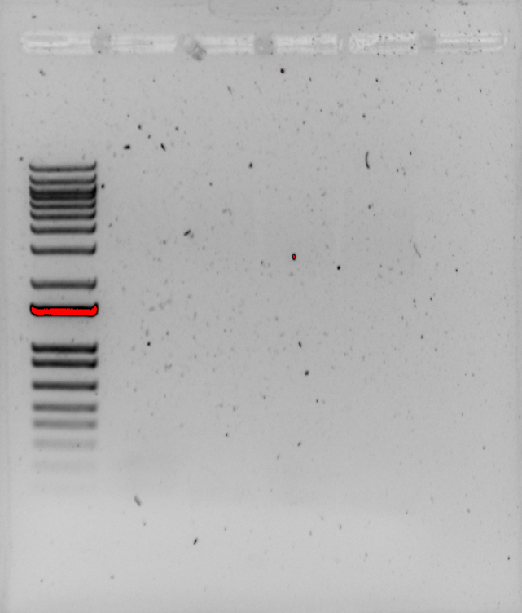

I made permanent stocks of pKR220 and pKR219 now that they have both been confirmed by sequencing. I prepared sequencing reactions for pKR220 again because now I’m questioning which minipreps I consolidated into the stock. I set up 2 reactions: one with KROL6 and the other with KROL7. They won’t be sequenced until next week because of the holiday, but at least they’re ready.

Wednesday, July 3, 2024
To Do:

- Transform LVS
- Investigate primer contamination
- Set up sequencing
- Repeat PCR
We were running low on KROL6 and KROL7 working stocks, so I made new 2.5mM stocks by adding 5ul of 100mM stocks to 195ul of 0.1X EB.
PCR 2.0:

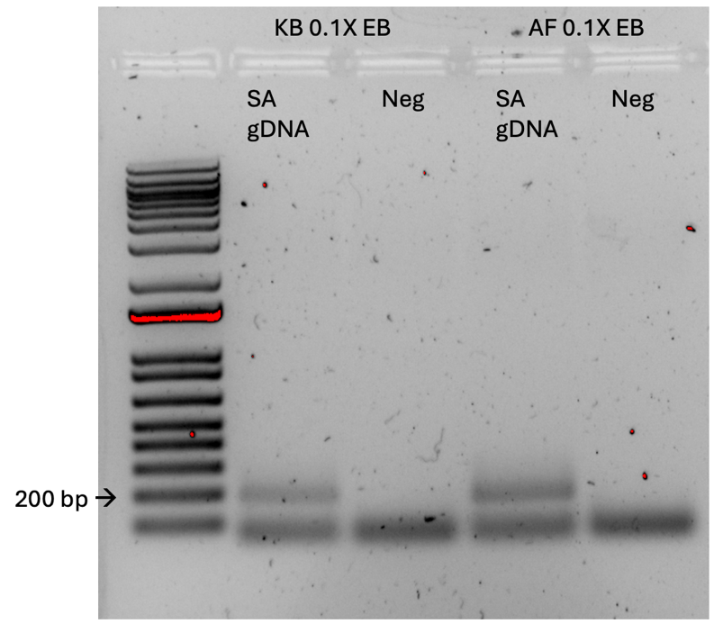
PCR of primers for amplification of rpsU in S. aureus. Lanes 2 and 3 are the primers reconstituted in my 0.1X EB. Lanes 4 and 5 are the primers reconstituted in Alex’s 0.1X EB.

Friday, July 5, 2024
To Do:

- Repeat PCR
- Patch presumptive primary integrants

There were colonies on both the negative control plates and the transformation plates. I picked 6 colonies to patch out and left them on the bench to grow over the weekend.

Monday, July 8, 2024
To Do:

- Patch presumptive primary integrants
- Make CHA-sucrose
I should have made CHA-sucrose plates last week, but I can make them today. The first 3 patches grew, but they I can let them grow more before I put them on sucrose. Patches 4-6 didn’t grow.

I made a batch of CHA-sucrose plates.

Tuesday, July 9, 2024
To Do:

- Make CHA-sucrose
- Sucrose counterselection

Sucrose counterselection:
To select for cross-outs using sucrose selection
-Scrape up small loop of cells and resuspend in sterile 1X PBS (1 ml)
-Dilute culture 1:10 in sterile PBS to 1x10⁻⁷
Perform first dilution 1:100 so first dilution tube is 1x10⁻², adding 10 uL of resuspended cells to 990 ul 1x PBS
Perform subsequent dilutions 1:10, diluting 50 uL cells into 450 uL 1X PBS
-Spread-plate 100 uL of last dilution (1x10⁻⁷) onto CHAH plates.
-Spread-plate 100 μL of each dilution 10⁻² – 10⁻⁷ on CHAH + 10% sucrose plates. If you have extra sucrose plates, can plate some or all dilutions twice.
-Incubate plates at 37°C for 3-4 days, or until single colonies appear. It is generally a good idea to test both large and smaller single colonies. Note that there should be many more colonies on the CHAH plate with the 1x10⁻⁷ dilution than on the sucrose plate with the corresponding dilution. If there seem to be similar numbers of colonies, the 1° integrant may have an inactivating mutation in sacB and is not worth keeping.
Make freezer stocks of 1° integrants
-Add 800 uL MHB to cryovial per 1° integrant
-Scrape up 1° integrant cells using loop into cryovial
-Completely resuspend cells in cryovial
-Add 200 uL 75% glycerol, close tube, mix by vortexing, and freeze at -80°C.
I froze Patches 1, 2, and 3, and performed sucrose selection on 1 and 2. The frozen stocks are in my LVS glycerol stocks Box 3.

Wednesday, July 10, 2024
To Do:

- Sucrose counterselection
- Real PCR on SA rpsU primers and PCR cleanup
- Streak out KRSA2 and KRSA12
- Patch LVS rpsU2-HA and LVS

Total reaction volume | 100
Total number of reactions | 2
 |  |  |  | Factor
Component | Stock concentration | Final concentration | 1 rxn volume | 3
ddiH2O |  |  | 62.0 | 186
PrimeSTAR GXL Buffer | 5x | 1x | 20.0 | 60
dNTPs | 2.5 mM | 0.2 mM | 8.0 | 24
oligo F | 10 uM | 0.3 uM | 3.0 | 9
oligo R | 10 uM | 0.3 uM | 3.0 | 9
template | 100 ng/ul | 2 ng/ul | 2.0 | 6
PrimeSTAR GXL DNA Polymerase | 1.25 U/ul | 0.025 U/ul | 2.0 | 6
 |  | Total volume | 100 | 300

I intended to do 100ul reactions but I didn’t have enough gDNA so I did 50ul reactions.

Thursday, July 11, 2024
To Do:

- Real PCR on SA rpsU primers
- Streak out KRSA2 and KRSA12
- Patch LVS rpsU2-HA and LVS
- Start overnights of KRSA2 and KRSA12
- Make single-use aliquots of LVS rpsU2-HA
- Start overnights of LVS wt and LVS rpsU2-HA

I did not do these things. I worked from home instead and asked Alex to take things out of the incubator if necessary.

Friday, July 12, 2024
To Do:

- Start overnights of KRSA2 and KRSA12
- Make single-use aliquots of LVS rpsU2-HA and LVS
- Digest on SA rpsU and pPEPSA5 and gel
- Patch colonies from sucrose plates

I made about 20 single-use aliquots each of LVS and LVS rpsU2-HA.
I patched 6 colonies each from the sucrose plates of Patch A and Patch B primary integrants. The plates were not heavy with colonies. I took from plates 10⁻³ and 10⁻⁴. There was growth on the 10⁻⁷ plates without sucrose and none on the 10⁻⁷ plates with sucrose, but again, there was no growth by 10⁻⁵ for either patch. It was a little tricky to get at isolated colonies that weren’t surrounded by smaller, breakthrough colonies.

DNA digest
Protocol by John Church

- Make a reaction table with desired digests:
Tube | DNA | Enzyme(s) | DNA Volume (uL) | H₂O Volume (uL)
1 | Purified PCR rpsU insert | KpnI, BamHI | 15 | -
2 | Backbone pEPSA5 | BamHI, KpnI | 5 | 10

- Set up master mix table:

BamHI/KpnI:

Components | Volumes in 1 reaction (uL) | Volumes in Master Mix 3x (uL)
H₂O | 10.8 | 32.4
10x Buffer* | 3.0 | 9.0
DNA | (15.0) | -
BamHI | 0.6 | 1.8
KpnI | 0.6 | 1.8
Total | 30.0 (15.0 actual b/c of DNA)

*Cutsmart Buffer is used for all the “HF” enzymes. Check the NEB website for buffer compatibility with non-HF restriction enzymes.

- Add indicated amounts of H₂O and 10x buffer to master mix tube (MM).
- Add indicated amount of DNA or DNA+water (for backbone tubes) to individual tubes for digest (1.5 mL microfuge tubes for digests in incubator, PCR strip tubes for reactions incubated in the thermocycler).
- Add indicated amount of each enzyme (___uL) to the master mix tube (MM).
- Mix the master mix by pipetting up and down.
- Add master mix to individual tubes. Volume to add to each tube is the volume in 1 reaction minus the DNA volume (____ul).
- Incubate at 37°C for 1 hour or up to overnight.
- If using digest for plasmid construction then after incubation at 37°C, add 0.5ul of CIP enzyme to backbone tube, mix by pipetting and put back in 37°C incubator for 10 minutes. (this step removes the phosphates from the ends of the plasmid to prevent re-ligation). If using the new Quick CIP – add 1 uL, mix, incubate (at 37º) for 10 mins, then put at 80C for 2 minutes to inactivate the CIP.
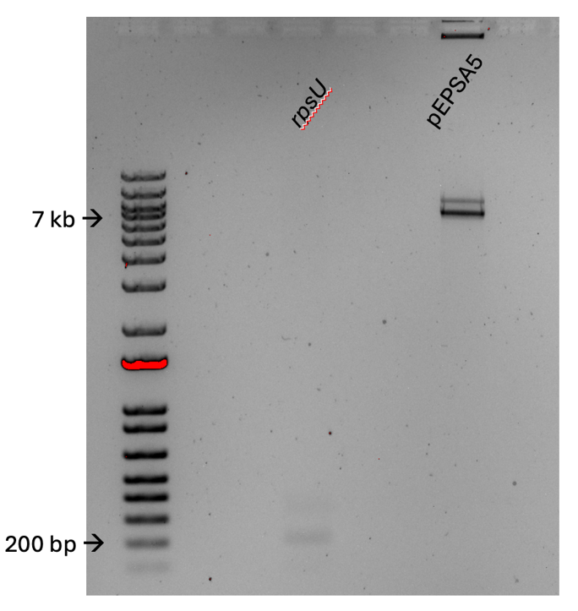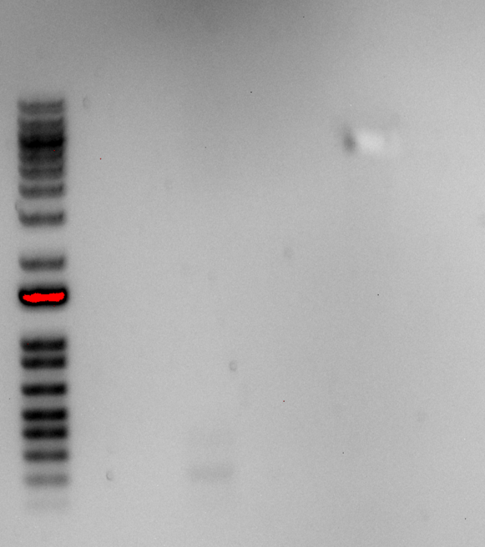
Digest of rpsU and pEPSA5. I could not excise the rpsU fragment out of the gel because it was so light I couldn’t see it. I tried to cut of pEPSA5 (lower band) without getting the higher band but I can’t tell by the after picture if I got it. In any case, the digest will have to be repeated. I do have a pEPSA5 gel extract from last year that I could maybe use going forward.

Reminder for Staph Minipreps (when it’s time):
Each overnight will be 5 ml, and in the morning I will set up a second 5 ml culture for each and add 250ul Cm. I will combine the overnight culture with the new culture (now 10 ml) and let them shake for a couple of hours. After that, I will split the 10ml culture back into two 5ml cultures which I will use for minipreps. Each pair of cultures will be pooled on the same column during miniprep.
I started 3 overnight cultures each from mutant and wild-type. I grew them in BHI because that is the medium I use for the MICs.

Saturday, July 13, 2024
To Do:

- Start overnights of KRSA2 and KRSA12
- Make single-use aliquots of LVS rpsU2-HA and LVS
- Digest on SA rpsU and pPEPSA5 and gel
- Reconstitute iron pyrophosphate
- Patch colonies from sucrose plates
- Growth curve on KRSA2 and KRSA12
- Supplement MHB
I did not come in because I didn’t want to drive in the heavy rain.

Monday, July 15, 2024
To Do:

- Boil prep presumptive 2ndary recombinant DNA
- Amplify DNA for diagnostic digest
- PCR purify
- Diagnostic digest and gel
- Streak out new KRSA2 and KRSA12 plates (or maybe start overnights from refrigerated colonies?)
- Concentrate IP sample for sucrose gradient
- Make Buffer B
- Patch LVS and rpsU2-HA

KROL144 and KROL145
Total fragment is 851 bp
Fragment 1 is 228, Fragment 2 is 615
The 10mM stock of KROL144 is missing from the box and no one is using it so I made a new one.
Total reaction volume | 50
Total number of reactions | 4
 |  |  |  | Factor
Component | Stock concentration | Final concentration | 1 rxn volume | 5
ddiH2O |  |  | 31.0 | 155
PrimeSTAR GXL Buffer | 5x | 1x | 10.0 | 50
dNTPs | 2.5 mM | 0.2 mM | 4.0 | 20
oligo F | 10 uM | 0.3 uM | 1.5 | 7.5
oligo R | 10 uM | 0.3 uM | 1.5 | 7.5
template | 100 ng/ul | 2 ng/ul | 1.0 | 5
PrimeSTAR GXL DNA Polymerase | 1.25 U/ul | 0.025 U/ul | 1.0 | 5
 |  | Total volume | 50 | 250

Diagnostic Digest:
Tube | DNA | Enzyme(s) | DNA Volume (uL) | H₂O Volume (uL)
1 | PCR purified rpsU2-HA | Not1 | 2 | -
2 | LVS gDNA | Not1 | 2
3 | pKR219 | Not1 | 2
4 | Neg | Not1 | - | 2

Components | Volumes in 1 reaction (uL) | Volumes in Master Mix 5x (uL)
H₂O | 15.5 | 77.5
10x Buffer* | 2.0 | 10
DNA | (2.0) | -
Enzyme 1 | 0.5 | 2.5
Enzyme 2 | N/A | -
Total | 20.0 (18) actual b/c of DNA)

- Add indicated amounts of H₂O and 10x buffer to master mix tube (MM).
- Add indicated amount of DNA or DNA+water (for backbone tubes) to individual tubes for digest (1.5 mL microfuge tubes for digests in incubator, PCR strip tubes for reactions incubated in the thermocycler).
- Add indicated amount of each enzyme (___uL) to the master mix tube (MM).
- Mix the master mix by pipetting up and down.
- Add master mix to individual tubes. Volume to add to each tube is the volume in 1 reaction minus the DNA volume (____ul).
- Incubate at 37°C for 1 hour or up to overnight.
- If using digest for plasmid construction then after incubation at 37°C, add 0.5ul of CIP enzyme to backbone tube, mix by pipetting and put back in 37°C incubator for 10 minutes. (this step removes the phosphates from the ends of the plasmid to prevent re-ligation). If using the new Quick CIP – add 1 uL, mix, incubate (at 37º) for 10 mins, then put at 80C for 2 minutes to inactivate the CIP.

*Since this is only a diagnostic digest, there is no need to add CIP.

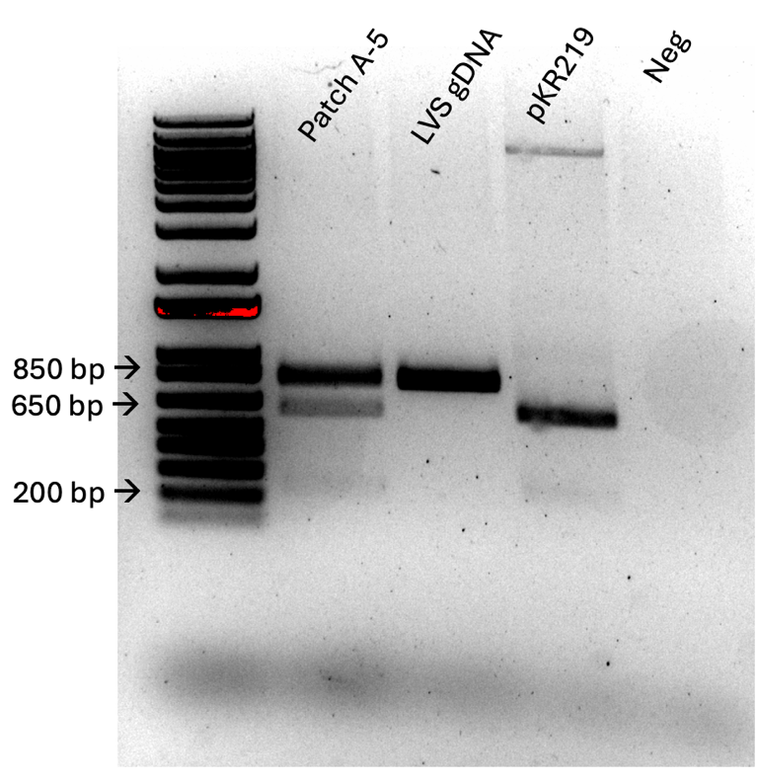
That’s a bust, looks like a primary integrant.

Concentrating Samples with 100 K MWCO
Using Pierce Concentrator, 0.5 mL
Note: spin steps are at 4ºC.
- Place sample into the Concentrator sample chamber (500ul).
- Cap, then insert the Sample chamber into a collection tube.
- Place into the rotor, with a counterbalance of another Concentrator, and centrifuge at 12,000 xg until the desired concentration factor is achieved. For 100K molecular weight cutoff, start with 3 minutes in order to reduce volume without leading to precipitation. If volume is not reduced at least by half, spin longer.
- Decant filtrate.
- Dilute remaining sample in the sample chamber to the original volume (500 ul) with Exchange Buffer (i.e. if there is 100 ul left in the chamber, add 400 ul of exchange buffer). I am using the rest of the sample until it is all concentrated.
- Repeat Steps 3-5 at least 3 times until the solute is reduced.
  - For sucrose gradients, imagine that you are beginning with 50% sucrose with a goal of reducing to 0.5% sucrose. If each replacement is reducing 1:5 (as in the example above), then must spin a total of 3 times to reach 0.4%. If each replacement is reducing 1:2 (i.e. 250 ul left in chamber after each spin), then must spin a total of 7 times to reach 0.39%.
- Move sample to new, clean microfuge tube and store in -80ºC.
I started with about 100ul and ended with about 50ul.
I made some more Lysis buffer in anticipation of performing another IP soon.
Buffer A + PI +BB (Lysis)
Final composition | Stock solutions | For 25 mL
25 mM KHEPES pH 7.9 | 1 M KHEPES | 625 uL
10 mM MgCl₂ | 1 M MgCl₂ | 250 uL
10 mM NH₄Cl | 1 M NH₄Cl | 250 uL
1X Bug Buster | 10X Bug Buster | 2.5 mL
10% glycerol | 75% glycerol | 3.3 mL
Water |  | 18 mL
 | + 2 tablets protease inhibitor

Tuesday, July 16, 2024
To Do:

- Boil prep presumptive 2ndary recombinant DNA
- Amplify DNA for diagnostic digest
- PCR purify
- Diagnostic digest and gel
- Streak out new KRSA2 and KRSA12 plates (or maybe start overnights from refrigerated colonies?)
- Concentrate IP sample for sucrose gradient
- Make Buffer B
- Patch LVS and rpsU2-HA
- Supplement MHB
- Start overnights of S. aureus
- Start overnights of LVS

Sample | Observed OD600 | Calculated OD600 | Starting Volume for OD600 0.003 (ul)
LVS wt | 0.02 | 0.4 | 600
LVS rpsU2-HA | 0.023 | 0.46 | 522
I know this isn’t in the linear range, but I went with it anyway. Also have to hope that the shaker doesn’t shut itself off overnight.

Wednesday, July 17, 2024
To Do:

- Supplement MHB
- Start overnights of S. aureus
- Start overnights of LVS
- Make IP cell pellets
- Sucrose gradient
- Growth curve on S. aureus

The shaker was still shaking when I came in this morning. I checked the OD on the LVS cultures at 9:30 but they needed more time.
Sample | Observed OD600 | Calculated OD600 | Starting Volume for OD600 0.003 (ul) | OD600 9:30 am next day | OD600 at 11 am | OD600 12pm
LVS wt | 0.02 | 0.4 | 600 | 0.216 | 0.264 | 0.309
LVS rpsU2-HA | 0.023 | 0.46 | 522 | 0.231 | 0.286 | 0.343

S. aureus Growth Curve:
Check OD600:
Dilute resuspended cells 1:20 in MHB (50 uL cells, 950 uL MHB) I’m using BHI
Check OD600 using 1 mL MHB BHI as blank
Calculate actual OD600 (measured OD600 multiplied by dilution factor [20])*
Calculate what volume of cells you need to obtain an OD600 of 0.08 in 10 mL*

For each sample, inoculate one glass culture tube so that the final OD600 is 0.08
Example:
OD600 of resuspended cells: 4.0
(9 mL )(0.08 OD600) / (4.0 OD600) = 0.18 mL resuspended cells (180 uL)
Either:
-Add 9 mL MHB BHI per tube and add 820 uL more MHB and 180 uL resuspended cells
OR
-Add 10 mL MHB BHI
per tube, remove 180 uL, and add back 180 uL resuspended cells
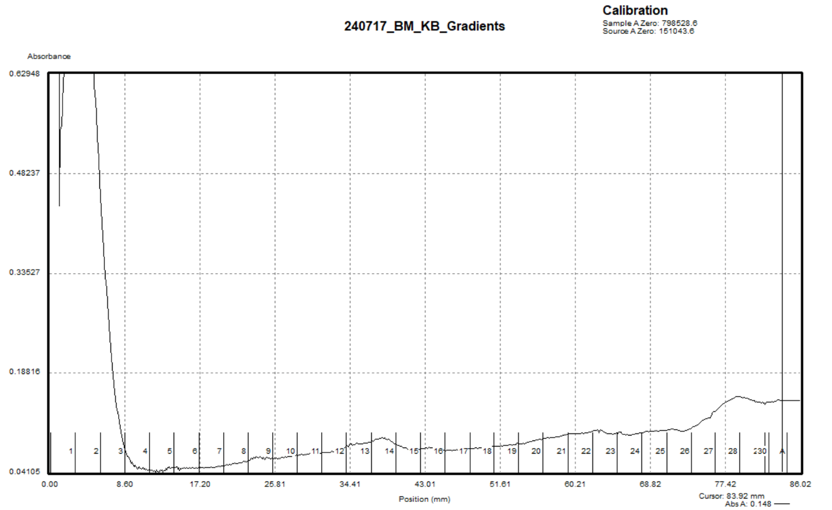

Figure 1: Sucrose Gradient of HA-IP 6/17/24

Thursday, July 18, 2024
To Do:

- Make IP cell pellets
- Sucrose gradient
- Growth curve on S. aureus
- HA-IP

Immunoprecipitation with HA antibody 7/18/24
**Note this is scaled down from previous IPs
Prepare cell lysate (Day 3)
Required reagents:
Buffer A + PI + BB Bug Buster (see recipe at end)
DNase I (Lucigen Corporation # D9905K)
30 mL syringe
MillexGP 0.22 micrometer syringe filter
Nonsterile 50 mL conical tubes
Microfuge tubes

1M NH₄Cl
10% NP-40

- Check for stock solutions; make Buffer A+ PI +BB if not enough in freezer (~10 mL per sample), prepare Buffer B if not enough at 4°C.
- Write out samples in table:

Sample# Date Genotype of cells Volume of cells OD600 at harvest
1 07/17/2024 LVS wt 80 mL 0.309
2. 07/17/2024 LVS rpsU2-HA 80 mL 0.343

- Resuspend samples in 1.5 mL Buffer A + PI + BB by pipetting with P1000 pipette. Be sure no clumps remain.
- Add 1.5 uL DNase I (Lucigen/Epiceter), mix by pipetting.
- Incubate at 37°C for 30’. Cool down centrifuge while waiting.
- Spin conical tubes at 4°C for 20’ at max speed.
- Transfer lysates into new 1.5 mL micro centrifuge tubes, leaving behind insoluble material at bottom (okay to leave some behind; better than taking too much).
- Filter-sterilize lysates using 3mL syringe and syringe filter into new (nonsterile) 1.5mL microcentrifuge tube. Specifically, pull plunger out from 3mL syringe, thread tip of syringe onto syringe use filter (use MillexGP 0.22 micrometer filter, has 33mm diameter), pour/pipette lysate into syringe, insert plunger and recover filtered lysate into new (nonsterile) 1.5mL microcentrifuge tube.
- Obtain a good estimate of sample volume using pipette. HA=750ul, Neg=750ul
- Adjust buffer concentration to Buffer B by adding to each sample:
10 uL 1M NH₄Cl / mL sample for final concentration of 100 mM NH₄Cl HA=75ul, Neg=75ul
1 uL 10% NP-40 /mL sample final concentration of 0.1% NP-40 HA=7.5ul, Neg=7.5ul
- Remove 25 uL into microfuge tube for control analysis (LYS).

In cold room
- Cut tip of 1mL pipette tip slightly.
- Resuspend Anti-HA magnetic beads in storage solution by repeated inversion.
- Pipette 75 uL magnetic beads into 1.5ml microcentrifuge tube.
- Wash beads with 1 mL of Buffer B. Using the magnetic rack, wait until the beads have completely gone towards the magnet before removing the liquid.
- Invert tubes for 1 minute, discard supernatant.
- Add 1 sample per tube, close tube and make sure and it is not dripping liquid.
- Incubate samples with beads, rocking on their sides at 4°C, for 1 hour.
- After 1 hour incubation, place on magnetic rack.
- Save 25 uL aliquot of flow through in microfuge tube (FT1), discard remaining.
- Wash beads 5x with 1 mL Buffer B rotating for 2 minutes. Discard flow through but save 25 ul from each wash (FT2-6).
- Add 200 ul KBE-3 buffer with HA peptide.
- Incubate rocking at 4°C overnight.

- Recover eluates by magnetic rack; aliquot 20ul (EL-1) and transfer remaining sample to a new, clearly labeled microfuge tube. Repeat elution (EL-2). Store samples at -80ºC.
- Keep 50u 25ul of beads and store in -20ºC.

Friday, July 19, 2024
To Do:

- HA-IP
- Silver stain

Silver Stain:
Lane | Content | Volume
1 | BenchMark Ladder 1:10 | 10 ul
2 | LVS -rpsU2-HA LYS | 10 ul
3 | LVS wt LYS | 10 ul
4 | LVS -rpsU2-HA FT2 | 10 ul
5 | LVS wt FT2 | 10 ul
6 | LVS -rpsU2-HA FT6 | 10 ul
7 | LVS wt FT6 | 10 ul
8 | LVS -rpsU2-HA Anti-HA agarose beads | 10 ul
9 | LVS wt Anti- HA Agarose Beads | 10 ul
10 | LVS-pF Anti- HA Agarose Beads (6/17) | 10 ul
11 | LVS pF-rspU2-HA Anti- HA Agarose Beads (6/17) | 10 ul
12 | 1xSLB | 10 ul
13 | LVS wt EL | 10 ul
14 | LVS -rpsU2-HA EL | 10 ul
15 | LVS-pF EL (6/17) | 10 ul
16 | LVS pF-rspU2-HA (6/17) | 10 ul
17 | Hannah’s Ribosomes | 3 ul

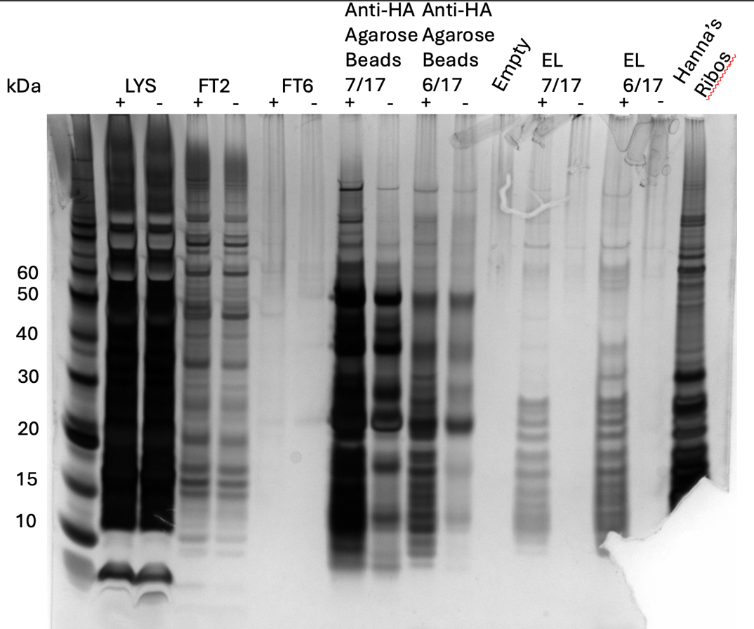

Figure 2: Sliver Stain of HA-IP 7/17/24

Monday, July 22, 2024
To Do:

- Silver stain
- Patch LVS strains for IP
- Make MHB and BHI for Staph
Reminder that BHI is 18.5 g in 500 ml of water.

Tuesday, July 23, 2024
To Do:

- Silver stain
- Patch LVS strains for IP
- Make MHB and BHI for Staph
- Patch LVS strains
- Streak S. aureus strains
Instead of repeating the IP, I’m going to practice the whole cell harvest step. I will do a growth curve on LVS rpsU2-HA and a Western Blot tomorrow.

Wednesday, July 24, 2024
To Do:

- Patch LVS strains
- Streak S. aureus strains
- LVS growth curve
- Western Blot
- Start S. aureus overnights

LVS Growth Curve:
Check OD600:
Dilute resuspended cells 1:10 in MHB (100 uL cells, 900 uL MHB)
Check OD600 using 1 mL MHB as blank
Calculate actual OD600 (measured OD600 multiplied by dilution factor [10])*
Calculate what volume of cells you need to obtain an OD600 of 0.08 in 10 mL*

For each sample, inoculate one glass culture tube so that the final OD600 is 0.08
Example:
OD600 of resuspended cells: 4.0
(9 mL )(0.08 OD600) / (4.0 OD600) = 0.18 mL resuspended cells (180 uL)
Either:
-Add 9 mL MHB per tube and add 820 uL more MHB and 180 uL resuspended cells
OR
-Add 10 mL MHB per tube, remove 180 uL, and add back 180 uL resuspended cells

Western Blot:
Lane | Content | Volume
1 | WesternSure  Ladder | 5 ul
2 | LVS -rpsU2-HA LYS | 10 ul
3 | LVS wt LYS | 10 ul
4 | LVS -rpsU2-HA FT2 | 10 ul
5 | LVS wt FT2 | 10 ul
6 | LVS -rpsU2-HA FT6 | 10 ul
7 | LVS wt FT6 | 10 ul
8 | LVS -rpsU2-HA Anti-HA agarose beads | 10 ul
9 | LVS wt Anti- HA Agarose Beads | 10 ul
10 | LVS-pF Anti- HA Agarose Beads (6/17) | 10 ul
11 | LVS pF-rspU2-HA Anti- HA Agarose Beads (6/17) | 10 ul
12 | 1xSLB | 10 ul
13 | LVS wt EL | 10 ul
14 | LVS -rpsU2-HA EL | 10 ul
15 | LVS-pF EL (6/17) | 10 ul
16 | LVS pF-rspU2-HA (6/17) | 10 ul
17 | LVS pF-rpsU2-HA WCL | 10 ul

Thursday, July 25, 2024
To Do:

- LVS growth curve
- Western Blot
- Start S. aureus overnights
- S. aureus growth curve
- Western Day 2
- Sucrose gradient

Figure 3: Doubling time of KRSA2 wild-type vs KRSA12 ∆rpsU mutant

Concentrating Samples with 100 K MWCO
Using Pierce Concentrator, 0.5 mL
Note: spin steps are at 4ºC.
- Place sample into the Concentrator sample chamber (500ul).
- Cap, then insert the Sample chamber into a collection tube.
- Place into the rotor, with a counterbalance of another Concentrator, and centrifuge at 12,000 xg until the desired concentration factor is achieved. For 100K molecular weight cutoff, start with 3 minutes in order to reduce volume without leading to precipitation. If volume is not reduced at least by half, spin longer.
- Decant filtrate.
- Dilute remaining sample in the sample chamber to the original volume (500 ul) with Exchange Buffer (i.e. if there is 100 ul left in the chamber, add 400 ul of exchange buffer). I am using the rest of the sample until it is all concentrated.
- Repeat Steps 3-5 at least 3 times until the solute is reduced.
  - For sucrose gradients, imagine that you are beginning with 50% sucrose with a goal of reducing to 0.5% sucrose. If each replacement is reducing 1:5 (as in the example above), then must spin a total of 3 times to reach 0.4%. If each replacement is reducing 1:2 (i.e. 250 ul left in chamber after each spin), then must spin a total of 7 times to reach 0.39%.
- Move sample to new, clean microfuge tube and store in -80ºC.
I started with a little less than 175ul and ended with about 25ul.
I don’t think I’ll see a peak on this gradient.

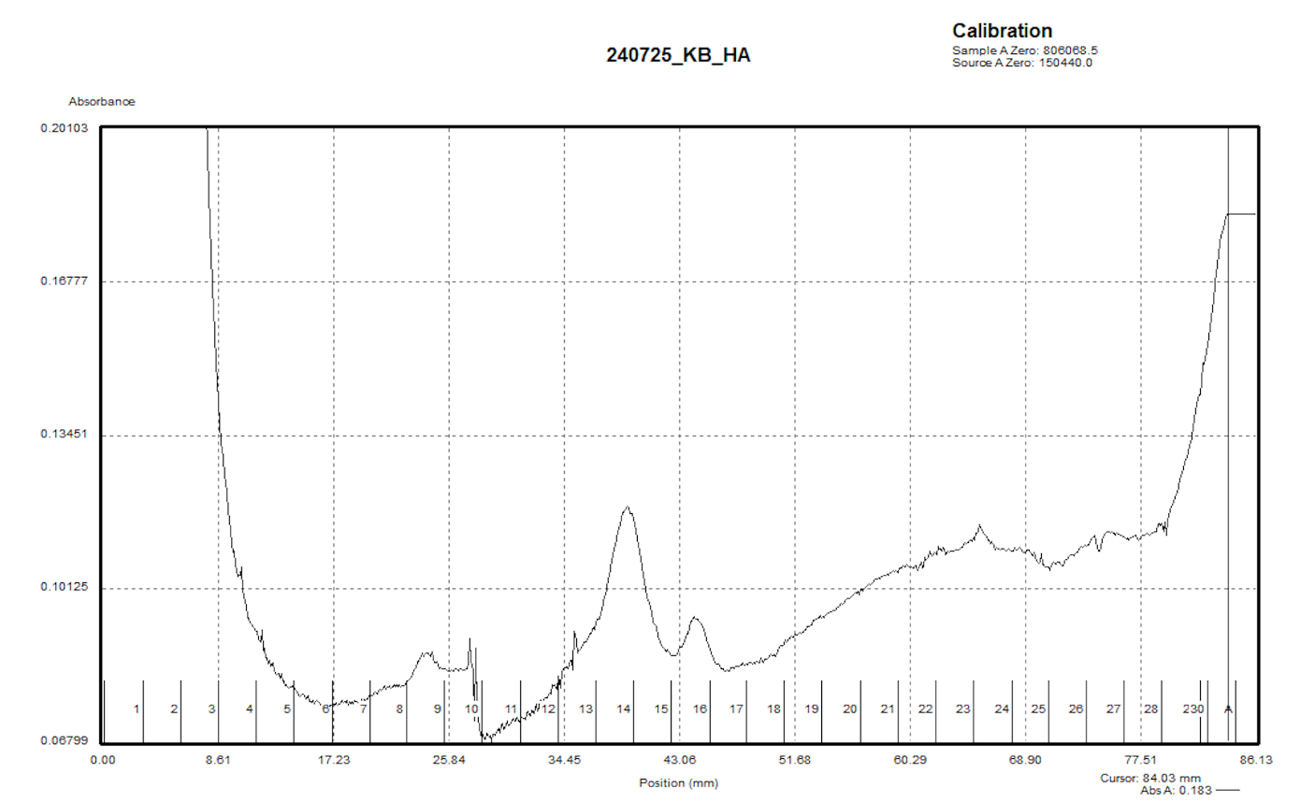

Figure 4: Sucrose gradient of LVS rpsU2-HA
This had to really scaled to see the peaks, but it’s following the same pattern as previous gradients.

August 2024

Monday, August 5, 2024
To Do:

- S. aureus growth curve
- Western Day 2
- Sucrose gradient
- Dissolve iron pyrophosphate
- Streak out MRE600
- Streak out KRSA2 and KRSA12
The MRE600 is to practice lysis with liquid nitrogen.
Tuesday, August 6, 2024
To Do:

- Dissolve iron pyrophosphate
- Streak out MRE600
- Streak out KRSA2 and KRSA12
- Start overnight cultures of MRE600, KRSA2, and KRSA12

Wednesday, August 7, 2024
To Do:

- Start overnight cultures of MRE600, KRSA2, and KRSA12
- MICs assay

MICs:
I am performing this assay using a lower and shorter range of antibiotic concentrations.
Antibiotic | Stock conc  mg/mL | Range of concs (mg/mL) | Antibiotic  Class | Target
Carb | 100 | 0.0625-2 | penicillin | Cell wall
Chlor | 50 | 0.5-16 | chloramphenicol | 50S subunit
Kan | 50 | 0.5-16 | aminoglycoside | 30S subunit
Vanc | 100 | 0.125-4 | glycopeptide | Cell wall

 | C1 (ug/ml) | V1 (ul) | C2 (ug/ml) | V2 (ul)
Carb | 100,000 | 2.56 | 256 | 1,000
Chlor | 50,000 | 20.48 | 1024 | 1,000
Kan | 50,000 | 10.24 | 512 | 1,000
Vanc | 100,000 | 5.12 | 512 | 1,000

For ease of pipetting, I’m going to prepare each antibiotic as listed above and then perform serial dilutions until I get to the starting concentrations for each plate.

Plate map:
 |  |  | Antibiotic Concentration
 |  |  | 1 | 2 | 3 | 4 | 5 | 6 | 7 | 8 | 9 | 10 | 11 | 12
 |  |  | Carb | Carb | Carb | Chlor | Chlor | Chlor | Kan | Kan | Kan | Van | Van | Van
Antibiotic | A | Conc 1 | 2 | 2 | 2 | 16 | 16 | 16 | 16 | 16 | 16 | 4 | 4 | 4
Antibiotic | B | Conc 2 | 1 | 1 | 1 | 8 | 8 | 8 | 8 | 8 | 8 | 2 | 2 | 2
Antibiotic | C | Conc 3 | 0.5 | 0.5 | 0.5 | 4 | 4 | 4 | 4 | 4 | 4 | 1 | 1 | 1
Antibiotic | D | Conc 4 | 0.25 | 0.25 | 0.25 | 2 | 2 | 2 | 2 | 2 | 2 | 0.5 | 0.5 | 0.5
Antibiotic | E | Conc 5 | 0.125 | 0.125 | 0.125 | 1 | 1 | 1 | 1 | 1 | 1 | 0.25 | 0.25 | 0.25
Antibiotic | F | Conc 6 | 0.0625 | 0.0625 | 0.0625 | 0.5 | 0.5 | 0.5 | 0.5 | 0.5 | 0.5 | 0.125 | 0.125 | 0.125
Antibiotic | G | No Abx | 0 | 0 | 0 | 0 | 0 | 0 | 0 | 0 | 0 | 0 | 0 | 0
Antibiotic | H | Blank | Blank | Blank | Blank | Blank | Blank | Blank | Blank | Blank | Blank | Blank | Blank | Blank

Population Analysis Assay (microplate method)
Based on Barnes et a,l 2023

Methods:
- Grow overnight cultures of S. aureus strains.
- The next day, back-dilute cultures to an OD600 of 0.3
- Prepare BHI broth with antibiotics by making the medium 2X the highest drug concentration in test range.
- In a 96-well plate, add 100ul of BHI with antibiotics to each well in Row A using a multi-channel pipet.
- In Rows B-H add 50ul of BHI without antibiotics
- Perform a serial two-fold dilution by adding 50ul of BHI with antibiotics from wells in Row A to Row B.
- Continue the serial dilution until Row F.
- Perform a ten-fold serial dilution of bacterial cultures by adding 10ul of overnight cultures to 990ul of TSB BHI to create a 10⁻² dilution, then add 100ul of that dilution to 900ul of new TSB BHI for a dilution of 10⁻³. Prepare the bacterial culture by diluting it 1:100 (100ul in 10ml of BHI).
- Add 50ul of each bacterial dilution culture to the wells in the appropriate columns (i.e. 10⁻² to the wells in Columns 1 through 7). In Rows A through G.
- Incubate plate at 37ºC for 20 hours.

Thursday, August 8, 2024
To Do:

- MICs assay
- MICs results

Tuesday, August 13, 2024
To Do:

- MICs results
- Patch out JR’s 1º integrants
- Start overnights of KRSA2 and KRSA12

Wednesday, August 14, 2024
To Do:

- Patch out JR’s 1º integrants
- Start overnights of KRSA2 and KRSA12
- MICs
The patches haven’t grown yet, so I’ll wait until tomorrow to do the PCR (hopefully they grow!)
KROL707 and KROL708

MICs:
I am performing this assay using a lower and shorter range of antibiotic concentrations.
Antibiotic | Stock conc  mg/mL | Range of concs (mg/mL) | Antibiotic  Class | Target
Carb | 100 | 0.0625-2 | penicillin | Cell wall
Chlor | 50 | 0.5-16 | chloramphenicol | 50S subunit
Kan | 50 | 0.5-16 | aminoglycoside | 30S subunit
Vanc | 100 | 0.125-4 | glycopeptide | Cell wall

 | C1 (ug/ml) | V1 (ul) | C2 (ug/ml) | V2 (ul)
Carb | 100,000 | 1.92 | 128 | 1,500
Chlor | 50,000 | 3.84 | 128 | 1,500
Kan | 50,000 | 3.84 | 128 | 1,500
Vanc | 100,000 | 1.92 | 128 | 1,500

I’m preparing all antibiotics to 128ug/ml and then performing serial dilution until I get to the appropriate starting concentration for each antibiotic.
 | Measured OD600 | Actual OD600 | Final Volume (ul) | Starting Volume for OD600 0.3 | Final OD600
KRSA2 | 0.221 | 4.42 | 1500 | 101.8 | 0.237
KRSA12 | 0.09 | 1.8 | 1500 | 250.0 | 0.431

Plate map:
 |  |  | Antibiotic Concentration
 |  |  | 1 | 2 | 3 | 4 | 5 | 6 | 7 | 8 | 9 | 10 | 11 | 12
 |  |  | Carb | Carb | Carb | Chlor | Chlor | Chlor | Kan | Kan | Kan | Van | Van | Van
Antibiotic | A | Conc 1 | 2 | 2 | 2 | 16 | 16 | 16 | 16 | 16 | 16 | 4 | 4 | 4
Antibiotic | B | Conc 2 | 1 | 1 | 1 | 8 | 8 | 8 | 8 | 8 | 8 | 2 | 2 | 2
Antibiotic | C | Conc 3 | 0.5 | 0.5 | 0.5 | 4 | 4 | 4 | 4 | 4 | 4 | 1 | 1 | 1
Antibiotic | D | Conc 4 | 0.25 | 0.25 | 0.25 | 2 | 2 | 2 | 2 | 2 | 2 | 0.5 | 0.5 | 0.5
Antibiotic | E | Conc 5 | 0.125 | 0.125 | 0.125 | 1 | 1 | 1 | 1 | 1 | 1 | 0.25 | 0.25 | 0.25
Antibiotic | F | Conc 6 | 0.0625 | 0.0625 | 0.0625 | 0.5 | 0.5 | 0.5 | 0.5 | 0.5 | 0.5 | 0.125 | 0.125 | 0.125
Antibiotic | G | No Abx | 0 | 0 | 0 | 0 | 0 | 0 | 0 | 0 | 0 | 0 | 0 | 0
Antibiotic | H | Blank | Blank | Blank | Blank | Blank | Blank | Blank | Blank | Blank | Blank | Blank | Blank | Blank

Thursday, August 15, 2024
To Do:

- MICs
- PCR on JR’s samples
- Read MIC plates

Total reaction volume | 20
Total number of reactions | 5
 |  |  |  | Factor
Component | Stock concentration | Final concentration | 1 rxn volume | 6
ddiH2O |  |  | 12.4 | 74.4
PrimeSTAR GXL Buffer | 5x | 1x | 4.0 | 24
dNTPs | 2.5 mM | 0.2 mM | 1.6 | 9.6
oligo F | 10 uM | 0.3 uM | 0.6 | 3.6
oligo R | 10 uM | 0.3 uM | 0.6 | 3.6
template | 100 ng/ul | 2 ng/ul | 0.4 | 2.4
PrimeSTAR GXL DNA Polymerase | 1.25 U/ul | 0.025 U/ul | 0.4 | 2.4
 |  | Total volume | 20 | 120
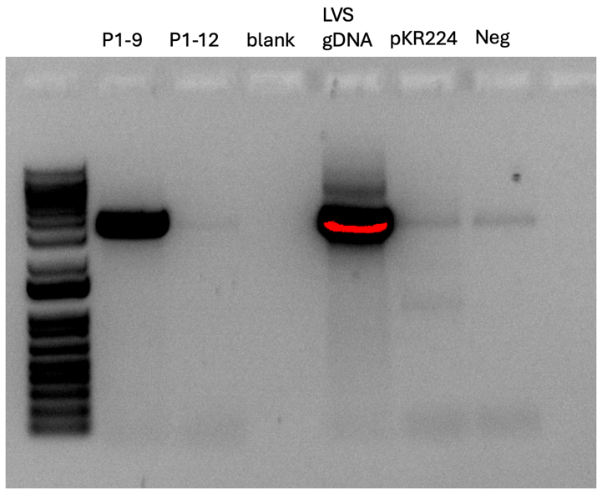

Figure 5: PCR of potential primary integrants of Kan interrupting mpl gene in LVS
Primers used: KROL681 and KROL682. Expected size: ~3500 bp. P1-9 is wild-type but P1-12 could maybe the mutant. It is difficult to tell if there is no amplification and the faint band is just contamination (like what is in the negative control) or if the amount of DNA in the sample is insufficient.

Friday, August 16, 2024
To Do:

- PCR on JR’s samples
- Survival assay

Freshwater Survival Assay
- Prep sterile setup for assay with these materials: reservoir, sterile multichannel pipettes (5-20uL and 50-300uL) sterile 96 well plate and sterile PBS.
- Dilute cells from overnight culture to 0.03 OD600 in 10ml of freshwater in a 50ml falcon tube.
- Aseptically, pour about 5-10 mL of sterile PBS into reservoir.
- Load 180 uL of sterile PBS into Rows B-G in the “highlighted” columns, don’t load PBS into Row A.
- Load 100 uL of sample cells into each designated well in Row A.
- Using the multichannel pipette, transfer 20 uL of the sample cells from Row A to Row B. Repeat this for each well, 1A to 1B. 1B to 1C etc.
- Once all wells have been diluted (except the first wells), prep 12 plates of CHAH (2 per sample).
- Using the 5 – 20 uL multichannel, load 10 uL of the first column, for example, 1A, 1B, 1C, 1D, 1E, 1F, 1G and plate the 10 uL, holding the plate at slant
- Let the liquid run down the plate, but not too fast!! Can’t allow samples to hit the bottom.
- Once all 12 plates are done, incubate plates in 37 degrees Celsius for the next couple of days.

Plate map:
 | LVS-A |  | LVS-B |  | LVS-C |  | P1-12-A |  | P1-12-B |  | P1-12-C
 | 1 | 2 | 3 | 4 | 5 | 6 | 7 | 8 | 9 | 10 | 11 | 12
A | 100 ul |  | 100 ul |  | 100 ul |  | 100 ul |  | 100 ul |  | 100 ul
B | 1.00E-01 |  | 1.00E-01 |  | 1.00E-01 |  | 1.00E-01 |  | 1.00E-01 |  | 1.00E-01
C | 1.00E-02 |  | 1.00E-02 |  | 1.00E-02 |  | 1.00E-02 |  | 1.00E-02 |  | 1.00E-02
D | 1.00E-03 |  | 1.00E-03 |  | 1.00E-03 |  | 1.00E-03 |  | 1.00E-03 |  | 1.00E-03
E | 1.00E-04 |  | 1.00E-04 |  | 1.00E-04 |  | 1.00E-04 |  | 1.00E-04 |  | 1.00E-04
F | 1.00E-05 |  | 1.00E-05 |  | 1.00E-05 |  | 1.00E-05 |  | 1.00E-05 |  | 1.00E-05
G | 1.00E-06 |  | 1.00E-06 |  | 1.00E-06 |  | 1.00E-06 |  | 1.00E-06 |  | 1.00E-06

On the LVS-A plates the some of the streaks ran together. I made sure to keep the plate tilted while I pipetted the samples onto it and that made a huge difference.

Monday, August 19, 2024
To Do:

- Survival assay
- Count colonies

Tuesday, August 20, 2024
To Do:

- Count colonies
- PCR on maybe mutant
- Make more pKR2
Kathryn would like me to run a PCR on the prospective mutant and this time amplify the piece of the KanR gene that was inserted into mpl. I am using pKR2 as a control, but I noticed that there isn’t a lot left, so I’m transforming XL1-blue with pKR2 to make more.
Total reaction volume | 50
Total number of reactions | 5
 |  |  |  | Factor
Component | Stock concentration | Final concentration | 1 rxn volume | 6
ddiH2O |  |  | 31.0 | 186
PrimeSTAR GXL Buffer | 5x | 1x | 10.0 | 60
dNTPs | 2.5 mM | 0.2 mM | 4.0 | 24
oligo F KROL567 | 10 uM | 0.3 uM | 1.5 | 9
oligo R KROL568 | 10 uM | 0.3 uM | 1.5 | 9
template | 100 ng/ul | 2 ng/ul | 1.0 | 6
PrimeSTAR GXL DNA Polymerase | 1.25 U/ul | 0.025 U/ul | 1.0 | 6
 |  | Total volume | 50 | 300

Reaction numbers | Sample | Primers | Expected size
1 | P1-12 | KROL567 and KROL568 | 295 bp
2 | P1-12 dil | KROL567 and KROL568 | 296 bp
3 | pKR2 | KROL567 and KROL568 | 297 bp
4 | LVS gDNA | KROL567 and KROL568 | 0 bp
5 | -DNA | KROL567 and KROL568 | 0 bp
6 | pKR224 | KROL567 and KROL568 | 295 bp

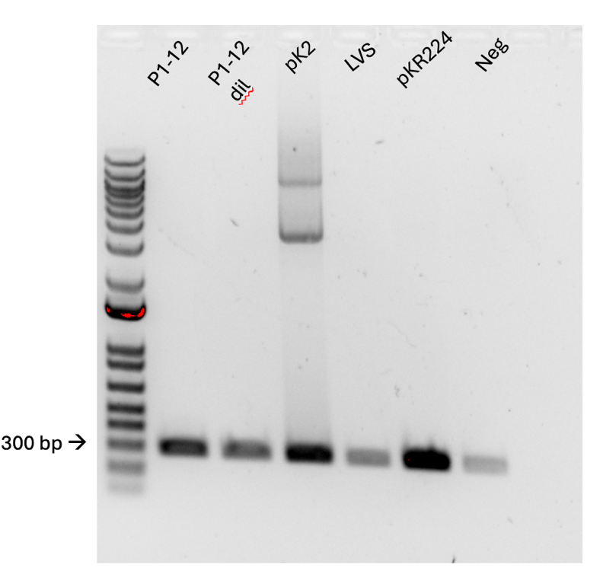

Figure 6: PCR of mpl interrupted by KanR

Bibliography

Ramsey, K. M. and Dove, S. L. (2016) ‘ A response regulator promotes Francisella tularensis intramacrophage growth by repressing an anti-virulence factor ’, Molecular Microbiology. doi: 10.1111/mmi.13418.

