Table of Contents
August 2022 2
Figure 1. bS21-2-TAP purification from 10/22/20. 3
Figure 2. Quantification of inoculums from 8/16/22 macrophage assay. 9
Figure 3. Recovery of LVS from 8/16/22 macrophage assay. 10
Figure 4. Recovery of all cells from 8/16/22 macrophage assay. 12
Figure 5. PCR of rpsU promoters for GFP fusion plasmids. 13
Figure 6. Digest and gel purification of rpsU promoters for GFP fusion plasmids. 14
Figure 7. Pellets of cells to miniprep for potential GFP fusion plasmids. 16
Figure 8. bS21-2-TAP purification from 9/2/22. 20
Future To-Do 22

August 2022

Monday, August 8, 2022

To Do:
- Plan
- Submit data to GEO
Results and Data:

PmrA
After discussion with Simon about PmrA project, need to assess how lysis conditions (5 minutes vs 30 minutes) impacts recovery of ∆pmrA cells.
Test:
WT
KMLFT37 ∆pmrA
KMLFT69 ∆pmrA mre(S)
KRLVS40 ∆pmrA

Need to plan.
Thursday: pour plates
Friday: thaw macrophage
Monday: Seed
Tuesday: infect
Wednesday: plate

Design:
-rpsU1-GFP
-rpsU3-GFP
Replace rpsU gene with GFP? In that case, the bS21 homolog wouldn’t repress its own production… but we might not see the same phenotypes in cells with rpsU genes, which is what we are interested in. Keep it a translational fusion. And double check that GFP is bright, versus the other proteins that Sierra tested.

IP bS21-ribosomes
Have samples after TEV cleavage from bS21 TAP purification (201022: E1). Run on gel to see if ribosome is associated.

Grow more cells with pKR72 pF-rpsU2-TAP. Try purification with buffers containing Mg2+.
Thursday: electroporation
Monday: patch cells
Tuesday: grow cells, harvest
Wednesday: IP

Tuesday, August 9, 2022

To Do:
- Run gel of old protein samples
- silver stain gel
- Coomassie stain gel
- Check for Kan plates for transformation
- Lab meeting
- Check with Sierra about fluorescent proteins (GFP is brightest!)
- Design translational GFP fusions, order oligos
Results and Data:
Gel to assess TAP purification:
4-12% MES, 15 well
Lane | Volume | Contents | Processing
1 | 10 uL | 1x SLB | Silver stain
2 | 10 uL | Benchmark ladder 1:10 | Silver stain
3 | 7 uL | E1A: LVS pF | Silver stain
4 | 7 uL | E2A: LVS pF-rpsU-TAP | Silver stain
5 | 7 uL | E3A: LVS rpoC-TAP | Silver stain
6 | 7 uL | ribosomes | Silver stain
7 | 10 uL | 1x SLB | Silver stain
8 | 10 uL | 1x SLB | Silver stain
9 | 10 uL | 1x SLB | Coomassie stain
10 | 10 uL | Ladder | Coomassie stain
11 | 7 uL | E1A: LVS pF | Coomassie stain
12 | 7 uL | E2A: LVS pF-rpsU-TAP | Coomassie stain
13 | 7 uL | E3A: LVS rpoC-TAP | Coomassie stain
14 | 7 uL | ribosomes | Coomassie stain
15 | 10 uL | 1x SLB | Coomassie stain
Ribosome from 3/22/2019 (26.7 ug/ul): For today, dilute 2 ul into 23 ul 1xSLB and load 7 ul

Run at 140 V for 55 min. Yellow dye and blue dye are visible at bottom of gel.
Cut in half and stain with silver and Coomassie as indicated.
Incubate in Coomassie stain from ~1:40 – after 4:40 (Sierra will remove the stain and add water for me).
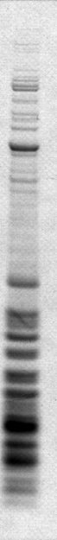
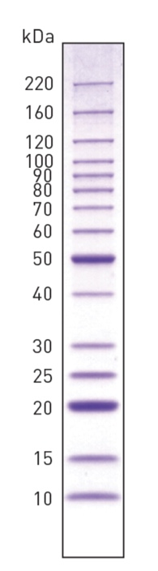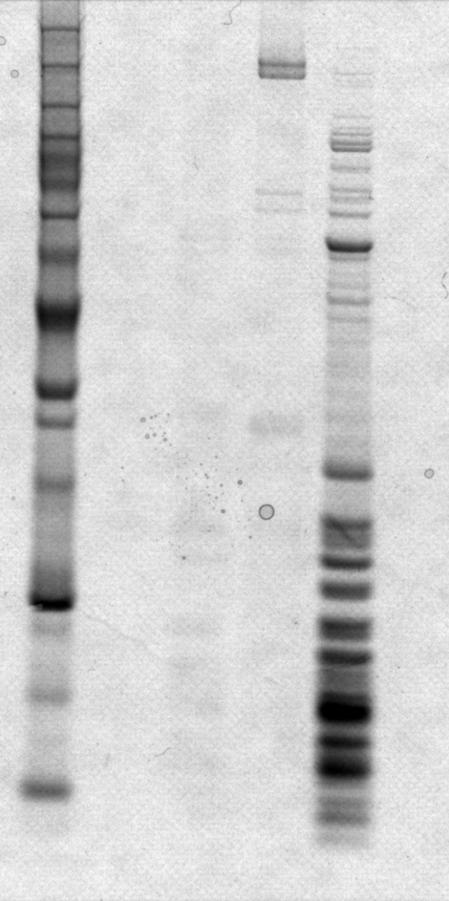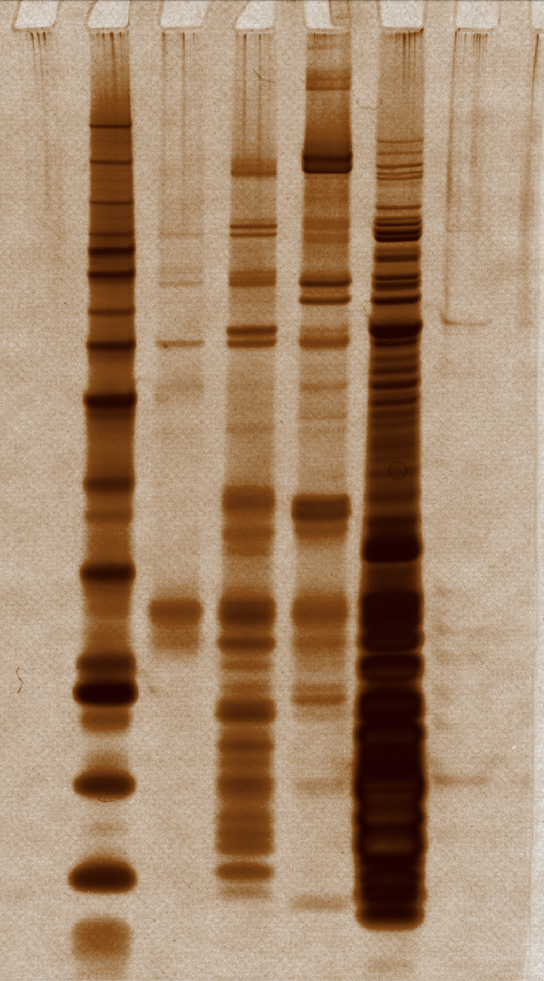
30
10
15
20
25
40
30
25
20
15
10
Omega: 8.1 kDa
bS21-2 with CBP: 12.8 kDa

Figure 1. bS21-2-TAP purification from 10/22/20.
The RNAP purification isn’t so clean, but that makes sense- this is only the first IP step. Can see the omega subunit, which is 8.1 kDa.
bS21-2 with the CBP moiety should be 12.76 kDa.
For electroporations on Thursday:
-Hannah is making more CHA-Kan plates tomorrow
-I have one vial of EC LVS

Wednesday, August 10, 2022

To Do:
- Spend time with K. Palmer and family
Thursday, August 11, 2022

To Do:
- Pour macrophage plates
- Transform LVS with pF-rpsU2-TAP
- Plate electroporations
- Prep fresh DMEM-F
Results and Data:
Plan for macrophage experiment next week:
Expectations:
WT ~ equal amounts recovery
KMLFT37 ∆pmrA less at 5’, more at 30’
KMLFT69 ∆pmrA mre(S) unknown?
KRLVS40 ∆pmrA unknown?

Testing recovery after 5’ vs 30’ lysis. Rationale: potential that KMLFT37 will have less recovery after 5’ and more after 30’ compared to WT. If this is due to priM production, then we expect to see that KRLVS40 and KMLFT69 will have the same phenotype. If this is due to the SNP in FTL_0146, then we expect that KMLFT37 and KMLFT69 will have the same phenotype but KRLVS40 will have a different phenotype.
Potentially, it has nothing to do with lysis times. In that case, we expect less recovery of all bacteria at 5’ and more at 30’.

Plan:
Infect macrophage, wash after 2 hours (no 2 hour timepoint)
Lyse 2 plates of bacteria after 24 hours. Plate one set of wells after 5 minutes of lysis. Plate the same set after 25 more minutes, and plate from another set of wells after 30 mins.

Plate needs:
3 wells * 2 plates * 4 strains = 24 plates per timepoint
3 timepoints = 72 square plates
 | Number of plates- CHA
Use | Round | Square | Notes
Patch strains for infections | 5 |  | 2x each, each 1/2 plate
Plate inoculumns | 0 | 10 | 5 strains in duplicate
Timepoint 2 hours | 0 | 0 | Round: 5 strains x triplicate wells x duplicate
Timepoint 24 hours | 6 | 72 | Square: 4 strains x 3 wells x 2 plates x 3 timepoints; round: ∆pigR x 3 wells x 2 plates
Total plates | 11 | 82 | Round plates: 24 mL, 25 per flask; Square plates: 30 mL, 20 per flask
Flasks of 600 mL CHA | 0.44 | 4.1
Total number of CHA flasks | 4.54

Electroporate LVS with pKR72 pF-rpsU2-TAP
Electroporation Cells Plasmid vol DNA time constant
1 LVS pKR72 3 didn’t note
1 LVS pF 3 4.5

Electrocomp LVS from 8-16-19
10:37 - ~2:15pm (~3.75 hrs). Plated 20 uL and 200 uL.

Friday, August 12, 2022

To Do:
- Joint lab meeting
- Thaw macrophage
- Bring nieces to NYC

Results and Data:
Thawed P5 J774.1 stock, in DMEMF supplemented yesterday (8/11/22).

Monday, August 15, 2022

To Do:
- Streak cells
- Seed macrophage
- Patch LVS cells with pF or pKR72

Results and Data:
Remove media, wash with 5 mL media.
Add back ~8 mL media.
Scrape cells off plate.
Transfer cells to 15 mL conical
Spin 750xg for 5 minutes
Remove media, resuspend cell pellet in 7 mL using 5 mL pipet.
Check cell density:
combine 50 ul of cells with 50 ul of trypan blue.
Pipet 10 uL into single use hemocytometer
Count cells
1st measurement
68 | 36 | 40 | 45
Average |  |  |  | 47.25
Undiluted |  |  |  | 94.5
Density |  |  |  | 9.45E+05
Dubious that the first measurement is representative. Should be 1.6 mL resuspended cells plus 10.4 mL media. Adjust calculations so that I’m adding 2 mL resuspended cells to 10 mL media.
Macrophage Calculations
Cells per well | 2.50E+04
Volume to plate (mL) | 0.2
Density needed (cells/mL) | 1.25E+05
Total volume needed (mL) | 12
Measured cells per ml | 9.45E+05
Volume stock needed (mL) | 2.0
Volume media for dilution | 10.0

Make appropriate dilution in sterile reservoir
Use multichannel to pipet 200 ul cells into each well, as indicated, for 2 x 96 well plates
 | 1 |  | 2 | 3 | 4 | 5 |  | 6 |  | 7 | 8 | 9 | 10 | 11 | 12
A | LVS |  | LVS | LVS |  | KMLFT37 |  | KMLFT37 |  | KMLFT37 |  | ∆pigR | ∆pigR | ∆pigR
B
C
D | ∆pmrA mre(S) |  | ∆pmrA mre(S) | ∆pmrA mre(S) |  | KRLVS40 |  | KRLVS40 |  | KRLVS40
E
F
G
H
1 |  | LVS |  |  |  |  | -
2 |  | KMLFT37.1 (KR lab fine) |  |  |  |  | KMLFT37
3 |  | KRLVS40.1 |  |  |  |  | KRLVS40
4 |  | ∆pmrA mre(S) |  |  |  |  | KMLFT69
5 |  | ∆pigR |  |  |  |  | JCLVS106

Plate 1mL of responded cells with 9mL media into 100 mm TC dish (P6).
Place all cells back in incubator, 37°C 5% CO₂ at ~5pm.
Check actual density of resuspension:
2nd measurement
4 | 5 | 10 | 9
10 | 7 | 19 | 9
9 | 17 | 9 | 16
Average |  |  |  | 10.33
Undiluted |  |  |  | 20.66666667
Density |  |  |  | 2.07E+05
Measured cells per ml, seeded |  |  |  | 2.07E+05
Measured cells per well |  |  |  | 4.13E+04

Higher than I’d like (aim for 2.5x10⁵)! So glad to have the ∆pigR control. If the macrophage don’t behave properly, then the ∆pigR cells won’t be killed.

Check electroporations:
All worked well, too many cells on the 200 ul plate to get good single colonies. Even the 20ul plates are crowded. Patch 2 colonies from each electroporation onto a CHA plate.

Tuesday, August 16, 2022

To Do:
- Infect macrophage
- Wash macrophage
- Grow cultures for TAP purification
- Freeze down patches of cells for future TAP purification

Results and Data:
Checked macrophage plates under microscope, look good. Forgot to put CHA plates with bacteria at 37°C last night! Grew at room temp, all the cells started from single-use aliquots (all except ∆pmrA mre(S)) obviously grew well enough for at least the mac assay. Try to scrape up what’s there and move forward.
Prep 96-well plate with wells B1 – F5 with 180 ul sterile 1x PBS (multichannel).

Scrape up bacteria and resuspend in 400 uL DMEMF. Add 450 uL more. Check OD600 (100 uL in 900 uL DMEMF), dilute to OD600 of 0.04 in 1 mL, check OD600 again with 600 uL. Dilute cells to OD600 of 0.00075.
 |  |  | For final vol 1 mL at 0.04 |  | For final vol 1 mL at 0.00075
Number | Strain | Resuspend cells to (OD600) | Cells (uL) | OD600 | Cells (uL) | Volume media (uL)
1 | LVS | 0.91 | 44.0 | 0.039 | 19.2 | 981
2 | KMLFT37 | 1.42 | 28.2 | 0.042 | 17.9 | 982
3 | KRLVS40 | 2.06 | 19.4 | 0.034 | 22.1 | 978
4 | KMLFT69 |  | - | - | - | -
5 | JCLVS106 | 1.77 | 22.6 | 0.06 | 12.5 | 988

Adjust setup: no KMLFT69 ∆pmrA mre(S), now strain 4 = ∆pigR!

Add 50 uL of appropriate cells to each well, as indicated, in each 96-well plate (2x).
 | 1 | 2 | 3 | 4 | 5 | 6 | 7 | 8 | 9 | 10 | 11 | 12
A | LVS | LVS | LVS |  | KMLFT37 | KMLFT37 | KMLFT37
B
C
D | KRLVS40 | KRLVS40 | KRLVS40 |  | ∆pigR | ∆pigR | ∆pigR
E
F
G
H

Put infected macrophage back at 37°C with 5% CO₂ at 9:00am.

Transfer 200 ul of each inoculum to wells A1 – A5, one per well.
Perform 10x serial dilutions down plate.
Plate each dilution 2x on square CHA plates using drip plate method, 10 uL at top. Put plates at 37°C.

At ~11:00am, wash macrophage twice with sterile 1x PBS and replace media with media containing 10 ug/mL gentamicin.
(14 mL)(10 ug/mL)/(50,000 ug/mL gent) = 2.8 uL

NO T=2 timepoint.

Check on tissue culture. P6 macrophage look good and media is still pretty pink- no need to feed yet.

Shaking incubator is at 30°C overnight, so plan on growing cells for TAP purification on another night. Freeze down cells in the meantime.
Froze down 2 cryovials each of:
LVS pKR72 pF-rpsU2-TAP patch A
LVS pKR72 pF-rpsU2-TAP patch B
LVS pF patch A
LVS pF patch B
Put in “KMR working” box in -80°C.

Wednesday, August 17, 2022

To Do:
- Macrophage T=24
Results and Data:
At ~11:00 am, lyse macrophage and plate T=24 timepoint. Process 2 plates separately.

First wash 1 plate twice with 1x PBS and add 200 ul 1% saponin in 1x PBS. Incubate 5’ and plate out LVS, KMLFT37, KRLVS40 (don’t bother with ∆pigR). For this plating step, remove only 20 uL and perform serial dilutions, leaving remainder of liquid in wells. When plating, plate out diluted material and manually add 10 uL of undiluted for the first track. Leave saponin in plate to plate more after 30’.

While first plate continues to incubate, wash second plate twice with 1x PBS and add 200 ul 1% saponin in 1x PBS. Incubate for 30’.

While second plate incubates, after 1st plate has incubated for 30’, plate out LVS, KMLFT37, and KRLVS40 again, plus ∆pigR.

After 2nd plate has incubated for 30’, plate out LVS, KMLFT37, KRLVS40, and ∆pigR.

For each plating step, transfer 190ul of wells with samples 1 – 3 to top of one 96-well plate, samples 4 to top of second 96 well plate. Perform 10x serial dilutions. Plate undiluted plus 5 dilutions (dilution factor 1 – 0.00001) for each well 2x using track plate method (10 ul). Plate 50 uL twice on round plates for all samples from ∆pigR (5). Put plates at 37°C.

Check on P6 macrophage. Look good, should deal with tomorrow if I want to continue culturing. Not sure it’s worth it- I need to see results from this experiment before planning the next one, and I expect it will be Saturday or Sunday before all the colonies from the T=24 plates are ready to count. Not really soon enough to have another experiment planned for early next week.

Thursday, August 18, 2022

To Do:
- Count inoculum plates
Results and Data:
Check on track plates with inoculums. Can clearly count plates from samples 1 (LVS) and 2 (KMLFT37). Not surprising that KRLVS40 still has pretty small colonies, so not worth trying to count today- this growth defect is expected based on past experiments. However, sample 4, which is ∆pigR, also has tiny colonies! That’s not expected, ∆pigR typically grows like WT. Keep an eye on this.
Current MOIs calculated:
LVS: 4.7
KMLFT37: 3.2

These are lower than I’d like, but there were more macrophage plated that I usually use. Hopefully it all turns out okay.

Friday, August 19, 2022

To Do:
- Count remaining inoculum plates
- Count T=24 plates for faster growers
- Autoclave media to grow TAP strains next week

Results and Data:
Checked on plates from macrophage assay.
From the inoculum plates, can count KRLVS40 and ∆pigR. Note that the ∆pigR colonies are a bit strange, as there seem to be large and small sizes. Not typical, should have grown like WT and be consistently big by today. Also fewer cells than expected. Not sure what’s happening there.

Inoculum
 | Replicate | 3 | 4 | Dilution factor counted |  | Cells / mL |  | Average Cells / mL |  | St dev |  | CFU/well | St dev | MOI (based on number of seeded macrophage- see setup)
LVS | 1A | TMTC | 41 | 0.001 |  | 4.10E+06 |  | 3.90E+06 |  | 2.83E+05 |  | 1.95E+05 | 1.41E+04 | 4.7
LVS | 1B | TMTC | 37 | 0.001 |  | 3.70E+06
LVS ∆pmrA KMLFTS37 | 2A | TMTC | 35 | 0.001 |  | 3.50E+06 |  | 2.64E+06 |  | 1.22E+06 |  | 1.32E+05 | 6.12E+04 | 3.2
LVS ∆pmrA KMLFTS37 | 2B | 177 | 37 | 0.01 |  | 1.77E+06
LVS ∆pmrA KRLVS40 | 3A | TMTC | 52 | 0.001 |  | 5.20E+06 |  | 5.00E+06 |  | 2.83E+05 |  | 2.50E+05 | 1.41E+04 | 6.0
LVS ∆pmrA KRLVS40 | 3B | TMTC | 48 | 0.001 |  | 4.80E+06
LVS ∆pigR | 5A | TMTC | 17 | 0.001 |  | 1.70E+06 |  | 1.35E+06 |  | 4.95E+05 |  | 6.75E+04 | 2.47E+04 | 1.6
LVS ∆pigR | 5B | TMTC | 10 | 0.001 |  | 1.00E+06
Dilution Factor |  | 0.01 | 0.001

Strain | CFU/well | St dev | MOI
LVS | 1.95E+05 | 1.41E+04 | 4.7
LVS ∆pmrA KMLFT37 | 1.32E+05 | 6.12E+04 | 3.2
LVS ∆pmrA KRLVS40 | 2.50E+05 | 1.41E+04 | 6.0
LVS ∆pigR | 6.75E+04 | 2.47E+04 | 1.6

Figure 2. Quantification of inoculums from 8/16/22 macrophage assay.
They look pretty even! MOIs are a bit lower than I’d like, particularly ∆pigR, but should be fine.

The only 24 hour plates countable today are the LVS plates (check on others Sat or Sunday). Results so far:
 | Plating after 5'
 |  | Average CFU per well | St Dev | Original MOI | T-test (vs LVS) | Fold change from WT
1 | LVS | 1.02E+05 | 2.76E+04 | 4.7 |  | 1.00

 | Plating after 30' (2nd plating)
 |  | Average CFU per well | St Dev | Original MOI | T-test (vs LVS 5') | Fold change from WT 5'
1 | LVS | 1.87E+05 | 6.45E+04 | 4.7 | 0.103671 | 1.84

 | Plating after 30' (1st plating)
 |  | Average CFU per well | St Dev | Original MOI | T-test (vs LVS) | Fold change from WT 5'
1 | LVS | 2.24E+05 | 8.35E+04 | 4.7 | 0.074226 | 2.20

Figure 3. Recovery of LVS from 8/16/22 macrophage assay.
As expected, recovered more LVS after 30’ incubation with saponin than after a 5’ incubation. Not really sure how to interpret the second plating after 30’, since lysis must be uneven and the volume is reduced. Probably disregard this timepoint.

Sunday, August 21, 2022

To Do:
- Check on plates, remove if necessary
Results and Data:
Removed plates, some colonies look quite big. Leave on bench at RT.

Monday, August 22, 2022

To Do:
- Wrap up family visit

Results and Data:
Family still in town, take day off.

Tuesday, August 23, 2022

To Do:
- Finish counting macrophage assay plates
- Patch out LVS pF and LVS pKR72 cells
Results and Data:
Count all remaining macrophage assay plates:
5 min
 |  | Track Plate 1 |  |  |  | Track Plate 2
 | Plate | 1 | 2 | 3 | 4 | 1 | 2 | 3 | 4 | Dilution factor counted | Average Cells | CFU per well
LVS | 1A | TMTC | TMTC | 66 | 6 | TMTC | TMTC | 67 | 13 | 0.01 | 66.5 | 1.33E+05
LVS | 1B | TMTC | TMTC | 50 | 6 | TMTC | TMTC | 41 | 6 | 0.01 | 45.5 | 9.10E+04
LVS | 1C | TMTC | TMTC | 33 | 6 | TMTC | TMTC | 48 | 17 | 0.01 | 40.5 | 8.10E+04
LVS ∆pmrA KMLFT37 | 2A |  | 12 |  |  |  | 10 |  |  | 0.1 | 11 | 2.20E+03
LVS ∆pmrA KMLFT37 | 2B |  | 13 |  |  |  | 9 |  |  | 0.1 | 11 | 2.20E+03
LVS ∆pmrA KMLFT37 | 2C |  | 14 |  |  |  | 12 |  |  | 0.1 | 13 | 2.60E+03
LVS ∆pmrA KRLVS40 | 3A | 3 |  |  |  | 6 |  |  |  | 1 | 4.5 | 9.00E+01
LVS ∆pmrA KRLVS40 | 3B | 3 |  |  |  | 3 |  |  |  | 1 | 3 | 6.00E+01
LVS ∆pmrA KRLVS40 | 3C | 12 |  |  |  | 5 |  |  |  | 1 | 8.5 | 1.70E+02
Dilution Factor |  | 1 | 0.1 | 0.01 | 0.001 | 1 | 0.1 | 0.01 | 0.001

30 min (2nd plating)
 |  | Track Plate 1 |  |  |  | Track Plate 2
 | Plate | 1 | 2 | 3 | 4 | 1 | 2 | 3 | 4 | Dilution factor counted | Average Cells | CFU per well
LVS | 1A | TMTC | TMTC | TMTC | 14 | TMTC | TMTC | TMTC | 12 | 0.001 | 13 | 2.60E+05
LVS | 1B | TMTC | TMTC | 80 | 8 | TMTC | TMTC | 81 | 10 | 0.01 | 80.5 | 1.61E+05
LVS | 1C | TMTC | TMTC | 70 |  | TMTC | TMTC | 69 |  | 0.01 | 69.5 | 1.39E+05
LVS ∆pmrA KMLFT37 | 2A |  | 12 |  |  |  |  |  |  | 0.1 | 12 | 2.40E+03
LVS ∆pmrA KMLFT37 | 2B |  | 17 |  |  |  | 22 |  |  | 0.1 | 20 | 3.90E+03
LVS ∆pmrA KMLFT37 | 2C |  | 13 |  |  |  | 17 |  |  | 0.1 | 15 | 3.00E+03
LVS ∆pmrA KRLVS40 | 3A | 5 |  |  |  | 5 |  |  |  | 1 | 5 | 1.00E+02
LVS ∆pmrA KRLVS40 | 3B | 6 |  |  |  | 4 |  |  |  | 1 | 5 | 1.00E+02
LVS ∆pmrA KRLVS40 | 3C | 12 |  |  |  | 10 |  |  |  | 1 | 11 | 2.20E+02
LVS ∆pigR* | 5A | 1 |  |  |  |  |  |  |  | 1 | 1 | 1.00E+01
LVS ∆pigR* | 5B | 3 |  |  |  |  |  |  |  | 1 | 3 | 3.00E+01
LVS ∆pigR* | 5C | 4 |  |  |  | 0 |  |  |  | 1 | 2 | 2.00E+01
Dilution Factor |  | 1 | 0.1 | 0.01 | 0.001 | 1 | 0.1 | 0.01 | 0.001
*Plated 50 ul on circular plate

30 min (1st plating)
 |  | Track Plate 1 |  |  |  | Track Plate 2
 | Plate | 1 | 2 | 3 | 4 | 1 | 2 | 3 | 4 | Dilution factor counted | Average Cells | CFU per well
LVS | 1A | TMTC | TMTC | 94 | 10 | TMTC | TMTC | 77 | 9 | 0.01 | 85.5 | 1.71E+05
LVS | 1B | TMTC | TMTC | TMTC | 15 | TMTC | TMTC | TMTC | 17 | 0.001 | 16 | 3.20E+05
LVS | 1C | TMTC | TMTC | TMTC | 11 | TMTC | TMTC | TMTC | 7 | 0.001 | 9 | 1.80E+05
LVS ∆pmrA KMLFT37 | 2A |  | 53 |  |  |  | 46 |  |  | 0.1 | 50 | 9.90E+03
LVS ∆pmrA KMLFT37 | 2B |  | 58 |  |  |  | 64 |  |  | 0.1 | 61 | 1.22E+04
LVS ∆pmrA KMLFT37 | 2C |  | 80 | 7 |  |  |  | 7 |  | 0.1 | 80 | 1.60E+04
LVS ∆pmrA KRLVS40 | 3A | 27 |  |  |  | 21 |  |  |  | 1 | 24 | 4.80E+02
LVS ∆pmrA KRLVS40 | 3B | 33 |  |  |  | 31 |  |  |  | 1 | 32 | 6.40E+02
LVS ∆pmrA KRLVS40 | 3C | 5 |  |  |  | 3 |  |  |  | 1 | 4 | 8.00E+01
LVS ∆pigR* | 5A | 2 |  |  |  | 4 |  |  |  | 1 | 3 | 3.00E+01
LVS ∆pigR* | 5B | 3 |  |  |  | 5 |  |  |  | 1 | 4 | 4.00E+01
LVS ∆pigR* | 5C | 4 |  |  |  | 2 |  |  |  | 1 | 3 | 3.00E+01
Dilution Factor |  | 1 | 0.1 | 0.01 | 0.001 | 1 | 0.1 | 0.01 | 0.001
*Plated 50 ul on circular plate

Plating after 5'
 | Average CFU per well | St Dev | Original MOI | T-test (vs LVS) | Fold change from WT 5'
LVS | 1.02E+05 | 2.76E+04 | 4.7 |  | 1.00
LVS ∆pmrA KMLFT37 | 2.33E+03 | 2.31E+02 | 3.2 | 0.003 | -43.57
LVS ∆pmrA KRLVS40 | 1.07E+02 | 5.69E+01 | 6.0 | 0.003 | -953.13

Plating after 30' (2nd plating)
 | Average CFU per well | St Dev | Original MOI | T-test (vs LVS 5') | Fold change from WT 5'
LVS | 1.87E+05 | 6.45E+04 | 4.7 | 0.103671 | 1.84
LVS ∆pmrA KMLFT37 | 3.10E+03 | 7.55E+02 | 3.2 |  | -32.80
LVS ∆pmrA KRLVS40 | 1.40E+02 | 6.93E+01 | 6.0 |  | -726.19
LVS ∆pigR | 2.00E+01 | 1.00E+01 | 1.6 |  | -5083.33

Plating after 30' (1st plating)
 | Average CFU per well | St Dev | Original MOI | T-test (vs LVS) | Fold change from WT 5' | Fold change from WT 30'
LVS | 2.24E+05 | 8.35E+04 | 4.7 | 0.074226 | 2.20 | 1.00
LVS ∆pmrA KMLFT37 | 1.27E+04 | 3.08E+03 | 3.2 |  | -8.01 | -17.61
LVS ∆pmrA KRLVS40 | 4.00E+02 | 2.88E+02 | 6.0 |  | -254.17 | -559.17
LVS ∆pigR | 3.33E+01 | 5.77E+00 | 1.6 |  | -3050.00 | -6710.00

I’m not really sure how to interpret the results from “Plating after 30’ (second plating)” because there has been some volume loss and there is the potential for heterogeneity. I think I should just focus on the two independent plates, which were plated after either 5 or 30 minutes.

 | Fold Change (30' vs 5') | St dev | T-test  (30' vs 5')
LVS | 2.20 | 1.02 | 0.0742
LVS ∆pmrA KMLFT37 | 5.44 | 1.43 | 0.0044
LVS ∆pmrA KRLVS40 | 3.75 | 3.36 | 0.159

Figure 4. Recovery of all cells from 8/16/22 macrophage assay.
Important points:
- Seeing more LVS recovered in this experiment, likely due to higher numbers of initial macrophage. Note that I didn’t do a 2 hr timepoint so unclear how replication rate compares to previous experiments.
- In previous experiments, saw ~10x reduction in KMLFT37 recovered and ~100x reduction in KRLVS40 recovered. After 5’ lysis, we see 50x reduction in KMLFT37 and almost 1,000x reduction in KRLVS40.

Wednesday, August 24, 2022

To Do:
- PCR for GFP reporter plasmids (pKR153 and pKR154)
- Clean up PCR
- Run on gel
- Supplement media to grow 2x500 mL cultures O/N
- Start growing LVS pKR72 (bS21-TAP) cells overnight
Results and Data:
PCR for pKR153 and pKR154. Resuspend primers (KROL551 – KROL554) and making working stocks.
Reaction | Locus | Primers | DNA | Expected size
1 | PrpsU1 | KROL551, KROL552 | LVS gDNA | 250
2 | PrpsU2 | KROL553, KROL554 | LVS gDNA | 384
3 | PrpsU2 | KROL553, KROL554 | - | -

Total reaction volume | 100
Total number of reactions | 3
Component | Stock concentration | Final concentration | 1 rxn volume | Master Mix
ddiH2O |  |  | 62 | 186
PrimeSTAR GXL Buffer | 5x | 1x | 20 | 60
dNTPs | 2.5 mM | 0.2 mM | 8 | 24
PrimeSTAR GXL DNA Polymerase | 1.25 U/ul | 0.025 U/ul | 2 | 6
Primer 1 | 10 uM | 0.3 uM | 3 | indiv
Primer 2 | 10 uM | 0.3 uM | 3 | indiv
template | 100 ng/ul | 2 ng/ul | 2 | indiv
 |  | Total volume | 100 | 276
Use STN1 with a 30” extension time.
Run 5 uL of each PCR on a gel.
3: (-)DNA
1: P_{rpsU1}
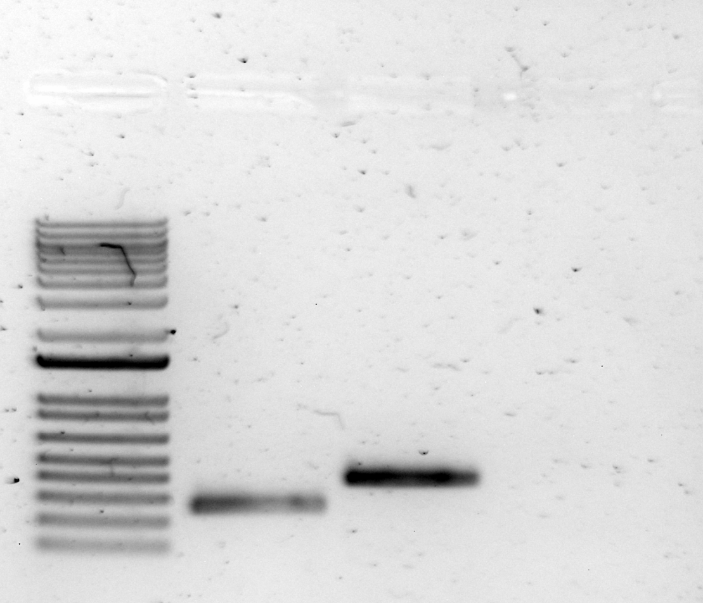
2: P_{rpsU3}

Figure 5. PCR of rpsU promoters for GFP fusion plasmids.

Use PCR cleanup kit, purify PCRs 1 and 2, elute each in 35 uL 0.1x EB. Want to check on the Nanodrop, so check concentrations.
Sample ID | Nucleic Acid | Unit | A260 (Abs) | A280 (Abs) | 260/280 | 260/230 | Sample Type | Factor
PCR1 PrpsU1 | 131.2 | ng/µl | 2.624 | 1.38 | 1.9 | 27.99 | DNA | 50
PCR2 PrpsU3 | 184.1 | ng/µl | 3.682 | 1.961 | 1.88 | 7.32 | DNA | 50
Looks good, no issues with Nanodrop today. Freeze purified PCRs and set up digest tomorrow.

Start cells O/N for future TAP purification. Supplement 500 mL of MH broth in baffled flasks.
Number | Cells | OD600 | vol cells | vol media | dilution factor | Actual OD600 | For 0.003 in 500 mL
1 | LVS pKR72 | 0.196 | 25 | 975 | 40 | 7.84 | 191.3
2 | LVS pF | 0.247 | 25 | 975 | 40 | 9.88 | 151.8
Started cells at ~3pm.
Thursday, August 25, 2022

To Do:
- Harvest LVS pKR72 (bS21-TAP) cells
- Digest PCR products for GFP reporter plasmids (pKR153 and pKR154)
- Run gel of digests for GFP reporter plasmids (pKR153 and pKR154)
- Gel-purify for GFP reporter plasmids (pKR153 and pKR154)
- Ligate for GFP reporter plasmids (pKR153 and pKR154)
Results and Data:
bS21-TAP
Check on O/N cultures for TAP purification at ~9:15 am.
Number | Cells | OD600
1 | LVS pKR72 | 0.373
2 | LVS pF | 0.481
Spin down cells in TX-1000 rotor, 1 L bottles at 3108rpm, 2257xg for 20 mins, after splitting each sample into two bottles. Should have split into two in 250 mL tubes and used fixed-angle rotor so could spin faster. OOPS! It was just on the cool-down run. Cells look mostly pelleted, so give them 5’ more spin at max speed. Remove supernatants, leave a bit, transfer to 50ml conical. Spin down 5’ at max speed in rotor for conical tubes. Discard supernatants, freeze pellets at -80°C.

Cloning pKR153 and pKR154
Set up digests of PCR products to make pKR153 and pKR154.
 | 1  PCR 1 P_{rpsU1} | 2  PCR 2 P_{rpsU3} | pKR145 backbone
H₂O | 10.8 | 10.8 | 22.8
10x CSB | 3.0 | 3.0 | 3.0
DNA | 15.0 | 15.0 | 3.0
KpnI-HF | 0.6 | 0.6 | 0.6
NotI-HF | 0.6 | 0.6 | 0.6
Total | 30.0 | 30.0 | 30.0
Incubate in thermocycler for 1 hour at 37°C.
CIP backbone with new Quick CIP – add 1 uL, mix, incubate for 10 mins at 37°C, then put at 80°C for 2 minutes to inactivate the CIP.

Run digests (entire volume) on 1% agarose gel.
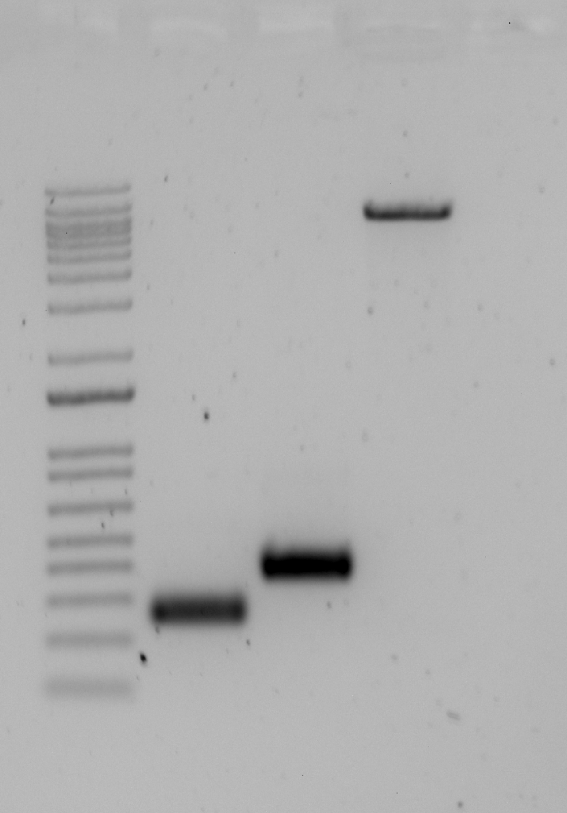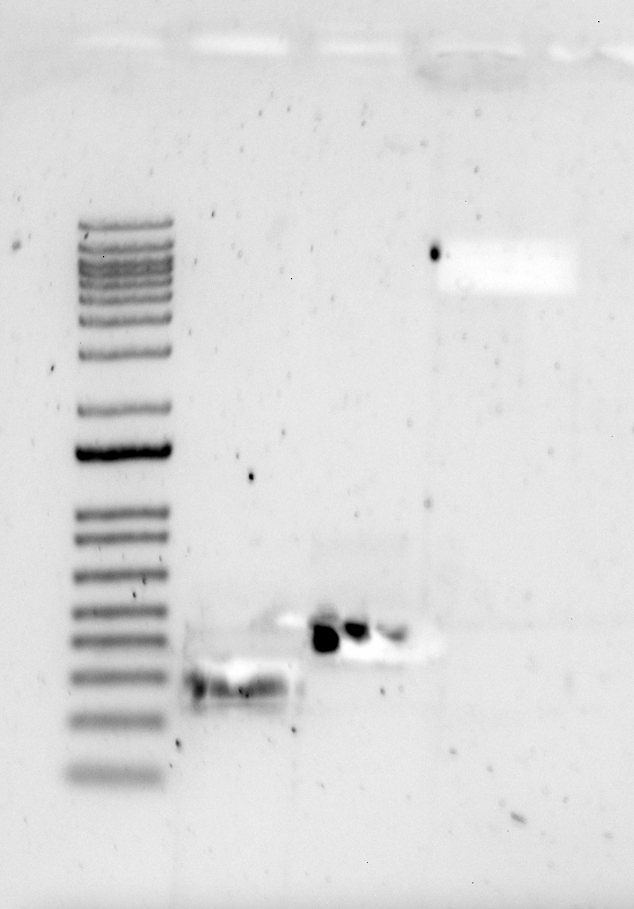
3: pKR145
1: P_{rpsU1}
2: P_{rpsU3}

Figure 6. Digest and gel purification of rpsU promoters for GFP fusion plasmids.
Cutting was tough, it’s not dark in the lab! Move forward with what I’ve got. Gel-purify slices, elute in 35 uL 0.1x EB.
Plan ligations:
Tube | Insert | Backbone
1 | NotI, KpnI digested, purified PCR1 | NotI, KpnI digested, purified pKR145
2 | NotI, KpnI digested, purified PCR2 | NotI, KpnI digested, purified pKR145
3 | - | NotI, KpnI digested, purified pKR145

Set up master mix table:
Component | Reaction 1 (uL) | Reaction 2 (uL) | Reaction 3 (uL) | Master Mix (3.5x)
H₂O | 11.5 | 11.5 | 15.5 | 40.25
10x ligase buffer | 2 | 2 | 2 | 7
Insert | 4 | 4 | - | -
Backbone | 2 | 2 | 2 | 7
Ligase | 0.5 | 0.5 | 0.5 | 1.75
TOTAL | 20 | 20 | 20 | -
Add 4 uL of either DNA (insert, reactions 1&2) or water (reaction 3) to 16 uL of master mix in 0.2 mL PCR strip tubes. Incubate at 16°C O/N in thermocycler.

Friday, August 26, 2022

To Do:
- Transform XL1 Blue E. coli with ligations for GFP reporter plasmids (pKR153 and pKR154)
- Start TAP purification?
Results and Data:
Transform ligations
Tube number | Purpose | DNA | Volume of DNA | Final volume to plate | Number of kanamycin-containing plates
1 | pKR153 | Ligation 1 | 8 uL | 100 uL, remaining | 2
2 | pKR154 | Ligation 2 | 8 uL | 100 uL, remaining | 2
3 | backbone control | Ligation 3 (backbone only) | 8 uL | remaining | 1
4 | (+) control | pKR145 | 1 uL | 20 ul, 100 ul | 2
Total number of plates |  |  |  |  | 7

Add DNA to sterile tubes for transformation as indicated above. Thaw chemically competent XL1 blue cells on ice. Transfer 100 uL of cells to each transformation tube. Incubate on ice for 20’. Heatshock at 42°C for 30”. Put tubes on ice, add 1 mL LB, recover in shaking incubator (set at 30°C today) for ~1 hour.
Plate as indicated above. Put all plates at 37°C O/N at 1pm, except for pKR145 20 uL- put that at 30°C to see if there are single colonies by Sunday night at 30°C.

Saturday, August 27, 2022

To Do:
- Pull transformation plates from 37°C incubator

Sunday, August 28, 2022

To Do:
- Pick colonies for GFP reporter plasmids (pKR153 and pKR154)
Results and Data:
Transformation results (~4pm)
Tube number | Purpose | DNA | 20 uL | 100 uL | Remaining
1 | pKR153 | Ligation 1 | - | 0 | 3
2 | pKR154 | Ligation 2 | - | 0 | 1
3 | backbone control | Ligation 3 (backbone only) | - | - | 0
4 | (+) control | pKR145 | 2 | 14 | -
Had the pKR145 remaining plate at 30°C since Friday at ~2pm. Single colonies present. Had other plates at 37°C O/N, left on bench until today. Start O/N cultures of all colonies from ligations 1 and 2, plus two of pKR145.

Monday, August 29, 2022

To Do:
- Miniprep for GFP reporter plasmids (pKR153 and pKR154)
- Send miniprep plasmids to sequence
Results and Data:
Pellet cells to miniprep. Check out pellet colors! Looks like I probably have at least pKR154!
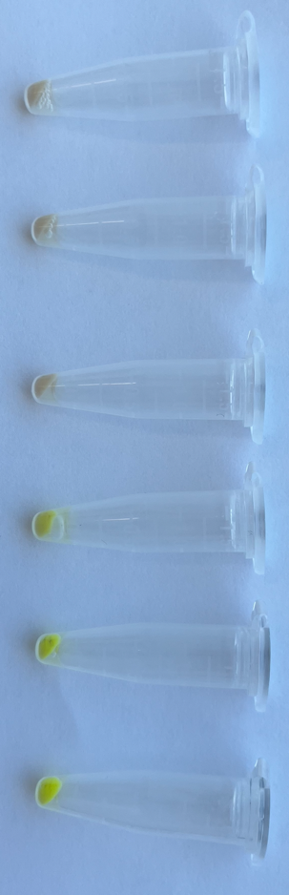
pKR145
pKR145
2-1
1-3
1-2
1-1

Figure 7. Pellets of cells to miniprep for potential GFP fusion plasmids.
Finish miniprep, elute in 50 uL 0.1x EB.
Check concentration by Nanodrop:
Sample ID | Nucleic Acid | Unit | A260 (Abs) | A280 (Abs) | 260/280 | 260/230
pKR153-1 | 426.7 | ng/µl | 8.534 | 4.543 | 1.88 | 2.45
pKR153-2 | 345 | ng/µl | 6.899 | 3.677 | 1.88 | 2.5
pKR153-3 | 365.8 | ng/µl | 7.317 | 3.914 | 1.87 | 2.48
pKR154-1 | 362.9 | ng/µl | 7.258 | 3.937 | 1.84 | 2.33
pKR145a | 265.2 | ng/µl | 5.304 | 2.846 | 1.86 | 2.52
pKR145b | 333.3 | ng/µl | 6.666 | 3.563 | 1.87 | 2.49
All look good! Send to sequence with KROL525 (HT used this to sequence pKR145 recently).
Delivered samples to Janet in INBRE.
Sample number | Template Type | Template Name |  | Primer Nameª | A. | B. | E. | F.
 | (plasmid or PCR) |  |  |  | Template Size (bases) | Template Stock Conc. (ng/μl) | PLASMID template: | Volume H₂O needed
 |  |  |  |  |  |  | Volume =
 |  |  |  |  |  |  | 2x(~200 ÷ B)μl | (12 less E - 2.56)μl
KR1 | Plasmid | 153-1 |  | KROL525 | 7800 | 426.7 | 0.94 | 8.50
KR2 | Plasmid | 153-2 |  | KROL525 | 7800 | 345 | 1.16 | 8.28
KR3 | Plasmid | 153-3 |  | KROL525 | 7800 | 365.8 | 1.09 | 8.35
KR4 | Plasmid | 154-1 |  | KROL525 | 7800 | 362.9 | 1.10 | 8.34
a.Add 2.56 μl of 2.5 μM stock to each reaction
Tuesday, August 30, 2022

To Do:
- COP retreat
- Sierra struck out LVS for me
Wednesday, August 31, 2022

To Do:
- Make EC LVS cells
- Electroporate LVS with pKR153 and pKR154
- Plate electroporations
Results and Data:
Sequencing results back- pKR153 confirmed, combine all three plasmid preps. The pKR154 isn’t confirmed yet- Janet thinks there may have been a problem with the instrument and will re-run tomorrow. Be optimistic and move forward with it anyway.

Sierra plated two lawns for EC cells; one of them has a point of contamination and the other looks like it might. Nervous about using them, so loot from JW’s old freezer boxes for now.
EP Cells Plasmid vol DNA (uL) time constant
1 LVS pKR153 3 4.6
2 LVS pKR154 3 4.4
3 LVS pF 3 4.5
4 LVS - 3ul 0.1xEB 4.3
Electrocomp LVS from Jamie W’s electropcomp cells box, tubes labeled 8-13 (undocumented year)
1:30pm – 3pm (~1.5 hours). Plated 20 uL and 200 uL.

Thursday, September 1, 2022

To Do:
- Start TAP purification
Results and Data:
Purify bS21-2-TAP from samples harvested on 8/25, use modified TAP protocol to IP, capturing Protein A moiety on IGG beads. Buffers:
Buffer A + PI +BB (modified Buffer 1)
Final composition | Stock solutions | For 10 mL
20 mM KHEPES pH 7.9 | 1 M KHEPES | 200 uL
10 mm MgCl₂ | 1 M MgCl₂ | 100 uL
10 mM NH₄Cl | 1 M NH₄Cl | 100 uL
0.5 mM DTT | 0.5 M DTT | 10 uL
1X Bug Buster | 10X Bug Buster | 1 mL
10% glycerol | 75% glycerol | 1.33 mL
Water |  | 7.26 mL
 | + 1 tablet protease inhibitor

Buffer B (modified buffer IPP150)
Final composition | Stock solutions | For 25 mL
20 mM KHEPES pH 7.9 | 1 M KHEPES | 500 uL
10 mm MgCl₂ | 1 M MgCl₂ | 250 uL
50 mM NH₄Cl | 1 M NH₄Cl | 1250 ul
0.1% NP-40 | 10% NP-40 | 250 uL
Water |  | 22.75
*needs to be compatible with TEV!
TEV Cleavage Buffer MOD
Composition | Stock solutions | For 30 mL
20 mM KHEPES pH 7.9 | 1 M KHEPES | 600 uL
10 mm MgCl₂ | 1 M MgCl₂ | 300 uL
50 mM NH₄Cl | 1 M NH₄Cl | 1500 uL
0.1% NP40 | 10.00% | 300 uL
1 mM DTT | 0.5 M | 60 uL
 | Water | 27.24 mL

- Resuspend samples in 4.5 mL Buffer A + PI + BB by pipetting with 5 mL pipette. Be sure no clumps remain
- Add 10 uL DNase I (Lucigen/Epiceter), mix by pipetting
- Incubate at 37°C for 30’. Cool down centrifuge while waiting.
- Spin 50 mL conical tubes at 4°C for 20’ at max speed (14635xg).
- Transfer lysates into new 50 mL conical tubes, leaving behind insoluble material at bottom (okay to leave some behind; better than taking too much)
- Filter-sterilize lysates using 30mL syringe and syringe filter into new 50mL conical tube. Specifically, pull plunger out from 30mL syringe, thread tip of syringe onto syringe use filter (use MillexGP 0.22 micrometer filter, has 33mm diameter), pour/pipette lysate into syringe, insert plunger and recover filtered lysate into new (nonsterile) 50mL conical tube
- Obtain a good estimate of sample volume using pipette.
- Adjust buffer concentration to buffer B by adding to each sample:
50 uL 1M NH₄Cl / mL sample -> __ uL for final 50 mM NH₄Cl
10 uL 10% NP-40 /mL sample -> __ uL for final 0.1% NP-40
Sample 1: 4.5 mL
225 uL for final 50 mM NH₄Cl
45 uL for final 0.1% NP-40
Sample 2: 4 mL
200 uL for final 50 mM NH₄Cl
40 uL for final 0.1% NP-40
- Remove 50 uL into microfuge tube for control analysis (LYS).
In cold room
- Cut tip of 1mL pipette tip slightly
- Resuspend IgG Sepharose beads completely
- Pipette 200 uL IgG Sepharose beads into each column, placing column on top of Qiagen tip holder placed on 50 mL conical for flow-through
- Wash beads with 10 mL of buffer B
- When all the buffer B has passed through the column, cap the bottom of the column
- Add 1 sample per polyprep column, add top cap to close column (make sure column is closed completely and is not dripping liquid)
- Incubate samples with beads, rocking at 4°C, for 2 hours (2:34pm)
- During incubation, prepare:
  - TEV Cleavage Buffer MOD for this set of purifications, ~13 mL per purification
  - Make more :
Buffer B (modified buffer IPP150)
Final composition | Stock solutions | For 150 mL
20 mM KHEPES pH 7.9 | 1 M KHEPES | 3 mL
10 mm MgCl₂ | 1 M MgCl₂ | 1.5 mL
50 mM NH₄Cl | 1 M NH₄Cl | 7.5 mL
0.1% NP-40 | 10% NP-40 | 1.5 mL
Water |  | 136.5 mL

- After 2 hour incubation, open columns and let lysate pass through column.
- Save 50 uL aliquot of flow through in microfuge tube (FT1), discard remaining.
- Wash columns 3x with 10 mL buffer B, discarding flow through
- Wash columns with 10 mL TEV Cleavage buffer MOD, discarding flow through
- Cap column bottoms, add 1 mL TEV Cleavage buffer MOD and 10 uL AcTEV Protease to each.
- Incubate rocking at 4°C overnight- make sure columns are closed completely and are not dripping liquid.
Remainder of protocol FOR TOMORROW:
- Recover TEV eluates by gravity flow (1 ml)
- Rinse each column with additional 200 ul of TEV Cleavage Buffer MOD

Friday, September 2, 2022

To Do:
- Check on EP plates
- Finish TAP purification
- Check pKR154 sequencing results
Results and Data:
TAP purification continued:
- Recover TEV eluates by gravity flow (1 ml)
- Washed columns with 200 uL TEV Cleavage Buffer MOD to get beads to the bed.
- Rinse each column with additional 200 ul of TEV Cleavage Buffer MOD.
- Keep samples at 4°C.

EP plates look good- clearly see pinpoint colonies!

Check second run of pKR154 sequencing. Sequence is correct, have pKR154! Put in appropriate boxes.

Saturday, September 3, 2022

To Do:
- Patch out LVS pKR153 and LVS pKR154
- Run gel of purified proteins
- Stain gel with purified proteins (silver)
Results and Data:
Gel to assess modified TAP purification. Use the remainder of the E2A purification from 10/22/20.
Combine elutions 1:1 with 2x SLB.
4-12% MES, 15 well
Lane | Volume | Contents
1 | 10 uL | Benchmark ladder 1:10
2 | 10 uL | E2- LVS pF
3 | 10 uL | E1- LVS pF-rpsU2-TAP
4 | 10 uL | Ribosomes diluted 1:10
5 | 10 uL | Benchmark ladder 1:10
6 | 5 uL | E2- LVS pF
7 | 5 uL | E1- LVS pF-rpsU2-TAP
8 | 10 uL | Ribosomes diluted 1:100
9 | 5 uL | E2A: LVS pF-rpsU-TAP (10/22/20 purification)
10 | 5 uL | Ribosomes diluted 1:10
Ribosome from 3/22/2019 (26.7 ug/ul): For today, dilute 2 ul into 23 ul 1xSLB (~2.1 ug/ul) and dilute further as indicated.
Run at 120 V for 50 min. Yellow dye and blue dye are visible at bottom of gel.
Use SilverQuest kit to stain.
E1A old: LVS pF-rpsU2-TAP
E2: LVS pF
E1: LVS pF-rpsU2-TAP
LVS ribosomes
1:100, 10 uL
Benchmark ladder
LVS ribosomes
1:10, 10 uL
Benchmark ladder
E1: LVS pF-rpsU2-TAP
LVS ribosomes
1:10, 5 uL
E2: LVS pF

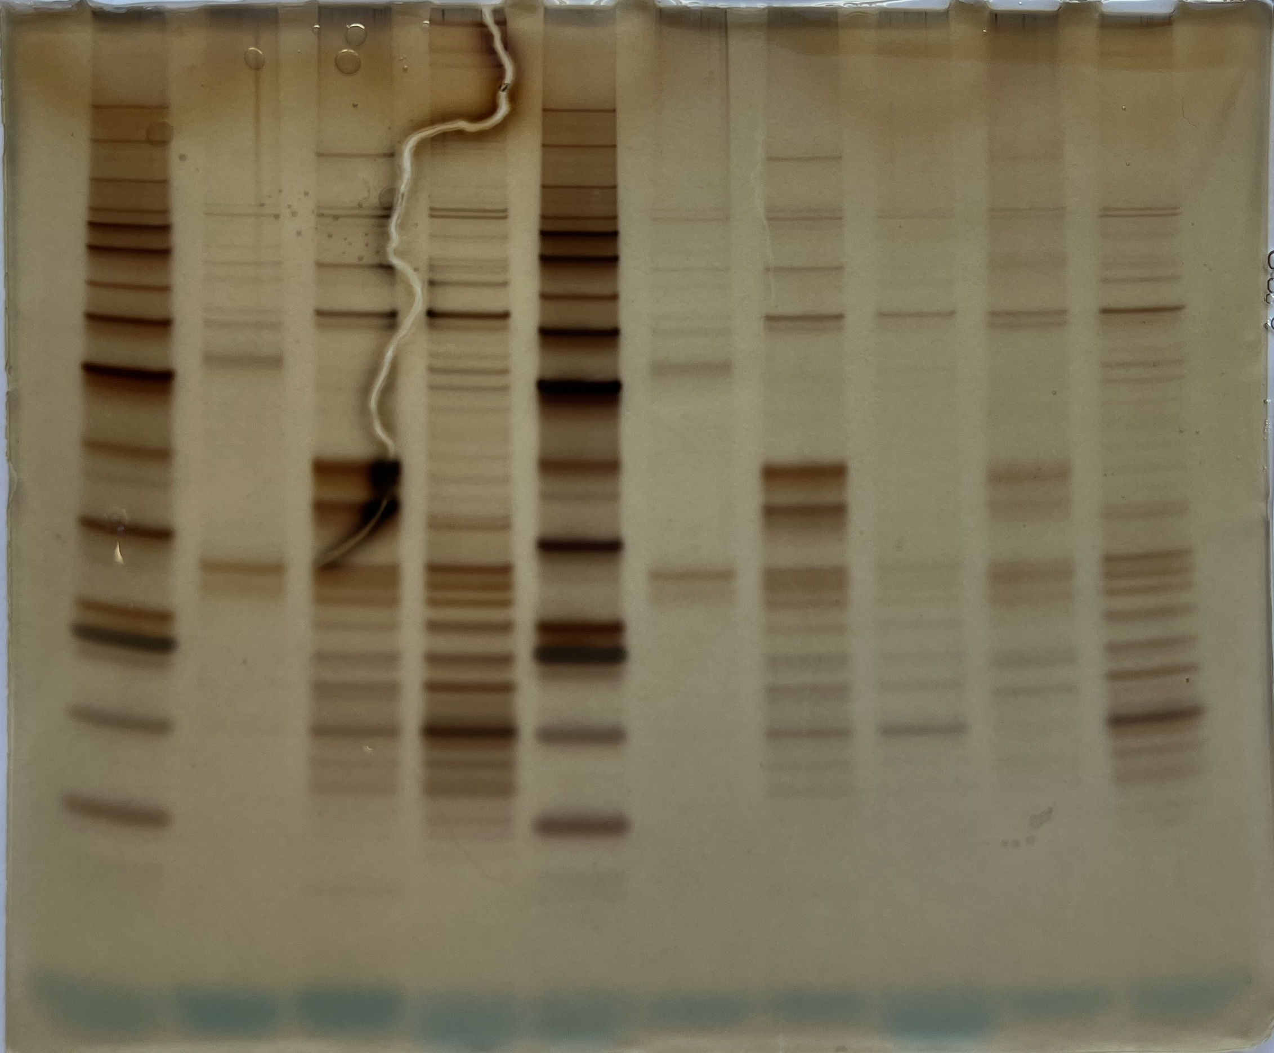
???
40
S1: 62 kDa
60
50
bS21-2 with CBP?? 12.8 kDa
10
15
20
25
30

Figure 8. bS21-2-TAP purification from 9/2/22.
bS21-2 with the CBP moiety should be 12.76 kDa. Can see S1. There seem to be some lower bands missing- is this only the 30S and not the 50S? And what is between 30kDa and 40kDa? Not something from the purification, because it’s not appearing in the LVS pF control.

Looks pretty good, but I should send to mass spec to see what is actually there. Where to send?

These are the ribosomal proteins purified from our previous mass spec, in ascending size order:
Molecular Weight (kDa) | Gene Locus | Gene Name | Protein
5 | FTL_0175 | rpmH | 50S ribosomal protein L34
6 | FTL_0521 | rpmG | 50S ribosomal protein L33
7 | FTL_1143 | rpmF | 50S ribosomal protein L32
7 | FTL_0254 | rpmD | 50S ribosomal protein L30
7 | FTL_1405 | rpmI | 50S ribosomal protein L35
8 | FTL_0244 | - | 50S ribosomal protein L29
8 | FTL_1025 | rpsR | 30S ribosomal protein S18
8 | FTL_1303 | rpmE | 50S ribosomal protein L31
8 | FTL_1047 | rpsU2 | 30S ribosomal protein S21-2
8 | FTL_0456 / FTL_1360 | rpsU1 / rpsU3 | 30S ribosomal protein S21
9 | FTL_0522 | rpmB | 50S ribosomal protein L28
9 | FTL_1738 | rpsP | 30S ribosomal protein S16
9 | FTL_1452 | rpmA | 50S ribosomal protein L27
10 | FTL_1538 | rpsO | 30S ribosomal protein S15
10 | FTL_0240 | rpsS | 30S ribosomal protein S19
10 | FTL_0245 | rpsQ | 30S ribosomal protein S17
10 | FTL_0070 | rpsT | 30S ribosomal protein S20
11 | FTL_0247 | rplX | 50S ribosomal protein L24
11 | FTL_0950 | - | 50S ribosomal protein L25
11 | FTL_0238 | rplW | 50S ribosomal protein L23
12 | FTL_0249 | rpsN | 30S ribosomal protein S14
12 | FTL_0235 | rpsJ | 30S ribosomal protein S10
12 | FTL_0241 | rplV | 50S ribosomal protein L22
12 | FTL_1453 | rplU | 50S ribosomal protein L21
13 | FTL_1745 | rplL | 50S ribosomal protein L7/L12
13 | FTL_0246 | rplN | 50S ribosomal protein L14
13 | FTL_0252 | rplR | 50S ribosomal protein L18
13 | FTL_1735 | rplS | 50S ribosomal protein L19
13 | FTL_0258 | rpsM | 30S ribosomal protein S13
13 | FTL_1404 | rplT | 50S ribosomal protein L20
13 | FTL_1024 | rpsF | 30S ribosomal protein S6
14 | FTL_0250 | rpsH | 30S ribosomal protein S8
14 | FTL_0259 | - | 30S ribosomal protein S11
14 | FTL_0232 | rpsL | 30S ribosomal protein S12
15 | FTL_1186 | rpsI | 30S ribosomal protein S9
15 | FTL_1748 | rplK | 50S ribosomal protein L11
15 | FTL_0255 | rplO | 50S ribosomal protein L15
16 | FTL_1026 | rplI | 50S ribosomal protein L9
16 | FTL_1187 | rplM | 50S ribosomal protein L13
16 | FTL_0243 | rplP | 50S ribosomal protein L16
17 | FTL_0262 | rplQ | 50S ribosomal protein L17
18 | FTL_0253 | rpsE | 30S ribosomal protein S5
18 | FTL_0233 | rpsG | 30S ribosomal protein S7
19 | FTL_1746 | rplJ | 50S ribosomal protein L10
19 | FTL_0251 | rplF | 50S ribosomal protein L6
20 | FTL_0248 | rplE | 50S ribosomal protein L5
22 | FTL_0236 | rplC | 50S ribosomal protein L3
23 | FTL_0260 | rpsD | 30S ribosomal protein S4
23 | FTL_0237 | rplD | 50S ribosomal protein L4
25 | FTL_0242 | rpsC | 30S ribosomal protein S3
25 | FTL_1747 | rplA | 50S ribosomal protein L1
26 | FTL_0224 | rpsB | 30S ribosomal protein S2
30 | FTL_0239 | rplB | 50S ribosomal protein L2
62 | FTL_1912 | rpsA | 30S ribosomal protein S1

Patch out LVS pF, LVS pKR153, LVS pKR154, four patches each (A-D) and put at 37°C O/N.
Electroporation plates look great:
EP Cells Plasmid 20 uL plate 200 ul plate remaining plate
1 LVS pKR153 22 >100 -
2 LVS pKR154 17 >100 -
3 LVS pF ~80 >100 -
4 LVS - ~4 pinprick-sized ~50? Pinprick sized

Good reminder that Kan selection isn’t perfect- LVS will start growing on kan plates if left long enough- not genetically resistant. Can see some pinprick-sized colonies on the transformations with plasmid DNA, probably background just like on negative control.

Patch out LVS pF, LVS pKR153, LVS pKR154, four patches each (A-D) and put at 37°C O/N.

Sunday, September 4, 2022

To Do:
- Freeze down LVS pKR153 and LVS pKR154
Results and Data:
Words

Future To-Do

Check on plasmids that might restore growth to ∆rpsU1∆rpsU2 cells (Hannah’s gDNA insert screen, Oli’s Fall 2021 project).

Move 1° LVS pKR10-1 into strain box

Bibliography

Suh, Moo-Jin et al. “Extending ribosomal protein identifications to unsequenced bacterial strains using matrix-assisted laser desorption/ionization mass spectrometry.” Proteomics vol. 5,18 (2005): 4818-31. doi:10.1002/pmic.200402111

