Table of Contents
June 2022 2
Lab goals 2
Future To-Do 6

June 2022

Lab goals
PmrA / PriM
Re-do macrophage assay with ∆pmrA strains
Isolate gDNA from ∆pmrA experiment in (April?) and check by qPCR

Monday, June 20, 2022

To Do:
- Plan
Results and Data:

Notes from last summer and the ∆pmrA strains:
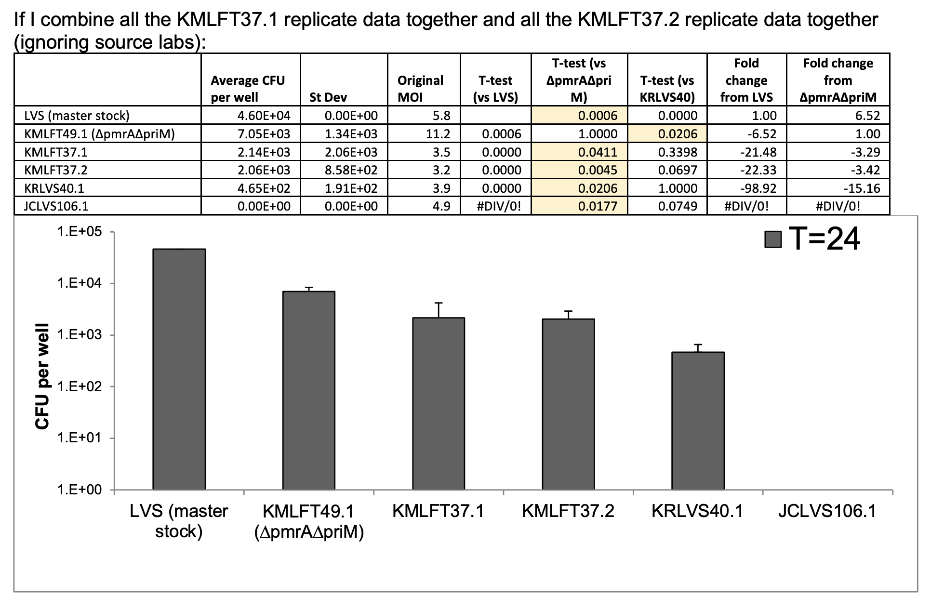
Based on these data, I should re-check the phenotypes of:
LVS WT
KMLFT37 ∆pmrA
KRLVS40.1 ∆pmrA
KMLFT49 ∆pmrA∆priM
JCLVS106 ∆pigR
I also would like to use a method that doesn’t depend on lysing macrophage cells. Ideally, I would dissociate the J774A.1 cells from the dishes and either (1) isolate total DNA or (2) check by flow cytometry. Or both.
I previously attempted to dissociate J774A cells using TrypLE Express (Invitrogen). This didn’t work (see notes 4/30/21). Based on extensive googling, it seems like enzymatic dissociation is not a great approach. Mini cell scrapers to remove cells from 96-well plates exist. Seems like trying 12-well plates and a normal cell scraper might be the way to go.

Need to plan
- the above standard macrophage experiment
- testing flow cytometry with gfp-expressing LVS
Friday, June 24, 2022

To Do:
- Thaw macrophage
- Pour plates for macrophage experiment
Results and Data:
Poured CHA plates for macrophage experiment next week.
Use | Round | Square | Notes
Patch strains for infections | 5 |  | 2x each, each 1/2 plate
Plate inoculums | 0 | 10 | 5 strains in duplicate
Timepoint 2 hours | 30 | 0 | Round: 5 strains x triplicate wells x duplicate
Timepoint 24 hours | 6 | 24 | Square: 4 strains x 3 wells x 2 plates; round: ∆pigR x 3 wells x 2 plates
Total plates | 41 | 34 | Round plates: 24 mL, 25 per flask; Square plates: 30 mL, 20 per flask
Flasks of 600 mL CHA | 1.64 | 1.7
Total number of CHA flasks | 3.34

Round up to 4 flasks, 50 round plates and 40 square plates. Needed to autoclave in CBLS because Avedisian autoclaves are not functioning.

Thaw J774A.1 cells, P5 aliquot. Supplement new 500 mL of DMEM with 50 mL FBS, but replace as soon as new DMEM comes in- this DMEM technically expired 5/30/22. Plate cells in 100 mm TC dish in 10 mL media and incubate at 37°C 5% CO2.

Sunday, June 26, 2022

To Do:
- Streak out strains
- Seed macrophage
- Start dishwasher
Results and Data:
Streak out cells for mac assay:
Strain Aliquot date
LVS 4/23/21
KMR37.1 4/2/21
KRLVS 4/23/21
∆pmrA∆priM 4/23/21
JCLV106 11/11/21
Plates @ 37°C by about 1:30pm.

Seed cells a bit early, planning on coming in early in the morning to start experiment (try to limit overlap with students).

Remove media, add back 10 mL media.
Scrape cells off plate.
Transfer cells to 15 mL conical
Spin 1,000xg for 5 minutes
Remove media, resuspend cell pellet in 6 mL using 5 mL pipet.
Check cell density:
combine 50 ul of cells with 50 ul of trypan blue.
Pipet 10 uL into single use hemocytometer
Count cells
1st measurement
16 | 17 | 26 | 36
Average |  |  |  | 23.75
Undiluted |  |  |  | 47.5
Density |  |  |  | 4.75E+05

Macrophage Calculations
Cells per well | 2.50E+04
Volume to plate (mL) | 0.2
Density needed (cells/mL) | 1.25E+05
Total volume needed (mL) | 12
Measured cells per ml | 4.75E+05
Volume stock needed (mL) | 3.2
Volume media for dilution | 8.8

Make appropriate dilution in sterile reservoir
Use multichannel to pipet 200 ul cells into each well, as indicated, for 2 x 96 well plates
 | 1 | 2 | 3 | 4 | 5 | 6 | 7 | 8 | 9 | 10 | 11 | 12
A | LVS | LVS | LVS |  | KMLFT37 | KMLFT37 | KMLFT37 |  | KRLVS40 | KRLVS40 | KRLVS40
B
C
D | ∆pmrA∆priM | ∆pmrA∆priM | ∆pmrA∆priM |  | ∆pigR | ∆pigR | ∆pigR
E
F
G
H

Plate remainder of cells in 100 mm TC dish.
Place all cells back in incubator, 37°C 5% CO₂ at ~3pm.
Check actual density of resuspension:
2nd measurement
1 | 4 | 10 | 9
3 | 5 | 0 | 6
3 | 6 | 6 | 7
Average |  |  |  | 5.00
Undiluted |  |  |  | 10
Density |  |  |  | 1.00E+05
Measured cells per ml, seeded |  |  |  | 1.00E+05
Measured cells per well |  |  |  | 2.00E+04

A bit lower than I’d like (aim for 2.5x10⁵)- I think cells were clumpy when I measured them the first time.

Monday, June 27, 2022

To Do:
- Infect macrophage
- Plate inoculums
- Plate T=2
- Order Wilkem items
  - Black and white 96-well plates
  - cuvettes
- Order more 100% ethanol
Results and Data:
Checked macrophage plates under microscope, look good. Bacteria on CHA plates have grown well, so continue with mac assay.

Prep 96-well plate with wells B1 – F5 with 180 ul sterile 1x PBS (multichannel).

Scrape up bacteria and resuspend in DMEMF. Check OD600 (100 uL in 900 uL DMEMF), dilute to OD600 of 0.04 in 1 mL, check OD600 again with 600 uL. Dilute cells to OD600 of 0.0004.
 |  |  | For final vol 1 mL at 0.04 |  | For final vol 4 mL at 0.0004
Number | Strain | Resuspend cells to (OD600) | Cells (uL) | OD600 | Cells (uL) | Volume media (uL)
1 | LVS | 3.32 | 12.0 | 0.037 | 10.8 | 989
2 | KMLFT37 | 3.07 | 13.0 | 0.036 | 11.1 | 989
3 | KRLVS40 | 1.52 | 26.3 | 0.045 | 8.9 | 991
4 | KMLFT49 | 1.88 | 21.3 | 0.042 | 9.5 | 990
5 | JCLVS106 | 2.16 | 18.5 | 0.037 | 10.8 | 989

Add 50 uL of appropriate cells to each well, as indicated, in each 96-well plate (2x).
 | 1 | 2 | 3 | 4 | 5 | 6 | 7 | 8 | 9 | 10 | 11 | 12
A | LVS | LVS | LVS |  | KMLFT37 | KMLFT37 | KMLFT37 |  | KRLVS40 | KRLVS40 | KRLVS40
B
C
D | ∆pmrA∆priM | ∆pmrA∆priM | ∆pmrA∆priM |  | ∆pigR | ∆pigR | ∆pigR
E
F
G
H

Put infected macrophage back at 37°C with 5% CO₂ at 8:30am.

Transfer 200 ul of each inoculum to wells A1 – A5, one per well.
Perform 10x serial dilutions down plate.
Plate each dilution 2x on square CHA plates using drip plate method, 10 uL at top. For inoculums 3 and 5, looked like drips on one plate reached bottom so re-do one plate. Put plates at 37°C.

From overnight plates used to make the inoculums, scrape up cells, put in sterile 1x PBS, pellet, and freeze at -20°C. May want to triple-check genotypes of the cells actually used in the assay in the future.

At 10:30am, wash macrophage twice with sterile 1x PBS and replace media with media containing 10 ug/mL gentamicin.
(13 mL)(10 ug/mL)/(50,000 ug/mL gent) = 2.6 uL

At 12:30pm, lyse macrophage and plate T=2 timepoint. Washed wells twice with sterile 1x PBS, replaced media with 1% saponin in 1X PBS, mixed 9x, incubated plates for 30 minutes, mixed 9x. Plated 50 uL on round plates, 2x for each well, spread with glass beads. Transfer plates to 37°C.

Check on tissue culture. P6 macrophage look good and media is still pretty pink- no need to feed yet.

Tuesday, June 28, 2022

To Do:
- T=24
- Plate out a single-use aliquots of GFP strain and LVS
- Seed plate with larger wells with macs for GFP

Results and Data:
At 10:30am, lyse macrophage and plate T=24 timepoint. Had prepped everything earlier so I could pop out of lab meeting and wash 2x with PBS and add 200 ul 1% saponin in 1x PBS. Incubate plates for about 30 minutes, mix 9x. Transfer 190ul of wells with samples 1 – 3 to top of one 96-well plate, samples 4 to top of second 96 well plate. Perform 10x serial dilutions. Plate 50 uL twice on round plates for all samples from ∆pigR (5). For remaining samples (1 – 4), plate undiluted plus 4 dilutions (dilution factor 1 – 0.0001) for each well 2x using track plate method (10 ul). Put plates at 37°C.

Check on P6 macrophage. Look good, will need to deal with (re: splitting or seeding) tonight. In the meantime, feed by removing media and replacing with 10 mL fresh DMEMF.

Don’t have coverslips for 12-well plates, so order poly-lysine treated coverslips. Hannah said that she imaged KRLVS113 (Tn7::GFP cells) under the microscope and could see individual fluorescent cells. Already have single-use aliquots, so plate those and some LVS out today.
Plan for some trial experiments:
Seed macrophage in two 12-well plates today – 4:30PM
Infect with LVS and LVS Tn7::GFP tomorrow
Scrape up cells and use confocal microscope to see if I can detect fluorescent bacteria in the cells! Scraping and mounting is far from perfect, but this will just be a trial run.

Seed macrophage:
Remove media, add back 10 mL media.
Scrape cells off plate.
Transfer cells to 15 mL conical
Spin 1,000xg for 5 minutes
Remove media, resuspend cell pellet in 6 mL using 5 mL pipet.
Check cell density:
combine 50 ul of cells with 50 ul of trypan blue.
Pipet 10 uL into single use hemocytometer
Count cells
1st measurement
42 | 53 | 80 | 69
Average |  |  |  | 61
Undiluted |  |  |  | 122
Density |  |  |  | 1.22E+06

Macrophage Calculations | 96 well | 12 well | ratio
Surface area (cm^2) | 0.32 | 3.8 | 11.875
Cells per well | 2.50E+04 | 2.97E+05 | 11.875
Volume to plate (mL) | 0.2 | 1
Density needed (cells/mL) | 1.25E+05 | 2.97E+05
Total volume needed (mL) |  | 16.0
Measured cells per ml |  | 1.22E+06
Volume stock needed (mL) |  | 4.0
Volume media for dilution |  | 12.0

Adjusted upwards slightly- calculated needed 3.93 mL, so round up to 4 mL.
Make appropriate dilution in 50 mL conical (can’t use 15 mL bc making up 16 mL!)
Use 5 mL pipet to add 1 mL per well as indicated, for 2 x 12 well plates
 | 1 | 2 | 3 | 4
A | LVS |  | KMRLVS113
B | LVS |  | KMRLVS113
C | LVS |  | KMRLVS113
 | # | Strain | Strain Number
 | 1 | LVS | -
 | 2 | LVS Tn7::GFP | KRLVS113

Combine 1 mL of resuspended cells (1.22x106) with 9 mL DMEMF, plate in 100 mm TC dish.
Place all cells back in incubator, 37°C 5% CO₂ at ~4:30pm.
Check actual density of resuspension:
2nd measurement
18 | 10 | 15 | 13
10 | 23 | 19 | 17
27 | 14 | 13 | 12
Average |  |  |  | 15.9167
Undiluted |  |  |  | 31.8333
Density |  |  |  | 3.18E+05
Measured cells per ml, seeded |  |  |  | 3.18E+05
Measured cells per well |  |  |  | 3.18E+05

A bit higher than I’d aimed for (aim for 2.97x10⁵), but should be fine.

Wednesday, June 29, 2022

To Do:
- Infect larger plates with GPF-expressing cells
- Wash bacteria off macrophage
- Scrape macrophage out of wells (1 plate) and check on microscope with MMR
- Isolate RNA with Sierra
- Order
  - Rainin tips
  - Cuvettes (wilkem)

Results and Data:
GFP trial run infection:
Checked macrophage plates under microscope, look good. Bacteria on CHA plates have grown well, so continue with mac assay.
Since I’m infecting a 12-well plate, the calculations for the inoculum are a bit different AND I’m going to go with a higher MOI, MOI of 20, to increase the chances that I’ll easily find macrophage with bacteria after infection in this trial run.
Bacterial Calculations | 96well | 12 well
MOI | 5 | 20
Macrophage cells per well | 3.18E+05 | 3.18E+05
Volume bacteria to add (mL) | 0.05 | 0.1
Bacterial density needed (cells/mL) | 3.18E+07 | 6.37E+07
Cells/mL per OD600 | 5.81E+09 | 5.81E+09
OD needed for given density | 0.00548 | 0.01096
Resuspend to |  | 0.1
Final MOI 20, dilute 1:10 |  | 0.01
Note that I’ll be infecting with a smaller relative volume of bacteria so that also increases the relative density of the inoculum.

Scrape up bacteria and resuspend in DMEMF. Check OD600 (100 uL in 900 uL DMEMF), dilute to OD600 of 0.1 in 1 mL, check OD600 again with 550 uL.
 |  |  |  |  |  | For final vol 1 mL at goal OD
Number |  | Strain |  | Resuspend cells to (OD600) (Tube R) |  | Cells (uL) |  | Media (uL) | OD600  (Tube D)
1 |  | LVS |  | 2.9 |  | 34.5 |  | 965.5 | 0.09
2 |  | LVS Tn7::GFP |  | 4.12 |  | 24.3 |  | 975.7 | 0.099
 | Resuspension Goal OD: |  | 0.1 |  | Adjusted Final Goal OD (MOI 20):
 | Final Goal OD (MOI 20): |  | 0.01 |  | 0.009

While prepping this trial run experiment, I don’t think I need everything in triplicate. Instead, I should leave a well uninfected and maybe try an even higher MOI. So, change plan while prepping inoculum:
 | 1 | 2 | 3 | 4
A | LVS MOI 200 |  | LVS GPF MOI 200
B | LVS MOI 20 |  | LVS GPF MOI 20
C | Uninfected |  | LVS GPF MOI 20

So, make final inoculum dilutions and adjust goals for “inoculum” (MOI 20) to be 0.009 instead of 0.01.
Number | Strain | OD600 | Volume to dilute in 500 uL (~ 1:10  (Tube I))
1 | LVS | 0.09 | 50.00
2 | LVS Tn7::GFP | 0.099 | 45.50

For two 12-well plates:
Well Strain Tube OD600 Volume
A1 LVS 1D 0.09 100 uL
B1 LVS 1I 0.009 100 uL
C1 N/A Media - 100 uL
A3 LVS GFP 2D 0.099 91 uL
B3 LVS GFP 2I 0.009 100 uL
C3 LVS GFP 2I 0.009 100 uL

*This change in plans was on the fly and I likely didn’t execute perfectly. It’s possible that A1 got 91 uL instead of A3. And I had to re-make the LVS GFP inoculum (2I) because I didn’t anticipate needing 400 uL. But again, this is just a trial run. Let’s see what is visible!

Put infected macrophage back at 37°C with 5% CO₂ at 8:00am.

At 10:00am, wash macrophage twice with sterile 1x PBS. For one plate, keep in 1xPBS and scrape up wells for visualization. For other plate, replace media with media containing 10 ug/mL gentamicin.
(10 mL)(10 ug/mL)/(50,000 ug/mL gent) = 2.0 uL

Visualized cells
Matthew Ramsey helped- not a microscope demo, he drove and assisted imaging single macrophage with LVS Tn7::GFP in them.

Notes: when imaging the GFP bacteria alone, the signal bleached extremely quickly. Seemed to bleach less quickly when imaging with macrophage (?).
Image 1 (1 infected macrophage)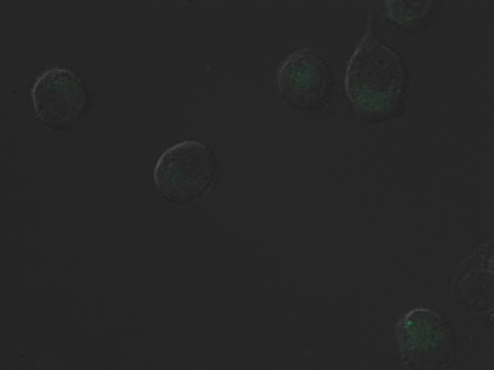
Image 2 (no bacteria)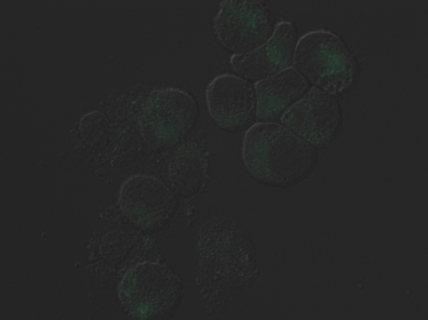
Image 3 (2 macrophage with bacteria)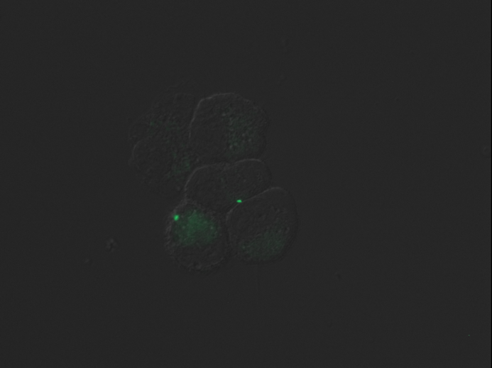
Image 4 (2 macrophage with bacteria)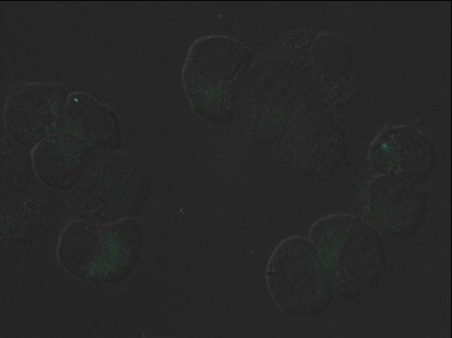
Image 5 (2 infected macrophage, one with 2 bacteria- one is out of focus) 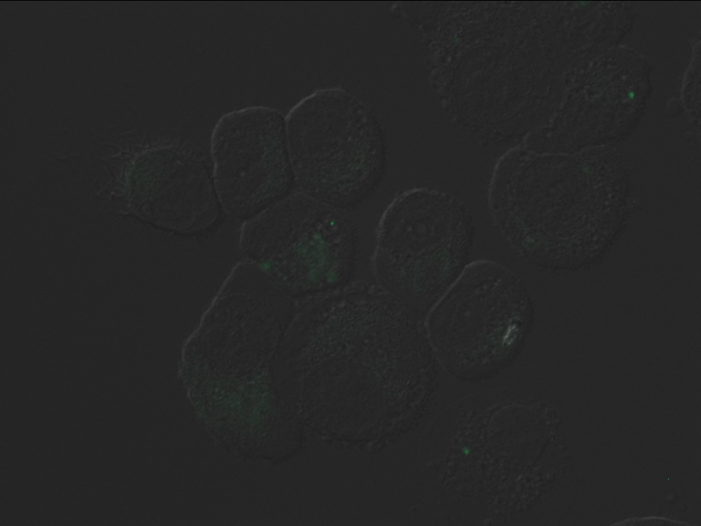

Design primers to check large deletion reported in WGRS from inducible bS21 strains. This deletion is theoretically 3,914 bp. Actually, after working on this a bit, it looks like it’s not deleted, but that what is a duplicated region in LVS is only a single copy in the other strains.
Annotated in LVS:
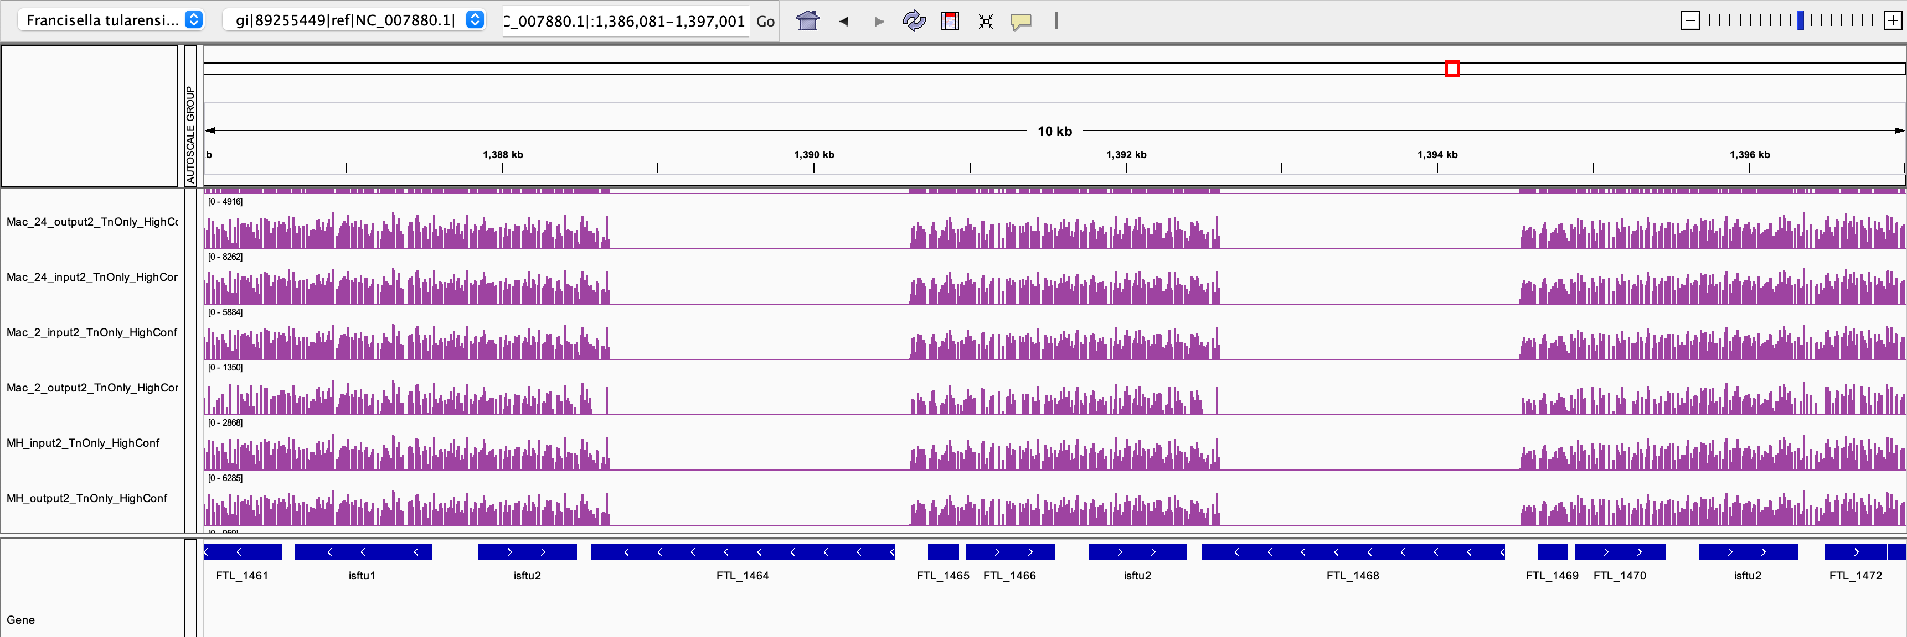FTL_1464 is the same as FTL_1468
FTL_1465 is the same as FTL_1469
FTL_1466 is the same as FTL_1470
There is an isftu2 region replicated on either side and in the middle.
630 bp corresponding to annotated isftu2 is exactly replicated on left side and in middle.
621 bp of isftu (lacking part of 3’ end) are found 5 times in genome- less corresponds to 2, more corresponds to more locations. Eg: 593 bp of isftu (lacking part of 3’ end) are found 30 times in genome
Just to highlight that it’s not entirely unique to this region.

So the question becomes- is the original genome annotation with a replicated region accurate or is it a mistake?
Prepare the following:
Set | Primers | Description | If 1 copy | If 2 copies
1 | KROL526, KROL527 | Amplify inside of deletion, from FTL_1464 – FTL_1465 (and FTL_1468 – FTL_1469) | 351 bp | 351 bp
2 | KROL528, KROL529 | Amplify inside FTL_1464 (/FTL_1468) | 428 bp | 428 bp
3 | KROL526, KROL529 | Amplify from FTL_1464, across FTL_1465, FTL_1466, isftu2, into FTL_1468 | 3231 bp | 0

Well, that was poorly designed! Should have a reverse primer in the 5’ region of FTL_1468 and a forward primer in the 3’ region of FTL_1466.

Make more.

Insertion check
LVS 281
Insertion 374 (maybe can cut with BglII?)

Friday, July 1, 2022

To Do:
- Count plates

Results and Data:

Turns out the incubator has been broken- it’s reading 37°C but only holding about 30°C, which is why my plates have grown terribly (was worried I’d done a poor job with making the master dry CHA mix!)
Can count pretty much all of them today – some are pretty darn small, so double-check counts on Monday.

It is absolutely wild how poorly the ∆pmrA strain used to grow for me in macrophage compared to these results. Is it because we now lyse for 30 minutes instead of just 5 minutes? I may need to test this.

Going way back to testing lysis by saponin in 2016 (Lab notebooks 18 and 19):
Data from 11/11/16, Notebook 19 page 12
Time | 0 | 5 | 10 | 15 | 20 | 30 | 40 | 50 | 60
Replicate 1 |  | 122 | 60 | 72 | 44 | 116 | 90 | 94 | 50
Replicate 2 |  | 58 | 26 | 98 | 42 | 90 | 118 | 108 | 34
Average | 185000.00 | 90.00 | 43.00 | 85.00 | 43.00 | 103.00 | 104.00 | 101.00 | 42.00
St Dev | 21984.84 | 45.25 | 24.04 | 18.38 | 1.41 | 18.38 | 19.80 | 9.90 | 11.31

This is with LVS. There is substantial variability in early timepoints, then some drop off in colony counts after an hour (suggesting killing of the bacteria?).

Why would bacterial cells without PmrA be less likely to be released from saponin-treated macrophage?

Future To-Do

Move 1° LVS pKR10-1 into strain box

Bibliography

Suh, Moo-Jin et al. “Extending ribosomal protein identifications to unsequenced bacterial strains using matrix-assisted laser desorption/ionization mass spectrometry.” Proteomics vol. 5,18 (2005): 4818-31. doi:10.1002/pmic.200402111

