Table of Contents
January 2022 2
Lab goals 2
Future To-Do 3

January 2022

Lab goals
PmrA / PriM
Re-do macrophage assay with ∆pmrA strains
Isolate gDNA from ∆pmrA experiment in (April?) and check by qPCR

Saturday, January 15, 2022

To Do:
- Streak out chaC related cells
- Check glycerol stocks

Results and Data:
To confirm phenotypes, streak out the following cells on CHA:

Strain Number | Description | Expected colony phenotype
- | LVS | Normal
KMLFT114 | LVS ∆chaC | Mucoid
8-3 | LVS ∆chaC propagated (9/5/19) | Mucoid
8-7 | LVS ∆chaC suppressor (9/5/19) | Normal
8-8 | LVS ∆chaC suppressor (sequenced) (9/5/19) | Normal
8-9 | LVS ∆chaC suppressor (9/5/19) | Normal
KRLVS42 | LVS ∆chaC | Mucoid

I did NOT freeze down 8-7 and there is only a single vial of each suppressor strain. Will need to make more stocks to ship to the Mougous lab.

Tuesday, January 18, 2022

To Do:
- Image plates
- Streak appropriate strains for stocks
Results and Data:
Incubator wasn’t on from Sat – today, so no single colonies yet. Have cold symptoms so getting COVID tested and will stay out of lab. Hannah checked on plates and the ∆chaC_S 8-8 plate has a bit of mold contamination, so she’s re-streaking it for me.

Thursday, January 20, 2022

To Do:
- Image plates
- Streak appropriate strains for stocks
Results and Data:
Hannah reports that the plates only have very tiny colonies. Will image them tomorrow.

Friday, January 21, 2022

To Do:
- Image plates
- Streak appropriate strains for stocks
Results and Data:
Strains struck out over weekend have reasonable colonies, but ∆chaC_S 8-8 still only has tiny colonies.
Take photos of plates next to flame, illuminating with 2 flashlights (Hannah held one, I held the other).
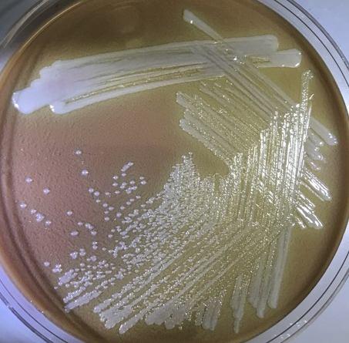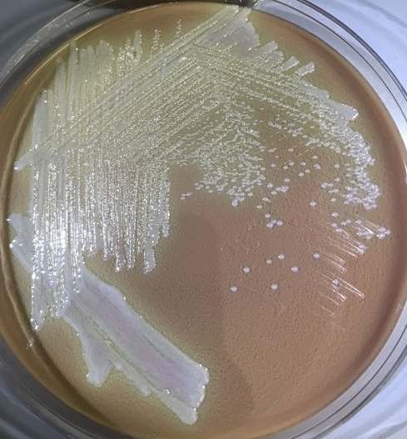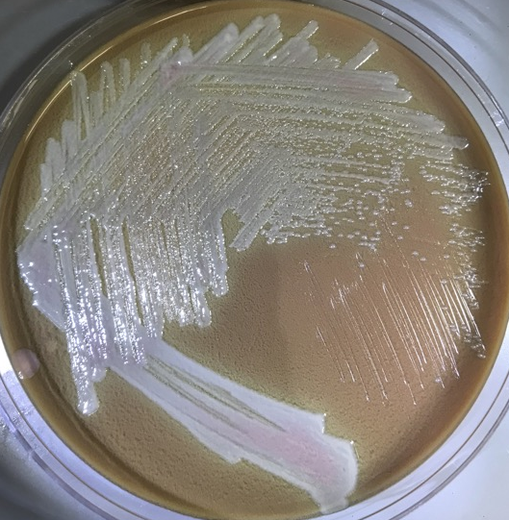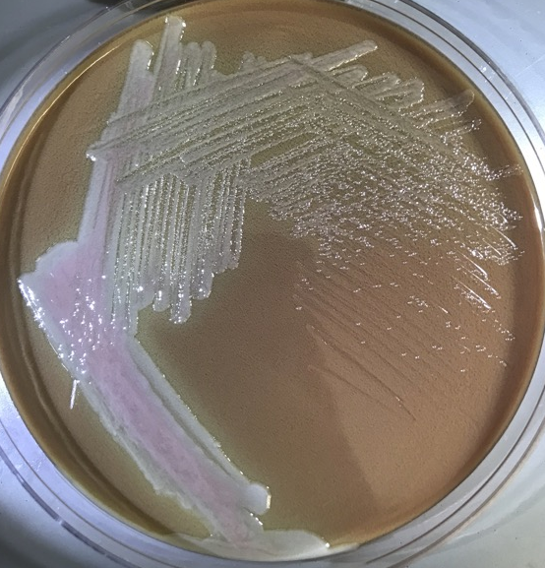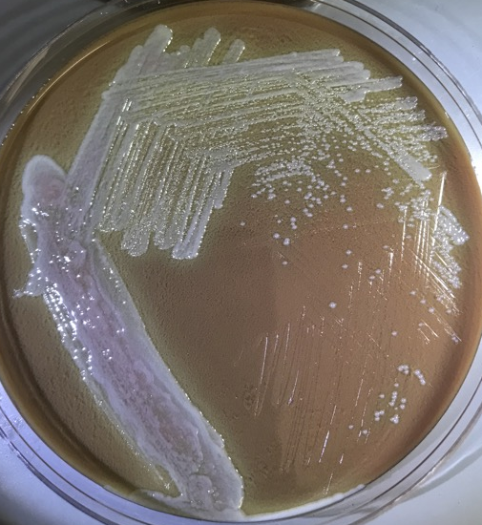
∆chaC suppressor 8-9
∆chaC suppressor 8-3
KMLFT114 ∆chaC
LVS
KRLVS42 ∆chaC
Differences between LVS and ∆chaC strains aren’t huge! It looks like the ∆chaC cells have slightly less white colonies, mucoidy isn’t super evident. The differences are much clearer when comparing ∆chaC_S 8-3 (much smaller, more transparent-looking) and ∆chaC_S 8-9 (larger colonies, brighter white).
Try imaging tomorrow to see if the differences are more evident when colonies get larger.

Saturday, January 22, 2022

To Do:
- Image plates
- Streak out strains again
Results and Data:
Take more images of plates. Illuminate with brighter flashlight from yesterday and a larger powered flashlight, both propped.
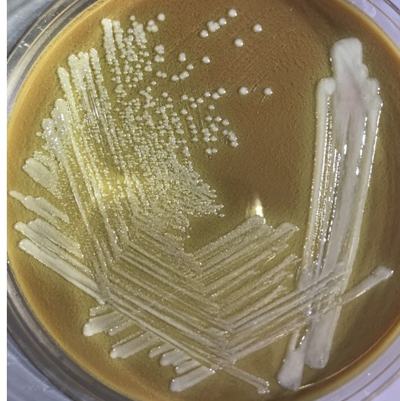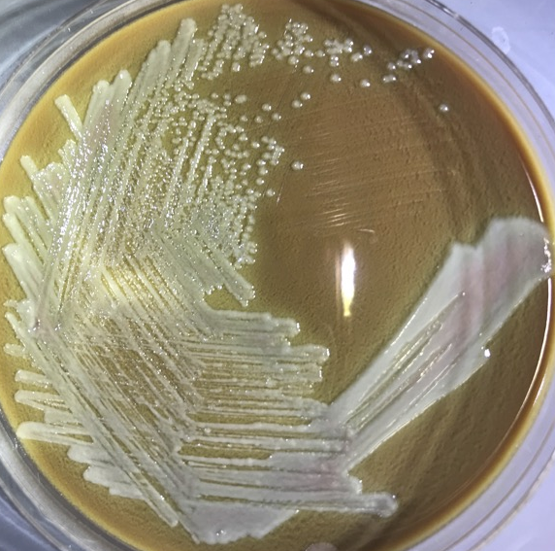
∆chaC KRLVS42
LVS
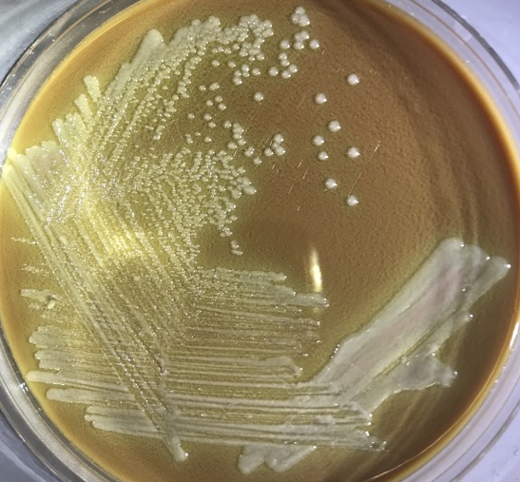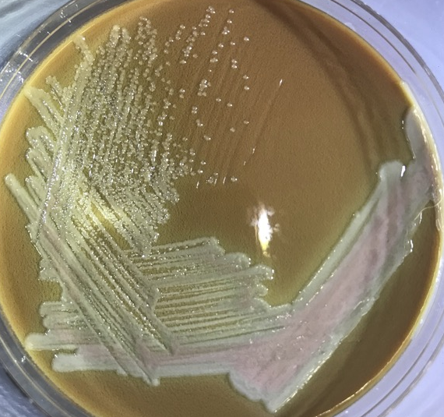
∆chaC suppressor 8-3
∆chaC KMLFT114
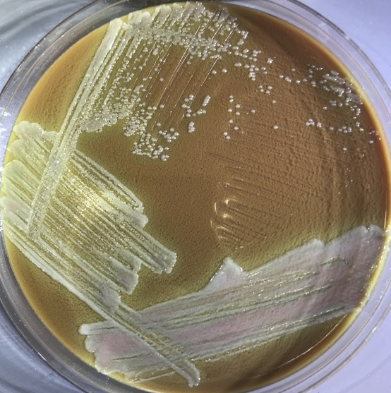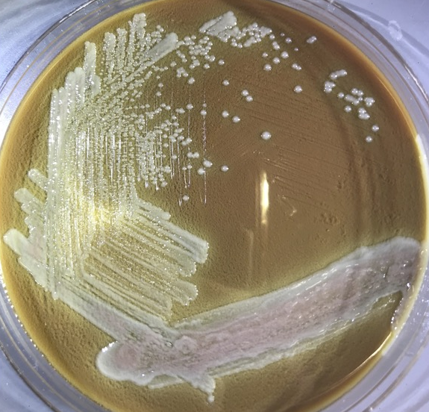
∆chaC suppressor 8-9
∆chaC suppressor 8-8

Struck out strains to single colony again. Will need more CHA plates to patch out cells and make glycerol stocks to mail.

Sent email to Brook, Simon, Joseph with photos:

Hi folks,

I've compiled some ∆chaC information for you, below. The tl;dr version is that I can ship out the LVS, two independently generated ∆chaC strains (slightly mucoid), and two strains with a less mucoid phenotype and one strain with a more mucoid phenotype either Tuesday or Wednesday.

Photographs and phenotypes:
I struck all these strains out to single colony and took photos (links attached). Note that ∆chaC suppressor strain 8-8 had to be re-plated due to some contamination, so it's a day behind in growth. I've struck them out again to hopefully get more comparable photos. All the plates are the standard cysteine heart agar + hemoglobin plates (CHAH).

What I hope you can appreciate from the photos is that both ∆chaC strains (KMLFT114 and KRLVS42) are a bit more mucoid than wild type LVS and have a slightly different color (less white, more green?). The mucoidy is most evident when looking at colonies next to each other- the LVS colonies stay a bit more separate while the ∆chaC colonies look almost blurred together. The phenotype is not very obvious, but by the time I was generating the second ∆chaC strain I had noticed it and I indicated in my notes that I could successfully predict which colonies were the deletion strain by looking at relative mucoidy.

Regarding the phenotype of the derived strains that are less or more mucoid (see isolation below), ∆chaC suppressor 8-9 looks to me brighter white. The ∆chaC suppressor 8-8 looks a bit in between, but that may be because it's a day behind in growth. Finally, strain ∆chaC suppressor 8-3 appears more mucoid and smaller than the original ∆chaC strains.

Summary of strains
LVS: non-mucoid, original strain
∆chaC KMFLT114: original ∆chaC strain made from LVS at CHB, slightly mucoid
∆chaC KRLVS42: re-construction of ∆chaC from LVS made at URI, slightly mucoid
∆chaC suppressor 8-3: passaged ∆chaC, more mucoid
∆chaC suppressor 8-8: passaged ∆chaC, less/non-mucoid, SNP identified (see below)
∆chaC suppressor 8-9: passaged ∆chaC, less/non-mucoid

Isolation of the ∆chaC mucoid phenotype suppressors:
When performing the macrophage assays to test intracellular replication of the ∆chaC cells, I was having difficulty preparing a consistent inoculum. So I performed an experiment to assess the viable CFU per OD600 for all the relevant strains in tissue culture media (DMEM+FBS). In this experiment, I included LVS and ∆chaC cells with and without empty vector and ChaC complementation. I scraped up cells from CHAH plates, resuspended the cells in DMEM+FBS as I would for a macrophage assay, normalized OD600 to 0.03 in DMEM+FBS, 10-fold serially diluted in 1x PBS, and plated for CFU on our standard cysteine heart agar + hemoglobin plates.

In that particular experiment, I didn't find any significant differences in viable cells per CFU among the strains. But when counting the ∆chaC colonies (no plasmid, and only these cells), I saw a mixture of normal looking colonies (opaque and white, potential suppressors) and mucoid colonies (pearly and smaller, more typical of ∆chaC). I patched out 6 mucoid colonies and 3 normal/suppressor colonies, confirmed by PCR that all were ∆chaC cells (no LVS contamination), and froze down 2 normal/suppressor colonies (8-8 and 8-9) and one mucoid colony (8-3).

Whole genome resequencing
When sending out some gDNA for WGRS, I included our LVS strain, the original ∆chaC strain (KMLFT114) and ∆chaC suppressor 8-8. I did this sequencing at MiGS (https://www.migscenter.com/). As a caveat to these results, MiGS uses a Nextera kit that relies on Tn5 transposons to add adapters. When using this method with all our LVS strains, there is insertion bias that leads to extreme variability in sequencing coverage across the genome. It is formally possible that there is an undetected mutation. I think the lowest coverage we had in these samples was around 15x, so I don't think it's a strong possibility. However, it is entirely possible that there are duplications that we could not possibly detect using this method.

Compared to the reference genome, our LVS has very few mutations, nothing that appears significant.

Compared to LVS, the original ∆chaC strain (KMLFT114) has no chaC and one slight difference from LVS: our LVS cells appear to have a mixed population of the reference sequence and a SNP in the pepN coding sequence which alters methionine 819 to isoleucine. This SNP has become fixed in the ∆chaC cells; apart from the deletion of chaC, this is the only difference detected between LVS and ∆chaC.

The only difference detected between the ∆chaC cells and the chaC suppressor 8-8 is in the capA gene (FTL_1414), a single deletion of a T in a run of Ts at bp 1343201. This is a missense mutation that leads the mutant to incorporate 5 incorrect amino acids before a stop codon. CapA is normally 403 aa, and the mutant version is truncated after 373 aa. Specifically:
LVS and ∆chaC: 368 – Lys-Lys-Tyr-Asn-Thr-Ile...Lys-STOP (403 aa)
∆chaC suppressor 8-8: 368 – Lys-Asn-Thr-Ile-Leu-Tyr-STOP (after 373 aa), missing 30 aa

Confirmation by Sanger sequencing
I subsequently used Sanger sequencing to sequence ~300 bp around the SNP in LVS, the original ∆chaC (KMLFT114), ∆chaC suppressor 8-3, ∆chaC suppressor 8-8, and ∆chaC suppressor 8-9. Only ∆chaC suppressor 8-8 had the single bp deletion in capA.

Let me know if I can provide any other information. I hope this is all helpful and I'm looking forward to hearing about what you find!

All the very best,
Kathryn

Monday, January 24, 2022

To Do:
- Image plates
- Streak out strains for glycerol stocks
Results and Data:
Words here.

Wednesday, January 26, 2022

To Do:
- Make glycerol stocks
- Ship strains
Results and Data:

Note included in shipping:
Strains enclosed

1 vial F. tularensis subsp. holarctica LVS
Derived from F. tularensis subsp. holarctica LVS:
1 vial KMLFT114 LVS ∆chaC (∆FTL_1548)
1 vial KRLVS42 LVS ∆chaC (∆FTL_1548)
Derived from KMLFT114 LVS ∆chaC:
1 vial LVS ∆chaC suppressor 8-3
1 vial LVS ∆chaC suppressor 8-8
1 vial LVS ∆chaC suppressor 8-9

Future To-Do

Move 1° LVS pKR10-1 into strain box

Bibliography

Suh, Moo-Jin et al. “Extending ribosomal protein identifications to unsequenced bacterial strains using matrix-assisted laser desorption/ionization mass spectrometry.” Proteomics vol. 5,18 (2005): 4818-31. doi:10.1002/pmic.200402111

