Table of Contents
June 2021 2
Future To-Do 6

June 2021
Sunday, June 6, 2021

To Do:
- Count plates
- Diagnostic digests
Results and Data:

When Marisa digested pKR14, pKR15, and pKR16 with NdeI/BamHI, we expected bands of ~260 bp. Hannah sequenced these plasmids after she made them and both cut site are in the region she sequenced, so I didn’t expect any issues. However, the digest yielded 2 bands of high molecular weight (poorly resolved). Note that the size of the plasmid is about 7,700 bp. So the sizes could be consistent with a single cut of some plasmid and some uncut. But one digest performed with pKR14 went overnight (see Marisa’s results from 6/2/21)- unlikely to be uncut if it went overnight. Are there two populations of plasmid? Would be surprising if all three had a contaminating plasmid.

Perform some diagnostic digests:

Digest | Plasmid | Enzyme 1 | Enzyme 2 | Bands | Logic
1 | pKR14 | NdeI | BamHI-HF | 7450, 262 | Can I replicate Marisa’s digest?
2 | pKR14 | KpnI-HF | BamHI-HF | 7109, 339, 264 | Can I cut out rpsU1 and is it the right size?
3 | pKR14 | NdeI | EcoRV-HF | 7418, 294 | Can I cut out rpsU1 with NdeI and EcoRV? Is NdeI working?
4 | pKR21 | NdeI | BamHI-HF | 7449, 1576 | Does this work on another pF plasmid?
5 | pKR21 | NdeI | EcoRV-HF | 7417, 1608 | Mistake- meant to use NotI-HF and BamHI-HF
6 | pKL85 | NdeI | BamHI-HF | 7944, 351 | Is it this combination of enzymes or the plasmid??
7 | pKL85 | NdeI | EcoRV-HF | 4334, 3784, 177 | Is it NdeI?

pKR14 pF-nat-rpsU1 is the plasmid we had been trying to clone with.
pKR21 pF-nat-FTL-1251 is the plasmid we can try cloning with (and an alternate strategy that uses a NotI site)
pKL85 is a pEX plasmid (not a pF plasmid at all, to see if something odd happened with all the pF plasmids)

Master mix:
Number of rxns |  | 8
Water | 15 | 120
10x CSB | 2 | 16
Plasmid | 2 | indiv
Enzyme 1 | 0.5 | indiv
Enzyme 2 | 0.5 | indiv
Total Vol | 20

Aliquot 17ul water plus cutsmart buffer, add plasmid and enzymes individually. Incubate 37°C for ~50’

Run gel. Have ladder on both ends and load 2uL of uncut plasmid before each digest:

Lane Contents
- ladder (thermo 1kb plus)
- pKR14 uncut
- Digest 1: pKR14 NdeI/BamHI
- Digest 2: pKR14 KpnI/BamHI
- Digest 3: pKR14 NdeI/EcoRV
- pKR21 uncut
Lane Contents
- Digest 4: pKR21 NdeI/BamHI
- Digest 5: pKR21 NdeI/EcoRV
- pKL85 uncut
- Digest 6: pKL85 NdeI/BamHI
- Digest 7: pKL85 NdeI/EcoRV
- ladder (thermo)

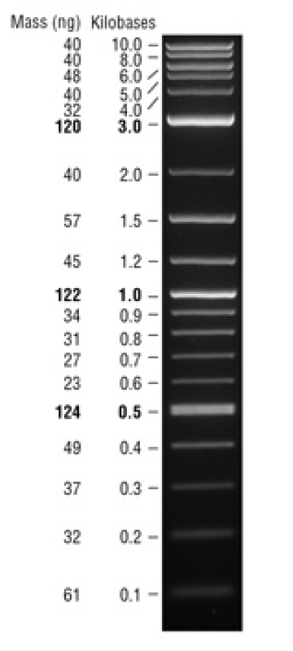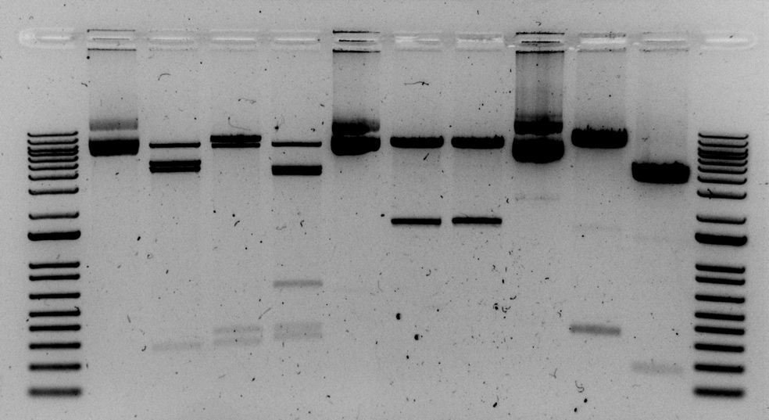
pKR14 pKR21 pKL85

uncut NdeI/ KpnI/ NdeI/ uncut NdeI/ NdeI/ uncut NdeI/ NdeI/
BamHI BamHI EcoRV BamHI EcoRV BamHI EcoRV
In this first image, you can see the lower MW bands well. In the second image, you can see the individual higher bands more clearly.
pKR14 pKR21 pKL85

uncut NdeI/ KpnI/ NdeI/ uncut NdeI/ NdeI/ uncut NdeI/ NdeI/
BamHI BamHI EcoRV BamHI EcoRV BamHI EcoRV

Conclusions- there’s something off about pKR14. I can see the band corresponding to rpsU1, but there are two extra bands. Looks like an extra NdeI cut site? Or another plasmid is present- need to actually figure out what size those bands are. Run longer to see (although I don’t have much time, so can’t be too much longer! )

pKR14 pKR21 pKL85

uncut NdeI/ KpnI/ NdeI/ uncut NdeI/ NdeI/ uncut NdeI/ NdeI/
BamHI BamHI EcoRV BamHI EcoRV BamHI EcoRV

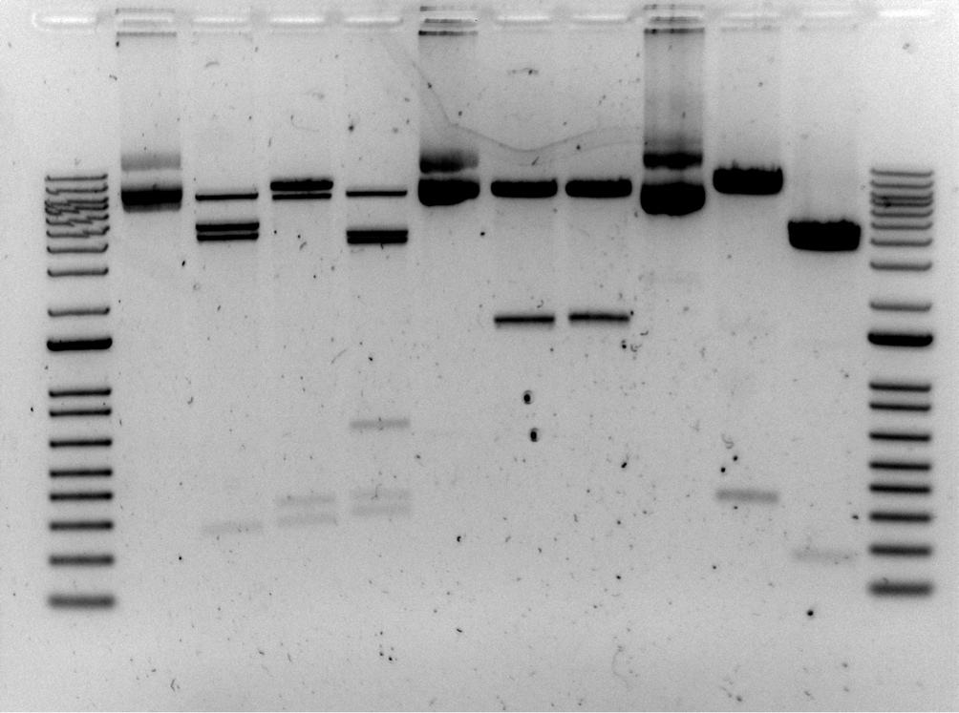

pKR14 pKR21 pKL85

uncut NdeI/ KpnI/ NdeI/ uncut NdeI/ NdeI/ uncut NdeI/ NdeI/
BamHI BamHI EcoRV BamHI EcoRV BamHI EcoRV
1,000
2,000

Is pKR14 contaminated with a pEX plasmid?

Future To-Do

Move 1° LVS pKR10-1 into strain box

Bibliography

Chalabaev, S., Anderson, C., Onderdonk, A., Kasper, D. (2011). Sensitivity of Francisella tularensis to ultrapure water and deoxycholate: implications for bacterial intracellular growth assay in macrophages. Journal of microbiological methods 85(3), 230 - 232. https://dx.doi.org/10.1016/j.mimet.2011.03.006

Hoang, K., Fitch, J., White, P., Mohapatra, N., Gunn, J. (2020). The sensor kinase QseC regulates the unlinked PmrA response regulator and downstream gene expression in Francisella Journal of Bacteriology https://dx.doi.org/10.1128/jb.00321-20

