Table of Contents
July 2020 2
August 2020 2
Generate cDNA (half protocol) 4
Generate cDNA (half protocol) 5
September 2020 7
qRT-PCR results from 9/12/20 9
Thoughts 9
Data Analysis 10
Future To-Do 13
Bibliography 14

July 2020
Tuesday, July 28, 2020

To Do:
- Streak out plates for RNA
Results and Data:

Streak out:
Number | Description | Strain number
1 | LVS | 0
2 | LVS FTL_0146(F315L) | KRLVS69
3 | LVS ∆pmrA | KRLVS40
4 | LVS ∆pmrA FTL_0146(F213L) | KRLVS81
5 | LVS ∆pmrA(sup) | KMLFT37

Note that KMLFT37 was struck from Jamie’s stock (label ∆pmrA suppressor)
LVS ∆pmrA was a single-use aliquot from Jamie
Both KRLVS69 and KRLVS81 need to be moved from Jamie’s boxes to the lab strain boxes

Thursday, July 30, 2020

To Do:
- Make glycerol stocks for strains
- Make single-use aliquots for strains
- Streak out to single colony again, just in case.

Results and Data:

Made a single 1.2 mL glycerol stock per strain and 6x100uL single use stocks. (1500uL cells in MH+ and 380 uL 75% glycerol)

August 2020

Saturday, August 1, 2020

To Do:
- Patch out single colonies
Results and Data:

Will need to validate the identity of the strains I’m using. Confirm:
Presence/absence of pmrA
Presence/absence of priM
Presence/absence of FTL_0146(F315L) mutation

Sunday, August 2, 2020

To Do:
- Grow cells, isolate RNA
Results and Data:

Setup:
Number | Description | Strain number
1 | LVS | 0
2 | LVS FTL_0146(F315L) | KRLVS69
3 | LVS ∆pmrA | KRLVS40
4 | LVS ∆pmrA FTL_0146(F213L) | KRLVS81
5 | LVS ∆pmrA(sup) | KMLFT37

Note that LVS ∆pmrA(sup) didn’t grow very well- 6 patches, 5 with little to no growth and the last with pretty robust growth (which makes me concerned!). The robust growth patch is replicate “C”. I could use a single patch for replicate “B”, and I had to scrape up some extra, non-single colony cells for replicate “A.”

 |  | Diluted OD600 | Dilution Factor | Actual OD600 | Desired OD600 | Total volume (mL) | Volume cells (uL) | Volume MHB (ul, + 7 mL)
1A | LVS | 0.347 | 20 | 6.94 | 0.08 | 8 | 92.2 | 907.8
1B | LVS | 0.424 | 20 | 8.48 | 0.08 | 8 | 75.5 | 924.5
1C | LVS | 0.406 | 20 | 8.12 | 0.08 | 8 | 78.8 | 921.2
2A | LVS FTL_0146(F315L) | 0.34 | 20 | 6.8 | 0.08 | 8 | 94.1 | 905.9
2B | LVS FTL_0146(F315L) | 0.302 | 20 | 6.04 | 0.08 | 8 | 106.0 | 894.0
2C | LVS FTL_0146(F315L) | 0.332 | 20 | 6.64 | 0.08 | 8 | 96.4 | 903.6
3A | LVS ∆pmrA | 0.29 | 20 | 5.8 | 0.08 | 8 | 110.3 | 889.7
3B | LVS ∆pmrA | 0.162 | 20 | 3.24 | 0.08 | 8 | 197.5 | 802.5
3C | LVS ∆pmrA | 0.175 | 20 | 3.5 | 0.08 | 8 | 182.9 | 817.1
4A | LVS ∆pmrA FTL_0146(F213L) | 0.268 | 20 | 5.36 | 0.08 | 8 | 119.4 | 880.6
4B | LVS ∆pmrA FTL_0146(F213L) | 0.215 | 20 | 4.3 | 0.08 | 8 | 148.8 | 851.2
4C | LVS ∆pmrA FTL_0146(F213L) | 0.106 | 20 | 2.12 | 0.08 | 8 | 301.9 | 698.1
5A | LVS ∆pmrA(sup) | 0.436 | 10 | 4.36 | 0.08 | 8 | 146.8 | 853.2
5B | LVS ∆pmrA(sup) | 0.22 | 10 | 2.2 | 0.08 | 8 | 290.9 | 709.1
5C | LVS ∆pmrA(sup) | 0.349 | 20 | 6.98 | 0.08 | 8 | 91.7 | 908.3

Tuesday, August 4, 2020

To Do:
- Final RNA purification
- Run gel
- Make cDNA
Results and Data:

Generate cDNA (half protocol)
REACTION SIZE CUT IN HALF from Lory lab microarray protocol
Combine the first components for primer annealing:
Component | Volume or Amount | Final Concentration
RNA | 3 ug | 267 - 333 ng/ ul
(NS)₅ Primer (250 ng/ul) | 1.5 ul | 25 ng/ul
RNase-free water | up to 15 ul

 | Gel |  | cDNA
Sample ID | RNA (1.5 ug) | Water | RNA (3 ug) | Water
1A | 3.53 | 6.47 | 7.06 | 6.44
1B | 3.57 | 6.43 | 7.15 | 6.35
1C | 3.33 | 6.67 | 6.67 | 6.83
2A | 2.96 | 7.04 | 5.91 | 7.59
2B | 2.72 | 7.28 | 5.44 | 8.06
2C | 2.87 | 7.13 | 5.74 | 7.76
3A | 3.55 | 6.45 | 7.10 | 6.40
3B | 5.12 | 4.88 | 10.24 | 3.26
3C | 4.75 | 5.25 | 9.51 | 3.99
4A | 3.17 | 6.83 | 6.35 | 7.15
4B | 2.93 | 7.07 | 5.87 | 7.63
4C | 2.92 | 7.08 | 5.84 | 7.66
5A | 4.22 | 5.78 | 8.44 | 5.06
5B | 3.55 | 6.45 | 7.11 | 6.39
5C | 2.79 | 7.21 | 5.58 | 7.92

Incubate using program JSScDNA1:
Step Temp Time
1 70°C 10'
2 25°C 10'
3 4°C hold

While waiting, prepare the cDNA synthesis reaction in master mix format:
Component | Final Concentration | Volume or Amount | x 16.5
5X 1st strand buffer | 1x | 6 ul | 8.25
RNase-free water |  | 2.88 ul | 47.52
100 mM DTT | 10 mM | 3.0 ul | 49.5
10 mM dNTPs | 0.5 mM | 1.5 ul | 24.75
Superscript III (200 U/ul) | 10.8 U/ul | 1.63 | 26.9
Aliquot 15 ul per reaction
Screwed up- check out that buffer volume indicated above- waaay off! Will need to re-do another time.

Wednesday, August 26, 2020

To Do:
- Make cDNA
Results and Data:

Generate cDNA (half protocol)
REACTION SIZE CUT IN HALF from Lory lab microarray protocol
Combine the first components for primer annealing:
Component | Volume or Amount | Final Concentration
RNA | 3 ug | 267 - 333 ng/ ul
(NS)₅ Primer (250 ng/ul) | 1.5 ul | 25 ng/ul
RNase-free water | up to 15 ul

 |  |  |  |  | cDNA
Number | Sample ID |  | Date isolated | RNA Conc (ng/ul) | RNA | H2O | Total RNA
1 | 1A | LVS | 8/4/20 | 424.9 | 7.06 | 6.44 | 3000.0
2 | 1B | LVS | 8/4/20 | 419.7 | 7.15 | 6.35 | 3000.0
3 | 1C | LVS | 8/4/20 | 449.9 | 6.67 | 6.83 | 3000.0
4 | 2A | LVS FTL_0146(F315L) | 8/4/20 | 507.3 | 5.91 | 7.59 | 3000.0
5 | 2B | LVS FTL_0146(F315L) | 8/4/20 | 551.9 | 5.44 | 8.06 | 3000.0
6 | 2C | LVS FTL_0146(F315L) | 8/4/20 | 522.7 | 5.74 | 7.76 | 3000.0
7 | 3A | LVS ∆pmrA | 8/4/20 | 422.7 | 7.10 | 6.40 | 3000.0
8 | 3B | LVS ∆pmrA | 8/4/20 | 292.9 | 10.24 | 3.26 | 3000.0
9 | 3C | LVS ∆pmrA | 8/4/20 | 315.6 | 9.51 | 3.99 | 3000.0
10 | 4A | LVS ∆pmrA FTL_0146(F213L) | 8/4/20 | 472.8 | 6.35 | 7.15 | 3000.0
11 | 4B | LVS ∆pmrA FTL_0146(F213L) | 8/4/20 | 511.5 | 5.87 | 7.63 | 3000.0
12 | 4C | LVS ∆pmrA FTL_0146(F213L) | 8/4/20 | 513.8 | 5.84 | 7.66 | 3000.0
13 | 5A | LVS ∆pmrA(sup) | 8/4/20 | 355.6 | 8.44 | 5.06 | 3000.0
14 | 5B | LVS ∆pmrA(sup) | 8/4/20 | 422.2 | 7.11 | 6.39 | 3000.0
15 | 5C | LVS ∆pmrA(sup) | 8/4/20 | 537.3 | 5.58 | 7.92 | 3000.0
16 | 1A | LVS ∆pmrA (old) | 11/14/19 | 150.96 | 13.50 | 0.00 | 2038.0
17 | 1B | LVS ∆pmrA (old) | 11/14/19 | 196.01 | 13.50 | 0.00 | 2646.1
18 | 1C | LVS ∆pmrA (old) | 11/14/19 | 185.08 | 13.50 | 0.00 | 2498.6
19 | 2A | LVS ∆pmrA (new) | 11/14/19 | 383.44 | 7.82 | 5.68 | 3000.0
20 | 2B | LVS ∆pmrA (new) | 11/14/19 | 353.3 | 8.49 | 5.01 | 3000.0
21 | 2C | LVS ∆pmrA (new) | 11/14/19 | 388.73 | 7.72 | 5.78 | 3000.0

Incubate using program JSScDNA1:
Step Temp Time
1 70°C 10'
2 25°C 10'
3 4°C hold

While waiting, prepare the cDNA synthesis reaction in master mix format:
Component | Final Concentration | Volume | x 22.5
5X 1st strand buffer | 1x | 6 | 135
RNase-free water |  | 2.88 | 64.8
100 mM DTT | 10 mM | 3 | 67.5
10 mM dNTPs | 0.5 mM | 1.5 | 33.75
Superscript III (200 U/ul) | 10.8 U/ul | 1.63 | 36.68
Aliquot 15 ul per reaction

Incubate using program JSScDNA2
Step Temp Time
1 25°C 10'
2 37°C 60'
4 42°C 60'
5 70°C 10'
6 4°C hold

Move samples to -80°C until I can purify them.

Monday, August 31, 2020

To Do:
- Purify cDNA
- Set up RT-PCR reactions
Results and Data:

Add 10 ul of 1N NaOH
Incubate 65°C for 30'
Neutralize with 10 ul of 1N HCl
Final volume is 50 ul
Purify cDNA using Qiagen PCR clean-up column
Elute in 60 ul of 0.1x EB

Check concentration by Nanodrop:
Number | Sample ID | Strain | Nucleic Acid Conc (ng/µl) | A260 | A280 | 260/280 | 260/230
1 | 1A | LVS | 19.4 | 0.587 | 0.321 | 1.83 | 1.29
2 | 1B | LVS | 54.4 | 1.649 | 0.915 | 1.8 | 1.76
3 | 1C | LVS | 21.1 | 0.639 | 0.349 | 1.83 | 1.57
4 | 2A | LVS FTL_0146(F315L) | 59 | 1.788 | 1.003 | 1.78 | 1.9
5 | 2B | LVS FTL_0146(F315L) | 53 | 1.607 | 0.902 | 1.78 | 1.75
6 | 2C | LVS FTL_0146(F315L) | 44.7 | 1.355 | 0.758 | 1.79 | 1.87
7 | 3A | LVS ∆pmrA | 46.5 | 1.41 | 0.791 | 1.78 | 2.08
8 | 3B | LVS ∆pmrA | 47.7 | 1.447 | 0.81 | 1.79 | 1.7
9 | 3C | LVS ∆pmrA | 38.6 | 1.171 | 0.653 | 1.79 | 1.78
10 | 4A | LVS ∆pmrA FTL_0146(F213L) | 55.3 | 1.674 | 0.936 | 1.79 | 1.68
11 | 4B | LVS ∆pmrA FTL_0146(F213L) | 39.8 | 1.206 | 0.669 | 1.8 | 1.29
12 | 4C | LVS ∆pmrA FTL_0146(F213L) | 50.7 | 1.536 | 0.865 | 1.78 | 1.66
13 | 5A | LVS ∆pmrA(sup) | 26.3 | 0.796 | 0.441 | 1.81 | 1.56
14 | 5B | LVS ∆pmrA(sup) | 48 | 1.453 | 0.831 | 1.75 | 2.02
15 | 5C | LVS ∆pmrA(sup) | 40.6 | 1.229 | 0.68 | 1.81 | 1.58
16 | 1A | LVS ∆pmrA (old) | 26.8 | 0.813 | 0.448 | 1.82 | 1.49
17 | 1B | LVS ∆pmrA (old) | 36.9 | 1.118 | 0.624 | 1.79 | 0.97
18 | 1C | LVS ∆pmrA (old) | 34.4 | 1.042 | 0.572 | 1.82 | 1.25
19 | 2A | LVS ∆pmrA (new) | 41.1 | 1.246 | 0.689 | 1.81 | 2.07
20 | 2B | LVS ∆pmrA (new) | 34.1 | 1.034 | 0.563 | 1.84 | 2.03
21 | 2C | LVS ∆pmrA (new) | 38.8 | 1.174 | 0.657 | 1.79 | 1.9
1 | 1A | LVS | 19.2 | 0.582 | 0.304 | 1.91 | 1.24

Multiple samples have poor results (high 260/280 ratios).

September 2020

Saturday, September 12, 2020

To Do:
- Set up RT-PCR reactions
- Streak out cells for gDNA isolation
  - ∆pmrA ∆priM KMLFT49
  - ∆pmrA KMLFT37
  - ∆pmrA priM(S) KMLFT67
  - ∆pmrA mreA(S) KMLFT69
  - LVS
Results and Data:
Testing priM and tul4 transcript abundances. Can only fit 16 samples per plate with 2 primer pairs.

Dilute cDNA to 1.5 ng/uL
 |  | Volumes to dilute for 1.5 ng/uL
Sample | [cDNA] | cDNA | H2O
1 | 19.4 | 2 | 23.9
2 | 54.4 | 2 | 70.5
3 | 21.1 | 2 | 26.1
4 | 59 | 2 | 76.7
5 | 53 | 2 | 68.7
6 | 44.7 | 2 | 57.6
7 | 46.5 | 2 | 60.0
8 | 47.7 | 2 | 61.6
9 | 38.6 | 2 | 49.5
10 | 55.3 | 2 | 71.7
11 | 39.8 | 2 | 51.1
12 | 50.7 | 2 | 65.6
13 | 26.3 | 2 | 33.1
14 | 48 | 2 | 62.0
15 | 40.6 | 2 | 52.1
16 | 26.8 | 2 | 33.7

Can fit 16 samples per plate, analyzing priM and tul4
 | 1 | 2 | 3 | 4 | 5 | 6 | 7 | 8 | 9 | 10 | 11 | 12
A | A1 |  |  | A9 |  |  | B1 |  |  | B9
B | A2 |  |  | A10 |  |  | B2 |  |  | B10
C | A3 |  |  | A11 |  |  | B3 |  |  | B11
D | A4 |  |  | A12 |  |  | B4 |  |  | B12
E | A5 |  |  | A13 |  |  | B5 |  |  | B13
F | A6 |  |  | A14 |  |  | B6 |  |  | B14
G | A7 |  |  | A15 |  |  | B7 |  |  | B15
H | A8 |  |  | A16 |  |  | B8 |  |  | B16

16 samples * 3.5 + 3.5 = 59.5 reactions per primer pair
Reactions
A | priM | P437 P438
B | tul4 | KROL63 KROL64

 | 1x | Master Mix
2x Power Up | 10 | 595
5 uM primers | 1 | 59.5
H2O | 8 | 476
-Aliquot 3.5 uL cDNA per tube
-Add 66.5 uL master mix
-Dispense 20uL per well

Place in real-time machine and run rxn.
Parameters for old step-one program:
1. 95°C 10’
2. 95°C 15”
3. 60°C 60”
4. Go to step 2, 39x (total 40 cycles)
5. 95°C 10”
6. 65°C 60”
7. 97°C 60”

Sunday, September 13, 2020

To Do:
- Analyze RT-PCR data
- Set up second set of RT-PCR reactions
- Isolate gDNA
Results and Data:
Set up second set of RT-PCR reactions
Dilute cDNA to 1.5 ng/uL
 |  | Volumes to dilute for 1.5 ng/uL
Sample | [cDNA] | cDNA | H2O
17 | 36.9 | 2 | 47.2
18 | 34.4 | 2 | 43.9
19 | 41.1 | 2 | 52.8
20 | 34.1 | 2 | 43.5
21 | 38.8 | 2 | 49.7

 | 1 | 2 | 3 | 4 | 5 | 6
A | A17 |  |  | B17
B | A18 |  |  | B18
C | A19 |  |  | B19
D | A20 |  |  | B20
E | A21 |  |  | B21
F
G
H

5 samples * 3.5 + 3.5 = 21 rxns per primer pair
Reactions
A | priM | P437 P438
B | tul4 | KROL63 KROL64

 | 1x | Master Mix
2x Power Up | 10 | 210
5 uM primers | 1 | 21
H2O | 8 | 168

-Aliquot 3.5 uL cDNA per tube
-Add 66.5 uL master mix
-Dispense 20uL per well

Place in real-time machine and run rxn.
Parameters for old step-one program:
1. 95°C 10’
2. 95°C 15”
3. 60°C 60”
4. Go to step 2, 39x (total 40 cycles)
5. 95°C 10”
6. 65°C 60”
7. 97°C 60”

Get data from last plate and perform analysis on first set of samples:

qRT-PCR results from 9/12/20
Thoughts
Looking over the data, the ∆pmrA A sample is quite a bit of an outlier. Most of the samples with pmrA (WT background) have very little priM, so high ∆Ct values for priM. The pmrA replicates B and C are consistent with previous findings- much lower ∆Ct values for priM. If I include replicate A in the analysis, there is only 44x more priM in ∆pmrA than in wild-type. But if I exclude replicate A, there is a 112x difference in priM abundance. The second scenario is more similar to what we’ve seen before (although lower than the 300x both Jamie and I have found previously). Going back to the growth curves, I was actually quite suspicious of the ∆pmrA replicate A culture- it grew faster and reached a higher final density than replicates B and C. For these reasons, I suspect it was contaminated with a different strain- don’t use that replicate in the analysis.

Looking back at the growth curves, there was also significant differences in the ∆pmrA(sup) strain; replicate C grew faster and achieved a higher final density than replicates A and B. If I include that replicate, the fold change is 127x. If I exclude it, the fold change increases to 167. This is all strange because Jamie replicated that the ∆pmrA(sup) strain had about 30-40x increase in priM over wild-type, compared to 200-300x increase of priM in ∆pmrA. I’m a bit concerned about the genotypes of these cells! For now, keep all the replicates.

Data Analysis
priM | average | stdev | tul4 | average | stdev | DCt
LVS A | 28.14 | 0.056 | LVS A | 19.66 | 0.031 | 8.483
LVS B | 26.70 | 0.038 | LVS B | 17.72 | 0.010 | 8.983
LVS C | 28.79 | 0.000 | LVS C | 20.00 | 0.015 | 8.787
LVS FTL_0146(F315L) A | 26.53 | 0.074 | LVS FTL_0146(F315L) A | 17.63 | 0.021 | 8.900
LVS FTL_0146(F315L) B | 26.78 | 0.095 | LVS FTL_0146(F315L) B | 17.72 | 0.015 | 9.063
LVS FTL_0146(F315L) C | 26.88 | 0.006 | LVS FTL_0146(F315L) C | 17.91 | 0.030 | 8.967
LVS ∆pmrA A | 22.82 | 0.042 | LVS ∆pmrA A | 17.39 | 0.040 | 5.423
LVS ∆pmrA B | 18.02 | 0.015 | LVS ∆pmrA B | 17.06 | 0.012 | 0.967
LVS ∆pmrA C | 17.92 | 0.035 | LVS ∆pmrA C | 17.45 | 0.006 | 0.468
LVS ∆pmrA FTL_0146(F213L) A | 22.25 | 0.096 | LVS ∆pmrA FTL_0146(F213L) A | 17.27 | 0.035 | 4.973
LVS ∆pmrA FTL_0146(F213L) B | 23.38 | 0.135 | LVS ∆pmrA FTL_0146(F213L) B | 19.02 | 0.015 | 4.363
LVS ∆pmrA FTL_0146(F213L) C | 23.00 | 0.047 | LVS ∆pmrA FTL_0146(F213L) C | 18.02 | 0.021 | 4.980
LVS ∆pmrA(sup) A | 20.21 | 0.015 | LVS ∆pmrA(sup) A | 19.84 | 0.015 | 0.370
LVS ∆pmrA(sup) B | 17.77 | 0.031 | LVS ∆pmrA(sup) B | 18.06 | 0.006 | -0.290
LVS ∆pmrA(sup) C | 20.05 | 0.114 | LVS ∆pmrA(sup) C | 18.63 | 0.006 | 1.420
LVS ∆pmrA (old) A | 18.04 | 0.036 | LVS ∆pmrA (old) A | 18.78 | 0.026 | -0.740

 | average DCt | stdev | DDCT vs control | s | 1.8^-averDDCT | DDCT +/- stdev | 1.8^-DDCT+/- stdev |  | error bars
LVS | 8.751 | 0.252 | 0.000 | 0.356 | 1.000 | 0.356 | 0.81 | + | 0.189
 |  |  |  |  |  | -0.356 | 1.23 | - | 0.233
LVS FTL_0146(F315L) | 8.977 | 0.082 | 0.226 | 0.265 | 0.876 | 0.490 | 0.75 | + | 0.126
 |  |  |  |  |  | -0.039 | 1.02 | - | 0.148
∆pmrA | 0.717 | 0.352 | -8.034 | 0.433 | 112.398 | -7.600 | 87.13 | + | 25.264
 |  |  |  |  |  | -8.467 | 144.99 | - | 32.589
LVS ∆pmrA FTL_0146(F213L) | 4.772 | 0.354 | -3.979 | 0.435 | 10.368 | -3.544 | 8.03 | + | 2.337
 |  |  |  |  |  | -4.413 | 13.39 | - | 3.017
LVS ∆pmrA(sup) | 0.500 | 0.862 | -8.251 | 0.898 | 127.727 | -7.353 | 75.33 | + | 52.401
 |  |  |  |  |  | -9.150 | 216.58 | - | 88.855

Started DNA purification but accidentally put tubes at 95°C instead of 65°C!
Re-streak cells and do tomorrow.

Monday, September 14, 2020

To Do:
- Analyze RT-PCR data
- Isolate gDNA

Results and Data:
Purify gDNA
Samples:
1 | KMLFT49 | ∆pmrA ∆priM
2 | KMLFT37 | ∆pmrA
3 | KMLFT67 | ∆pmrA priM(S)
4 | KMLFT69 | ∆pmrA mreA(S)
5 |  | LVS

DNA Purification Protocol
1. Dilute 1 μl of Proteinase K into 300 μl of Tissue and Cell Lysis Solution for each sample (can use 310 uL to account for pipetting error). 5x310ul = 1550 uL + 5.17 uL Proteinase K
2. Scrape up cells from plate, resuspend in 1X PBS, pellet, and discard the supernatant, leaving approximately 25 μl of liquid. Put at -20°C for ~30’ until ready for next step.
3. Vortex for 10 seconds to resuspend the cell pellet.
4. Add 300 ul of Tissue and Cell Lysis Solution containing the Proteinase K and mix thoroughly.
5. Incubate at 65°C for 15 minutes; vortex every 5 minutes.
6. Cool the samples to 37°C and add 2 μl of 5 mg/ml RNase A to the sample; mix thoroughly. Added 1uL RNase A (oops).
7. Incubate at 37°C for 30 minutes.
8. Place the samples on ice for 3-5 minutes and then proceed with total DNA precipitation. Put samples at -80°C for 3’.
1. Add 150 μl of MPC Protein Precipitation Reagent to 300 μl of lysed sample and vortex vigorously for 10 seconds.
2. Pellet the debris by centrifugation at 4°C for 10 minutes at ≥10,000 x g in a microcentrifuge. If the resultant pellet is clear, small, or loose, add an additional 25 μl of MPC Protein Precipitation Reagent, mix, and pellet the debris again.
3. Transfer the supernatant to a clean microcentrifuge tube and discard the pellet.
4. Add 500 μl of isopropanol to the recovered supernatant. Invert the tube 30-40 times.
5. Pellet the DNA by centrifugation at 4°C for 10 minutes in a microcentrifuge.
6. Carefully pour off the isopropanol without dislodging the DNA pellet.
7. Rinse twice with 70% ethanol, being careful to not dislodge the pellet. Centrifuge briefly if the pellet is dislodged. Remove all of the residual ethanol with a pipet and let dry completely under hood.
8. Resuspend the DNA in 35 μl of 0.1x EB Buffer. Put on ice to help dissolve, and add 50 μl of additional buffer if DNA is very goopy. Added 35 ul to all but #1 (70 uL). Put at -20°C until have time to move forward.

Wednesday, September 16, 2020

To Do:
- Quantify gDNA
- Set up PCR reactions
- Purify PCR reactions
- Send to sequence

Results and Data:
gDNA quantity and quality look good
 |  |  |  |  |  |  | Volume (ul) for dilutions (100 n/ul)
# | Sample ID | [DNA] (ng/ul) | A260 | A280 | 260/280 | 260/230 | gDNA | 0.1x EB
1 | KMLFT49 ∆pmrA ∆priM | 1557.9 | 31.159 | 15.053 | 2.07 | 1.68 | 5 | 72.9
2 | KMLFT37 ∆pmrA | 3087.8 | 61.756 | 29.726 | 2.08 | 1.96 | 5 | 149.4
3 | KMLFT67 ∆pmrA priM(S) | 1694.1 | 33.882 | 16.88 | 2.01 | 1.88 | 5 | 79.7
4 | KMLFT69 ∆pmrA mreA(S) | 1949.1 | 38.983 | 20.223 | 1.93 | 1.73 | 5 | 92.5
5 | LVS | 1161.9 | 23.239 | 11.428 | 2.03 | 1.64 | 5 | 53.1

Make indicated dilutions and set up 3 PCR reactions:
Reaction | Locus | Primers | Expected size (WT) | Expected size (∆) | Sequencing primer
A | pmrA | KROL61, KROL62 | 1204 | 535 | -
B | priM | KROL155, KROL156 | 1792 | 352 | -
C | FTL_0146 | KROL270, KROL271 | 1320 | - | KROL270

Sample Number | Strain number | Strain name
1 | KMLFT49 | ∆pmrA ∆priM
2 | KMLFT37 | ∆pmrA
3 | KMLFT67 | ∆pmrA priM(S)
4 | KMLFT69 | ∆pmrA mreA(S)
5 |  | LVS
6 |  | -DNA

Total reaction volume | 30
Total number of reactions | 6
Total number of master mixes | 3
 |  |  |  | 3 master mixes | Individual master mix
Component | Stock concentration | Final concentration | 1 rxn volume | 22 | 7
ddiH2O |  |  | 18.6 | 409.2 | 193.2
PrimeSTAR GXL Buffer | 5x | 1x | 6 | 132 | 193.2
dNTPs | 2.5 mM | 0.2 mM | 2.4 | 52.8 | 193.2
PrimeSTAR GXL DNA Polymerase | 1.25 U/ul | 0.025 U/ul | 0.6 | 13.2 | 193.2
Oligo 1 | 10 uM | 0.3 uM | 0.9 | - | 6.3
Oligo 2 | 10 uM | 0.3 uM | 0.9 | - | 6.3
template | 100 ng/ul | 2 ng/ul | 0.6
 |  | Total volume | 30 | 607.2 | 205.8

Use STN1 with a 2’ extension time.

PCR-purify reactions C1-C5
# | Sample ID | [DNA] (ng/ul) | A260 | A280 | 260/280 | 260/230
C1 | FTL_0146_∆pmrA∆priM | 68.9 | 1.377 | 0.767 | 1.8 | 2.39
C2 | FTL_0146_∆pmrA | 67.7 | 1.353 | 0.754 | 1.8 | 2.35
C3 | FTL_0146_∆pmrApriM(S) | 76 | 1.52 | 0.848 | 1.79 | 2.4
C4 | FTL_0146_∆pmrAmreA(S) | 75.1 | 1.501 | 0.842 | 1.78 | 2.36
C5 | FTL_0146_LVS | 74.3 | 1.487 | 0.841 | 1.77 | 2.37

Dilute all gDNA 1:10.

Set up and submit sequencing reactions with KROL270
Sample number | Template Name | Primer Name | A. | B. | C. | D. | F.
 |  |  | Template Size (bases) | Template Stock Conc. (ng/μl) | PCR template: | PCR template: | Volume  H₂O
 |  |  |  |  | ng needed = | Volume =
 |  |  |  |  | (A ÷ 100) × 2.5 | (C ÷ B)μl | (12 less D or E - 2.56)μl
KMR_C1 | FTL_0146_∆pmrA∆priM | KROL270 | 1320 | 6.8 | 33.00 | 4.85 | 4.59
KMR_C2 | FTL_0146_∆pmrA | KROL270 | 1320 | 6.8 | 33.00 | 4.85 | 4.59
KMR_C3 | FTL_0146_∆pmrApriM(S) | KROL270 | 1320 | 6.8 | 33.00 | 4.85 | 4.59
KMR_C4 | FTL_0146_∆pmrAmreA(S) | KROL270 | 1320 | 6.8 | 33.00 | 4.85 | 4.59
KMR_C5 | FTL_0146_LVS | KROL270 | 1320 | 6.8 | 33.00 | 4.85 | 4.59

Thursday, September 17, 2020

To Do:
- Finish analyzing and reviewing qRT-PCR data

Results and Data:

Have data from 9/13/20 that I never put into the spreadsheet. Analyze now:

priM | average | stdev | tul4 | average | stdev | DCt
LVS ∆pmrA (old) A | 18.04 | 0.036 | LVS ∆pmrA (old) A | 18.78 | 0.026 | -0.740
LVS ∆pmrA (old) B | 17.81 | 0.059 | LVS ∆pmrA (old) B | 17.86 | 0.035 | -0.047
LVS ∆pmrA (old) C | 17.86 | 0.021 | LVS ∆pmrA (old) C | 17.91 | 0.025 | -0.057
LVS ∆pmrA (new) A | 17.81 | 0.04 | LVS ∆pmrA (new) A | 17.97 | 0.025 | -0.153
LVS ∆pmrA (new) B | 18.23 | 0.015 | LVS ∆pmrA (new) B | 18.87 | 0.045 | -0.633
LVS ∆pmrA (new) C | 18.19 | 0.026 | LVS ∆pmrA (new) C | 18.75 | 0.006 | -0.557

This RNA was isolated on a different day that the LVS control (for the RNA-Seq experiment), but make the comparison for this particular experiment:
 | average DCt | stdev | DDCT vs control | s | 1.8^-averDDCT | DDCT +/- stdev | 1.8^-DDCT+/- stdev |  | error bars
LVS | 8.751 | 0.252 | 0.000 | 0.356 | 1.000 | 0.356 | 0.81 | + | 0.189
 |  |  |  |  |  | -0.356 | 1.23 | - | 0.233
LVS ∆pmrA (old) | -0.281 | 0.397 | -9.032 | 0.471 | 202.152 | -8.562 | 153.31 | + | 48.845
 |  |  |  |  |  | -9.503 | 266.56 | - | 64.407
LVS ∆pmrA (new) | -0.448 | 0.258 | -9.199 | 0.360 | 222.958 | -8.838 | 180.39 | + | 42.571
 |  |  |  |  |  | -9.559 | 275.58 | - | 52.618

Both of these samples look like they are expressing quite a bit of priM!
This is notable because we didn’t see a difference in the RNA-Seq data comparing the ∆pmrA and ∆pmrA(sup) strain; this experiment validates that finding but also highlights that both strains are producing high levels of priM!

Reviewing the RNA-Seq data:
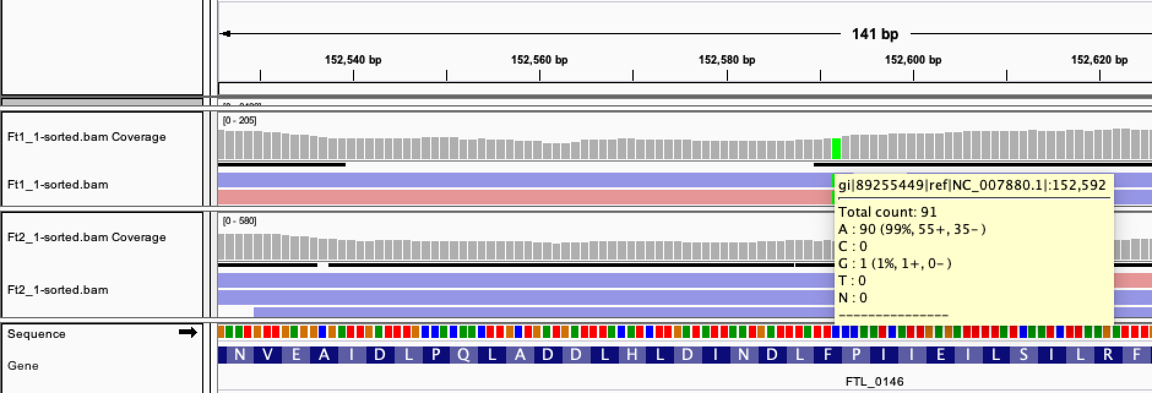
The FTL_0146 mutation is absolutely present in the ∆pmrA(old) sample.

The conflicting results:
Old ∆pmrA = ∆pmrA(sup); New ∆pmrA = ∆pmrA

-Coomassie gel (JMW, 8/20/19):
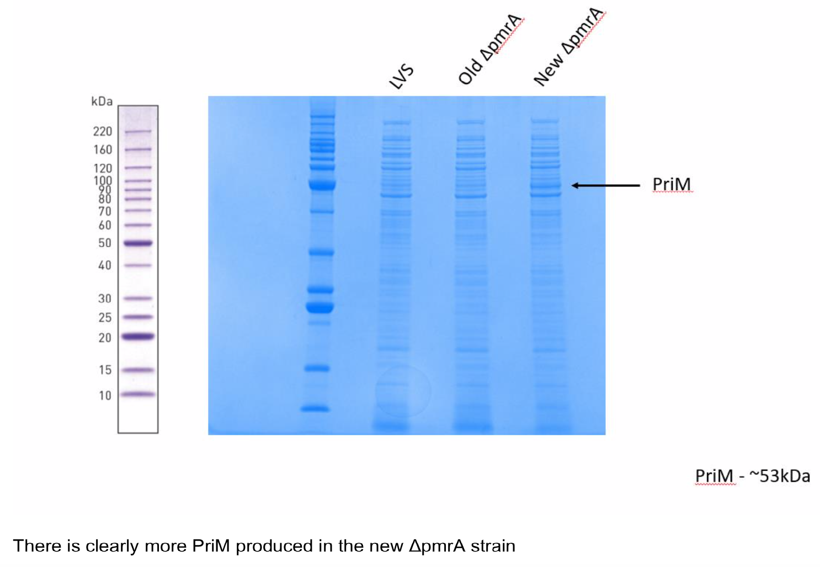
-RNA-Seq (KMR, analyzed by JMW): 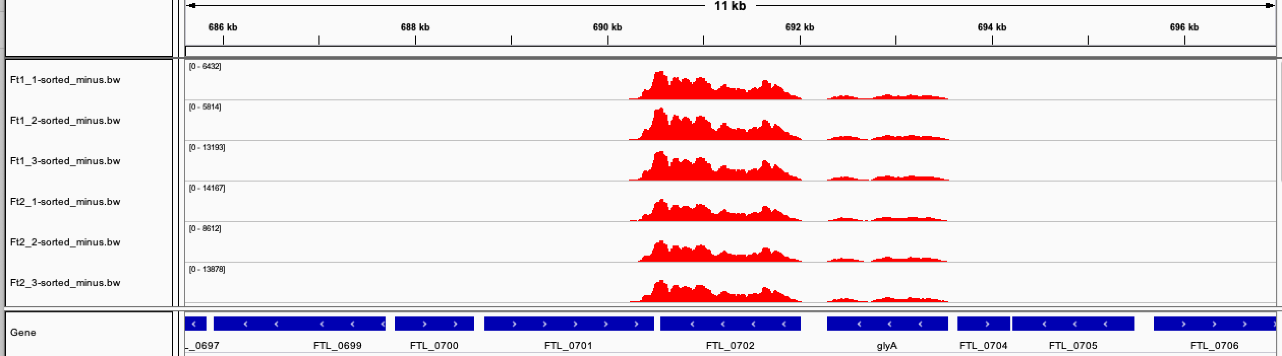
∆pmrA(new)
∆pmrA(old)
∆pmrA(new) and ∆pmrA(old) have similar amounts of priM transcript, and it is quite abundant (no other transcript of similar abundance nearby)
-qRT-PCR validation of RNA-Seq (KMR, 9/13/20) (note that LVS sample isn’t the perfect comparison).
***Conflict between transcript abundance detected and protein levels
Jamie struck out these cells; maybe picked the wrong “old” ∆pmrA?

-Are these actually different strains? I double-checked that the RNA-Seq samples have the FTL_0146 mutation, but do they have the other two mutations Jamie found in the ∆pmrA(sup) strain?
Gene or Region | Locus Number | Nucleotide Change | Mutations
ATP Binding Protein | FTL_0146 | C152592A | F315L
Proton-dependent oligopeptide transport | FTL_1339 | C1274708A | G421G
Upstream of hypothetical protein | Upstream of FTL_0869 | G849877T | N/A

The FTL_1339 mutation is present:
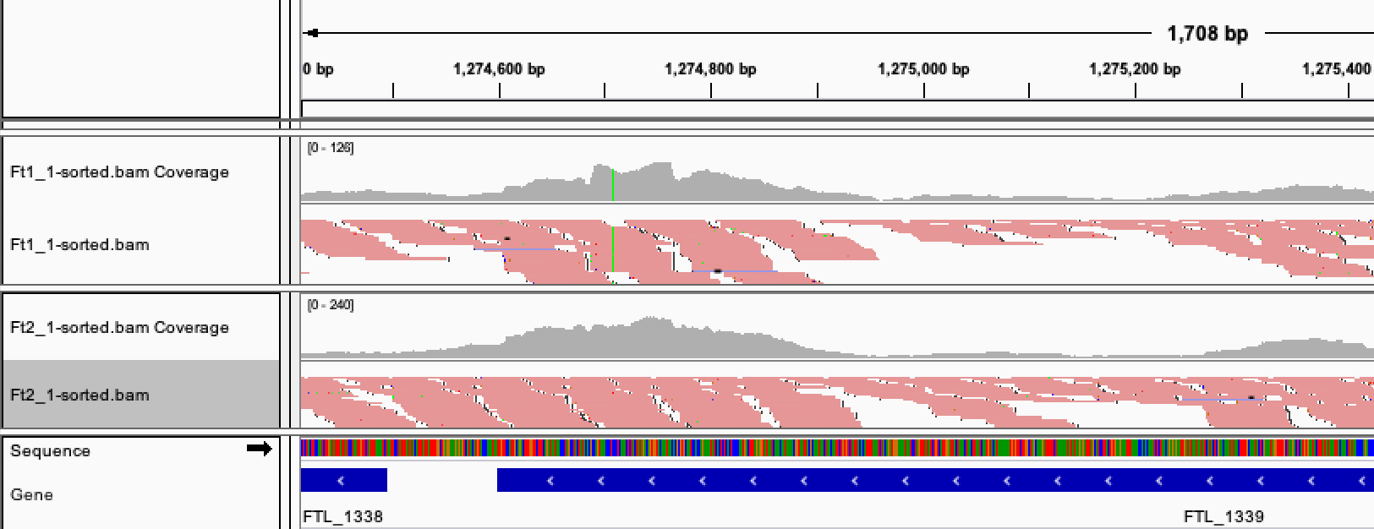

Not enough coverage in the FTL_0869 region to tell.
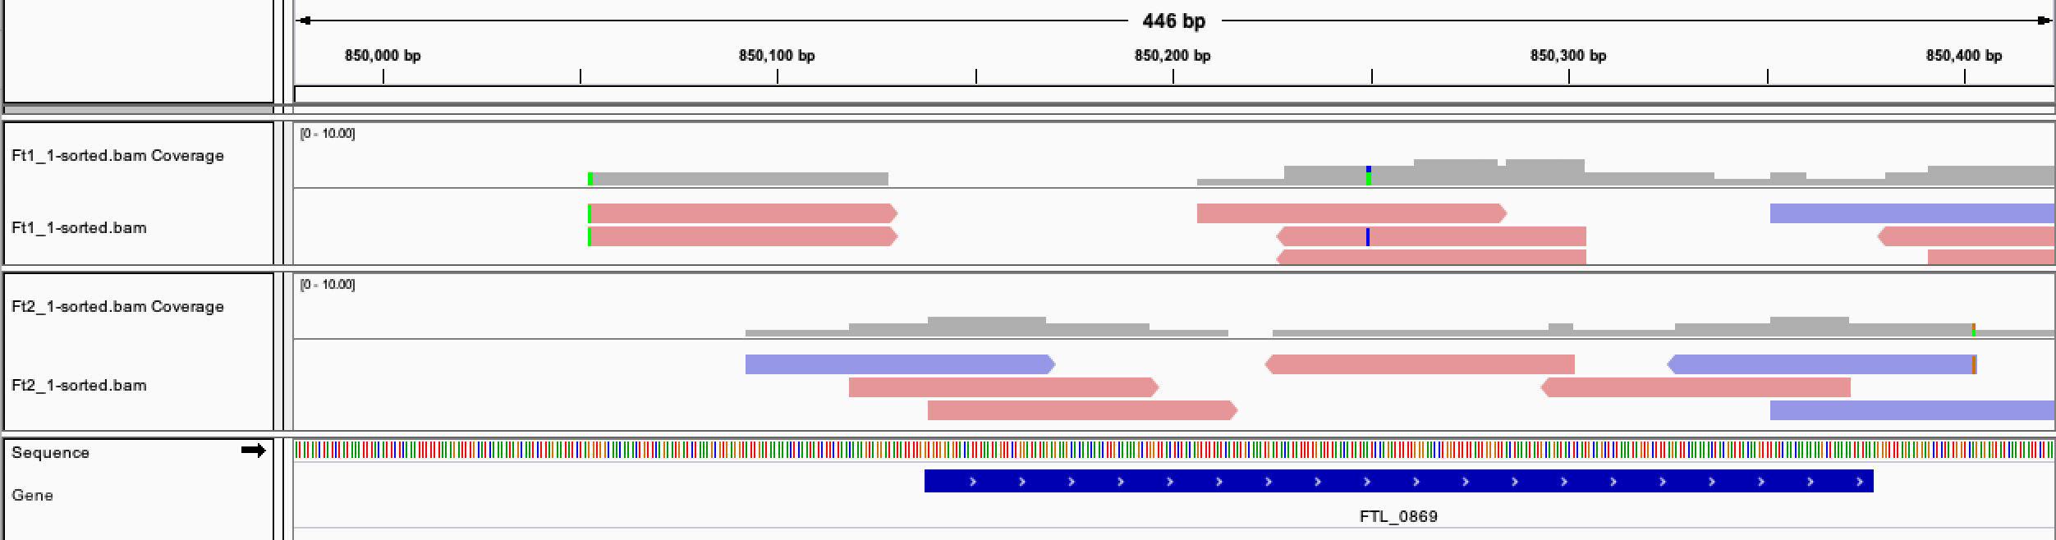

If the discrepancies between the RNA-Seq data and Jamie’s qPCR data are due to accidentally using different strains, maybe they would grow differently?

When I isolated RNA, the old grew better than the new.

Friday, September 18, 2020

To Do:
- Review sequencing data
- Run gel of PCR products
- Determine genotype of strains struck out from glycerol stocks

Results and Data:

Results of sequencing the FTL_0146 mutation region:
Sample name | Strain | Results
KMR_C1 | KMLFT49 ∆pmrA ∆priM | No SNP
KMR_C2 | KMLFT37 ∆pmrA | SNP
KMR_C3 | KMLFT67 ∆pmrA priM(S) | No SNP
KMR_C4 | KMLFT69 ∆pmrA mreA(S) | SNP
KMR_C5 | LVS | No SNP

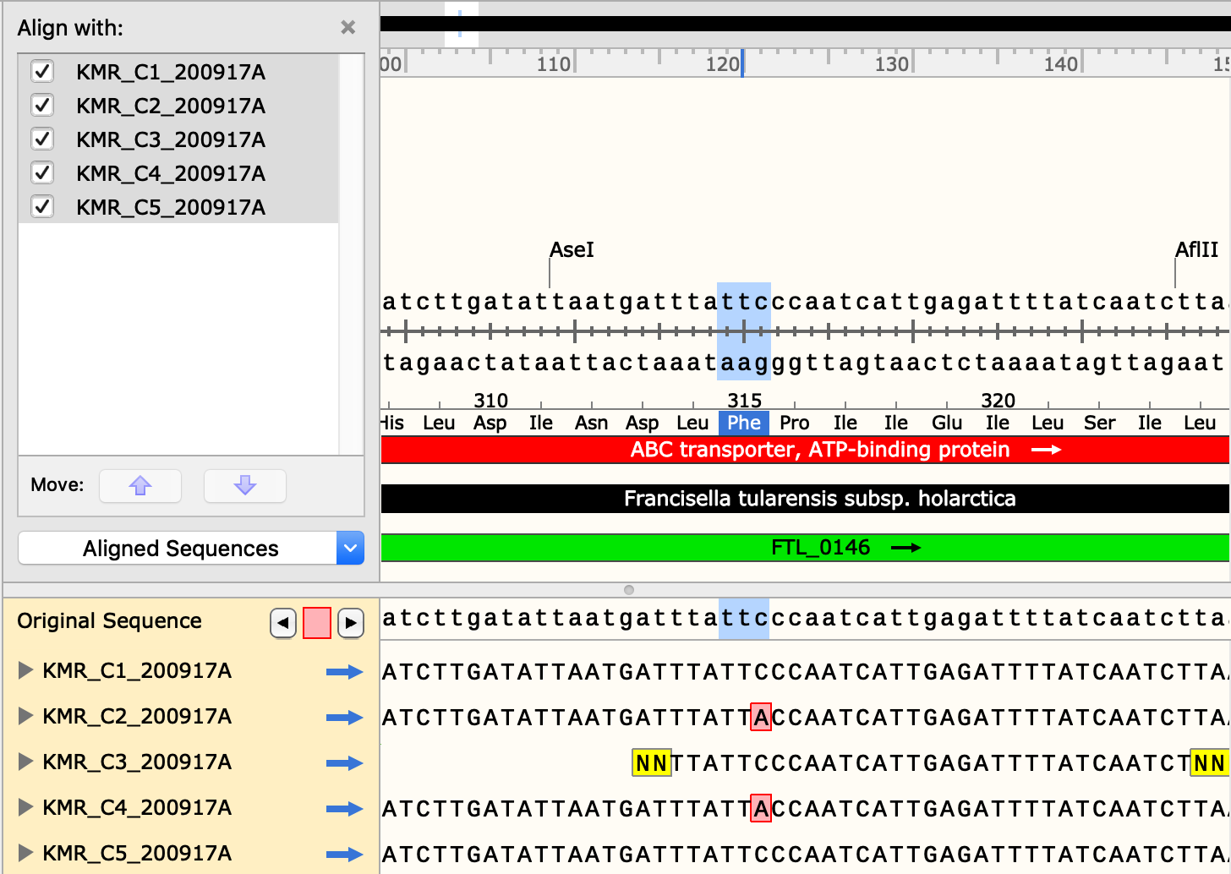

The ∆pmrA mreA(S) strain has the FTL_0146 F315L mutation, but I found that it could not replicate in macrophage.

I don’t think the FTL_0146 SNP is causing the ∆pmrA(sup) intramacrophage replication phenotype.

Reaction | Locus | Primers | Expected size (WT) | Expected size (∆) | Sequencing primer
A | pmrA | KROL61, KROL62 | 1204 | 535 | -
B | priM | KROL155, KROL156 | 1792 | 352 | -
C | FTL_0146 | KROL270, KROL271 | 1320 | - | KROL270

Sample Number | Strain number | Strain name | Result Rxn A | Result Rxn B
1 | KMLFT49 | ∆pmrA ∆priM | ~535 | ~352
2 | KMLFT37 | ∆pmrA | ~535 | ~1792
3 | KMLFT67 | ∆pmrA priM(S) | ~535 | ~1792
4 | KMLFT69 | ∆pmrA mreA(S) | ~535 | ~1792
5 |  | LVS | ~1204 | ~1792
6 |  | -DNA | -
A B C
1 2 3 4 5 6 1 2 3 4 5 6 6

All pmrA and priM genotypes as expected.

Consider re-doing the WGRS all these strains:

1 LVS
2 ∆pmrA(sup) KMLFT37
3 ∆pmrA (new) KRLVS40
4 ∆pmrA ∆priM KMLFT49
5 ∆pmrA priM(S) KMLFT67
6 ∆pmrA mreA(S) KMLFT69
7 LVS FTL_0146 F315L KRLVS69
8 ∆pmrA FTL_0146 F315L KRLVS81

But for now, review the WGRS data (did we miss anything in the variant calling??) and check the SDS-sensitivity of ∆pmrA cells.

Monday, September 21, 2020

To Do:

Results and Data:

Reviewing old NGS data. Folks from MiGS (sequencing facility) have no idea why the coverage is so variable.

Looking back to see if there is another undetected SNP. In the new ∆pmrA strain, there is a mutation in pepN (C 1883383 A which changes the codon for methionine 819 from ATG to ATT, so isoleucine (M819I). This mutation looks like it’s present in our LVS cells (about 50/50 WT : mutant) but not completely fixed and became fixed in the new ∆pmrA strain.

Future To-Do

Move 1° LVS pKR10-1 into strain box

