Table of Contents
March 2020 2
Future To-Do 5
Bibliography 6

March 2020
Thursday, March 12, 2020

To Do:
- Start cultures for T6SS assay
- Check culture OD600s
- Collect samples for T6SS assay
  - cell pellets
  - supernatant; filter-sterilize, add 100% TCA, put at 4°C O/N
Results and Data:

Yesterday, made BHIc -/+ 5% KCl (250 mL each) and struck out LVS, ∆pigR, ∆rpsU2 (HT’s stock)

Today, supplement BHIc (6.25 mL 20% glucose, 2.5 mL ß-NAD [1mg/mL], 2.5 mL heme-histidine)
Resuspend cells in sBHIc (-KCl):
Number | Strain | Resuspended cells to | Desired volume | Desired OD600 | Volume cells
1 | LVS | 6.65 | 7000 | 0.08 | 84.2
2 | ∆pigR | 6.31 | 7000 | 0.08 | 88.7
3 | ∆rpsU2 | 5.11 | 7000 | 0.08 | 109.6

Inoculated cultures at ~11am, used 600 uL to check OD600 values
Number | Strain | Media | 11:00am | 1:45pm | 3:20pm
1 | LVS | sBHIc | 0.081 | 0.231 | 0.522
2 | ∆pigR | sBHIc | 0.081 | 0.255 | 0.578
3 | ∆rpsU2 | sBHIc | 0.079 | 0.159 | 0.271
4 | LVS | sBHIc + 5% KCl | 0.105 | 0.113 | 0.128
5 | ∆pigR | sBHIc + 5% KCl | 0.113 | 0.15 | 0.218
6 | ∆rpsU2 | sBHIc + 5% KCl | 0.102 | 0.107 | 0.112

At 3:20pm, harvested 1 mL cell pellets (kept supernatant) and extra 1.8 mL supernatant.
Resuspended pellets in 1x SLB (OD in mL), boiled, froze.
Filter-sterilized supernatant, aliquoted 1.5 mL in one tube with 150 uL 100% TCA, 450 uL into another tube with 45uL 100% TCA. Put in cold room overnight.

Friday, March 13, 2020

To Do:
- Pellet TCA-precipitated proteins
- Add SLB
Results and Data:

Spin the tubes with more supernatant for 30’ at 4°C max speed.
Discard supernatant.
Vortex the tubes with the remaining supernatant.
Transfer liquid to first set of tubes, spin 30’ 4°C max speed.
Add 1 mL ice-cold 100% ethanol, spin 4°C 30’ max speed.
Remove supernatant, let pellet dry.
Add appropriate amount of 1x SLB to normalize to OD600 (as indicated below).

Number | Strain | Media | Final OD600 | 1X SLB
1 | LVS | sBHIc | 0.522 | 163.1
2 | ∆pigR | sBHIc | 0.578 | 180.6
3 | ∆rpsU2 | sBHIc | 0.271 | 84.7
4 | LVS | sBHIc + 5% KCl | 0.128 | 40.0
5 | ∆pigR | sBHIc + 5% KCl | 0.218 | 68.1
6 | ∆rpsU2 | sBHIc + 5% KCl | 0.112 | 35.0

Boil samples 5’, put at -20°C until ready to run gel.

After ~ 17 hrs of transfer (7V, 4°C), stopped transfer. Cut membranes to pieces with 3 well each (hopefully!) and incubate in blocking buffer in cold room, rocking, until Monday.

Wednesday, January 15, 2019

To Do:
- Perform WB
Results and Data:
Blot | Protein | kDa | Rec dilution | Planned dilution | Volume in 10 mL
1 | Tul4 | 17 | 1:5000 | 1:20000 | 0.5
2 | IglA | 20.9 | 1:2000 | 1:2000 | 5
3 | IglB | 57.9 | 1:1000 | 1:1000 | 10
4 | IglC | 22.1 | 1:1000 | 1:1000 | 10
5 | IglD | 46.4 | 1:1000 | 1:1000 | 10
6 | PdpC | 155.9 | 1:2500 | 1:1000 | 10
7 | PdpB | 127.5 | 1:1000 | 1:1000 | 10
8 | PdpA | 95.3 | 1:1000 | 1:500 | 20
9 | PdpB | 127.5 | 1:1000 | 1:500 | 20
10 | PdpA | 95.3 | 1:1000 | 1:200 | 50
Don’t bother with PdpD antibody- would be 140kDa, but is a pseudogene in LVS.

Incubate in 10 mL 1° for 1 hr

Wash 4 x 10’ (approx.- sometimes a bit more)

Re-block in 5 mL blocking buffer for 20’ (+ probably 10-15’ more)
Add 2° antibody directly to 5 mL blocking buffer- 1 uL of goat anti-mouse or goat anti-rabbit, as indicated below. Incubate 1 hr.

Blot | Protein | Antibody type
1 | Tul4 | mouse monoclonal
2 | IglA | rabbit polyclonal
3 | IglB | mouse monoclonal
4 | IglC | mouse monoclonal
5 | IglD | mouse monoclonal
6 | PdpC | rabbit polyclonal
7 | PdpB | mouse monoclonal
8 | PdpA | mouse monoclonal
9 | PdpB | mouse monoclonal
10 | PdpA | mouse monoclonal

Wash 4 x 10’
Develop ~3’ with 5 mL developer mix each

Initial general impressions:
Too much anti-rabbit secondary. Both blot 2 and 6 have LOTS of background
Anti-PdpA has a background band (just as here, in the CoA):
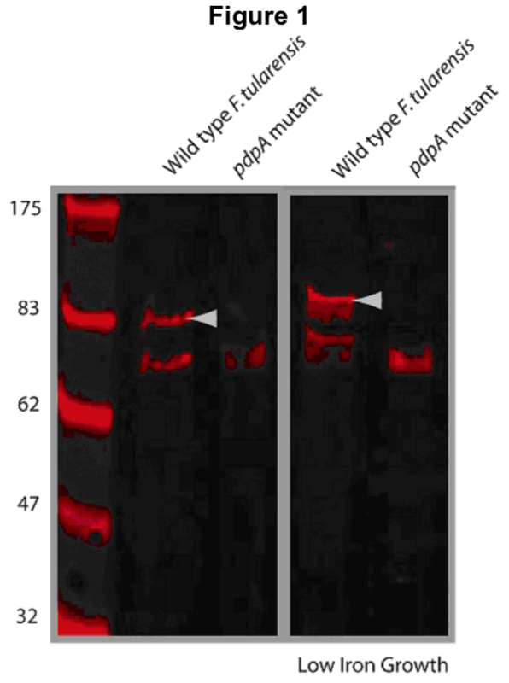 Actually, I thought the background band on my blot was above the PdpA protein… May need to look more carefully at the ladder. Should be at 93 kDa, the background on this blot is closer to 70 kDa.
Can’t really see PdpC. Maybe if there was less backgound? The CoA blot isn’t particularly convincing.
IglB, IglC, IglD antibodies look great!
IglA looks pretty good with a VERY brief exposure. Will probably be great with less background.
Tul4 / LpnA continues to look excellent.

WT vs ∆rpsU2 impressions
Much less PdpA!
Much less PdpB!
Can’t tell about PdpC
May actually be slightly less IglB, C, D – although this may be a loading issue. No control, and LpnA/Tul4 blot is cut off, so can’t tell relative amounts.

Aliquot plan

Tul4 / LpnA : 3 uL
IglA: 10 uL
IglB: 20 uL
IglC: 20 uL

IglD: 20 uL
PdpC: 50 uL
PdpB: 20 uL
PdpA: 40 uL

Made 5 aliquots of each (only 4 of Tul4- there is only 100 uL total and I’m sending 15 uL to Mougous lab)
Scans of the blots:
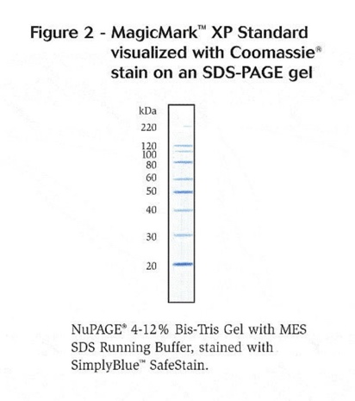
Note that for PdpA, there is an extra band running around the size of PdpB, which is 127.5 kDa. It makes sense that the slightly lower band (closer to the 100 kDa band) would be PdpA, which is 95.3 kDa.

Future To-Do

Move 1° LVS pKR10-1 into strain box

Bibliography

