Table of Contents
January 2020 2
Future To-Do 3
Bibliography 4

January 2020
Friday, January 10, 2020

To Do:
- Run gel for antibody tests
- Start O/N transfer for antibody tests
Results and Data:
Run 2x 4-12% Bis-Tris gels using 1x MOPS buffer, with the following loading / plan:
1 | LVS (1, 12.14.19) | Tul4 |  | 1 | LVS (1, 12.14.19) | PdpD
2 | ∆rpsU2 (3, 12.14.19) | Tul4 |  | 2 | ∆rpsU2 (3, 12.14.19) | PdpD
3 | Magic Mark ladder | Tul4 |  | 3 | Magic Mark ladder | PdpD
4 | LVS (1, 12.14.19) | IglA |  | 4 | LVS (1, 12.14.19) | PdpC
5 | ∆rpsU2 (3, 12.14.19) | IglA |  | 5 | ∆rpsU2 (3, 12.14.19) | PdpC
6 | Magic Mark ladder | IglA |  | 6 | Magic Mark ladder | PdpC
7 | LVS (1, 12.14.19) | IglB |  | 7 | LVS (1, 12.14.19) | PdpB
8 | ∆rpsU2 (3, 12.14.19) | IglB |  | 8 | ∆rpsU2 (3, 12.14.19) | PdpB
9 | Magic Mark ladder | IglB |  | 9 | Magic Mark ladder | PdpB
10 | LVS (1, 12.14.19) | IglC |  | 10 | LVS (1, 12.14.19) | PdpA
11 | ∆rpsU2 (3, 12.14.19) | IglC |  | 11 | ∆rpsU2 (3, 12.14.19) | PdpA
12 | Magic Mark ladder | IglC |  | 12 | Magic Mark ladder | PdpA
13 | LVS (1, 12.14.19) | IglD |  | 13 | LVS (1, 12.14.19)
14 | ∆rpsU2 (3, 12.14.19) | IglD |  | 14 | ∆rpsU2 (3, 12.14.19)
15 | Magic Mark ladder | IglD |  | 15 | Magic Mark ladder
Ran 10 uL of each lysate (from pellets grown in sBHIc for T6SS assay by HT) and 1 uL ladder

Used new gel running chambers. Ran gels at 150V for ~1 hr.
Transfer using new blot modules. Put at 4°C O/N, running at 7V (start ~5:20pm). New module does not fit in ice bucket to keep cool.

Saturday, January 11, 2020

To Do:
- Stop transfer, put membranes in blocking buffer at 4°C
Results and Data:
After ~ 17 hrs of transfer (7V, 4°C), stopped transfer. Cut membranes to pieces with 3 well each (hopefully!) and incubate in blocking buffer in cold room, rocking, until Monday.

Wednesday, January 15, 2020

To Do:
- Perform WB
Results and Data:
Blot | Protein | kDa | Rec dilution | Planned dilution | Volume in 10 mL
1 | Tul4 | 17 | 1:5000 | 1:20000 | 0.5
2 | IglA | 20.9 | 1:2000 | 1:2000 | 5
3 | IglB | 57.9 | 1:1000 | 1:1000 | 10
4 | IglC | 22.1 | 1:1000 | 1:1000 | 10
5 | IglD | 46.4 | 1:1000 | 1:1000 | 10
6 | PdpC | 155.9 | 1:2500 | 1:1000 | 10
7 | PdpB | 127.5 | 1:1000 | 1:1000 | 10
8 | PdpA | 95.3 | 1:1000 | 1:500 | 20
9 | PdpB | 127.5 | 1:1000 | 1:500 | 20
10 | PdpA | 95.3 | 1:1000 | 1:200 | 50
Don’t bother with PdpD antibody- would be 140kDa, but is a pseudogene in LVS.

Incubate in 10 mL 1° for 1 hr

Wash 4 x 10’ (approx.- sometimes a bit more)

Re-block in 5 mL blocking buffer for 20’ (+ probably 10-15’ more)
Add 2° antibody directly to 5 mL blocking buffer- 1 uL of goat anti-mouse or goat anti-rabbit, as indicated below. Incubate 1 hr.

Blot | Protein | Antibody type
1 | Tul4 | mouse monoclonal
2 | IglA | rabbit polyclonal
3 | IglB | mouse monoclonal
4 | IglC | mouse monoclonal
5 | IglD | mouse monoclonal
6 | PdpC | rabbit polyclonal
7 | PdpB | mouse monoclonal
8 | PdpA | mouse monoclonal
9 | PdpB | mouse monoclonal
10 | PdpA | mouse monoclonal

Wash 4 x 10’
Develop ~3’ with 5 mL developer mix each

Initial general impressions:
Too much anti-rabbit secondary. Both blot 2 and 6 have LOTS of background
Anti-PdpA has a background band (just as here, in the CoA):
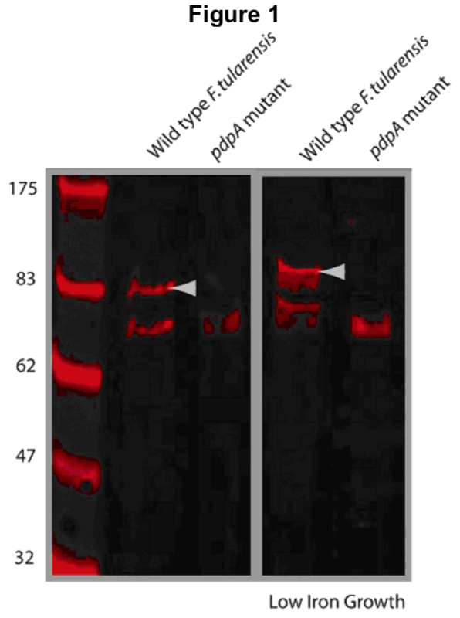 Actually, I thought the background band on my blot was above the PdpA protein… May need to look more carefully at the ladder. Should be at 93 kDa, the background on this blot is closer to 70 kDa.
Can’t really see PdpC. Maybe if there was less backgound? The CoA blot isn’t particularly convincing.
IglB, IglC, IglD antibodies look great!
IglA looks pretty good with a VERY brief exposure. Will probably be great with less background.
Tul4 / LpnA continues to look excellent.

WT vs ∆rpsU2 impressions
Much less PdpA!
Much less PdpB!
Can’t tell about PdpC
May actually be slightly less IglB, C, D – although this may be a loading issue. No control, and LpnA/Tul4 blot is cut off, so can’t tell relative amounts.

Aliquot plan

Tul4 / LpnA : 3 uL
IglA: 10 uL
IglB: 20 uL
IglC: 20 uL

IglD: 20 uL
PdpC: 50 uL
PdpB: 20 uL
PdpA: 40 uL

Made 5 aliquots of each (only 4 of Tul4- there is only 100 uL total and I’m sending 15 uL to Mougous lab)
Scans of the blots:
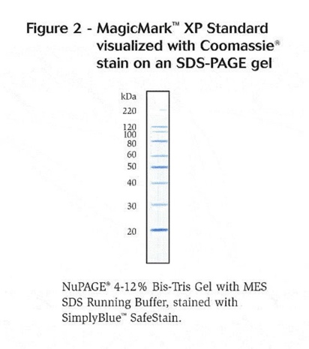
Note that for PdpA, there is an extra band running around the size of PdpB, which is 127.5 kDa. It makes sense that the slightly lower band (closer to the 100 kDa band) would be PdpA, which is 95.3 kDa.

Future To-Do

Move 1° LVS pKR10-1 into strain box

Bibliography

