Table of Contents
April 2019 2
May 2019 16
Bibliography 18

April 2019

Friday, April 5, 2019

To Do:
- Electroporate reporter strains with pF plasmids with C. Bouchard (making up CMB415 lab work)
- Pour CHAH plates with Kan50 and Xgal100

Results and Data:

Electroporations:
Number | Strain | Plasmid | Notes
1 | LVS P_{priM}-lacZ | pF | EP by C. Bouchard
2 | LVS ∆pmrA P_{priM}-lacZ | pF | EP by C. Bouchard; arced
3 | LVS ∆pmrA P_{priM}-lacZ | pF-PmrA | EP by C. Bouchard
4 | LVS ∆pmrA P_{priM}-lacZ | pSD26 | EP by C. Bouchard
5 | LVS P_{priM}-lacZ | pF | EP by KMR
6 | LVS ∆pmrA P_{priM}-lacZ | pF | EP by KMR
7 | LVS ∆pmrA P_{priM}-lacZ | pF-PmrA | EP by KMR
8 | LVS ∆pmrA P_{priM}-lacZ | pSD26 | EP by KMR

50 ul of cells, 3 ul of plasmid per electroporation
Recovered in 5 mL MHB from ~9- 12:30pm

Plated 20 and 100 from EPs 1-3, 5-7
Plated 2x 100 ul, 2x 500 ul, 2x 1mL for EPs 4 and 8

Wednesday, April 10, 2019

To Do:
- Check on electroporation plates
- Streak out white colonies from transponson insertion electroporation

Results and Data:

Electroporation Results: colony appearance
Number | Strain | Plasmid | Notes
1 | LVS P_{priM}-lacZ | pF | White, large
2 | LVS ∆pmrA P_{priM}-lacZ | pF | Blue, small
3 | LVS ∆pmrA P_{priM}-lacZ | pF-PmrA | White, large
4 | LVS ∆pmrA P_{priM}-lacZ | pSD26 | Mostly blue, small, a few white
5 | LVS P_{priM}-lacZ | pF | White, large
6 | LVS ∆pmrA P_{priM}-lacZ | pF | Blue, small
7 | LVS ∆pmrA P_{priM}-lacZ | pF-PmrA | White, large
8 | LVS ∆pmrA P_{priM}-lacZ | pSD26 | Mostly blue, small, a few white

Patched out

Thursday, April 11, 2019

To Do:
- PCR for lacZ gene from transposon insertion clones
- PCR for pKR32

Results and Data:

Reaction | DNA | Expected result
1 | 1:10 patch 1 (white) | ?
2 | 1:10 patch 2 (white) | ?
3 | 1:10 patch 3 (white) | ?
4 | 1:10 patch 4 (white) | ?
5 | 1:10 patch 5 (blue) | 3469 (lacZ)
6 | LVS gDNA | 1792 (priM)
7 | Negative control, no template
Transposon from pSD26 is 1441 bp; integration into lacZ would result in product of 4,910 bp

Total reaction volume |  | 20
Total number of reactions |  | 7
 |  |  |  | Factor
Component | Stock concentration | Final concentration | 1 rxn volume | 8.7
ddiH2O |  |  | 4 | 34.8
KOD buffer | 2x | 1x | 10 | 87
dNTPs | 2 mM | 0.4 mM | 4 | 34.8
oligo F | 10 uM | 0.3 uM | 0.6 | 5.22
oligo R | 10 uM | 0.3 uM | 0.6 | 5.22
template | 100 ng/ul | 2 ng/ul | 0.4
KOD | 1 U/ul | 0.02 U/ul | 0.4 | 3.48
 |  | Total volume | 20
Used 2 ul lysates and 0.6 uL H20 or gDNA.
Run program STN1 with 5’ extension.

Reaction | DNA | Expected result
1 | 1:10 patch 1 (white) | ?
2 | 1:10 patch 2 (white) | ?
3 | 1:10 patch 3 (blue) | 3469
4 | LVS gDNA | 1792
5 | Negative control, no template
Transposon from pSD26 is 1441 bp; integration into lacZ would result in product of 4,910 bp

PCR setup for C. Bouchard:
Total reaction volume |  | 20
Total number of reactions |  | 5
 |  |  |  | Factor
Component | Stock concentration | Final concentration | 1 rxn volume | 6.6
ddiH2O |  |  | 4 | 26.4
KOD buffer | 2x | 1x | 10 | 66
dNTPs | 2 mM | 0.4 mM | 4 | 26.4
oligo F | 10 uM | 0.3 uM | 0.6 | 3.96
oligo R | 10 uM | 0.3 uM | 0.6 | 3.96
template | Bacterial cells | 2 ng/ul | 1 | -
KOD | 1 U/ul | 0.02 U/ul | 0.4 | 2.64
 |  | Total volume | 20 | 132
Make master mix tube
Aliquot out reactions into PCR strip tubes: 19.6ul of master mix
Add template (bacterial cells)
Put tubes in thermocycler, use program STN1 with 5’ extension time
Run gel Tuesday

Start cloning pKR32:
Set up PCR:
Reactions
Number | Primers | Target | Expected size | For plasmid
1 | KROL157, KROL158 | FTL_1548_frag | 317 bp | pKR32
2 | KROL15 FTL1251fragF KROL16 FTL1251fragR | Positive control: FTL_1251 internal | 456 bp | Positive control
3 | KROL15 FTL1251fragF KROL16 FTL1251fragR | Negative control: FTL_1251 internal | 456 bp | No DNA

Total reaction volume |  | 100
Total number of reactions |  | 2
 |  |  |  | Factor
Component | Stock concentration | Final concentration | 1 rxn volume | 3.3
ddiH2O |  |  | 20 | 66
KOD buffer | 2x | 1x | 50 | 165
dNTPs | 2 mM | 0.4 mM | 20 | 66
oligo F | 10 uM | 0.3 uM | 3 | -
oligo R | 10 uM | 0.3 uM | 3 | -
template | 100 ng/ul | 2 ng/ul | 2 | -
KOD | 1 U/ul | 0.02 U/ul | 2 | 6.6
 |  | Total volume | 100 | 330

Aliquot 92 ul into tube 1, aliquot 46 ul into tubes 2, 3
Add 3 ul each primer to tube 1, 1.5 ul each primer to tubes 2,3
Add 2 ul LVS gDNA to tube 1, 1uL to tube 2, 1 ul water to tube 3

Run STN1 with 30’ extension

Friday, April 12, 2019

To Do:
- PCR-purify FTL_1548 fragment
- Check FTL_1548 fragment on gel
- Run gel of lacZ PCR
- Set up O/N digest of FTL_1548 fragment

Results and Data:

Check PCR for lacZ:
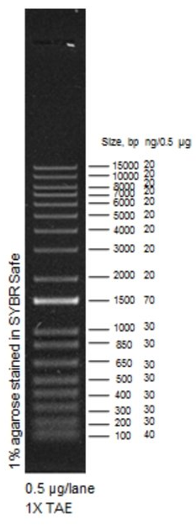
kb
5
4
3
kb
5
4
3
C. Bouchard
1 2 3 LVS (-)DNA
KMR
1 2 3 4 5 LVS (-)DNA
Expected results:
lacZ (no insertion) 3,469 bp
lacZ with pSD26 insertion 4,910 bp
priM (WT LVS only) 1,792 bp

Negative control is clean, LVS gDNA looks correct- controls are good!
KMR 5 and CB 3 are from LVS ∆pmrA P_{priM}-lacZ pSD26 insertions that are blue. lacZ should be intact and those bands appear to be running in the correct location, 3,469 bp.
All of the white colonies appear to have bands running at the size corresponding to a transposon insertion into lacZ. There is some background, likely carryover cells from the plate since we didn’t purify these clones.
Cloning pKR32
PCR-purify PCR reaction 1 from yesterday (4/11)
Run 5 uL on gel and 5 uL of reactions 2 and 3:

1 2 (-)DNA

Looks like the PCR worked great, but there is some contamination. !

Move forward with digest- will be gel-purifying anyway.

Digest to clone pKR32:
 | 1  FTL_1548 frag | 2  pKL02 backbone
H₂O | 15.8 | 20.8
10x CSB | 3 | 3
DNA | 10 | 5
KpnI-HF | 0.6 | 0.6
NotI-HF | 0.6 | 0.6
Total | 30 | 30
Incubate 37°C O/N

Saturday, April 13, 2019

To Do:
- CIP-treat pKL02 backbone
- Gel-purify fragments
- Ligate for pKR32
- Transform ligations
- Purify gDNA from LVS, KRLVS7, potential strains EP46-1, EP46-2

Results and Data:

Cloning pKR32
Add 10 uL CIP to pKL02 and incubate 10’ more
Run digests on gel:
Pre-cut Post-cut

2
pKL02
1
FTL_1548 frag
1
FTL_1548 frag
2
pKL02

The fainter bands are pretty difficult to see with the blue screen, even with the lights out. Pretty imperfect cutting, but move forward.
Gel slice weights: 370, 160 mg, respectively.

Gel-purify using Qiagen kit. Elute in 30 uL 0.1x EB.

Ligate
Set up ligations:
 | 1 | 2
H₂O | 9.5 uL | 15.5 uL
10x CSB | 2 uL | 2 uL
FTL_1548 frag | 6 uL | -
pKL133 | 2 uL | 2 uL
Ligase | 0.5 uL | 0.5 uL

Incubate at room temp 10’

Transform ligations
Aliquot 8 uL each ligation to sterile 1.5 mL tubes. Use 0.5 uL of pKL02 as positive control.
Add 100 uL XL1-Blue cells to the three tubes, incubate on ice for about 8’
Heat-shock for 30” at 42°C
Add 1mL LB and shake at 37°C for about 45 minutes
Plate 20ul and 100 ul of positive control transformation, plate 100 ul and remaining volume of ligation transformations
Put plates at 37°C O/N

Isolating gDNA
Have cell pellets from 3/15/19 to purify gDNA using Lucigen (formerly Epicenter) MasterPure DNA isolation kit:
LVS
EP46-1
EP46-2
KRLVS7

Thaw tubes, vortex
Make 1300 uL tissue cell lysis solution with 4.33 uL Proteinase K
Add 300 uL per sample
Incubate at 65°C for 15 minutes, vortexing every 5 minutes
Add 1 uL 3 uL RNase A to each sample (samples very viscous, recall having RNA contamination in isolations in Dove lab)
Incubate at 37°C for 30’
Add 175uL MPC protein precipitation reagent, vortex 10 seconds
Pellet 10’ 15,000 rpm 4°C in Dutta lab centrifuge
Transfer supernatant to clean tube
Add 500 uL 100% isopropanol, invert 40 times
Spin 10’ 15,000 rpm 4°C Dutta lab centrifuge
Remove isopropanol
Add ~1 mL 70% ethanol, remove, repeat for 2 washes
Let pellet dry on bench
Add 100 uL 0.1x EB to each pellet, add another 100 ul to LVS pellet.
Put at 4°C O/N.

Sunday, April 14, 2019

To Do:
- Grow E. coli with pKL02 and potential pKR32 O/N

Results and Data:

Transformation results:
Reaction Contents 20 uL plate 100 uL plate 1 mL plate
1 FTL_1548 frag & cut pKL02 - 96 colonies TMTC
2 cut pKL02 only - 0 colonies 15 colonies
3 pKL02 plasmid >50, TMTC TMTC -

Pick 4 colonies from transformation reaction 1 (potential pKR32) and 2 colonies from pKL02, inoculate 5 mL LB + Kan50, grow ON at 37°C shaking

Monday, April 15, 2019

To Do:
- Miniprep potential pKR32, pKL02
- Check [DNA] by Nanodrop
- Set up sequencing reactions

Results and Data:

Miniprepped O/N cultures, eluted in 50 uL 0.1x EB. Checked concentration by Nanodrop, also checked concentration of gDNA isolations (had to add at least 200 uL more 0.1x EB to each tube):
Sample ID | ng/ul | A260 | A280 | 260/280 | 260/230 | Constant | Cursor Pos. | Cursor abs.
1 | 901.67 | 18.033 | 9.57 | 1.88 | 2.32 | 50 | 230 | 7.766
2 | 484.01 | 9.68 | 5.255 | 1.84 | 2.3 | 50 | 230 | 4.215
3 | 481.58 | 9.632 | 5.271 | 1.83 | 2.28 | 50 | 230 | 4.229
4 | 408.66 | 8.173 | 4.404 | 1.86 | 2.32 | 50 | 230 | 3.521
pKL02 | 874.74 | 17.495 | 9.253 | 1.89 | 2.32 | 50 | 230 | 7.527
LVS gDNA | 990.73 | 19.815 | 10.775 | 1.84 | 1.34 | 50 | 230 | 14.788
KRLVS7 gDNA | 1155.69 | 23.114 | 12.546 | 1.84 | 1.41 | 50 | 230 | 16.335
EP46-1 gDNA | 1148.4 | 22.968 | 12.499 | 1.84 | 1.27 | 50 | 230 | 18.039
EP46-2 gDNA | 718.41 | 14.368 | 7.767 | 1.85 | 1.16 | 50 | 230 | 12.423

Plasmid preps look good, send all the sequence.
gDNA looks cloudy, has high 260/230 ratio. Consider re-purifying? Really need to just try PCR to check for integration of pKR2 into the EP46 isolates.

Tuesday, April 16, 2019

To Do:
- Set up sequencing reactions

Results and Data:

Submitted samples for sequencing:
Sample number | Well | Template Type | Template Name | Primer Nameª | A. | B. | E. | F.
 | (GSC use only) | (plasmid or PCR) |  |  | Template Size (bases) | Template Stock Conc. (ng/μl) | PLASMID template: | Volume H₂O needed
 |  |  |  |  |  |  | Volume =
 |  |  |  |  |  |  | 2x(~400 ÷ B)μl | (20 less D or E)μl
1 |  | Plasmid | KMR_pKR32_1 | KROL6 | 5435 | 901.67 | 0.9 | 19.1
2 |  | Plasmid | KMR_pKR32_2 | KROL6 | 5435 | 484.01 | 1.7 | 18.3
3 |  | Plasmid | KMR_pKR32_3 | KROL6 | 5435 | 481.58 | 1.7 | 18.3
4 |  | Plasmid | KMR_pKR32_4 | KROL6 | 5435 | 408.66 | 2.0 | 18.0
5 |  | Plasmid | KMR_pKR10_6 | P793 | 11325 | 439 | 1.8 | 18.2

Wednesday, April 17, 2019

To Do:
- Check sequencing results
- Electroporate pKL32 into LVS
- Plate electroporations

Results and Data:

Sequencing results:
Sample number | Template Name | Result
1 | KMR_pKR32_1 | Deletion around NotI site? Incorrect, discard
2 | KMR_pKR32_2 | Correct
3 | KMR_pKR32_3 | Correct
4 | KMR_pKR32_4 | Correct
5 | KMR_pKR10_6 | ??

Combine minipreps from 2, 3, 4 = pKR32!

Sequencing of potential pKR10 (PchaC-lacZ): using P793, there should have been sequence from the flanking region surrounding FTL_1548. Instead, results are sequence from about 400 bp into lacZ gene!

All of the results with this attempt at making pKR10 have been odd. Try to re-do, potentially after classes have ended.

Electroporations:
Number | Strain | Plasmid | Notes
48 | LVS | pKR32
49 | LVS | pKR32
50 | LVS | pKR32
51 | LVS | pKR32

Recovered at about 11:45am, plated each EP onto 2 CHA-Kan plates around 7:15pm (about 7.5 hours recovery).

Thursday, April 18, 2019

To Do:
- Check on electroporation plates
- PCR for integration of pKR2

Results and Data:

Electroporation 50 plates contaminated- discard.

Reaction | DNA
1 | EP 46-1 gDNA
2 | EP 46-2 gDNA
3 | KRLVS7 gDNA
4 | LVS gDNA
5 | Negative control, no template

 |  | For 200 uL at 100 ng/ul
DNA sample | Concentration | gDNA | water
LVS gDNA | 990.73 | 20.2 | 179.8
KRLVS7 gDNA | 1155.69 | 17.3 | 182.7
EP46-1 gDNA | 1148.4 | 17.4 | 182.6
EP46-2 gDNA | 718.41 | 27.8 | 172.2

Total reaction volume |  | 20
Total number of reactions |  | 5
 |  |  |  | Factor
Component | Stock concentration | Final concentration | 1 rxn volume | 6.6
ddiH2O |  |  | 4 | 26.4
KOD buffer | 2x | 1x | 10 | 66
dNTPs | 2 mM | 0.4 mM | 4 | 26.4
KROL1 | 10 uM | 0.3 uM | 0.6 | 3.96
KROL7 | 10 uM | 0.3 uM | 0.6 | 3.96
template | 100 ng/ul | 2 ng/ul
KOD | 1 U/ul | 0.02 U/ul | 0.4 | 2.64
 |  | Total volume | 20 | 132
Run program STN1 with 1’ extension.
KROL1 & KROL17 = 765 bp if integrated (no product otherwise)

Friday, April 19, 2019

To Do:
- Pellet cells for RNAP TAP purification with/for Jamie
- Run gel of PCR for integration of pKR2
- Spot-plate pmrA variant strains

Results and Data:

RNAP purification assistance
Jamie started the pelleting of the LVS β′-TAP cells. I washed each 400 mL volume with about 10 mL Buffer P1, transferred to 50mL conicals, pelleted and discarded the Buffer P1, and froze at -80°C.

Spot-plating of pmrA variants
Jamie struck out strains yesterday. Strains for spot plating:

1 LVS
2 LVS ∆pmrA
3 LVS ∆pmrA ∆priM
4 LVS ∆pmrA priM_mtip2
5 LVS pmrAD51A
6 LVS ∆pigR

Plan for spot plating. Note that cells/mL per OD600 is based on DMEM numbers; may be slightly off for MHB.

Cells/mL per OD600
5.81E+09
Spot | OD600 | Cells/mL | colonies in 5 uL
1 | 5 | 2.91E+10 | 1.45E+08
2 | 0.5 | 5.81E+09 | 2.91E+07
3 | 0.025 | 1.45E+08 | 7.26E+05
4 | 0.00125 | 3.63E+06 | 1.82E+04
5 | 0.0000625 | 9.08E+04 | 4.54E+02
6 | 0.000003125 | 2.27E+03 | 1.13E+01

Scrape up cells in ~300 uL MHB and check OD600.

Strain | Measured OD600 (1:20) | Actual OD600 | For 150 uL at 7.88 | MHB
1 | 0.539 | 10.78 | 109.6 | 40.4
2 | 0.394 | 7.88 | 150.0 | 0.0
3 | 0.822 | 16.44 | 71.9 | 78.1
4 | 0.57 | 11.4 | 103.7 | 46.3
5 | 0.864 | 17.28 | 68.4 | 81.6
6 | 0.844 | 16.88 | 70.0 | 80.0

Normalize OD600 as indicated. Dilute 20ul into 180 MHB in 96-well plate, dilute down 1:10 for 5 dilutions. **Note for future- should have prepped enough to normalize OD in 96-well plate, would have been much easier!

Spot out 5 uL of each dilution (including no dilution) of each strain onto standard CHA plates (using CHA from either BD or Alpha Biosciences) and no-salt CHA plates (homemade, no NaCl added). Did once with normal pipette, worried I may have contaminated the plate with the plate edge. Re-do using multichannel. Much easier! Still need to hand-spot the undiluted cells, but less of an issue.

Because the cells Jamie plated 2 days ago on no salt media have not grown yet, concerned that there may be an issue with density. To address this, pellet 50 uL of the normalized OD strains x2. Discard most of the sup, plate concentrated cells on BD plates and no salt plates – effectively 10x the most concentrated cells on the dilution plates.

Strain construction: ∆ggt ∆chaC dptA(-)? (AKA ∆FTL_0766 ∆FTL_1568 FTL_1251(-), KRLVS6 pKR2

Have cells from electroporation on 2/25/19, EP 46, patched on 2/28/19, checked for integration using colony PCR on 3/1/19 (nothing worked) and 3/2/19 (confirmed integration for other strains).

Despite the negative colony PCR result, I thought it was possible I had the correct strain; cells were Kan resistant with decent growth, for the first time in about 8 electroporations. I had frozen down the cells (labeled EP46-1 and EP46-2) and saved pellets for gDNA extraction (see extraction, 4/13/19). Peformed PCR yesterday, ran entire PCR on gel today:

LVS KRLVS7 EP46-1 EP46-2 -DNA
Correct product in lane with KRLVS7 (thank goodness), only background bands in LVS and very similar background bands in both EP46 strains.
Discard EP46 cells.

Still don’t have ∆ggt ∆chaC dptA(-)

Sunday, April 21, 2019

To Do:
- Patch out colonies from LVS pKR32 electroporations

Results and Data:
Patched from #of colonies
49 1
51 4
52 5

Monday, April 22, 2019

To Do:
- PCR to check for correct integration of pKR32
- Mail Simon and Sam plasmid
- Mail Mougous lab strain
- Check on salt plates

Results and Data:
FTL_1548-V strain construction
All patches except 51-2 grew on Kan plates
Check for correct integration by PCR

Reaction | DNA
1 | EP 49 colony 1
2 - 4 | EP 51 colony 1, 3, 4
5 - 9 | EP 52 colony 1 - 5
10 | pKR32 (1:10)
11 | LVS gDNA
12 | Negative control, no template

Total reaction volume |  | 20
Total number of reactions |  | 12
 |  |  |  | Factor
Component | Stock concentration | Final concentration | 1 rxn volume | 14.3
ddiH2O |  |  | 4 | 57.2
KOD buffer | 2x | 1x | 10 | 143
dNTPs | 2 mM | 0.4 mM | 4 | 57.2
KROL159 | 10 uM | 0.3 uM | 0.6 | 8.58
P35 | 10 uM | 0.3 uM | 0.6 | 8.58
template | 100 ng/ul | 2 ng/ul | 1
KOD | 1 U/ul | 0.02 U/ul | 0.4 | 5.72
 |  | Total volume | 20 | 286
STN1 with 30” extension
KROL159 & P35 = 421 bp

LVS (-)
49-1 51-1 51-3 51-4 52-1 52-2 52-3 54-3 52-5 pKR32 gDNA DNA

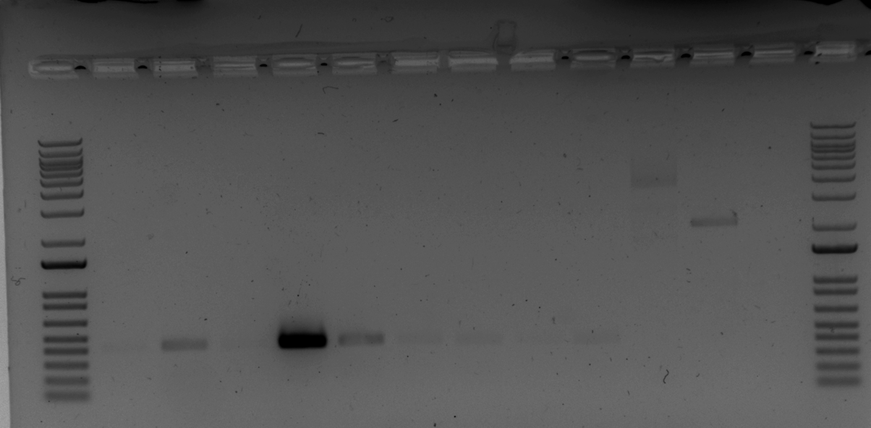

All reactions had product of correct size and need to freeze down cells and ship out immediately, so chose patches with most cells:
EP 52-2 = KRLVS14.1
EP 49-1 = KRLVS14.2
Freeze down 3 glycerol stocks of KRLVS14.1, ship one immediately to Hannah Ledvina in Joseph Mougous’s lab.
Sensitivity of pmrA variant strains to low osmolarity:
Strains on plates with no additional salt added:
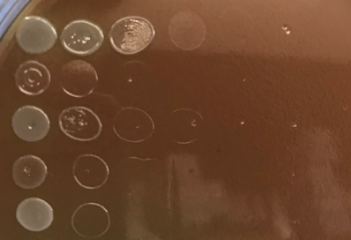190422_nosalt_1b
LVS

∆pmrA

∆pmrA ∆priM

∆pmrA priM_mtip2

prmAD51A
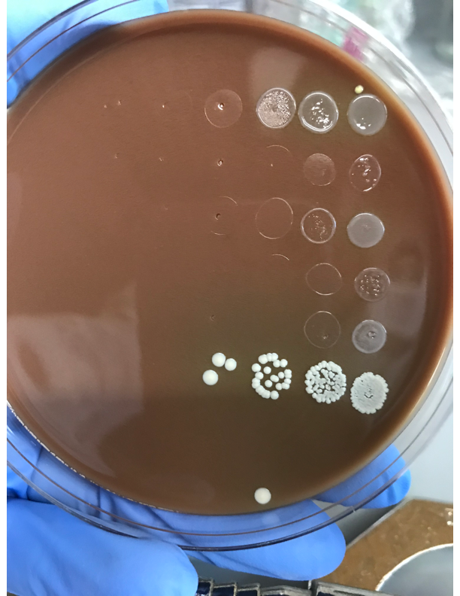190422_nosalt_2
LVS

∆pmrA

∆pmrA ∆priM

∆pmrA priM_mtip2

prmAD51A

Strains on standard CHA plates:
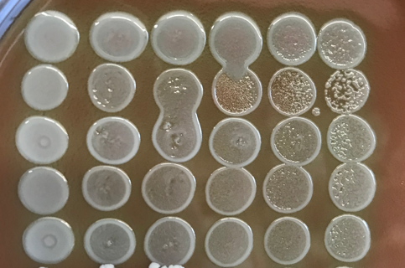190422_normalCHA_1
LVS

∆pmrA

∆pmrA ∆priM

∆pmrA priM_mtip2

prmAD51A

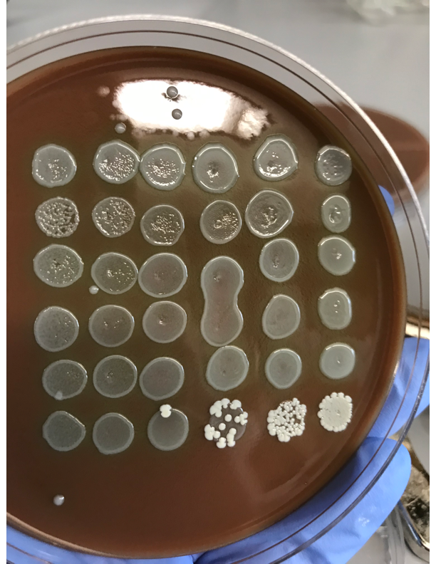190422_normalCHA_2
LVS

∆pmrA

∆pmrA ∆priM

∆pmrA priM_mtip2

prmAD51A

Will continue to see how strains grow on low osmolarity medium; clearly didn’t get down to single colonies on standard CHA (incorrect calculations for CFU/mL in PBS??). It does appear that the ∆pmrA strain started with fewer cells than the other strains. However, the ∆pmrA priM_mtip2 mutant has a similar growth phenotype on the plates without added salt and even the pmrAD51A mutant is somewhat attenuated. The most rescue is with the ∆pmrA ∆priM strain; expression of priM is making the cells more sensitive to low osmolarity.

Interpretation:

Tuesday, April 23, 2019

To Do:
- PCR to check for correct integration of pKR32
- Mail Simon and Sam plasmid
- Mail Mougous lab strain

Results and Data:
FTL_1548-V strain construction
All patches except 51-2 grew

May 2019

Friday, May 30, 2019

To Do:
- Check on patches of strains from Mougous lab
- Patch out strains for macrophage assay
- Seed macrophage

Results and Data:

Patches of strains from Mougous lab:

∆ggt Tn7:ggt Grew well
∆ggt Tn7:chaC Did not grow well
∆chaC Tn7:chaC Grew well
dptA(-) Tn7:dptA Grew well

Prep new glycerol stock for ∆ggt Tn7:chaC.
In the meantime, prepare for macrophage experiment testing the following strains, patching 2 per plate 2x for a total of 4 plates (made with BD cystine heart agar):

LVS
KRLVS1.1 dptA(-)
HLLVS dptA(-) Tn7:dptA
JCLVS106.1 ∆pigR

Scraped up all macrophage (P6, thawed yesterday), spin down (5’ at 1000xg in Dutta lab centrifuge) and resuspended in about 7.5 mL DMEMF.
Not quite as many cells as I’d like- density is already lower than ideal, but move forward anyway.

Hemocytometer count # | Counts
1 | 4 | 1 | 2 | 3
2 | 3 | 4 | 0 | 2
3 | 4 | 1 | 3 | 8
4 | 2 | 3 | 8 | 1
5 | 8 | 0 | 6 | 10
6 | 3 | 7 | 6 | 3
Average | 3.83
Cells per mL | 7.67E+04

Macrophage Calculations | Actual
Cells per well | 2.00E+04
Volume to plate (mL) | 0.2
Density needed (cells/mL) | 1.00E+05
Total volume needed (mL) | 7
Measured cells per ml | -
Volume stock needed (mL) | -
Volume media for dilution | -
Measured cells per ml, seeded | 7.67E+04
Measured cells per well | 1.53E+04

Add remaining cells back to DMEMF (about 2 mL cells left, add ~8mL DMEMF) and put back in incubator.

Bibliography

