Table of Contents
January 2019 3
Sunday, January 6, 2019 3
Monday, January 7, 2019 3
Tuesday, January 8, 2019 3
Wednesday, January 9, 2019 3
Thursday, January 10, 2019 4
Friday, January 11, 2019 4
Monday, January 14, 2019 5
Tuesday, January 15, 2019 5
Wednesday, January 16, 2019 5
Thursday, January 17, 2019 7
Friday, January 18, 2019 7
Saturday, January 19, 2019 7
Monday, January 21, 2019 7
February 2019 12
Monday, February 25, 2019 16
Tuesday, February 26, 2019 17
19
March 2019 20
Bibliography 39

DNA ladders used:

NEB 2-log 1Kb Plus DNA ladder from ThermoFisher
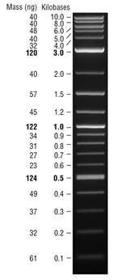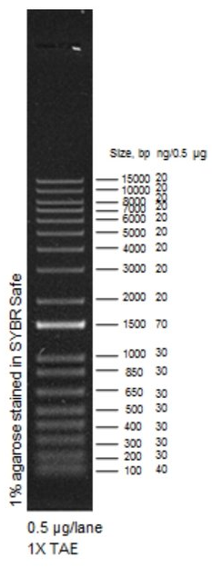

January 2019

Sunday, January 6, 2019

To Do:
- Make EC cells: ∆FTL_1548, ∆FTL_1548 ∆ggt

Monday, January 7, 2019

To Do:
- Electroporate pKR2 into KRLVS4 and KRLVS6
- Plate electroporations
- Demo vacuum filter for minipreps?
- Thaw J774A cells with Jamie
- Hannah- intro, start cultures

Results and Data:

Electroporations:
Number | Strain | Plasmid | Notes
20 | LVS ∆ggt | pKR2
21 | LVS ∆ggt | pKR2
22 | LVS ∆FTL_1548 ∆ggt | pKR2
23 | LVS ∆FTL_1548 ∆ggt | pKR2

Electroporated at 8:30 am, plated each EP onto 2 CHA-Kan plates around 3:30pm (about 7 hours recovery).

Tuesday, January 8, 2019

To Do:
- Prepare more CHA media for CHA plates
- Work with Jamie on macrophage assay

Results and Data:

The standing 37°C incubator with our plates was not holding temperature last night. Apparently if the door opens for too long (which can be a variable amount of time, as little as 30” according to the Howlett lab) it stops heating. Re-start incubator.

Wednesday, January 9, 2019

To Do:
- Work with Jamie on macrophage assay
- Streak out last strains to make stocks and send to Hannah Ledvina at UWashington: KRLVS1, KRLVS2, KRLVS6
- Check to see if any potential integrants from electroporations on 1/7

Results and Data:

There are no colonies visible on CHA-Kan plates from Monday’s electroporations. It is possible that colonies will come up a day slow because of the incubator not holding temp on Monday night. Will not have integrants, which would be FTL_1251(-) strains, to send to Hannah tomorrow.

Thursday, January 10, 2019

To Do:
- Mail strains to Hannah Ledvina at UWashington:
  - LVS ∆ggt
  - LVS ∆FTL_1548 ∆ggt
  - LVS FTL_1251(-)
  - LVS ∆FTL_1548 FTL_1251(-)
  - Potential LVS ∆FTL_1251

Friday, January 11, 2019

To Do:
- Electroporate pKR2 into ∆FTL_1548 and ∆FTL_1548 ∆ggt
- Plate electroporations

Results and Data:

Electroporations:
Try again to make FTL_1251(-) strains in ∆chaC [FTL_1548] and ∆chaC∆ggt backgrounds.

Note that protocol indicates that electroporations should be done using the following settings:
2.5 kV, 25 μF, and 600 Ω
Thus far at URI, using the Nelson lab electroporator, I have been using the pre-set 2.5 kV E. coli setting. This setting specifies 200 Ω. I have had several reactions arc, but most electroporations have been successful.
Jamie, John, and Joe have all been using the electroporator set to 600 Ω and have had issues with arcing. The first set of electroporations that Jamie and John performed, trying to introduce pKL115 into LVS and LVS ∆pmrA, all arced. I used the plasmid John had purified and tried electroporating it into some of my EC LVS (which did not have significant rates of arcing, so presumably have been washed well). Both electroporations using my EC cells arced. This suggested the cause of the arcing was the plasmid. I instructed Jamie, John, and Joe to wash future minipreps with 3 PE washes prior to purification to decrease the salt content. Despite this, all of Joe’s subsequent electroporations (introducing pKL116 into LVS and ∆pmrA) arced.
Perhaps the difference in resistance settings is leading to a higher likelihood of arcing? Try using the higher resistance setting on my next electroporations:

Electroporations:
Number | Strain | Plasmid | Notes
24 | LVS ∆ggt | pKR2 | Resistance 600 Ω; arced
25 | LVS ∆ggt | pKR2 | Resistance 200 Ω; no arc
26 | LVS ∆FTL_1548 ∆ggt | pKR2 | Resistance 200 Ω; arced
27 | LVS ∆FTL_1548 ∆ggt | pKR2 | Resistance 200 Ω; no arc

Note that these are the same cells and the same plasmid I used for the electroporations on 1/7/19. Unclear why I had no arcing previously and now 50% of my electroporations arced.
Regardless, the resistance setting does not seem to be the critical factor.

Recover in 4 mL MHB at 9:30 am – about 2:15 pm (~4:45 hours recovery). Plate each EP on 2 CHA-Kan plates.

Monday, January 14, 2019

To Do:
- Streak out LVS and put in 37°C aerobically and anaerobically
- Check electroporation plates

Results and Data:

No growth on plates from 1/11/19 electroporations

Tuesday, January 15, 2019

To Do:
- Check electroporation plates
- Patch out potential FTL_1251(-) integrants

Results and Data:

Colonies on electroporation plates from 1/11/19: looks like there may be 1° integrants from all the electroporations! Patch 3 per electroporation on CHA-Kan plates.

Wednesday, January 16, 2019

To Do:
- Check potential FTL_1251(-) strains for correct integration by PCR
- Check potential FTL_1251 deletion strain with new primers
Morning: no growth on patches yet. Did I patch out too late or are these background colonies?

In the meantime, start a PCR to check for deletion of FTL_1251 with new primers:
Reactions
Reaction Set | Primers | Target | WT size | Deletion size
A | KROL45, KROL46 | FTL_1251 locus | 2402 bp | 887 bp
B | KROL8, KROL9 | FTL_0766 locus | 782 bp | -

DNA number | DNA
1 | Potential ∆FTL_1251
2 | LVS
3 | pKR1 (1:10)
4 | Negative control, no template
 |  |  |  | Factor
Component | Stock concentration | Final concentration | 1 rxn volume | 5.5
ddiH2O |  |  | 4 | 22
KOD buffer | 2x | 1x | 10 | 55
dNTPs | 2 mM | 0.4 mM | 4 | 22
oligo F | 10 uM | 0.3 uM | 0.6 | 3.3
oligo R | 10 uM | 0.3 uM | 0.6 | 3.3
template | 100 ng/ul | 2 ng/ul | 0.4 | 2.2
KOD | 1 U/ul | 0.02 U/ul | 0.4 | 2.2
 |  | Total volume | 20 | 110

STN1 with 2:30 extension
Run entire PCR on gel:
A- B
∆FTL_1251? pKR1 ∆FTL_1251? pKR1
LVS -DNA LVS -DNA

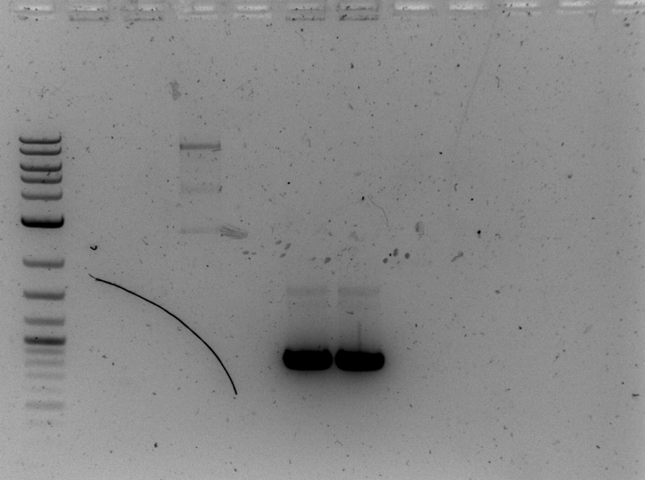
Interpretation:
It appears that for some reason KROL45 and KROL46 don’t amplify, even from LVS colonies. This means we continue to lack diagnostic primers to determine if cells lack FTL_1251. Although news from Hannah in the Mougous lab indicates that the FTL_1251(-) cells have a phenotype- no growth on Cys-Gly or glutathione and this potential FTL_1251 deletion mutant does not have the same phenotype- so perhaps the first primer set I used to try to diagnose deletion of FTL_1251 (KROL1 and KROL5) *is* useful. Although given that the FTL_1251(-) mutant has a phenotype, I think we should be moving forward with these strains.

Check patches of FTL_1251(-) strains: some tiny amount of growth? Leave in incubator to see if there is better growth tomorrow

Thursday, January 17, 2019

To Do:
- Check FTL_1251(-) patches

Results and Data:

Check patches of FTL_1251(-) strains: some tiny amount of growth? Is this a growth phenotype or just background? Scrape growth off these plates and try re-patching.

Friday, January 18, 2019

To Do:
- Check FTL_1251(-) patches
- Electroporate ∆pmrA cells with pKL116 for Joe

Results and Data:

Performed 2 electroporations:
5 uL pKL116 miniprepped by Jamie and John
50 uL EC cells prepped by Joe
Used re-sterilized electroporation cuvettes
No arc on #1, arced on #2
Recover in 4 mL MH ~10am - ~4pm (Jamie plated on CHA-Kan)

Not much growth of FTL_1251(-) patches. Put at room temp over weekend

Saturday, January 19, 2019

To Do:
- Test plate cells on sMHA made by Jamie and John yesterday

Results and Data:
Plated 10-fold dilutions of LVS on CHA (room temp), sMHA (room temp), sMHA (37°C), sMHA (37°C anaerobic)

Monday, January 21, 2019

To Do:
- Mail pF-FTL_1548, pF2-FTL_1548, pF, and pF2 to Hannah in Mougous lab
- Start making pKR10: pEX_PchaC-lacZ
- Check for 1° integration of pKR2 in potential FTL_1251(-) patches

Results and Data:

Planning pKR10
Digest pKL133 and pKL61 with NotI; want to subclone lacZ fragment from pKL61 into pKL133 to make pKR10, which will be used to replace chaC with lacZ. Can then subsequently use this to screen for activation of chaC at the level of transcription.
This is the junction of the FTL_1548 flanking region and the proposed lacZ insertion:
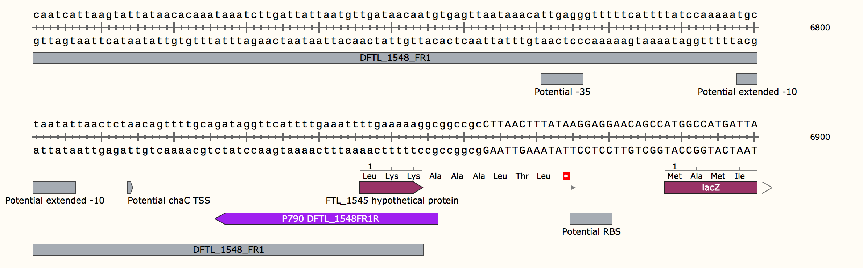
The potential TSS is intact and there is a good RBS for lacZ.
Design considerations:
Inserting lacZ into the NotI site allows for insertion in either direction. Pick out a diagnostic digest that will distinguish between the two.
Plan: PciI digest (Needs to happen in Buffer 3.1!!)
Correct pKR10: 3756, 9661, 10,964
Incorrect lacZ insertion: 3756, 7159, 10,964

Digest to clone pKR10:
 | 1 | 2
H2O | 16.9 | 20.7
10x CSB | 2.5 | 7.5
DNA | 5 | indiv
NotI | 0.6 | 1.8
 | 25
Incubate 37°C for ~1:20, add 10 uL CIP to pKL133 and incubate 10’ more.

Load entire digest on gel.
1 2
1 2
Gel-purify fragments, elute in 30 uL 0.1x EB.

Set up ligations:
 | 1 | 2
H₂O | 9.5 uL | 15.5 uL
10x CSB | 2 uL | 2 uL
lacZ | 6 uL | -
pKL133 | 2 uL | 2 uL
Ligase | 0.5 uL | 0.5 uL
Put at 16°C O/N

FTL_1251(-) strains:
There is reasonable growth for all the CHA-Kan patches from 1/17. Check for integration of pKR2 in cells from electroporations 24, 25, 26, 27.
Reaction | DNA
1 – 3 | Colony PCR from cells from EP24 1-3
4 – 6 | Colony PCR from cells from EP25 1-3
7 – 9 | Colony PCR from cells from EP26 1-3
10 – 12 | Colony PCR from cells from EP27 1-3
13 | pKR2 (1:10)
14 | Negative control- colony PCR from LVS
15 | Negative control, no template

Reminder about what these electroporations are for:
Number | Strain | Plasmid | Notes
24 | LVS ∆ggt | pKR2 | For FTL_1251 (-)
25 | LVS ∆ggt | pKR2 | For FTL_1251 (-)
26 | LVS ∆FTL_1548 ∆ggt | pKR2 | For FTL_1251 (-)
27 | LVS ∆FTL_1548 ∆ggt | pKR2 | For FTL_1251 (-)

Total reaction volume |  | 20
Total number of reactions |  | 15
 |  |  |  | Factor
Component | Stock concentration | Final concentration | 1 rxn volume | 17.6
ddiH2O |  |  | 4 | 70.4
KOD buffer | 2x | 1x | 10 | 176
dNTPs | 2 mM | 0.4 mM | 4 | 70.4
KROL1 | 10 uM | 0.3 uM | 0.6 | 10.56
KROL17 | 10 uM | 0.3 uM | 0.6 | 10.56
template | 100 ng/ul | 2 ng/ul | 0.4 | indiv
KOD | 1 U/ul | 0.02 U/ul | 0.4 | 7.04
 |  | Total volume | 20 | 352
STN1 with 1’ extension
Run entire PCR on gel:

Confirm integration with KROL1 & KROL17 = 765 bp if integrated (no product otherwise)

24- 25- 26- 27- -DNA
1 2 3 1 2 3 1 2 3 1 2 3 pKR2

None of these patches appears to have a product at 765 bp. Discard. Will have to re-try making FTL_1251(-) strains

Tuesday, January 22, 2019

To Do:
- Email Hannah about plasmids
- Transform ligations (and pKR1, 3, other plasmids?)

Results and Data:

Transform ligations:
# | Volume | Reaction | Plate
1 | 8 uL | Ligation 1: lacZ and pKL133 | 100 uL, remaining
2 | 8 uL | Ligation 2: pKL133 cut only | 100 uL, remaining
3 | 8 uL | pKR2 | 20 uL, 100 uL
4 | 8 uL | pKR3 | 20 uL, 100 uL
Add 100 uL cells to indicated DNA in sterile 1.5 mL Eppendorf tube
Incubate on ice for ~1hr 10’, HS 42°C 30”, recover in 1 mL LB shaking at 37°C for ~1 hr
Plate as indicated on LB-Kan50, put at 37°C O/N

Wednesday, January 23, 2019

To Do:
- Start overnight cultures from transformed E. coli plasmids

Results and Data:

Picked colonies from ligation 1 and 2 colonies each from pKR2 and pKR3. Grow O/N in 5 mL LB + Kan50

Thursday, January 24, 2019

To Do:
- Miniprep plasmids
- Check plasmids by digest
- Start ribosome isolation with Gregory lab and Hannah

Results and Data:

John helped miniprep cultures.

Set up PciI digest:
PciI digest (Needs to happen in Buffer 3.1!!)
Correct pKR10: 5905, 4117, 1303
Incorrect lacZ insertion: 4117, 3805, 3403

x8
H₂0 15.5 uL 124
10x buffer 3.1 2.0 uL 16
DNA 2.0 uL indiv
PciI 0.5 uL 4
Total volume 20.0 uL

Reaction 1 – 6 are minipreps, 7 is pKL133 backbone.

[When ran these digests out, ran too far! Never got answer from this digest]

Tuesday, January 30, 2019

To Do:
- Diltute gDNA samples for arb PCR and general PCR

 | Original Conc (ng/ul) | 160 ng/ul | volume 0.1x eb | 100 ng/ul | volume 0.1x eb
LVS | 979.9 | 16.33 | 83.67 | 10.21 | 89.79
pKL97 Tn6 | 779.3 | 20.53 | 79.47
pKL97 Tn3 | 570.82 | 28.03 | 71.97

February 2019

Sunday, February 17, 2019

To Do:
- Electroporate ∆ggt and ∆ggt ∆chaC with pKR2

Results and Data:

Electroporations:
Number | Strain | Plasmid | Notes
28 | LVS ∆ggt | pKR2
29 | LVS ∆ggt | pKR2
30 | LVS ∆FTL_1548 ∆ggt | pKR2
31 | LVS ∆FTL_1548 ∆ggt | pKR2 | arced

Electroporated at 11:45 am, plated each EP onto 2 CHA-Kan plates around 5:20 (about 5.5 hours recovery).

Monday, February 18, 2019

To Do:
- Pour sucrose plates (15%, 20%)
- Plate out LVS on various plates to check growth
Results and Data:
Poured ½ sleeve of 15% and 20% sucrose CHA plates. The 20% had such a small amount of liquid, it definitely looked caramelized. The 15% less so, but still not great.

Thawed single-use aliquot of LVS. Added 900 uL 1x PBS, made 4 1:10 dilutions. Plated spots (5 spots per plate) on:
CHA (2/14)
CHA-Kan (2/14)
CHA 10% sucrose (2/14)
CHA 15% sucrose (2/18)
CHA 20% sucrose (2/18)
Put in 37°C incubator after 8pm

Tuesday, February 19, 2019

To Do:
- Electroporate ∆ggt and ∆ggt ∆chaC with pKR2
- Patch more ∆ggt and ∆ggt∆chaC for EC cells
- Check LVS growth on various plates (Kan, sucrose, etc)
- Plate out electroporations
- Pour more CHA-Kan plates (JW did!)
- Streak out LVS and ∆rpsU1 (KMLFT104) for Hannah’s stocks
- Mail out Jamie’s RNAP preps

Results and Data:

Electroporations:
Number | Strain | Plasmid | Notes
32 | LVS ∆ggt | pKR2
33 | LVS ∆ggt | pKR2
34 | LVS ∆FTL_1548 ∆ggt | pKR2
35 | LVS ∆FTL_1548 ∆ggt | pKR2

Recovered at about 8:30 am, plated each EP onto 2 CHA-Kan plates around 2:45 (about 5:15 hours recovery).

3:20 PM- check plates
CHA (2/14) 4 spots visible growth
CHA-Kan (2/14) Rings for first 2 dilutions visible
CHA 10% sucrose (2/14) 4 spots visible growth
CHA 15% sucrose (2/18) 1 ring visible
CHA 20% sucrose (2/18) 1 ring barely visible

Cells are not healthy enough on 15% and 20% sucrose.

Checked on plates from 2/17 electroporations (EP 28-31): almost a lawn of cells? Seeing more growth than I should.

Wednesday, February 20, 2019

To Do:
- Make more ∆ggt and ∆ggt∆chaC EC cells
- Check LVS growth on various plates (Kan, sucrose, etc)

Results and Data:

9:55 AM- check plates
CHA (2/14) 5 spots visible growth
CHA-Kan (2/14) no visible growth
CHA 10% sucrose (2/14) 5 spots visible growth
CHA 15% sucrose (2/18) visible growth only on 1 ring
CHA 20% sucrose (2/18) no visible growth

Jamie does this:
Try re-doing 15 and 20% sucrose plates:
20% plates:
4% hemoglobin 150 mL
CHA 250 mL
60% sucrose 200 mL
600 mL

15% plates
4% hemoglobin 150 mL
CHA 300 mL
60% sucrose 150 mL
600 mL

Thursday, February 21, 2019

To Do:
- Check electroporations
- Patch potential 1° integrants

Results and Data:

Lots of colonies on all the electroporation plates from 2/17 (EP 28 – 33).
Patch out 4 per electroporation onto new Kan plate, check by PCR tomorrow

Friday, February 22, 2019

To Do:
- Check on patches for proper integration of pKR2
- Thaw macrophage
- Pour plates for macrophage expt
- Electroporate ∆ggt and ∆ggt ∆chaC with pKR2
- Plate out electroporations

Results and Data:
The patches from 2/17 electroporations (EP 28 – 33) don’t have much growth at all. Not promising, but give them another day; there may be a slow growth phenotype.

In the meantime, try the electroporations again with more controls:

Electroporations:
Number | Strain | Plasmid | Notes
36 | LVS ∆ggt | pKL02
37 | LVS ∆ggt | pKR2
38 | LVS ∆ggt | pKR2
39 | LVS ∆ggt | No DNA
40 | LVS ∆FTL_1548 ∆ggt | pKL02
41 | LVS ∆FTL_1548 ∆ggt | pKR2
42 | LVS ∆FTL_1548 ∆ggt | pKR2
43 | LVS ∆FTL_1548 ∆ggt | No DNA

Recovered at about 10:45 am, plated each EP onto 2 CHA-Kan plates around 3:45 (about 5 hours recovery).

Thaw macrophage:
Use Howlett lab hood. Thaw 1 vial of P3 J774A.1 cells. We only have 1 P3 vial left, so freeze a bunch of vials down at P4!
Resuspended cells from vial in 9 mL DMEM with 10% FBS from January.
Spin in Howlett lab centrifuge for 4’ at 12,000 rpm
Resuspend pellet in 10 mL fresh DMEMF, split into two plates (5 mL each with 5 mL fresh DMEMF)
Incubate in Dutta lab 37°C CO₂ incubator.

Saturday, February 23, 2019

To Do:
- Check on patches for proper integration of pKR2
- Check on macrophage

Results and Data:

Patches from 2/17 electroporations (EP 28 – 33) still look like they are just limping along. Keep at 37°C. One plate has some contaminant in a few patches.

Macrophage look good. Media is still pretty reddish.

Sunday, February 24, 2019

To Do:
- Check electroporation plates
- Plate strains for macrophage expt
  - LVS
  - pmrA D51A
  - ∆pmrA
  - ∆pigR
- Seed macrophage
Results and Data:

Electroporations 40 – 43 from 2/22/19 are all contaminated with yeast! Discard ∆ggt ∆chaC electrocompetent cells made on 2/20/19.

Macrophage:
Took both plates out of incubator- looked good, cells look happy and more numerous. Media is yellowish and ready to change!
Removed media, added 10 mL DMEMF (total between two plates), scraped up cells, pelleted at 12,000 rpm for 4’
Removed media, resuspended in 7 mL DMEMF. Add 50 mL cells + 50 mL Trypan Blue. Check cell density using hemocytometer.
Remember: Average of 10 cells per square across 4 corners = 1x10⁵ cells per mL (not taking into account dilution factors).
Number of cells per square over 3 counts:
6, 5, 0, 2
9, 2, 0, 3
4, 1, 2, 2,

That average is 3. Accounting for the dilution factor (2), that means I have 6x10⁴ cells per mL?!?!? That’s not enough (I need 7 mL at 1x10⁵ cells per mL) and seems low!!!
Maybe the spins were too fast and the pipetting too vigorous? There does seem to be a good amount of cell debris!

Can’t start assay tonight. Put macrophage back into a plate (now P4) and see how they look tomorrow.

Monday, February 25, 2019

To Do:
- Check on electroporations
- Make single-use ∆pmrA, pmrAD51A, ∆pigR cells
- Make more EC LVS
- Electroporate LVS and ∆ggt ∆chaC with pKR2
- Plate out electroporations
- Change media on P4 J774A cells

Results and Data:
The plates from 2/22 electroporations (EP 36 – 39):
Number | Strain | Plasmid | Notes
36 | LVS ∆ggt | pKL02 | >10 colonies
37 | LVS ∆ggt | pKR2 | 0 colonies
38 | LVS ∆ggt | pKR2 | 2 colonies on one plate!!!
39 | LVS ∆ggt | No DNA | 0 colonies
Patch out the two LVS ∆ggt pKR2 colonies onto Kan!

Confirm that I can get pKR2 into LVS. Also try older vial of ∆FTL_1548 ∆chaC with pKR2
Electroporations:
Number | Strain | Plasmid | Notes
44 | LVS | pKR2
45 | LVS | -DNA
46 | LVS ∆FTL_1548 ∆ggt | pKR2 | Arc
47 | LVS ∆FTL_1548 ∆ggt | No DNA | Arc

Recovered at about 9:30 am, plated each EP onto 2 CHA-Kan plates around 5pm (about 7.5 hours recovery).

Tuesday, February 26, 2019

To Do:
- Check on electroporations
- PCR to check potential ∆ggt FTL_1251(-) cells (from EP 38)
- Make more EC ∆FTL_1548 ∆ggt cells
- Thaw J774A cells P2
- Feed J774A P4 cells

Results and Data:

Check for FTL_1251(-) strains
Have two colonies from electroporation 38, ∆ggt with pKR2, which should yield single integration into the FTL_1251 gene, resulting in ∆ggt FTL_1251(-) cells. Check integration by PCR:
Reaction | DNA
1 | Colony from EP38 cells, patch 1
2 | Colony from EP38 cells, patch 2
3 | Positive control- cells from KRLVS1.1, LVS FTL_1251(-)
4 | Negative control- colony PCR from cells
5 | Negative control, no template

Total reaction volume |  | 20
Total number of reactions |  | 6
 |  |  |  | Factor
Component | Stock concentration | Final concentration | 1 rxn volume | 7.7
ddiH2O |  |  | 4 | 30.8
KOD buffer | 2x | 1x | 10 | 77
dNTPs | 2 mM | 0.4 mM | 4 | 30.8
KROL1 | 10 uM | 0.3 uM | 0.6 | 4.62
KROL17 | 10 uM | 0.3 uM | 0.6 | 4.62
template | 100 ng/ul | 2 ng/ul | 0.4 | -
KOD | 1 U/ul | 0.02 U/ul | 0.4 | 3.08
 |  | Total volume | 20 | 154
Add 2ul of lysate per reaction.
Amplify with STN1, 1’ extension.
KROL1 & KROL17 = 765 bp if integrated (no product otherwise)

Check for correct pKR10
Use different digest, SacI
SacI-HF digest
Correct pKR10: 5896, 5424
Incorrect lacZ insertion: 6690, 4635
pKL133: linearize, 8217

x8
H20 15.5 uL 124
10x CSB 2.0 uL 16
DNA 2.0 uL indiv
EcoRV-HF 0.5 uL 4
Total volume 20.0 uL

Reaction 1 – 6 are minipreps, 7 is pKL133 backbone. -> 37°C around 1:20 PM

Run entire PCR and digest on gel:
PCR
38- KRLVS1 -DNA
1 2 neg lysate
Digest
clone
1 2 3 4 5 6 pKL133

6 kb
5 kb
*** note transition to new ladder, 1Kb Plus DNA ladder from ThermoFisher***

PCR results
The positive control band is really really faint; I’ve been having this issue with unreliable PCR on older cells- this is new, and I’m a bit surprised by it.

But- I have the correct integration!
38-2 is KRLVS7.1 = ∆ggt FTL_1251(-)
How many electroporations did that take?
# electroporations
Date ∆ggt ∆ggt∆FTL_1548
1/7/19 2 2
1/11/19 2 2
2/17/19 2 2
2/19/19 2 2
2/22/19 2 (contaminated)

Finally have 1 correct integrant after 10 electroporations!
Still don’t have FTL_1251(-) in ∆ggt∆FTL_1548

Digest results:
Looking for
Correct pKR10: 5896, 5424
Incorrect lacZ insertion: 6690, 4635

Clones 1 – 5 definitely don’t look correct.
Maybe clone 6 is good?
Run gel out further.

Same gel run out further (and cropped):

clone
1 2 3 4 5 6 pKL133

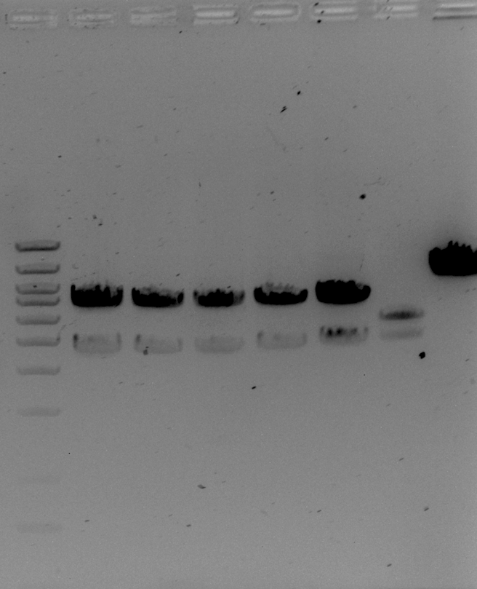
6 kb
5 kb

Digest results:
Looking for
Correct pKR10: 5896, 5424
Incorrect lacZ insertion: 6690, 4635

Clones 1 – 5 look like both bands are running too high.

Clone 6 actually looks good, though!

Tissue culture
Thaw P2 cells.
P4 cells look good; can probably split 1:4. Remove media, replace with 10 mL fresh DMEMF. Scrape up cells and pellet 4’ at 10,000 rpm in Howlett lab centrifuge. Resuspend in 10 mL DMEMF. Check cell viability using Trypan Blue (1:2) and looking at cells on hemocytometer. It looks like about half the cells are dead! Was very gentle when handling; maybe an issue with spinning too fast?
Split 1:2- cells are now P5.

March 2019

Friday, March 1, 2019

To Do:
- PCR to check potential ∆ggt FTL_1251(-) cells (from EP 46)
- Split J774A cells P2

Results and Data:
Reaction | DNA
1 | Colony from EP46 cells, patch 1, 2/28/19
2 | Colony from EP46 cells, patch 2, 2/28/19
3 | Colony from KRLVS7 cells, plate from 2/26/19
4 | Colony from EP38 cells, patch 1, 2/25/19
5 | Colony from EP38 cells, patch 2, 2/25/19
6 | Colony from KRLVS1 cells, plate from 2/21/19
7 | Negative control, no template

Total reaction volume |  | 20
Total number of reactions |  | 6
 |  |  |  | Factor
Component | Stock concentration | Final concentration | 1 rxn volume | 7.7
ddiH2O |  |  | 4 | 30.8
KOD buffer | 2x | 1x | 10 | 77
dNTPs | 2 mM | 0.4 mM | 4 | 30.8
oligo F | 10 uM | 0.3 uM | 0.6 | 4.62
oligo R | 10 uM | 0.3 uM | 0.6 | 4.62
template | 100 ng/ul | 2 ng/ul | 0.4
KOD | 1 U/ul | 0.02 U/ul | 0.4 | 3.08
 |  | Total volume | 20 | 154
Used 2 uL lysates
Run STN1 with 1’ extension.
KROL1 & KROL17 = 765 bp if integrated (no product otherwise)
1 2 3 4 5 6 7

No products??!! Maybe too much lysate; try again with 1:10 amount of lysate template (and include a darn negative control!)

Saturday, March 2, 2019

To Do:
- PCR to check potential ∆ggt FTL_1251(-) cells (from EP 46)
- Split J774A cells P2, feed P5

Results and Data:
Tissue culture
Forgot to split (and feed!!) J774A cells yesterday! Very yellow today. Tons of dead cells!
Remove media, wash with 10 mL DMEMF, replace 10 mL DMEMF. Check after 30’
The P5 cells are looking better. Replace media. Expect I could use them in a macrophage assay on Sunday (if the weather is okay). Don’t split P2s!

Reaction | DNA
1 | 1:10 Colony from EP46 cells, patch 1, 2/28/19
2 | 1:10 Colony from EP46 cells, patch 2, 2/28/19
3 | 1:10 Colony from KRLVS7 cells, plate from 2/26/19
4 | 1:10 Colony from EP38 cells, patch 1, 2/25/19
5 | 1:10 Colony from EP38 cells, patch 2, 2/25/19
6 | 1:10 Colony from KRLVS1 cells, plate from 2/21/19
7 | LVS gDNA
8 | Negative control, no template

Total reaction volume |  | 20
Total number of reactions |  | 7
 |  |  |  | Factor
Component | Stock concentration | Final concentration | 1 rxn volume | 8.7
ddiH2O |  |  | 4 | 34.8
KOD buffer | 2x | 1x | 10 | 87
dNTPs | 2 mM | 0.4 mM | 4 | 34.8
oligo F | 10 uM | 0.3 uM | 0.6 | 5.22
oligo R | 10 uM | 0.3 uM | 0.6 | 5.22
template | 100 ng/ul | 2 ng/ul | 0.4
KOD | 1 U/ul | 0.02 U/ul | 0.4 | 3.48
 |  | Total volume | 20
Used 2 ul lysates and 0.6 uL H20 or gDNA.
Run program STN1 with 1’ extension.
KROL1 & KROL17 = 765 bp if integrated (no product otherwise)

1 2 3 4 5 6 7 8

This is much better, in that I can see the band of the correct size. Was using too much lysate previously; something in the cells is inhibitory to the PCR.
But the cells from EP 46 (∆ggt∆FTL_1548) apparently don’t have the correct integration! Will need to try again.

Tuesday, March 5, 2019

To Do:
- Streak out LVS cells for macrophage assay
- Seed plates for macrophage assay
Jamie fed macrophage (both P2 and P5) on Sunday and Monday.

Streak out LVS, LVS pmrAD51A (test strain), LVS ∆pmrA, and LVS ∆pigR (control strains) – before noon.

Around 5pm, seed macrophage:
Remove media from P5 cells, rinse plates once with 5 mL DMEMF, add 5 mL fresh DEMF to each plate.
Scrape up both plates and transfer to 15 mL conical.
Combine 50 uL cells with 50 uL 0.4% Trypan Blue and count viable cells using hemocytometer.
First set: 17, 12, 14, 15
Flicked tube, second set: 24, 26, 34, 22
Flicked tube again, 3rd set: 25, 29, 25, 24

Seems like cells weren’t well-mixed for the first count, so calculate cell density based on second 2 counts:
Average(24, 26, 34, 22, 25, 29, 25, 24) = 26.125 *2 (dilution from Trypan Blue) = 52.25 cells per square.
1 cell per square = 1x10⁴ cells per mL
Concentration of cells = 5.225 x 10⁵ cells/ mL

Dilute 1.33 mL J774A cells (5.225 x 10⁵ cells/mL) into 5.7 mL DMEMF for 7 mL cells at ~1x10⁵ cells/mL.
Combine 50 uL cells with 50 uL 0.4% Trypan Blue and check that cell density looks good. Appears within target range (5 cells per grid).
Aliquot 200 uL per well in 2 96 well plates as indicated in plate setup, move plates to CO₂ incubator (Dutta lab).

Count final viable cell concentration using hemocytometer:
Set | Counts
1 | 8 | 2 | 4 | 1
2 | 1 | 2 | 2 | 2
3 | 2 | 7 | 5 | 2
4 | 1 | 5 | 7 | 4
5 | 3 | 7 | 3 | 4
6 | 3 | 6 | 5 | 8
Average | 3.92
Cells per mL | 7.83E+04

A little lower than I’d like, but close.

Calculation sheet:
Macrophage Calculations
Cells per well | 2.00E+04
Volume to plate (mL) | 0.2
Density needed (cells/mL) | 1.00E+05
Total volume needed (mL) | 7
Measured cells per ml | 5.23E+05
Volume stock needed (mL) | 1.3
Volume media for dilution | 5.7
Measured cells per ml, seeded | 7.83E+04
Measured cells per well | 1.57E+04

Plate macrophage
Plate 2.5 mL from cells scraped up (so ½ each original plate) into a new plate, twice.
Now have 2 plates of P6.

Wednesday, March 6, 2019

To Do:
- Macrophage assay:
  - Infect
  - Wash
  - T=2
- Check on tissue culture cells / J774A.1 cells

Prepare inoculum for macrophage assay:
 |  |  | For final vol 1.3 mL at 0.028 |  |  |  | Dilute ~1:100 for final inoculum
Number | Strain | Resuspend cells to (OD600) | Cells (uL) | Media (x2, uL) | OD600 | Dilute 1:10, OD600 (in 1.3 mL) | Volume cells (uL) | Volume media (uL)
1 | LVS | 0.205 | 177.6 | 561 | 0.267 | 0.023 | 12.2 | 987.8
2 | pmrAD51A | 0.18 | 202 | 549 | 0.273 | 0.027 | 9.6 | 990.4
3 | ∆pmrA | 0.293 | 124 | 588 | 0.271 | 0.021 | 13.3 | 986.7
4 | ∆pigR | 0.247 | 147 | 576 | 0.268 | 0.02 | 14 | 986

**Note that the first values, “Resuspend cells to (OD600)” should be 10x! This is why I had to dilute 1:10 again.

Added 50 uL to each well as indicated in plate setup sheet:
Infected at 10:30am, moved plates to MRamsey lab CO₂ incubator (no water in bottom! Had to fill; worried about humidity!)

After putting plates in incubator, plated inoculums.
Transfer 200 uL each inoculum to top of 96 well plate.
Have 3 rows of 180uL 1x PBS under each inoculum.
Dilute 1:10 down plate using electronic multichannel pipette. (20 uL into 180 uL, 300 uL pipette).
Mix each column (dilution of each strain) briefly with 300 uL pipette before using 200 uL pipette to aliquot 10 uL per column to top of square plate. Allow media to dry as it drips down plate.
Put plates in 37°C incubator (with humidity, bc plates are a little older and drier!).

Wash at 12:30pm.
Remove old media from plates, wash 2x with 1x PBS (~270 uL), remove all the PBS and replace with 200uL DMEMF with gentamycin (1.4 uL 50mg/mL in 7 mL; final conc 10 ug/mL).
Put plates back in MRamsey lab CO₂ incubator.

Lyse for T=2 at 2:30
Remove old media from plates, wash 2x with 1x PBS (~270 uL)
Remove all the PBS and replace with 200uL 1% saponin in 1X PBS. Mix by pipetting.
Incubate for 30’ at RT. Mix by pipetting.
Plate 50 uL per well, 2x, on round plates on 3rd floor. Exception- plate 100 uL of controls on 1 round plate each.
Put plates in 37°C incubator (with humidity, bc plates are a little older and drier!).

Macrophage tissue culture
Split P2 into P3:
Remove media, add 10mL fresh media to P2 plate.
Prep new plates: 5 100 cm plates with 8 mL fresh DMEMF each
Scrape up cells from P2 plate
Add 2 mL cells to each new plate for 5 plates of J774A.1 P3 cells

Feed P6 cells
Remove old media
Replace with 10mL fresh DMEMF
Incubate in Dutta lab 37°C CO₂ incubator

Thursday, March 7, 2019

To Do:
- Macrophage assay:
  - T=24
- Check on tissue culture cells / J774A.1 cells

Tissue culture:
Cells still look okay from yesterday- no action necessary

Macrophage assay: lyse for T=24 at 12:30

Remove old media from plates, wash 2x with 1x PBS (~270 uL)
Remove all the PBS and replace with 200uL 1% saponin in 1X PBS. Mix by pipetting.
Incubate for 30’ at RT. Mix by pipetting.
Samples from wells in row A (not control: LVS, pmrAD51A): dilute serially 1:10 in PBS for 4 dilutions (5 wells total- undiluted plus 4 dilutions), 30 uL into 270 uL.
Samples from wells in row D (not control; LVS ∆pmrA, LVS ∆pigR): plate 50 uL per well, 2x, on round plates (use sterile spreaders in 4th floor Camberg lab hood).
Plate 10 uL of dilutions on track plates, 2x
Controls: plate 100 uL of lysate from control wells on 1 round plate each.
Put plates in 37°C incubator (with humidity, bc plates are a little older and drier!).

Friday, March 8, 2019

To Do:
- Macrophage assay:
  - Check inoculum plates
- Check on tissue culture cells / J774A.1 cells

Count plates:
Note that I realized I plated 20 uL on track plates for inoculum!

∆pmrA inoculum is clearly contaminated / bad- lots of tiny white growth, no clear LVS growth, looks like there might be LVS but growing slower.
Disregard ∆pmrA strain for this experiment.
Otherwise, inoculums look even!

Feed J774A.1 cells
Remove old media
Replace with 10mL fresh DMEMF
Incubate in Dutta lab 37°C CO₂ incubator

Saturday, March 9, 2019

To Do:
- Macrophage assay:
  - Check T=2, T=24 plates
- Check on tissue culture cells / J774A.1 cells
Count T=2 plates
While the T-test and chart might suggest that different amounts of cells entered the macrophage, I would argue that too few cells were counted to really be valid. Probably all the same entry.

Count T=24 plates
Plate 2-3 not yet readable (too dry?), ∆pigR plates and control plates not ready to count yet. See tomorrow for all data.

Feed J774A.1 cells
Remove old media
Replace with 10mL fresh DMEMF
Incubate in Dutta lab 37°C CO₂ incubator

Sunday, March 10, 2019

To Do:
- Macrophage assay:
  - Check T=2, T=24 plates
- Check on tissue culture cells / J774A.1 cells

Tissue culture
Remove old media
Replace with 10mL fresh DMEMF
Incubate in Dutta lab 37°C CO₂ incubator

Macrophage experiment
Final results:

Inoculum was lower than I’d like, and resulting replication wasn’t great- normally see closer to 10⁵ cells per well, although looking back at the PmrA paper, there are definitely experiments with about this much LVS replication. I think I’m just displeased by not having ∆pmrA cells. The ∆pigR control looks exactly as expected.

Previous pmrAD51A experiments:
160323:

In this experiment, pmrAD51A has an intermediate phenotype between LVS and ∆pmrA; some inhibition of intramacrophage survival but not as much as ∆pmrA. Note that at the 2 hour timepoint, there was really no difference between these three strains.

160525:
The downside to this experiment was how well ∆pmrA grew- that’s atypical, so not sure how reliable the other numbers are.

Will need to repeat experiment, but results do suggest that cells with non-phosphorylatable PmrA are not attenuated for intramacrophage survival. Suggests that PriM is not produced even if PmrA is not phosphorylated. ? Not sure how this squares with Hannah’s data about PmrAD51A-V at the priM promoter, although her error bars were quite large. All needs repetition.

Monday, March 11, 2019

To Do:
- Make & test CDM
- Check on tissue culture cells / J774A.1 cells

Chamberlain’s Defined Media (CDM)
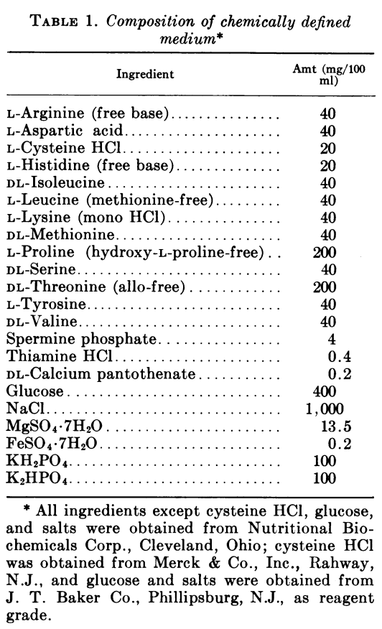 From Chamberlain, Applied Microbiology, 1965

Used recipe Carly made with stocks Carly, John, and Joe made. One exception- MMR indicated that FeSO4 should be made fresh, so re-make the stock (Carly made in February).
CDM recipe indicates FeSO₄•7H₂O. I can’t find this; MMR has FeSO₄ anhydrous. Modify recipe to use anhydrous.

Compound MW
FeSO₄•7H₂O 278.01 g/mol
FeSO₄ 151.91 g/mol

For CDM, need 0.2 mg/100mL ferrous sulfate heptahydrate.
0.2 (278.01/151.91) = 0.366 mg / 100 mL = 0.00366 mg / mL final concentration
Looking for a stock solution of 250x the final conc
0.00366 * 250 = 0.92 mg/mL
Weigh out enough for 50 mL = 45 mg = 0.045 g FeSO₄
Dissolve in ~30 mL type I ddiH₂0, adjust volume to 50 mL, don’t sterilize bc will regularly make up new and will need to filter-sterilize final media anyway.

After discussion with MMR, he suggested the following groups:

Note that I added the glucose and group 3 to to ~330 mL type I ddiH2O. Then I added all the amino acids (group 1), all group 2, then the ferrous sulfate and lastly (once it was also slightly warmer, close to room temp) the magnesium. I adjusted the pH from ~8.0 to ~7.5, then increased the volume to 500 mL and filter-sterilized.

For making plates, will need to use agarose. Use 7 g / L, or 3.5 g per 500 mL.
Make 250mL of 2X CDM (same volumes as above, only start with ~80 mL H₂O). Filter-sterilize.
Autoclave 3.5 g agarose in 250 mL using the 20’ cycle.
Combine and pour plates, 24 mL each.

To test CDM, try growing LVS overnight.
Scrape up LVS from plate in CDM. Check OD600: 3.56
Dilute in both CDM and MHB to the following OD600 in 5mL:

 | Desired OD600 | Dilution of cells | Volume cells
1 | 0.0005 | 1:10 | 70.2
2 | 0.01 | 1:10 | 140.4
3 | 0.05 | 1 | 70.2
4 | 0.1 | 1 | 140.4

Make dilutions in both CDM and MHB; also incubate 5mL media without cells (check for sterility!)

Check OD600 of tube 4- OD600 should be 0.1, remove 500 uL to test:
CDM: 0.050
MHB: 0.051
Perfect!
Grow O/N in 37°C shaking incubator, starting ~5pm

Tissue culture
All plates look pretty confluent, but no time to split today. Feed them all, tomorrow split P6 and freeze down P3.
Remove old media
Replace with 10mL fresh DMEMF
Incubate in Dutta lab 37°C CO₂ incubator

Tuesday, March 12, 2019

To Do:
- Check cells grown in CDM vs MH
- Plate LVS on CDM and CHA plates HT will do
- Pour CDM-sucrose plates? HT did
- Split J774A P6
- Freeze down J774A P3
- Check on sucrose selection

CDM test

Check OD600 after overnight (and a few hours later):
Both cultures grew well overnight. Cells in CDM reached a higher OD, although cells in MHB grew faster.

Will need to do a growth curve.

*****All tissue culture using different pipettor (old, corded version)****
J774A.1 stocks
To freeze J774A.1: (From ATCC website): Freeze medium: Complete growth medium supplemented with 5% (v/v) DMSO

Based on my notes, freezing down a concentration of about 4x10⁶ cells/mL would be good.

Steps:
- Pool cells into one tube (5 plates scraped up into a total of 15 mL)
- Check density
1:2 dilution with 4% Trypan Blue, check on hemocytometer:
184, 175, 179, 177 = average of 176.5 x 2 = 353 cells / square
= 3.53 x10⁶ cells/mL
- Determine volume for resuspension
This is already close to the concentration I’d like, so just resuspend in 15 mL DMEMF+5% DMSO
(15mL)(0.05) = 0.75 mL DMSO + 14.25 mL DMEMF
- Spin down cells
Use Howlett lab centrifuge, 900 rpm, 5’ (pellet looks great, maybe less rpm next time!)

- Resuspend cells in DMEMF, add appropriate amount of DMSO
- Aliquot 1 mL per cryotube, put into liquid nitrogen tank
- Check concentration of final aliquoted cells:
Dilute 50 uL with 50 uL 4% Trypan
Check on hemocytometer:
118, 162, 131, 115 = average of 131.5 *2 = 262
  - x10⁶ cells in each vial (cells/mL, have 1 mL per vial)
**Note that cells were pretty clumpy-worried about killing cells by pipetting too harshly.

Passage J774A.1 P6
Remove media from 1 plate of J774A.1 P6
Wash with ~3 mL DMEMF
Add 10 mL DMEMF
Scrape up cells
Transfer 5 mL to 2 diff plates with 5 mL DMEMF -> P7
Incubate in Dutta lab 37°C CO₂ incubator

Friday, March 15, 2019

To Do:
- Isolate gDNA from KRLVS7, putative ∆ggt∆FTL_1548 FTL_1251 (EP46-1, 2), LVS control
- Check for insertional inactivation of FTL_1251 by PCR
- Make EC ∆ggt∆FTL_1548
- Electroporate for ∆ggt∆FTL_1548 FTL_1251(-)

----------------------
Notes for later:

STN1 with 1’ extension
Run entire PCR on gel:
12- 13- 17- 19- -
1 2 3 4 5 1 1 1 DNA

Confirm integration with KROL1 & KROL17 = 765 bp if integrated (no product otherwise)
Looks great! It’s quite clear that at least 12-1, 12-13, 12-5, and 17-1 have the expected integration of pKR2!

pKR2 is a single-integration inactivation plasmid; these cells now should have inactive versions of FTL_1251, which encodes a transporter we think is involved in utilization of glutathione as a cysteine source.

Need these strains:
LVS ∆ggt FTL_1251(minus)
LVS ∆chaC ∆ggt FTL_1251(minus) (presuming this is viable in rich media)

Bibliography

Ramsey, K. M. and Dove, S. L. (2016) ‘ A response regulator promotes Francisella tularensis intramacrophage growth by repressing an anti-virulence factor ’, Molecular Microbiology. doi: 10.1111/mmi.13418.

