Table of Contents
May 2024 4
Prepping CHAH Plates 4
Check ongoing Survival Assay 4
Prepping CHAH + 10% Sucrose Plates 5
Patching out Primary Integrant 5
Selecting Cross-outs for Sucrose Selection 6
Setup for Sucrose Selection 7
Protocol for Freshwater Survival Assay (LVS Flasks) 8
Patching Crossouts onto CHAH 9
Table. Sucrose Selection Dilution Plate Count 9
Day 43 Survival Assay Plate Count 9
Preparing Square CHAH Plates 10
Preparing LB Agar 11
Prepping for Colony PCR 11
Transferring Patches to PCR strip tubes (diluted strip tubes, first step) 11
PCR Protocol 12
Table. Reactions for Colony PCR 13
Table. Master Mix for Colony PCR 13
Table. Mastermix Table after Mistake 14
Observations of Patch Plates from 05/28/24 15
Setting up to run gel 15
Figure. Colony PCR Gel 05/30/2024 16
Prepping for Colony PCR 16
Transferring Patches to PCR strip tubes (diluted strip tubes, first step) 16
PCR Protocol 17
Table. Colony PCR #2 Reaction Table 18
Table. Master mix for Colony PCR #2 18
Setting up to run gel 18
Gel Image of Colony PCR #2 19
Shock Assay Protocol 20
Finding an OD of about 1.0 22
June 2024 23
Shock Assay Bar Graph 23
Patching LVS strain and DFTL strain on CHAH 23
Making Minimal Media Plates 24
Shock Assay Protocol 25
Finding an OD of about 1.0 26
Selecting Cross-outs for Sucrose Selection 27
Setup for Sucrose Selection 28
50% Sucrose Protocol 28
Miniprep KMR Pelleted Cells 29
Observations of Shock Assay 29
PCR Protocol 30
Colony PCR Sample ID Table 31
PCR Reaction Table 31
Setting up to run gel 32
Shock Assay Protocol 32
Finding an OD of about 1.0 34
Gel Observation #1 35
Check ongoing Survival Assay Day 67 36
Making CHA Powder Mix 36
Reaction Table for Test PCR 37
Master Mix Table for Test PCR 37
Receiving Primers Protocol 38
Observation of Shock Assay Plates 38
Setting up to run practice gel 38
Gel of Test PCR of Primers 707 & 708 39
Babysitting Instructions: 40
PCR for Making pKR224 41
DNA Digests 43
Setting up to run gel 44
Setting up to run gel 44
Gel Extraction & Purification Protocol 44
Table for gel purification 45
Selecting Cross-outs for Sucrose Selection 45
Gel Extraction & Purification Protocol 45
Table for gel purification 46
Ligation of digested DNA 47
Transformation of PKR200 47
Overnight Cultures 49
Glycerol Stocks for KRLVS 274 49
PCR for Making pKR202 49
PCR for Making pKR203 50
Miniprep Protocol 51
Shock Assay Protocol 51
Protocol for Making Glycerol Stocks 52
Bibliography 53

May 2024

Tuesday, May 21, 2024
To Do:
- Prep CHAH plates
- Check ongoing survival assay
- Make accumulated graph of survival assay

Prepping CHAH Plates
For 600 mL of CHA
1. Measure out 30.6g of cystine heart agar into 1L flask (non-baffled; 10.2g/100mL)
2. Add 300mL of ddiH₂O (type I)
3. Add stirbar to flask
4. Heat on low, stirring, for about 10 minutes (media should be totally dissolved)
5. Autoclave on 30’ liquid cycle, filling the water bin up to the height of the media
6. Cool down (ideally to ~55C)
7. Separately (before), prepare hemoglobin 2% solution
8. Add 6g freeze-dried hemoglobin to 300mL of ddiH₂O (type I)
9. Autoclave on 20’ liquid cycle with water in the bin
10. Cool down (ideally to ~55C)
11. Using sterile technique, pour hemoglobin into CHA
12. Using a 50mL pipet, aliquot 24mL of CHAH mixture into each 100mm plate (should make approximately 25 plates) Try to avoid bubbles!

Check ongoing Survival Assay

- Retrieve 6 flasks from 4-degree Celsius fridge
- Use 12 CHAH plates to plate the samples
- For LVS flask 1, aseptically plate 100 uL onto the round CHAH plates, use glass beads to spread the cells.
- Repeat step 3 for LVS Flasks 2 & 3
- For mutant flask 4, aseptically plate 300 ul onto the round CHAH plates, use glass beads to spread the cells
- Repeat step 5 for mutant Flasks 5 & 6
- Incubate for 3-4 days in 37 degrees Celsius
Notes:
- I prepped 25 plates of CHAH
- KMR found the primary integrants, I need to use for Tuesday’s experiment. Primary Integrants 4&5 are found in 6D in the MRamsey Lab freezer (4.11)
- I conducted Day 15 survival assay using the round CHAH plates. I plated 100 uL of the LVS strain on 6 plates, 2 plates for each flask. I plated 300 uL of the mutant strain on the other 6 plates, 2 for each flask. I noticed when I was plating the mutant strain for flask 5&6 there was some dense liquid, maybe 300 uL was a little too much? We will observe cell viability again after the incubation period

Wednesday, May 22, 2024
To Do:
- Prep sucrose plates
- Patch out primary integrant on CHAH
- Make accumulated graph of survival assay
- Fill DIH20 water jug
- Hazardous Waste Training
- Initial Lab Safety Training
- Biosafety Training

Prepping CHAH + 10% Sucrose Plates
CHAH plates with 10% sucrose
Mix:
5 g Beef Heart Infusion
5 g Protease Peptone
5 g Glucose
0.5 g L-Cystine
7.5 g Agar
with 150 mL type I ddiH₂O. Stir on low heat until completely dissolved, about 10 minutes.
Autoclave 30’, being EXTREMELY careful media does not boil over
While autoclaving, warm 250 mL of 2% hemoglobin and sterilized 50% sucrose (in 50°C oven or in water bath at 55°C)
Place CHA flask in 50°C oven or in water bath at 55°C, let temperature equilibrate
Wipe down flask and bottles with ethanol and using sterile technique, pour hemoglobin into CHA flask
Add 100 mL 50% sucrose to CHA-hemoglobin flask
Mix media
Use sterile pipette, pour ~24 mL media per plate (~20 plates for 500 mL media)

Patching out Primary Integrant
- Patch entire plate with recipient LVS strain on CHAH using aspectic technique

Notes:
- Using Ben’s method to autoclave media in the instant pot
- As for patching the primary integrant, I patched out #4 and #5 on CHAH (I made duplicates for both just in case). I patched these out around 11AM today. By tomorrow morning around noon time I can start day 6 of allelic exchange

Thursday, May 23, 2024
To Do:
- Perform day 6 of allelic exchange (dilutions)
- Move contents from KMR -80C freezer
- Complete Citi Training
- Look over accumulated graph with Alex & Ben

Selecting Cross-outs for Sucrose Selection

Kanamycin-resistant cells should be 1° integrants. Make stocks of up to 4 potential 1° integrants, but only move forward with identifying cross-outs from two 1° integrants per strain
To select for cross-outs using sucrose selection
1. Scrape up small loop of cells and resuspend in 1X PBS
2. Dilute culture 1:10 in sterile PBS to 1x10⁻⁷
3. Perform first dilution 1:100 so first dilution tube is 1x10⁻², adding 10 uL of resuspended cells to 990 ul 1x PBS
4. Perform subsequent dilutions 1:10, diluting 25 uL cells into 225 uL 1X PBS
-Plate 100 uL of last dilution (1x10⁻⁷) onto CHAH plates.
-Plate 100 μL of each dilution 10⁻² – 10⁻⁷ on CHAH + 10% sucrose plates. If you have extra sucrose plates, can plate some or all dilutions twice.
5. Incubate plates at 37°C for 3-4 days, or until single colonies appear. It is generally a good idea to test both large and smaller single colonies. Note that there should be many more colonies on the CHAH plate with the 1x10⁻⁷ dilution than on the sucrose plate with the corresponding dilution. If there seem to be similar numbers of colonies, the 1° integrant may have an inactivating mutation in sacB and is not worth keeping.

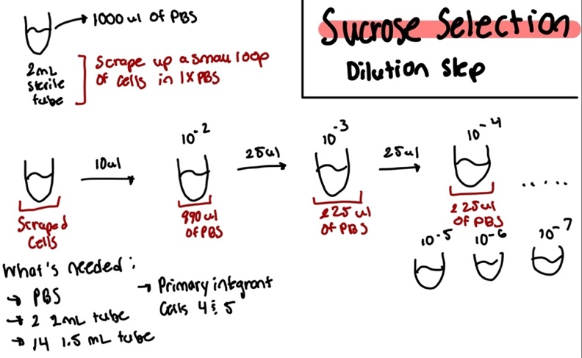
Setup for Sucrose Selection
Notes: For the steps when it came to plating the cells, I only did a duplicate of 10^-5 and 10^-6, as I had to use the other 100 uL of 10^-7 for the CHAH plates.
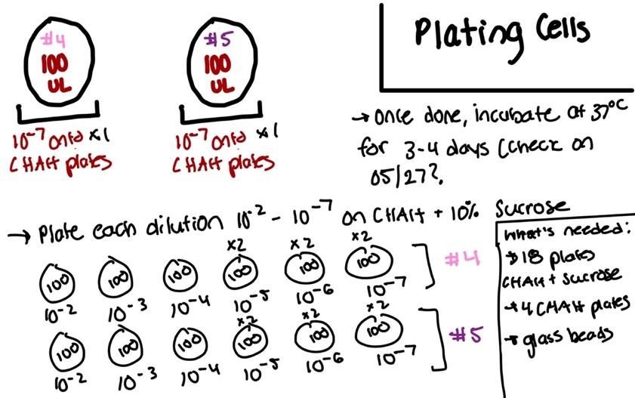

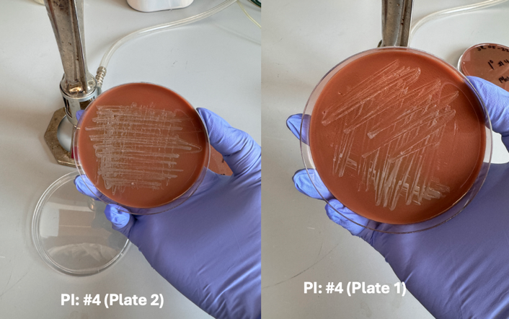
Primary Integrant Patch Plates:

Notes: I used PI #5 (Plate 4) and PI #4 (Plate 2) when prepping dilutions for sucrose selection.
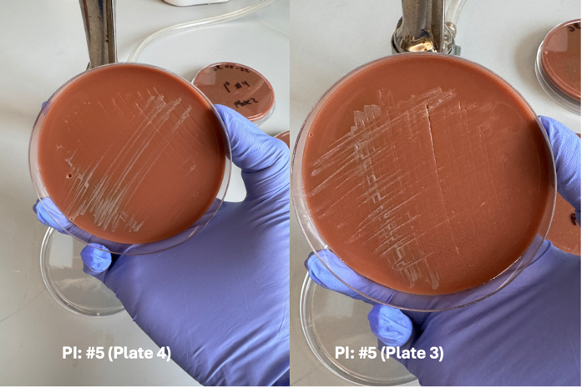

Friday, May 24, 2024
To Do:
- Count colonies on Day 43 Survival Assay plates
- Meet with KMR on accumulated graph
- Conduct survival assay of LVS Flasks

Protocol for Freshwater Survival Assay (LVS Flasks)
- Prep sterile setup for assay with these materials: reservoir, sterile multichannel pipettes (5-20uL and 50-300uL) sterile 96 well plate and sterile PBS.
- Aspectically, pour about 5-10 mL of sterile PBS into reservoir.
- Load 180 uL of sterile PBS into each “highlighted” column, don’t load PBS into first well of each column since that will be loaded with the cells.
- Load 100 uL of sample cells into each designated well
- Using the multichannel, transfer 20 uL of the sample cells from the first well into the next well. Repeat this for each well, 1A to 1B. 1B to 1C etc.
- Once all wells have been diluted (except the first wells), prep 12 plates of CHAH.
- Using the 5 – 20 uL multichannel, load 10 uL of the first column, for example, 1A, 1B, 1C, 1D, 1E, 1F, 1G, 1H, and plate the 10 uL, holding the plate at slant
- Let the liquid run down the plate, but not too fast!! Can’t allow samples to hit the bottom.
- Once all12 plates are done, incubate plates in 37 degrees Celsius for the next couple of days.

Notes:
I only did a survival assay on flasks 1, 2, and 3. So there were 6 plates.

Tuesday, May 28, 2024
To Do:
- Count colonies on Day 43 Survival Assay LVS plates
- Pick single colonies from sucrose plates w/ KMR
- Prepare square CHAH plates
- Prepare LB Agar for Kira

Patching Crossouts onto CHAH
Pick single colonies (cross-outs) from sucrose plates and patch onto CHAH, 8 – 16 per 1° integrant.
-Optional: cross-patch to CHAH-Kan. Note that it is common to pick up some background cells so some amount of kanamycin-resistant growth is not yet a concern. However, if there is robust kanamycin-resistant growth from all patches from a single 1° integrant on the next day, the 1° integrant may have an inactivating mutation in sacB and is not worth keeping.
Observation Notes:
I patched the single colonies on 4 CHAH plates and 4 CHAH-Kan plates. 4 plates (2 CHAH, 2 CHAH-Kan) were designated for primary integrant #4 and 4 plates were designated for primary integrant #5. I labeled one plate 1-12 and the other 13-24. When I started patching, KMR suggested that I pick 4 big single colonies, 4 small single colonies and again 4 big single colonies. Before I started, I made a few observations about the serial dilution sucrose plates. On my CHAH 10⁻⁷ plates, I noticed the greenish halo around the colonies, these colonies were very big {insert total amount of colonies}. On my sucrose plates, the colonies were relatively small and had this greyish tint. KMR made note that when deleting the mpl gene, there might be a growth defect. On my primary integrant #5 plates, I noticed contamination on about 4-5 of these plates that were not Fransciella.

Table. Sucrose Selection Dilution Plate Count
 | PI #4 10⁻⁷ | PI#5 10⁻⁷
CHAH | 114 | 99
CHAH + 10% Sucrose | 48 | 43

Day 43 Survival Assay Plate Count
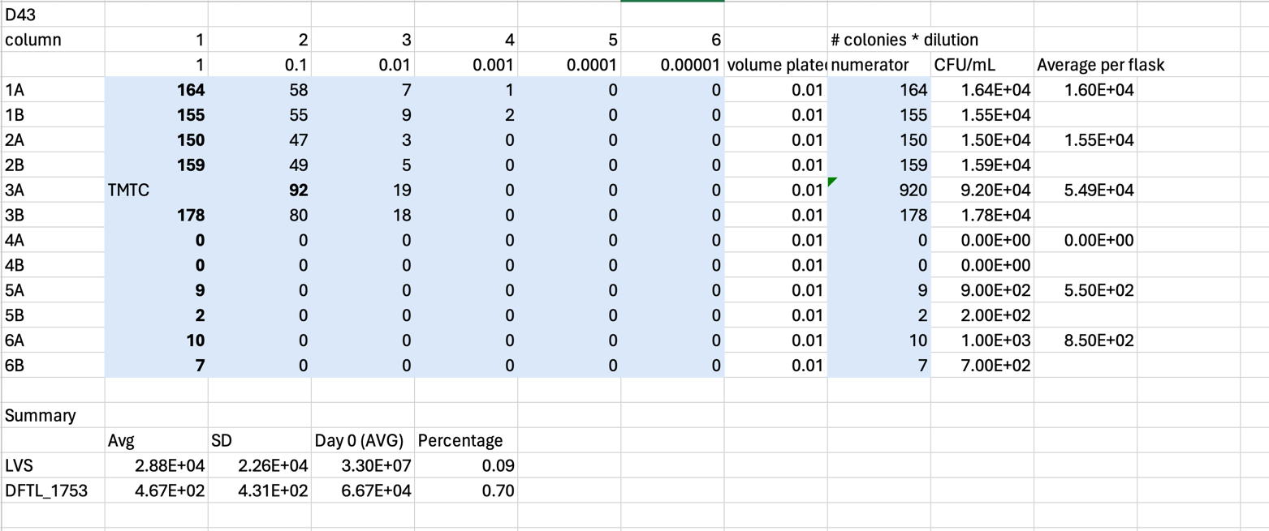

Figure 1. In this image is a graph of the survival percentage of LVS (blue) and DFTL_1753 (orange) over a period of 43 days.
Figure 2. In this image is a graph of the average CFU/mL over 43 days. The lines represent LVS (blue) and DFTL_1753 (orange) with the addition of error bars.
Notes: I had a discussion with KMR on Friday where we talked about the graphs. The days plotted on the graph include data from Day 0, 7, 15, and 43. There were also two datasets, Day 1 and Day 3 which were excluded from this current graph (That graph can be found in my lab notebook 20242401). Day 3 was an anomaly because we saw an a peak in the DFTL_1753. KMR suggested that the next time I do a survival assay with my mutant, I should instead resuspend the cells in PBS, check the OD, pellet the cells and then resuspend again in PBS and water (our experimental group). She suggested this because when I first resuspended the cells in water, the mutant cells experienced hypo-osmotic shock and that the cells I plated on Day 0 were dead. By resupending the cells in PBS, we can provide an explanation for why the Day 0 CFU/mL are different.

Preparing Square CHAH Plates
For 600 mL of CHA
1. out 30.6g of cystine heart agar into 1L flask (non-baffled; 10.2g/100mL)
2. Add 300mL of ddiH₂O (type I)
3. Add stirbar to flask
4. Heat on low, stirring, for about 10 minutes (media should be totally dissolved)
5. Autoclave on 30’ liquid cycle, filling the water bin up to the height of the media
6. Cool down (ideally to ~55C)
7. Separately (before), prepare hemoglobin 2% solution
8. Add 6g freeze-dried hemoglobin to 300mL of ddiH₂O (type I)
9. Autoclave on 20’ liquid cycle with water in the bin
10. Cool down (ideally to ~55C)
11. Using sterile technique, pour hemoglobin into CHA
12. Using a 50mL pipet, aliquot 30 mL of CHAH mixture into each square plate. Try to avoid bubbles!
Notes: I made 40 square plates of CHAH.

Preparing LB Agar
- For 500 mL of LB-agar, weigh out the following components and add to a 1 L (non-baffled) flask:
  - 6 g agar
  - 5 g NaCl
  - 5 g Tryptone
  - 2.5 g Yeast extract
- Add stirbar to flask
- Add 500 mL ddiH20
- Mix on stirplate until components are dissolved
- Cover top of flask with foil and add a small piece of autoclave tape
- Autoclave on 30 minute liquid cycle

Notes: KB asked me to make 2 500 mL LB agar flasks, they are stored on the shelf.

Wednesday, May 29, 2024
To Do:
- Colony PCR
- Observations of patch plates
- Run gel of PCR
- Streak out cells for osmotic shock

Prepping for Colony PCR

Transferring Patches to PCR strip tubes (diluted strip tubes, first step)
- Load 50 uL of H20 into PCR strip tubes
- Aseptically, scrape a few cells on one patch (from CHAH plate) at a time using a wooden stick and mix with the H2O in the designated PCR strip tube. Patch 1 goes into PCR strip tube 1 etc.
- Repeat this for the set number of patches and PCR strip tubes
- Resuspended via vortexing and spin down
- Put in thermocycler for 95 degrees for 10 minutes
- Label new PCR strip tubes w numbers
- Add 18 uL of h2o, transfer 2 uL from first tube to 2nd tube

PCR Protocol
- Acquire and label PCR tubes. Be sure to include at least 1 positive and 1 negative control for each PCR experiment.
- Get a container of ice to keep the components on
- Acquire the following components and put them on ice, labeling tubes if necessary:
  - Molecular grade H2O in 1.5 mL microfuge tube
  - KOD/primestar buffer
  - dNTPs
  - oligo F (10uM)
  - oligo R (10uM)
  - template (eg. LVS gDNA, plasmid, colony, etc.)
  - Note: KOD/primestar enzyme should be kept in the freezer until it is used as it is expensive and should be added last
- Centrifuge the microfuge tubes to get any solution out of the microfuge tube cover
- If any of the solutions are frozen, be sure to vortex the microfuge tube in order to dissolve it (tubes with frozen components may not be homogenized)
  - DO NOT vortex the enzyme itself or any solution with enzyme because vortexing will expose it to oxygen and degrade it
- Use PCR_worksheet.xlsx to make establish the specifics of what will be added
  - The file is located in the Protocols folder
  - Also setup table below to specify which primers and source DNA will be used
- Prepare a master-mix in a 1.5 mL microfuge tube by adding the following according to the worksheet and using micropipettes:
  - ddi H2O
  - primers
  - Add dNTPs
  - Add buffer
  - Add enzyme (last!)
- Mix the master-mix solution by pipetting up and down
  - Do not vortex to mix
- Add 18uL of master-mix to each PCR tube (can use same tip)
- Add template to each PCR tube (2 ul each, change tip each time)
- Close PCR Tubes until the caps are tight
- Place the PCR Tubes in the thermocycler on STN 1 – the following settings should be in place:
Lid: 105°C
Volume: 20uL change depending on sample volume
      - 94°C 2’
      - 94°C 20”
      - 50°C 30”
      - 68°C 3’40”. This is the step to change depending on product size
      - Go to step 2, 32x
      - 68°C 5 mins
      - 12°C Hold

Table. Reactions for Colony PCR
Reaction numbers | Sample | Expected size
1 | pKR200-4-6 | 3549 or 2212
2 | pKR200-4-13 | 3549 or 2212
3 | pKR200-4-19 | 3549 or 2212
4 | pKR200-4-1 | 3549 or 2212
5 | pKR200-4 | ?
6 | pKR200-5-2 | 3549 or 2212
7 | pKR200-5-6 | 3549 or 2212
8 | pKR200-5-9 | 3549 or 2212
9 | pKR200-5-14 | 3549 or 2212
10 | pKR200-5-18 | 3549 or 2212
11 | pKR200-5-20 | 3549 or 2212
12 | pKR200-5-1 | 3549 or 2212
13 | pKR200-5 | ?
14 | pKR200 1:10 | -
15 | LVS gDNA | 3549
16 | -DNA | no product

Table. Master Mix for Colony PCR
Total reaction volume | 20
Total number of reactions | 16
 |  |  |  | Factor
Component | Stock concentration | Final concentration | 1 rxn volume | 17
ddiH2O |  |  | 10.8 | 183.6
PrimeSTAR GXL Buffer | 5x | 1x | 4.0 | 68
dNTPs | 2.5 mM | 0.2 mM | 1.6 | 27.2
oligo F | 10 uM | 0.3 uM | 0.6 | 10.2
oligo R | 10 uM | 0.3 uM | 0.6 | 10.2
template | 100 ng/ul | 2 ng/ul | 2.0
PrimeSTAR GXL DNA Polymerase | 1.25 U/ul | 0.025 U/ul | 0.4 | 6.8
 |  | Total volume | 20 | 306

Notes for protocol:
Helpful notes for when starting PCR, DO mix your primers in the mastermix and do not vortex once you add DNA polymerase. I am going to take 2.0 uL of template into MM spin those down and then add the mastermix (spin again one more time).

Notes after protocol:
I accidentally transferred 2 ul of master mix into the diluted cells from PI #4 strip tube. So with the help of BM, we created a new diluted 1:10 of PI #4 and I edited the master mix table where I changed the total number of reactions to 1 to help add more contents of buffer, primers, dNTPS, polymerase and water. After adding to the master mix, I continued on with the protocol as written.

Table. Mastermix Table after Mistake
Total reaction volume | 20
Total number of reactions | 1
 |  |  |  | Factor
Component | Stock concentration | Final concentration | 1 rxn volume | 2
ddiH2O |  |  | 10.8 | 21.6
PrimeSTAR GXL Buffer | 5x | 1x | 4.0 | 8
dNTPs | 2.5 mM | 0.2 mM | 1.6 | 3.2
oligo F | 10 uM | 0.3 uM | 0.6 | 1.2
oligo R | 10 uM | 0.3 uM | 0.6 | 1.2
template | 100 ng/ul | 2 ng/ul | 2.0
PrimeSTAR GXL DNA Polymerase | 1.25 U/ul | 0.025 U/ul | 0.4 | 0.8
 |  | Total volume | 20 | 36

Observations of Patch Plates from 05/28/24
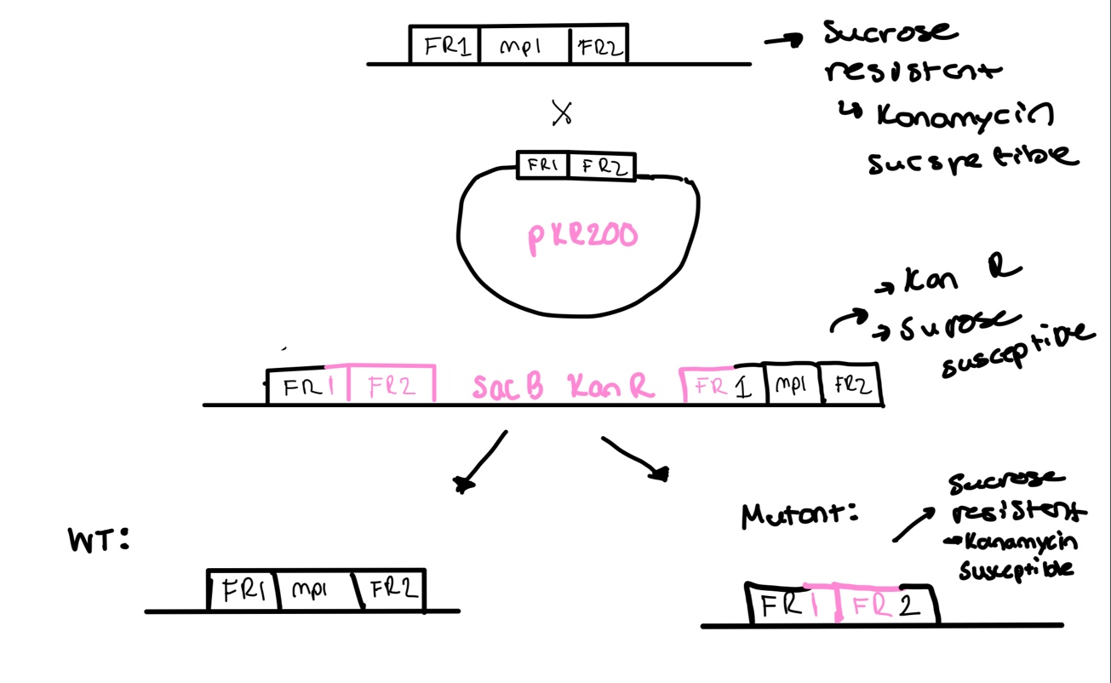
Figure. Above is an image of a “flow chart” which depicts the process of homologous recombination. In the first event we have the original F. tularensis genome and my plasmid pKR200 (deletion of mpl). This crossover event produces the recombinated fragments. Cells from this event are kanamycin resistant and sucrose susceptible. The next crossover event we should have the deleted gene, hence these cells should be sucrose resistant and kanamycin susceptible.

There was more growth on our CHAH plates for PI #4 and PI #5 but there was also some growth on the CHAH-Kan plates for the primary integrants.

Setting up to run gel
- Grab PCR samples of PI #4 and PI #5
- Set up agarose gel rig (used the larger, green rig bc there is more volume).
- Load 12 uL of Sybersafe (mix with column) Pour agarose gel into rig after cools. And let sit until solidified.
- Load 10 ul of 1Kb ladder dye into ladder
- Mix 5 uL of loading dye into the each 20 uL PCR colony strip tube. Using the multichannel, to load the dye into PCR strip tubes.
- Load PCR strips tubes into each well about 20 uL
- Run to red when connecting power pack to casting tray. Covered tray with aluminum foil so Sybersafe does not degrade under light.

Figure. Colony PCR Gel 05/30/2024

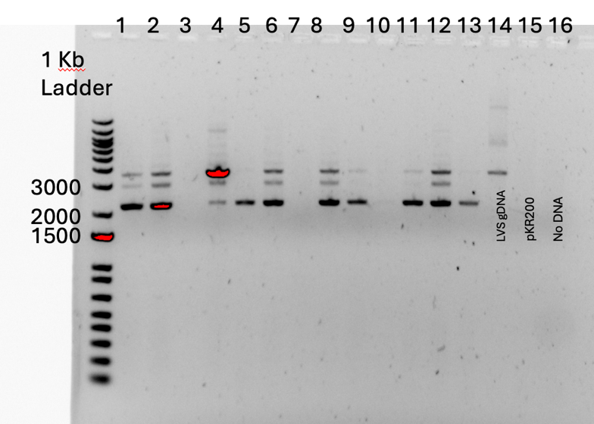

Thursday, May 30, 2024
To Do:
- Place square plates for shock assay in incubator
- Conduct Shock Assay
- Redo 05/29 Colony PCR
- Run gel of colony PCR

Prepping for Colony PCR

Transferring Patches to PCR strip tubes (diluted strip tubes, first step)
- Load 50 uL of H20 into PCR strip tubes
- Aseptically, scrape a few cells on one patch (from CHAH plate) at a time using a wooden stick and mix with the H2O in the designated PCR strip tube. Patch 1 goes into PCR strip tube 1 etc.
- Repeat this for the set number of patches and PCR strip tubes
- Resuspended via vortexing and spin down
- Put in thermocycler for 95 degrees for 10 minutes
- Label new PCR strip tubes w numbers
- Add 18 uL of h2o, transfer 2 uL from first tube to 2nd tube

PCR Protocol
- Acquire and label PCR tubes. Be sure to include at least 1 positive and 1 negative control for each PCR experiment.
- Get a container of ice to keep the components on
- Acquire the following components and put them on ice, labeling tubes if necessary:
  - Molecular grade H2O in 1.5 mL microfuge tube
  - KOD/primestar buffer
  - dNTPs
  - oligo F (10uM)
  - oligo R (10uM)
  - template (eg. LVS gDNA, plasmid, colony, etc.)
  - Note: KOD/primestar enzyme should be kept in the freezer until it is used as it is expensive and should be added last
- Centrifuge the microfuge tubes to get any solution out of the microfuge tube cover
- If any of the solutions are frozen, be sure to vortex the microfuge tube in order to dissolve it (tubes with frozen components may not be homogenized)
  - DO NOT vortex the enzyme itself or any solution with enzyme because vortexing will expose it to oxygen and degrade it
- Use PCR_worksheet.xlsx to make establish the specifics of what will be added
  - The file is located in the Protocols folder
  - Also setup table below to specify which primers and source DNA will be used
- Prepare a master-mix in a 1.5 mL microfuge tube by adding the following according to the worksheet and using micropipettes:
  - ddi H2O
  - primers
  - Add dNTPs
  - Add buffer
  - Add enzyme (last!)
- Mix the master-mix solution by pipetting up and down
  - Do not vortex to mix
- Add 18uL of master-mix to each PCR tube (can use same tip)
- Add template to each PCR tube (2 ul each, change tip each time)
- Close PCR Tubes until the caps are tight
- Place the PCR Tubes in the thermocycler on STN 1 – the following settings should be in place:
Lid: 105°C
Volume: 20uL change depending on sample volume
      - 94°C 2’
      - 94°C 20”
      - 50°C 30”
      - 68°C 3’40”. This is the step to change depending on product size
      - Go to step 2, 32x
      - 68°C 5 mins
      - 12°C Hold

Table. Colony PCR #2 Reaction Table
Reaction numbers | Sample | Expected size
1 | pKR200-4-6 | 3549 or 2212
2 | pKR200-4-19 | 3549 or 2212
3 | pKR200-5-6 | 3549 or 2212
4 | pKR200-5-18 | 3549 or 2212
5 | pKR200-4 | ?
6 | LVS gDNA | 3549
7 | pKR200 1:10 | -
8 | no DNA | -

Table. Master mix for Colony PCR #2
Total reaction volume | 20
Total number of reactions | 8
 |  |  |  | Factor
Component | Stock concentration | Final concentration | 1 rxn volume | 9
ddiH2O |  |  | 10.8 | 97.2
PrimeSTAR GXL Buffer | 5x | 1x | 4.0 | 36
dNTPs | 2.5 mM | 0.2 mM | 1.6 | 14.4
oligo F | 10 uM | 0.3 uM | 0.6 | 5.4
oligo R | 10 uM | 0.3 uM | 0.6 | 5.4
template | 100 ng/ul | 2 ng/ul | 2.0
PrimeSTAR GXL DNA Polymerase | 1.25 U/ul | 0.025 U/ul | 0.4 | 3.6
 |  | Total volume | 20 | 162

Setting up to run gel
- Grab PCR samples of PI #4 and PI #5
- Set up agarose gel rig (used the smaller, yellow rig bc there is more volume).
- Load 6 uL of Sybersafe (mix with column) Pour agarose gel into rig after cools. And let sit until solidified.
- Load 10 ul of 1Kb ladder dye into ladder
- Mix 5 uL of loading dye into the each 20 uL PCR colony strip tube. Using the multichannel, to load the dye into PCR strip tubes.
- Load PCR strips tubes into each well about 20 uL
- Run to red when connecting power pack to casting tray. Covered tray with aluminum foil so Sybersafe does not degrade under light.

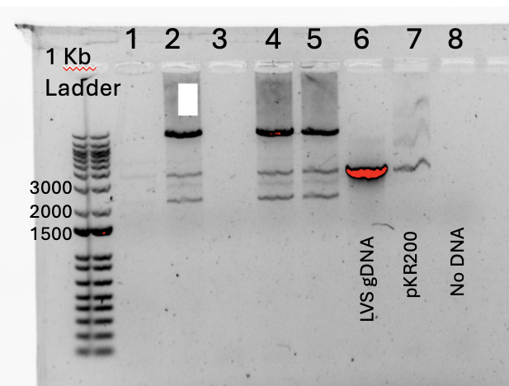
Gel Image of Colony PCR #2

In this image,

Friday, May 31, 2024
To Do:
- Place square plates for shock assay in incubator
- Conduct Shock Assay

Shock Assay Protocol
- Use one sterile 1.5 mL tubes and add 300 uL of sterile PBS to mutant tube and 300 uL to LVS tube.
- Scrap up 2 loopful of cells from mutant plate and resuspend in the 300 uL of sterile PBS. After, add 700 uL of sterile PBS into tube. Repeat for LVS plates
- Using cuvettes, add 900 uL of sterile PBS into each cuvette. For one cuvette (mutant), add 100 uL of resuspended cells into 900 uL of PBS. Repeat for LVS
- Measure absorbances of cuvettes using the spectrometer. Remember you also must use a blank filled with the same liquid (use sterile PBS) that the cells were resuspended in.
- Since we diluted by a dilution factor of 1:10, multiply absorbance by 10, this will get our final OD. (pretend we measured 0.2 – that means the OD is 2.0.
- If you have not the OD you want, repeat steps 2-5 until you do.

2500 * 0.03 = 2.0 * volume to add to 50 ml conical
(2500 * 0.03) /2.0 = volume to add to 50 ml conical = 37.5 uL

Add 37.5 uL of resuspended cells to 50 mL conical and add enough PBS to make 2.5 mL

2 options:
Add 2,462.5 ul of PBS to conical and add 37.5 uL of resuspended cells
OR
Add 2.5 mL PBS to conical, remove and discard 37.5 ul of PBS, add 37.5 ul of resuspended cells

- After this, for each strain, there is a 50 mL conical containing 2.5 mL of cells at 0.03 OD.
- For each strain, aliquot 1 mL of cells from 50 mL conical into two different sterile 1.5 mL tubes.
- Pellet these cells in centrifuge, max speed for 1 minute
- Remove all supernatants, for each strain, resuspend one pellet in 1mL of 1x PBS. Resuspend the other pellet in 1 mL of sterile freshwater.
- Wait 30 minutes after resuspension and prepare serial dilution well plate
- Perform serial dilution in 96 well plate

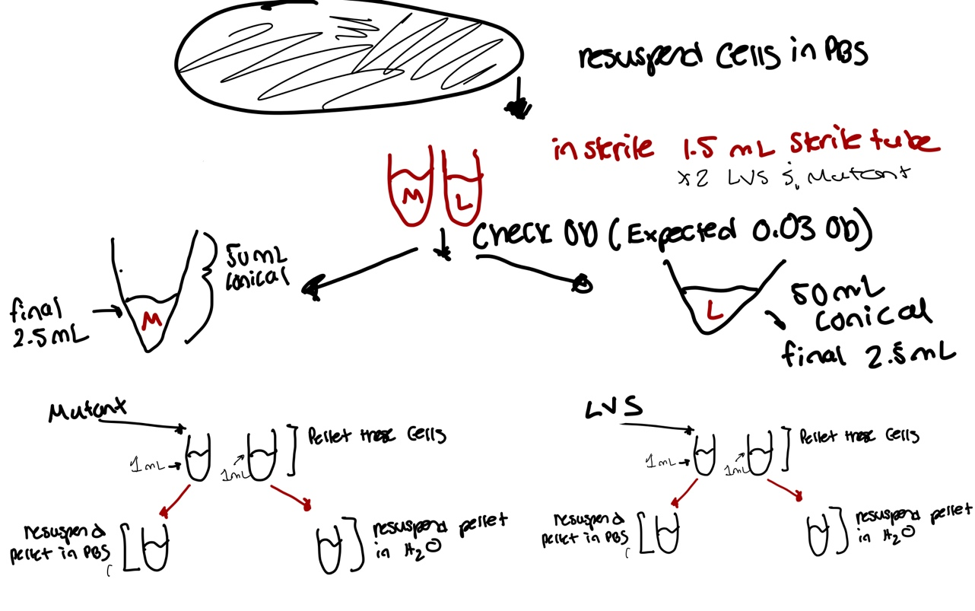

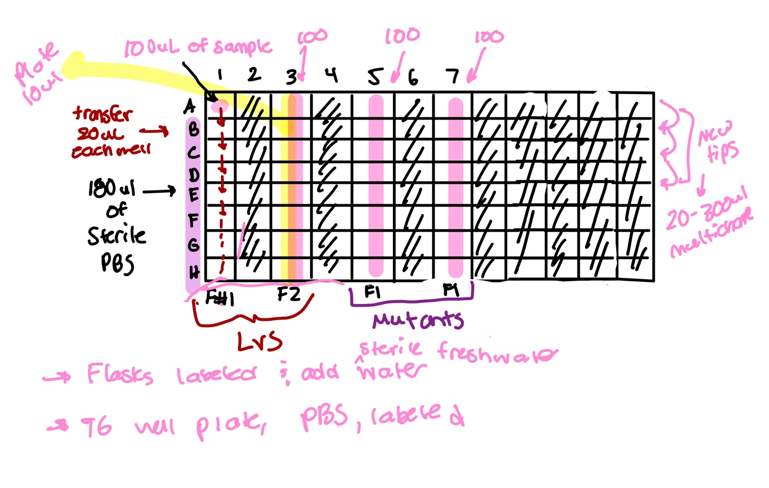

Finding an OD of about 1.0

Sample: | Absorbance:
LVS | 0.146
Mutant | 0.172
I multiplied the absorbance by 10 since we diluted 1:10. Therefore 0.l46 is now 1.46.

Equation for LVS:
2500 * 0.03 = 1.46 * V2 -> V2 = 51.36 uL

I added 2500 uL of sterile 1x PBS to a 50 mL conical, where I removed 51.36 uL of PBS and added 51.36 uL of the mutant cells.

Equation for Mutant:
2500 * 0.03 = 1.72 * V2 -> V2 = 43.60 uL

I added 2500 uL of sterile 1x PBS to a 50 mL conical, where I removed 43.60 uL of PBS and added 43.60 uL of the mutant cells.

Notes:
Flask #1: LVS resuspended in H2O
Flask #2: LVS resuspended in PBS
Flask #3: Mutant resuspended in PBS
Flask #4: Mutant resuspended in H2O

When I was pelleting the cells, the pellets were very small (almost pinhead like), except for flask #4, it was probably so small that it was not visible or there was no pellet at all. Other than that observation, I was able to resuspend the other 3 pellets with their designated pellets. Since the pellets were really small Alex recommended that I remove 900 uL of the supernatant with the P1000 and then remove the rest using a P20/ P10.

June 2024

Wednesday, June 5, 2024
To Do:
- Make observations on Shock Assay plates from 05/31
- Create bar graph for shock assay
- Patch LVS and DFTL_1753 on CHAH plates for tomorrows shock assay
- Make Sucrose plates for Friday’s sucrose selection dilution
- Make minimal media plates for KMR

Shock Assay Bar Graph
Figure. This bar graph depicts the CFU/mL of each strain LVS and DFTL_1753 in their experimental environments. These experimental environments are H2O (sterile freshwater) and sterile 1X PBS. The two strains were resuspended in these model environments and were plated on CHAH square plates, where they were incubated at 37°C for 3-4 days. On a logarithmic scale, I can observe that the LVS resuspended in PBS vs DFTL_1753 resuspended in PBS have a very similar cell viability count (measured in CFU/mL). Compared to the strains resuspended in sterile freshwater, where there is a visible difference, the mutant had a lower cell viability count than LVS. I can infer that the cells most likely experienced hypoosmotic shock when resuspended in the sterile freshwater.

Patching LVS strain and DFTL strain on CHAH
- Using aseptic technique, use a wooden stick to scrape from single use aliquot of LVS on a CHAH plate
- Repeat step for DFTL strain.

Making Sucrose Plates
CHAH plates with 10% sucrose
Mix:
5 g Beef Heart Infusion
5 g Protease Peptone
5 g Glucose
0.5 g L-Cystine
7.5 g Agar
with 150 mL type I ddiH₂O. Stir on low heat until completely dissolved, about 10 minutes.
Autoclave 30’, being EXTREMELY careful media does not boil over
While autoclaving, warm 250 mL of 2% hemoglobin and sterilized 50% sucrose (in 50°C oven or in water bath at 55°C)
Place CHA flask in 50°C oven or in water bath at 55°C, let temperature equilibrate
Wipe down flask and bottles with ethanol and using sterile technique, pour hemoglobin into CHA flask
Add 100 mL 50% sucrose to CHA-hemoglobin flask
Mix media
Use sterile pipette, pour ~24 mL media per plate (~20 plates for 500 mL media)

Making Minimal Media Plates

Prepare 5X M9 Salts (for 100 mL of M9 Salts)

- In a 250 mL flask, add 6.4g of sodium phosphate
  - Add 7.5g of potassium phosphate
  - Add 0.25g of sodium chloride
  - Add 0.5g of Ammonium chloride
  - Add 500 mL of diH2O
- Stir contents for a few minutes
Combine M9 Salts, agar and H2O
- In two separate flasks:
  - Add 50 mL of M9 salts
  - Add 3g of Agar
  - Add 195 mL of H2O
- Stir contents on hot plate on low heat for 10 minutes
- Autoclave contents on liquid 30’ cycle
Adding other contents
- When flasks are cool, add the following contents in each flask:
  - 5 mL of 1M MgSO4
  - 0.5 mL of 1M CaCl2
  - 250 mL of Kanamycin
- Stir on hot plate to mix
- Pour ~24 mL into each plate

Thursday, June 6, 2024
To Do:
- Place square plates for shock assay in incubator
- Conduct Shock Assay

Shock Assay Protocol
- Use one sterile 1.5 mL tubes and add 300 uL of sterile PBS to mutant tube and 300 uL to LVS tube.
- Scrap up 2 loopful of cells from mutant plate and resuspend in the 300 uL of sterile PBS. After, add 700 uL of sterile PBS into tube. Repeat for LVS plates
- Using cuvettes, add 900 uL of sterile PBS into each cuvette. For one cuvette (mutant), add 100 uL of resuspended cells into 900 uL of PBS. Repeat for LVS
- Measure absorbances of cuvettes using the spectrometer. Remember you also must use a blank filled with the same liquid (use sterile PBS) that the cells were resuspended in.
- Since we diluted by a dilution factor of 1:10, multiply absorbance by 10, this will get our final OD. (pretend we measured 0.2 – that means the OD is 2.0.
- If you have not the OD you want, repeat steps 2-5 until you do.

2500 * 0.03 = 2.0 * volume to add to 50 ml conical
(2500 * 0.03) /2.0 = volume to add to 50 ml conical = 37.5 uL

Add 37.5 uL of resuspended cells to 50 mL conical and add enough PBS to make 2.5 mL

2 options:
Add 2,462.5 ul of PBS to conical and add 37.5 uL of resuspended cells
OR
Add 2.5 mL PBS to conical, remove and discard 37.5 ul of PBS, add 37.5 ul of resuspended cells

- After this, for each strain, there is a 50 mL conical containing 2.5 mL of cells at 0.03 OD.
- For each strain, aliquot 1 mL of cells from 50 mL conical into two different sterile 1.5 mL tubes.
- Pellet these cells in centrifuge, max speed for 1 minute
- Remove all supernatants, for each strain, resuspend one pellet in 1mL of 1x PBS. Resuspend the other pellet in 1 mL of sterile freshwater.
- Wait 30 minutes after resuspension and prepare serial dilution well plate
- Perform serial dilution in 96 well plate

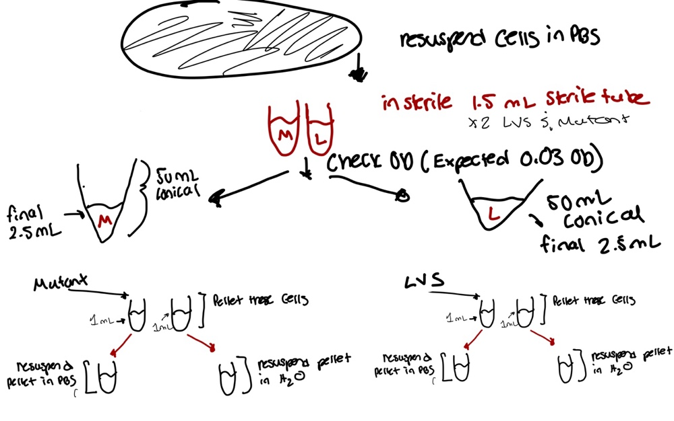

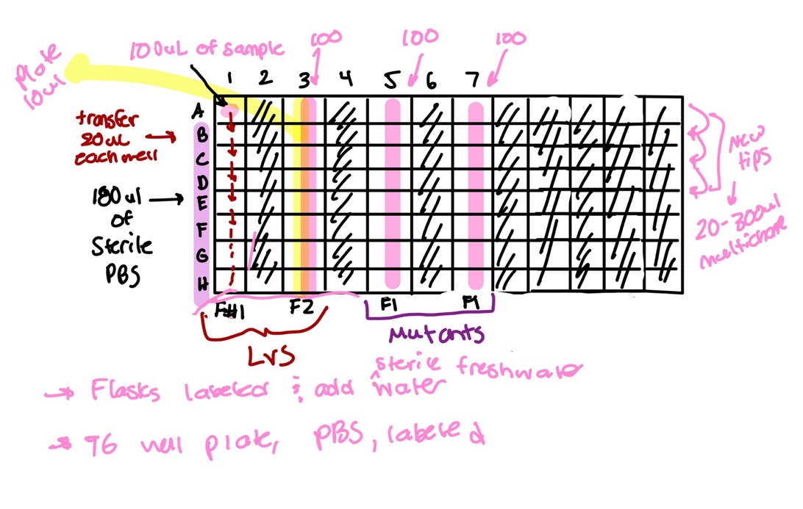

Finding an OD of about 1.0

Sample: | Absorbance:
LVS | 0.134
Mutant | 0.187

Notes:
Flask #1: LVS resuspended in PBS
Flask #2: LVS resuspended in H2O
Flask #3: Mutant resuspended in PBS
Flask #4: Mutant resuspended in H2O

Friday, June 7, 2024
To Do:
- Conduct Sucrose Selection
- Create protocol for Minimal Media
- Place baffled flasks in autoclave to be sterilized
- Review freshwater paper

Selecting Cross-outs for Sucrose Selection

Kanamycin-resistant cells should be 1° integrants. Make stocks of up to 4 potential 1° integrants, but only move forward with identifying cross-outs from two 1° integrants per strain
To select for cross-outs using sucrose selection
1. Scrape up small loop of cells and resuspend in 1X PBS
2. Dilute culture 1:10 in sterile PBS to 1x10⁻⁷
3. Perform first dilution 1:100 so first dilution tube is 1x10⁻², adding 10 uL of resuspended cells to 990 ul 1x PBS
4. Perform subsequent dilutions 1:10, diluting 25 uL cells into 225 uL 1X PBS
-Plate 100 uL of last dilution (1x10⁻⁷) onto CHAH plates.
-Plate 100 μL of each dilution 10⁻² – 10⁻⁷ on CHAH + 10% sucrose plates. If you have extra sucrose plates, can plate some or all dilutions twice.
5. Incubate plates at 37°C for 3-4 days, or until single colonies appear. It is generally a good idea to test both large and smaller single colonies. Note that there should be many more colonies on the CHAH plate with the 1x10⁻⁷ dilution than on the sucrose plate with the corresponding dilution. If there seem to be similar numbers of colonies, the 1° integrant may have an inactivating mutation in sacB and is not worth keeping.

Setup for Sucrose Selection
Notes: For the steps when it came to plating the cells, I only did a duplicate of 10^-5 and 10^-6, as I had to use the other 100 uL of 10^-7 for the CHAH plates.

Monday, June 10, 2024
To Do:
- Check sucrose plates from Thursday, June 6
- Miniprep KMR pelleted cells
- Make 50% sucrose
- Check shock assay plates
- Patch out sucrose colonies on patch plates

50% Sucrose Protocol

Combine 360 g of sucrose and enough type I ddiH₂O to make 720 mL.
Autoclave for 20’.
Suggested method: in 1 L beaker, add ~100 g increments of sucrose into ~250 mL type I ddiH₂O, heating slightly (below boiling point!) and waiting for each addition to be completely dissolved before adding next mass of sucrose. Measure final volume in graduated cylinder and add type I ddiH₂O until volume is 720 mL.

Miniprep KMR Pelleted Cells
- Pellet 1-5 ml bacterial overnight culture by centrifugation at >8000 rpm for 3 min room temp
- Resuspend pelleted bacterial cells in 250 ul Buffer P1 and transfer to microcentrifuge tube (from fridge)
- Add 250 ul Buffer P2 and mix thoroughly by inverting tube 4-6 times until solution becomes clear. Do not allow lysis reaction to proceed for more than 5 min.
- Add 350 ul Buffer N3 and mix immediately and thoroughly by inverting the tube 4-6 times
- Centrifuge for 10 min at 13000 rpm
- Apply 800 ul supernatant from step 5 to the QIAprep 2.0 spin column by pipetting. Centrifuge for 30-60s and discard the flow through
- Recommended: Wash the QIAprep 2.0 spin column by adding 0.5 ml Buffer PB. Centrifuge for 30-60s and discard flow through
- Wash QIAprep 2.0 spin column by adding 0.75 ml Buffer PE. Centrifuge for 30-60s and discard flow through (do 3 times?) Transfer QIAprep 2.0 spin column to collection tube
- Centrifuge 3 min to remove residual wash buffer
- Place QIAprep 2.0 column in a clean 1.5 ml microcentrifuge tube. To elute DNA, add 50 ul Buffer 0.1x EB, let stand for 1 minute and centrifuge for 1 min.
- If extracted DNA is to be analyzed on a gel, add 1 volume of loading dye to 5 ul volumes of purified DNA. Mix the solution by pipetting up and down before loading

Tuesday, June 11, 2024
To Do:
- Conduct colony PCR
- Run products on gel
- Streak out cells for osmotic shock assay
- Observations of shock assay from Thursday

Observations of Shock Assay
Notes: After 4 days in the incubator, I took out the plates. Upon observation, there was contamination on all 12 mutant plates. There was growth of what was F. tularensis but there was pinkish cell growth on top of the F. tularensis growth. There was no contamination on the LVS plates. However, it was recommended by KMR to repeat the shock assay again tmwr.

PCR Protocol
- Acquire and label PCR tubes. Be sure to include at least 1 positive and 1 negative control for each PCR experiment.
- Get a container of ice to keep the components on
- Acquire the following components and put them on ice, labeling tubes if necessary:
  - Molecular grade H2O in 1.5 mL microfuge tube
  - KOD/primestar buffer
  - dNTPs
  - oligo F (10uM)
  - oligo R (10uM)
  - template (eg. LVS gDNA, plasmid, colony, etc.)
  - Note: KOD/primestar enzyme should be kept in the freezer until it is used as it is expensive and should be added last
- Centrifuge the microfuge tubes to get any solution out of the microfuge tube cover
- If any of the solutions are frozen, be sure to vortex the microfuge tube in order to dissolve it (tubes with frozen components may not be homogenized)
  - DO NOT vortex the enzyme itself or any solution with enzyme because vortexing will expose it to oxygen and degrade it
- Use PCR_worksheet.xlsx to make establish the specifics of what will be added
  - The file is located in the Protocols folder
  - Also setup table below to specify which primers and source DNA will be used
- Prepare a master-mix in a 1.5 mL microfuge tube by adding the following according to the worksheet and using micropipettes:
  - ddi H2O
  - primers
  - Add dNTPs
  - Add buffer
  - Add enzyme (last!)
- Mix the master-mix solution by pipetting up and down
  - Do not vortex to mix
- Add 18uL of master-mix to each PCR tube (can use same tip)
- Add template to each PCR tube (2 ul each, change tip each time)
- Close PCR Tubes until the caps are tight
- Place the PCR Tubes in the thermocycler on STN 1 – the following settings should be in place:
Lid: 105°C
Volume: 20uL change depending on sample volume
      - 94°C 2’
      - 94°C 20”
      - 50°C 30”
      - 68°C 3’40”. This is the step to change depending on product size
      - Go to step 2, 32x
      - 68°C 5 mins
      - 12°C Hold

Colony PCR Sample ID Table
Reaction numbers | Sample | Expected size
1 | pKR200-4-1 | 3549 or 2212
2 | pKR200-4-8 | 3549 or 2212
3 | pKR200-4-12 | 3549 or 2212
4 | pKR200-4-16 | 3549 or 2212
5 | pKR200-4-26 | 3549 or 2212
6 | pKR200-4-45 | 3549 or 2212
7 | pKR200-4-49 | 3549 or 2212
8 | pKR200-4-55 | 3549 or 2212
9 | pKR200-4-59 | 3549 or 2212
10 | pKR200-4-68 | 3549 or 2212
11 | pKR200-4-70 | 3549 or 2212
12 | pKR200-4-72 | 3549 or 2212
13 | pKR200-4-79 | 3549 or 2212
14 | pKR200-4-92 | 3549 or 2212
15 | pKR200-5-6 | 3549 or 2212
16 | pKR200-5-8 | 3549 or 2212
17 | pKR200-5-43 | 3549 or 2212
18 | pKR200-5-44 | 3549 or 2212
19 | pKR200-5-46 | 3549 or 2212
20 | pKR200-5-63 | 3549 or 2212
21 | pKR200-5-68 | 3549 or 2212
22 | pKR200-5-71 | 3549 or 2212
23 | pKR200-5-78 | 3549 or 2212
24 | pKR200-5-90 | 3549 or 2212
25 | pKR200-5-108 | 3549 or 2212
26 | LVS gDNA | 3549
27 | pKR200 1:10 | -
28 | no DNA | -

PCR Reaction Table

Total reaction volume | 20
Total number of reactions | 28
 |  |  |  | Factor
Component | Stock concentration | Final concentration | 1 rxn volume | 29
ddiH2O |  |  | 10.8 | 313.2
PrimeSTAR GXL Buffer | 5x | 1x | 4.0 | 116
dNTPs | 2.5 mM | 0.2 mM | 1.6 | 46.4
oligo F | 10 uM | 0.3 uM | 0.6 | 17.4
oligo R | 10 uM | 0.3 uM | 0.6 | 17.4
template | 100 ng/ul | 2 ng/ul | 2.0
PrimeSTAR GXL DNA Polymerase | 1.25 U/ul | 0.025 U/ul | 0.4 | 11.6
 |  | Total volume | 20 | 522

Setting up to run gel
- Grab PCR samples of PI #4 and PI #5
- Set up agarose gel rig (used the smaller, yellow rig bc there is more volume).
- Load 6 uL of Sybersafe (mix with column) Pour agarose gel into rig after cools. And let sit until solidified.
- Load 10 ul of 1Kb ladder dye into ladder
- Mix 5 uL of loading dye into the each 20 uL PCR colony strip tube. Using the multichannel, to load the dye into PCR strip tubes.
- Load PCR strips tubes into each well about 20 uL
- Run to red when connecting power pack to casting tray. Covered tray with aluminum foil so Sybersafe does not degrade under light.

Wednesday, June 12, 2024
To Do:
- Attend professional workshop at 10am-11:30am
- Conduct osmotic shock assay
- Observe gels from Tuesday’s colony PCR
- Streak potential mutants for single colonies

Shock Assay Protocol
- Use one sterile 1.5 mL tubes and add 300 uL of sterile PBS to mutant tube and 300 uL to LVS tube.
- Scrap up 2 loopful of cells from mutant plate and resuspend in the 300 uL of sterile PBS. After, add 700 uL of sterile PBS into tube. Repeat for LVS plates
- Using cuvettes, add 900 uL of sterile PBS into each cuvette. For one cuvette (mutant), add 100 uL of resuspended cells into 900 uL of PBS. Repeat for LVS
- Measure absorbances of cuvettes using the spectrometer. Remember you also must use a blank filled with the same liquid (use sterile PBS) that the cells were resuspended in.
- Since we diluted by a dilution factor of 1:10, multiply absorbance by 10, this will get our final OD. (pretend we measured 0.2 – that means the OD is 2.0.
- If you have not the OD you want, repeat steps 2-5 until you do.

2500 * 0.03 = 2.0 * volume to add to 50 ml conical
(2500 * 0.03) /2.0 = volume to add to 50 ml conical = 37.5 uL

Add 37.5 uL of resuspended cells to 50 mL conical and add enough PBS to make 2.5 mL

2 options:
Add 2,462.5 ul of PBS to conical and add 37.5 uL of resuspended cells
OR
Add 2.5 mL PBS to conical, remove and discard 37.5 ul of PBS, add 37.5 ul of resuspended cells

- After this, for each strain, there is a 50 mL conical containing 2.5 mL of cells at 0.03 OD.
- For each strain, aliquot 1 mL of cells from 50 mL conical into two different sterile 1.5 mL tubes.
- Pellet these cells in centrifuge, max speed for 1 minute
- Remove all supernatants, for each strain, resuspend one pellet in 1mL of 1x PBS. Resuspend the other pellet in 1 mL of sterile freshwater.
- Wait 30 minutes after resuspension and prepare serial dilution well plate
- Perform serial dilution in 96 well plate

Finding an OD of about 1.0

Sample: | Absorbance:
LVS | 0.117
Mutant | 0.126

Notes for plates:

Flask 1: LVS H2O Flask 2: LVS PBS Flask 3: Mutant PBS Flask 4: Mutant H2O

Gel Observation #1

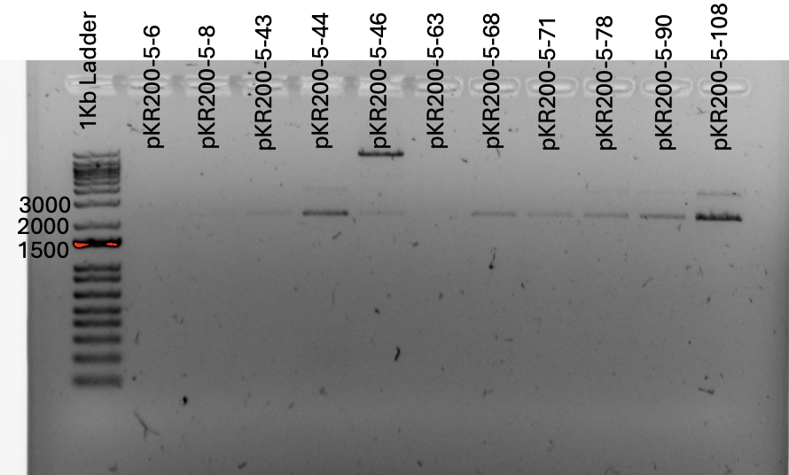

Figure. In this picture, we have gel rig #1 which contains the samples 15-22 plus the samples 23-25. I can observe 4 possible mutants, pKR200-5-68, pKR200-5-71, pKR200-5-43, and pKR200-5-8. These samples have 1 band at 2212 bp possibly indicating these are mutants. The other samples have very faint two bands which indicate that those samples are primary integrant.

Thursday, June 13, 2024
To Do:
- Conduct Freshwater Survival Assay
- Maybe make more CHAH plates!!!
- Make more CHA Mix powder

Check ongoing Survival Assay Day 67

- Retrieve 6 flasks from 4-degree Celsius fridge
- Use 12 CHAH plates to plate the samples
- For LVS flask 1, aseptically plate 100 uL onto the round CHAH plates, use glass beads to spread the cells.
- Repeat step 3 for LVS Flasks 2 & 3
- For mutant flask 4, aseptically plate 300 ul onto the round CHAH plates, use glass beads to spread the cells
- Repeat step 5 for mutant Flasks 5 & 6
- Incubate for 3-4 days in 37 degrees Celsius

Making CHA Powder Mix
Combine the following components, making sure to break up any clumps prior to adding to the container:
75 g Beef Heart Infusion
75 g Protease Peptone
75 g Glucose
7.5 g L-Cystine
112.5 g Agar
37.5 g NaCl
Put in recycled BD container, shake well to mix, and update tape with date made.

Friday, June 14, 2024
To Do:
- Create babysitting calendar/instructions for next week
- Send KMR payroll sheet in morning
- Pick colonies from single streaks and patch on plates
- Do test PCR of pKR224 with primers 707 and 708
- If time, do 3rd shock assay
- Receiving primers protocol for primer 707 and 708

Reaction Table for Test PCR

Reaction numbers | Sample | Expected size
1 | LVS gDNA + primers 707&708 | ~3500
2 | LVS gDNA + primers 6 & 7 | ~3500
3 | H2O + primers 707 & 708 | -

Master Mix Table for Test PCR
Total reaction volume | 20
Total number of reactions | 3
 |  |  |  | Factor
Component | Stock concentration | Final concentration | 1 rxn volume | 4
ddiH2O |  |  | 10.8 | 43.2
PrimeSTAR GXL Buffer | 5x | 1x | 4.0 | 16
dNTPs | 2.5 mM | 0.2 mM | 1.6 | 6.4
oligo F | 10 uM | 0.3 uM | 0.6 | 2.4
oligo R | 10 uM | 0.3 uM | 0.6 | 2.4
template | 100 ng/ul | 2 ng/ul | 2.0
PrimeSTAR GXL DNA Polymerase | 1.25 U/ul | 0.025 U/ul | 0.4 | 1.6
 |  | Total volume | 20 | 72

Receiving Primers Protocol
By: Hannah Trautmann

- Spin primers at maximum speed in tabletop centrifuge for 3 minutes so dessicated primers go to the bottom of the tube.
- Add 0.1x EB to a final concentration of 100 uM. Calculate this by multiplying the reported nm by 10 and adding that volume in ul (i.e. 12.7 nmoles = add 127 uL of 0.1xEB).
- Put on 42°C heat block for 5 minutes to help primers dissolve
- Vortex and brief spin.
- Label tubes with KROL numbers on the top and put in the appropriate 100 uM stock box in the -20°C freezer.
- Optional: Make dilution for intended purpose of primer.
  - If a PCR primer, make a 10 uM stock by diluting 20 uL of the 100 uM stock into 180 uL of 0.1xEB. Label with purple sticker and put in appropriate freezer box.
  - If a sequencing primer, make a 2.5 uM stock by diluting 5 uL of the 100 uM stock into 195 uL of 0.1x EB. Label with blue sticker and put in appropriate freezer box.
- Put Certificate of Analysis sheet in “Oligos Spec Sheet” binder and shipping sheet in Invoices box.

Observation of Shock Assay Plates
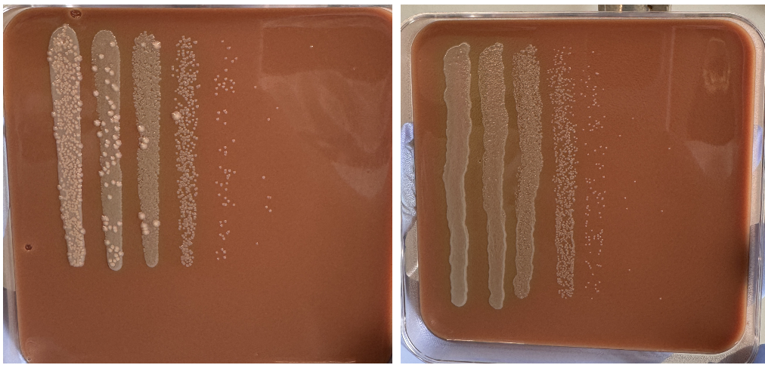

Image. On the left is a plate that has cells from Flask 4 (KRLVS 274) and on the right is a plate that has cells from Flask 1 (LVS). The very pink colonies are growing on top of F. tularensis and are very robust. This type of contamination was seen on all mutant plates including plates from the shock assay from 6/6/2024. This type of contamination was not seen on any of the LVS plates.

Setting up to run practice gel
- Grab the 3 PCR strip tubes from the thermocycler
- Set up agarose gel rig (used the small yellow one, yellow rig bc there is less volume).
- Load 6 uL of Sybersafe (mix with column) Pour agarose gel into rig after cools. And let sit until solidified.
- Load 10 ul of 1Kb ladder dye into ladder
- Mix 5 uL of loading dye into the each 20 uL PCR colony strip tube. Using the multichannel, to load the dye into PCR strip tubes.
- Load PCR strips tubes into each well about 20 uL
- Run to red when connecting power pack to casting tray. Covered tray with aluminum foil so Sybersafe does not degrade under light.

Gel of Test PCR of Primers 707 & 708

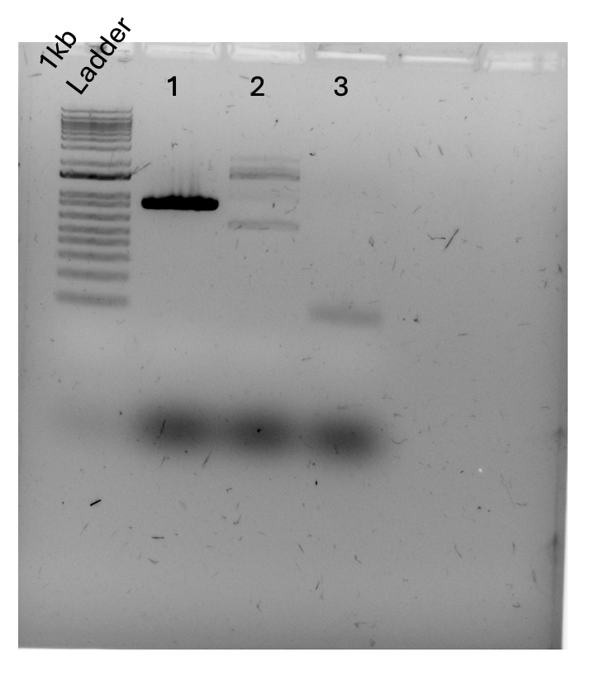

Monday, June 17 - Friday, June 21, 2024

Babysitting Instructions:

Counting Day 67 Freshwater Survival Plates (Ben)
- Take plates out of incubator. These plates were plated on Thursday, 6/13. And will be incubating for 3-4 days.
- Using the clicker, count the number of colonies on each plate.
- Record the number of colonies on a table for the designated plate. Plates 1-3 are LVS and plates 4-6 are Mutant. When I come back, I will organize the data in the excel sheet
Observing Patch Plates that were picked from Single Colony
- KMR will observe plates which were plated on Friday, 6/14
“Contamination Plates”
- KMR will also observe these plates that were plated on Friday, 6/14
- Check lab notebook date 6/14 for pictures of the contamination saw on previous shock assay to see if contamination is similar to these plates.

Thursday, June 20, 2024
To Do:
- Prepare CHAH + 10% Sucrose Plates for Sucrose Selection w/ Kira’s PI and my PI
- Possible PCR larger volume?
- Update colony count from Ben’s time counting the plates

PCR for Making pKR224
Master Mix Table
Total reaction volume | 100
Total number of reactions | 2
 |  |  |  | Factor
Component | Stock concentration | Final concentration | 1 rxn volume | 3
ddiH2O |  |  | 62.0 | 186
PrimeSTAR GXL Buffer | 5x | 1x | 20.0 | 60
dNTPs | 2.5 mM | 0.2 mM | 8.0 | 24
oligo F | 10 uM | 0.3 uM | 3.0 | 9
oligo R | 10 uM | 0.3 uM | 3.0 | 9
template | 100 ng/ul | 2 ng/ul | 2.0
PrimeSTAR GXL DNA Polymerase | 1.25 U/ul | 0.025 U/ul | 2.0 | 6
 |  | Total volume | 100 | 294

Sample ID for PCR
Reaction numbers | Sample | Expected size
1 | LVS gDNA + primers 707&708 | ~886
2 | H2O+ primers 707 & 708 | -

Notes: this was an STN1 reaction, and the extension time was 1 minute since we have a product size of 886 base pairs

Monday, June 24, 2024
To Do:
- Patch out my PI and Kira’s PI for sucrose selection
- Conduct PCR purification
- Run PCR purification on gel
- Conduct DNA digests to make pKR224
- Prepare CHAH square plates
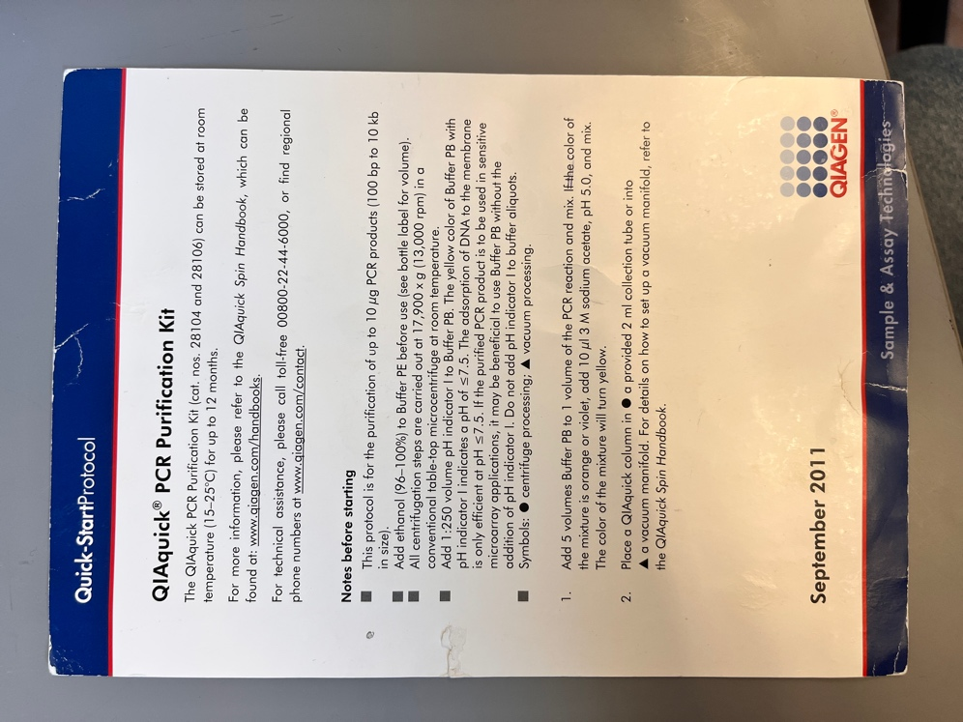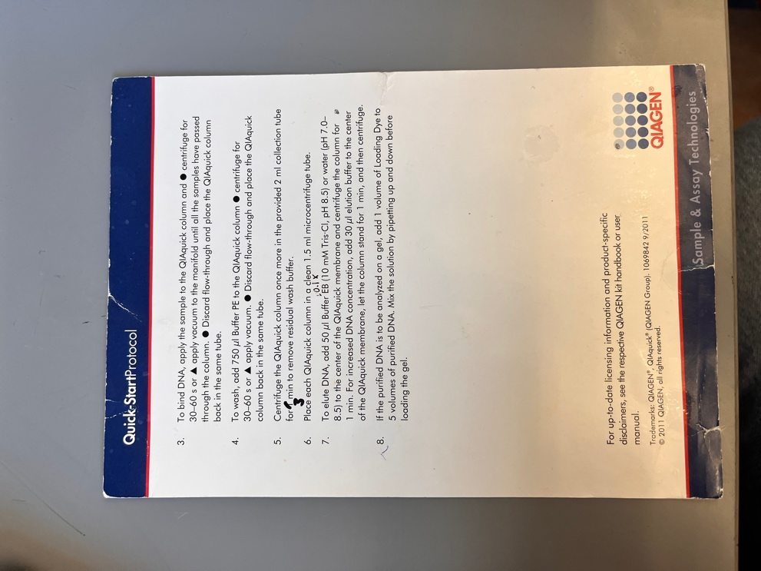

Amount of Buffer PB | Amount of Buffer PE | Amount of Buffer EB 0.1x | Amount of PCR product
500 uL | 750 uL | 50 uL | 100 uL 2

DNA Digests
- Make a reaction table with desired digests:
Tube | DNA | Enzyme(s) | DNA Volume (uL) | H₂O Volume (uL)
1 | Purified PCR | KpnI, EcoRI | 15 | -
2 | Backbone (pKR2) | KpnI, EcoRI | 5 | 10

- Set up master mix table:
Components | Volumes in 1 reaction (uL) | Volumes in Master Mix 3x (uL)
H₂O | 10.8 | 32.4
10x Buffer* | 3.0 | 9.0
DNA | (15.0) | -
Enzyme 1 | 0.6 | 1.8
Enzyme 2 | 0.6 | 1.8
Total | 30.0 (15.0 actual b/c of DNA)
*Cutsmart Buffer is used for all the “HF” enzymes. Check the NEB website for buffer compatibility with non-HF restriction enzymes.

- Add indicated amounts of H₂O and 10x buffer to master mix tube (MM).
- Add indicated amount of DNA or DNA+water (for backbone tubes) to individual tubes for digest (1.5 mL microfuge tubes for digests in incubator, PCR strip tubes for reactions incubated in the thermocycler).
- Add indicated amount of each enzyme (1.8 uL) to the master mix tube (MM).
- Mix the master mix by pipetting up and down.
- Add master mix to individual tubes. Volume to add to each tube is the volume in 1 reaction minus the DNA volume (15 ul).
- Incubate at 37°C for 1 hour or up to overnight.
- If using digest for plasmid construction then after incubation at 37°C, add 0.5ul of CIP enzyme to backbone tube, mix by pipetting and put back in 37°C incubator for 10 minutes. (this step removes the phosphates from the ends of the plasmid to prevent re-ligation). If using the new Quick CIP – add 1 uL (only to backbone), mix, incubate for 10 mins, then put at 80C for 2 minutes to inactivate the CIP.

Setting up to run gel
- Grab the 2 PCR strip tubs
- Set up agarose gel rig (used the small yellow one, yellow rig bc there is less volume).
- Load 6 uL of Sybersafe (mix with column) Pour agarose gel into rig after cools. And let sit until solidified.
- Load 10 ul of 1Kb ladder dye into ladder
- Mix 5 uL of loading dye into the each 5 uL PCR colony strip tube.
- Load PCR strips tubes into each well about 10 uL
Run to red when connecting power pack to casting tray. Covered tray with aluminum foil so Sybersafe does not degrade under light

Tuesday, June 25, 2024
To Do:
- Conduct sucrose selection on my PI and KB’s PI
- Possible Shock Assay
- Run digest on gel
- Conduct gel extraction and purification

Setting up to run gel
- Thawed FR1, FR2 and Backbone
- Set up agarose gel rig (used the larger, green rig bc there is more volume).
- Load 11 uL of Sybersafe (mix with column) Pour agarose gel into rig after cools. And let sit until solidified.
- Load 10 ul of 1Kb ladder dye into ladder
- Mix 6 uL of loading dye into the tube of 30 uL of FR1. Spin and vortex sample. Repeat for FR2 and backbone.
- Load FR1 after empty lane. Leave a lane empty next to FR1. Then load FR2 into lane next to empty lane. Repeat for backbone.
- Run to red when connecting power pack to casting tray. Covered tray with aluminum foil so Sybersafe does not degrade under light.

Gel Extraction & Purification Protocol
- Excise DNA fragment from agarose gel with clean, sharp scalpel
- Weigh the gel slice in a colorless tube. Add 3 volumes Buffer QG to 1 volume gel.
- Incubate at 42 C for less for 10 mins or until gel has fully dissolved. Vortex the tube every 2-3 min to help dissolve gel
- Add 1 gel volume isopropanol to the sample and mix
- Place a QIAquick spin column in a provided 2 ml collection tube into a vaccum manifold. To bind DNA, apply the sample to the QIAquick column and centrifuge for 1 min or apply to vaccum manifold. Discard and place QIAquick back into same tube
- Add 500 uL Buffer QG to column and centrifuge for 1 minute. Discard Waste
- To wash, add 750 uL Buffer PE to QIAquick column and centrifuge for 1 min. Discard flow-through and place QIAquick column back into same tube.
- Place QIAquick column into a clean 1.5 ml microcentrifuge tube
- To elute DNA add 30 uL of Buffer 0.1x EB (because of increase of DNA concentration) to center of QIAquick membrane. Let column stand for 1 min and then centrifuge for 1 min.

Table for gel purification
 | Gel Weight (mg) | Buffer QG (uL) | Isopropanol (uL)
FR1
PKR12 Backbone

Selecting Cross-outs for Sucrose Selection

Kanamycin-resistant cells should be 1° integrants. Make stocks of up to 4 potential 1° integrants, but only move forward with identifying cross-outs from two 1° integrants per strain
To select for cross-outs using sucrose selection
1. Scrape up small loop of cells and resuspend in 1X PBS
2. Dilute culture 1:10 in sterile PBS to 1x10⁻⁷
3. Perform first dilution 1:100 so first dilution tube is 1x10⁻², adding 10 uL of resuspended cells to 990 ul 1x PBS
4. Perform subsequent dilutions 1:10, diluting 25 uL cells into 225 uL 1X PBS
-Plate 100 uL of last dilution (1x10⁻⁷) onto CHAH plates.
-Plate 100 μL of each dilution 10⁻² – 10⁻⁷ on CHAH + 10% sucrose plates. If you have extra sucrose plates, can plate some or all dilutions twice.
5. Incubate plates at 37°C for 3-4 days, or until single colonies appear. It is generally a good idea to test both large and smaller single colonies. Note that there should be many more colonies on the CHAH plate with the 1x10⁻⁷ dilution than on the sucrose plate with the corresponding dilution. If there seem to be similar numbers of colonies, the 1° integrant may have an inactivating mutation in sacB and is not worth keeping.

Wednesday, June 26, 2024
To Do:
- Perform Ligation of digested DNA

Gel Extraction & Purification Protocol
- Excise DNA fragment from agarose gel with clean, sharp scalpel
- Weigh the gel slice in a colorless tube. Add 3 volumes Buffer QG to 1 volume gel.
- Incubate at 42 C for less for 10 mins or until gel has fully dissolved. Vortex the tube every 2-3 min to help dissolve gel
- Add 1 gel volume isopropanol to the sample and mix
- Place a QIAquick spin column in a provided 2 ml collection tube into a vaccum manifold. To bind DNA, apply the sample to the QIAquick column and centrifuge for 1 min or apply to vaccum manifold. Discard and place QIAquick back into same tube
- Add 500 uL Buffer QG to column and centrifuge for 1 minute. Discard Waste
- To wash, add 750 uL Buffer PE to QIAquick column and centrifuge for 1 min. Discard flow-through and place QIAquick column back into same tube.
- Place QIAquick column into a clean 1.5 ml microcentrifuge tube
- To elute DNA add 30 uL of Buffer 0.1x EB (because of increase of DNA concentration) to center of QIAquick membrane. Let column stand for 1 min and then centrifuge for 1 min.

Table for gel purification
 | Gel Weight (mg) | Buffer QG (uL) | Isopropanol (uL)
FR1 | 270 mg | 810 | 270
PKR12 Backbone | 480 mg | 1440 | 480

Thursday, June 27, 2024
To Do:
- Perform Ligation of digested DNA
- Nanodrop DNA after purification
- Transformation of ligation

Ligation of digested DNA
- Thaw FR1, FR2 and PKR12 backbone on ice. Also thaw 10x Buffer Ligase.
- Label 2 PCR tubes. One PCR tube will have FR1, backbone, H2O, buffer ligase and ligase. The other PCR tube will have just backbone, H2O, buffer ligase and ligase because it is the control.
- Load components into each PCR tube. (Do not add ligase just yet!)
- Once you load components, vortex & spin PCR tubes with just buffer, H2O, fragments and backbone.
- Add calculated enzyme ligase into each PCR tube
- Place into thermocycler overnight at 16 C
Master Mix for Ligaton
 | Number of samples | 2
 | Master mix factor | 3
Components | Volumes in 1 reaction (uL) | Volumes in Master Mix (uL)
H₂O | 11.5 | 34.5
10x ligase buffer | 2.0 | 6
Insert | 4.0
Backbone | 2.0 | 6
Ligase | 0.5 | 1.5
Total | 20 | 48

Transformation of PKR200
- Set up reaction table. Always include a positive and negative control for each antibiotic. If transforming plasmids (from previous plasmid prep), use 0.5 – 1 uL of plasmid. If transforming ligations, use 8 uL per ligation. If transforming plasmid, plate 20 uL and 100 uL. If transforming a ligation, plate 100 uL and remaining culture.
  - Note: The plasmid used for the positive control plates should be the regular circular plasmid, not the digest/purified one.
  - There should always be a backbone control if testing a ligation. This is the digested and ligated backbone with NO INSERT.
- Check to be sure you have enough LB-Kan plates with appropriate antibiotic. If plates were stored at 4°C, warm at 37°C until needed.
- Obtain DNA and thaw on ice if necessary.
- Thaw appropriate number of competent cell tubes on ice (5 reactions per tube of competent cells)
- Label sterile tubes as indicated in reaction table. Add indicated volume of indicated DNA on ice.
- When competent cells are thawed (check by probing for frozen cells using a sterile pipette tip), gently pipette 100 uL of cells into each reaction tube directly onto DNA using aseptic technique.
- Incubate cells on ice for 20 minutes. During incubation, find or set heat block to 42°C.
- Place tubes with cells and DNA onto 42°C heat block for 30 seconds (heat shock step).
- After heat shock, place tubes back on ice until next step (don’t keep them here too long).
- Using aseptic technique, add 1 mL LB (1000 uL) (no antibiotic) to each microfuge tube.
- Using autoclave tape, tape microfuge tubes down in shaking incubator set to 37°C.
- Allow cells to recover for 1 hour at 37°C, shaking. Place in a rack after shaking (NOT back on ice).
- Using aseptic technique, plate indicated amount of cells on appropriate antibiotic plates (LB-Kan), spreading until plates look dry. For “remaining” volume, spin tubes at max speed in benchtop centrifuge for 30 seconds. Remove 800 uL of media. Using 200 uL pipette, resuspend cells at bottom of tube and plate all the remaining culture.
Tube number | Purpose | DNA | Volume of DNA | Final volume to plate | Number of kanamycin-containing plates
1 | (+) control | pKR2 | 1 uL | 100 ul | 1
2 | (-) control | None | 0 | 100 ul | 1
3 | Backbone Ligation | pKR2(digested) | 8 uL | 20 uL, 200 uL | 2
4 | Ligation | pKR224 | 8 uL | 20uL, 200 uL | 2
Total number of plates |  |  |  |  | 6

Friday, June 28, 2024
To Do:
- Check colonies from Transformation plates 6/27
- Check selectivity on sucrose plates, if selective, patch on to CHAH-Kan and CHAH
- Take shock assay plates out
- Check plates of patched out PBS, LVS and KRLVS 274
- Make CHAH plates
Notes on Sucrose Plates:
There was no selectivity on JR sucrose plates. The growth on the 10 ⁻⁷ sucrose plates had small colonies and were light while KB’s ¹⁰⁻⁷ sucrose plates had no growth but clear, robust growth on CHAH only plates, indicting the sucrose plates were selective for her primary integrant. KMR told me to not continue forth with this specific task.

Notes on Shock Assay and Possible Contamination Aliquots:
There was again contamination of the shock assay plates, so I patched out sterile PBS on CHAH, as well as the LVS and KRLVS 274 aliquots. There was no contamination growth on these plates, and the labeled aliquots did not look like my labeled aliquots, so perhaps my aliquots were contaminated.

Monday, July 1, 2024
To Do:
- Check colonies from Transformation plates 6/27
- Prepare overnight cultures
- Start PCR to make two plasmids
- Work on lab presentation

Overnight Cultures

- Add 45 mL of LB broth to a sterile 50 mL conical (makes enough for 8 tubes: 9*5=45)
- Add 45 uL of kanamycin (Kan50) to the conical.
- Label 4 glass sterile test tubes for each new plasmid and 2 for each existing plasmid (controls are not needed).
- Pipette out 5 mL of LB + Kan media into each of the tubes.
- Pick 4 colonies from each reaction and inoculate the tube.
  - Do this by using a stick and picking an isolated colony from plate
- Place in the 37º shaking incubator overnight. ~16-22 hours

Glycerol Stocks for KRLVS 274
For single use stocks: follow steps 2 - 5 but instead of step 6, pipet 50 – 100 ul of cells to sterile labeled microfuge tubes. Note that if you don’t have many cells, you can reduce the volume of MHB and glycerol (keep the same ratio, with a final concentration of glycerol of 15%. E.g. 800 uL MHB and 200 uL 75% glycerol).

- Make 4 cryovials for each strain (permanent stocks), label!
- (add specific strain info here!)
- Prepare 3.2 mL of MHB in a 50mL conical (adjust if you are also making single use stocks)
- Take at least half of a thickly spread plate and add cells to the MHB tube
- Resuspend until there are no clumps in the MHB
- Add 800 ul MHB into each cryovial
- Add 200 ul of 75% glycerol to the 3.2 mL mix by pipetting
- Aliquot 1mL per cryovial, freeze at -80

PCR for Making pKR202
Reaction numbers | Sample | Expected size
1 | LVS gDNA + primers 668 & 669 | ~489
2 | H2O+ primers 668 & 669 | -
Total reaction volume | 100
Total number of reactions | 2
 |  |  |  | Factor
Component | Stock concentration | Final concentration | 1 rxn volume | 3
ddiH2O |  |  | 62.0 | 186
PrimeSTAR GXL Buffer | 5x | 1x | 20.0 | 60
dNTPs | 2.5 mM | 0.2 mM | 8.0 | 24
oligo F | 10 uM | 0.3 uM | 3.0 | 9
oligo R | 10 uM | 0.3 uM | 3.0 | 9
template | 100 ng/ul | 2 ng/ul | 2.0
PrimeSTAR GXL DNA Polymerase | 1.25 U/ul | 0.025 U/ul | 2.0 | 6
 |  | Total volume | 100 | 294

PCR for Making pKR203
Reaction numbers | Sample | Expected size
1 | LVS gDNA + primers 670 & 671 | ~1371
2 | H2O+ primers 670 & 671 | -
Total reaction volume | 100
Total number of reactions | 2
 |  |  |  | Factor
Component | Stock concentration | Final concentration | 1 rxn volume | 3
ddiH2O |  |  | 62.0 | 186
PrimeSTAR GXL Buffer | 5x | 1x | 20.0 | 60
dNTPs | 2.5 mM | 0.2 mM | 8.0 | 24
oligo F | 10 uM | 0.3 uM | 3.0 | 9
oligo R | 10 uM | 0.3 uM | 3.0 | 9
template | 100 ng/ul | 2 ng/ul | 2.0
PrimeSTAR GXL DNA Polymerase | 1.25 U/ul | 0.025 U/ul | 2.0 | 6
 |  | Total volume | 100 | 294

Tuesday, July 2, 2024
To Do:
- KMR Meet
- Miniprep of overnight cultures
- Make more square CHAH plates?
- Prep minipreps for sequencing

Miniprep Protocol

- Pellet 1-5 ml bacterial overnight culture by centrifugation at >8000 rpm for 3 min room temp
- Resuspend pelleted bacterial cells in 250 ul Buffer P1 and transfer to microcentrifuge tube (from fridge)
- Add 250 ul Buffer P2 and mix thoroughly by inverting tube 4-6 times until solution becomes clear. Do not allow lysis reaction to proceed for more than 5 min.
- Add 350 ul Buffer N3 and mix immediately and thoroughly by inverting the tube 4-6 times
- Centrifuge for 10 min at 13000 rpm
- Apply 800 ul supernatant from step 5 to the QIAprep 2.0 spin column by pipetting. Centrifuge for 30-60s and discard the flow through
- Recommended: Wash the QIAprep 2.0 spin column by adding 0.5 ml Buffer PB. Centrifuge for 30-60s and discard flow through
- Wash QIAprep 2.0 spin column by adding 0.75 ml Buffer PE. Centrifuge for 30-60s and discard flow through (do 3 times?) Transfer QIAprep 2.0 spin column to collection tube
- Centrifuge 3 min to remove residual wash buffer
- Place QIAprep 2.0 column in a clean 1.5 ml microcentrifuge tube. To elute DNA, add 50 ul Buffer 0.1x EB, let stand for 1 minute and centrifuge for 1 min.
- If extracted DNA is to be analyzed on a gel, add 1 volume of loading dye to 5 ul volumes of purified DNA. Mix the solution by pipetting up and down before loading

Tuesday, July 7, 2024
To Do:
- Finish abstract editing
- Resuspend KROL Primers

Receiving Primers Protocol
By: Hannah Trautmann

- Spin primers at maximum speed in tabletop centrifuge for 3 minutes so dessicated primers go to the bottom of the tube.
- Add 0.1x EB to a final concentration of 100 uM. Calculate this by multiplying the reported nm by 10 and adding that volume in ul (i.e. 12.7 nmoles = add 127 uL of 0.1xEB).
- Put on 42°C heat block for 5 minutes to help primers dissolve
- Vortex and brief spin.
- Label tubes with KROL numbers on the top and put in the appropriate 100 uM stock box in the -20°C freezer.
- Optional: Make dilution for intended purpose of primer.
  - If a PCR primer, make a 10 uM stock by diluting 20 uL of the 100 uM stock into 180 uL of 0.1xEB. Label with purple sticker and put in appropriate freezer box.
  - If a sequencing primer, make a 2.5 uM stock by diluting 5 uL of the 100 uM stock into 195 uL of 0.1x EB. Label with blue sticker and put in appropriate freezer box.
- Put Certificate of Analysis sheet in “Oligos Spec Sheet” binder and shipping sheet in Invoices box.

Thursday, July 7, 2024
To Do:
- PCR of complement strains
- LVS glycerol stocks
- PCR purification of complement strains
- Work on Personal Statement

Making pKR202
Total reaction volume | 100
Total number of reactions | 2
 |  |  |  | Factor
Component | Stock concentration | Final concentration | 1 rxn volume | 3
ddiH2O |  |  | 62.0 | 186
PrimeSTAR GXL Buffer | 5x | 1x | 20.0 | 60
dNTPs | 2.5 mM | 0.2 mM | 8.0 | 24
oligo F | 10 uM | 0.3 uM | 3.0 | 9
oligo R | 10 uM | 0.3 uM | 3.0 | 9
template | 100 ng/ul | 2 ng/ul | 2.0
PrimeSTAR GXL DNA Polymerase | 1.25 U/ul | 0.025 U/ul | 2.0 | 6
 |  | Total volume | 100 | 294

Reaction numbers | Sample | Expected size
1 | LVS gDNA + primers 668 & 721 | ~498
2 | H2O+ primers 668 & 721 | -

Making pKR203
Total reaction volume | 100
Total number of reactions | 2
 |  |  |  | Factor
Component | Stock concentration | Final concentration | 1 rxn volume | 3
ddiH2O |  |  | 62.0 | 186
PrimeSTAR GXL Buffer | 5x | 1x | 20.0 | 60
dNTPs | 2.5 mM | 0.2 mM | 8.0 | 24
oligo F | 10 uM | 0.3 uM | 3.0 | 9
oligo R | 10 uM | 0.3 uM | 3.0 | 9
template | 100 ng/ul | 2 ng/ul | 2.0
PrimeSTAR GXL DNA Polymerase | 1.25 U/ul | 0.025 U/ul | 2.0 | 6
 |  | Total volume | 100 | 294

Reaction numbers | Sample | Expected size
1 | LVS gDNA + primers 671 & 722 | ~1371
2 | H2O+ primers 671 & 722 | -

Monday, July 15, 2024
To Do:
- Perform digest
- Run gel
- Gel purification of complement plasmids
- Send minipreps to sequencing
- Count colonies of shock assay

DNA Digests
- Make a reaction table with desired digests:

pKR 202
Tube | DNA | Enzyme(s) | DNA Volume (uL) | H₂O Volume (uL)
1 | Purified PCR | Ndel, BamHI | 15 | -
2 | Backbone (pKR14) | Ndel, BamHI | 5 | 10

pKR203
Tube | DNA | Enzyme(s) | DNA Volume (uL) | H₂O Volume (uL)
1 | Purified PCR | Ndel, BamHI | 15 | -
2 | Backbone (pKR14) | Ndel, BamHI | 5 | 10

- Set up master mix table:
Components | Volumes in 1 reaction (uL) | Volumes in Master Mix 3x (uL)
H₂O | 10.8 | 32.4
10x Buffer* | 3.0 | 9.0
DNA | (15.0) | -
Enzyme 1 | 0.6 | 1.8
Enzyme 2 | 0.6 | 1.8
Total | 30.0 (15.0 actual b/c of DNA)
*Cutsmart Buffer is used for all the “HF” enzymes. Check the NEB website for buffer compatibility with non-HF restriction enzymes.

- Add indicated amounts of H₂O and 10x buffer to master mix tube (MM).
- Add indicated amount of DNA or DNA+water (for backbone tubes) to individual tubes for digest (1.5 mL microfuge tubes for digests in incubator, PCR strip tubes for reactions incubated in the thermocycler).
- Add indicated amount of each enzyme (1.8 uL) to the master mix tube (MM).
- Mix the master mix by pipetting up and down.
- Add master mix to individual tubes. Volume to add to each tube is the volume in 1 reaction minus the DNA volume (15 ul).
- Incubate at 37°C for 1 hour or up to overnight.
- If using digest for plasmid construction then after incubation at 37°C, add 0.5ul of CIP enzyme to backbone tube, mix by pipetting and put back in 37°C incubator for 10 minutes. (this step removes the phosphates from the ends of the plasmid to prevent re-ligation). If using the new Quick CIP – add 1 uL (only to backbone), mix, incubate for 10 mins, then put at 80C for 2 minutes to inactivate the CIP.

Making LB-Amp plates
Pouring plates
- Add antibiotic using aseptic technique if necessary. Typical antibiotic concentrations:
Antibiotic | Stock Concentration | Working Concentration (Concentration in plates)
Ampicillin | 100 mg/mL | 100 µg/mL
Carbenicillin | 100 mg/mL | 100 µg/mL
Kanamycin | 50 mg/mL | 50 µg/mL
- Keep antibiotic stocks on ice. For kanamycin, add 500 uL to 500 mL of LB-agar media. Stir on stirplate to mix media.
- Open a new sleeve of sterile plates. Don’t open plates unless next to flame.
- Next to flame, open foil top of flask. Pass flask opening through flame.
- Open a plate next to flame and pour ~20-25 mL LB-agar into plate; the bottom of the plate should be covered in media.
- Continue to pour media into plates until media is gone.
- Immediately rinse out flask
- Stack plates and mark the side to indicate which antibiotic is used. (blue = kanamycin, black = carbenicillin / ampicillin).
- Let plates sit at room temperature for one night, then store at 4°C with tape indicating date poured. Don’t use antibiotic plates older than 3 months.

Setting up to run gel
- Grab the 2 PCR strip tubs
- Set up agarose gel rig (used the small yellow one, yellow rig bc there is less volume).
- Load 6 uL of Sybersafe (mix with column) Pour agarose gel into rig after cools. And let sit until solidified.
- Load 10 ul of 1Kb ladder dye into ladder
- Mix 5 uL of loading dye into the each 5 uL PCR colony strip tube.
- Load PCR strips tubes into each well about 10 uL
Tuesday, July 15, 2024
To Do:
- Gel purification of complement plasmids
- Make CHAH square plates

Gel Extraction & Purification Protocol
- Excise DNA fragment from agarose gel with clean, sharp scalpel
- Weigh the gel slice in a colorless tube. Add 3 volumes Buffer QG to 1 volume gel.
- Incubate at 42 C for less for 10 mins or until gel has fully dissolved. Vortex the tube every 2-3 min to help dissolve gel
- Add 1 gel volume isopropanol to the sample and mix
- Place a QIAquick spin column in a provided 2 ml collection tube into a vaccum manifold. To bind DNA, apply the sample to the QIAquick column and centrifuge for 1 min or apply to vaccum manifold. Discard and place QIAquick back into same tube
- Add 500 uL Buffer QG to column and centrifuge for 1 minute. Discard Waste
- To wash, add 750 uL Buffer PE to QIAquick column and centrifuge for 1 min. Discard flow-through and place QIAquick column back into same tube.
- Place QIAquick column into a clean 1.5 ml microcentrifuge tube
- To elute DNA add 30 uL of Buffer 0.1x EB (because of increase of DNA concentration) to center of QIAquick membrane. Let column stand for 1 min and then centrifuge for 1 min.

Wednesday, July 17, 2024
To Do:
- Ligation of complement plasmids
- Transformation of E. coli
- Review sequencing results of pKR224
- Count colonies of shock assay

Sequencing Results for pKR224
I had 4 minipreps for which I did 8 sequencing reactions. Miniprep 1 was JR1 & JR2, Miniprep 2 was JR3 and JR4, Miniprep 3 was JR5 and JR6, and Miniprep 4 was JR7 and JR 8. When BM and I reviewed the sequencing results, it was found that JR1 and JR5 had low quality sequencing results so Miniprep 1 and 3 were disregarded. However, Miniprep 2 had the best quality and did align with the sequencing data on pKR224 that was designed by KMR. I will be moving forward with Miniprep 2, this sample will be electroporated into LVS next week.

Ligation of digested DNA
- Thaw FR1 of pKR202 and PKR14 backbone for 202, FR1 of pKR203 and pKR14 backbone for 203 ice. Also thaw 10x Buffer Ligase.
- Label 4 PCR tubes. Two PCR tubes will have FR’s, backbone, H2O, buffer ligase and ligase. The other two PCR tubes will have just backbone, H2O, buffer ligase and ligase because it is the control.
- Load components into each PCR tube. (Do not add ligase just yet!)
- Once you load components, vortex & spin PCR tubes with just buffer, H2O, fragments and backbone.
- Add calculated enzyme ligase into each PCR tube
- Place into thermocycler overnight at 16. Can do at room temp for 10 minutes if necessary.

Sample ID for pKR202
Tube | Insert | Backbone
1 | BamHI, NdeI digested, purified PCR | BamHI, NdeI digested, purified pK14
2 | - | BamHI, NdeI digested, purified pKR14

Component | Reaction 1 (uL) | Reaction 2 (uL) | Master Mix (3x)
H₂O | 11.5 | 11.5 | 34.5
10x ligase buffer | 2.0 | 2.0 | 6
Insert | 4.0 | - | -
Backbone | 2.0 | 2.0 | 6
Ligase | 0.5 | 0.5 | 1.5
TOTAL | 20.0 | 20.0 | 48

Sample ID for pKR203
Tube | Insert | Backbone
1 | BamHI, NdeI digested, purified PCR | BamHI, NdeI digested, purified pK14
2 | - | BamHI, NdeI digested, purified pKR14

Component | Reaction 1 (uL) | Reaction 2 (uL) | Master Mix (3x)
H₂O | 11.5 | 11.5 | 34.5
10x ligase buffer | 2.0 | 2.0 | 6
Insert | 4.0 | - | -
Backbone | 2.0 | 2.0 | 6
Ligase | 0.5 | 0.5 | 1.5
TOTAL | 20.0 | 20.0 | 48

Transformation into E. coli
Reaction table for pKR202
Tube number | Purpose | DNA | Volume of DNA | Final volume to plate | Number of kanamycin-containing plates
1 | (+) control | pKR14 | 1 uL | 100 ul | 1
2 | (-) control | None | 0 | 100 ul | 1
3 | Backbone Ligation | pKR14(digested) | 8 uL | 20 uL, 200 uL | 2
4 | Ligation | pKR202 | 8 uL | 20uL, 200 uL | 2
Total number of plates |  |  |  |  | 6

Reaction table for pKR203
Tube number | Purpose | DNA | Volume of DNA | Final volume to plate | Number of kanamycin-containing plates
1 | (+) control | pKR14 | 1 uL | 100 ul | 1
2 | (-) control | None | 0 | 100 ul | 1
3 | Backbone Ligation | pKR14(digested) | 8 uL | 20 uL, 200 uL | 2
4 | Ligation | pKR203 | 8 uL | 20uL, 200 uL | 2
Total number of plates |  |  |  |  | 6

- Check to be sure you have enough LB-Kan plates with appropriate antibiotic. If plates were stored at 4°C, warm at 37°C until needed.
- Obtain DNA and thaw on ice if necessary.
- Thaw appropriate number of competent cell tubes on ice (5 reactions per tube of competent cells)
- Label sterile tubes as indicated in reaction table. Add indicated volume of indicated DNA on ice.
- When competent cells are thawed (check by probing for frozen cells using a sterile pipette tip), gently pipette 100 uL of cells into each reaction tube directly onto DNA using aseptic technique.
- Incubate cells on ice for 20 minutes. During incubation, find or set heat block to 42°C.
- Place tubes with cells and DNA onto 42°C heat block for 30 seconds (heat shock step).
- After heat shock, place tubes back on ice until next step (don’t keep them here too long).
- Using aseptic technique, add 1 mL LB (1000 uL) (no antibiotic) to each microfuge tube.
- Using autoclave tape, tape microfuge tubes down in shaking incubator set to 37°C.
- Allow cells to recover for 1 hour at 37°C, shaking. Place in a rack after shaking (NOT back on ice).
- Using aseptic technique, plate indicated amount of cells on appropriate antibiotic plates (LB-Kan), spreading until plates look dry. For “remaining” volume, spin tubes at max speed in benchtop centrifuge for 30 seconds. Remove 800 uL of media. Using 200 uL pipette, resuspend cells at bottom of tube and plate all the remaining culture.

Friday, July 19, 2024
To Do:
- Transformation of E. coli

Transformation into E. coli
Reaction table for pKR202
Tube number | Purpose | DNA | Volume of DNA | Final volume to plate | Number of kanamycin-containing plates
1 | (+) control | pKR14 | 1 uL | 20 ul | 1
2 | (-) control | None | 0 | Whole volume | 1
3 | Backbone Ligation | pKR14(digested) | 12 uL | 200 uL, remaining | 2
4 | Ligation | pKR202 | 12 uL | 200 uL, remaining | 2
Total number of plates |  |  |  |  | 6

Reaction table for pKR203
Tube number | Purpose | DNA | Volume of DNA | Final volume to plate | Number of kanamycin-containing plates
1 | (+) control | pKR14 | 1 uL | 20 ul | 1
2 | (-) control | None | 0 | Whole Volume | 1
3 | Backbone Ligation | pKR14(digested) | 12 uL | 200 uL, remaining | 2
4 | Ligation | pKR203 | 12 uL | 200 uL, remaining | 2
Total number of plates |  |  |  |  | 6

- Check to be sure you have enough LB-Kan plates with appropriate antibiotic. If plates were stored at 4°C, warm at 37°C until needed.
- Obtain DNA and thaw on ice if necessary.
- Thaw appropriate number of competent cell tubes on ice (5 reactions per tube of competent cells)
- Label sterile tubes as indicated in reaction table. Add indicated volume of indicated DNA on ice.
- When competent cells are thawed (check by probing for frozen cells using a sterile pipette tip), gently pipette 100 uL of cells into each reaction tube directly onto DNA using aseptic technique.
- Incubate cells on ice for 20 minutes. During incubation, find or set heat block to 42°C.
- Place tubes with cells and DNA onto 42°C heat block for 30 seconds (heat shock step).
- After heat shock, place tubes back on ice until next step (don’t keep them here too long).
- Using aseptic technique, add 1 mL LB (1000 uL) (no antibiotic) to each microfuge tube.
- Using autoclave tape, tape microfuge tubes down in shaking incubator set to 37°C.
- Allow cells to recover for 1 hour at 37°C, shaking. Place in a rack after shaking (NOT back on ice).
- Using aseptic technique, plate indicated amount of cells on appropriate antibiotic plates (LB-Kan), spreading until plates look dry. For “remaining” volume, spin tubes at max speed in benchtop centrifuge for 30 seconds. Remove 800 uL of media. Using 200 uL pipette, resuspend cells at bottom of tube and plate all the remaining culture.

Monday, July 22, 2024
To Do:
- Electroporation into LVS
- Fill DiH20
- Overnight cultures for complement plasmids

Electroporating into LVS
Prepare electrocompetent (EC) cells
-Scrape up entire plate of cells into 400 uL of sterile 10% sucrose and resuspend (alternately, cells can be grown to mid-log in MHB)
-Add 1.1 mL of 10% sucrose to a final volume of 1.5 mL
-Spin for 3 minutes at 10,000 rpm
-remove supernatant, throw out, and resuspend in fresh 1 mL 10% sucrose
-Repeat 3x-5x in 10% sucrose
-After final spin, remove all supernatant.
-Resuspend cells in 10% sucrose at high density (corresponding to ~1x10¹¹ cells /mL); these are EC cells by slowly adding 110 uL at a time. It should be about equal amounts of cells as sucrose.
-For any extra EC cells, aliquot ~110 μL / sterile tube (enough for 2 electroporations) and freeze at -80°C

Electroporate plasmid into EC cells*
-For each electroporation, aliquot 4 mL MHB into glass test tubes for recovery, warm in shaker at 37°C
-For each electroporation, in a 2 mm sterile electroporation cuvette, combine:
5 μL of pEX-based allelic exchange construct (mini-prep concentration, at least 100 ng/μL)
50 μL electrocompetent cells
-Have recovery media ready
-Electroporate using the following settings: 2.5 kV, 25 μF, and 600 Ω
-Immediately after individual electroporations, use 1 mL warm recovery media from test tube to wash cells out of cuvette and transfer cells to recovery test tube
-Recover cells for 4-8 hours, shaking at 37°C
-Pellet cells by centrifugation in sterile 2 mL tubes, 1’ at 10,000 x g.
-Plate on CHAH-Kan plates, using 1 plate for each 2 mL tube (2 plates per electroporation)
-Incubate plates at 37°C for 3 days (or until single colonies appear)

Overnight Cultures

- Add 45 mL of LB broth to a sterile 50 mL conical (makes enough for 8 tubes: 9*5=45)
- Add 45 uL of carbecilin (Carb50) to the conical.
- Label 4 glass sterile test tubes for each new plasmid and 2 for each existing plasmid (controls are not needed).
- Pipette out 5 mL of LB + Carb media into each of the tubes.
- Pick 4 colonies from each reaction and inoculate the tube.
  - Do this by using a stick and picking an isolated colony from plate
- Place in the 37º shaking incubator overnight. ~16-22 hours

Tuesday, July 23, 2024
To Do:
- Minipreps for complement plasmids
- Fill DiH2O

Miniprep Protocol

- Pellet 1-5 ml bacterial overnight culture by centrifugation at >8000 rpm for 3 min room temp
- Resuspend pelleted bacterial cells in 250 ul Buffer P1 and transfer to microcentrifuge tube (from fridge)
- Add 250 ul Buffer P2 and mix thoroughly by inverting tube 4-6 times until solution becomes clear. Do not allow lysis reaction to proceed for more than 5 min.
- Add 350 ul Buffer N3 and mix immediately and thoroughly by inverting the tube 4-6 times
- Centrifuge for 10 min at 13000 rpm
- Apply 800 ul supernatant from step 5 to the QIAprep 2.0 spin column by pipetting. Centrifuge for 30-60s and discard the flow through
- Recommended: Wash the QIAprep 2.0 spin column by adding 0.5 ml Buffer PB. Centrifuge for 30-60s and discard flow through
- Wash QIAprep 2.0 spin column by adding 0.75 ml Buffer PE. Centrifuge for 30-60s and discard flow through (do 3 times?) Transfer QIAprep 2.0 spin column to collection tube
- Centrifuge 3 min to remove residual wash buffer
- Place QIAprep 2.0 column in a clean 1.5 ml microcentrifuge tube. To elute DNA, add 50 ul Buffer 0.1x EB, let stand for 1 minute and centrifuge for 1 min.
- If extracted DNA is to be analyzed on a gel, add 1 volume of loading dye to 5 ul volumes of purified DNA. Mix the solution by pipetting up and down before loading

Wednesday, July 23, 2024
To Do:
- My last day in the Ramsey lab forever
- Prep minipreps for sequencing
- Observe CHAH-Kan electroporation plates

Sequencing Prep Notes:

I prepped 2 minipreps for sequencing after checking concentrations on the nanodrop. I had 5 minipreps: 4 from possible pKR203 and 1 from possible pKR202. However, #3 and# 4 of pKR203, as well as pKR202 had really low concentrations below 30. So, I just prepped miniprep 1 and 2 of pKR203 for sequencing. In the paper spreadsheet for sequencing submission, I submitted KMR’s email, that way she can she receive the results.

Future Direction Notes:
I did an electroporation into LVS on Monday, these electroporated cells were plated on the same day. Based on the Allelic exchange protocol, the next step is to be completed on Day 5 (the weekend of July 27th). I did take a look at the plates this morning, and there is very very minimal growth on the experimental plates but I really can’t tell anything until day 5. On Day 5 or 6, these are the next steps.

Day 5 (maybe 6):
-Pick single colonies from electroporation plates and patch onto CHAH-Kan plates (large patches, maximum 6 per plate, ideally 3-4 per plate). Pick at least 4, if there are 4 colonies (preferably from different electroporations to minimize the chance of picking the same integrant).

Day 6:
-Kanamycin-resistant cells should be 1° integrants. Make stocks of up to 4 potential 1° integrants, but only move forward with identifying cross-outs from two 1° integrants per strain

I believe it will be best to stop at Day 6 unless KMR says its best to continue on. Hopefully, by Day 6 pKR224 has some primary integrants!!! Peace out

Bibliography

Ramsey, K. M. and Dove, S. L. (2016) ‘ A response regulator promotes Francisella tularensis intramacrophage growth by repressing an anti-virulence factor ’, Molecular Microbiology. doi: 10.1111/mmi.13418.

