Table of Contents
May 2024 3
Prepping CHAH Plates 3
Check ongoing Survival Assay 3
Prepping CHAH + 10% Sucrose Plates 4
Patching out Primary Integrant 4
Selecting Cross-outs for Sucrose Selection 5
Setup for Sucrose Selection 6
Protocol for Freshwater Survival Assay (LVS Flasks) 7
Patching Crossouts onto CHAH 8
Table. Sucrose Selection Dilution Plate Count 8
Day 43 Survival Assay Plate Count 8
Preparing Square CHAH Plates 9
Preparing LB Agar 10
Prepping for Colony PCR 10
Transferring Patches to PCR strip tubes (diluted strip tubes, first step) 10
PCR Protocol 11
Table. Reactions for Colony PCR 12
Table. Master Mix for Colony PCR 12
Table. Mastermix Table after Mistake 13
Observations of Patch Plates from 05/28/24 14
Setting up to run gel 14
Figure. Colony PCR Gel 05/30/2024 15
Prepping for Colony PCR 15
Transferring Patches to PCR strip tubes (diluted strip tubes, first step) 15
PCR Protocol 16
Table. Colony PCR #2 Reaction Table 17
Table. Master mix for Colony PCR #2 17
Setting up to run gel 17
Shock Assay 18
Shock Assay 18
Bibliography 18

May 2024

Tuesday, May 21, 2024
To Do:
- Prep CHAH plates
- Check ongoing survival assay
- Make accumulated graph of survival assay

Prepping CHAH Plates
For 600 mL of CHA
1. Measure out 30.6g of cystine heart agar into 1L flask (non-baffled; 10.2g/100mL)
2. Add 300mL of ddiH₂O (type I)
3. Add stirbar to flask
4. Heat on low, stirring, for about 10 minutes (media should be totally dissolved)
5. Autoclave on 30’ liquid cycle, filling the water bin up to the height of the media
6. Cool down (ideally to ~55C)
7. Separately (before), prepare hemoglobin 2% solution
8. Add 6g freeze-dried hemoglobin to 300mL of ddiH₂O (type I)
9. Autoclave on 20’ liquid cycle with water in the bin
10. Cool down (ideally to ~55C)
11. Using sterile technique, pour hemoglobin into CHA
12. Using a 50mL pipet, aliquot 24mL of CHAH mixture into each 100mm plate (should make approximately 25 plates) Try to avoid bubbles!

Check ongoing Survival Assay

- Retrieve 6 flasks from 4-degree Celsius fridge
- Use 12 CHAH plates to plate the samples
- For LVS flask 1, aseptically plate 100 uL onto the round CHAH plates, use glass beads to spread the cells.
- Repeat step 3 for LVS Flasks 2 & 3
- For mutant flask 4, aseptically plate 300 ul onto the round CHAH plates, use glass beads to spread the cells
- Repeat step 5 for mutant Flasks 5 & 6
- Incubate for 3-4 days in 37 degrees Celsius
Notes:
- I prepped 25 plates of CHAH
- KMR found the primary integrants, I need to use for Tuesday’s experiment. Primary Integrants 4&5 are found in 6D in the MRamsey Lab freezer (4.11)
- I conducted Day 15 survival assay using the round CHAH plates. I plated 100 uL of the LVS strain on 6 plates, 2 plates for each flask. I plated 300 uL of the mutant strain on the other 6 plates, 2 for each flask. I noticed when I was plating the mutant strain for flask 5&6 there was some dense liquid, maybe 300 uL was a little too much? We will observe cell viability again after the incubation period

Wednesday, May 22, 2024
To Do:
- Prep sucrose plates
- Patch out primary integrant on CHAH
- Make accumulated graph of survival assay
- Fill DIH20 water jug
- Hazardous Waste Training
- Initial Lab Safety Training
- Biosafety Training

Prepping CHAH + 10% Sucrose Plates
CHAH plates with 10% sucrose
Mix:
5 g Beef Heart Infusion
5 g Protease Peptone
5 g Glucose
0.5 g L-Cystine
7.5 g Agar
with 150 mL type I ddiH₂O. Stir on low heat until completely dissolved, about 10 minutes.
Autoclave 30’, being EXTREMELY careful media does not boil over
While autoclaving, warm 250 mL of 2% hemoglobin and sterilized 50% sucrose (in 50°C oven or in water bath at 55°C)
Place CHA flask in 50°C oven or in water bath at 55°C, let temperature equilibrate
Wipe down flask and bottles with ethanol and using sterile technique, pour hemoglobin into CHA flask
Add 100 mL 50% sucrose to CHA-hemoglobin flask
Mix media
Use sterile pipette, pour ~24 mL media per plate (~20 plates for 500 mL media)

Patching out Primary Integrant
- Patch entire plate with recipient LVS strain on CHAH using aspectic technique

Notes:
- Using Ben’s method to autoclave media in the instant pot
- As for patching the primary integrant, I patched out #4 and #5 on CHAH (I made duplicates for both just in case). I patched these out around 11AM today. By tomorrow morning around noon time I can start day 6 of allelic exchange

Thursday, May 23, 2024
To Do:
- Perform day 6 of allelic exchange (dilutions)
- Move contents from KMR -80C freezer
- Complete Citi Training
- Look over accumulated graph with Alex & Ben

Selecting Cross-outs for Sucrose Selection

Kanamycin-resistant cells should be 1° integrants. Make stocks of up to 4 potential 1° integrants, but only move forward with identifying cross-outs from two 1° integrants per strain
To select for cross-outs using sucrose selection
1. Scrape up small loop of cells and resuspend in 1X PBS
2. Dilute culture 1:10 in sterile PBS to 1x10⁻⁷
3. Perform first dilution 1:100 so first dilution tube is 1x10⁻², adding 10 uL of resuspended cells to 990 ul 1x PBS
4. Perform subsequent dilutions 1:10, diluting 25 uL cells into 225 uL 1X PBS
-Plate 100 uL of last dilution (1x10⁻⁷) onto CHAH plates.
-Plate 100 μL of each dilution 10⁻² – 10⁻⁷ on CHAH + 10% sucrose plates. If you have extra sucrose plates, can plate some or all dilutions twice.
5. Incubate plates at 37°C for 3-4 days, or until single colonies appear. It is generally a good idea to test both large and smaller single colonies. Note that there should be many more colonies on the CHAH plate with the 1x10⁻⁷ dilution than on the sucrose plate with the corresponding dilution. If there seem to be similar numbers of colonies, the 1° integrant may have an inactivating mutation in sacB and is not worth keeping.

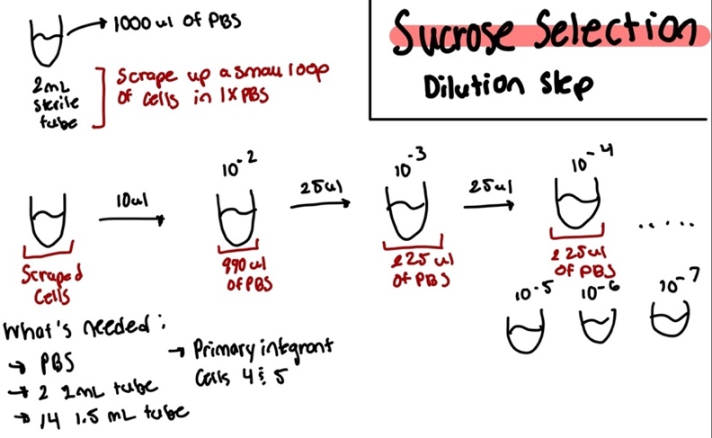
Setup for Sucrose Selection
Notes: For the steps when it came to plating the cells, I only did a duplicate of 10^-5 and 10^-6, as I had to use the other 100 uL of 10^-7 for the CHAH plates.
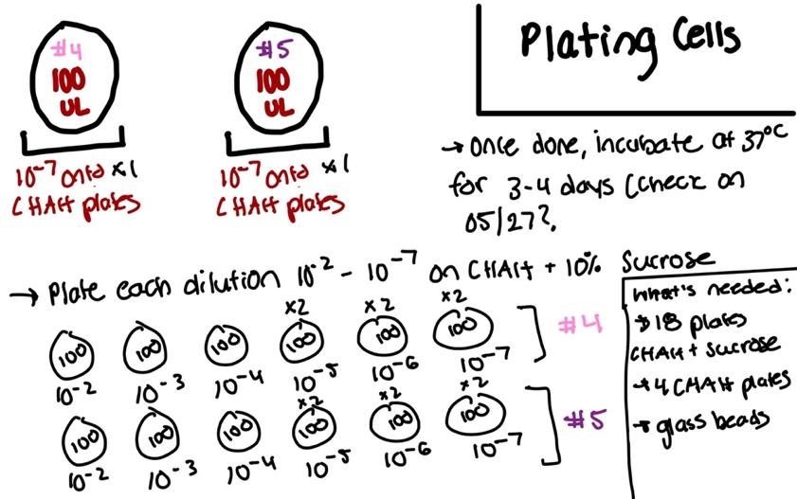

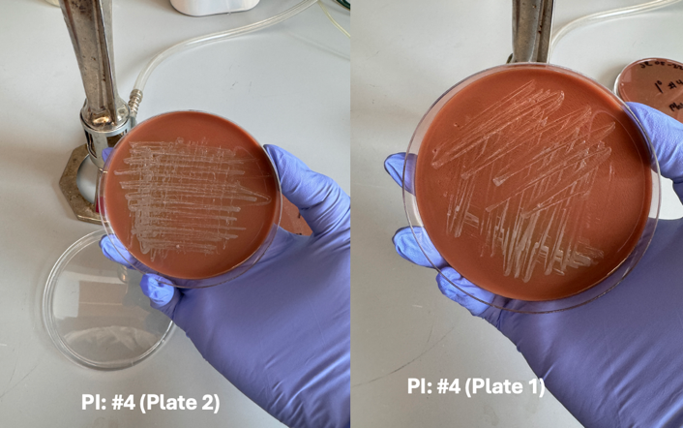
Primary Integrant Patch Plates:

Notes: I used PI #5 (Plate 4) and PI #4 (Plate 2) when prepping dilutions for sucrose selection.
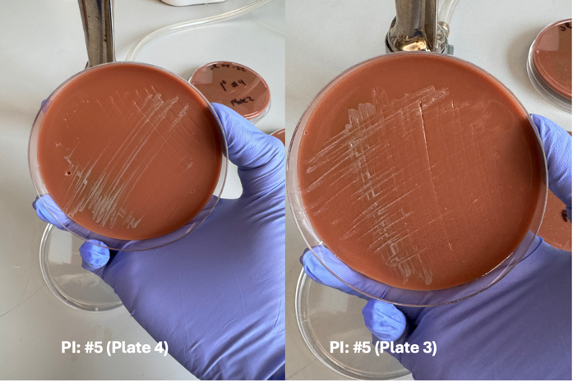

Friday, May 24, 2024
To Do:
- Count colonies on Day 43 Survival Assay plates
- Meet with KMR on accumulated graph
- Conduct survival assay of LVS Flasks

Protocol for Freshwater Survival Assay (LVS Flasks)
- Prep sterile setup for assay with these materials: reservoir, sterile multichannel pipettes (5-20uL and 50-300uL) sterile 96 well plate and sterile PBS.
- Aspectically, pour about 5-10 mL of sterile PBS into reservoir.
- Load 180 uL of sterile PBS into each “highlighted” column, don’t load PBS into first well of each column since that will be loaded with the cells.
- Load 100 uL of sample cells into each designated well
- Using the multichannel, transfer 20 uL of the sample cells from the first well into the next well. Repeat this for each well, 1A to 1B. 1B to 1C etc.
- Once all wells have been diluted (except the first wells), prep 12 plates of CHAH.
- Using the 5 – 20 uL multichannel, load 10 uL of the first column, for example, 1A, 1B, 1C, 1D, 1E, 1F, 1G, 1H, and plate the 10 uL, holding the plate at slant
- Let the liquid run down the plate, but not too fast!! Can’t allow samples to hit the bottom.
- Once all12 plates are done, incubate plates in 37 degrees Celsius for the next couple of days.

Notes:
I only did a survival assay on flasks 1, 2, and 3. So there were 6 plates.

Tuesday, May 28, 2024
To Do:
- Count colonies on Day 43 Survival Assay LVS plates
- Pick single colonies from sucrose plates w/ KMR
- Prepare square CHAH plates
- Prepare LB Agar for Kira

Patching Crossouts onto CHAH
Pick single colonies (cross-outs) from sucrose plates and patch onto CHAH, 8 – 16 per 1° integrant.
-Optional: cross-patch to CHAH-Kan. Note that it is common to pick up some background cells so some amount of kanamycin-resistant growth is not yet a concern. However, if there is robust kanamycin-resistant growth from all patches from a single 1° integrant on the next day, the 1° integrant may have an inactivating mutation in sacB and is not worth keeping.
Observation Notes:
I patched the single colonies on 4 CHAH plates and 4 CHAH-Kan plates. 4 plates (2 CHAH, 2 CHAH-Kan) were designated for primary integrant #4 and 4 plates were designated for primary integrant #5. I labeled one plate 1-12 and the other 13-24. When I started patching, KMR suggested that I pick 4 big single colonies, 4 small single colonies and again 4 big single colonies. Before I started, I made a few observations about the serial dilution sucrose plates. On my CHAH 10⁻⁷ plates, I noticed the greenish halo around the colonies, these colonies were very big {insert total amount of colonies}. On my sucrose plates, the colonies were relatively small and had this greyish tint. KMR made note that when deleting the mpl gene, there might be a growth defect. On my primary integrant #5 plates, I noticed contamination on about 4-5 of these plates that were not Fransciella.

Table. Sucrose Selection Dilution Plate Count
 | PI #4 10⁻⁷ | PI#5 10⁻⁷
CHAH | 114 | 99
CHAH + 10% Sucrose | 48 | 43

Day 43 Survival Assay Plate Count
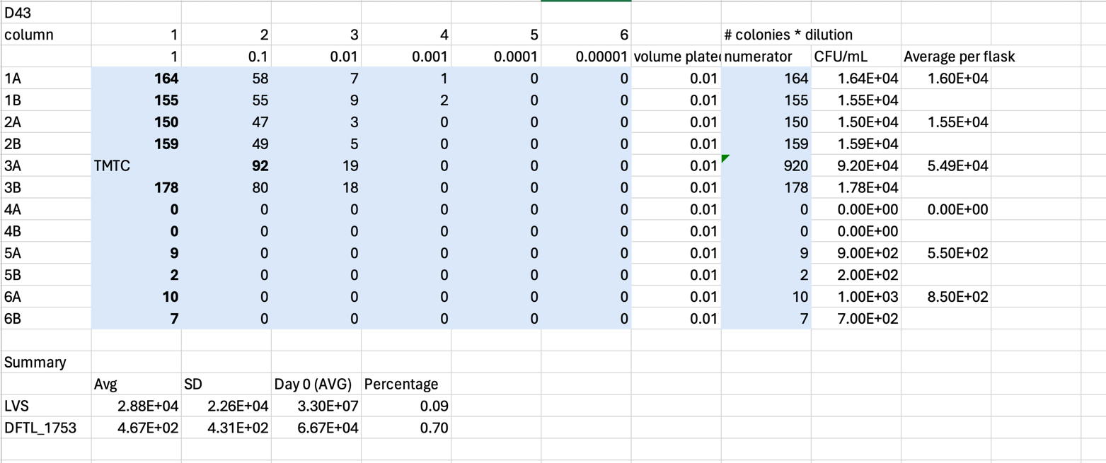

Figure 1. In this image is a graph of the survival percentage of LVS (blue) and DFTL_1753 (orange) over a period of 43 days.
Figure 2. In this image is a graph of the average CFU/mL over 43 days. The lines represent LVS (blue) and DFTL_1753 (orange) with the addition of error bars.
Notes: I had a discussion with KMR on Friday where we talked about the graphs. The days plotted on the graph include data from Day 0, 7, 15, and 43. There were also two datasets, Day 1 and Day 3 which were excluded from this current graph (That graph can be found in my lab notebook 20242401). Day 3 was an anomaly because we saw an a peak in the DFTL_1753. KMR suggested that the next time I do a survival assay with my mutant, I should instead resuspend the cells in PBS, check the OD, pellet the cells and then resuspend again in PBS and water (our experimental group). She suggested this because when I first resuspended the cells in water, the mutant cells experienced hypo-osmotic shock and that the cells I plated on Day 0 were dead. By resupending the cells in PBS, we can provide an explanation for why the Day 0 CFU/mL are different.

Preparing Square CHAH Plates
For 600 mL of CHA
1. out 30.6g of cystine heart agar into 1L flask (non-baffled; 10.2g/100mL)
2. Add 300mL of ddiH₂O (type I)
3. Add stirbar to flask
4. Heat on low, stirring, for about 10 minutes (media should be totally dissolved)
5. Autoclave on 30’ liquid cycle, filling the water bin up to the height of the media
6. Cool down (ideally to ~55C)
7. Separately (before), prepare hemoglobin 2% solution
8. Add 6g freeze-dried hemoglobin to 300mL of ddiH₂O (type I)
9. Autoclave on 20’ liquid cycle with water in the bin
10. Cool down (ideally to ~55C)
11. Using sterile technique, pour hemoglobin into CHA
12. Using a 50mL pipet, aliquot 30 mL of CHAH mixture into each square plate. Try to avoid bubbles!
Notes: I made 40 square plates of CHAH.

Preparing LB Agar
- For 500 mL of LB-agar, weigh out the following components and add to a 1 L (non-baffled) flask:
  - 6 g agar
  - 5 g NaCl
  - 5 g Tryptone
  - 2.5 g Yeast extract
- Add stirbar to flask
- Add 500 mL ddiH20
- Mix on stirplate until components are dissolved
- Cover top of flask with foil and add a small piece of autoclave tape
- Autoclave on 30 minute liquid cycle

Notes: KB asked me to make 2 500 mL LB agar flasks, they are stored on the shelf.

Wednesday, May 29, 2024
To Do:
- Colony PCR
- Observations of patch plates
- Run gel of PCR
- Streak out cells for osmotic shock

Prepping for Colony PCR

Transferring Patches to PCR strip tubes (diluted strip tubes, first step)
- Load 50 uL of H20 into PCR strip tubes
- Aseptically, scrape a few cells on one patch (from CHAH plate) at a time using a wooden stick and mix with the H2O in the designated PCR strip tube. Patch 1 goes into PCR strip tube 1 etc.
- Repeat this for the set number of patches and PCR strip tubes
- Resuspended via vortexing and spin down
- Put in thermocycler for 95 degrees for 10 minutes
- Label new PCR strip tubes w numbers
- Add 18 uL of h2o, transfer 2 uL from first tube to 2nd tube

PCR Protocol
- Acquire and label PCR tubes. Be sure to include at least 1 positive and 1 negative control for each PCR experiment.
- Get a container of ice to keep the components on
- Acquire the following components and put them on ice, labeling tubes if necessary:
  - Molecular grade H2O in 1.5 mL microfuge tube
  - KOD/primestar buffer
  - dNTPs
  - oligo F (10uM)
  - oligo R (10uM)
  - template (eg. LVS gDNA, plasmid, colony, etc.)
  - Note: KOD/primestar enzyme should be kept in the freezer until it is used as it is expensive and should be added last
- Centrifuge the microfuge tubes to get any solution out of the microfuge tube cover
- If any of the solutions are frozen, be sure to vortex the microfuge tube in order to dissolve it (tubes with frozen components may not be homogenized)
  - DO NOT vortex the enzyme itself or any solution with enzyme because vortexing will expose it to oxygen and degrade it
- Use PCR_worksheet.xlsx to make establish the specifics of what will be added
  - The file is located in the Protocols folder
  - Also setup table below to specify which primers and source DNA will be used
- Prepare a master-mix in a 1.5 mL microfuge tube by adding the following according to the worksheet and using micropipettes:
  - ddi H2O
  - primers
  - Add dNTPs
  - Add buffer
  - Add enzyme (last!)
- Mix the master-mix solution by pipetting up and down
  - Do not vortex to mix
- Add 18uL of master-mix to each PCR tube (can use same tip)
- Add template to each PCR tube (2 ul each, change tip each time)
- Close PCR Tubes until the caps are tight
- Place the PCR Tubes in the thermocycler on STN 1 – the following settings should be in place:
Lid: 105°C
Volume: 20uL change depending on sample volume
      - 94°C 2’
      - 94°C 20”
      - 50°C 30”
      - 68°C 3’40”. This is the step to change depending on product size
      - Go to step 2, 32x
      - 68°C 5 mins
      - 12°C Hold

Table. Reactions for Colony PCR
Reaction numbers | Sample | Expected size
1 | pKR200-4-6 | 3549 or 2212
2 | pKR200-4-13 | 3549 or 2212
3 | pKR200-4-19 | 3549 or 2212
4 | pKR200-4-1 | 3549 or 2212
5 | pKR200-4 | ?
6 | pKR200-5-2 | 3549 or 2212
7 | pKR200-5-6 | 3549 or 2212
8 | pKR200-5-9 | 3549 or 2212
9 | pKR200-5-14 | 3549 or 2212
10 | pKR200-5-18 | 3549 or 2212
11 | pKR200-5-20 | 3549 or 2212
12 | pKR200-5-1 | 3549 or 2212
13 | pKR200-5 | ?
14 | pKR200 1:10 | -
15 | LVS gDNA | 3549
16 | -DNA | no product

Table. Master Mix for Colony PCR
Total reaction volume | 20
Total number of reactions | 16
 |  |  |  | Factor
Component | Stock concentration | Final concentration | 1 rxn volume | 17
ddiH2O |  |  | 10.8 | 183.6
PrimeSTAR GXL Buffer | 5x | 1x | 4.0 | 68
dNTPs | 2.5 mM | 0.2 mM | 1.6 | 27.2
oligo F | 10 uM | 0.3 uM | 0.6 | 10.2
oligo R | 10 uM | 0.3 uM | 0.6 | 10.2
template | 100 ng/ul | 2 ng/ul | 2.0
PrimeSTAR GXL DNA Polymerase | 1.25 U/ul | 0.025 U/ul | 0.4 | 6.8
 |  | Total volume | 20 | 306

Notes for protocol:
Helpful notes for when starting PCR, DO mix your primers in the mastermix and do not vortex once you add DNA polymerase. I am going to take 2.0 uL of template into MM spin those down and then add the mastermix (spin again one more time).

Notes after protocol:
I accidentally transferred 2 ul of master mix into the diluted cells from PI #4 strip tube. So with the help of BM, we created a new diluted 1:10 of PI #4 and I edited the master mix table where I changed the total number of reactions to 1 to help add more contents of buffer, primers, dNTPS, polymerase and water. After adding to the master mix, I continued on with the protocol as written.

Table. Mastermix Table after Mistake
Total reaction volume | 20
Total number of reactions | 1
 |  |  |  | Factor
Component | Stock concentration | Final concentration | 1 rxn volume | 2
ddiH2O |  |  | 10.8 | 21.6
PrimeSTAR GXL Buffer | 5x | 1x | 4.0 | 8
dNTPs | 2.5 mM | 0.2 mM | 1.6 | 3.2
oligo F | 10 uM | 0.3 uM | 0.6 | 1.2
oligo R | 10 uM | 0.3 uM | 0.6 | 1.2
template | 100 ng/ul | 2 ng/ul | 2.0
PrimeSTAR GXL DNA Polymerase | 1.25 U/ul | 0.025 U/ul | 0.4 | 0.8
 |  | Total volume | 20 | 36

Observations of Patch Plates from 05/28/24
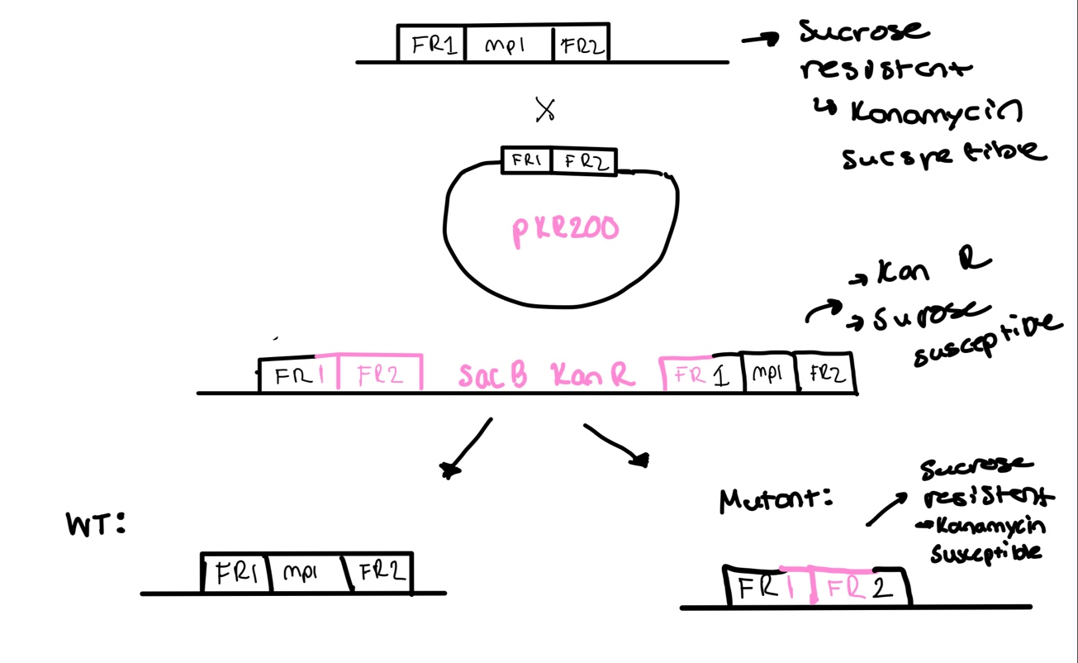
Figure. Above is an image of a “flow chart” which depicts the process of homologous recombination. In the first event we have the original F. tularensis genome and my plasmid pKR200 (deletion of mpl). This crossover event produces the recombinated fragments. Cells from this event are kanamycin resistant and sucrose susceptible. The next crossover event we should have the deleted gene, hence these cells should be sucrose resistant and kanamycin susceptible.

There was more growth on our CHAH plates for PI #4 and PI #5 but there was also some growth on the CHAH-Kan plates for the primary integrants.

Setting up to run gel
- Grab PCR samples of PI #4 and PI #5
- Set up agarose gel rig (used the larger, green rig bc there is more volume).
- Load 12 uL of Sybersafe (mix with column) Pour agarose gel into rig after cools. And let sit until solidified.
- Load 10 ul of 1Kb ladder dye into ladder
- Mix 5 uL of loading dye into the each 20 uL PCR colony strip tube. Using the multichannel, to load the dye into PCR strip tubes.
- Load PCR strips tubes into each well about 20 uL
- Run to red when connecting power pack to casting tray. Covered tray with aluminum foil so Sybersafe does not degrade under light.

Figure. Colony PCR Gel 05/30/2024

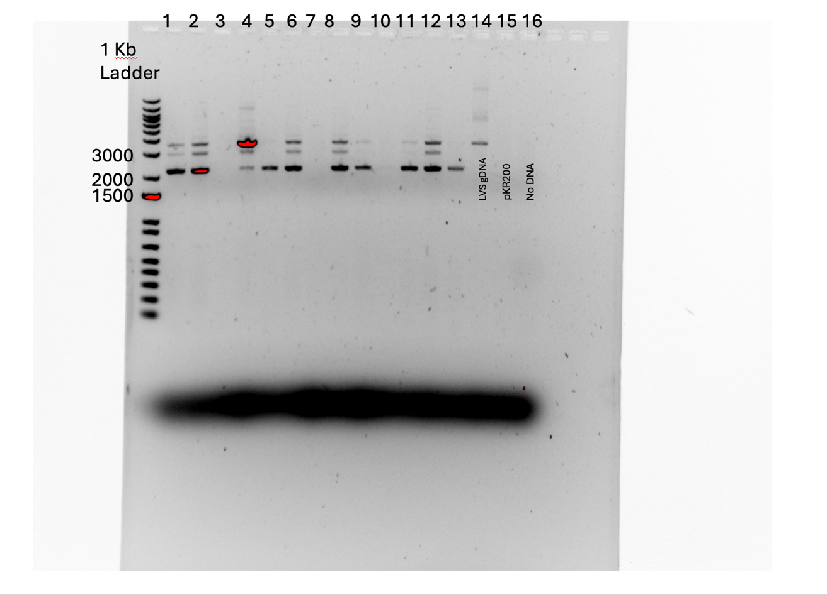

Thursday, May 30, 2024
To Do:
- Place square plates for shock assay in incubator
- Conduct Shock Assay
- Redo 05/29 Colony PCR
- Run gel of colony PCR

Prepping for Colony PCR

Transferring Patches to PCR strip tubes (diluted strip tubes, first step)
- Load 50 uL of H20 into PCR strip tubes
- Aseptically, scrape a few cells on one patch (from CHAH plate) at a time using a wooden stick and mix with the H2O in the designated PCR strip tube. Patch 1 goes into PCR strip tube 1 etc.
- Repeat this for the set number of patches and PCR strip tubes
- Resuspended via vortexing and spin down
- Put in thermocycler for 95 degrees for 10 minutes
- Label new PCR strip tubes w numbers
- Add 18 uL of h2o, transfer 2 uL from first tube to 2nd tube

PCR Protocol
- Acquire and label PCR tubes. Be sure to include at least 1 positive and 1 negative control for each PCR experiment.
- Get a container of ice to keep the components on
- Acquire the following components and put them on ice, labeling tubes if necessary:
  - Molecular grade H2O in 1.5 mL microfuge tube
  - KOD/primestar buffer
  - dNTPs
  - oligo F (10uM)
  - oligo R (10uM)
  - template (eg. LVS gDNA, plasmid, colony, etc.)
  - Note: KOD/primestar enzyme should be kept in the freezer until it is used as it is expensive and should be added last
- Centrifuge the microfuge tubes to get any solution out of the microfuge tube cover
- If any of the solutions are frozen, be sure to vortex the microfuge tube in order to dissolve it (tubes with frozen components may not be homogenized)
  - DO NOT vortex the enzyme itself or any solution with enzyme because vortexing will expose it to oxygen and degrade it
- Use PCR_worksheet.xlsx to make establish the specifics of what will be added
  - The file is located in the Protocols folder
  - Also setup table below to specify which primers and source DNA will be used
- Prepare a master-mix in a 1.5 mL microfuge tube by adding the following according to the worksheet and using micropipettes:
  - ddi H2O
  - primers
  - Add dNTPs
  - Add buffer
  - Add enzyme (last!)
- Mix the master-mix solution by pipetting up and down
  - Do not vortex to mix
- Add 18uL of master-mix to each PCR tube (can use same tip)
- Add template to each PCR tube (2 ul each, change tip each time)
- Close PCR Tubes until the caps are tight
- Place the PCR Tubes in the thermocycler on STN 1 – the following settings should be in place:
Lid: 105°C
Volume: 20uL change depending on sample volume
      - 94°C 2’
      - 94°C 20”
      - 50°C 30”
      - 68°C 3’40”. This is the step to change depending on product size
      - Go to step 2, 32x
      - 68°C 5 mins
      - 12°C Hold

Table. Colony PCR #2 Reaction Table
Reaction numbers | Sample | Expected size
1 | pKR200-4-6 | 3549 or 2212
2 | pKR200-4-19 | 3549 or 2212
3 | pKR200-5-6 | 3549 or 2212
4 | pKR200-5-18 | 3549 or 2212
5 | pKR200-4 | ?
6 | LVS gDNA | 3549
7 | pKR200 1:10 | -
8 | no DNA | -

Table. Master mix for Colony PCR #2
Total reaction volume | 20
Total number of reactions | 8
 |  |  |  | Factor
Component | Stock concentration | Final concentration | 1 rxn volume | 9
ddiH2O |  |  | 10.8 | 97.2
PrimeSTAR GXL Buffer | 5x | 1x | 4.0 | 36
dNTPs | 2.5 mM | 0.2 mM | 1.6 | 14.4
oligo F | 10 uM | 0.3 uM | 0.6 | 5.4
oligo R | 10 uM | 0.3 uM | 0.6 | 5.4
template | 100 ng/ul | 2 ng/ul | 2.0
PrimeSTAR GXL DNA Polymerase | 1.25 U/ul | 0.025 U/ul | 0.4 | 3.6
 |  | Total volume | 20 | 162

Setting up to run gel
- Grab PCR samples of PI #4 and PI #5
- Set up agarose gel rig (used the smaller, yellow rig bc there is more volume).
- Load 6 uL of Sybersafe (mix with column) Pour agarose gel into rig after cools. And let sit until solidified.
- Load 10 ul of 1Kb ladder dye into ladder
- Mix 5 uL of loading dye into the each 20 uL PCR colony strip tube. Using the multichannel, to load the dye into PCR strip tubes.
- Load PCR strips tubes into each well about 20 uL
- Run to red when connecting power pack to casting tray. Covered tray with aluminum foil so Sybersafe does not degrade under light.

Shock Assay
- Use one sterile1.5 mL tubes and add 300 uL of sterile PBS to tube
- Scrap up 2 loopful of cells from LVS plate and resuspend in the 300 uL of sterile H₂O. Repeat this step for KRLVS 274 plate and tube. After, add 700 uL of H₂O into each tube.
- Using cuvettes, add 950 uL of sterile into each cuvette. For one cuvette (LVS), add 50 uL of resuspended cells into 950 uL of water. Repeat for mutant resuspended cells
- Measure absorbances of cuvettes using the spectrometer. Remember you also must use a blank filled with the same liquid that the cells were resuspended in.
- Since we diluted by a dilution factor of 1:20, multiply absorbance by 20, this will get our final OD.
- If you have not the OD you want, repeat steps 2-5 until you do.

Shock Assay
- Use one sterile 1.5 mL tubes and add 300 uL of sterile PBS to tube
- Scrap up 2 loopful of cells from mutant plate and resuspend in the 300 uL of sterile PBS. After, add 700 uL of sterile PBS into tube.
- Using cuvettes, add 900 uL of sterile PBS into each cuvette. For one cuvette (mutant), add 100 uL of resuspended cells into 900 uL of PBS.
- Measure absorbances of cuvettes using the spectrometer. Remember you also must use a blank filled with the same liquid (use sterile PBS) that the cells were resuspended in.
- Since we diluted by a dilution factor of 1:10, multiply absorbance by 10, this will get our final OD.
- If you have not the OD you want, repeat steps 2-5 until you do.

Bibliography

Ramsey, K. M. and Dove, S. L. (2016) ‘ A response regulator promotes Francisella tularensis intramacrophage growth by repressing an anti-virulence factor ’, Molecular Microbiology. doi: 10.1111/mmi.13418.

