Table of Contents
January 2024 4
Patching LVS 4
Patching LVS 4
Transformation of PKL02 into E. coli 4
Protocol for Making Glycerol Stocks 5
Protocol for Electroporation 6
Preparing LB-agar 8
February 2024 9
Miniprep Protocol 9
February 2024 9
Patching LVS 10
Sucrose Selection Protocol from Allelic Exchange in LVS 10
Day 3 Plate Count of serial dilution 11
Day 4 Plate Count of serial dilution 11
Transferring Patches to PCR strip tubes 12
PCR Protocol 12
Setting up to run gel 13
March 2024 17
Setting up to run practice gel 17
Day 4 Plate Count of serial dilution 20
Setting up to run practice gel 20
Picture of gel #2 21
Receiving Primers Protocol 24
Table. Reactions for Colony PCR 25
Transferring Patches to PCR strip tubes 27
PCR strip tubes to dilution tubes 27
Setting up to run gel 27
Protocol for Making Glycerol Stocks 27
April 2024 28
Making CHAH Square Plates for Serial Dilution 28
Making CHAH Square Plates for Serial Dilution 29
Protocol for finding the OD of Cells (Looking for 6 OD) 30
Protocol for Inoculation of Flasks 31
Protocol for Freshwater Survival Assay 31
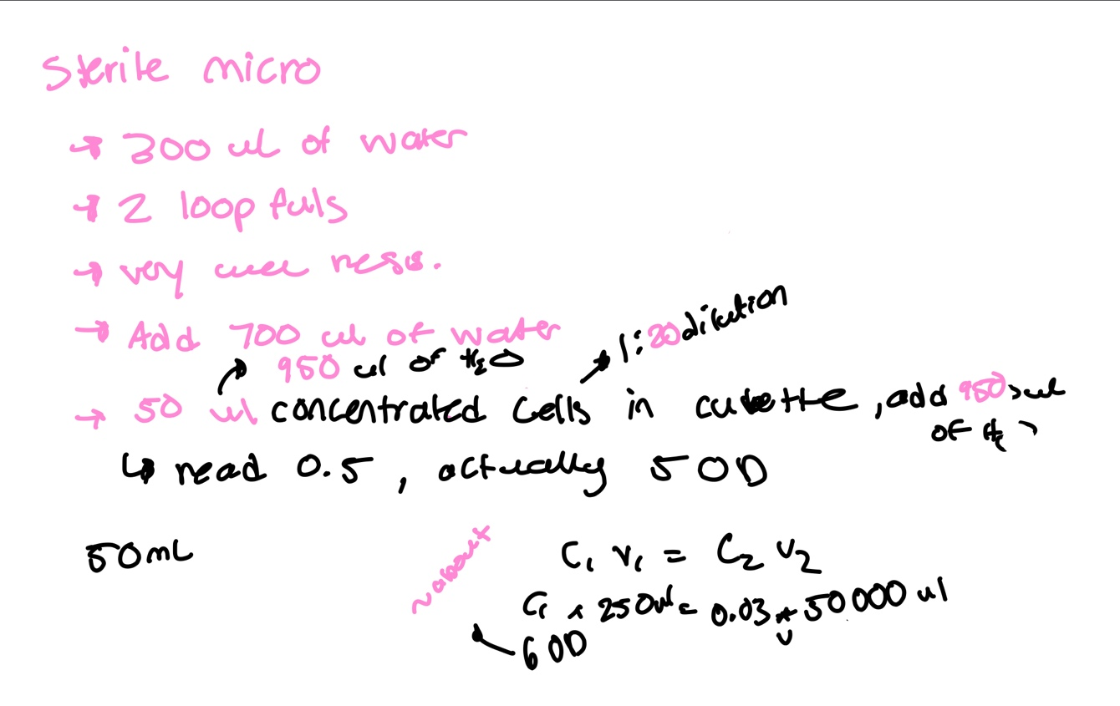 32
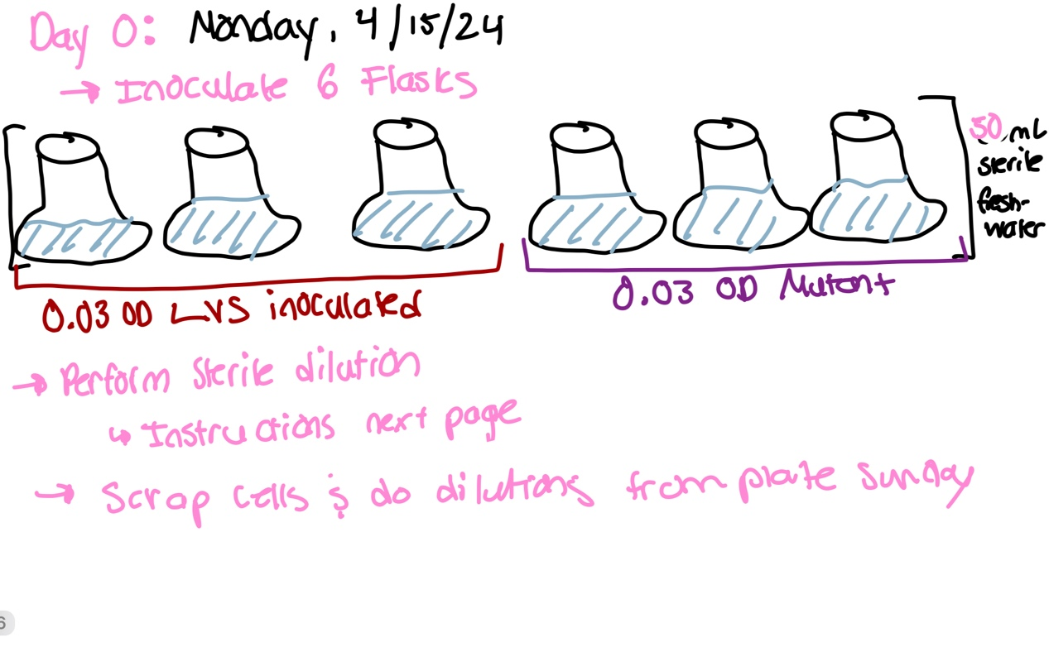 32
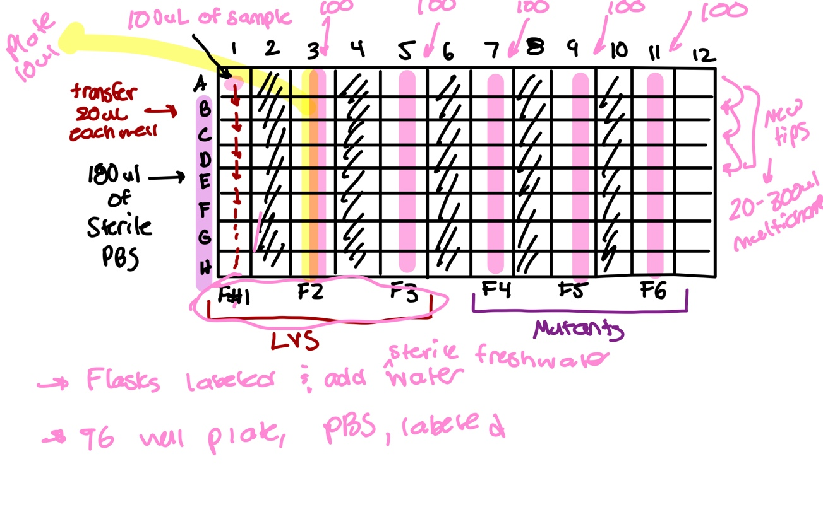 33
Protocol for Freshwater Survival Assay 33
Bibliography 33

PKR200 – plasmid

January 2024

Monday, January 22, 2024
To Do:
- Patch out LVS on CHAH and CHAH-Kan to check in plasmid is present in stock

Patching LVS
- Thawed KB’s stock of LVS of ice and HB’s stock was not thawed but was kept out of the freezer for a brief couple of minutes to complete protocol
- Once stock is thawed, start aspectically patching LVS on CHAH and CHAH-Kan
- Remember to aseptically remove wooden sticks from holder and keep cap closed
- Once LVS is patched onto plates, place in incubator at 37 ° C for 24 hours
Reflection:
- I used Kira’s LVS stock and Hannah’s stock to compare to see if there was a plasmid

Monday, January 29, 2024
To Do:
- Patch out LVS on CHAH
- Transforming PKL02 into E. coli via chemical transformation

Patching LVS
- Thawed LVS on ice
- Once stock is thawed, start aseptically patching LVS on CHAH using spread method
- Remember to aseptically remove wooden sticks from holder and keep cap closed
- Once LVS is patched onto plates, place in incubator at 37 ° C for 24 hours

Transformation of PKL02 into E. coli
- Set up reaction table. Always include a positive and negative control for each antibiotic.
- Note: The plasmid used for the positive control plates should be the regular circular plasmid, not the digest/purified one
- Check to be sure you have enough LB-Kan plates with appropriate antibiotic. If plates were stored at 4°C, warm at 37°C until needed.
- Obtain DNA and thaw on ice if necessary.
- Thaw appropriate number of competent cell tubes on ice (5 reactions per tube of competent cells)
- Label sterile tubes as indicated in reaction table. (Using 2 sterile tubes) Add indicated volume of indicated DNA on ice.
- When competent cells are thawed (check by probing for frozen cells using a sterile pipette tip), gently pipette 100 uL of cells into each reaction tube directly onto DNA using aseptic technique.
- Incubate cells on ice for 20 minutes. During incubation, find or set heat block to 42°C.
- Place tubes with cells and DNA onto 42°C heat block for 30 seconds (heat shock step).
- After heat shock, place tubes back on ice until next step (don’t keep them here too long).
- Using aseptic technique, add 1 mL LB (no antibiotic) to each microfuge tube.
- Using autoclave tape, tape microfuge tubes down in shaking incubator set to 37°C.
- Allow cells to recover for 1 hour at 37°C, shaking. Place in a rack after shaking (NOT back on ice).
- Using aseptic technique, plate indicated amount of cells on appropriate antibiotic plates (LB-Kan), spreading until plates look dry. For “remaining” volume, spin tubes at max speed in benchtop centrifuge for 30 seconds. Remove 800 uL of media. Using 200 uL pipette, resuspend cells at bottom of tube and plate all the remaining culture
- Incubated at 37 for 24 hours
Table for pKL02 Transformation
Tube Number | Purpose | DNA | Volume of DNA | Final Volume to Plate | Number of Kanamycin containing plates
1 | (+) control | pKL02 | 1 ul | 20 ul, 100 ul | 2
2 | (-) control | 0 ul | 0 ul | 20 ul, 100 ul | 2

Tuesday, January 30, 2024
To Do:
- Make glycerol stocks of LVS to prepare for future electroporation
- Electroporation of LVS
- Fill ddiH2O container
- Make 2 500mL LB agar
- Make 2 500 mL TSB
- Plate electroporated LVS cells

Protocol for Making Glycerol Stocks

For single use stocks: follow steps 2 - 5 but instead of step 6, pipet 50 – 100 ul of cells to sterile labeled microfuge tubes. Note that if you don’t have many cells, you can reduce the volume of MHB and glycerol (keep the same ratio, with a final concentration of glycerol of 15%. E.g. 800 uL MHB and 200 uL 75% glycerol).

- Make 4 cryovials for each strain (permanent stocks), label!
- (add specific strain info here!)
- Prepare 3.2 mL of MHB in a 50mL conical (adjust if you are also making single use stocks)
- Take at least half of a thickly spread plate and add cells to the MHB tube
- Resuspend until there are no clumps in the MHB
- Add 800 ul MHB into each cryovial
- Add 200 ul of 75% glycerol to the 3.2 mL mix by pipetting
- Aliquot 1mL per cryovial, freeze at -80
Note: You will also be making single use aliquots!
Reflection: I placed the 4 cryovials into KB’s LVS box in the -80 Celsius freezer

Protocol for Electroporation

From Allelic exchange protocol; Edited by Hannah Trautmann
Prepare electrocompetent (EC) cells
-Scrape up entire plate of cells into 400 uL of sterile 10% sucrose and resuspend (alternately, cells can be grown to mid-log in MHB)
-Add 1.1 mL of 10% sucrose to a final volume of 1.5 mL
-Spin for 3 minutes at 10,000 rpm
-remove supernatant, throw out, and resuspend in fresh 1 mL 10% sucrose
-Repeat 3x-5x in 10% sucrose
-After final spin, remove all supernatant.
-Resuspend cells in 10% sucrose at high density (corresponding to ~1x10¹¹ cells /mL); these are EC cells by slowly adding 110 uL at a time. It should be about equal amounts of cells as sucrose.
-For any extra EC cells, aliquot ~110 μL / sterile tube (enough for 2 electroporations) and freeze at -80°C

Electroporate plasmid into EC cells*
-For each electroporation, aliquot 4 mL MHB into glass test tubes for recovery, warm in shaker at 37°C
-For each electroporation, in a 2 mm sterile electroporation cuvette, combine:
5 μL of pEX-based allelic exchange construct or Tn7 plasmids (mini-prep concentration, at least 100 ng/μL)
*for pF-based plasmids, can use 3 ul
50 μL electrocompetent cells
-Have recovery media ready
-Electroporate using the following settings: 2.5 kV, 25 μF, and 600 Ω
-Immediately after individual electroporations, use 1 mL warm recovery media from test tube to wash cells out of cuvette and transfer cells to recovery test tube
-Recover cells for 4-8 hours, shaking at 37°C
*For pF-based plasmids, only recover 2-3 hours
-For pEX plasmids: pellet cells by centrifugation in sterile 2 mL tubes, 1’ at 10,000 x g. Plate on CHAH-Kan plates, using 1 plate for each 2 mL tube (2 plates per electroporation)

-Incubate plates at 37°C for 3 days (or until single colonies appear)

*Always include a control electroporation with no plasmid. Eventually single break-through colonies may start appearing; at that point, single colonies on the experimental plates are also likely to just be break-through growth.
Reflection:
- Using 6 plates of CHAH-Kan
  - 2 plates for pKR200
  - 2 plates for pKL02 (+) control
  - 2 plates for no DNA (-) control
- Placed cells in shaking incubator for 6 hours
- Cells were dense and took a while to during specifically E1 for no DNA (-) control
Reflection on plated electroporated cells:
- There was contamination on all 6 of the CHAH-Kan plates
- Morphology of the cells:
  - Pink/greyish color
  - Large, circular
  - Did not look like Fransciella
- Ben decided to test other reagents used in electroporation process for contamination, tested:
  - MHB supplement (no growth on those plates)
  - Sucrose (no growth)
  - Glycerol (no growth
- He is now testing to see if the contamination came from E. coli as it is the only bacteria used in the lab that has Kanamycin resistance

Preparing LB-agar
- For 500 mL of LB-agar, weigh out the following components and add to a 1 L (non-baffled) flask:
  - 6 g agar
  - 5 g NaCl
  - 5 g Tryptone
  - 2.5 g Yeast extract
- Add stirbar to flask
- Add 500 mL ddiH20
- Mix on stirplate until components are dissolved
- Cover top of flask with foil and add a small piece of autoclave tape
- Autoclave on 30 minute liquid cycle

February 2024

Thursday, February 2, 2024
To Do:
- Miniprep pelleted cells of plasmid pKL02

Miniprep Protocol

- Pellet 1-5 ml bacterial overnight culture by centrifugation at >8000 rpm for 3 min room temp
- Resuspend pelleted bacterial cells in 250 ul Buffer P1 and transfer to microcentrifuge tube (from fridge)
- Add 250 ul Buffer P2 and mix thoroughly by inverting tube 4-6 times until solution becomes clear. Do not allow lysis reaction to proceed for more than 5 min.
- Add 350 ul Buffer N3 and mix immediately and thoroughly by inverting the tube 4-6 times
- Centrifuge for 10 min at 13000 rpm
- Apply 800 ul supernatant from step 5 to the QIAprep 2.0 spin column by pipetting. Centrifuge for 30-60s and discard the flow through
- Recommended: Wash the QIAprep 2.0 spin column by adding 0.5 ml Buffer PB. Centrifuge for 30-60s and discard flow through
- Wash QIAprep 2.0 spin column by adding 0.75 ml Buffer PE. Centrifuge for 30-60s and discard flow through (do 3 times?) Transfer QIAprep 2.0 spin column to collection tube
- Centrifuge 3 min to remove residual wash buffer
- Place QIAprep 2.0 column in a clean 1.5 ml microcentrifuge tube. To elute DNA, add 50 ul Buffer 0.1x EB, let stand for 1 minute and centrifuge for 1 min.
- If extracted DNA is to be analyzed on a gel, add 1 volume of loading dye to 5 ul volumes of purified DNA. Mix the solution by pipetting up and down before loading
Notes:
- I had to dilute the purified sample by a 1:10 ratio using 0.1x EB Buffer. I organized the PCR strip tubes 1, 2, 3, and 4. In each strip I pipetted 5 ul of DNA and added 45 ul of 0.1x EB Buffer for a total of 50 ul.

February 2024

Monday, February 5, 2024
To Do:
- Patch LVS on CHAH, prepare for electroporation on Tuesday
- Make 75% glycerol aliquot

Patching LVS
- Thawed LVS on ice
- Once stock is thawed, start aseptically patching LVS on CHAH using spread method
- Remember to aseptically remove wooden sticks from holder and keep cap closed
- Once LVS is patched onto plates, place in incubator at 37 ° C for 24 hours

Monday, February 12, 2024
To Do:
- Moving forward with allelic exchange and identifying cross outs using sucrose selection

Sucrose Selection Protocol from Allelic Exchange in LVS
To select for cross-outs using sucrose selection
-Scrape up small loop of cells and resuspend in 1X PBS
-Dilute culture 1:10 in sterile PBS to 1x10⁻⁷
Perform first dilution 1:100 so first dilution tube is 1x10⁻², adding 10 uL of resuspended cells to 990 ul 1x PBS
Perform subsequent dilutions 1:10, diluting 25 uL cells into 225 uL 1X PBS
-Plate 100 uL of last dilution (1x10⁻⁷) onto CHAH plates.
-Plate 100 μL of each dilution 10⁻² – 10⁻⁷ on CHAH + 10% sucrose plates. If you have extra sucrose plates, can plate some or all dilutions twice.
-Incubate plates at 37°C for 3-4 days, or until single colonies appear. It is generally a good idea to test both large and smaller single colonies. Note that there should be many more colonies on the CHAH plate with the 1x10⁻⁷ dilution than on the sucrose plate with the corresponding dilution. If there seem to be similar numbers of colonies, the 1° integrant may have an inactivating mutation in sacB and is not worth keeping.
Monday, February 12, 2024
To Do:
- Count plates of serial dilution
- Make LB Agar

Day 3 Plate Count of serial dilution
Plate # | 10⁻² | 10⁻³ | 10⁻⁴ | 10⁻⁵ | 10⁻⁶ | CHAH 10⁻⁷ | CHAH+Sucrose 10⁻⁷
1 | Lawn | Lawn | Lawn | Lawn (single colonies start to form) | Very small colonies, could not really count | ~45 colonies  Small colonies | ~32 colonies  Very small
2 | Lawn | Lawn | Lawn | Lawn (single colonies starting to form) | Too many to count | ~50 colonies | ~40 colonies
Friday, February 16, 2024
To Do:
- Count plates of serial dilution
- Cross patch LVS to reconfirm that cells are kanamycin resistant on CHAH and CHAH-Kan

Day 4 Plate Count of serial dilution
Plate # | 10⁻² | 10⁻³ | 10⁻⁴ | 10⁻⁵ | 10⁻⁶ | CHAH 10⁻⁷ | CHAH+Sucrose 10⁻⁷
1 | Lawn | Lawn | Lawn | Lawn (single colonies start to form) | Very small colonies, could not really count | ~49 colonies  Small colonies | ~32 colonies  Very small
2 | Lawn | Lawn | Lawn | Lawn (single colonies starting to form) | Too many to count | ~52 colonies | ~56 colonies

Tuesday, February 20, 2024
To Do:

Thursday, February 22, 2024
To Do:
- Perform colony PCR
- Transferring colony patches to PCR strip tubes

Notes before starting e

Transferring Patches to PCR strip tubes
- Load 10 uL of H20 into PCR strip tubes
- Aseptically, scrape a few colonies on one patch (of CHAH) at a time using a wooden stick and mix with the H2O in the designated PCR strip tube. Patch 1 goes into PCR strip tube 1 etc.
- Repeat this for the set number of patches and PCR strip tubes

PCR Protocol
- Acquire and label PCR tubes. Be sure to include at least 1 positive and 1 negative control for each PCR experiment.
- Get a container of ice to keep the components on
- Acquire the following components and put them on ice, labeling tubes if necessary:
  - Molecular grade H2O in 1.5 mL microfuge tube
  - KOD/primestar buffer
  - dNTPs
  - oligo F (10uM)
  - oligo R (10uM)
  - template (eg. LVS gDNA, plasmid, colony, etc.)
  - Note: KOD/primestar enzyme should be kept in the freezer until it is used as it is expensive and should be added last
- Centrifuge the microfuge tubes to get any solution out of the microfuge tube cover
- If any of the solutions are frozen, be sure to vortex the microfuge tube in order to dissolve it (tubes with frozen components may not be homogenized)
  - DO NOT vortex the enzyme itself or any solution with enzyme because vortexing will expose it to oxygen and degrade it
- Use PCR_worksheet.xlsx to make establish the specifics of what will be added
  - The file is located in the Protocols folder
  - Also setup table below to specify which primers and source DNA will be used
- Add appropriate volume (based on PCR worksheet) of each experiment specific primer (forward and reverse) to PCR tubes
- Add ddi H2O to negative control tube
  - Template volume for 1 reaction
- Prepare a master-mix in a 1.5 mL microfuge tube by adding the following according to the worksheet and using micropipettes:
  - Add ddi H2O
  - Add dNTPs
  - Add KOD buffer
  - Add KOD enzyme
- Mix the master-mix solution by pipetting up and down
  - Do not vortex to mix
- Add appropriate volume of master-mix to negative control PCR tube
- Add template to Master Mix
  - Factor template volume minus 1 template reaction volume
- Add appropriate volume of master mix to each PCR tube (except negative control) and pipette up and down to mix (conserves tips)
- Close PCR Tubes until the caps are tight
- Place the PCR Tubes in the thermocycler on STN 1 – the following settings should be in place:

Friday, February 23, 2024
To Do:
- Run 26 samples of PCR colony on gel

Setting up to run gel
- Thaw 26 CHAH PCR colonies and 26 CHAH-KAN PCR colonies
- Set up agarose gel rig (used the larger, green rig bc there is more volume). Using two gel rigs, one for CHAH and one for CHAH KAN.
- Load 12 uL of Sybersafe (mix with column) Pour agarose gel into rig after cools. And let sit until solidified.
- Load 10 ul of 1Kb ladder dye into ladder
- Mix 5 uL of loading dye into the each 20 uL PCR colony strip tube. Using the multichannel, to load the dye into PCR strip tubes.
- Load PCR strips tubes into each well about 20 uL
- Run to red when connecting power pack to casting tray. Covered tray with aluminum foil so Sybersafe does not degrade under light.

Reflection:
- The gels came out smudgy and were hard to read. The ladder was not clear as well.
- This could have been due to the way the gels were loaded, either too much volume or pipetting error from JR
- Ben will see if we have enough sample to run again on gel
- Will talk to K Ramsey for steps moving forward since gel is unclear.
4strsaa

Tuesday, February 27, 2024
To Do:
- Make CHAH + 10% sucrose plates

CHAH plates with 10% sucrose
Mix:
5 g Beef Heart Infusion
5 g Protease Peptone
5 g Glucose
0.5 g L-Cystine
7.5 g Agar
with 150 mL type I ddiH₂O. Stir on low heat until completely dissolved, about 10 minutes.
Autoclave 30’, being EXTREMELY careful media does not boil over
While autoclaving, warm 250 mL of 2% hemoglobin and sterilized 50% sucrose (in 50°C oven or in water bath at 55°C)
Place CHA flask in 50°C oven or in water bath at 55°C, let temperature equilibrate
Wipe down flask and bottles with ethanol and using sterile technique, pour hemoglobin into CHA flask
Add 100 mL 50% sucrose to CHA-hemoglobin flask
Mix media
Use sterile pipette, pour ~24 mL media per plate (~20 plates for 500 mL media)

Thursday, February 29, 2024
To Do:
- Conduct serial dilution of Primary integrant #3
- Plate serial dilutions on CHAH + 10% Sucrose
- Do practice PCR
Serial dilution
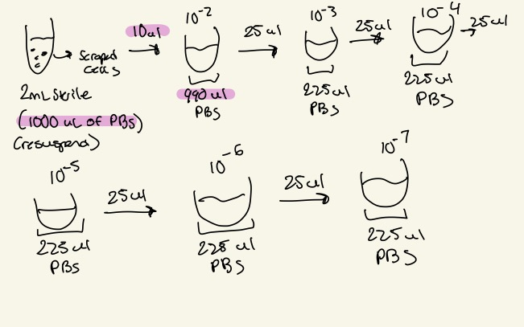
(Image of Serial dilution)
-Kanamycin-resistant cells should be 1° integrants. Make stocks of up to 4 potential 1° integrants, but only move forward with identifying cross-outs from two 1° integrants per strain

To select for cross-outs using sucrose selection
-Scrape up small loop of cells and resuspend in 1X PBS
-Dilute culture 1:10 in sterile PBS to 1x10⁻⁷
Perform first dilution 1:100 so first dilution tube is 1x10⁻², adding 10 uL of resuspended cells to 990 ul 1x PBS
Perform subsequent dilutions 1:10, diluting 25 uL cells into 225 uL 1X PBS
-Plate 100 uL of last dilution (1x10⁻⁷) onto CHAH plates.
-Plate 100 μL of each dilution 10⁻² – 10⁻⁷ on CHAH + 10% sucrose plates. If you have extra sucrose plates, can plate some or all dilutions twice.
-Incubate plates at 37°C for 3-4 days, or until single colonies appear. It is generally a good idea to test both large and smaller single colonies. Note that there should be many more colonies on the CHAH plate with the 1x10⁻⁷ dilution than on the sucrose plate with the corresponding dilution. If there seem to be similar numbers of colonies, the 1° integrant may have an inactivating mutation in sacB and is not worth keeping.

Make freezer stocks of 1° integrants
-Add 800 uL MHB to cryovial per 1° integrant
-Scrape up 1° integrant cells using loop into cryovial
-Completely resuspend cells in cryovial
-Add 200 uL 75% glycerol, close tube, mix by vortexing, and freeze at -80°C.

Practice PCR
Sample number | Reaction name
1 | Primary Integrant (from serial dilution 10⁻²⁾
2 | LVS from colony 1:10
3 | gDNA
4 | pKR200 diluted 1:100
5 | No DNA

MasterMix:
Total reaction volume | 20
Total number of reactions | 5
 |  |  |  | Factor
Component | Stock concentration | Final concentration | 1 rxn volume | 6
ddiH2O |  |  | 12.4 | 74.4
PrimeSTAR GXL Buffer | 5x | 1x | 4.0 | 24
dNTPs | 2.5 mM | 0.2 mM | 1.6 | 9.6
oligo F | 10 uM | 0.3 uM | 0.6 | 3.6
oligo R | 10 uM | 0.3 uM | 0.6 | 3.6
template | 100 ng/ul | 2 ng/ul | 0.4
PrimeSTAR GXL DNA Polymerase | 1.25 U/ul | 0.025 U/ul | 0.4 | 2.4
 |  | Total volume | 20 | 117.6
Protocol for PCR
- Acquire and label PCR tubes. Be sure to include at least 1 positive and 1 negative control for each PCR experiment.
- Get a container of ice to keep the components on
- Acquire the following components and put them on ice, labeling tubes if necessary:
  - Molecular grade H2O in 1.5 mL microfuge tube
  - KOD/primestar buffer
  - dNTPs
  - oligo F (10uM)
  - oligo R (10uM)
  - template (eg. LVS gDNA, plasmid, colony, etc.)
  - Note: KOD/primestar enzyme should be kept in the freezer until it is used as it is expensive and should be added last
- Centrifuge the microfuge tubes to get any solution out of the microfuge tube cover
- If any of the solutions are frozen, be sure to vortex the microfuge tube in order to dissolve it (tubes with frozen components may not be homogenized)
  - DO NOT vortex the enzyme itself or any solution with enzyme because vortexing will expose it to oxygen and degrade it
- Use PCR_worksheet.xlsx to make establish the specifics of what will be added
  - The file is located in the Protocols folder
  - Also setup table below to specify which primers and source DNA will be used
- Add appropriate volume (based on PCR worksheet) of each experiment specific primer (forward and reverse) to PCR tubes
- Add ddi H2O to negative control tube
  - Template volume for 1 reaction
- Prepare a master-mix in a 1.5 mL microfuge tube by adding the following according to the worksheet and using micropipettes:
  - Add ddi H2O
  - Add dNTPs
  - Add KOD buffer
  - Add KOD enzyme
- Mix the master-mix solution by pipetting up and down
  - Do not vortex to mix
- Add appropriate volume of master-mix to negative control PCR tube
- Add template to Master Mix
  - Factor template volume minus 1 template reaction volume
- Add appropriate volume of master mix to each PCR tube (except negative control) and pipette up and down to mix (conserves tips)
- Close PCR Tubes until the caps are tight
- Place the PCR Tubes in the thermocycler on STN 1 – the following settings should be in place:
  - Heat at 94 degrees for 2 minutes,
  - 94 degrees C for 20 seconds
  - 50 degrees C for 30 seconds
  - 68 degrees C for 1 minute/kb (adjust based on expected size of product)
  - Go back to step 2
  - Repeat 32x
  - 68 degrees C for 5 minutes
  - 12 degrees C for infinity

March 2024

Monday, March 4 , 2024
To Do:
- Run gel of practice PCR from Thursday
- Repeat practice PCR
- Count serial dilution plates

Setting up to run practice gel
- Thaw 5 PCR strip tubes
- Set up agarose gel rig (used the small yellow one, yellow rig bc there is less volume).
- Load 6 uL of Sybersafe (mix with column) Pour agarose gel into rig after cools. And let sit until solidified.
- Load 10 ul of 1Kb ladder dye into ladder
- Mix 5 uL of loading dye into the each 20 uL PCR colony strip tube. Using the multichannel, to load the dye into PCR strip tubes.
- Load PCR strips tubes into each well about 20 uL
- Run to red when connecting power pack to casting tray. Covered tray with aluminum foil so Sybersafe does not degrade under light.
Picture of gel

Reflection:
BM and I observed the gel and there were no present bands except with the chance of primer dimers. If there is an issue with all of the 5 reaction samples, this could have been a mastermix error. BM suggested that this can be since we used a DNA polymerase from his cloning box that was an aliquot and could have been an older aliquot.

Practice PCR #2
Sample number | Reaction name
1 | Primary Integrant (from serial dilution 10⁻²⁾
2 | LVS from colony 1:10
3 | gDNA
4 | pKR200 diluted 1:100
5 | No DNA

MasterMix:
Total reaction volume | 20
Total number of reactions | 5
 |  |  |  | Factor
Component | Stock concentration | Final concentration | 1 rxn volume | 6
ddiH2O |  |  | 12.4 | 74.4
PrimeSTAR GXL Buffer | 5x | 1x | 4.0 | 24
dNTPs | 2.5 mM | 0.2 mM | 1.6 | 9.6
oligo F | 10 uM | 0.3 uM | 0.6 | 3.6
oligo R | 10 uM | 0.3 uM | 0.6 | 3.6
template | 100 ng/ul | 2 ng/ul | 0.4
PrimeSTAR GXL DNA Polymerase | 1.25 U/ul | 0.025 U/ul | 0.4 | 2.4
 |  | Total volume | 20 | 117.6
Protocol for PCR
- Acquire and label PCR tubes. Be sure to include at least 1 positive and 1 negative control for each PCR experiment.
- Get a container of ice to keep the components on
- Acquire the following components and put them on ice, labeling tubes if necessary:
  - Molecular grade H2O in 1.5 mL microfuge tube
  - KOD/primestar buffer
  - dNTPs
  - oligo F (10uM)
  - oligo R (10uM)
  - template (eg. LVS gDNA, plasmid, colony, etc.)
  - Note: KOD/primestar enzyme should be kept in the freezer until it is used as it is expensive and should be added last
- Centrifuge the microfuge tubes to get any solution out of the microfuge tube cover
- If any of the solutions are frozen, be sure to vortex the microfuge tube in order to dissolve it (tubes with frozen components may not be homogenized)
  - DO NOT vortex the enzyme itself or any solution with enzyme because vortexing will expose it to oxygen and degrade it
- Use PCR_worksheet.xlsx to make establish the specifics of what will be added
  - The file is located in the Protocols folder
  - Also setup table below to specify which primers and source DNA will be used
- Add appropriate volume (based on PCR worksheet) of each experiment specific primer (forward and reverse) to PCR tubes
- Add ddi H2O to negative control tube
  - Template volume for 1 reaction
- Prepare a master-mix in a 1.5 mL microfuge tube by adding the following according to the worksheet and using micropipettes:
  - Add ddi H2O
  - Add dNTPs
  - Add KOD buffer
  - Add KOD enzyme
- Mix the master-mix solution by pipetting up and down
  - Do not vortex to mix
- Add appropriate volume of master-mix to negative control PCR tube
- Add template to Master Mix
  - Factor template volume minus 1 template reaction volume
- Add appropriate volume of master mix to each PCR tube (except negative control) and pipette up and down to mix (conserves tips)
- Close PCR Tubes until the caps are tight
- Place the PCR Tubes in the thermocycler on STN 1 – the following settings should be in place:
  - Heat at 94 degrees for 2 minutes,
  - 94 degrees C for 20 seconds
  - 50 degrees C for 30 seconds
  - 68 degrees C for 1 minute/kb (adjust based on expected size of product)
  - Go back to step 2
  - Repeat 32x
  - 68 degrees C for 5 minutes
  - 12 degrees C for infinity

Day 4 Plate Count of serial dilution
Plate # | 10⁻² | 10⁻³ | 10⁻⁴ | 10⁻⁵ | 10⁻⁶ | CHAH 10⁻⁷ | CHAH+Sucrose 10⁻⁷
1 | Lawn | Lawn | Lawn | Lawn + two colonies with zone of inhibition | Too many to count but single colonies start to form | ~116 colonies  Small colonies | ~79-80 colonies  Very small
Reflection:
The number colony count for CHAH and CHAH + Sucrose 10⁻⁷ is different than I thought, there was more of a count on regular CHAH than sucrose plates. Will use CHAH +Sucrose 10⁻⁷ plates when patching out 24 colonies on regular CHAH for colony PCR.
Tuesday, March 5 , 2024
To Do:
- Run gel of practice PCR from Monday (again)
- Repeat PCR again with some modifications

Setting up to run practice gel
- Thaw 5 PCR strip tubes
- Set up agarose gel rig (used the small yellow one, yellow rig bc there is less volume).
- Load 6 uL of Sybersafe (mix with column) Pour agarose gel into rig after cools. And let sit until solidified.
- Load 10 ul of 1Kb ladder dye into ladder
- Mix 5 uL of loading dye into the each 20 uL PCR colony strip tube. Using the multichannel, to load the dye into PCR strip tubes.
- Load PCR strips tubes into each well about 20 uL
- Run to red when connecting power pack to casting tray. Covered tray with aluminum foil so Sybersafe does not degrade under light.
Reflection:
When I was loading sample 5 (no DNA), I noticed the volume was the same as the loading volume into the well. I believe I missed the 0.4 uL of water?

Picture of gel #2

Reflection:
No bands appeared on the image of the gel for the 2nd time. KB and I talked about it and this could have been due to the amount of template for each sample. There was a really small volume for the template, about 0.4 uL. So KB recommended that we up the volume to 1.0 uL and instead add the template first to the pcr strip tubes, spin those down and then add the mastermix (spin again one more time). When I run the gel on Thursday, we will see if the results are the same.

Practice PCR #3
Sample number | Reaction name
1 | Primary Integrant (from serial dilution 10⁻²⁾
2 | LVS from colony 1:10
3 | gDNA
4 | pKR200 diluted 1:100
5 | No DNA

MasterMix:
Total reaction volume | 20
Total number of reactions | 5
 |  |  |  | Factor
Component | Stock concentration | Final concentration | 1 rxn volume | 6
ddiH2O |  |  | 12.4 | 74.4
PrimeSTAR GXL Buffer | 5x | 1x | 4.0 | 24
dNTPs | 2.5 mM | 0.2 mM | 1.6 | 9.6
oligo F | 10 uM | 0.3 uM | 0.6 | 3.6
oligo R | 10 uM | 0.3 uM | 0.6 | 3.6
template | 100 ng/ul | 2 ng/ul | 1.00
PrimeSTAR GXL DNA Polymerase | 1.25 U/ul | 0.025 U/ul | 0.4 | 2.4
 |  | Total volume | 20 | 117.6
Protocol for PCR
- Acquire and label PCR tubes. Be sure to include at least 1 positive and 1 negative control for each PCR experiment.
- Get a container of ice to keep the components on
- Acquire the following components and put them on ice, labeling tubes if necessary:
  - Molecular grade H2O in 1.5 mL microfuge tube
  - KOD/primestar buffer
  - dNTPs
  - oligo F (10uM)
  - oligo R (10uM)
  - template (eg. LVS gDNA, plasmid, colony, etc.)
  - Note: KOD/primestar enzyme should be kept in the freezer until it is used as it is expensive and should be added last
- Centrifuge the microfuge tubes to get any solution out of the microfuge tube cover
- If any of the solutions are frozen, be sure to vortex the microfuge tube in order to dissolve it (tubes with frozen components may not be homogenized)
  - DO NOT vortex the enzyme itself or any solution with enzyme because vortexing will expose it to oxygen and degrade it
- Use PCR_worksheet.xlsx to make establish the specifics of what will be added
  - The file is located in the Protocols folder
  - Also setup table below to specify which primers and source DNA will be used
- Add appropriate volume (based on PCR worksheet) of each experiment specific primer (forward and reverse) to PCR tubes
- Add ddi H2O to negative control tube
  - Template volume for 1 reaction
- Prepare a master-mix in a 1.5 mL microfuge tube by adding the following according to the worksheet and using micropipettes:
  - Add ddi H2O
  - Add dNTPs
  - Add KOD buffer
  - Add KOD enzyme
- Mix the master-mix solution by pipetting up and down
  - Do not vortex to mix
- Add appropriate volume of master-mix to negative control PCR tube
- Add template to Master Mix
  - Factor template volume minus 1 template reaction volume
- Add appropriate volume of master mix to each PCR tube (except negative control) and pipette up and down to mix (conserves tips)
- Close PCR Tubes until the caps are tight
- Place the PCR Tubes in the thermocycler on STN 1 – the following settings should be in place:
  - Heat at 94 degrees for 2 minutes,
  - 94 degrees C for 20 seconds
  - 50 degrees C for 30 seconds
  - 68 degrees C for 1 minute/kb (adjust based on expected size of product)
  - Go back to step 2
  - Repeat 32x
  - 68 degrees C for 5 minutes
  - 12 degrees C for infinity

Thursday, March 7 , 2024
To Do:
- Repeat PCR but this time with only two samples to test primers
- Maybe re-aliquot primers from cryovial

Practice PCR w/ KROL 15 & 16
Sample number | Reaction name
1 | LVS gDNA
2 | No DNA
Practice PCR w/ KROL 661 & 662
Sample number | Reaction name
3 | LVS gDNA
4 | No DNA

Total reaction volume | 20
Total number of reactions | 4
 |  |  |  | Factor
Component | Stock concentration | Final concentration | 1 rxn volume | 5
ddiH2O |  |  | 12.4 | 62
PrimeSTAR GXL Buffer | 5x | 1x | 4.0 | 20
dNTPs | 2.5 mM | 0.2 mM | 1.6 | 8
oligo F | 10 uM | 0.3 uM | 0.6 | 3
oligo R | 10 uM | 0.3 uM | 0.6 | 3
template | 100 ng/ul | 2 ng/ul | 0.4
PrimeSTAR GXL DNA Polymerase | 1.25 U/ul | 0.025 U/ul | 0.4 | 2
 |  | Total volume | 20 | 98

Notes: I will not adding the KROL primers in the MasterMix instead I will be adding 0.6ul of each primer in the PCR strip tubes.

Receiving Primers Protocol
By: Hannah Trautmann

- Spin primers at maximum speed in tabletop centrifuge for 3 minutes so dessicated primers go to the bottom of the tube.
- Add 0.1x EB to a final concentration of 100 uM. Calculate this by multiplying the reported nm by 10 and adding that volume in ul (i.e. 12.7 nmoles = add 127 uL of 0.1xEB).
- Put on 42°C heat block for 5 minutes to help primers dissolve
- Vortex and brief spin.
- Label tubes with KROL numbers on the top and put in the appropriate 100 uM stock box in the -20°C freezer.
- Optional: Make dilution for intended purpose of primer.
  - If a PCR primer, make a 10 uM stock by diluting 20 uL of the 100 uM stock into 180 uL of 0.1xEB. Label with purple sticker and put in appropriate freezer box.
  - If a sequencing primer, make a 2.5 uM stock by diluting 5 uL of the 100 uM stock into 195 uL of 0.1x EB. Label with blue sticker and put in appropriate freezer box.
- Put Certificate of Analysis sheet in “Oligos Spec Sheet” binder and shipping sheet in Invoices box.

Tuesday, March 19 , 2024
To Do:
- Perform colony PCR of #4

Table. Reactions for Colony PCR
Reaction Number | Plasmid/Region | Source DNA | Primers | Length (bps)
1 | Checking deletion of FTL_0508 | 1.1 | KROL681&682 | 3549 or 2212
2 | Checking deletion of FTL_0508 | 1.2 | KROL681&682 | 3549 or 2212
3 | Checking deletion of FTL_0508 | 1.3 | KROL681&682 | 3549 or 2212
4 | Checking deletion of FTL_0508 | 1.4 | KROL681&682 | 3549 or 2212
5 | Checking deletion of FTL_0508 | 1.5 | KROL681&682 | 3549 or 2212
6 | Checking deletion of FTL_0508 | 1.6 | KROL681&682 | 3549 or 2212
7 | Checking deletion of FTL_0508 | 1.7 | KROL681&682 | 3549 or 2212
8 | Checking deletion of FTL_0508 | 1.8 | KROL681&682 | 3549 or 2212
9 | Checking deletion of FTL_0508 | 1.9 | KROL681&682 | 3549 or 2212
10 | Checking deletion of FTL_0508 | 1.10 | KROL681&682 | 3549 or 2212
11 | Checking deletion of FTL_0508 | 1.11 | KROL681&682 | 3549 or 2212
12 | Checking deletion of FTL_0508 | 1.12 | KROL681&682 | 3549 or 2212
13 | Checking deletion of FTL_0508 | 2.1 | KROL681&682 | 3549 or 2212
14 | Checking deletion of FTL_0508 | 2.2 | KROL681&682 | 3549 or 2212
15 | Checking deletion of FTL_0508 | 2.3 | KROL681&682 | 3549 or 2212
16 | Checking deletion of FTL_0508 | 2.4 | KROL681&682 | 3549 or 2212
17 | Checking deletion of FTL_0508 | 2.5 | KROL681&682 | 3549 or 2212
18 | Checking deletion of FTL_0508 | 2.6 | KROL681&682 | 3549 or 2212
19 | Checking deletion of FTL_0508 | 2.7 | KROL681&682 | 3549 or 2212
20 | Checking deletion of FTL_0508 | 2.8 | KROL681&682 | 3549 or 2212
21 | Checking deletion of FTL_0508 | 2.9 | KROL681&682 | 3549 or 2212
22 | Checking deletion of FTL_0508 | 2.10 | KROL681&682 | 3549 or 2212
23 | Checking deletion of FTL_0508 | 2.11 | KROL681&682 | 3549 or 2212
24 | Checking deletion of FTL_0508 | 2.12 | KROL681&682 | 3549 or 2212
25 | Control | LVS colony (from plate from 2/6) | KROL681&682 | 3549
26 | Control | LVS gDNA | KROL681&682 | 3549
27 | Control | pKR200 plasmid (diluted 1:10) | KROL681&682 | 2212?

MasterMix
Total reaction volume | 20
Total number of reactions | 27
 |  |  |  | Factor
Component | Stock concentration | Final concentration | 1 rxn volume | 28
ddiH2O |  |  | 12.4 | 347.2
PrimeSTAR GXL Buffer | 5x | 1x | 4.0 | 112
dNTPs | 2.5 mM | 0.2 mM | 1.6 | 44.8
oligo F | 10 uM | 0.3 uM | 0.6 | 16.8
oligo R | 10 uM | 0.3 uM | 0.6 | 16.8
template | 100 ng/ul | 2 ng/ul | 0.4
PrimeSTAR GXL DNA Polymerase | 1.25 U/ul | 0.025 U/ul | 0.4 | 11.2
 |  | Total volume | 20 | 548.8

Transferring Patches to PCR strip tubes
- Load 50 uL of H20 into PCR strip tubes
- Aseptically, scrape a few colonies on one patch (of CHAH) at a time using a wooden stick and mix with the H2O in the designated PCR strip tube. Patch 1 goes into PCR strip tube 1 etc.
- Repeat this for the set number of patches and PCR strip tubes

PCR strip tubes to dilution tubes
- Load 10ul from PCR strip tubes into diluted tubes (after heating step)
- Load 90 uL of water into the diluted tubes

Thursday, March 21 , 2024
To Do:
- Run 16 samples of PCR colony on gel

Setting up to run gel
- Thaw 16 CHAH PCR colonies
- Set up agarose gel rig (used the larger, green rig bc there is more volume). Using one gel rig.
- Load 12 uL of Sybersafe (mix with column) Pour agarose gel into rig after cools. And let sit until solidified.
- Load 10 ul of 1Kb ladder dye into ladder
- Mix 3 uL of loading dye into the each 15 uL PCR colony strip tube. Using the multichannel, to load the dye into PCR strip tubes.
- Load PCR strips tubes into each well about 20 uL
- Run to red when connecting power pack to casting tray. Covered tray with aluminum foil so Sybersafe does not degrade under light.

Monday, March 25 , 2024
To Do:
- Make CHAH square plates

Tuesday, March 26 , 2024
To Do:
- Make single use glycerol stocks

Protocol for Making Glycerol Stocks

For single use stocks: follow steps 2 - 5 but instead of step 6, pipet 50 – 100 ul of cells to sterile labeled microfuge tubes. Note that if you don’t have many cells, you can reduce the volume of MHB and glycerol (keep the same ratio, with a final concentration of glycerol of 15%. E.g. 800 uL MHB and 200 uL 75% glycerol).

- Make 4 cryovials for each strain (permanent stocks), label!
- (add specific strain info here!)
- Prepare 3.2 mL of MHB in a 50mL conical (adjust if you are also making single use stocks)
- Take at least half of a thickly spread plate and add cells to the MHB tube
- Resuspend until there are no clumps in the MHB
- Add 800 ul MHB into each cryovial
- Add 200 ul of 75% glycerol to the 3.2 mL mix by pipetting
- Aliquot 1mL per cryovial, freeze at -80

April 2024

Tuesday, April 2 , 2024
To Do:
- Make CHAH square plates

Making CHAH Square Plates for Serial Dilution

For 600 mL of CHA
1. out 30.6g of cystine heart agar into 1L flask (non-baffled; 10.2g/100mL)
2. Add 300mL of ddiH₂O (type I)
3. Add stirbar to flask
4. Heat on low, stirring, for about 10 minutes (media should be totally dissolved)
5. Autoclave on 30’ liquid cycle, filling the water bin up to the height of the media
6. Cool down (ideally to ~55C)
7. Separately (before), prepare hemoglobin 2% solution
8. Add 6g freeze-dried hemoglobin to 300mL of ddiH₂O (type I)
9. Autoclave on 20’ liquid cycle with water in the bin
10. Cool down (ideally to ~55C)
11. Using sterile technique, pour hemoglobin into CHA
12. Using a 50mL pipet, aliquot 30 mL of CHAH mixture into each square plate. Try to avoid bubbles!

Friday, April 5 , 2024
To Do:
- Make CHAH square plates

Making CHAH Square Plates for Serial Dilution

For 600 mL of CHA
1. out 30.6g of cystine heart agar into 1L flask (non-baffled; 10.2g/100mL)
2. Add 300mL of ddiH₂O (type I)
3. Add stirbar to flask
4. Heat on low, stirring, for about 10 minutes (media should be totally dissolved)
5. Autoclave on 30’ liquid cycle, filling the water bin up to the height of the media
6. Cool down (ideally to ~55C)
7. Separately (before), prepare hemoglobin 2% solution
8. Add 6g freeze-dried hemoglobin to 300mL of ddiH₂O (type I)
9. Autoclave on 20’ liquid cycle with water in the bin
10. Cool down (ideally to ~55C)
11. Using sterile technique, pour hemoglobin into CHA
12. Using a 50mL pipet, aliquot 30 mL of CHAH mixture into each square plate. Try to avoid bubbles!

Sunday, April 7, 2024
To Do:
- Patch out LVS and KRLVS 274 on CHAH plates for Monday’s set up

- Thaw 1 aliquot of LVS and 1 aliquot of KRLVS 274 on ice
- Using aseptic technique, pipette 25 uL of LVS on center of CHAH plate
- With a sterile wooden stick spread the cells on the plate avoiding the corner of plates
- Repeat step for the other half of LVS aliquot and KRLVS 274
- Place plates in incubator at 36 degress Celsius overnight

Monday, April 15, 2024
To Do:
- Dilute cells to inoculate the 6 flasks
- Start survival assay
Flask # | Bacteria | Temp
1 | LVS A | 4 degrees Celsius
2 | LVS B | 4 degrees Celsius
3 | LVS C | 4 degrees Celsius
4 | KRLVS 274 A | 4 degrees Celsius
5 | KRLVS 274 B | 4 degrees Celsius
6 | KRLVS 274 C | 4 degrees Celsius

Protocol for finding the OD of Cells (Looking for 6 OD)
- Use two sterile 1.5 mL tubes and add 300 uL of sterile water to each, label one tube LVS and the other Mutant (KRLVS 274)
- Scrap up 3-4 loopful of cells from LVS plate and resuspend in the 300 uL of sterile H₂O. Repeat this step for KRLVS 274 plate and tube. After, add 700 uL of H₂O into each tube.
- Using cuvettes, add 950 uL of sterile into each cuvette. For one cuvette (LVS), add 50 uL of resuspended cells into 950 uL of water. Repeat for mutant resuspended cells
- Measure absorbances of cuvettes using the spectrometer. Remember you also must use a blank filled with the same liquid that the cells were resuspended in.
- Since we diluted by a dilution factor of 1:20, multiply absorbance by 20, this will get our final OD.
- If you have not the OD you want, repeat steps 2-5 until you do.
Run # | LVS (Abs) | Mutant (Abs)
1 | 0.043 | 0.020
2 | 0.097 | 0.016
3 | ----- | 0.023
4 | 0.612 | 0.258
5 | ----- | 0.331

Observations:
I accidentally diluted 1:10.5 of LVS, therefore I had to multiply the absorbance by 10.5 when calculating OD. After multiplying by 10.5, the final OD for LVS was 6.43. After multiplying by 20, the final OD for Mutant was 6.62.

Protocol for Inoculation of Flasks

- Start by using 6 sterile Erlenmeyer flasks, aseptically (using a serological pipette) pipetting 50 mL of sterile freshwater into each flask
- After calculating the OD and amount of cells to inoculate, inoculate 233 uL of LVS resuspended cells in 3 LVS flasks. Then inoculate 227 uL of mutant resuspended cells into 3 mutant flasks.
- Swirl flasks after inoculating. Store flasks at 4 degrees Celsius.

Protocol for Freshwater Survival Assay
- Prep sterile setup for assay with these materials: reservoir, sterile multichannel pipettes (5-20uL and 50-300uL) sterile 96 well plate and sterile PBS.
- Aspectically, pour about 5-10 mL of sterile PBS into reservoir.
- Load 180 uL of sterile PBS into each “highlighted” column, don’t load PBS into first well of each column since that will be loaded with the cells.
- Load 100 uL of sample cells into each designated well
- Using the multichannel, transfer 20 uL of the sample cells from the first well into the next well. Repeat this for each well, 1A to 1B. 1B to 1C etc.
- Once all wells have been diluted (except the first wells), prep 12 plates of CHAH.
- Using the 5 – 20 uL multichannel, load 10 uL of the first column, for example, 1A, 1B, 1C, 1D, 1E, 1F, 1G, 1H, and plate the 10 uL, holding the plate at slant
- Let the liquid run down the plate, but not too fast!! Can’t allow samples to hit the bottom.
- Once all12 plates are done, incubate plates in 37 degrees Celsius for the next couple of days.
Below are pictures of the setup I prepared for the assay:

Thursday, April 18, 2024
To Do:
- 1st day of serial dilution
- Day 0 plates count

Protocol for Freshwater Survival Assay
- Prep sterile setup for assay with these materials: reservoir, sterile multichannel pipettes (5-20uL and 50-300uL) sterile 96 well plate and sterile PBS.
- Aspectically, pour about 5-10 mL of sterile PBS into reservoir.
- Load 180 uL of sterile PBS into each “highlighted” column, don’t load PBS into first well of each column since that will be loaded with the cells.
- Load 100 uL of sample cells into each designated well
- Using the multichannel, transfer 20 uL of the sample cells from the first well into the next well. Repeat this for each well, 1A to 1B. 1B to 1C etc.
- Once all wells have been diluted (except the first wells), prep 12 plates of CHAH.
- Using the 5 – 20 uL multichannel, load 10 uL of the first column, for example, 1A, 1B, 1C, 1D, 1E, 1F, 1G, 1H, and plate the 10 uL, holding the plate at slant
- Let the liquid run down the plate, but not too fast!! Can’t allow samples to hit the bottom.
- Once all12 plates are done, incubate plates in 37 degrees Celsius for the next couple of days.
Day 0 Plate Pictures:
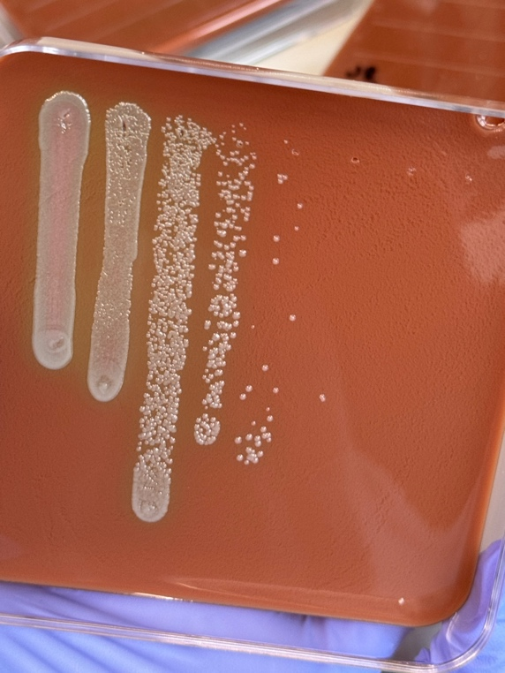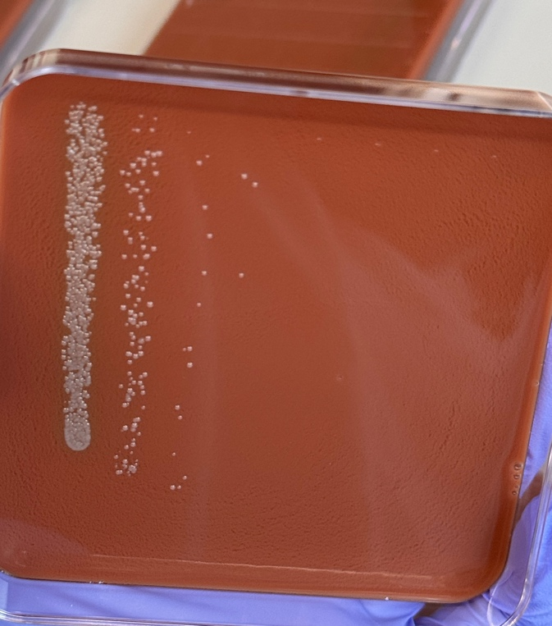
Flask 1: Day 0 Flask 6: Day 0

D0 | Dilution factor
column | 1 | 2 | 3 | 4 | 5 | 6
 | 1 | 0.1 | 0.01 | 0.001 | 0.0001 | 0.00001
1A | TMTC | TMTC | TMTC | 102 | 26 | 0
1B | TMTC | TMTC | TMTC | 49 | 12 | 0
2A | TMTC | TMTC | TMTC | TMTC | 52 | 0
2B | TMTC | TMTC | TMTC | TMTC | 42 | 0
3A | TMTC | TMTC | TMTC | TMTC | 46 | 0
3B | TMTC | TMTC | TMTC | TMTC | 43 | 0
4A | TMTC | 55 | 3 | 0 | 0 | 0
4B | TMTC | 56 | 15 | 0 | 0 | 0
5A | TMTC | 74 | 14 | 0 | 0 | 0
5B | TMTC | 70 | 7 | 0 | 0 | 0
6A | TMTC | 76 | 14 | 0 | 0 | 0
6B | TMTC | 69 | 16 | 0 | 0 | 0

Monday, April 22, 2024
To Do:
- 3rd day of serial dilution

Protocol for Freshwater Survival Assay
- Prep sterile setup for assay with these materials: reservoir, sterile multichannel pipettes (5-20uL and 50-300uL) sterile 96 well plate and sterile PBS.
- Aspectically, pour about 5-10 mL of sterile PBS into reservoir.
- Load 180 uL of sterile PBS into each “highlighted” column, don’t load PBS into first well of each column since that will be loaded with the cells.
- Load 100 uL of sample cells into each designated well
- Using the multichannel, transfer 20 uL of the sample cells from the first well into the next well. Repeat this for each well, 1A to 1B. 1B to 1C etc.
- Once all wells have been diluted (except the first wells), prep 12 plates of CHAH.
- Using the 5 – 20 uL multichannel, load 10 uL of the first column, for example, 1A, 1B, 1C, 1D, 1E, 1F, 1G, 1H, and plate the 10 uL, holding the plate at slant
- Let the liquid run down the plate, but not too fast!! Can’t allow samples to hit the bottom.
- Once all12 plates are done, incubate plates in 37 degrees Celsius for the next couple of days.

Day 1 Plate Count for Survival Assay

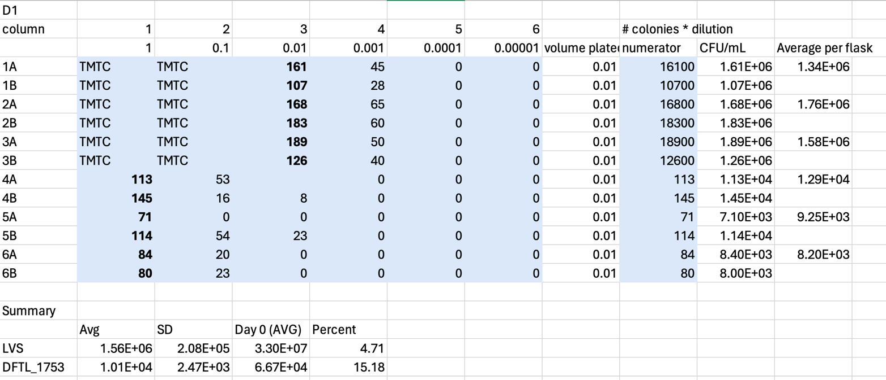

Tuesday, April 23, 2024
To Do:
- Make CHAH square plates for next serial dilution
- Prepare LB Media

Making CHAH Square Plates for Serial Dilution

For 600 mL of CHA
1. out 30.6g of cystine heart agar into 1L flask (non-baffled; 10.2g/100mL)
2. Add 300mL of ddiH₂O (type I)
3. Add stirbar to flask
4. Heat on low, stirring, for about 10 minutes (media should be totally dissolved)
5. Autoclave on 30’ liquid cycle, filling the water bin up to the height of the media
6. Cool down (ideally to ~55C)
7. Separately (before), prepare hemoglobin 2% solution
8. Add 6g freeze-dried hemoglobin to 300mL of ddiH₂O (type I)
9. Autoclave on 20’ liquid cycle with water in the bin
10. Cool down (ideally to ~55C)
11. Using sterile technique, pour hemoglobin into CHA
12. Using a 50mL pipet, aliquot 30 mL of CHAH mixture into each square plate. Try to avoid bubbles!

Thursday, April 25, 2024
To Do:
- Day 3 Plate Count
- Plate for Day 7 of Survival Assay

Day 3 of Survival Assay Plate Count

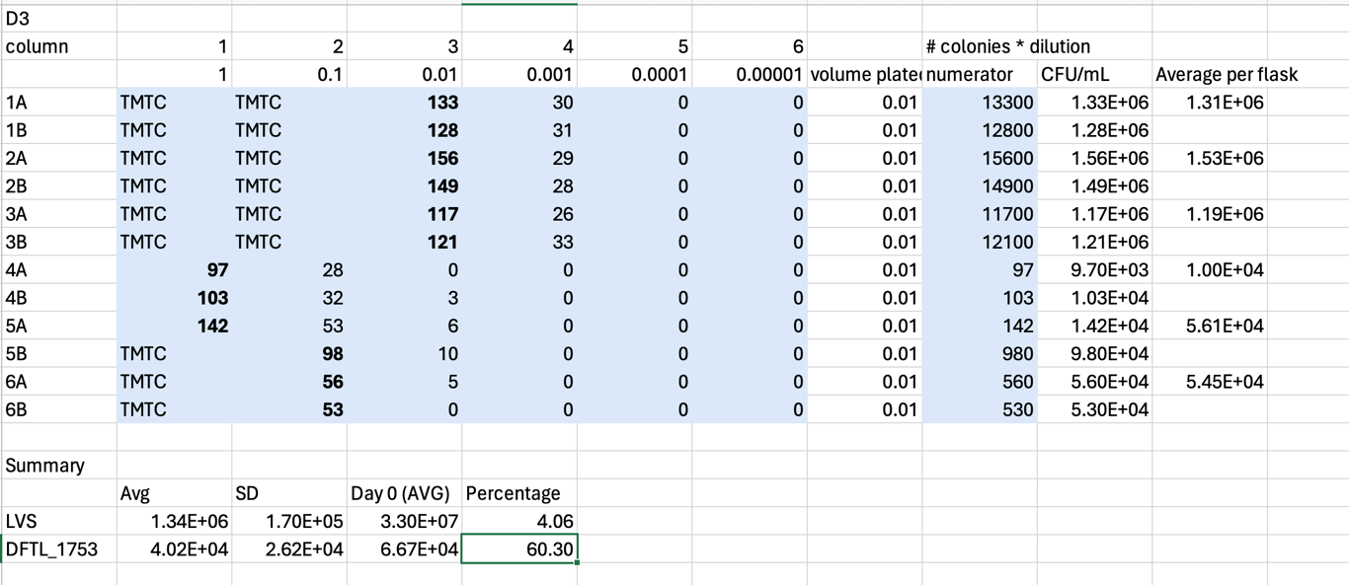

Protocol for Freshwater Survival Assay
- Prep sterile setup for assay with these materials: reservoir, sterile multichannel pipettes (5-20uL and 50-300uL) sterile 96 well plate and sterile PBS.
- Aspectically, pour about 5-10 mL of sterile PBS into reservoir.
- Load 180 uL of sterile PBS into each “highlighted” column, don’t load PBS into first well of each column since that will be loaded with the cells.
- Load 100 uL of sample cells into each designated well
- Using the multichannel, transfer 20 uL of the sample cells from the first well into the next well. Repeat this for each well, 1A to 1B. 1B to 1C etc.
- Once all wells have been diluted (except the first wells), prep 12 plates of CHAH.
- Using the 5 – 20 uL multichannel, load 10 uL of the first column, for example, 1A, 1B, 1C, 1D, 1E, 1F, 1G, 1H, and plate the 10 uL, holding the plate at slant
- Let the liquid run down the plate, but not too fast!! Can’t allow samples to hit the bottom.
- Once all12 plates are done, incubate plates in 37 degrees Celsius for the next couple of days.
Monday, April 29, 2024
To Do:
- Make CHAH square plates

Making CHAH Square Plates for Serial Dilution

For 600 mL of CHA
1. out 30.6g of cystine heart agar into 1L flask (non-baffled; 10.2g/100mL)
2. Add 300mL of ddiH₂O (type I)
3. Add stirbar to flask
4. Heat on low, stirring, for about 10 minutes (media should be totally dissolved)
5. Autoclave on 30’ liquid cycle, filling the water bin up to the height of the media
6. Cool down (ideally to ~55C)
7. Separately (before), prepare hemoglobin 2% solution
8. Add 6g freeze-dried hemoglobin to 300mL of ddiH₂O (type I)
9. Autoclave on 20’ liquid cycle with water in the bin
10. Cool down (ideally to ~55C)
11. Using sterile technique, pour hemoglobin into CHA
12. Using a 50mL pipet, aliquot 30 mL of CHAH mixture into each square plate. Try to avoid bubbles!

Thursday, May 2, 2024
To Do:
- Day 7 Plate Count
- Prep for Day 15 Survival Assay

Day 7 Plate Count
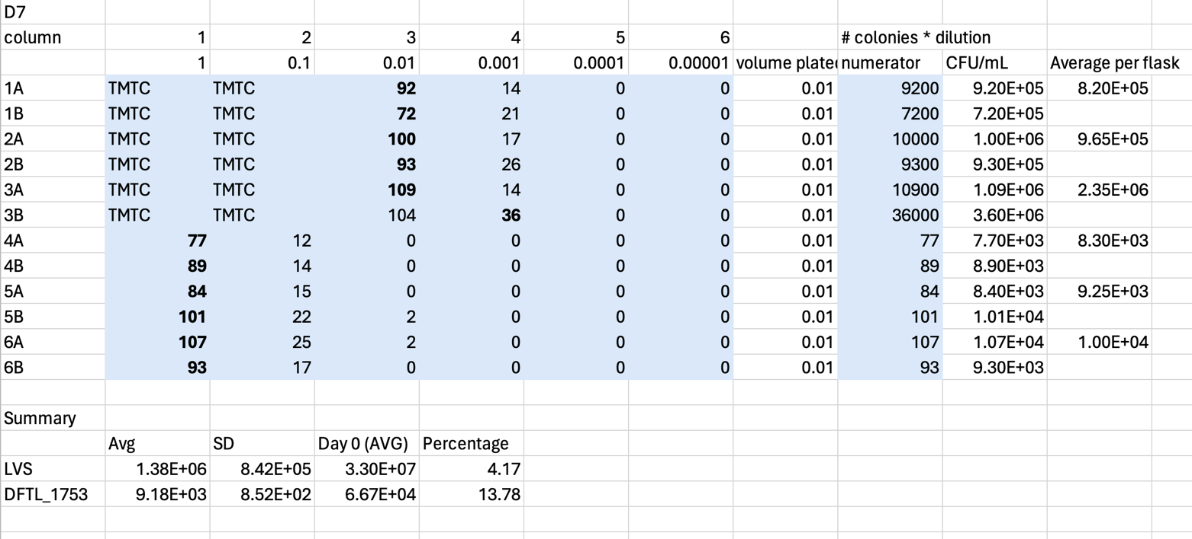

Protocol for Freshwater Survival Assay
- Prep sterile setup for assay with these materials: reservoir, sterile multichannel pipettes (5-20uL and 50-300uL) sterile 96 well plate and sterile PBS.
- Aspectically, pour about 5-10 mL of sterile PBS into reservoir.
- Load 180 uL of sterile PBS into each “highlighted” column, don’t load PBS into first well of each column since that will be loaded with the cells.
- Load 100 uL of sample cells into each designated well
- Using the multichannel, transfer 20 uL of the sample cells from the first well into the next well. Repeat this for each well, 1A to 1B. 1B to 1C etc.
- Once all wells have been diluted (except the first wells), prep 12 plates of CHAH.
- Using the 5 – 20 uL multichannel, load 10 uL of the first column, for example, 1A, 1B, 1C, 1D, 1E, 1F, 1G, 1H, and plate the 10 uL, holding the plate at slant
- Let the liquid run down the plate, but not too fast!! Can’t allow samples to hit the bottom.
- Once all12 plates are done, incubate plates in 37 degrees Celsius for the next couple of days.

Bibliography
Ramsey, K. M. and Dove, S. L. (2016) ‘ A response regulator promotes Francisella tularensis intramacrophage growth by repressing an anti-virulence factor ’, Molecular Microbiology. doi: 10.1111/mmi.13418.

