Table of Contents
September 2023 2
Patching LVS 2
Protocol for LB- Agar 2
Receiving Primers Protocol 3
PCR Protocol (updated 7/1/19) 3
Observations: 5
September 2023 6
PCR Purification Protocol: 6
Gels 7
September 2023 8
October 2023 14
Setting up to run gel 14
Gel Extraction & Purification Protocol 15
Table for purification 16
Ligation of digested DNA 16
Bibliography 17

September 2023

Tuesday, September 12, 2023
To Do:
- Patch LVS to make glycerol stocks
- Preparing LB-Agar

Patching LVS
- Sterlize workspace
- Used sterilized stick to swab LVS from vial
- Created a lawn on CHA agar
- Incubate overnight at 37°C

Protocol for LB- Agar
- For 500 mL of LB-agar, weigh out the following components and add to a 1 L (non-baffled) flask:
  - 6 g agar
  - 5 g NaCl
  - 5 g Tryptone
  - 2.5 g Yeast extract
- Add stirbar to flask
- Add 500 mL ddiH20
- Mix on stirplate until components are dissolved
- Cover top of flask with foil and add a small piece of autoclave tape
- Autoclave on 30 minute liquid cycle

Wednesday, September 13, 2023
To Do:
- Patch LVS to make glycerol stocks
- Preparing LB-Agar
- PCR Protocol
- Receiving Primers

Receiving Primers Protocol
By: Hannah Trautmann
- Spin primers at maximum speed in tabletop centrifuge for 3 minutes so dessicated primers go to the bottom of the tube.
- Add 0.1x EB to a final concentration of 100 uM. Calculate this by multiplying the reported nm by 10 and adding that volume in ul (i.e. 12.7 nmoles = add 127 uL of 0.1xEB).
- Put on 42°C heat block for 5 minutes to help primers dissolve
- Vortex and brief spin.
- Label tubes with KROL numbers on the top and put in the appropriate 100 uM stock box in the -20°C freezer.
- Optional: Make dilution for intended purpose of primer.
  - If a PCR primer, make a 10 uM stock by diluting 20 uL of the 100 uM stock into 180 uL of 0.1xEB. Label with purple sticker and put in appropriate freezer box.
  - If a sequencing primer, make a 2.5 uM stock by diluting 5 uL of the 100 uM stock into 195 uL of 0.1x EB. Label with blue sticker and put in appropriate freezer box.
- Put Certificate of Analysis sheet in “Oligos Spec Sheet” binder and shipping sheet in Invoices box.

Primer | nm | Volume to add (uL)
KROL660 | 18.6 | 186
KROL661 | 18.6 | 186
KROL662 | 17 | 170
KROL663 | 20.3 | 203

PCR Protocol (updated 7/1/19)
- Acquire and label PCR tubes. Be sure to include at least 1 positive and 1 negative control for each PCR experiment.
- Get a container of ice to keep the components on
- Acquire the following components and put them on ice, labeling tubes if necessary:
  - Molecular grade H2O in 1.5 mL microfuge tube
  - KOD/primestar buffer
  - dNTPs
  - oligo F (10uM)
  - oligo R (10uM)
  - template (eg. LVS gDNA, plasmid, colony, etc.)
  - Note: KOD/primestar enzyme should be kept in the freezer until it is used as it is expensive and should be added last
- Centrifuge the microfuge tubes to get any solution out of the microfuge tube cover
- If any of the solutions are frozen, be sure to vortex the microfuge tube in order to dissolve it (tubes with frozen components may not be homogenized)
  - DO NOT vortex the enzyme itself or any solution with enzyme because vortexing will expose it to oxygen and degrade it
- Use PCR_worksheet.xlsx to make establish the specifics of what will be added
  - The file is located in the Protocols folder
  - Also setup table below to specify which primers and source DNA will be used
- Add appropriate volume (based on PCR worksheet) of each experiment specific primer (forward and reverse) to PCR tubes
- Add ddi H2O to negative control tube
  - Template volume for 1 reaction
- Prepare a master-mix in a 1.5 mL microfuge tube by adding the following according to the worksheet and using micropipettes:
  - Add ddi H2O
  - Add dNTPs
  - Add KOD buffer
  - Add KOD enzyme
- Mix the master-mix solution by pipetting up and down
  - Do not vortex to mix
- Add appropriate volume of master-mix to negative control PCR tube
- Add template to Master Mix
  - Factor template volume minus 1 template reaction volume
- Add appropriate volume of master mix to each PCR tube (except negative control) and pipette up and down to mix (conserves tips)
- Close PCR Tubes until the caps are tight
- Place the PCR Tubes in the thermocycler on STN 1 – the following settings should be in place:
  - Heat at 94 degrees for 2 minutes,
  - 94 degrees C for 20 seconds
  - 50 degrees C for 30 seconds
  - 68 degrees C for 1 minute/kb (adjust based on expected size of product)
  - Go back to step 2
  - Repeat 32x
  - 68 degrees C for 5 minutes
  - 12 degrees C for infinity
Reaction Number | Plasmid/Region | Source DNA | Primers | Length (bps)
1 | FTL_0508_F1 | LVS gDNA | KROL660 and KROL661 | 531
2 | FTL_0508_F2 | LVS gDNA | KROL662, KROL663 | 660
3 | - controlF1 | - | KROL660, KROL661 | -
4 | -controlF2 | - | KROL662, KROL663 | -

Master Mix Table
Total reaction volume | 100
Total number of reactions | 4
 |  |  |  | Factor
Component | Stock concentration | Final concentration | 1 rxn volume | 5
ddiH2O |  |  | 62.0 | 310
PrimeSTAR GXL Buffer | 5x | 1x | 20.0 | 100
dNTPs | 2.5 mM | 0.2 mM | 8.0 | 40
oligo F | 10 uM | 0.3 uM | 3.0 | 15
oligo R | 10 uM | 0.3 uM | 3.0 | 15
template | 100 ng/ul | 2 ng/ul | 2.0
PrimeSTAR GXL DNA Polymerase | 1.25 U/ul | 0.025 U/ul | 2.0 | 10
 |  | Total volume | 100 | 490

Observations:
Christina created the template vial while I created the Master Mix. When it came to adding the Master Mix into the PCR vials, I pipetted the Master Mix into the negative controls PCR vial and Christina pipetted the Master Mix into the experimental vials.

September 2023

Thursday, September 14, 2023
To Do:
- PCR Protocol
- Receiving Primers
- Purifying PCR
- Run on Gel

PCR Purification Protocol:

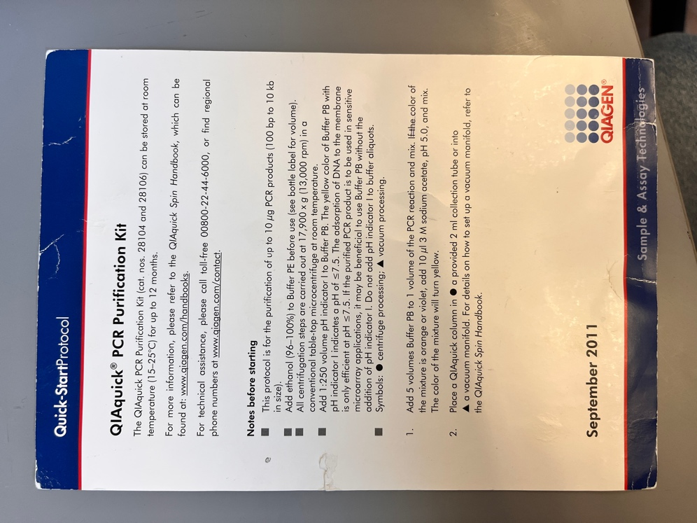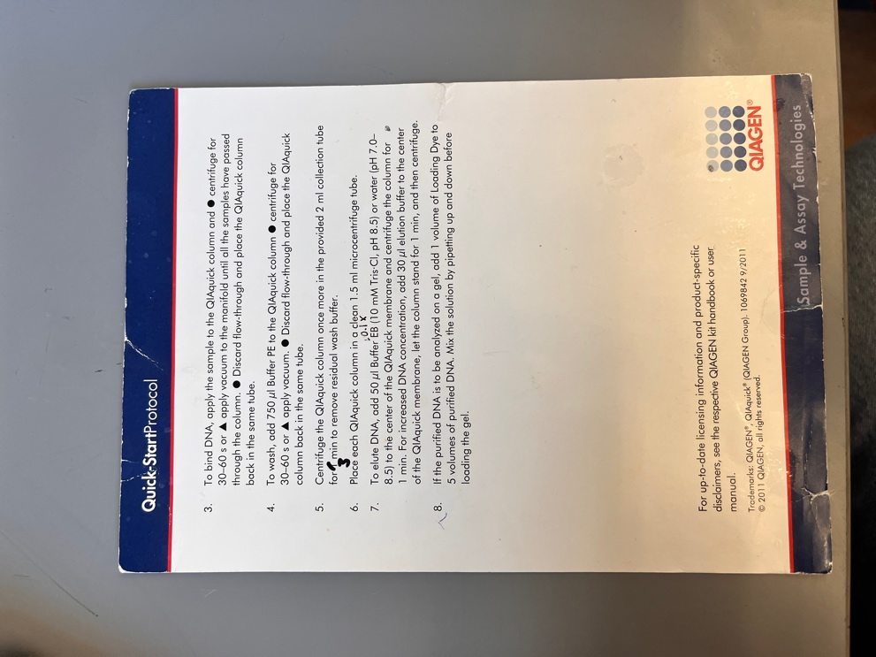

Gels
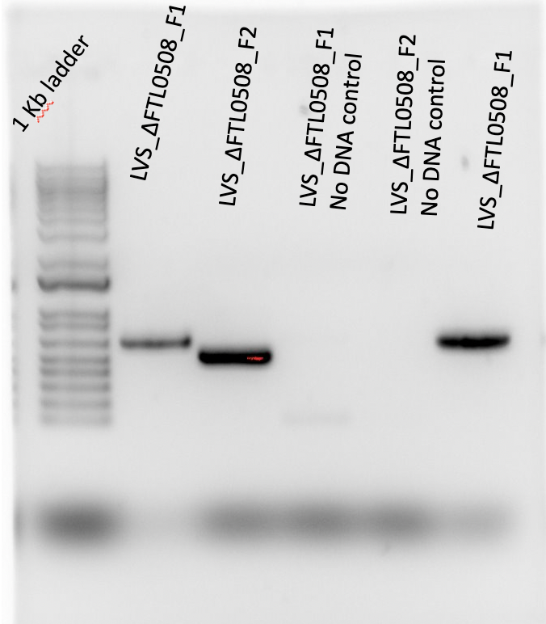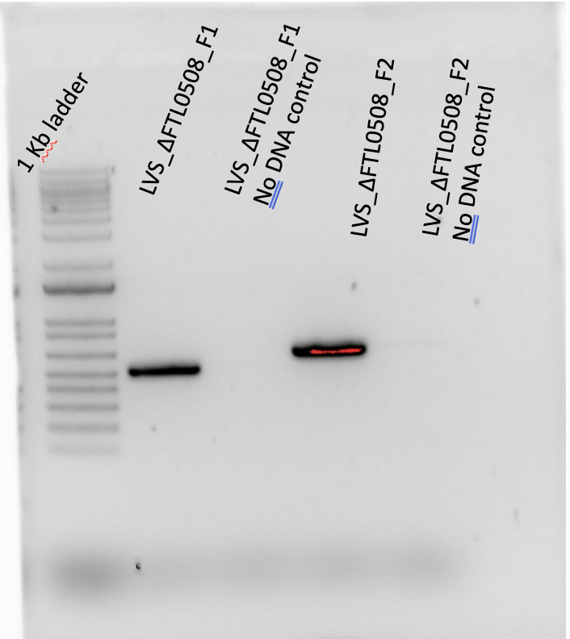

On left, is PCR protocol conducted by Christina and I. Under LVS_ΔFTL0508_F1 No DNA control is appearing to be a primer dimer (unclear for If there may have been contamination)
On right, is PCR protocol conducted by Kira. PCR protocol deemed acceptable.

September 2023

Monday, September 18, 2023
To Do:
- PCR Protocol
- Receiving Primers
- Purifying PCR
- Run on Gel
- PCR Protocol

Running PCR protocol again, refer to protocol/pcr/PCR protocol
Reaction Number | Plasmid/Region | Source DNA | Primers | Length (bps)
1 | FTL_0508_F1 | LVS gDNA | KROL660 and KROL661 | 531
3 | - controlF1 | - | KROL660, KROL661 | -

Total reaction volume | 100
Total number of reactions | 2
 |  |  |  | Factor
Component | Stock concentration | Final concentration | 1 rxn volume | 3
ddiH2O |  |  | 62.0 | 186
PrimeSTAR GXL Buffer | 5x | 1x | 20.0 | 60
dNTPs | 2.5 mM | 0.2 mM | 8.0 | 24
oligo F | 10 uM | 0.3 uM | 3.0 | 9
oligo R | 10 uM | 0.3 uM | 3.0 | 9
template | 100 ng/ul | 2 ng/ul | 2.0
PrimeSTAR GXL DNA Polymerase | 1.25 U/ul | 0.025 U/ul | 2.0 | 6
 |  | Total volume | 100 | 294

Tuesday, September 18, 2023
To Do:
- PCR Protocol
- PCR Purification
- Gels

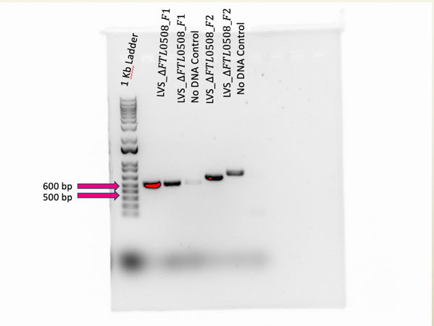

Wednesday, September 20, 2023
To Do:
- PCR Protocol
Running PCR again
Reaction Number | Plasmid/Region | Source DNA | Primers | Length (bps)
1 | FTL_0508_F1 | LVS gDNA | KROL660 and KROL661 | 531
3 | - controlF1 | - | KROL660, KROL661 | -
 | + controlF1 | - |  | -

Total reaction volume | 100
Total number of reactions | 3
 |  |  |  | Factor
Component | Stock concentration | Final concentration | 1 rxn volume | 4
ddiH2O |  |  | 62.0 | 248
PrimeSTAR GXL Buffer | 5x | 1x | 20.0 | 80
dNTPs | 2.5 mM | 0.2 mM | 8.0 | 32
oligo F | 10 uM | 0.3 uM | 3.0 | 12
oligo R | 10 uM | 0.3 uM | 3.0 | 12
template | 100 ng/ul | 2 ng/ul | 2.0
PrimeSTAR GXL DNA Polymerase | 1.25 U/ul | 0.025 U/ul | 2.0 | 8
 |  | Total volume | 100 | 392

Thursday, September 21, 2023
To Do:
- PCR Protocol
- PCR Purification
- Gels
- Digests

- Make a reaction table with desired digests:
Tube | DNA | Enzyme(s) | DNA Volume (uL) | H₂O Volume (uL)
1 | DFTL_0508_F1 | BamHI-HF and Noti-HF | 15 | -
2 | DFTL_0508_F2 | NotI-HF and KpnI-HF | 15 | -
3 | Backbone (pKR12) | BamHI-HF and KpnI-HF | 5 | 10

- Set up master mix table:
F1:
Components | Volumes in 1 reaction (uL) | Volumes in Master Mix 2x (uL)
H₂O | 10.8 | 21.6
10x Buffer* | 3 | 6
DNA | -15
BamHI | 0.6 | 1.2
NotI | 0.6 | 1.2
Total | 30.0 (15.0 actual b/c of DNA)

F2:
Components | Volumes in 1 reaction (uL) | Volumes in Master Mix 2x (uL)
H₂O | 10.8 | 21.6
10x Buffer* | 3 | 6
DNA | -15
NotI | 0.6 | 1.2
KpnI-HF | 0.6 | 1.2
Total | 30.0 (15.0 actual b/c of DNA)

Backbone:
Components | Volumes in 1 reaction (uL) | Volumes in Master Mix 2x (uL)
H₂O | 10.8 | 21.6
10x Buffer* | 3 | 6
DNA | -15
BamHI | 0.6 | 1.2
KpnI-HF | 0.6 | 1.2
Total | 30.0 (15.0 actual b/c of DNA)

*Cutsmart Buffer is used for all the “HF” enzymes. Check the NEB website for buffer compatibility with non-HF restriction enzymes.

- Add indicated amounts of H₂O and 10x buffer to master mix tube (MM).
- Add indicated amount of DNA or DNA+water (for backbone tubes) to individual tubes for digest (1.5 mL microfuge tubes for digests in incubator, PCR strip tubes for reactions incubated in the thermocycler).
- Add indicated amount of each enzyme (___uL) to the master mix tube (MM).
- Mix the master mix by pipetting up and down.
- Add master mix to individual tubes. Volume to add to each tube is the volume in 1 reaction minus the DNA volume (____ul).
- Incubate at 37°C for 1 hour
- If using digest for plasmid construction then after incubation at 37°C, add 0.5ul of CIP enzyme to backbone tube, mix by pipetting and put back in 37°C incubator for 10 minutes. (this step removes the phosphates from the ends of the plasmid to prevent re-ligation). If using the new Quick CIP – add 1 uL, mix, incubate for 10 mins, then put at 80C for 2 minutes to inactivate the CIP. Then placed into freezer

October 2023

Monday, October 16, 2023
To Do:
- Pour agarose gel
- Run agarose gel with digested DNA
- Cut out bands of DNA
- Gel purify digested DNA

Setting up to run gel
- Thawed FR1, FR2 and Backbone
- Set up agarose gel rig (used the larger, green rig bc there is more volume).
- Load 11 uL of Sybersafe (mix with column) Pour agarose gel into rig after cools. And let sit until solidified.
- Load 10 ul of 1Kb ladder dye into ladder
- Mix 6 uL of loading dye into the tube of 30 uL of FR1. Spin and vortex sample. Repeat for FR2 and backbone.
- Load FR1 after empty lane. Leave a lane empty next to FR1. Then load FR2 into lane next to empty lane. Repeat for backbone.
- Run to red when connecting power pack to casting tray. Covered tray with aluminum foil so Sybersafe does not degrade under light.
Observations:
- For FR1 & FR2, must’ve been about 27 uL when Dr. Ramsey and I tried to load the samples into the wells. Dr. Ramsey suggested that some of the sample may have been evaporated or I must’ve missed adding something into the samples, therefore resulting in a lesser volume.
- For backbone, it was the opposite and there was more volume to the sample, so about 34 uL
Picture of gel before extraction:
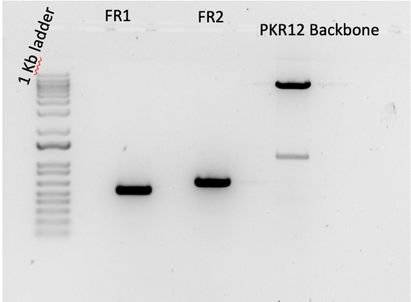
Picture of gel after extraction:
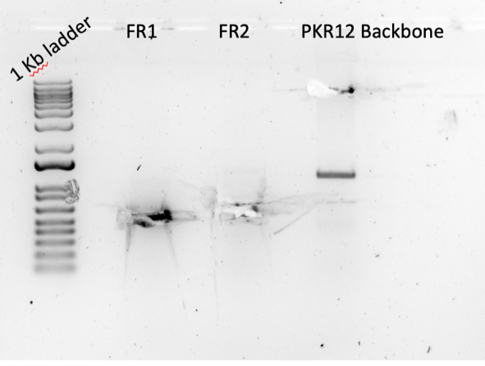

Gel Extraction & Purification Protocol
- Excise DNA fragment from agarose gel with clean, sharp scalpel
- Weigh the gel slice in a colorless tube. Add 3 volumes Buffer QG to 1 volume gel.
- Incubate at 42 C for less for 10 mins or until gel has fully dissolved. Vortex the tube every 2-3 min to help dissolve gel
- Add 1 gel volume isopropanol to the sample and mix
- Place a QIAquick spin column in a provided 2 ml collection tube into a vaccum manifold. To bind DNA, apply the sample to the QIAquick column and centrifuge for 1 min or apply to vaccum manifold. Discard and place QIAquick back into same tube
- Add 500 uL Buffer QG to column and centrifuge for 1 minute. Discard Waste
- To wash, add 750 uL Buffer PE to QIAquick column and centrifuge for 1 min. Discard flow-through and place QIAquick column back into same tube.
- Place QIAquick column into a clean 1.5 ml microcentrifuge tube
- To elute DNA add 30 uL of Buffer 0.1x EB (because of increase of DNA concentration) to center of QIAquick membrane. Let column stand for 1 min and then centrifuge for 1 min.

Table for purification
 | Gel Weight (mg) | Buffer QG (uL) | Isopropanol (uL)
FR1 | 140 | 420 | 140
FR2 | 400 | 1200 | 400
PKR12 Backbone | 290 | 870 | 290

Observations:
- Placed FR1 Digest pure, FR2 digest pure and PKR12 backbone digest pure into 20 C freezer overnight. Next day will be nanodrop measurement.

Tuesday, October 17, 2023
To Do:
- Pour agarose gel
- Run agarose gel with digested DNA
- Cut out bands of DNA
- Gel purify digested DNA
- Ligation of digested DNA

Ligation of digested DNA
- Thaw FR1, FR2 and PKR12 backbone on ice. Also thaw 10x Buffer Ligase.
- Label 2 PCR tubes. One PCR tube will have FR1, FR2, backbone, H2O, buffer ligase and ligase. The other PCR tube will have just backbone, H2O, buffer ligase and ligase because it is the control.
- Load components into each PCR tube. (Do not add ligase just yet!)
- Once you load components, vortex & spin PCR tubes with just buffer, H2O, fragments and backbone.
- Add calculated enzyme ligase into each PCR tube
- Place into thermocycler overnight at 16 C
MasterMix table
 | PCR Tube 1 | PCR Tube 2 (control)
H2O | 11.5 ul | 15.5 ul
10x ligase buffer | 2 uL | 2 uL
Insert 1 (FR1) | 4 uL | -
Insert 2 (FR2) | 4 uL | -
Backbone | 2 uL | 2 uL
Ligase enzyme | 0.5 uL | 0.5 uL
Total Volume | 20 uL | 20 uL

Observations:
- Note: Do not vortex when you add ligase. Instead you can resuspend with a 20 uL pipette
- The amount of H2O was 11.5 uL when it should have been 7.5 uL, this may have diluted the sample, making it another reason for why the ligation could not work.

Wednesday, October 18, 2023
To Do:
- Perform Transformation of ligated fragments and backbone

Transformation of PKR200
- Set up reaction table. Always include a positive and negative control for each antibiotic. If transforming plasmids (from previous plasmid prep), use 0.5 – 1 uL of plasmid. If transforming ligations, use 8 uL per ligation. If transforming plasmid, plate 20 uL and 100 uL. If transforming a ligation, plate 100 uL and remaining culture.
  - Note: The plasmid used for the positive control plates should be the regular circular plasmid, not the digest/purified one.
  - There should always be a backbone control if testing a ligation. This is the digested and ligated backbone with NO INSERT.

Reaction table
Tube number | Purpose | DNA | Volume of DNA | Final volume to plate | Number of kanamycin-containing plates
1 | (+) control | pKR12 | 1 uL | 100 ul | 1
2 | (-) control | None | 0 | 100 ul | 1
3 | Backbone Ligation | pKR12 (digested) | 8 uL | 20 uL, 200 uL | 2
4 | Ligation | Pkr200 | 8 uL | 20uL, 200 uL | 2
Total number of plates |  |  |  |  | 6

- Check to be sure you have enough LB-Kan plates with appropriate antibiotic. If plates were stored at 4°C, warm at 37°C until needed.
- Obtain DNA and thaw on ice if necessary.
- Thaw appropriate number of competent cell tubes on ice (5 reactions per tube of competent cells)
- Label sterile tubes as indicated in reaction table. Add indicated volume of indicated DNA on ice.
- When competent cells are thawed (check by probing for frozen cells using a sterile pipette tip), gently pipette 100 uL of cells into each reaction tube directly onto DNA using aseptic technique.
- Incubate cells on ice for 20 minutes. During incubation, find or set heat block to 42°C.
- Place tubes with cells and DNA onto 42°C heat block for 30 seconds (heat shock step).
- After heat shock, place tubes back on ice until next step (don’t keep them here too long).
- Using aseptic technique, add 1 mL LB (1000 uL) (no antibiotic) to each microfuge tube.
- Using autoclave tape, tape microfuge tubes down in shaking incubator set to 37°C.
- Allow cells to recover for 1 hour at 37°C, shaking. Place in a rack after shaking (NOT back on ice).
- Using aseptic technique, plate indicated amount of cells on appropriate antibiotic plates (LB-Kan), spreading until plates look dry. For “remaining” volume, spin tubes at max speed in benchtop centrifuge for 30 seconds. Remove 800 uL of media. Using 200 uL pipette, resuspend cells at bottom of tube and plate all the remaining culture.
Notes:
- Backbone ligation had ONLY backbone digest of PKR12
- Ligation had FR1, FR2, and backbone digest
- Next time, need to do two plates each instead of one plate each for negative and positive control
Thursday, October 19, 2023
To Do:
- Perform Transformation of ligated fragments and backbone
- Observations of transformation into E. coli
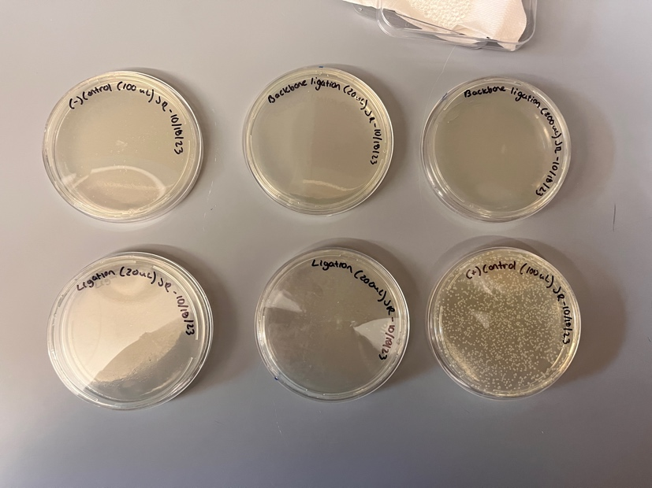
Observations:
- No growth of backbone ligation or ligation
  - The ligation did not work, this could’ve been because I did not extract enough gel DNA of FR1 therefore there may have not been enough of FR1 to ligate completely.
- Growth of (+) control

Tuesday, October 24, 2023
To Do:
- Ligation of FR1, FR2, and backbone
- Transformation of ligated fragments
- Prepared LB-Kanamycin plates

Ligation
Reaction Tables:
 |  | Reaction Mix 3X | ul needed
 |  | Backbone | 4.55
 |  | Insert 1 | 3.50
 |  | Insert 2 | 3.10
 |  | T4 Ligase buffer | 2.00
 |  | T4 ligase | 0.50
 |  | water | 6.36
 |  | total | 20 ul

 | Reaction Mix 5X | ul needed
 | Backbone | 4.55
 | Insert 1 | 5.83
 | Insert 2 | 5.17
 | T4 Ligase buffer | 2.00
 | T4 ligase | 0.50
 | water | 1.96
 | total | 20 ul

Protocol for Ligation
- Obtain ice to assemble and keep the reactions on. This is important, as the reaction happens at 16°C and the ligase buffer (which contains ATP) needs to be kept cold in order to avoid degradation. Take a 10 uL aliquot of 10X ligase buffer from the miscellaneous buffers box in the -20C.
- Obtain and label PCR tubes for the reactions. Be sure to include the date and your initials.
- To the individual tubes, add indicated amounts of H₂O, 10x buffer, insert, and backbone.
- Add indicated amount of ligase to the individual tubes. Remember to keep the ligase in a mini cooler.
- After all of the components have been added, mix each tube with a pipette set to 18 uL.
- Place in the thermocycler or water bath overnight at 16ºC. Did at room temp for 10 minutes if necessary.
Notes:
- PCR strip tubes 1&2 contained 3X Reaction Mix (Did today on 10/24)
  - PCR strip tube #2 contained just the backbone
  - PCR strip tube #1 contained inserts & backbone
- PCR strip tubes 3&4 contained 5X Reaction Mix
  - PCR strip tube #3 contained inserts and backbone
  - PCR strip tube #4 contained just backbone

Transformation into E. coli
Reaction table
Tube number | Purpose | DNA | Volume of DNA | Final volume to plate | Number of kanamycin-containing plates
1 | (+) control | pKR12 | 1 uL | 20uL,100 ul | 2
2 | (-) control | None | 0 | 20ul ,100 ul | 2
3 | Backbone Ligation | pKR12 (digested) | 8 uL | 100 uL, remaning | 2
4 | Ligation | Pkr200 | 8 uL | 100uL, remaining | 2
Total number of plates |  |  |  |  | 8
- Check to be sure you have enough LB-Kan plates with appropriate antibiotic. If plates were stored at 4°C, warm at 37°C until needed.
- Obtain DNA and thaw on ice if necessary.
- Thaw appropriate number of competent cell tubes on ice (5 reactions per tube of competent cells)
- Label sterile tubes as indicated in reaction table. Add indicated volume of indicated DNA on ice.
- When competent cells are thawed (check by probing for frozen cells using a sterile pipette tip), gently pipette 100 uL of cells into each reaction tube directly onto DNA using aseptic technique.
- Incubate cells on ice for 20 minutes. During incubation, find or set heat block to 42°C.
- Place tubes with cells and DNA onto 42°C heat block for 30 seconds (heat shock step).
- After heat shock, place tubes back on ice until next step (don’t keep them here too long).
- Using aseptic technique, add 1 mL LB (1000 uL) (no antibiotic) to each microfuge tube.
- Using autoclave tape, tape microfuge tubes down in shaking incubator set to 37°C.
- Allow cells to recover for 1 hour at 37°C, shaking. Place in a rack after shaking (NOT back on ice).
- Using aseptic technique, plate indicated amount of cells on appropriate antibiotic plates (LB-Kan), spreading until plates look dry. For “remaining” volume, spin tubes at max speed in benchtop centrifuge for 30 seconds. Remove 800 uL of media. Using 200 uL pipette, resuspend cells at bottom of tube and plate all the remaining culture.

Notes:
- Only did 3X Reaction Mix ligation for transformation today (10/24)
- Tube 1: was 1 ul of pKR12
- Tube 2: was NO DNA (no ligation)
- Tube 3: was just backbone aka PCR strip tube #2
- Tube 4: was backbone + inserts aka PCR strip tube #1

Pouring LB-Kanamycin into plates
- Add antibiotic using aseptic technique if necessary. Typical antibiotic concentrations:
Antibiotic | Stock Concentration | Working Concentration (Concentration in plates)
Ampicillin | 100 mg/mL | 100 µg/mL
Carbenicillin | 100 mg/mL | 100 µg/mL
Kanamycin | 50 mg/mL | 50 µg/mL
- Keep antibiotic stocks on ice. For kanamycin, add 500 uL to 500 mL of LB-agar media. Stir on stirplate to mix media.
- Open a new sleeve of sterile plates. Don’t open plates unless next to flame.
- Next to flame, open foil top of flask. Pass flask opening through flame.
- Open a plate next to flame and pour ~20-25 mL LB-agar into plate; the bottom of the plate should be covered in media.
- Continue to pour media into plates until media is gone.
- Immediately rinse out flask
- Stack plates and mark the side to indicate which antibiotic is used. (blue = kanamycin, black = carbenicillin / ampicillin).
- Let plates sit at room temperature for one night, then store at 4°C with tape indicating date poured. Don’t use antibiotic plates older than 3 months.

Wednesday, October 25, 2023
To Do:
- Transformation of ligated fragments of 5X Reaction Mix

Transformation into E. coli
Reaction table
Tube number | Purpose | DNA | Volume of DNA | Final volume to plate | Number of kanamycin-containing plates
1 | (+) control | pKR12 | 1 uL | 20uL,100 ul | 2
2 | (-) control | None | 0 | 20ul ,100 ul | 2
3 | Backbone Ligation | pKR12 (digested) | 8 uL | 100 uL, remaning | 2
4 | Ligation | Pkr200 | 8 uL | 100uL, remaining | 2
Total number of plates |  |  |  |  | 8
- Check to be sure you have enough LB-Kan plates with appropriate antibiotic. If plates were stored at 4°C, warm at 37°C until needed.
- Obtain DNA and thaw on ice if necessary.
- Thaw appropriate number of competent cell tubes on ice (5 reactions per tube of competent cells)
- Label sterile tubes as indicated in reaction table. Add indicated volume of indicated DNA on ice.
- When competent cells are thawed (check by probing for frozen cells using a sterile pipette tip), gently pipette 100 uL of cells into each reaction tube directly onto DNA using aseptic technique.
- Incubate cells on ice for 20 minutes. During incubation, find or set heat block to 42°C.
- Place tubes with cells and DNA onto 42°C heat block for 30 seconds (heat shock step).
- After heat shock, place tubes back on ice until next step (don’t keep them here too long).
- Using aseptic technique, add 1 mL LB (1000 uL) (no antibiotic) to each microfuge tube.
- Using autoclave tape, tape microfuge tubes down in shaking incubator set to 37°C.
- Allow cells to recover for 1 hour at 37°C, shaking. Place in a rack after shaking (NOT back on ice).
- Using aseptic technique, plate indicated amount of cells on appropriate antibiotic plates (LB-Kan), spreading until plates look dry. For “remaining” volume, spin tubes at max speed (15,000 RPM) in benchtop centrifuge for 1 minute. Remove 800 uL of media (put into waste). Using 200 uL pipette, resuspend cells at bottom of tube and plate all the remaining culture.

Notes:
- Only did 5X Reaction Mix ligation for transformation today (10/25)
- Tube 1: was 1 ul of pKR12
- Tube 2: was NO DNA (no ligation)
- Tube 3: was just backbone aka PCR strip tube #4
- Tube 4: was backbone + inserts aka PCR strip tube #3

Wednesday, October 25, 2023
To Do:
Tuesday, October 31, 2023 (Happy Halloween!)
To Do:
- Perform digest
- Run on gel

Make a reaction table with desired digests:
Tube | DNA | Enzyme(s) | DNA Volume (uL) | H₂O Volume (uL)
1 | DFTL_0508_F1 | BamHI-HF and Noti-HF | 15 | -
2 | DFTL_0508_F2 | NotI-HF and KpnI-HF | 15 | -
3 | Backbone (pKR12) | BamHI-HF and KpnI-HF | 5 | 10

Make Master Mix table:
F1:
Components | Volumes in 1 reaction (uL) | Volumes in Master Mix 2x (uL)
H₂O | 10.8 | 21.6
10x Buffer* | 3 | 6
DNA | -15
BamHI-HF | 0.6 | 1.2
NotI | 0.6 | 1.2
Total | 30.0 (15.0 actual b/c of DNA)

F2:
Components | Volumes in 1 reaction (uL) | Volumes in Master Mix 2x (uL)
H₂O | 10.8 | 21.6
10x Buffer* | 3 | 6
DNA | -15
NotI-HF | 0.6 | 1.2
KpnI-HF | 0.6 | 1.2
Total | 30.0 (15.0 actual b/c of DNA)

Backbone:
Components | Volumes in 1 reaction (uL) | Volumes in Master Mix 2x (uL)
H₂O | 10.8 | 21.6
10x Buffer* | 3 | 6
DNA | -15
BamHI-HF | 0.6 | 1.2
KpnI-HF | 0.6 | 1.2
Total | 30.0 (15.0 actual b/c of DNA)

*Cutsmart Buffer is used for all the “HF” enzymes. Check the NEB website for buffer compatibility with non-HF restriction enzymes.
- Add indicated amounts of H₂O and 10x buffer to master mix tube (MM).
- Add indicated amount of DNA or DNA+water (for backbone tubes) to individual tubes for digest (1.5 mL microfuge tubes for digests in incubator, PCR strip tubes for reactions incubated in the thermocycler).
- Add indicated amount of each enzyme (1.2 uL) to the master mix tube (MM).
- Mix the master mix by pipetting up and down.
- Add master mix to individual tubes. Volume to add to each tube is the volume in 1 reaction minus the DNA volume (15ul).
- Incubate at 37°C for 15 minutes
- If using digest for plasmid construction then after incubation at 37°C, add 0.5ul of CIP enzyme to backbone tube, mix by pipetting and put back in 37°C incubator for 10 minutes. (this step removes the phosphates from the ends of the plasmid to prevent re-ligation). If using the new Quick CIP – add 1 uL, mix, incubate for 10 mins (this will go into backbone only), then put at 80C for 2 minutes to inactivate the CIP.
Notes:
- Initially I did not aliquot 30 ul the master mix 1x reaction into the correct Dmpl 1.5 mL tubes, so I ended up adding 1ul of QuickCip to the backbone (which would make it harder to load into the gel for a later step)
- Fragment digest have been incubated for 45 minutes

Setting up to run gel
- Set up agarose gel rig (used the larger, green rig bc there is more volume).
- Load 6 uL of Sybersafe (mix with column) Pour agarose gel into rig after cools. And let sit until solidified.
- Load 10 ul of 1Kb ladder dye into ladder
- Mix 6 uL of loading dye into the tube of 30 uL of FR1. Spin and vortex sample. Repeat for FR2 and backbone.
- Load FR1 after empty lane. Leave a lane empty next to FR1. Then load FR2 into lane next to empty lane. Repeat for backbone.
- Run to red when connecting power pack to casting tray. Covered tray with aluminum foil so Sybersafe does not degrade under light.
- Run fragments and backbone until it gets a little past halfway on the gel

Wednesday, November 1, 2023
To Do:
- Gel Purification

Gel Extraction & Purification Protocol
- Excise DNA fragment from agarose gel with clean, sharp scalpel
- Weigh the gel slice in a colorless tube. Add 3 volumes Buffer QG to 1 volume gel.
- Incubate at 42 C for less for 10 mins or until gel has fully dissolved. Vortex the tube every 2-3 min to help dissolve gel
- Add 1 gel volume isopropanol to the sample and mix
- Place a QIAquick spin column in a provided 2 ml collection tube into a vaccum manifold. To bind DNA, apply the sample to the QIAquick column and centrifuge for 1 min or apply to vaccum manifold. Discard and place QIAquick back into same tube
- Add 500 uL Buffer QG to column and centrifuge for 1 minute. Discard Waste
- To wash, add 750 uL Buffer PE to QIAquick column and centrifuge for 1 min. Discard flow-through and place QIAquick column back into same tube.
- Place QIAquick column into a clean 1.5 ml microcentrifuge tube
- To elute DNA add 30 uL of Buffer 0.1x EB (because of increase of DNA concentration) to center of QIAquick membrane. Let column stand for 1 min and then centrifuge for 1 min.

Table for purification
 | Weight of Tube | Tube w/ gel weight | Gel weight (mg) | QG Volume | Isopropanol Volume
FR1 | 1.13 | 1.45 | 320 | 960 | 320
FR2 | 1.12 | 1.34 | 220 | 660 | 220
Backbone | 1.12 | 1.54 | 420 | 1260 | 420

Thursday, November 2, 2023
To Do:
- Ligation of fragments and backbone
- Transformation into E. coli

Protocol for Ligation
- Obtain ice to assemble and keep the reactions on. This is important, as the reaction happens at 16°C and the ligase buffer (which contains ATP) needs to be kept cold in order to avoid degradation. Take a 10 uL aliquot of 10X ligase buffer from the miscellaneous buffers box in the -20C.
- Obtain and label PCR tubes for the reactions. Be sure to include the date and your initials.
- To the individual tubes, add indicated amounts of H₂O, 10x buffer, insert, and backbone.
- Add indicated amount of ligase to the individual tubes. Remember to keep the ligase in a mini cooler. Put 1.5 ul in mastermix
- After all of the components have been added, mix each tube with a pipette set to 18 uL.
- Place in the thermocycler or water bath overnight at 16ºC. Did at room temp for 10 minutes if necessary.
Reaction Table for ligation:

Component | Reaction 1 (uL) | Reaction 2 (uL) | Master Mix (3x)
H₂O | 11.5 | 11.5 | 34.5
10x ligase buffer | 2.0 | 2.0 | 6
Insert | 4.0 | - | -
Backbone | 2.0 | 2.0 | 6
Ligase | 0.5 | 0.5 | 1.5
TOTAL | 20.0 | 20.0 | 48

Transformation into E. coli
Reaction table
Tube number | Purpose | DNA | Volume of DNA | Final volume to plate | Number of kanamycin-containing plates
1 | (+) control | pKR12 | 1 uL | 20uL,100 ul | 2
2 | (-) control | None | 0 | 20ul ,100 ul | 2
3 | Backbone Ligation | pKR12 (digested) | 8 uL | 100 uL, remaning | 2
4 | Ligation | Pkr200 | 8 uL | 100uL, remaining | 2
Total number of plates |  |  |  |  | 8
- Check to be sure you have enough LB-Kan plates with appropriate antibiotic. If plates were stored at 4°C, warm at 37°C until needed.
- Obtain DNA and thaw on ice if necessary.
- Thaw appropriate number of competent cell tubes on ice (5 reactions per tube of competent cells)
- Label sterile tubes as indicated in reaction table. Add indicated volume of indicated DNA on ice.
- When competent cells are thawed (check by probing for frozen cells using a sterile pipette tip), gently pipette 100 uL of cells into each reaction tube directly onto DNA using aseptic technique.
- Incubate cells on ice for 20 minutes. During incubation, find or set heat block to 42°C.
- Place tubes with cells and DNA onto 42°C heat block for 30 seconds (heat shock step).
- After heat shock, place tubes back on ice until next step (don’t keep them here too long).
- Using aseptic technique, add 1 mL LB (1000 uL) (no antibiotic) to each microfuge tube.
- Using autoclave tape, tape microfuge tubes down in shaking incubator set to 37°C.
- Allow cells to recover for 1 hour at 37°C, shaking. Place in a rack after shaking (NOT back on ice).
- Using aseptic technique, plate indicated amount of cells on appropriate antibiotic plates (LB-Kan), spreading until plates look dry. For “remaining” volume, spin tubes at max speed (15,000 RPM) in benchtop centrifuge for 1 minute. Remove 800 uL of media (put into waste). Using 200 uL pipette, resuspend cells at bottom of tube and plate all the remaining culture.

Sunday, November 5, 2023
To Do:
- Count colonies of E. Coli
- Perform overnight cultures

Counting colonies on ligation plates
Plates: | (+) ctrl, 20ul | (+) ctrl, 200 ul | (-) ctrl, 20 ul | (-) ctrl, 200 ul | BB only 20 ul | BB only, 200ul | Ligation, 100ul | Ligation R
# of colonies | too many to count | too many to count | 0 | 0 | 0 | 0 | 2 | 23

Overnight Cultures Protocol

- Add 45 30 mL of LB broth to a sterile 50 mL conical (makes enough for 8 tubes: 9*5=45)
- Add 45 30 uL of kanamycin (Kan50) to the conical.
- Label 5 glass sterile test tubes for each new plasmid and 2 for each existing plasmid (controls are not needed).
- Pipette out 5 mL (serological) of LB + Kan media into each of the tubes.
- Pick 5 colonies from each reaction and inoculate the tube.
  - Do this by using a stick and picking an isolated colony from plate (Remember to flame the tube before and after)
- Place in the 37º shaking incubator overnight. ~16-22 hours

Monday, November 6, 2023
To Do:
- Miniprep of overnight cultures

Miniprep Protocol

- Pellet 1-5 ml bacterial overnight culture by centrifugation at >8000 rpm for 3 min room temp
- Resuspend pelleted bacterial cells in 250 ul Buffer P1 and transfer to microcentrifuge tube (from fridge)
- Add 250 ul Buffer P2 and mix thoroughly by inverting tube 4-6 times until solution becomes clear. Do not allow lysis reaction to proceed for more than 5 min.
- Add 350 ul Buffer N3 and mix immediately and thoroughly by inverting the tube 4-6 times
- Centrifuge for 10 min at 13000 rpm
- Apply 800 ul supernatant from step 5 to the QIAprep 2.0 spin column by pipetting. Centrifuge for 30-60s and discard the flow through
- Recommended: Wash the QIAprep 2.0 spin column by adding 0.5 ml Buffer PB. Centrifuge for 30-60s and discard flow through
- Wash QIAprep 2.0 spin column by adding 0.75 ml Buffer PE. Centrifuge for 30-60s and discard flow through (do 3 times?) Transfer QIAprep 2.0 spin column to collection tube
- Centrifuge 3 min to remove residual wash buffer
- Place QIAprep 2.0 column in a clean 1.5 ml microcentrifuge tube. To elute DNA, add 50 ul Buffer 0.1x EB, let stand for 1 minute and centrifuge for 1 min.
- If extracted DNA is to be analyzed on a gel, add 1 volume of loading dye to 5 ul volumes of purified DNA. Mix the solution by pipetting up and down before loading
Notes:
- I had to dilute the purified sample by a 1:10 ratio using 0.1x EB Buffer. I organized the PCR strip tubes 1, 2, 3, and 4. In each strip I pipetted 5 ul of DNA and added 45 ul of 0.1x EB Buffer for a total of 50 ul.

Wednesday, November 21, 2023
To do:
- Prepare TSA, LB and MHA media

Preparing MHB Media
1.Weigh out 10.5g of Mueller-Hinton broth into 1L square-bottle
2. Add 500mL of ddiH₂O (type I)
4. Cool down to 37 ̊C or cooler
5. Can keep this sterile media indefinitely without supplements
6. Add 5mL of 10% glucose
7. Add 5mL of 2.5% iron pyrophosphate
8. Add isovitalex (combine 10mL from liquid vial with solids, add entire volume to broth)
9. Can keep this supplemented media for 2 weeks, storing at 4 ̊C

Preparing LB Media
- For 250 mL of LB, weigh out the following components and add to a 500 mL bottle:
  - 2.5 g NaCl -> 5.0g
  - 2.5 g Tryptone -> 5.0g
  - 1.25 g Yeast extract -> 2.50 g
- Add 500 mL type I ddiH20
- Close tightly and shake to mix
- Loosen cap and add a small piece of autoclave tape with the date
- Autoclave on 30 minute liquid cycle
Sterile media can be stored indefinitely

TSA x 2
- 15g of tryptic soy
- 7.5 g of agar
- 500 ml water

Monday, November 27, 2023
To do:
- Patching LVS

Patching LVS
- Sterlize workspace
- Used sterilized stick to swab LVS from vial
- Created a lawn on CHA agar
- Incubate overnight at 37°C

Tuesday, November 28, 2023
To do:
- Make glycerol stocks
- Electroporation into LVS

Electroporation into LVS
From Allelic exchange protocol; Edited by Hannah Trautmann

Prepare electrocompetent (EC) cells
-Scrape up entire plate of cells into 400 uL of sterile 10% sucrose and resuspend (alternately, cells can be grown to mid-log in MHB)
-Add 1.1 mL of 10% sucrose to a final volume of 1.5 mL
-Spin for 3 minutes at 10,000 rpm
-remove supernatant, throw out, and resuspend in fresh 1 mL 10% sucrose
-Repeat 3x-5x in 10% sucrose
-After final spin, remove all supernatant.
-Resuspend cells in 10% sucrose at high density (corresponding to ~1x10¹¹ cells /mL); these are EC cells by slowly adding 110 uL at a time. It should be about equal amounts of cells as sucrose.
-For any extra EC cells, aliquot ~110 μL / sterile tube (enough for 2 electroporations) and freeze at -80°C

Electroporate plasmid into EC cells*
-For each electroporation, aliquot 4 mL MHB into glass test tubes for recovery, warm in shaker at 37°C
-For each electroporation, in a 2 mm sterile electroporation cuvette, combine:
5 μL of pEX-based allelic exchange construct or Tn7 plasmids (mini-prep concentration, at least 100 ng/μL)
*for pF-based plasmids, can use 3 ul
50 μL electrocompetent cells
-Have recovery media ready
-Electroporate using the following settings: 2.5 kV, 25 μF, and 600 Ω
-Immediately after individual electroporations, use 1 mL warm recovery media from test tube to wash cells out of cuvette and transfer cells to recovery test tube
-Recover cells for 4-8 hours, shaking at 37°C
*For pF-based plasmids, only recover 2-3 hours
-For pEX plasmids: pellet cells by centrifugation in sterile 2 mL tubes, 1’ at 10,000 x g. Plate on CHAH-Kan plates, using 1 plate for each 2 mL tube (2 plates per electroporation)
- Two 2ml tubes for each tube
- spin for 1 min, 10,000
-spread with beads

*For pF-plasmids: plate 10 ul and 100 ul on CHAH-kan plates
*For Tn7 plasmids: plate 100 ul and remaining on CHAH-kan plates
-Incubate plates at 37°C for 3 days (or until single colonies appear)

*Always include a control electroporation with no plasmid. Eventually single break-through colonies may start appearing; at that point, single colonies on the experimental plates are also likely to just be break-through growth.

Notes:
- Kira did the first half of the protocol where she prepared the electrocompetent cells and then electroporated plasmid into EC cells up to recovering the cells in the shaking incubator for 4-8 hours
- I picked up on the part where I pelleted the cells by centrifugation and spread plated the cells on CHAH-Kan plates, will incubate plates for 37C for 3 days

Thursday, November 30, 2023
To do:
- Make sucrose plates

Protocol for Sucrose Plates
2% hemoglobin (can make ahead and store at 4°C)
Mix 6 g freeze-dried hemoglobin with 300 mL type I ddiH₂O in 1 L flask
Autoclave 20’
Can make extra and aliquot to sterilized 100 mL bottles for later use

50% sucrose
Combine 360 g of sucrose and enough type I ddiH₂O to make 720 mL.
Autoclave for 20’.
Suggested method: in 1 L beaker, add ~100 g increments of sucrose into ~250 mL type I ddiH₂O, heating slightly (below boiling point!) and waiting for each addition to be completely dissolved before adding next mass of sucrose. Measure final volume in graduated cylinder and add type I ddiH₂O until volume is 720 mL.

Cystine heart agar with hemoglobin (CHAH plates) and CHAH plates with kanamycin x2 FLASKS
Mix 30.6 g cystine heart agar (Difco #247100) with 300 mL type I ddiH₂O
Autoclave 30’, being very careful media does not boil over
While autoclaving, warm 300 mL of 2% hemoglobin (in 50°C oven or in water bath at 55°C)
Place CHA flask in 50°C oven or in water bath at 55°C, let temperature equilibrate
Wipe down flask and bottles with ethanol and using sterile technique, pour hemoglobin into CHA flask
FOR CHAH-Kan plates:
Add 60 μL of 50 mg/mL kanamycin
Mix media
Use sterile pipette, pour ~24 mL media per plate (25 plates for 600 mL media)

CHAH plates with 10% sucrose
Mix:
5 g Beef Heart Infusion
5 g Protease Peptone
5 g Glucose
0.5 g L-Cystine
7.5 g Agar
with 150 mL type I ddiH₂O. Stir on low heat until completely dissolved, about 10 minutes.
Autoclave 30’, being EXTREMELY careful media does not boil over
While autoclaving, warm 250 mL of 2% hemoglobin and sterilized 50% sucrose (in 50°C oven or in water bath at 55°C)
Place CHA flask in 50°C oven or in water bath at 55°C, let temperature equilibrate
Wipe down flask and bottles with ethanol and using sterile technique, pour hemoglobin into CHA flask
Add 100 mL 50% sucrose to CHA-hemoglobin flask
Mix media
Use sterile pipette, pour ~24 mL media per plate (~20 plates for 500 mL media)

December 2023

Friday, December 1, 2023
To do:
- Patch out F. tularensis colonies on plates

Patch F. tularensis on CHAH-Kan plates
      - Aseptically pick a colony from original plates
      - Streak for isolation on CHAH-Kan plates in 3 quadrants for each colony
      - Let sit in room temperature over the weekend

Monday, December 4, 2023
To do:
- Patching LVS

Patching LVS
1. Sterlize workspace
- Used sterilized stick to swab LVS from vial
- Created a lawn on CHA agar
- Incubate overnight at 37°C

Tuesday, December 5, 2023
To do:
- Electroporation into LVS

Electroporation into LVS
From Allelic exchange protocol; Edited by Hannah Trautmann

Prepare electrocompetent (EC) cells
-Scrape up entire plate of cells into 400 uL of sterile 10% sucrose and resuspend (alternately, cells can be grown to mid-log in MHB)
-Add 1.1 mL of 10% sucrose to a final volume of 1.5 mL
-Spin for 3 minutes at 10,000 rpm
-remove supernatant, throw out, and resuspend in fresh 1 mL 10% sucrose
-Repeat 3x-5x in 10% sucrose
-After final spin, remove all supernatant.
-Resuspend cells in 10% sucrose at high density (corresponding to ~1x10¹¹ cells /mL); these are EC cells by slowly adding 110 uL at a time. It should be about equal amounts of cells as sucrose.
-For any extra EC cells, aliquot ~110 μL / sterile tube (enough for 2 electroporations) and freeze at -80°C

Electroporate plasmid into EC cells*
-For each electroporation, aliquot 4 mL MHB into glass test tubes for recovery, warm in shaker at 37°C
-For each electroporation, in a 2 mm sterile electroporation cuvette, combine:
5 μL of pEX-based allelic exchange construct or Tn7 plasmids (mini-prep concentration, at least 100 ng/μL)
*for pF-based plasmids, can use 3 ul
50 μL electrocompetent cells
-Have recovery media ready
-Electroporate using the following settings: 2.5 kV, 25 μF, and 600 Ω
-Immediately after individual electroporations, use 1 mL warm recovery media from test tube to wash cells out of cuvette and transfer cells to recovery test tube
-Recover cells for 4-8 hours, shaking at 37°C
*For pF-based plasmids, only recover 2-3 hours
-For pEX plasmids: pellet cells by centrifugation in sterile 2 mL tubes, 1’ at 10,000 x g. Plate on CHAH-Kan plates, using 1 plate for each 2 mL tube (2 plates per electroporation)
*For pF-plasmids: plate 10 ul and 100 ul on CHAH-kan plates
*For Tn7 plasmids: plate 100 ul and remaining on CHAH-kan plates
-Incubate plates at 37°C for 3 days (or until single colonies appear)

*Always include a control electroporation with no plasmid. Eventually single break-through colonies may start appearing; at that point, single colonies on the experimental plates are also likely to just be break-through growth.

Friday, December 8, 2023
To do:
- Patch out F. tularensis colonies on plates

Patch F. tularensis on CHAH-Kan plates
      - Aseptically pick a colony from original plates
      - Streak for isolation on CHAH-Kan plates in 3 quadrants for each colony
Let sit in room temperature over the weekend

Monday, December 11, 2023

To do:
- Patching LVS

Patching LVS
1. Sterlize workspace
- Used sterilized stick to swab LVS from vial
- Created a lawn on CHA agar
- Incubate overnight at 37°C

Tuesday, December 12, 2023
To do:
- Electroporation into LVS

Electroporation into LVS
From Allelic exchange protocol; Edited by Hannah Trautmann

Prepare electrocompetent (EC) cells
-Scrape up entire plate of cells into 400 uL of sterile 10% sucrose and resuspend (alternately, cells can be grown to mid-log in MHB)
-Add 1.1 mL of 10% sucrose to a final volume of 1.5 mL
-Spin for 3 minutes at 10,000 rpm
-remove supernatant, throw out, and resuspend in fresh 1 mL 10% sucrose
-Repeat 3x-5x in 10% sucrose
-After final spin, remove all supernatant.
-Resuspend cells in 10% sucrose at high density (corresponding to ~1x10¹¹ cells /mL); these are EC cells by slowly adding 110 uL at a time. It should be about equal amounts of cells as sucrose.
-For any extra EC cells, aliquot ~110 μL / sterile tube (enough for 2 electroporations) and freeze at -80°C

Electroporate plasmid into EC cells*
-For each electroporation, aliquot 4 mL MHB into glass test tubes for recovery, warm in shaker at 37°C
-For each electroporation, in a 2 mm sterile electroporation cuvette, combine:
5 μL of pEX-based allelic exchange construct or Tn7 plasmids (mini-prep concentration, at least 100 ng/μL)
*for pF-based plasmids, can use 3 ul
50 μL electrocompetent cells
-Have recovery media ready
-Electroporate using the following settings: 2.5 kV, 25 μF, and 600 Ω
-Immediately after individual electroporations, use 1 mL warm recovery media from test tube to wash cells out of cuvette and transfer cells to recovery test tube
-Recover cells for 4-8 hours, shaking at 37°C
*For pF-based plasmids, only recover 2-3 hours
-For pEX plasmids: pellet cells by centrifugation in sterile 2 mL tubes, 1’ at 10,000 x g. Plate on CHAH-Kan plates, using 1 plate for each 2 mL tube (2 plates per electroporation)
*For pF-plasmids: plate 10 ul and 100 ul on CHAH-kan plates
*For Tn7 plasmids: plate 100 ul and remaining on CHAH-kan plates
-Incubate plates at 37°C for 3 days (or until single colonies appear)

*Always include a control electroporation with no plasmid. Eventually single break-through colonies may start appearing; at that point, single colonies on the experimental plates are also likely to just be break-through growth.

Notes:
- Pipette 1.3 mL of supernatant into waste to prevent cells from spilling cells

Bibliography

Ramsey, K. M. and Dove, S. L. (2016) ‘ A response regulator promotes Francisella tularensis intramacrophage growth by repressing an anti-virulence factor ’, Molecular Microbiology. doi: 10.1111/mmi.13418.

