Table of Contents
May 2023 4
QIAquick Gel Extraction 5
Nano-Glo® Luciferase Assay Protocol 6
Miniprep of pKR147 from Minimal Media 8
Ligation for LanYFP (pKR189) and iLov (pKR190) Plasmids 9
JUNE 2023 10
Transforming Chemically Competent E. coli 10
Pelleting MRE600 Cells for Ribosome Purification 11
Primer Design for Intermediate Plasmid 12
Figure. A first set of primers with a Ser-Gly-Arg linker at the NotI cut site. 13
Figure. A second set of primers with an Ala-Ala-Ala linker at the NotI cut site. 13
Sample Loading Buffer Recipe 14
Hemoglobin 2% Solution 14
Miniprep of plasmids pKR189 (LanYFP) and pKR190 (iLov) 15
Figure. Yellow supernatant (L) compared to natural supernatant (R). 15
Table. Nanodrop concentrations of Miniprepped pKR189 and pKR190 16
Preparation of 70S Ribosomes for Biochemistry 16
Sequence Reactions Protocol 17
PCR (20 uL Reaction) for Intermediate Plasmid 18
Miniprep of pKR189 and pKR190 Samples 20
Table. Concentrations of pKR189 and pKR190 samples via Nanodrop 21
Sequence Reactions Protocol 21
Figure. Sequencing submission form for pKR189 and pKR190. 22
PCR Gel 22
Figure. PCR gel with ladder, nLuc fragment (543 bp), pdpA/tul4 UTR fragment (179 bp), positive control, and negative controls. 23
PCR (100 uL Reaction) 23
Master Mix 23
Individual Reactions 24
Sequence Reactions Protocol 25
PCR Purification 25
Restriction Digest 26
PCR Gel 27
Figure. PCR gel with ladder, nLuc fragment (543 bp), pdpA/tul4 UTR fragment (179 bp), positive control, and negative controls. 28
Filtering 10 uM KROL672 and KROL673 Stocks with 100 K MWCO 29
PCR (20 uL Reaction) for Intermediate Plasmid 29
Master Mix 30
Individual Reactions 30
PCR Gel 31
Figure. PCR gel with ladder, nLuc fragment (543 bp), pdpA/tul4 UTR fragment (179 bp), positive control,andnegativecontrols. Discarded PCR tubes from restriction enzyme digestion that had been incubating overnight. We will have to rerun this after receiving the new primers. 32
PCR Gel 33
Figure. PCR gel with ladder, nLuc fragment (543 bp), pdpA/tul4 UTR fragment (179 bp), positive control, and negative controls. 34
PCR (20 uL Reaction) 34
Master Mix 35
Individual Reactions 35
PCR Gel 36
Figure. PCR gel with ladder, gDNA, positive control, negative control, and the primers with potential contamination. 37
PCR (20 uL Reaction) 37
Master Mix 38
Individual Reactions 38
PCR Gel 39
Figures. PCR gel with ladder, reactions 1-5, reactions 6-10, and reaction 11. Bottom image was adjusted to show bands more distinctly. 40
Made more 1% agarose gel: 41
Made 2x500 mL flasks of LB: 41
Made 2x500 mL flasks of MHB: 41
PCR Gel 41
Figures. PCR gel with ladder, reactions 1-5, reaction 6, and reaction 4 from 6/21/23. Bottom image was adjusted to show bands more distinctly. 42
PCR (20 uL Reaction) for Intermediate Plasmid 43
Master Mix 43
Individual Reactions 43
PCR Gel 44
Figure. PCR gel with ladder, old (contaminated primers), new primers (from 100 uM stocks), and positive control. 45
July 2023 46
Lab Tasks – Media Preparation 46
CHA Mix 46
Hemoglobin 2% Solution 46
20 ul PCR Protocol 47
Master Mix 47
Individual Reactions Volumes 48
20 ul PCR Protocol 49
Master Mix 49
Individual Reactions Volumes 49
PCR Purification 51
Restriction Digest 51
Miniprep of pKR206 and pKR207 52
Prepare samples for sequencing 53
Sequence Reactions Protocol 54
Bibliography 56

May 2023

Wednesday, May 24, 2023
To Do:
- Reviewed lab tasks
- Set up bench space
- Set up lab notebook
- Filled out mentor-mentee compact
Results and Data:
- We went down to the loading dock and took our biohazard waste and trash
- Learned about different pipettes and tools I will be using frequently
- We reviewed steps on cloning and the basic process

Friday, May 26, 2023
To Do:
- Design plasmid for in vitro assay
- Observe in vitro assay with purified E. coli ribosomes
- Gel purification
Results and Data:

NOTES:
- Plasmid design notes
  - Snap gene program(can design plasma and primers- hep w PCR reaction)
    - Can construct something before building it in lab
  - plasmid contain genes that bacteria like to keep because it gives them some properties(like antibiotic resistance)- bacteria can transfer plasmids from one cell to another
    - replicates independently from rest of the bacterial DNA
    - promotors activate certain region for transcription
    - restriction sights is where restriction enzumes cut
  - to Modify 5 ́ untranslated region (UTR) of pdpA to include a perfect Shine
    - ideal SD matches up( AGGAGG)- binds to anti SD on ribosome
    - hannahs info
      - when SD is perfect- translation of PdpA is not significantly impacted by presence or absence of BS21-2 but when you have a modified SD sequence(bad or naturally occurring), the prfesence of BS21-2 causes a higher level of translation than when it is absent
      - BS21-2 most abundant that’s why were using it
      - Design primers that tell RNA. Polymerase where to start copying
        - Copy it and change sequence to paste it back
        - Want forward and reverse primer (half point arrows)
          - Only sequence between gets copied
- Transcription vs translation
  - Transcription is first step in gene expression
  - Copies into from dna(double stranded) to Rna(single stranded)
  - Enzymes called RNA polymerase- copy the stand and make long chain of RNA
  - T7 RNA polymerase- extracted from T7 bacterial phase a virus
  - Start transcribing at promotor and ends at terminator
- Next stage Translation
  - From RNA to protein- happened in ribosome (made up of 2 subunits - 30s and 50s subunit)
  - RNA is fed through ribosome and as it encounters a specific region w/I ribosome, its matched up w molecules of TRNA
  - RNA that goes into ribosome is mRNA(messenger RNA)
  - Ribosome paired onto that is tRNA(transfer RNA)
  - tRNA has an amino acid at end of it that is joined together to form protein
  - steps: initiation, elongation, termination

- PdpA
  - Gene in francisella - associated w infections properties of francicella
  - BS21 has an effect on regulating the translation of PdpA gene through its interaction with the SD sequence
  - Causes disease tularemia
  - franc. Has clusters of genes called franc. Pathogenicity island
  - part of pathogenicity island

- 5’3’ ends of DNA and RNA
  - 1 prime carbon is connect to base(ACT or G)
  - 5 prime is connected to phosphate
  - Processes are directional

- Shine delgarno sequence
  - Ribosomal binding site in bacterial and mRNA(helps ribosome know where to bind)
  - Generally located around 8 bases up of AUG- start codon – met
  - Ligation is paste step

QIAquick Gel Extraction

All centrifugation steps are carried out at 17,900 x g (13,000 rpm) in a conventional table-top microcentrifuge.
- Excise the DNA fragment from the agarose gel with a clean, sharp scalpel.
- Weigh the gel slice in a colorless tube (50 mL conical). Add 3 volumes Buffer QG to 1 volume gel (100 mg gel ~100 μl). The maximum amount of gel per spin column is 400 mg. For &gt;2% agarose gels, add 6 volumes Buffer QG.

 | Gel Weight  (mg) | Gel Volume  (uL) | Buffer Volume  (uL)
LanYFP | 40 | 40 | 120
iLov | 70 | 70 | 210
Backbone | 50 | 50 | 150

- Incubate at 50°C for 10 min (or until the gel slice has completely dissolved). Vortex the tube every 2–3 min to help dissolve gel. After the gel slice has dissolved completely, check that the color of the mixture is yellow (similar to Buffer QG without dissolved agarose). If the color of the mixture is orange or violet, add 10 μl 3 M sodium acetate, pH 5.0, and mix. The mixture turns yellow.
- Add 1 gel volume isopropanol to the sample and mix.
- Place a QIAquick spin column in a provided 2 ml collection tube or into a vacuum manifold. To bind DNA, apply the sample to the QIAquick column and centrifuge for 1 min or apply vacuum to the manifold until all the samples have passed through the column. Columns have a max of agarose they can handle, so you might have to split in two. Discard flow-through and place the QIAquick column back into the same tube. For sample volumes &gt;800 μl, load and spin/apply vacuum again.
- If DNA will subsequently be used for sequencing, in vitro transcription, or microinjection, add 500 μl Buffer QG to the QIAquick column and centrifuge for 1 min or apply vacuum. Discard flow-through and place the QIAquick column back into the same tube. Repeated this step one more time to get rid of residual agarose.
- To wash, add 750 μl Buffer PE to QIAquick column and centrifuge for 1 min or apply vacuum. Discard flow-through and place the QIAquick column back into the same tube. Repeated this step one more time.
  - Note: If the DNA will be used for salt-sensitive applications (e.g., sequencing, bluntended ligation), let the column stand 2–5 min after addition of Buffer PE.
  - Centrifuge the QIAquick column in the provided 2 ml collection tube for 1 3 min to remove residual wash buffer.
- Place QIAquick column into a clean 1.5 ml microcentrifuge tube.
- To elute DNA, add 50 μl Buffer 0.1X EB (10 mM Tris·Cl, pH 8.5) or water to the center of the QIAquick membrane and centrifuge the column for 1 min. For increased DNA concentration, add 30 μl Buffer EB to the center of the QIAquick membrane, let the column stand for 1 min, and then centrifuge for 1 min. After the addition of Buffer 0.1X EB to the QIAquick membrane, increasing the incubation time to up to 4 min can increase the yield of purified DNA.
- If purified DNA is to be analyzed on a gel, add 1 volume of Loading Dye to 5 volumes of purified DNA. Mix the solution by pipetting up and down before loading the gel.
  - Stored in -20C freezer in Ben Moore’s cloning box.

Nano-Glo® Luciferase Assay Protocol
- Prepare plate map and list samples and controls

 | 1 | 2 | 3 | 4 | 5 | 6 | 7 | 8 | 9 | 1 | 1 | 1
 |  |  |  |  |  |  |  |  |  | 0 | 1 | 2
A | 1. PURExpress + substrate |  |  |  | 2. Prev E. coli + substrate |  |  |  | 3. E. coli 1 + substrate
B
C
D
E | 4. E. coli 2 + substrate |  |  |  | 5. E. coli 3 + substrate |  |  |  | 6. Water + substrate
F
G
H |  |  | H10M10A50 Buffer + substrate |  |  |  | H10M10A50 Buffer

- Thaw Nano-Glo® Luciferase Assay Buffer and Nano-Glo® Luciferase Assay Substrate on ice – mix by pipetting
- Prepare appropriate volume of reconstituted reagent by combining one volume of substrate with 50 volumes of buffer – mix by pipetting
  - Example: for 225 uL of reagent mix 225 uL of buffer with 4.5 uL of substrate
- Pipet PURExpress ribosome kit reactions into Costar 3789A plate wells
  - Separate reactions by at least 2 wells in all directions
- Add equal volume of assay substrate to reaction volume (30 uL) – mix by pipetting
- Let stand for 3 mins (9 min before read)
- Measure luminescence using plate reader (SpectraMax ID3)
  - Acquisition settings: select luminescence; set wavelength to all; select plate as 96 well Costar 3789A
  - Hit read
  - Export data as text file
Note: Ensure luminescence values remain within the linear range of 10^3 and 10^8

Tuesday, May 30, 2023

To Do:
- Project Review
- Miniprep Minimal Media Overnights
- Ligation
- Streak Plate for MRE600
Results and Data:

Miniprep of pKR147 from Minimal Media
1. Removed tubes from shaking incubator in 27C environmental room at 9:30 AM.
2. There was growth in all six tubes for pKR147, but some (3, 5) were more turbid than others.
3. Added 2 mL culture from each glass tube to microcentrifuge tubes and spun at 13,000 rpm for 3 min.
4. Discarded supernatant, added an additional 2 mL of overnight culture, and spun again at 13,000 rpm for 3 min.
5. Discarded supernatant, added the remaining 1 mL of overnight culture, and spun again at 13,000 rpm for 3 min.
6. Discarded supernatant and resuspended pellets with 250 mL Buffer P1.
7. Added 250 uL Buffer P2 and mixed thoroughly by inverting the tube 4-6 times until the solution was more translucent.
8. Added 350 uL Buffer N3 and mixed immediately and thoroughly by inverting tube 4-6 times.
9. Centrifuged for 10 min at 13,000 rpm.
10. Applied 800 uL of supernatant from previous step to QIAprep 2.0 spin column by pipetting and centrifuged for 1 min at 13,000 rpm. Discarded the flow-through.
11. Washed the QIAprep 2.0 spin column by adding 0.5 mL Buffer PB. Centrifuged for 1 minute at 13,000 rpm. Discarded flow-through.
12. Washed the QIAprep 2.0 spin column by adding 0.75 mL Buffer PE. Centrifuged for 1 minute at 13,000 rpm and discarded flow-through 3 times (added 750ul of PE three times).
13. Centrifuged for 3 minutes at 13,000 rpm to remove residual wash buffer.
14. Placed the QIAprep 2.0 columns into clean 1.5 ml microcentrifuge tubes. To elute DNA, added 50 uL buffer 0.1xEB from a conical on the benchtop. Let them stand for 1 minute. Centrifuged for 1 minute at 13,000 rpm.
15. Concentrations were obtained via Nanodrop (table below). The concentration for sample 5 was taken in triplicate. Only sample 3 was above the desired threshold of 30 ng/uL, so this sample was stored at -20C and the other samples were discarded.

Sample | ng/uL | A260
pKR147_1 | 9.1 | 0.181
pKR147_2 | 12.1 | 0.241
pKR147_3 | 41.5 | 0.83
pKR147_4 | 6.3 | 0.126
pKR147_5 | 27.3 | 0.546
pKR147_5 | 18.1 | 0.363
pKR147_5 | 18.1 | 0.362
pKR147_6 | 13.6 | 0.272

Table. Nanodrop concentrations of Miniprepped pKR147

Ligation for LanYFP (pKR189) and iLov (pKR190) Plasmids

Protocol by John Church
The purpose of this is to ligate the cut plasmid backbone to the strand of PCR DNA.
- Make a reaction table with desired ligations. Always include a backbone only control for each plasmid backbone used.
Tube | Product ID | Insert | Backbone
1 | LanYFP (pKR189) | HpaI, NotI digested, purified PCR (nLuc) along with NotI, NcoI digested, purified PCR (LanYFP) | HpaI, NcoI digested, purified pKR144
2 | iLov (pKR190) | HpaI, NotI digested, purified PCR (nLuc) along with NotI, NcoI digested, purified PCR (iLov) | HpaI, NcoI digested, purified pKR144
3 | Control (backbone only) | - | HpaI, NcoI digested, purified pKR144

Set up master mix tables:
Component | Reaction 1 (uL) | Reaction 2 (uL) |  | Reaction 3(uL) | 4x Master Mix (uL)
H20 | 8.28 | 8.60 (8.28+0.32) | 15.02 (8.28+6.74) |  | 33.12
10x ligase buffer | 2.0 | 2.0 | 2.0 |  | 8.0
Insert 1 | 4.66 | 4.66 | - |  | -
Insert 2 | 2.08 | 1.76 | - |  | -
Backbone | 2.48 | 2.48 | 2.48 |  | -
T4 Ligase | 0.5 | 0.5 | 0.5 |  | 2.0
TOTAL | 20.0 | 20.0 | 20.0 |  | 43.12

- Obtain ice to assemble and keep the reactions on. This is important, as the reaction happens at 16C and the ligase buffer (which contains ATP) needs to be kept cold in order to avoid degradation. Take a 10 uL aliquot of 10X ligase buffer from the miscellaneous buffers box in the -20C. (No aliquots were left, so a tube of 10X ligase buffer was thawed and 20 aliquots of 10 uL were made and stored in the 10x ligase buffer box in the -20C.)
- Obtain and label PCR tubes for the reactions. Be sure to include the date and your initials.
- Added backbone and insert DNA to respective PCR tubes, along with any additional water (0.32 uL for reaction 2 and 6.74 uL for reaction 3).
- Made Master Mix with required amounts of water, ligase buffer, and T4 ligase and pipetted gently up and down.
- Transferred 10.78 uL Master Mix to each PCR tube and pipetted gently up and down.
- Place in the thermocycler or water bath overnight at 16C. Can do at room temp for 10 minutes if necessary.

JUNE 2023

Thursday, June 1, 2023

To Do:
- Design primers for intermediate plasmid
- Transform chemically competent E.coli(XL1-Blue) with LanYFP and iLov plasmids
- Grow and pellet MRE600 cells for ribosome purification

Results and Data:

Transforming Chemically Competent E. coli

- Set up reaction table. Always include a positive and negative control for each antibiotic (we are using carbenicillin). If transforming plasmids (from previous plasmid prep), use 0.5 – 1 uL of plasmid. If transforming plasmid, plate 20 uL and 100 uL (and remaining volume).

Tube number | Purpose | DNA | Volume of DNA | Final volume to plate | Number of carbenicillin-containing plates
1 | (-) control | none | 0 | 100 ul | 1
2 | (+) control | pKR144 | 1 uL | 20 ul, 100 ul | 2
3 | Plasmid with nLuc and LanYFP | pKR189 | 1 uL | 20 ul, 100 ul, remaining | 3
4 | Plasmid with nLuc and iLov | pKR190 | 1 uL | 20 ul, 100 ul, remaining | 3
Total number of plates |  |  |  |  | 9

- Check to be sure you have enough LB-Carb plates with appropriate antibiotic. If plates were stored at 4°C, warm at 37°C until needed. Obtain LB.
- Obtain ice. Label sterile tubes according to table and place on ice.
- Obtain plasmid DNA and thaw on ice.
- Thaw appropriate number of competent cell tubes on ice (5 reactions per tube of competent cells).
- Add 1 uL of each plasmid DNA to respective tubes on ice.
- When competent cells are thawed (check by probing for frozen cells using a sterile pipette tip), gently pipette 100 uL of cells into each reaction tube directly onto DNA using aseptic technique.
- Incubate cells on ice for 20 minutes. During incubation set heat block to 42°C.
- Place tubes with cells and DNA onto 42°C heat block for 30 seconds (heat shock step).
- After heat shock, place tubes back on ice until next step (don’t keep them here too long).
- Using aseptic technique, add 1 mL LB (no antibiotic) to each microfuge tube.
- Using autoclave tape, tape microfuge tubes down in shaking incubator set to 37°C. Allow cells to recover for 1 hour at 37°C, shaking.
- Place in a rack after shaking (NOT back on ice).
- Using aseptic technique, plate indicated amount of cells on appropriate antibiotic plates (LB-Carb), spreading until plates look dry. For “remaining” volume, spin tubes at max speed in benchtop centrifuge for 30 seconds. Remove 800 uL of media. Using 200 uL pipette, resuspend cells at bottom of tube and plate all the remaining culture.
- Incubated at 37C.

Pelleting MRE600 Cells for Ribosome Purification

- Streak fresh LB plate to isolated colonies overnight.
- Pick 3 colonies and grow overnights in 5 mL LB (no antibiotics) at 37C shaking.
- Prepare 6x500 mL LB in 1 liter baffled flasks. Label as 1a, 1b, 2a, 2b, 3a, and 3b.
- Inoculate 500 mL LB media with overnight MRE600 cultures. The initial OD 600 should be around 0.005.
  - Checked OD of overnight MRE600 cultures at 10:40 AM.
    - Culture 1 had an OD600 of 1.794.
    - Culture 2 had an OD600 of 1.789.
    - Culture 3 had an OD600 of 1.810.
  - Used the equation C1V1=C2V2 to calculate desired volume of inoculum to reach an OD600 of 0.005 in the 500 mL of LB media.
    - Culture 1: V1=(0.005 OD)(500 mL)/(1.794 OD) = 1.394 mL
    - Culture 2: V1=(0.005 OD)(500 mL)/(1.789 OD) = 1.397 mL
    - Culture 3: V1=(0.005 OD)(500 mL)/(1.810 OD) = 1.381 mL
  - Inoculated 500 mL LB media with appropriate volumes from overnight MRE600 cultures at 11:10 AM.
- Incubate with shake at 37 C to an OD 600 = 0.3-0.4. Incubation began at 12:40 PM.
- Checked OD600 of flask 1a at 2:05 PM and found it to be 0.049.
- Checked OD600 of flask 2a at 2:55 PM and found it to be 0.233.
- Checked OD600 of flask 3a at 3:25 PM and found it to be 0.513.
- Checked OD600 of all flasks at 3:40 PM and found them to be the following:

Sample | OD600
1a | 0.577
1b | 0.641
2a | 0.591
2b | 0.641
3a | 0.624
3b | 0.696

- *Take a 1 mL sample for whole cell proteins. Add equal amounts OD of 1x SLB (i.e. 0.3 OD, add 0.3 mL 1x SLB).
Store sample at -20C.*
- Chill the cultures on ice (chilled in 4C fridge) for 20 minutes, then harvest the cells by centrifuging using JA-10 rotor in floor centrifuge at 8,000 rpm for 5 mins (11,295xg).
- Resuspend the cells in 100 ml H10M10A50 and pellet as before.
- Resuspend the cell pellet in 30 ml H10M10A50 and pellet the cells in a 50 mL screw-cap tube. If using benchtop, do max speed for 30 mins.
- Freeze the cell pellet at -80C.

Primer Design for Intermediate Plasmid
We are engineering a plasmid based from the pKR144 template or from one of our dual-reporter plasmids (pKR147, pKR189, pKR190) that has a NotI cut site between the pdpA sequence and the nLuc gene. This will allow us to easily swap out the segment containing the pdpA and tul4 sequences and create modifications to the 5’ UTR regions. Eventually, we want to modify the Shine-Dalgarno sequence in the pdpA 5’UTR and make it a perfect Shine-Dalgarno, then see how translation of modified pdpA with and without bS21-2 compares to translation of wild-type pdpA.
This will be a three-way ligation. We should be able to use KROL628 as the forward primer for the first PCR product and KROL350 as the reverse primer for the second PCR product. We just need to design reverse and forward primers around the pdpA sequence that incorporate a NotI cut site between pdpA and nLuc. There are two sets of potential primers we could use. The first set of primers results in a Ser-Gly-Arg linker at the NotI cut site and the second set gives the traditional Ala-Ala-Ala, but the annotations look a little weird in SnapGene (see below). We will check with Kathryn to see how she would like us to proceed.
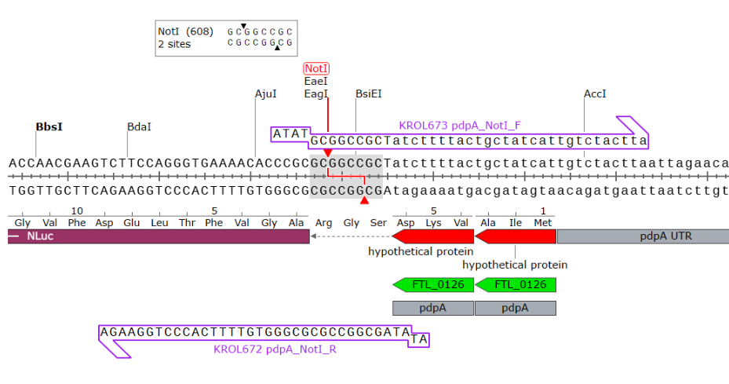

Figure. A first set of primers with a Ser-Gly-Arg linker at the NotI cut site.
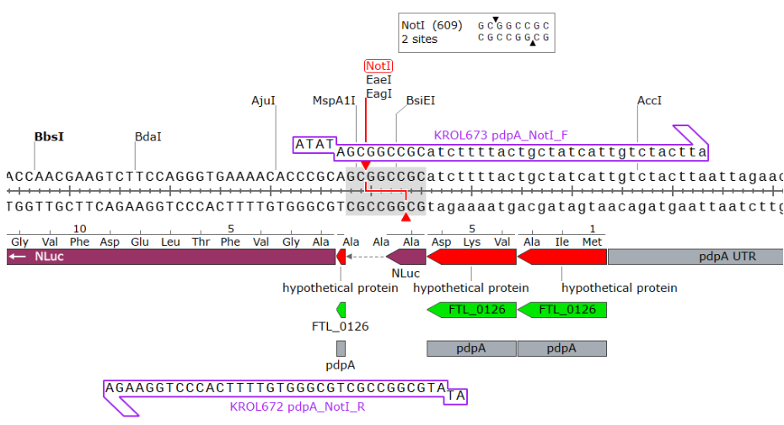

Figure. A second set of primers with an Ala-Ala-Ala linker at the NotI cut site.

Friday, June 2, 2023
To Do:
  - Make 1X SLB
  - Make 3 flasks of hemoglobin
  - Make overnight cultures for transformed plasmids
  - Made aliquots of 0.5M DTT

Results and Data:

Lab tasks:

Sample Loading Buffer Recipe
Makes 20 mL of 1X SLB
1. Add 5 mL of 4x loading dye (LDS) to a 50 mL conical
2. Add 2 mL of 0.5M DTT (10%)
3. Bring up to 20 mL with Type I ddiH2O (13 mL)
4. Aliquot into 10x2 mL microcentrifuge tubes and store in the "Protein Work" box in the -20C freezer.

Hemoglobin 2% Solution
- Add 6g freeze-dried hemoglobin to a 500 mL flask.
- Add 300mL of ddiH₂O (type I).
- Add aluminum foil and autoclave tape to the top of the flask.
- Autoclave on 20 minute liquid cycle with water in the bin.
- Cool down (ideally to ~55C – can be in water bath set to 56C) and store in 4C fridge.

- Made ~10x1.5 mL aliquots of 0.5M DTT and stored in Protein Work box in -20C freezer. DTT is 154.25 g/mol. When we use unit conversion, we get the following: 154.25 g/mol x 0.5 mol/L x 1 L/1000 mL x 15 mL = 1.16 g DTT into a total volume of 15 mL.

Monday, June 5 2023

To Do:
- Resuspend E.coli cell pellets for ribosome purification
- Miniprep plasmids for LanYFP and iLuv
- Ribosome purification Pt. 1
- Order primers for intermediate primers

Results and Data:

Miniprep of plasmids pKR189 (LanYFP) and pKR190 (iLov)
- Removed pellets for overnight cultures from -20C freezer prepared on 6/3/23. Some of
the pellets (pKR190_1 and pKR190_3) had a distinct yellow coloration – see image
below. This could be due to the presence of the iLov fluorescent protein.

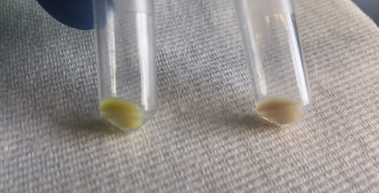
Figure. Yellow pellet (L) compared to natural pellet (R).

- Resuspended pellets with 250 mL Buffer P1.
- Added 250 uL Buffer P2 and mixed thoroughly by inverting the tube 4-6 times until the solution was more translucent.
- Added 350 uL Buffer N3 and mixed immediately and thoroughly by inverting tube 4-6 times.
- Centrifuged for 10 min at 13,000 rpm.
- Applied 800 uL of supernatant from previous step to QIAprep 2.0 spin column by pipetting. Some of the supernatant (pKR190_1 and pKR190_3) had a distinct yellow coloration – see image below.

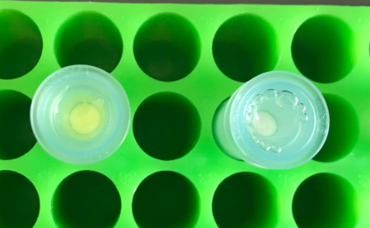

Figure. Yellow supernatant (L) compared to natural supernatant (R).
- Centrifuged for 1 min at 13,000 rpm. Discarded the flow-through.
- Washed the QIAprep 2.0 spin column by adding 0.5 mL Buffer PB. Centrifuged for 1 minute at 13,000 rpm. Discarded flow-through.
- Washed the QIAprep 2.0 spin column by adding 0.75 mL Buffer PE. Centrifuged for 1 minute at 13,000 rpm and discarded flow-through 3 times (added 750ul of PE three times).
- Centrifuged for 3 minutes at 13,000 rpm to remove residual wash buffer. (May have missed this step. Also, spin columns were left for a couple hours during lab meeting and French press for ribosome purification.)
- Placed the QIAprep 2.0 columns into clean 1.5 ml microcentrifuge tubes. To elute DNA, added 50 uL buffer 0.1xEB from a conical on the benchtop. Let them stand for 1 minute. Centrifuged for 1 minute at 13,000 rpm.
- Concentrations were obtained via Nanodrop (table below).
Sample | ng/uL | A260
pKR189_1 | 359.1 | 7.182
pKR189_2 | 394.1 | 7.882
pKR189_3 | 456 | 9.119
pKR190_1 | 271.8 | 5.436
pKR190_2 | 215.8 | 4.316
pKR190_3 | 470.9 | 9.418

Table. Nanodrop concentrations of Miniprepped pKR189 and pKR190

Preparation of 70S Ribosomes for Biochemistry
(Updated from original protocol of J. Thompson and S. Gregory from 3.22.03)

- Thawed the cell pellets prepared on 6/1/23 and resuspended them in 20 ml H 10 M 10 A 50 . Added 20 ml H^10 M^10 A^50 l of 1U/ul DNase (Lucigen) and passed three times through the French Press set on high. Collected the lysate in 50 mL conical tubes, then transferred to 30 ml Oakridge tubes.
- Pelleted the cell debris balanced (to within 0.002 g) with another tube of H 10 M 10 A 50 buffer in a 70 Ti rotor at 30,000 rpm, 15 minutes, 4 C. The tubes were left in the centrifuge for about an hour after the spin was complete and some of the pellet began to break off and settle at the bottom of the tube.
- Layered S30 supernatant over 10 ml sucrose cushion (H 10 M 10 A 500 + 20 % sucrose) in separate Oakridge tubes, being sure not to let the two layers mix. Balanced the tube to within 0.002 g.
- Centrifuged in a 70 Ti rotor at 40,000 rpm, 4 hours, 4 C. An orange-colored pellet formed at the bottom of each tube. Rinsed the ribosome pellets with 10 mL H^10 M 10^A 50 twice, washing off the orange film from the pellet, and resuspended in 1.0 ml of H^10 M^10 A^50 overnight without pipetting or vortexing.

Primers (KROL672 and KROL673) for intermediate plasmid (pKR204) were ordered.

Tuesday, June 6, 2023

To Do:
- Sequence plasmids for LanYFP and iLUV
- Continue ribosome purification
- Make buffers for ribosome purification
Results and Data:

Made 1 M MgCl2 solution as well as buffers H10M10A50, H10M10A500 + 20% sucrose, and H10M10A50 + 40% sucrose
- We added too much water to H10M10A50 + 40% sucrose the first time we made it, so we had to start over

Sequence Reactions Protocol
1. Use nanodrop to check concentrations of mini preps (dilute if necessary)
2. Dilute primers (2.5% - dilute 1:4 from working primer stock)
3. Set up sequence reaction worksheet
4. Add appropriate primer to each tube (2.56 uL for each)
5. Add appropriate miniprep to each tube
6. Add appropriate volume of water to each tube
7. Centrifuge tubes until all components are at bottom
8. Pipette up and down to mix
9. Bring PCR tubes and worksheet to genome sequencing lab

Submitted pKR189 samples 1-3 and pKR190 samples 1-3. Sequenced using primers KROL358, KROL540, and KROL257.

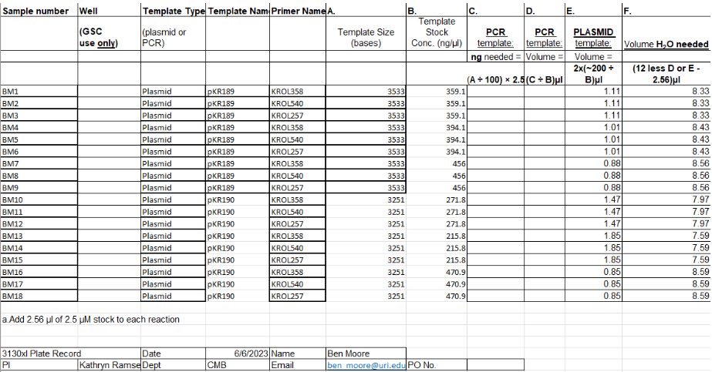

Friday, June 9, 2023

To Do:
- PCR (20 uL Reaction) for Intermediate Plasmid

Results and Data:

PCR (20 uL Reaction) for Intermediate Plasmid

- Set up table below to specify which primers and source DNA will be used.

Reaction Number | Plasmid/Region | Source DNA | Primers | Length(bps)
1 | pKR189 | same | KROL628,  KROL672 | 543
2 | pKR189 | same | KROL673,  KROL350 | 179
3 | +control | LVS gDNA | KROL15, KROL16 | 441
4 | -control | - | KROL628,  KROL672 | -
5 | -control | - | KROL673,  KROL350 | -

- Use PCR_worksheet.xlsx to make establish the specifics of what will be added.
- Plasmid was diluted 1:100.
- Buffer was aliquoted into 200 uL portions.
- dNTPs were aliquoted into 100 uL portions.

Master Mix
- 74.4 uL diH2O
- 24 uL buffer
- 9.6 uL dNTPs
- 2.4 uL Primestar Polymerase

Individual Reactions
- 0.6 uL forward primer
- 0.6 uL reverse primer
- 0.4 uL template
- 18.4 uL MM
- Acquire and label PCR tubes. Be sure to include at least 1 positive and 1 negative control for each PCR experiment.
- Get a container of ice to keep the components on.
- Acquire the following components and put them on ice, labeling tubes if necessary:
  - Molecular grade H2O in 1.5 mL microfuge tube
  - KOD/primestar buffer
  - dNTPs
  - oligo F (10uM)
  - oligo R (10uM)
  - template (eg. LVS gDNA, plasmid, colony, etc.)
  - KOD/primestar enzyme: kept in the freezer until it is used as it is expensive and should be added last
- If any of the solutions are frozen, be sure to vortex the microfuge tube in order to dissolve it (tubes with frozen components may not be homogenized). Centrifuge the microfuge tubes to get any solution out of the microfuge tube cover. DO NOT vortex the enzyme itself or any solution with enzyme because vortexing will expose it to oxygen and degrade it.
- Add appropriate volume (based on PCR worksheet) of each experiment specific primer (forward and reverse) to PCR tubes.
- Add ddiH2O to the negative control tube corresponding to the template volume for 1 reaction.
- Prepare a master-mix in a 1.5 mL microfuge tube by adding the following according to the worksheet and using micropipettes:
  - Add ddiH2O
  - Add dNTPs
  - Add KOD buffer
  - Add KOD enzyme
- Mix the master-mix solution by pipetting up and down. Do not vortex to mix.
- Add appropriate volume of master-mix to negative control PCR tube. (We added master mix to all five reactions.)
- Add template to Master Mix (template volume minus 1 template reaction volume). (We did not add the template to the Master Mix, but to reactions 1 and 2.)
- Add appropriate volume of master mix to each PCR tube (except negative control) and pipette up and down to mix. (We added master mix to all five reactions.)
- Close PCR Tubes until the caps are tight
- Place the PCR Tubes in the thermocycler on STN 1 – the following settings should be in place:
  - Heat at 94 degrees for 2 minutes
  - 94 degrees C for 20 seconds
  - 50 degrees C for 30 seconds
  - 68 degrees C for 1 minute/kb (adjust based on expected size of product) (we ran this step for 40s)
  - Go back to step 2
  - Repeat 32x
  - 68 degrees C for 5 minutes
  - 12 degrees C for infinity

Wednesday, June 14, 2023

To Do:
- Miniprep pKR189 and pKR190 and prepare for sequencing
- PCR Gel
- 100 ul PCR reaction

Results and Data:

Miniprep of pKR189 and pKR190 Samples

1. Resuspended pellets with 250 mL Buffer P1.
2. Added 250 uL Buffer P2 and mixed thoroughly by inverting the tube 4-6 times until the
solution was more translucent.
3. Added 350 uL Buffer N3 and mixed immediately and thoroughly by inverting tube 4-6
times.
4. Centrifuged for 10 min at 13,000 rpm.
5. Applied 800 uL of supernatant from previous step to QIAprep 2.0 spin column by
pipetting and centrifuged for 1 min at 13,000 rpm. Discarded the flow-through.
6. Washed the QIAprep 2.0 spin column by adding 0.5 mL Buffer PB. Centrifuged for 1
minute at 13,000 rpm. Discarded flow-through.
7. Washed the QIAprep 2.0 spin column by adding 0.75 mL Buffer PE. Centrifuged for 1
minute at 13,000 rpm and discarded flow-through 3 times (added 750ul of PE three
times).
8. Centrifuged for 3 minutes at 13,000 rpm to remove residual wash buffer.
9. Placed the QIAprep 2.0 columns into clean 1.5 ml microcentrifuge tubes. To elute DNA,
added 50 uL buffer 0.1xEB from a conical on the benchtop. Let them stand for 1 minute.
Centrifuged for 1 minute at 13,000 rpm.
10. Concentrations were obtained via Nanodrop and the samples were stored at -20C.

Table. Concentrations of pKR189 and pKR190 samples via Nanodrop

Sample ID | ng/µl | A260 (Abs)
pKR189_1 | 452.3 | 9.047
pKR189_2 | 429.9 | 8.597
pKR190_1 | 418.7 | 8.374
pKR190_2 | 387 | 7.74
pKR190_3 | 399.7 | 7.994

Sequence Reactions Protocol
1. Use nanodrop to check concentrations of mini preps (dilute if necessary – we diluted our
samples 1:5 with a total volume of 20 uL – 4 uL sample into 16 uL 0.1xEB)
2. Dilute primers (2.5% - dilute 1:4 from working primer stock)
3. Set up sequence reaction worksheet
4. Add appropriate primer to each tube (2.56 uL for each)
5. We left the samples at this point in the interest of time and stored them in the -20C
freezer

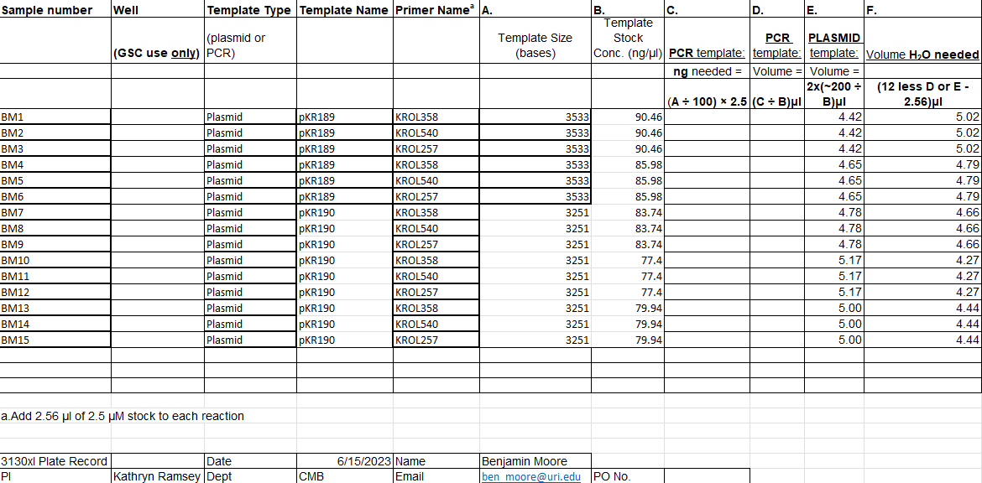

Figure. Sequencing submission form for pKR189 and pKR190.

PCR Gel
- Melt 1% agarose gel at 300C and let cool in water bath to 50-55C.
- Put gel cast into the gel rig sideways.
- Added 50 mL of 1% agarose gel into a flask along with 5 uL SYBR safe solution, swirled the flask to mix, and then poured into the gel rig.
- Inserted a comb to mold wells in the gel.
- Let sit until the 1% agarose – 1x SYBR safe solution had cooled and solidified into a gel.
- Carefully removed the comb.
- Poured 100 ml of 1x TAE buffer solution into the gel tank (add just enough to slightly submerge the gel itself).
- Added 4 uL 6x loading dye to 20 uL PCR solutions.
- Loaded 10 µL of 2x log ladder into the first well.
- Loaded 15 µL of the PCR-dye mixture into the wells in sequential order (nLuc fragment (543 bp), pdpA/tul4 UTR fragment (179 bp), positive control, and negative controls).
- Inserted the electrodes and ran the gel at about 113 volts for about 45 minutes.
- Looked at the gel with the GelDoc and imaged in Image Lab (see below).
- The band for the pdpA/tul4 UTR fragment (179 bp) was faint, but this was most likely because we ran the gel for too long before imaging – the bands on the ladder for smaller size fragments are faint as well.
- There were bands in the negative controls that may have indicated contamination with plasmid, because these lanes should have been empty.

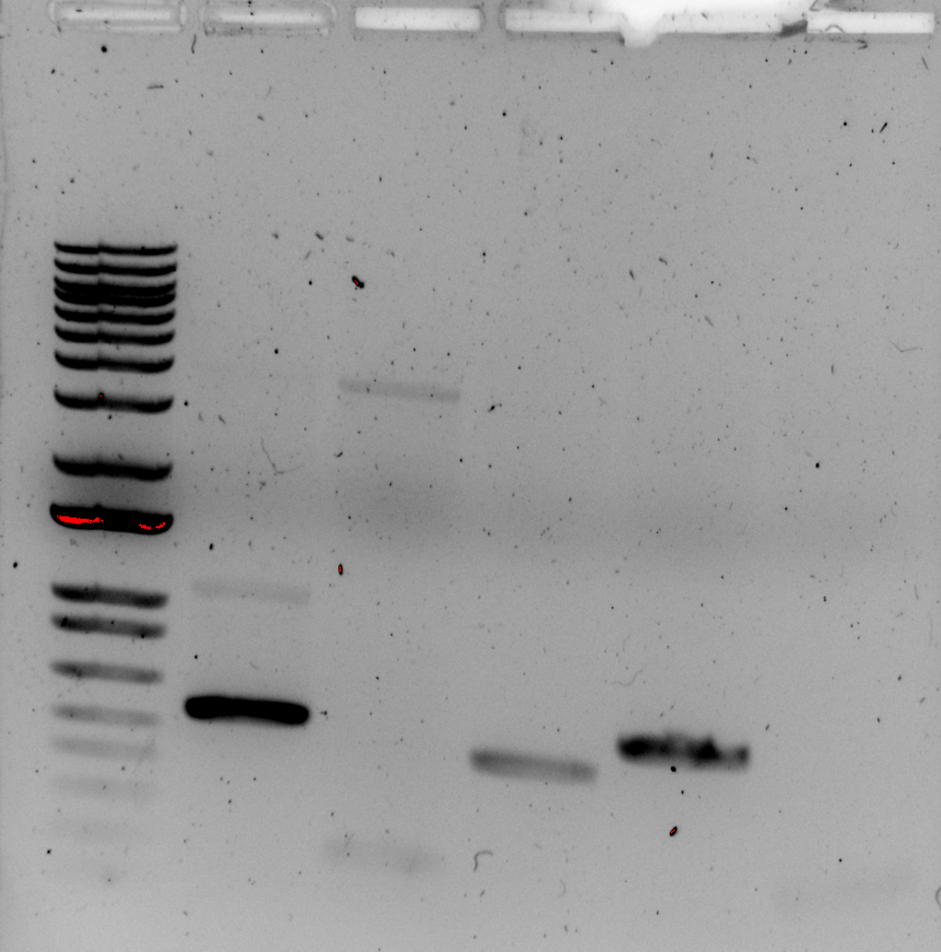

Figure. PCR gel with ladder, nLuc fragment (543 bp), pdpA/tul4 UTR fragment (179 bp), positive control, and negative controls.

PCR (100 uL Reaction)

Set up table below to specify which primers and source DNA will be used
- Use PCR_worksheet.xlsx to make establish the specifics of what will be added.
- Plasmid was diluted 1:100.

Master Mix
- 372 uL diH2O
- 120 uL buffer
- 48 uL dNTPs
- 12 uL Primestar Polymerase

Individual Reactions
- 3 uL forward primer
- 3 uL reverse primer
- 2 uL template
- 92 uL MM
- Acquire and label PCR tubes. Be sure to include at least 1 positive and 1 negative control for each PCR experiment.
- Get a container of ice to keep the components on.
- Acquire the following components and put them on ice, labeling tubes if necessary:
  - Molecular grade H2O in 1.5 mL microfuge tube
  - KOD/primestar buffer
  - dNTPs
  - oligo F (10uM)
  - oligo R (10uM)
  - template (eg. LVS gDNA, plasmid, colony, etc.)
  - KOD/primestar enzyme: kept in the freezer until it is used as it is expensive and should be added last
- If any of the solutions are frozen, be sure to vortex the microfuge tube in order to dissolve it (tubes with frozen components may not be homogenized). Centrifuge the microfuge tubes to get any solution out of the microfuge tube cover. DO NOT vortex the enzyme itself or any solution with enzyme because vortexing will expose it to oxygen and degrade it.
- Add appropriate volume (based on PCR worksheet) of each experiment specific primer (forward and reverse) to PCR tubes.
- Add ddiH2O to the negative control tube corresponding to the template volume for 1 reaction.
- Prepare a master-mix in a 1.5 mL microfuge tube by adding the following according to the worksheet and using micropipettes:
  - Add ddiH2O
  - Add dNTPs
  - Add KOD buffer
  - Add KOD enzyme
- Mix the master-mix solution by pipetting up and down. Do not vortex to mix.
- Add appropriate volume of master-mix to negative control PCR tube. (We added master mix to all five reactions.)
- Add template to Master Mix (template volume minus 1 template reaction volume). (We did not add the template to the Master Mix, but to reactions 1 and 2.)
- Add appropriate volume of master mix to each PCR tube (except negative control) and pipette up and down to mix. (We added master mix to all five reactions.)
- Close PCR Tubes until the caps are tight
- Place the PCR Tubes in the thermocycler on STN 1 – the following settings should be in place:
  - Heat at 94 degrees for 2 minutes
  - 94 degrees C for 20 seconds
  - 50 degrees C for 30 seconds
  - 68 degrees C for 1 minute/kb (adjust based on expected size of product) 40s
  - Go back to step 2
  - Repeat 32x
  - 68 degrees C for 5 minutes
  - 12 degrees C for infinity

Thursday, June 15, 2023

To Do:
- Finish preparing pKR189 and pKR190 for sequencing
- Restriction enzyme digestion (cut step)
- Gel purification
- Ligation

Results and Data:

Sequence Reactions Protocol
- Continued from yesterday
- Add appropriate miniprep to each tube
- Add appropriate volume of water to each tube
- Centrifuge tubes until all components are at bottom
- Pipette up and down to mix
- Bring PCR tubes and worksheet to genome sequencing lab
Submitted pKR189 samples 1-2 and pKR190 samples 1-3. Sequenced using primers KROL358, KROL540, and KROL257.
Ran PCR purification for PCR samples 1 and 2 from yesterday (nLuc fragment, pdpA/tul4 UTR fragment).

PCR Purification
- All centrifugation steps are carried out at 17,900 x g (13,000 rpm) in a conventional table-top microcentrifuge at room temperature.
- Add 5 volumes Buffer PB to 1 volume of the PCR reaction and mix. If the color of the mixture is orange or violet, add 10 µl 3 M sodium acetate, pH 5.0, and mix. The color of the mixture will turn yellow.
- Place a QIAquick column in a provided 2 ml collection tube or into a vacuum manifold. For details on how to set up a vacuum manifold, refer to the QIAquick Spin Handbook.
- To bind DNA, apply the sample to the QIAquick column and centrifuge for 30–60 s or apply vacuum to the manifold until all the samples have passed through the column. Discard flow-through and place the QIAquick column back in the same tube.
- To wash, add 750 µl Buffer PE to the QIAquick column, centrifuge for 30–60 s or apply vacuum. Discard flow-through and place the QIAquick column back into the same tube.
- Centrifuge the QIAquick column once more in the provided 2 ml collection tube for 1 min to remove residual wash buffer.
- Place each QIAquick column in a clean 1.5 ml microcentrifuge tube.
- To elute DNA, add 50 µl Buffer EB (10 mM Tris·Cl, pH 8.5) or water (pH 7.0–8.5) to the center of the QIAquick membrane and centrifuge the column for 1 min. For increased DNA concentration, add 30 µl elution buffer to the center of the QIAquick membrane, let the column stand for 1 min and then centrifuge.

Restriction Digest
- Make a reaction table with desired digests:
Tube | DNA | Enzyme(s) | DNA Volume((uL) | H20 Volume(uL)
1 | nLuc Purified PCR fragment | HpaI, NotI | 15 | -
2 | pdpA/tul4 UTR Purified PCR fragment | NotI, NotI | 15 | -
3 | pKR189 Backbone | HpaI, NotI | 5 | 10

- Set up master mix table:
Master Mix 1: HpaI, Not1 —> 1, 3
Components | Volumes in 1 reaction (uL) | Volumes in Master Mix 3x (uL)
H20 | 10.8 | 32.4
10x rCutsmart Buffer | 3.0 | 9
DNA | (15.0) | (15.0)
Enzyme 1 (HpaI) | 0.6 | 1.8
Enzyme 2 (NotI) | 0.6 | 1.8
Total | 30.0 (15.0 actual b/c of DNA) | 45

Master Mix 2: NotI —> 2

Components | Volumes in 1 reaction (uL) | Volumes in Master Mix 3x (uL)
H20 | 10.8 | 21.6
10x rCutsmart Buffer | 3.0 | 6
DNA | (15.0) | (15.0)
Enzyme 1 (Notl) | 1.2 | 2.4
Total | 30.0 (15.0 actual b/c of DNA) | 30

- Add indicated amounts of H2O and 10x buffer to master mix tubes (MM).
- Add indicated amount of DNA or DNA+water (for backbone tubes) to individual tubes for digest (1.5 mL microfuge tubes for digests in incubator, PCR strip tubes for reactions incubated in the thermocycler).
- Add indicated amount of each enzyme to the master mix tube (MM).
- Mix the master mix by pipetting up and down.
- Add master mix to individual tubes. Volume to add to each tube is the volume in 1 reaction minus the DNA volume (15 ul).
- Incubate at 37°C for 1 hour or up to overnight.

PCR Gel
- Diluted purified PCR fragments (nLuc fragment, pdpA/tul4 UTR fragment) by adding 5 uL sample to 15 uL ultrapure water. Used positive control (LVS gDNA) and negative controls run yesterday during the full 100 uL PCR reaction.
- Melted 1% agarose gel at 300C and let cool in water bath to 50-55C.
- Put gel cast into the gel rig sideways.
- Added 50 mL of 1% agarose gel into a flask along with 5 uL SYBR safe solution, swirled the flask to mix, and then poured into the gel rig.
- Inserted a comb to mold wells in the gel.
- Let sit until the 1% agarose – 1x SYBR safe solution had cooled and solidified into a gel.
- Carefully removed the comb.
- Poured 100 ml of 1x TAE buffer solution into the gel tank (add just enough to slightly submerge the gel itself).
- Added 4 uL 6x loading dye to 20 uL PCR solutions.
- Loaded 10 µL of 2x log ladder into the first well.
- Loaded 15 µL of the PCR-dye mixture into the wells in sequential order (nLuc fragment (543 bp), pdpA/tul4 UTR fragment (179 bp), positive control, and negative controls).
- Inserted the electrodes and ran the gel at about 113 volts for about 45 minutes.
- Looked at the gel with the GelDoc and imaged in Image Lab (see below).
- The band for the pdpA/tul4 UTR fragment (179 bp) was faint, this might have been because the length of time used for the elongation step was optimized for the longer nLuc fragment (543 bp). Next time, it would be reasonable to run this sample in a separate PCR reaction with a shorter time for the elongation step (around 15s).
- There were bands in the negative controls that indicated contamination with plasmid, because these lanes should have been empty. Kira said that she has had the same problem, even though she has refreshed her aliquots of buffer, dNTPs, polymerase, and water and that she tried making fresh primer stocks.

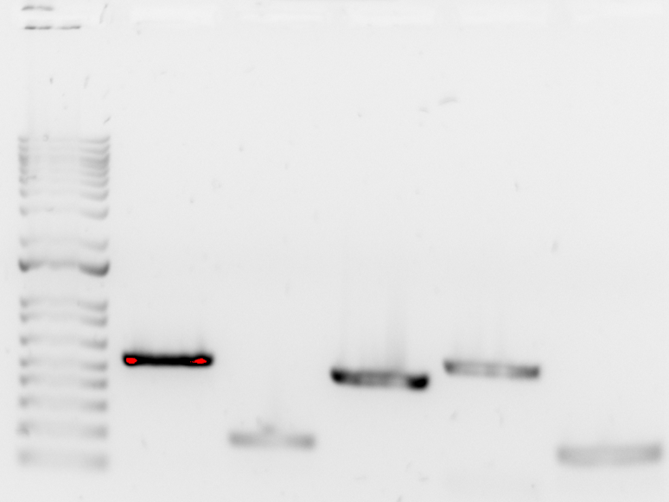

Figure. PCR gel with ladder, nLuc fragment (543 bp), pdpA/tul4 UTR fragment (179 bp), positive control, and negative controls.

Friday, June 16, 2023

To Do:
- Analyze sequence data for pKR189 and pKR190
- Filter 10 uM primers (KROL672 & 673) with 100 MWCO filter
- Run 20 uL test PCR and gel
- Make overnight cultures for pKR189 and pKR190

Results and Data:

We filtered the 10 uM working stocks for KROL672 and KROL673 and ran a test PCR to see if we could reduce or eliminate contamination from the 0.1x EB.

Filtering 10 uM KROL672 and KROL673 Stocks with 100 K MWCO
Using Pierce Concentrator, 0.5 mL
- Rinsed the Concentrator by adding 500 uL to the sample chamber and spinning at 12,000g for 5 minutes. Discarded flow-through.
- Placed sample into the Concentrator sample chamber.
- Capped, then inserted the Sample chamber into a collection tube.
- Placed into the rotor, counterbalanced with each other, oriented the concentrator so the numbers faced upward and were angled outward, and centrifuged at 12,000g for 5 minutes.
- Flow-through was transferred to 1.5 mL Eppendorf tubes and used for the PCR.

PCR (20 uL Reaction) for Intermediate Plasmid
- Set up table below to specify which primers and source DNA will be used.
Reaction Number | Plasmid/Region | Source DNA | Primers | Length(bps)
1 | pKR189 | same | KROL628, KROL672 | 543
2 | pKR189 | same | KROL673, KROL350 | 179
3 | + control | LVS gDNA | KROL15, KROL16 | 441
4 | - control | - | KROL628, KROL672 | -
5 | -control | - | KROL673, KROL350 | -

- Use PCR_worksheet.xlsx to make establish the specifics of what will be added.
- Plasmid was diluted 1:100.

Master Mix
- 74.4 uL diH2O
- 24 uL buffer
- 9.6 uL dNTPs
- 2.4 uL Primestar Polymerase

Individual Reactions
- 0.6 uL forward primer
- 0.6 uL reverse primer
- 0.4 uL template
- 18.4 uL MM
- Acquire and label PCR tubes. Be sure to include at least 1 positive and 1 negative control for each PCR experiment.
- Get a container of ice to keep the components on.
- Acquire the following components and put them on ice, labeling tubes if necessary:
  - Molecular grade H2O in 1.5 mL microfuge tube
  - KOD/primestar buffer
  - dNTPs
  - oligo F (10uM)
  - oligo R (10uM)
  - template (eg. LVS gDNA, plasmid, colony, etc.)
  - KOD/primestar enzyme: kept in the freezer until it is used as it is expensive and should be added last
- If any of the solutions are frozen, be sure to vortex the microfuge tube in order to dissolve it (tubes with frozen components may not be homogenized). Centrifuge the microfuge tubes to get any solution out of the microfuge tube cover. DO NOT vortex the enzyme itself or any solution with enzyme because vortexing will expose it to oxygen and degrade it.
- Add appropriate volume (based on PCR worksheet) of each experiment specific primer (forward and reverse) to PCR tubes.
- Add ddiH2O to the negative control tube corresponding to the template volume for 1 reaction.
- Prepare a master-mix in a 1.5 mL microfuge tube by adding the following according to the worksheet and using micropipettes:
  - Add ddiH2O
  - Add dNTPs
  - Add KOD buffer
  - Add KOD enzyme
- Mix the master-mix solution by pipetting up and down. Do not vortex to mix.
- Add appropriate volume of master-mix to negative control PCR tube. (We added master mix to all five reactions.)
- Add template to Master Mix (template volume minus 1 template reaction volume). (We did not add the template to the Master Mix, but to reactions 1 and 2.)
- Add appropriate volume of master mix to each PCR tube (except negative control) and pipette up and down to mix. (We added master mix to all five reactions.)
- Close PCR Tubes until the caps are tight
- Place the PCR Tubes in the thermocycler on STN 1 – the following settings should be in place:
  - Heat at 94 degrees for 2 minutes
  - 94 degrees C for 20 seconds
  - 50 degrees C for 30 seconds
  - 68 degrees C for 1 minute/kb (adjust based on expected size of product) (this step was run for 40s for samples 1,3, and 4 and for 15s for samples 2 and 5)
  - Go back to step 2
  - Repeat 32x
  - 68 degrees C for 5 minutes
  - 12 degrees C for infinity

PCR Gel
- Melted 1% agarose gel at 300C and let cool in water bath to 50-55C.
- Put gel cast into the gel rig sideways.
- Added 50 mL of 1% agarose gel into a flask along with 5 uL SYBR safe solution, swirled the flask to mix, and then poured into the gel rig.
- Inserted a comb to mold wells in the gel.
- Let sit until the 1% agarose – 1x SYBR safe solution had cooled and solidified into a gel.
- Carefully removed the comb.
- Poured 100 ml of 1x TAE buffer solution into the gel tank (add just enough to slightly submerge the gel itself).
- Added 4 uL 6x loading dye to 20 uL PCR solutions.
- Loaded 10 µL of 2x log ladder into the first well.
- Loaded 15 µL of the PCR-dye mixture into the wells in sequential order (nLuc fragment (543 bp), pdpA/tul4 UTR fragment (179 bp), positive control, and negative controls).
- Inserted the electrodes and ran the gel at about 113 volts for about 45 minutes.
- Looked at the gel with the GelDoc and imaged in Image Lab (see below).
The band for the pdpA/tul4 UTR fragment (179 bp) was faint although it was run in a separate thermoycler with the extension time set to 15 sec. This could be because the gel was run for too long – the smaller-sized bands on the ladder started to disappear. The gel was run for 40 minutes at 113 volts, but 30 minutes seems more ideal for this size gel.
There was a very faint band in the first negative control, so it seems that we found the source of the contamination, but filtering wasn't completely successful in removing it. The contamination seems to have come from the 0.1x EB that was used to reconstitute and dilute the new primers (KROL672 and KROL673) used for the PCR reaction. We discarded the primers KROL672 and 673 and ordered a new set from Thermo Fisher.

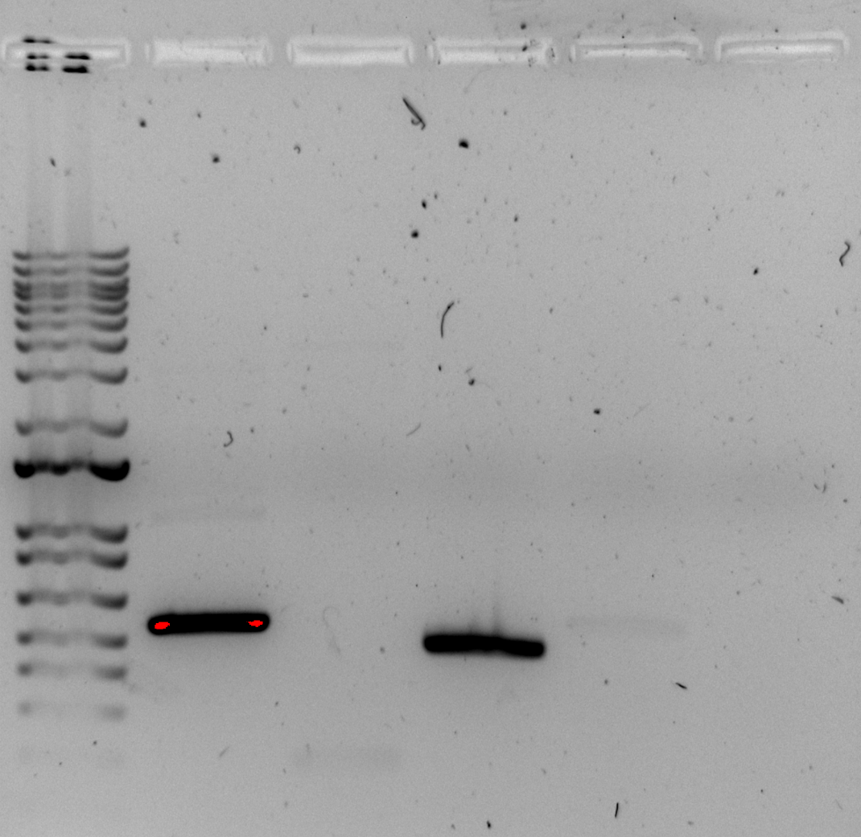

Figure. PCR gel with ladder, nLuc fragment (543 bp), pdpA/tul4 UTR fragment (179 bp), positive control,andnegativecontrols.
Discarded PCR tubes from restriction enzyme digestion that had been incubating overnight. We will have to rerun this after receiving the new primers.
Analyzed the second round of sequence data for pKR189 and pKR190 (folder BM_230615 in Sequencing > Results). This time, it looks like we have two good samples for each plasmid (pKR189_1: BM01-BM03, pKR189_2: BM04-BM06, pKR190_2: BM10-BM12, pKR190_3: BM13-BM15), although we will need to check with Kathryn about some questionable calls in the reads. Would it be appropriate to redo the Minipreps for these with the fresh 0.1x EB now that we found potential contamination? We put in some new overnight cultures (in 5 mL LB with 5 uL Carb at 37C) just in case it makes sense to run new Minipreps and sequence again on Tuesday.

Wednesday, June 21, 2023
To Do:
    - Present at lab meeting
    - Empty biohazard waste
    - PCR Gel
    - Run PCR with control primers
Results and Data:

PCR Gel
- Melt 1% agarose gel at 300C and let cool in water bath to 50-55C.
- Put gel cast into the gel rig sideways.
- Added 50 mL of 1% agarose gel into a flask along with 5 uL SYBR safe solution, swirled the flask to mix, and then poured into the gel rig.
- Inserted a comb to mold wells in the gel.
- Let sit until the 1% agarose – 1x SYBR safe solution had cooled and solidified into a gel.
- Carefully removed the comb.
- Poured 100 ml of 1x TAE buffer solution into the gel tank (add just enough to slightly submerge the gel itself).
- Added 4 uL 6x loading dye to 20 uL PCR solutions.
- Loaded 10 µL of 2x log ladder into the first well.
- Loaded 15 µL of the PCR-dye mixture into the wells in sequential order.
  - Reactions 3-7 were run in lanes 2-6.
- Inserted the electrodes and ran the gel at 113 volts for 30 minutes.
- Looked at the gel with the GelDoc and imaged in Image Lab (see below).
- 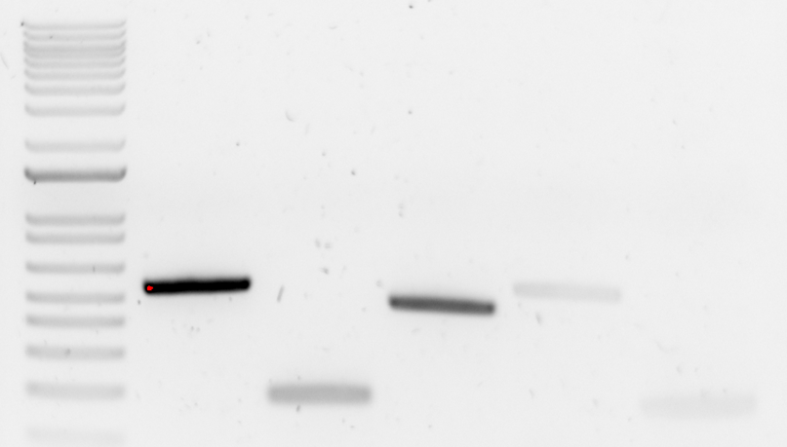

Figure. PCR gel with ladder, nLuc fragment (543 bp), pdpA/tul4 UTR fragment (179 bp), positive control, and negative controls.

There are still bands in the negative control lanes, so it seems that using fresh nuclease-free water and reagents is not addressing the source of the contamination.

PCR (20 uL Reaction)
- Set up table below to specify which primers and source DNA will be used.
Reaction Number | Plasmid/Region | Source DNA | Primers | Length(bps)
1 | LVS gDNA | LVS gDNA | KROL148, KROL149 | 1275
2 | + control | LVS gDNA | KROL15, KROL16 | 441
3 | - control | - | KROL148, KROL149 | -
4 | - control | - | KROL15, KROL16 | -
5 | - control | - | KROL628, KROL672 | -
6 | - control | - | KROL673, KROL350 | -
- Use PCR_worksheet.xlsx to make establish the specifics of what will be added.

Master Mix
- 86.8 uL diH2O
- 28 uL buffer
- 11.2 uL dNTPs
- 2.8 uL Primestar Polymerase

Individual Reactions
- 0.6 uL forward primer
- 0.6 uL reverse primer
- 0.4 uL template
- 18.4 uL MM
- Acquire and label PCR tubes. Be sure to include at least 1 positive and 1 negative control for each PCR experiment.
- Get a container of ice to keep the components on.
- Acquire the following components and put them on ice, labeling tubes if necessary:
  - Molecular grade H2O in 1.5 mL microfuge tube
  - KOD/primestar buffer
  - dNTPs
  - oligo F (10uM)
  - oligo R (10uM)
  - template (eg. LVS gDNA, plasmid, colony, etc.)
  - KOD/primestar enzyme: kept in the freezer until it is used as it is expensive and should be added last
- If any of the solutions are frozen, be sure to vortex the microfuge tube in order to dissolve it (tubes with frozen components may not be homogenized). Centrifuge the microfuge tubes to get any solution out of the microfuge tube cover. DO NOT vortex the enzyme itself or any solution with enzyme because vortexing will expose it to oxygen and degrade it.
- Add appropriate volume (based on PCR worksheet) of each experiment specific primer (forward and reverse) to PCR tubes.
- Add ddiH2O to the negative control tube corresponding to the template volume for 1 reaction.
- Prepare a master-mix in a 1.5 mL microfuge tube by adding the following according to the worksheet and using micropipettes:
  - Add ddiH2O
  - Add dNTPs
  - Add KOD buffer
  - Add KOD enzyme
- Mix the master-mix solution by pipetting up and down. Do not vortex to mix.
- Add appropriate volume of master-mix to negative control PCR tube.
- Add template to Master Mix (template volume minus 1 template reaction volume).
- Add appropriate volume of master mix to each PCR tube (except negative control) and pipette up and down to mix.
- Close PCR Tubes until the caps are tight
- Place the PCR Tubes in the thermocycler on STN 1 – the following settings should be in place:
  - Heat at 94 degrees for 2 minutes
  - 94 degrees C for 20 seconds
  - 50 degrees C for 30 seconds
  - 68 degrees C for 1 minute/kb (adjust based on expected size of product) (1.5 minutes)
  - Go back to step 2
  - Repeat 32x
  - 68 degrees C for 5 minutes
  - 12 degrees C for infinity
Thursday, June 22, 2023
To Do:
- Run PCR gel
- Run 20 uL test PCR and gel
Results and Data:
Ran a PCR gel for the reaction from yesterday which had incubated overnight.

PCR Gel
- Melt 1% agarose gel at 300C and let cool in water bath to 50-55C.
- Put gel cast into the gel rig sideways.
- Added 50 mL of 1% agarose gel into a flask along with 5 uL SYBR safe solution, swirled the flask to mix, and then poured into the gel rig.
- Inserted a comb to mold wells in the gel.
- Let sit until the 1% agarose – 1x SYBR safe solution had cooled and solidified into a gel.
- Carefully removed the comb.
- Poured 100 ml of 1x TAE buffer solution into the gel tank (add just enough to slightly submerge the gel itself).
- Added 4 uL 6x loading dye to 20 uL PCR solutions.
- Loaded 10 µL of 2x log ladder into the first well.
- Loaded 15 µL of the PCR-dye mixture into the wells in sequential order.
- Inserted the electrodes and ran the gel at 113 volts for 30 minutes.
- Looked at the gel with the GelDoc and imaged in Image Lab (see below).
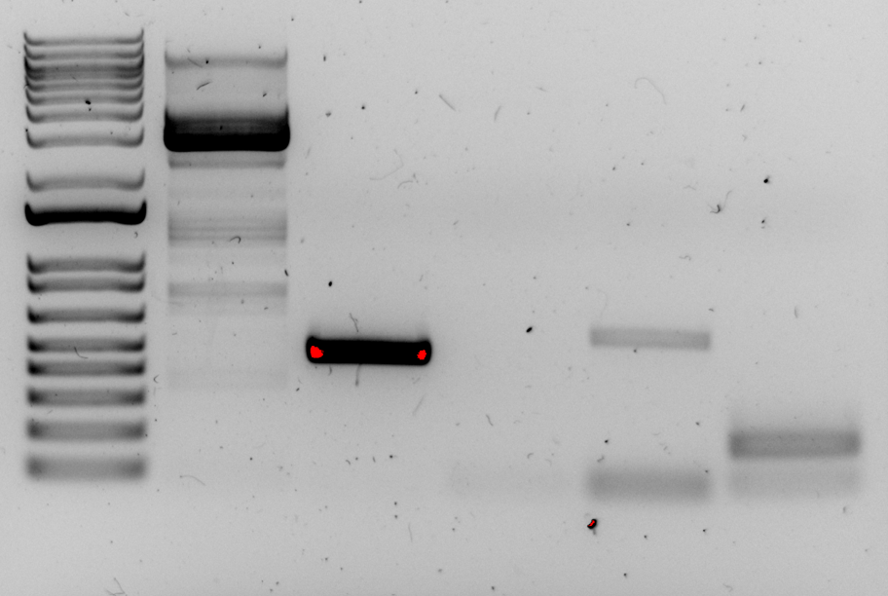

Figure. PCR gel with ladder, gDNA, positive control, negative control, and the primers with potential contamination.
PCR amplification was successful for gDNA with primer sets KROL148/KROL149 and KROL15/KROL16 and there was no amplification in the negative control lane. This shows that there should be no gDNA contamination in the reagents we are using. There were still bands in the negative control lanes for the primer sets we are investigating for contamination (KROL628/KROL672 and KROL673/KROL350) which means that there is still plasmid contamination in the primer stocks we are using or in the reagents.
Since the amplification is occurring in the nLuc region (KROL628/KROL672) or in the pdpA/tul4 region (KROL673/KROL350), the source of contamination must be a plasmid with these regions, potentially pKR144, pKR147, pKR189, or pKR190. We decided to run a PCR with different combinations of primers that would amplify from these plasmids to see which sets worked, to narrow down the primer stocks that might be the source of the contamination. Reaction numbers 1-4 and 6-9 are run with the primers we are investigating, paired with different primers we have not used before. Reaction numbers 5 and 10 are conducted with a primer set which is entirely different from what we have used before. Reactions 1-5 were conducted with a plasmid template and reactions 6-10 were conducted without a plasmid template.

PCR (20 uL Reaction)
- Set up table below to specify which primers and source DNA will be used.
Reaction Number | Plasmid/Region | Source DNA | Primers | Length (bps)
1 | pKR189 | same | KROL628, KROL518 | 601
2 | pKR189 | same | KROL672, KROL519 | 548
3 | pKR189 | same | KROL673, KROL467 | 176
4 | pKR189 | same | KROL350, KROL349 | 178
5 | pKR189 | same | KROL518, KROL519 | 606
6 | - control | - | KROL628, KROL518 | -
7 | - control | - | KROL672, KROL519 | -
8 | - control | - | KROL673, KROL467 | -
9 | - control | - | KROL350, KROL349 | -
10 | - control | - | KROL518, KROL519 | -
11 | + control | LVS gDNA | KROL15, KROL16 | 441

- Use PCR_worksheet.xlsx to make establish the specifics of what will be added.

Master Mix
- 148.8 uL diH2O
- 48 uL buffer
- 19.2 uL dNTPs
- 4.8 uL Primestar Polymerase

Individual Reactions
- 0.6 uL forward primer
- 0.6 uL reverse primer
- 0.4 uL template
- 18.4 uL MM
- Acquire and label PCR tubes. Be sure to include at least 1 positive and 1 negative control for each PCR experiment.
- Get a container of ice to keep the components on.
- Acquire the following components and put them on ice, labeling tubes if necessary:
  - Molecular grade H2O in 1.5 mL microfuge tube
  - KOD/primestar buffer
  - dNTPs
  - oligo F (10uM)
  - oligo R (10uM)
  - template (eg. LVS gDNA, plasmid, colony, etc.)
  - KOD/primestar enzyme: kept in the freezer until it is used as it is expensive and should be added last
- If any of the solutions are frozen, be sure to vortex the microfuge tube in order to dissolve it (tubes with frozen components may not be homogenized). Centrifuge the microfuge tubes to get any solution out of the microfuge tube cover. DO NOT vortex the enzyme itself or any solution with enzyme because vortexing will expose it to oxygen and degrade it.
- Add appropriate volume (based on PCR worksheet) of each experiment specific primer (forward and reverse) to PCR tubes.
- Add ddiH2O to the negative control tube corresponding to the template volume for 1 reaction.
- Prepare a master-mix in a 1.5 mL microfuge tube by adding the following according to the worksheet and using micropipettes:
  - Add ddiH2O
  - Add dNTPs
  - Add KOD buffer
  - Add KOD enzyme
- Mix the master-mix solution by pipetting up and down. Do not vortex to mix.
- Add appropriate volume of master-mix to negative control PCR tube.
- Add template to Master Mix (template volume minus 1 template reaction volume).
- Add appropriate volume of master mix to each PCR tube (except negative control) and pipette up and down to mix.
- Close PCR Tubes until the caps are tight
- Place the PCR Tubes in the thermocycler on STN 1 – the following settings should be in place:
  - Heat at 94 degrees for 2 minutes
  - 94 degrees C for 20 seconds
  - 50 degrees C for 30 seconds
  - 68 degrees C for 1 minute/kb (adjust based on expected size of product) (42 sec)
  - Go back to step 2
  - Repeat 32x
  - 68 degrees C for 5 minutes
  - 12 degrees C for infinity

PCR Gel
- Melt 1% agarose gel at 300C and let cool in water bath to 50-55C.
- Put gel cast into the gel rig sideways.
- Added 50 mL of 1% agarose gel into a flask along with 5 uL SYBR safe solution, swirled the flask to mix, and then poured into the gel rig.
- Inserted a comb to mold wells in the gel.
- Let sit until the 1% agarose – 1x SYBR safe solution had cooled and solidified into a gel.
- Carefully removed the comb.
- Poured 100 ml of 1x TAE buffer solution into the gel tank (add just enough to slightly submerge the gel itself).
- Added 4 uL 6x loading dye to 20 uL PCR solutions.
- Loaded 10 µL of 2x log ladder into the first well.
- Loaded 15 µL of the PCR-dye mixture into the wells in sequential order.
- Inserted the electrodes and ran the gel at 113 volts for 30 minutes.
- Looked at the gel with the GelDoc and imaged in Image Lab (see below).
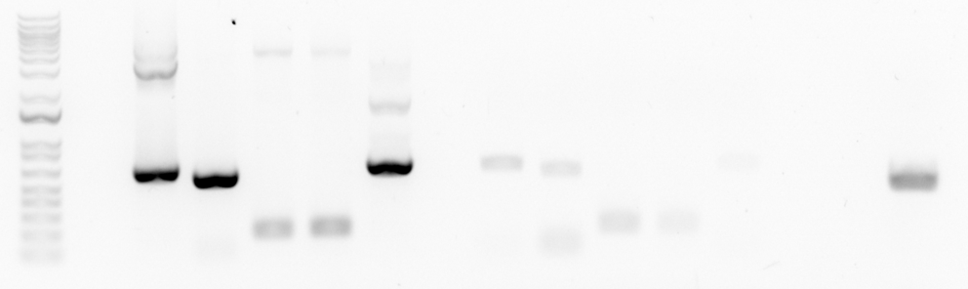
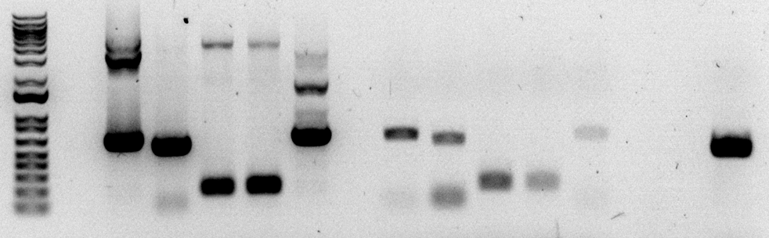

Figures. PCR gel with ladder, reactions 1-5, reactions 6-10, and reaction 11. Bottom image was adjusted to show bands more distinctly.
Reactions 1-5 with the plasmid template present were successful in amplifying the expected DNA fragment, so we know that these primer sets worked. Reactions 6-8 had distinct bands, so there is most likely contamination present in primer stocks for KROL628, KROL672, and KROL673. Reaction 9 had a faint band, so there is likely contamination in KROL350. Reaction 10 had a very faint band, so it is possible that these primers are amplifying residual plasmid DNA present somewhere, either in the primer stocks or in the Master Mix.

Friday, June 23, 2023
To Do:
    - Made agarose gel
    - PCR Gel
    - Made 2x500 mL flasks of LB:
    - Made 2x500 mL flasks of MHB:

Results and Data:

Made more 1% agarose gel:
- Add 1 g agarose powder to 100 mL 1x TAE buffer in 250 mL.
- Add stirbar to container.
- Heat to dissolve the agarose while stirring (don’t let it overboil, should look like clear liquid, no solids).
- Poured into flask with remaining agarose gel.

Made 2x500 mL flasks of LB:
- For 500 mL of LB, weigh out the following components and add to a 1 L flask:
  - 5 g NaCl
  - 5 g Tryptone
  - 2.5 g Yeast extract
- Add 500 mL type I ddiH20
- Close tightly and shake to mix
- Add a small piece of autoclave tape
- Autoclave on 30 minute liquid cycle

Made 2x500 mL flasks of MHB:
1. Weigh out 10.5g of Mueller-Hinton broth into 1L baffled flasks
2. Add 500mL of ddiH₂O (type I)
3. Autoclave on 30’ liquid cycle, filling the water bin up
Made 2x5 mL overnight cultures of MRE600 using colonies from the plate streaked out yesterday and placed in 37C shaking incubator.
PCR Gel
- Melt 1% agarose gel at 300C and let cool in water bath to 50-55C.
- Put gel cast into the gel rig sideways.
- Added 50 mL of 1% agarose gel into a flask along with 5 uL SYBR safe solution, swirled the flask to mix, and then poured into the gel rig.
- Inserted a comb to mold wells in the gel.
- Let sit until the 1% agarose – 1x SYBR safe solution had cooled and solidified into a gel.
- Carefully removed the comb.
- Poured 100 ml of 1x TAE buffer solution into the gel tank (add just enough to slightly submerge the gel itself).
- Added 4 uL 6x loading dye to 20 uL PCR solutions.
- Loaded 10 µL of 2x log ladder into the first well.
- Loaded 15 µL of the PCR-dye mixture into the wells in sequential order (reactions 1-6 from 6/22/23 and reaction 4 from 6/21/23).
- Inserted the electrodes and ran the gel at 113 volts for 30 minutes.
- Looked at the gel with the GelDoc and imaged in Image Lab (see below).
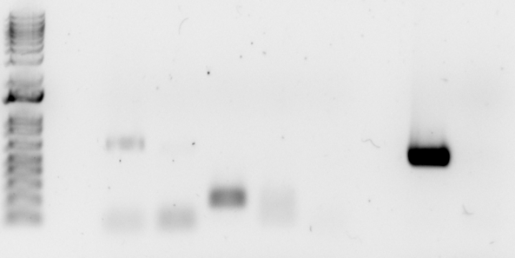
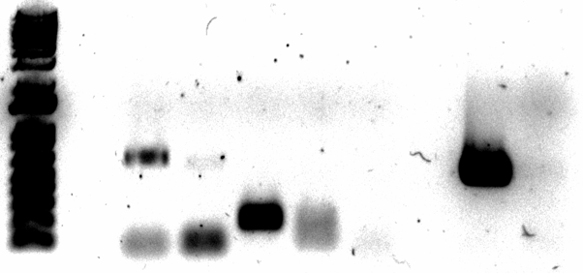
Figures. PCR gel with ladder, reactions 1-5, reaction 6, and reaction 4 from 6/21/23. Bottom image was adjusted to show bands more distinctly.

Reactions 1-4 had distinct bands, so there is most likely contamination present in primer stocks for KROL628, KROL672, KROL673, and KROL350. Reaction 5 did not have a band this time, so it seems like there is no issue with residual DNA in the water or reagents. Two differences between this PCR and the previous one are that, in this case, the PCR tubes were not spun down before being placed in the thermocycler, and no plasmid DNA was being used to set up the reactions. We realized that there may have been some handling mistakes in the PCR preparations: tubes containing plasmid or primers were popped open with a gloved hand in such a way that some liquid may have transferred between the glove and the inside of the cap. Also, the tubes with plasmid or primers were vortexed but not spun down, so residual liquid may have gotten into the lid during vortexing and been transferred when the tubes were opened. In the future, the tubes will be spun down before being opened, and more care will be taken in
Primers KROL628, KROL672, KROL673, and KROL350 were reordered.

Monday, June 26, 2023

To Do:

  - Lab meeting presentation
  - Restriction digest
Results and Data:
For the primers KROL628, KROL672, KROL673, and KROL350, made a 10 uM stock by diluting 20 uL of the 100 uM stock into 180 uL of 0.1xEB.

PCR (20 uL Reaction) for Intermediate Plasmid
- Set up table below to specify which primers and source DNA will be used. Be sure to include at least 1 positive and 1 negative control for each PCR experiment.
Reaction Number | Plasmid/Region | Source DNA | Primers | Length (bps)
1 | - control | old primers | KROL628, KROL672 | 543
2 | - control | old primers | KROL673, KROL350 | 179
3 | - control | new primers | KROL628, KROL672 | -
4 | - control | new primers | KROL673, KROL350 | -
5 | + control | LVS gDNA | KROL15, KROL16 | 441
- Use PCR_worksheet.xlsx to make establish the specifics of what will be added.

Master Mix
- 74.4 uL diH2O
- 24 uL buffer
- 9.6 uL dNTPs
- 2.4 uL Primestar Polymerase

Individual Reactions
- 0.6 uL forward primer
- 0.6 uL reverse primer
- 0.4 uL template
- 18.4 uL MM
- Acquire and label PCR tubes.
- Get a container of ice to keep the components on.
- Acquire the following components and put them on ice. If any of the solutions are frozen, be sure to vortex the microfuge tube in order to dissolve it (tubes with frozen components may not be homogenized). Centrifuge the microfuge tubes to get any solution out of the microfuge tube cover. DO NOT vortex the enzyme itself or any solution with enzyme because vortexing will expose it to oxygen and degrade it.
  - Molecular grade H2O in 1.5 mL microfuge tube
  - KOD/primestar buffer
  - dNTPs
  - oligo F (10uM)
  - oligo R (10uM)
  - template (eg. LVS gDNA, plasmid, colony, etc.)
  - KOD/primestar enzyme: kept in the freezer until it is used as it is expensive and should be added last
- Prepare a master-mix in a 1.5 mL microfuge tube by adding the following according to the worksheet and using micropipettes:
  - Add ddiH2O
  - Add dNTPs
  - Add KOD buffer
  - Add KOD enzyme
- Mix the master-mix solution by pipetting up and down. Do not vortex to mix.
- Add appropriate volume of master mix to each PCR tube.
- Add appropriate volume of each experiment specific primer (forward and reverse) to PCR tubes.
- Add appropriate volume of template (or ddiH2O to negative controls) to PCR tubes.
- Close PCR tubes until the caps are tight.
- Pulse spin gently in picofuge microcentrifuge.
- Place the PCR Tubes in the thermocycler on STN 1 – the following settings should be in place:
  - Heat at 94 degrees for 2 minutes
  - 94 degrees C for 20 seconds
  - 50 degrees C for 30 seconds
  - 68 degrees C for 1 minute/kb (adjust based on expected size of product) 40s
  - Go back to step 2
  - Repeat 32x
  - 68 degrees C for 5 minutes
  - 12 degrees C for infinity

PCR Gel
- Melt 1% agarose gel at 300C and let cool in water bath to 50-55C.
- Put gel cast into the gel rig sideways.
- Added 60 mL of 1% agarose gel into a flask along with 6 uL SYBR safe solution, swirled the flask to mix, and then poured into the gel rig.
- Inserted a comb to mold wells in the gel.
- Let sit until the 1% agarose – 1x SYBR safe solution had cooled and solidified into a gel.
- Carefully removed the comb.
- Poured 100 ml of 1x TAE buffer solution into the gel tank (add just enough to slightly submerge the gel itself).
- Added 4 uL 6x loading dye to 20 uL PCR solutions.
- Loaded 10 µL of 2x log ladder into the first well.
- Loaded 15 µL of the PCR-dye mixture into the wells in sequential order (nLuc fragment (543 bp), pdpA/tul4 UTR fragment (179 bp), positive control, and negative controls).
- Inserted the electrodes and ran the gel at about 113 volts for 30 minutes.
- Looked at the gel with the GelDoc and imaged in Image Lab (see below).
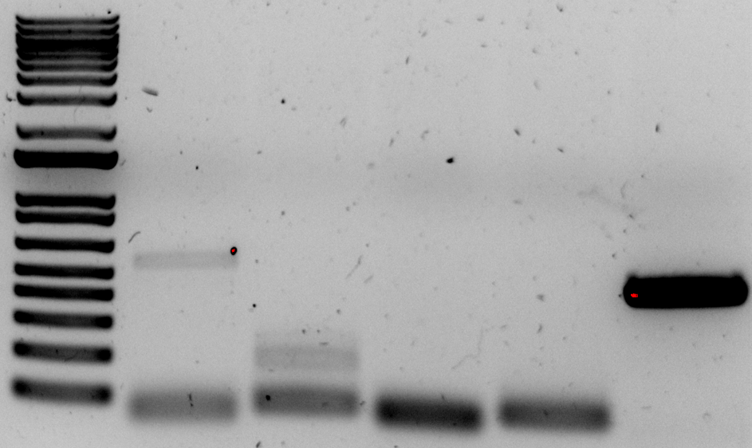

Figure. PCR gel with ladder, old (contaminated primers), new primers (from 100 uM stocks), and positive control.

The bands indicating contamination for the old primers were clearly visible, but there were no bands for the new primers remade from the 100 uM stocks, so it seems that we have identified the source of contamination and can proceed with the new primers. We will run a 100 uL PCR reaction next time with the new primers.

Wednesday, June 28, 2023

To Do:

  - PCR reaction(100ul)
  - Restriction digest
  - Phenol-chloroform purification
Results and Data:

Thursday, June 29, 2023

To Do:
- Gel purification

Results and Data:

July 2023

Friday, July 7, 2023

To Do:
- Make CHA mix
- Make hemoglobin 2% Solution

Results and Data:

Lab Tasks – Media Preparation

CHA Mix
Combine the following components, making sure to break up any clumps prior to adding to the container:
75 g Beef Heart Infusion
75 g Protease Peptone
75 g Glucose
7.5 g L-Cystine
112.5 g Agar
37.5 g NaCl
Put in recycled BD container, shake well to mix, and update tape with date made.

Hemoglobin 2% Solution
Add 6g freeze-dried hemoglobin to a 500 mL flask along with a large stir bar.
Add 300mL of ddiH₂O (type I).
Place the flask on a stir plate and stir for a few minutes to dissolve the hemoglobin.
Add aluminum foil and autoclave tape to the top of the flask.
Autoclave on a 20-minute liquid cycle with water in the bin.
Cool down (ideally to ~55C – can be in water bath set to 56C) and store in 4C fridge.

Monday, July 17, 2023

To Do:
- Diagnostic digest and gel for PKR204
- PCR and gel for new primer KROL674

Results and Data:

20 ul PCR Protocol
- Acquire and label PCR tubes. Be sure to include at least 1 positive and 1 negative control for each PCR experiment.
- Get a container of ice to keep the components on
- Acquire the following components and put them on ice, labeling tubes if necessary:
  - Molecular grade H2O in 1.5 mL microfuge tube
  - KOD/primestar buffer
  - dNTPs
  - oligo F (10uM)
  - oligo R (10uM)
  - template (eg. LVS gDNA, plasmid, colony, etc.)
  - Note: KOD/primestar enzyme should be kept in the freezer until it is used as it is expensive and should be added last
- Centrifuge the microfuge tubes to get any solution out of the microfuge tube cover
- If any of the solutions are frozen, be sure to vortex the microfuge tube in order to dissolve it (tubes with frozen components may not be homogenized)
  - DO NOT vortex the enzyme itself or any solution with enzyme because vortexing will expose it to oxygen and degrade it
- Use PCR_worksheet.xlsx to make establish the specifics of what will be added
  - The file is located in the Protocols folder
  - Also setup table below to specify which primers and source DNA will be used

Master Mix
- 248 uL diH2O
- 80 uL buffer
- 32 uL dNTPs
- 8 uL Primestar Polymerase

Individual Reactions Volumes
- 3 uL forward primer
- 3 uL reverse primer
- 2 uL template
- 92 uL MM

- Add appropriate volume (based on PCR worksheet) of each experiment specific primer (forward and reverse) to PCR tubes
- Add ddi H2O to negative control tube
  - Template volume for 1 reaction
- Prepare a master-mix in a 1.5 mL microfuge tube by adding the following according to the worksheet and using micropipettes:
  - Add ddi H2O
  - Add dNTPs
  - Add KOD buffer
  - Add KOD enzyme
- Mix the master-mix solution by pipetting up and down
  - Do not vortex to mix
- Add appropriate volume of master-mix to negative control PCR tube
- Add template to Master Mix
  - Factor template volume minus 1 template reaction volume
- Add appropriate volume of master mix to each PCR tube (except negative control) and pipette up and down to mix (conserves tips)
- Close PCR Tubes until the caps are tight
- Place the PCR Tubes in the thermocycler on STN 1 – the following settings should be in place:
  - Heat at 94 degrees for 2 minutes,
  - 94 degrees C for 20 seconds
  - 50 degrees C for 30 seconds
  - 68 degrees C for 1 minute/kb (adjust based on expected size of product)
  - Go back to step 2
  - Repeat 32x
  - 68 degrees C for 5 minutes
  - 12 degrees C for infinity
Reaction Number | Plasmid/Region | Source DNA | Primers | Length (bps)
1 | pKR205 | pKR205 | KROL674,  KROL350 | 179
2 | + control | LVS gDNA | KROL15, KROL16 | 441
3 | - control | - | KROL674,  KROL350 | -

Wednesday, July 19, 2023

To Do:
- PCR 20
- Poster work

Results and Data:

20 ul PCR Protocol
- Acquire and label PCR tubes. Be sure to include at least 1 positive and 1 negative control for each PCR experiment.
- Get a container of ice to keep the components on
- Acquire the following components and put them on ice, labeling tubes if necessary:
  - Molecular grade H2O in 1.5 mL microfuge tube
  - KOD/primestar buffer
  - dNTPs
  - oligo F (10uM)
  - oligo R (10uM)
  - template (eg. LVS gDNA, plasmid, colony, etc.)
  - Note: KOD/primestar enzyme should be kept in the freezer until it is used as it is expensive and should be added last
- Centrifuge the microfuge tubes to get any solution out of the microfuge tube cover
- If any of the solutions are frozen, be sure to vortex the microfuge tube in order to dissolve it (tubes with frozen components may not be homogenized)
  - DO NOT vortex the enzyme itself or any solution with enzyme because vortexing will expose it to oxygen and degrade it
- Use PCR_worksheet.xlsx to make establish the specifics of what will be added
  - The file is located in the Protocols folder
  - Also setup table below to specify which primers and source DNA will be used

Master Mix
- 248 uL diH2O
- 80 uL buffer
- 32 uL dNTPs
- 8 uL Primestar Polymerase

Individual Reactions Volumes
- 3 uL forward primer
- 3 uL reverse primer
- 2 uL template
- 92 uL MM

- Add appropriate volume (based on PCR worksheet) of each experiment specific primer (forward and reverse) to PCR tubes
- Add ddi H2O to negative control tube
  - Template volume for 1 reaction
- Prepare a master-mix in a 1.5 mL microfuge tube by adding the following according to the worksheet and using micropipettes:
  - Add ddi H2O
  - Add dNTPs
  - Add KOD buffer
  - Add KOD enzyme
- Mix the master-mix solution by pipetting up and down
  - Do not vortex to mix
- Add appropriate volume of master-mix to negative control PCR tube
- Add template to Master Mix
  - Factor template volume minus 1 template reaction volume
- Add appropriate volume of master mix to each PCR tube (except negative control) and pipette up and down to mix (conserves tips)
- Close PCR Tubes until the caps are tight
- Place the PCR Tubes in the thermocycler on STN 1 – the following settings should be in place:
  - Heat at 94 degrees for 2 minutes,
  - 94 degrees C for 20 seconds
  - 50 degrees C for 30 seconds
  - 68 degrees C for 1 minute/kb (adjust based on expected size of product)
  - Go back to step 2
  - Repeat 32x
  - 68 degrees C for 5 minutes
  - 12 degrees C for infinity
Reaction Number | Plasmid/Region | Source DNA | Primers | Length (bps)
1 | pKR205 | pKR205 | KROL674,  KROL350 | 179
2 | + control | LVS gDNA | KROL15, KROL16 | 441
3 | - control | - | KROL674,  KROL350 | -

Friday, July 21, 2023

To Do:

  - PCR Purification
  - Restriction Digest
Results and Data:

PCR Purification
1. All centrifugation steps are carried out at 17,900 x g (13,000 rpm) in a conventional table-top microcentrifuge at room temperature.
- Add 5 volumes Buffer PB to 1 volume of the PCR reaction and mix. If the color of the mixture is orange or violet, add 10 µl 3 M sodium acetate, pH 5.0, and mix. The color of the mixture will turn yellow.
- Place a QIAquick column in a provided 2 ml collection tube or into a vacuum manifold. For details on how to set up a vacuum manifold, refer to the QIAquick Spin Handbook.
- To bind DNA, apply the sample to the QIAquick column and centrifuge for 30–60 s or apply vacuum to the manifold until all the samples have passed through the column. Discard flow-through and place the QIAquick column back in the same tube.
- To wash, add 750 µl Buffer PE to the QIAquick column, centrifuge for 30–60 s or apply vacuum. Discard flow-through and place the QIAquick column back into the same tube.
- Centrifuge the QIAquick column once more in the provided 2 ml collection tube for 1 min to remove residual wash buffer.
- Place each QIAquick column in a clean 1.5 ml microcentrifuge tube.
- To elute DNA, add 50 µl Buffer EB (10 mM Tris·Cl, pH 8.5) or water (pH 7.0–8.5) to the center of the QIAquick membrane and centrifuge the column for 1 min. For increased DNA concentration, add 30 µl elution buffer to the center of the QIAquick membrane, let the column stand for 1 min and then centrifuge.

Restriction Digest
- Make a reaction table with desired digests:
Tube | DNA | Enzyme(s) | DNA Volume((uL) | H20 Volume(uL)
1 | pdpA idealSD | NotI | 15 | -
2 | pKR204 backbone | NotI | 5 | 10
3 | pKR205 backbone | NotI | 5 | 10

- Set up master mix table:

Master Mix 2:

Components | Volumes in 1 reaction (uL) | Volumes in Master Mix 4x (uL)
H20 | 10.8 | 43.2
10x rCutsmart Buffer | 3.0 | 12.0
DNA | (15.0) | -
Enzyme 1 (Notl) | 1.2 | 4.8
Total | 30.0 (15.0 actual b/c of DNA)

- Add indicated amounts of H2O and 10x buffer to master mix tubes (MM).
- Add indicated amount of DNA or DNA+water (for backbone tubes) to individual tubes for digest (1.5 mL microfuge tubes for digests in incubator, PCR strip tubes for reactions incubated in the thermocycler).
- Add indicated amount of each enzyme to the master mix tube (MM).
- Mix the master mix by pipetting up and down.
- Add master mix to individual tubes. Volume to add to each tube is the volume in 1 reaction minus the DNA volume (15 ul).
- Incubate at 37°C for 1 hour or up to overnight.

Wednesday, July 26, 2023

To Do:
  - Miniprep pKR206 and pKR207
  - SURF poster zoom

Results and Data:

Miniprep of pKR206 and pKR207
- Added 2 mL culture from each glass tube to microcentrifuge tubes and spun at 13,000 rpm for 3 min.
- Discarded supernatant, added an additional 2 mL of overnight culture, and spun again at 13,000 rpm for 3 min.
- Discarded supernatant, added the remaining 1 mL of overnight culture, and spun again at 13,000 rpm for 3 min.
- Pellets for pKR206 samples 4 and 6 were yellow. All pellets for pKR207 were yellow, so I selected four that were the most vibrantly colored (samples 2, 3, 9, and 10) and Miniprepped these.
- Resuspended pellets with 250 mL Buffer P1.
- Added 250 uL Buffer P2 and mixed thoroughly by inverting the tube 4-6 times until the solution was more translucent.
- Added 350 uL Buffer N3 and mixed immediately and thoroughly by inverting tube 4-6 times.
- Centrifuged for 10 min at 13,000 rpm.
- Applied 800 uL of supernatant from previous step to QIAprep 2.0 spin column by pipetting and filtered using vacuum filtration.
- Washed the QIAprep 2.0 spin column by adding 0.5 mL Buffer PB and filtered using vacuum filtration.
- Washed the QIAprep 2.0 spin column by adding 0.75 mL Buffer PE and filtered using vacuum filtration 3 times (added 750ul of PE three times).
- Placed the spin columns back into the collection tubes and centrifuged for 3 minutes at 13,000 rpm to remove residual wash buffer.
- Placed the QIAprep 2.0 columns into clean 1.5 ml microcentrifuge tubes. To elute DNA, added 50 uL buffer 0.1xEB from a conical on the benchtop. Let them stand for 1 minute. Centrifuged for 1 minute at 13,000 rpm.
- Stored in BM Box 1 in -20C freezer.

Thursday, July 27, 2023

To Do:
  - Prepare samples for sequencing

Results and Data:

Prepare samples for sequencing

Obtained concentrations via Nanodrop for pKR206 and pKR207 samples that were Miniprepped yesterday (table below).
Sample ID | ng/µl | A260 (Abs)
pKR206_4 | 203.8 | 4.076
pKR206_6 | 82.4 | 1.648
pKR207_2 | 181 | 3.62
pKR207_3 | 178.6 | 3.572
pKR207_9 | 188.7 | 3.774
pKR207_10 | 188.2 | 3.764

Sequence Reactions Protocol
- Use nanodrop to check concentrations of mini preps (dilute if necessary) – I diluted the samples to reach a total volume of 30 uL, using the values for V1 and Volume 0.1X EB in the table below. Sample pKR206_6 was already dilute (it was about 100 uL in volume, so elution buffer may have been added twice to the column during the Miniprep), so this sample was used as-is.
Sample | C1 | V1 | C2 | V2 | Volume 0.1X EB
pKR206_4 | 203.8 | 14.72 | 100 | 30 | 15.28
pKR206_6 | 82.4 | 36.41 | 100 | 30 | -6.41
pKR207_2 | 181 | 16.57 | 100 | 30 | 13.43
pKR207_3 | 178.6 | 16.80 | 100 | 30 | 13.20
pKR207_9 | 188.7 | 15.90 | 100 | 30 | 14.10
pKR207_10 | 188.2 | 15.94 | 100 | 30 | 14.06

- Dilute primers (2.5% - dilute 1:4 from working primer stock)
- Set up sequence reaction worksheet
- Add appropriate primer to each tube (2.56 uL for each)
- Add appropriate miniprep to each tube
- Add appropriate volume of water to each tube
- Centrifuge tubes until all components are at bottom
- Pipette up and down to mix
- Bring PCR tubes and worksheet to genome sequencing lab
pKR206 samples 4 and 6, and pKR207 samples 2 and 3 were sent in for sequencing.
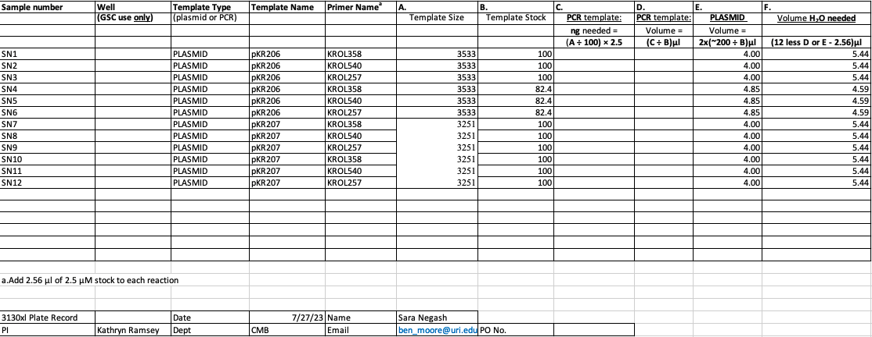
Figure. Sequencing submission form for pKR206 and pKR207

Bibliography

Ramsey, K. M. and Dove, S. L. (2016) ‘ A response regulator promotes Francisella tularensis intramacrophage growth by repressing an anti-virulence factor ’, Molecular Microbiology. doi: 10.1111/mmi.13418.

